V12-017 Release New Functionality Contents
V12-017 Release New Functionality Contents 1
Important Note 3
Accounts Payable 4
New Positive Pay Format for Bank of the West (22.61830) 4
New Positive Pay Format for Scotia Bank (22.62819) 6
New Positive Pay Format for First Security Bank (22.61413) 11
New Positive Pay Format for TRUIST Bank (22.64557) 14
New EFT Format for RBC Bank for Canadian Payments Only (23.66491) 18
New EFT Format for Deerwood Bank (22.63490) 24
New AP Third Party Payment Mode format for SunTrust bank for Credit Card Payments (22.63965) 26
Registry/Invoice Query – Gross Amount Column (22.64562) 29
New Bank of America Pay Format ‘BOA_6’ for AP Single & AP & PY Combined Positive Pay (22.64396) 30
New AP EFT file format for RBC Bank (22.62153) 33
AP EFT Payment Type Enhancement (23.67326) 42
Accounts Receivable 50
Import Functionality is added to AR Invoice Entry program (23.66396) 50
New AR Functionality to distribute AR Invoices by Preferred Contact Method (22.63452) 50
Analytics 54
BI Catalog Builder – User Defined Folder and Views (22.59247) 54
BI Catalog Builder - Copy Data Source Change (21.42008-191) 57
BI Catalog Builder – Create User Defined Logs Change (22.63581) 57
BI Catalog Builder – Views for User Extensions Tables (22.64317) 58
BI Catalog Builder – Switching Role Security On/Off (22.66056) 61
BI Catalog Builder – Search Enhancements (23.66907, (JIRA BI-225, BI-226)) 62
BI Catalog Builder – New Folders and Default Reports (23.67458) 65
BI Dashboard Builder – Duplicate Query/Dashboard Names (21.42008-177,180,181) 65
BI Dashboard Builder – Create User-Defined Folder (21.42008-184,185) 65
BI Dashboard Builder – ‘Get Link’ Enhancement (21.42008-196,197) 67
BI Dashboard Builder – Performance Analysis Report etc. (21.42008,22.64853,22.64877) 68
BI Dashboard Builder – Track Dashboard Events using Segment etc. (21.42008,21.46383,22.65163) 70
BI Dashboard Builder – Visualization Alignment (21.42008-215,216) 71
BI Dashboard Builder – Allow Update/Overwrite for Importing (21.42008-219,220) 72
BI Dashboard Builder – Import Dashboards to Different Data Sources (21.42008-228) 73
BI Dashboard Builder – Autoload Data (21.42008-229,230) 74
BI Dashboard Builder – Display Plotting Field Names (21.42008-234) 75
BI Dashboard Builder – Dashboard Metadata (21.42008-235) 77
BI Dashboard Builder – “Searchable in Builders Only”Setting (21.42008-239) 78
Equipment Costing 79
Group Location Code – New Transaction Code column (22.63435) 79
Equipment Class column in Group Location Transfer program (23.66506) 80
General Ledger 83
Financial Document Formatter live data preview from document printing (22.63488) 83
Financial Document Process Train (23.70726) 85
Imaging 87
Imaging Control – Hide Select/Deselect All on MOVE (22.61244) 87
International Payroll 90
Addition of NEW localized fields on Employee Profile and Employee History Screen - Dubai Region (22.57530) 90
Employee loan and advances pause loan installment (21.51716, HCM - 2149) 119
Job Billing 126
New Licensing options and New flag to print AIA G742 and G743 titles added (22.60355) 126
Job Costing 130
Added new scope of work detail field in PMCHGFM, PMSCFM, PMCOFM Program (21.51716) 130
Added Total for column commitments on Enter Cost Forecast program’s Cost Transaction screen.(22.61134) 132
GC Monitor: Added Tool bar ‘Notes’ button for Labor and other blocks (22.64229) 133
Job Entry - Manage workflow lookup (21.48122) 135
Added “Enter Job” field and “Query” button to the [Adjustment] pop-up in Enter Cost Transaction (22.64193) 136
Material Sales 137
Added Bank Department and Bank Account fields in MS External Invoice (23.71754) 137
Opportunity Management 148
New Data Filter field in Opportunity Management (22.53208) 148
Payroll US 150
Print Comments – Timesheet Edit Listing Report (22.63172) 150
Addition of new flag on pay groups screen ‘Override Account’ (22.61180) 156
Job Benefit/Deduction Setup (22.64386, HCM - 3393) 161
Non-Paid Hours Column Added to Hour Types Screen in US Payroll (23.68359, HCM - 2924) 165
Preventive Maintenance 173
Ability to prevent inter-company work order (23.69378) 173
Project Management 177
Specifications Extraction Verification Page – Prompt changes (22.63986,CF-3679) 177
Checklist Template Maintenance – Lock flags for both System and Project Level Templates (22.64346,CF-5548,CF-3362,CF-3933,CF-4099,CF-5544,CF-6112,CF-6186) 178
Checklist Template Maintenance – Added “Link to Parent Template” Flag (22.65039,CF-230,CF-456) 183
Checklist Template Maintenance – Field Security (23.66938,CF-6384,CF-6385, CF-6550) 188
PM System Options Flag- Show Company Code in front of Project Code (22.63802) 189
Field Security for Proceed and Forecast flags in PCI Entry (22.64451) 191
Contract Forecasting Kendo - Enhancements (22.63893) 193
Subcontract Change Order – Field Security for Expense Code (22.52799) 197
Subcontract Compliance Popup – Field Security for Certificate Number (22.62022) 199
Project Roles: View All Records Associated with Business Partner (22.64713,CF-510) 201
Project System Options – Auto-check Pay Request flag (22.64967) 201
Field security for SDI flag in Subcontract and Contract Type Maintenance programs (20.18275) 202
Locations Maintenance - Generate QR Codes (22.62042) 204
Field security for Phase Template on 'Add Phase/Category on the fly' (22.61012) 206
PCI/Subcontract Entry Cost Code Template – Active Flag (22.60044) 207
Submittals - Actual & Projected Schedule and Actual & Projected Timeline (22.65530/CF-4158) 209
Drawings and Specifications Upload – PDF Type (23.69000) 210
Contract Forecast Collapsible Summary Section, Reset Grid Layout (23.66681) 211
PCI Entry – Select Budget Lines Button (22.64387/PC-2822) 212
Purchase Order 216
Ability to allocate Discount % to PO Detail lines (22.62745) – Beta Version 216
Currency Code LOV in Purchase Order and Change Order entry program (22.62745) – Beta Version 228
Requisition 229
Create Purchase Order from Requisition Entry – Buyer ID column (22.63937) 229
Subcontract Management 233
AP/SC Advance Payment functionality (20.34826) – Draft 233
New Flag ‘Do Not Validate Total Contract Amount Against Control Contract Amount’ added (22.63192) 237

Important Note
Please be aware that some modifications and enhancements may require licensing, specific configurations, and setup, and may require involvement of CMiC Consulting in order to be utilized and further training may be required. Please contact your Account Manager/Project Manager for more information where needed.

Accounts Payable

New Positive Pay Format for Bank of the West (22.61830)

Overview:
A new Positive Pay Format is created for Bank of the West
Modifications:
West-Bank3 is a new Positive Pay Format created for Bank of the West. It is a Comma delimited file format.
Below example shows the new Positive Pay format:
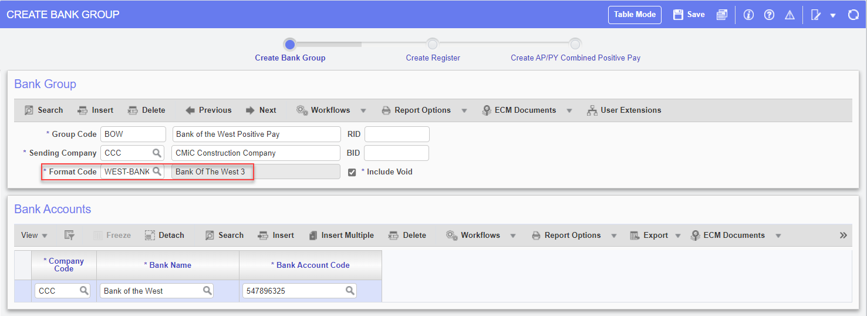
Create Positive Pay Register:
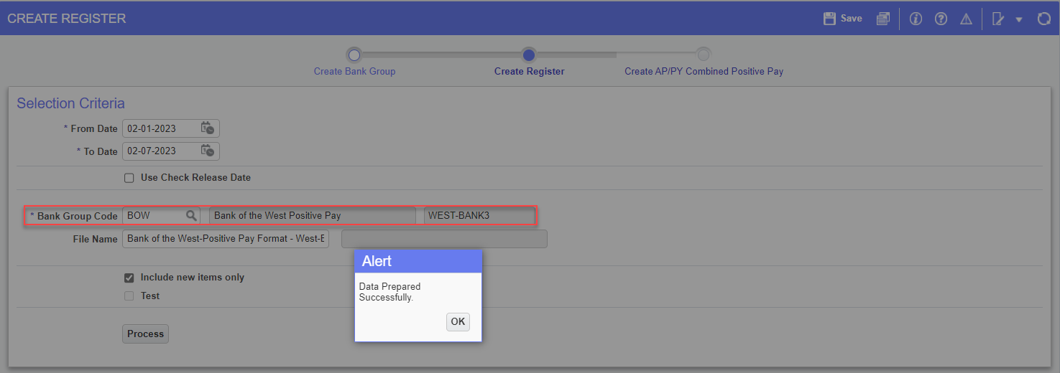
West-Bank3 Positive Pay File generated:
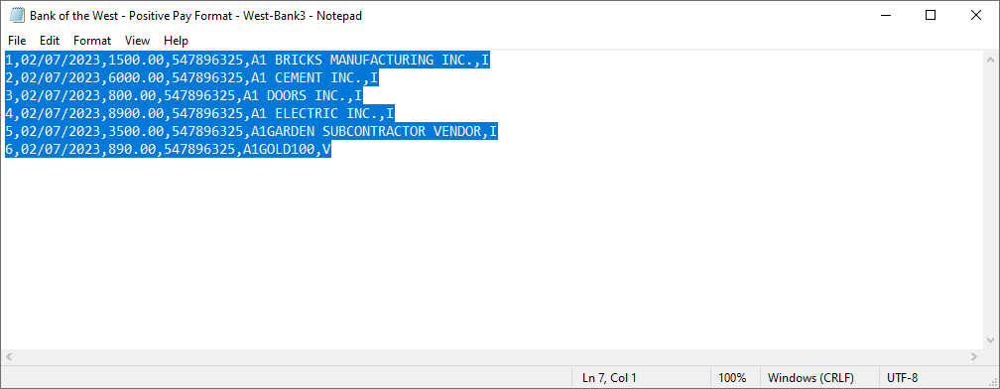
The above file generated follows the Format specifications from Bank of the West:
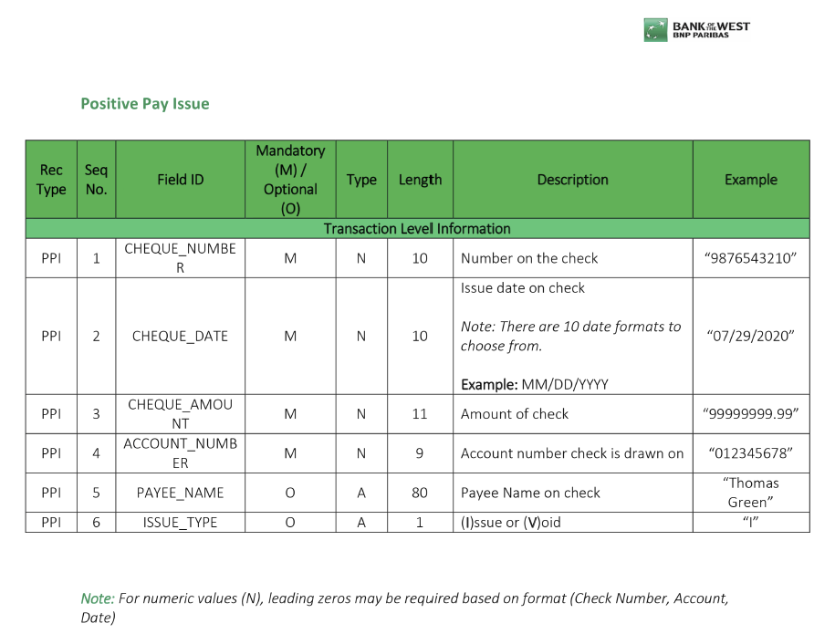
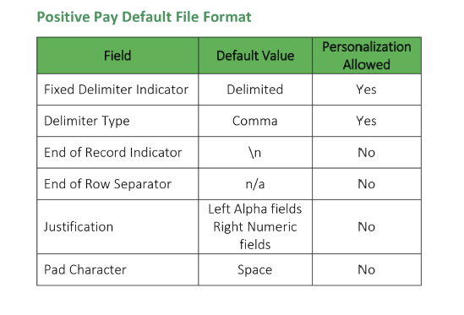

New Positive Pay Format for Scotia Bank (22.62819)

Overview:
A new Positive Pay File Format is added for Scotia Bank
Modifications:
The new Positive Pay File Format: ‘SCOTIABANK’ is added for Scotia Bank.
Example:
Bank Account Maintenance:
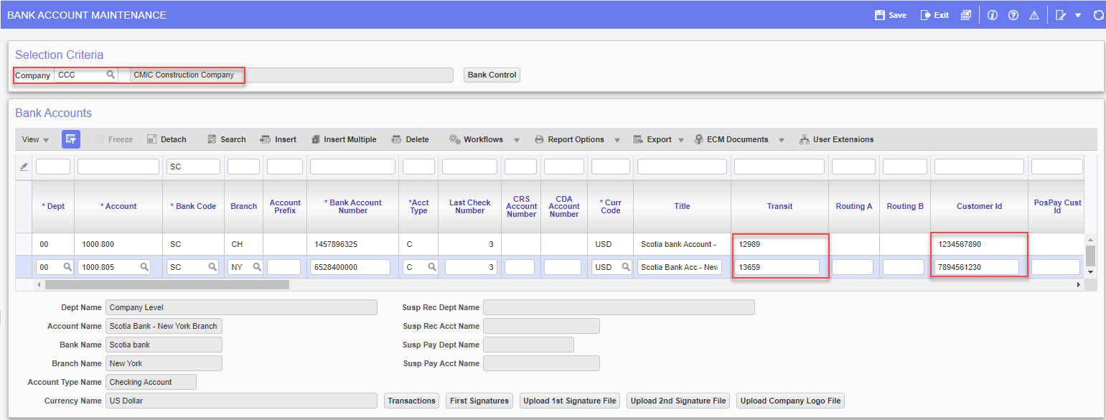
System data < Global Tables < Banking < Bank Account
Transit and Customer ID can be entered in the Bank Account Maintenance.
Below screenshot shows the new Positive Pay Format added:
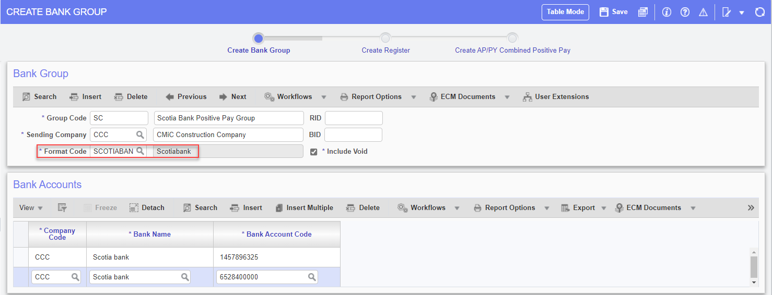
Accounts Payable < Check < Positive Pay Register
Create Positive Pay Register:
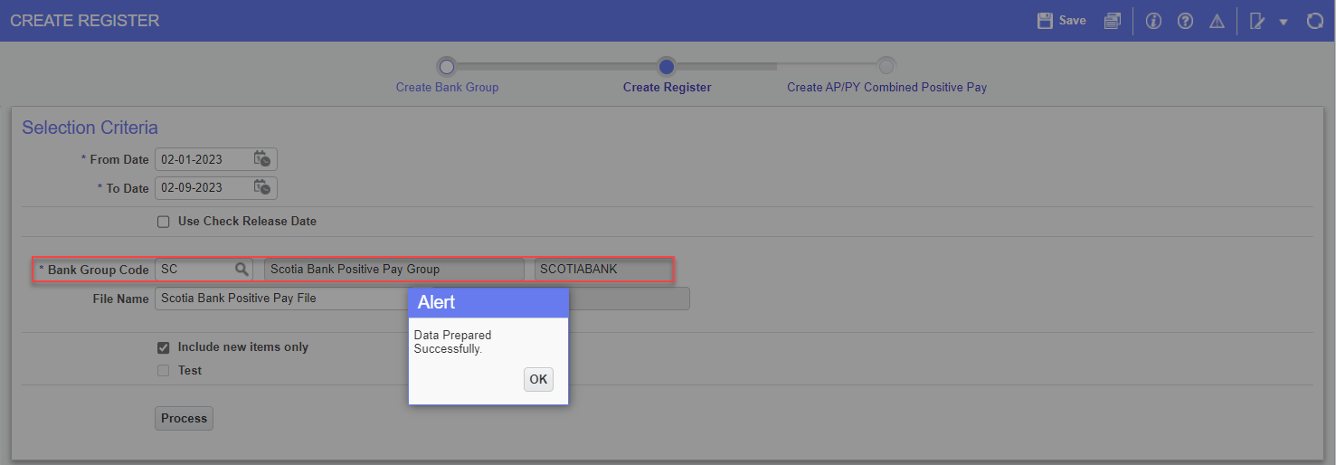
Scotia Bank Positive Pay File generated:
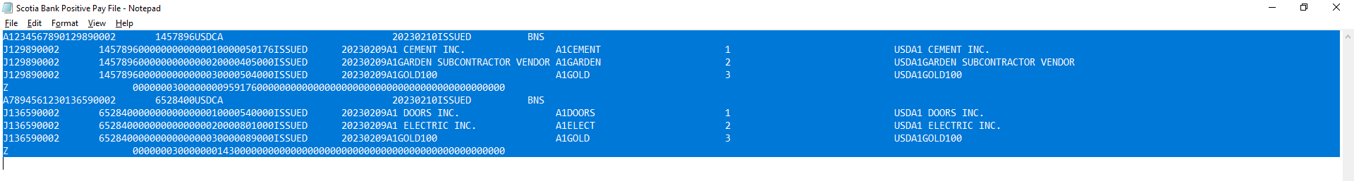
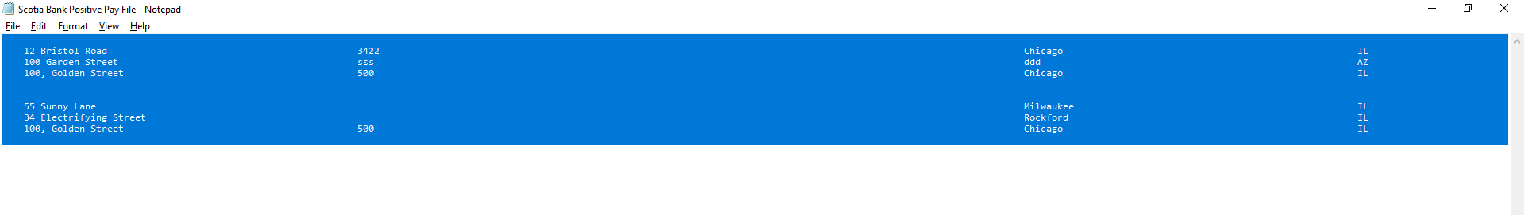
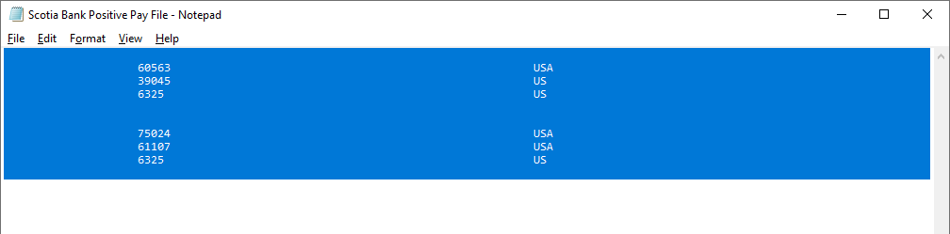
The above file generated follows the Format specifications provided by Scotia bank as shown below:
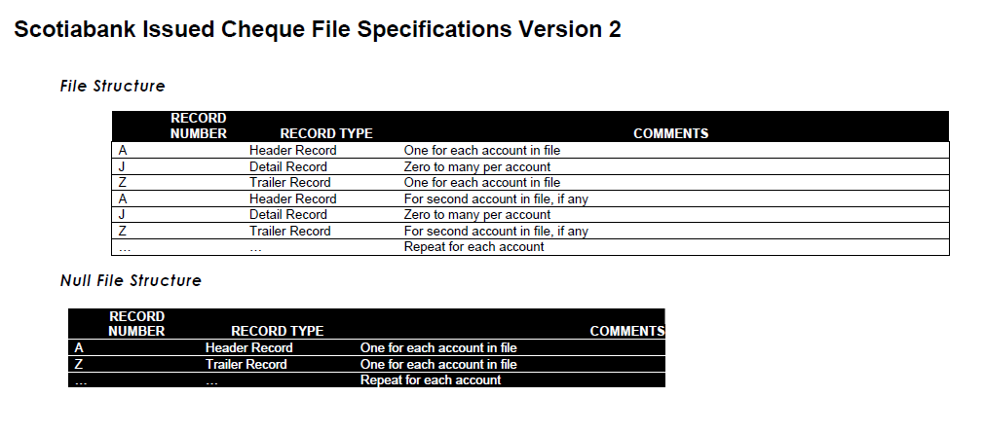
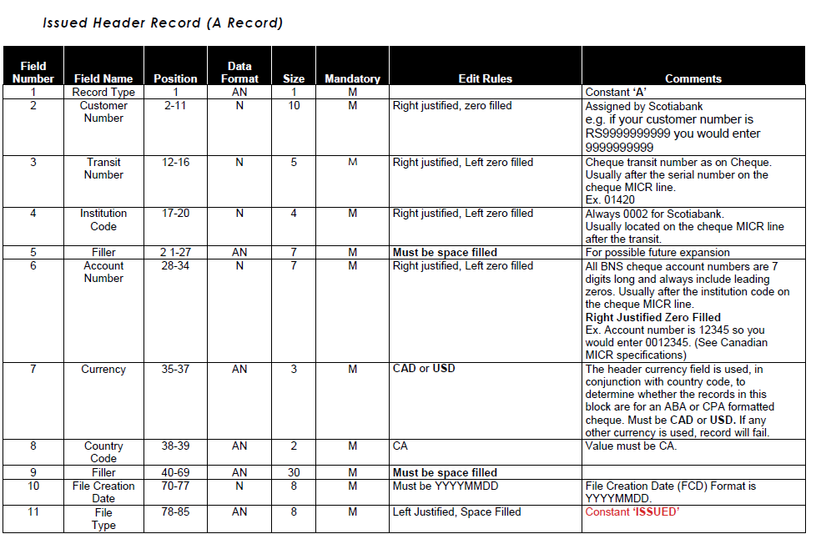
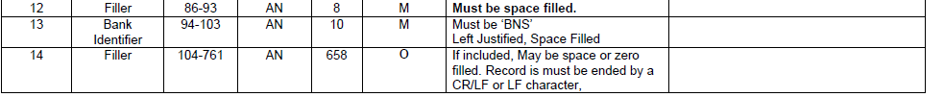
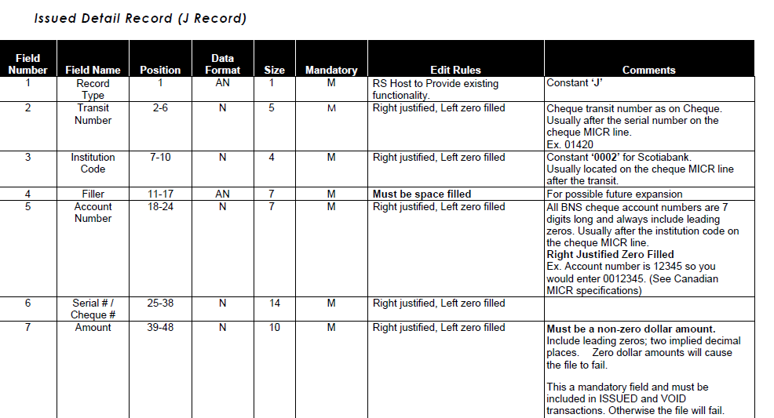
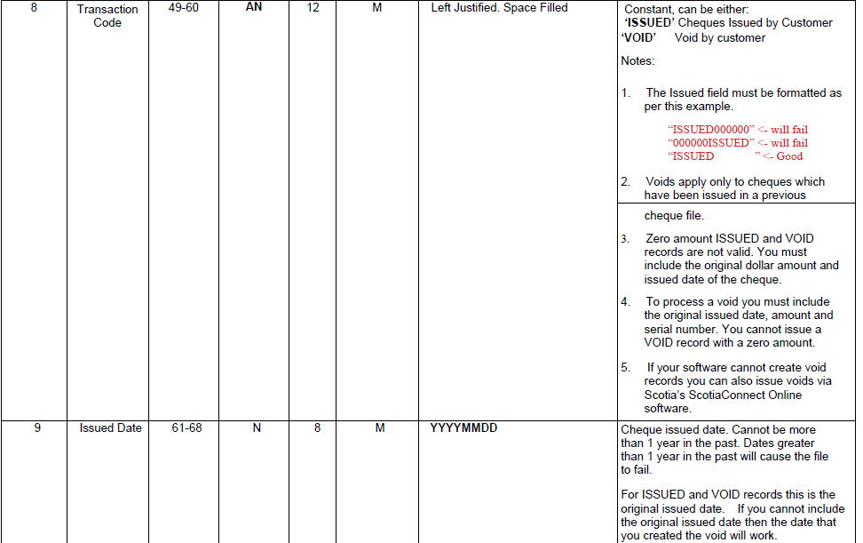
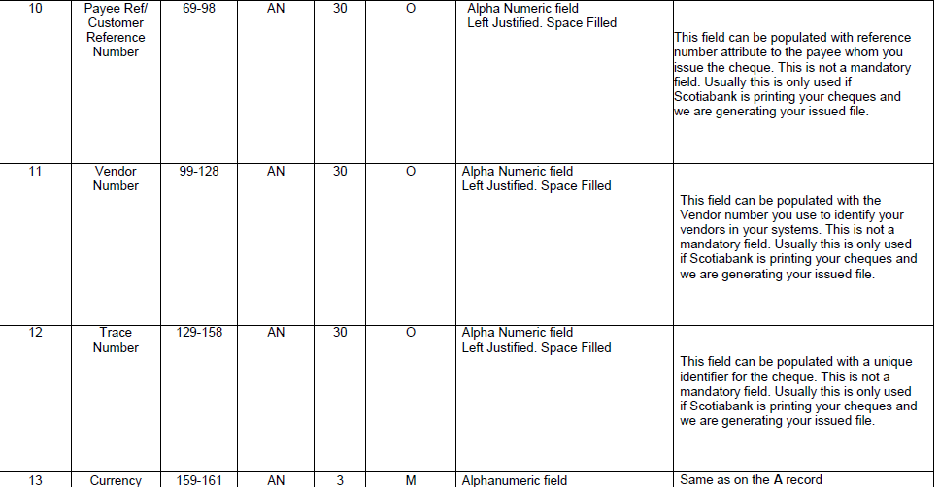
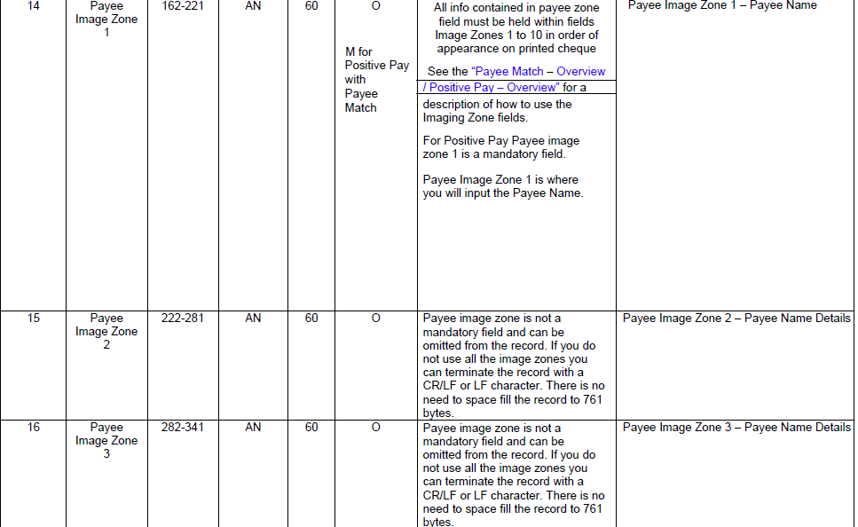
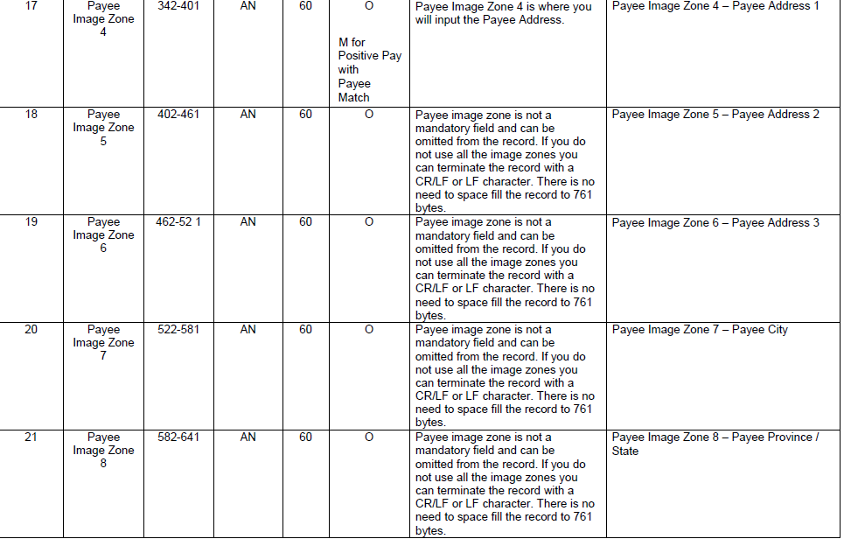
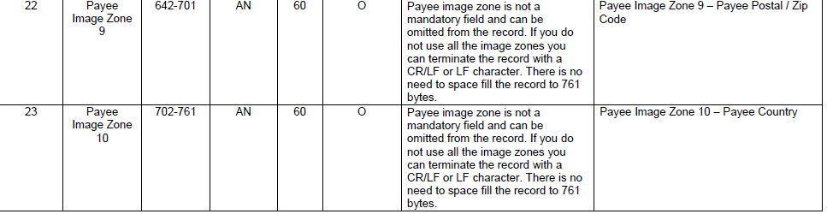
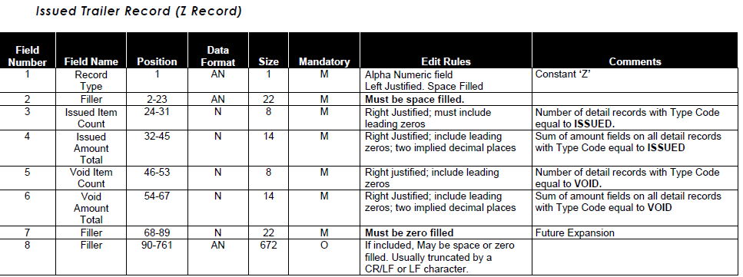

New Positive Pay Format for First Security Bank (22.61413)

Overview:
A new Positive Pay File Format is added for First Security Bank.
Modifications:
The new Positive Pay File Format: ‘FSBANK2’ is added for First Security Bank.
- It is a CSV comma delimited file format.
- Below are the file specifications:
- Four-digit bank field (0153)
- Account Number
- Cheque Number
- Cheque Date (MMDDYY)
- Cheque Amount (For Void, show 000)
- Payee Name (No commas, for void show void)
___________________________________________________________________________________
Note: File name format is "CustName345_PP_MMDDYY"
Group sending Company Name (First 10 Characters – Test Company) + Bank Account last three digits (345) + PP (Constant value) + Current System Date (MMDDYY - 082722)
Since file name has bank account number (last three digits) included so, therefore bank group code should not have more than one account specified. Separate group code should be used for each account.
___________________________________________________________________________________

Below screenshot shows the new Positive Pay Format added: FSBANK2
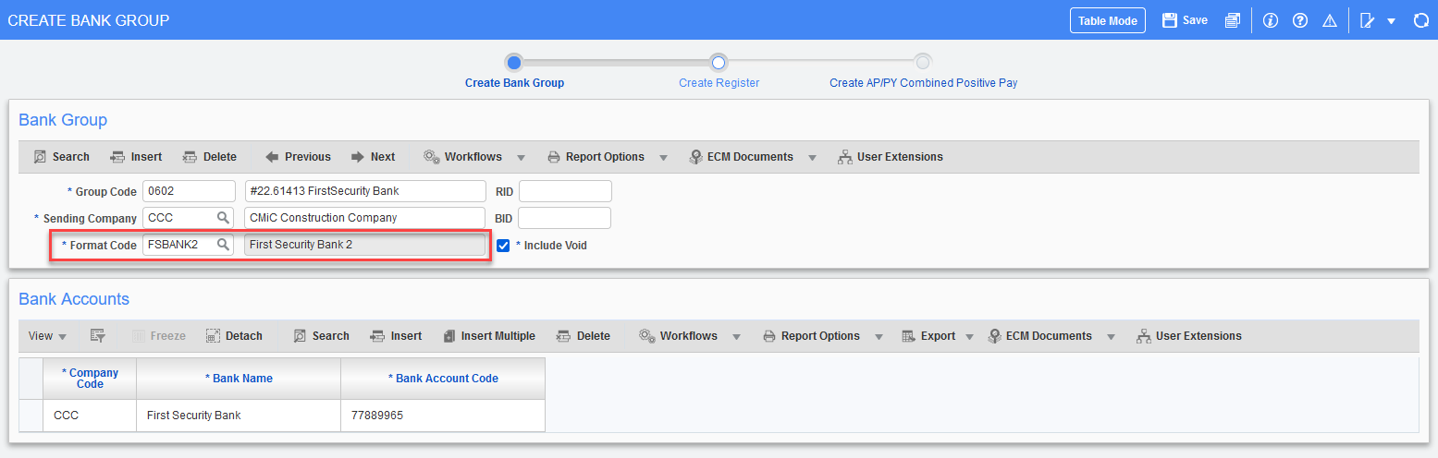
Accounts Payable < Check < Positive Pay Register

Create Positive Pay Register:
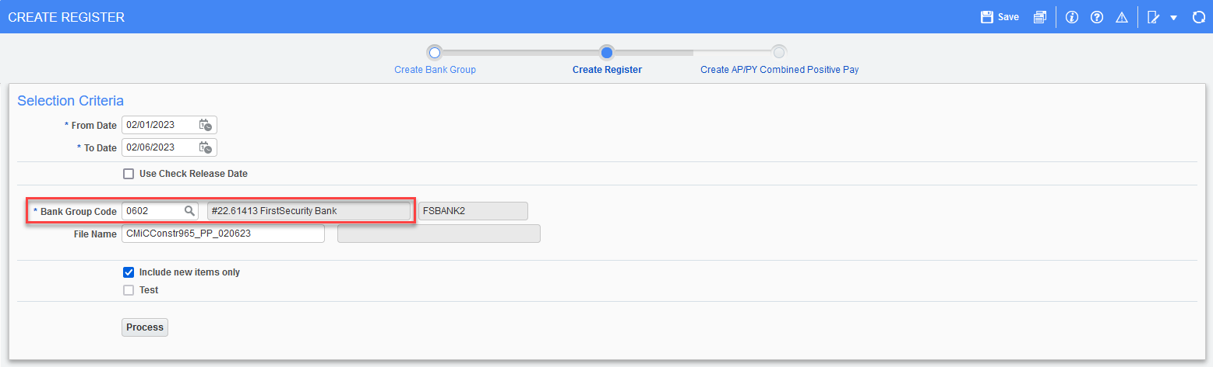

First Security Bank Positive Pay File generated:

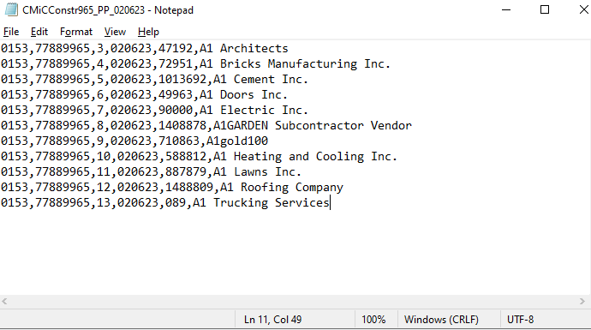

The above file generated follows the Format specifications provided by First Security Bank as shown below:

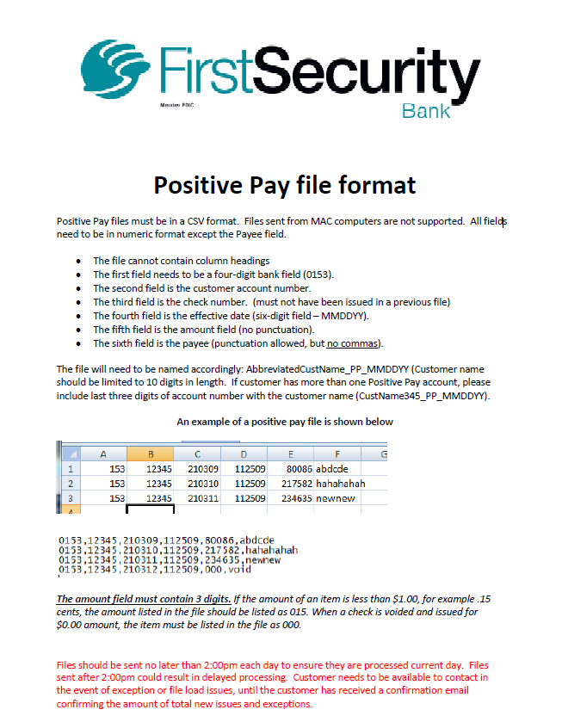

New Positive Pay Format for TRUIST Bank (22.64557)

Overview:
A new Positive Pay File Format is added for ‘TRUIST’ Bank.
Modifications:
The new Positive Pay File Format: ‘TRUIST’ is added for TRUIST Bank.
- It is a Fixed length ASCII File.
- This file will not contain any header and trailer records, only detail records.
- File format fields values and mapping are as follows.

- Record Code: C=Check or V=Void
- Account Number: Bank Cash Account Number
- Check Number: Check Number
- Amount: Check Amount
- Date: Check Date/Void Date
- Payee Data: Payee Name

Below screenshot shows the new Positive Pay Format added: TRUIST.
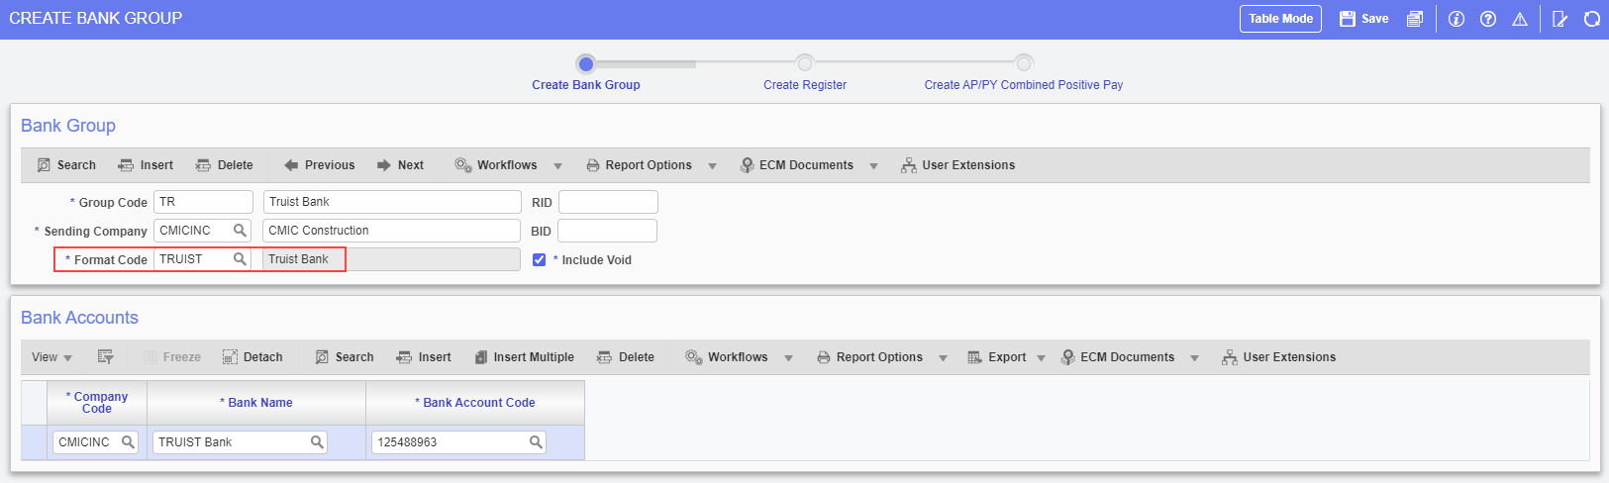
Accounts Payable < Check < Positive Pay Register
Create Positive Pay Register:
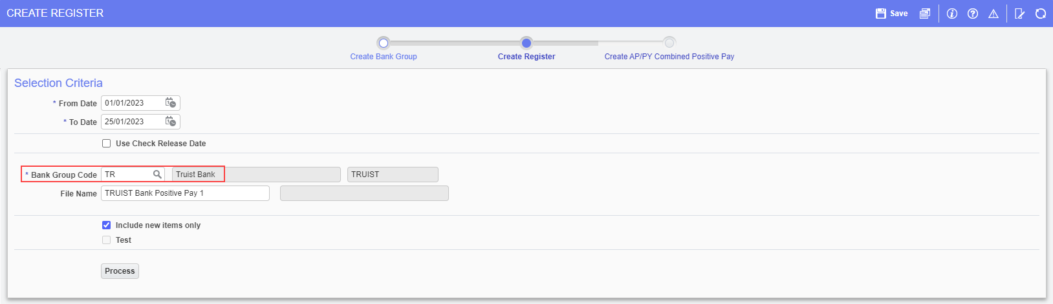
TRUIST Bank Positive Pay File:
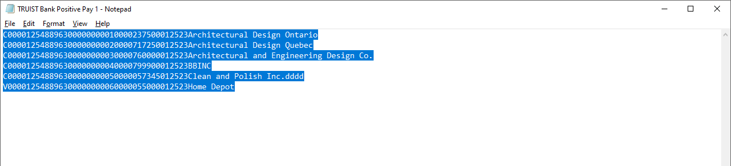
The above file generated follows the Format specifications provided by TRUIST BANK as shown in the next screen print.

TRUIST BANK Positive Pay File Format Specifications:
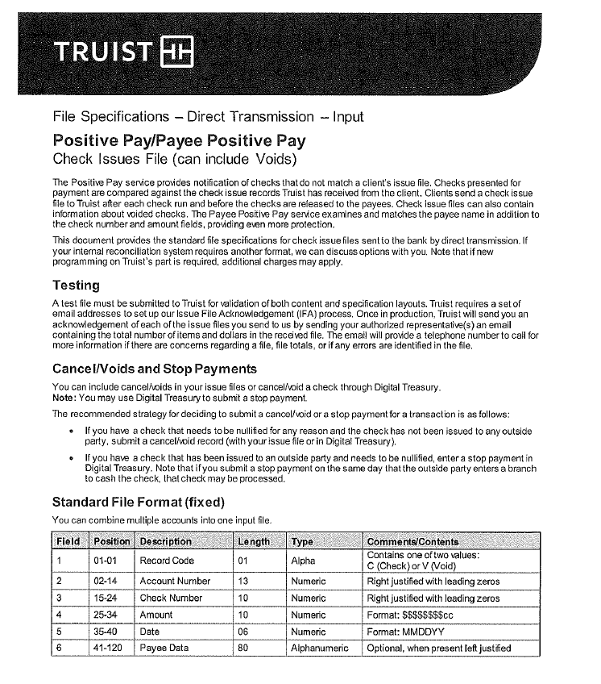
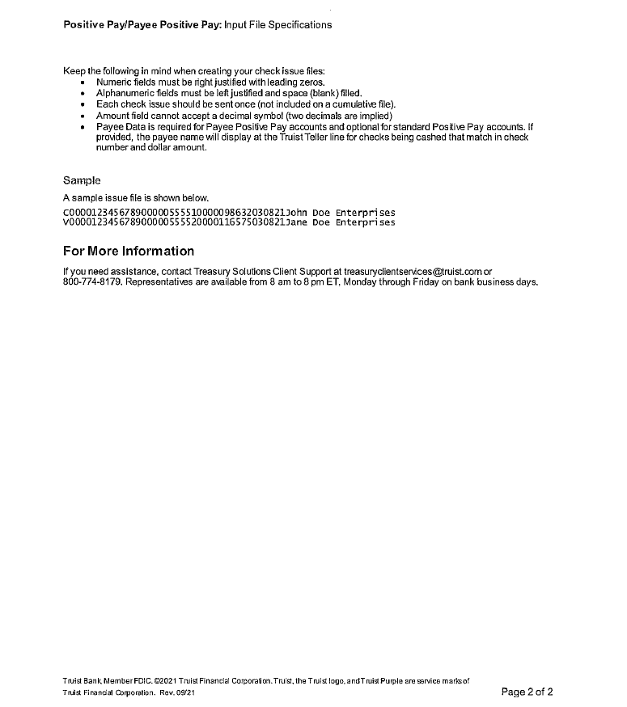

New EFT Format for RBC Bank for Canadian Payments Only (23.66491)

Overview:
A new AP EFT file format for RBC Bank is created.
Modifications:
The New AP EFT File format RBCBANKCPA is created for RBC for Canadian Payments Only
EFT Setup:
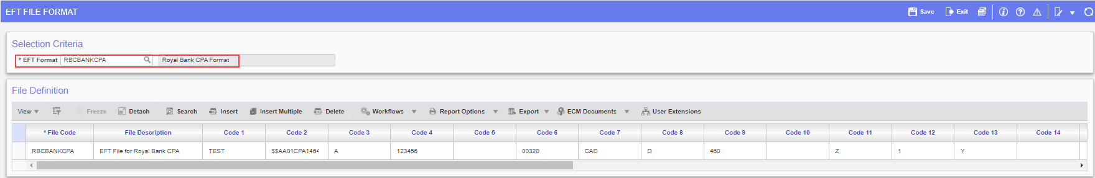
AP < Setup < Global Tables < EFT Formats
Code 2: Routing Record
Code 4: Client Number
Code 6: Royal bank Processing Centre
Code 7: Currency Code
Code 9: Transaction Code

Check Printing:
The Check Printing program allows users to select the available EFT File Codes. Users can select the Code and Generate EFT Files as required.
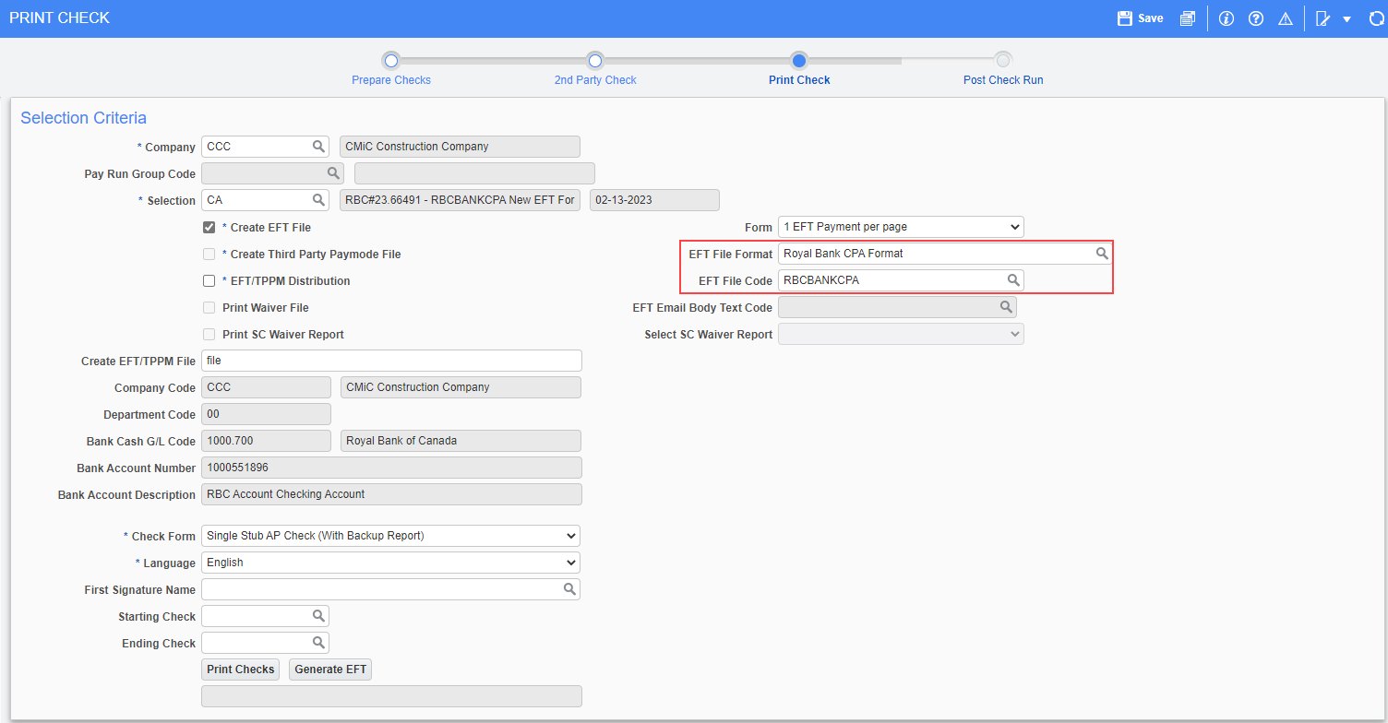
This is an example of the RBCBANKCPA EFT File:
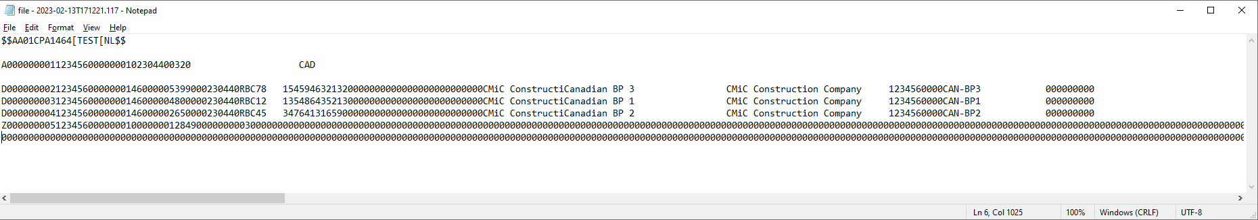

Following is the RBC’s ACH Direct Payments (PAP-PAD) Service Canadian Payments Association CPA-005, Debit File Format Specifications:

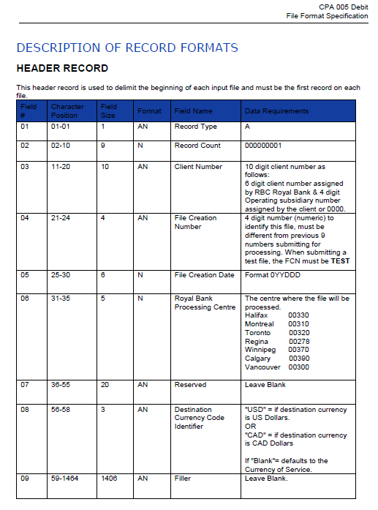
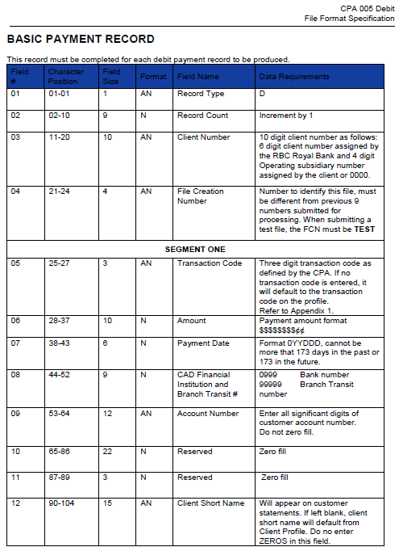
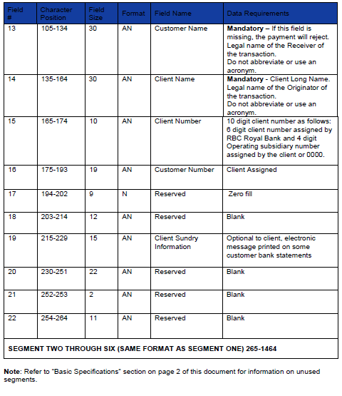
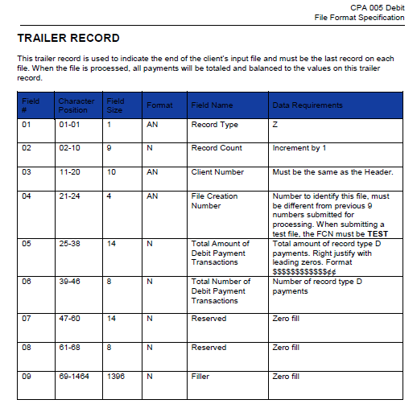
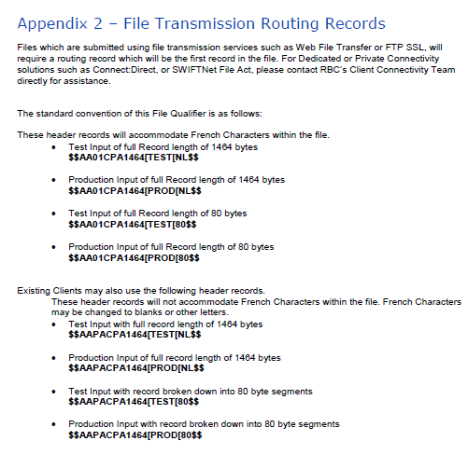

New EFT Format for Deerwood Bank (22.63490)

Overview:
A new AP EFT file format for Deerwood Bank is created.

Modifications:
New AP EFT File format DEERWOODBK is created for Deerwood Bank.
The format is same as the Standard EFT Format, the changes are on the file header only.

EFT Setup:
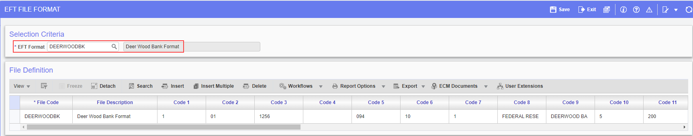
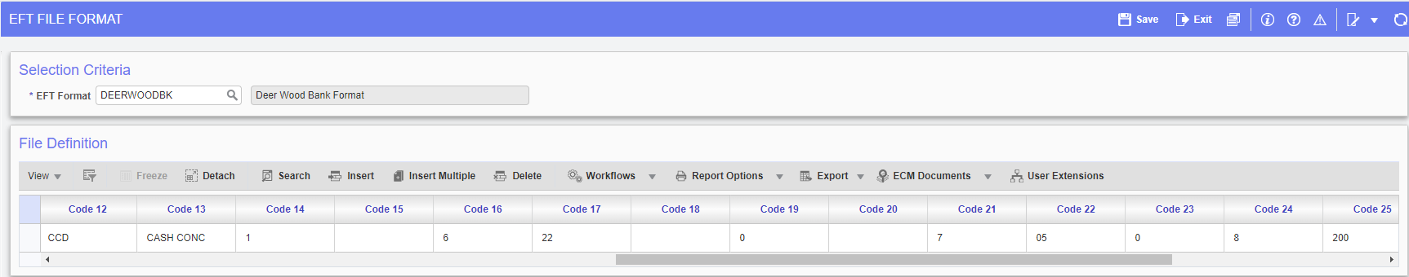
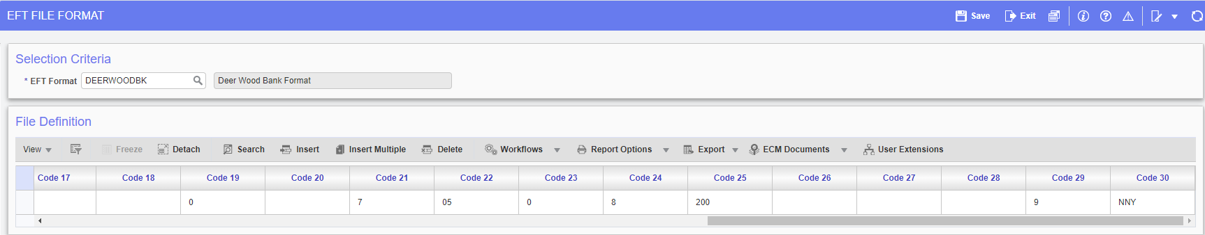
AP < Setup < Global Tables < EFT Formats
Note: Code 30 should be set NNY, to show 1 in front of TIN Number on Record2 and should start at space 41-50, to tell the system it is an electronic file.
Check Printing:
The Check Printing program allows users to select the available EFT File Codes. Users can select the Code and Generate EFT Files as required.
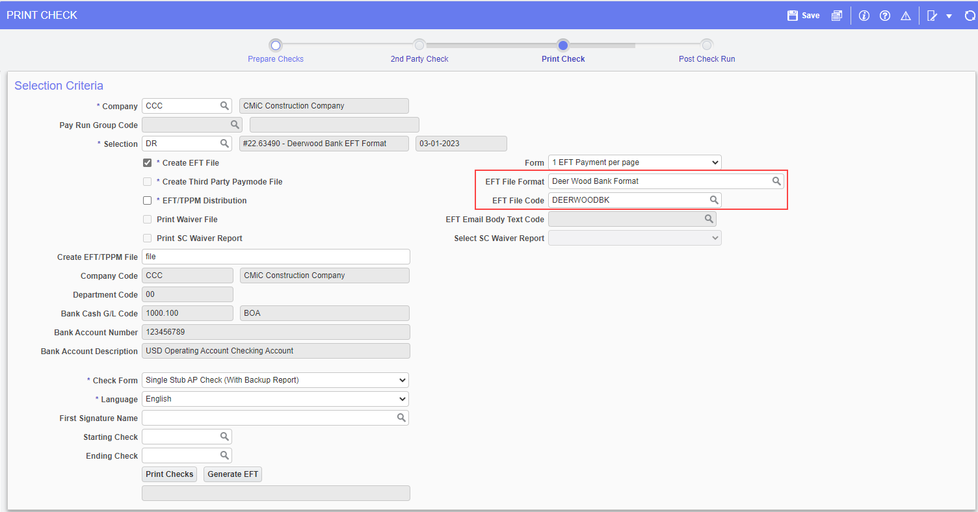
This is an example of the DEERWOODBK EFT File:
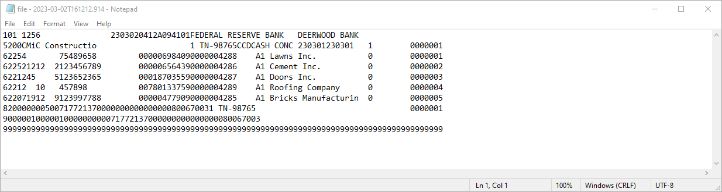

Following are the changes done in the header according to the specifications by Deerwood Bank:
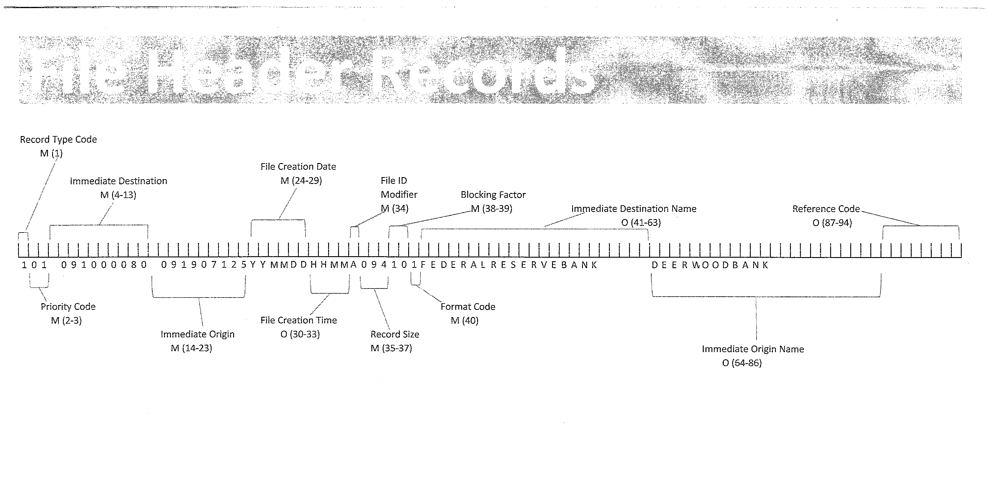

New AP Third Party Payment Mode format for SunTrust bank for Credit Card Payments (22.63965)

Overview:
A new AP Third Party Payment Mode format for SunTrust bank for credit card payments is added.

Modifications:
A new AP Third Party Payment Mode format "SunTrust 2" type - "Q" is added. File will be created from AP Print check screen.
It is a Tab Delimited ASCII text file with .txt file extension.
File fields and mapping is as follows:
Interface Type - (Always "PAYABLES" for all invoices being paid (this field is a Constant)
Invoice Number - (Invoice Number (alpha-numeric; Max field length 100)
Amount - (Invoice Payment Amount (16,2 - Numeric field)
Purchase Order Number - (PO number on Invoice (will not be used - please leave column blank)
Supplier Description - (Vendor name)
Supplier Number - (Vendor Code on invoice)
Contact Text - (Blank)
Check ID - (EFT Check#. When paying a single vendor multiple invoices on same day, use one check number)
Supplier Sub Number - (Blank)
Tax Amount - (Always zero 0)
Discount Amount - (Always zero 0)
Freight Amount - (Always zero 0)
Invoice Date - (Invoice Date - format(MM/DD/YYYY)

Note: There will be no report, just a bank file format.
Enter Voucher:
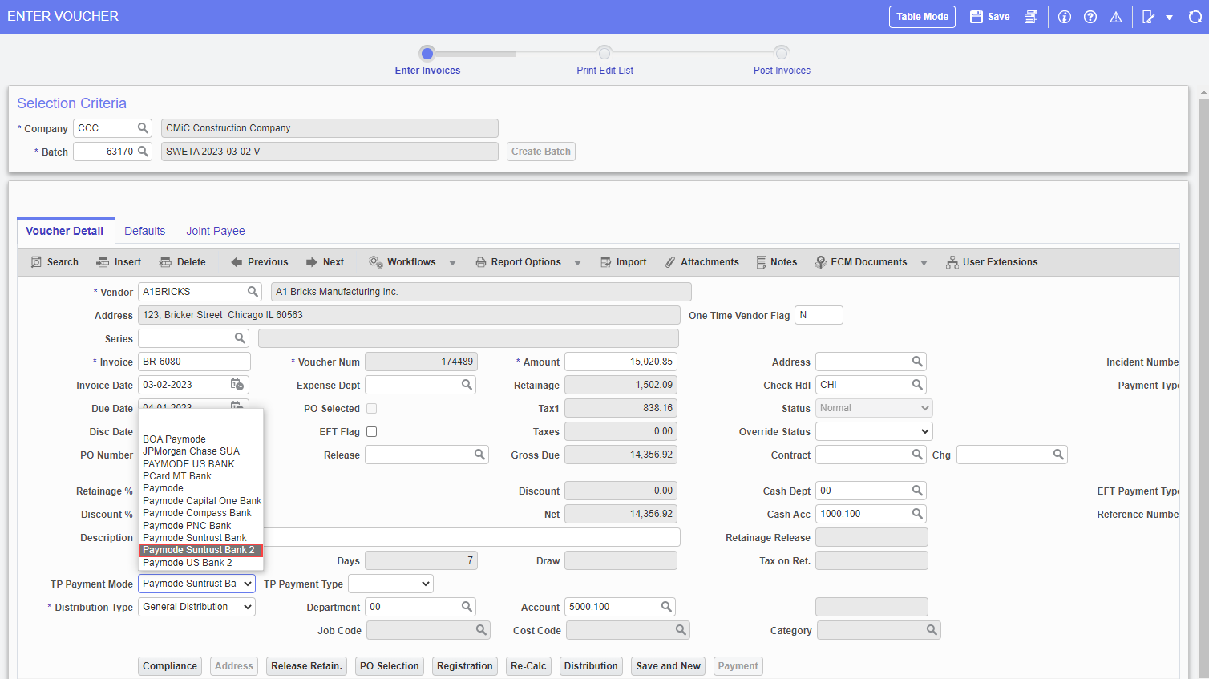
AP < Voucher < Enter Vouchers
The New Third Party Payment mode is available as Paymode Suntrust Bank 2, as shown in the above screenshot.

Select Payments:
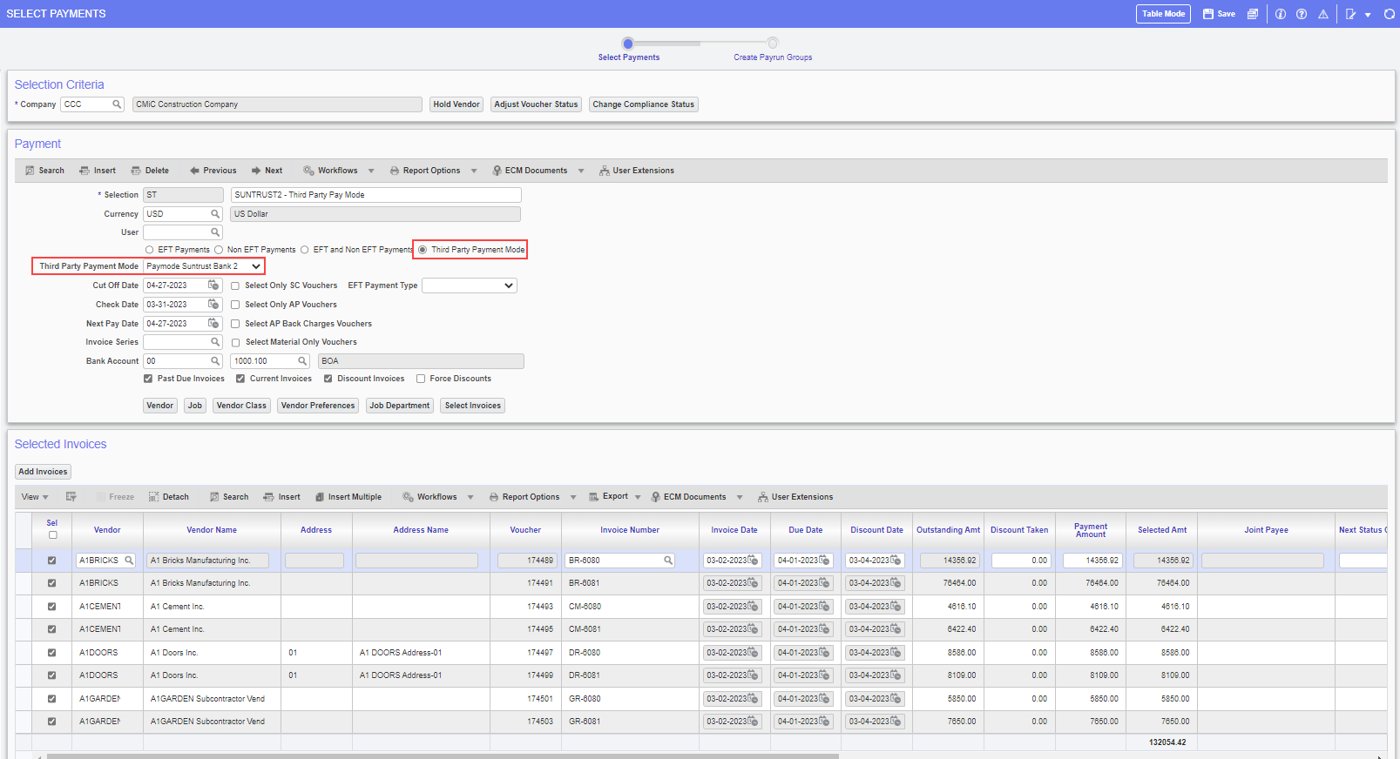
AP < Payment < Select Payment
Select ‘Third Party Payment Mode’ radio button and [Paymode Suntrust Bank 2] in ‘Third Party Payment Mode’ dropdown.
AP Print Check Screen:
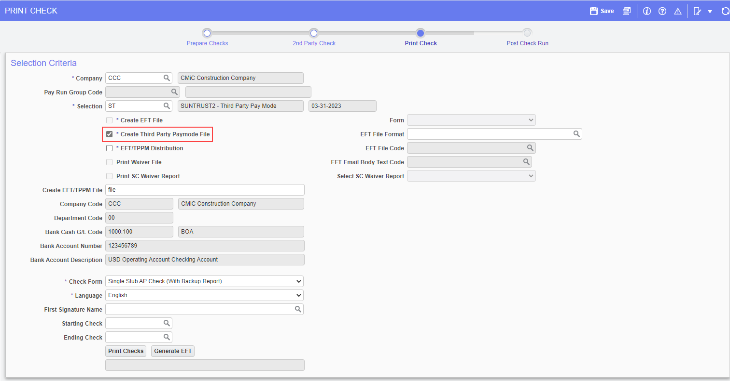
AP < Checks < Print Checks
Check the checkbox ‘Create Third Party Paymode File’ checkbox and click on ‘Generate EFT’ button to create the Third Party Payment Mode File.
Note: If the checkbox ‘Create Third Party Paymode File’ is not available in the Print Checks program, it can be added through Lite Editor.
Below is the Third Party Payment Mode File format for SunTrust bank - SunTrust 2
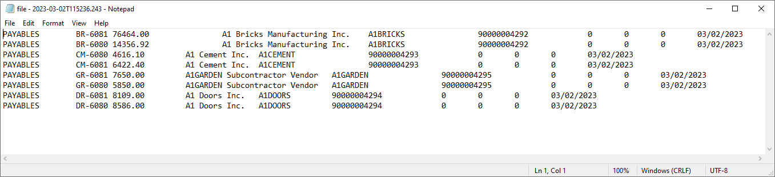

Registry/Invoice Query – Gross Amount Column (22.64562)

Overview:
A new column has been added to display the Gross Amount (VOU_APRI_GROSS_AMT) in Registry/Invoice Query program.

Modifications:

For both Registered invoice and Voucher records, a new column has been added in Voucher / Registry list screen to display the Gross Amount. The gross amount entered in Register Invoice screen or Enter Voucher screen flows through and shows up in the newly added Gross Amount column.

Implementation:

Account Payable > Query > Registry/Invoice Query
The Gross Amount column has been added to the Voucher/Registry details section, as can be seen in the screen print below.
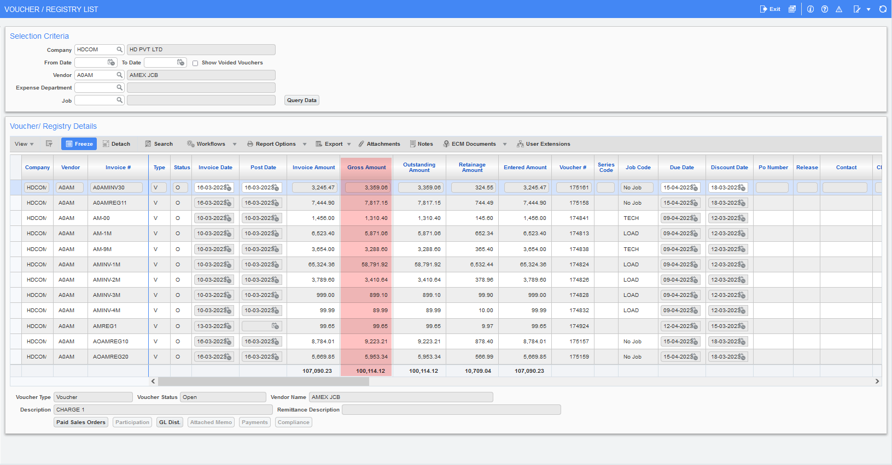

New Bank of America Pay Format ‘BOA_6’ for AP Single & AP & PY Combined Positive Pay (22.64396)

Overview:
Two new Positive Pay Formats are created for Bank of America. ‘BOA_6’ for AP Single and ‘BOA_2’ for AP & PY Combined Positive Pay

Modifications:
Two New Positive Pay Formats are created using the existing BOA Format to expand the Payee name to fit the entire Vendor Name.
‘BOA_6’ is new Positive Pay Format for AP Single
‘BOA_2’ is new Positive Pay Format for AP & PY Combined
BOA_6 for AP Single:

Below example shows the new Positive Pay format for BOA_6 for AP Single.
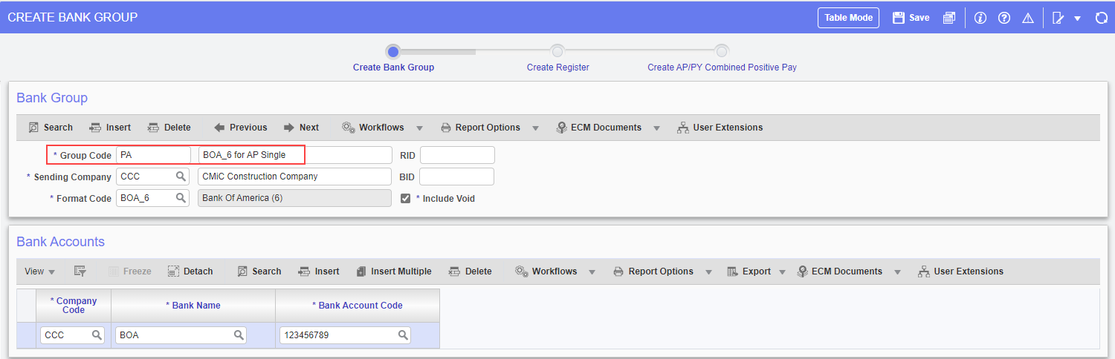

Create Positive Pay Register:
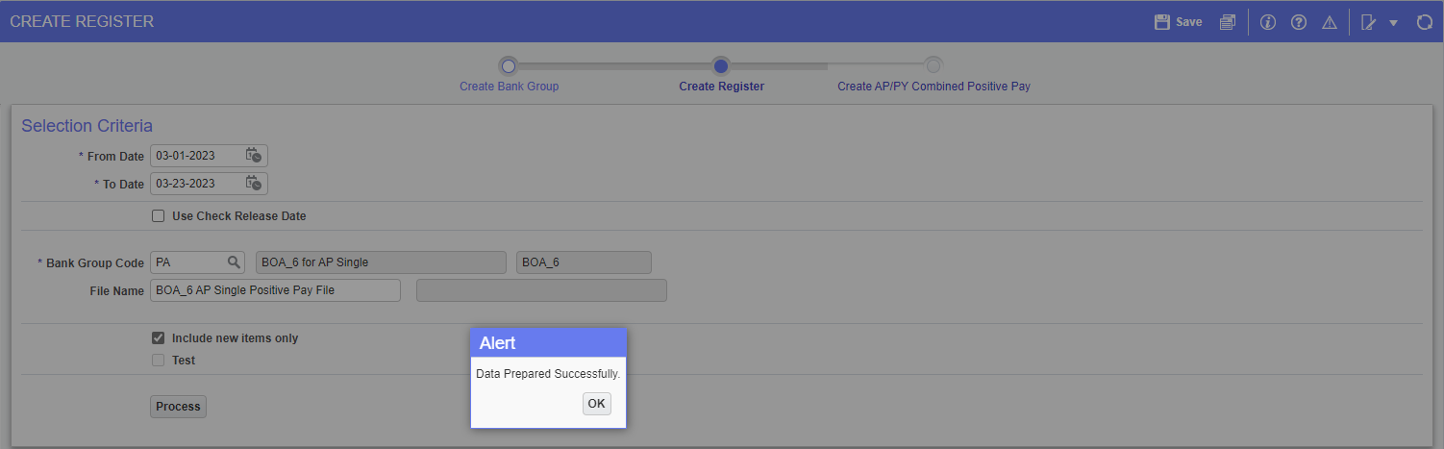

BOA_6 Positive Pay File generated:
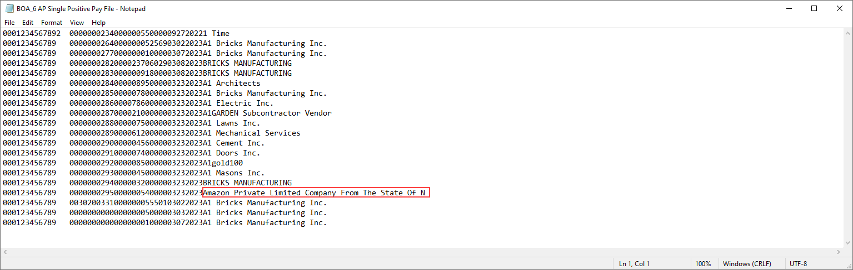

The entire Vendor name fits properly, ex: ‘Amazon Private Limited Company From The State Of N’
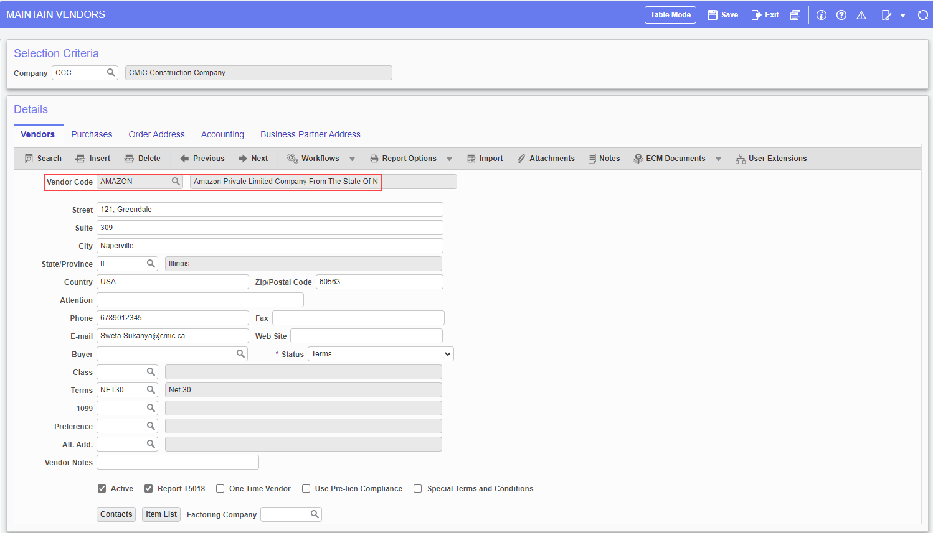

‘BOA_2’ for AP & PY Combined:

Below example shows the new Positive Pay format for ‘BOA_2’ for AP & PY Combined.
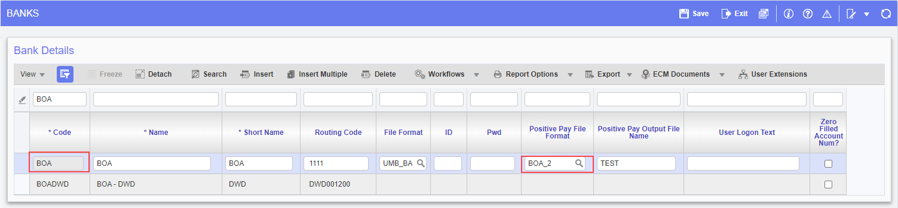

Create Positive Pay Register:
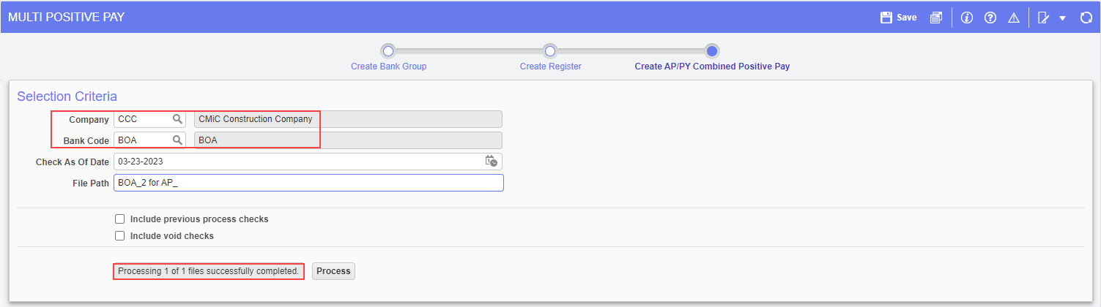

BOA_2 Positive Pay File generated:
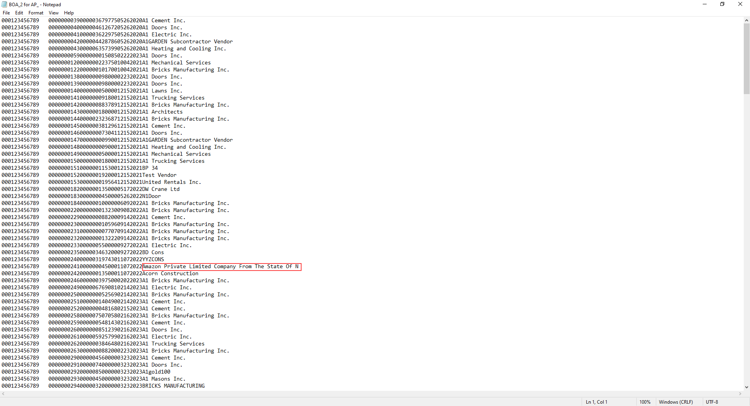

The entire Vendor name fits properly, ex: ‘Amazon Private Limited Company From The State Of N’

New AP EFT file format for RBC Bank (22.62153)

Overview:
A new AP EFT file format for RBC Bank has been created.

Modifications:
A new AP EFT file format for the Royal Bank of Canada, ACH Format 2 (RBCBNKACH2) has been created for RBC as per the RBC Standard File Format Specification.

EFT Setup:
The following screen shows EFT File Codes setup for RBCBNKACH2
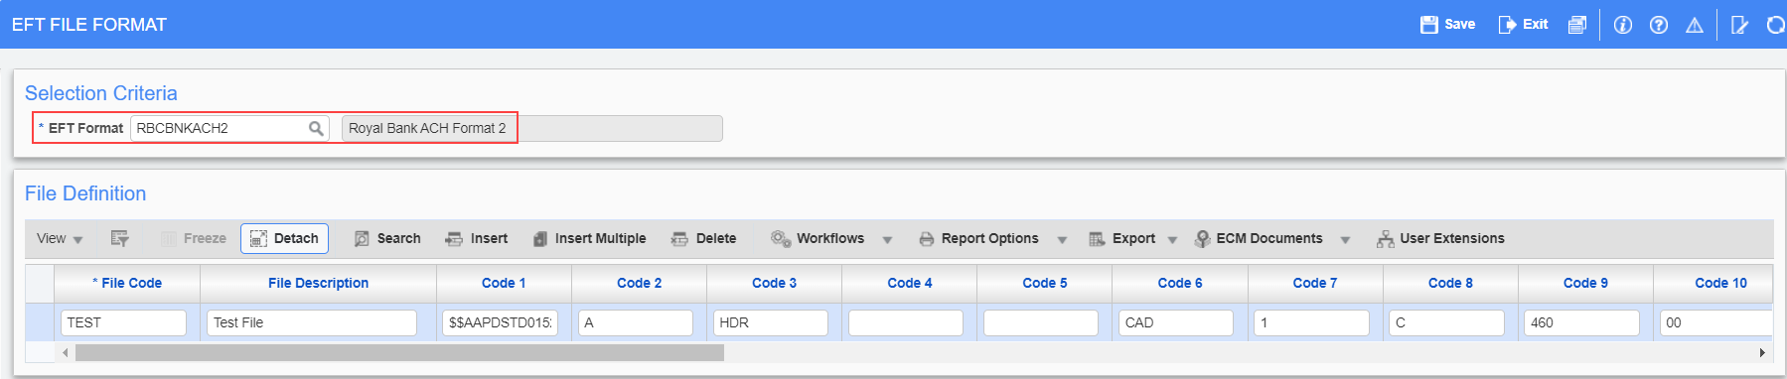
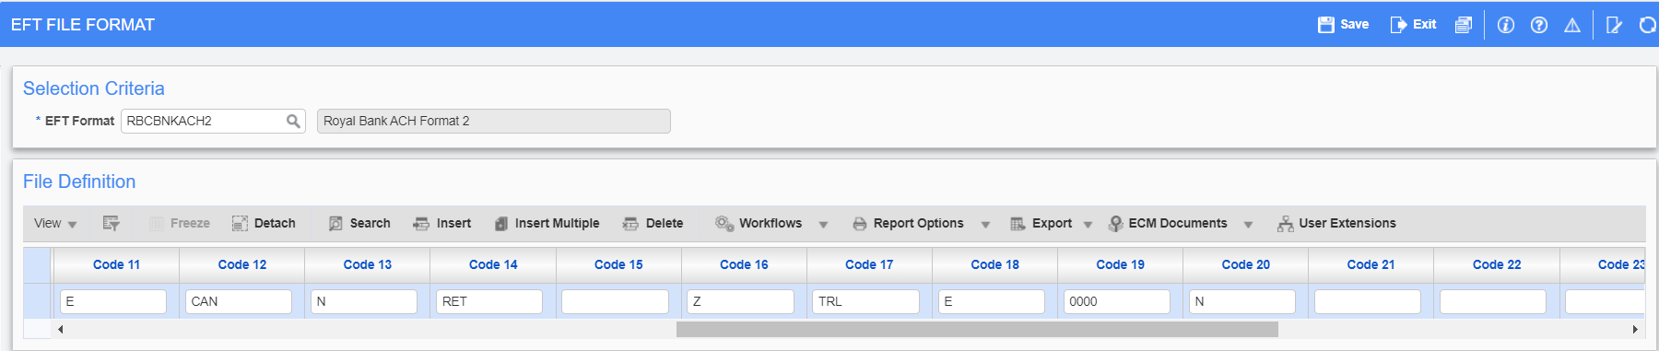
AP < Setup < Global Tables < EFT Formats

Code 1: File Routing Record
Code 2: File Header Record Type
Code 3: Transaction Code
Code 4: Client Number
Code 5: Subsidiary Number
Code 6: Currency Type
Code 7: Input Type
Code 8: File Detail Record Type
Code 9: Transaction Code
Code 10: Payment Number
Code 11: Language Code
Code 12: Destination Country
Code 13: Optional Record Indicator
Code 14: Transaction Code
Code 15: Sundry Information
Code 16: File Trailer Record Type
Code 17: Transaction Code
Code 18: Payment Medium
Code 19: File Creation #
Code 20: Auto-Numbering Flag

Check Printing:
The Check Printing program allows users to select the available EFT file codes. Users can select the code and generate EFT files as required.
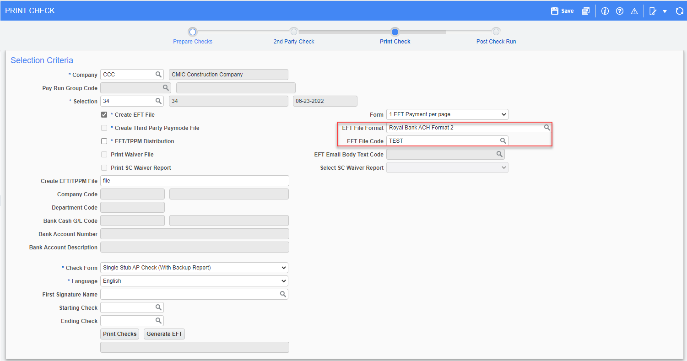
Following is the EFT File generated according to the RBC Standard File Format Specification:
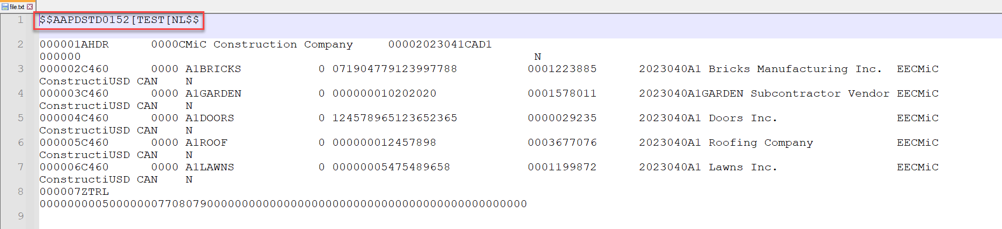
The first record (highlighted in red) in the above EFT File example is for Testing Purpose, if not required, remove the code1 from the EFT Setup.
Below is the RBC Standard File Format Specification:
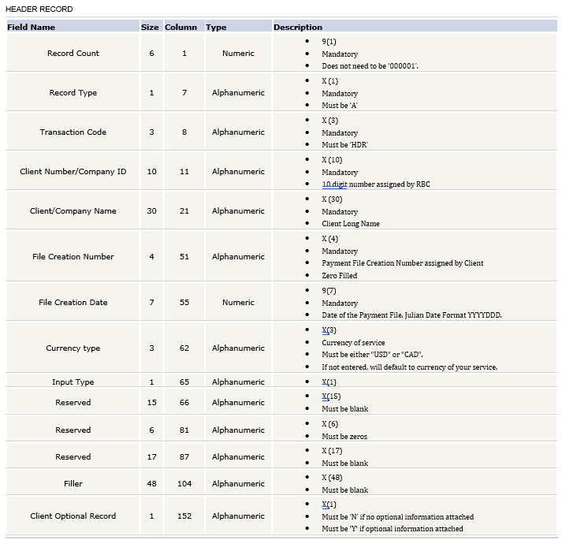
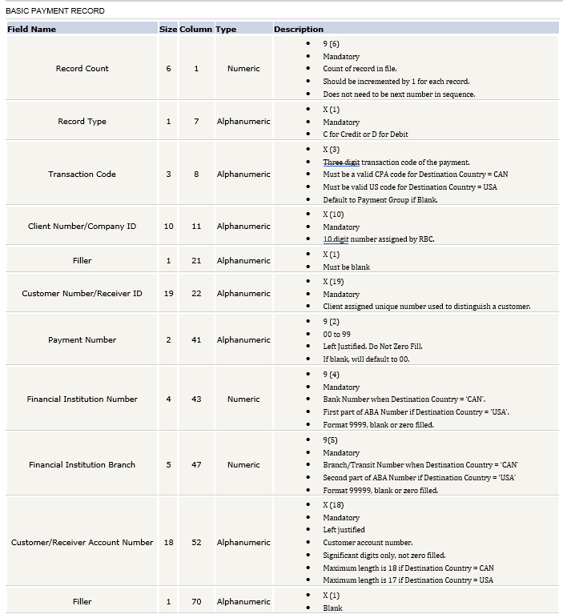
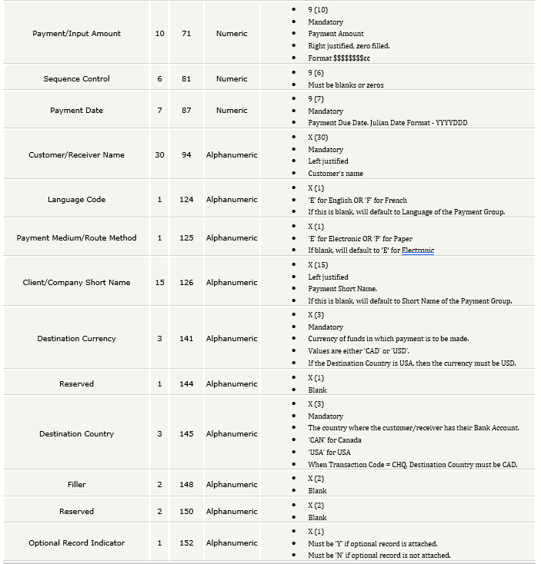
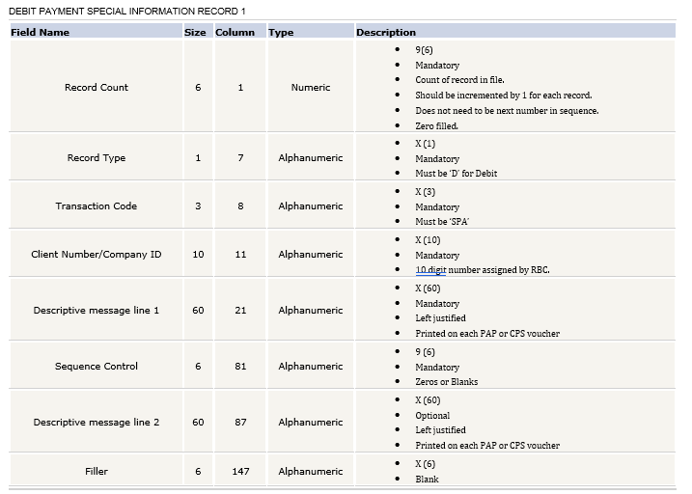
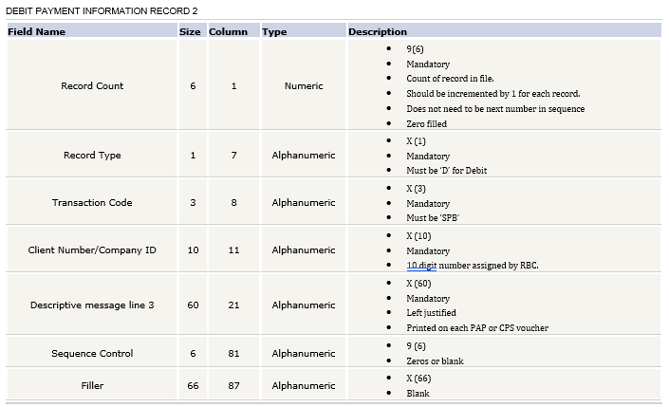
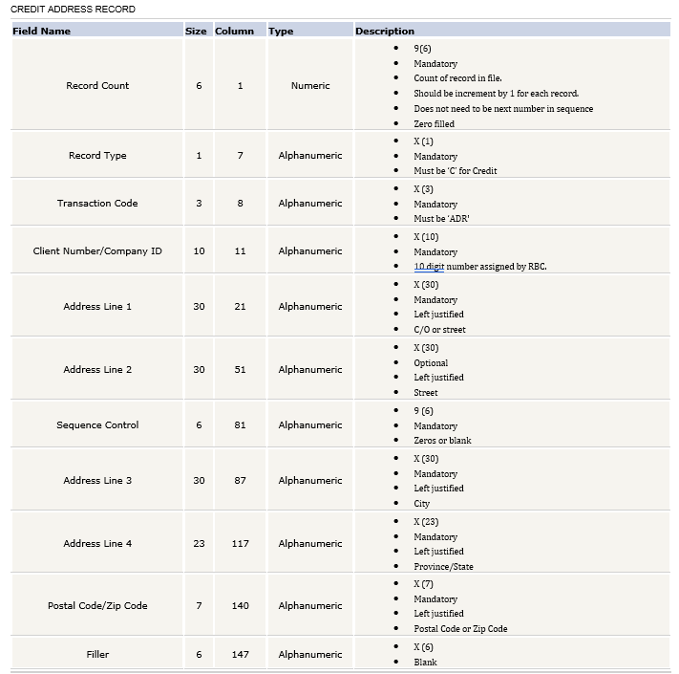
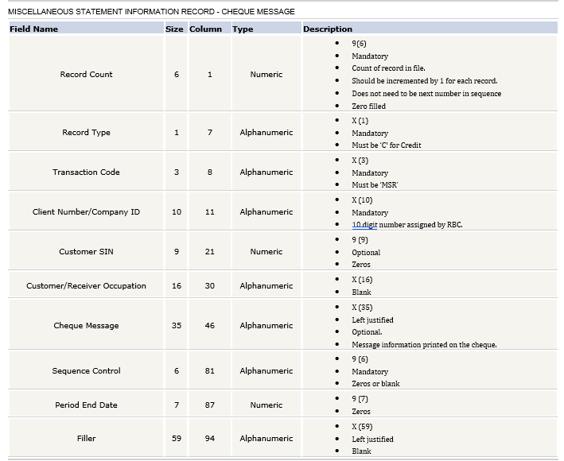
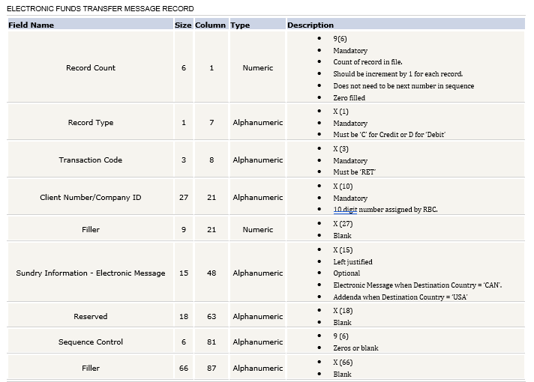
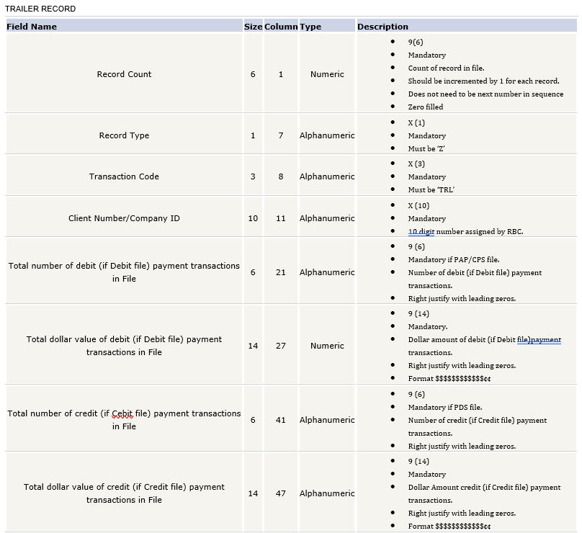
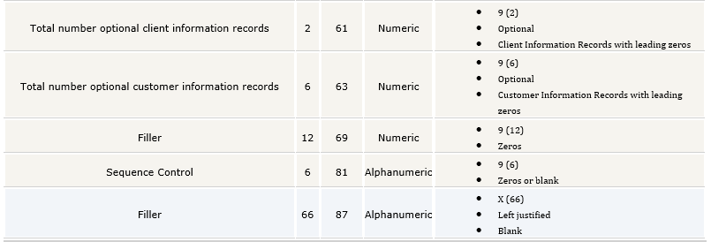

AP EFT Payment Type Enhancement (23.67326)

Overview:
AP EFT Payment Type Enhancement

Modifications:
To minimize the risk, increase audit compliance and reduce the need for editable CMiC generated bank ready files, the following EFT Payment Type enhancements are done:

- A new Program has been added : AP-Payment Types with the following fields:
- Payment Type Code (Input field, Required and Unique)
- Payment Type Name (Input field, Required and free form field)
- Payment Active Flag (Check box, Checked - Y , Unchecked - N ) If unchecked, will not be available in the EFT Payment type list.
Existing EFT Types in Enter Voucher has been inserted through script by default and cannot be deleted and the Type Codes cannot be edited.

- New EFT Payment Type field is added to Maintain Vendors under Accounting tab. By default this field is hidden and has to be added through the lite editor.

- EFT Payment Type selected in Maintain Vendors default to Image Manager, Registered Invoice and Enter Voucher.

- Any new EFT Payment Types that are added through the new AP-Payment Types Program is available in Image Manager, Registered Invoice, Enter Voucher, Adjust Voucher Status, and Select Payments programs.

- New table (ap_chq_ven_bank_info) has been created for audit purposes to store 6 fields values for each AP Cheque. Cheque unique column value is stored along with the following columns values to identify each cheque record in the new audit table:

a. Payment Selection EFT Payment Type
b. Vendor Bank Code
c. Vendor Swift BIC Code
d. Vendor IBAN Number
e. Vendor ABA Transit
f. Vendor Bank Account Number

- Cheque posting routine is modified to store the audit information.

Example with Screenshots:

The new Program: AP-Payment Types
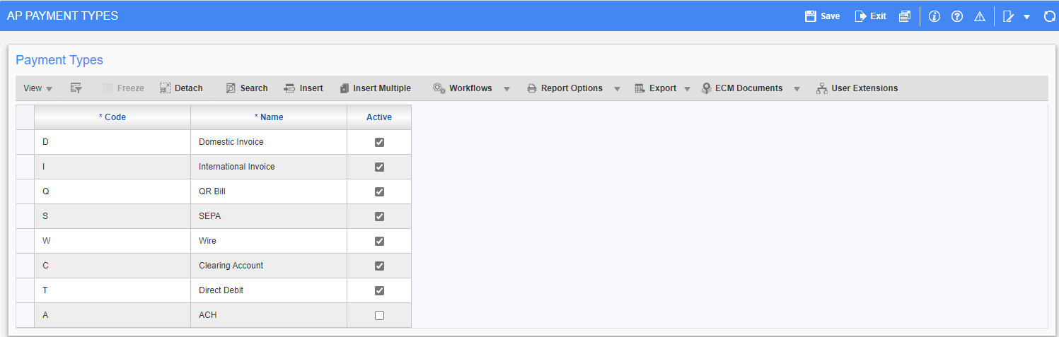

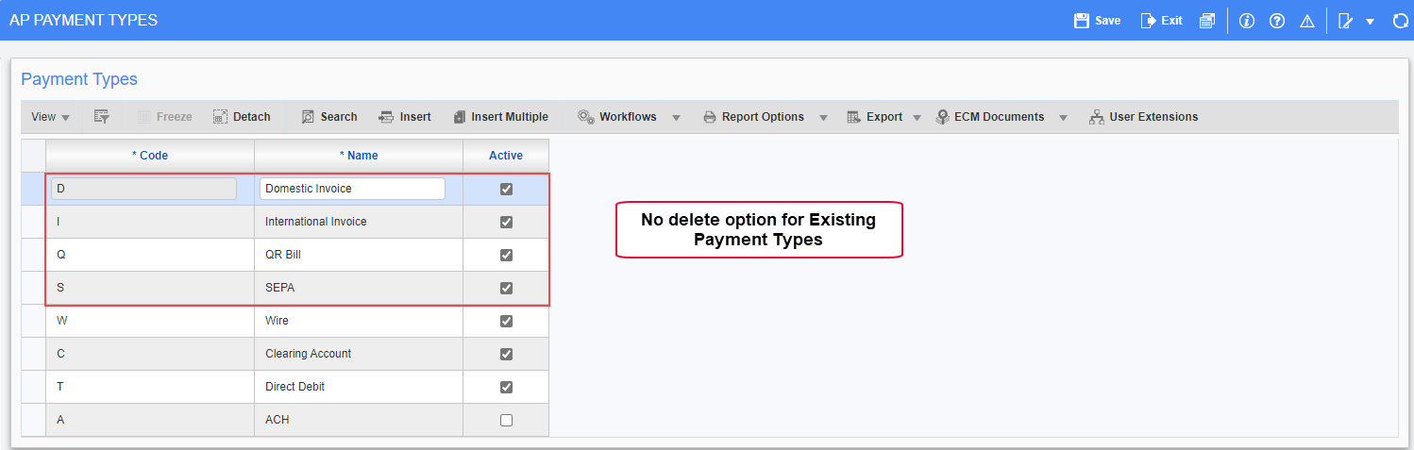

If user tries to enter a record with the same Code the following error message appears:
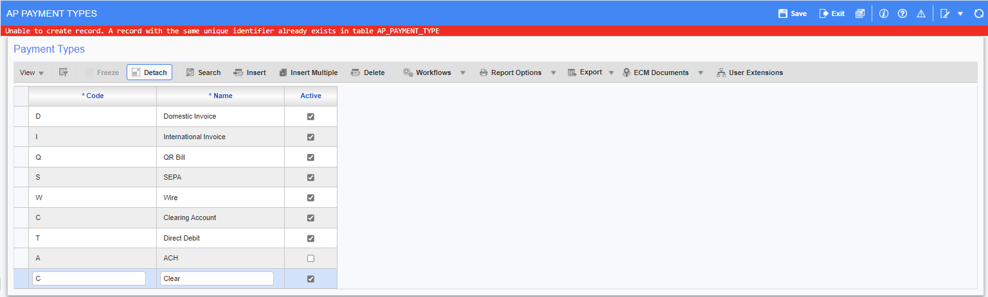

New EFT Payment Type field added to Maintain Vendors under Accounting tab. By default this field is hidden and has to be added through the lite editor. All the newly added EFT Payment Types through AP – Payment Types Program reflects in the EFT Payment Type list as shown below:
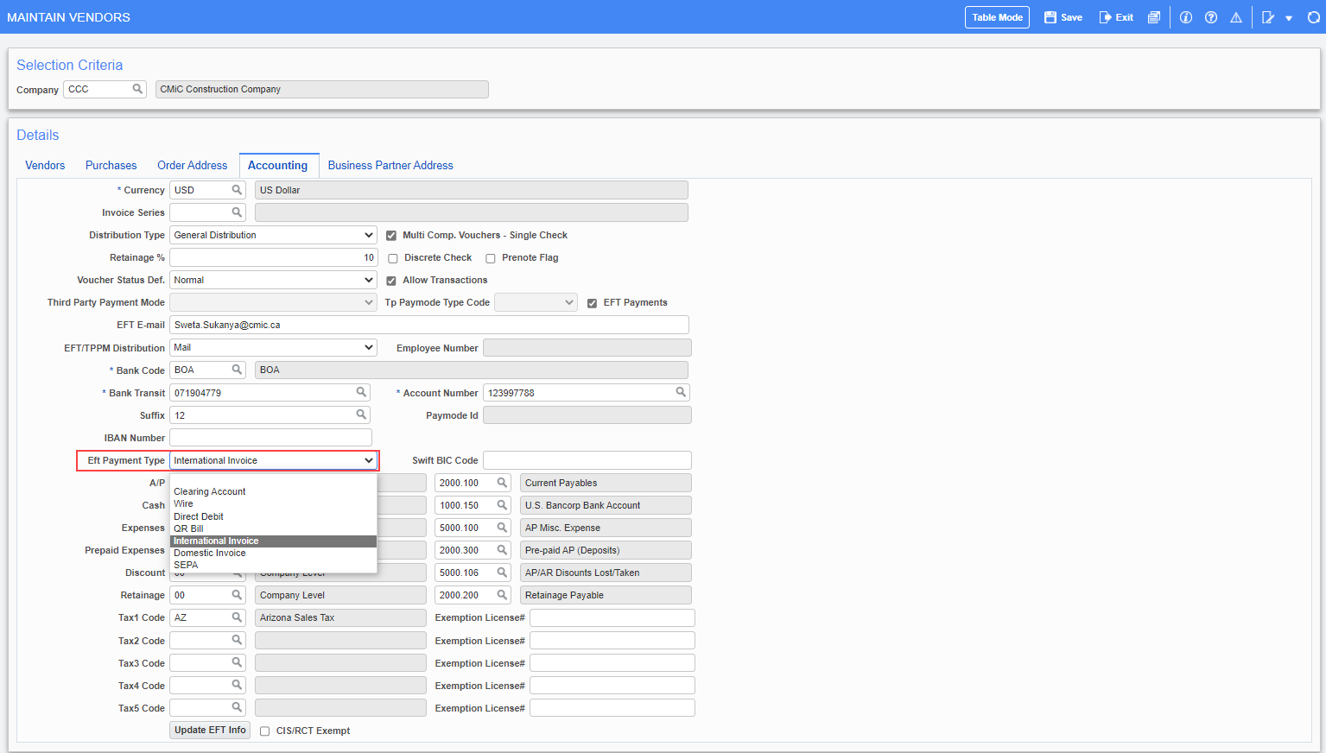

Register Voucher:
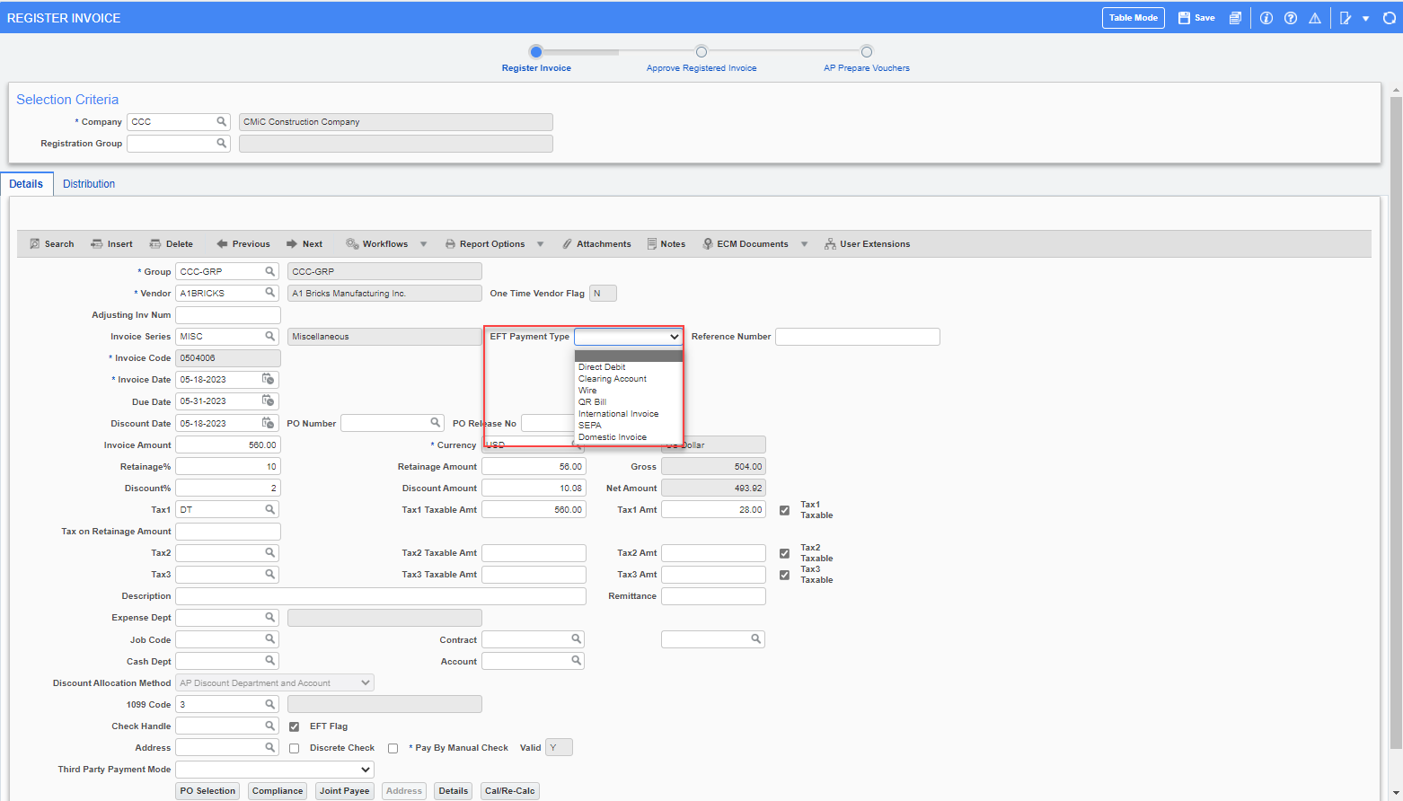

Enter Voucher:
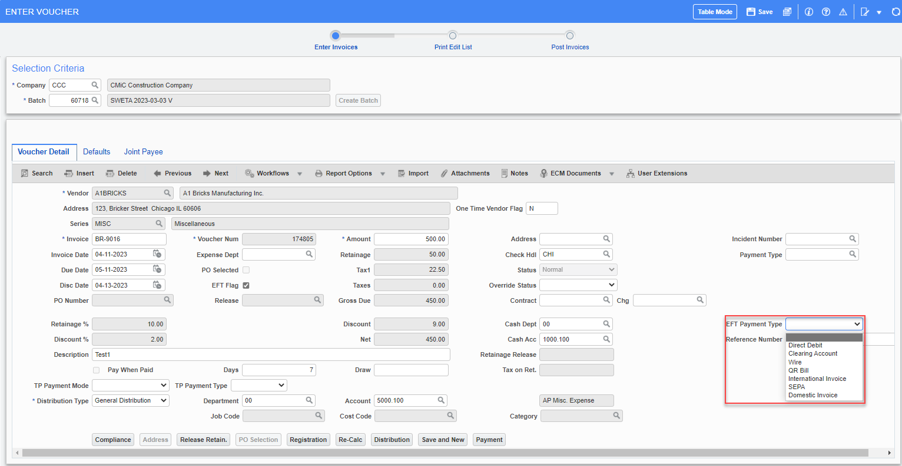

Adjust Voucher Status:
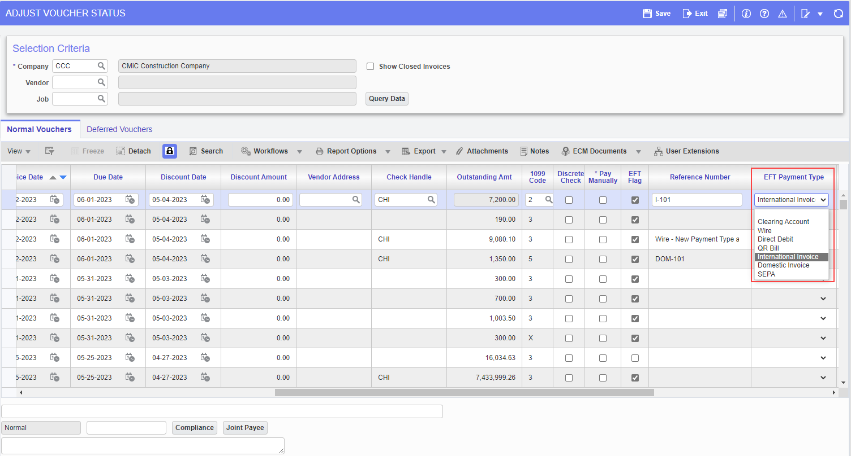

Select Payments:
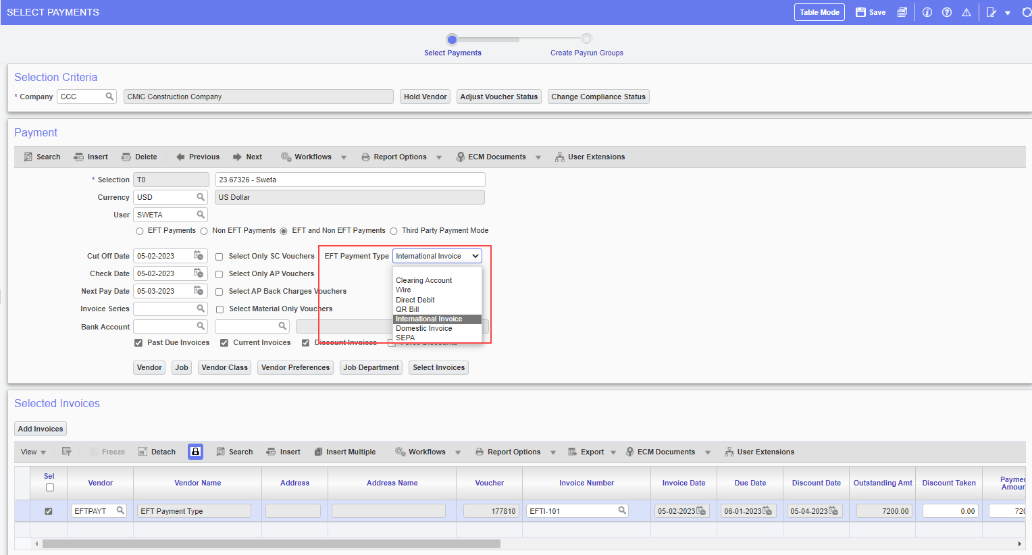

Image Manager:
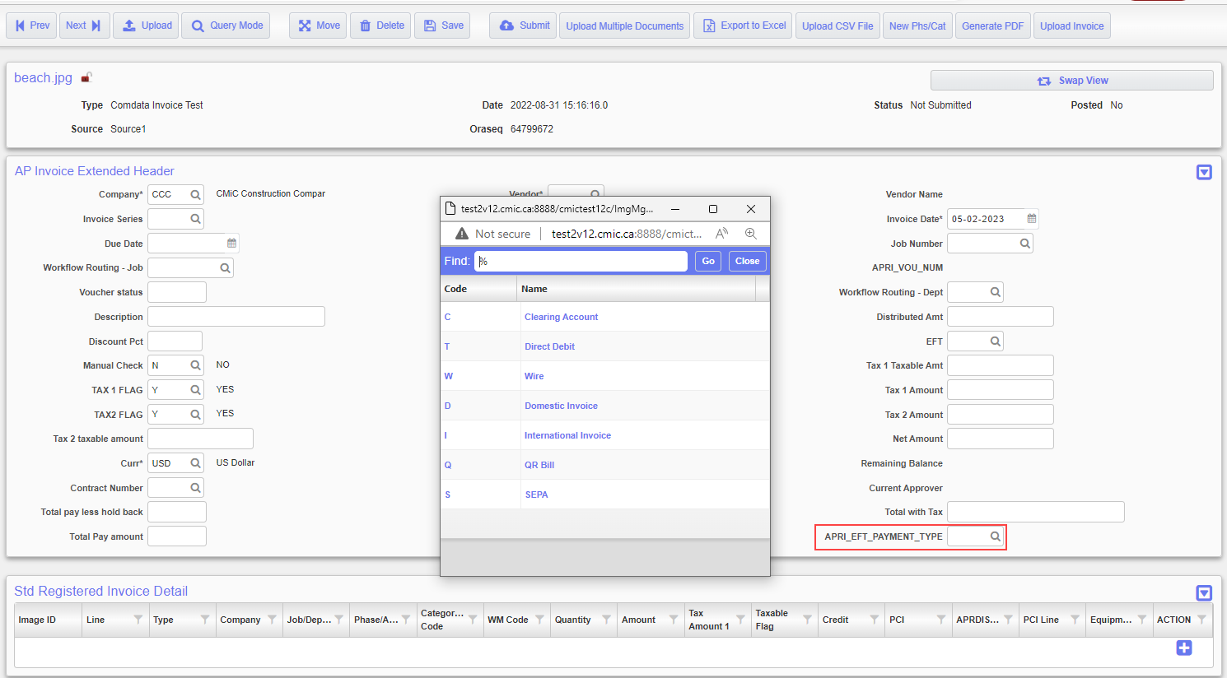

Flysheet:
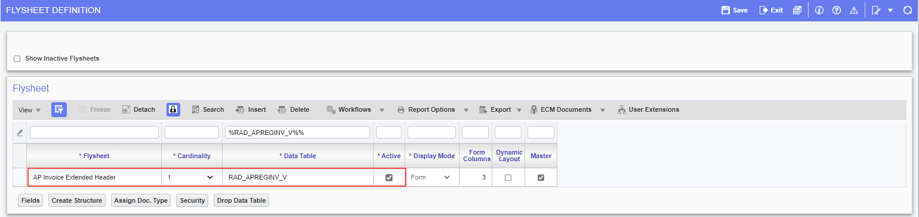

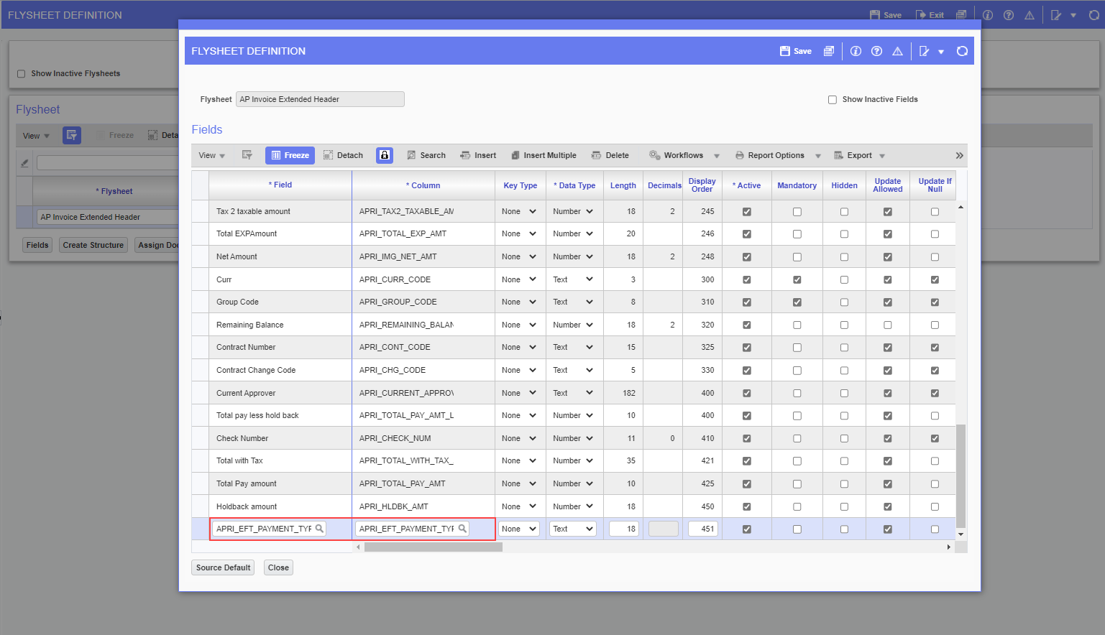

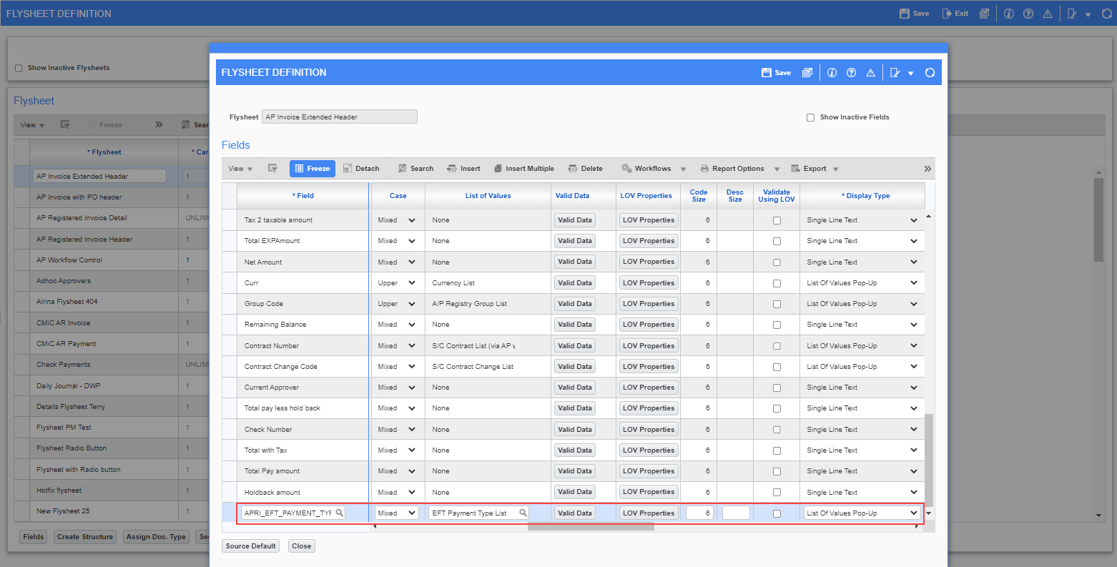

Default data :
SELECT BPVEN_EFT_PAYMENT_TYPE FROM BPVENDORS WHERE BPVEN_BP_CODE=:APRI_VEN_CODE AND BPVEN_COMP_CODE=:APRI_COMP_CODE
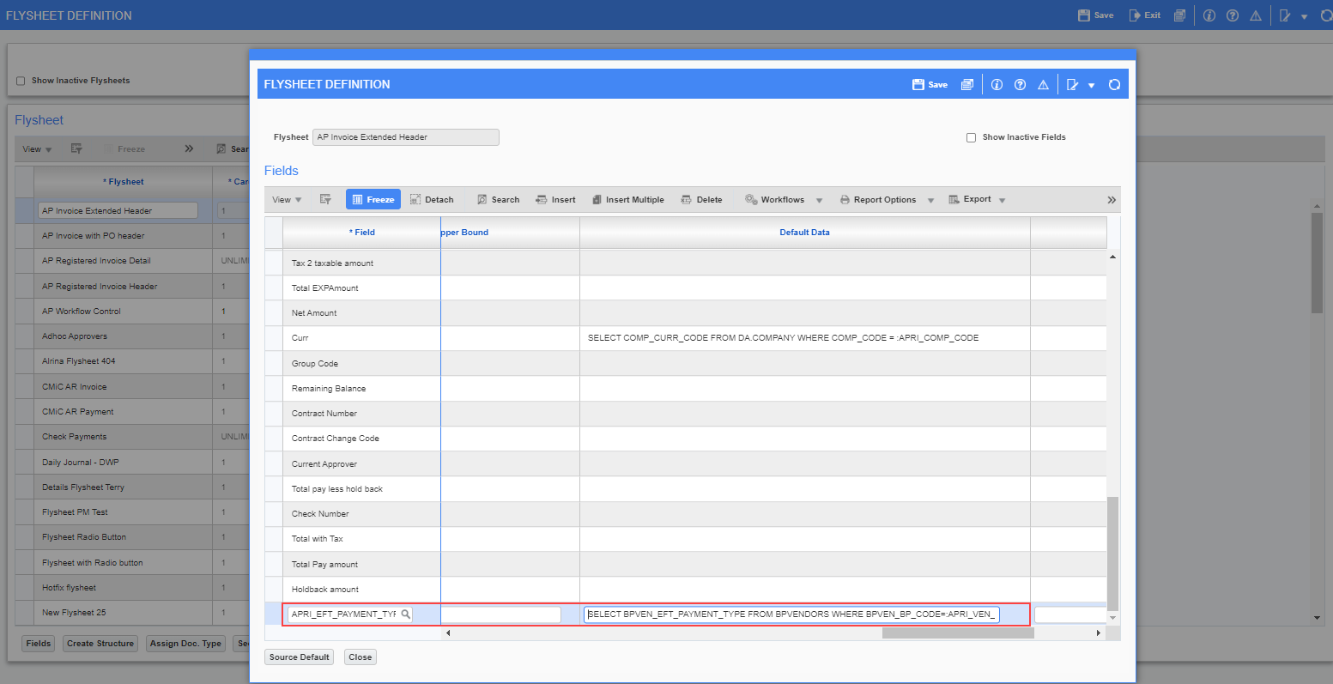

New table (ap_chq_ven_bank_info) after check posting:
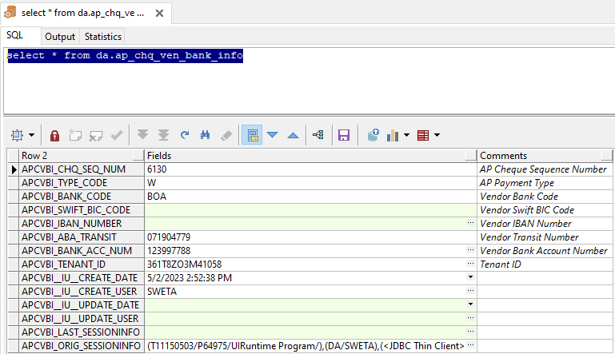

Accounts Receivable

Import Functionality is added to AR Invoice Entry program (23.66396)

Overview:
Import functionality is added to Accounts Receivable > Invoice > Enter Invoices > AR Invoice Entry program.

Modifications:
An Import button is added next to the Report Options button.
The following screen shows the new functionality.

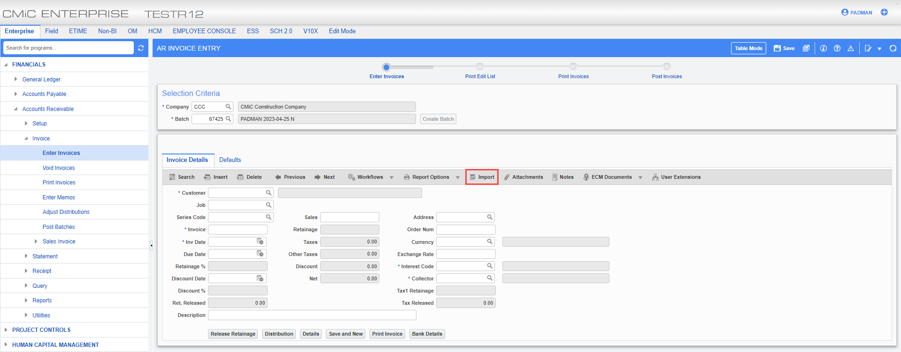

New AR Functionality to distribute AR Invoices by Preferred Contact Method (22.63452)

Overview:
New AR Functionality to distribute AR Invoices by Preferred Contact Method

Modifications:
A new AR Functionality is added to distribute AR Invoices by Preferred Contact Method.
- A new tab ‘E-Invoice’ is added in the AR Control.
- The Sender’s email address can be entered.
- The Email Subject Text Code and the Email Body Text Code can be selected through LOV.
- Text Type must be added. (System Data < Global Tables < Text Type)
- Text Code must be added for the Text Type for Email Subject and Body. (System Data < Global Tables < Text Code)
- The Preferred Contact Method option is enabled in the AR Print Invoices program to email the AR Invoices to Customers.

Example of Modification:
- A new tab ‘E-Invoice’ is added in the AR Control.
- The Sender’s email address can be entered.
- The Email Subject Text Code and the Email Body Text Code can be selected through LOV.
- Text Type must be added. (System Data < Global Tables < Text Type)
- Text Code must be added for the Text Type for Email Subject and Body. (System Data < Global Tables < Text Code)
NOTE: Text Type must be defined as AR-INV. Subject Text Code must be defined as Subject followed by any other text. Similarly for Body Text Code must be defined as Body followed by any other text.
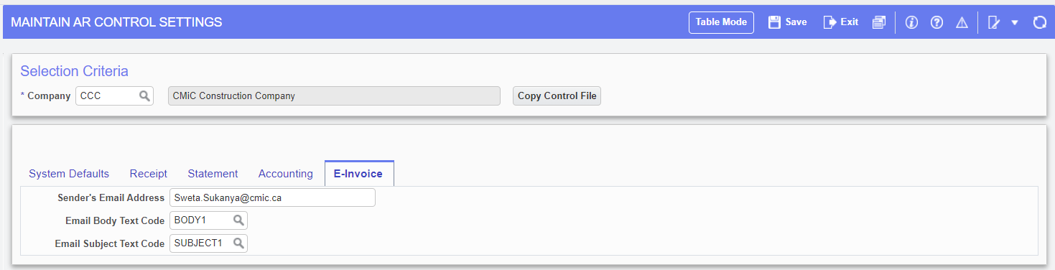
Standard Path: Accounts Receivable < Setup < Local Tables < Control File Options
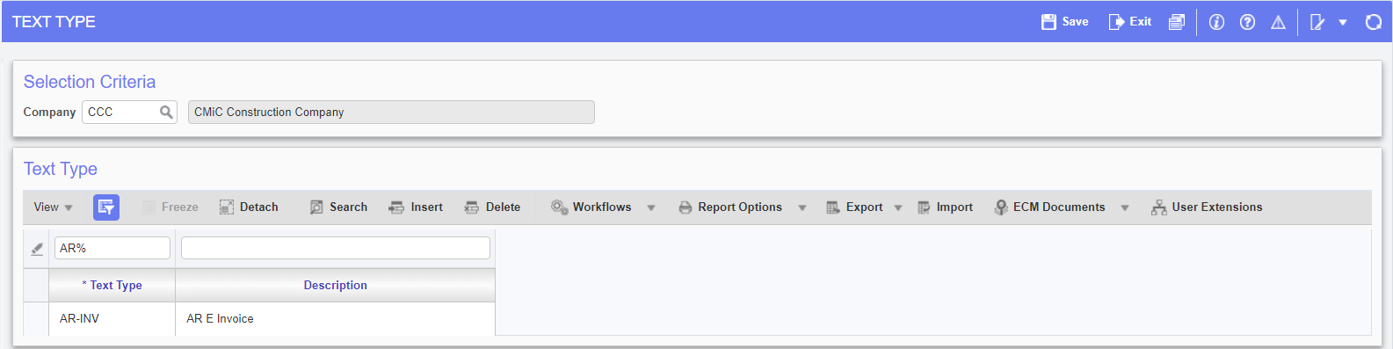
Standard Path: System Data < Global Tables < Text Type
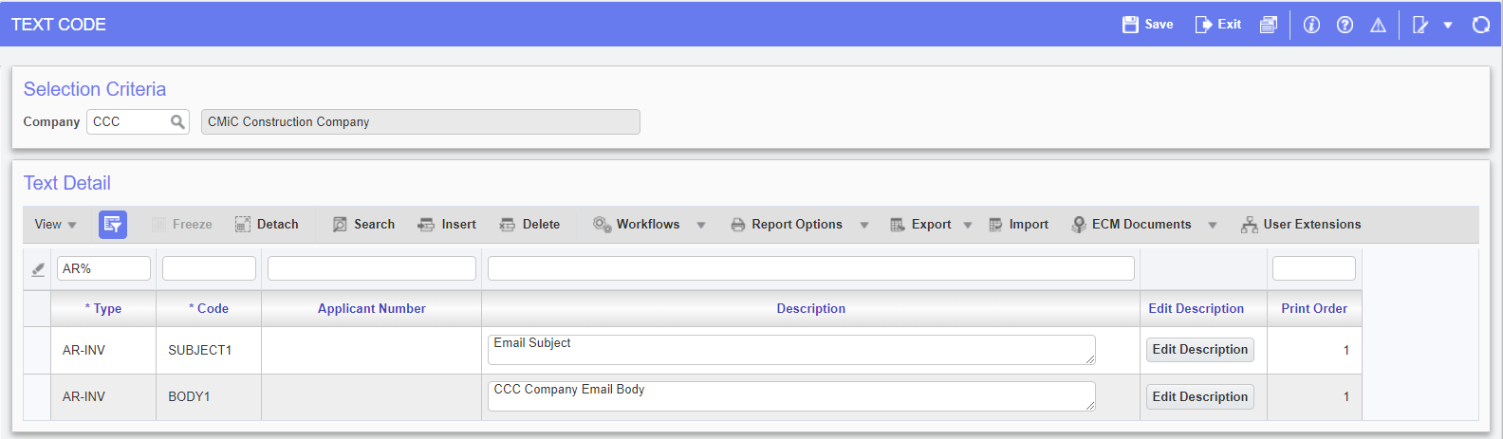
Standard Path: System Data < Global Tables < Text Code
The Preferred Contact Method option is enabled in the AR Print Invoices program to email the AR Invoices to Customers.
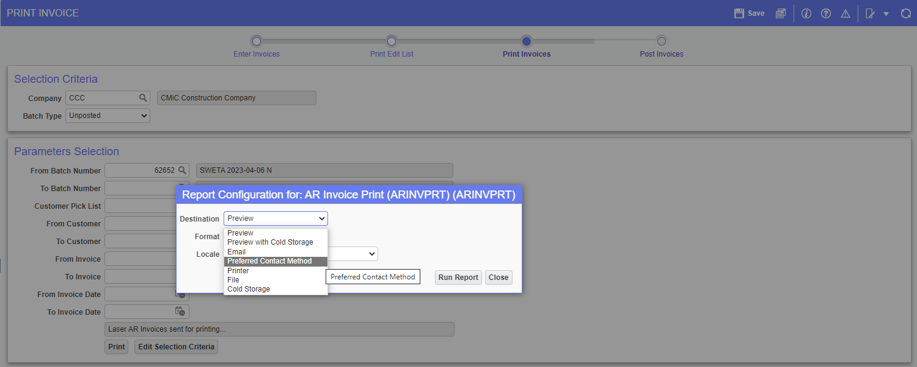
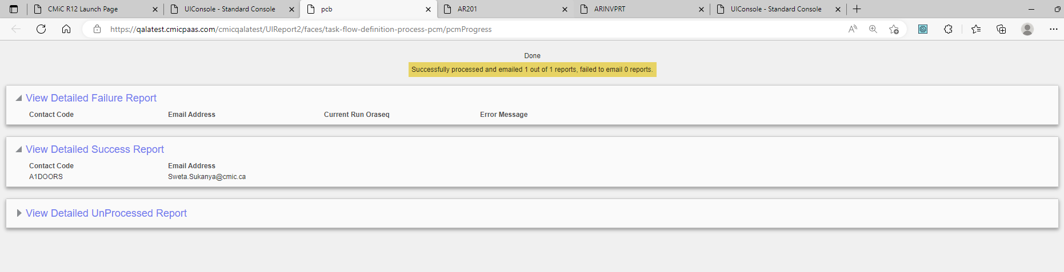
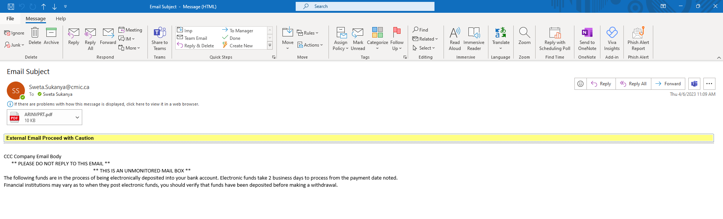
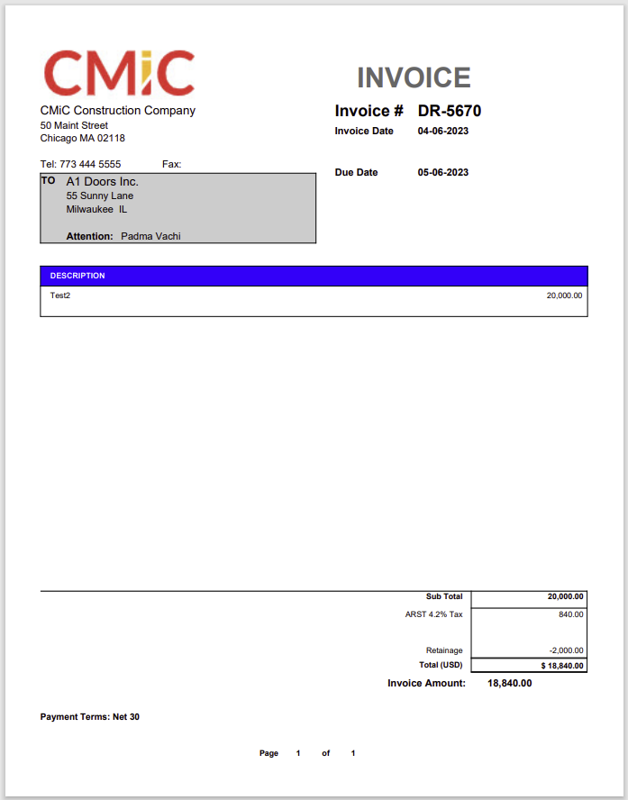

Analytics

BI Catalog Builder – User Defined Folder and Views (22.59247)

User-Defined Folders in Catalog Builder:
- User-Defined Folders can be created in Dashboard Builder using “Create User-Defined Folder” functionality.
- In Catalog Builder (Edit Data Sources screen) User-Defined Folders appear with black font for easy identification.
- When a new User-Defined Folder is created, the program will generate a corresponding User-Defined database view.
User-Defined Views
- Currently User-Defined Views can only be created by “Create User-Defined Folder” functionality in Dashboard Builder.
- User-Defined Views are created in CMIC_USER_DEFINED_VIEWS database schema.
- Once a User-Defined View is created, it can be added as a folder to any user’s data source the same way as any other database view (using “Edit Available Tables/Views” and “Edit Business Area” context menu options). Folders, created for User-Defined Views will appear in Catalog Builder using black font.
- For performance reasons, it is advised to avoid creating joins for folders based on User-Defined Views, as these views may already combine data from many different database tables and views.
User-Defined Views Maintenance
- User-Defined Views can be maintained using the program “User-Defined Views Maintenance” located in menu System Data => User Extensions.
- The program allows users to do the following:
  - Rename the views
  - Check views usage
  - Delete views (if no usage found).
  - Generate Views Export script (Enterprise Clients only).
- To rename or delete User-Defined views the user must have System Privilege “BIUDFOLDER”.
- Note: a User-Defined View Name is different from actual database view name. The actual database view name is autogenerated and cannot be changed.
User-Defined Views Export/Import (Enterprise Clients only)
- Export/Import of User-Defined Views is implemented via generated SQL scripts.
- To export views, generate a view installation script using “Export” button in “User-Defined Views Maintenance” for an individual view or using “Export All” button to generate a single script for all views.
- To import User-Defined views, the generated SQL script will need to be installed by Database Administrators.

Screenshots:
User-Defined Folders in Catalog Builder
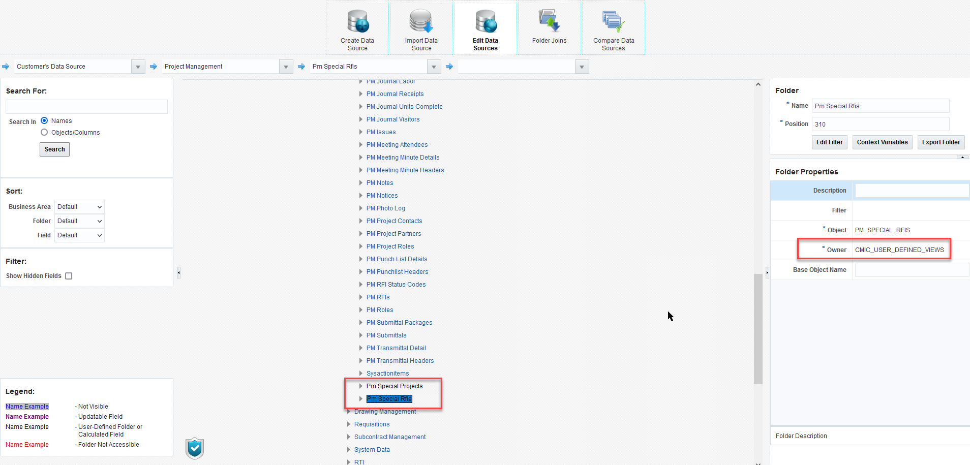

Add User-Defined Views to a Data Source:
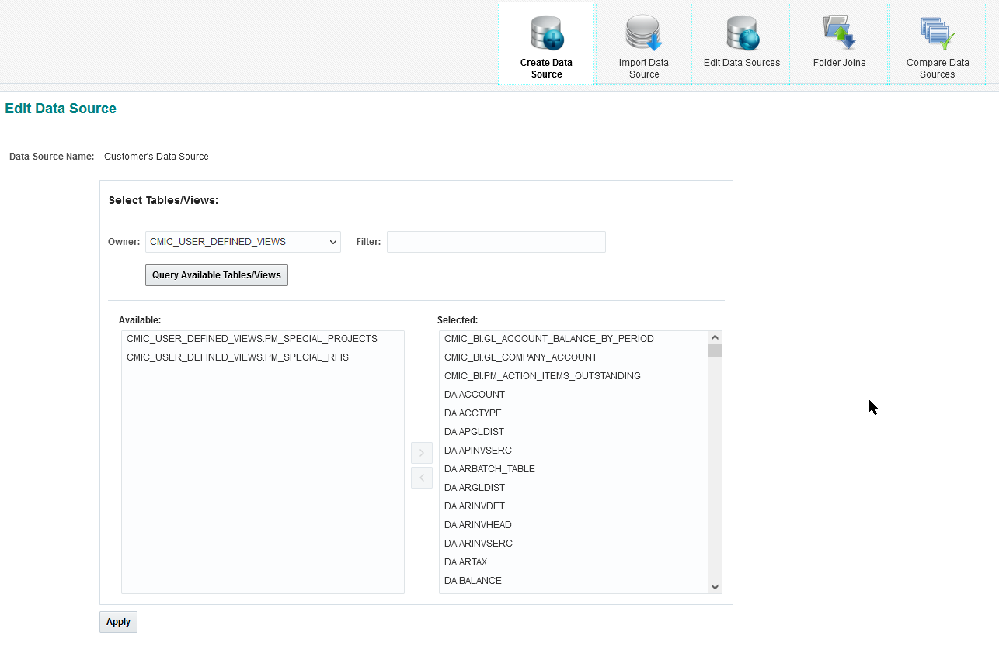

User-Defined Views Maintenance Program
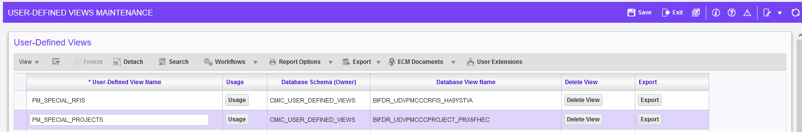
User-Defined Views Maintenance Program – Usage popup

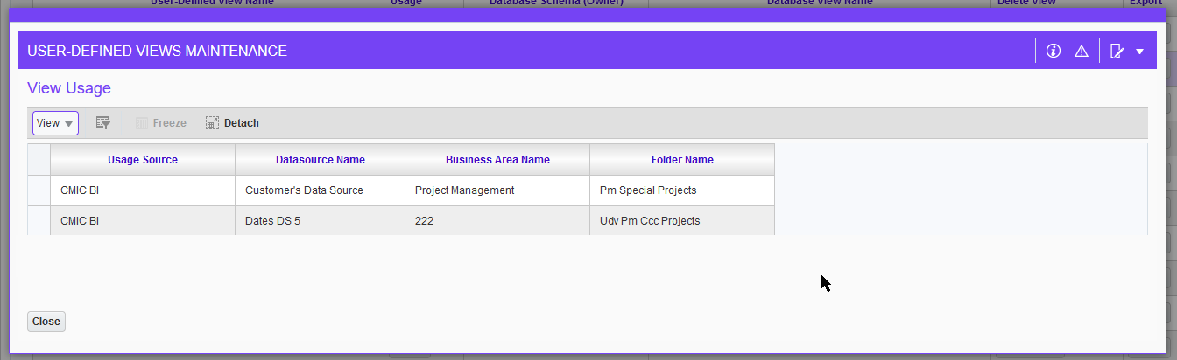

BI Catalog Builder - Copy Data Source Change (21.42008-191)

Copy Data Source functionality change:
- Users can now provide a name for the new data source.
- Default Analytics Canvas will now be copied along with all dashboards when the option is selected for CMIC Default Data Source.
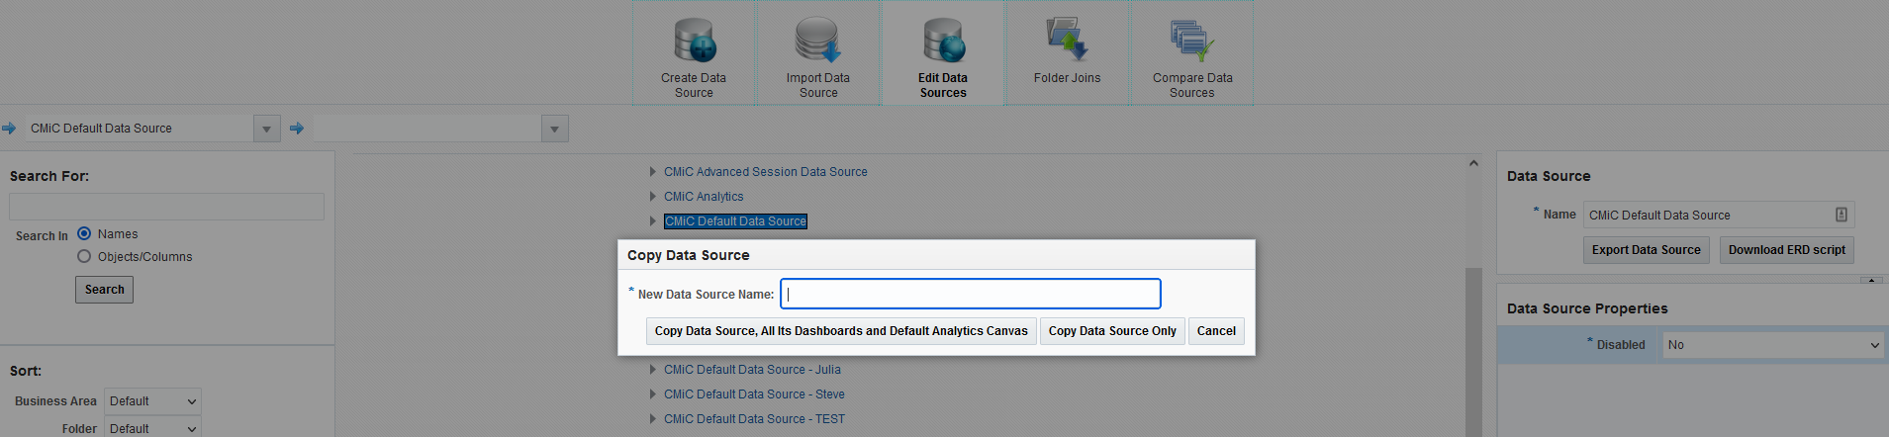

BI Catalog Builder – Create User Defined Logs Change (22.63581)

Create User-Defined Logs functionality change:
The generated views are now created in CMIC_USER_DEFINED_VIEWS schema and available in “User-Defined Views Maintenance” program. Views for previously generated logs also have been moved to CMIC_USER_DEFINED_VIEWS schema.

BI Catalog Builder – Views for User Extensions Tables (22.64317)

Overview:
- User Extensions.
When a new UE Table is created, a new “BI-friendly” User Defined View will be created.

- User Defined Views Maintenance program.
Added “Created By” column.
Modified security.

Details:
User Extensions:
When a new UE Table is created or modified, a corresponding “BI-friendly” User Defined View will be created. This new view will include columns with lookup data for LOVs. For example, if the UE Table includes a field JOB_CODE the new view will also include column JOB_DESC (Job Description).
The view will have the same name as its User Extension Table Code and will be located in CMIC_USER_DEFINED_VIEWS schema (owner).
The User Defined View will be generated for new User Extension Tables only. However, users can generate this view “on-demand” for previously created UE Tables by doing the following: Open System Data => User Extensions => Table Maintenance program, select a UE Table and press button “Generate Views”.

Example:
User Extension Table:
In this example we have JABADDINFO (Job Additional Info) UE Table where users can enter a “special” Category for a Job (field DM_CATCODE).
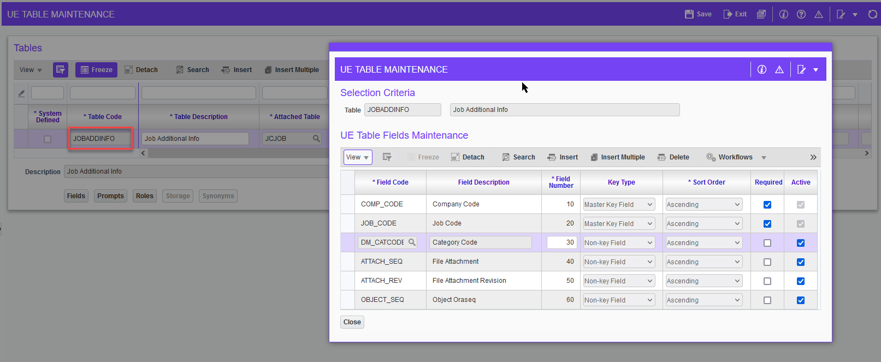

Catalog Builder:
Select your Data Source, open Edit Available Tables/Views dialog and add the corresponding view (CMIC_USER_DEFINED_VIEWS.JOBADDINFO).
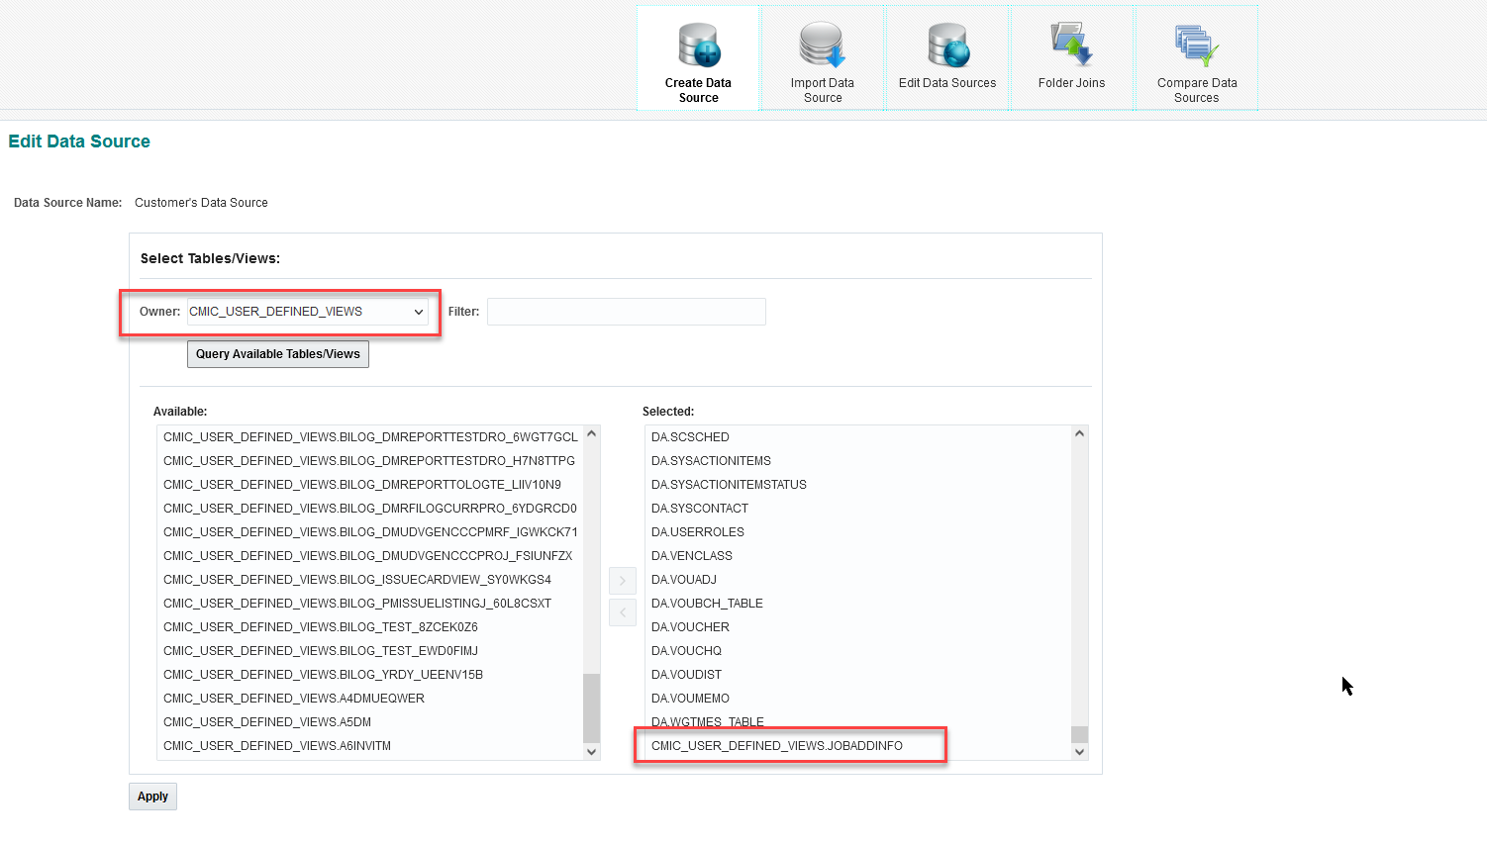

Then add the view into a Business Area:
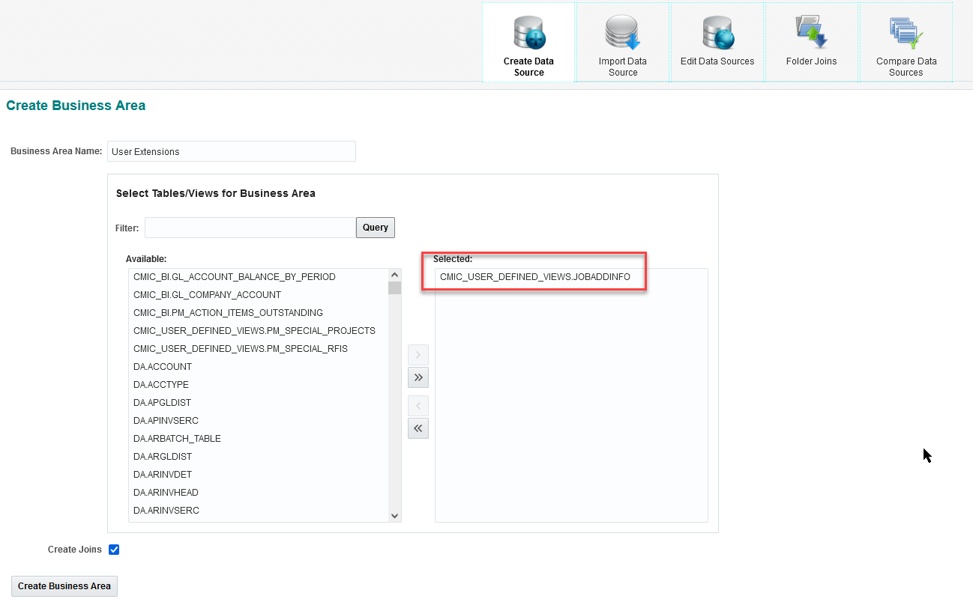
The new folder will be created containing look-up fields with descriptions for all “LOV-enabled” UE Fields:
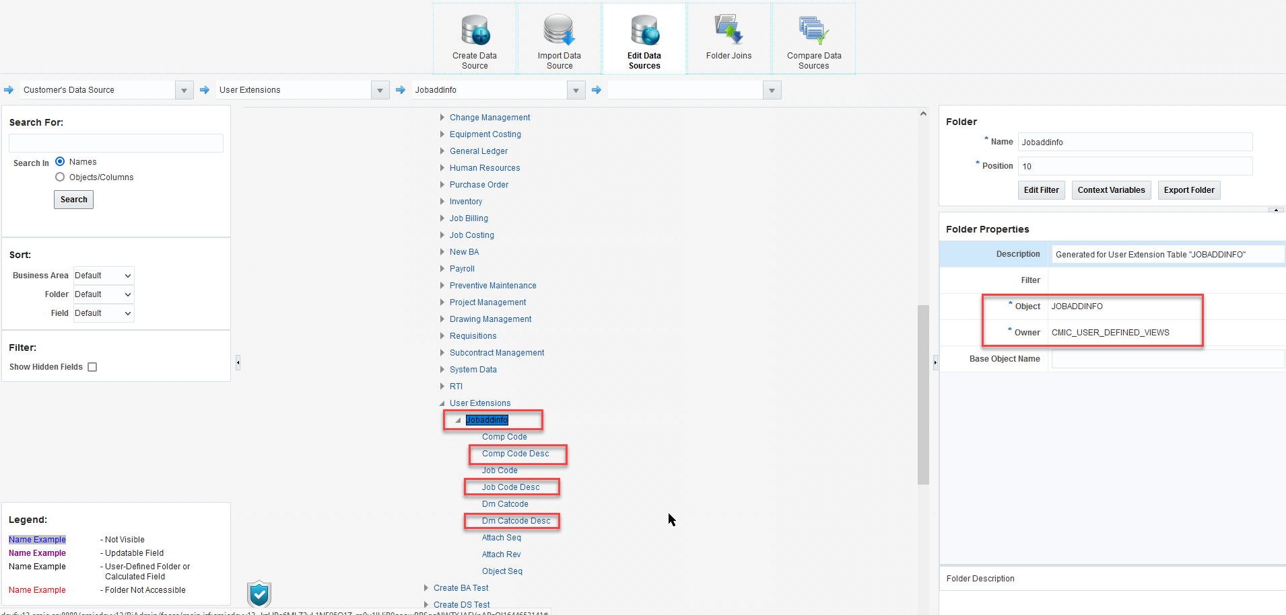

These User Defined Views will be generated automatically for all newly created User Extension Tables and whenever a previously created UE Table is modified.
Users can generate this view “on-demand” for previously created UE Tables by doing the following: open System Data => User Extensions => Table Maintenance program, select a UE Table and press button “Generate Views”.
This button can be used to regenerate all views related to selected UE Tables at any time.
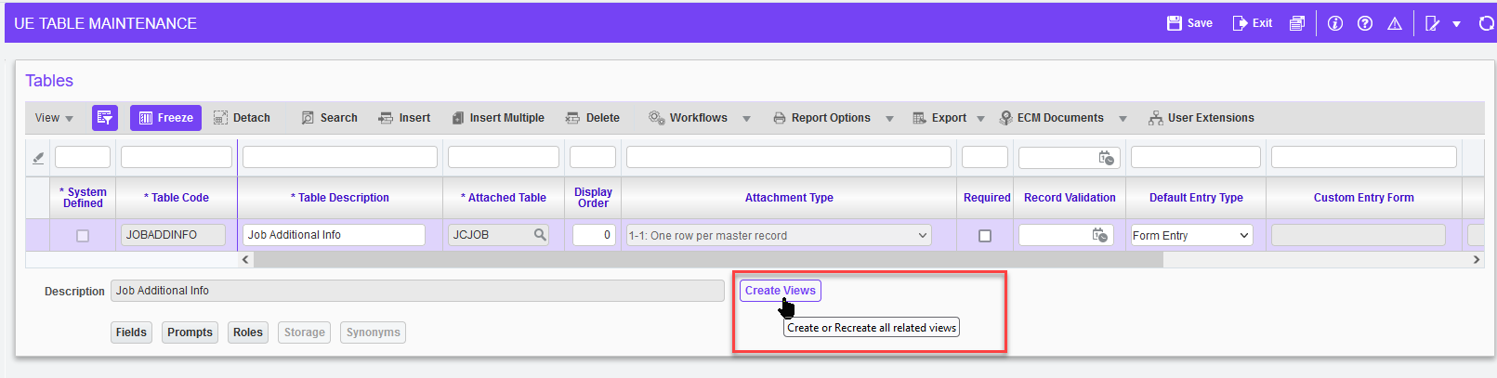
User Defined Views Maintenance program.
As any other User-Defined Views, these views can be renamed in “User-Defined Views Maintenance”program. Please, refer to the corresponding documentation on how to use this program.
The program now has a new column “Created By” to show the origin of each User-Defined View (the functionality that was used to generate the view).
Security change:
Depending on the origin of each User-Defined View as shown by the “Created By” column, the views can be modified or deleted only by users who have system privileges to use the original functionality. For example if a view has been created by “BI User-Defined Folder” functionality, then it can be modified only by users who have system privileges to create BI User-Defined Folders.
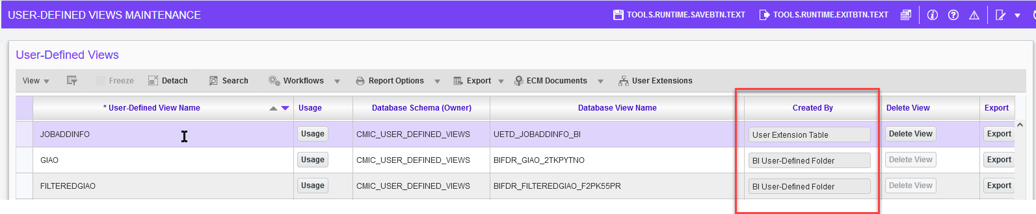

BI Catalog Builder – Switching Role Security On/Off (22.66056)

A new button has been added to Catalog Builder to explicitly switch Role Security On or Off.

The button is only available for those users that have System Privilege BISECMNG assigned (BISECMNG: “Allows the user to modify security”).

Before this change, Role Security was enabled automatically as soon as users assigned any role to any object in Catalog Builder.

After this change, Role Security should be enabled manually by pressing the Enable Role Security button once roles assignment for the catalog is completed by users. It can now also be disabled without removing the roles setup.

As a reminder, the Shield icon is displayed in the bottom left corner of the Catalog Builder screen when Roles Security is enabled (this is existing functionality which has not been modified).

Note: when this feature is installed via a patch, Role Security will be automatically enabled for those customers that currently has it enabled.

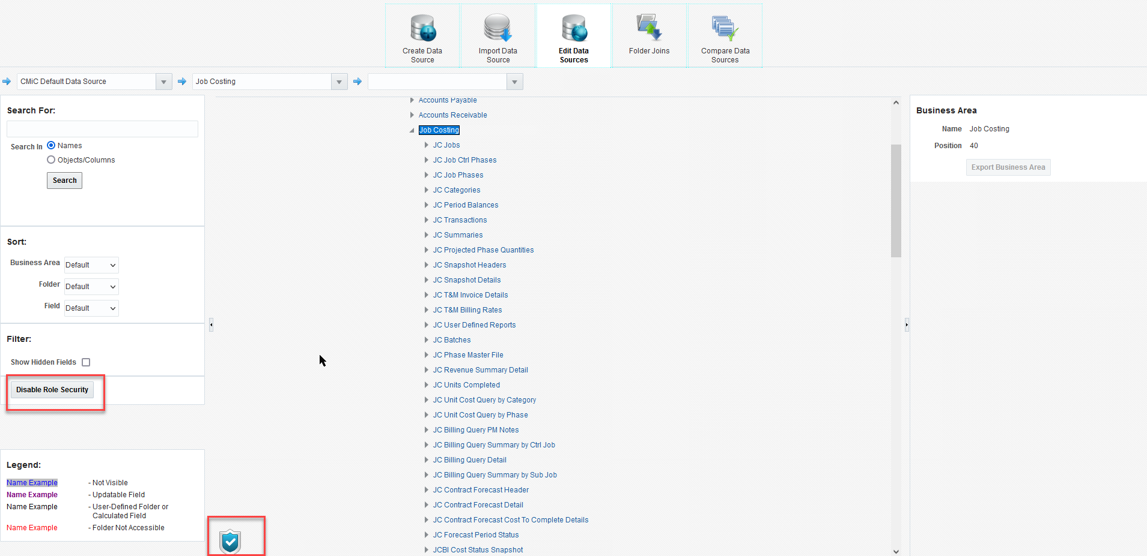

BI Catalog Builder – Search Enhancements (23.66907, (JIRA BI-225, BI-226))

The Search functionality has been improved in patch 017-2.

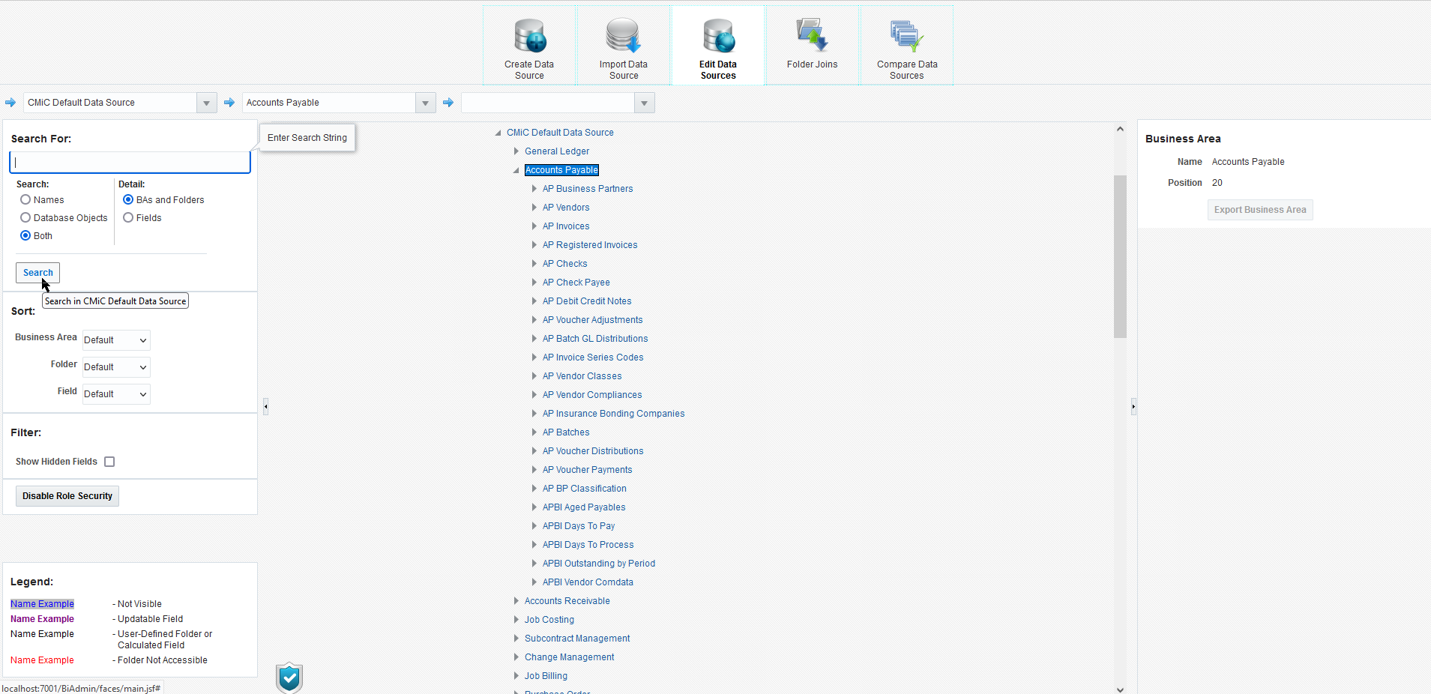

The Search panel now includes the following Search Options:
- Search:
Determines what will be searched.
  - Names
Search only in Object Name (Business Area Name, Folder Name, Field Name).

Examples:

Business Area:
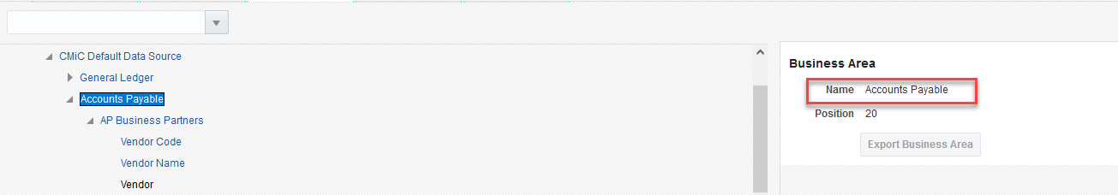

Folder:
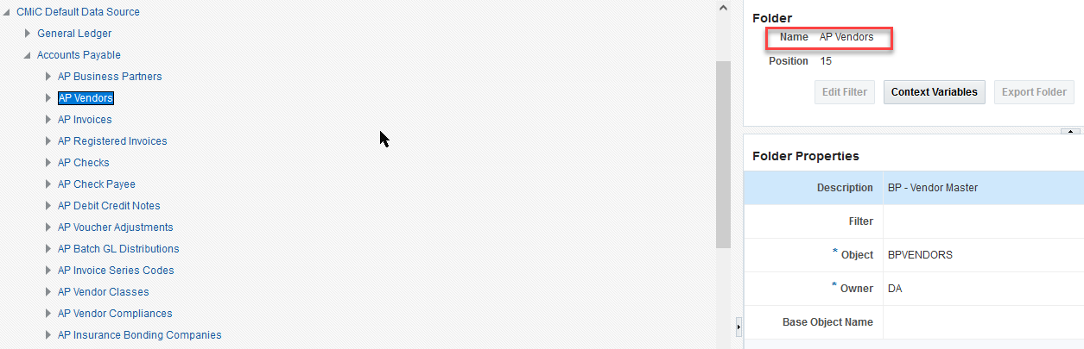
Field:
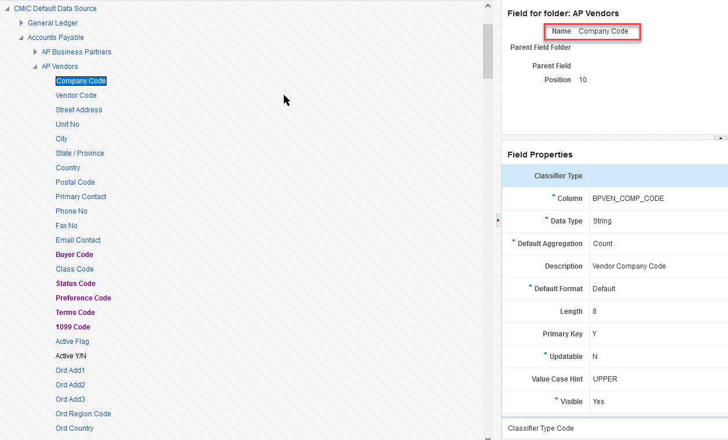
  - Database Objects
Search only in Database Object Name (Folder Property “Object”, Field Property “Column”, Field Property “Calculation”).
Use this option if you need to find Folder(s) that corresponds to a certain database View or Table, or if you need to find Field(s) that corresponds to a certain column of a database table or view.

Examples:

Folder:
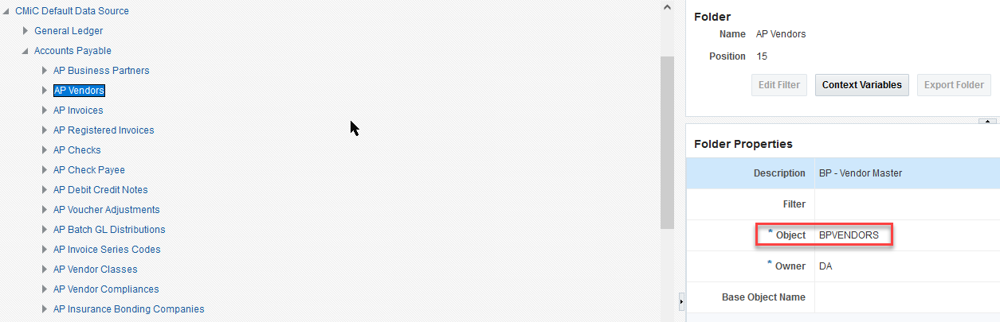

Field:
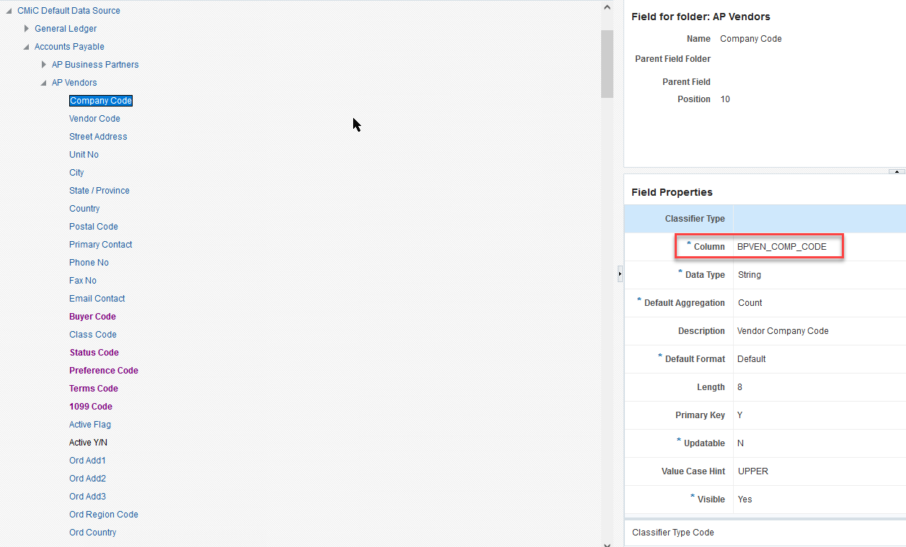
  - Both
Search in both Names and Database Object Names

- Detail:
Determines a Scope of the search:
  - BA and Folders
Use this option if you need to find Business Area(s) or Folder(s) inside a Data Source.
The search will be performed across all Business Areas and Folders in a currently selected Data Source only. Note: Fields won’t be searched.
  - Fields
Use this option if you need to find Field(s) inside a specific Folder or Business Area.
The search will be performed across all Fields in a currently selected Business Area or Folder only.

BI Catalog Builder – New Folders and Default Reports (23.67458)

The following updates have been done to the Catalog Builder:

New Default Reports:
- PM Subcontractor Dashboard
- PO Shipment Receiving Program Query

New Folders in Default Data Source:
- GLBI Financial Documents
- Location Table
- PO Shipment Headers
- PO Shipment Details

BI Dashboard Builder – Duplicate Query/Dashboard Names (21.42008-177,180,181)
The following enhancements have been made:

- Allow duplicate query/dashboard names if they are in different data sources.
- Make date functions useable in conditional formatting expressions. This includes:
- Add the date.truncate() function to return a date truncated to a specified unit
- Add the date.today() function to return the current server date without the time portion.
- Allow date functions to accept field references or function calls.
Examples:
switch(true, date.truncate([Retraining Date]) < date.today(), “#ff0000”)
date.today
Return the current server date without the time portion.
Syntax:
date.today()
date.truncate
Return a date truncated to a specified unit. The unit is optional. Without providing a unit, the function returns a date truncated to the day portion of <dateTime>. In other words, it returns <dateTime> without the time portion.
Syntax:
date.truncate([<unit>], <dateTime>)
<unit> supported values are “year” and “month”. “year” truncates <dateTime> to the first day of the year. “month” truncates <dateTime> to the first day of the month.
<dateTime> can be a date field reference or function that returns a date.

- Defect resolved: Expect date() function’s month parameter to start from 1 to 12 but it was 0 to 11.

BI Dashboard Builder – Create User-Defined Folder (21.42008-184,185)
CMiC has added the “Create User-Defined Folder...” option.

This feature is used to create a user-defined folder in the dashboard’s data source based on a table visualization/BI query table.

It is only available to users with the following system privileges:
BISECMNG (CMIC BI: Allows the user to modify security)
BICTLGBLDR (CMIC BI: Allows the user to access BI Catalog Builder)
BIUDFOLDER (CMIC BI: Allows the user to create User-Defined Folders)

This option is only available in BI Dashboard Builder; it is not available in dashboards at runtime. Note that only users with the system privileges will be able to see the Create User-Defined Folder menu item; otherwise, the menu item will not be available.

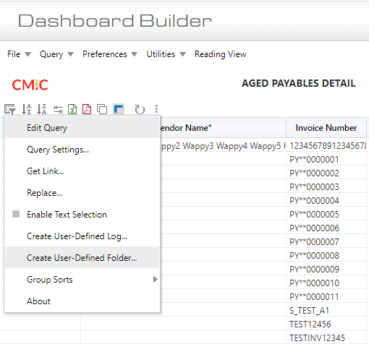

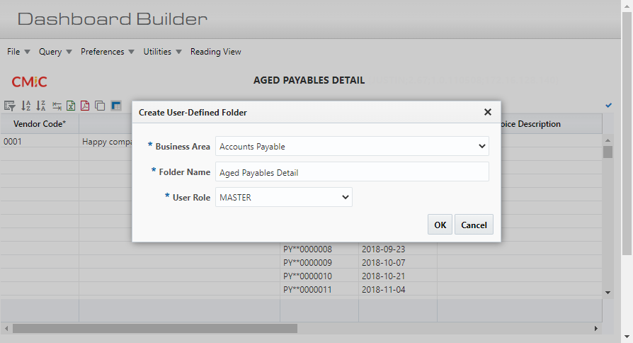

BI Dashboard Builder – ‘Get Link’ Enhancement (21.42008-196,197)
- Enhanced the “Get Link” popup to support the option of building a URL that can restore the current filtered view of a dashboard/visual. The URL can contain the current state of all page filters and substitution variables. This feature can be used to build a deep linking URL template for a dashboard. Note that this option does not include drill-through filters.
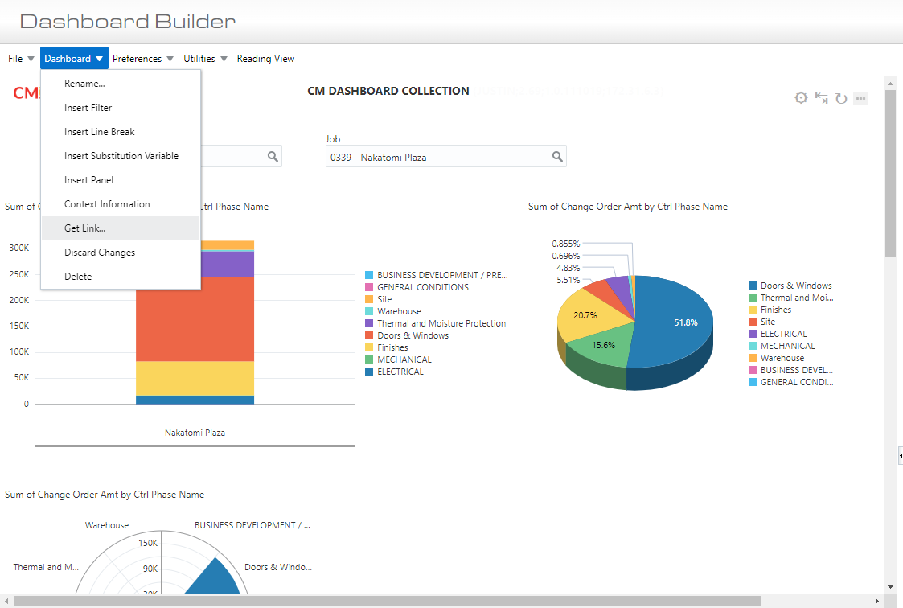

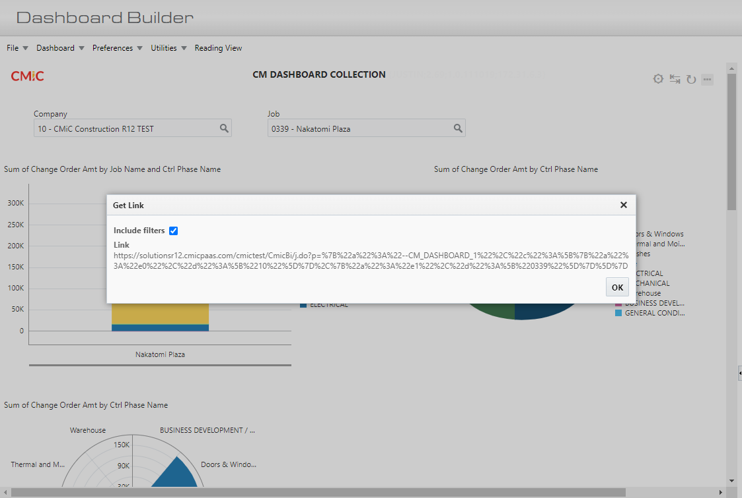

BI Dashboard Builder – Performance Analysis Report etc. (21.42008,22.64853,22.64877)

The following enhancements have been made:
- Added the Performance Analysis report for dashboards.
- Issue 22.64853: Data source cache module optimizations
- Issue 22.64877: New Calculated Column in Dashboard Builder Locks Screen

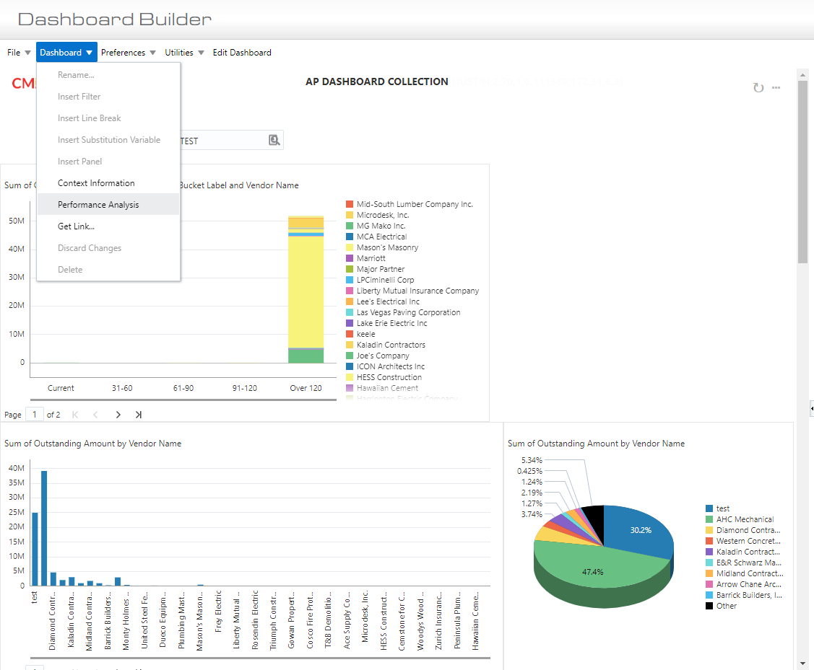

Highlight the visualization on mouse over a report line.
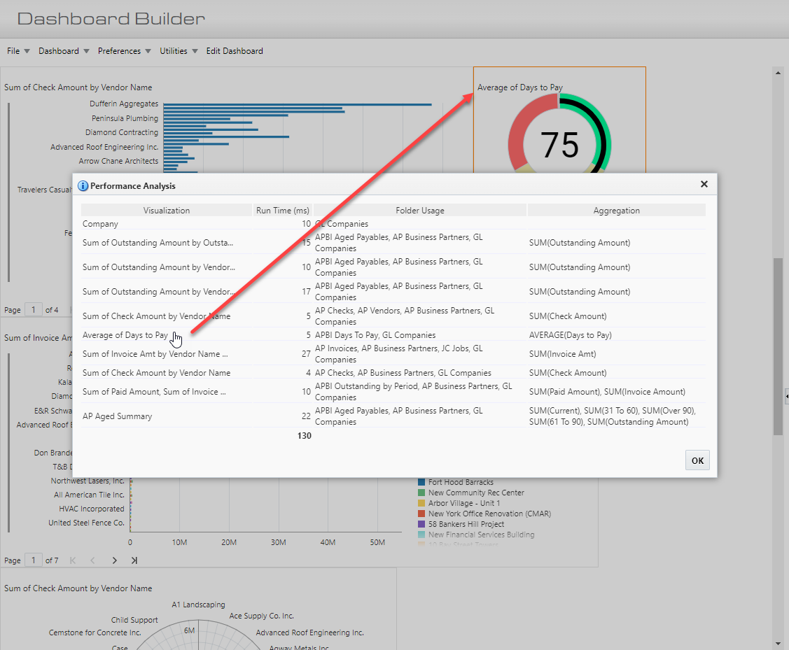

BI Dashboard Builder – Track Dashboard Events using Segment etc. (21.42008,21.46383,22.65163)

CMiC has introduced the following enhancements:

- Track dashboard-loaded events using Segment
- Track dashboard-saved events using Segment
- Don’t show dashboard edit link on mobile devices
- Trace dashboards’ lineage back to default dashboards, add this information to Segment dashboard-loaded events
- Added a web service for mobile canvas to load report names and links.
- Added mobile friendly setting for dashboard
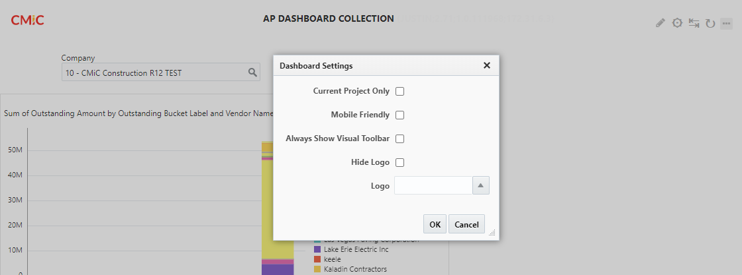
Resolved:
- Issue 21.46383: Support dashboard recovery when a folder/join used in a dashboard is removed from the data source
- Issue 22.65163: Customer was receiving error when trying to filter (QBE) down by product type (field in UDF tab).

BI Dashboard Builder – Visualization Alignment (21.42008-215,216)

CMiC has added an option for visualization alignment: Left, Center and Right. The default alignment is left-justified.

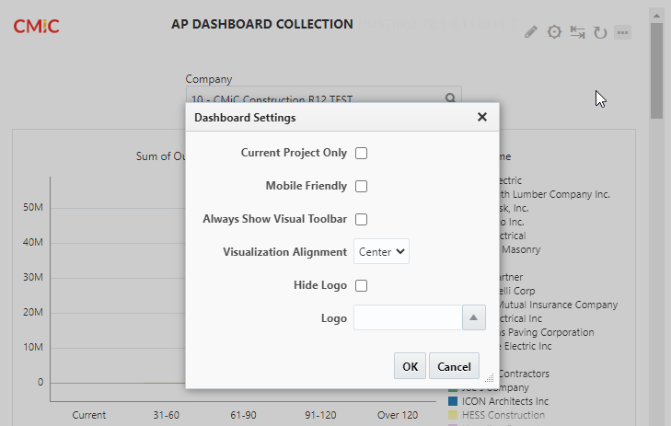

BI Dashboard Builder – Allow Update/Overwrite for Importing (21.42008-219,220)

Changes have been made to allow 'update/overwrite' functionality when importing a .bi file. The user needs the BISECMNG privilege for this feature. All existing access roles are retained.
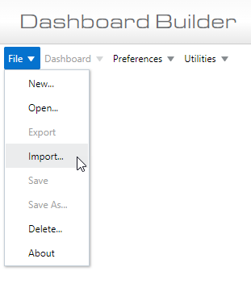
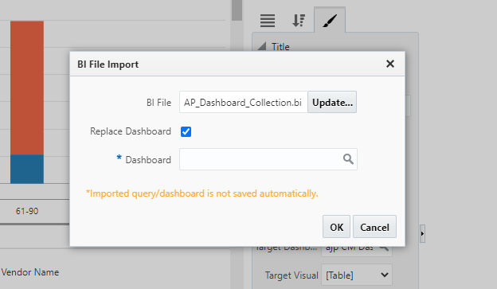

BI Dashboard Builder – Import Dashboards to Different Data Sources (21.42008-228)

CMiC has made changes to allow the user to import dashboards to different data sources in the same patch version. Folders and fields are uniquely identified by ID within a data source. Sometimes, the alternative data source may not contain the folder IDs or the field IDs in a dashboard for a successful import. Below are the replacement rules for missing folders and fields in a data source.
- When a folder ID is missing, a folder with the same name is used. All fields inside the missing folder are replaced by fields with the same name inside the replacement folder.
- When a field ID is missing, a field with the same name inside the field’s folder is used.
The user must be authorized to access all folders in the dashboard. Any inaccessible folders will cause the import to fail.
This feature makes it easier for users to add new default dashboards into their custom data sources.
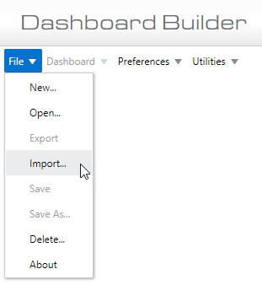

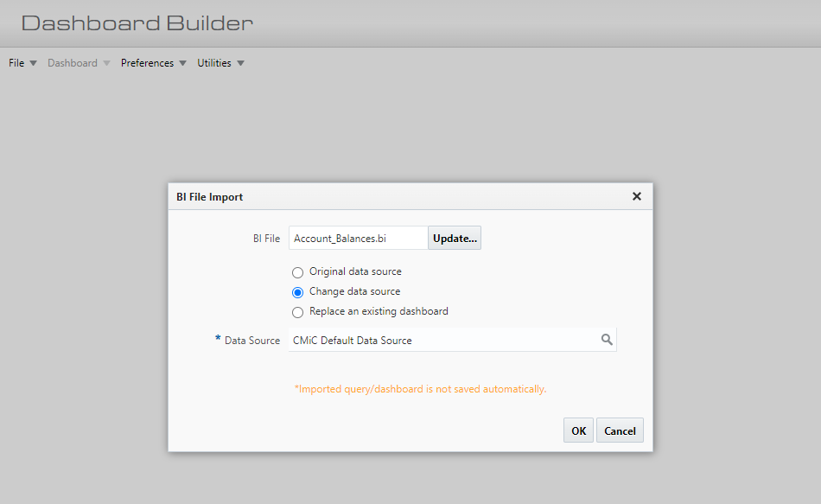

BI Dashboard Builder – Autoload Data (21.42008-229,230)

CMiC has added the autoload data feature in dashboard/query viewer. Users who do not have access to query/dashboard builder and are experiencing timeouts need to be able to turn autoload data off, then edit their filter selections without opening query/dashboard builder.

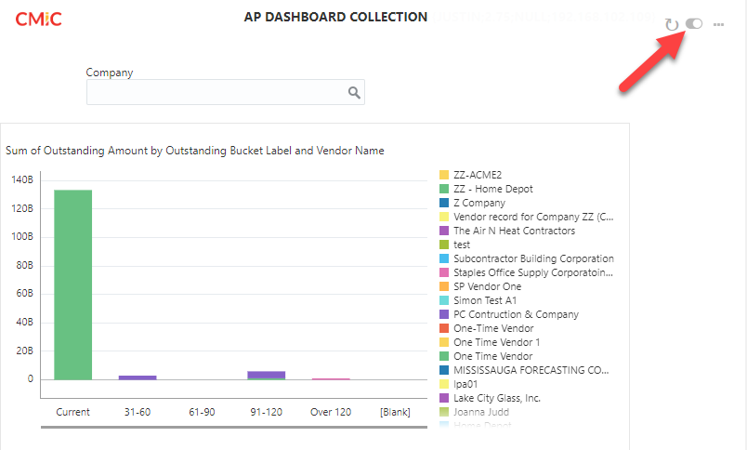

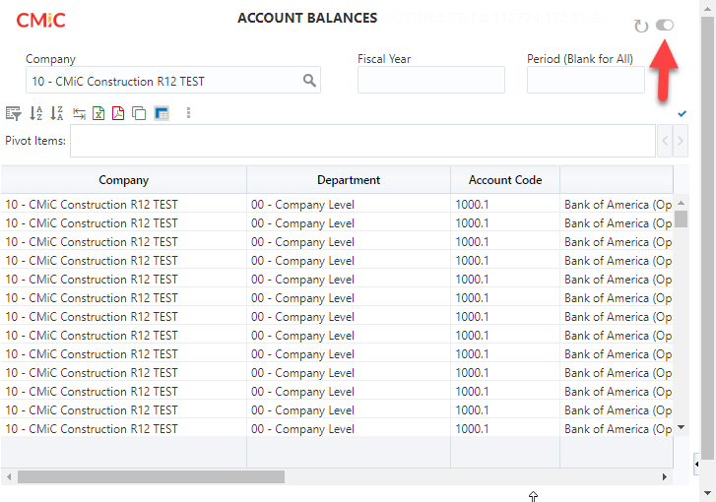

BI Dashboard Builder – Display Plotting Field Names (21.42008-234)

Enhancements applied:
- Instead of Group, Series and Value, display plotting field names on chart tooltips.
- Table visual: Copy column conditional formats to all other columns.
- Defect resolved: Expected Gantt visual property label to be "End Date" but it was "Start Date" (Merges are requested for 16HF and 17HF)

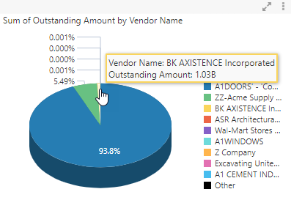

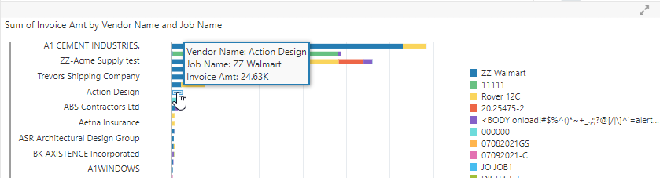

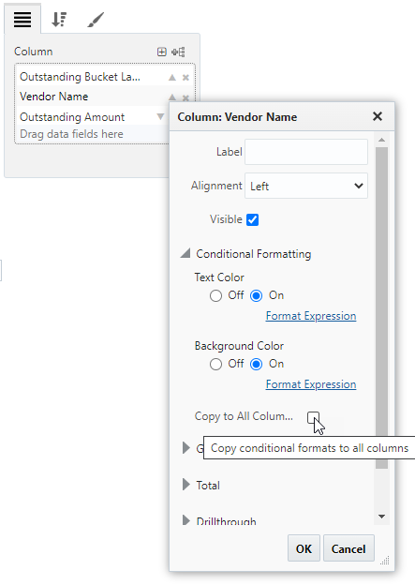

BI Dashboard Builder – Dashboard Metadata (21.42008-235)
CMiC has applied changes to show dashboard metadata (last modified by, last modified date, etc.)
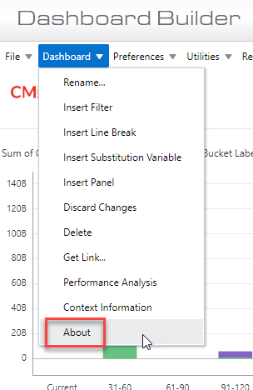

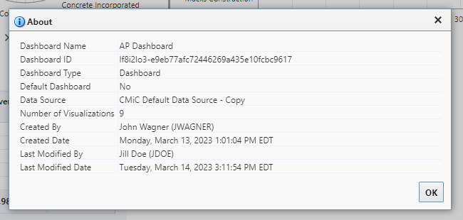

BI Dashboard Builder – “Searchable in Builders Only”Setting (21.42008-239)
CMiC has added the dashboard setting “Searchable in Builders Only”. When this setting is checked, the dashboard is searchable in Dashboard/Query Builder only. It is not searchable in Analytics or Web services. This setting allows the user to hide a dashboard (ex: drill-down dashboards, deep linking dashboards, etc.) that’s not relevant to the search in Analytics or Web services.

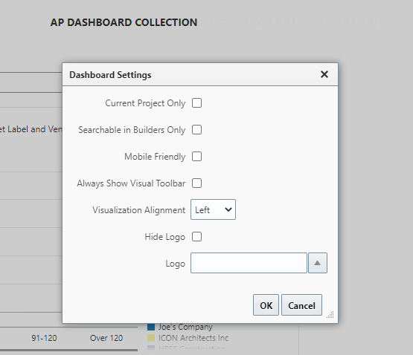

Equipment Costing

Group Location Code – New Transaction Code column (22.63435)
The Group Location Transfer program is modified with the addition of ‘From/To Transaction Code’ columns. The ‘From’ Transaction code column will show the Transaction Code defined for the related Equipment code. The ‘To’ Transaction will default the Transaction Code set in the EM Control File.
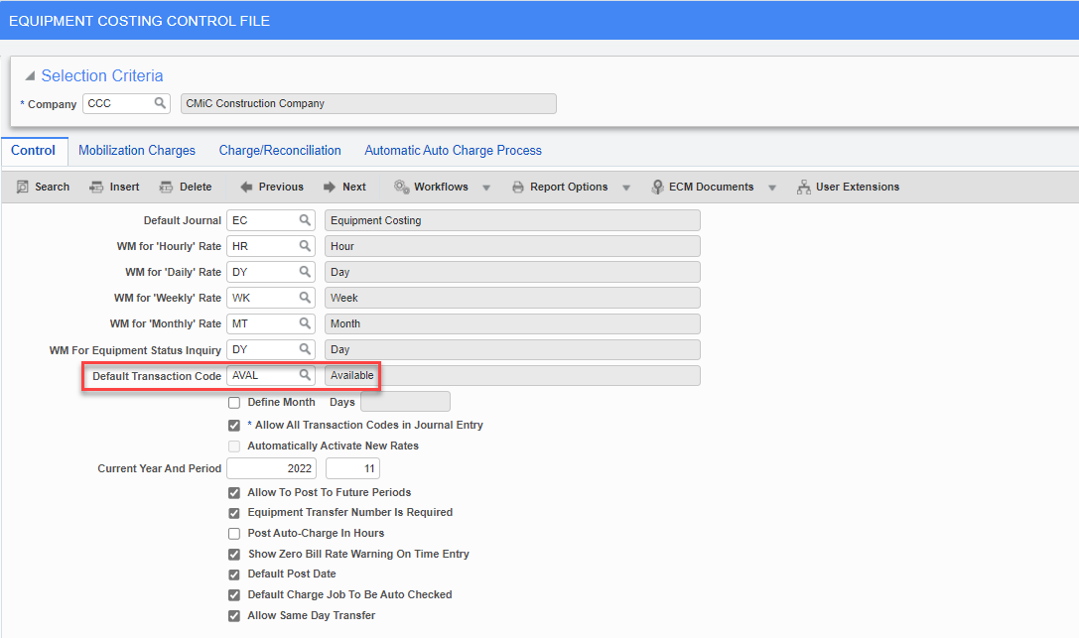
Columns added:
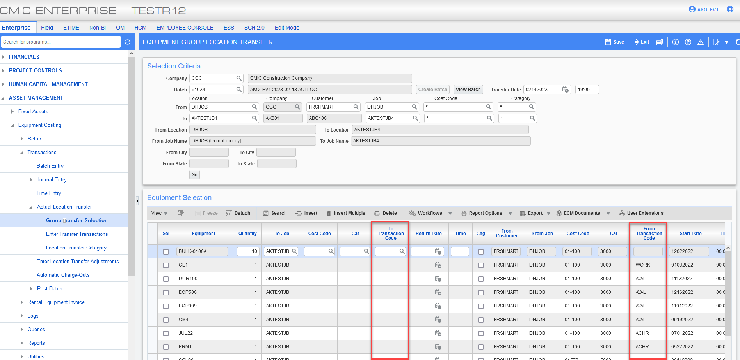
When selected, the ‘To Transaction Code’ will populated the value defined in the Control File:
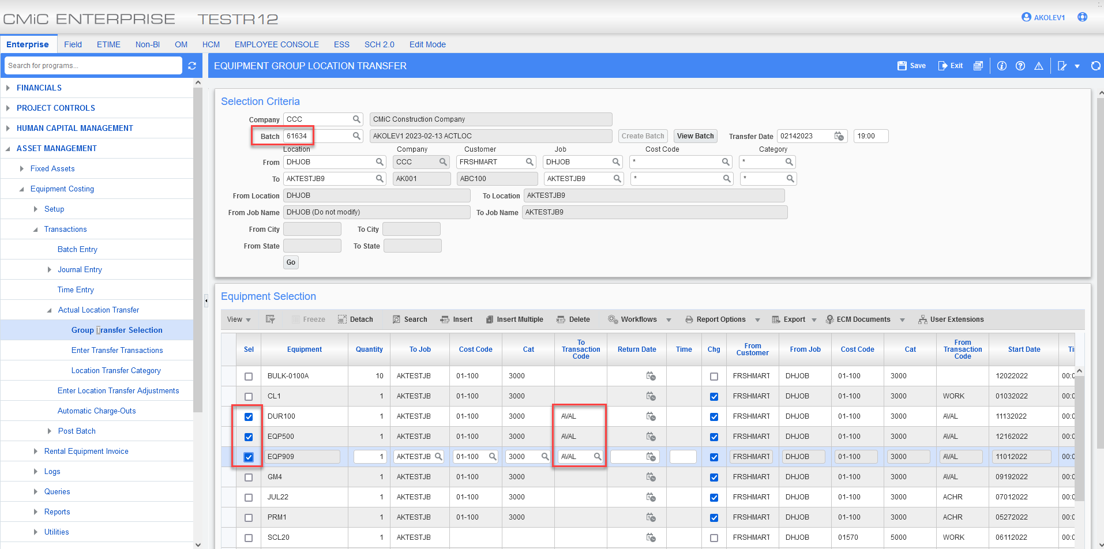
Upon saving and proccessing, these Transaction Codes will be carried over into the same numbered batch in other related programs, i.e. Enter Transfer Transactions:
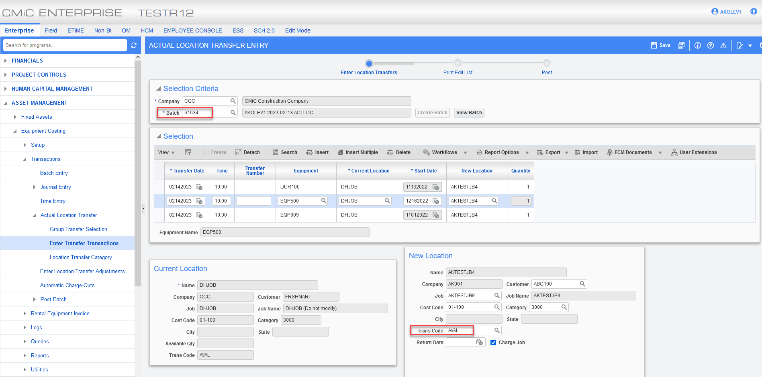

Equipment Class column in Group Location Transfer program (23.66506)
Overview
Added ‘Class’ column to ‘Equipment Selection’ block in Group Location Transfer. ‘Class Name’ field is also added to the program.
Modifications
Following screenshot shows the newly added field in Group Location Transfer program.
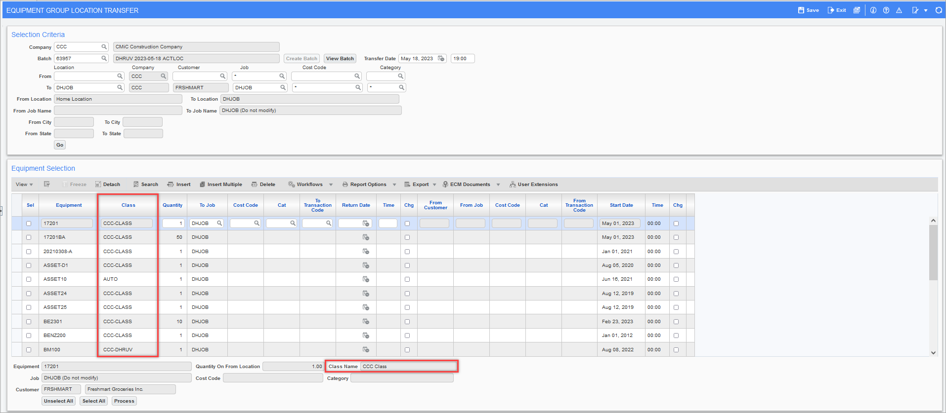Equipment Costing > Transactions > Actual Location Transfer > Group Transfer Selection
Implementation
Following section shows implementation – no change in existing functionality. Equipment Class and Class name will be displayed in the newly added fields.
Selected regular equipment, fixed asset equipment and bulk equipment for group location transfer. Class and Class name is displayed in highlighted fields.
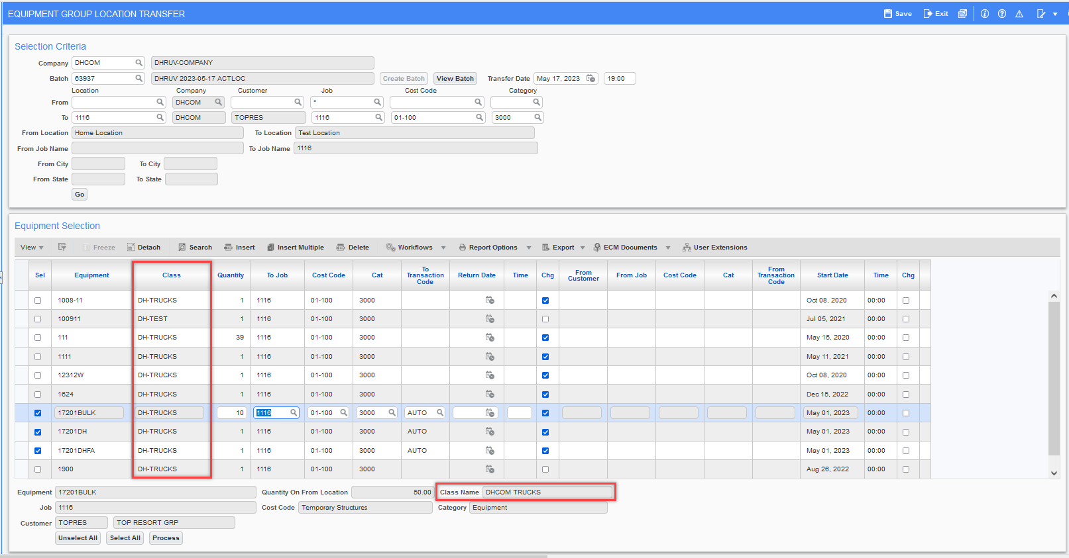
Click on [Process] button. Group transfer is processed, and transfer transaction is created. Review and post the transfer transaction.

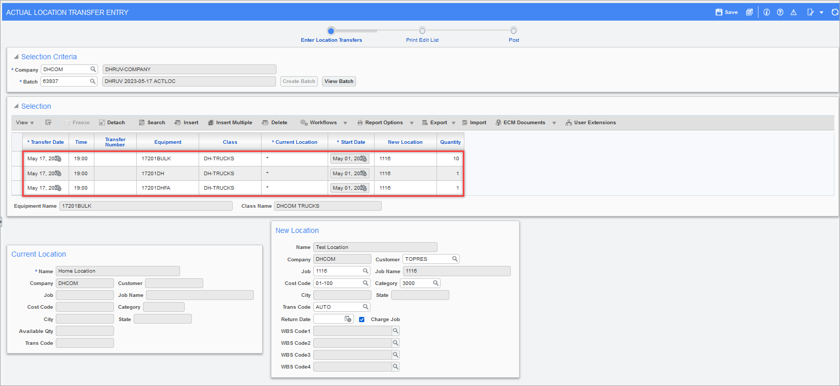

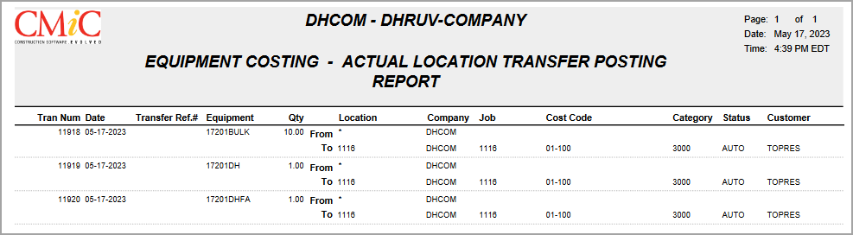

Location Query:
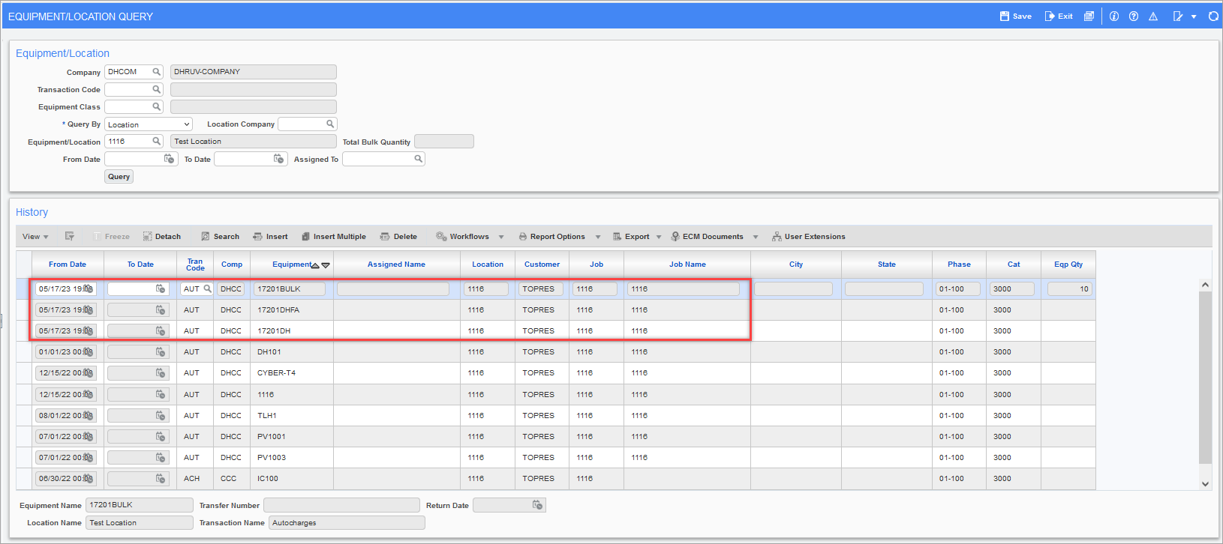

General Ledger

Financial Document Formatter live data preview from document printing (22.63488)
Overview
[Preview] button is added in ‘Print Documents’ program in Financial Document Formatter 2.0.
Dynamic data preview will be shown in a pop-up for the fiscal year and period provided in the header fields.
Modifications
[Preview] button is highlighted in the screen below. Preview data will follow Year and Period specified in ‘Printing Options’ header block.
Note: ‘Suppress Zero Detail Lines’ and ‘Suppress Zero Total Lines’ flags are applicable for Jasper report, not for preview.
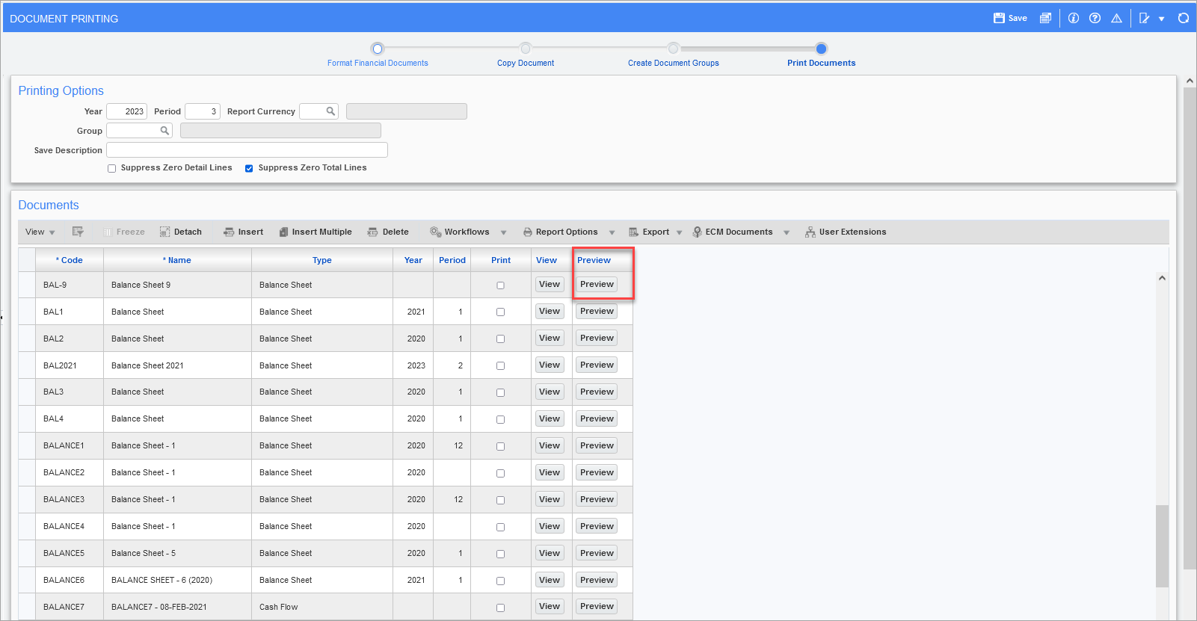

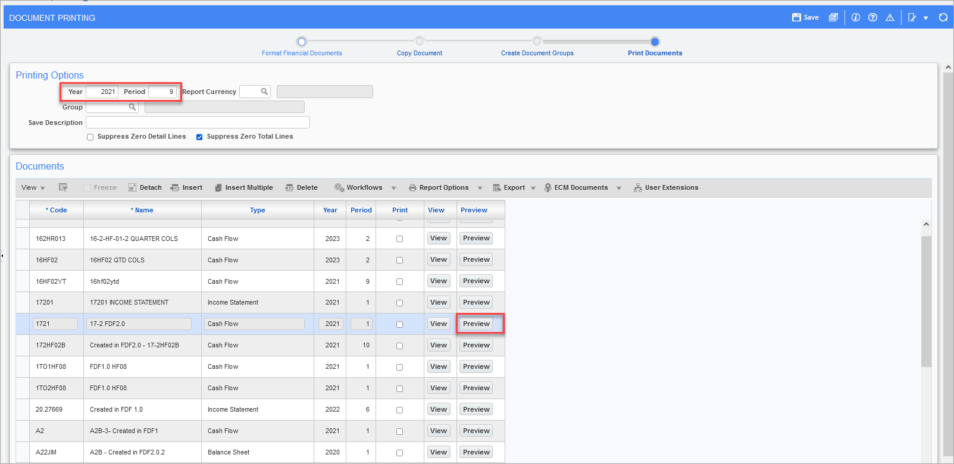

FDF2.0 document preview will show dynamic data and user will also have ability to drill range cells to BI query.
Note: FDF1.0 document preview will not have drilldown ability to BI query. Year and period specified in ‘Documents’ section in detail block displays year and period for previous jasper report run.

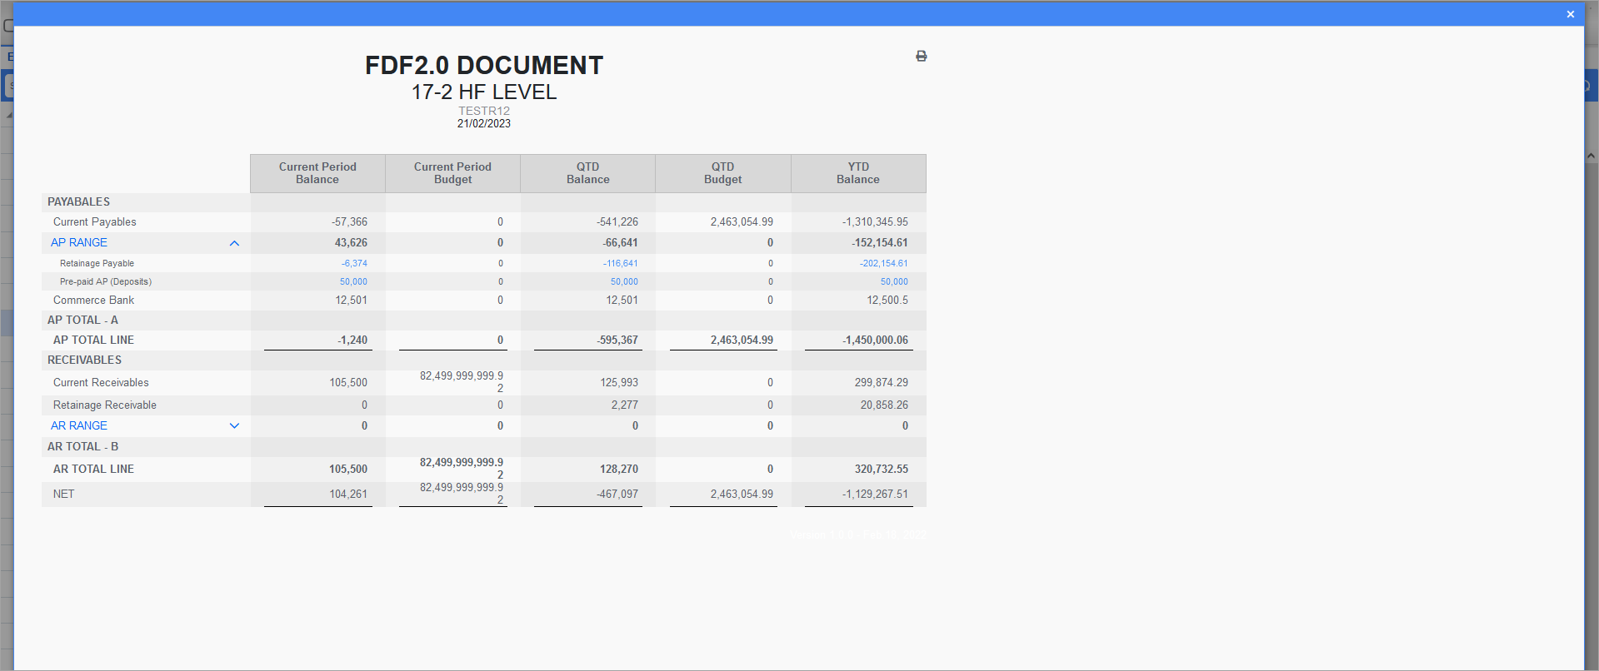
Previewing FDF1.0 document
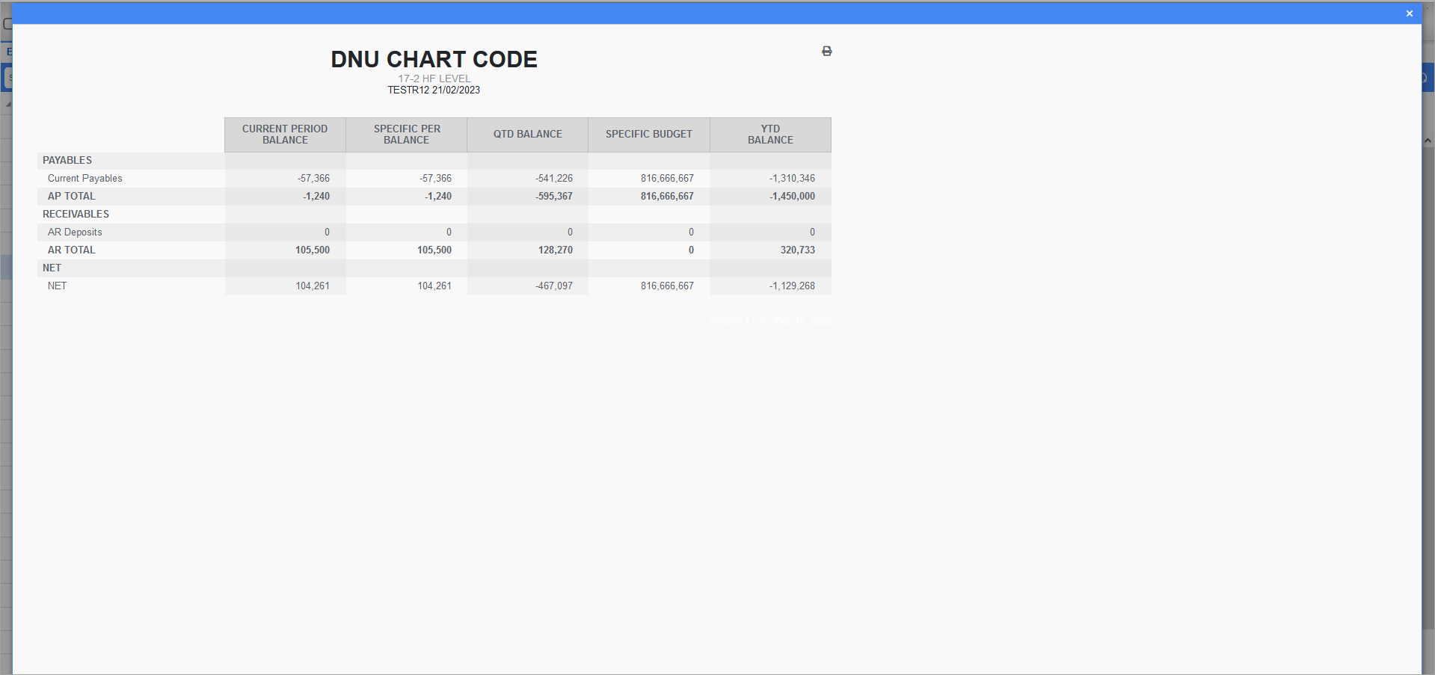

Financial Document Process Train (23.70726)
Overview

Financial document process train is added under General Ledger > Report > Financial Documents Process V3. User must use Treeview builder to add the new target.
Train consists of programs required for financial document processing i.e. Maintain Consolidations, Maintain Budget, Format Financial Documents, Copy Document, Created Document Groups, Process Documents.
Modification

Following screen shows the newly added financial documents process train.
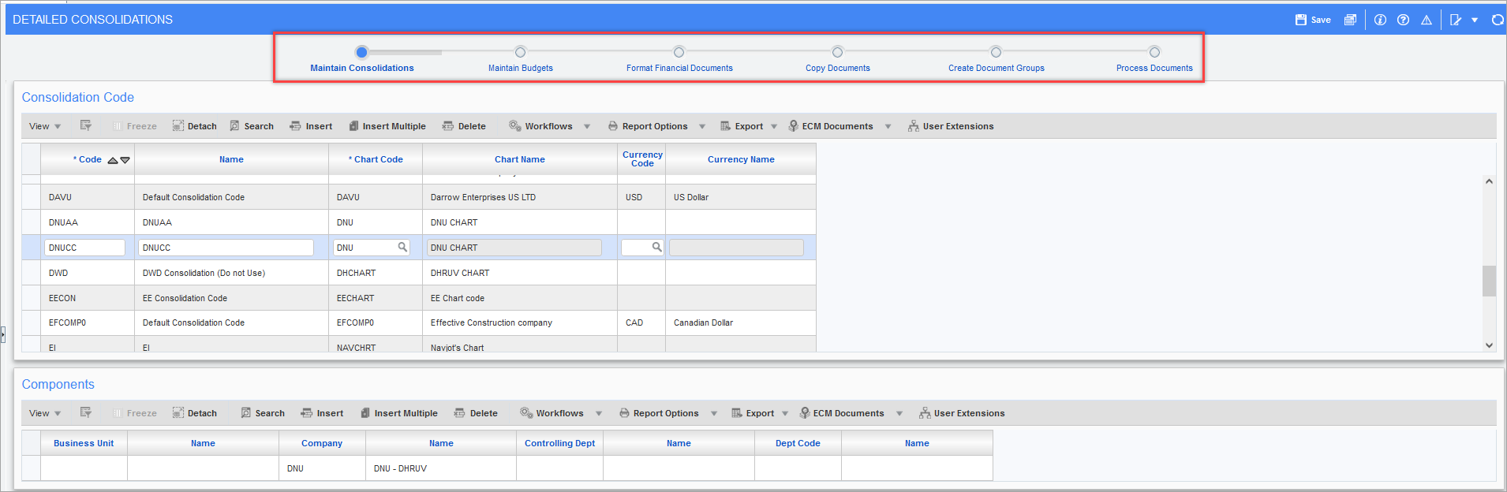GL > Reports > Financials Document Process V3 – Maintain Consolidation
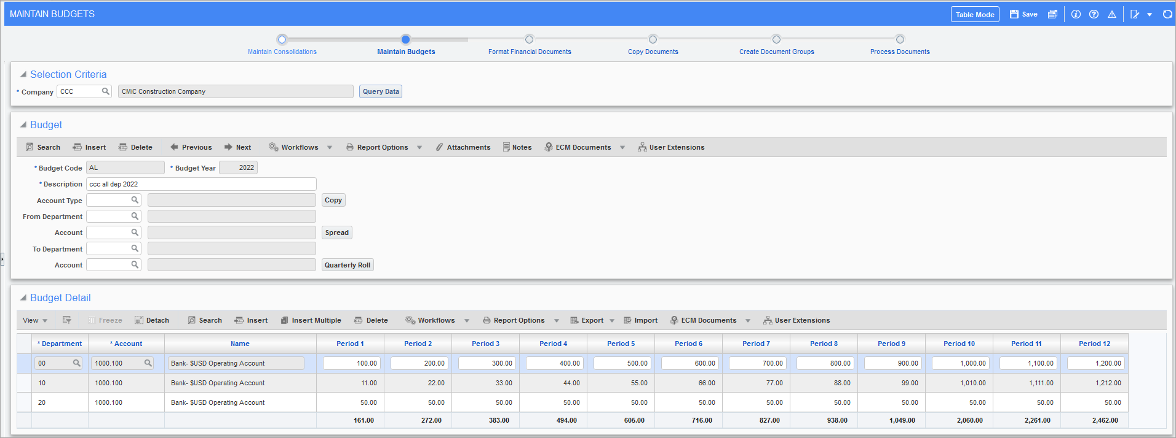GL > Reports > Financials Document Process V3 – Maintain Budgets
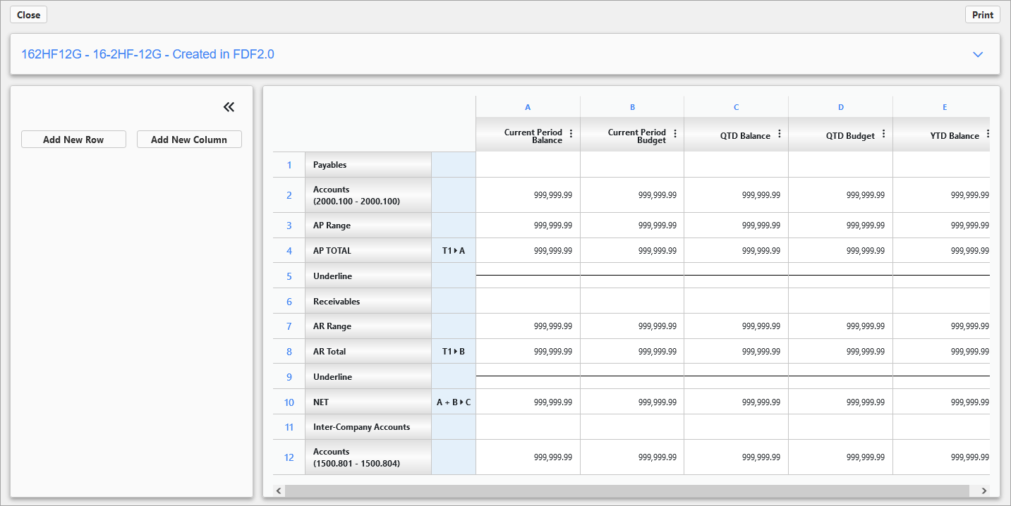GL > Reports > Financials Document Process V3 – Format Financial Documents
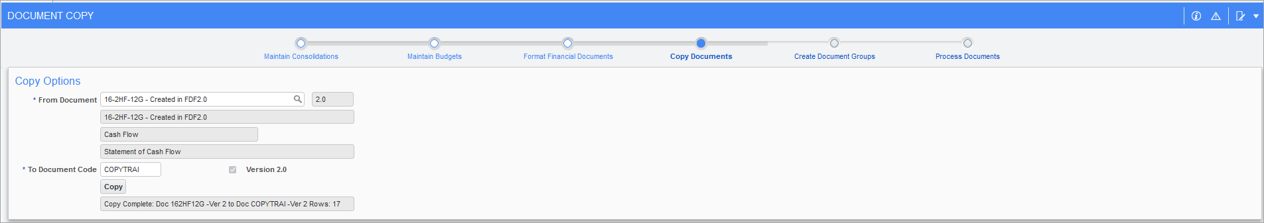GL > Reports > Financials Document Process V3 – Copy Documents
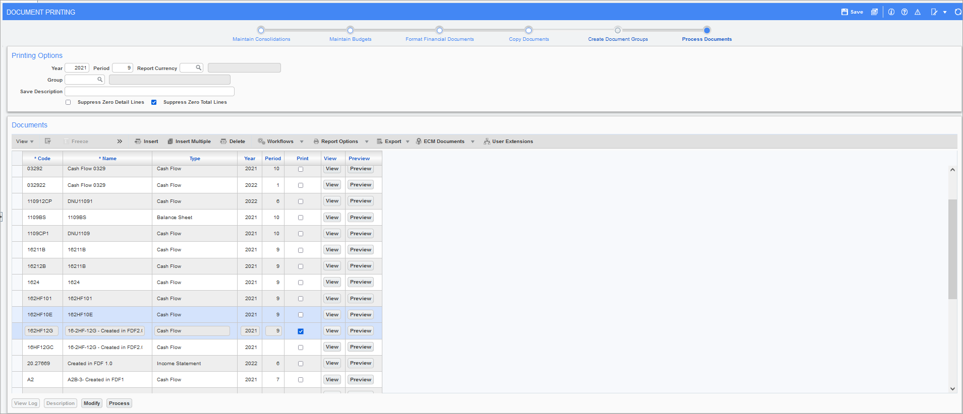GL > Reports > Financials Document Process V3 – Process Documents

Imaging

Imaging Control – Hide Select/Deselect All on MOVE (22.61244)
CMiC has added the ‘Hide Select/Deselect All’ checkbox to the Imaging Control to allow the user to decide if they want to display or hide the buttons in the MOVE screen in Image Manager.
By default, the flag is unchecked.
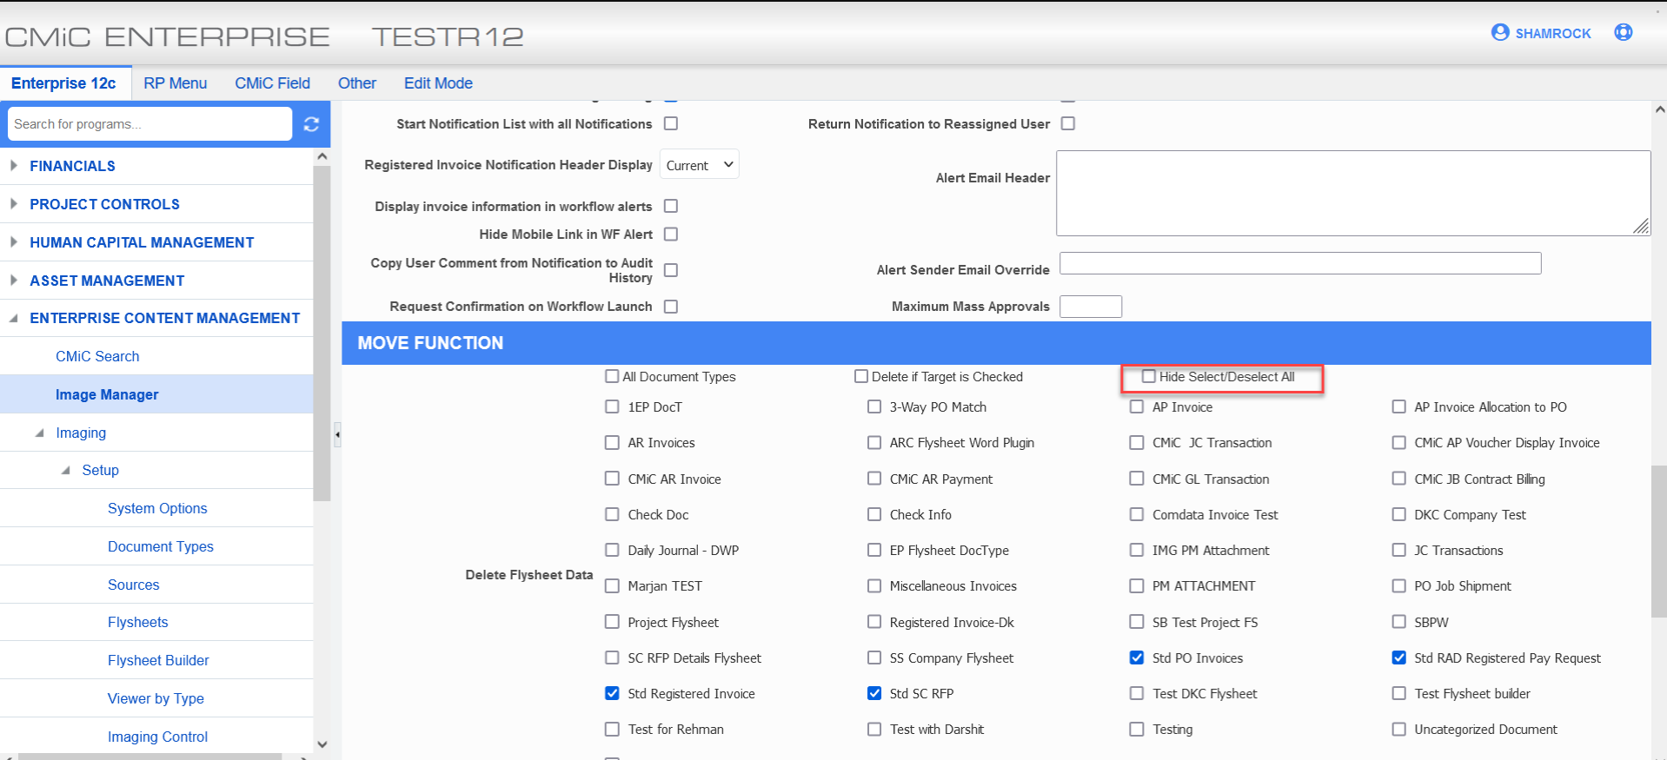

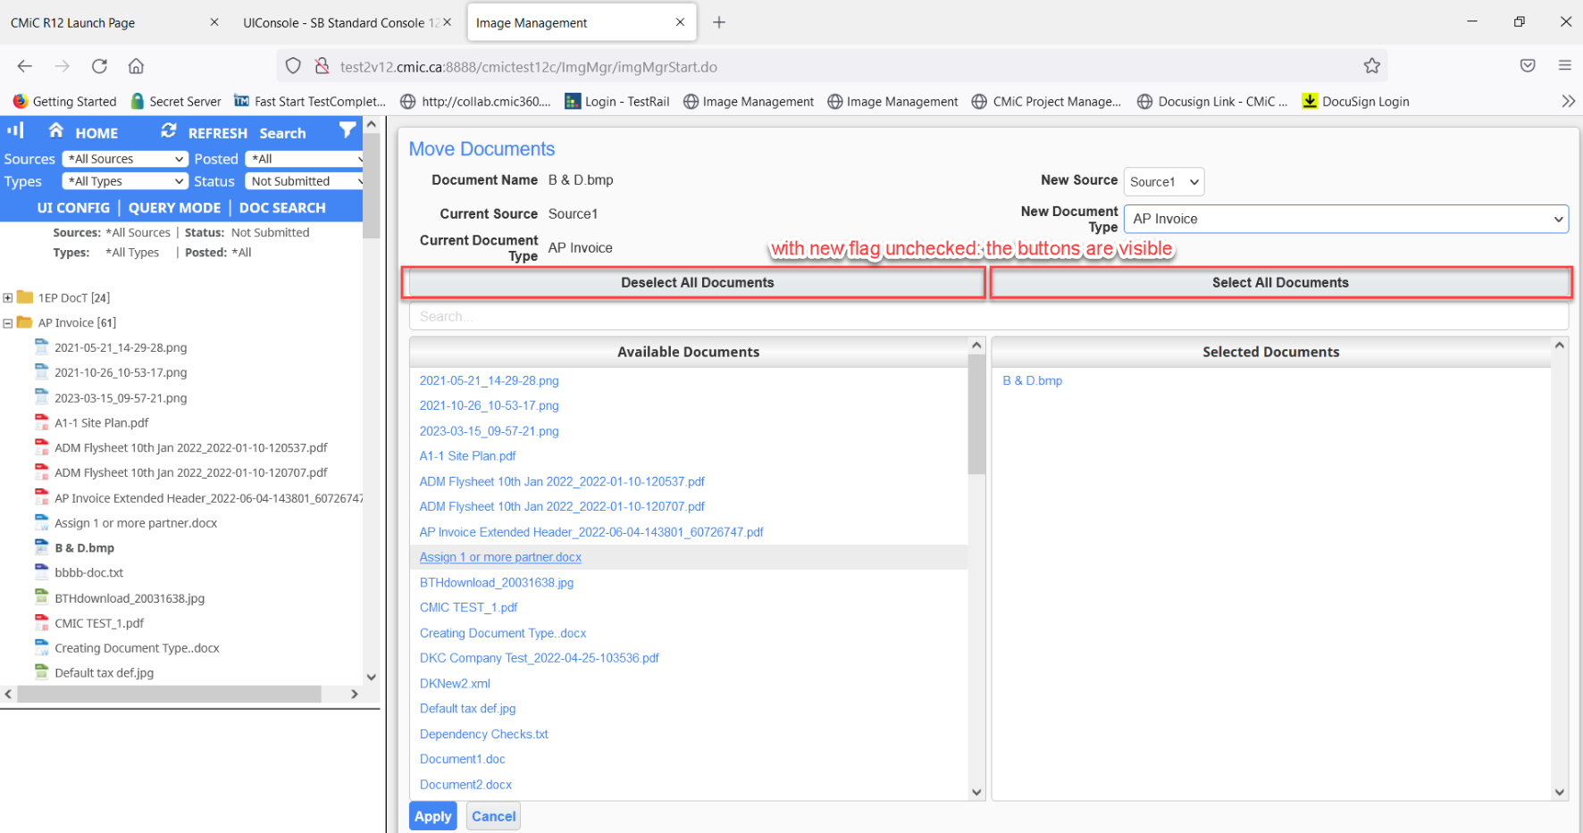

When the flag is checked:
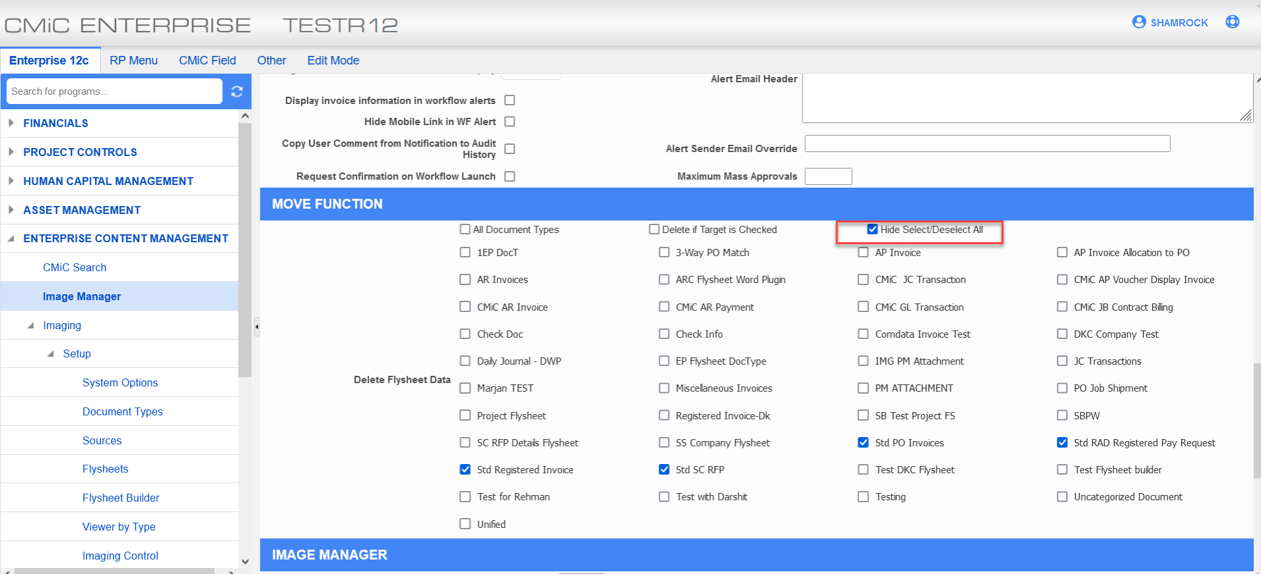

the buttons are hidden:
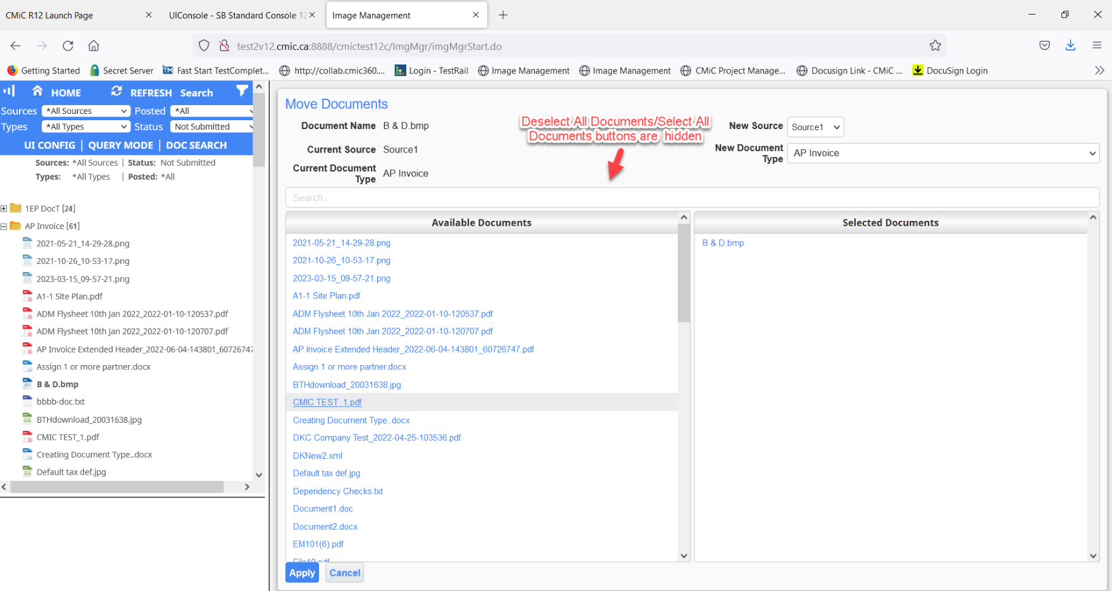

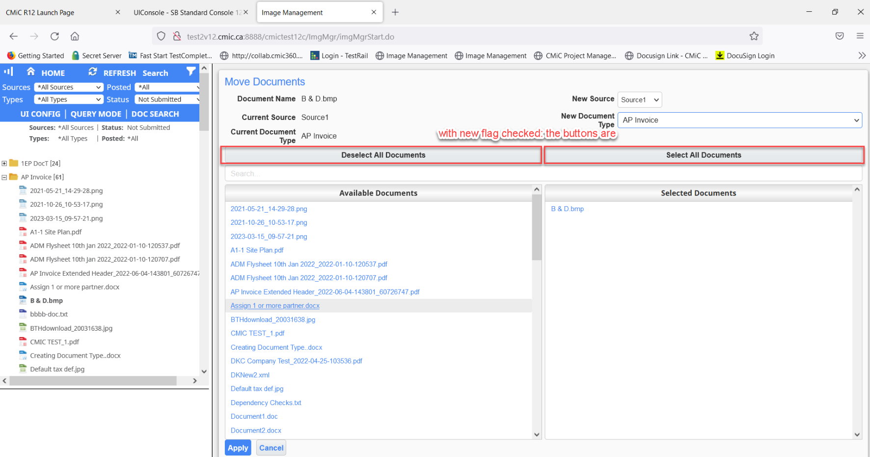

International Payroll

Addition of NEW localized fields on Employee Profile and Employee History Screen - Dubai Region (22.57530)
Overview
CMIC has added new localized screens and fields into HR and payroll for the Dubai region. Employee nationality, employee religion and airport destination are new localized screens added to international payroll, as well as other different fields integrated within HR and payroll.
Pre-requisites
The following are the PRD name and target name of the new screens that have been created. They are not in standard menu and need to be added from the treeview builder. Any new fields need to be visible through lite editor.
Employee Nationality
Program name: PYEMPNATIONAL
Target name: PY- Employee Nationality
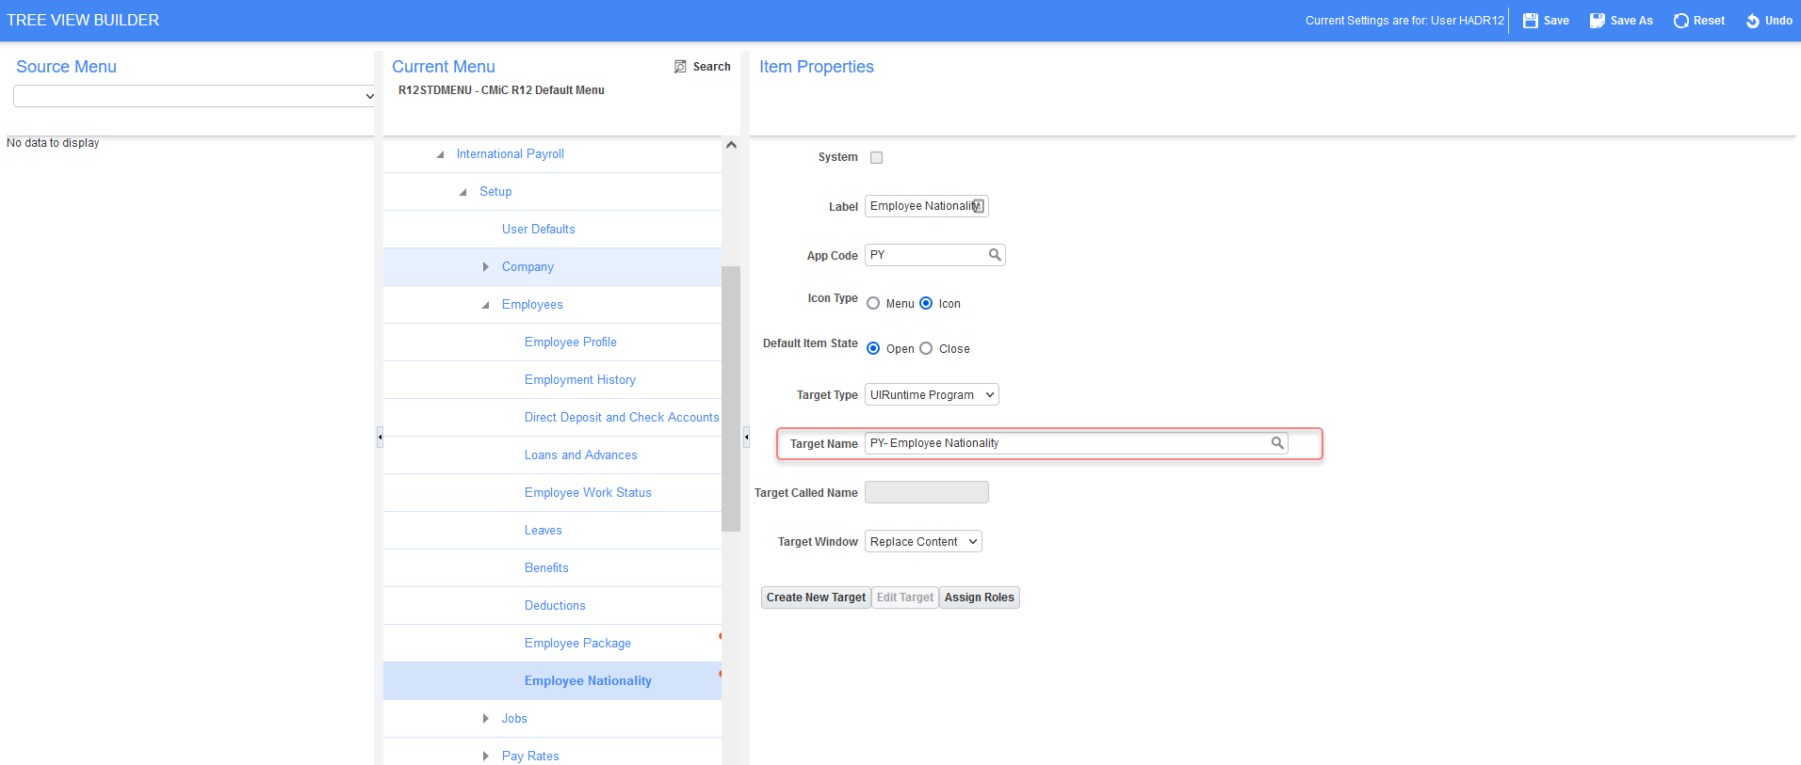
Employee Religion
Program name: PYRELIGION
Target name: PY - Employee Religion
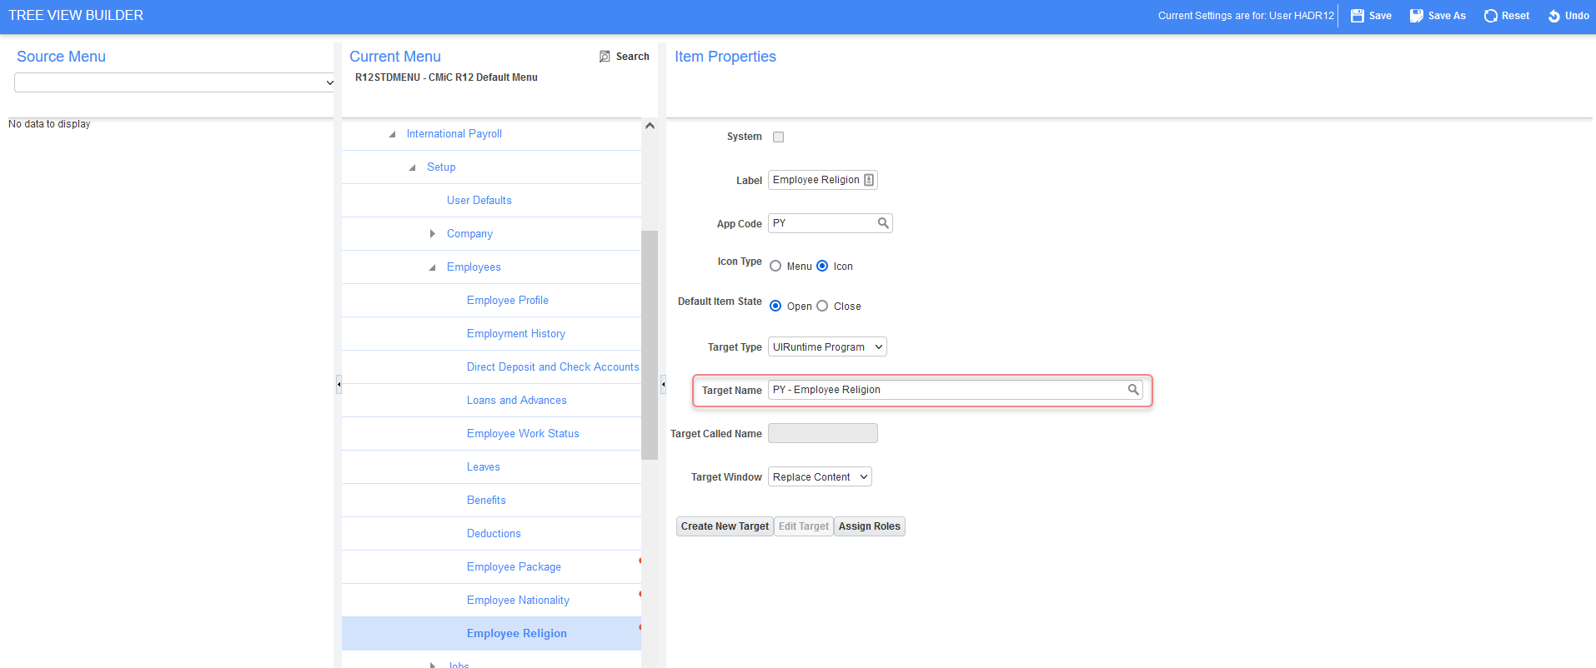
Airport Destination
Program name: PYAIRPORTS
Target name: PY- Airport Destination
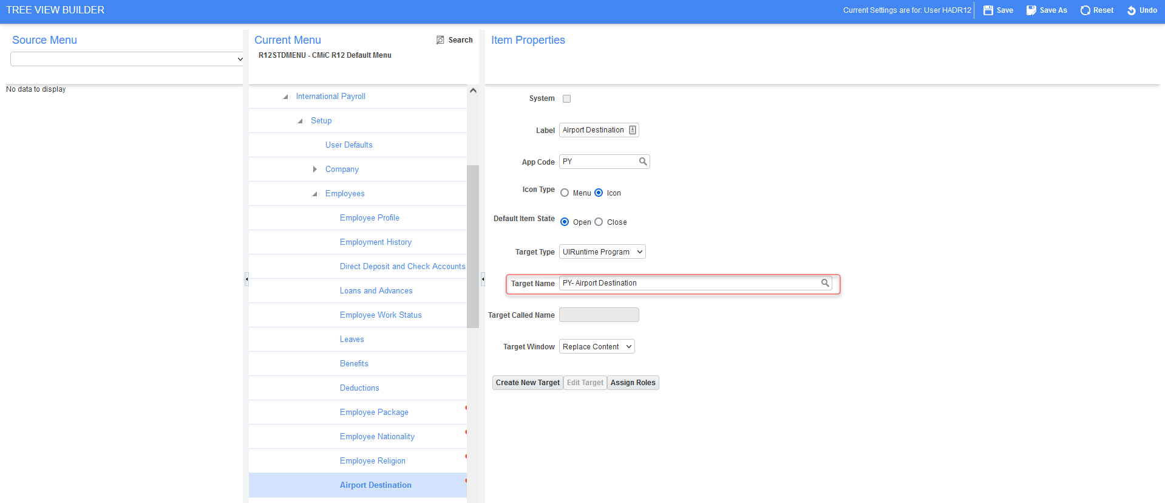
Modifications/Implementation
This section contains a description of the modifications. It includes details about what screens were created/updated/affected.
Countries:
CMIC utilized countries screen which can be found under local tables> setup> Geographies to manage applicant residence countries. CMIC added the standard import feature to the standard screen to allow users to import all countries at once.

The following is an example of the new import feature:
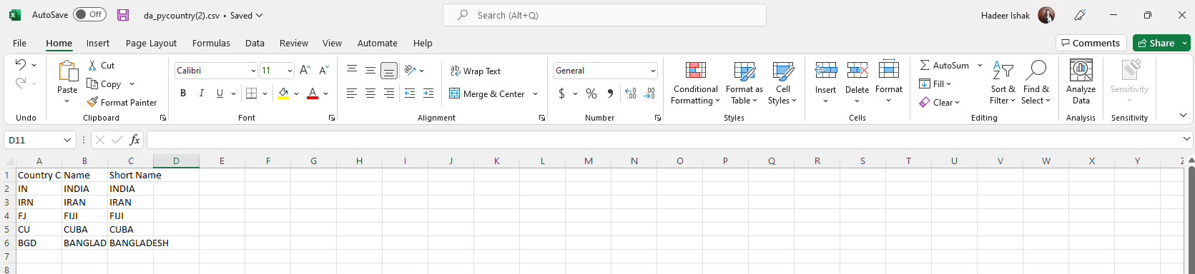
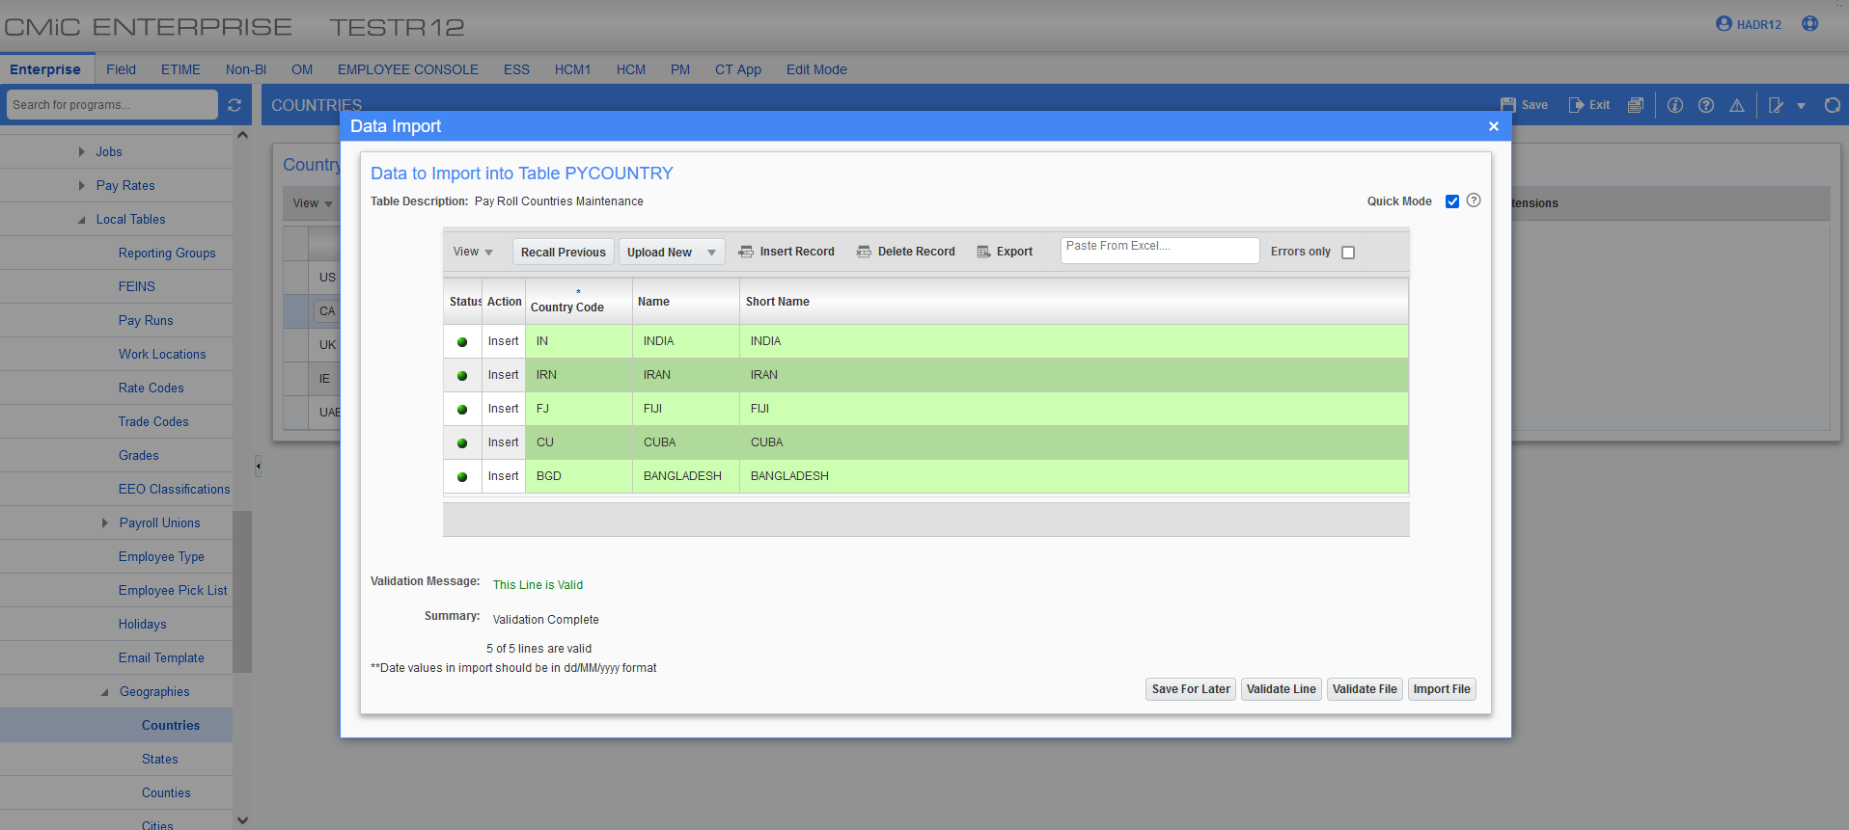
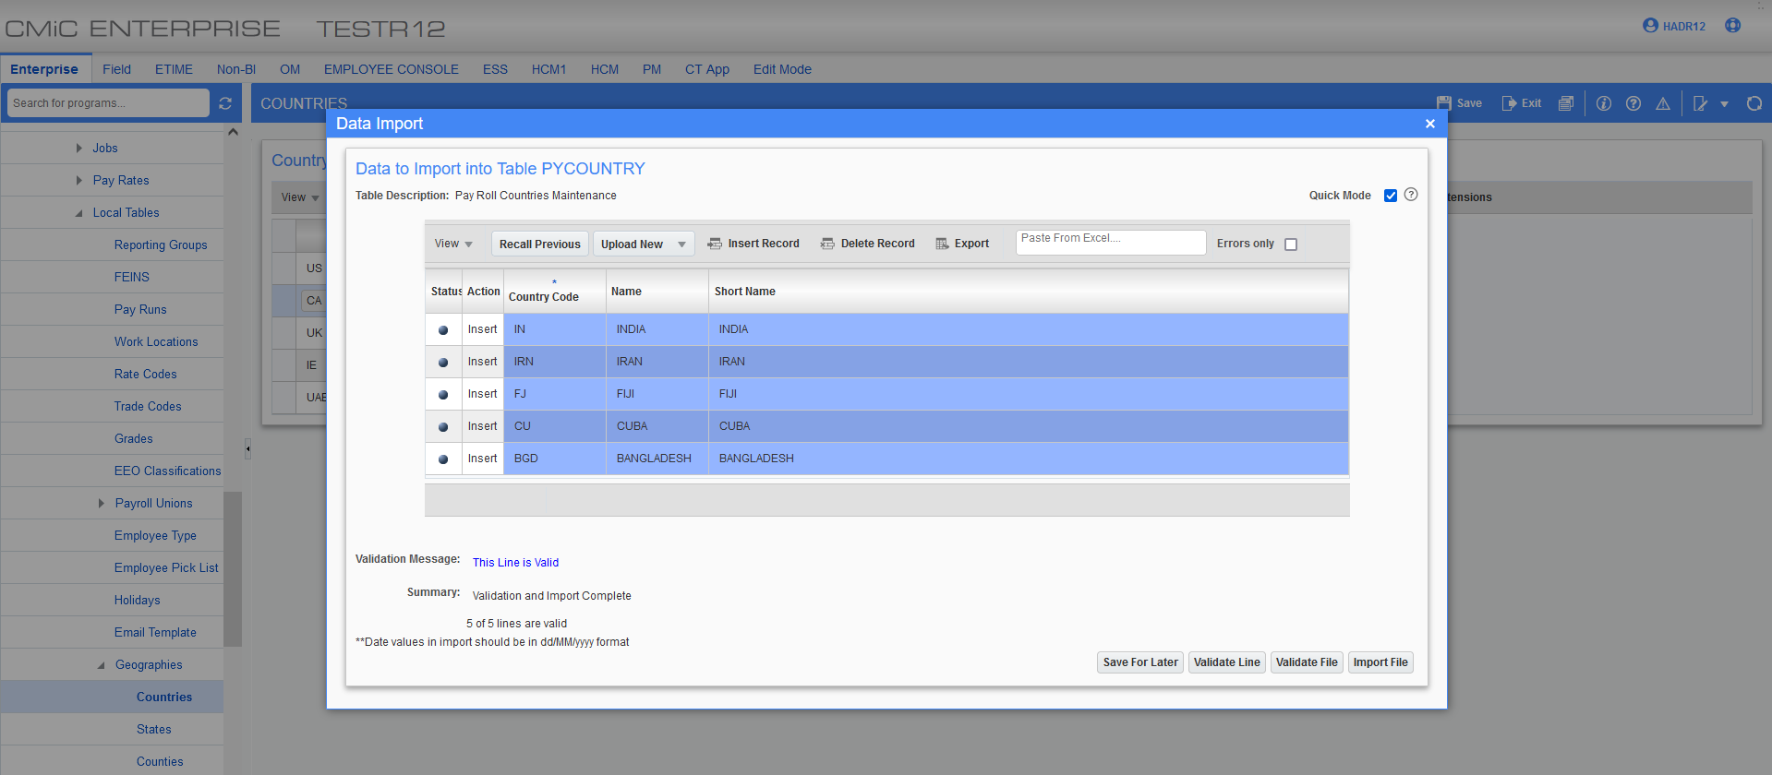
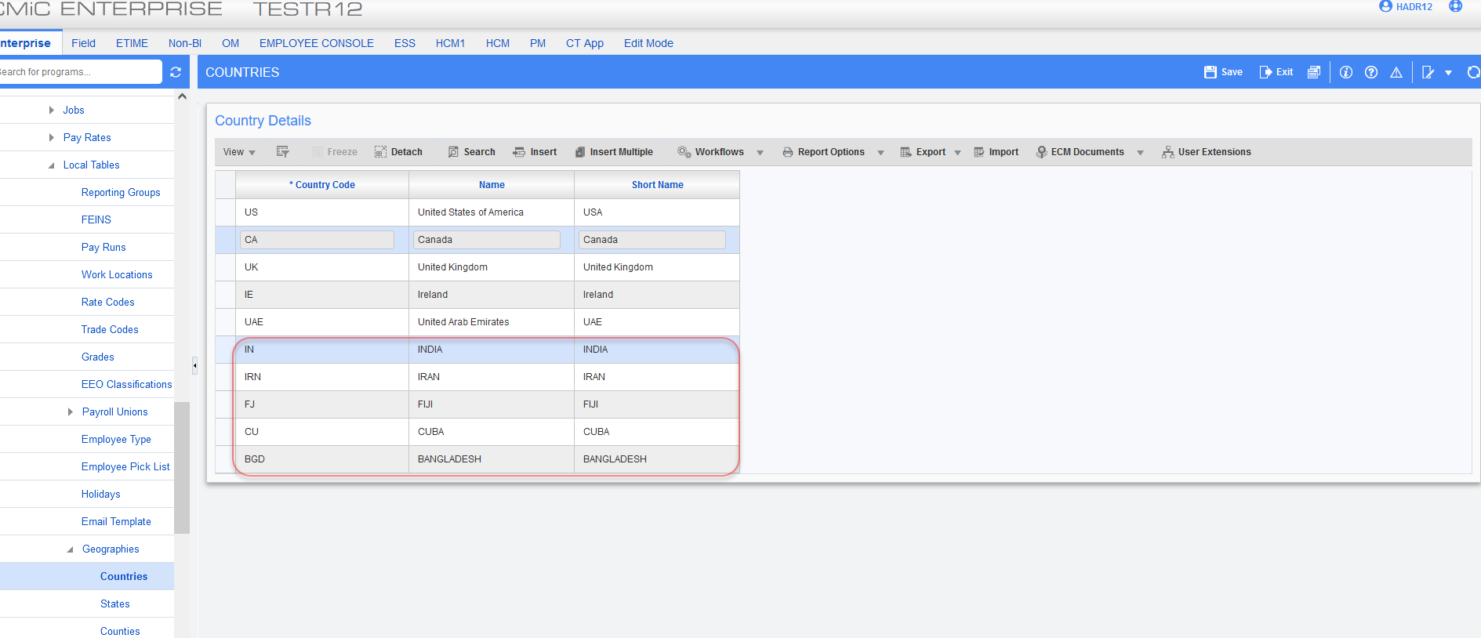

Employee Nationality:
CMIC has added employee nationality button to employee profile and employee history. Employee nationality program has been created to store applicant/ employee nationality/visa information.
Note: Validation for Pyen_Passport_Place_Issue and Pyen_Visa_Place_Issue have been removed & table mode and import have been removed.
The following information have been included in the new table:
Empno : (PK) Employee/Applicant number
Mother_mainden_name: Employee Mother Name
Primary_national : Employee primary nationality may be by birth
Secondary_national : Employee secondary nationality by migration
Passport_Place_of_issue: Passport Country
Passport_no : Current Passport Number
Passport_issue_date : Passport Issue date
Passport_expire_date : Passport Expiry Date
Emirates_id : Emirates ID
Visa_place_of_issue : Country place of issue
Visa_no : Employee Visa No
Visa_issue_date : Visa Issue Date
Visa_expire_date : Visa Expire Date

The following shows how to add employee nationality button from lite editor to employee profile and history and how it functions:

Employee profile:
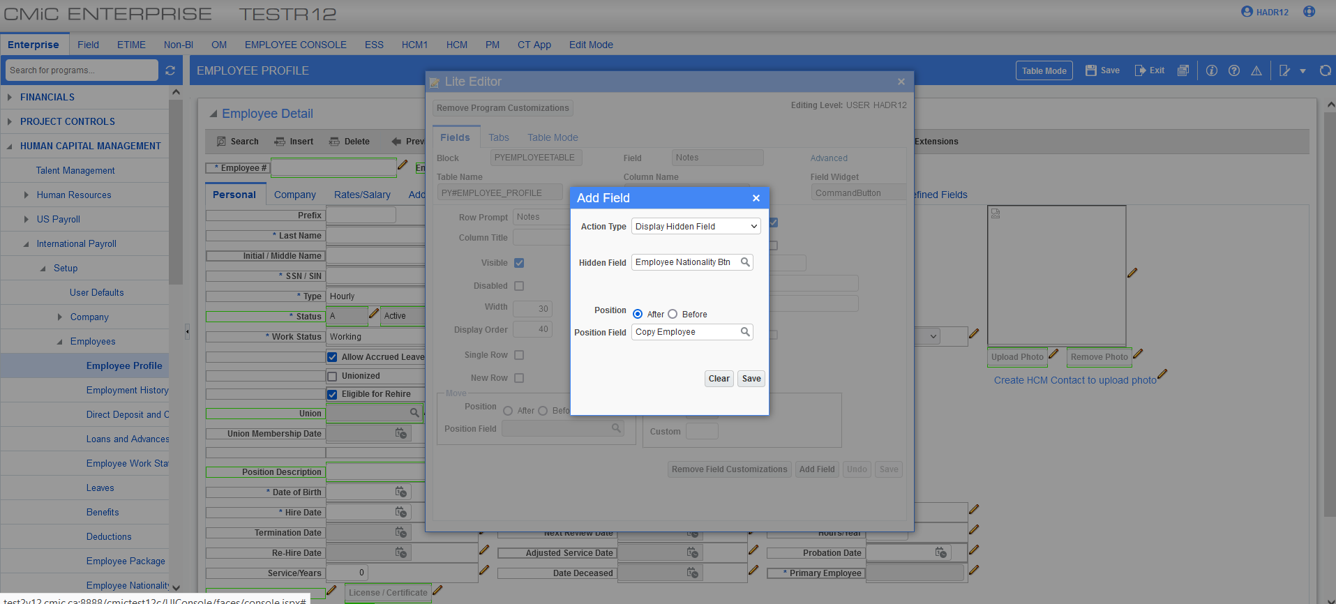
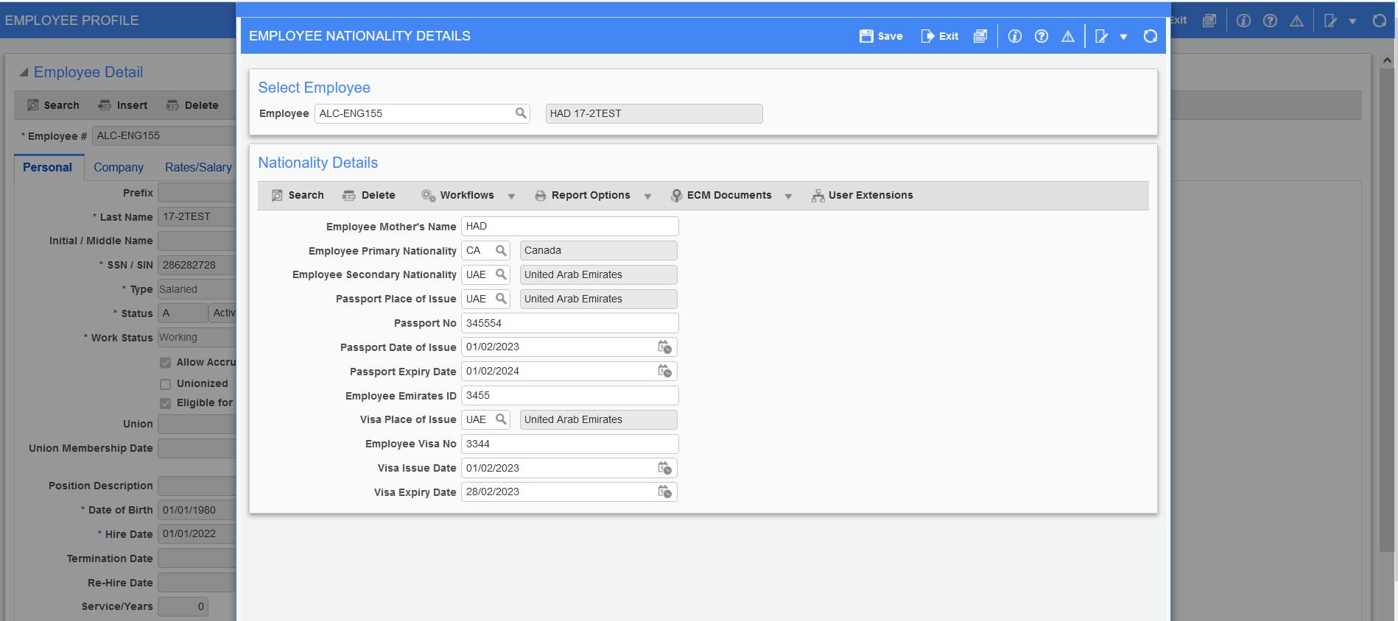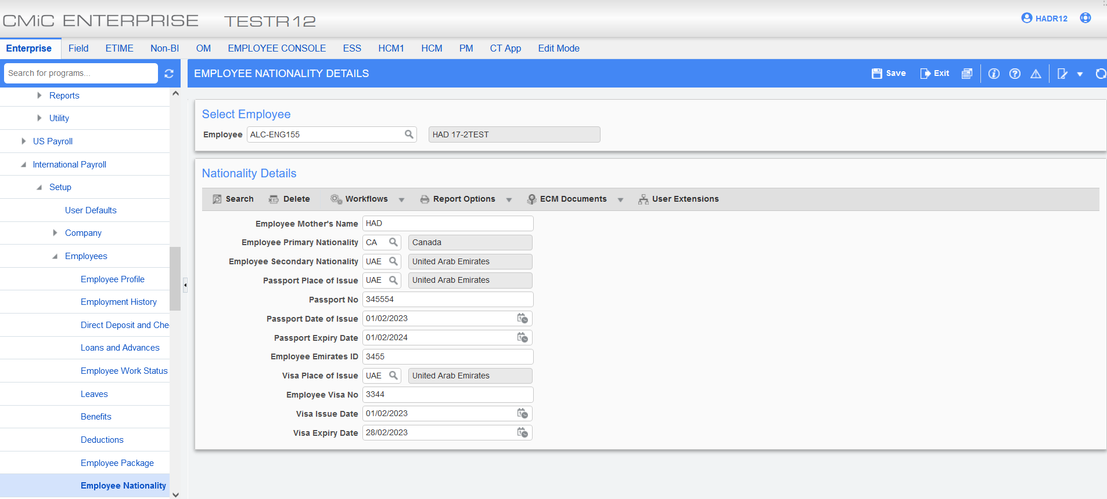
No error message or validations upon clicking save:
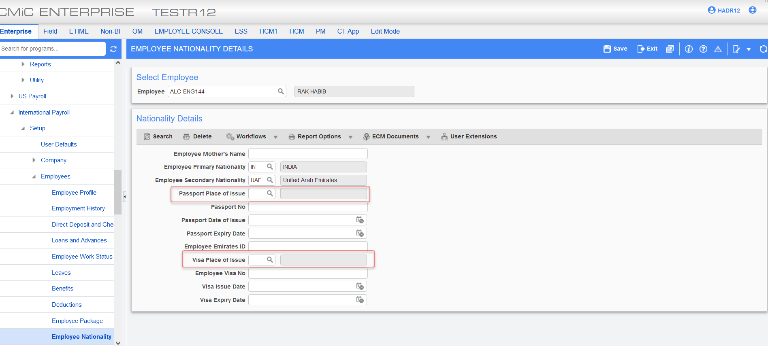
Employee history:
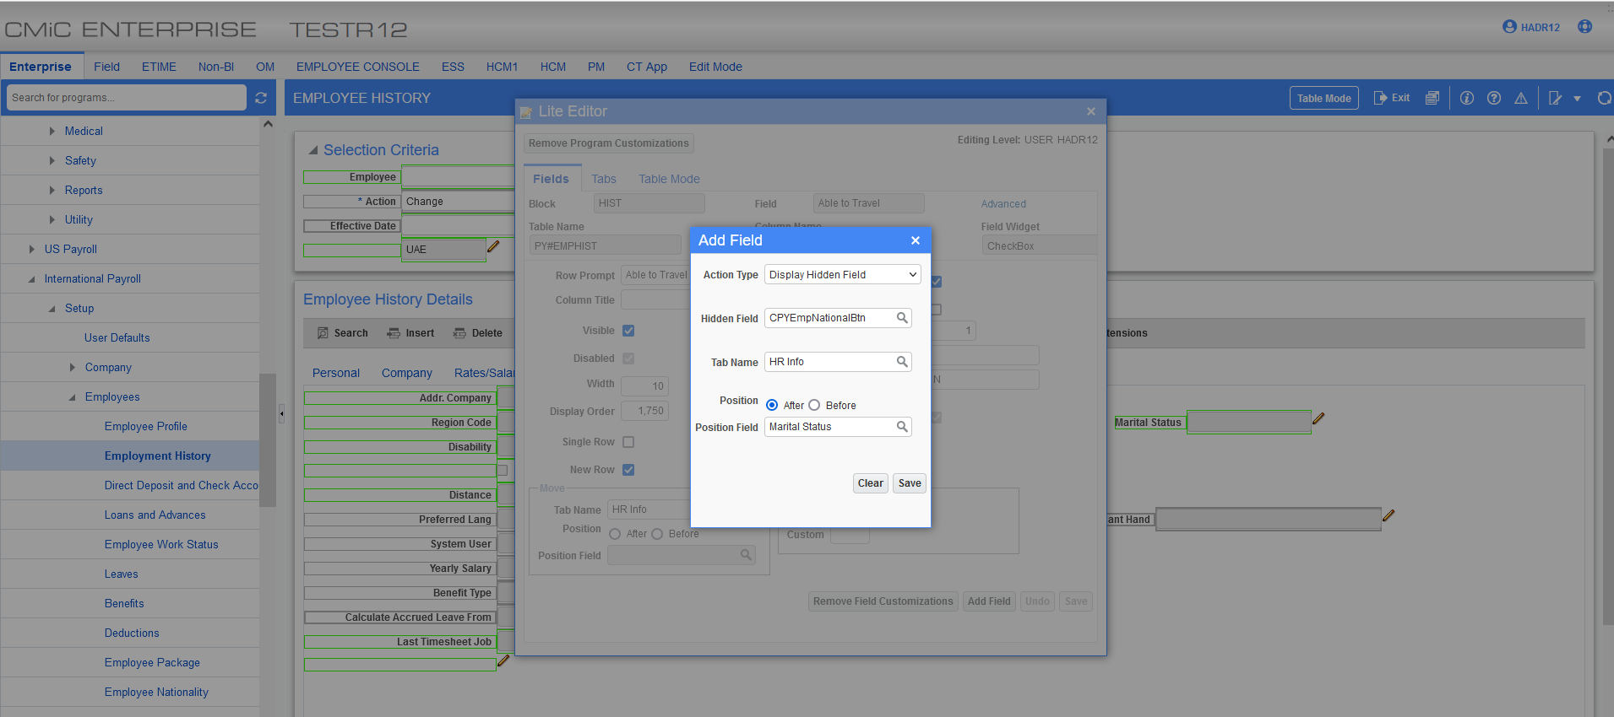
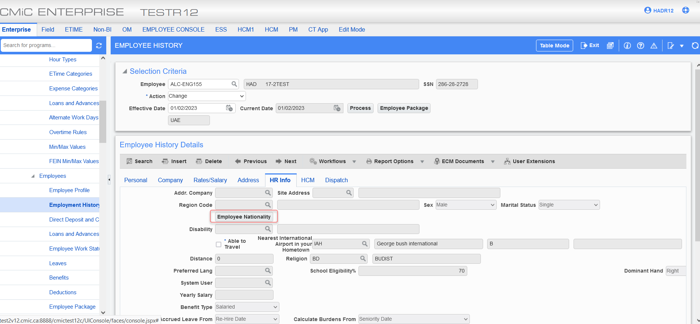
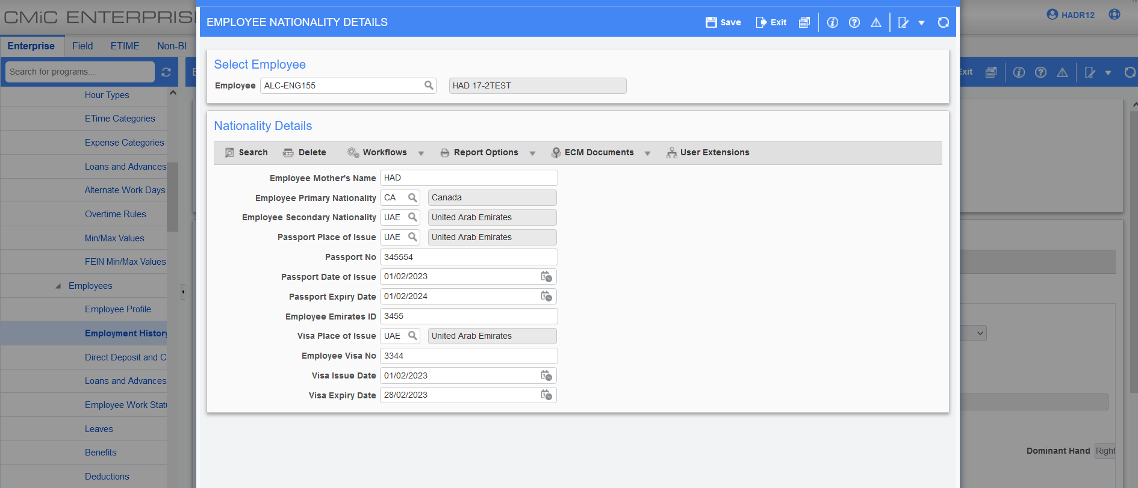

Employee Nationality Program:

HR Eligibility Rule:
EMP_PRIMARY_NATIONALITY, EMP_SECOND_NATIONALITY and EMP_MONTHLY_SALARY fields have been added to the HR eligibility rule to allow users to set up benefit eligibility rules.
The three new fields can be found in the rules criteria details > Rule field name LOV. The rule value will show the list of countries in the LOV.
Note: The list of countries for EMP_PRIMARY_NATIONALITY and EMP_SECOND_NATIONALITY is limited based on the employee nationality program.
Static values of EMP_PRIMARY_NATIONALITY and EMP_SECOND_NATIONALITY will only show the country selected in criteria details in the LOV.
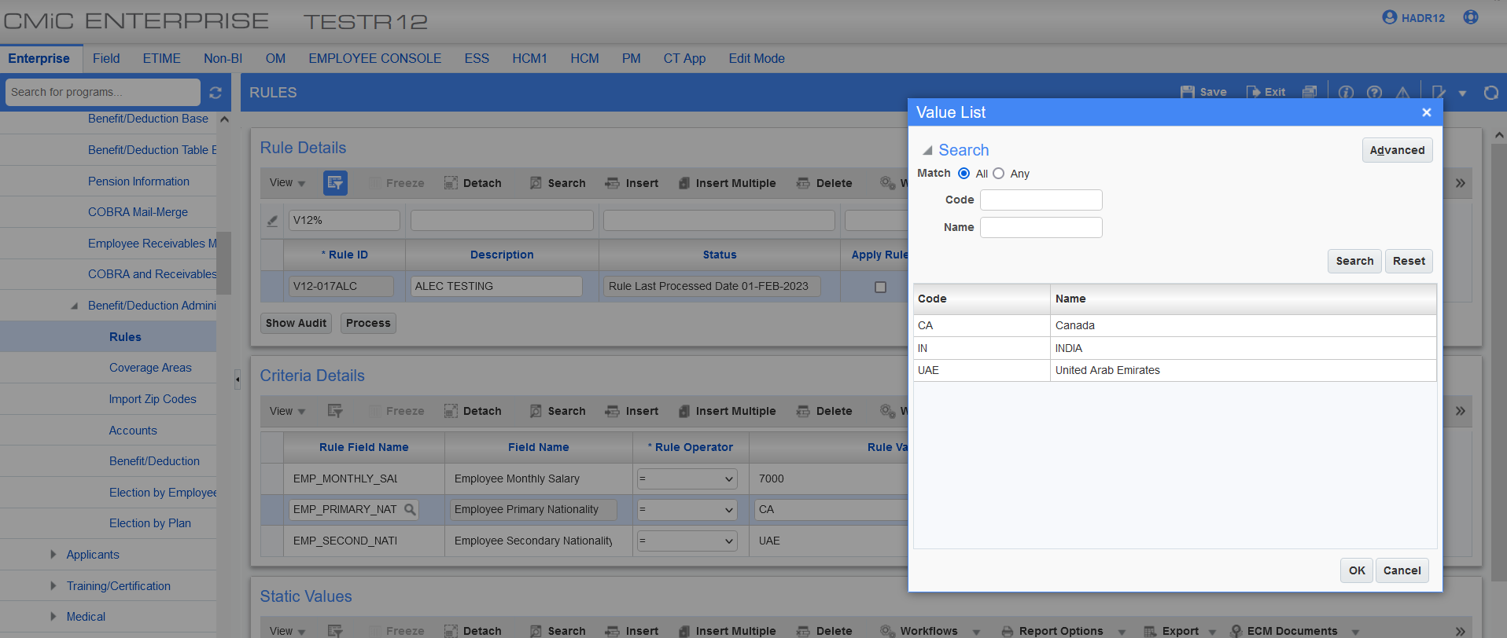

*Processed the rule with the two new fields “ALC-ENG155” has primary nationality of CA, secondary nationality of UAE and a monthly salary of 7000.
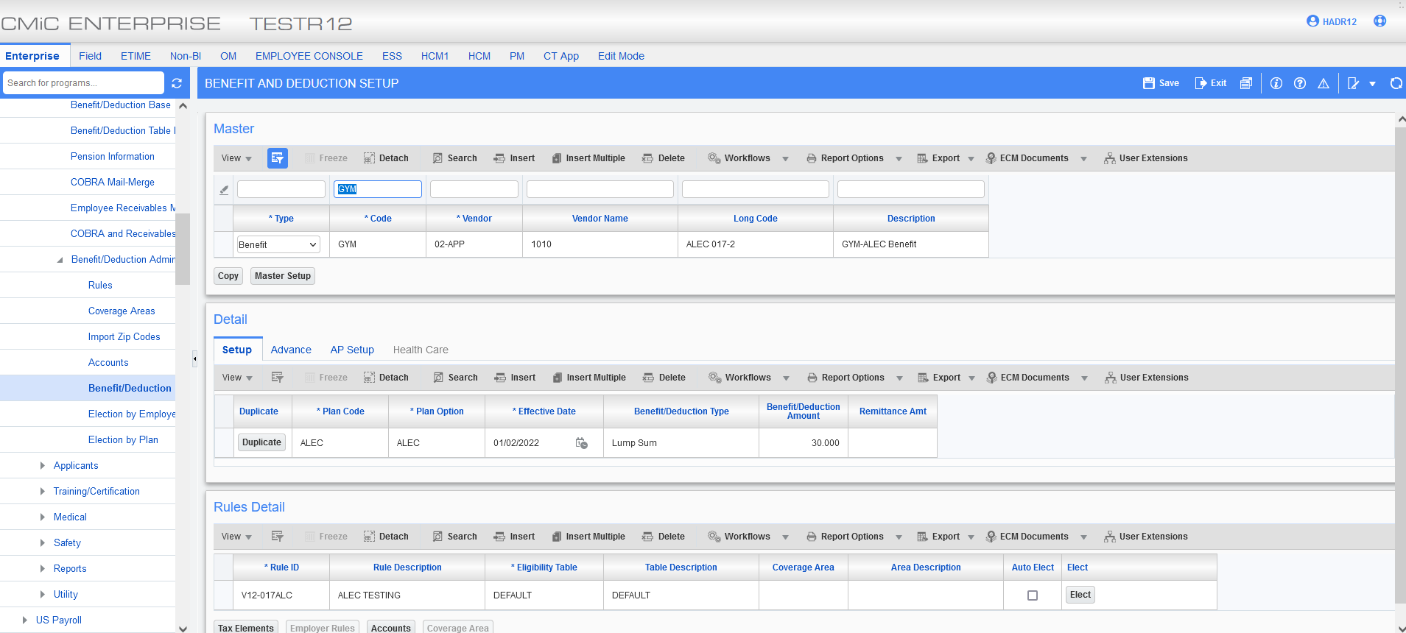
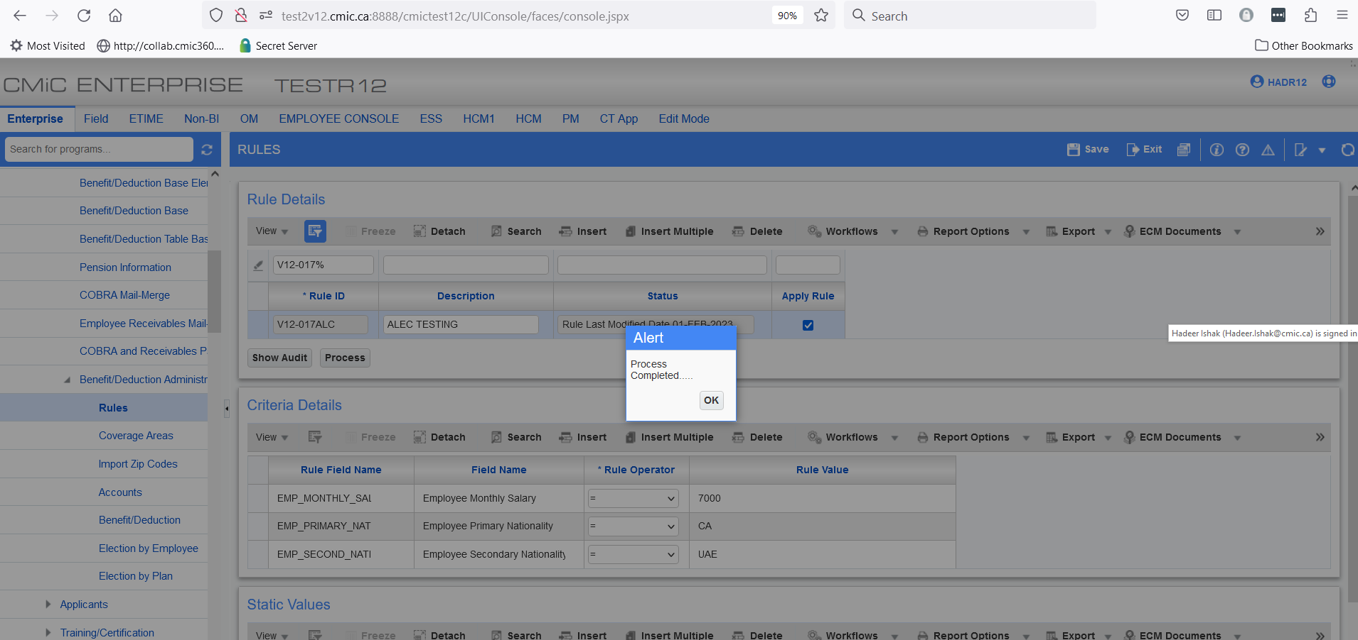
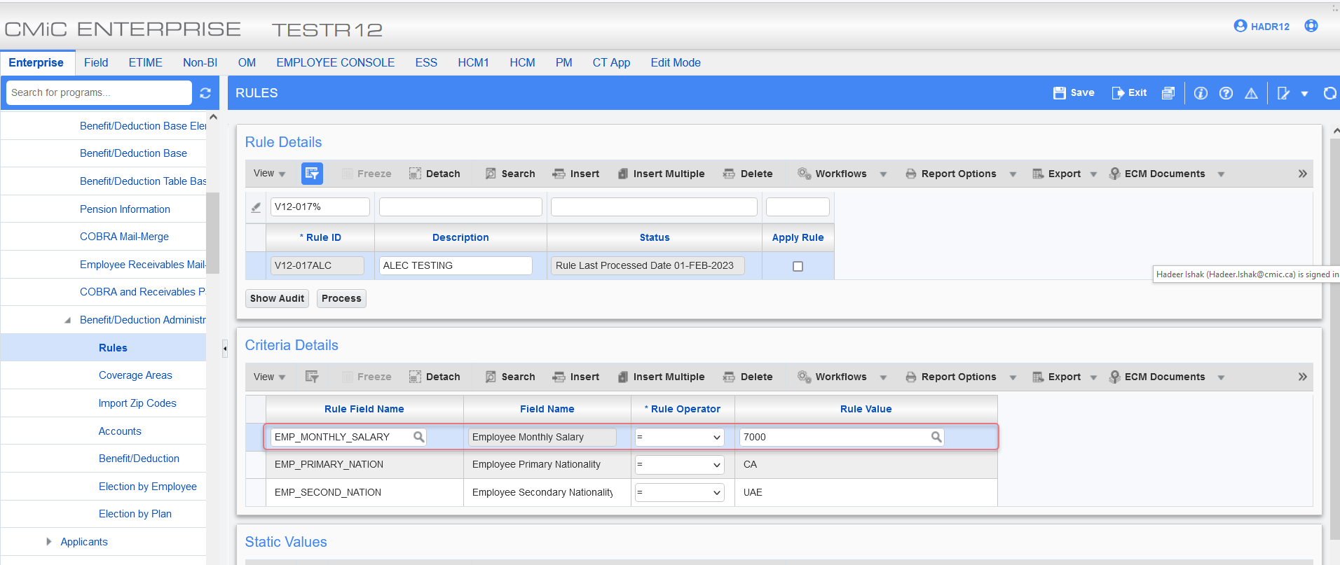
*Able to elect GYM benefit for the employee
. 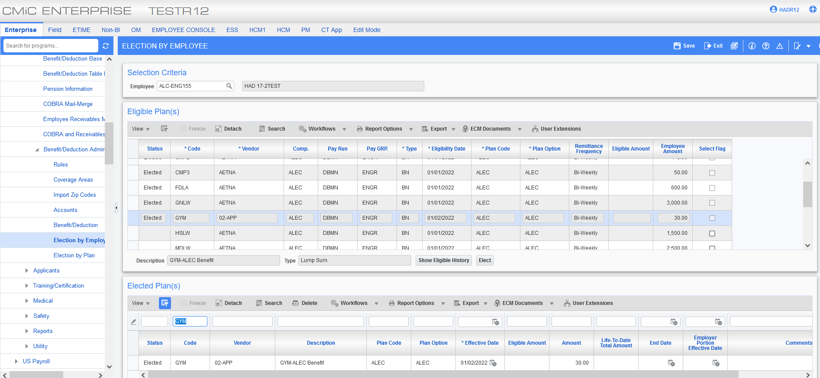
HR Relative Screen:
The below fields have been added to the employee related table/screen:
Primary_national : Employee primary nationality may be by birth
Secondary_national : Employee secondary nationality by migration
Hold_Residance_visa : This would be a ‘Yes’ or ‘No’ dropdown option for relatives if they have residence visa and living with employee

The new fields can be added from the lite editor as shown below:
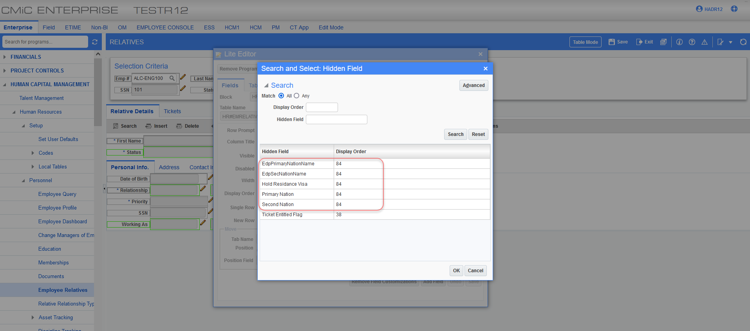
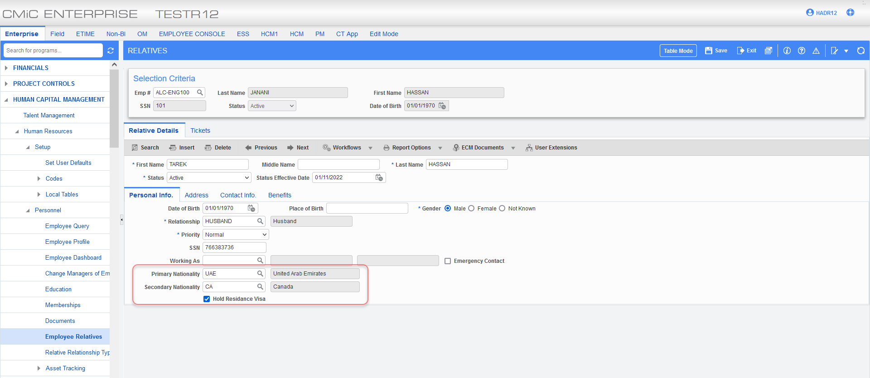
Employee Religion:
CMIC has added a new setup screen to allow users to set up ‘Religions’. The screen consists of religion code and religion name. The screen allows users to import data.
This information is needed in the Dubai Region for the foreman to maintain a proper schedule.
As an example, if a Friday schedule is needed for Muslims for Friday prayer.
Employee profile:
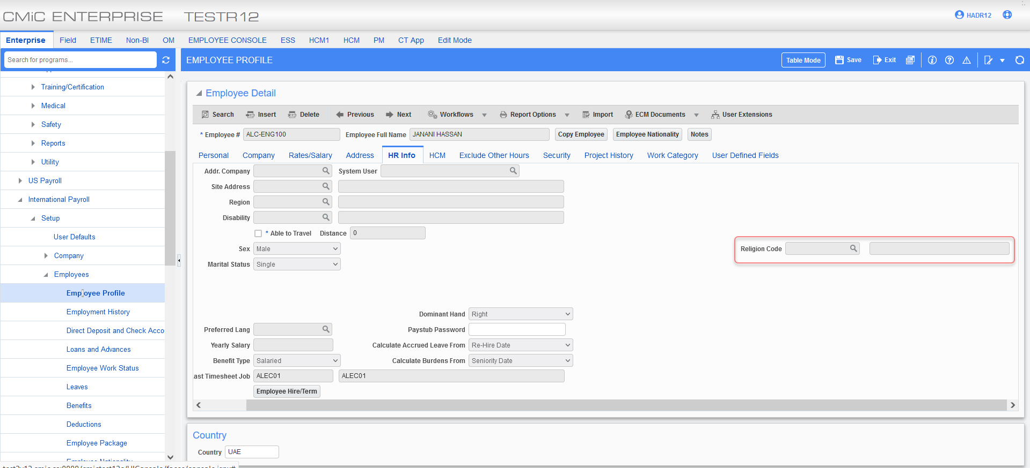
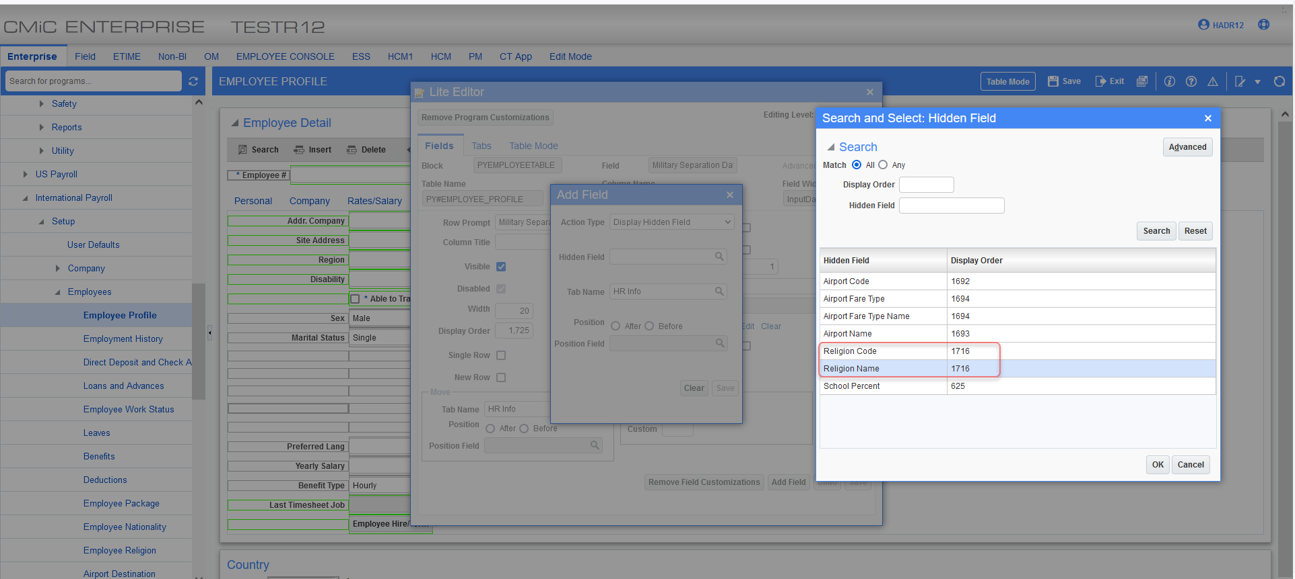

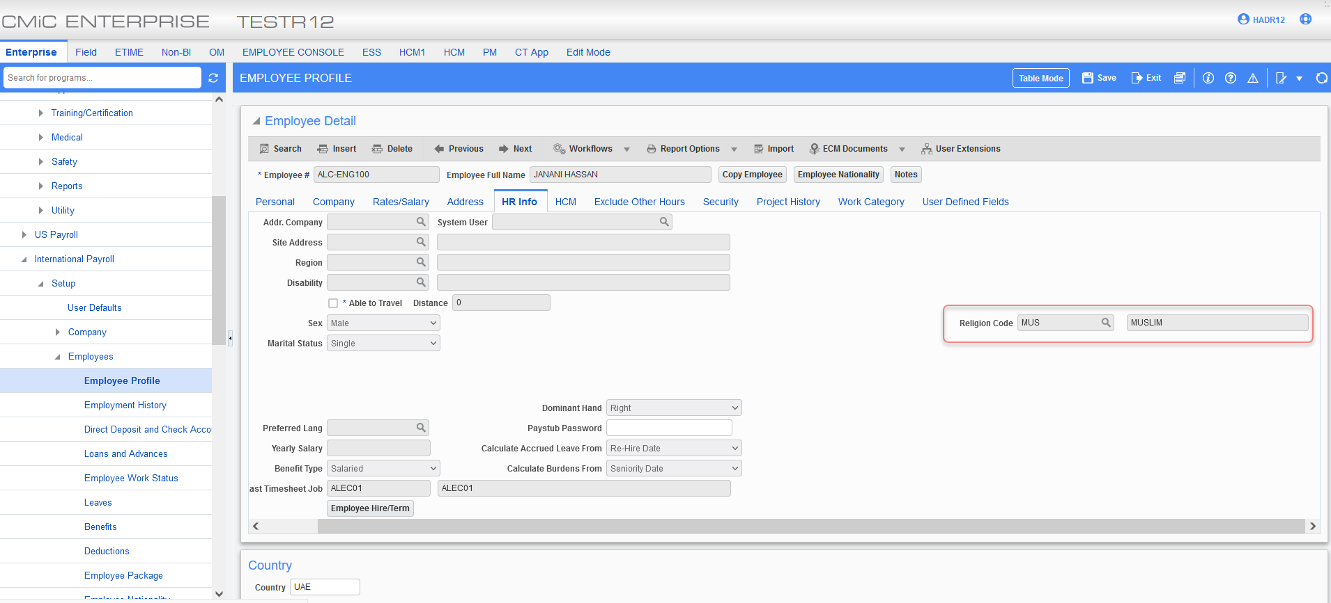
Employee History:
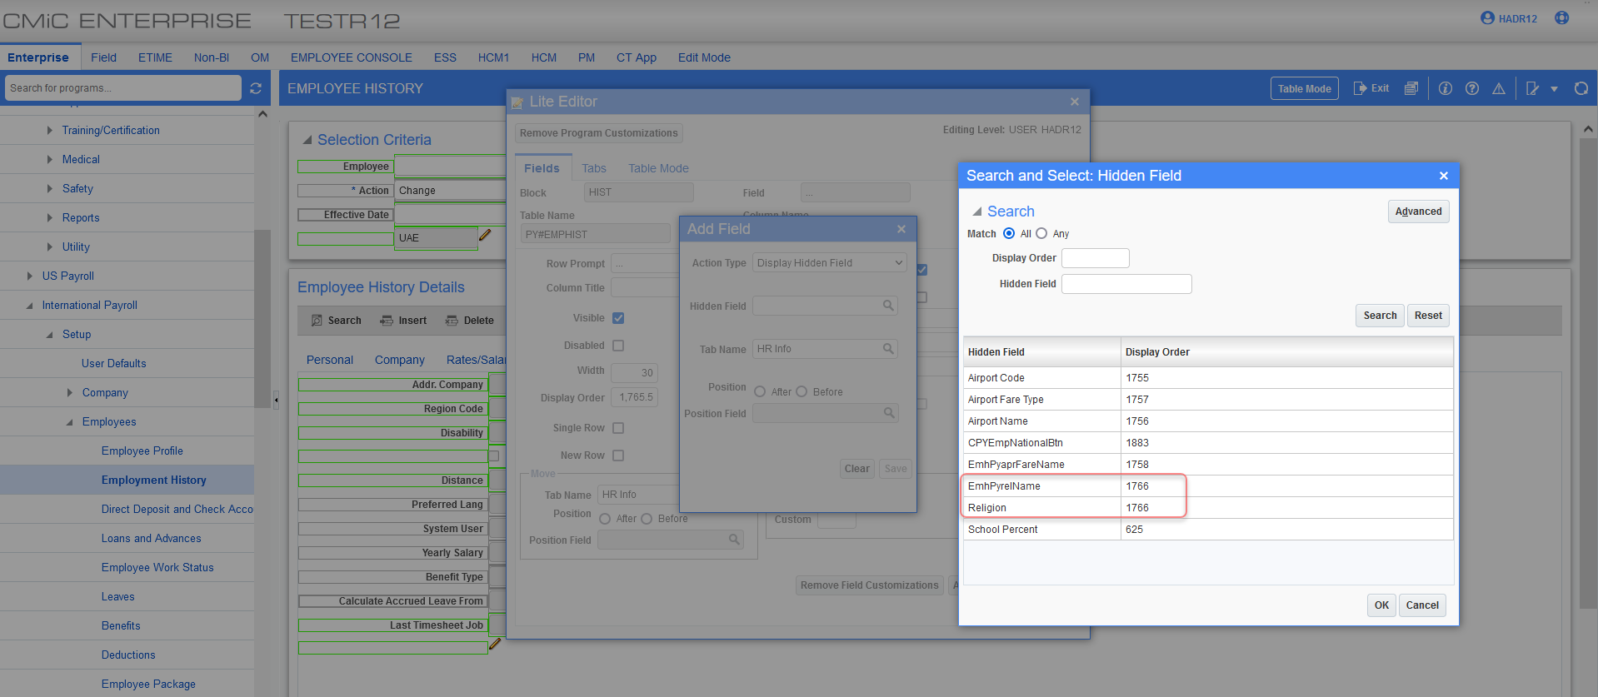
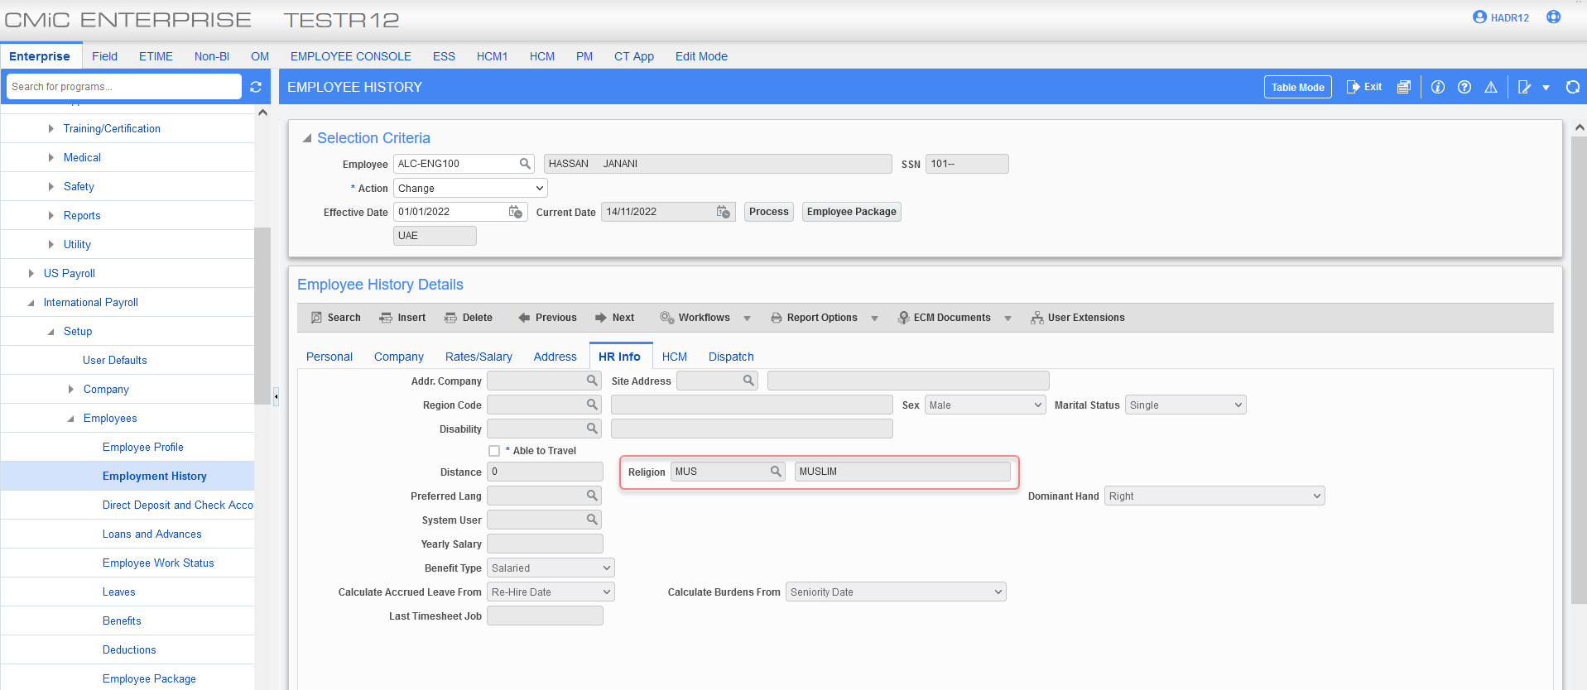
Employee Religion Program:
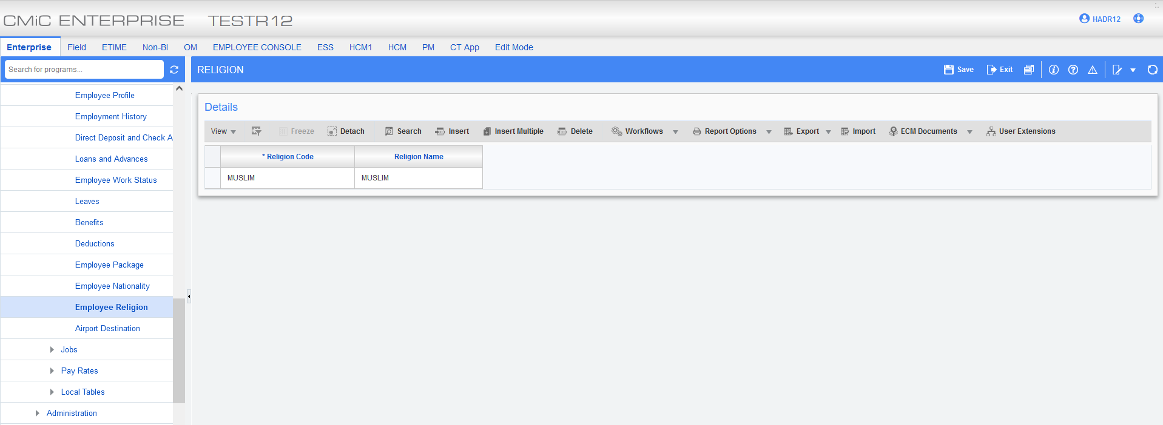
The following is an example of import:
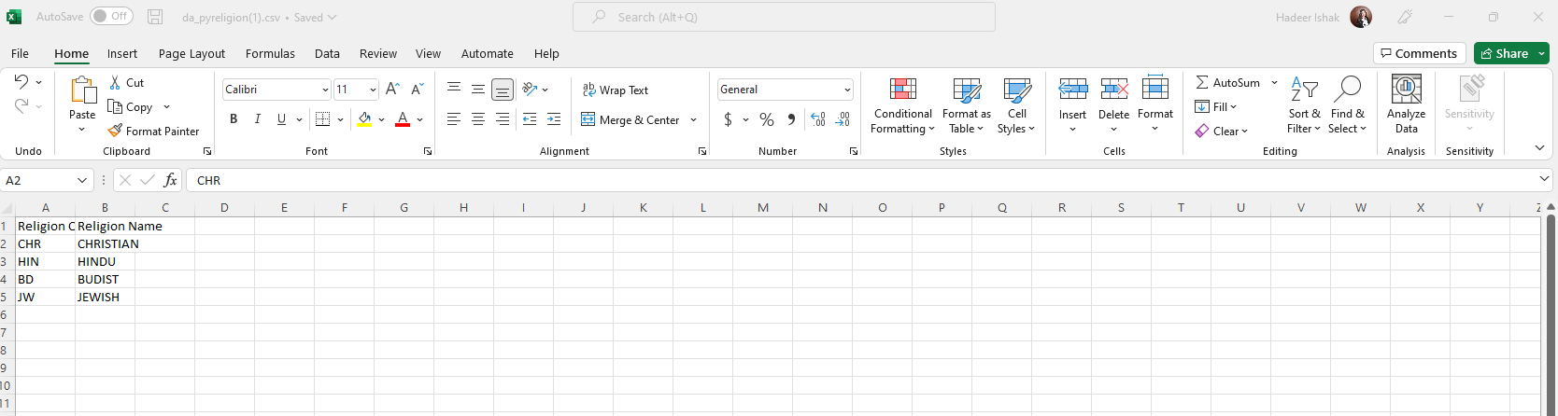
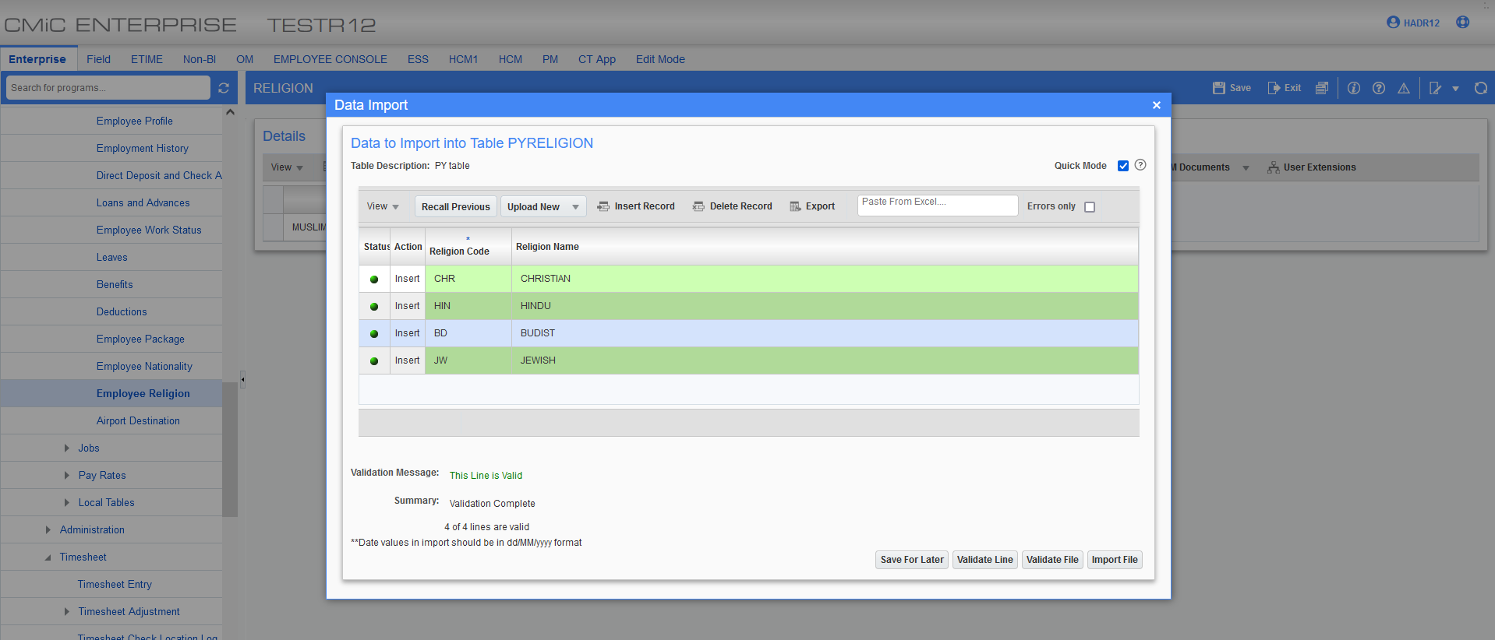
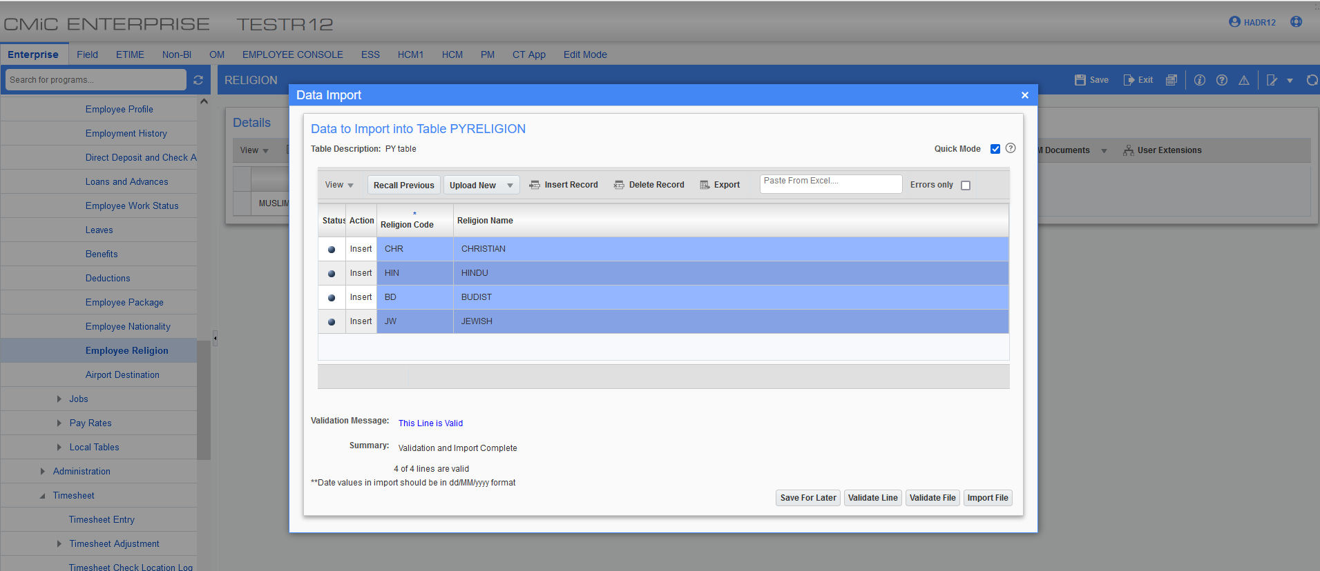
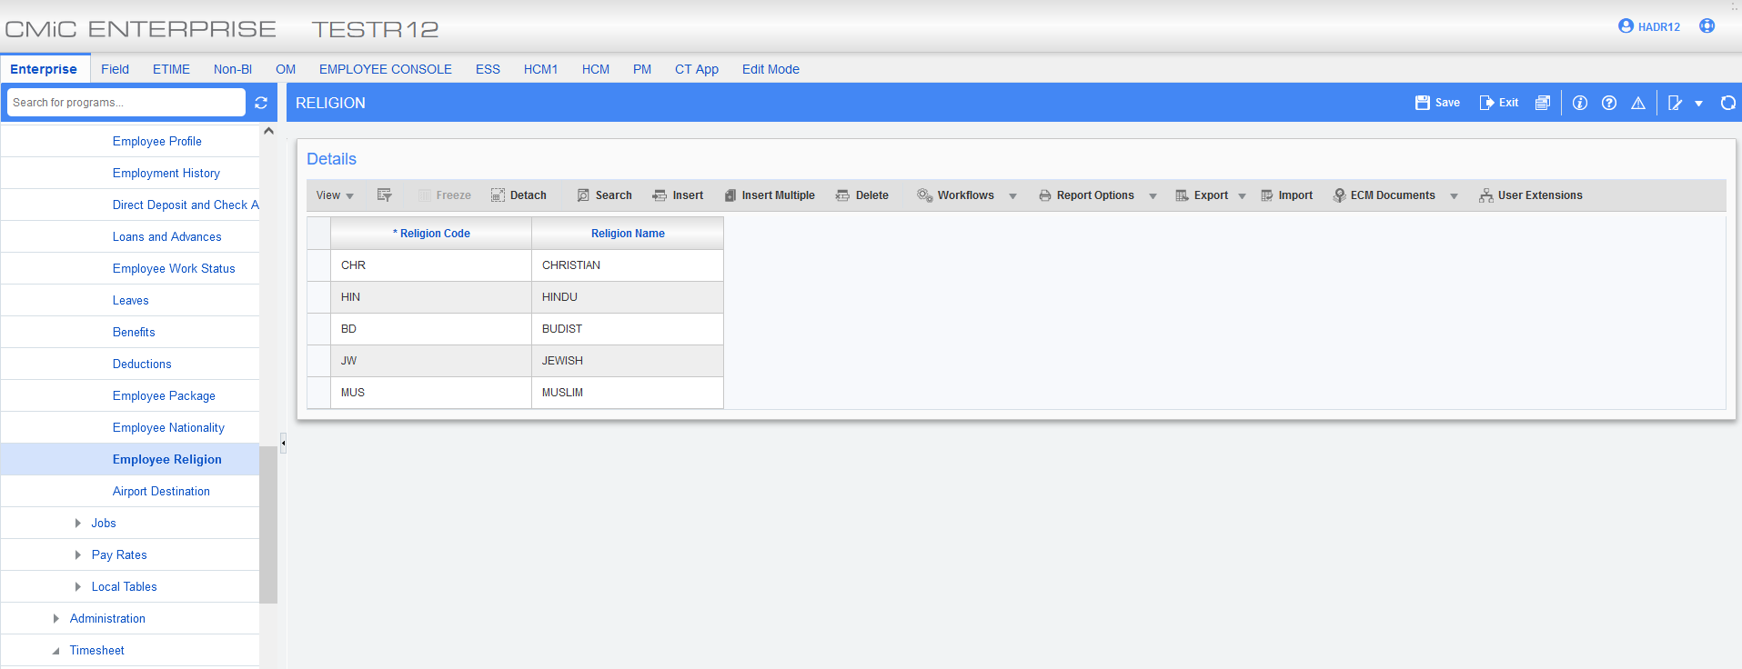

End of Probation:
CMIC has added a NEW field on HR control screen to allow users to set the default probation month under the general tab. The data can be set up using the drop-down option for users to select the frequency of “Weeks”, “Months” or “Not Applicable”.
An option has been added on employee profile to allow users to calculate probation based on the hire or re-hire date.
- The field is calculated based on the employee hire date.
- Currently ALEC probation period is six months.
HR control file:
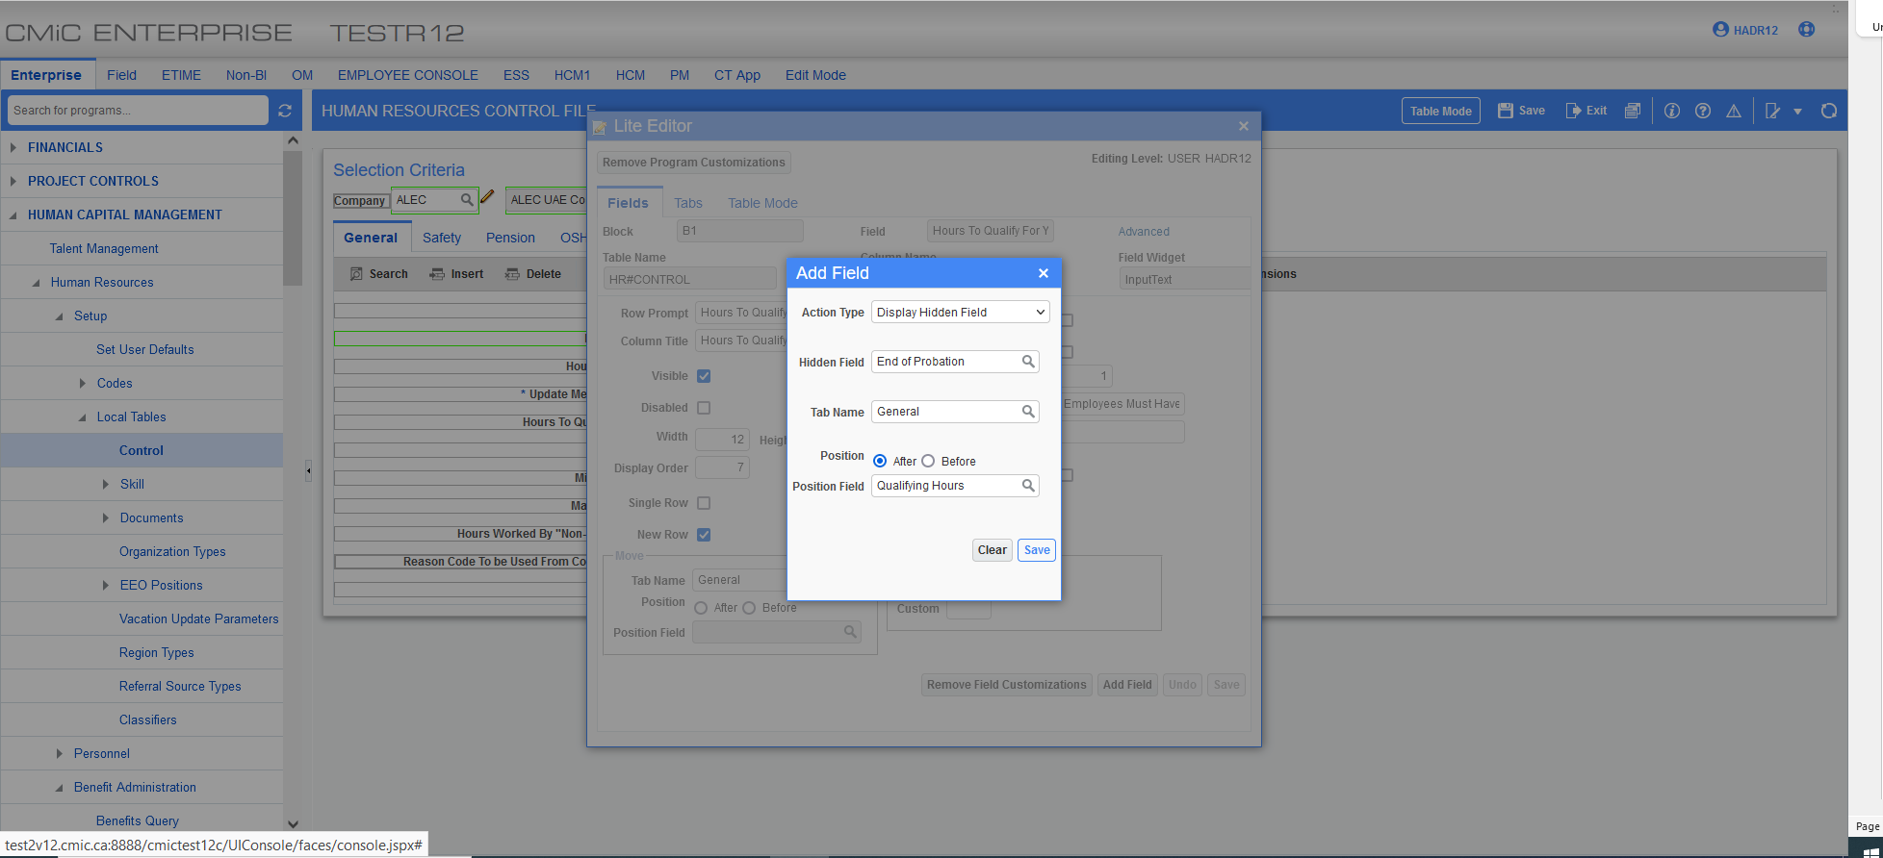
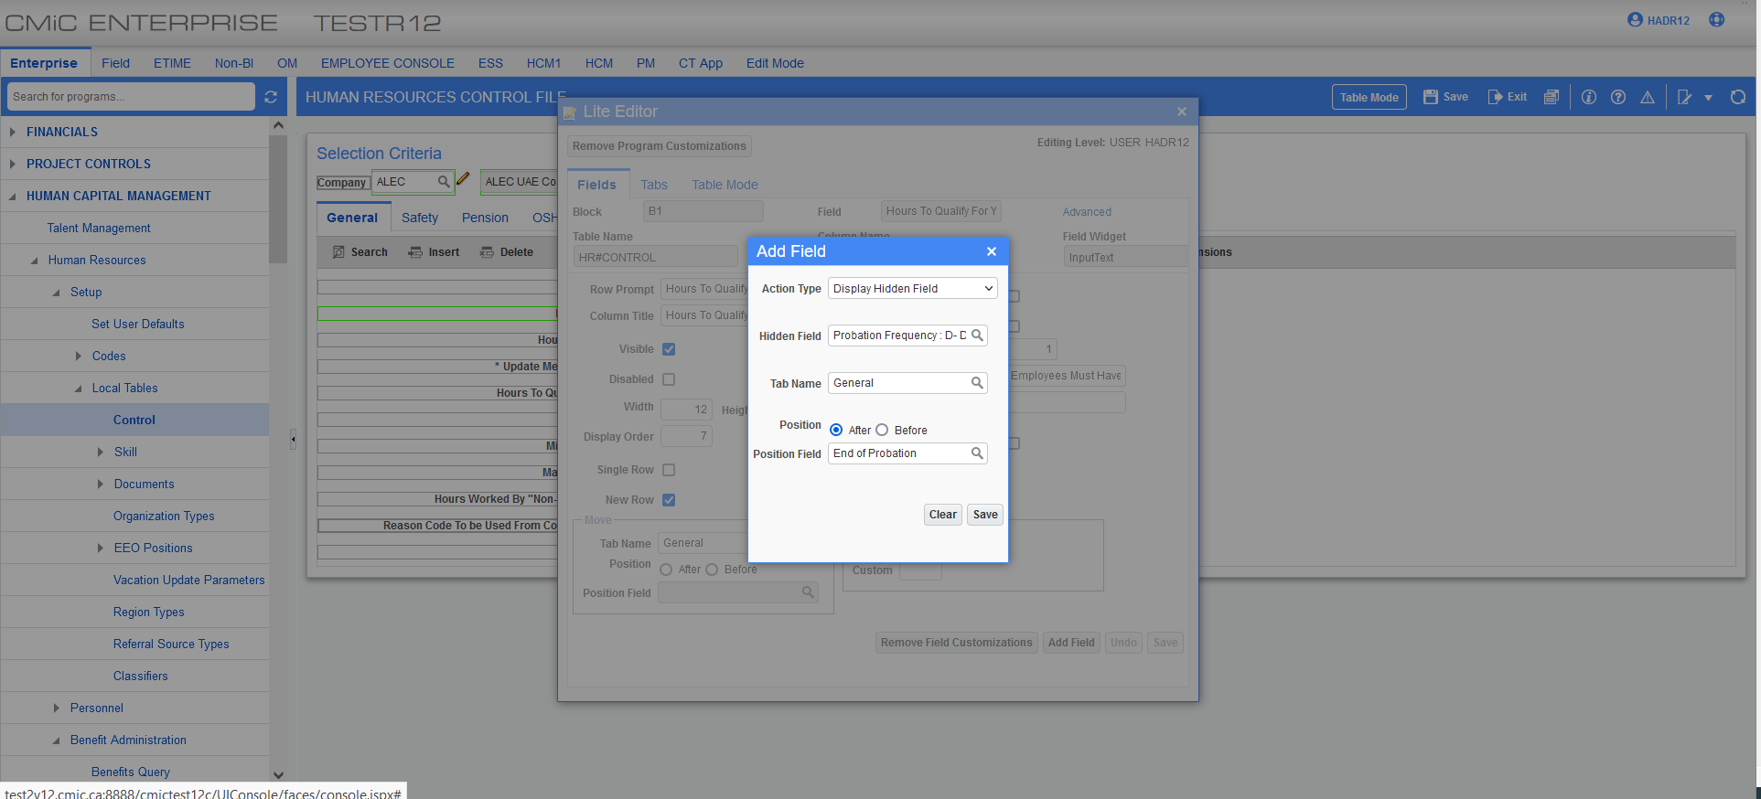

In the following example the probation period is six months:
Note: Upon updating end of probation on HR Control file an alert with the following “Do you want to update all employees with the new probation?” will be displayed upon clicking the save button.
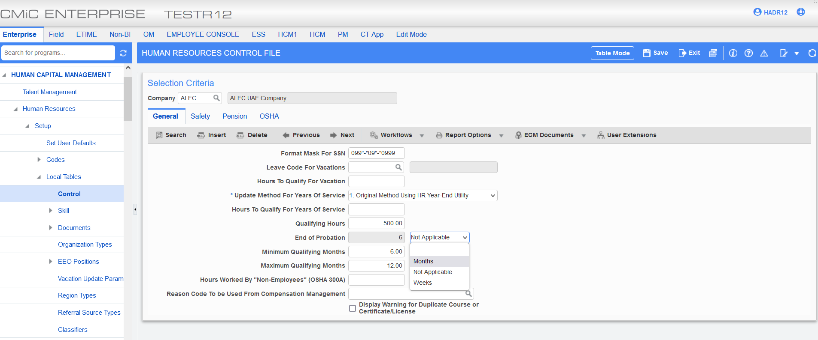
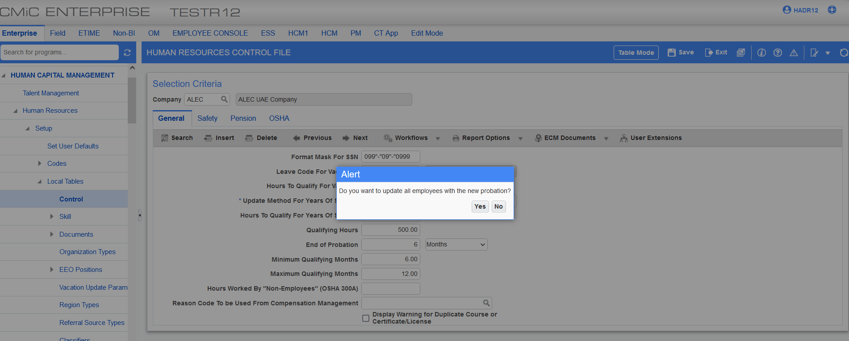
Employee profile:
The new field can be added from the lite editor after “Adjusted Service Date”.
Note: This field is not available on employee history.
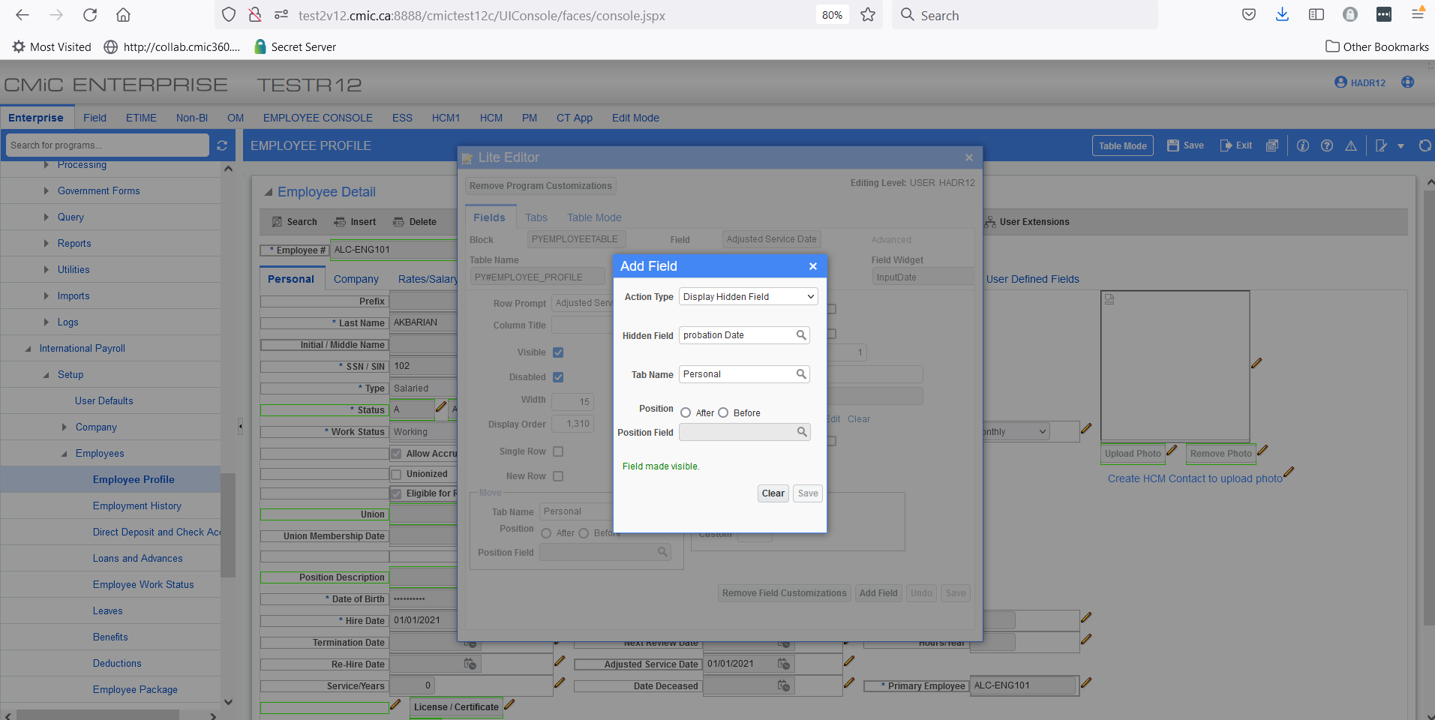
- When the frequency is set up as a month the formula would be:
End Of Probation Date: add_months(Hire Date, Probation Period)
- When the frequency is set up as Days the formula would be:
End Of Probation Date: Hire Date + (Probation Period * 7)
In this example the frequency is set up as 6 months:
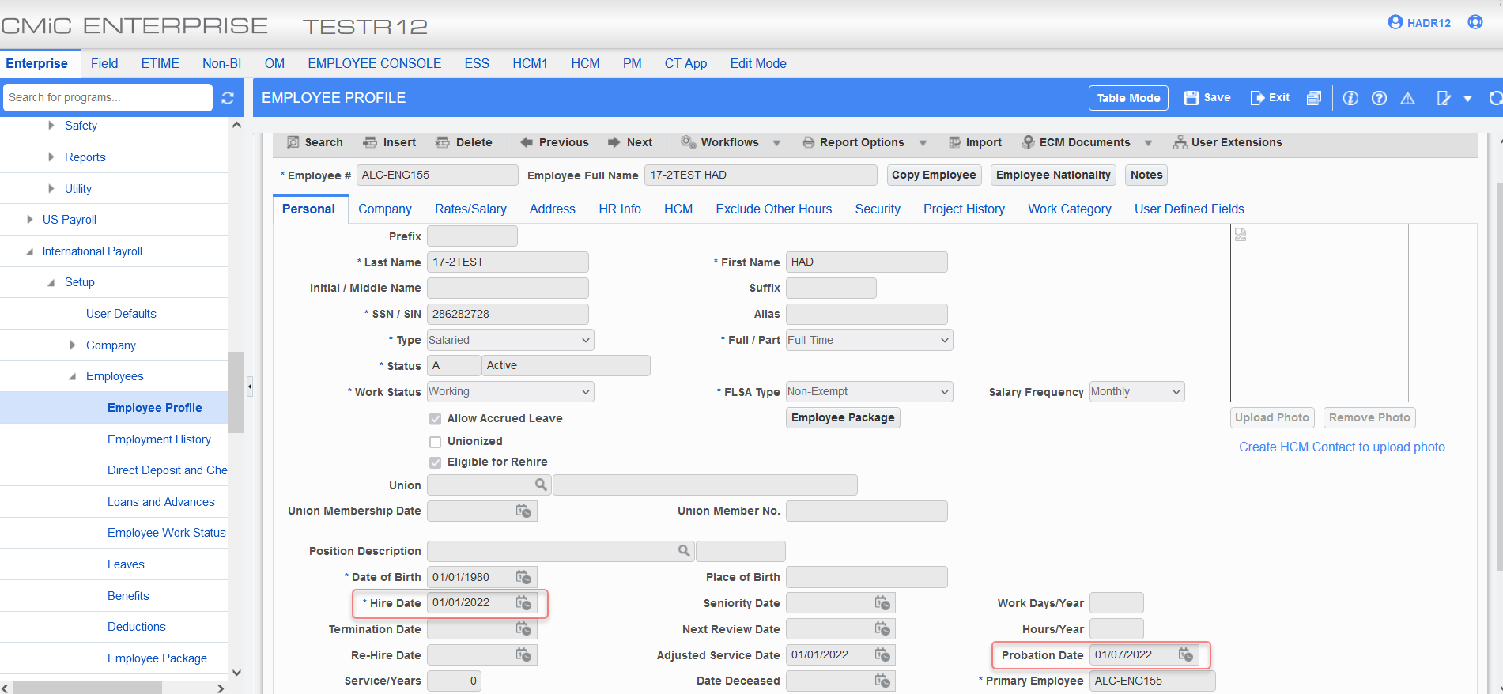
Example of 1 week:
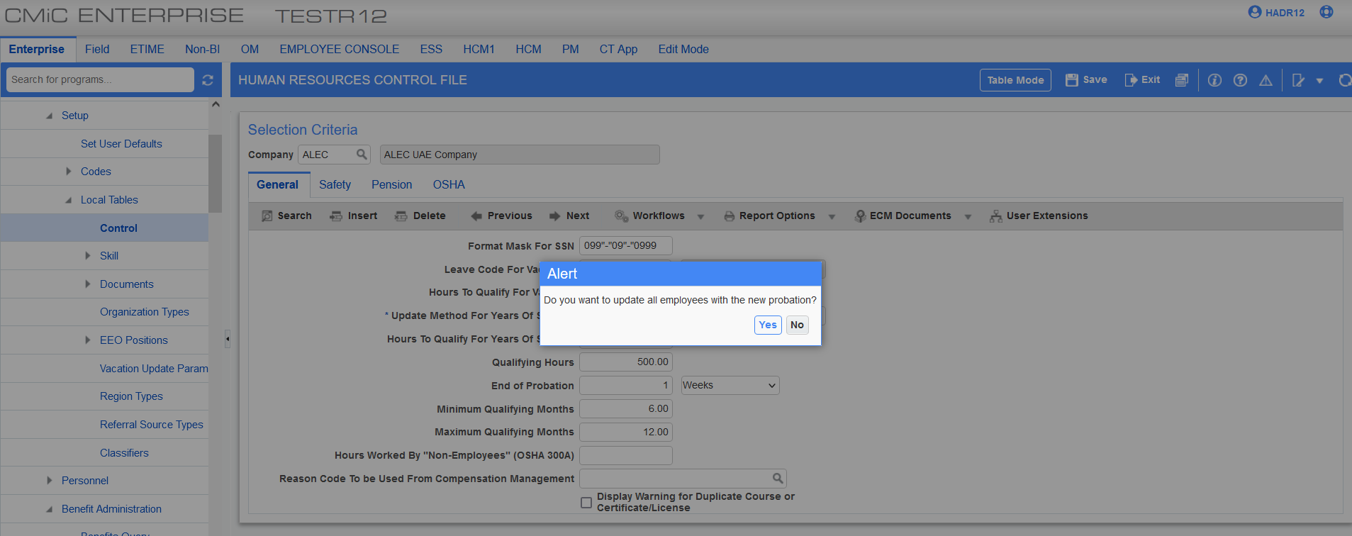
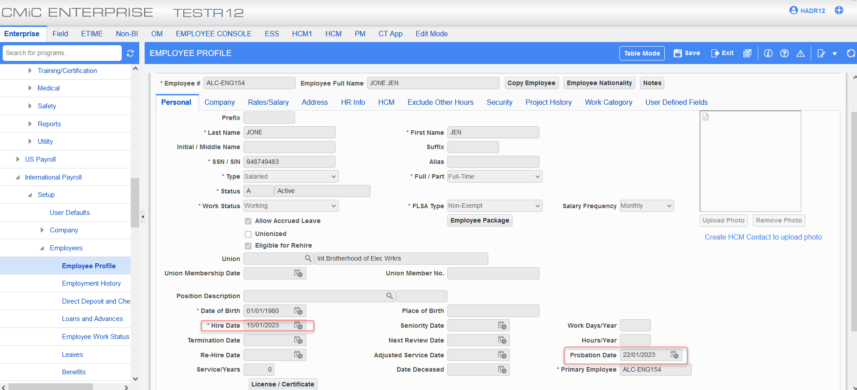
An example of Not Applicable:
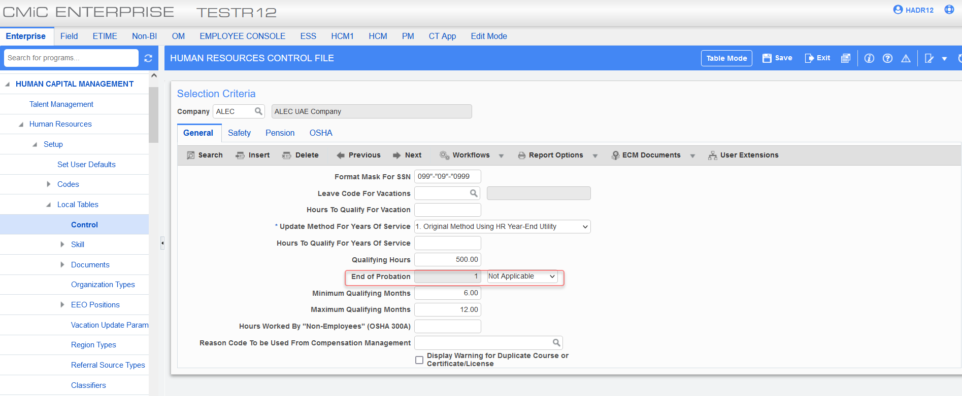
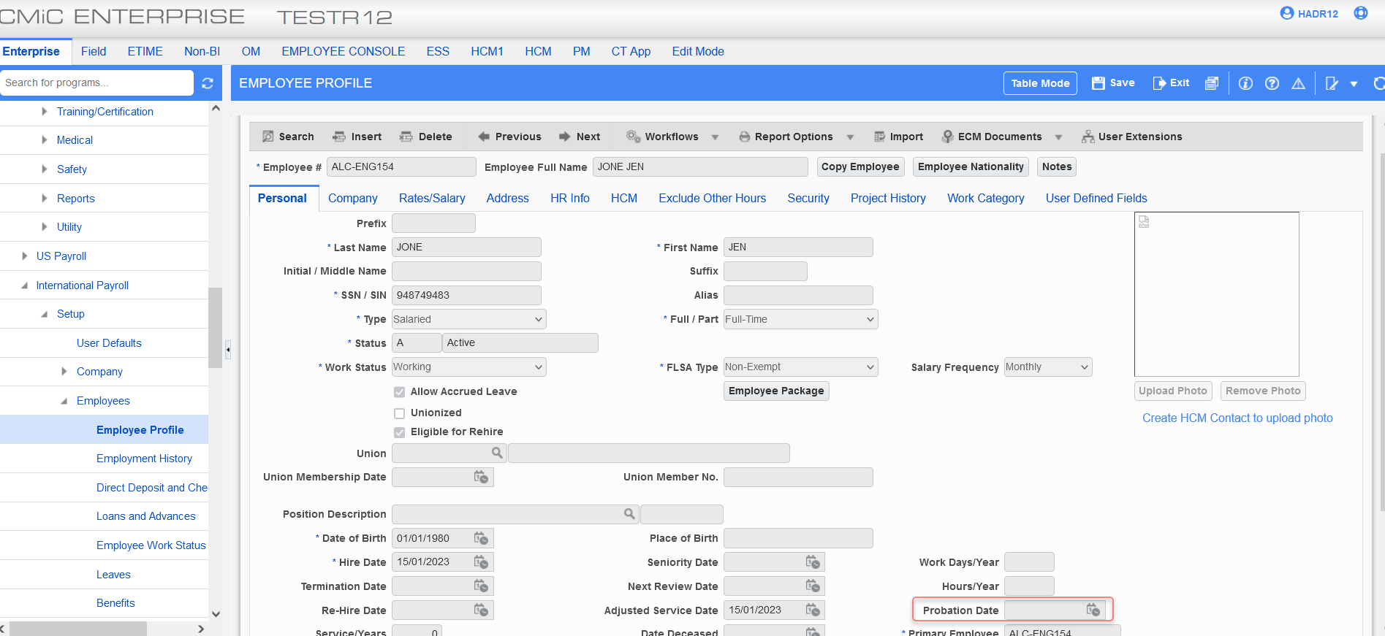
Airport Destination:
CMIC has created a new setup screen to allow users to set up airports in countries.
The detail section consists of Airport Code, Airport Name, Fare Type, Adult Fare, and Child Fare.
Airport Code: This would be the code set up by the user for the airport.
Airport Name: This would be the name of the airport.
Fare Type: This would be the type of fare with a drop-down option:
- Economy
- Business
- First Class
Adult Fare: This would be the average adult fare for the airport code setup.
Child Fare: This would be the average fare for the child for the selected airport.

The following fields have been added to employee profile and employee history: (Airport Code, Airport Name, Airport Fare Type, Airport Fare Type Name).
Employee Profile:
The new fields can be added from the lite editor:
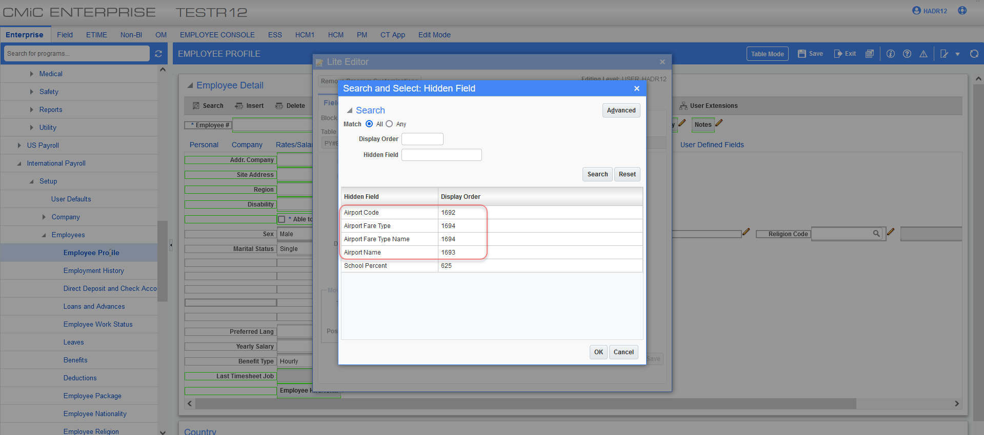
The new fields should be placed in HR tab beside “Able to Travel” field.
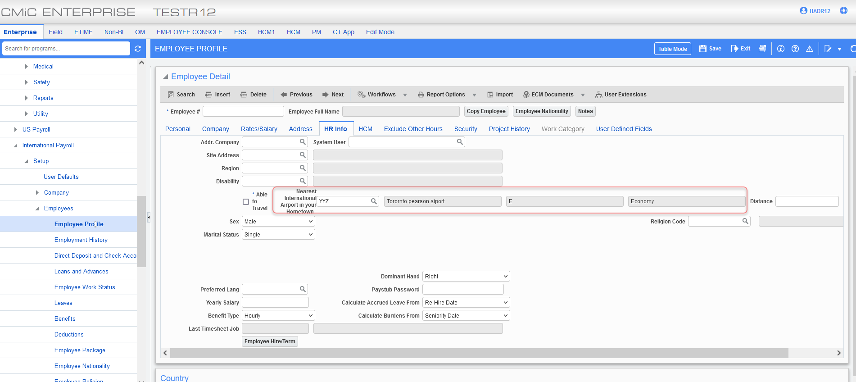

Employee History:
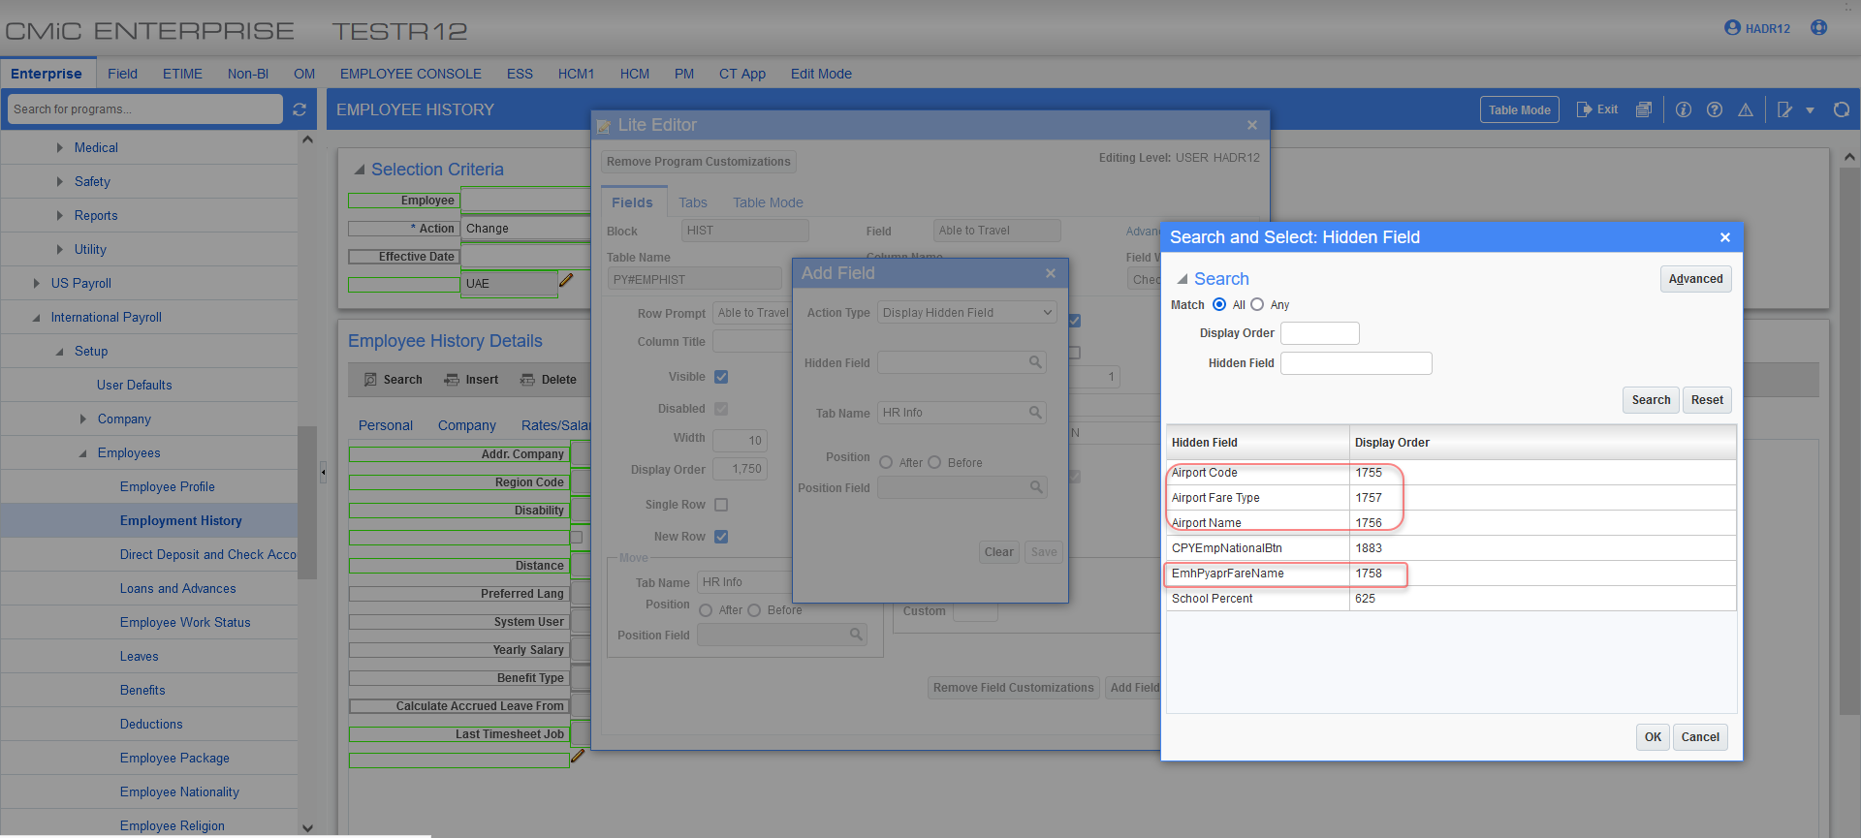
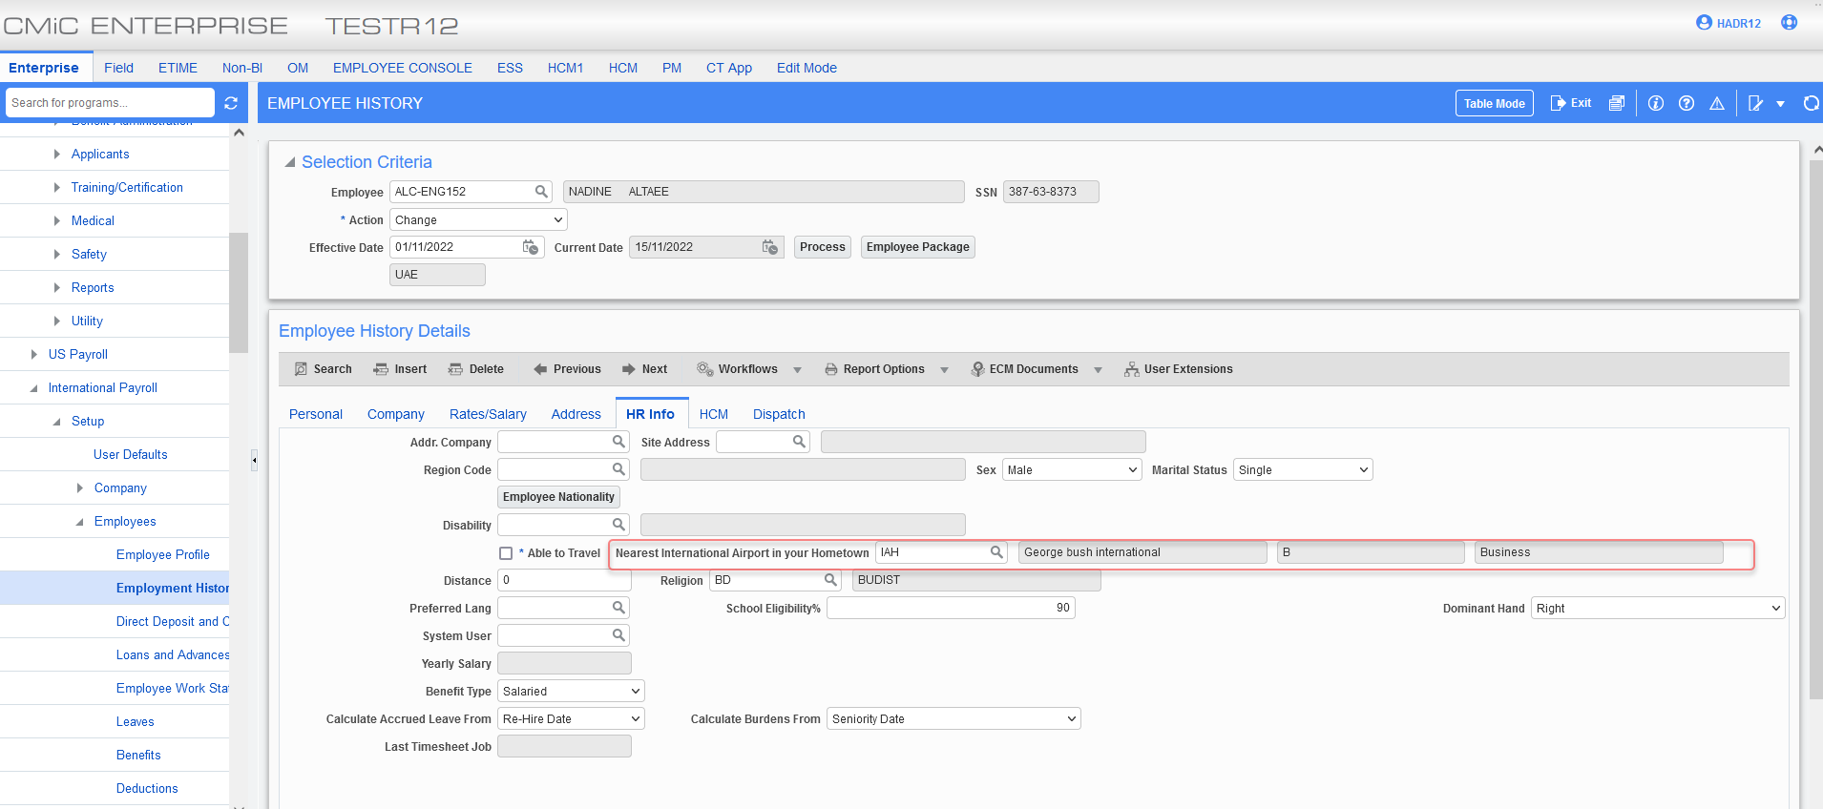
This information will be available on the employee relative screen > tickets tab:
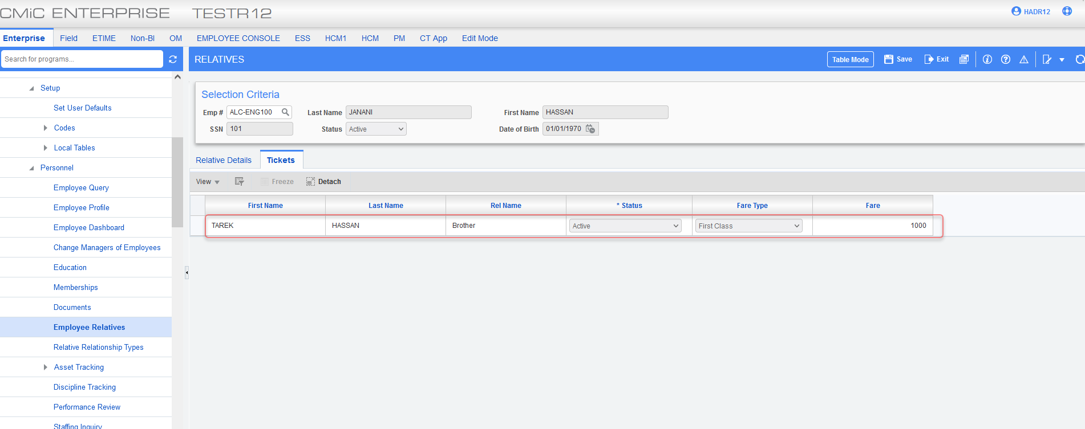
Example of ALC-ENG155 with an adult and child relative:
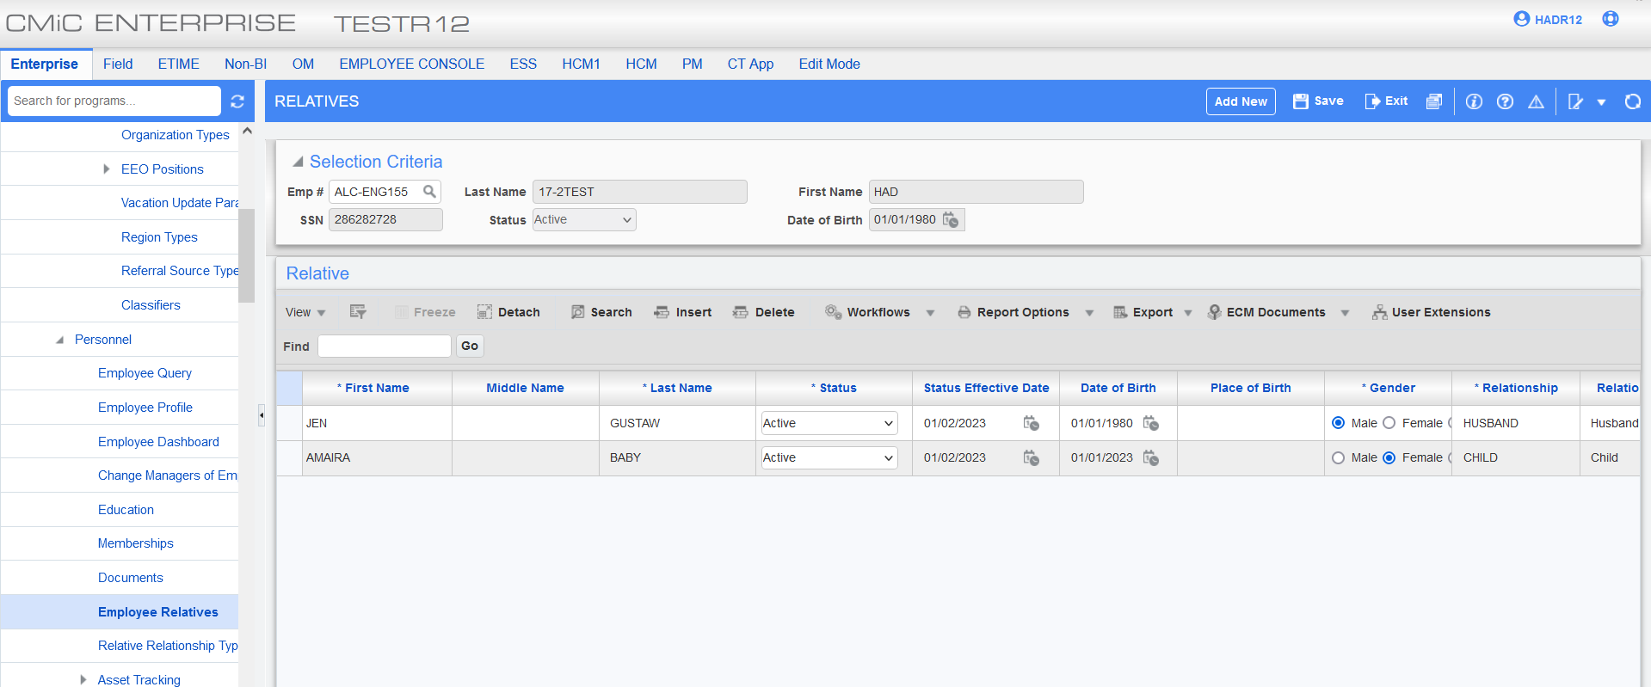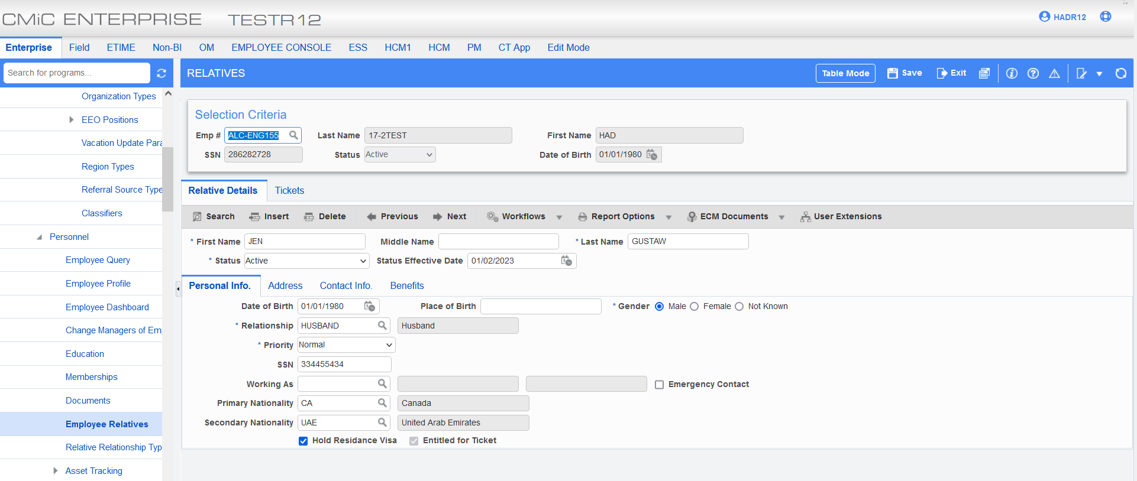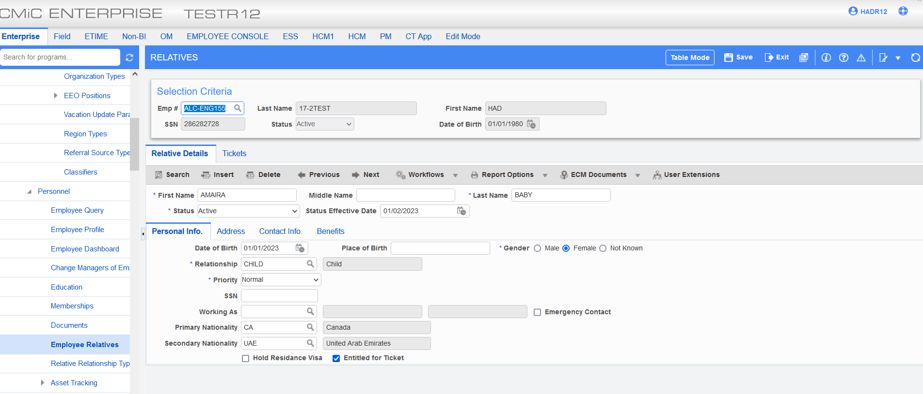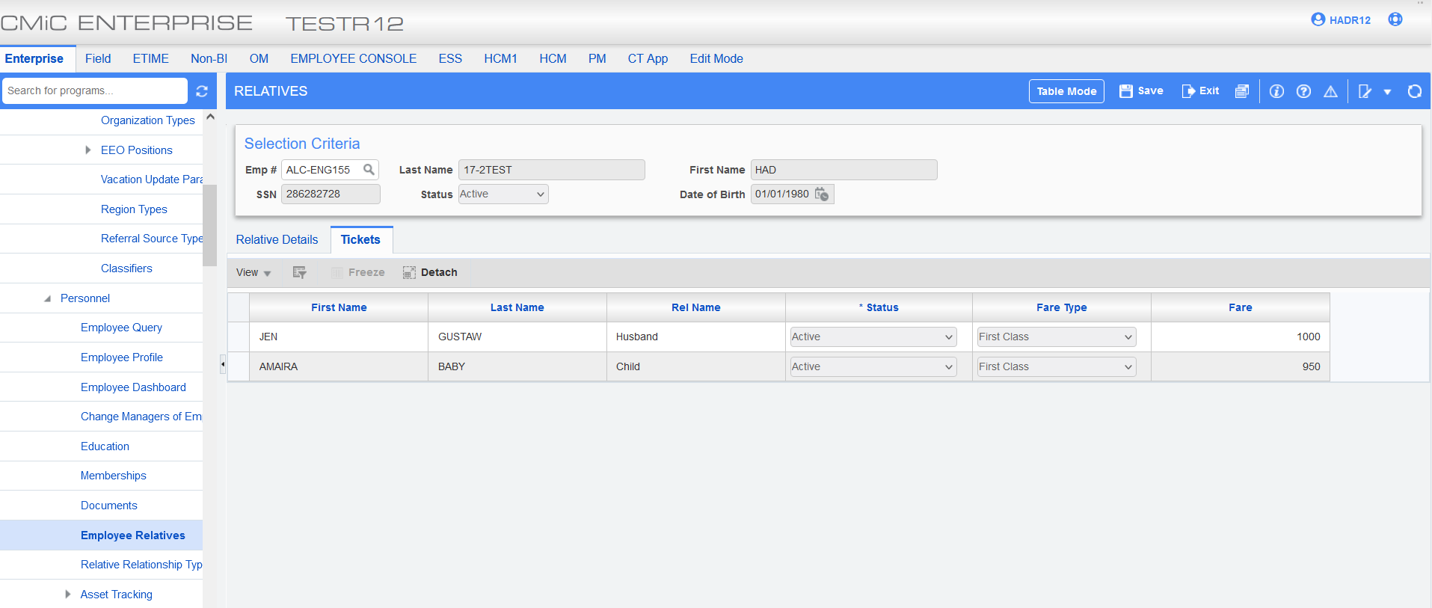
Airport Destination Program:
The following is an example of import:
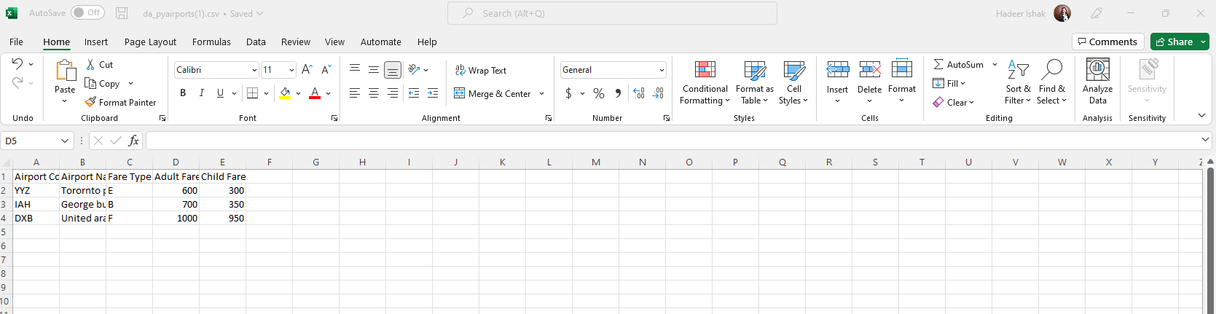
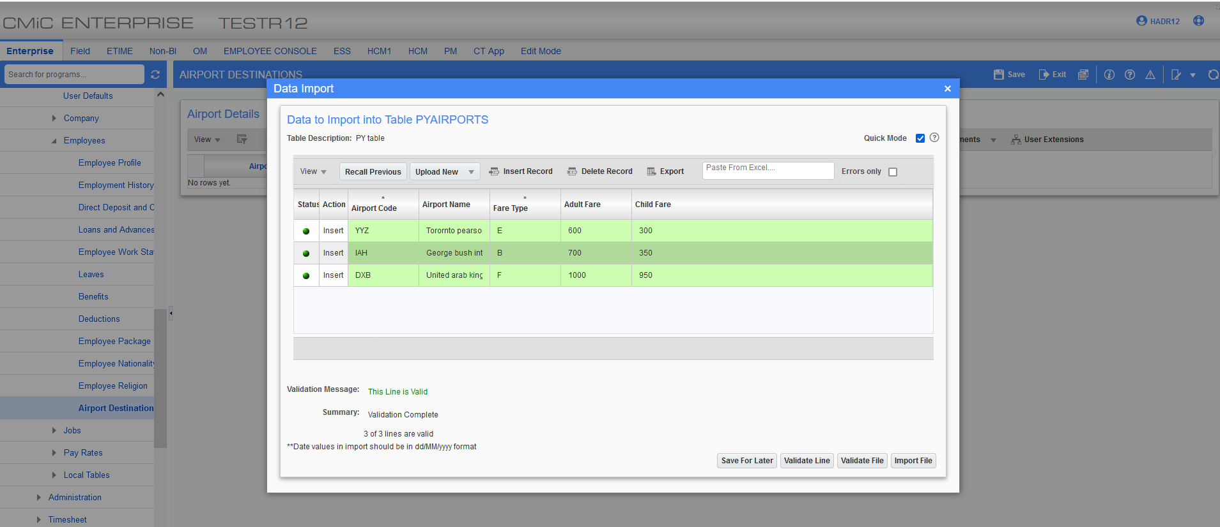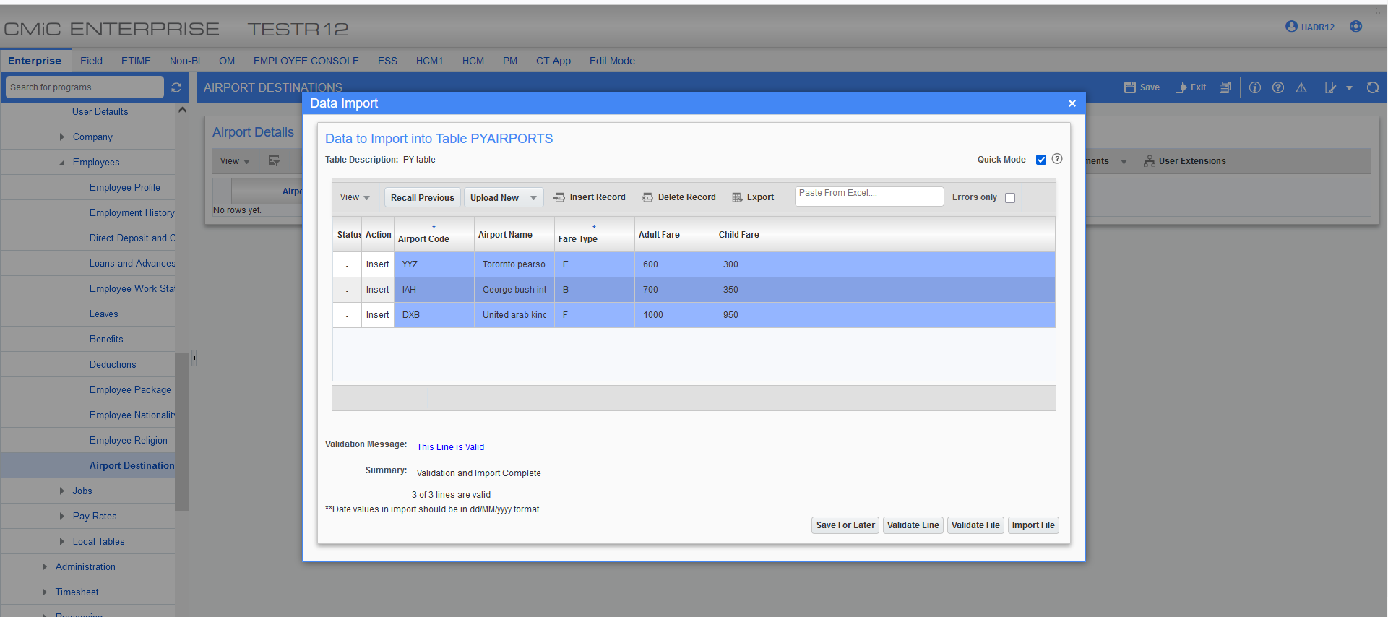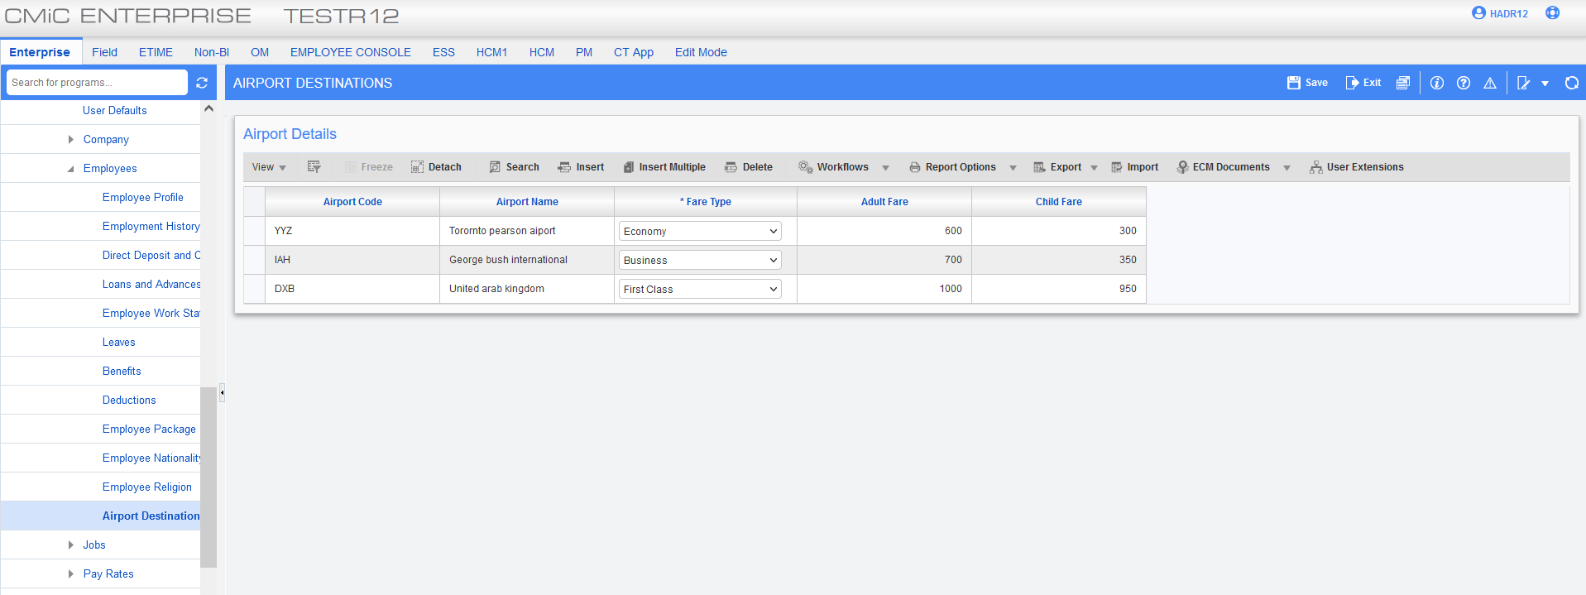

Grades:
Grades screen has been modified to add a new flag called “Eligible for Tickets”.
The flag can be added via lite editor:
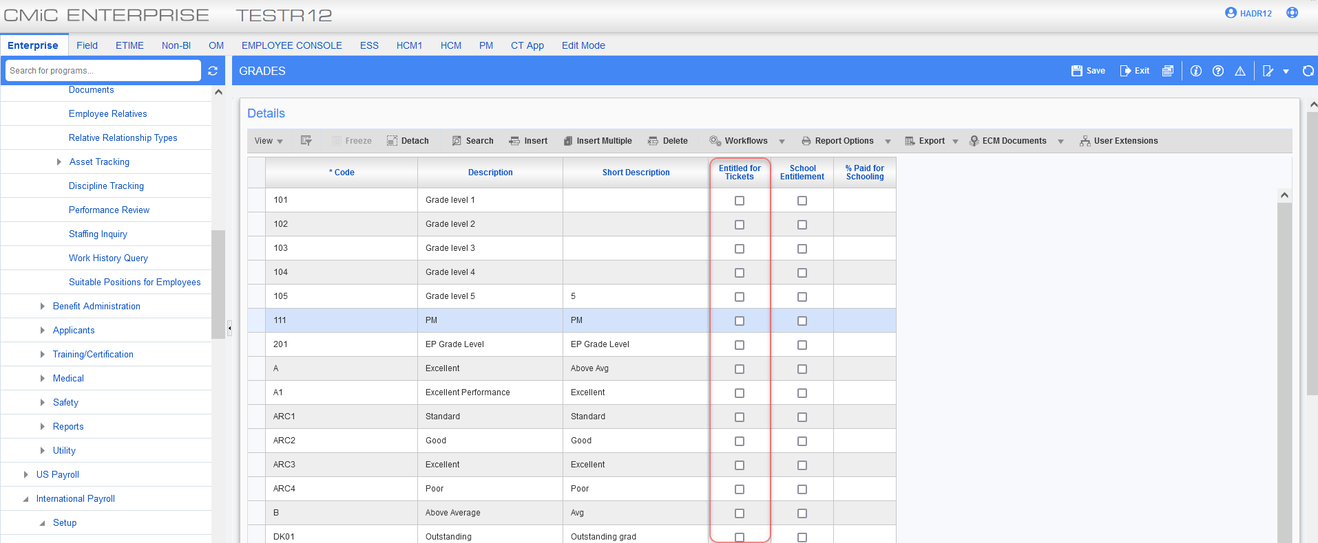
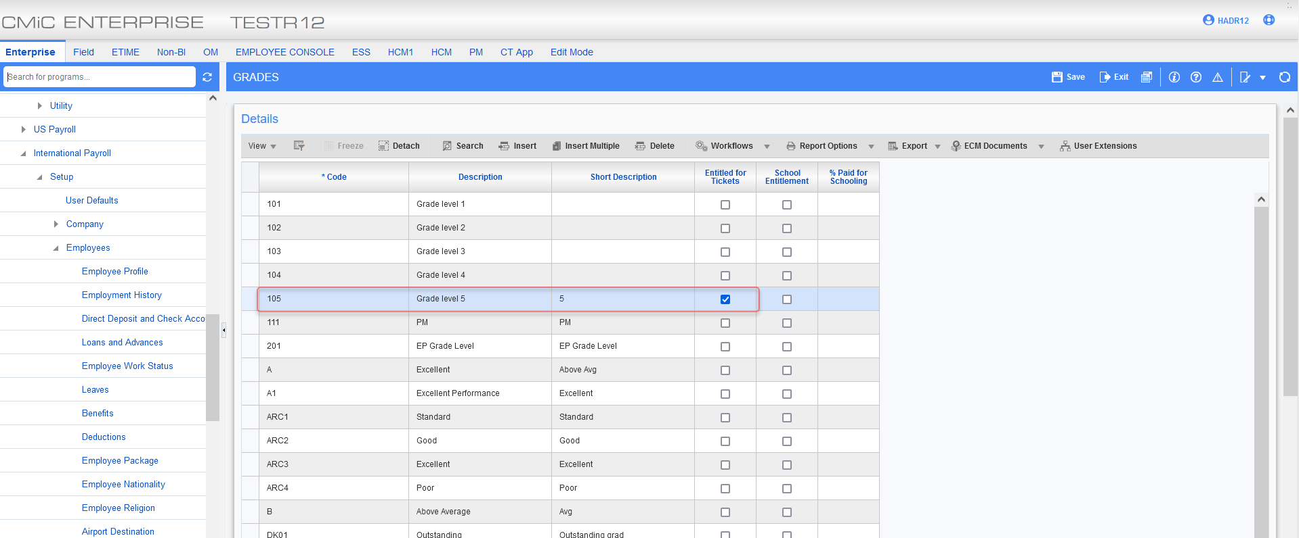

Assigned grade 105 to employee “ALC-ENG100”: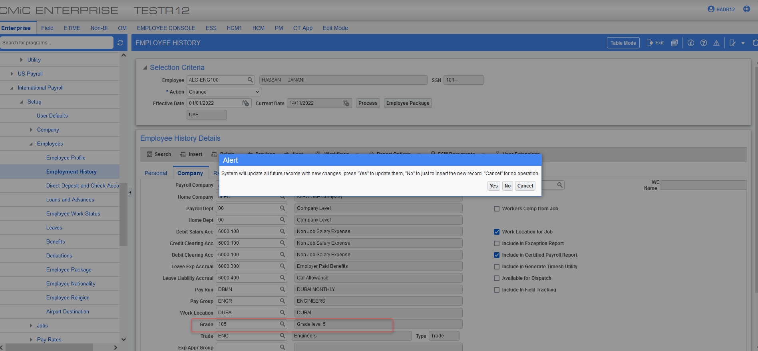

Employee Relative:
The employee relative screen has been modified to display the ticketing cost based on the employee airport destination.
The new tab “Tickets” have been added to Employee Relatives screen in HR. The tab displays all employee relatives’ names with the relationship. The tab displays the cost of the fare from the ‘airport destination’ table when the relation type is entitled to the tickets. The NEW flag is added on employee relative for users to setup if relative is entitled for ticket.
The adult fare is shown for all relationships except child.
The Ticket Entitled Flag can be added via the lite editor on the relative details tab.
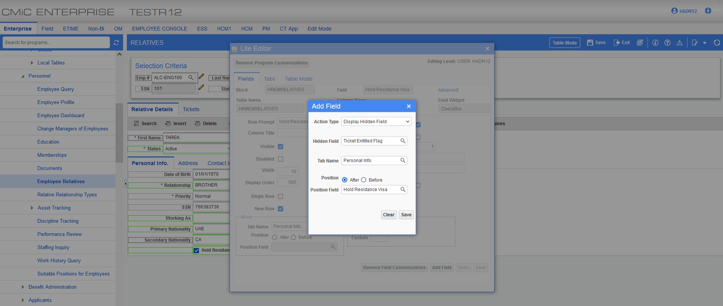
The following example of an employee with adults and child relative:
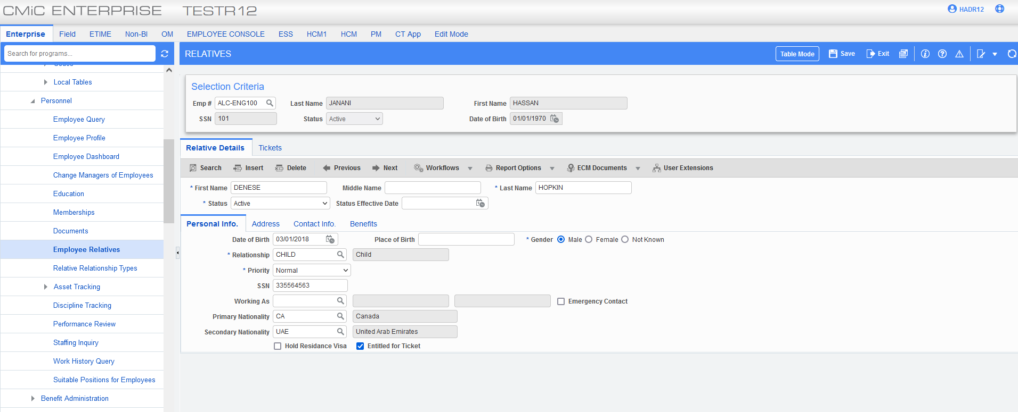
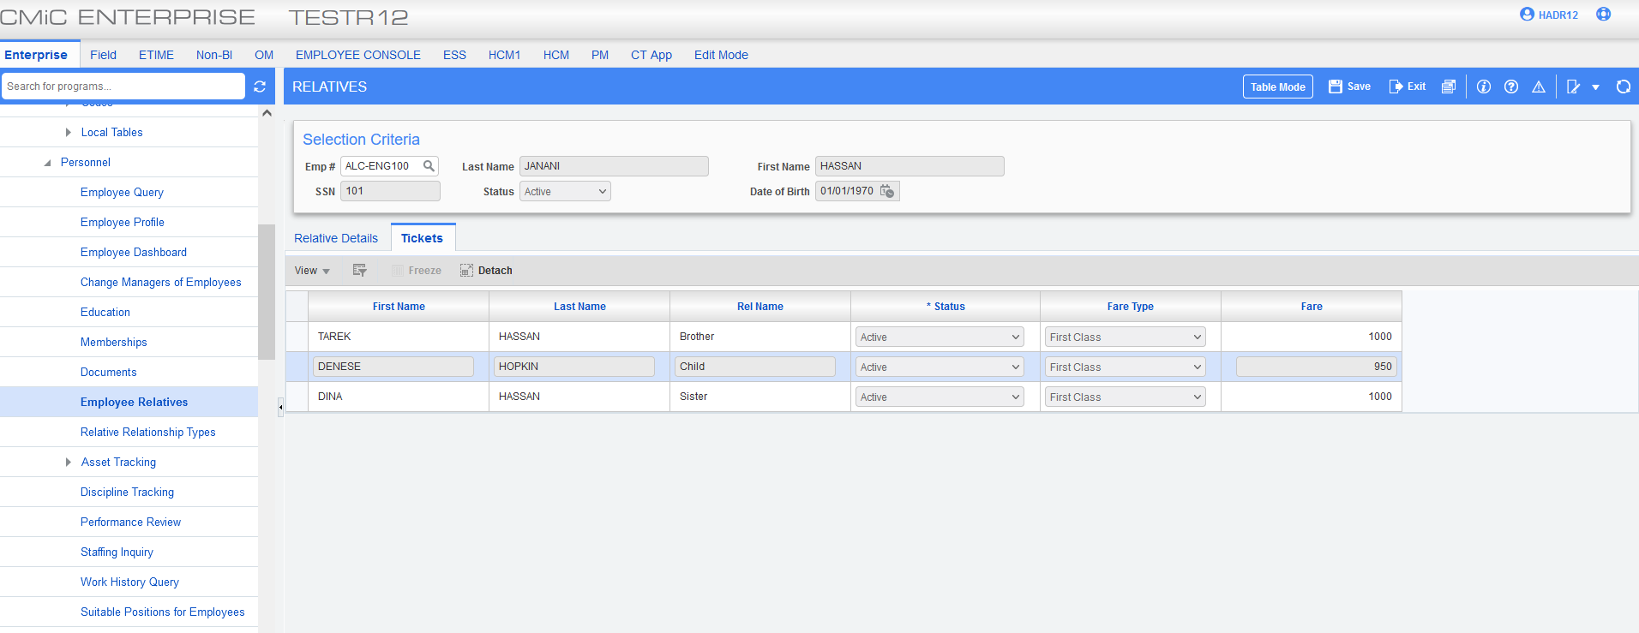
Note: When relative hold residence visa they are automatically entitled for ticket therefore having a cost fare on the tickets tab.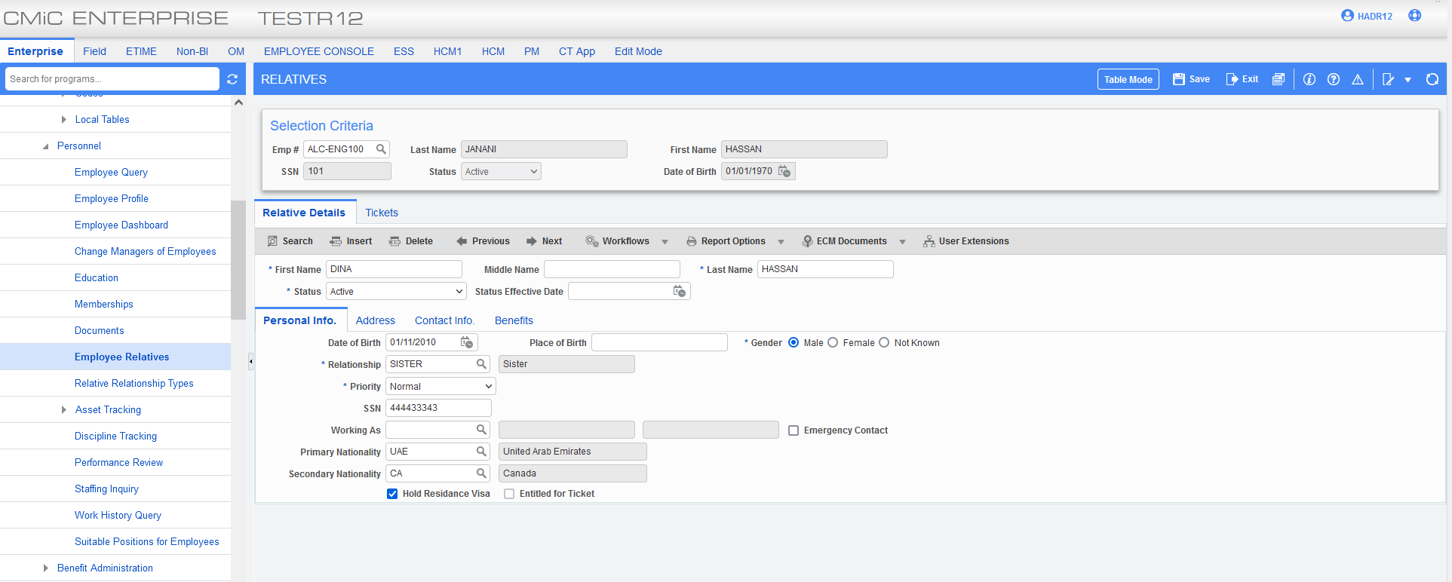 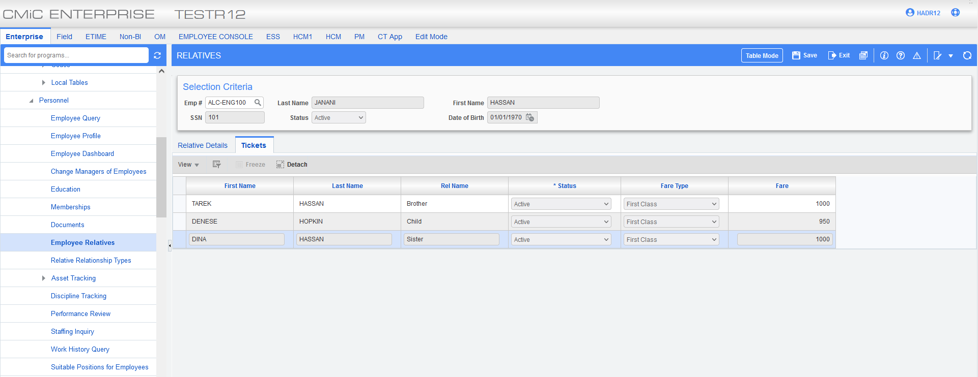
Schooling Eligibility:
CMIC has modified the Grade setup screen to add two new fields “School Entitlment” and the “% Paid for Schooling” against schooling fees to employees by employee grade. This allows users to set up the schooling entitlement.
The following fields can be added via lite editor:
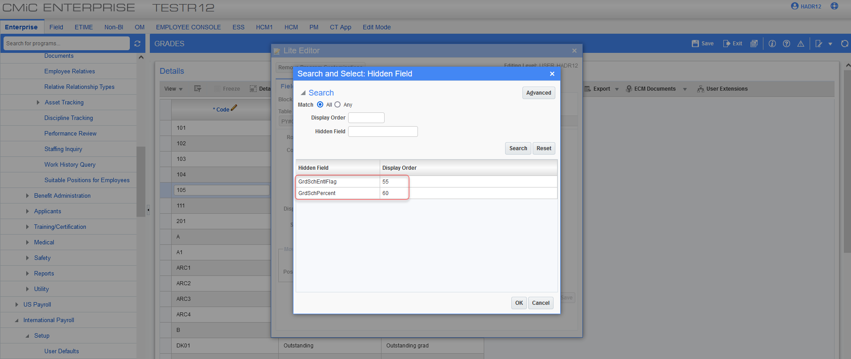
An example of how they are currently used:
New hires will be elected as per grade:
  - D1, D2 to D5 = 70%
  - E1 higher = 90%
  - C5 below = NA
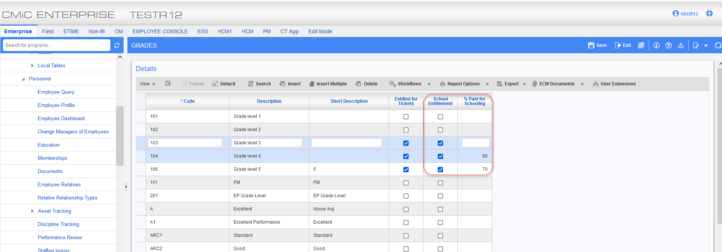
Employee Profile:
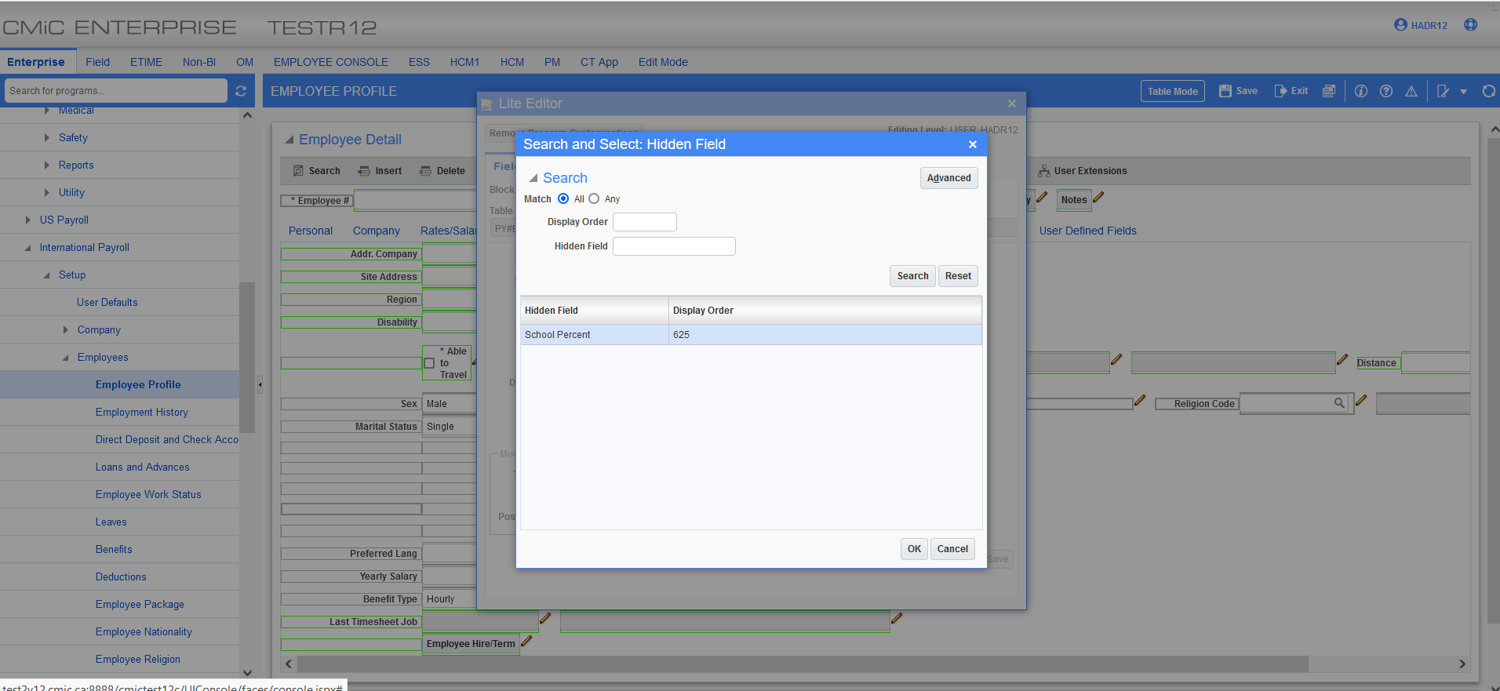
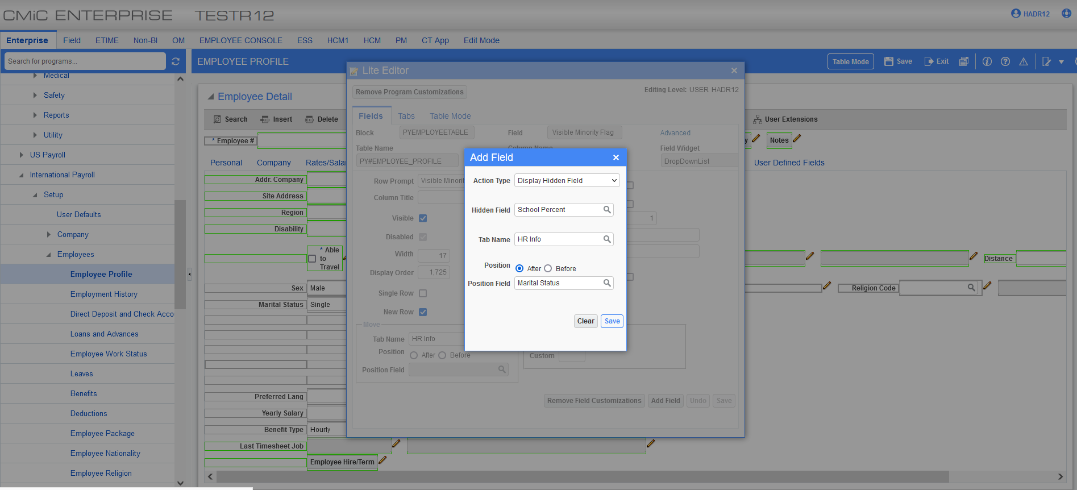
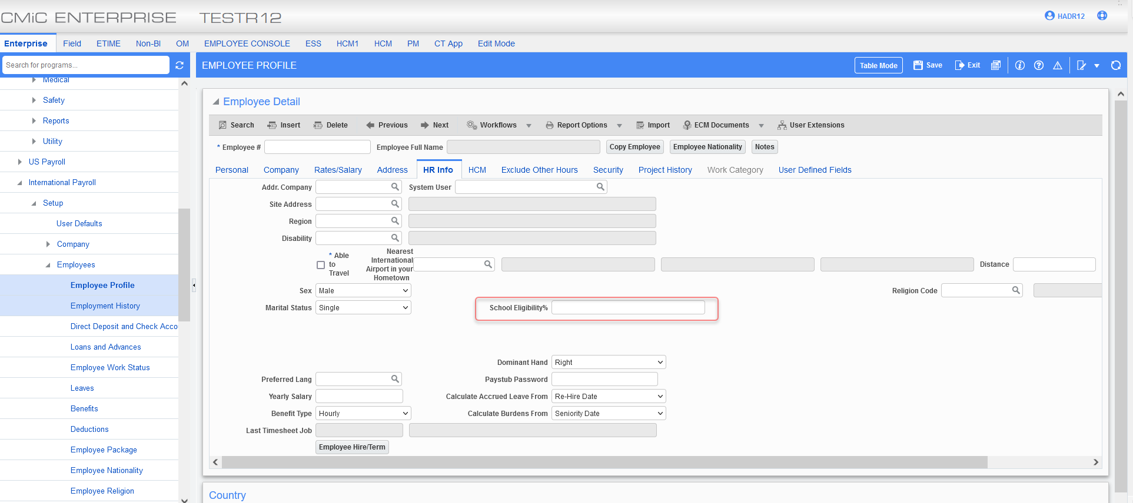
Employee History:
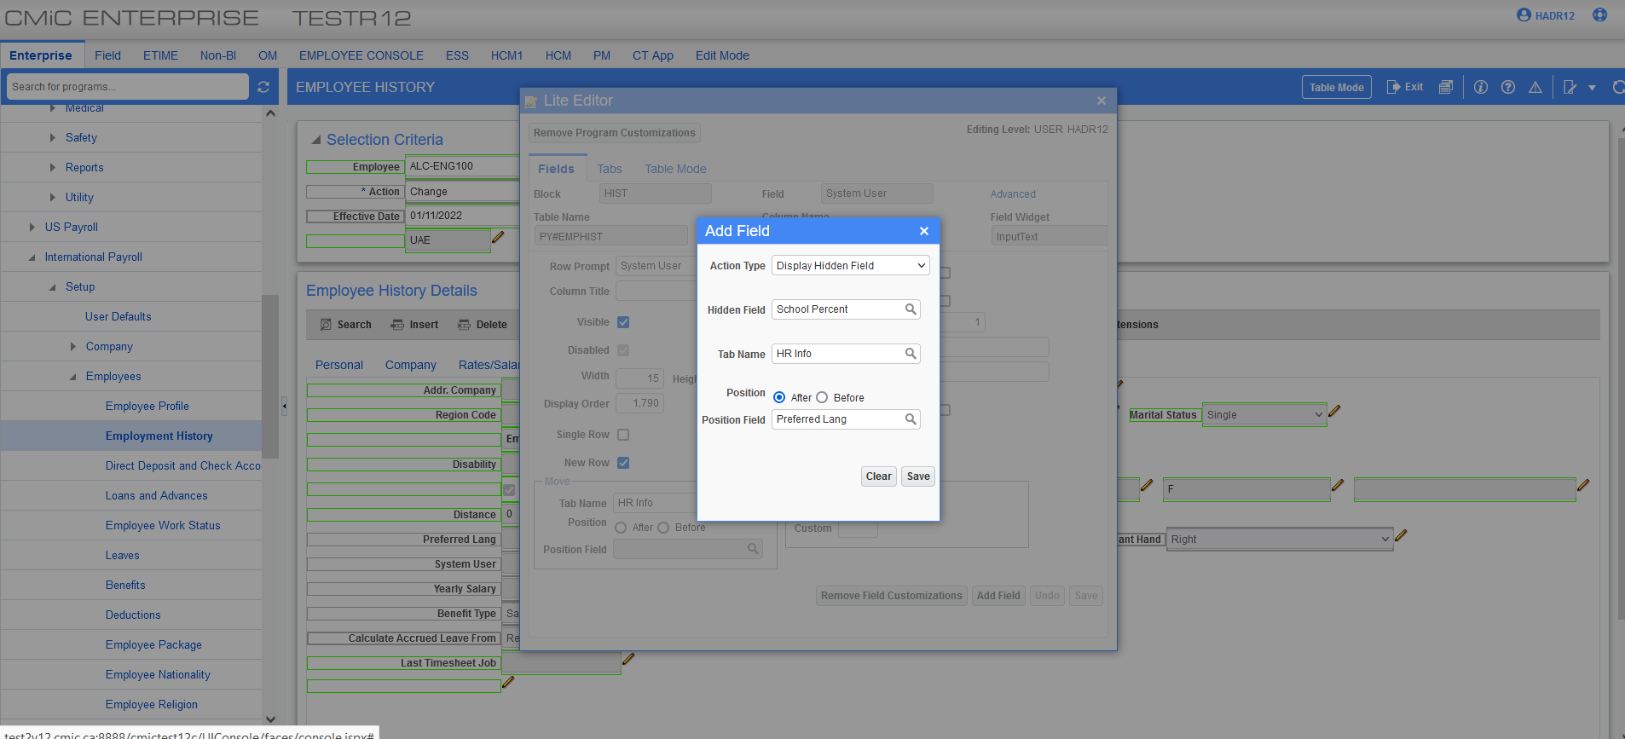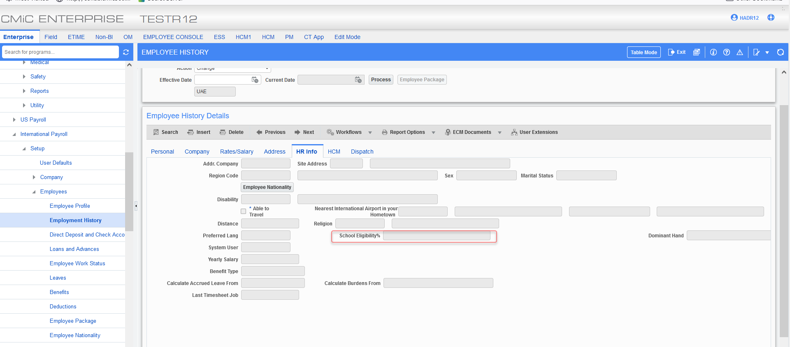
When grade is selected on employee history, school eligibility% on HR info tab populates automatically.
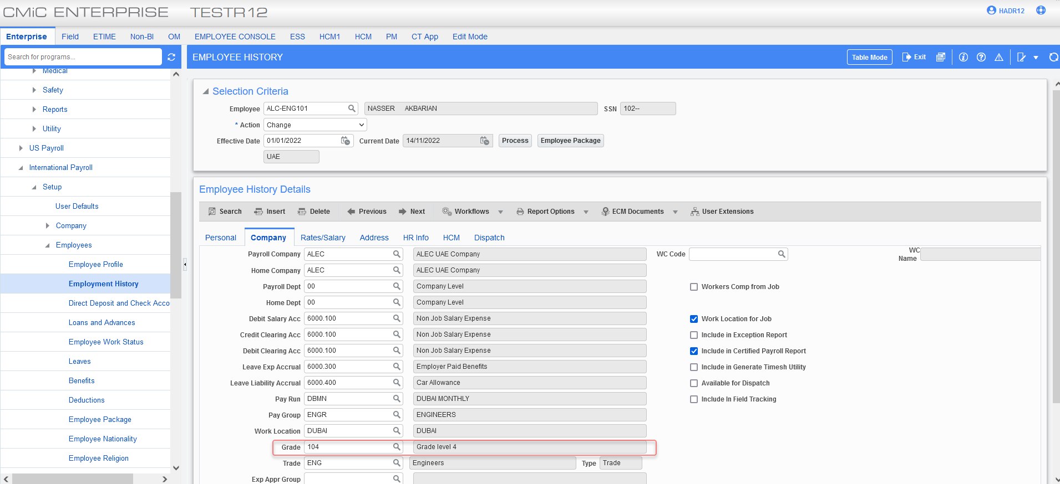

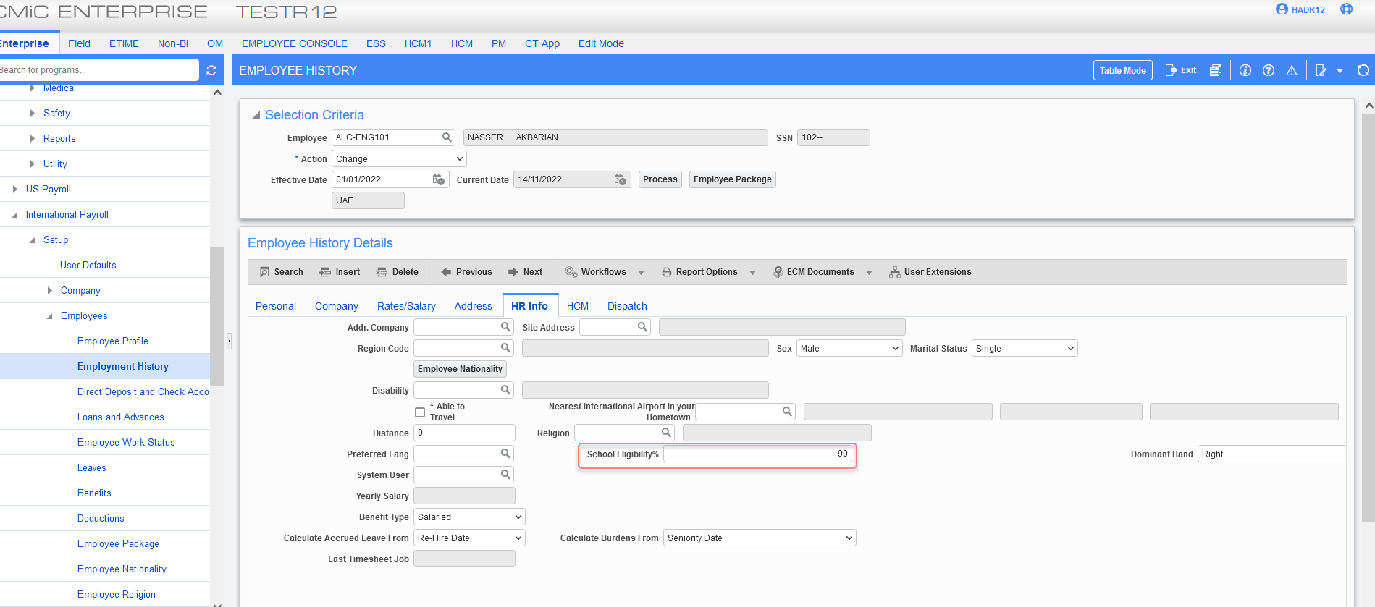

Employee loan and advances pause loan installment (21.51716, HCM - 2149)
Overview – Released in hot fix V12-017-2HF-02H.
CMIC has added new functionality to pause a loan payment through an absence period for Dubai region. New fields known as Pause Date, Resume Date, Pause Reason, and show details have been added to the employee loans and advances program.
Pre-requisites
- Alternate work days under company is required to be set to 7 working days as per Dubai region working days.
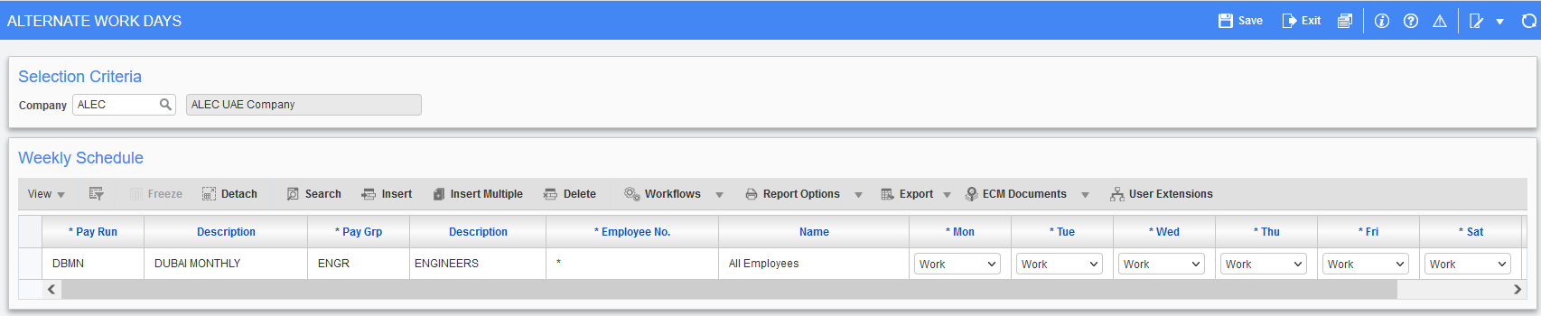
- The pro-rate loan amount flag needs to be added from the lite editor:
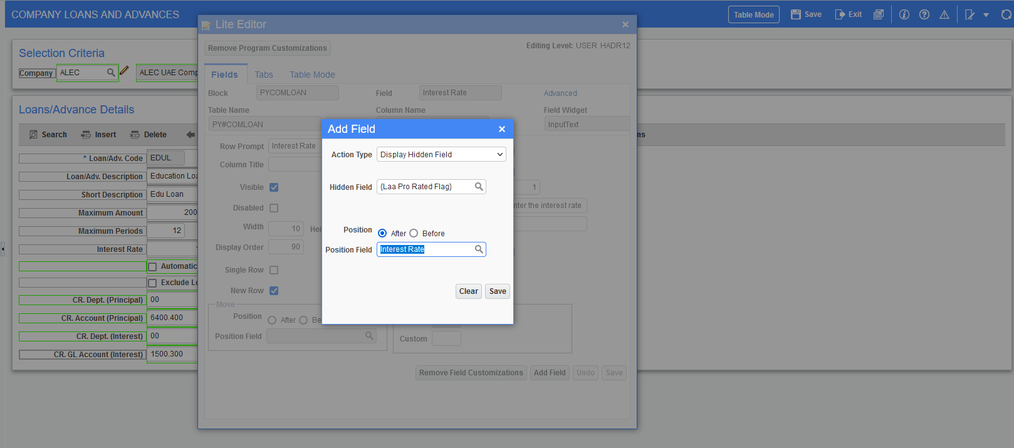
Modifications
Employee loans and advances screen has new columns added known as pause date, resume date, pause reason, and show details button.
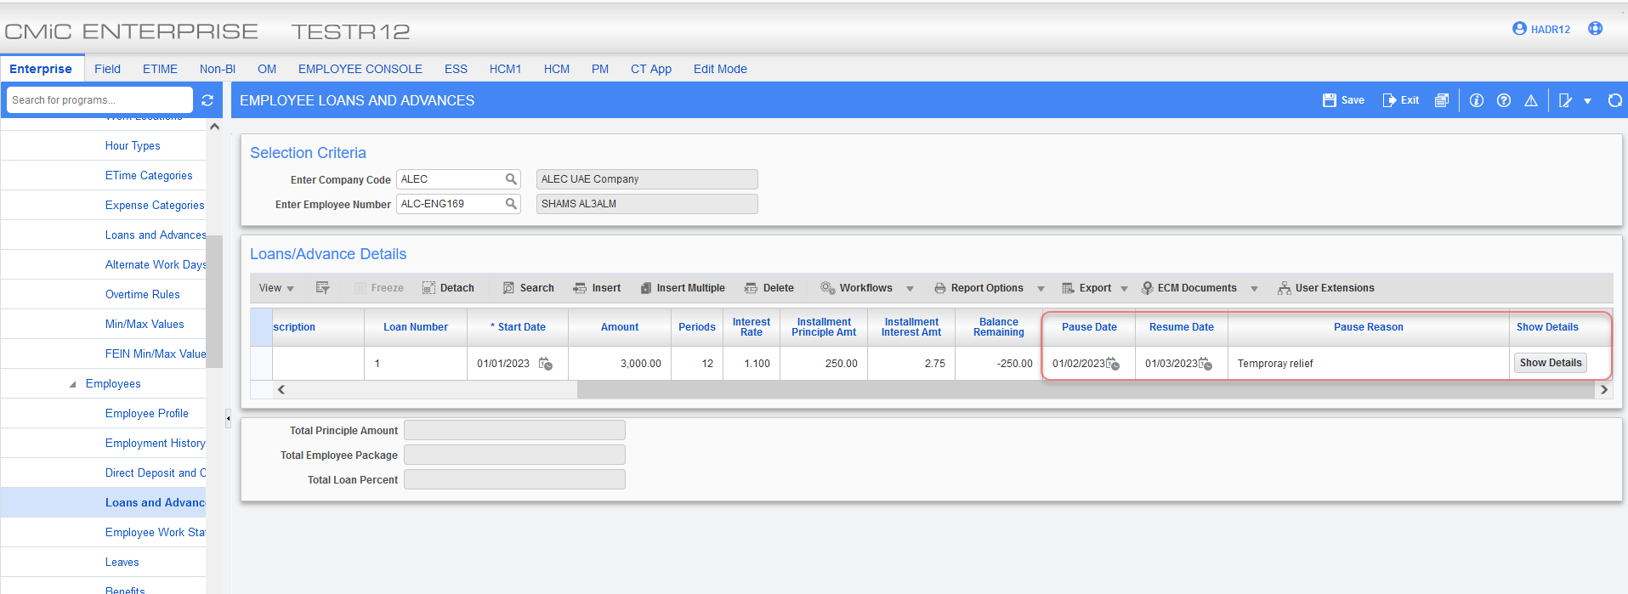
Implementation
Employee loan and advances screen does not allow the loan start date and pause date and resume date be on the same date.
Note: an error message is displayed to stop the user from entering same pause or resume date as start date.
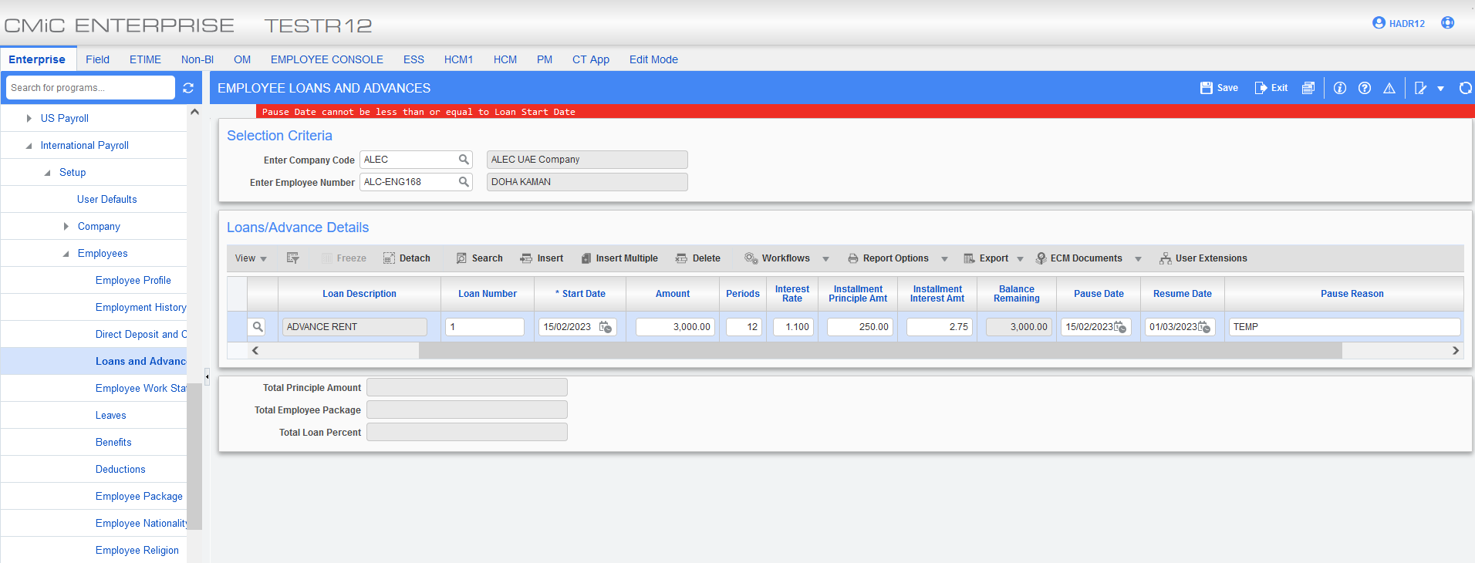
Example #1: Employee hired mid period 15/Feb./2023 with a loan paused from 16/Feb. to 1st/Mar.
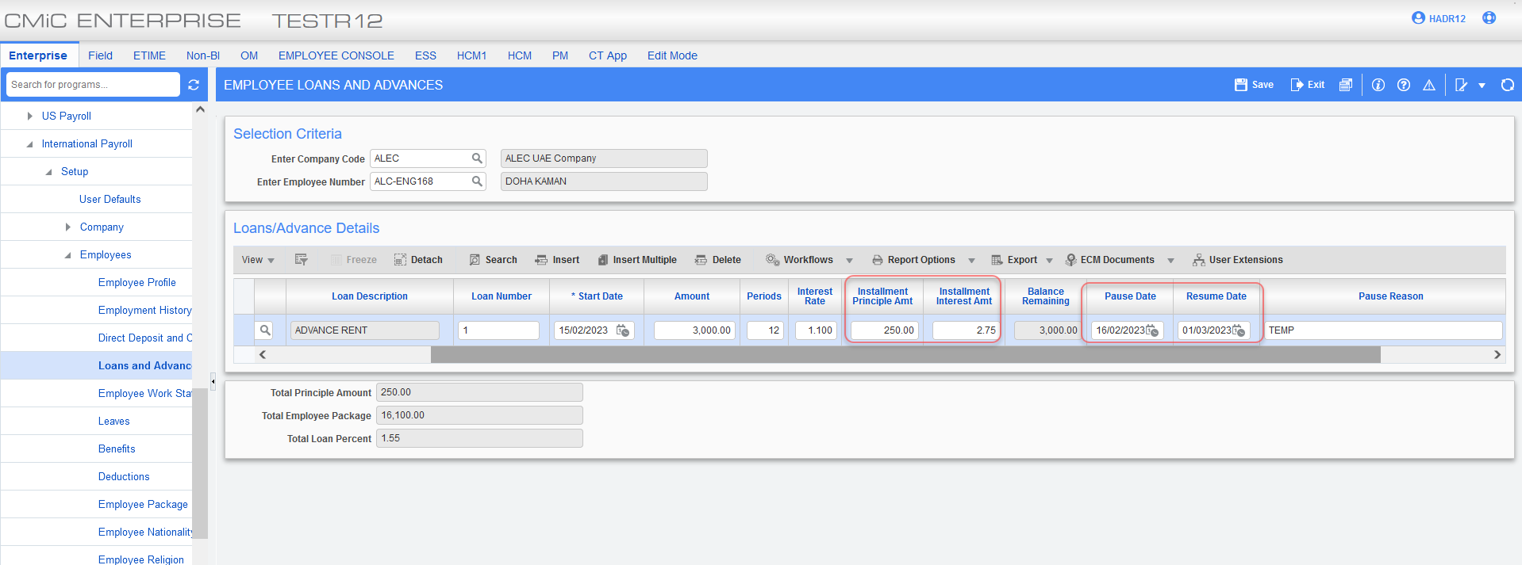
On mid year pay history LP and LI pro-rated for 1 working day in February as the loan started on 15/Feb. and is paused from 16/Feb. to 1st/Mar.
LP = 250*(1/28) = 8.93
LI= 2.75*(1/28) = 0.10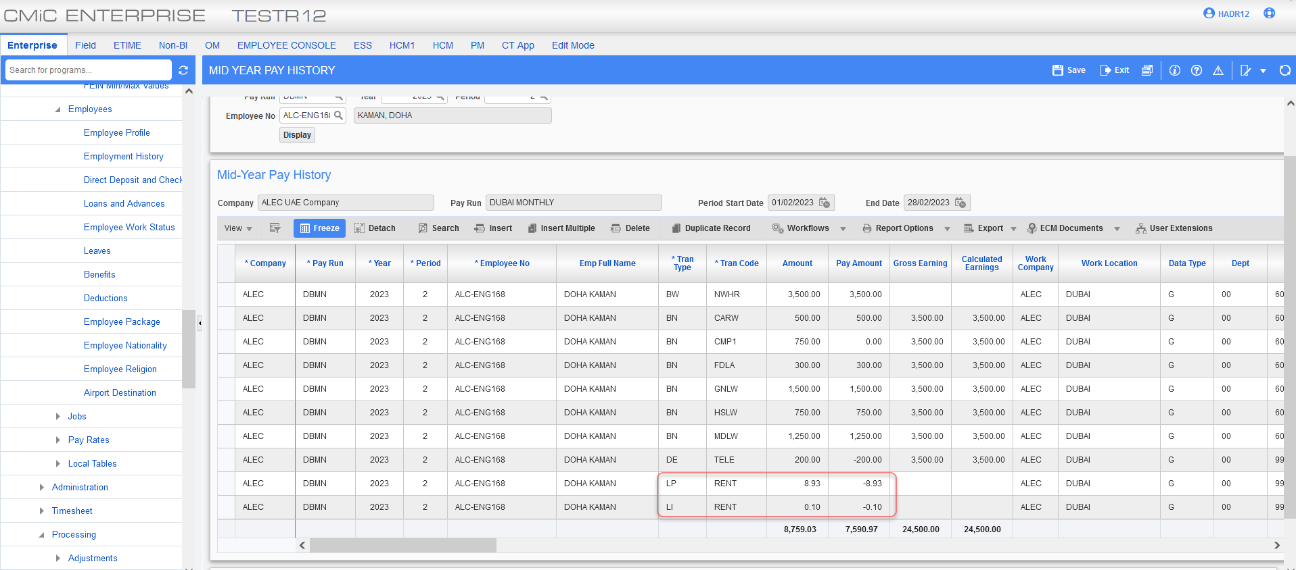
Example #2: Employee hired beginning of the period 01/Jan./2023 and loan paused from 1st/Feb. to 1st/Mar.
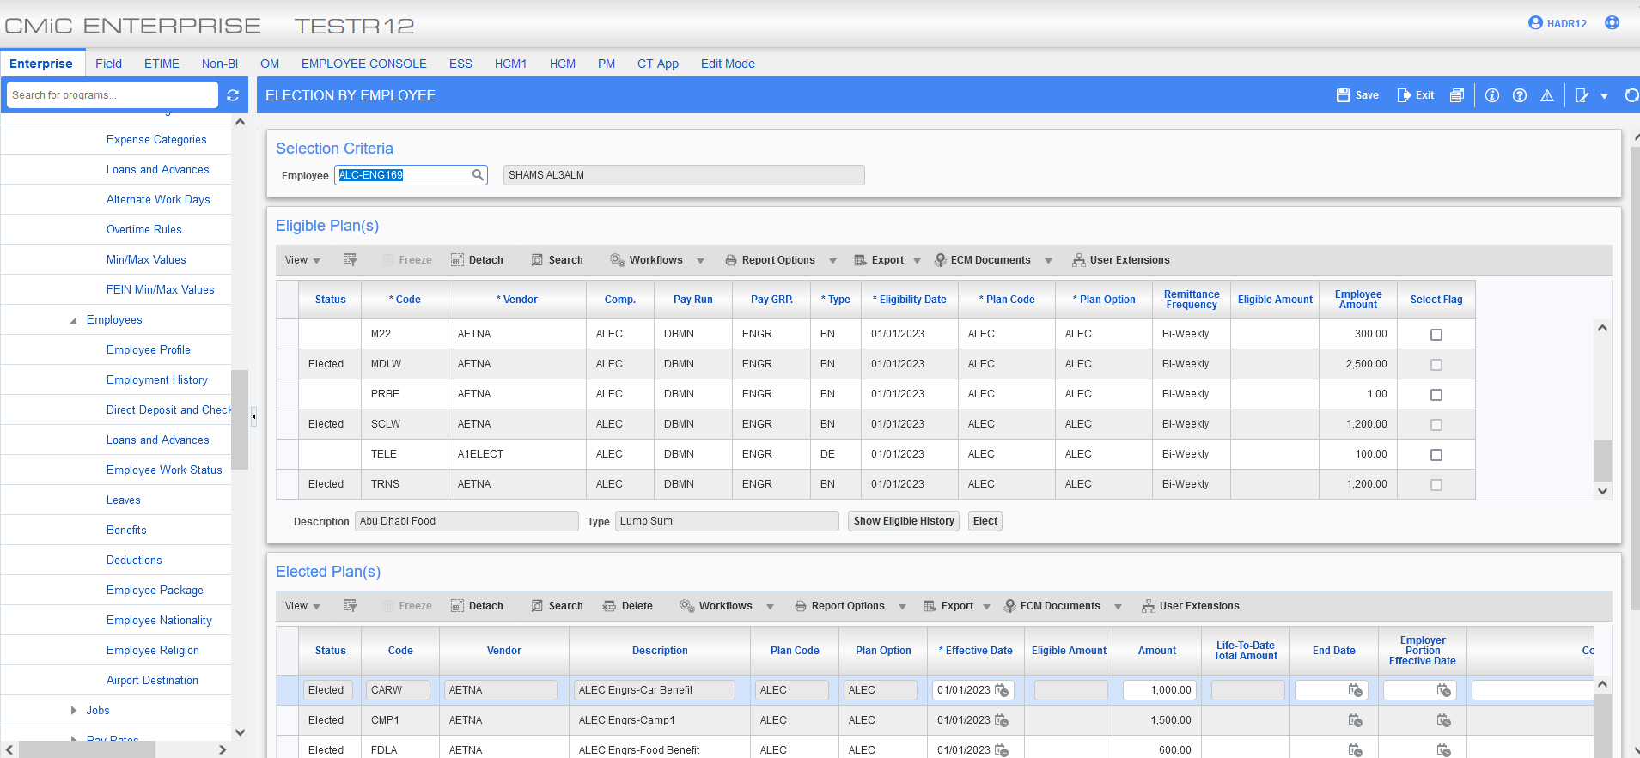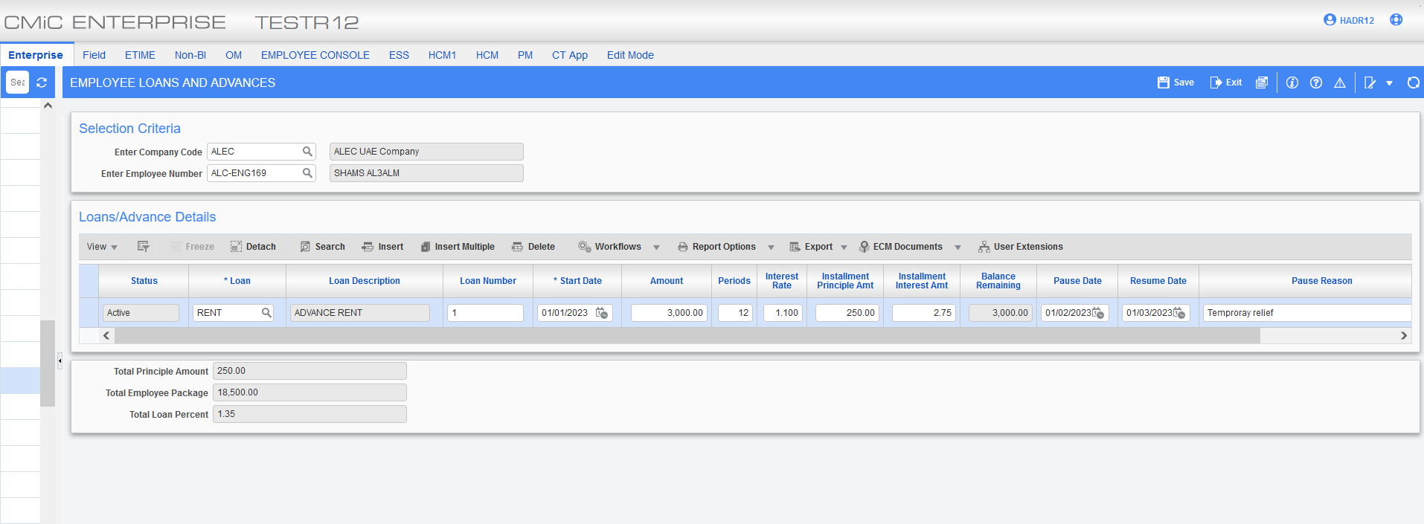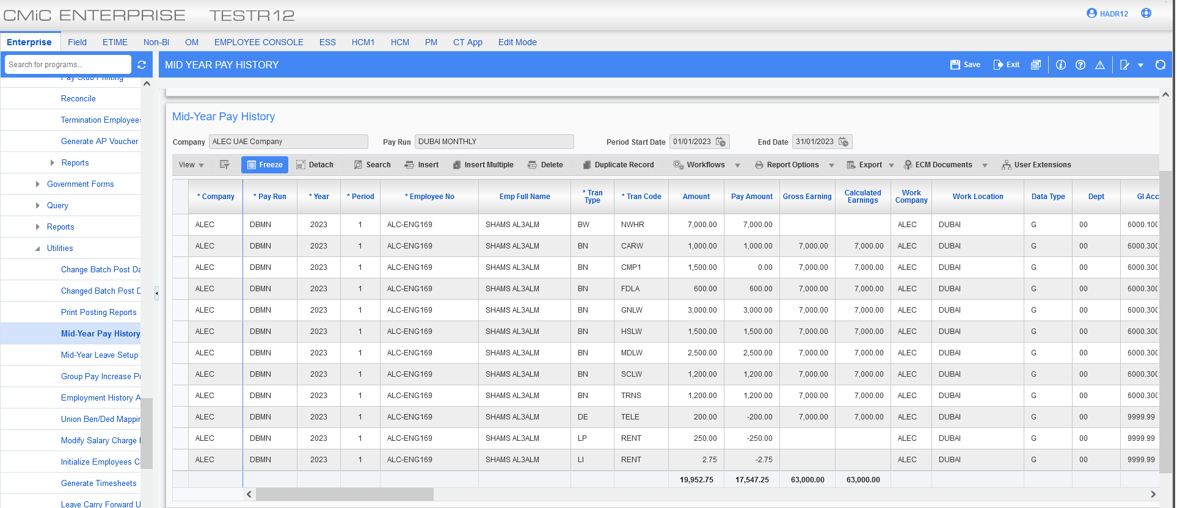
Loan didn’t calculate for the month of February as loan was paused during this period.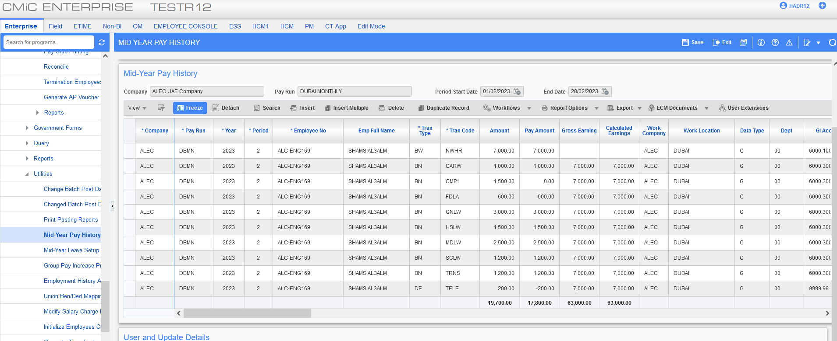
Loan resumed in March.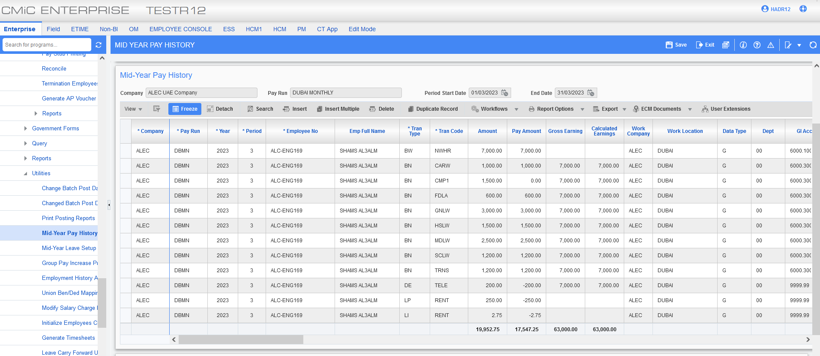
Example #3: Pro-rate loan amount flag is turned off.
Note: Only when the pro rate flag is on, it will calculate on per day basis. When it is off, it will either be full amount or none depending on the pause and resume dates.

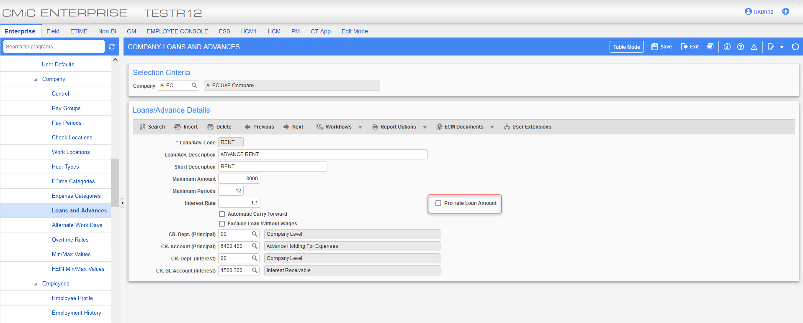
ALC-ENG169 loan is paused and not being calculated for the month of February.
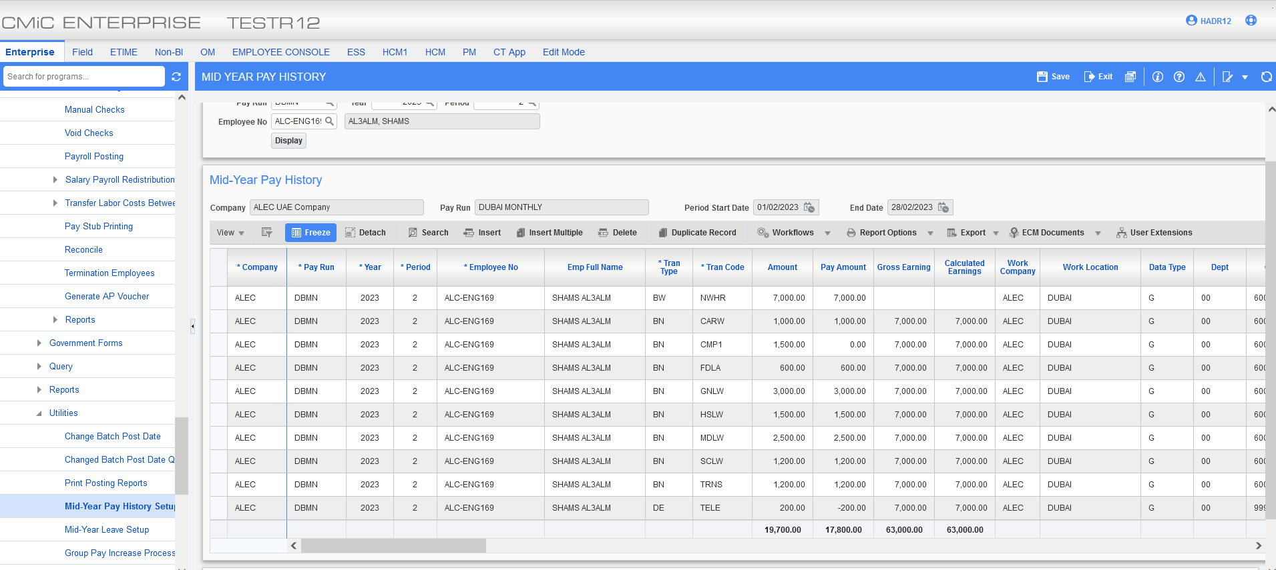
ALC-ENG168 no amount is pro-rated for the 1 workday as the pro-rate flag is turned off.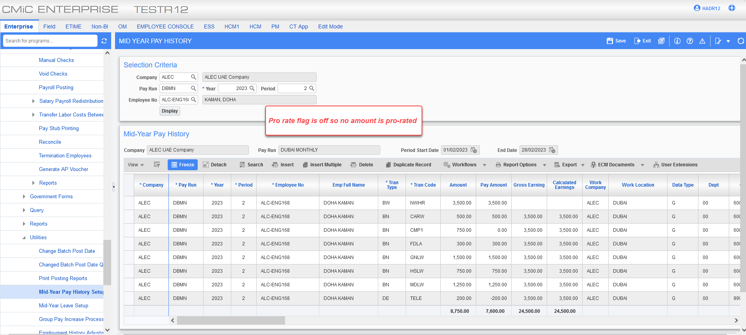
Note: When loan is paid out the status is showing as “Paid Out” and the new option on the employee loan screen “Show Details” pop up displays the actual loan deducted by period from the payroll table.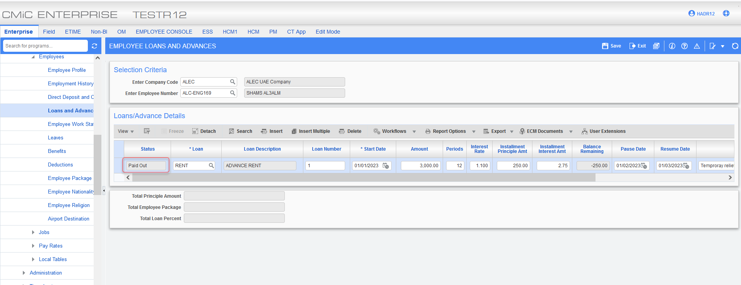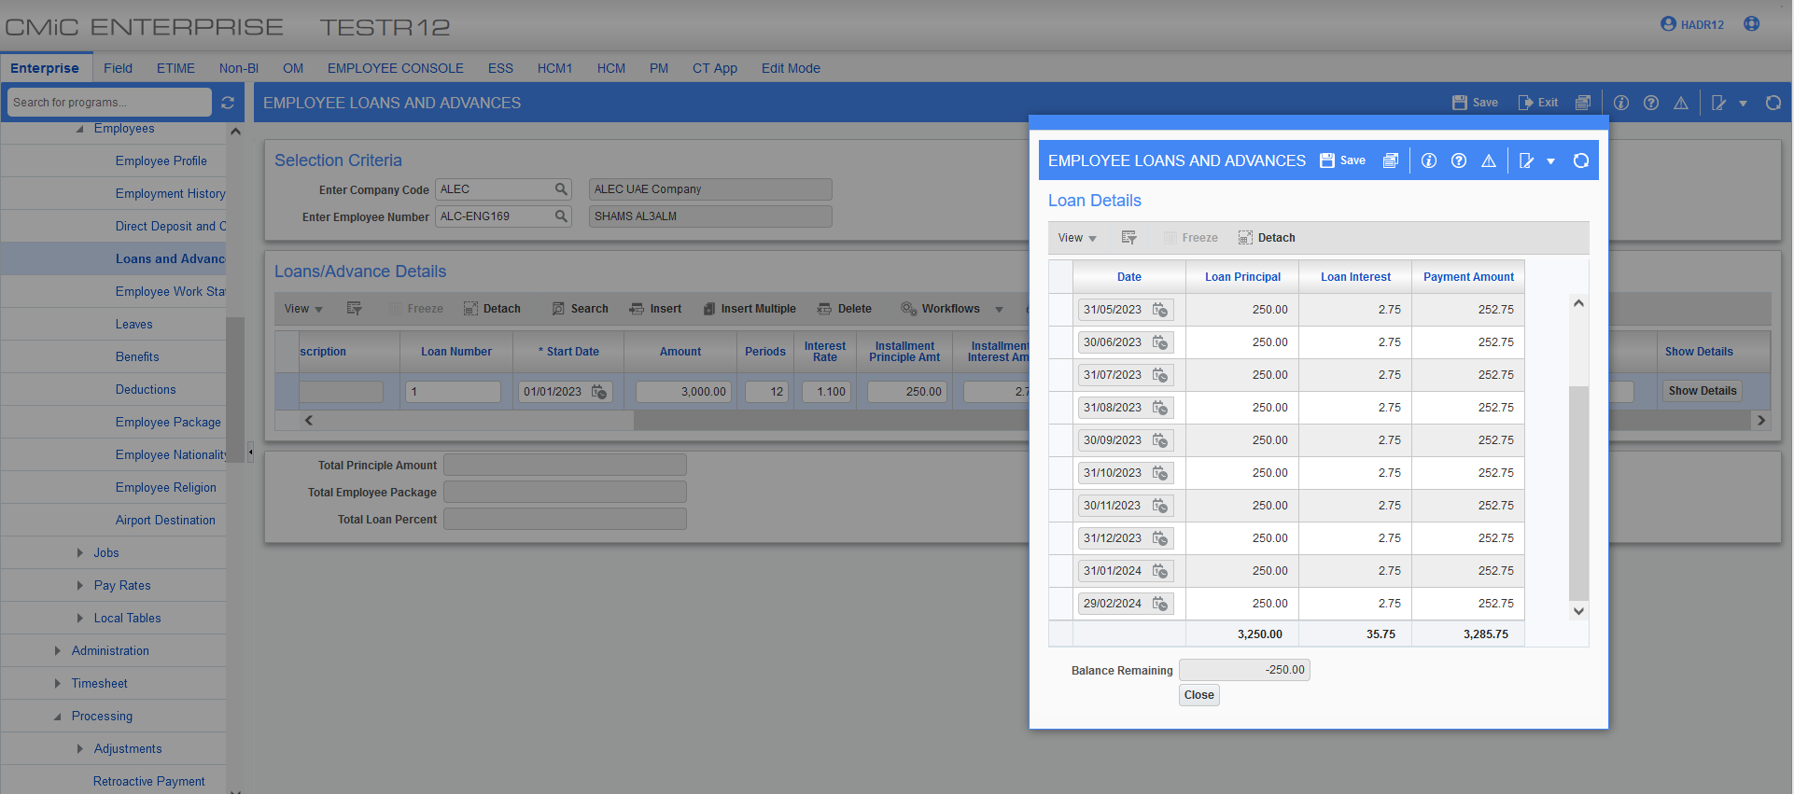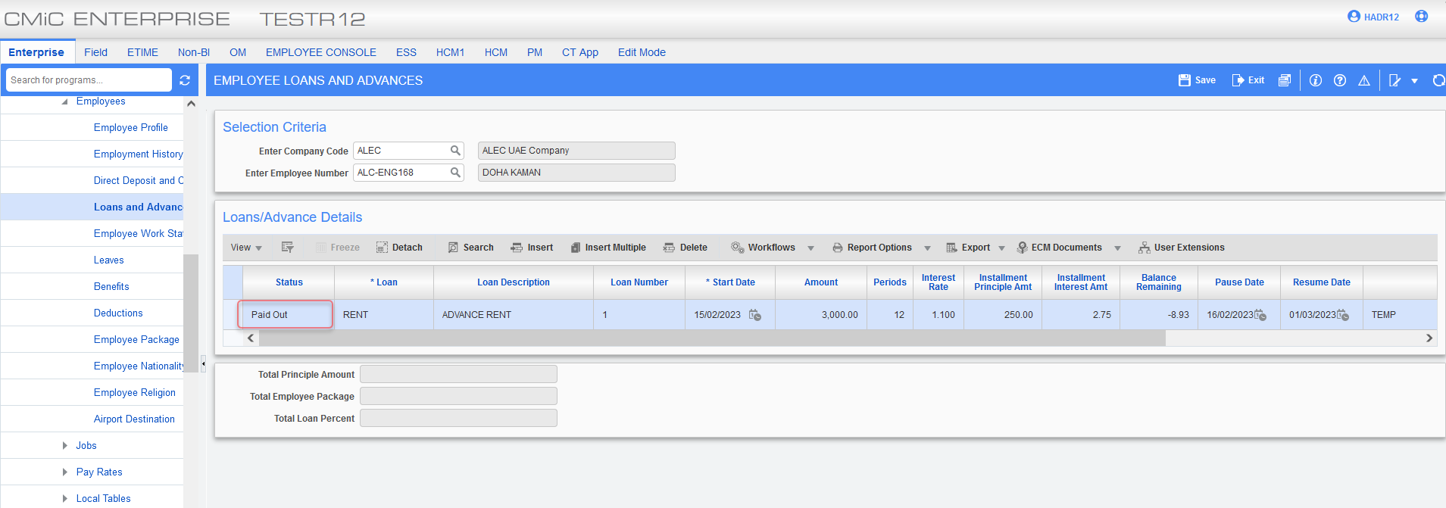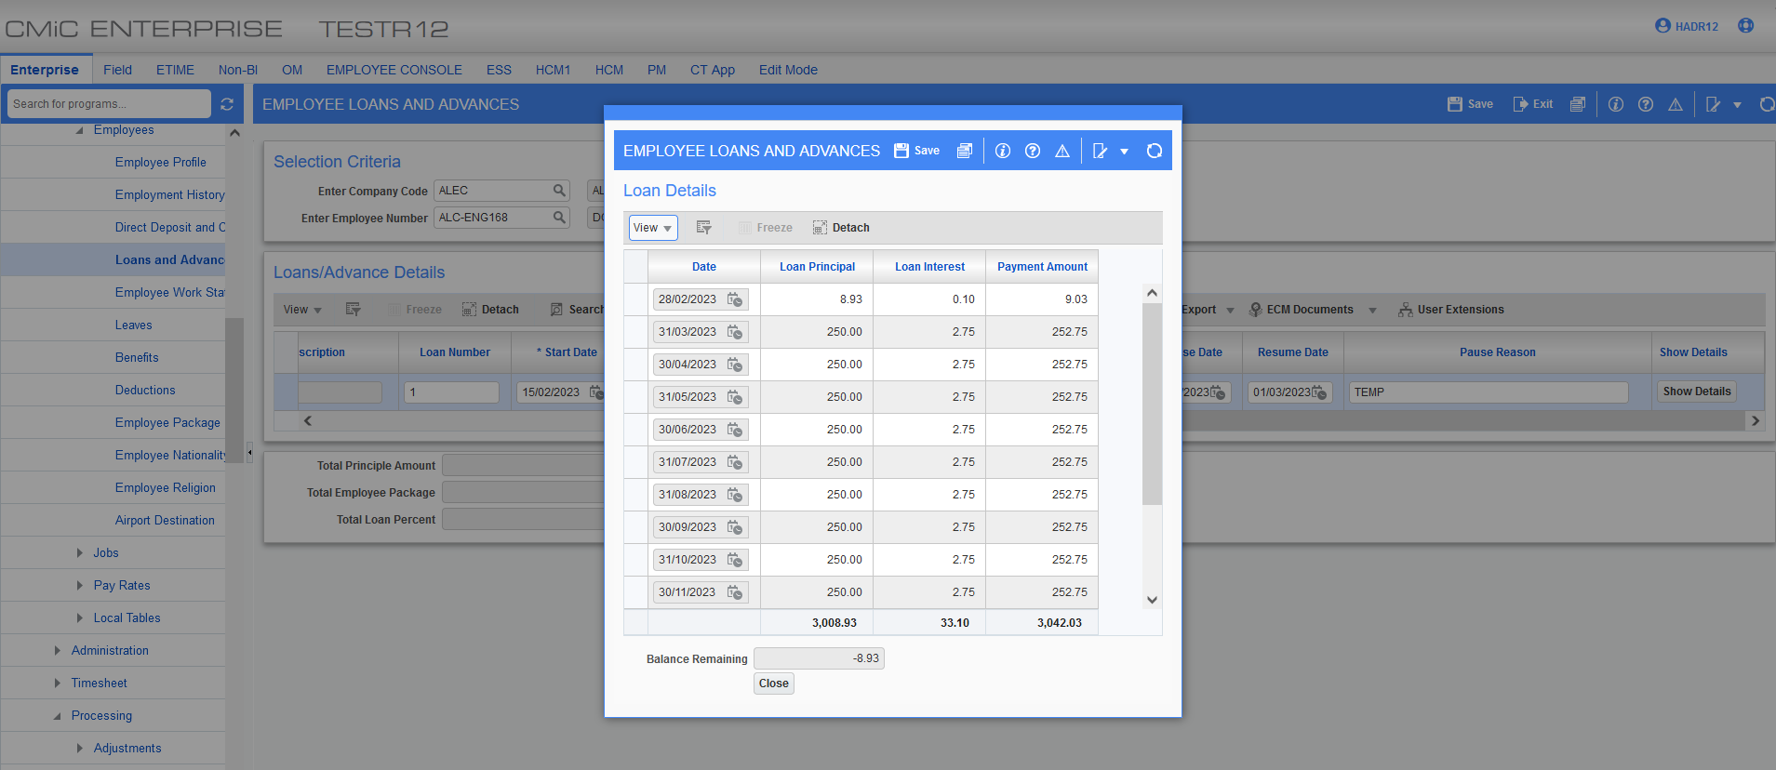

Job Billing

New Licensing options and New flag to print AIA G742 and G743 titles added (22.60355)

Overview:

- New flag to indicate the licensing option for AIA G742 and G743 added to the JB control.

- New Invoice format JBPB_G742 is created. This invoice format is based on existing JBPB_U11 format.

- New flag ‘Print AIA G742 and G743 titles’ added to the Invoice Formats screen.
Modifications:

- JB Control (JBCTRLFM) has been modified to include a new flag to indicate the licensing option for AIA G742 and G743. This flag needs to be checked (Y) and details of license number and expiration date need to be populated, in order to print the AIA verbiage at the bottom of the invoice.
- The program Invoice Formats (JBINVFMT) has been modified to include a new flag ‘Print AIA G742 and G743 Titles’.

- New invoice format JBPB_G742 is available and when setting up the invoice format, the flag ‘Print AIA G742 and G743 Titles’ should be checked, in order to show the AIA verbiage at the bottom of the invoice.
Screenshots:

Licensing option for AIA G742 and G743

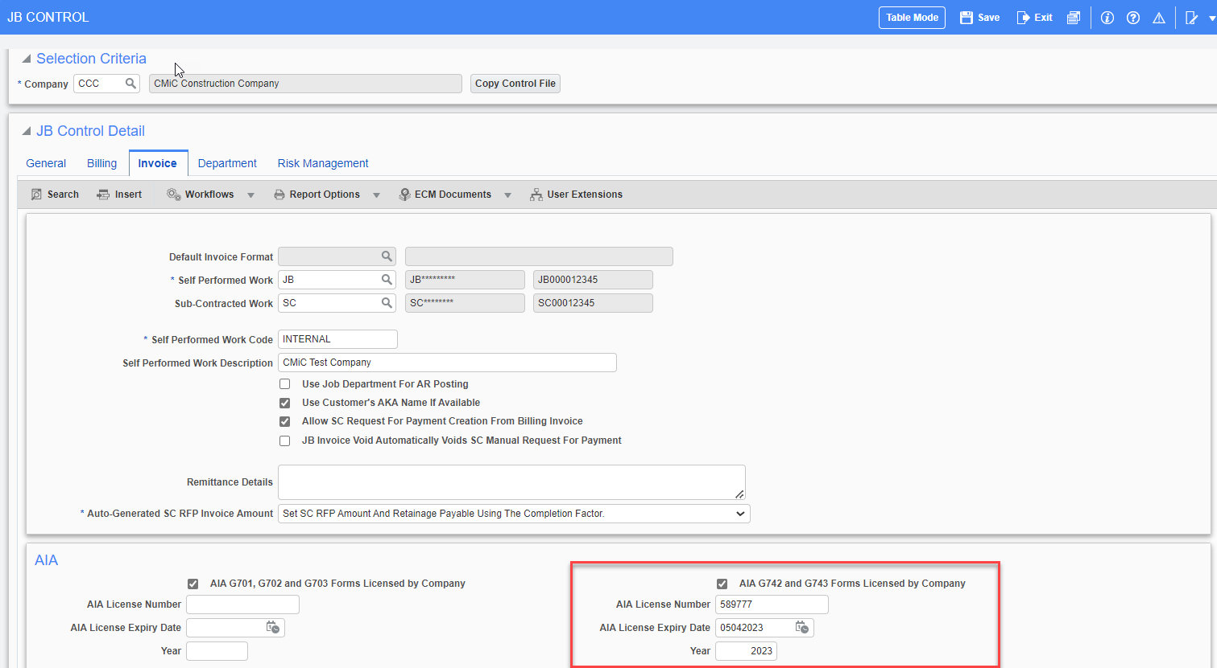

Job Billing Invoice Format:

New Invoice format JBPB_G742 is created. When setting it up, the ‘Print AIA G742 and G743 Titles’ flag must be checked, in order to show the AIA verbiage at the bottom of the invoice pages.
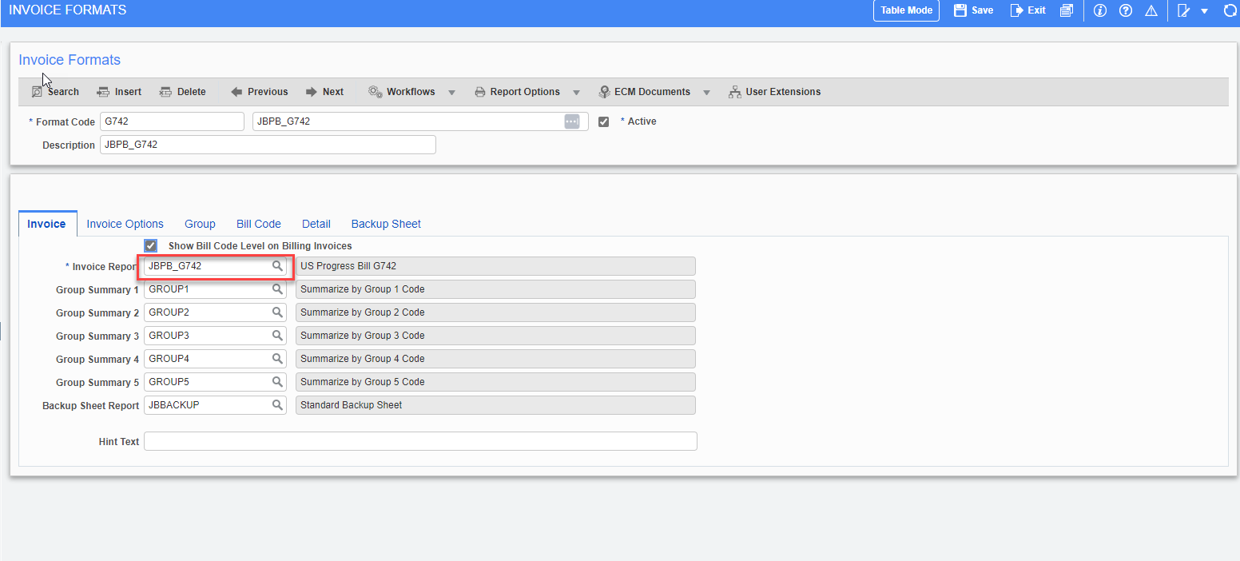

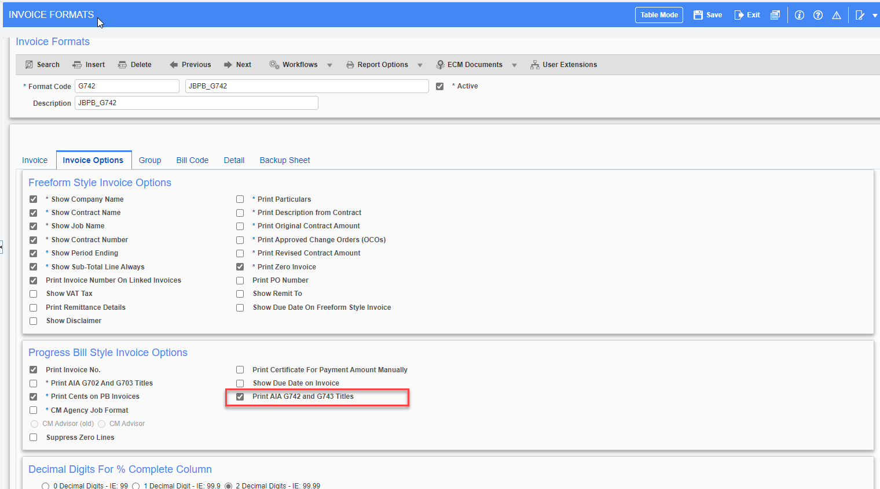

Sample Invoice:

Printing Invoice format from Prepare Billing Screen
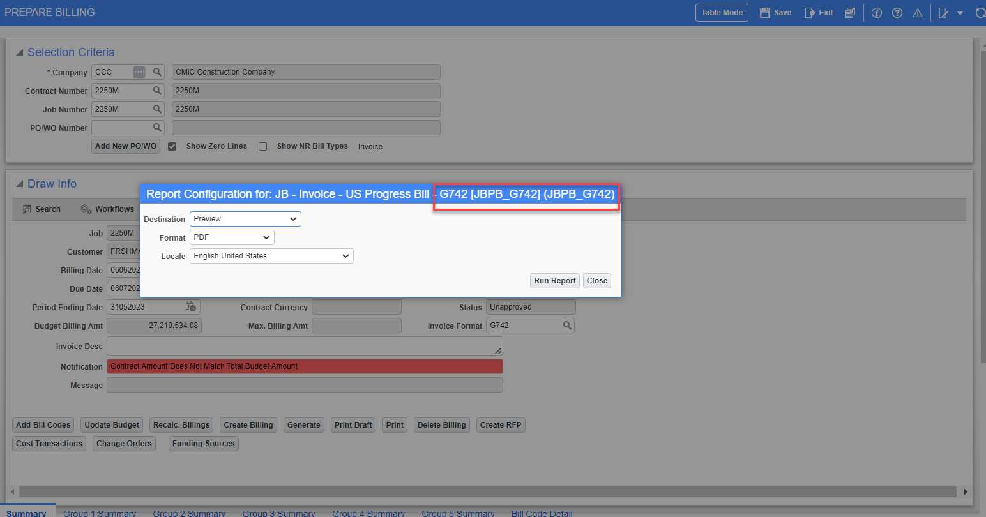

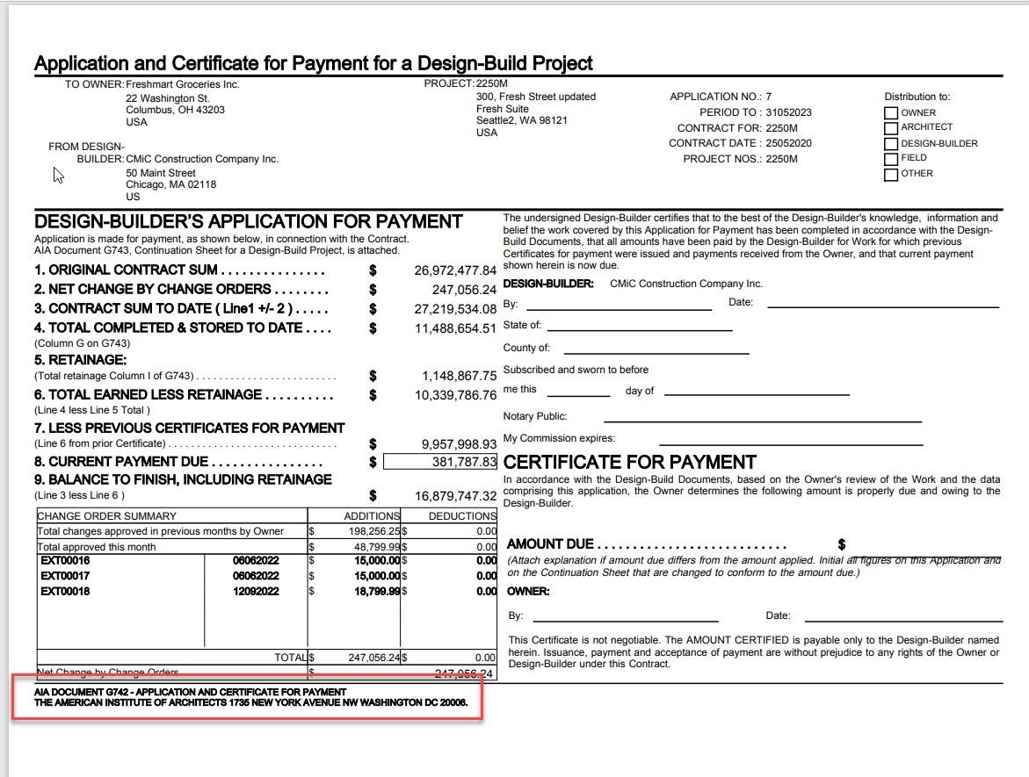

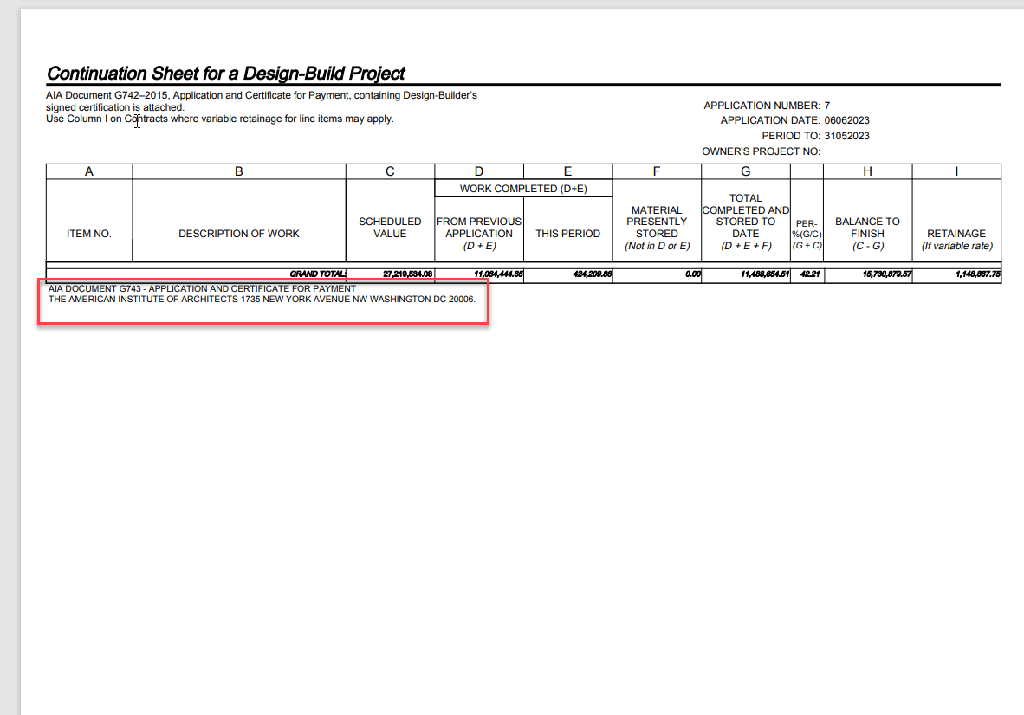

Job Costing

Added new scope of work detail field in PMCHGFM, PMSCFM, PMCOFM Program (21.51716)

1.In Enter PCI program (PMCHGFM)
New scope of work detail field called CMM_SCOPE_DESC_DET is added.

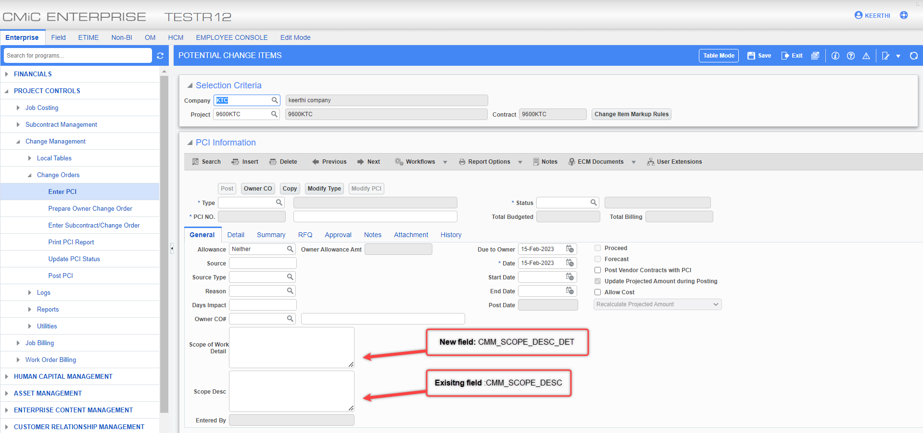

The field size is CLOB.While posting a PCI,user can enter desired text in scope of work detail
field and post the PCI.

2. In Enter Subcontracts/Change Order Program (PMSCFM)
New scope of work detail field called SCMST_SCOPE_DESC_DET is added.

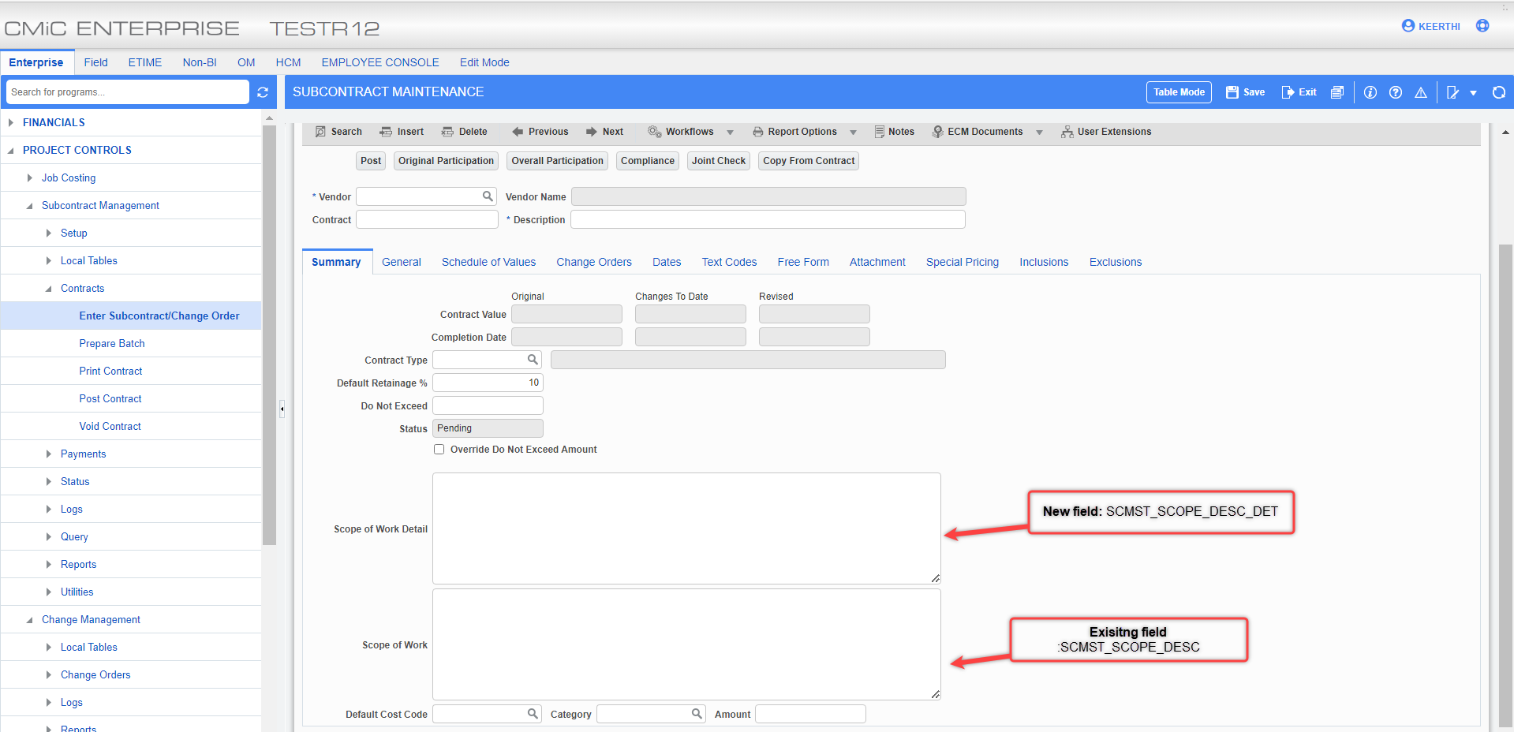

The field size is CLOB.While posting a subcontract ,user can enter desired text in scope of work
detail field and post .

3. In Enter Subcontracts/Change Order _Subcontract Change Order Maintenance Program (PMCOFM)
New scope of work detail field called SCMST_SCOPE_DESC_DET is added.
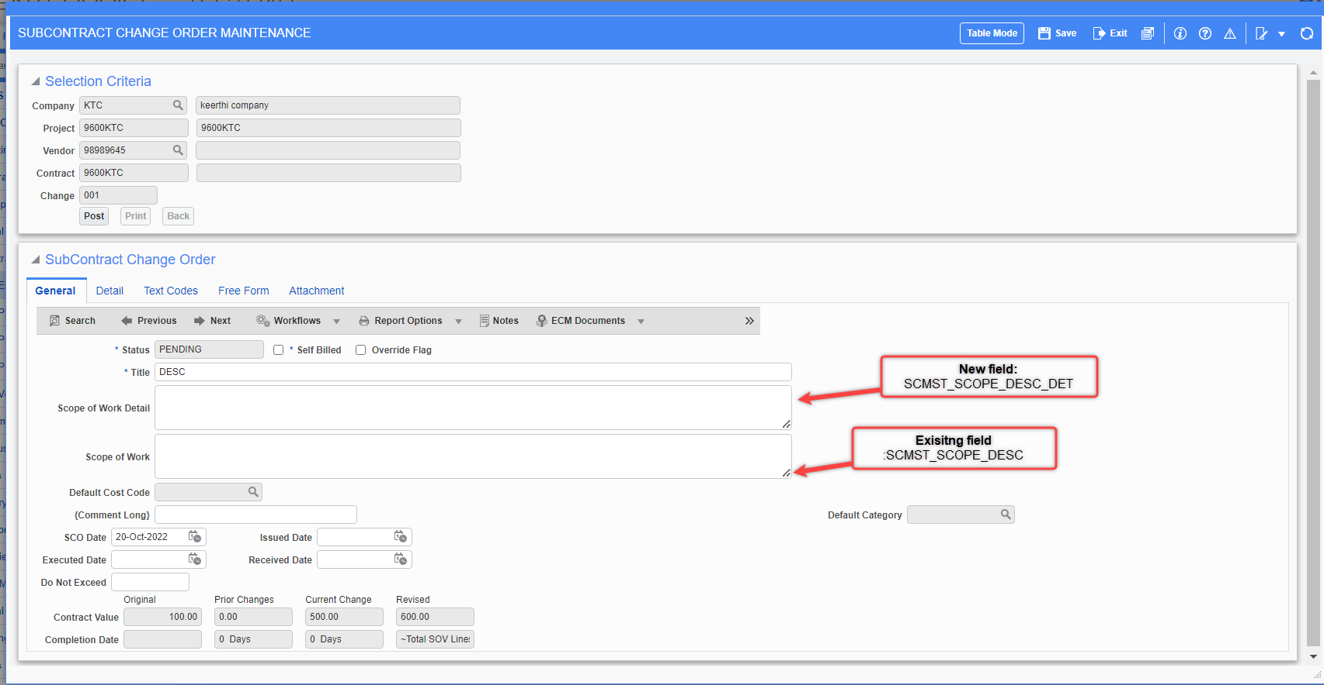

The field size is CLOB.While posting a subcontract Change Order ,user can enter desired text in scope
of work detail field and post.
The new field scope of work detail field is introduced to overcome limitations of Scope of work field.

Added Total for column commitments on Enter Cost Forecast program’s Cost Transaction screen.(22.61134)

Modification:
Current Cost button’s popup on Enter Cost Forecast Program is modified to show Total for commitment column at bottom.
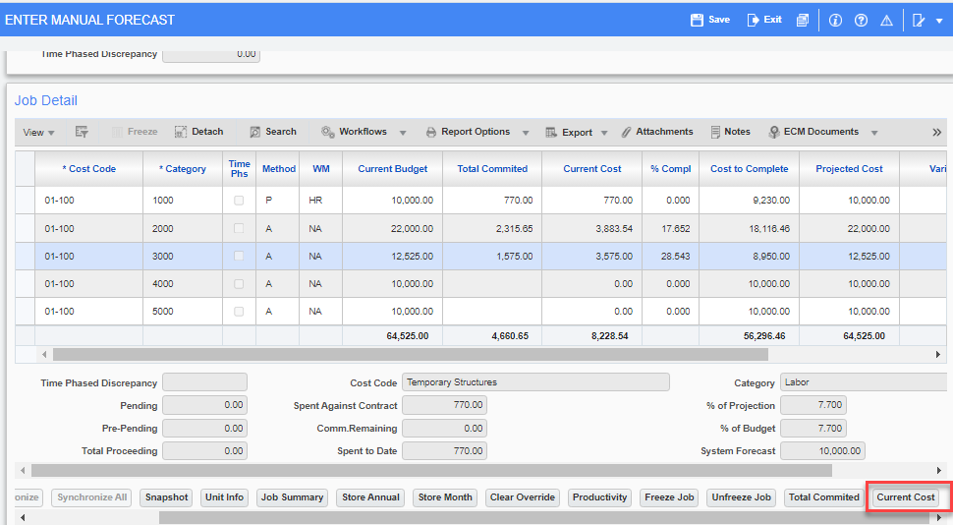
Project Controls > Job Costing > Forecasting > Enter Cost Forecast
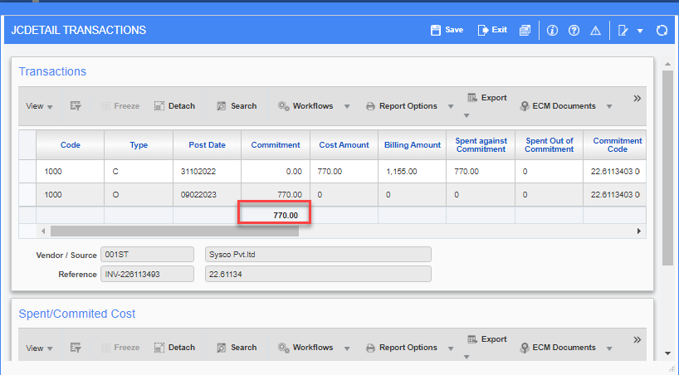
Project Controls > Job Costing > Forecasting > Enter Cost Forecast > Current Cost

GC Monitor: Added Tool bar ‘Notes’ button for Labor and other blocks (22.64229)

Added Toolbar button “Notes” to GC Monitor program for Labor and other blocks.
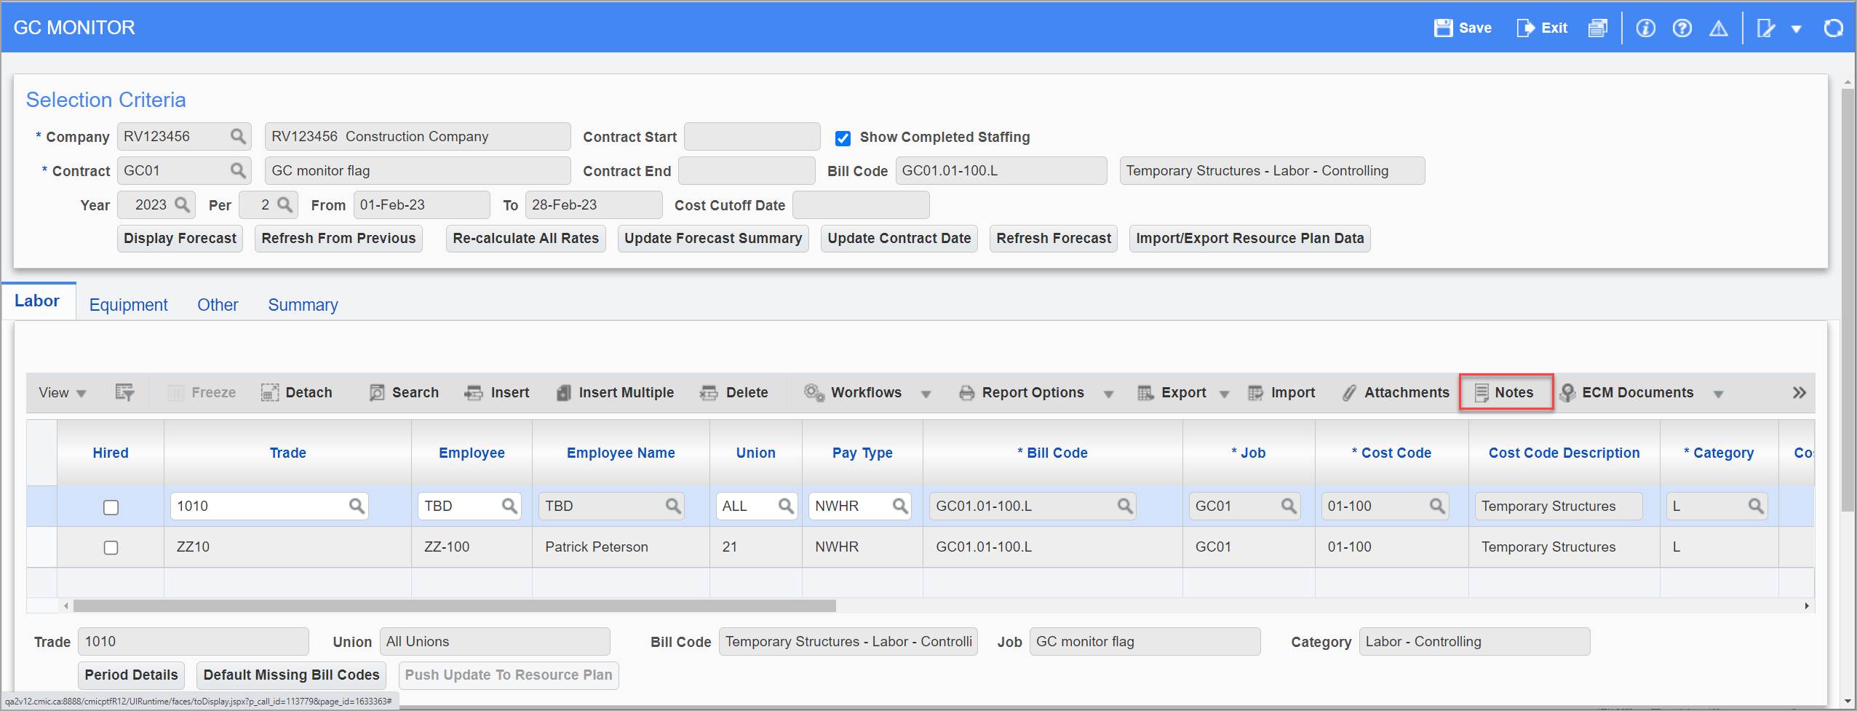
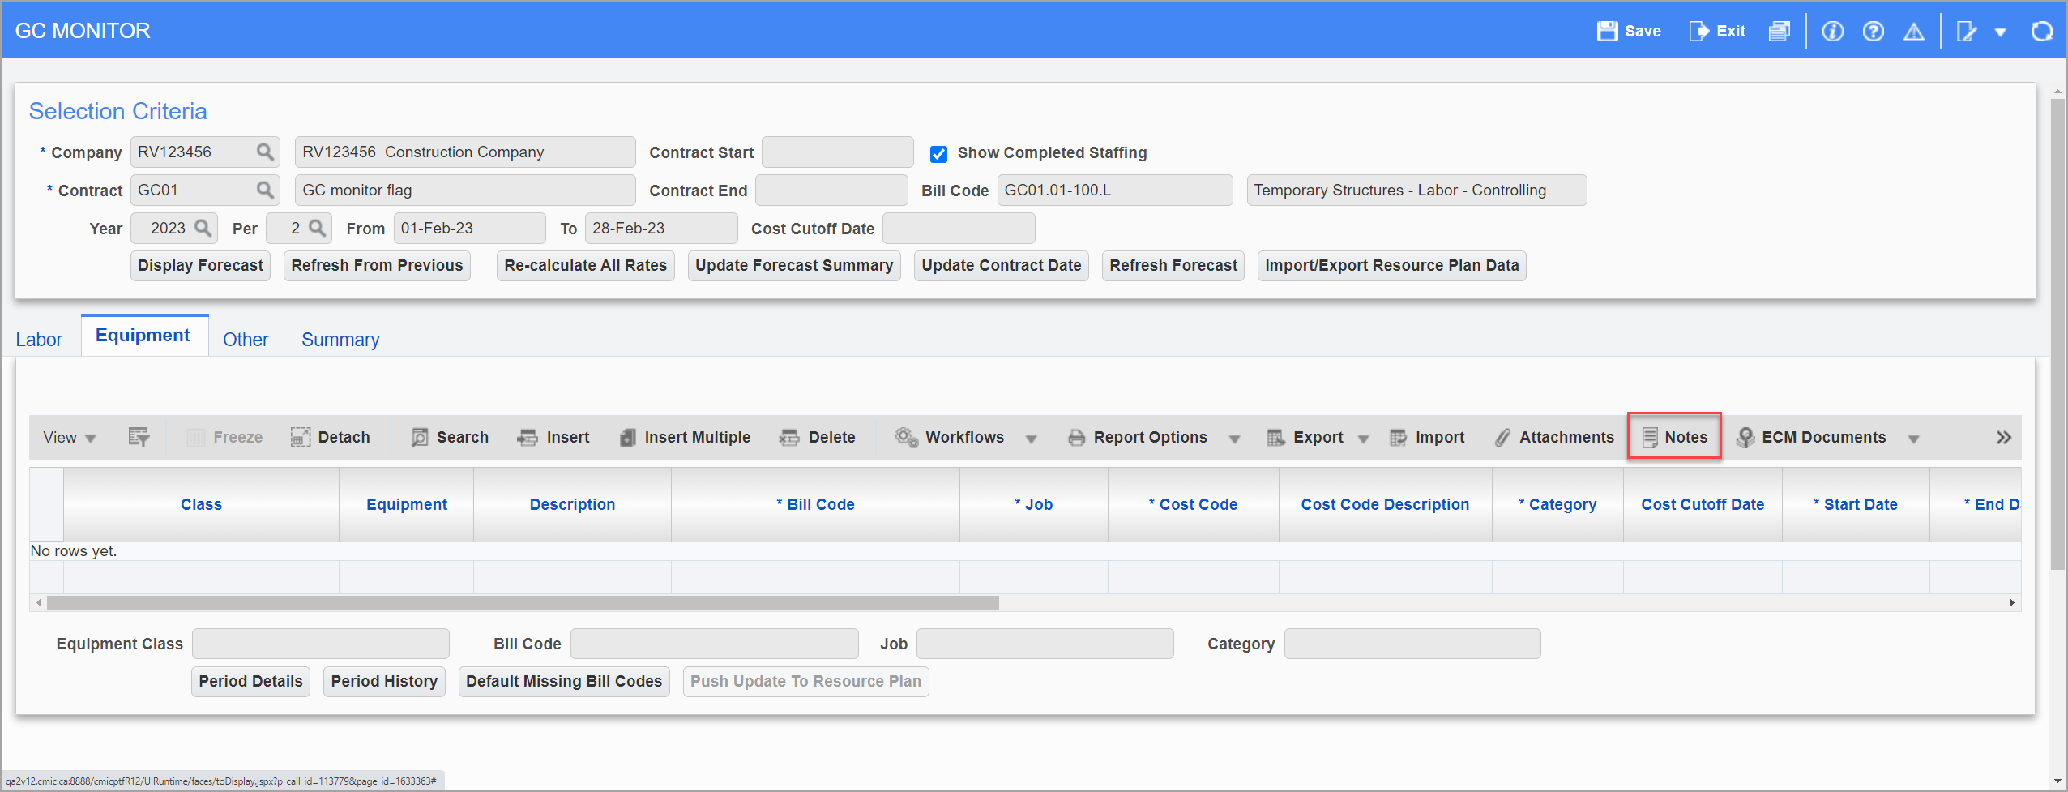
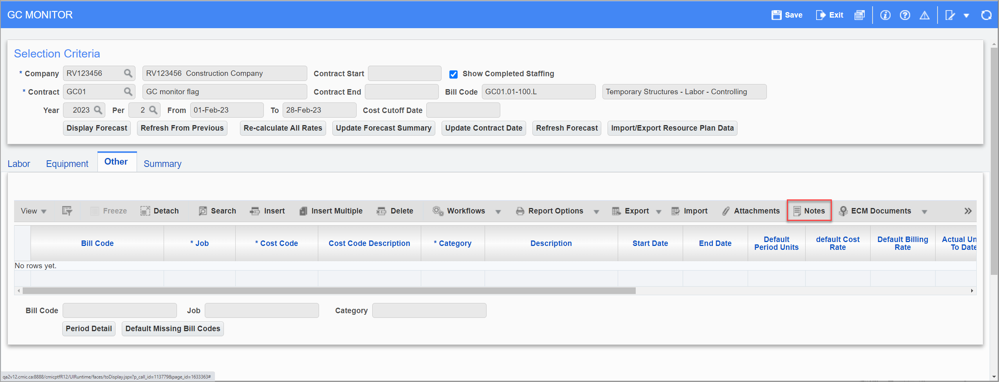
To add a new note for the record, user needs to select a record and click on “Notes” button in the Tool bar, on “Notes” popup window, enter subject and description and click on “OK”. User can edit or delete the note when needed.
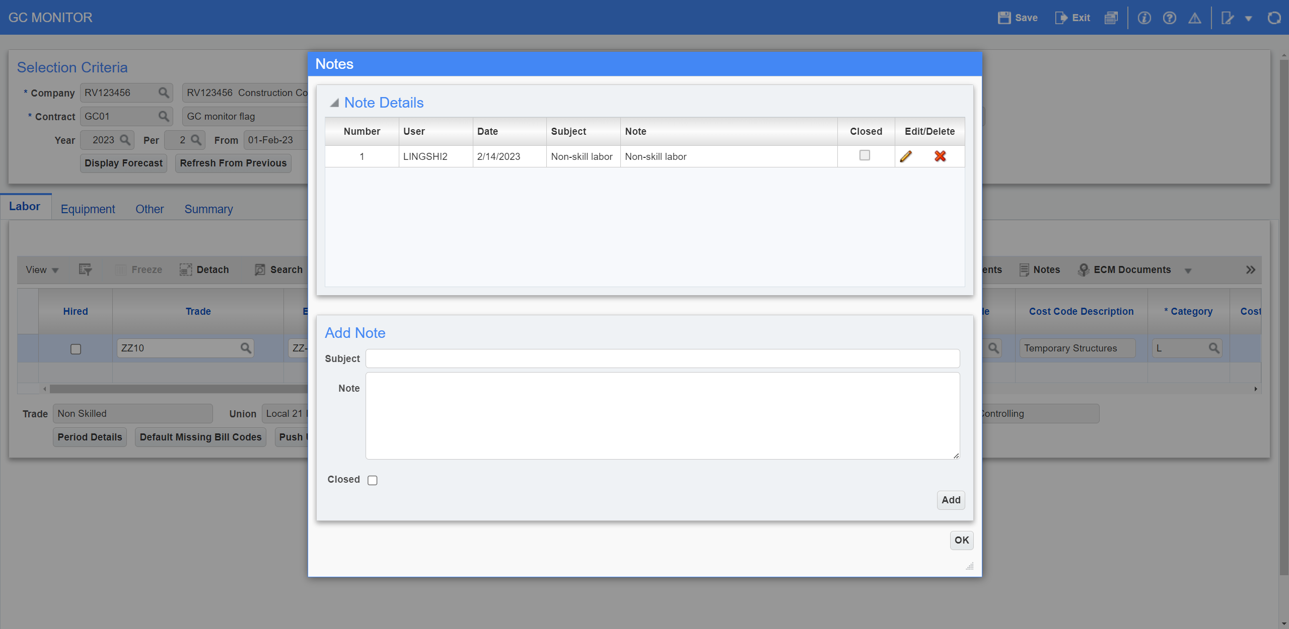
The number of notes added to the record can be seen in the brackets next to ‘Notes’ button.
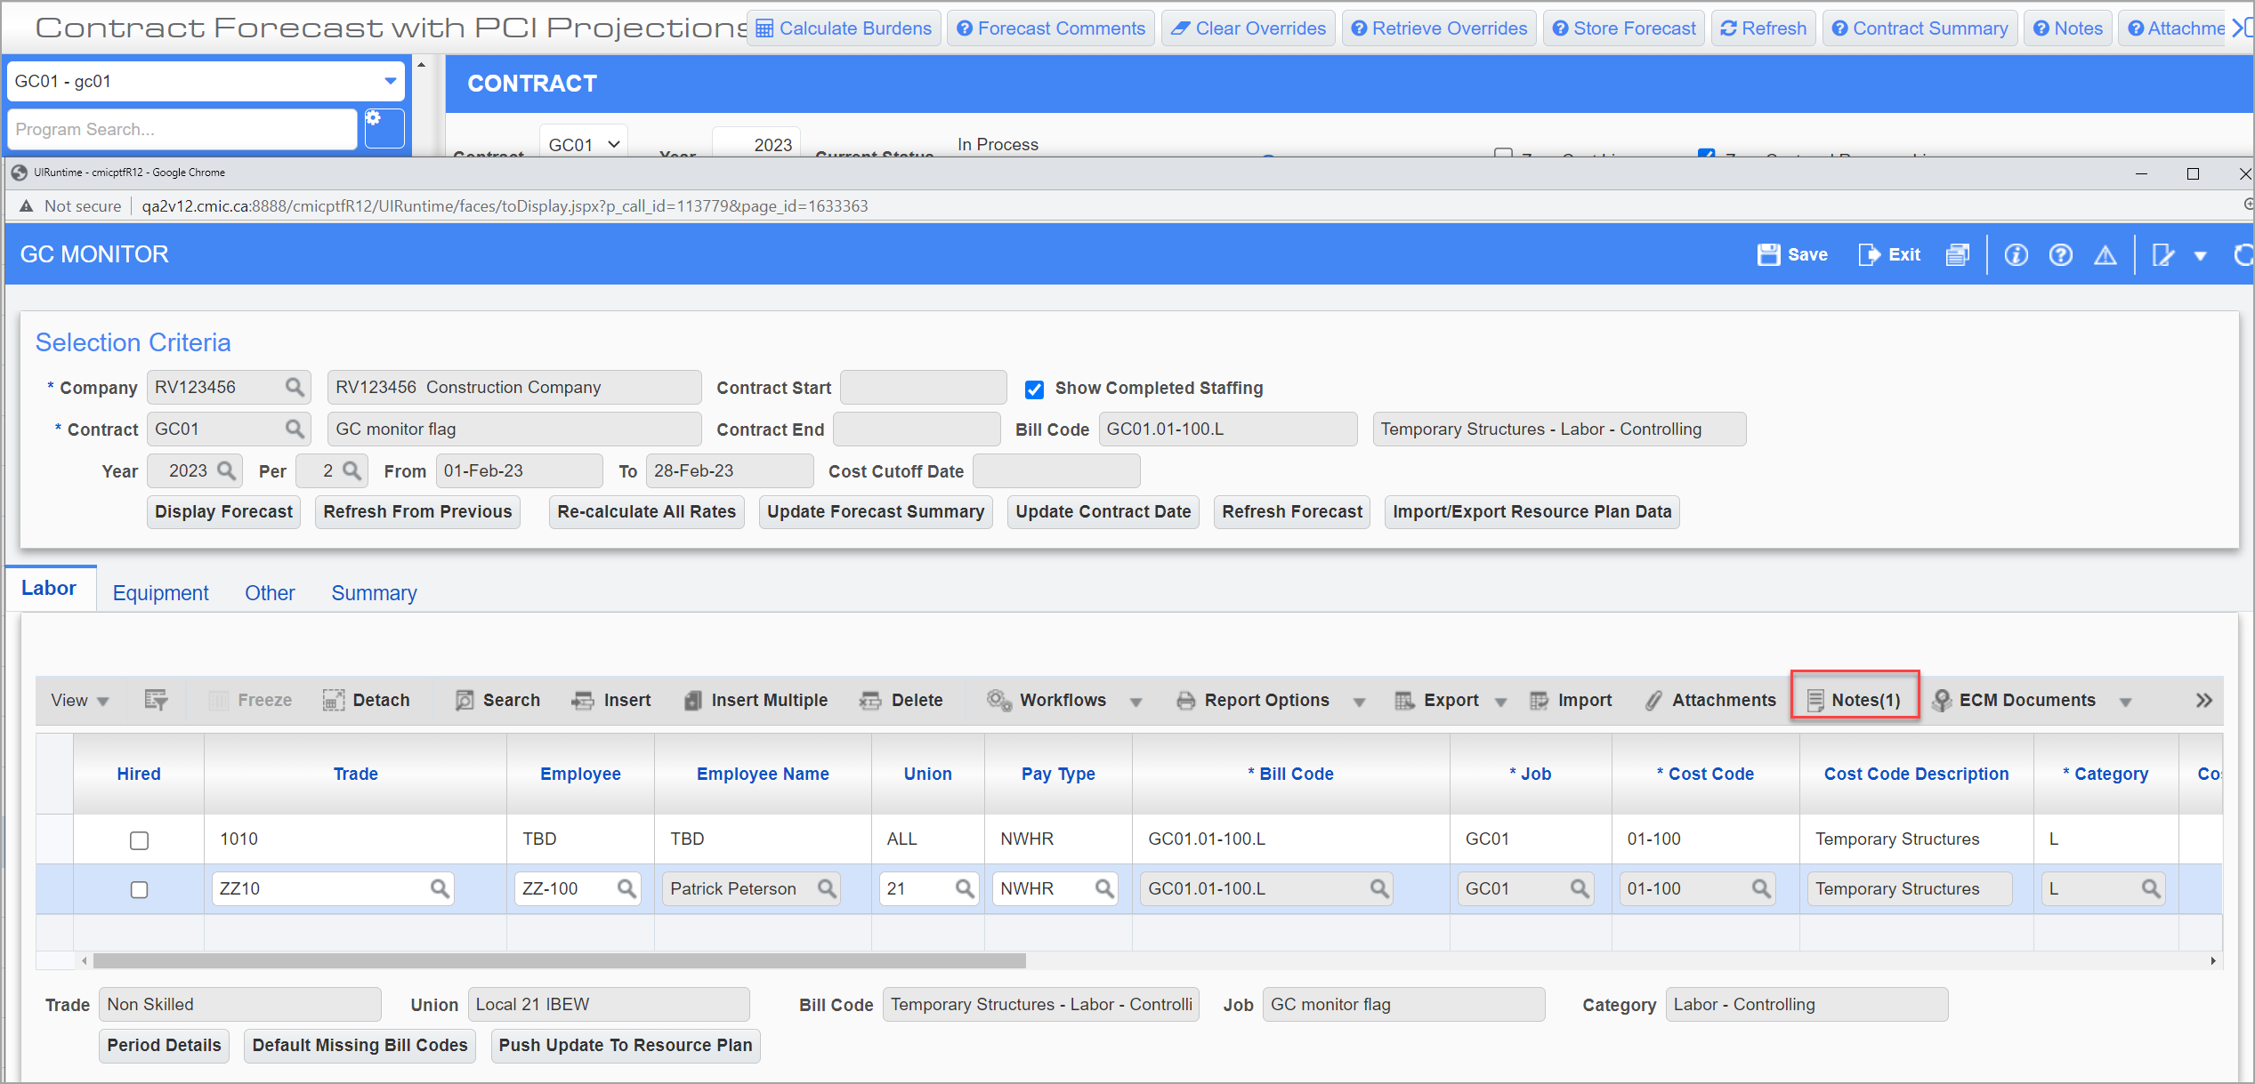

Job Entry - Manage workflow lookup (21.48122)
Added Workflow Lookup button to Job Entry program. Users must add it to the screen using the lite editor and position as required. This was an existing functionality in the previous version of the software and now converted into R12 version.
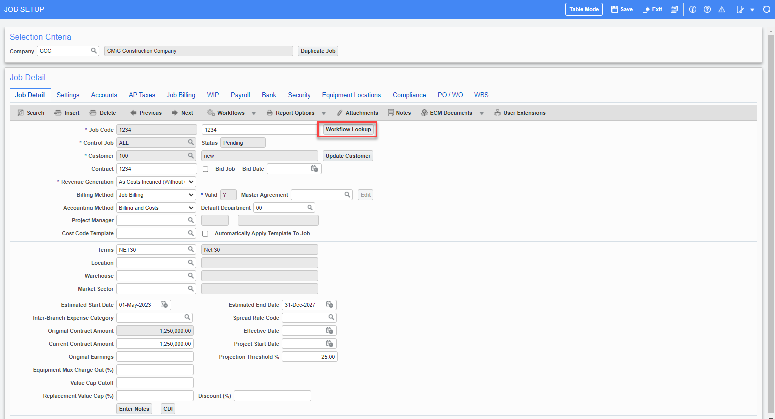

‘Workflow Button’ when pressed, opens the ‘Lookup data’ popup and users may select a lookup and assign approvers as needed. This lookup data is normally maintained at Workflow > Setup > Resource Lookup Rules.

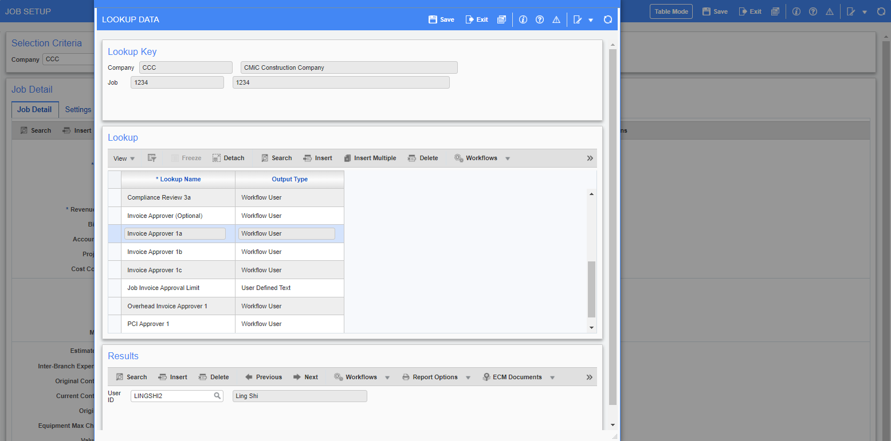

Added “Enter Job” field and “Query” button to the [Adjustment] pop-up in Enter Cost Transaction (22.64193)
Modified the logic of the [Adjustment] pop-up in Enter Cost Transaction so that the system does NOT auto-query the data. “Enter Job” field and “Query” button are added to the pop-up, if Job code is entered, upon tabbing off, the system will query JCDETAIL only for that job; if “Query” button is pressed, the system will query all records under the company.
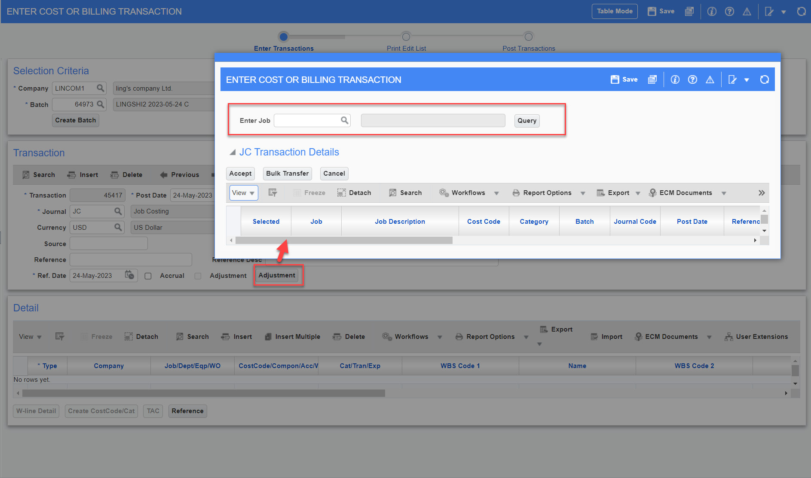

Material Sales

Added Bank Department and Bank Account fields in MS External Invoice (23.71754)
Overview

Added Bank Department and Bank Account fields in External Material Invoice program.
Bank Department and Bank Account fields are defaulted from Vendor maintenance.
Modifications

Following screen highlights the newly added fields:
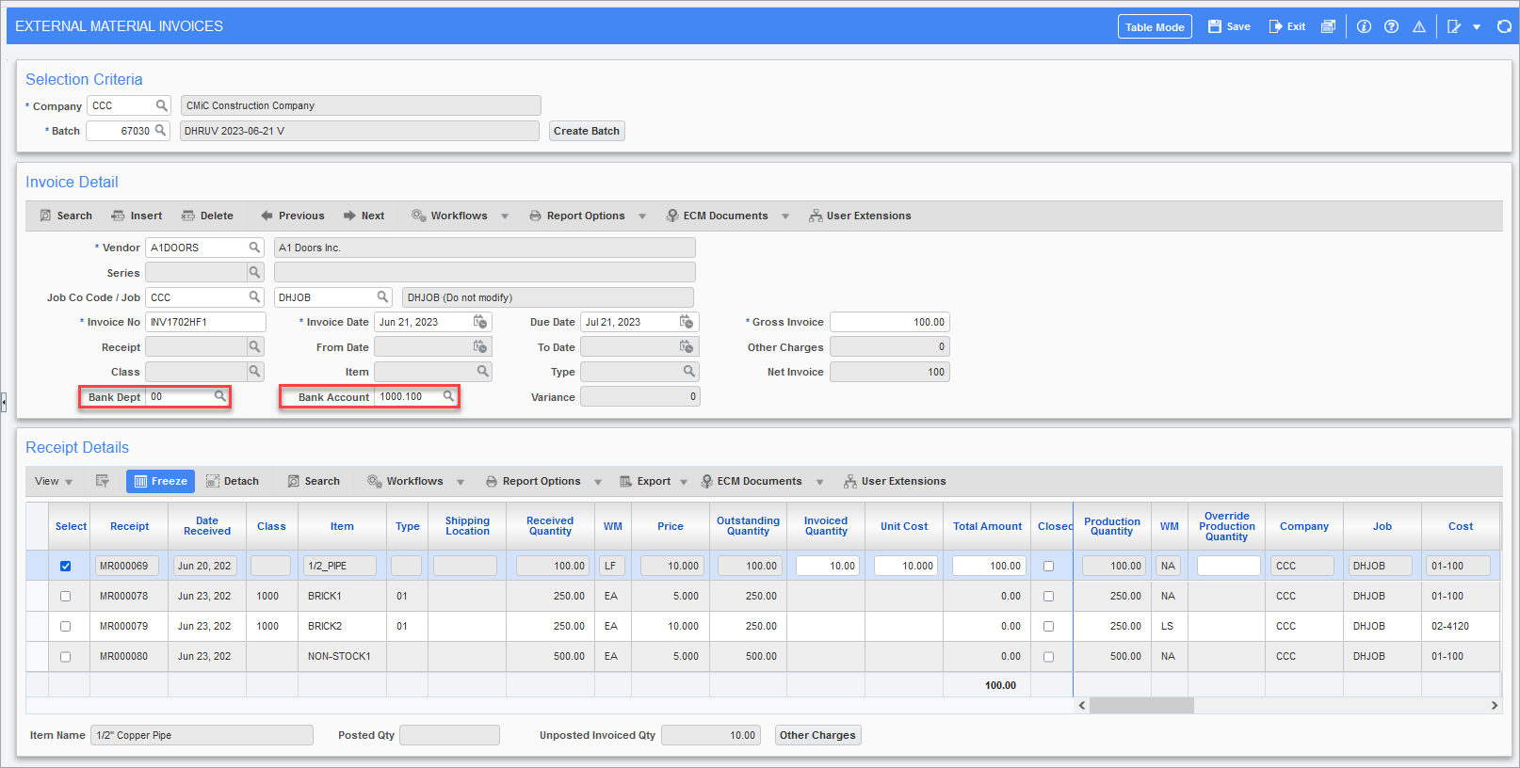Material Sales > Material Invoice > Enter External Invoices
Implementation

Purchase Agreement ‘17024D’
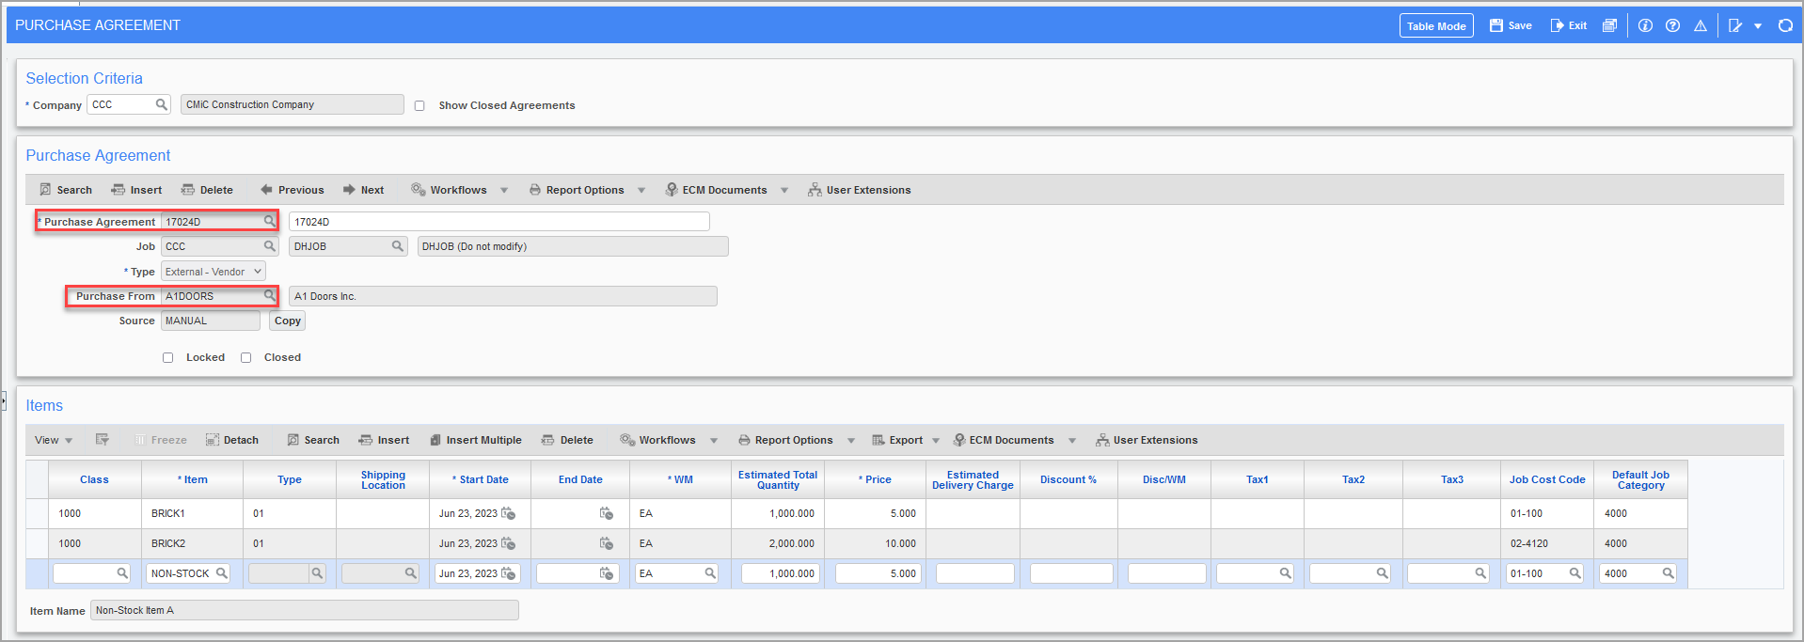
Enter material receipts for given purchase agreement.
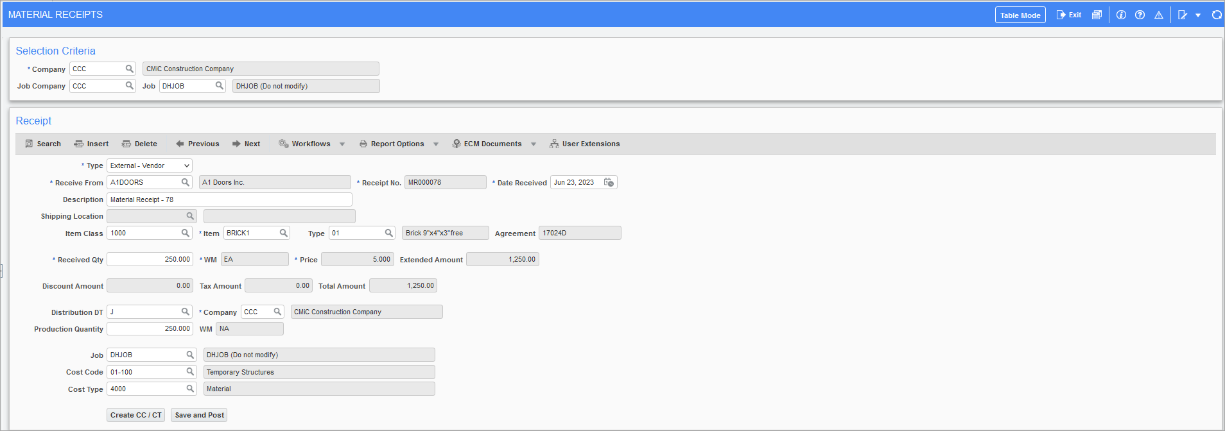
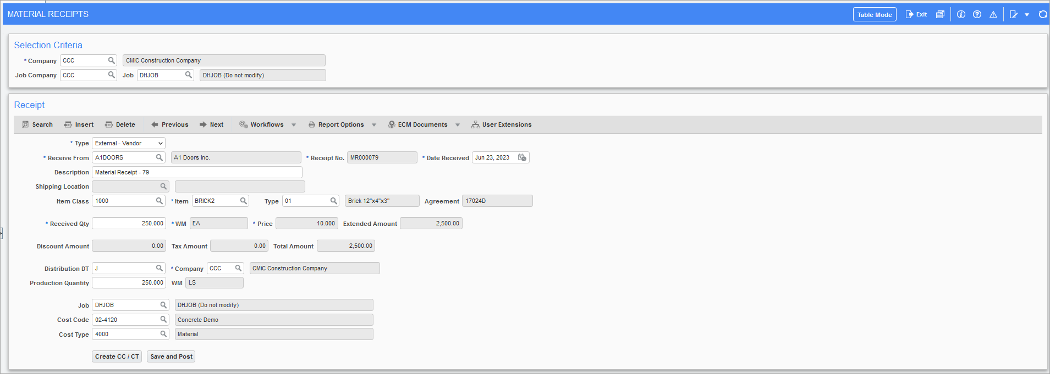
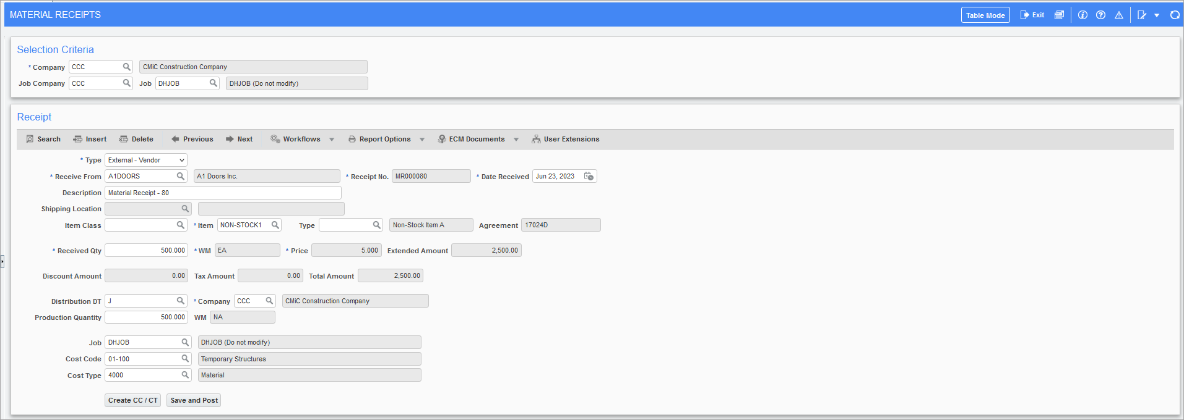

Added material receipt for Vendor having ‘1000.111’ – Canadian bank account.
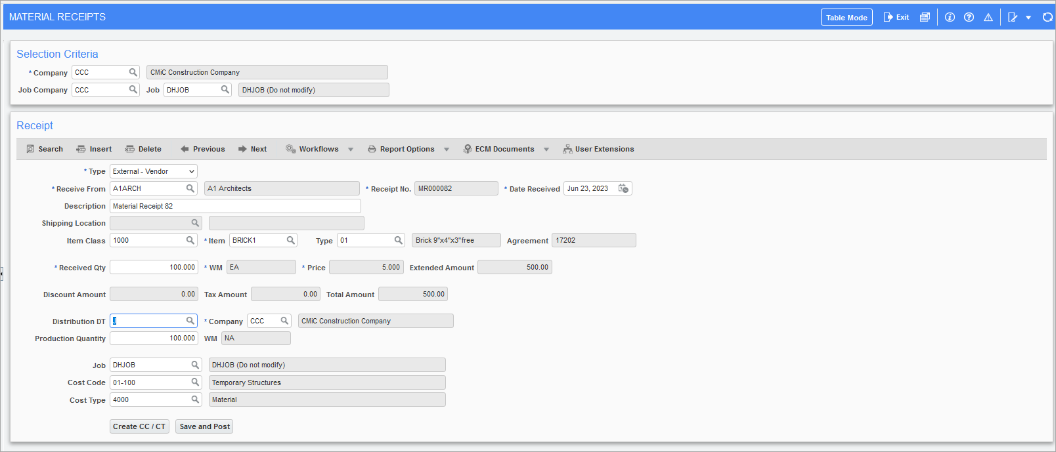
Entering External Material Invoices:
Vendor: A1DOORS
Bank Dept & Account: 00, 1000.100
Vendor: A1ARCH
Bank Dept & Account: 00, 1000.111
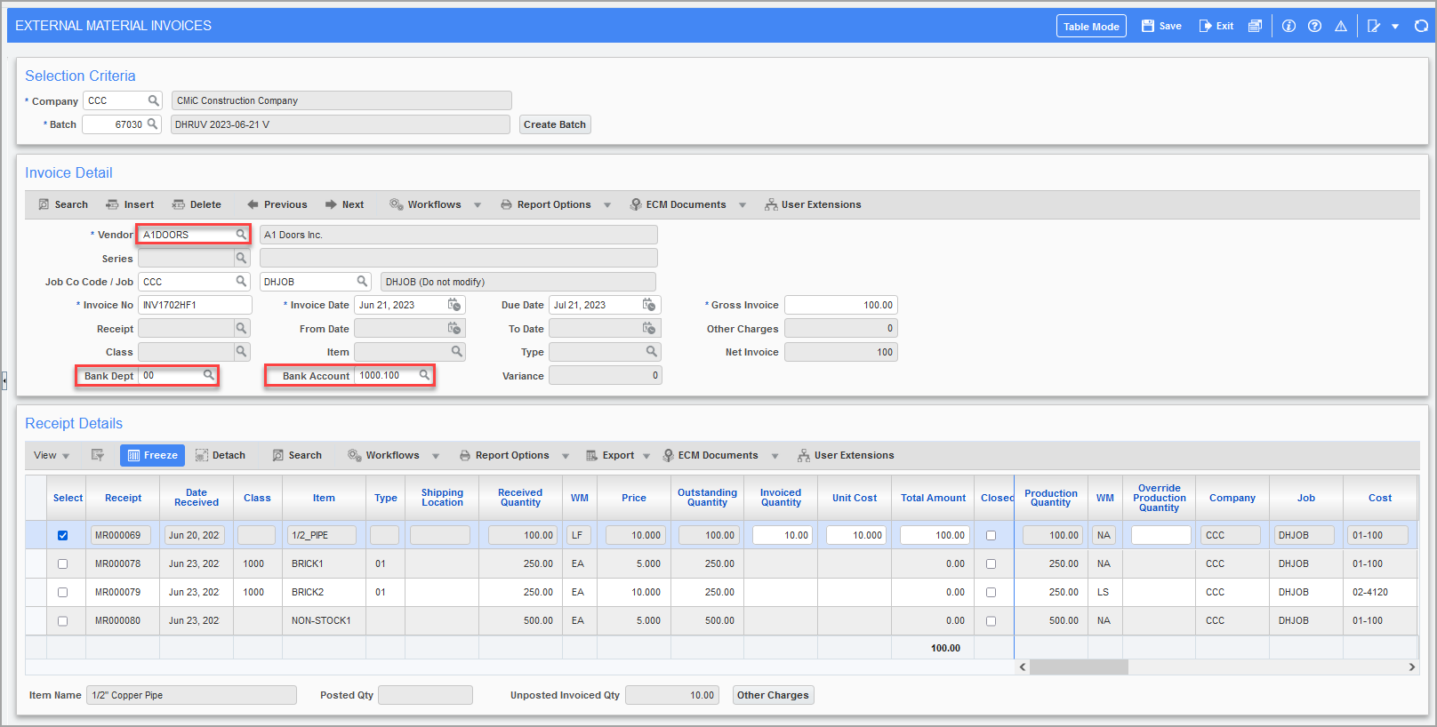
Bank Dept and Bank account is defaulted from A1DOORS vendor file (vendor maintenance), upon posting the voucher, invoice query displays corresponding bank department and account.
Posting Reports:
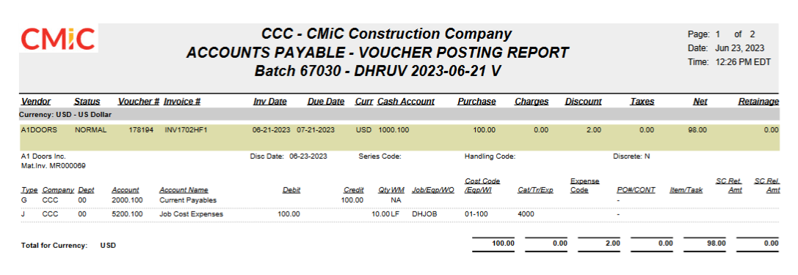
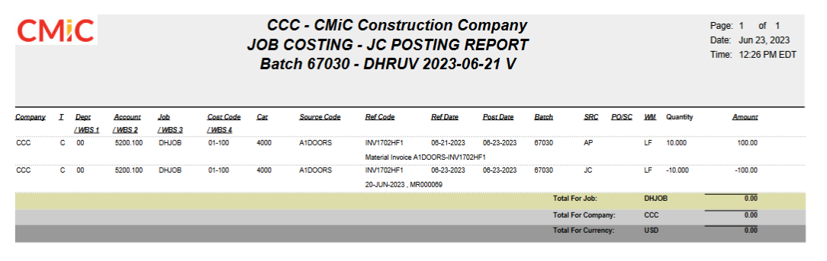
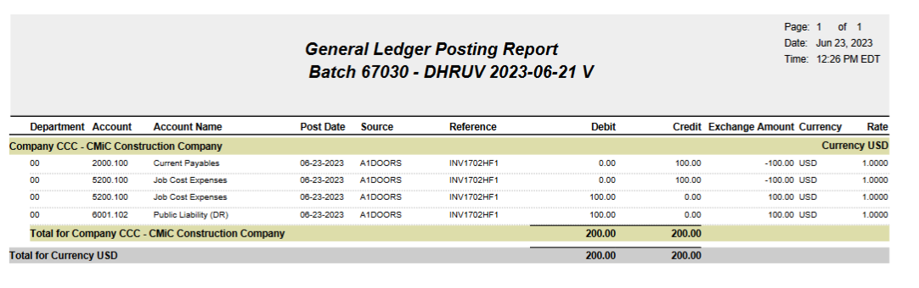
Distributing Variance across ‘Other Charges’
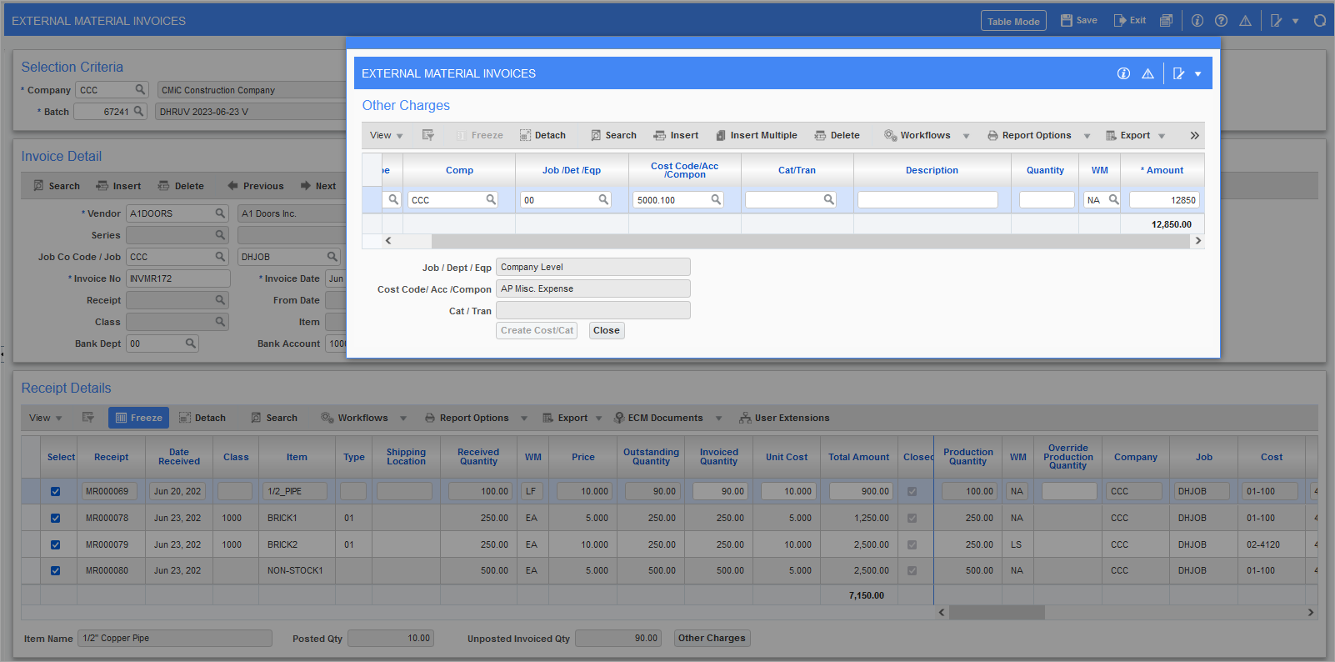
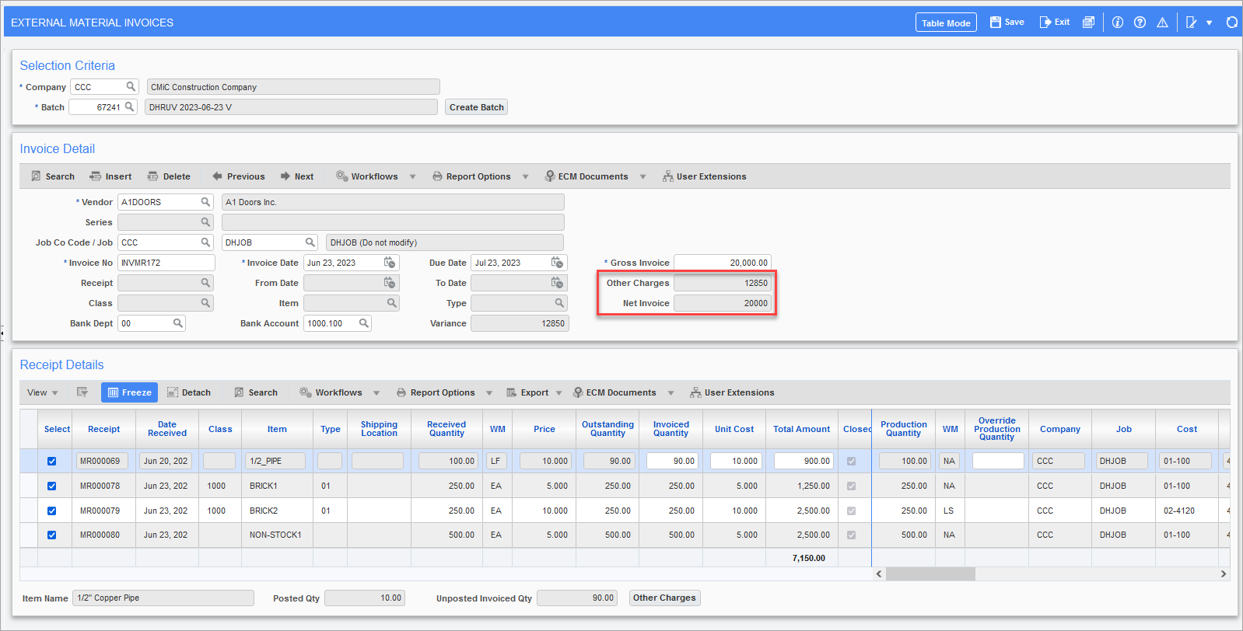
Posting reports:
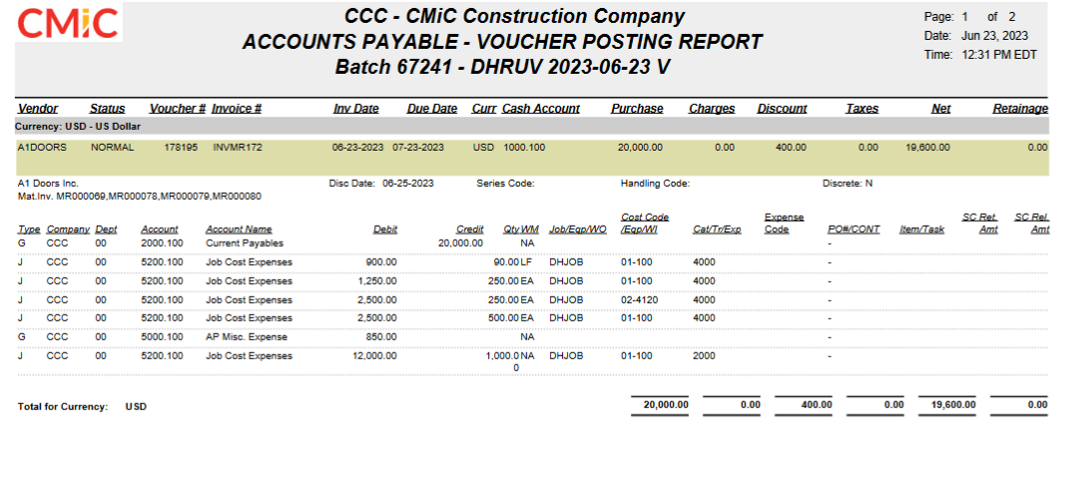
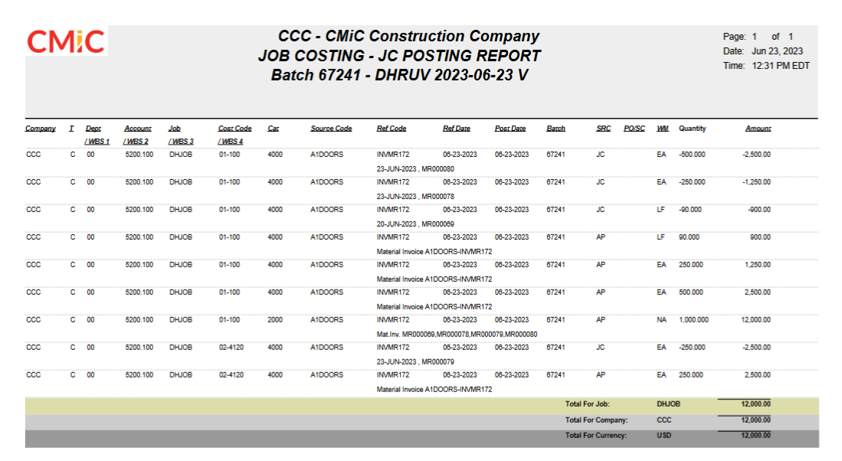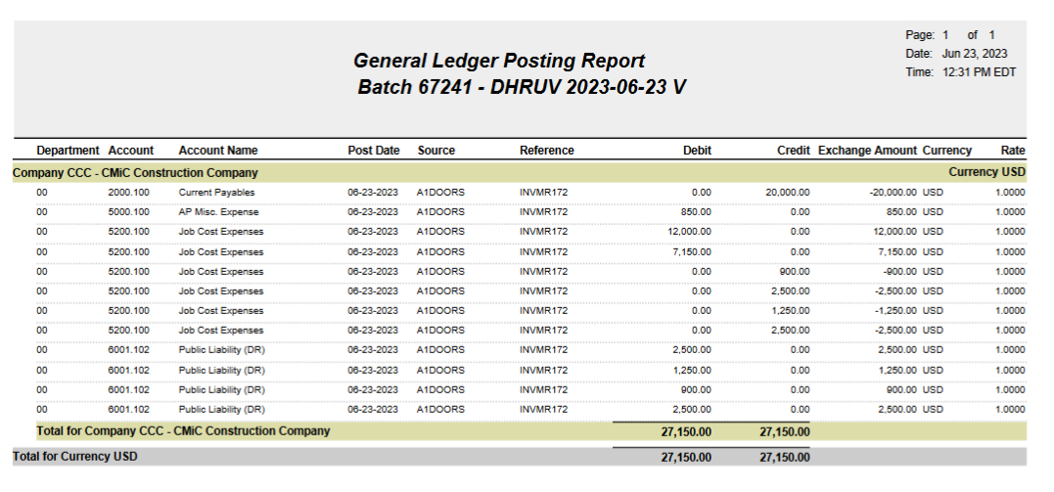
External Material Invoice for Vendor A1ARCH:
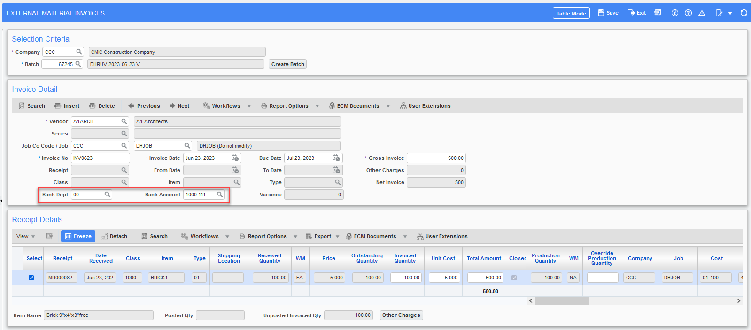
Posting reports:
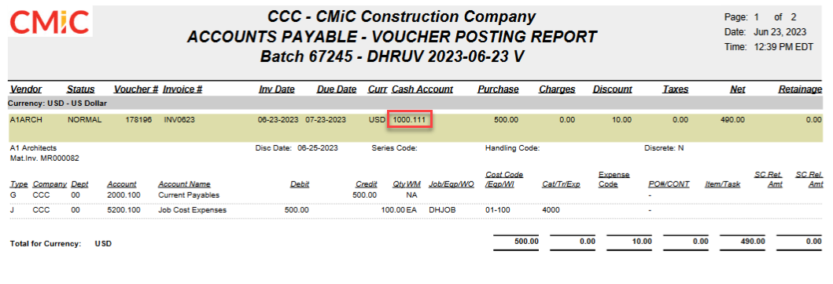
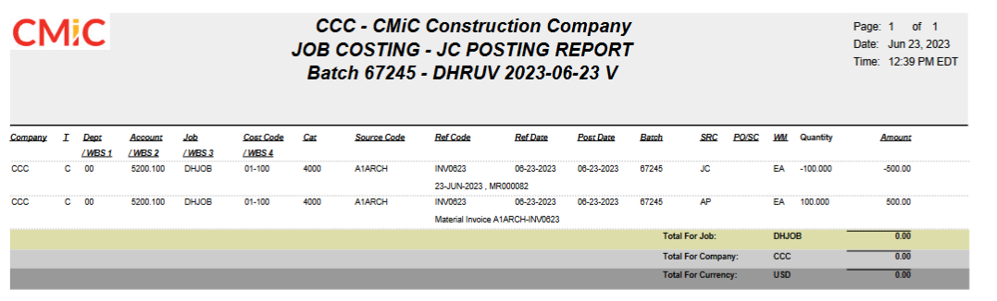
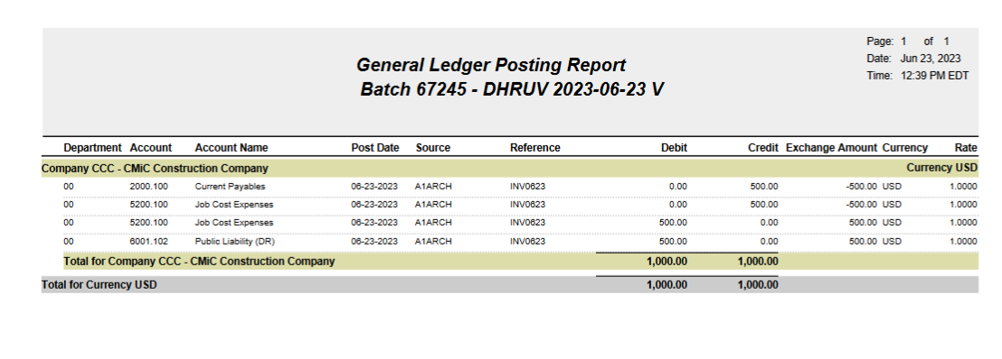
Canadian Vendor CANCOM with CAD and USD bank accounts – entering two invoices with different bank account. System utilizes exchange rates stored in exchange rate maintenance program for General Ledger posting.
Receipt:
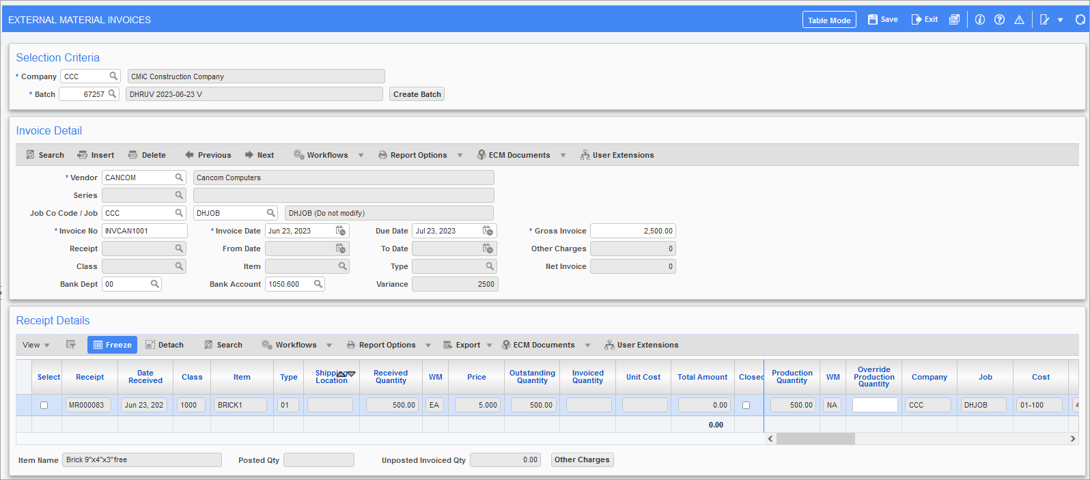
Case 1: Canadian Vendor with Canadian Bank account
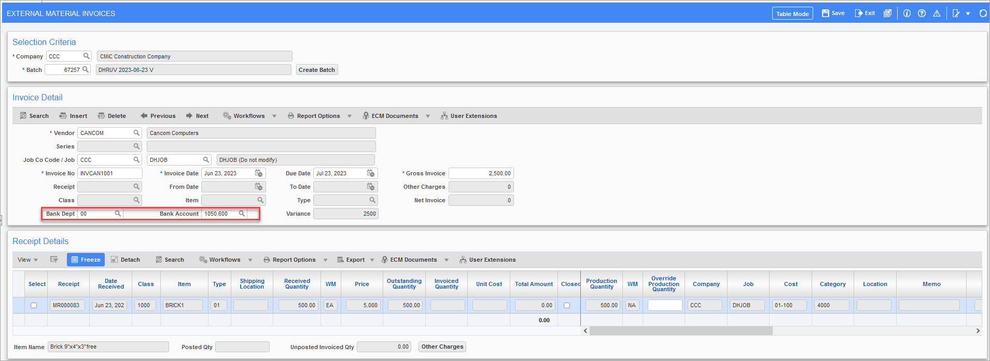
Posting reports:
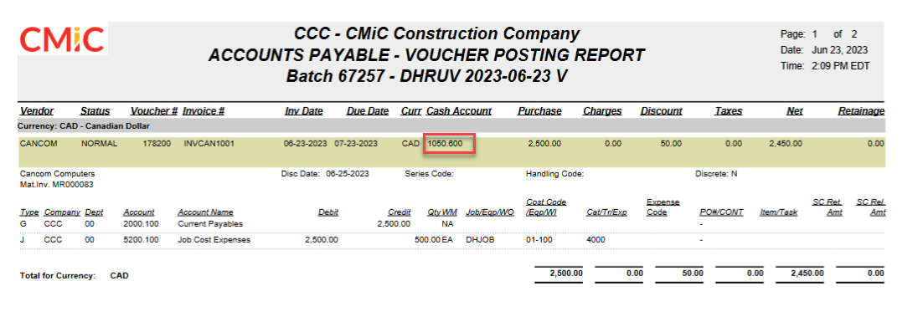
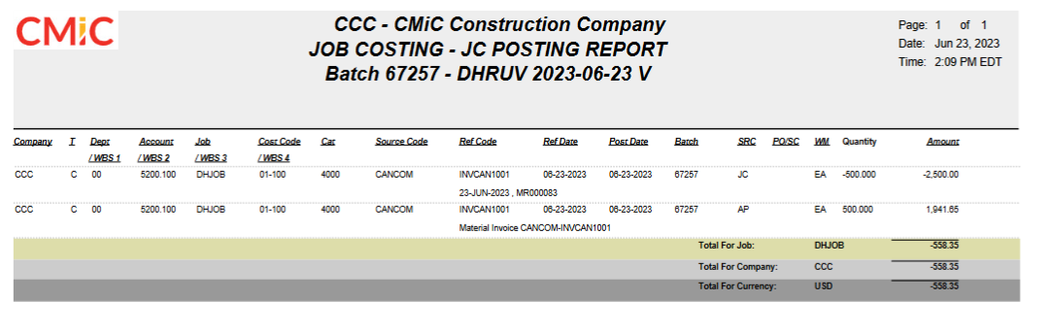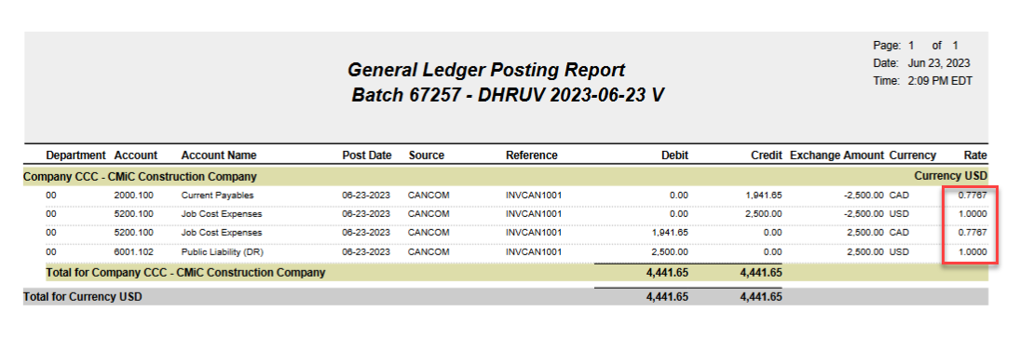
Case 2: Canadian Vendor with USD bank account
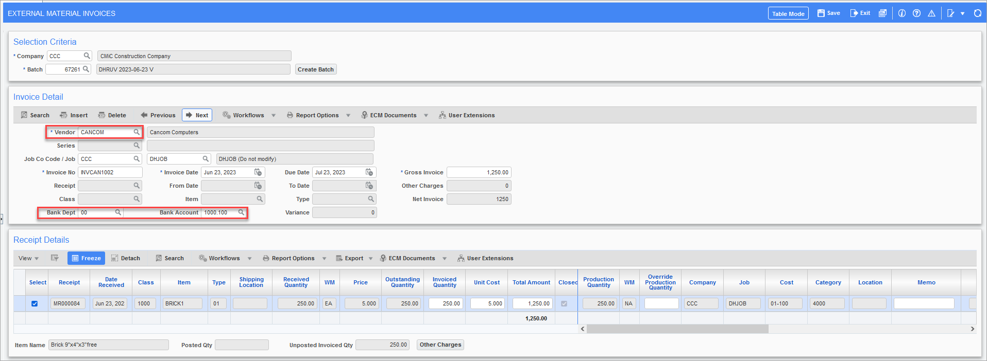
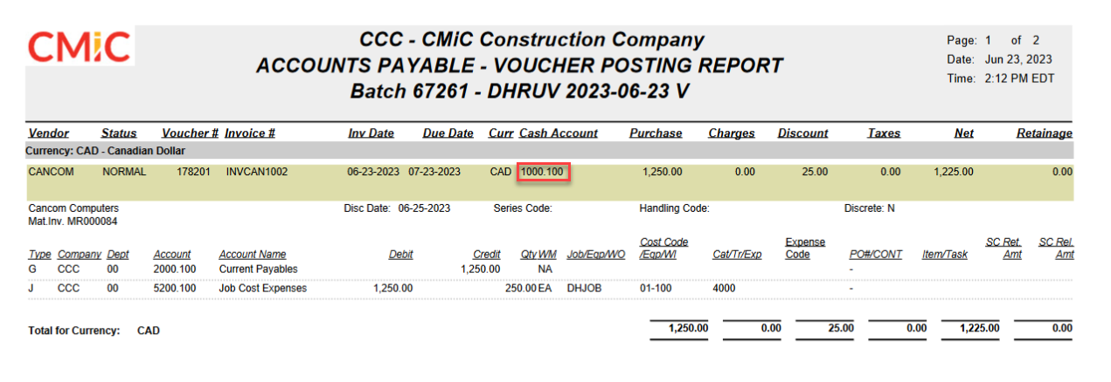
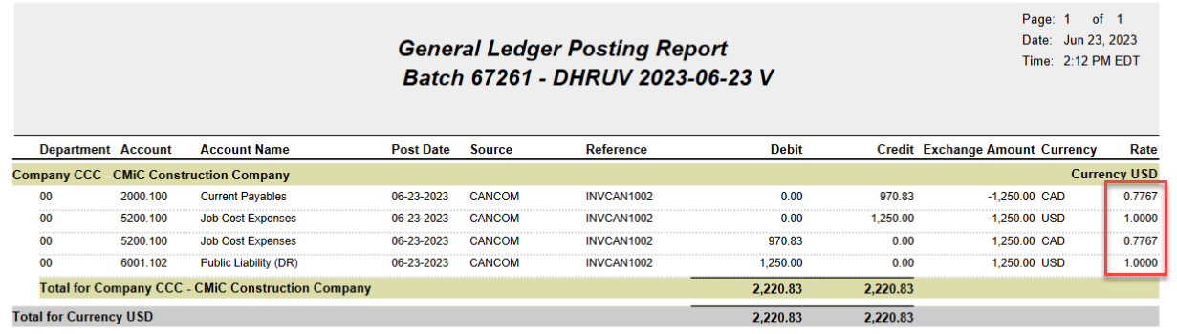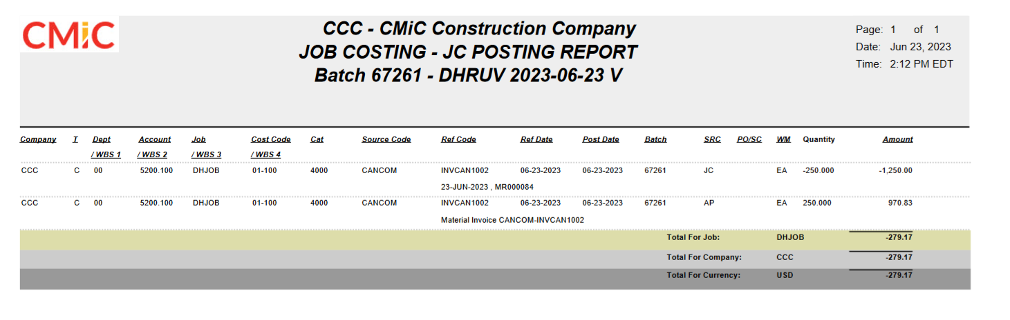

Opportunity Management

New Data Filter field in Opportunity Management (22.53208)

Modification:
A new field “Sub Opportunity” has been added to Data Filters to search opportunity using sub opportunity code. This field will not be present in Filters by default.
The Sub Opportunity field will be present under the Values section of Data Filter and can be added using “Add Value” button.
Users can create a new “Search Profile” with the new search field and save that profile for future use.
Search filter will work accurately when Search is done using “Contains” and putting Sub Opportunity code after winning the sub opportunity.
Implementation
STEPS
1.Navigate to Opportunity management ->Opportunities ->Click on SearchClick on Add Value
2.Search for Sub Opportunity
3.Select Sub Opportunity and Click OK
4.Click on Save Profile As ->Enter Profile Name and Click Ok

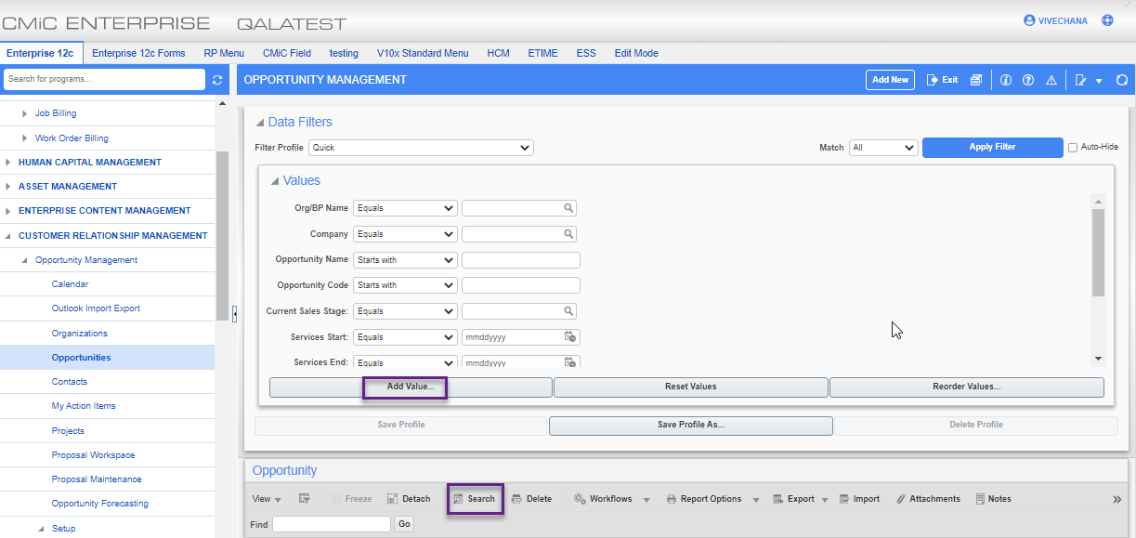
Customer Relationship Management>Opportunity Management >Opportunities>Search

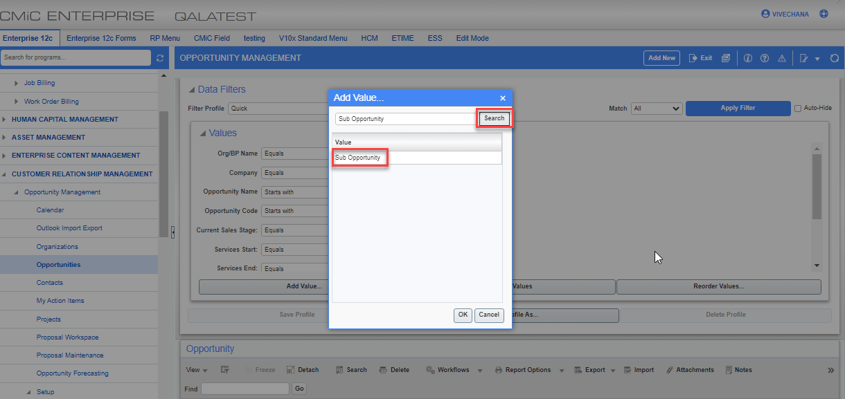
Customer Relationship Management>Opportunity Management >Opportunities>Search
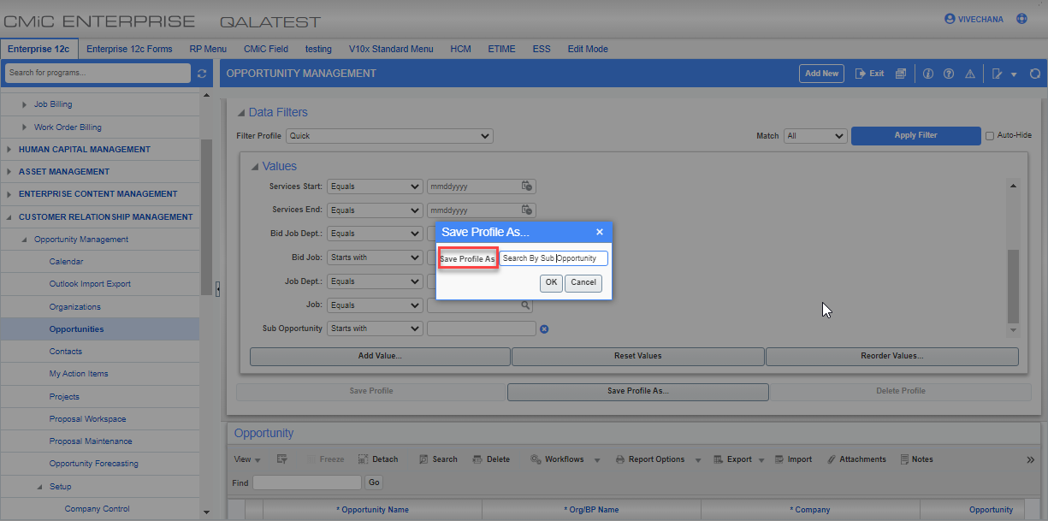
Customer Relationship Management>Opportunity Management >Opportunities>Search

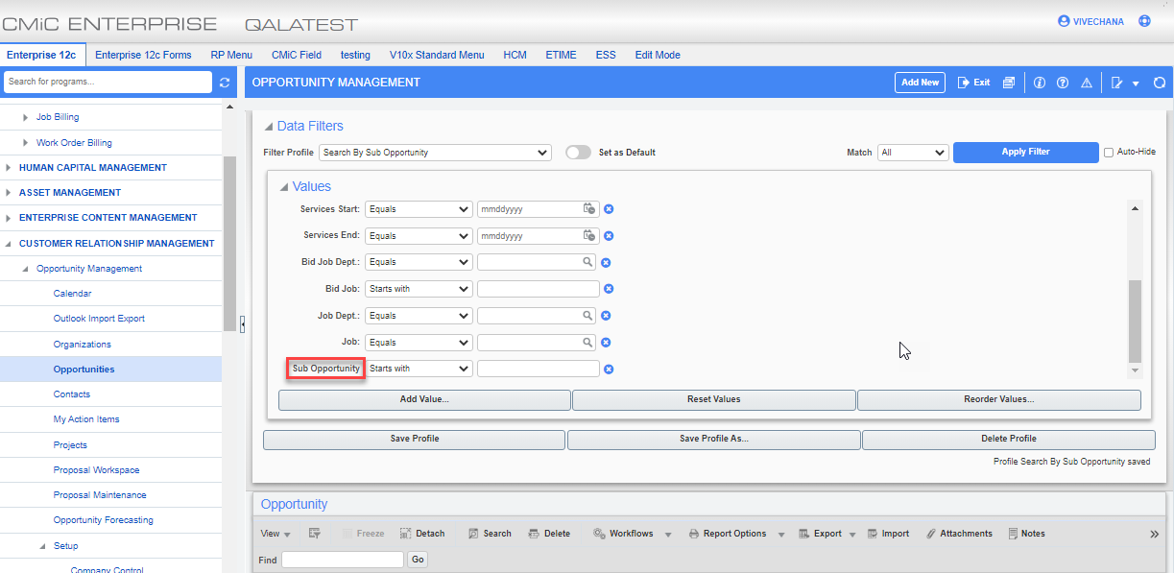
Customer Relationship Management>Opportunity Management >Opportunities>Search

Payroll US

Print Comments – Timesheet Edit Listing Report (22.63172)
Overview
CMiC has added a new checkbox to the Timesheet Edit List screen, which gives users the option of showing comments that were added to timesheets entered in E-Time and Crew Time. When the ‘Print Comments on the Report’ box is checked, the Timesheet Edit Listing Report (PY1010) will show the timesheets and comments for each employee by company.
Pre-requisites
Add comments while entering timesheets in E-Time and Crew Time.
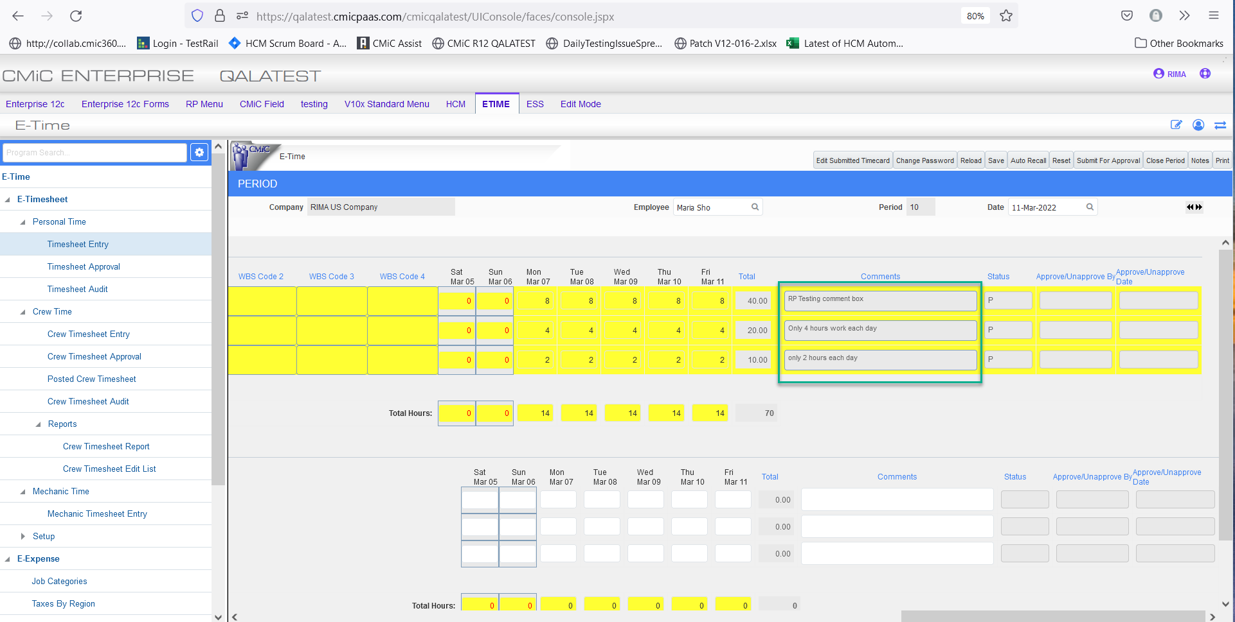
E-Time Timesheet Entry; standard Treeview path: E-Time > E-Timesheet > Timesheet Entry
The screenshot above shows comments added to the Comments field in the Timesheet Entry screen in E-Time.
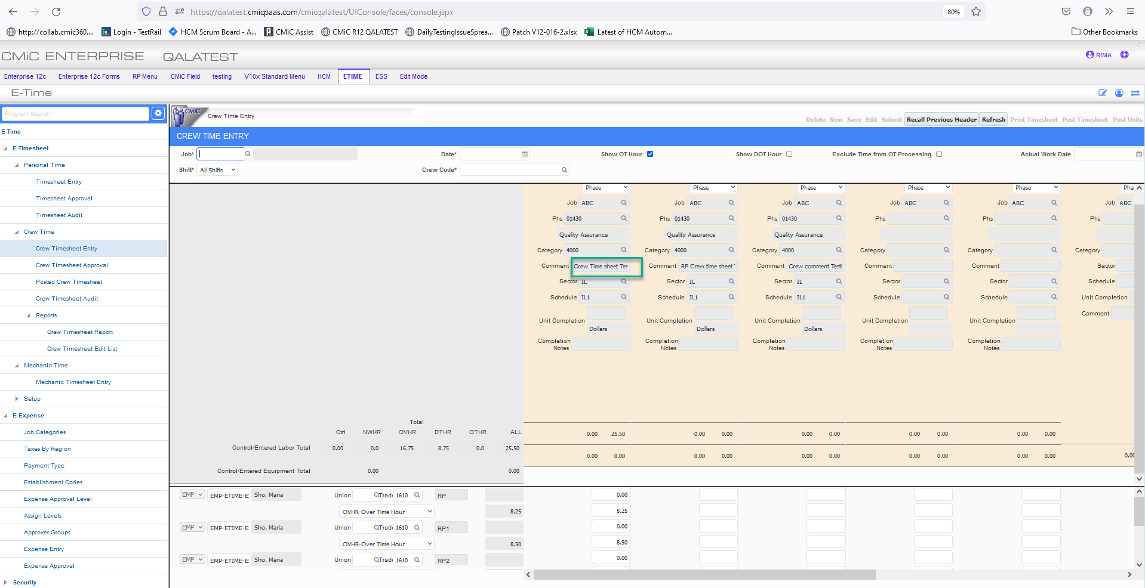
Crew Time Entry; standard Treeview path: E-Time > E-Timesheet > Crew Timesheet Entry
The screenshot above shows comments added to the Comment field in the Crew Timesheet Entry screen in Crew Time.
Modifications and Implementation
The ‘Print Comments on the Report’ checkbox has been added to the Timesheet Edit List screen in the Payroll module.
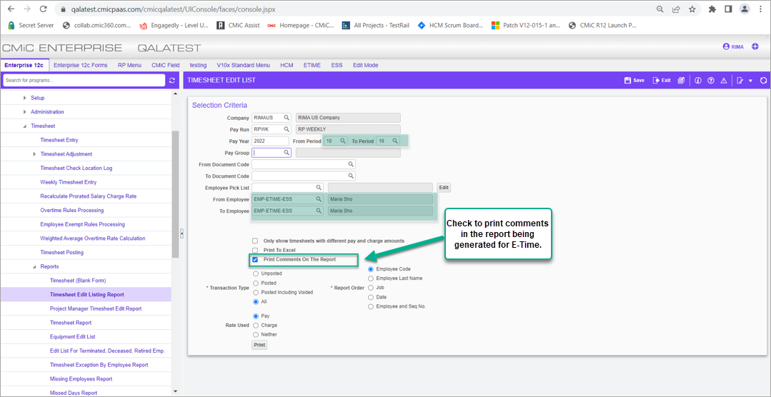
Pgm: PY1010 – Timesheet Edit List; standard Treeview path: US Payroll > Timesheet > Reports > Timesheet Edit Listing Report
Check this box to include comments from timesheets entered in E-Time when printing the Timesheet Edit Listing Report.

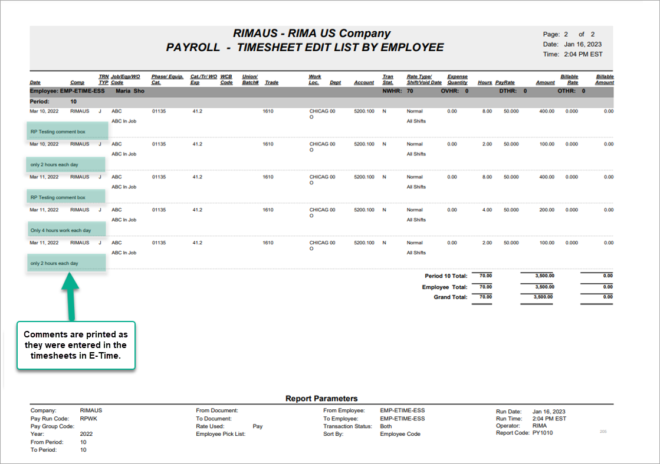
Timesheet Edit Listing Report showing comments from timesheets entered in E-Time
Comments that were added to the Comments field in the Timesheet Entry screen in E-Time are printed in the Timesheet Edit Listing Report.

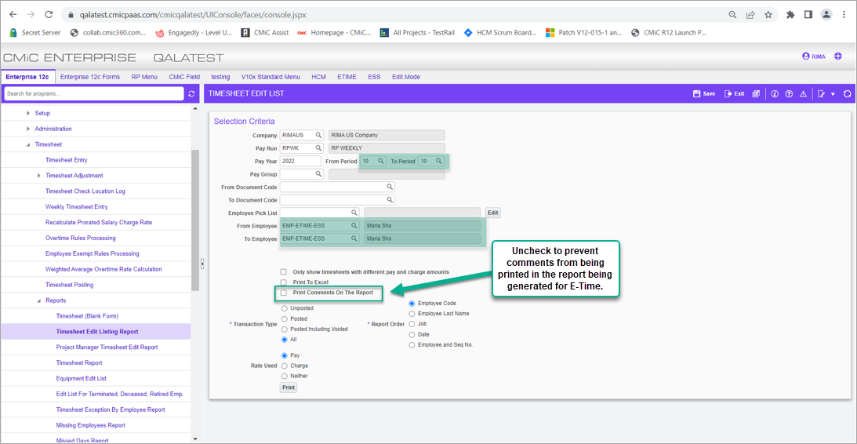
Pgm: PY1010 – Timesheet Edit List; standard Treeview path: US Payroll > Timesheet > Reports > Timesheet Edit Listing Report
Uncheck this checkbox so comments from timesheets entered in E-Time are not included when printing the Timesheet Edit Listing Report.
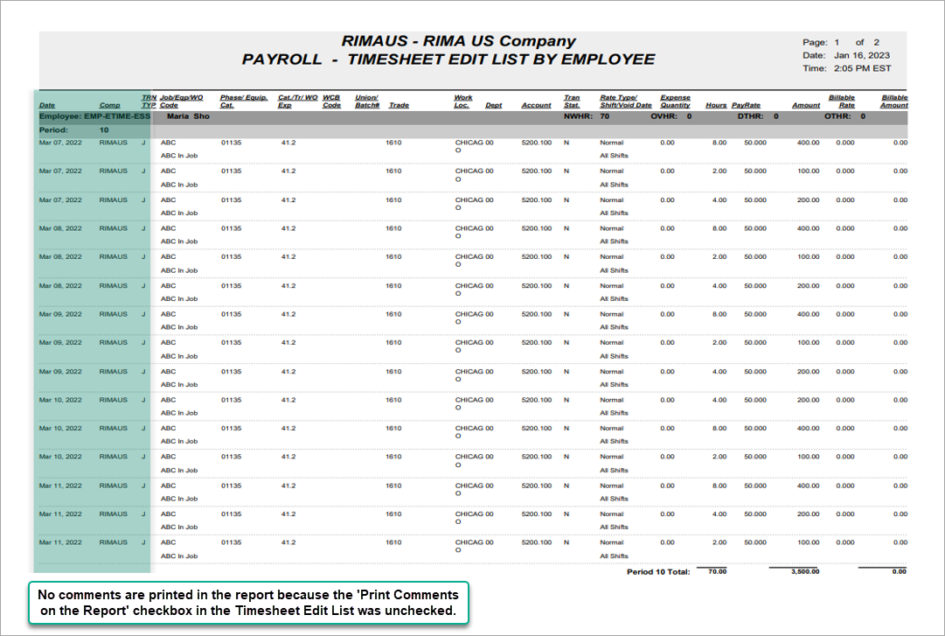
Timesheet Edit Listing Report showing no comments from timesheets entered in E-Time
No comments are printed because the ‘Print Comments on the Report’ box is unchecked in the Timesheet Edit List screen.

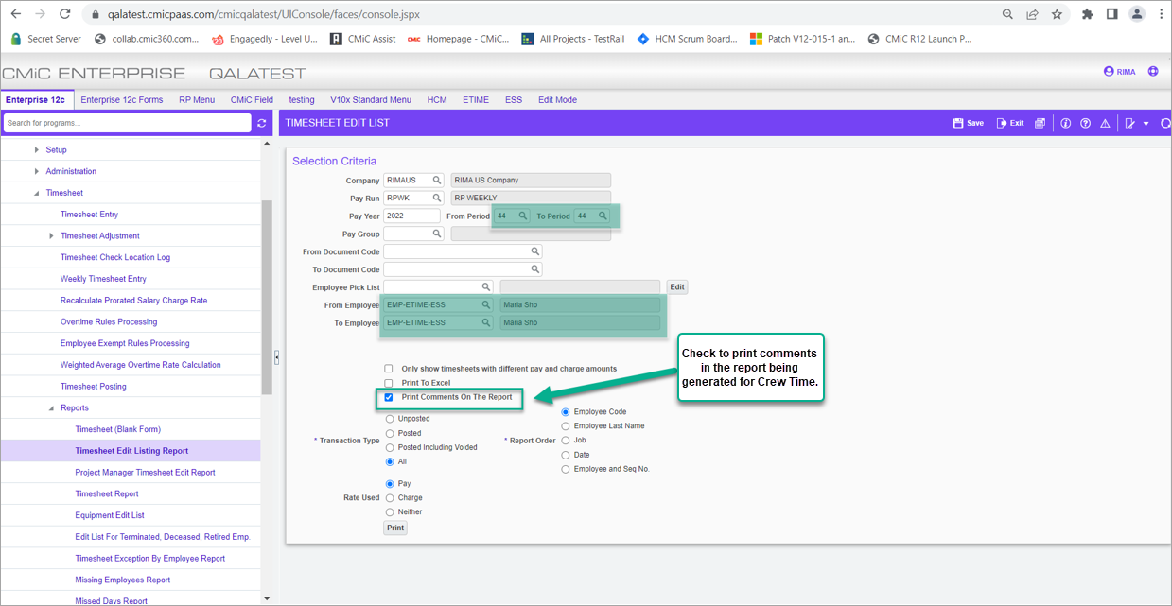
Pgm: PY1010 – Timesheet Edit List; standard Treeview path: US Payroll > Timesheet > Reports > Timesheet Edit Listing Report
Check this box to include comments from timesheets entered in Crew Time when printing the Timesheet Edit Listing Report.
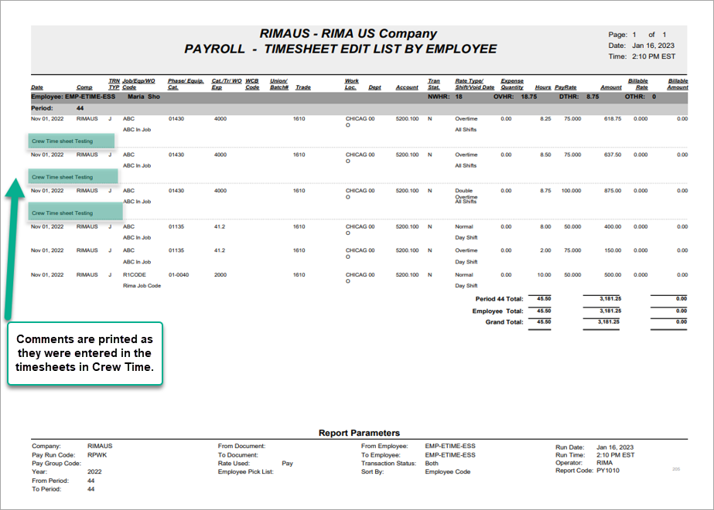
Timesheet Edit Listing Report showing comments from timesheets entered in Crew Time
Comments that were added to the Comments field in the Crew Timesheet Entry screen in Crew Time are printed in the Timesheet Edit Listing Report.

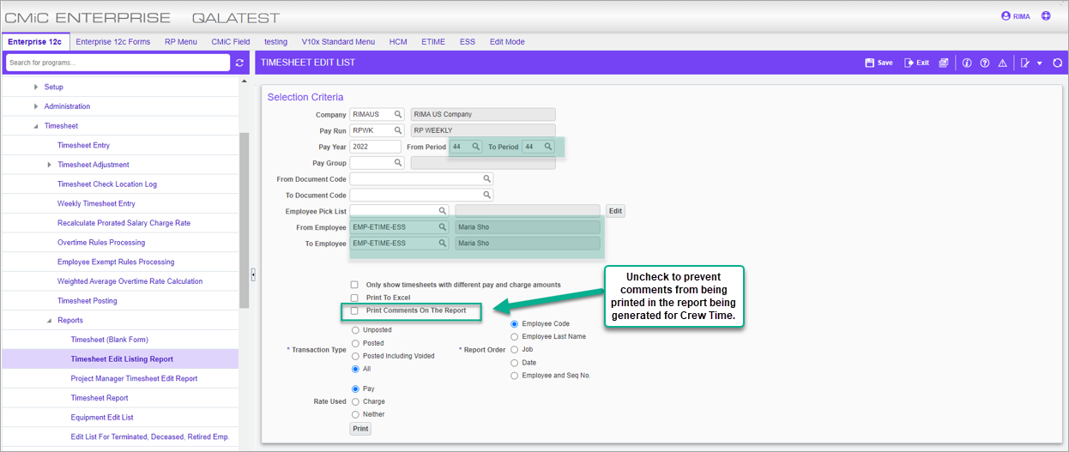
Pgm: PY1010 – Timesheet Edit List; standard Treeview path: US Payroll > Timesheet > Reports > Timesheet Edit Listing Report
Uncheck this checkbox so comments from timesheets entered in Crew Time are not included in the Timesheet Edit Listing Report.

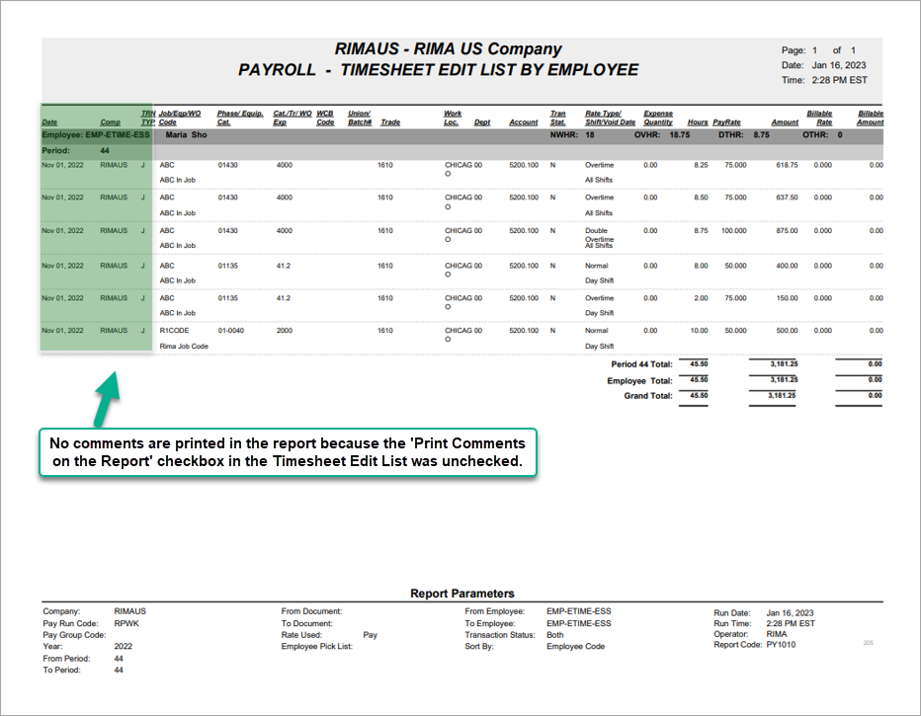
Timesheet Edit Listing Report showing no comments from timesheets entered in Crew Time
No comments are printed because the ‘Print Comments on the Report’ box is unchecked in the Timesheet Edit List screen.

Addition of new flag on pay groups screen ‘Override Account’ (22.61180)
Overview
ALEC payroll is processed at the end of the month and posted but does not necessarily pay to go to the employee's bank. The payments are later released after approval and could delay 3-5 days. The ALEC does not want to hit the CASH account when the final posting was done instead cash should hit the company control account. CMIC added a new “Override Account” flag on pay groups screen to allow users to override the cash account. The user can override the account on the pay group screen without changing it on the global bank account screen.
Pre-requisites
Alternate work days under company is required to be set to 7 working days as per Dubai region working days.
Override Account flag should be checked.
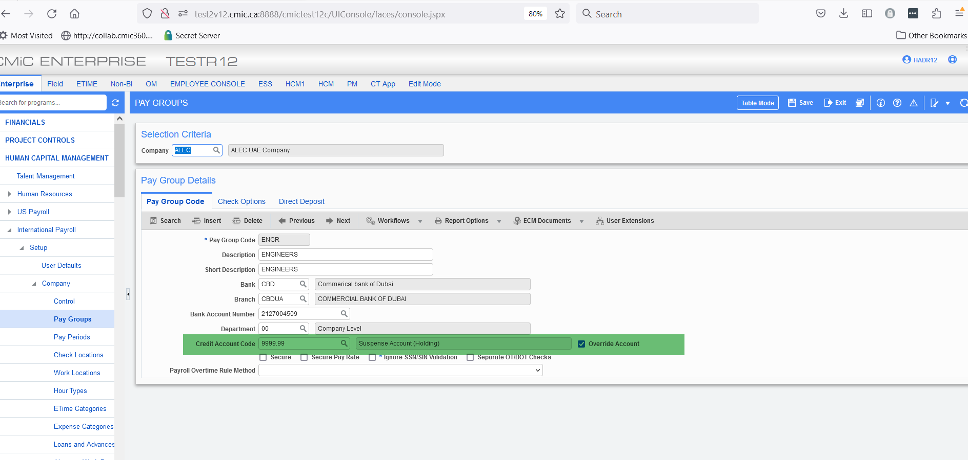

Modifications
A new flag is added on the pay groups screen known as “Override Account” for Dubai region. When the override account flag is checked user can select a credit account code and when its unchecked it will populate its original account before the change.
Implementation
An example of the functionality of the new flag is as follows:
Step#1: Check the override account flag and select the suspense holding account of 9999.99
Step#2: Print all checks after payroll processing and check processing.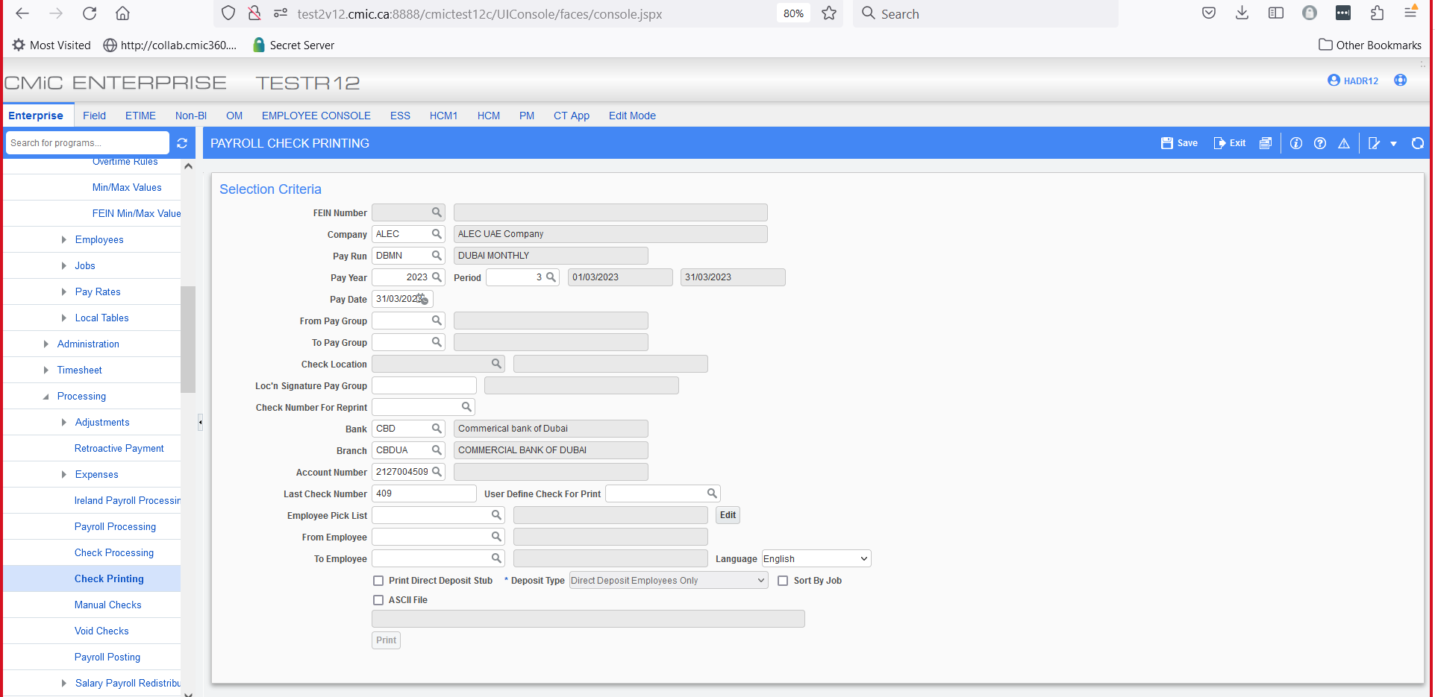
Step#3: Post payroll and verify that the GL posting report include the credit account “suspense account” selected on the pay group screen.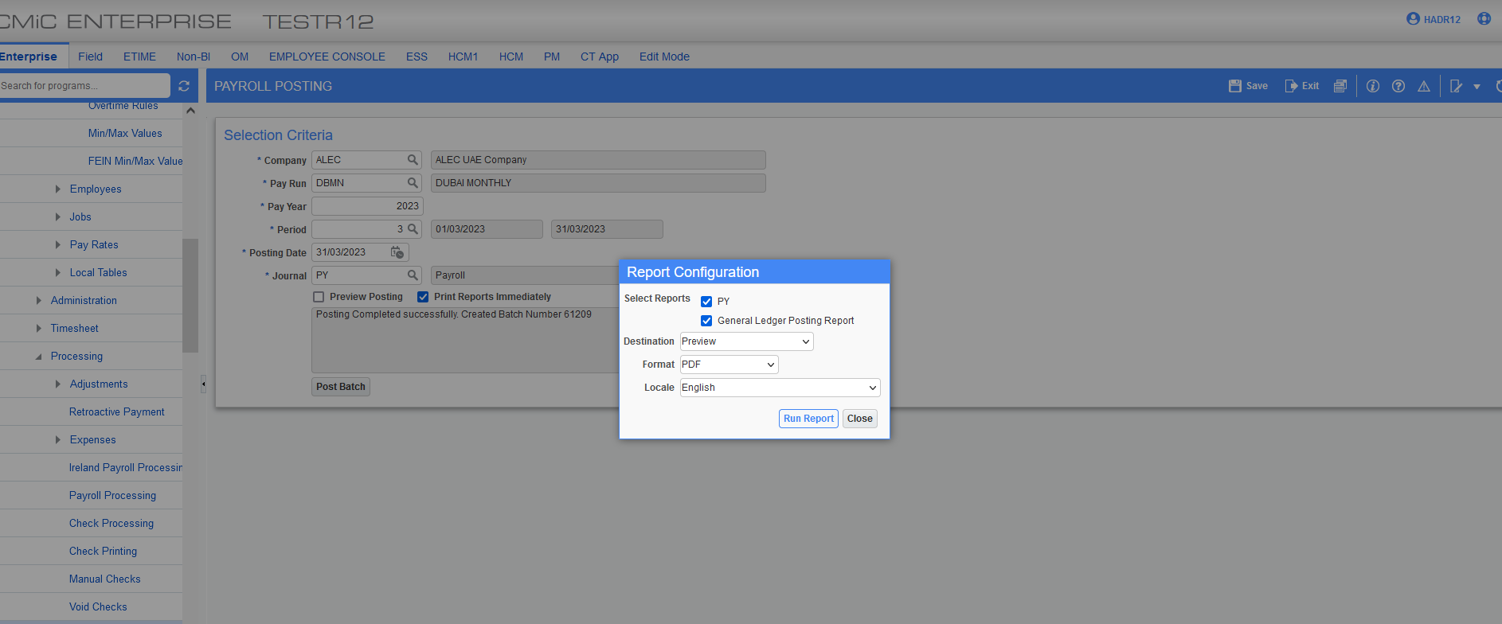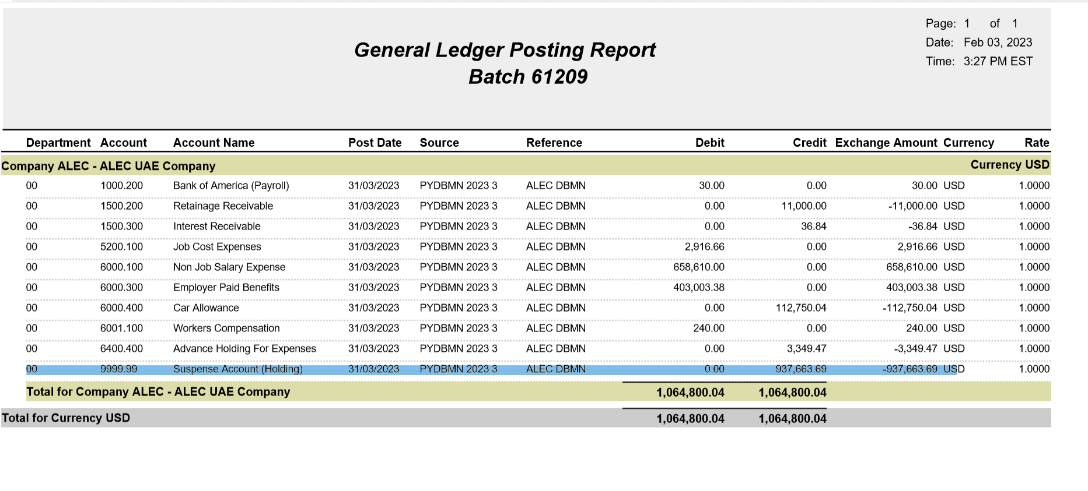Step#4: Manual General Journal Entries for further validation.
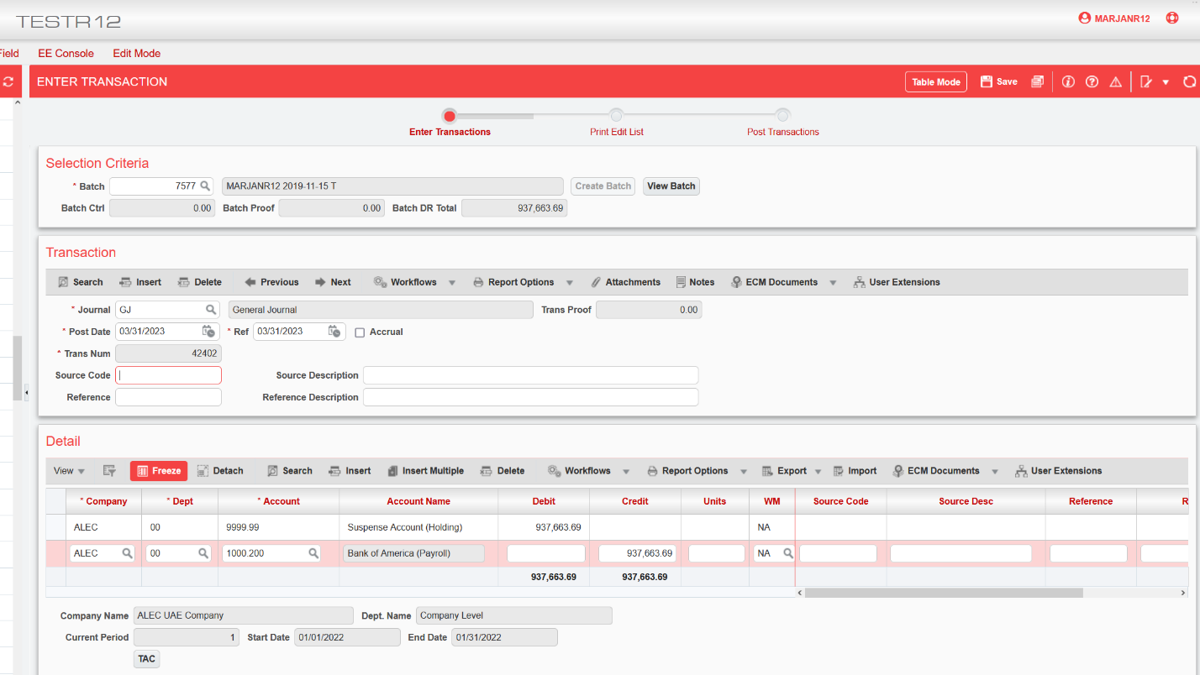
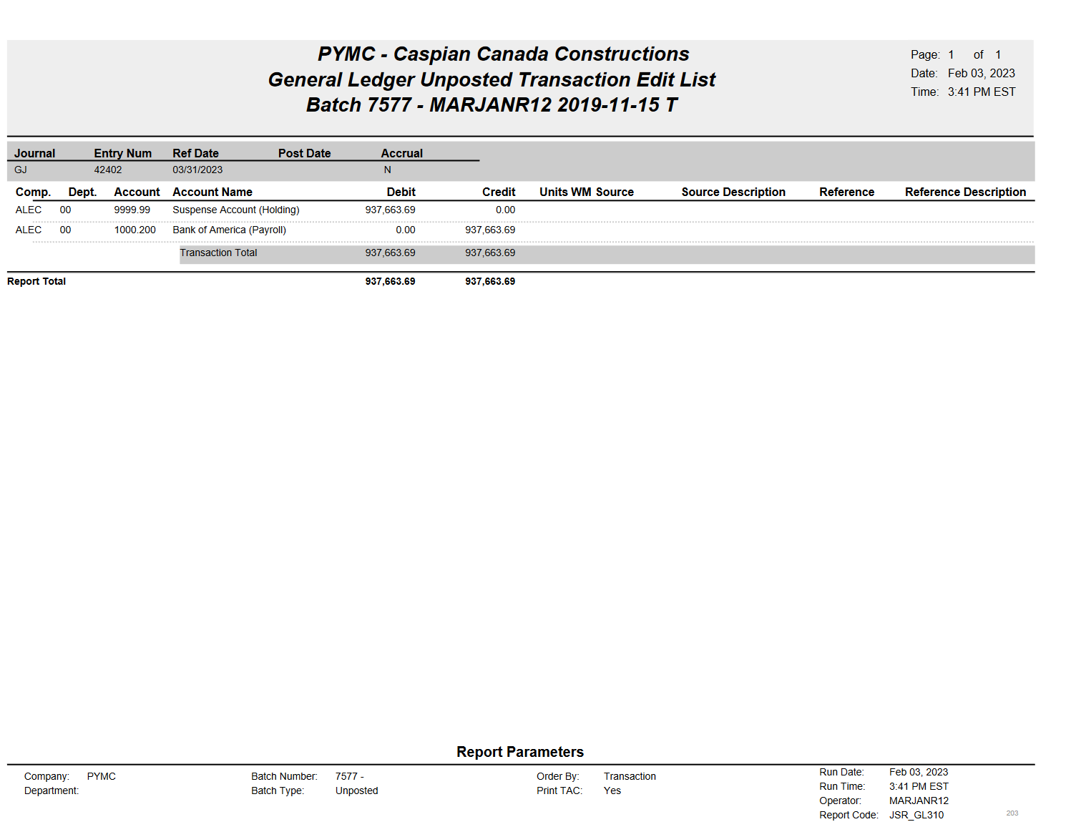
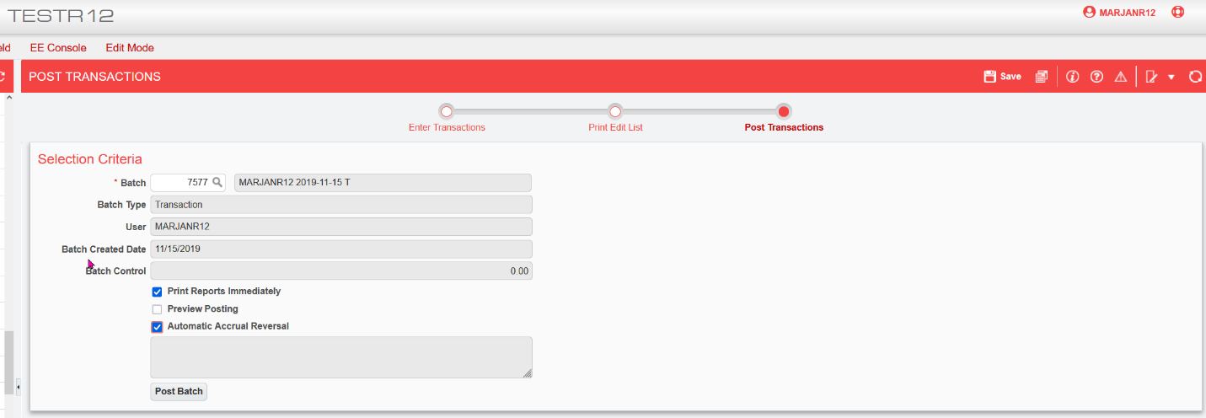
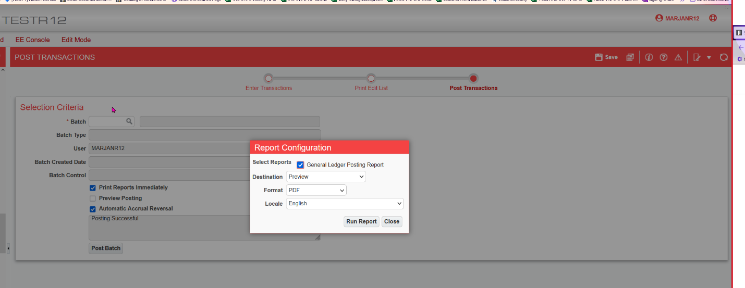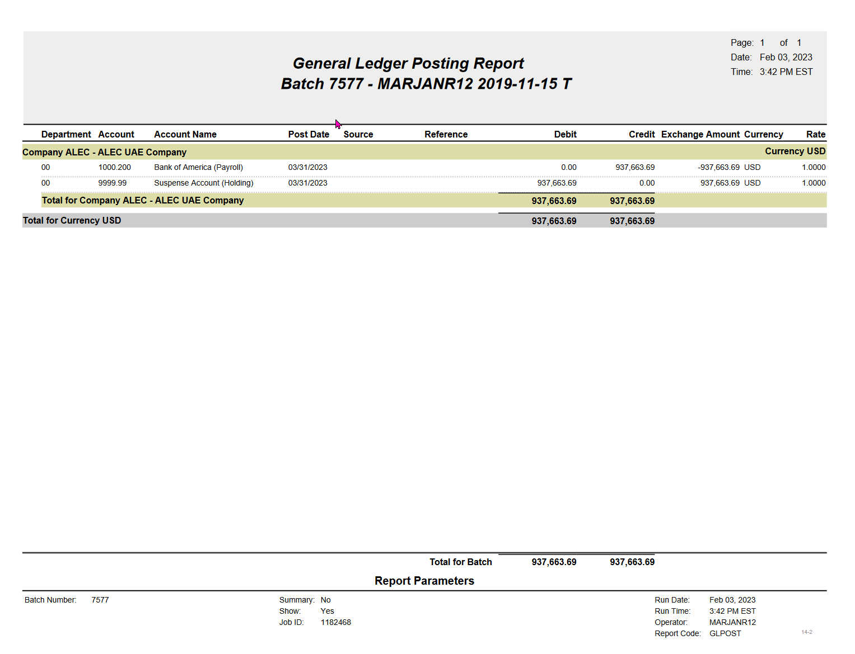

Job Benefit/Deduction Setup (22.64386, HCM - 3393)
Overview – Released in hot fix V12-017-2HF02N.
CMiC has enhanced the Job screen in the US Payroll module with several new features. Two new options have been added to the screen and the processing has been updated to allow benefits and deductions to be calculated at the controlling job level. With this enhancement, it’s now possible to calculate benefits and deductions for sub-jobs on a controlling job.
NOTE: The previous name for this screen was “Job Benefits”. As this screen allows for both benefits and deductions to be added to jobs, it has been re-named to “Job”.
Pre-requisites
Set up benefits/deductions at the job level.
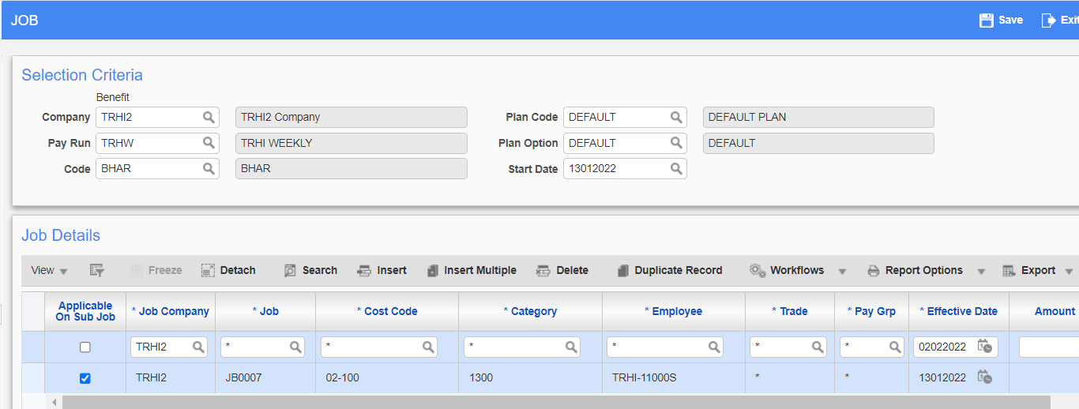
Modifications

Duplicate Record Button
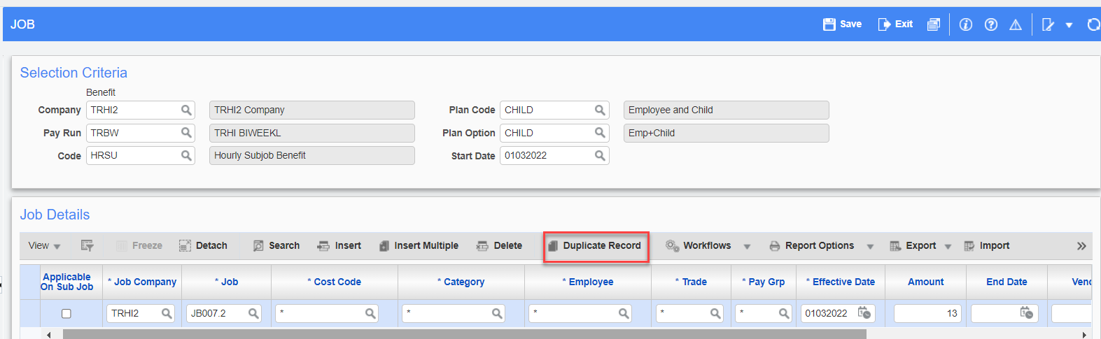
Pgm: PYJOBBEN – Job; standard Treeview path: US Payroll > Administration > Benefits > Job
A new [Duplicate Record] button has been added to the Block toolbar in the Job Details section of the Job screen. This button is used to save time when inserting job detail records by allowing an existing record to be copied when inserting a new record. Once a record exists in this section, if a new line is inserted, pressing the [Duplicate Record] button will duplicate the information from the previous record into the new record. The new record can then be edited as required.
Import Button
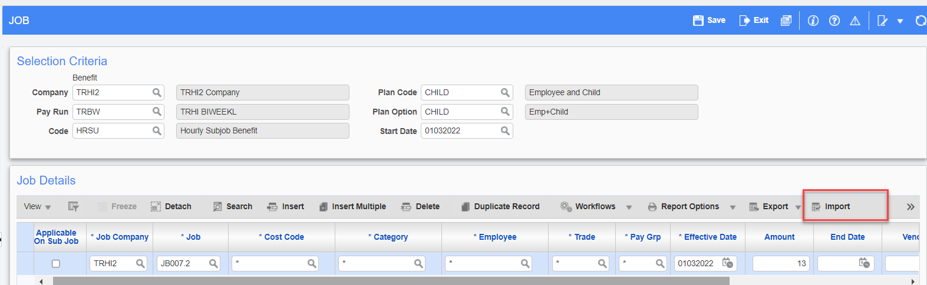
A new [Import] button has also been added to the Block toolbar in the Job Details section of the Job screen. This button is used to import job detail records. Data can be imported from a .csv file or by copying the data from an Excel spreadsheet and pasting it into the Data Import pop-up window.
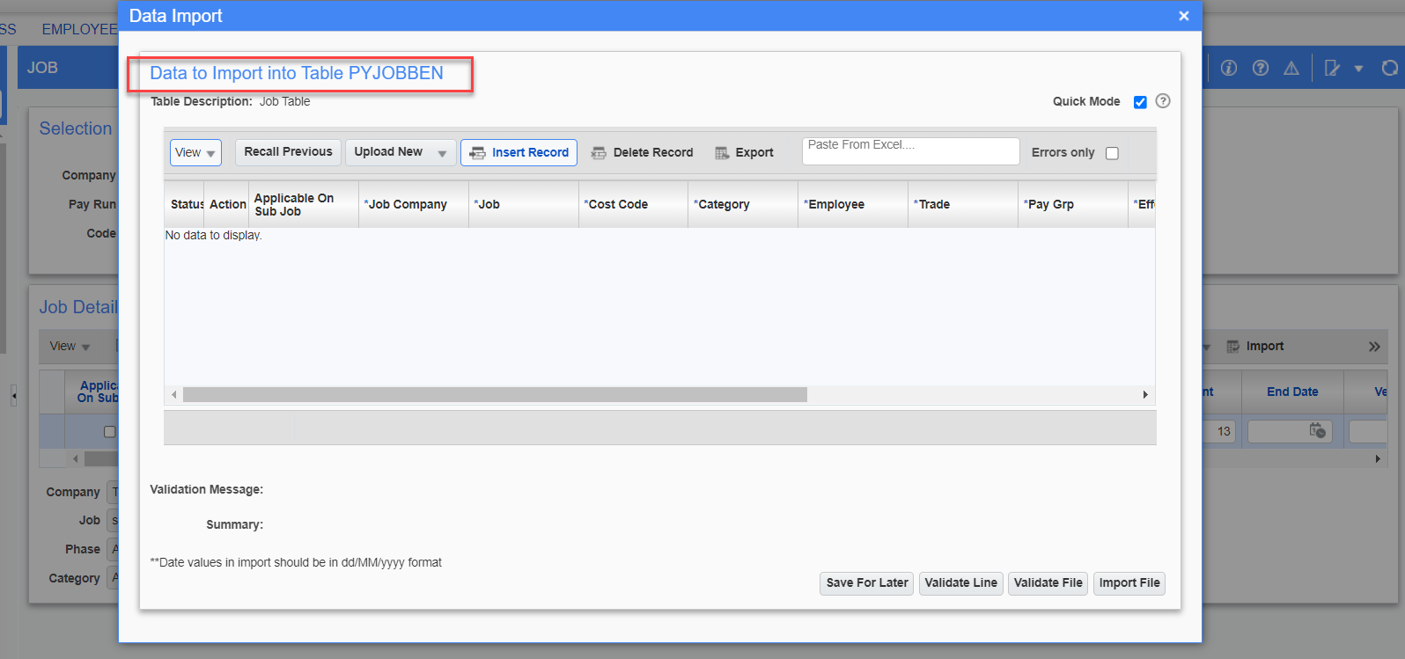

Setup by Controlling Job
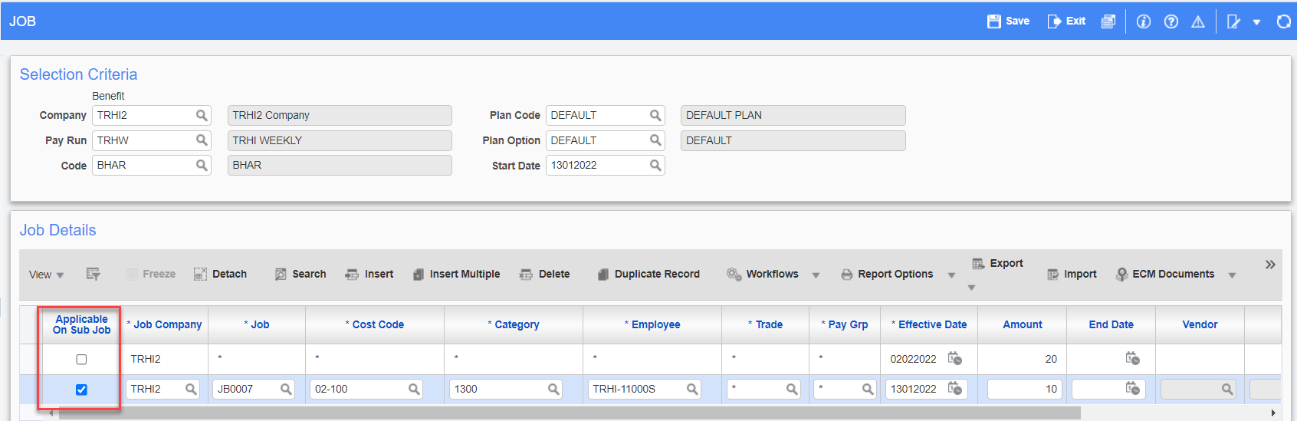
A new column titled “Applicable on Sub Job” has been added to the Job Details section of the Job screen. By default, the checkboxes for the records in this column will be unchecked for existing data. This checkbox will only be enabled for a controlling job.
Implementation
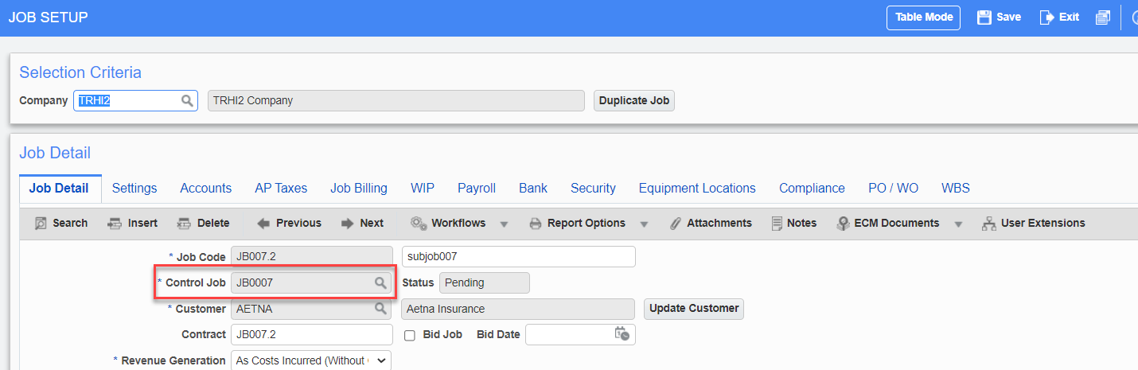
Pgm: JCJOBFM – Job Setup; standard Treeview path: Job Costing > Job > Enter Job – Job Detail tab
A sub-job must be assigned to a controlling job in the Job Costing module, as shown above.
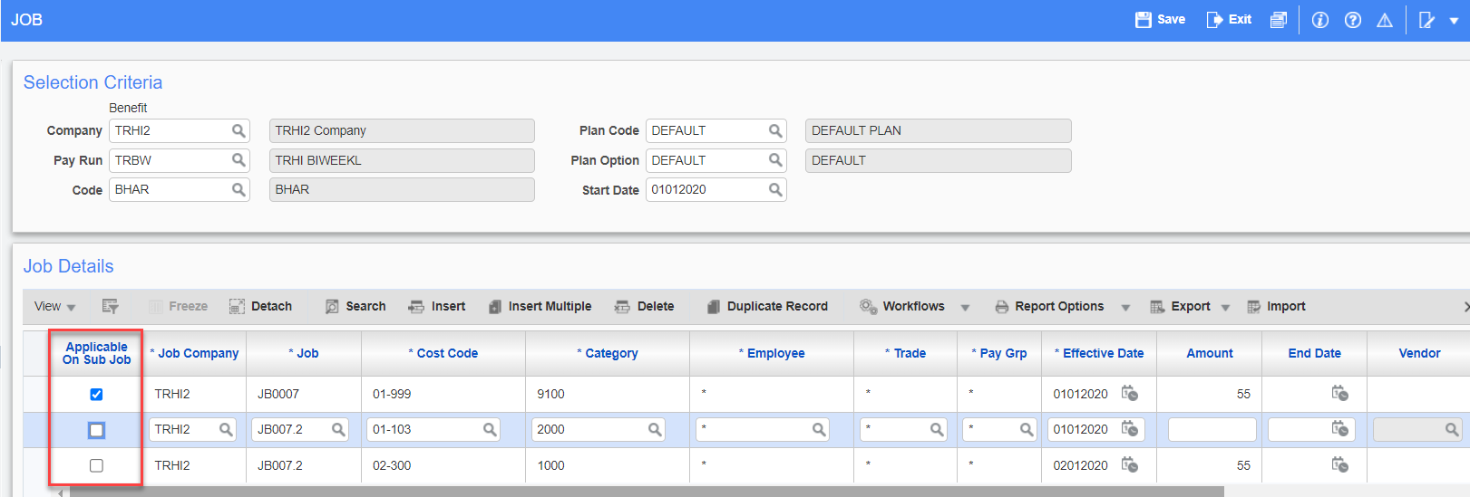
When the required job setup is complete in Job Costing, the checkboxes in the Applicable on Sub Job column will be enabled for a controlling job. By checking the box on a controlling job, the benefits/deductions will be applicable for all its sub-jobs.
As shown in the screenshot above, the job JB007.2 is a sub-job of controlling job JB0007.
If an employee inserted a timesheet against sub-job JB007.2, the benefit/deduction on the sub-job will be calculated automatically based on the ‘Applicable on Sub Job’ checkbox being enabled. If more sub-jobs are added to a controlling job, they will automatically be added to the processing.
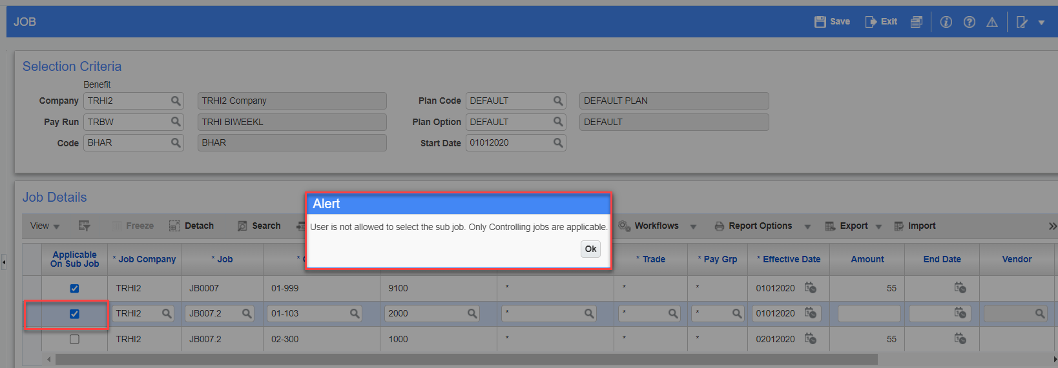
This checkbox is not enabled for sub-jobs. If an attempt is made to check the box for a sub-job, an Alert message will be issued.
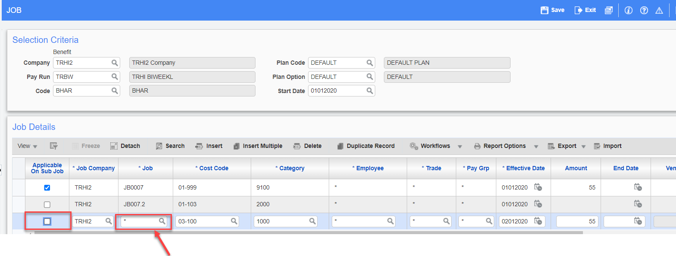
In addition, this checkbox is not applicable if the job under benefit/deduction is set up as “ALL JOBS”.
Exceptions:
For any employees who are not entitled to the benefit/deduction on a particular sub-job, a new record can be created for that sub-job with a zero amount. The processing will not calculate the benefit/deduction for the specific sub-job as the amount is zero.
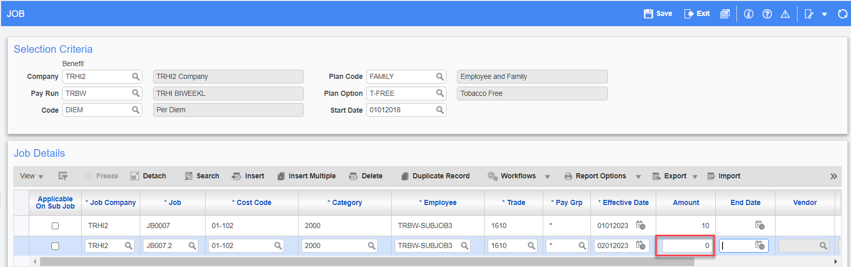
This could also be used if the sub-job has a different amount than controlling job.

Non-Paid Hours Column Added to Hour Types Screen in US Payroll (23.68359, HCM - 2924)
Overview – Released in hot fix V12-017-2HF03G.
CMiC has enhanced the Hour Types screen in the US Payroll module with a new column which is used for hour type codes that track non-paid working hours. Although employees are not paid for time recorded against these specific hour type codes, they will still be able to enter, submit, approve, and post the non-working hours for tracking purposes.
Modifications
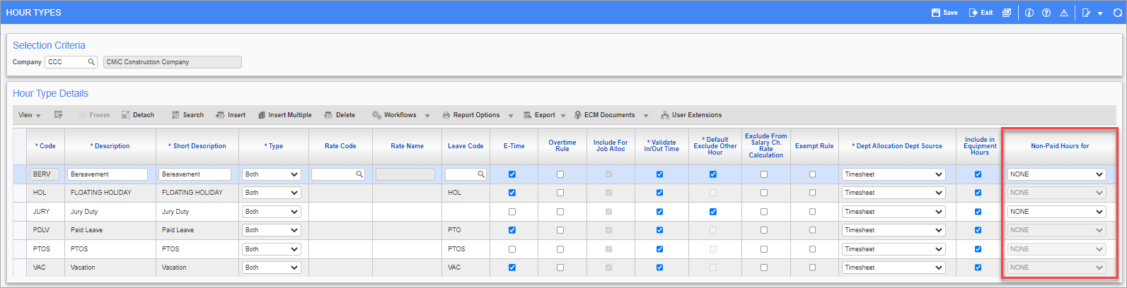
Pgm: PYHRTYPE – Hour Types; standard Treeview path: US Payroll > Setup > Company > Hour Types
The Hour Types screen is used to create hour type codes for hours that fall outside of the standard type of hours under which employees are paid in Timesheet Entry. A new Non-Paid Hours For column has been added to the screen, which is used in situations where the hour type being created is for non-paid hours (e.g., weather-related hours, sick hours, late hours, etc.).
Options available in the new column’s drop-down menu are as follows:
- None: Existing functionality. All rates will be populated in timesheet tables.
- All: The impact will be on all pay, charge, and bill rates (so no rates will be populated or posted).
- Charge & Billing: The hour type will not populate the charge and billing rate.
- Charge Only: The hour type will not populate the charge rate and will not cost in Job Costing.
- Billing Only: The hour type will not populate the billing rate and will not cost in billing.
NOTE: None of these hours will be inserted into the PYEMPPAYHIST table.
The options in this column are only enabled for hour type codes that are not associated with a leave code.
If an hour type code is mapped to a leave code, the Non-Paid Hours For column will be disabled and will display a default value of “NONE”.
Similarly, if an existing hour type code which was previously not mapped to a leave code is subsequently mapped to a leave code, the Non-Paid Hours For column will automatically become disabled and will display a default value of “NONE”.
This feature has been added to Timesheet Entry, E-Time, and Crew Timesheet.
Implementation
The screenshots below show an example of how this feature is used in the Timesheet Entry screen.
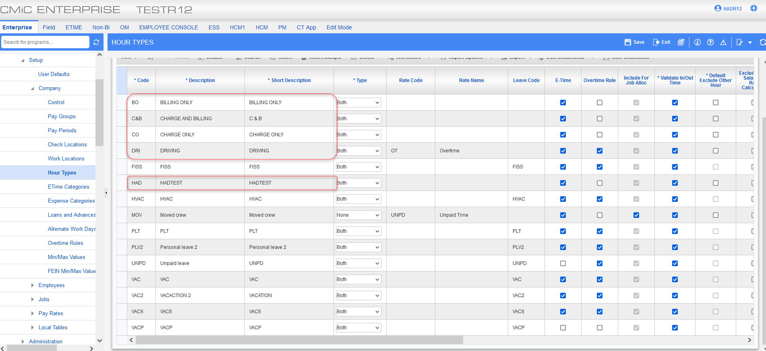
Pgm: PYHRTYPE – Hour Types; standard Treeview path: US Payroll > Setup > Company > Hour Types
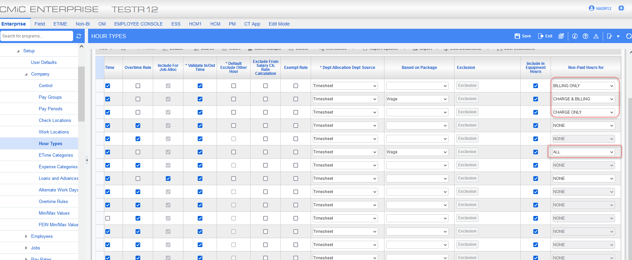
Pgm: PYHRTYPE – Hour Types; standard Treeview path: US Payroll > Setup > Company > Hour Types
The screenshots above show the Hour Types screen with five different hour types highlighted. Each of these hour types is using a different option in the Non-Paid Hours For column.
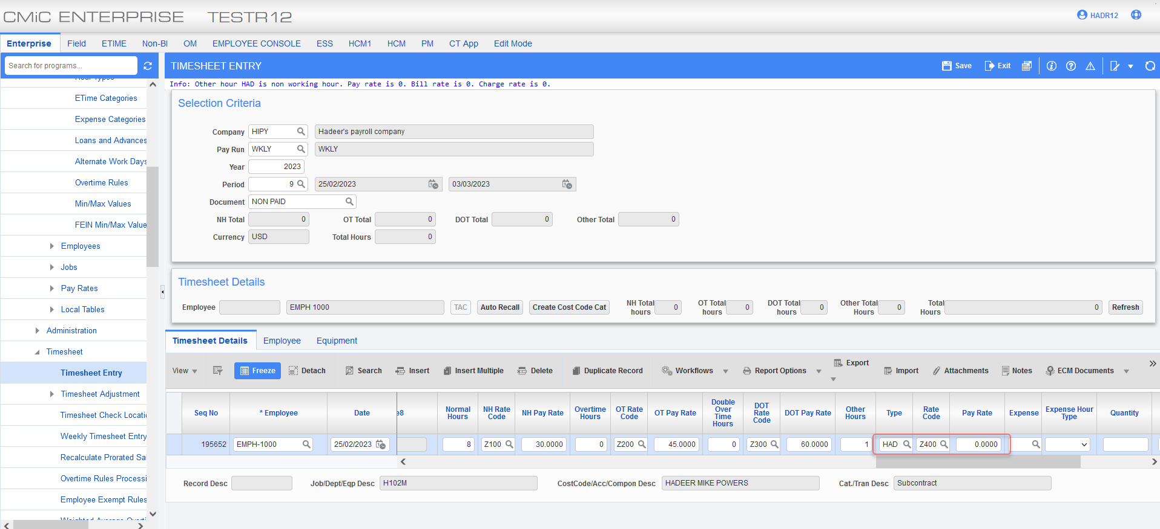
Pgm: PYTIMSTM – Timesheet Entry; standard Treeview path: US Payroll > Timesheet > Timesheet Entry – Timesheet Details tab
A work record has been entered for an employee in the Timesheet Entry screen using the HAD hour type code, which is tracking non-paid hours for “ALL”. The impact will be on all pay, charge, and bill rates (so no rates will be populated or posted).
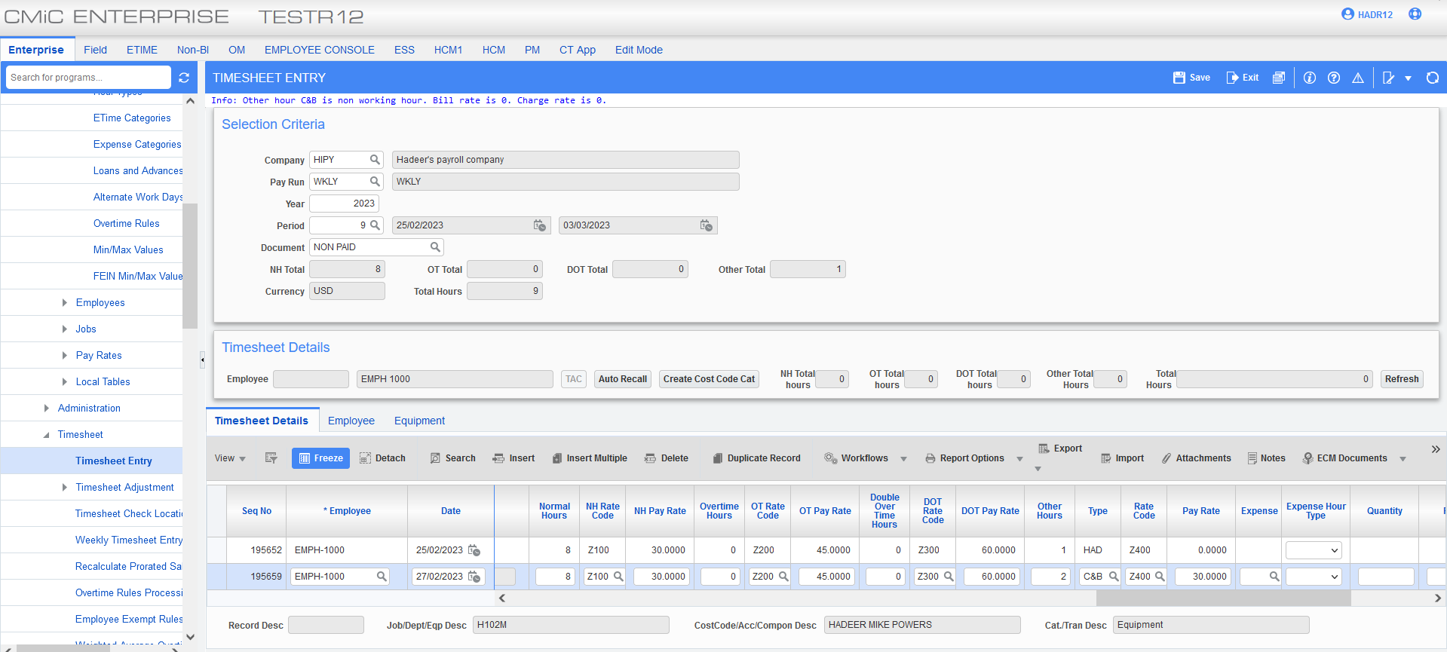
Pgm: PYTIMSTM – Timesheet Entry; standard Treeview path: US Payroll > Timesheet > Timesheet Entry – Timesheet Details tab
A work record has been entered for an employee in the Timesheet Entry screen using the C&B hour type code, which is tracking non-paid hours for “Charge & Billing”. The hour type will not populate the charge and billing rate.

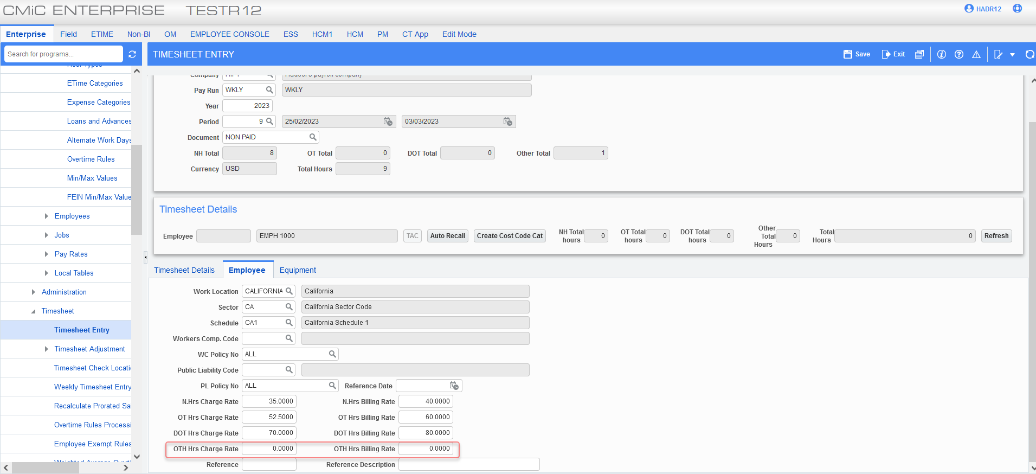
Pgm: PYTIMSTM – Timesheet Entry; standard Treeview path: US Payroll > Timesheet > Timesheet Entry – Employee tab
Clicking on the Employee tab of the Timesheet Entry screen shows that the Other Hours Charge Rate and Other Hours Billing Rate are 0.
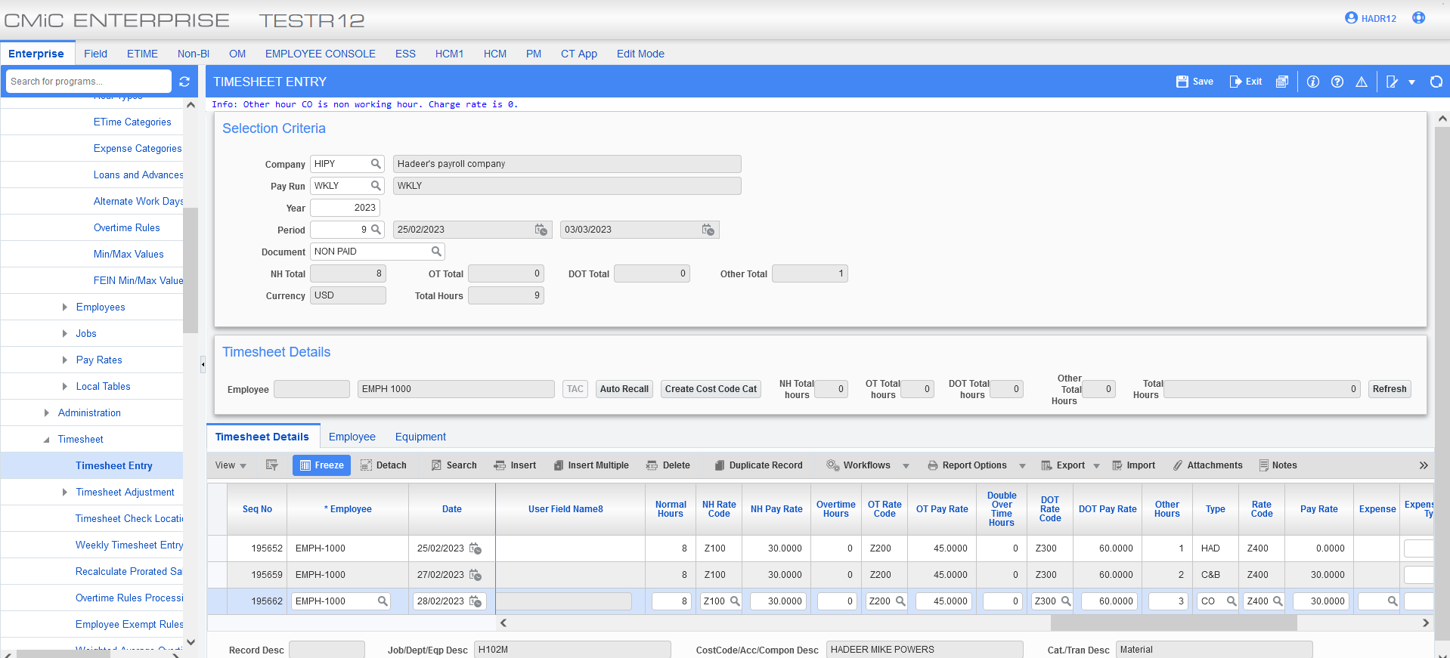
Pgm: PYTIMSTM – Timesheet Entry; standard Treeview path: US Payroll > Timesheet > Timesheet Entry – Timesheet Details tab
A work record has been entered for an employee in the Timesheet Entry screen using the CO hour type code, which is tracking non-paid hours for “Charge Only”. The hour type will not populate the charge rate and will not cost in Job Costing.

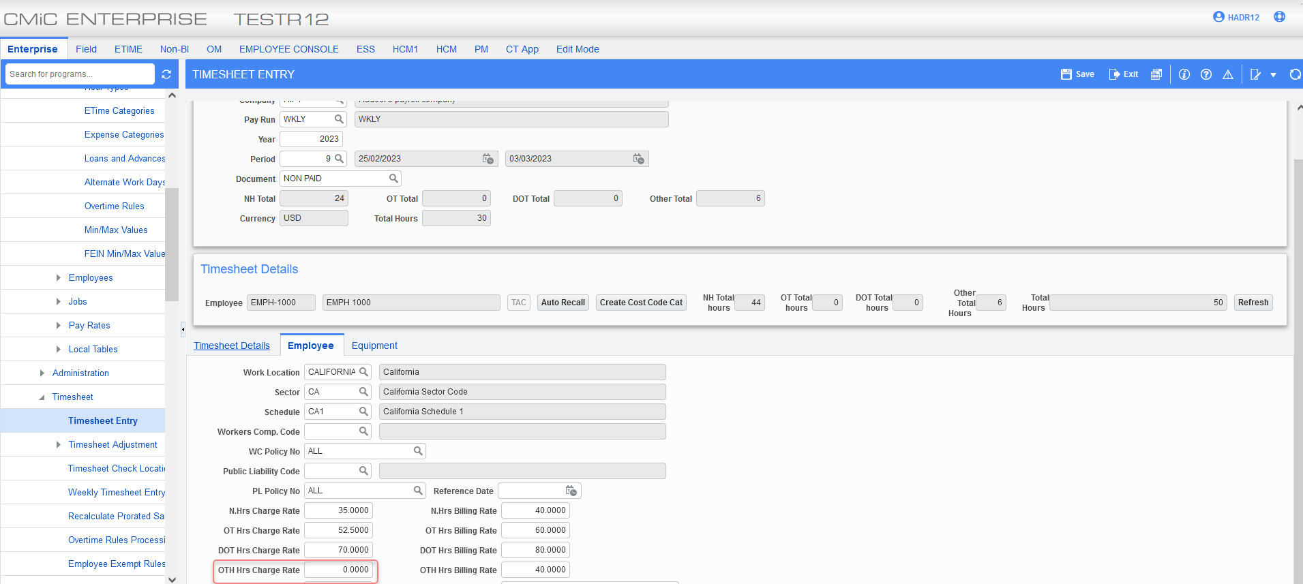
Pgm: PYTIMSTM – Timesheet Entry; standard Treeview path: US Payroll > Timesheet > Timesheet Entry – Employee tab
Clicking on the Employee tab of the Timesheet Entry screen shows that the Other Hours Charge Rate is 0.
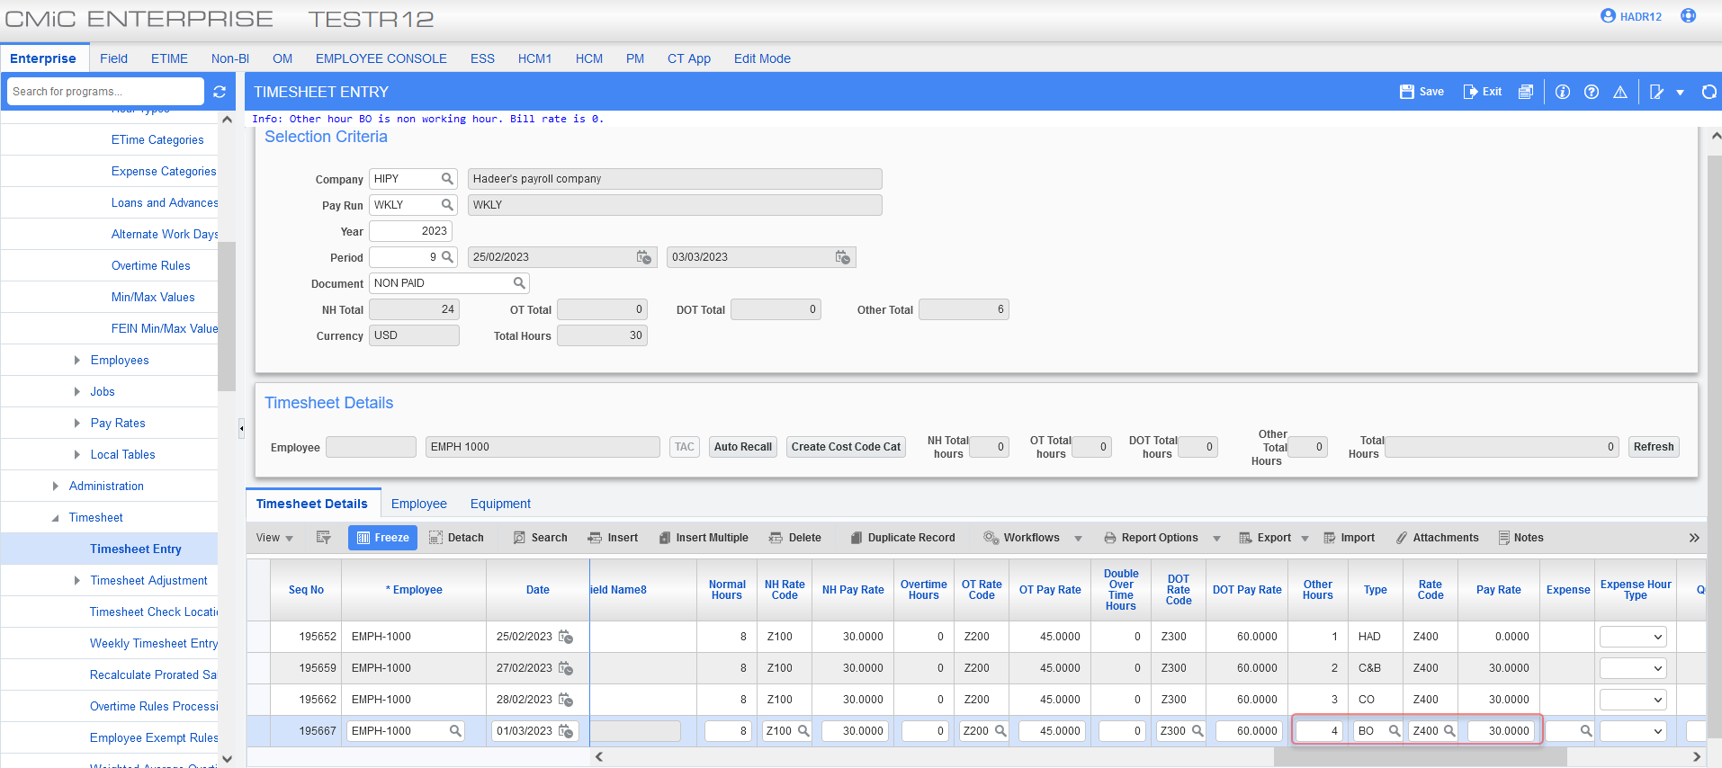
Pgm: PYTIMSTM – Timesheet Entry; standard Treeview path: US Payroll > Timesheet > Timesheet Entry – Timesheet Details tab
A work record has been entered for an employee in the Timesheet Entry screen using the BO hour type code, which is tracking non-paid hours for “Billing Only”. The hour type will not populate the billing rate and will not cost in billing.

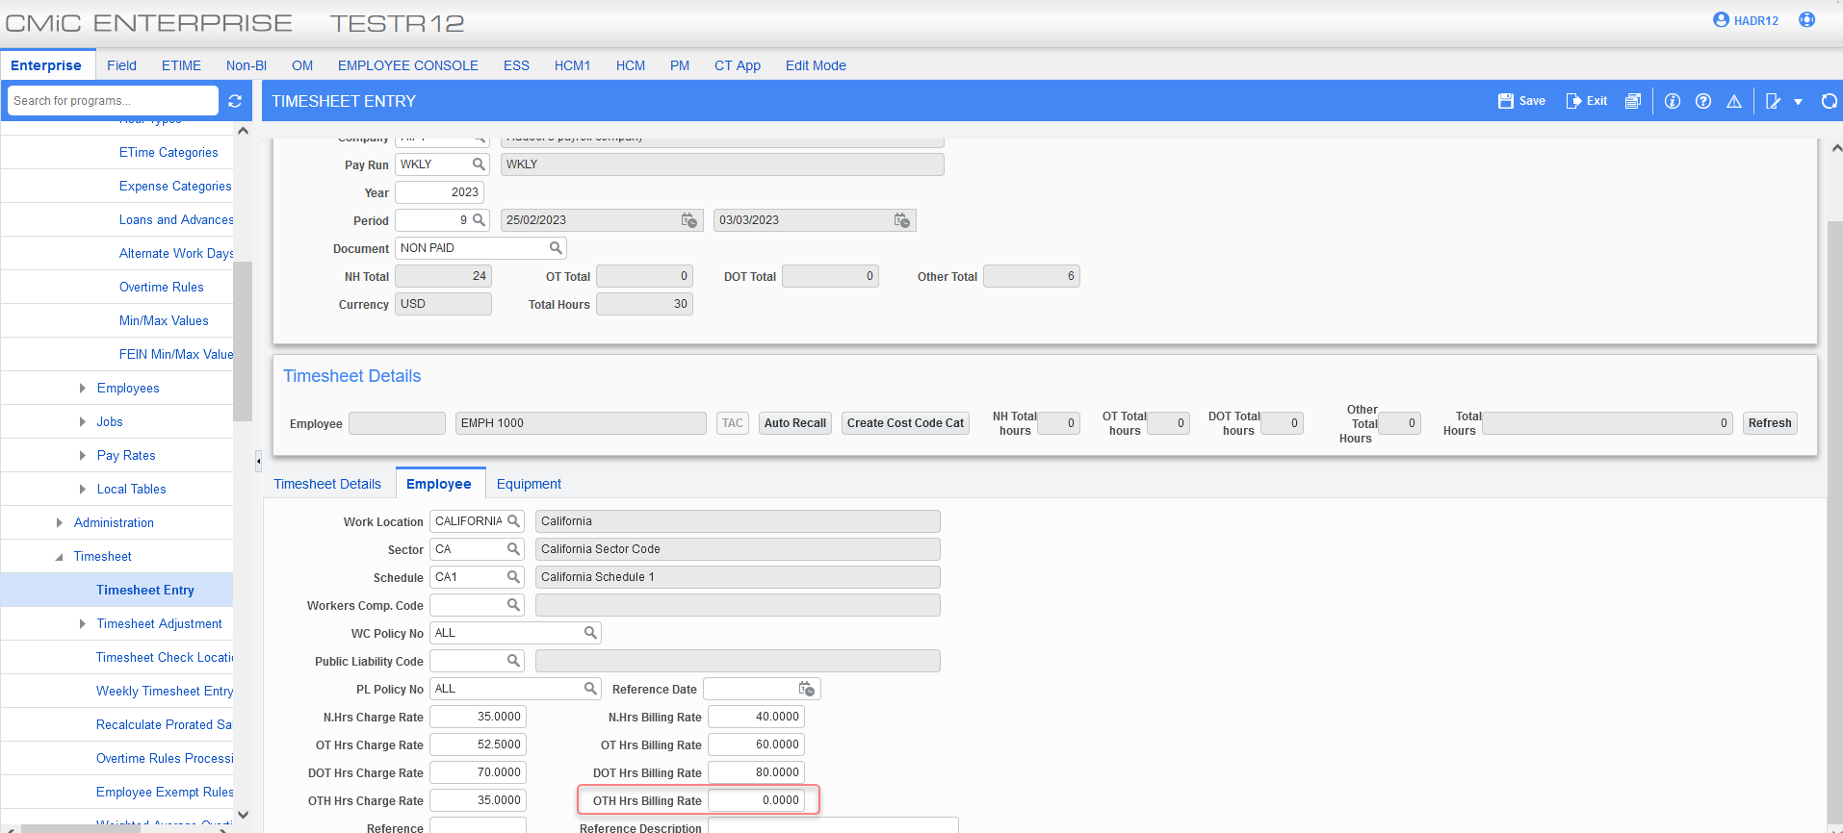
Pgm: PYTIMSTM – Timesheet Entry; standard Treeview path: US Payroll > Timesheet > Timesheet Entry – Employee tab
Clicking on the Employee tab of the Timesheet Entry screen shows that the Other Hours Billing Rate is 0.
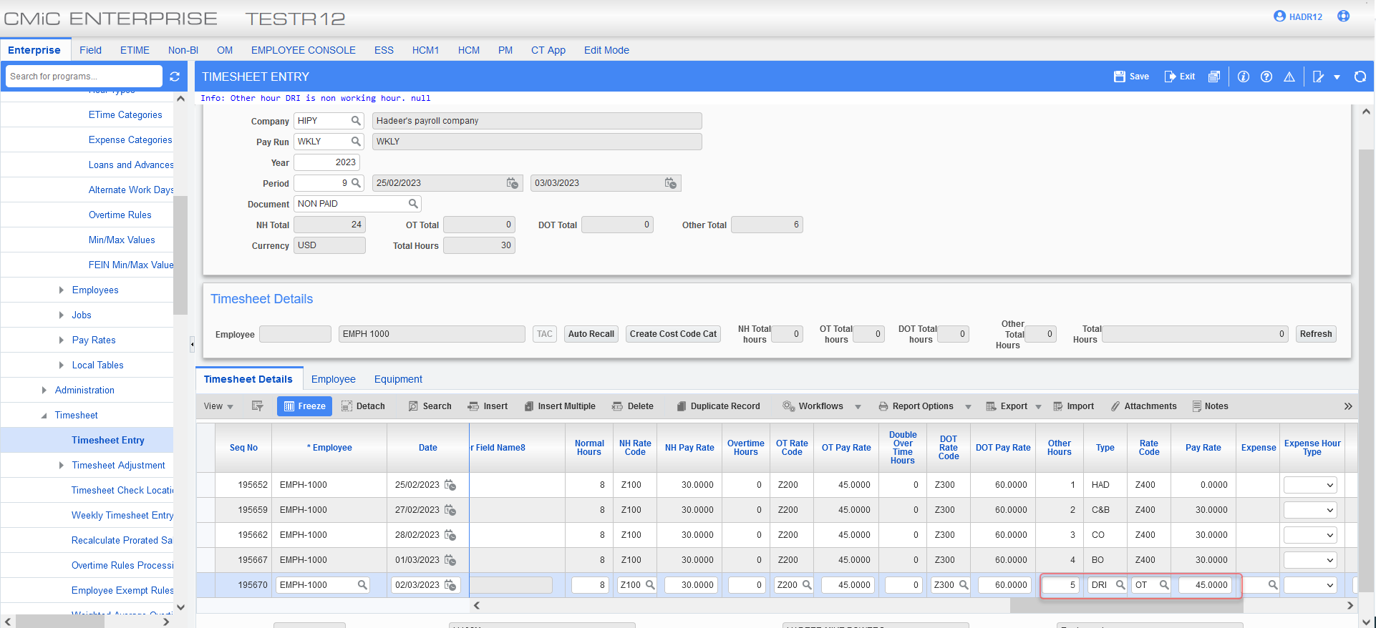
Pgm: PYTIMSTM – Timesheet Entry; standard Treeview path: US Payroll > Timesheet > Timesheet Entry – Timesheet Details tab
A work record has been entered for an employee in the Timesheet Entry screen using the DRI hour type code, which is tracking non-paid hours for “NONE”. All rates will be populated in timesheet tables.
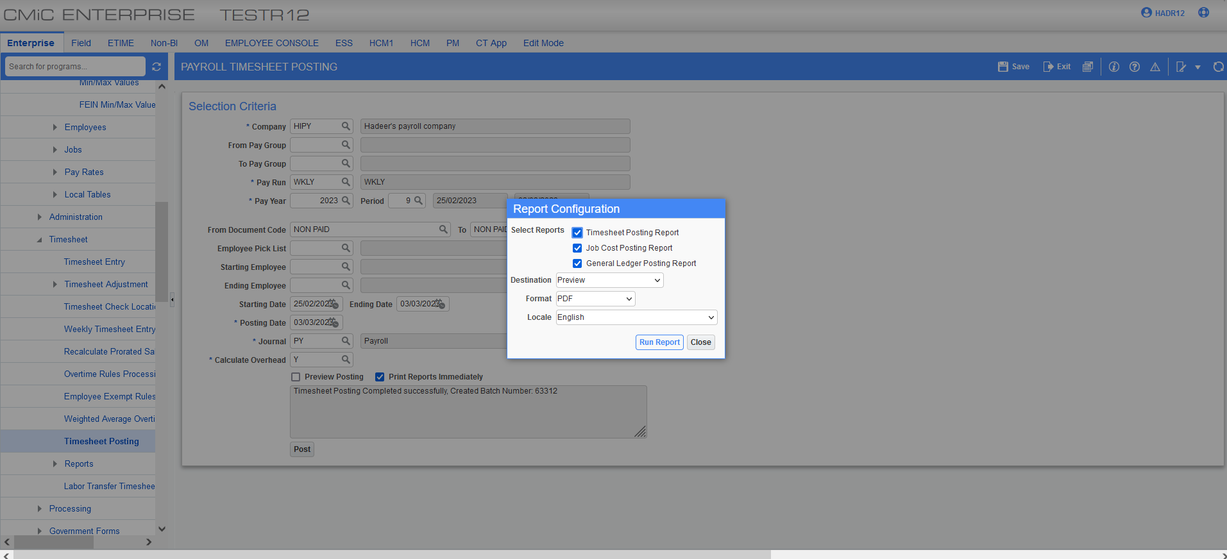
Pgm: PYTIMPST – Payroll Timesheet Posting; standard Treeview path: US Payroll > Timesheet > Timesheet Posting
The information entered for the specified period in the Timesheet Entry screen was posted in the Payroll Timesheet Posting screen. The posting reports are shown below.
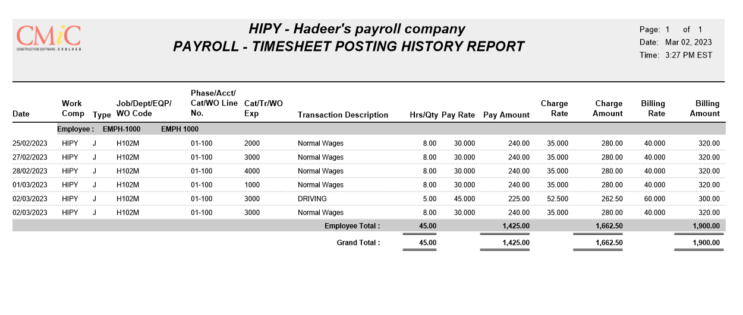

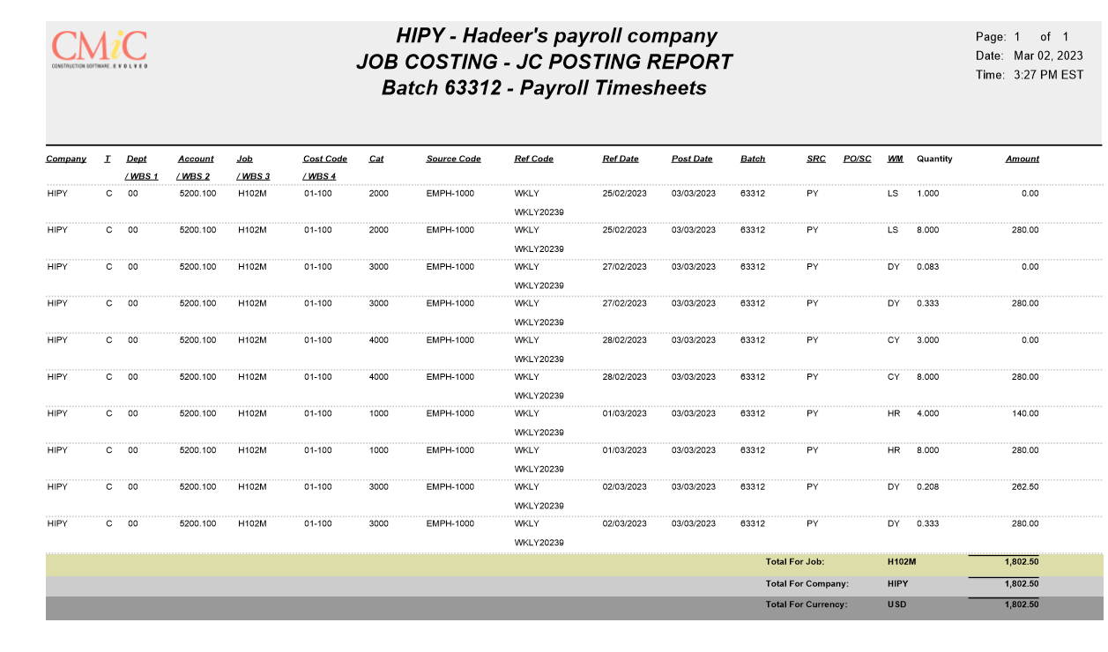

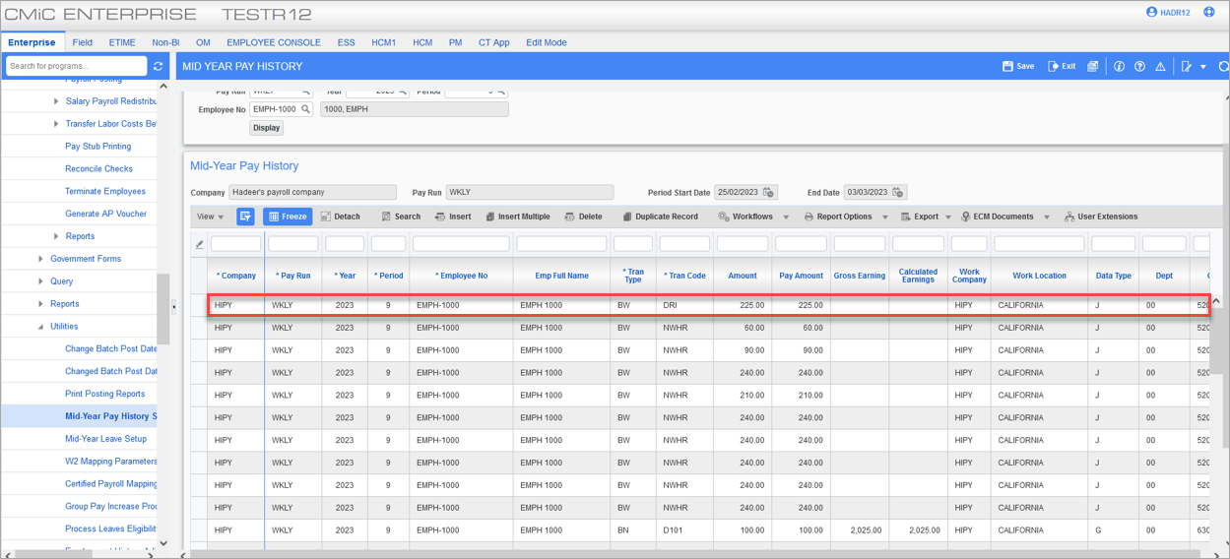
Pgm: PYEPHIST – Mid-Year Pay History; standard Treeview path: US Payroll > Utilities > Mid-year Pay History Setup
The Mid Year Pay History for the employee shows the hours tracked using the DRI hour type code were paid.

Preventive Maintenance

Ability to prevent inter-company work order (23.69378)
Overview
Provided ability to prevent inter-company work order. ‘Validate Inter-Company setup between Work Order and Equipment Company’ Flag has been added to Preventive Maintenance > System control file which will allow users to validate if inter-company clearing account exists between two company.
Program Modifications:
Following screen shows newly added Validate Inter-Company setup between Work Order and Equipment Company’ flag in PRM > System Control file. Flag is un-checked by default.
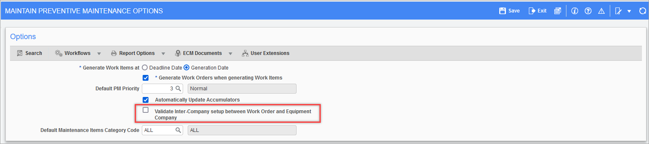Preventive Maintenance > Setup > Local Tables > System Control File
Implementation
Inter-Company Setup: Inter-company clearing account does not exist between CCC and RV123456 company.
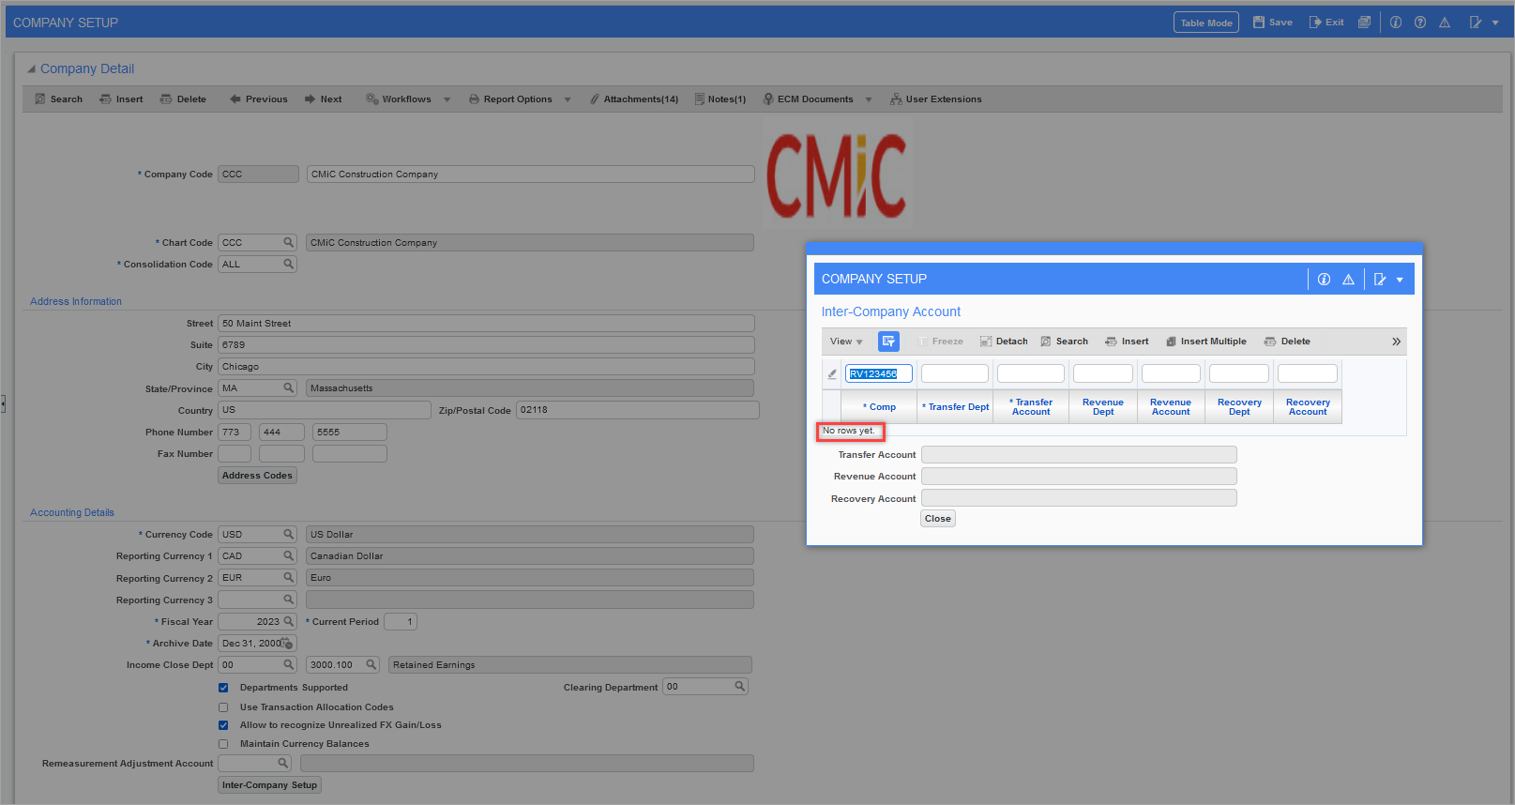General Ledger > Setup > Local Tables > Company Setup > [Inter-Company Setup] button
Case 1: Validate Inter-Company setup between Work Order and Equipment Company – N (Un-checked)
Preventive Maintenance > Setup > Local Tables > System Control File
Enter inter-company work order between CCC and RV123456.
- Inter-company work order added successfully without validation when ‘Validate Inter-Company setup between Work Order and Equipment Company’ is un-checked.
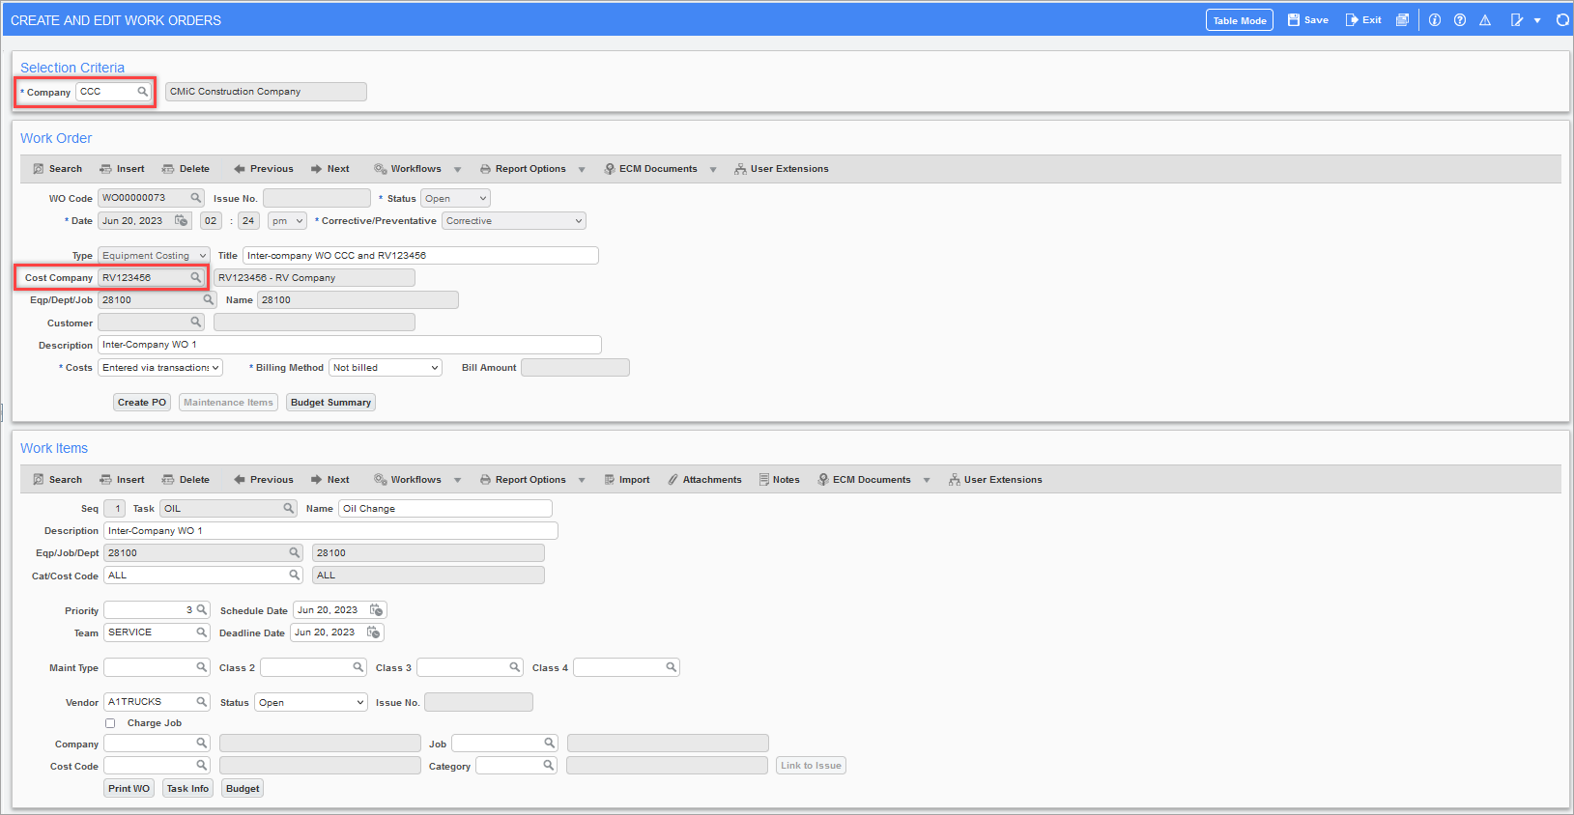Preventive Maintenance > Work Orders > Enter/Edit Work Orders
Case 2: Validate Inter-Company setup between Work Order and Equipment Company – Y (Checked)
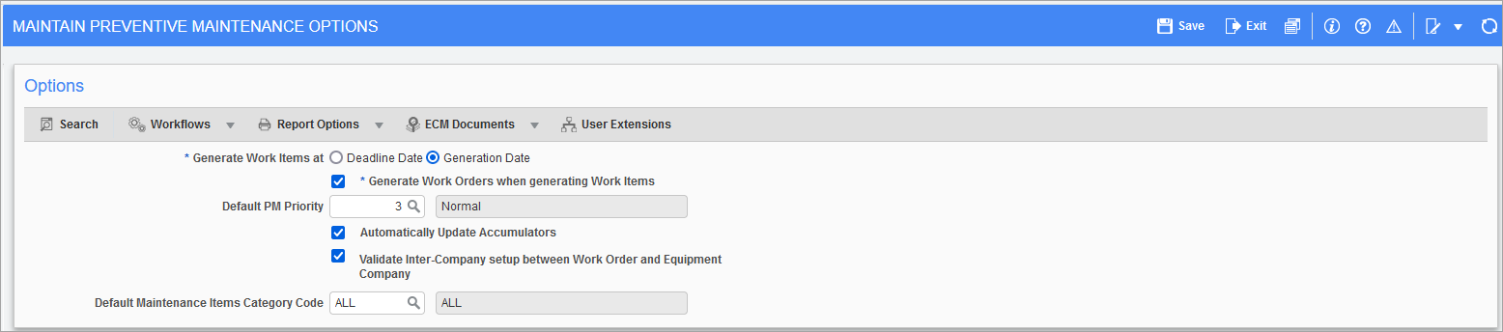 Preventive Maintenance > Setup > Local Tables > System Control File
Enter inter-company work order between CCC and RV123456.
- Validation is raised upon selecting inter-company equipment ‘Company CCC is not set up for intercompany with company RV123456’ when ‘Validate Inter-Company setup between Work Order and Equipment Company’ flag is checked.
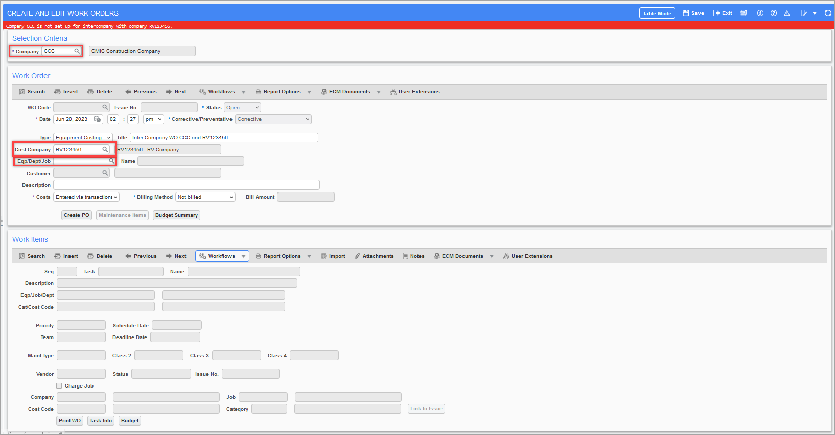Preventive Maintenance > Work Orders > Enter/Edit Work Orders
Setup inter-company account between CCC and RV123456 company.
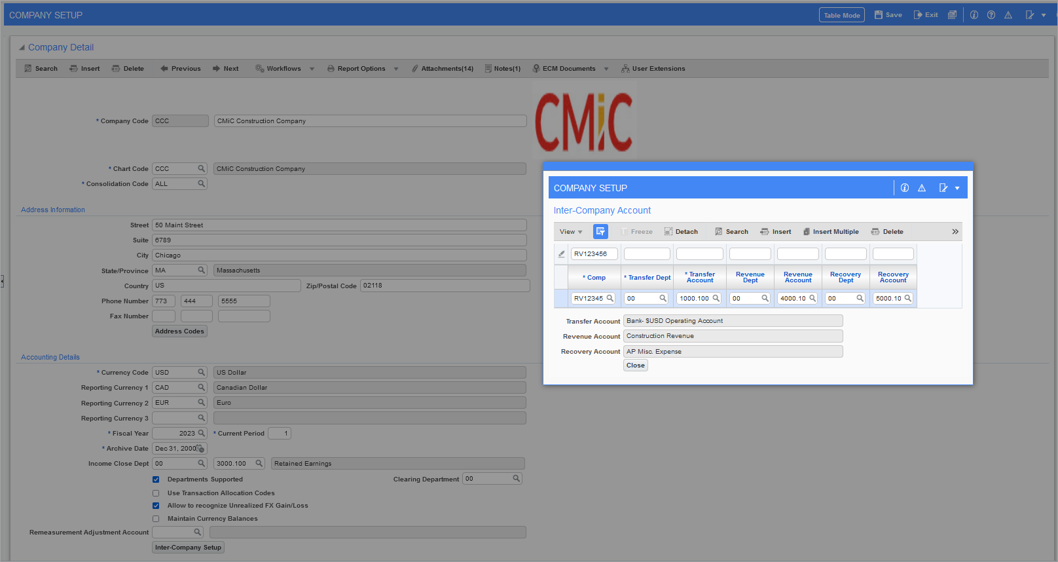 General Ledger > Setup > Local Tables > Company Setup > [Inter-Company Setup] button
Enter inter-company work order between CCC and RV123456. Work order is added successfully once inter-company account is setup when ‘Validate Inter-Company setup between Work Order and Equipment Company’ flag is checked.
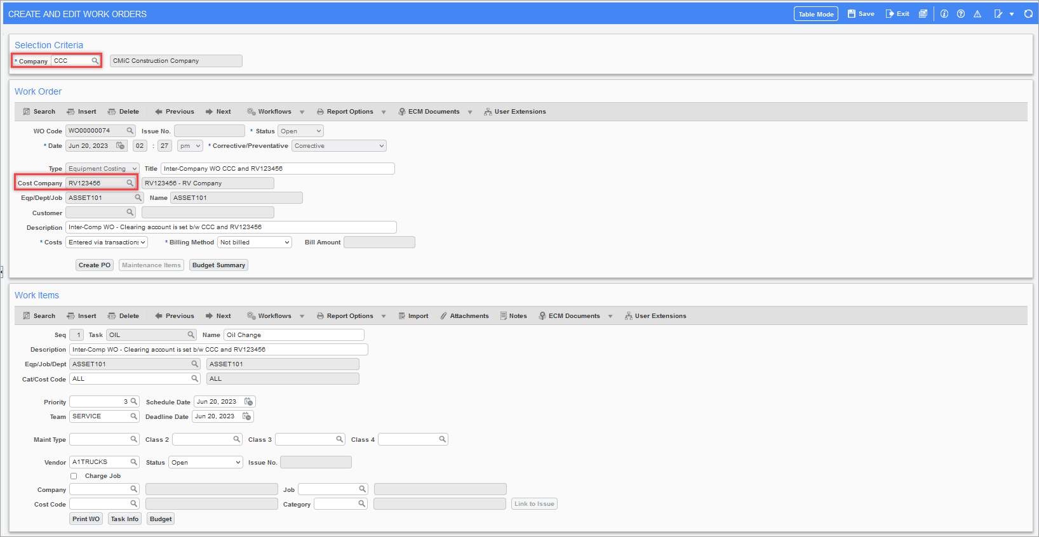 Preventive Maintenance > Work Orders > Enter/Edit Work Orders

Project Management

Specifications Extraction Verification Page – Prompt changes (22.63986,CF-3679)
The prompts in the Specifications Extraction Verification Page have been modified to display “Specifications” instead of “Drawings” in them.
Following are the new prompts added:
CMiC Specifications Extraction.
- Here is what we were able to extract from your specifications.
- Verify that we’ve extracted the expected values.
- Edit values on one or multiple rows.
- Select a new extraction region on one or multiple rows.

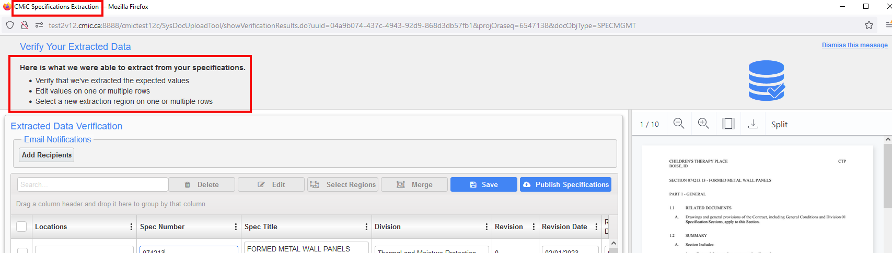

Checklist Template Maintenance – Lock flags for both System and Project Level Templates (22.64346,CF-5548,CF-3362,CF-3933,CF-4099,CF-5544,CF-6112,CF-6186)
A new LOCK flag has been added within the Checklist header and each checklist item for both System level and Project level templates to prevent alterations.
Pre-condition: ‘Checklist Admin’ flag for the user’s security Role must be checked.
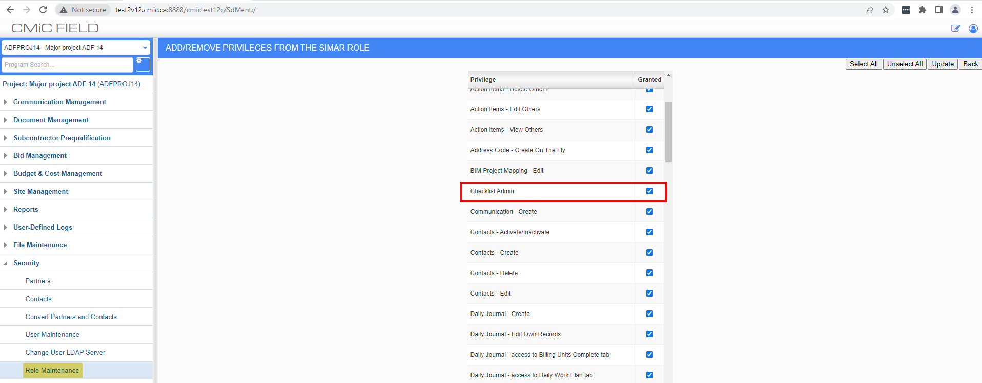
Additions:
LOCK-flag within the checklist header.
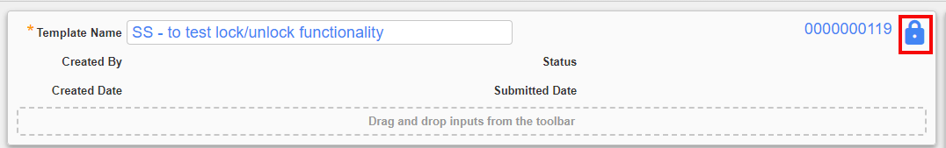
LOCK-flag within each checklist item.
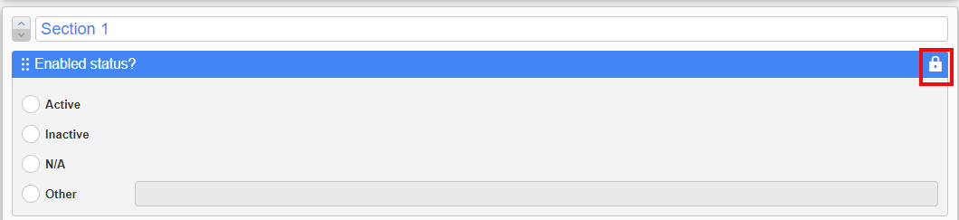
A tooltip – “Lock or Unlock the checklist template (and all items)”
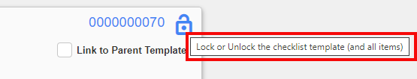
Checklist Item tooltip when header is locked – “To modify individual items, unlock the template header”.
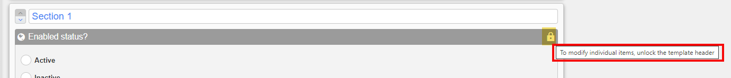
Checklist Item tooltip when header is unlocked – “Lock or Unlock this checklist item”.
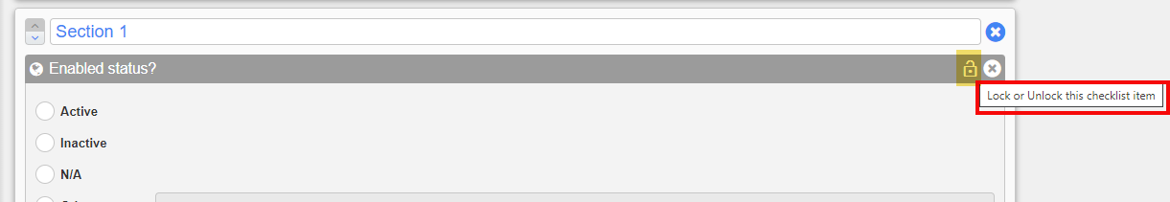

For System-level templates:
When the LOCK flag in the checklist header is enabled i.e., Header is locked, then it prevents all other edits to the template. Only the system admins would be able to edit the header’s LOCK status.
NOTE: System-level templates carries the status of the LOCK flag to the project-level templates when a checklist template is assigned to the project.

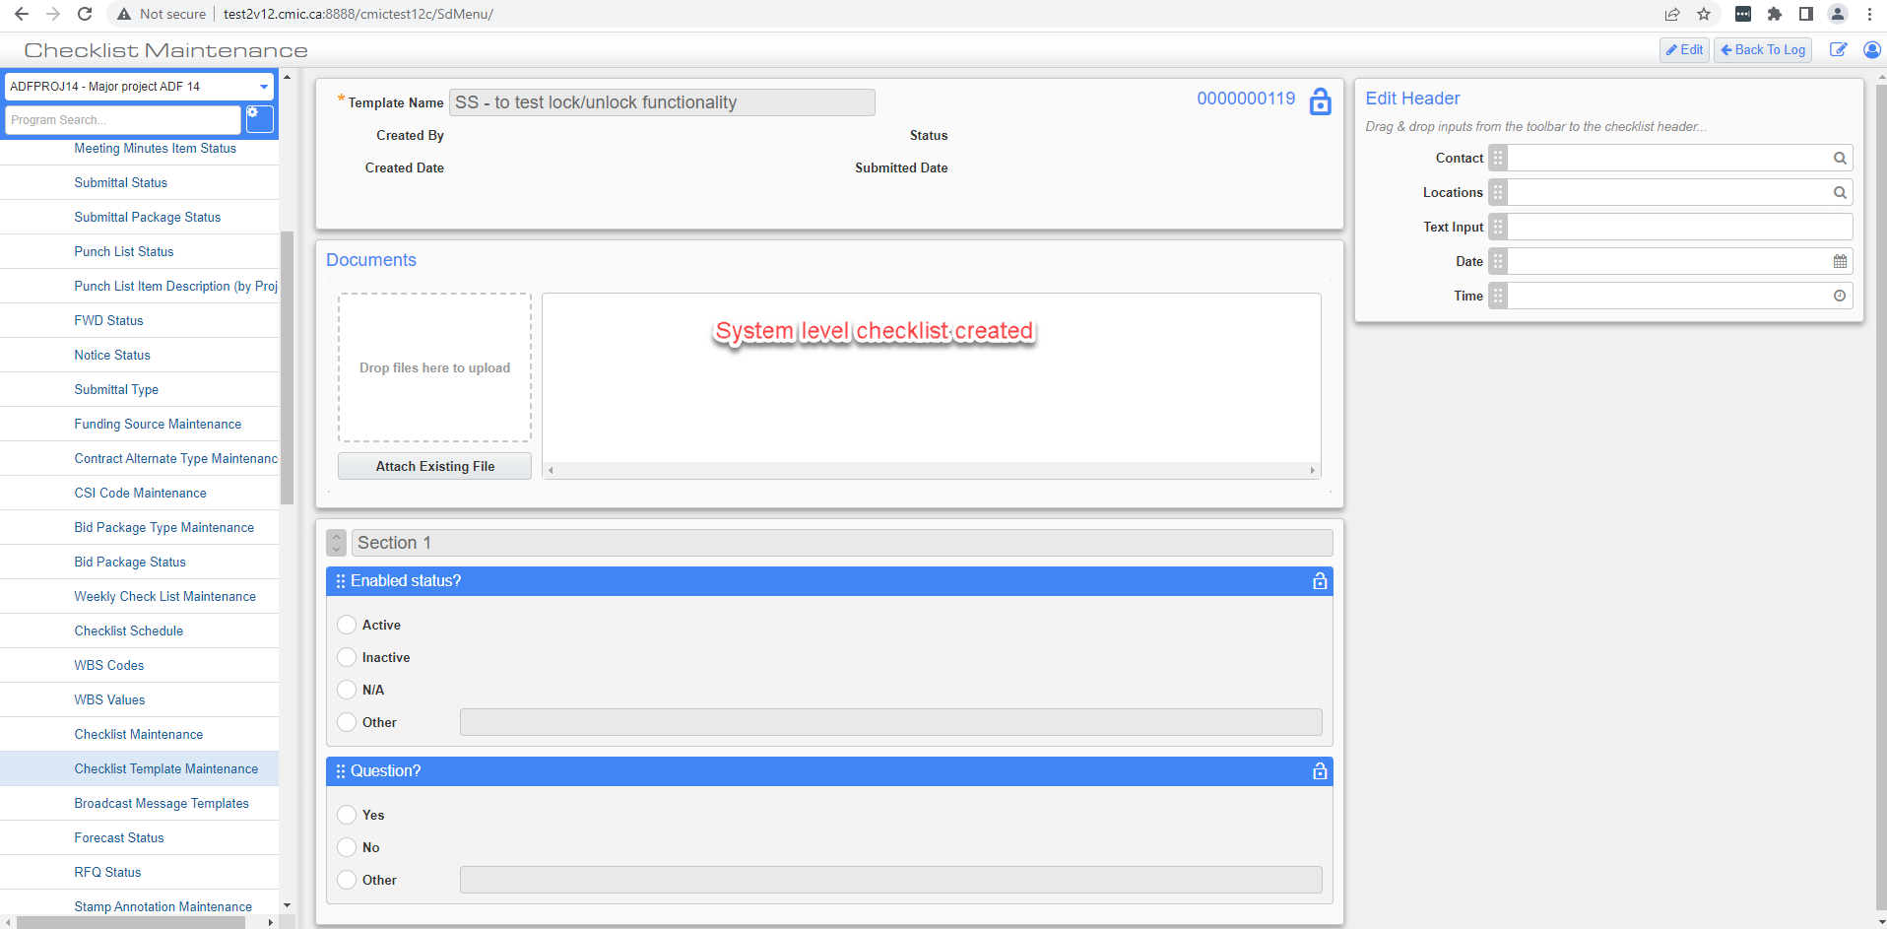

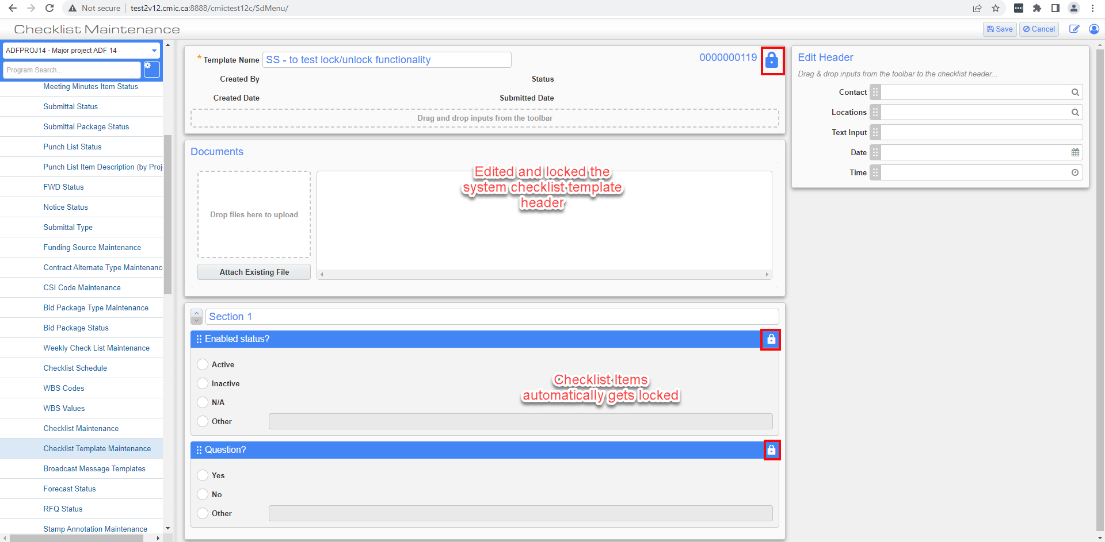
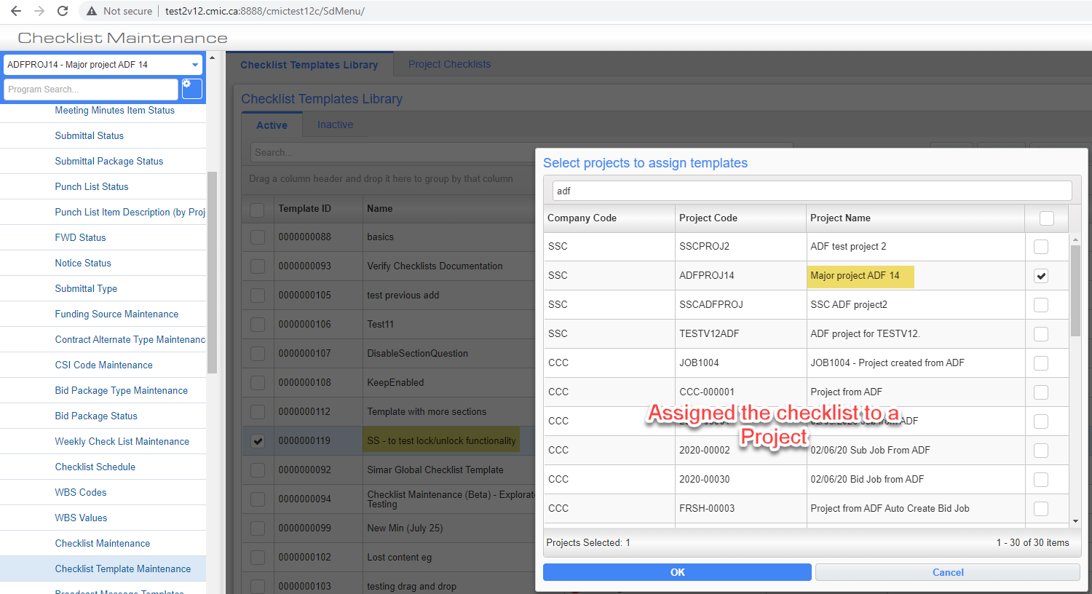
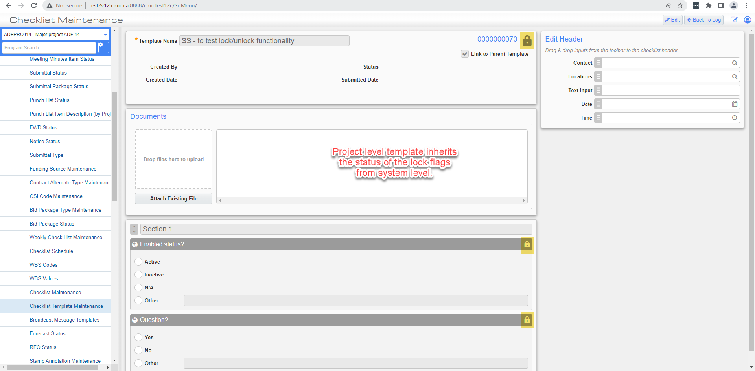

For Project-level templates:
When the LOCK flag in the checklist header is enabled i.e., Header is locked, then it prevents all other edits to the template.
Only “Checklist Admins” would be able to alter the status of LOCK flag when editing a project-level template.
Project level admins would not be able to enter Edit mode at all.
When the header is Locked – All individual items will be LOCKED.
When the header is Unlocked – All individual items will be UNLOCKED.

When the LOCK on a Checklist item is enabled, then users wouldn’t be able to edit the following:
Question type
Question value
Response options
Question’s active status (i.e., Question Enabled/Disabled).
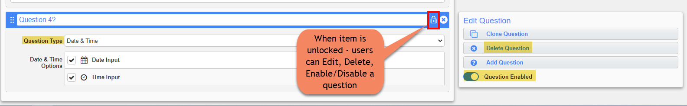
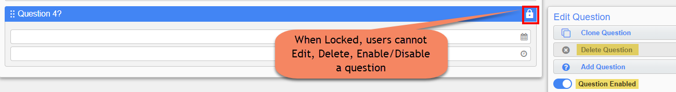

NOTES:
If a child item is ENABLED and LOCKED – the parent section cannot be disabled.
If a child item is LOCKED (regardless of enabled/disabled) – the parent section cannot be deleted.
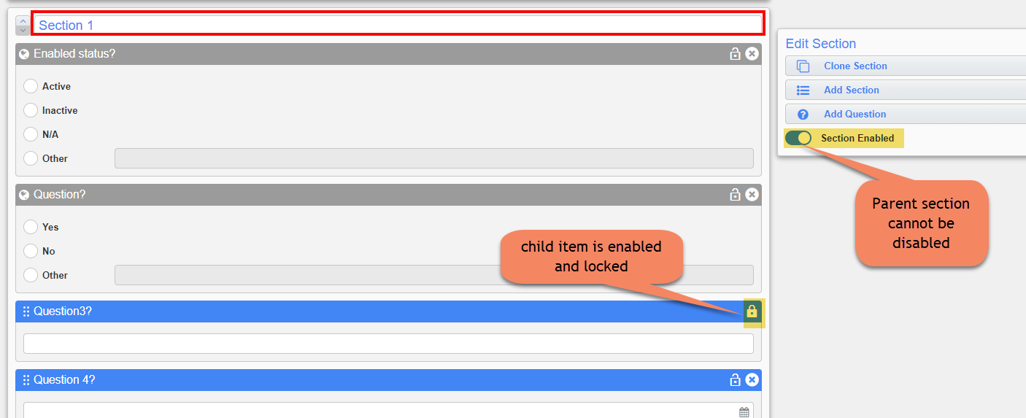
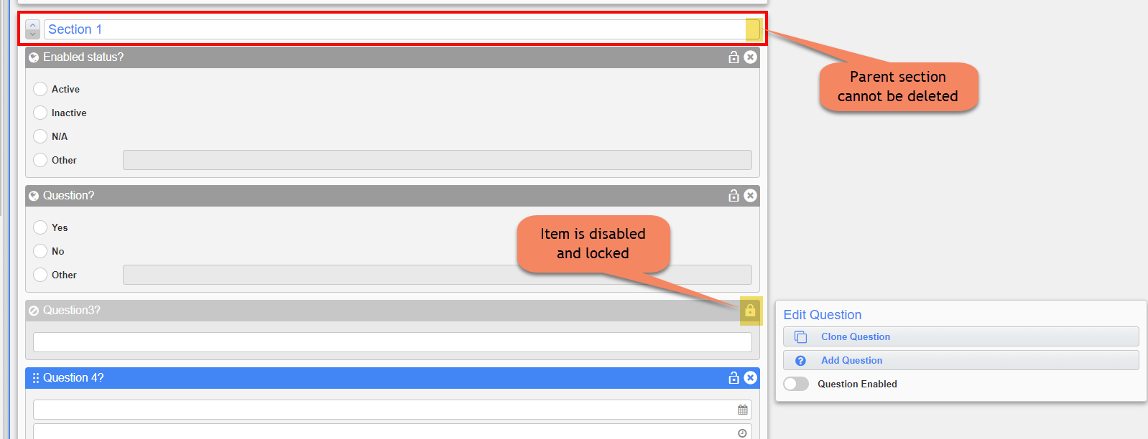

Checklist Template Maintenance – Added “Link to Parent Template” Flag (22.65039,CF-230,CF-456)
A new flag “Link to Parent Template” has been added within checklist templates at the project level.
The flag appears as hidden in the System-level template and enables by default when the template is assigned to a project.
Pre-condition: ‘Checklist Admin’ flag for the user’s security Role must be checked.
Steps followed for testing:
- PMJSP > File Maintenance > Local Tables > Checklist Template Maintenance screen.
- Create a Global/System checklist template. Add only the template name and save it.
- Click on [Back to log] button and assign the system template to the project.
- After assigning to the project, it appears in the Project Checklists tab.
- Open the Project checklist.
- “Link to Parent Template” flag appears in the Project Checklist. The flag appears as Checked by default.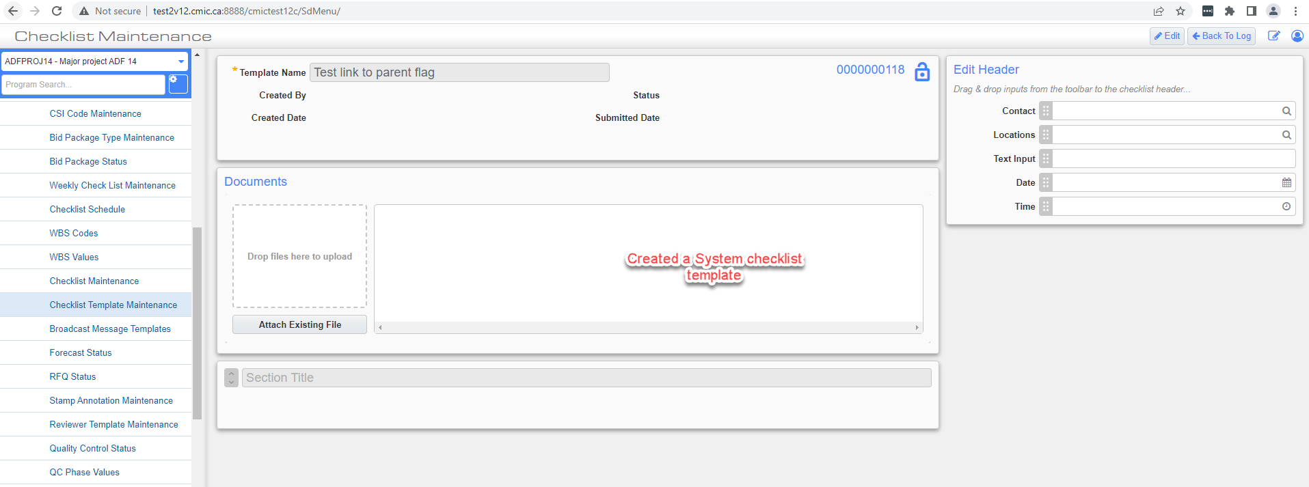

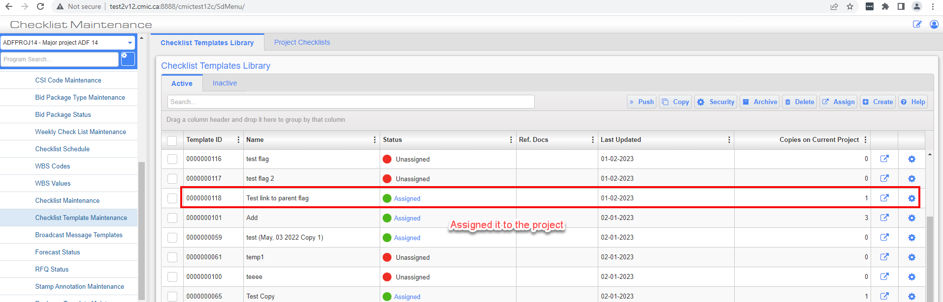

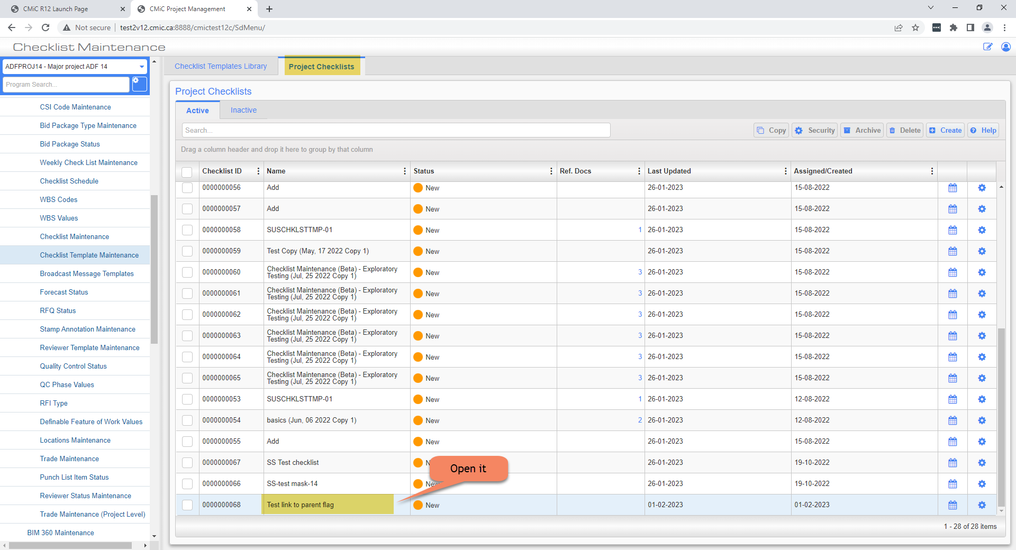

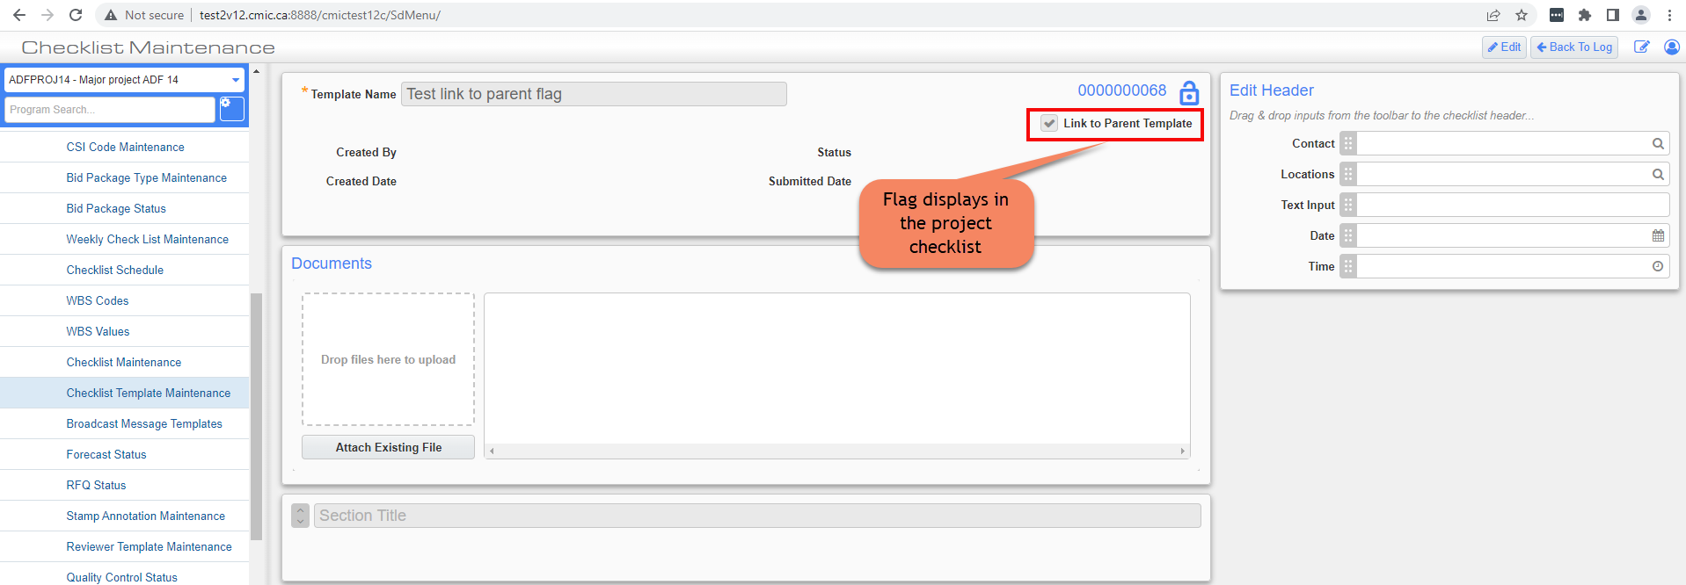

If changes are made to the Parent template (i.e., in Checklist Templates tab) – the changes will be pushed to project level versions of the template where the link-flag is checked.
For example: In the below screenshot, user has uploaded an attachment and added a section with a question in the Parent template i.e. the System/Global template > Saved it > Opened the template under Project Checklists tab > the ‘Document’ and the ‘Section/Question’ added in the parent template appears in the Project Template.
NOTE: The section inherited from the parent template will not be editable in the project template.
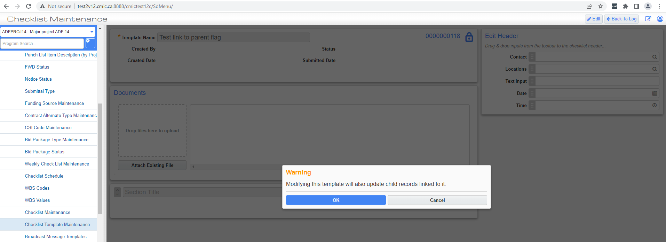
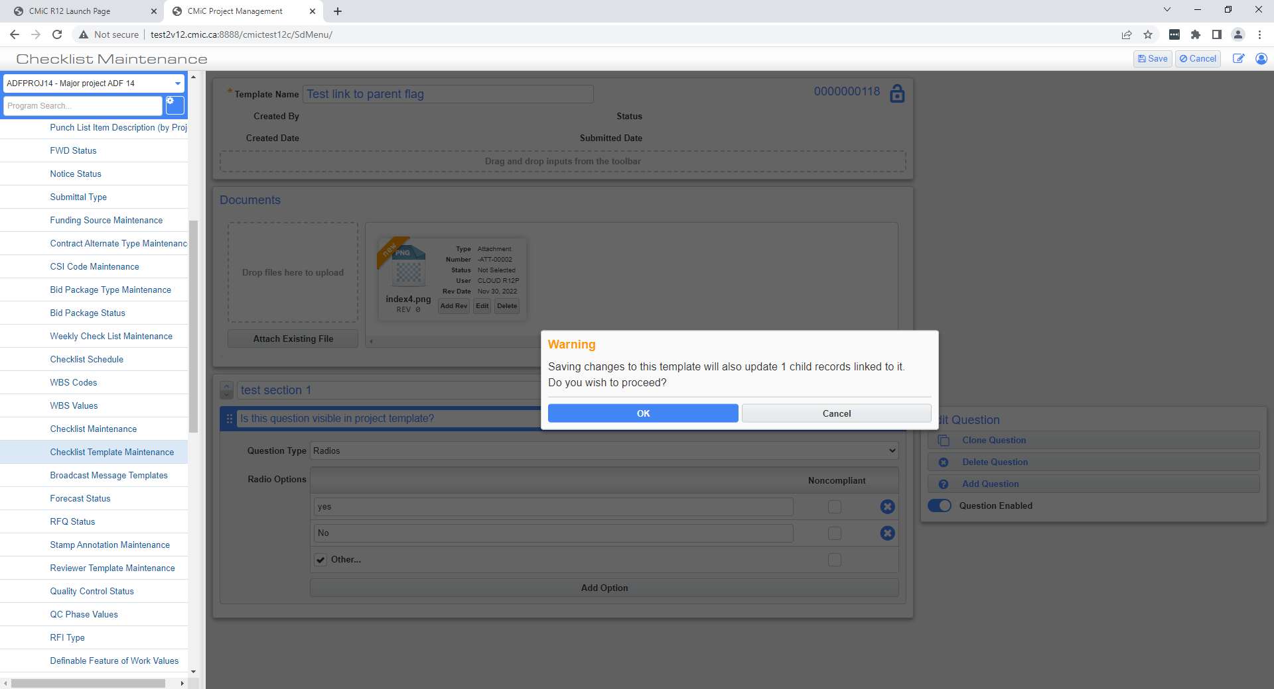

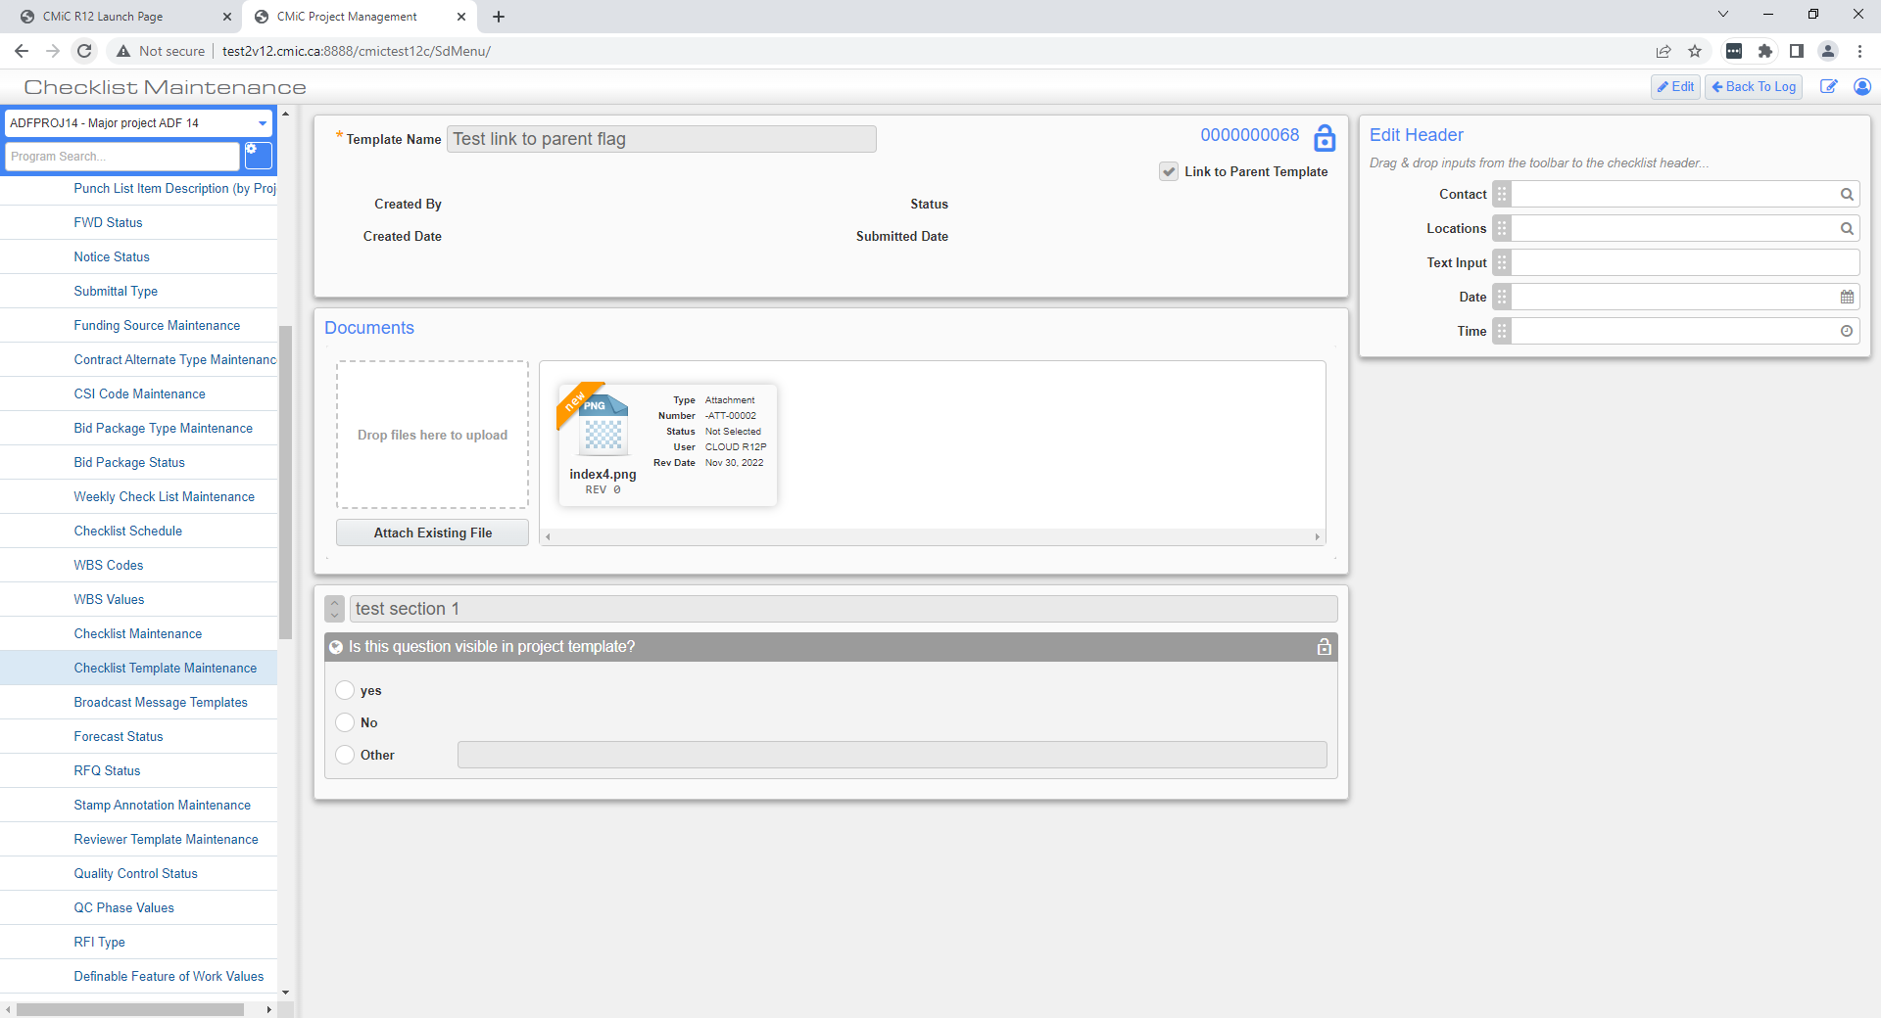

Editing a Project Template:
When user hits Edit button in a Project level template, then it displays a modal dialogue as shown in the below screenshot.

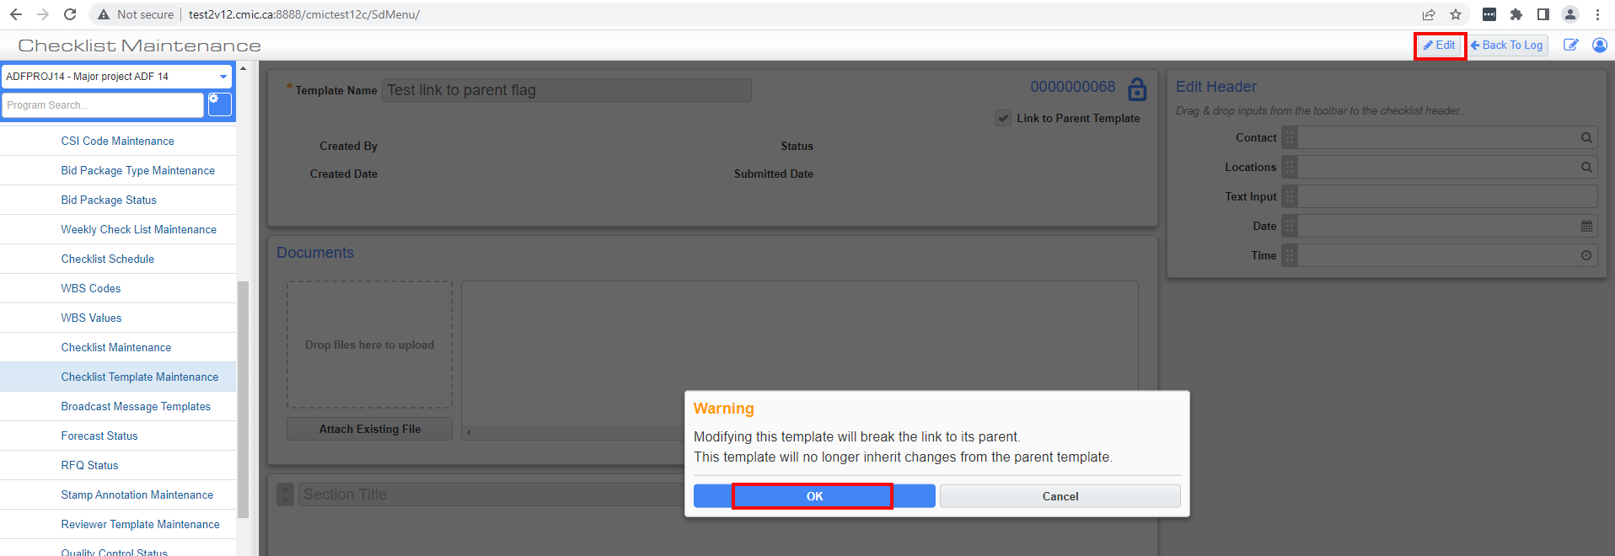

If user clicks [OK] then the project template will be put into Edit mode.
NOTE: In Edit mode – “Link to Parent Template” flag will appear as unchecked.

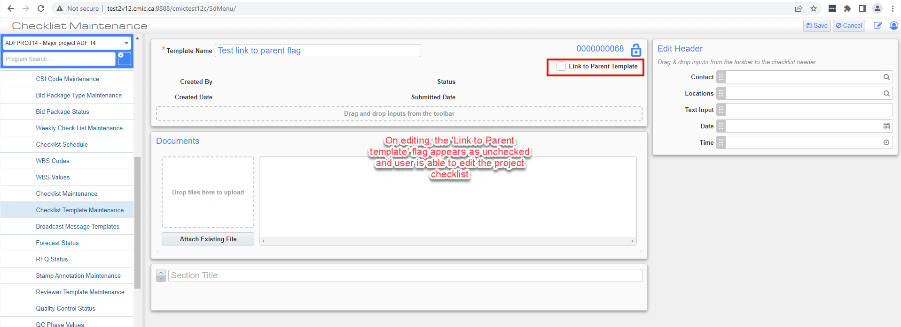
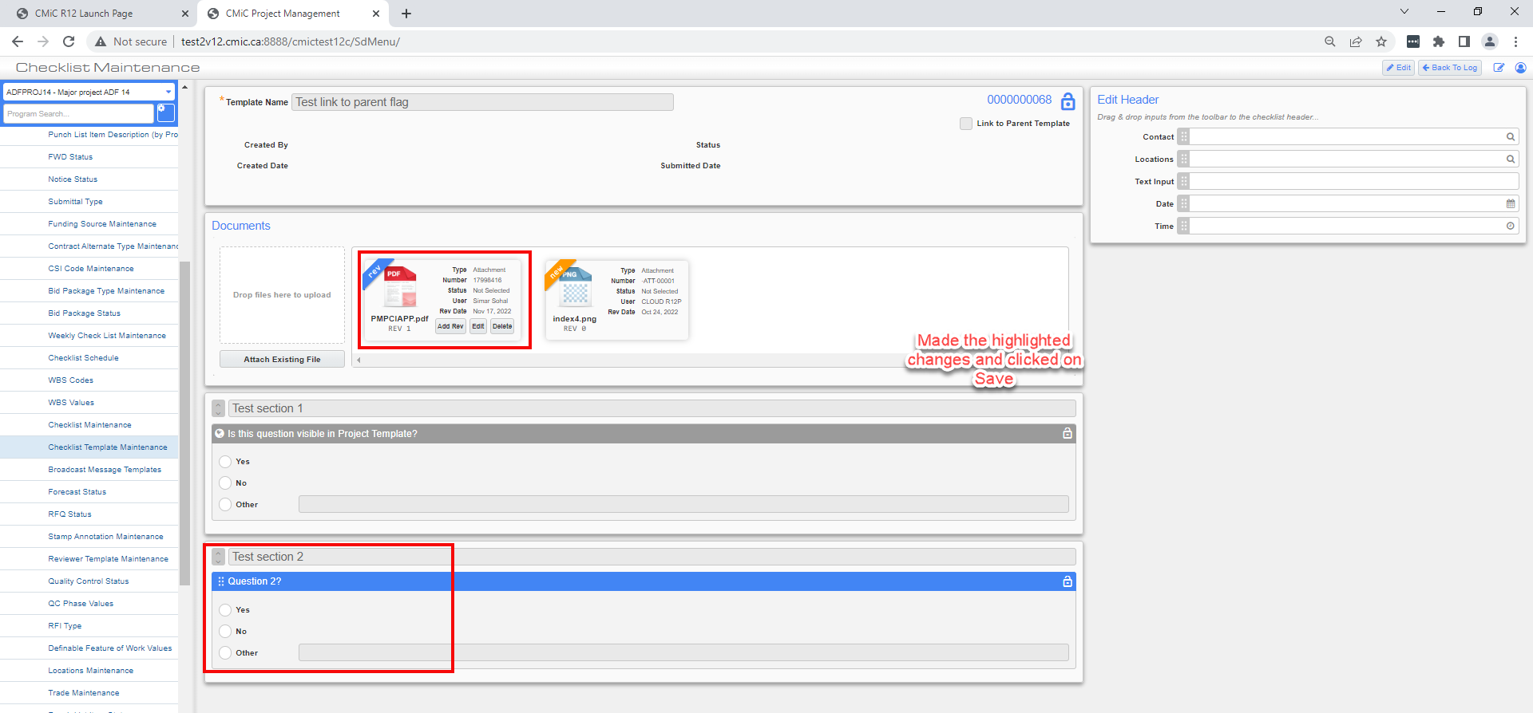
When LINK flag is unchecked on Project level template, and if user enters EDIT mode and enables the flag, then a modal dialogue will appear that depends on whether the template has child records on the project.
If there are no child records, then modal will display as in the screenshot below.
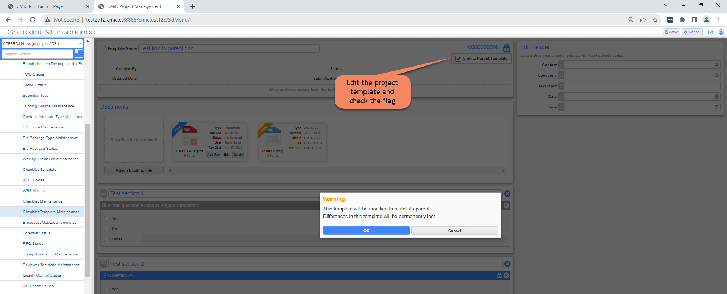
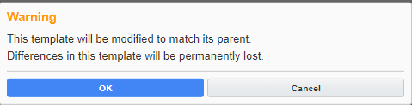
If the template has child records on the project – the modal will display as follows:
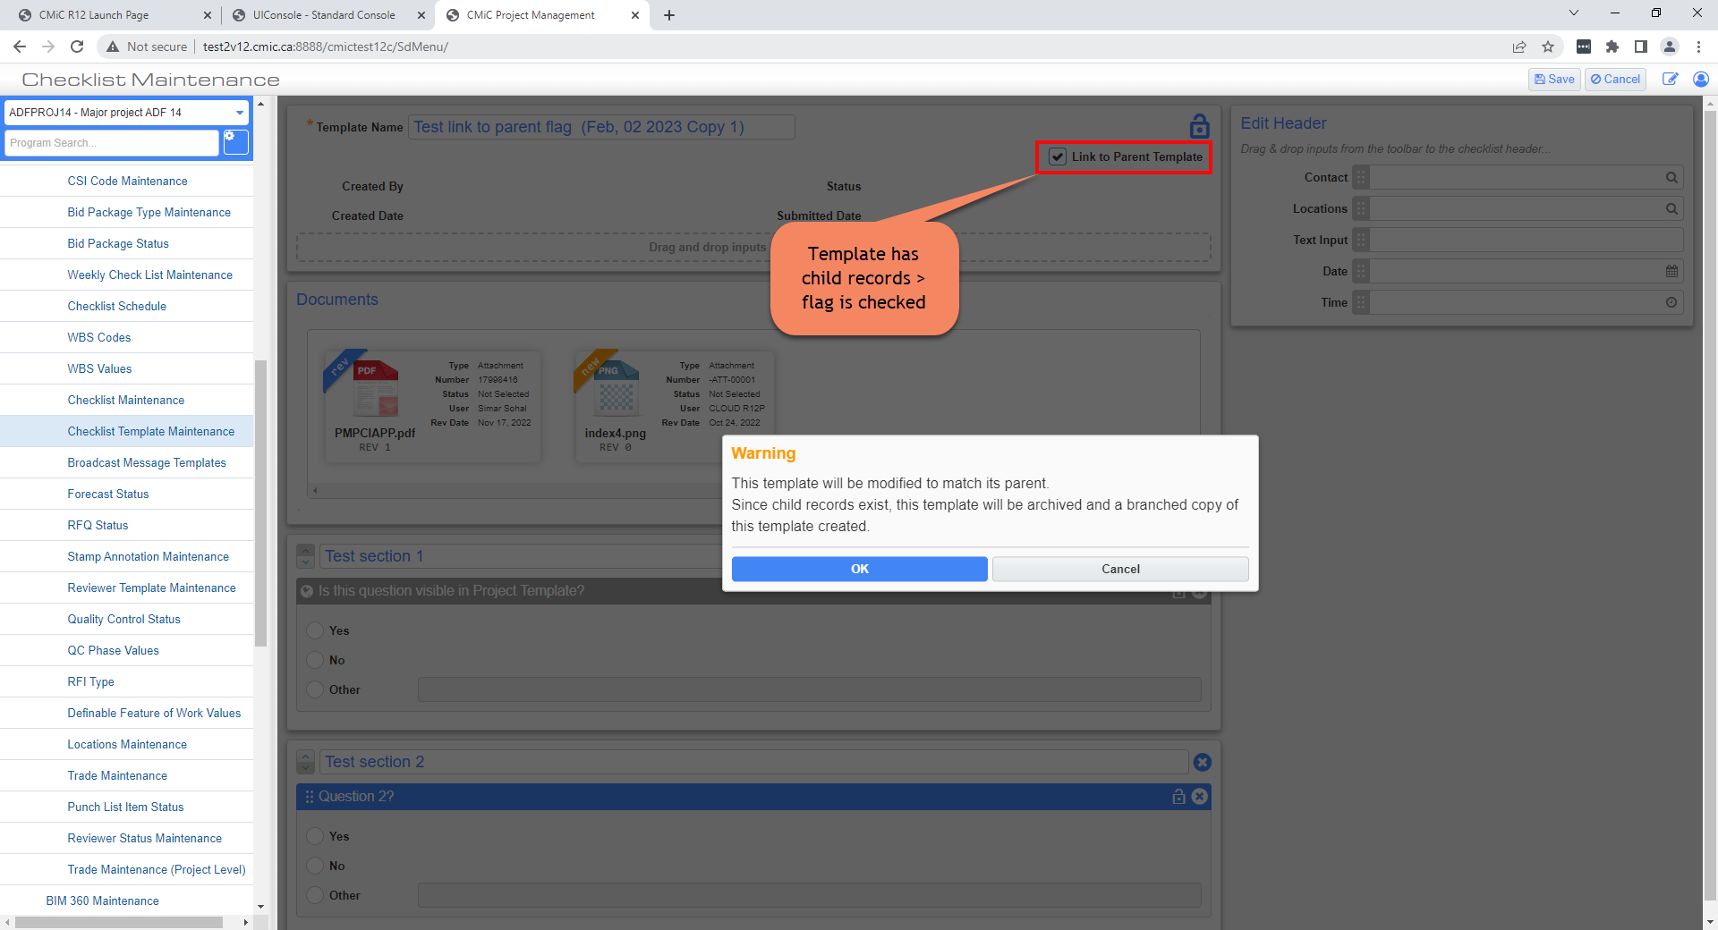
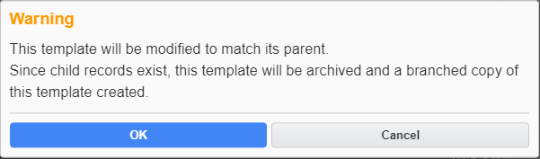

Checklist Template Maintenance – Field Security (23.66938,CF-6384,CF-6385, CF-6550)
A new Program has been added in the Field Security settings drop-down for Checklist Template Maintenance.
Following are the names of the items added to the Field Security settings:
Assign Checklist Template
Create Checklist Template
Edit a Checklist Template
Checklist Template Settings
Delete Checklist Template
Schedule Checklist Template for completion
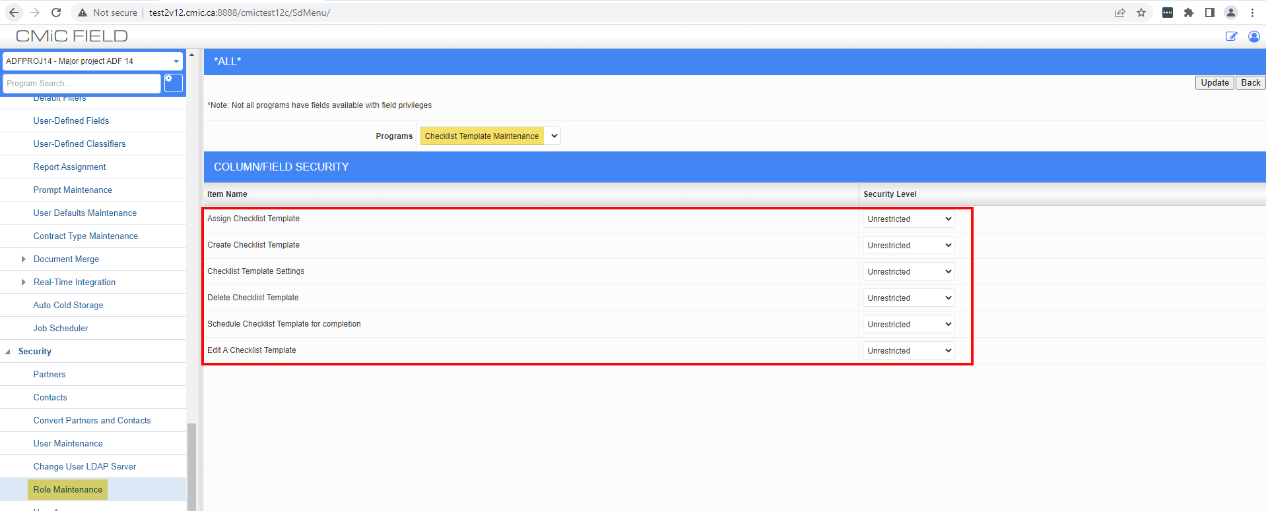

NOTE: Hidden and Unrestricted field security options can be applied to all the above items.
Items affected by above Field Security settings in the Checklist Template Maintenance screen are mentioned below:
Assign Checklist Features – Push and Assign functionalities.
Create Checklist Features – Copy and Create (for both active and inactive checklists) functionalities.
Edit Checklist Template – Add, Remove or Modify checklist questions/items – The primary “EDIT” button in the toolbar will be the effective control.
Template Settings – Settings, Archive, Re-activate (within the “Inactive” tab).
Delete Checklist Feature – Delete functionality.

PM System Options Flag- Show Company Code in front of Project Code (22.63802)
A new Project System Options flag has been added:
Go to Project System Options > General > Show Company Code in front of the Project Code
By default – “Show Company Code in front of the Project Code” is unchecked.
When the flag is checked:
- the user can see the Company Code in front of the Project in the Project Selection area of the tree view
- in Project Maintenance screen the user can see the Company Code in front of the Company Name

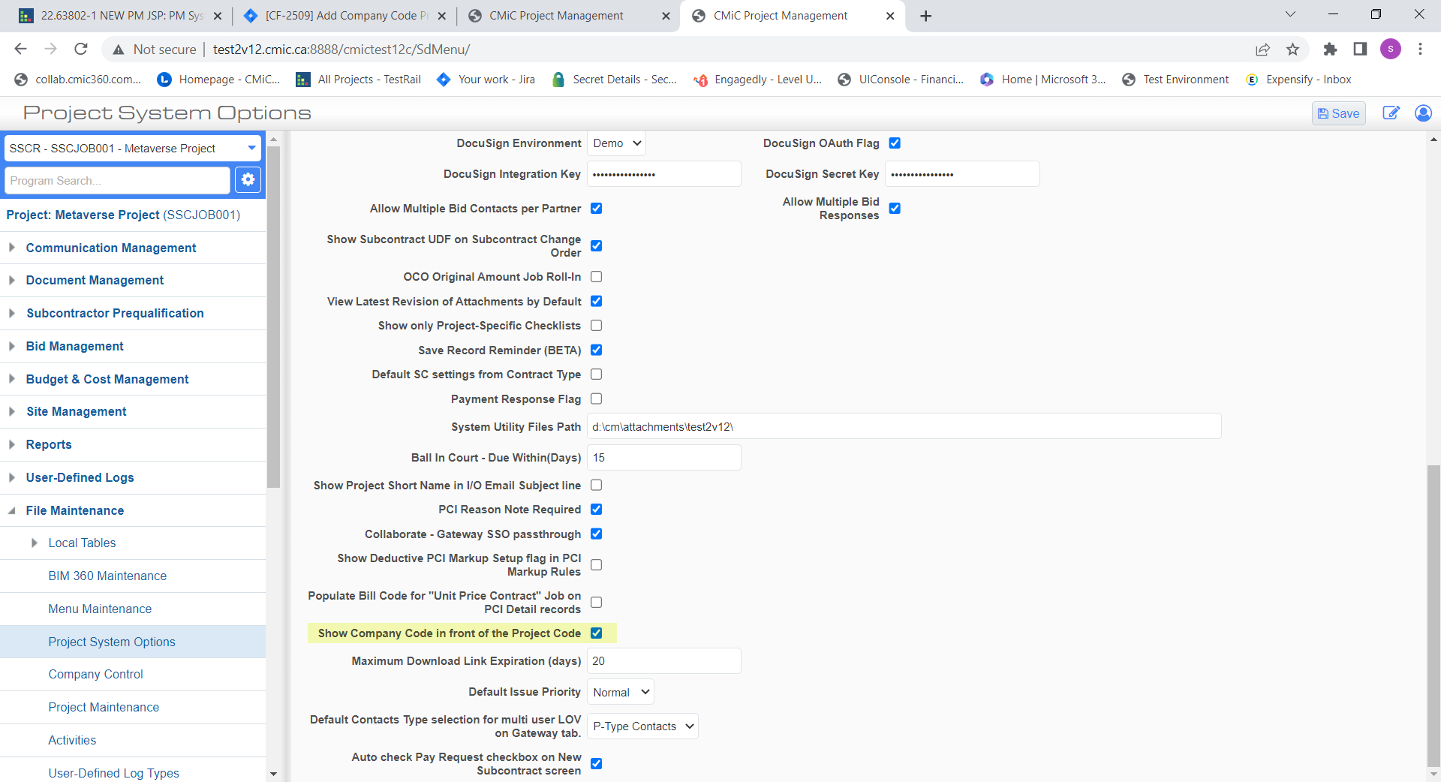

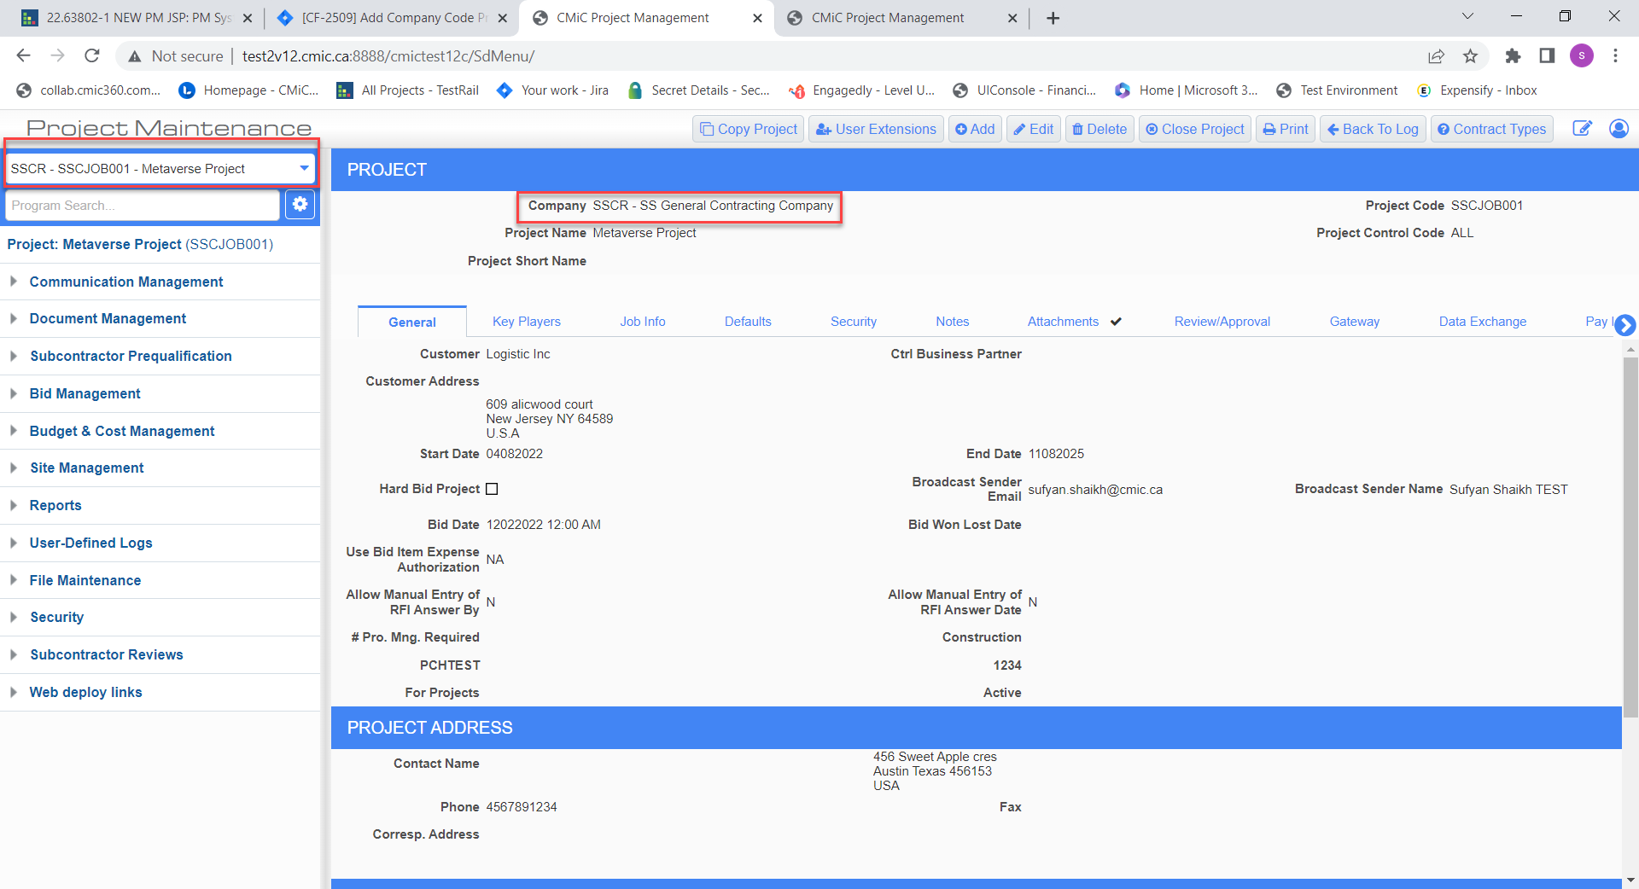
When the flag is unchecked:
- the user will not see the Company Code in front of the Project in the Project Selection area of the tree view
- in the Project Maintenance screen, user will not see Company Code in front of the Company Name
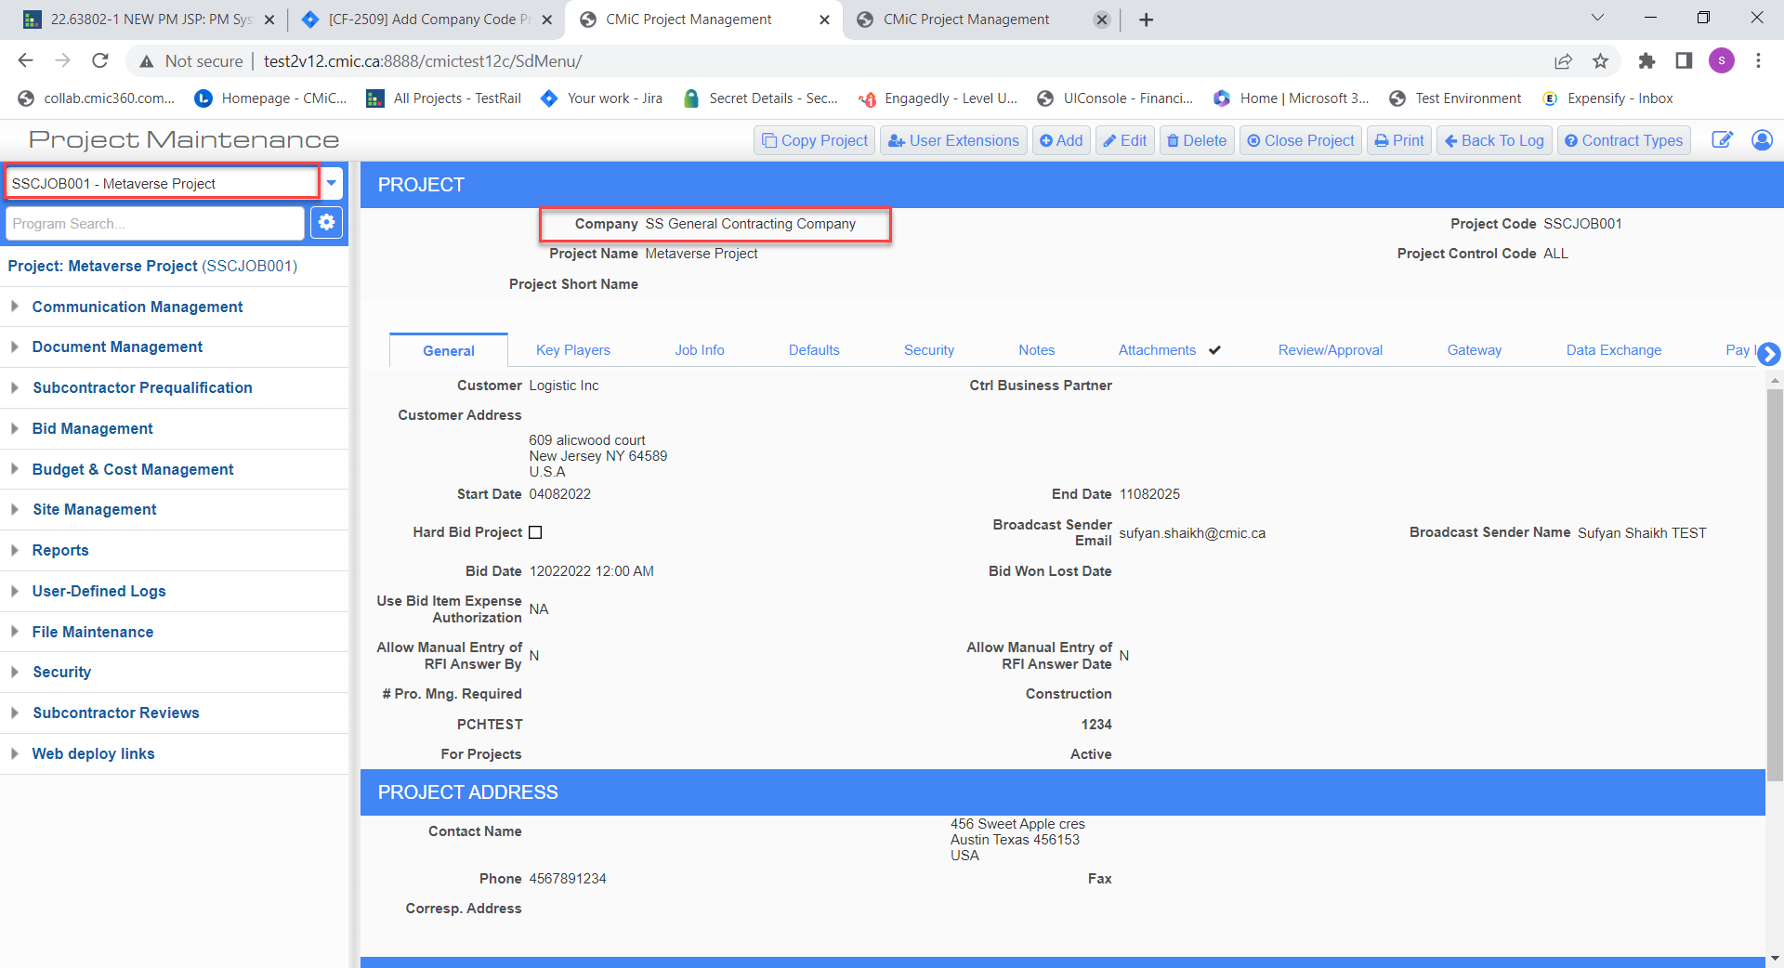

Field Security for Proceed and Forecast flags in PCI Entry (22.64451)
The Potential Change Item (PCI) screen has field security introduced for the Forecast and Proceed flags.
To change the field security, go to Role Maintenance > *ALL* Role > Assign Field Security
When field security is set to Read Only:
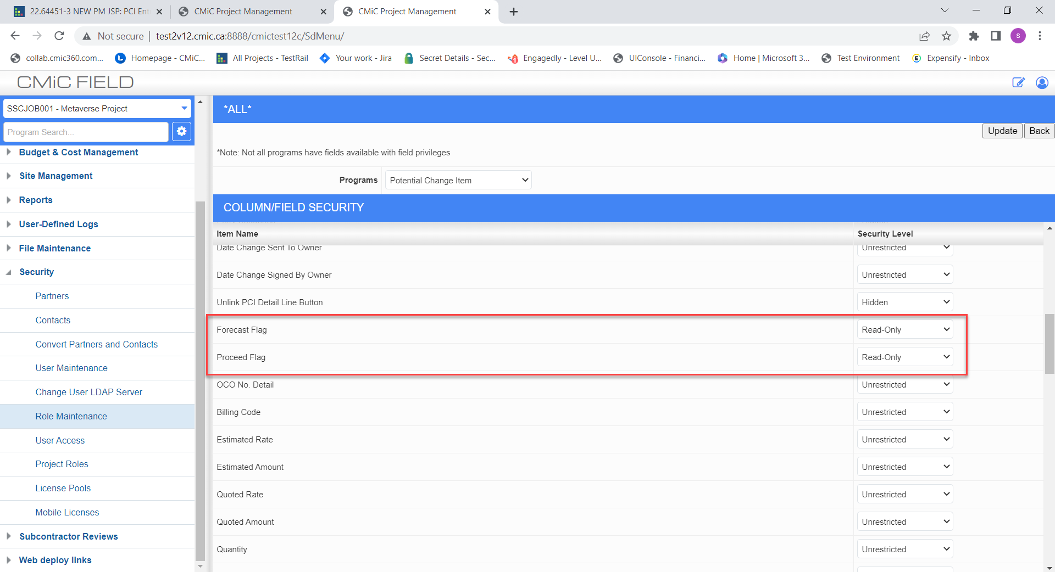

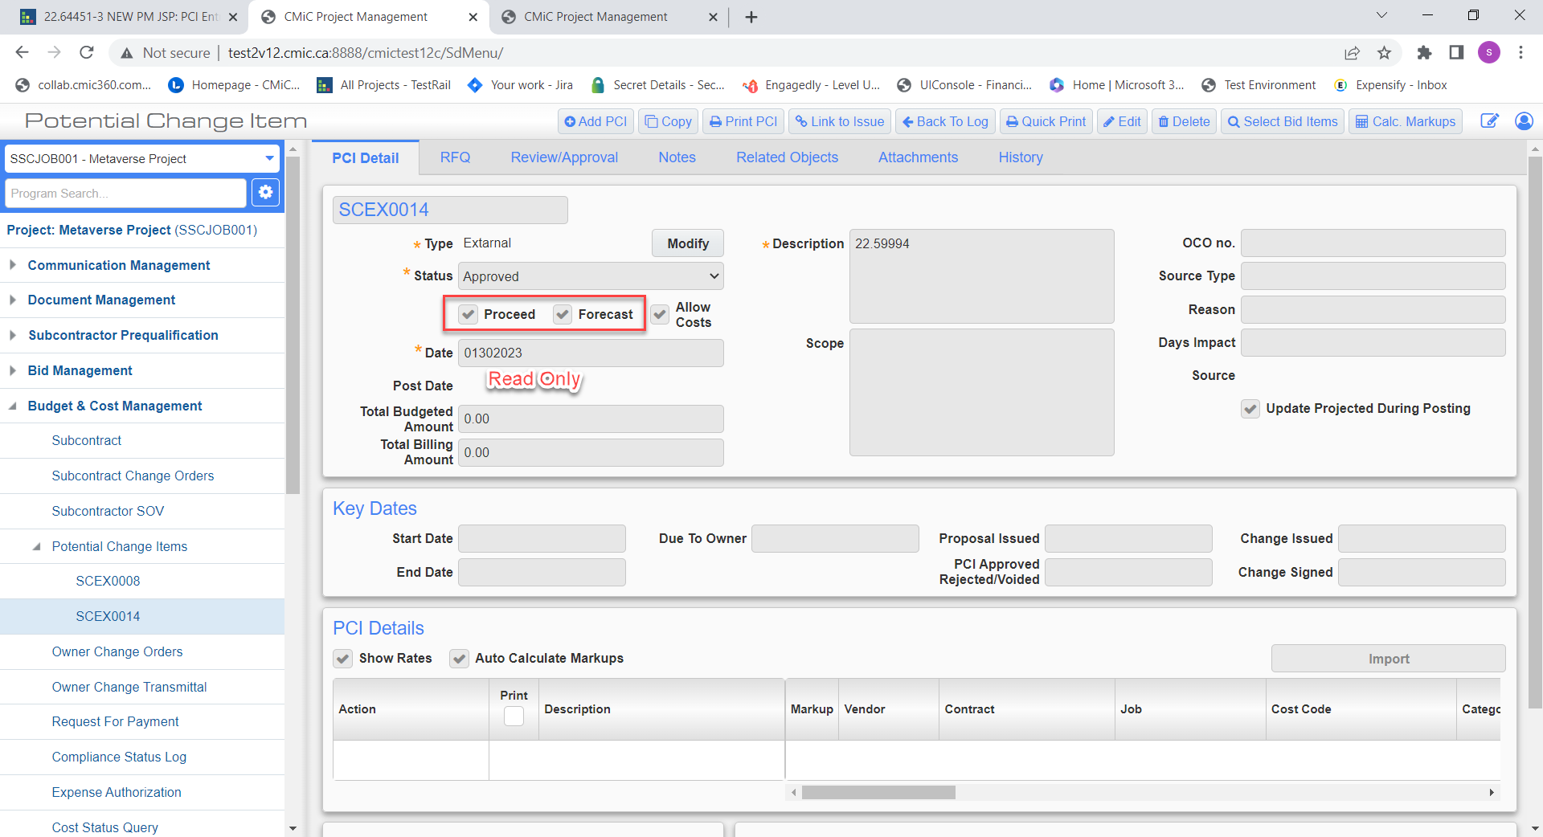

When field security is set to Hidden:
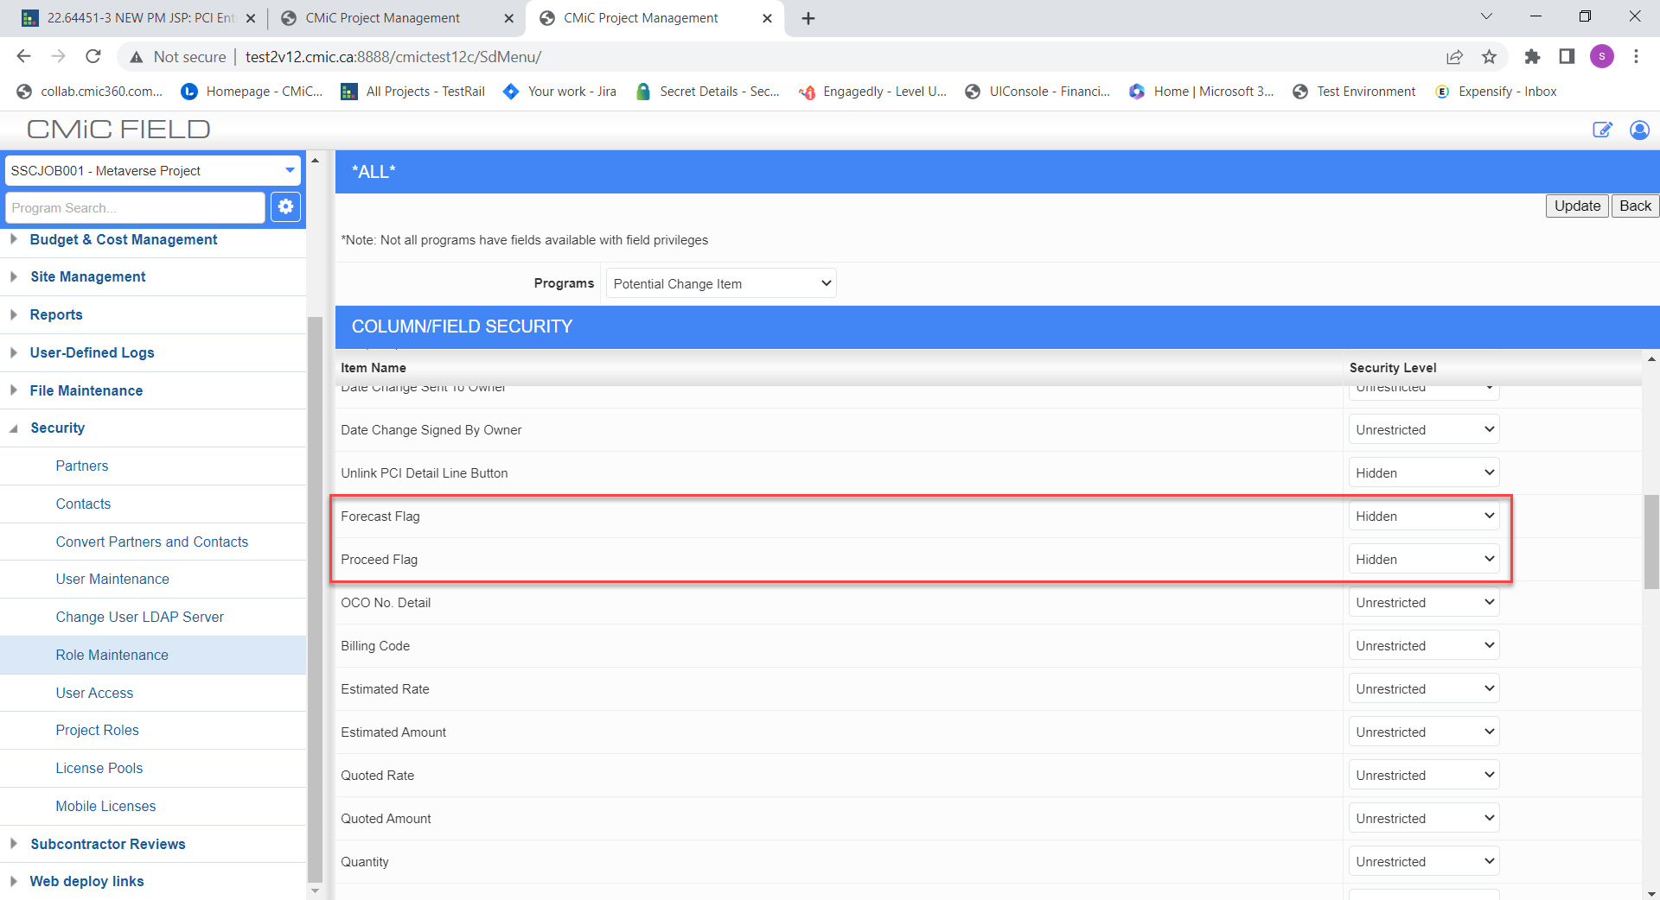

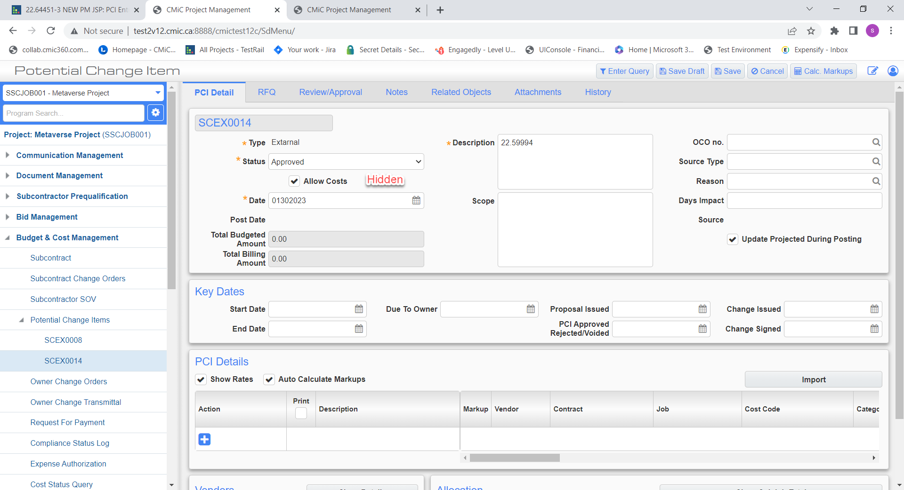

Contract Forecasting Kendo - Enhancements (22.63893)

Some additional changes have been made to the Contract Forecasting Kendo-based version.
Note that users can add the custom menu item “Contract Forecasting Kendo” in the tree-view from the Menu Maintenance screen:
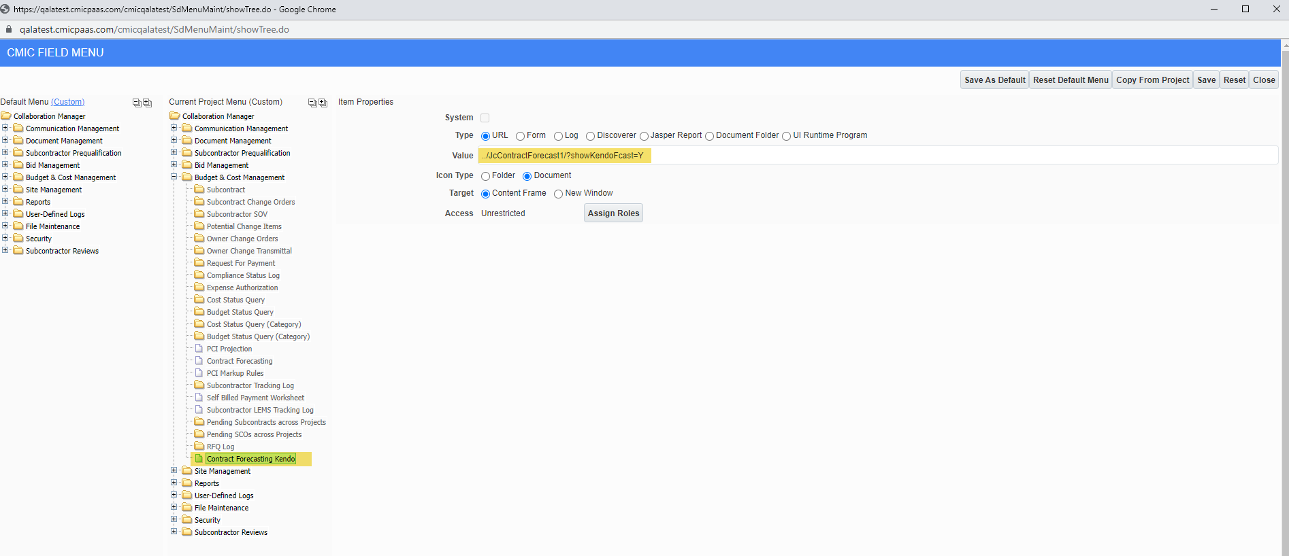

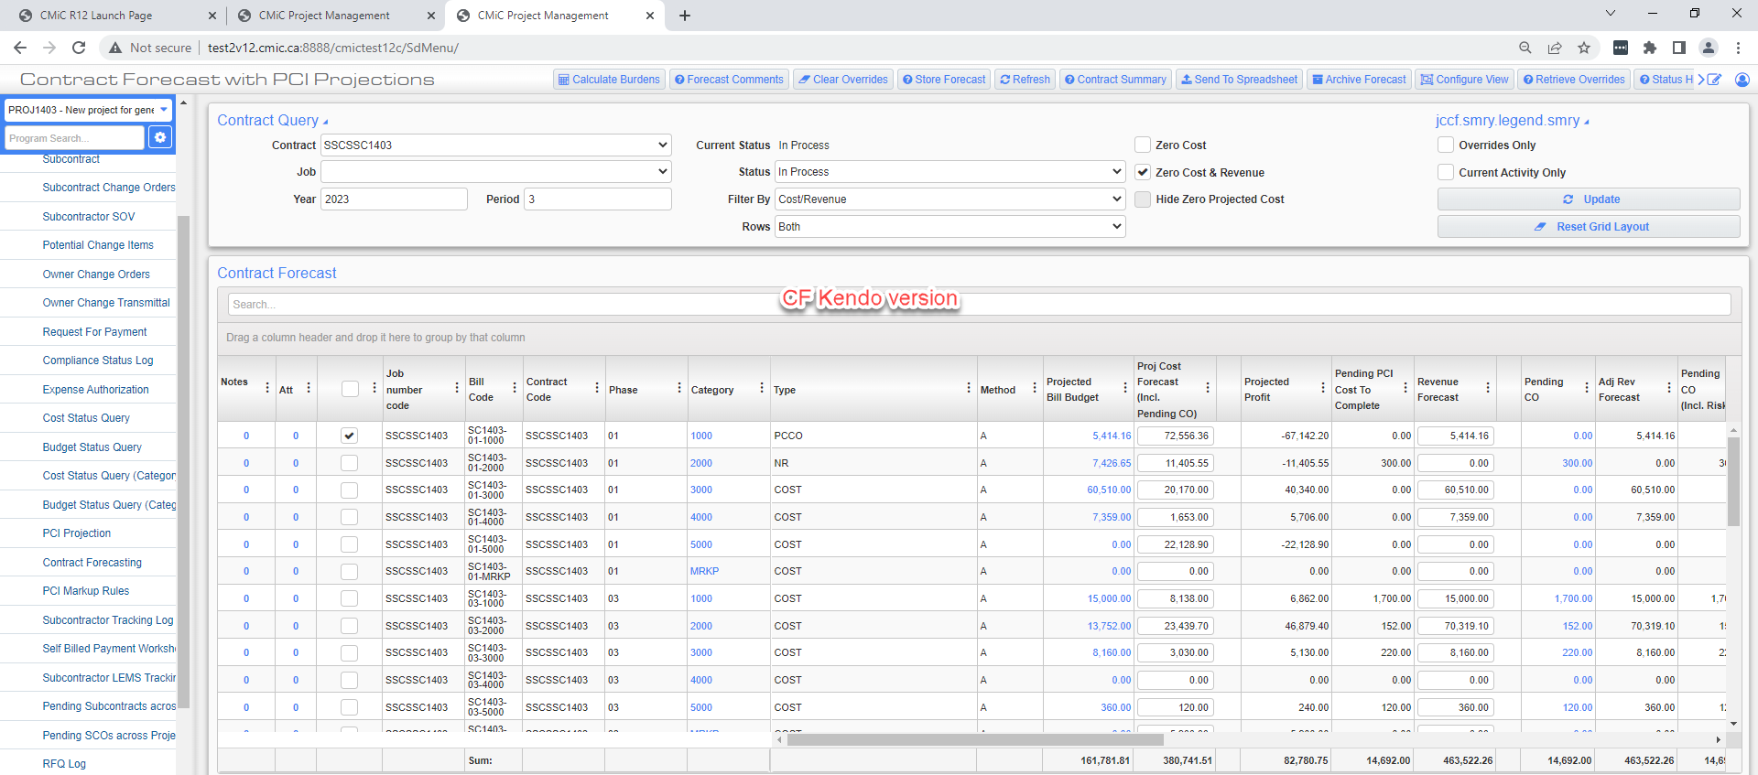

Following are the features added to the Kendo-based version of the Contract Forecast screen:

- Filter section has been made collapsible.
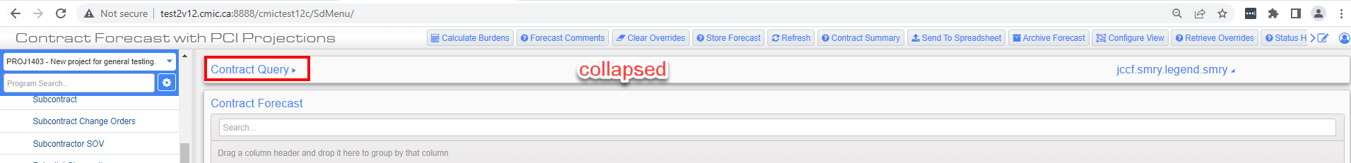

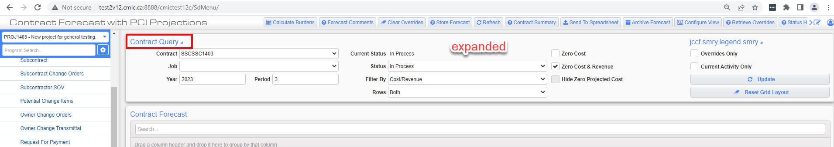

- Some of the radio buttons have been removed and displayed in the form of drop-down in the filter section.
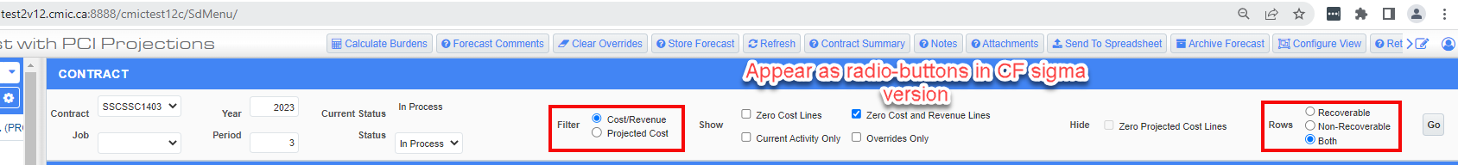

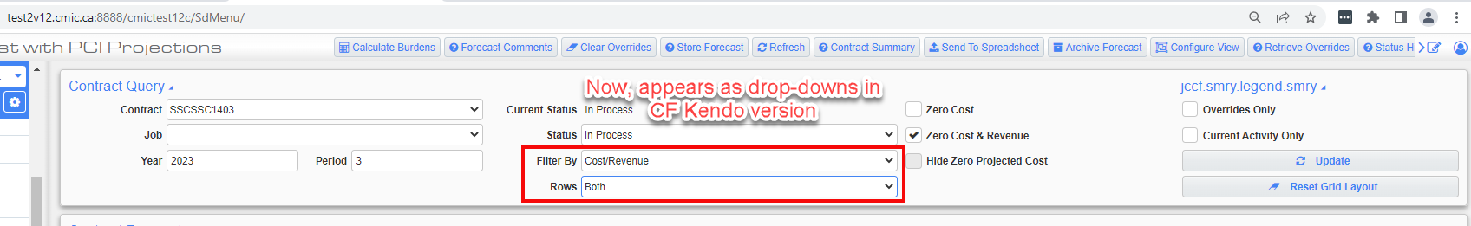
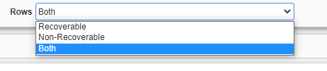
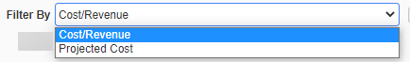

- Search field has been added.
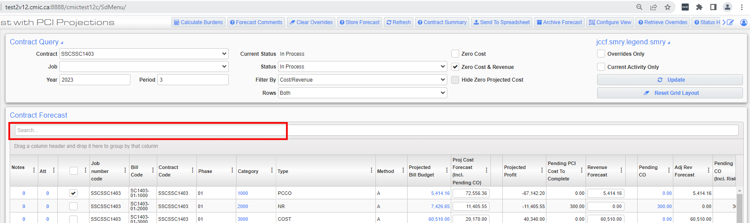
- [Go] button has been updated with [Update] button.
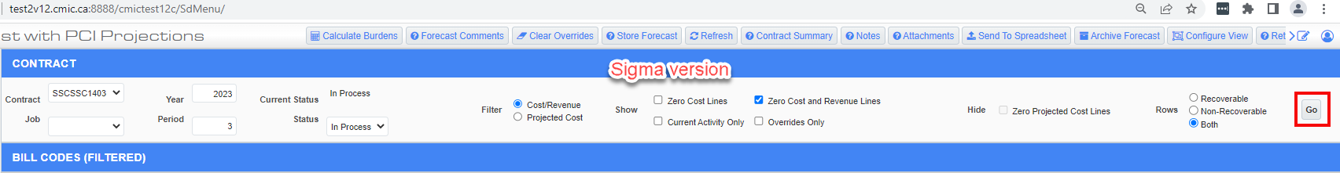
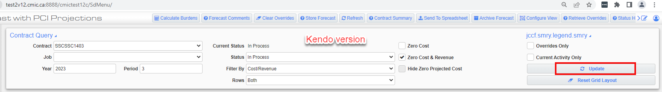
- [Note] and [Attachment] buttons have been removed from the header bar. User just need to click on the link for notes and attachments columns for a particular row to add a note and attachment.
{NOTE: The Notes Count field is clickable and opens Notes popup.}
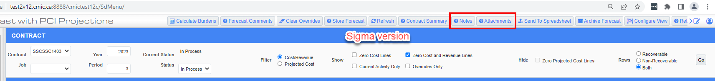
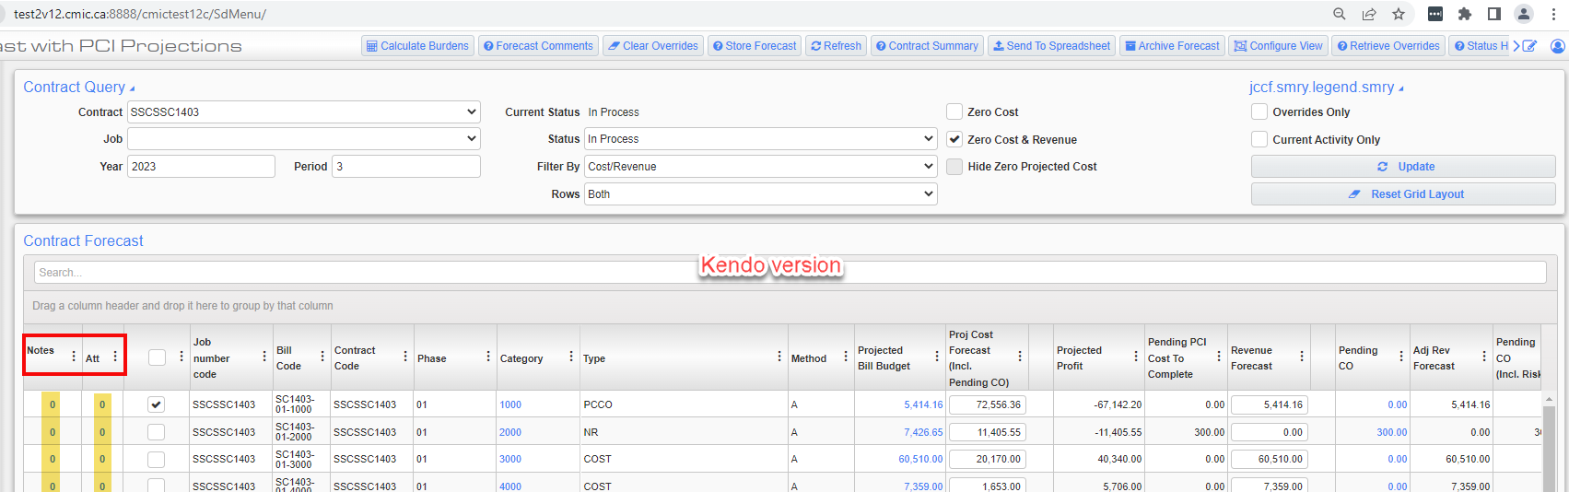
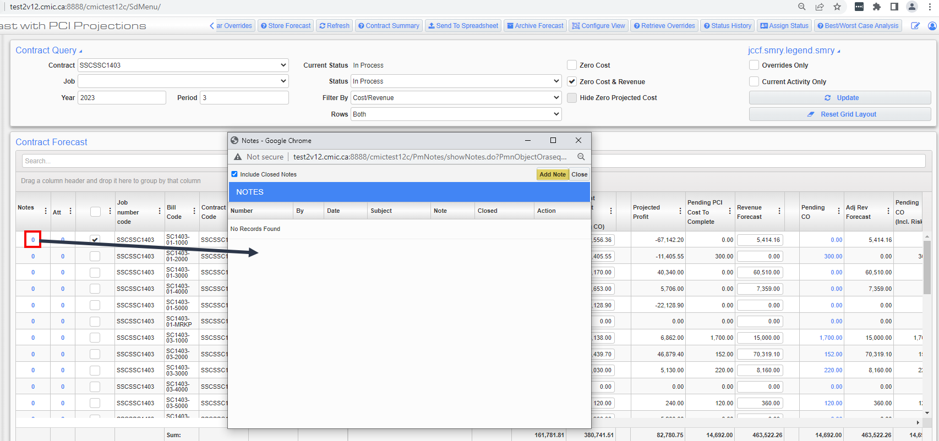
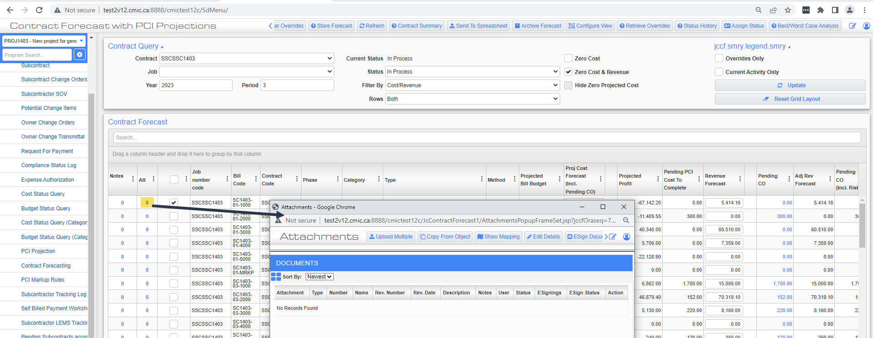

- Pagination has been removed from the Contract Forecast Kendo version. In the kendo version all the Bill Code lines appear on the same page and can be accessed using the vertical scroll bar.
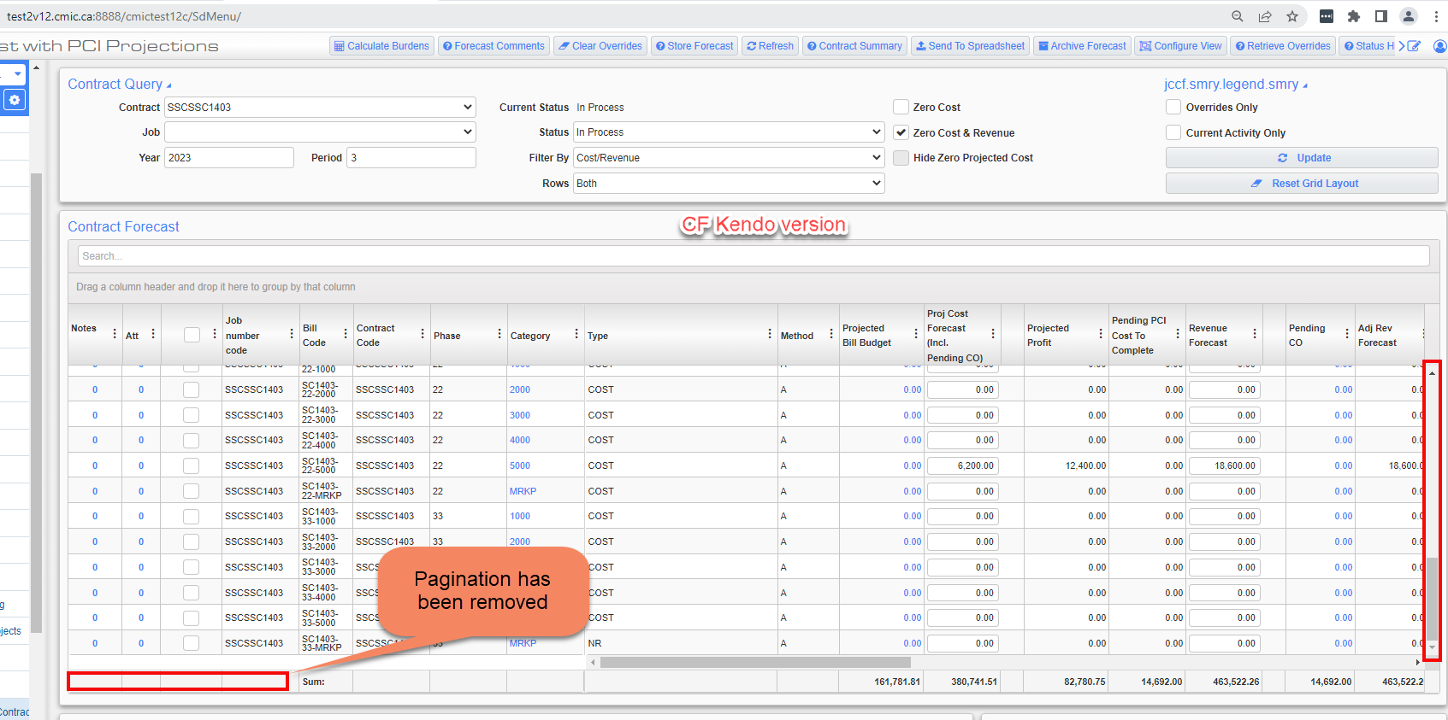
- In Contract Forecast Kendo version, subtotals have been added to groupings.
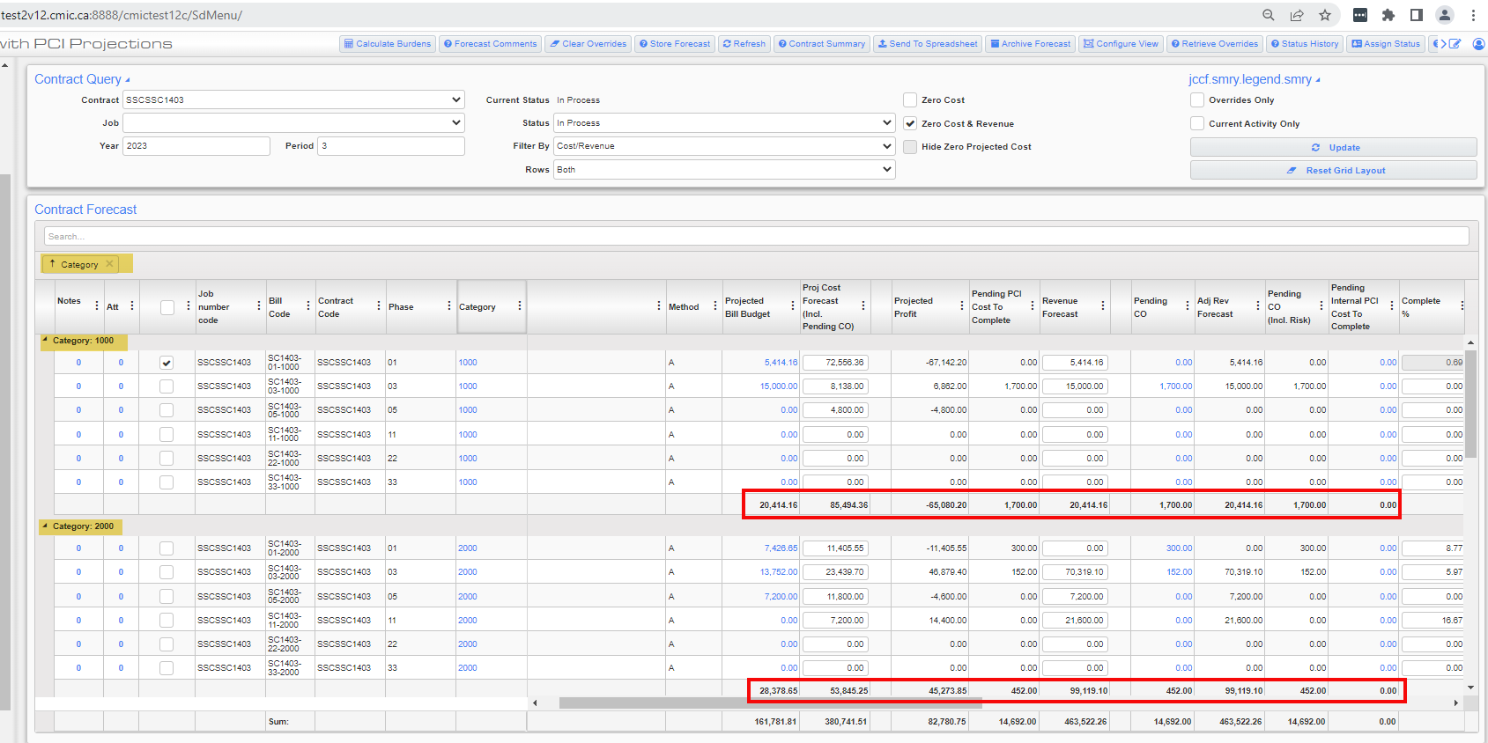

Subcontract Change Order – Field Security for Expense Code (22.52799)

CMiC has added field security to the “Expense Code” field in Subcontract Change Order. Now, the user can apply the field security (Hidden, Unrestricted, Read-Only) to “Expense Code”.

By default, the “Expense Code” field is set to HIDDEN in the Schedule of Values (SOV).

To set the field security navigate in tree view as given below:
Security > Role Maintenance > *ALL* > Assign Field Security from drop-down for program: Subcontract Change Order
Hidden: When “Hidden” is selected, the Expense Code will not be visible in the Schedule of Values.
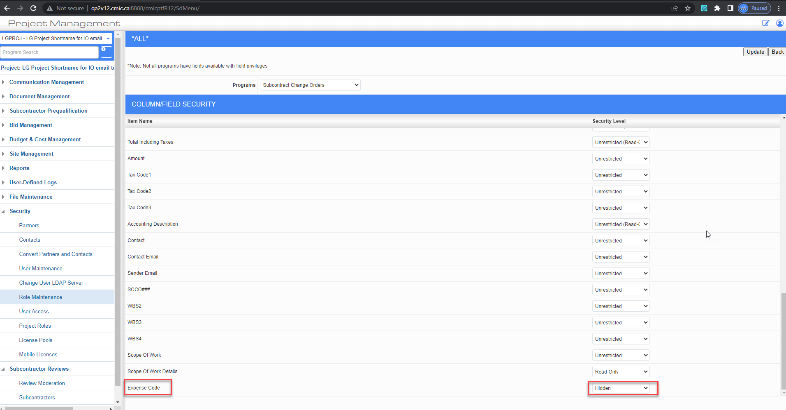

Unrestricted: When “Unrestricted” is selected, the Expense Code will be visible in the Schedule of Values. Users can edit the Expense Code field.

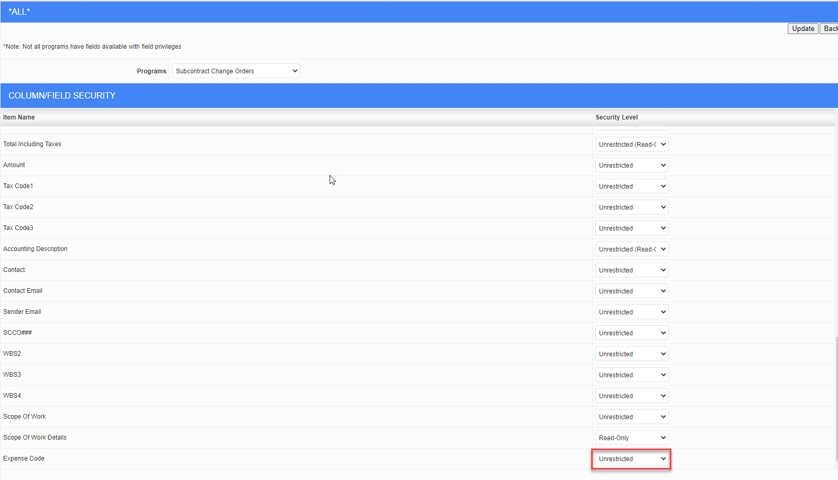

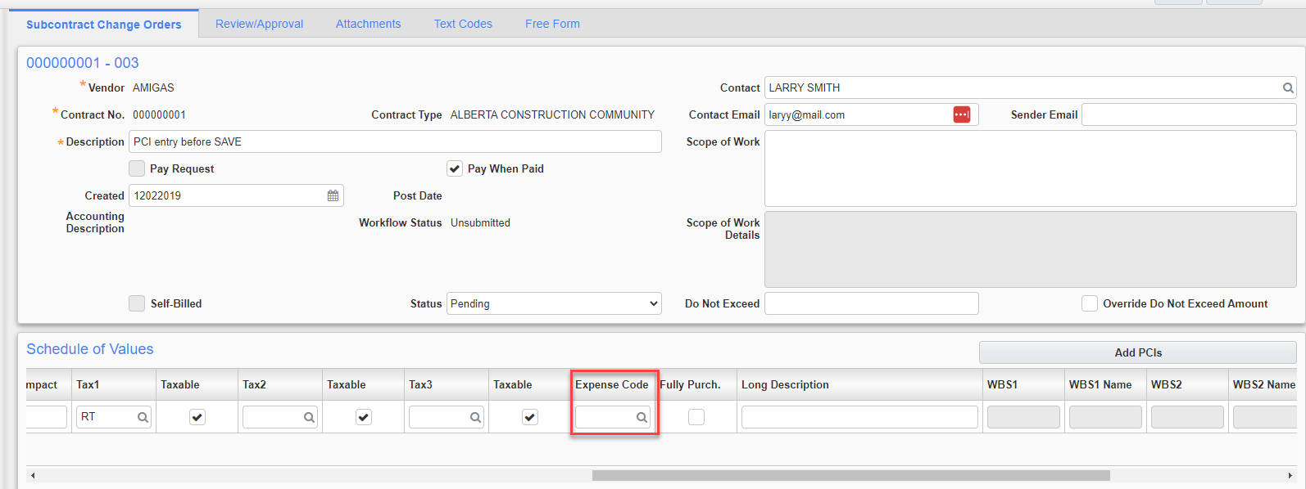

Read-Only: When “Read-Only” is selected, the Expense Code will be visible in the Schedule of Values but users cannot edit the Expense Code field.
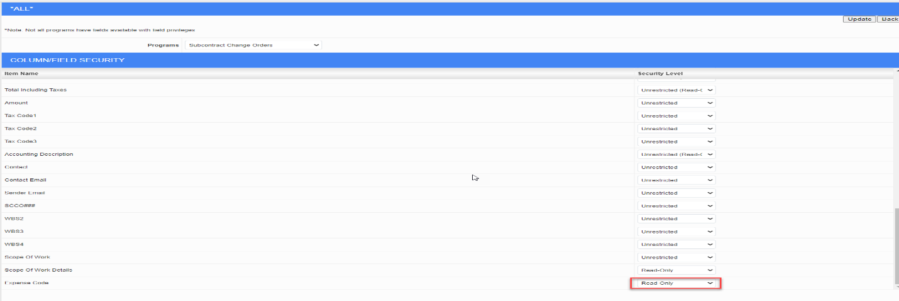
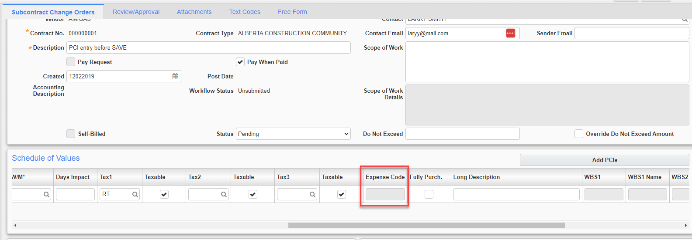

Subcontract Compliance Popup – Field Security for Certificate Number (22.62022)

CMiC has added field security for the Subcontract Compliance popup “Certificate Number” field. Now users can apply the field security (Hidden, Unrestricted, Read-Only) to the “Certificate Number” field in the Compliance pop-up.

To set the field security navigate in tree view as given below:
Navigate to Security -> Role Maintenance -> *ALL*> Assign Field Security (from drop-down) for the Compliance Popup program.

Hidden: When “Hidden” is selected, the Certificate Number will not be visible in the Compliance popup (Field Only).

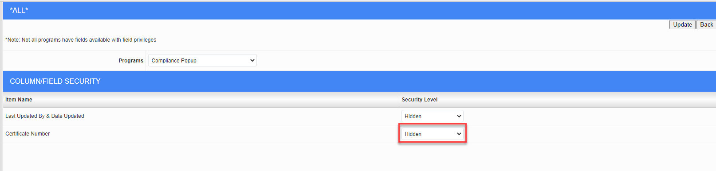
Unrestricted: when “Unrestricted” is selected, Certificate Number continues to function as it does now. Users can edit the Certificate Number field. If Unrestricted, the system will default the ‘*’ value in the field.
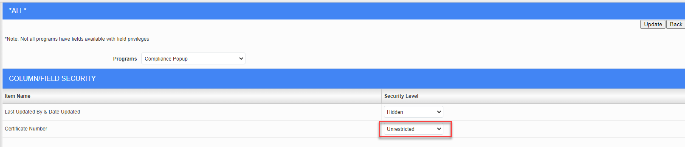

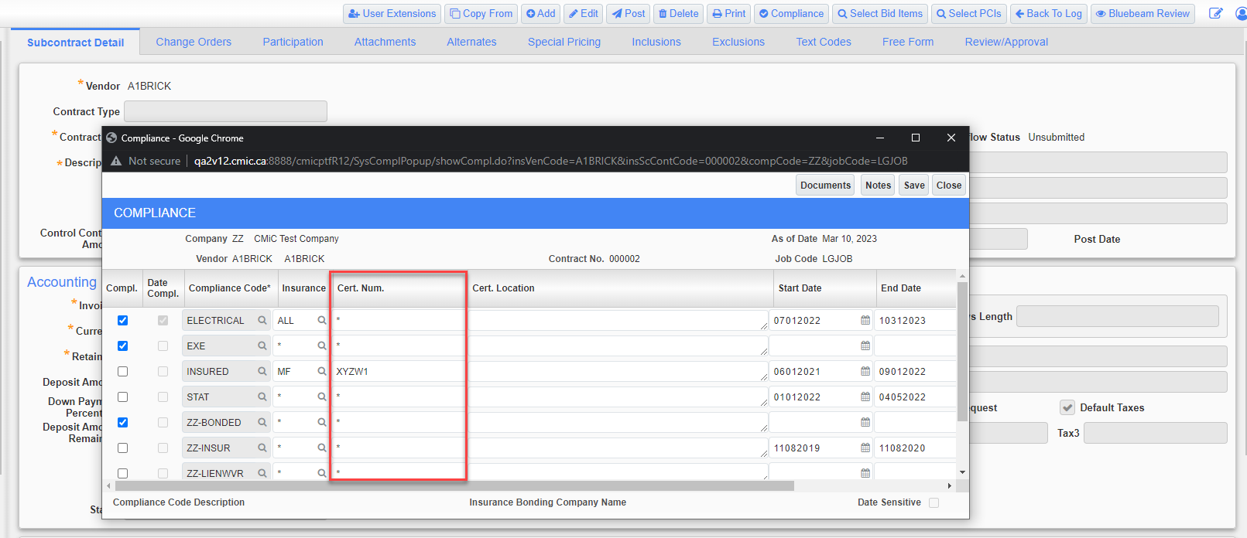

Read-Only: When “Read-Only” is selected, the Certificate Number will be visible but disabled, the user cannot modify the Certificate Number.
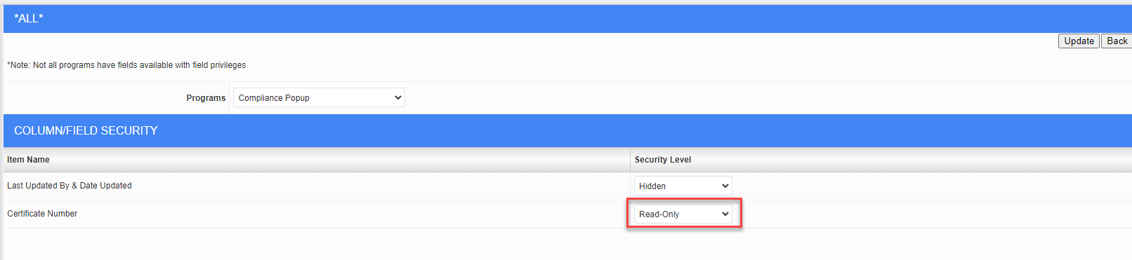

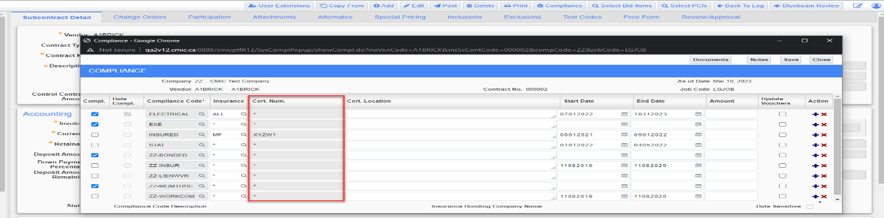

Project Roles: View All Records Associated with Business Partner (22.64713,CF-510)
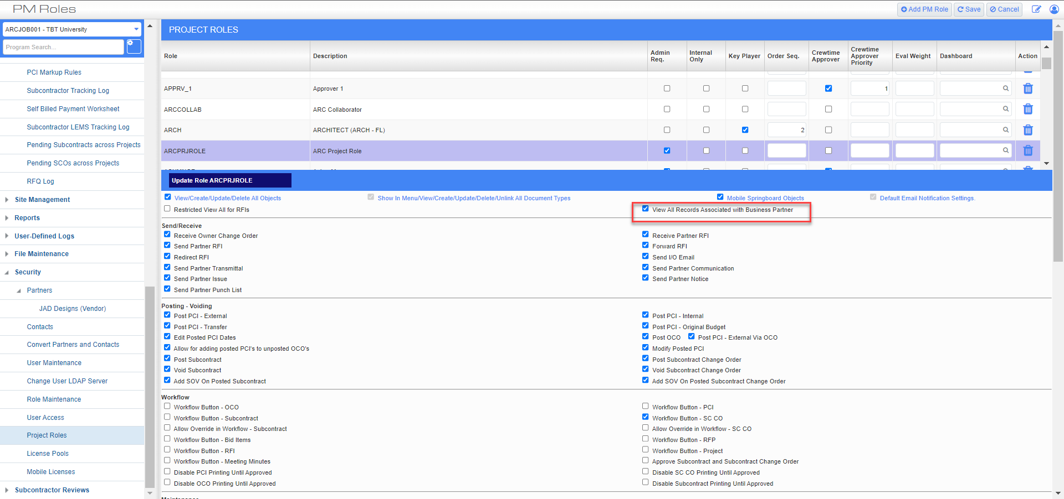

CMiC has introduced a new flag in the Project Roles screen: "View All Records Associated with Business Partner" which will provide a user with the ability to:
- see all Submitted records addressed to contacts under the same Business Partner as the user (i.e., all records addressed to other contacts at the same company as the user). So, if another user is the TO-contact or the CC-contact it gives the user the privilege to view the record.
- see all Submitted records created by users under the same Business Partner

- PM Objects to be included: Submittals, RFIs, Issues, Punchlist Items, Daily Journals, Checklist records, Meeting Minutes

Project System Options – Auto-check Pay Request flag (22.64967)
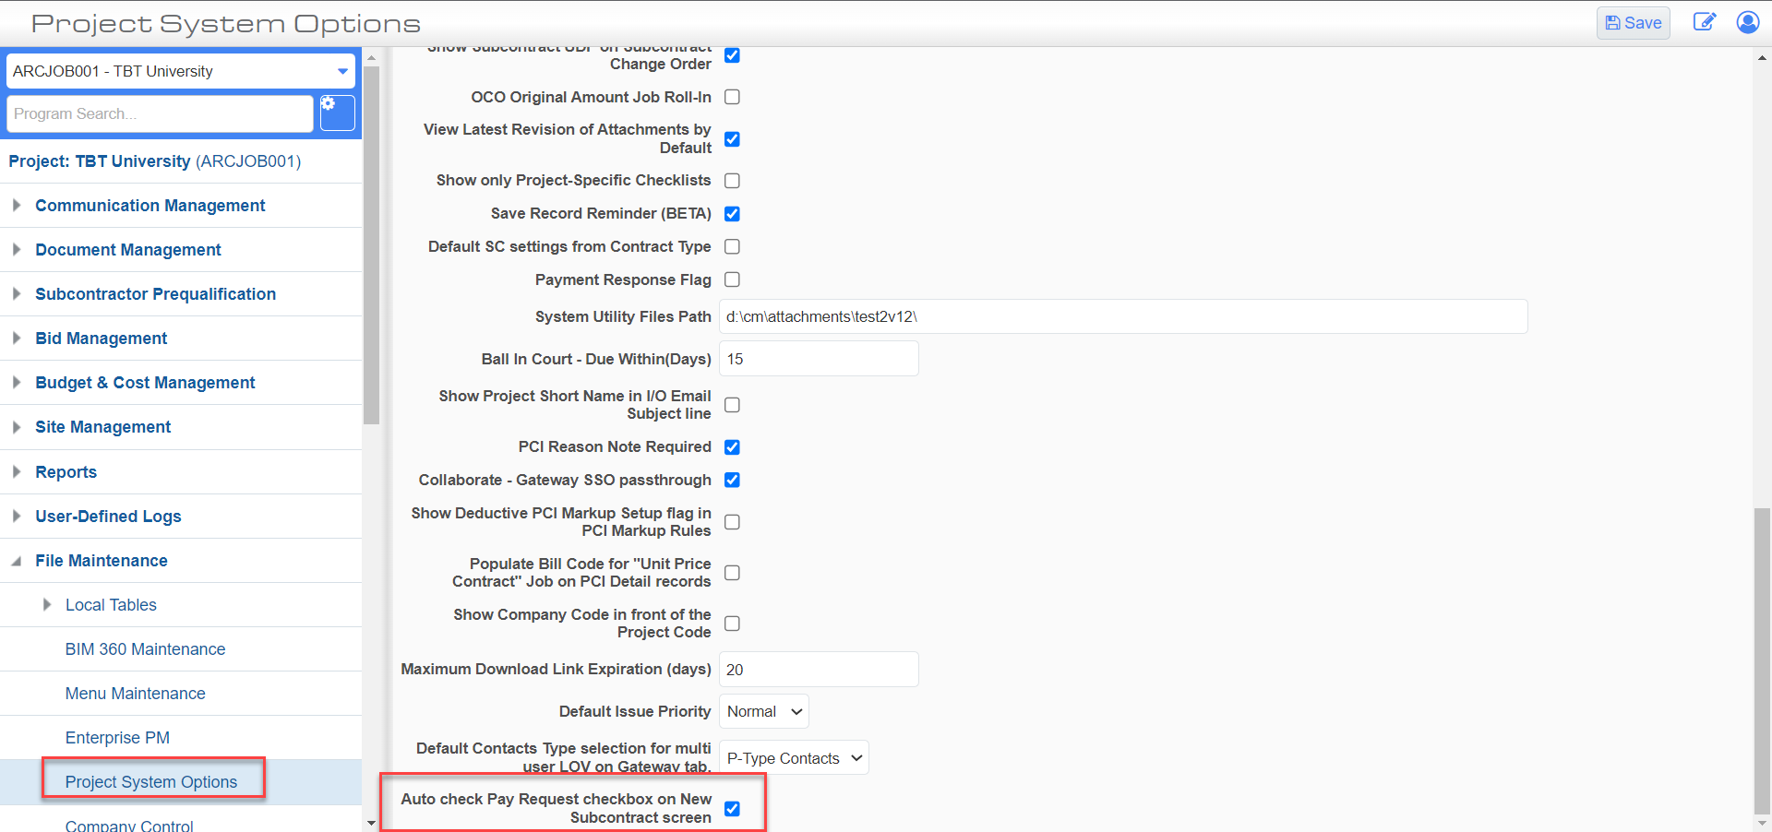

A new flag called “Auto check Pay Request checkbox on New Subcontract screen” has been added to Project System Options which when checked will auto check the Pay Request field in Subcontract screen:

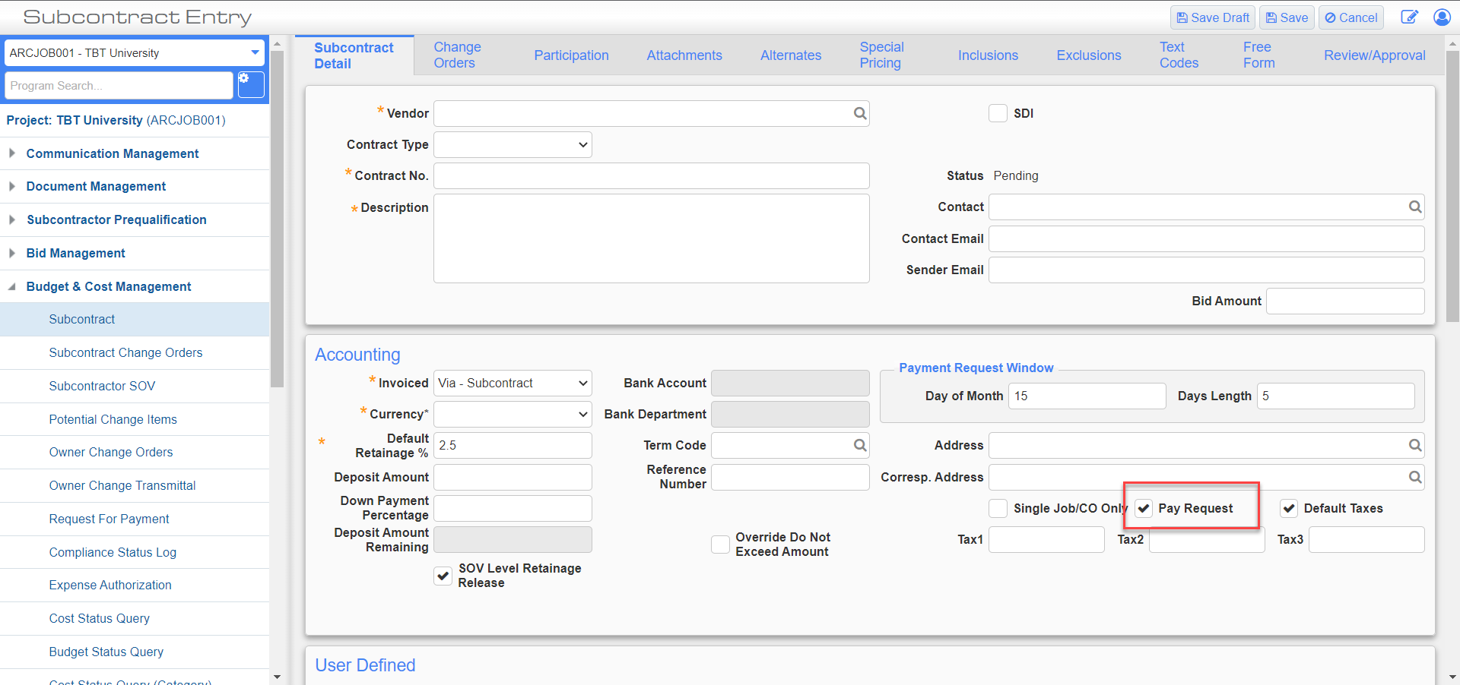

Field security for SDI flag in Subcontract and Contract Type Maintenance programs (20.18275)

Field security for the SDI Flag has been added in Subcontract and Contract Type Maintenance programs.

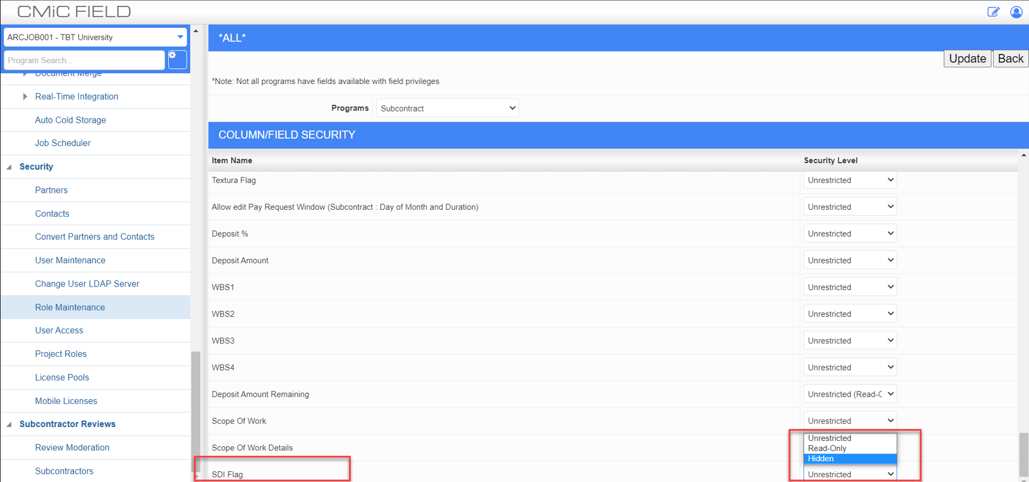
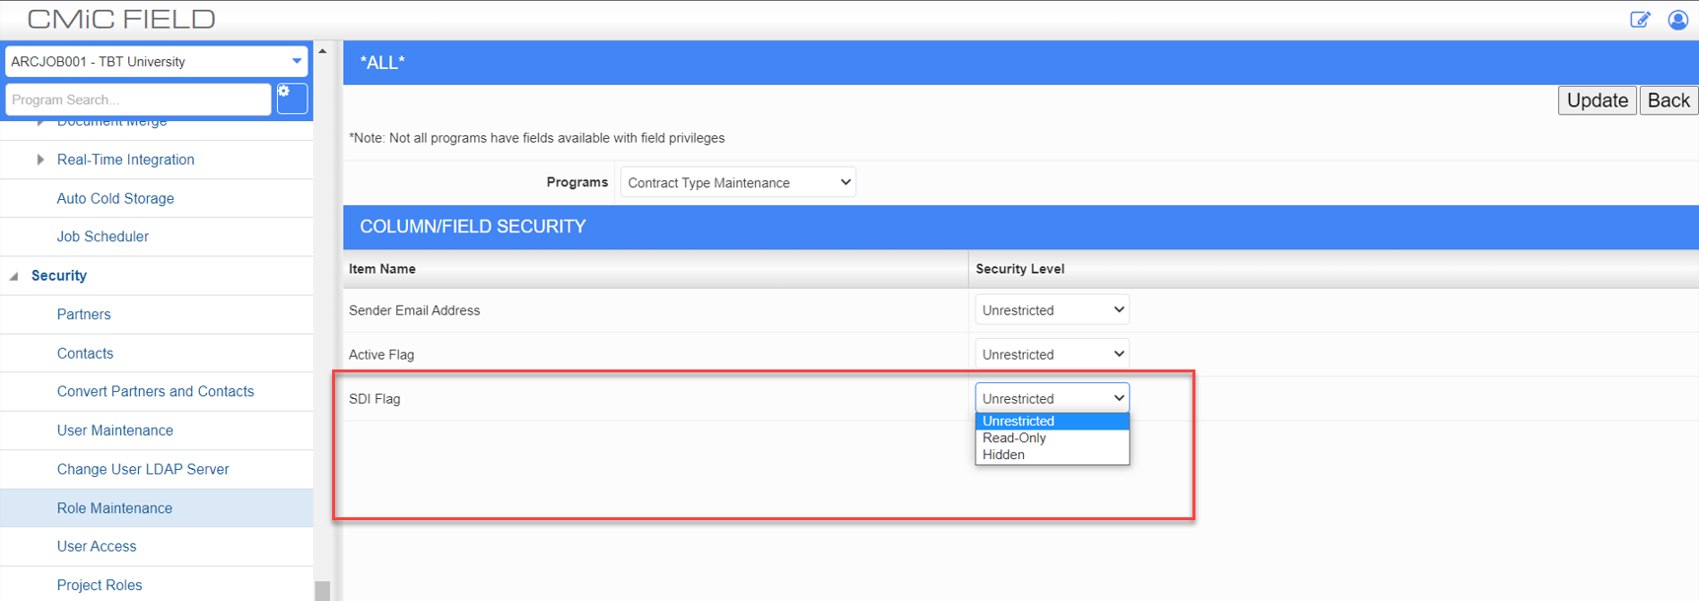

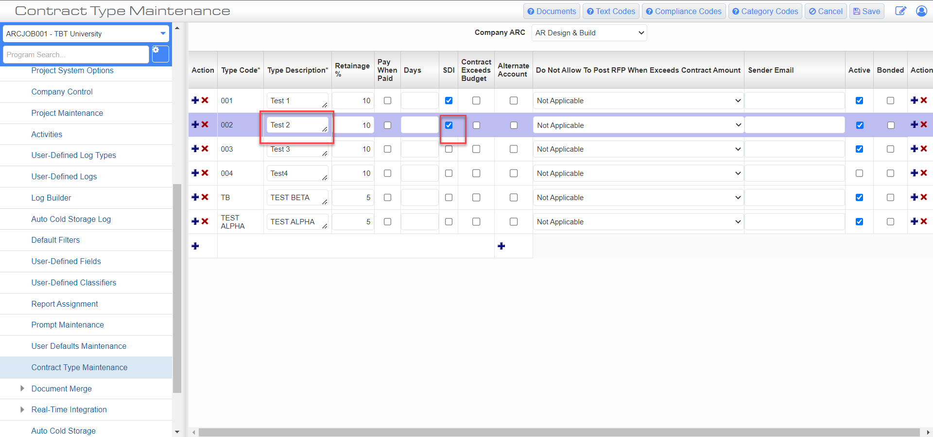

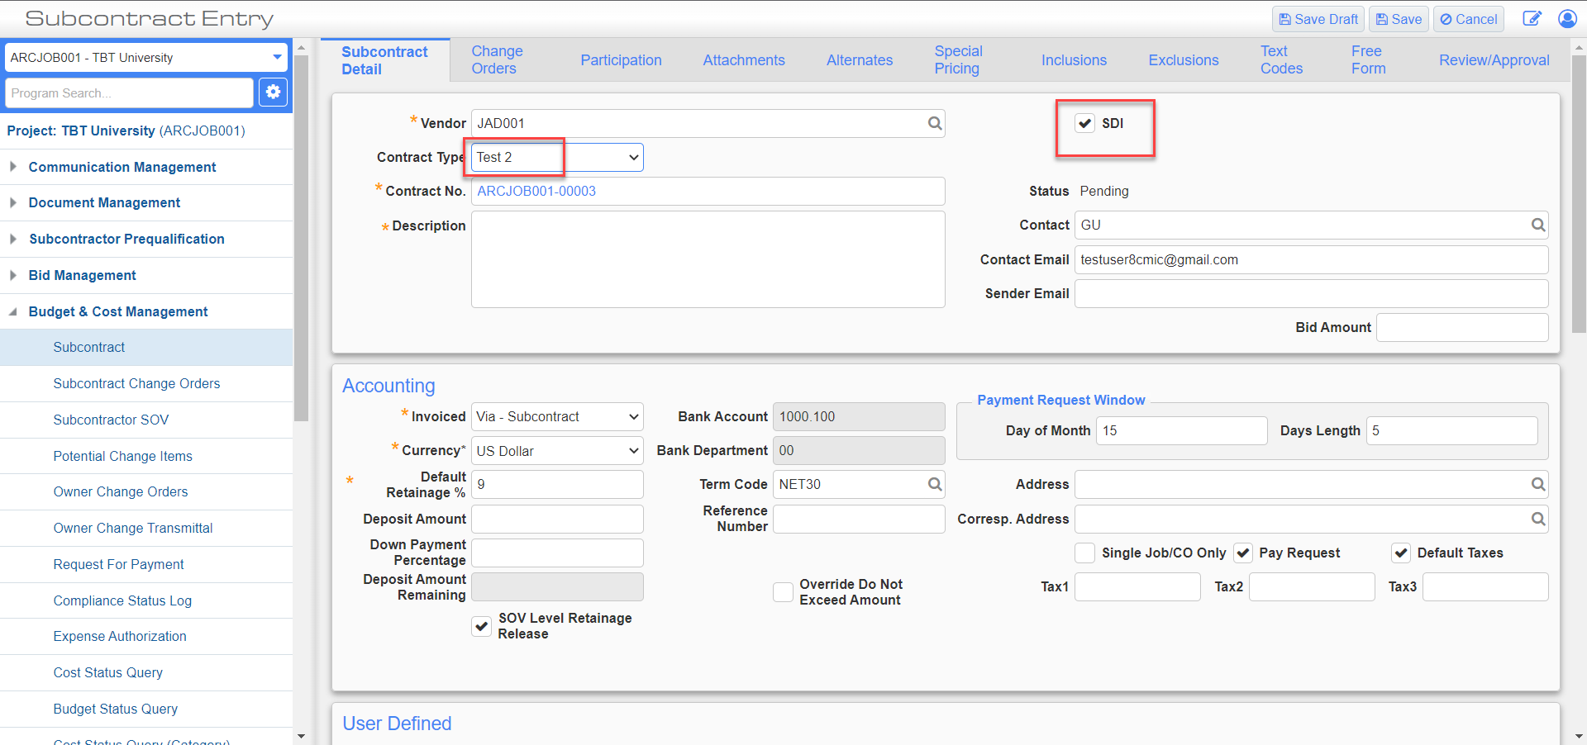

Locations Maintenance - Generate QR Codes (22.62042)

QR codes are handy reference points to quickly pull up information.

CMiC has introduced QR Code capability in Locations Maintenance. By generating QR Codes for the location codes on the project we can scan the QR code and pull all the records (RFIs, Issues and PL Items) that have that location code.

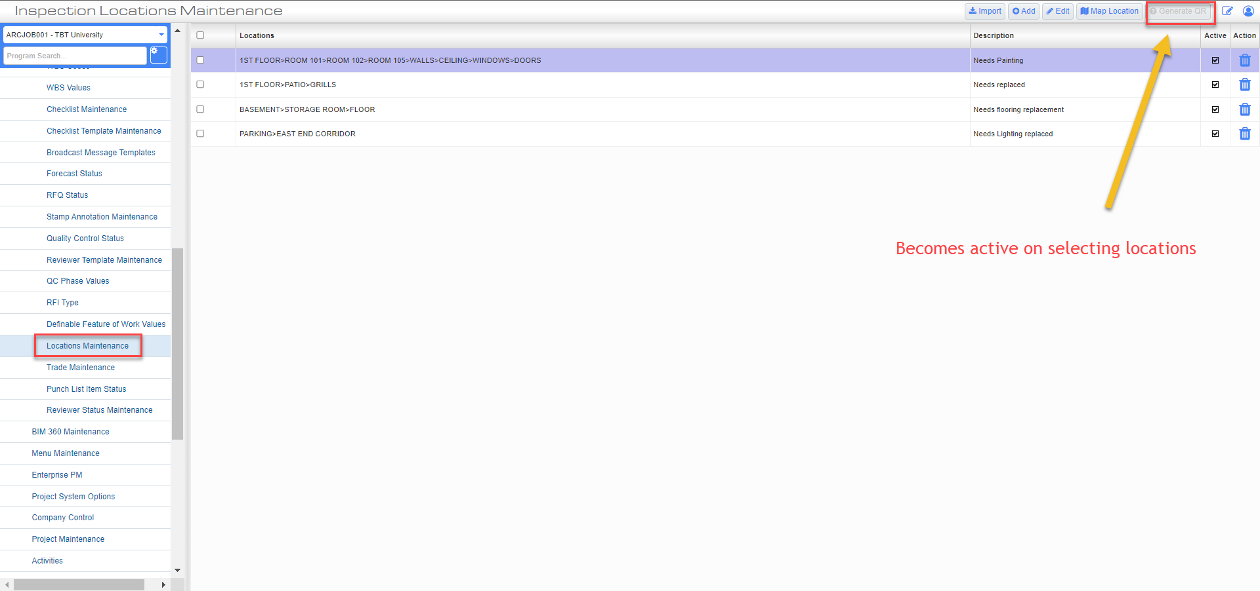
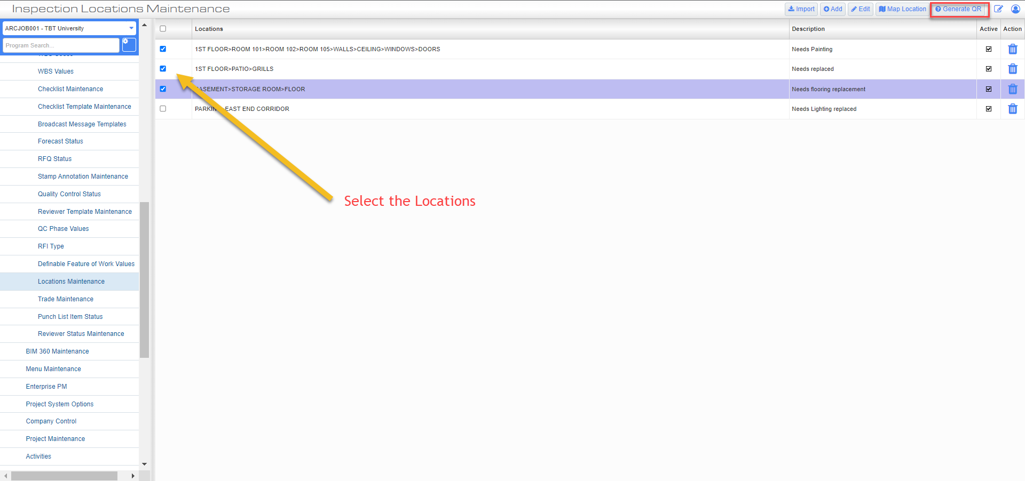
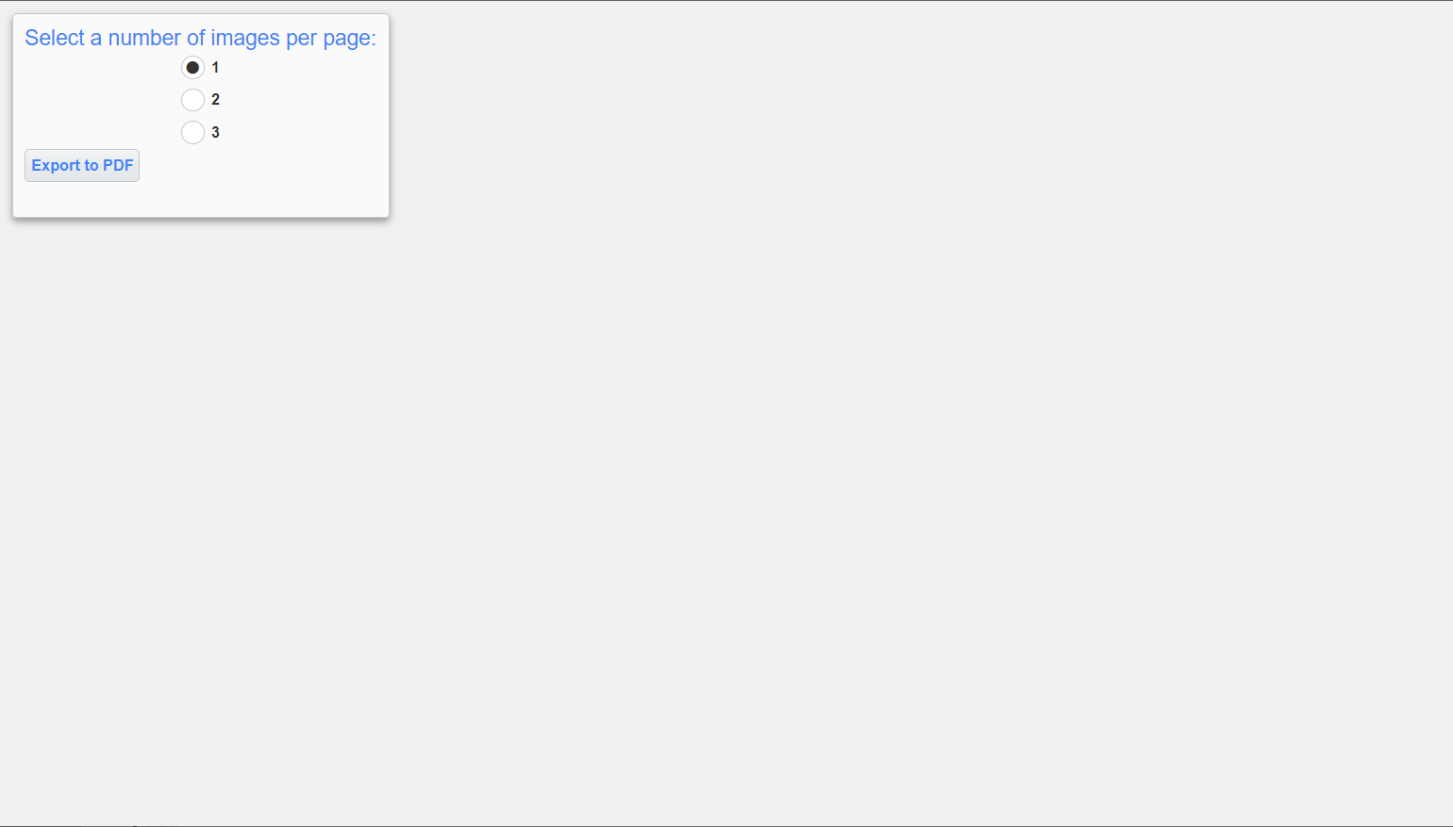
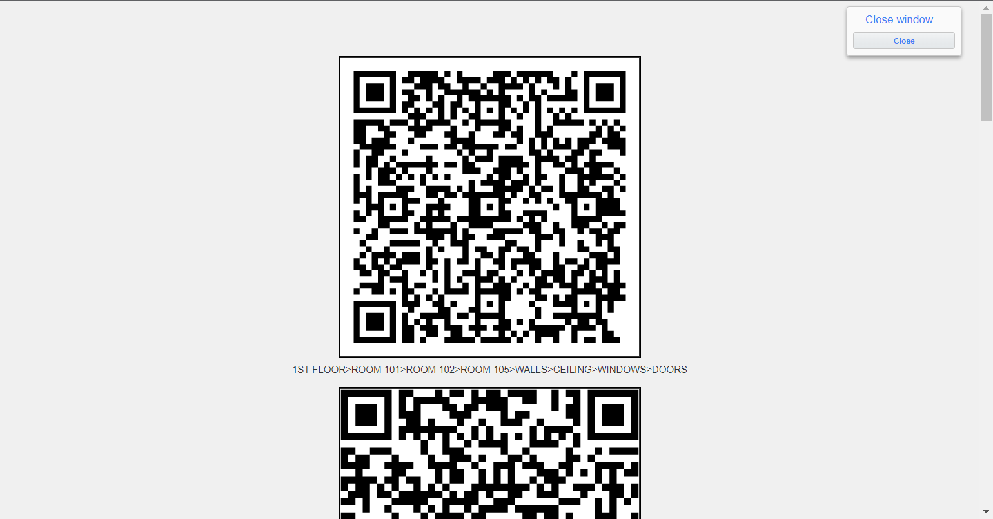

Field security for Phase Template on 'Add Phase/Category on the fly' (22.61012)

Field security for Phase Template on 'Add Phase/Category on the fly' popup has been added.
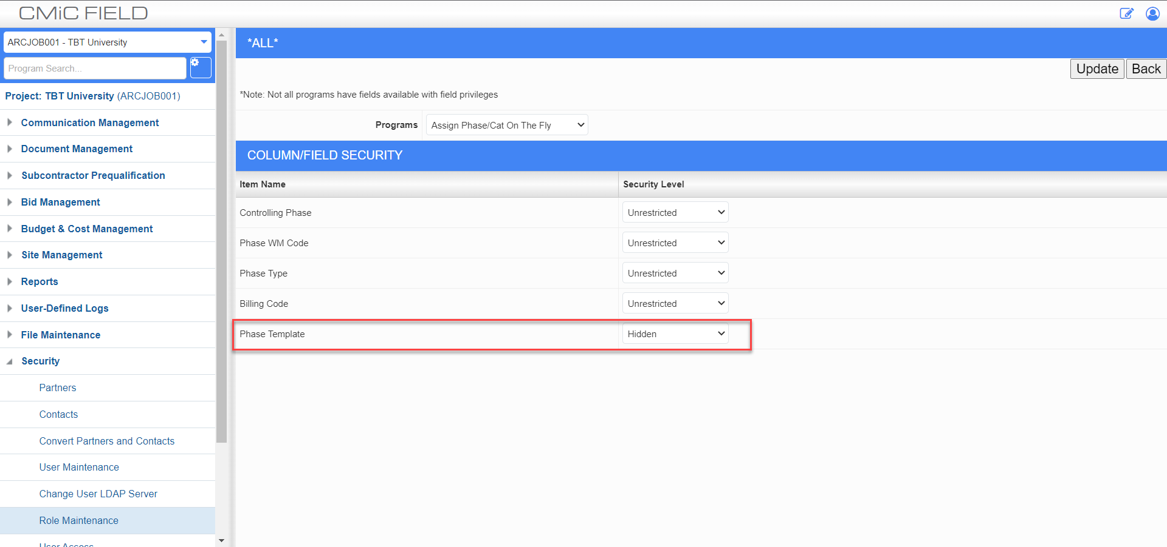
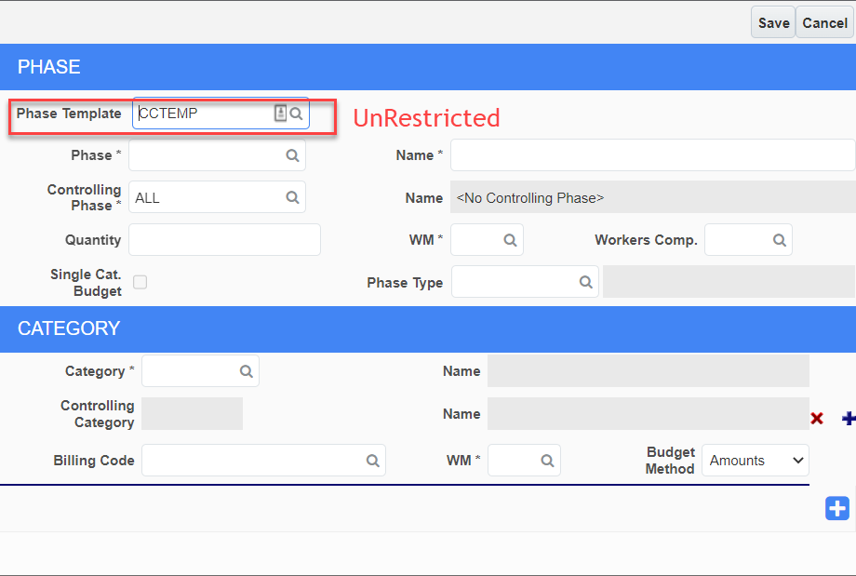
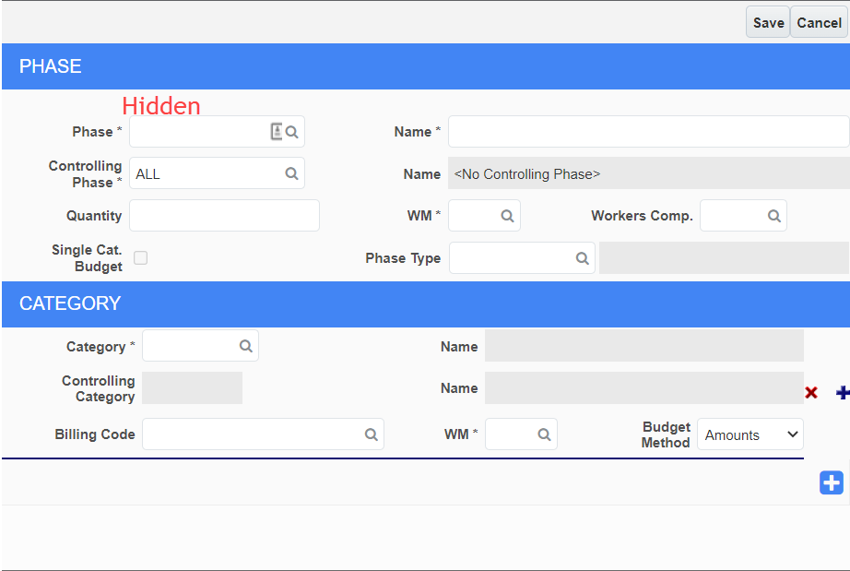

PCI/Subcontract Entry Cost Code Template – Active Flag (22.60044)

The Active flag (default is ‘Y’) has been introduced in the Cost Code Template header (ADF).

When unchecked the template will not be available in Assign Cost Codes (ADF) nor in PCI/Subcontract Add New ‘on-the-fly’ Cost Code screen (ADF, JSP).

Functionally the inactive template would behave as if the template was deleted.
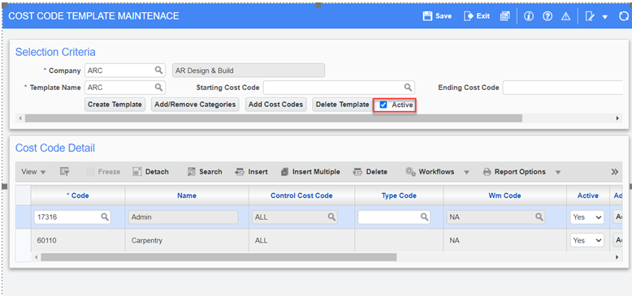

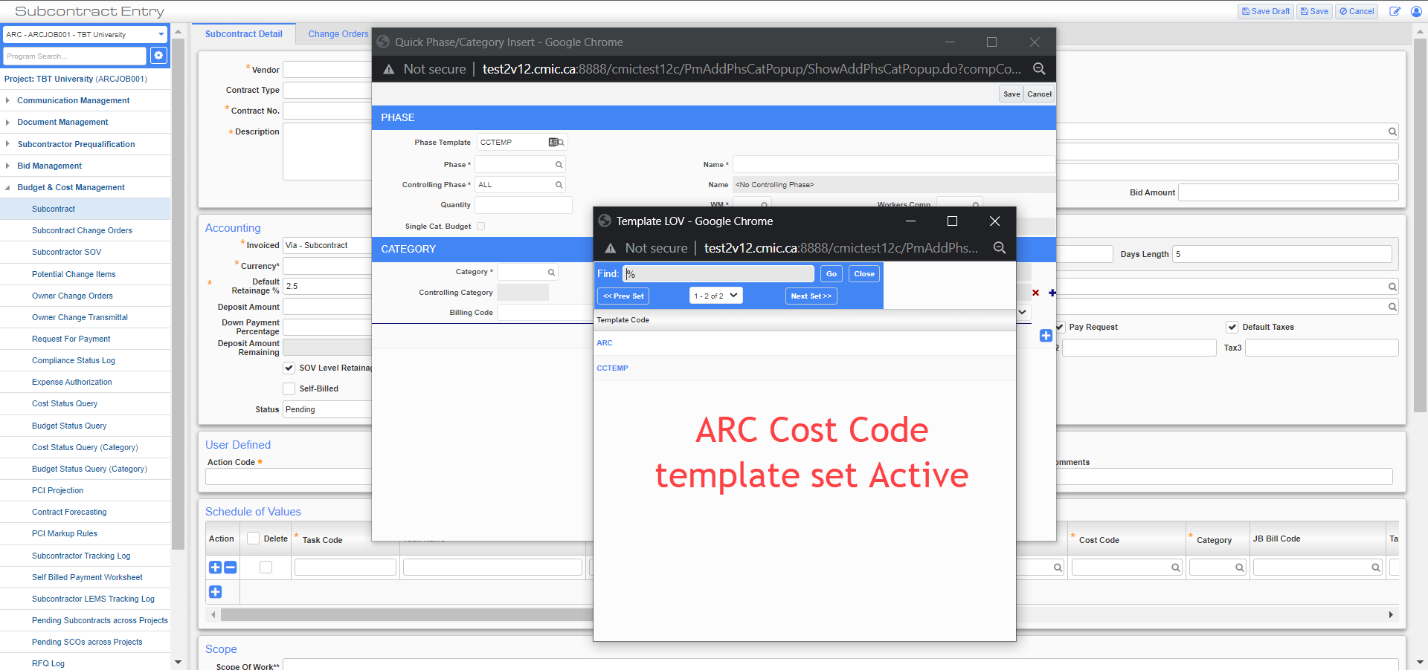

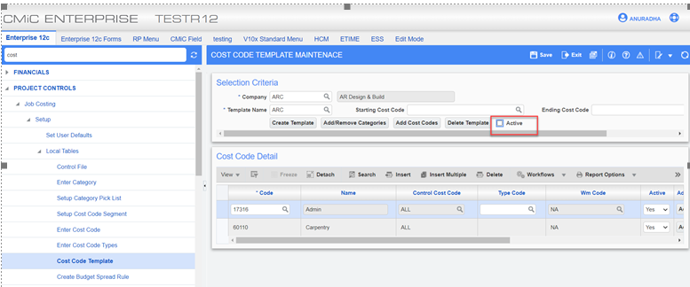

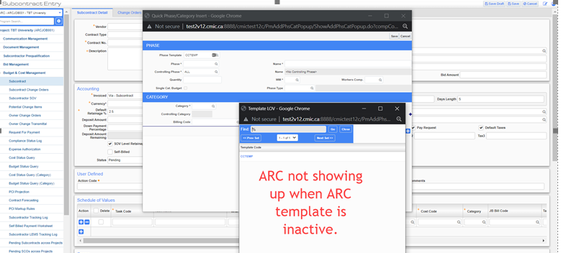

Submittals - Actual & Projected Schedule and Actual & Projected Timeline (22.65530/CF-4158)

Updated the labels for the Submittal Schedule as follows:
line 1 (as is): “Planned Schedule”
line 2: "Actual & Projected Schedule"
line 3: "Actual & Projected Timeline"
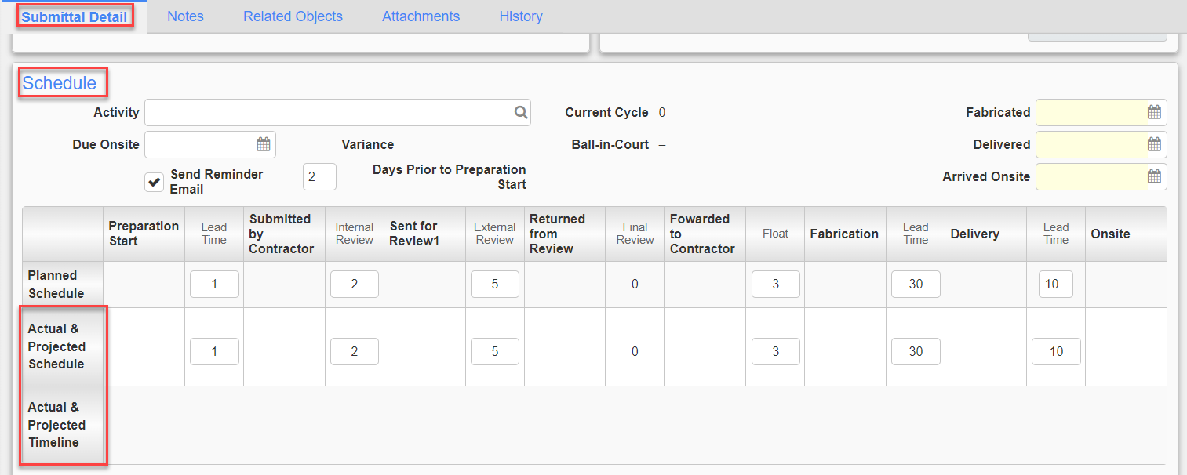
Calculation 1:

Float
- When the Actual or Projected date of “Forwarded to Contractor” falls before the planned “Fabrication” day
Float = Difference between Actual/Project “Forwarded to Contractor” date and the Planned “Fabrication” date

Variance
When the Actual or Projected date of “Forwarded to Contractor” falls before the planned “Fabrication” day
Variance = Float

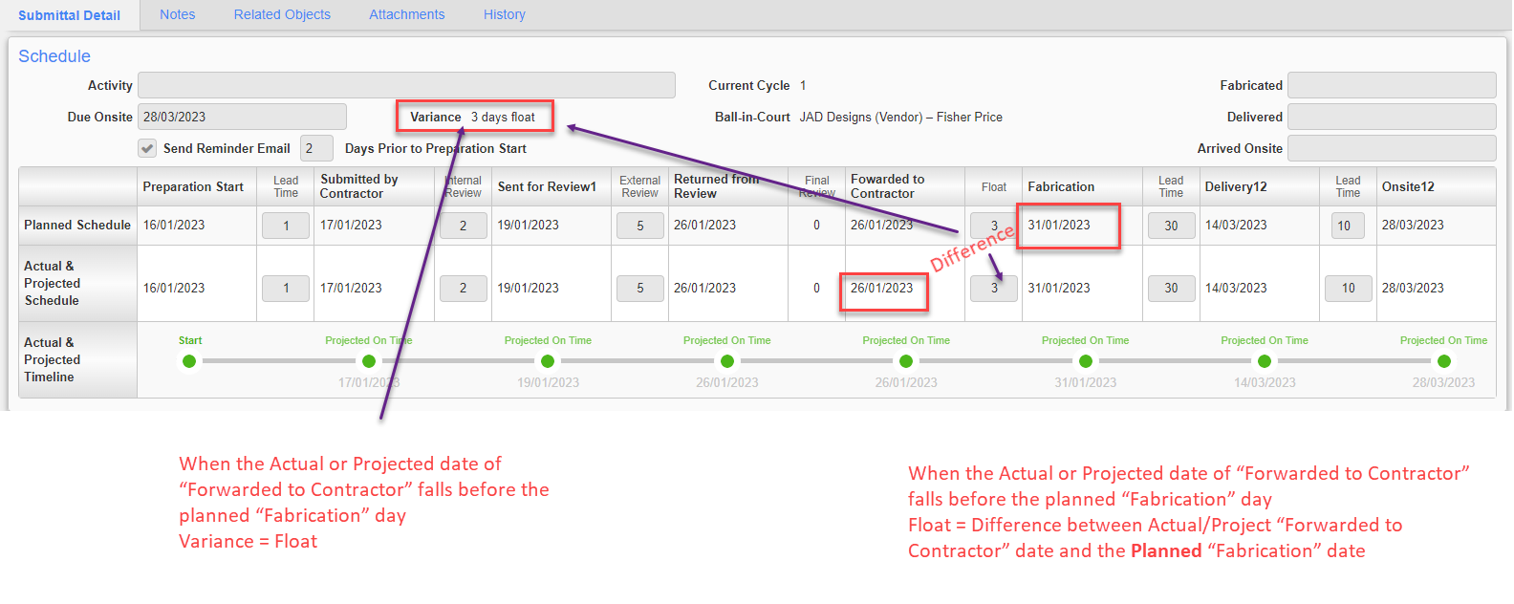

Calculation 2:

Float
- When the Actual or Projected date of “Forwarded to Contractor” falls AFTER the planned “Fabrication” day
Float = 0 – Pass

Variance
- When the Actual or Projected date of “Forwarded to Contractor” falls AFTER the planned “Fabrication” day
Variance = the difference between the Planned Onsite date and the Projected/Actual Onsite date -Pass

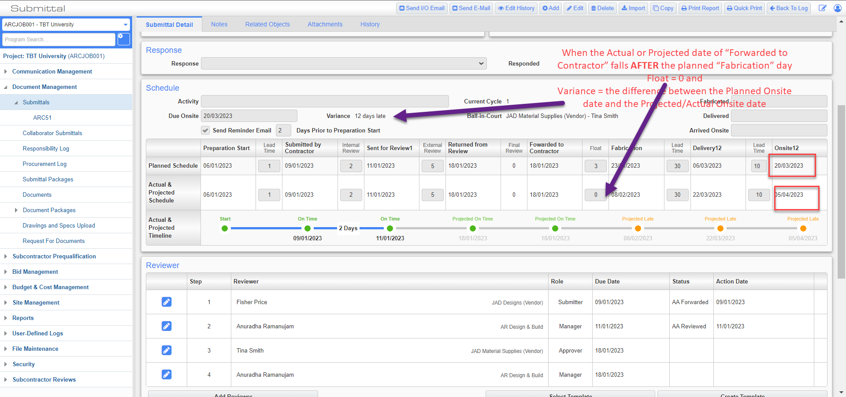

Drawings and Specifications Upload – PDF Type (23.69000)
CMiC has added new field "PDF Type" to the verification screens. The possible value you will see in this field is:
Vector - if the PDF sheet is a vector file
or Image - if the PDF sheet is a rasterized image
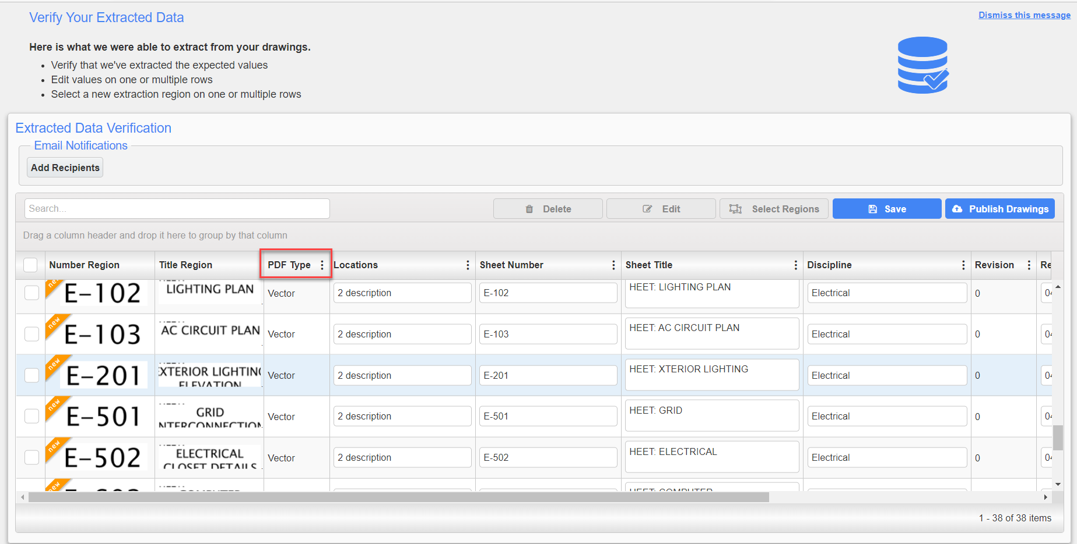

Contract Forecast Collapsible Summary Section, Reset Grid Layout (23.66681)
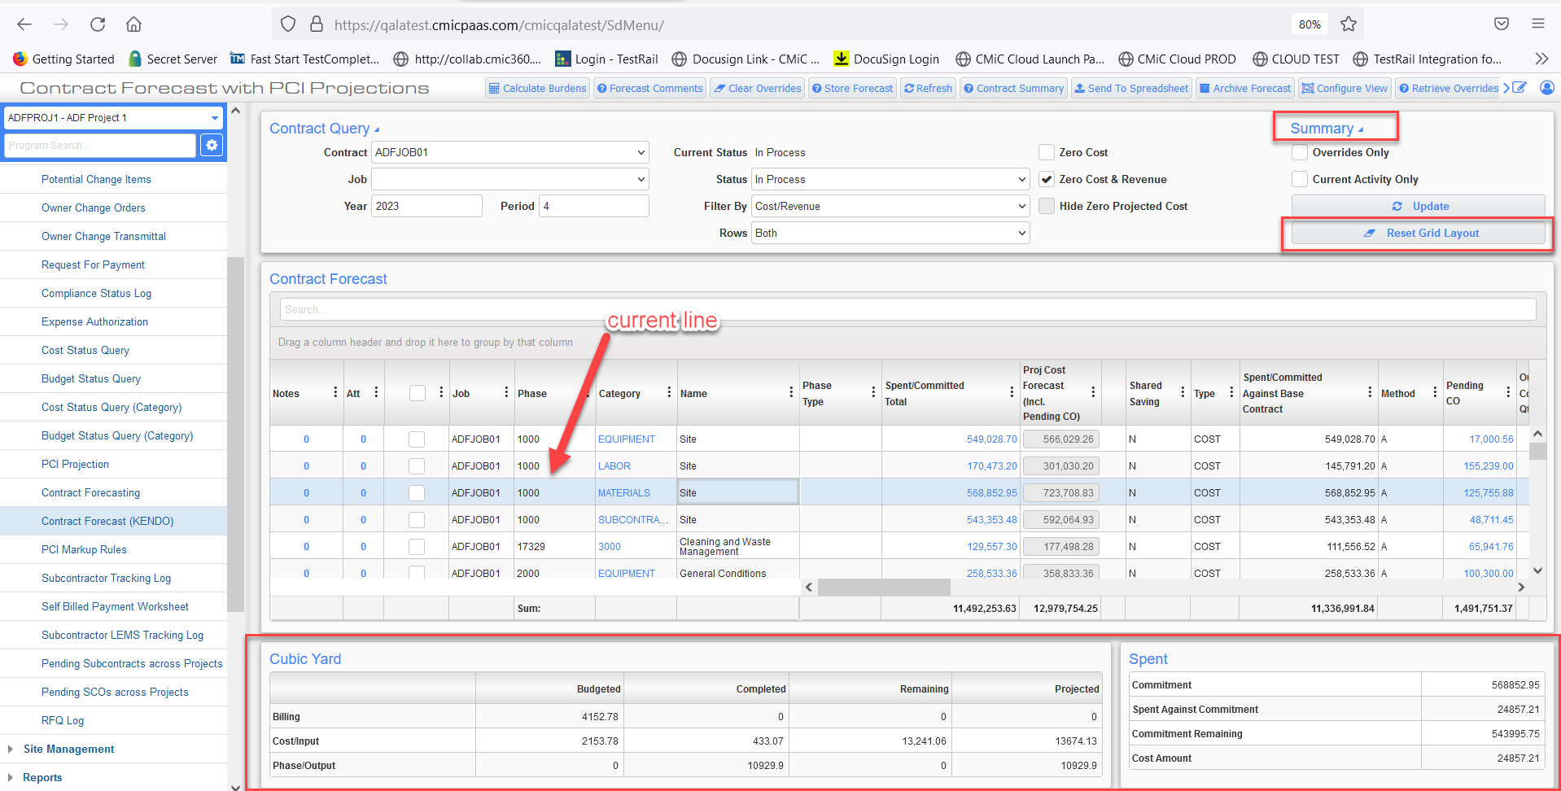
CMiC has made the following enhancements to the Contract Forecast (Kendo grid):
- allow the Summary Section to be collapsible. The Summary Section give the user important high-level information as they click on a
row in the forecast.
- a [Reset Grid Layout] button has also been added to delete Kendo Grid Options from local storage.

PCI Entry – Select Budget Lines Button (22.64387/PC-2822)
CMiC has added a new pop-up window to the PCI screen. The purpose of the pop-up is to display the budget amounts for the cost code category and then allow users to select line items that will populate the PCI Details.
This enhancement is effected through a new button labelled ‘Select Budget Lines’. When clicked, a pop-up will display, and users can select a cost code category to populate the PCI Details.
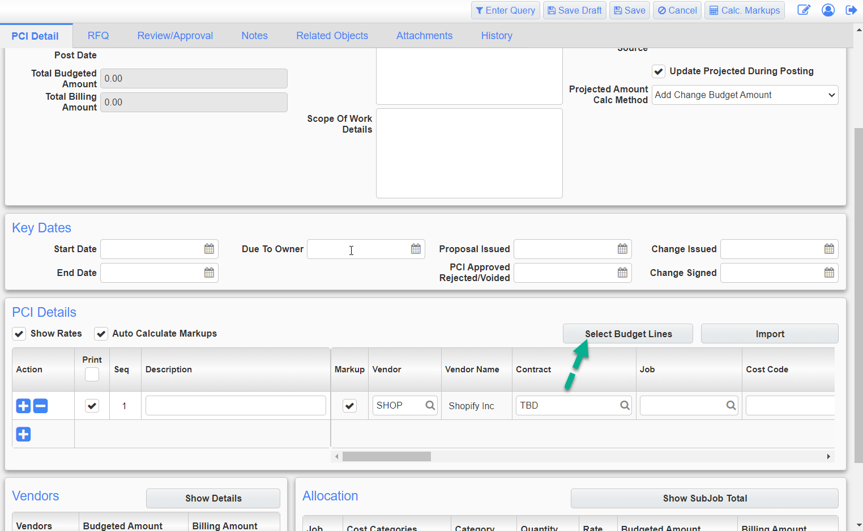

Field security (with Unrestricted, Hidden) can be applied on the “Select Budget Lines” button, and the default level of field security is Un-Restricted.
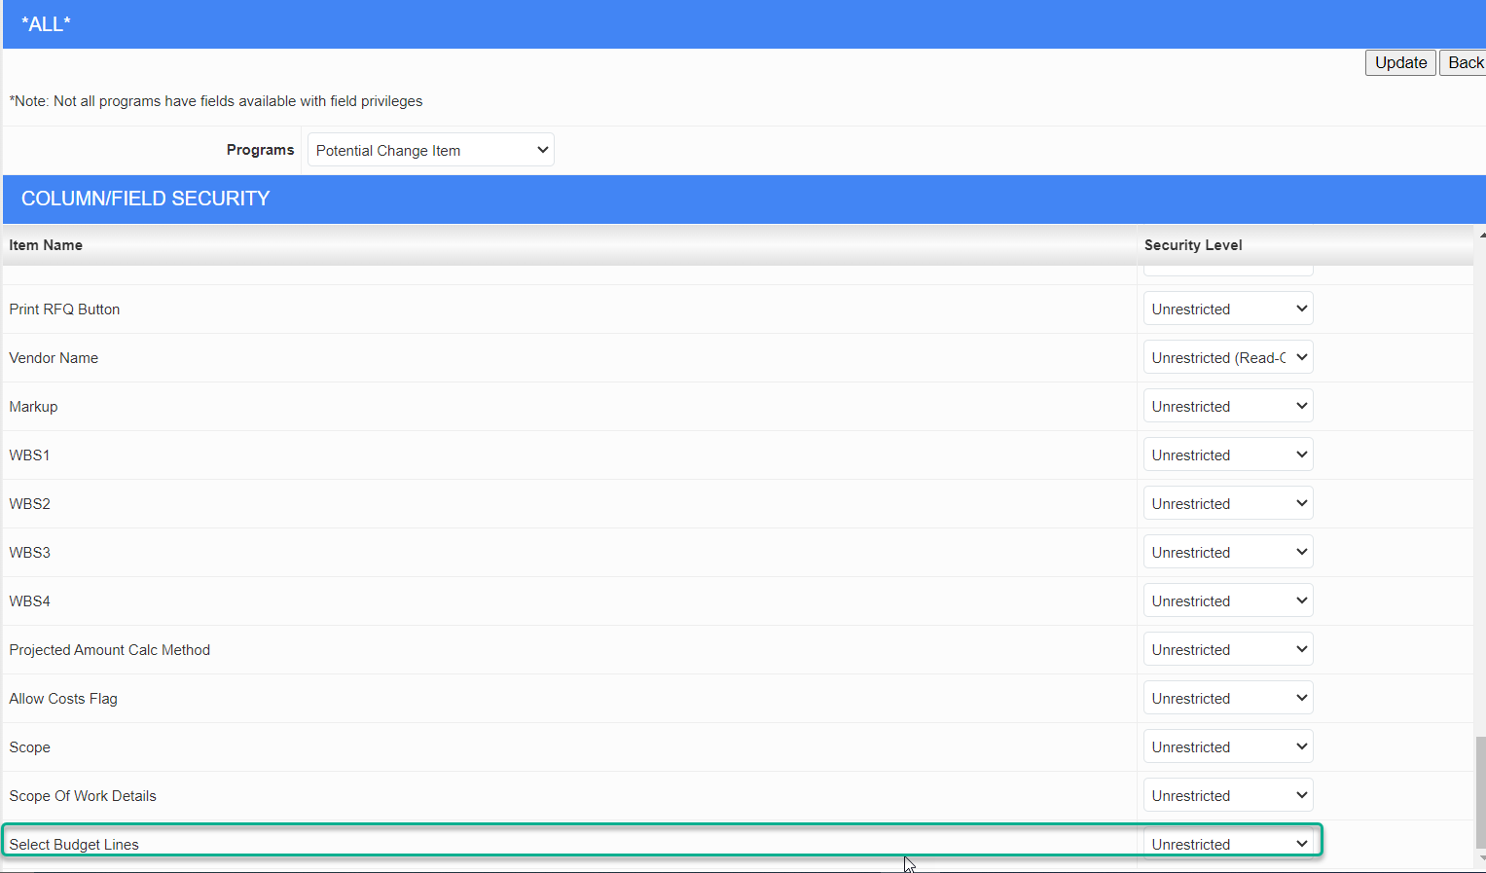
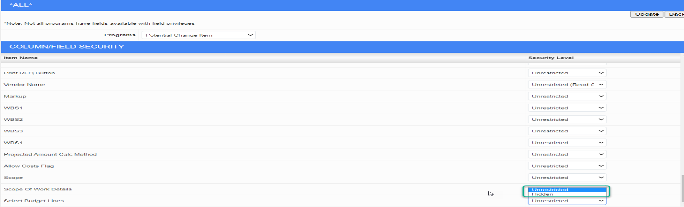
The following columns will be displayed on the pop-up:
i. Job code
ii. Cost code
iii. Category
iv. Committed Vendor: vendor from posted SC against cost code category. Display “Multiple” if more than 1 vendor
v. Current Cost Budget. Data source: Cost Status Query
vi. Projected Cost Budget. Data source: Cost Status Query
vii. Actual Cost. Data source: Cost Status Query
viii. Committed Cost. Data source: Cost Status Query
ix. Actual / Committed. Data source: Cost Status Query (Committed Cost plus value spent outside of commitment)
x. Cost to Complete. Data source: Cost Status Query
xi. Current Revenue Budget. Data Source: Budget Status Query
xii. Projected Revenue Budget. Data Source: Budget Status Query
xiii. Prepare Billings Completed and Stored. (Current total gross billed by bill code).
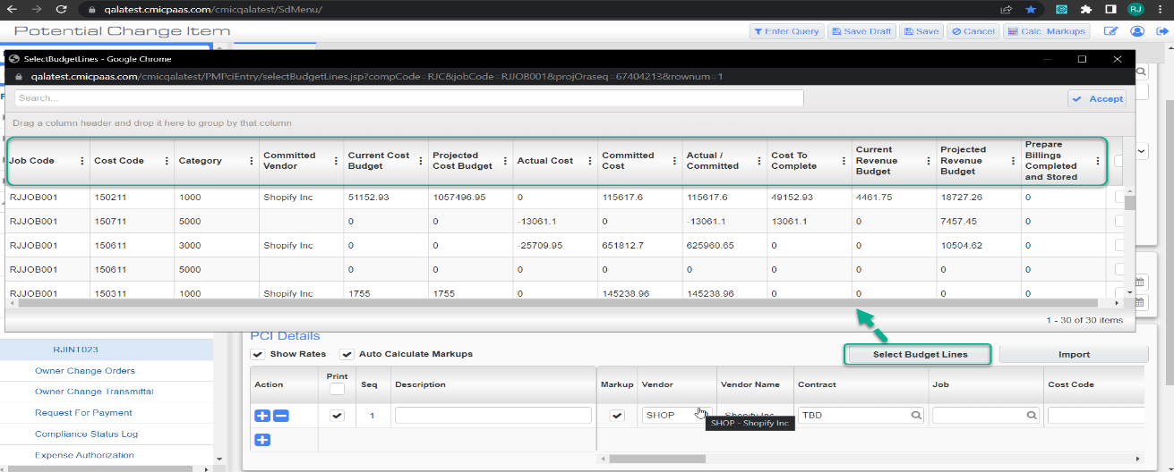

The search bar is used to search across all columns.
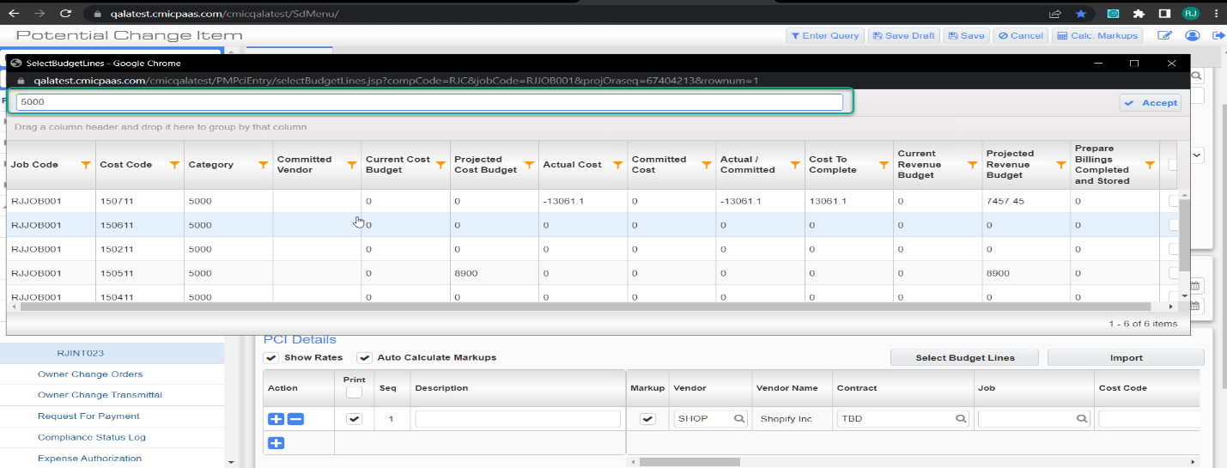

Users will have the ability to filter within the pop-up.
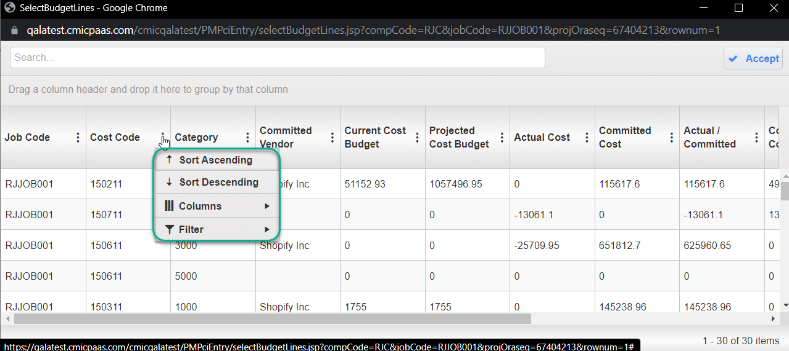

Users can add multiple cost codes at same time with the help of checkboxes.
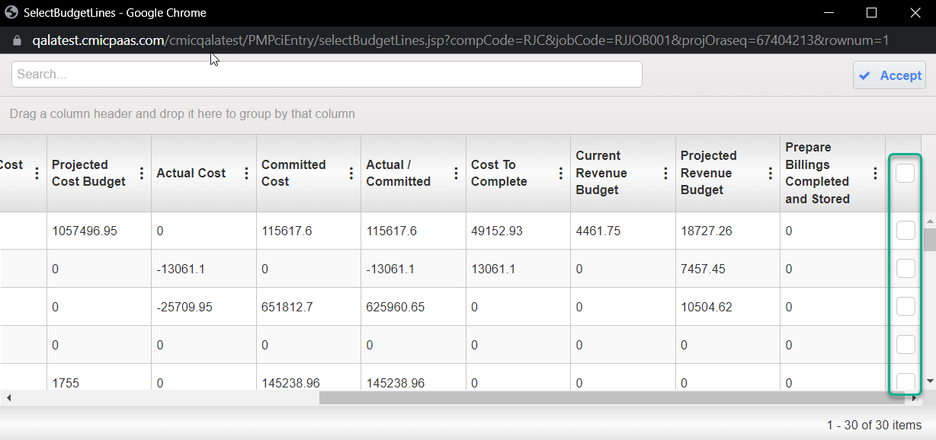
Note: If the user wants to add multiple lines of the same cost code category, they will have to reopen the popup and select again.

Users can select line items in the pop-up that will populate the PCI Details with only the Job Code, Cost Code, and Category Code.
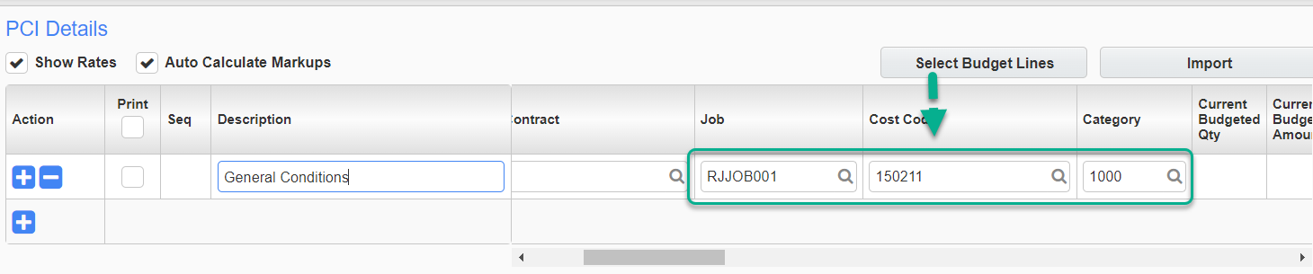

Purchase Order

Ability to allocate Discount % to PO Detail lines (22.62745) – Beta Version
Overview
Added ability to allocate discount % to purchase order details and apply discounts on the extended amount. This eventually flows to payable where vendors need to be paid at discounted amount.
Fields added under this enhancement:
- Discount % and Suggested Price column is added to Purchase Order detail and Change Order detail.
- Discount % field and [Recalculate Discount%] button is added to Purchase order and Change order header.
- On Order Qty column is added to Requisition query.
- Currency Code field in PO header is now editable and user can select values from LOV.
- Currency code field in change order is a display only field and displays Currency Code of the purchase order.
User now has ability to provide discount % to entire PO or individual PO detail lines. Suggested price column will display suggested price for an item, discount is applied on suggested price. ‘Price’ field is the derived final price (unit cost) after calculating discount on suggested price.
Update Suggested Price → Price and Total field is updated.
Update Discount % → Price and Total field is updated.
Update Price → Total and Discount % is updated.
Enter discount % in purchase order header and click on [Recalculate Discount%] → Discount% entered in header will be applied to each detail line.
Program Modifications:

Enter Purchase Order:
Header: Discount % field, [Recalculate Discount%] button, Currency Code LOV is now editable
Detail Columns: Suggested Price, Discount%
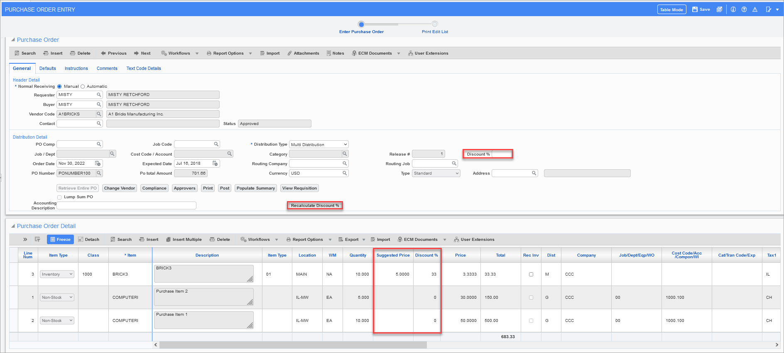
Chane Order Entry:
Header: Discount% field, [Recalculate Discount%] button, Currency Code LOV (Display only)
Detail Columns: Suggested Price, Discount%
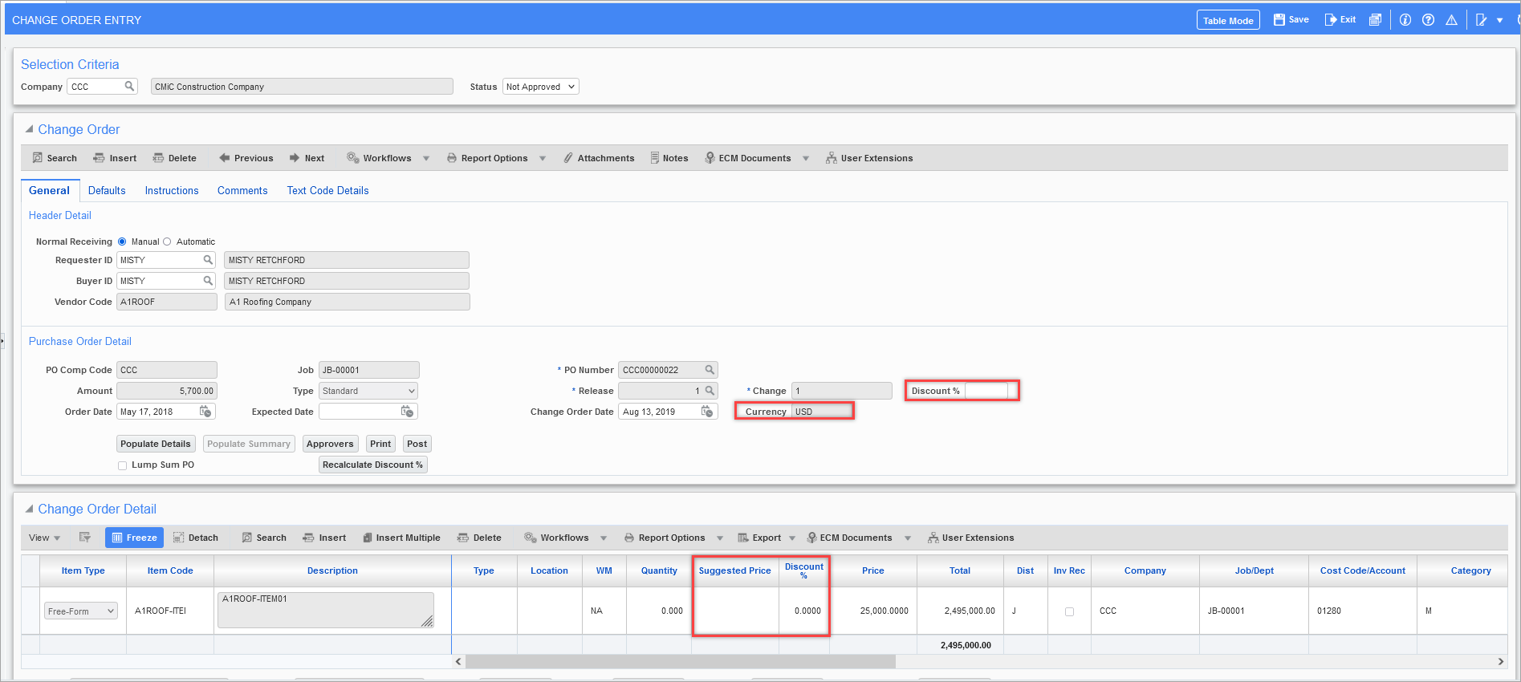
Requisition Entry: On reserve field is not visible in requisition entry program.
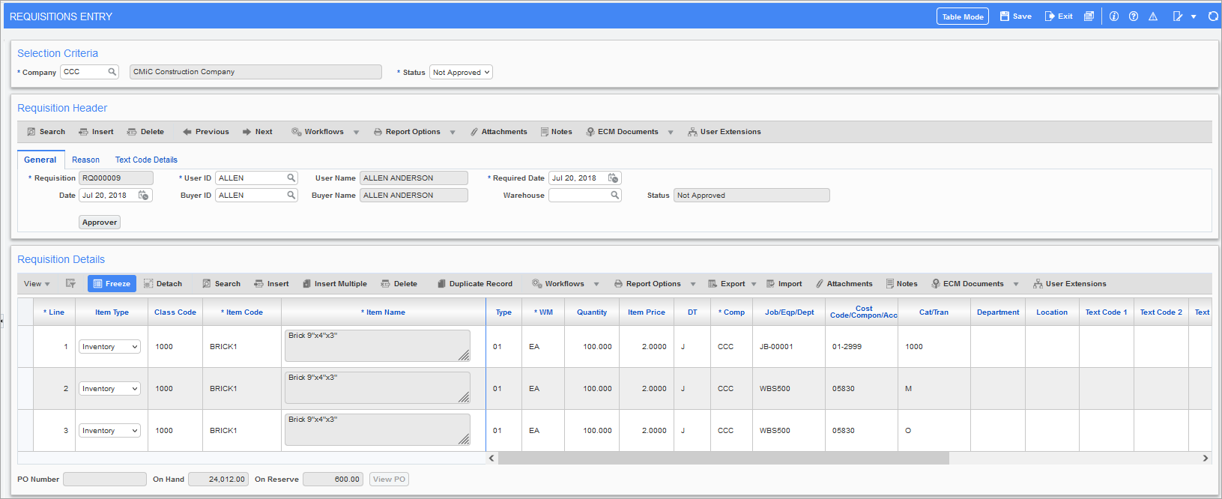
Requisition Query: On Order Qty is added to requisition query.
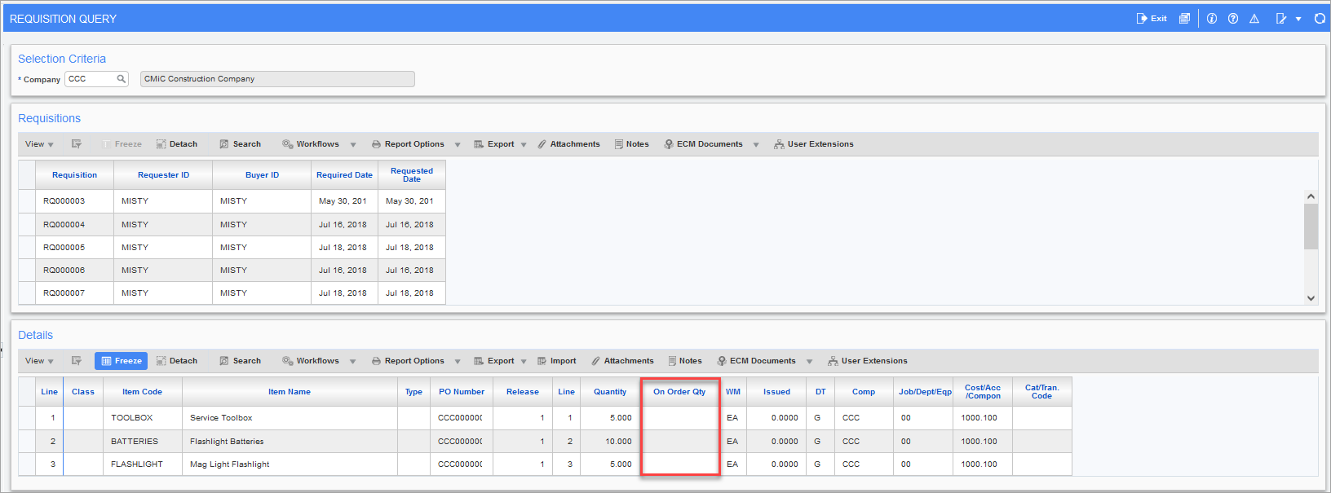

Implementation
Create Purchase Order from PO Entry program:
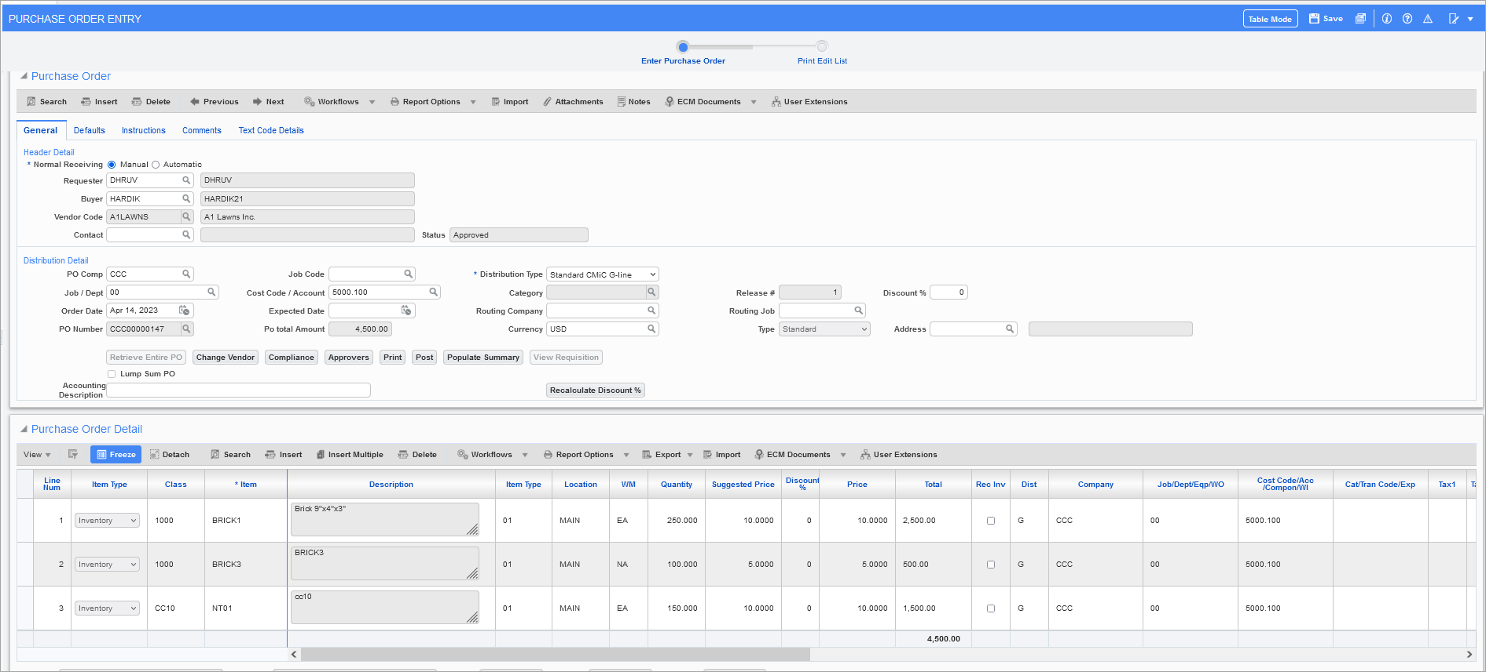
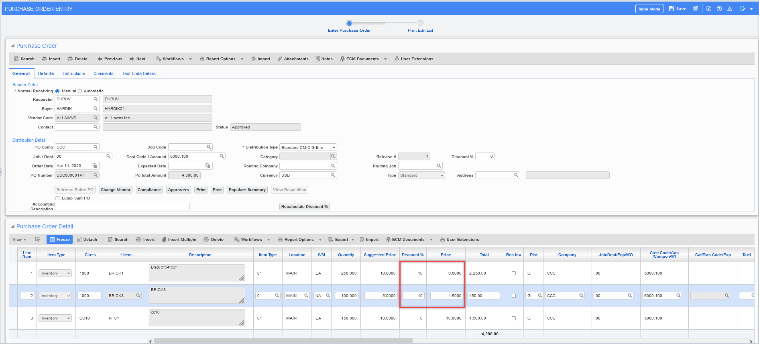
Update Discount % on purchase order header to 20 % and click on [Recalculate Discount %] button.
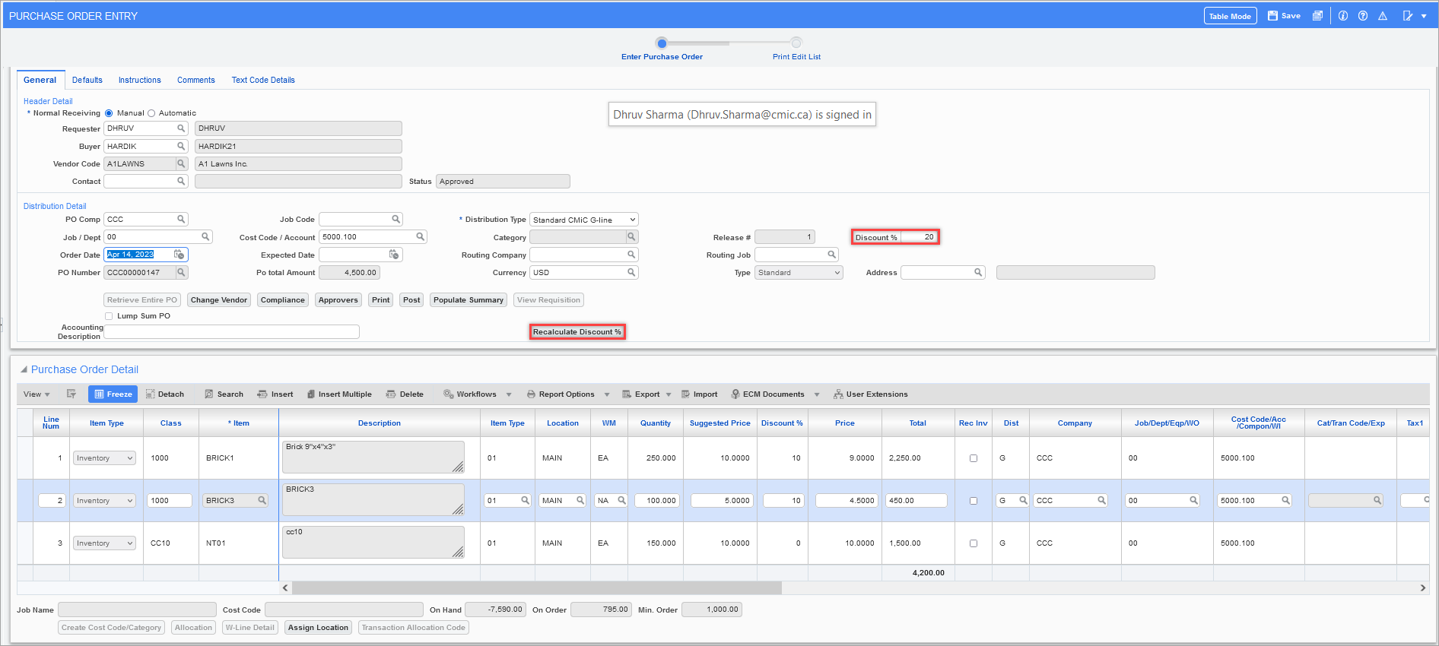
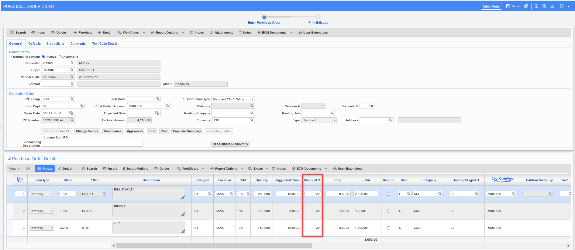
- Update Discount % - Price and Total will be update according to new discount %
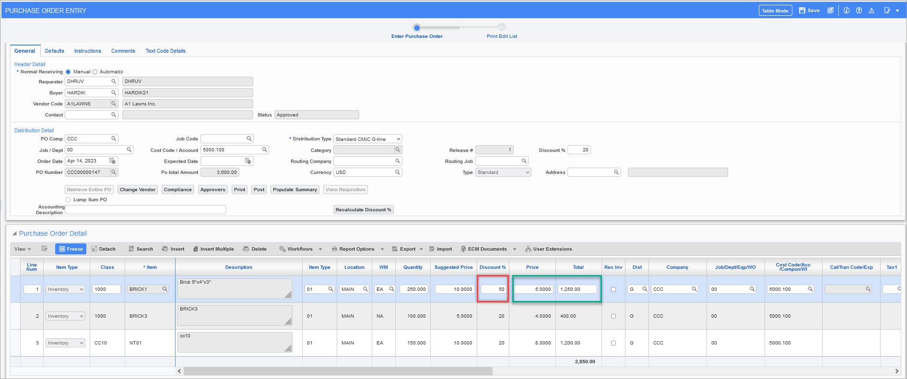

- If Price is changed – Total and Discount % field is updated.
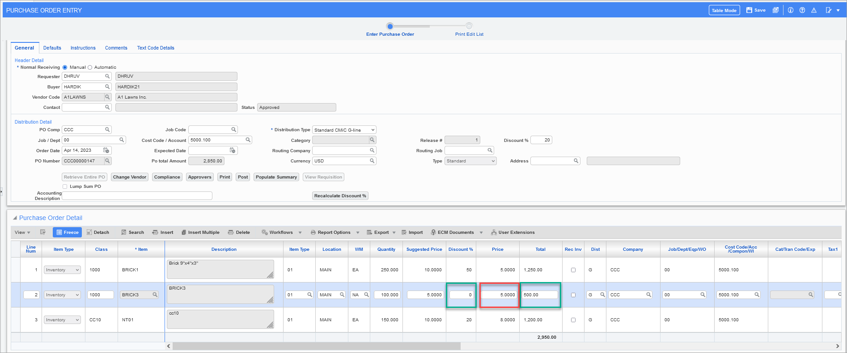
- If suggested Price is changed – Price and total is updated
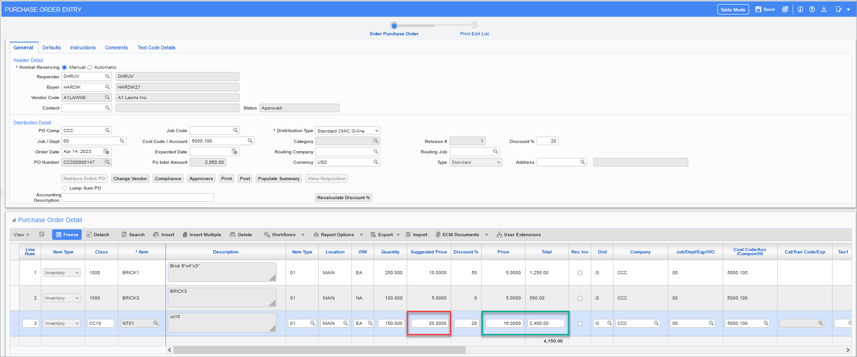
Change Order Entry
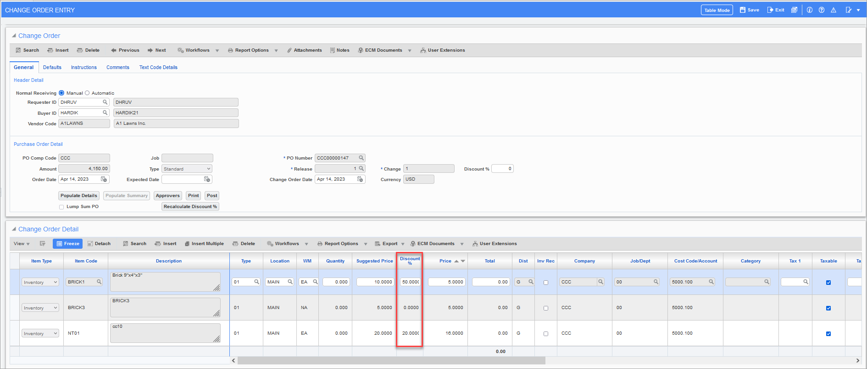
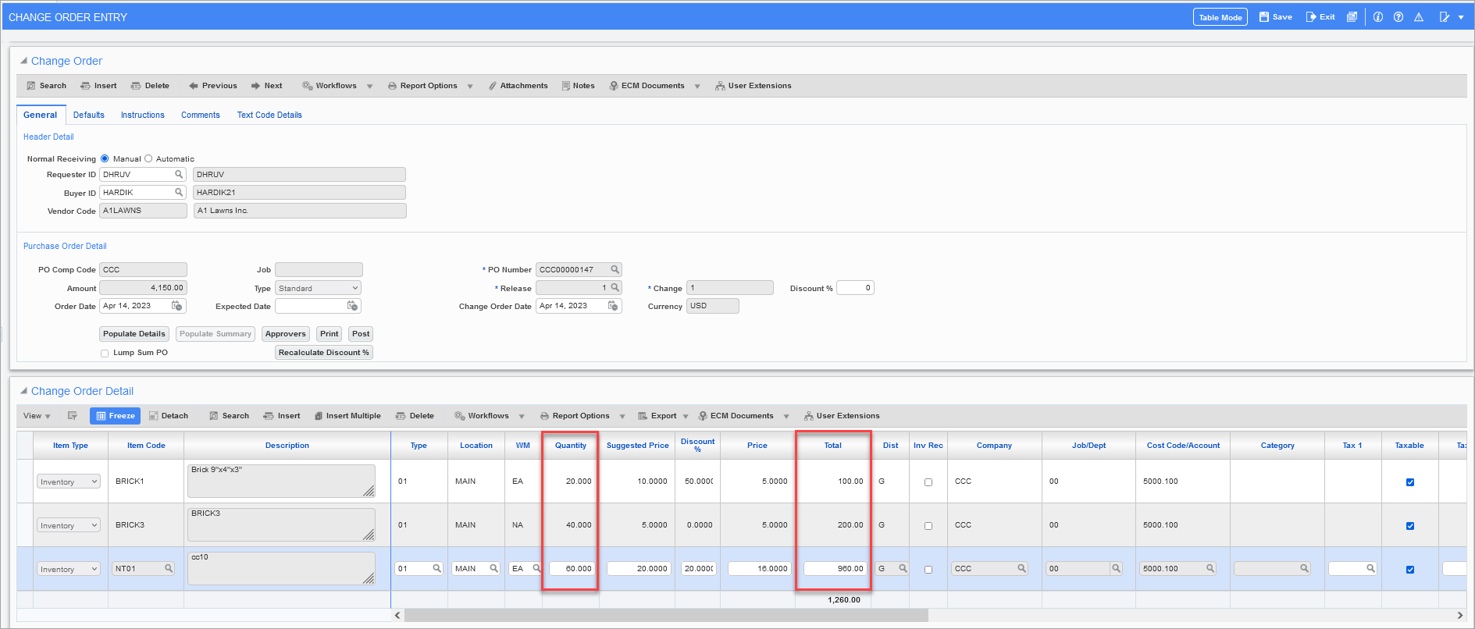
Update the Discount% in CO detail line – Update discount to 10% so now price is 4.50
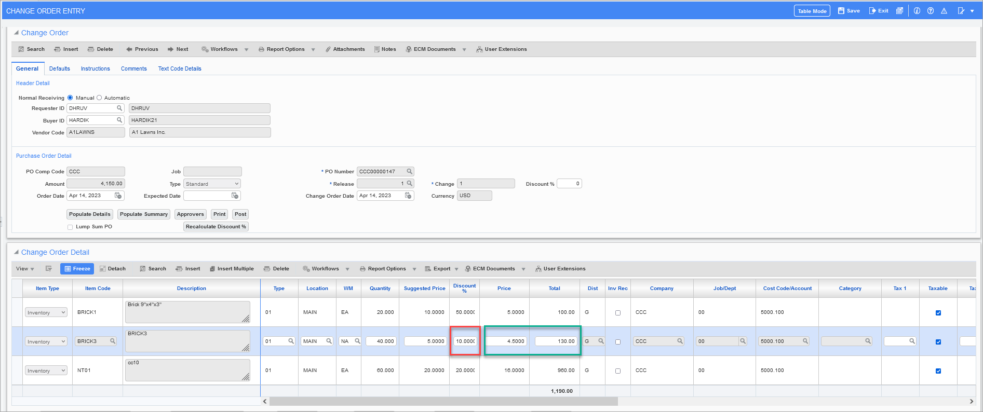
Update Price
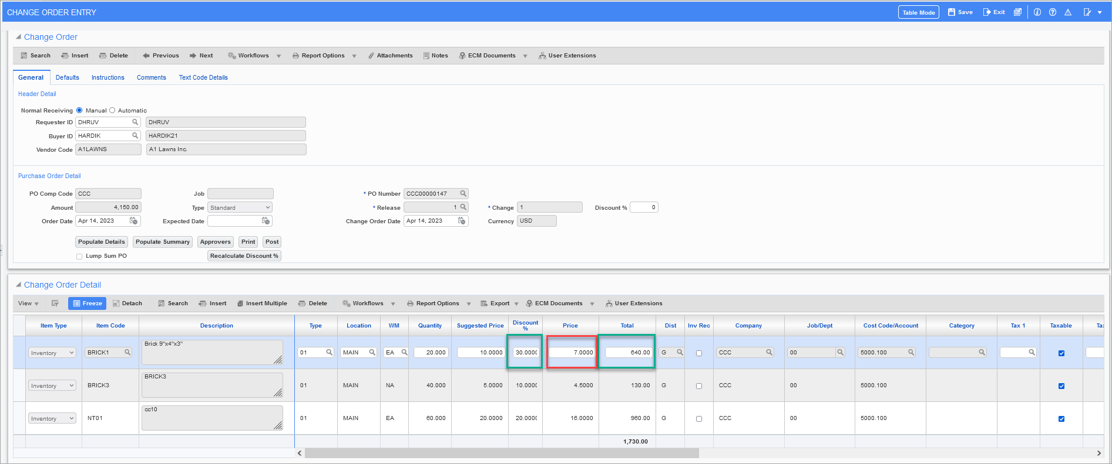
Update Suggested Price
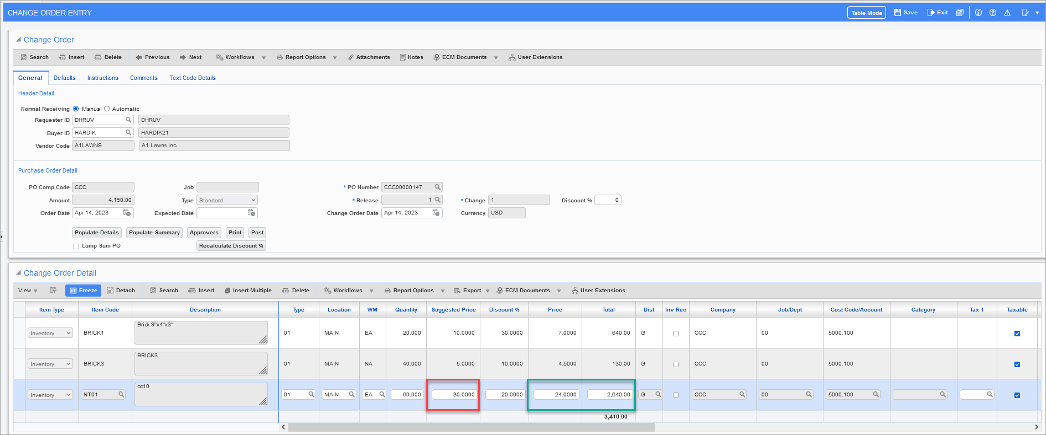
Update Discount % on change order header and click on [Recalculate Discout%] button
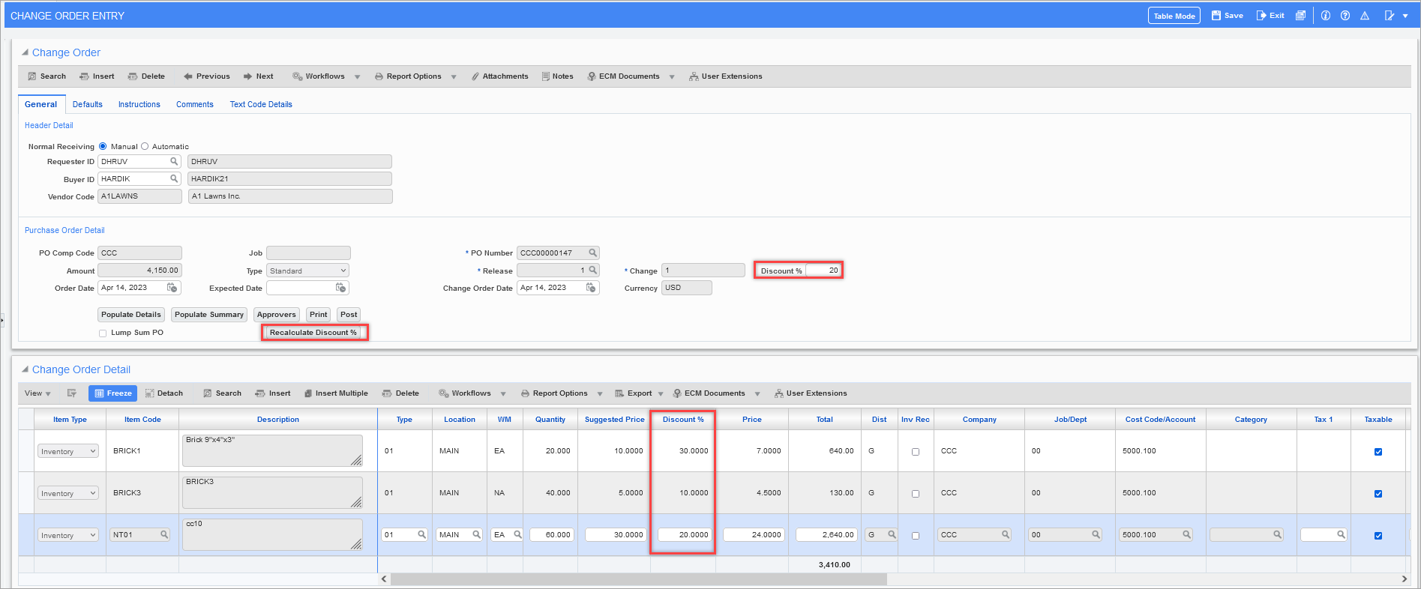
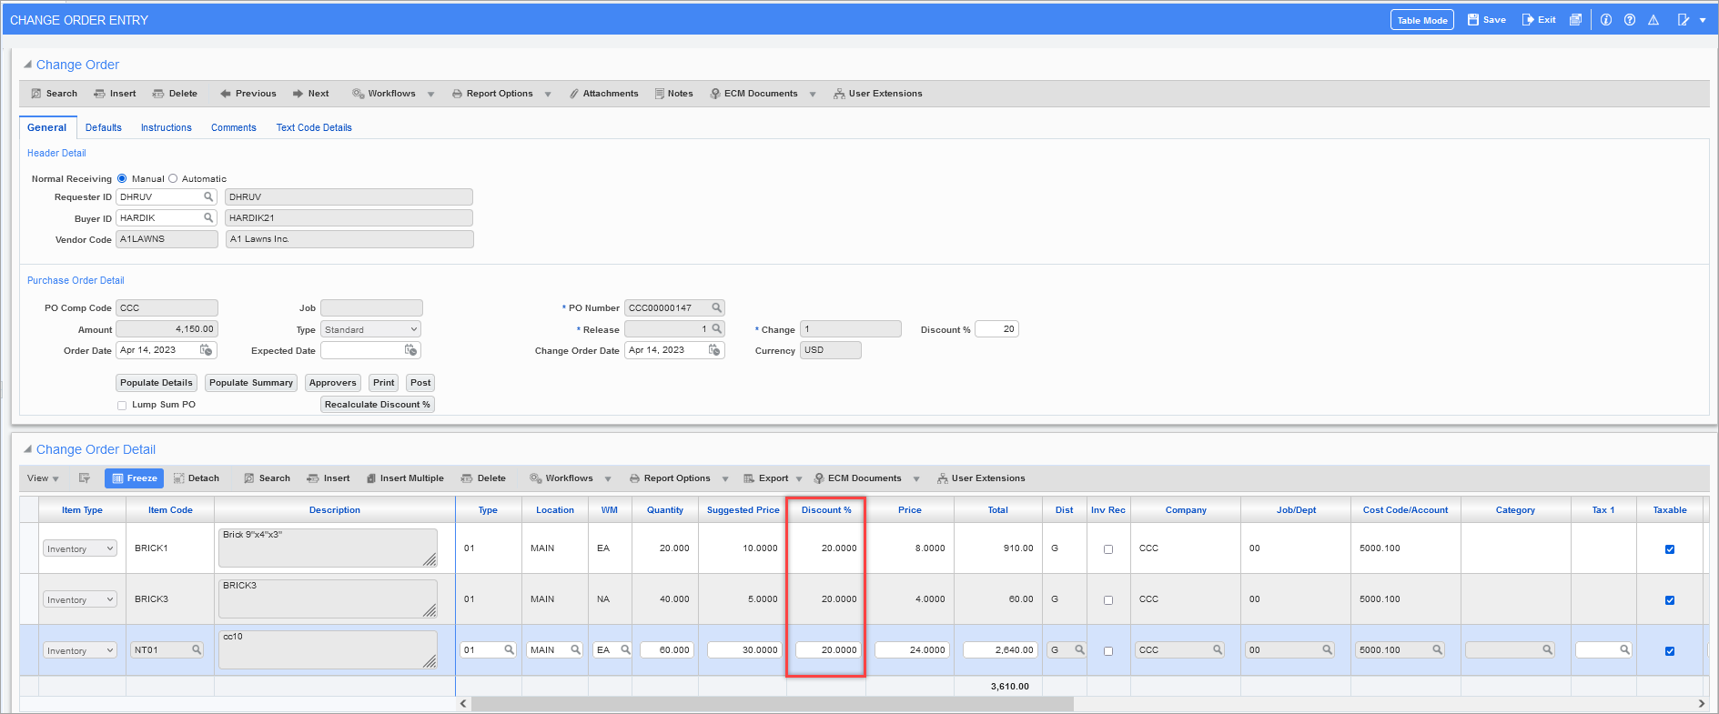
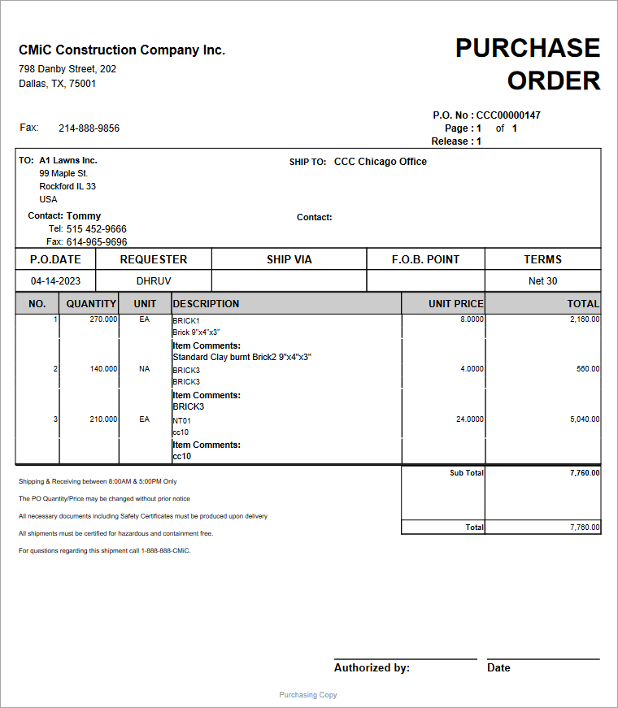

Create PO From Requisition
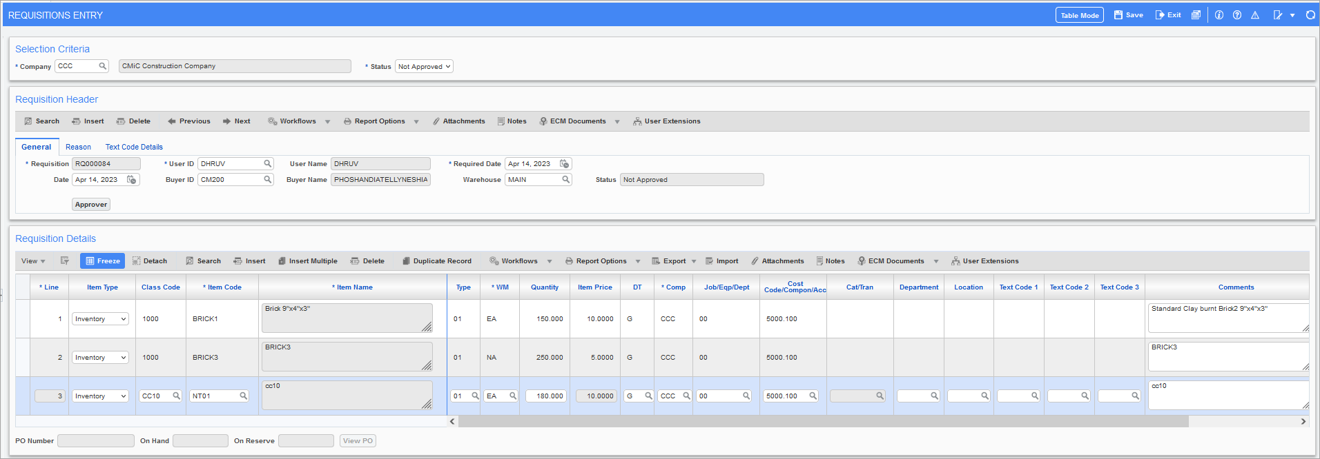
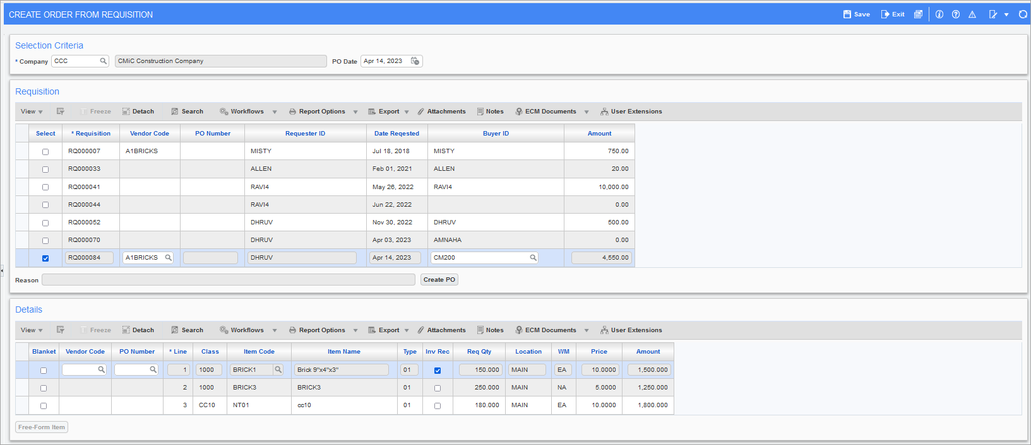
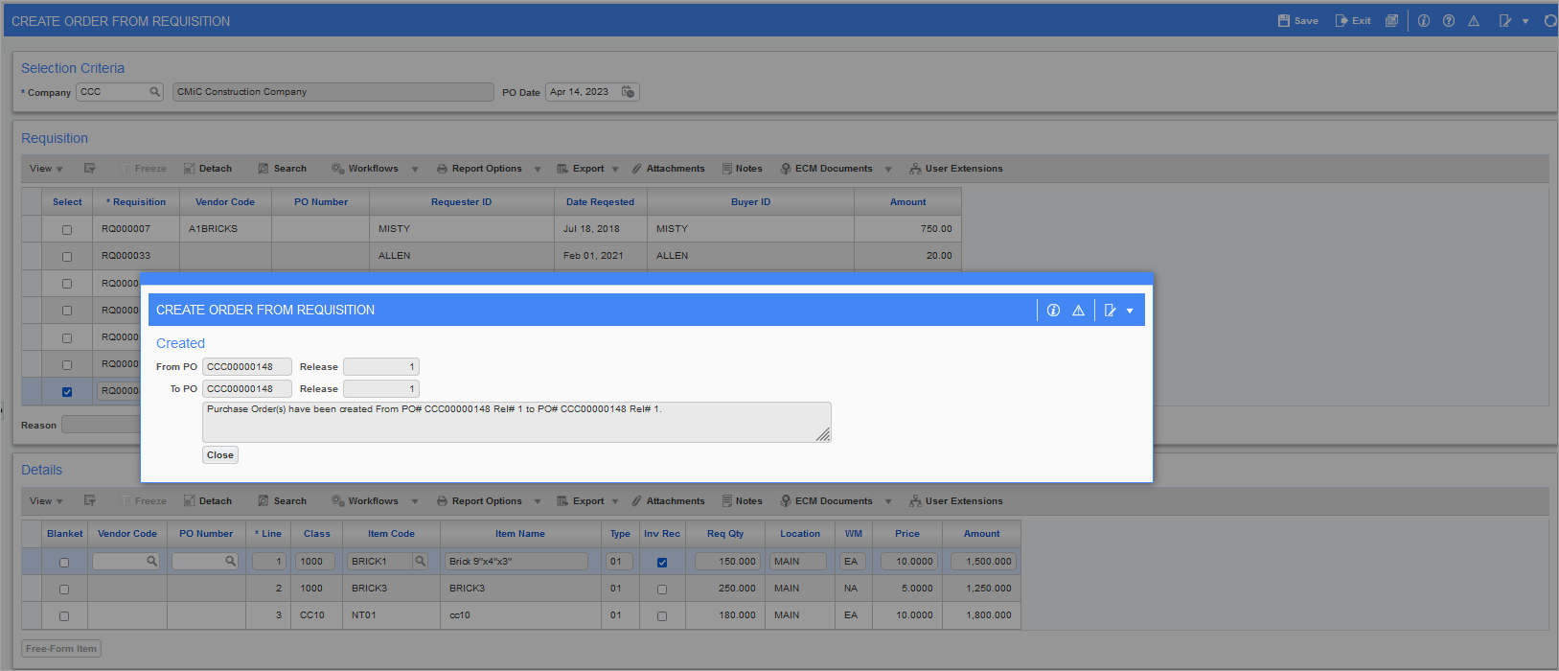
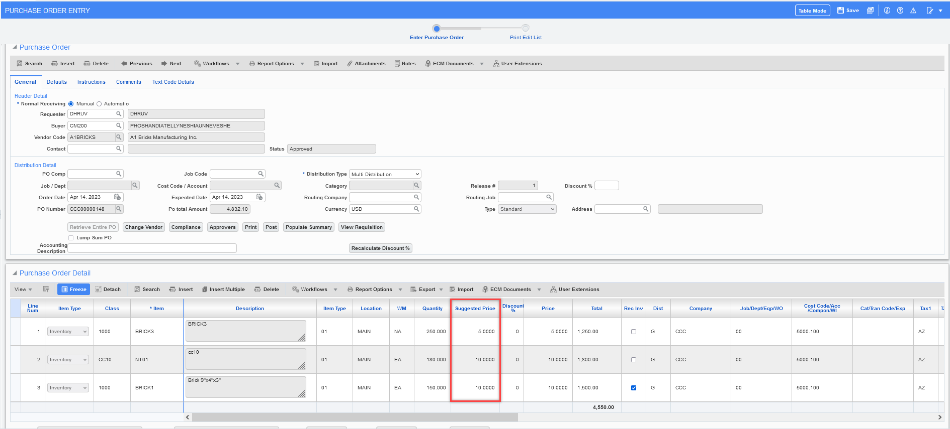

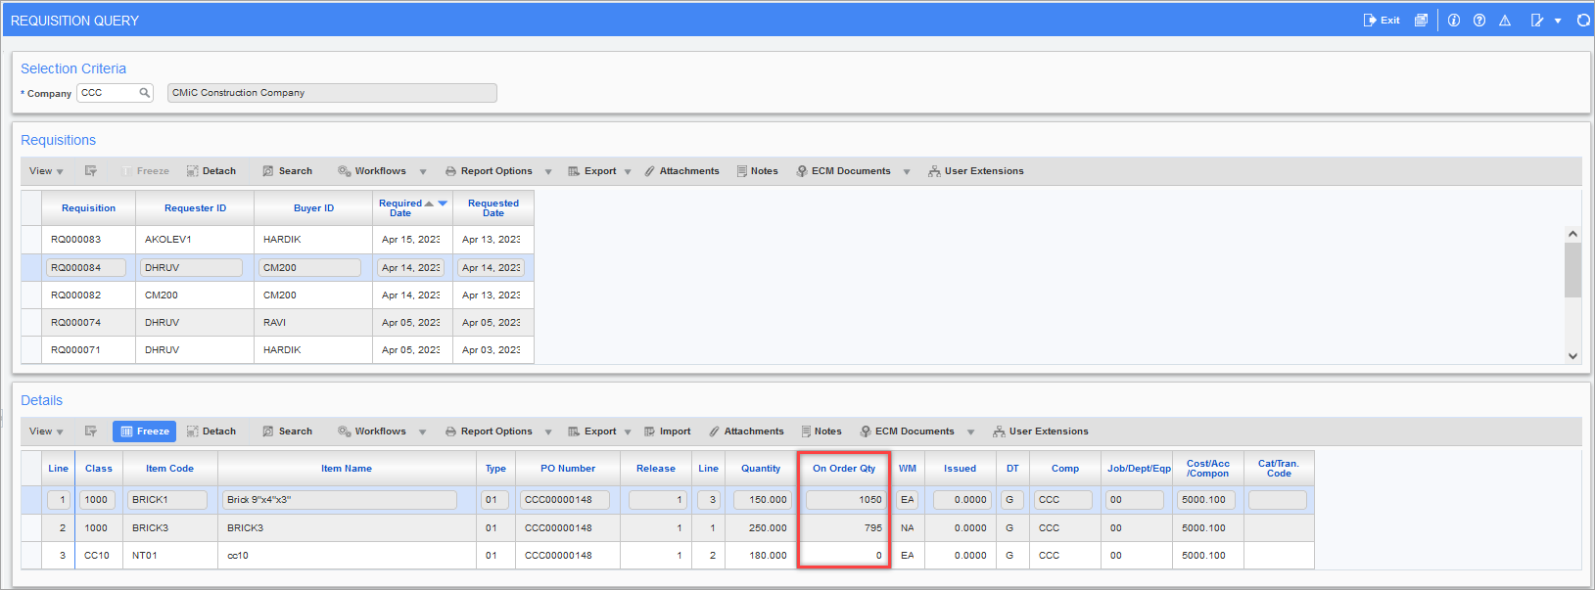
Currency Code LOV
Note: Users should only update currency if required. Payable would require an invoice currency similar to purchase order currency.
Vendor Currency: USD, Vendor: A1CEMENT
PO Amount: 3500.00 CAD, PO Currency: CAD
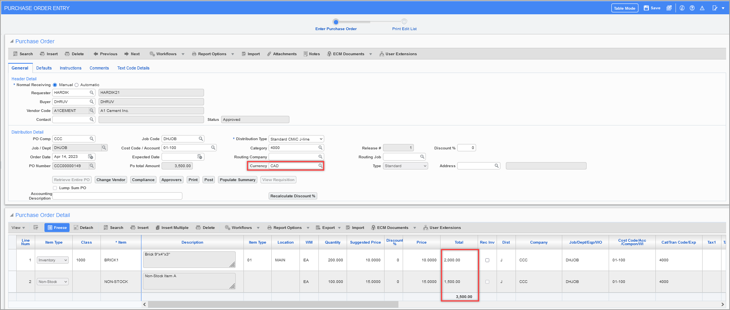
Post the PO – Commitment is posted in USD.
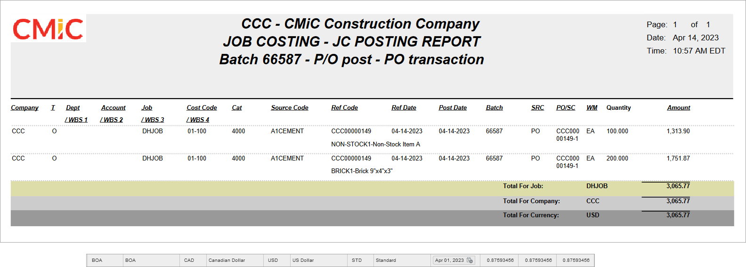
Enter Change Order – Currency code is pulled form PO and it’s a display only field.
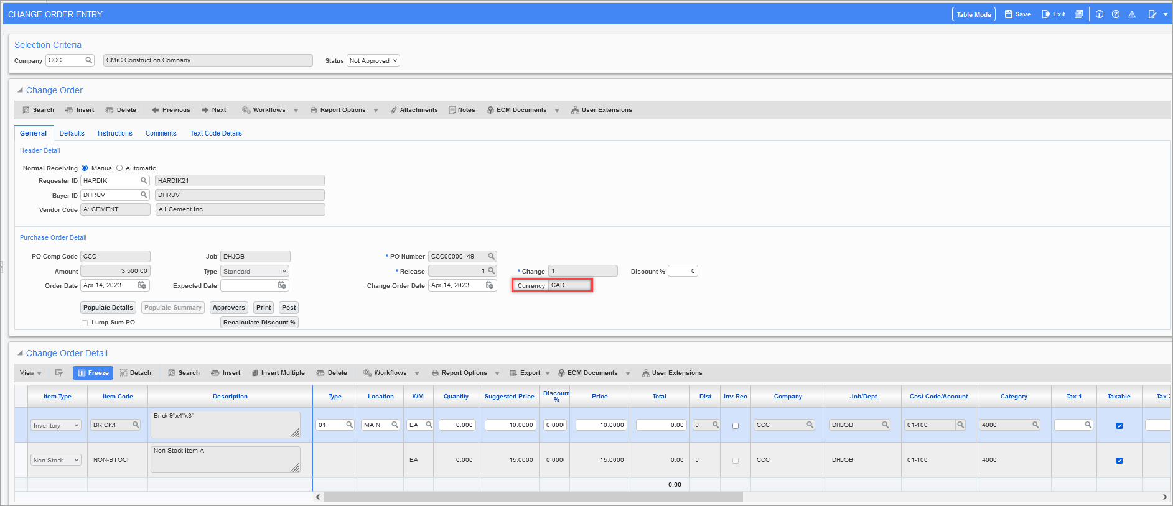
Original Commitment is reversed, and new commitment is created
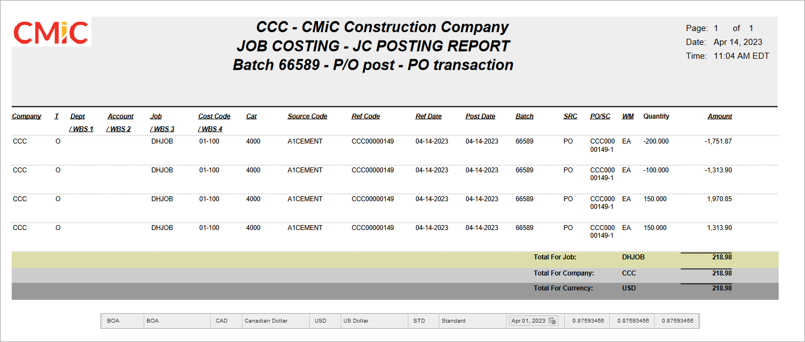
Entering Warehouse Receipt
Posted partial shipment for 100 qty for both the purchase order detail lines.
JC Posting report – Cost is posted to the job in USD for 875.93
GL Post – GL Posted in USD after conversion
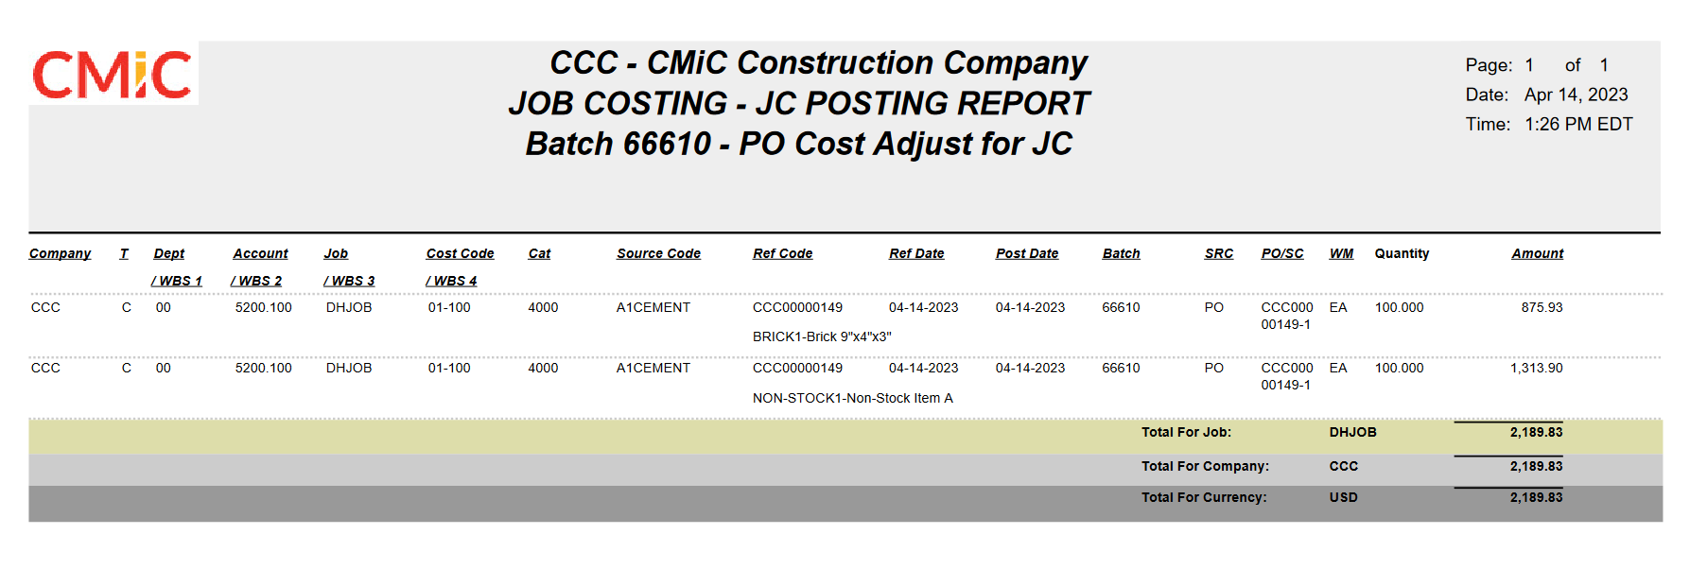
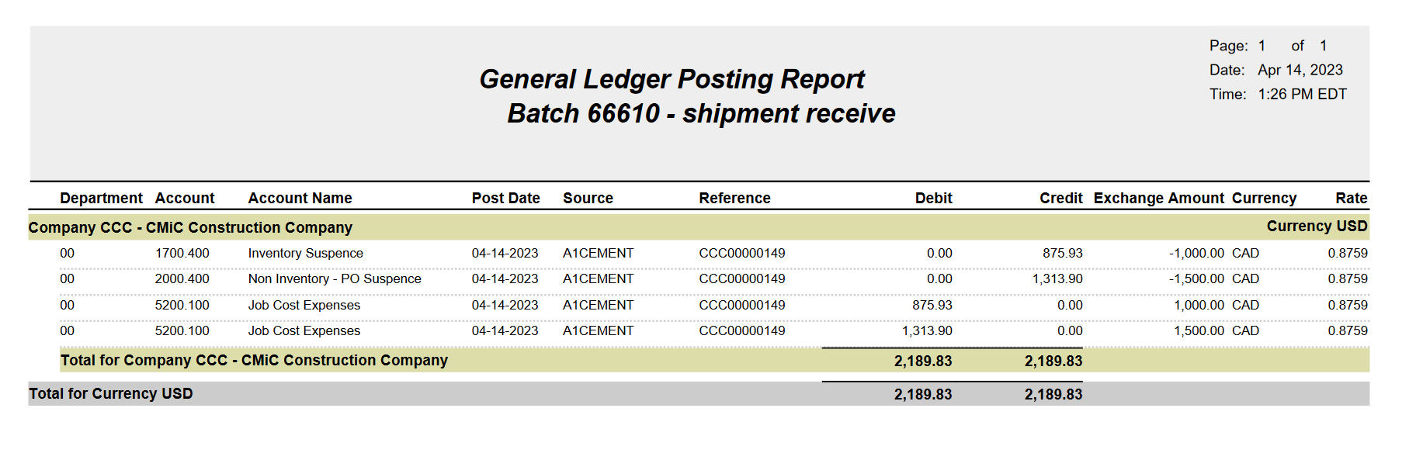
Posted AP Voucher for the PO
Note: Invoice currency is SAME as the PO currency; users must keep same invoice currency and purchase order currency.
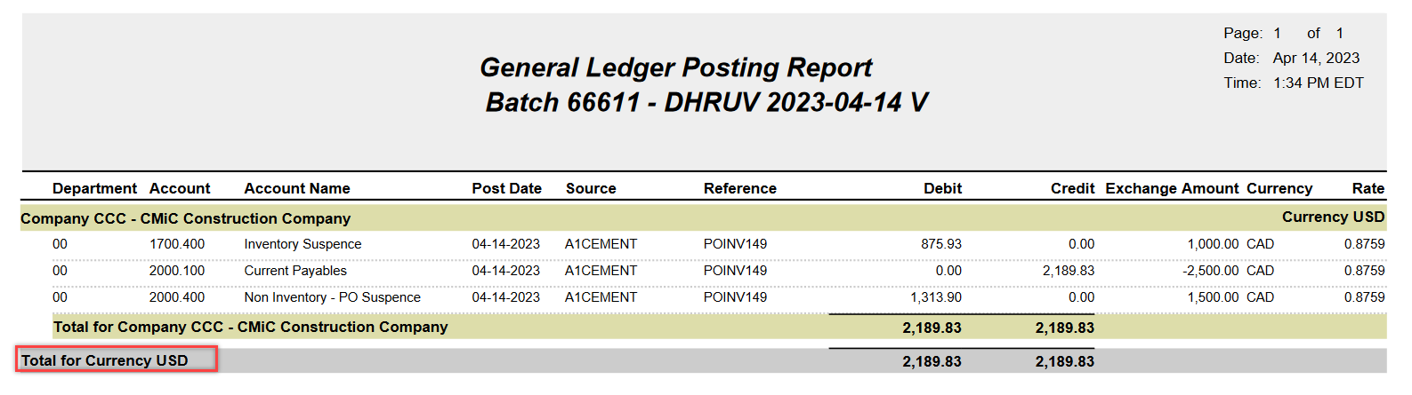
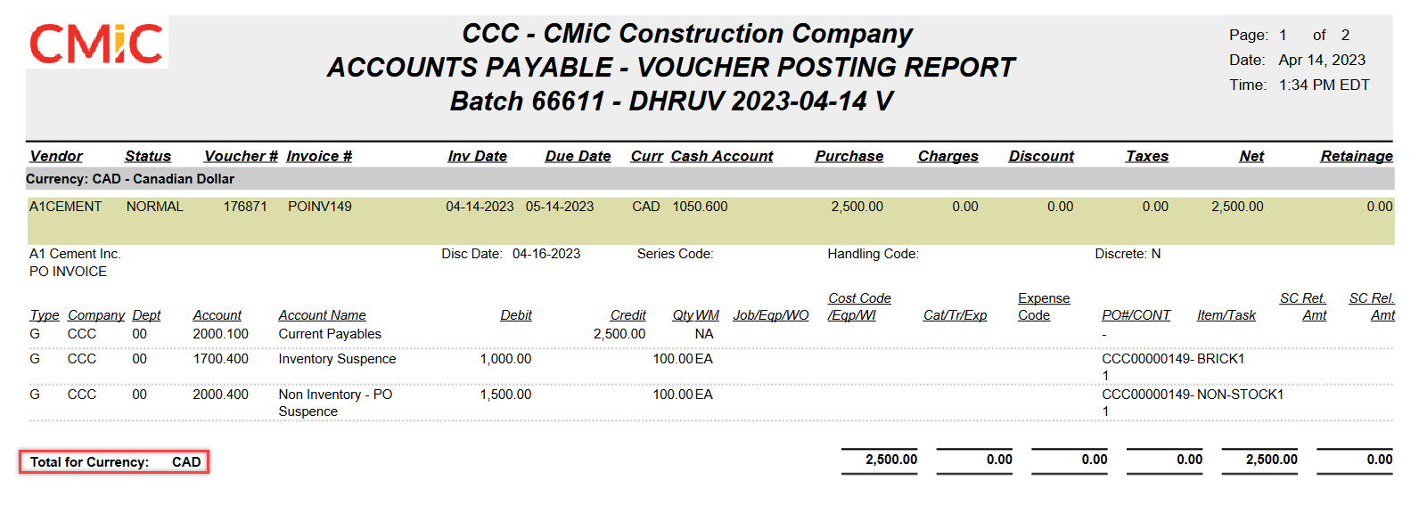
Post Check Run
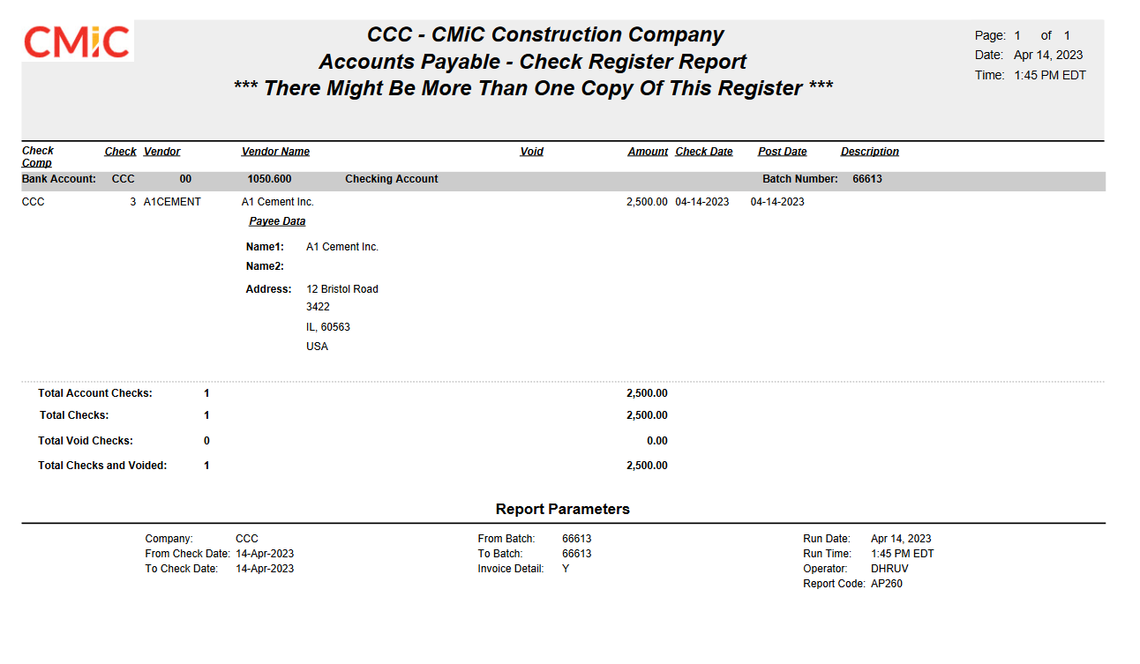
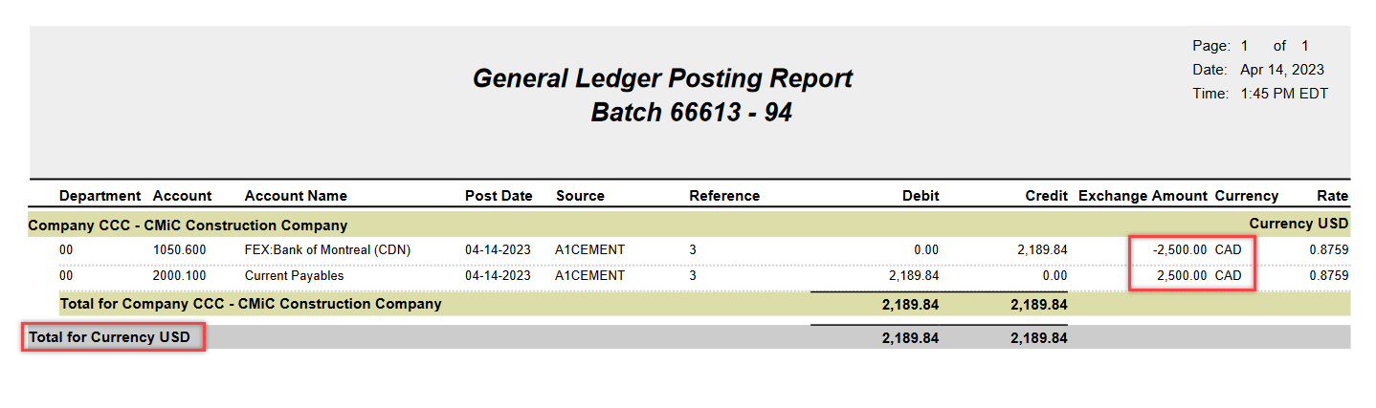
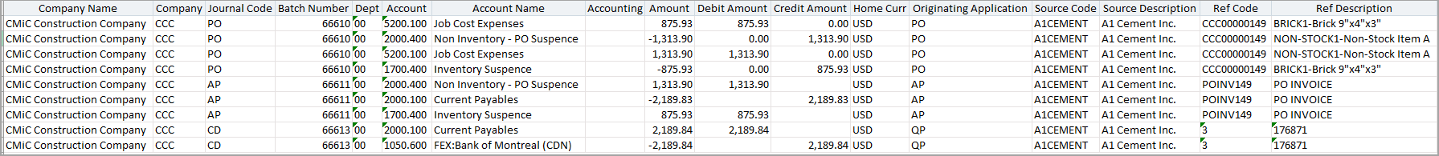

Currency Code LOV in Purchase Order and Change Order entry program (22.62745) – Beta Version

Purchase Order Entry

Currency code LOV is now editable in Purchase Order entry program. Default currency is defaulted from vendor.

Note: Users should only update currency code different from vendor currency if required. Payables invoice currency will be required to match with purchase order currency for invoicing.

Purchase Order Entry – Currency code LOV

Change Order Entry:

Currency code field added in change order entry program is a display only field. It will display the purchase order currency.

Change Order Entry – Currency Code

Requisition

Create Purchase Order from Requisition Entry – Buyer ID column (22.63937)

A new Buyer Id column has been added to Create Order from Requisition screen. It is not available by default and must be added through light editor. This column can be marked mandatory, if required, through light editor for both Header and Details. If Buyer ID field is marked as required, user will not be able to create PO without selecting the Buyer id.

- Buyer ID selected in the Requisition Details section, will be used when creating a Standard/Blanket PO.

- If the required checkbox for the buyer id column in the light editor is left unchecked and the buyer id field is left blank, the system will use the buyer id from the Requisition Header when creating Standard/Blanket PO.
Implementation:

Requisition Entry > Detail Section > Buyer ID column:

Buyer ID column can be added in the details section, using the light editor, and can be marked as ‘Required’. The following screen prints show the buyer ID column made visible.

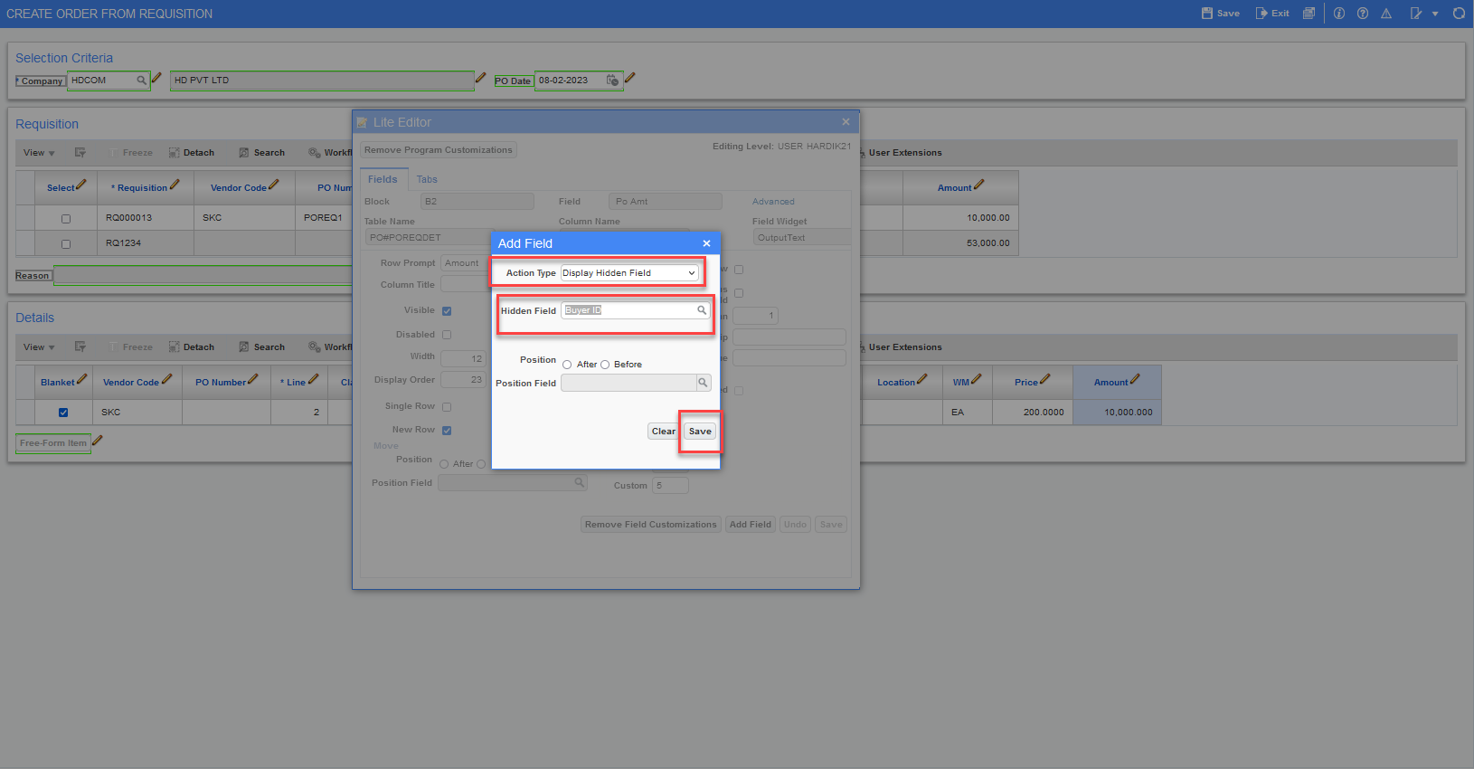
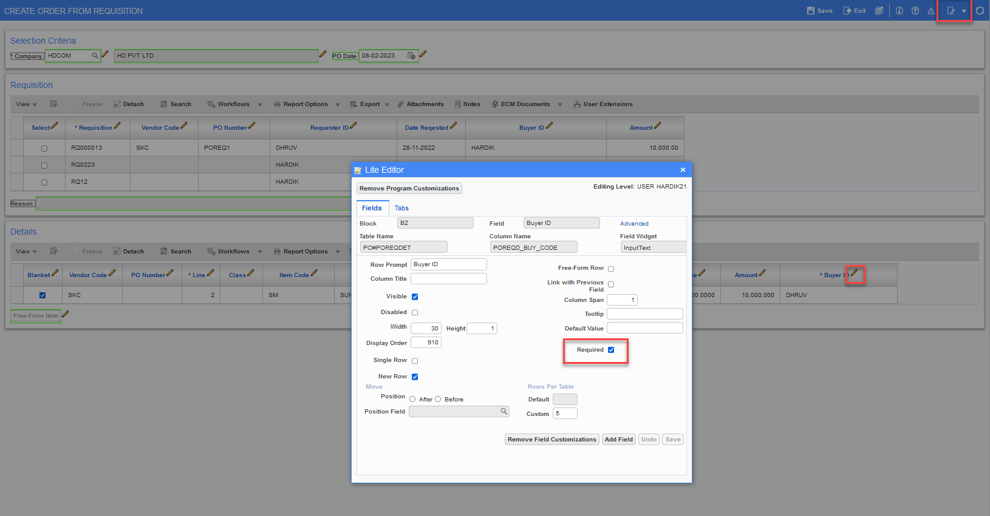
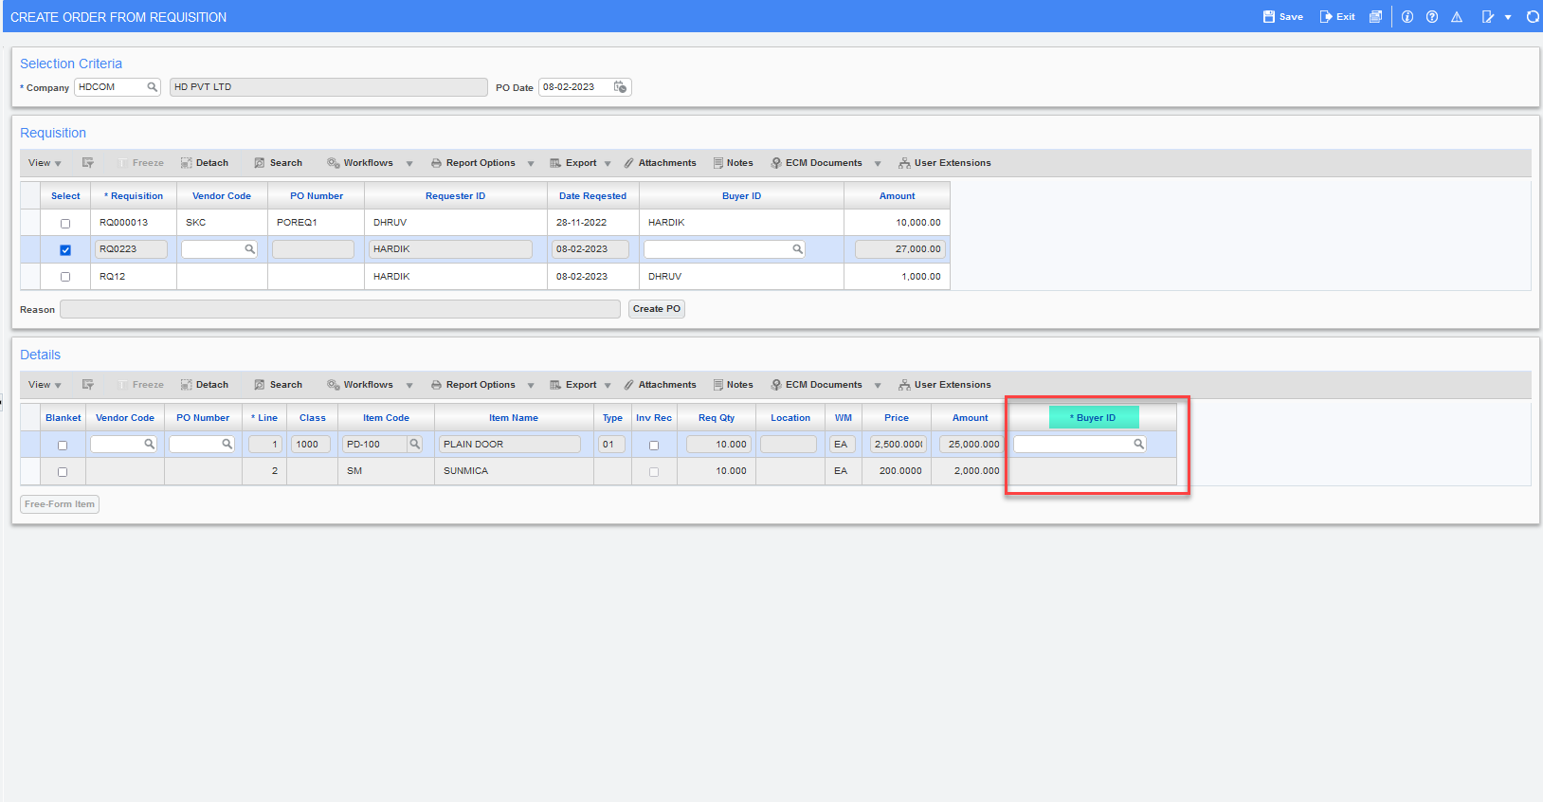

Create Purchase Order from Requisition, when Buyer ID selected in the Details:

Under the Requisition Detail section, if buyer id is selected, system will use the buyer id when creating Standard/Blanket PO.

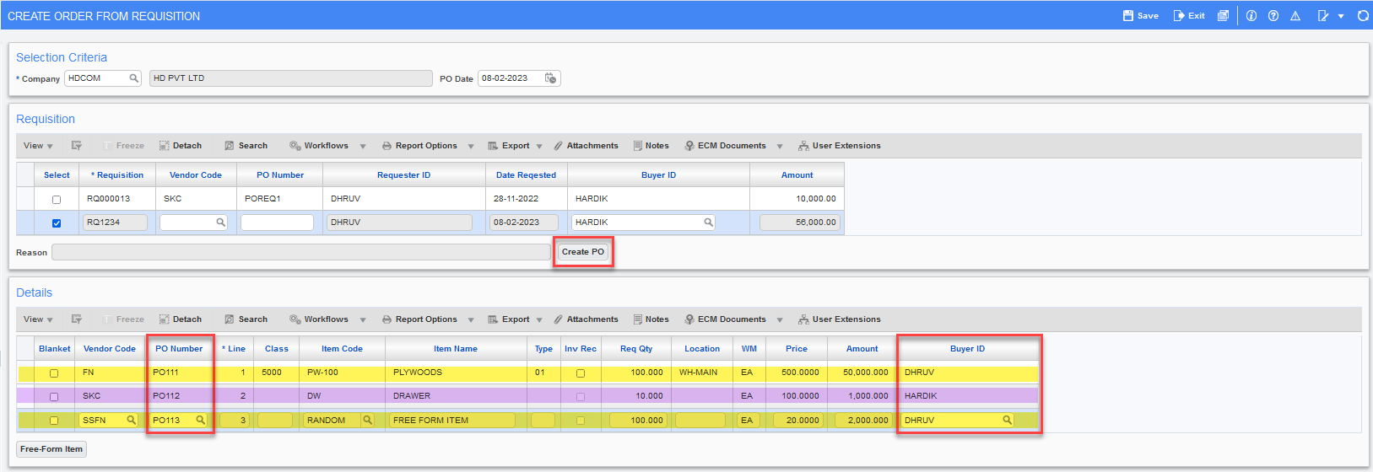

The Purchase Order Entry Screen shown below, the buyer id is taken from the Requisition Details when creating Standard/Blanket PO.
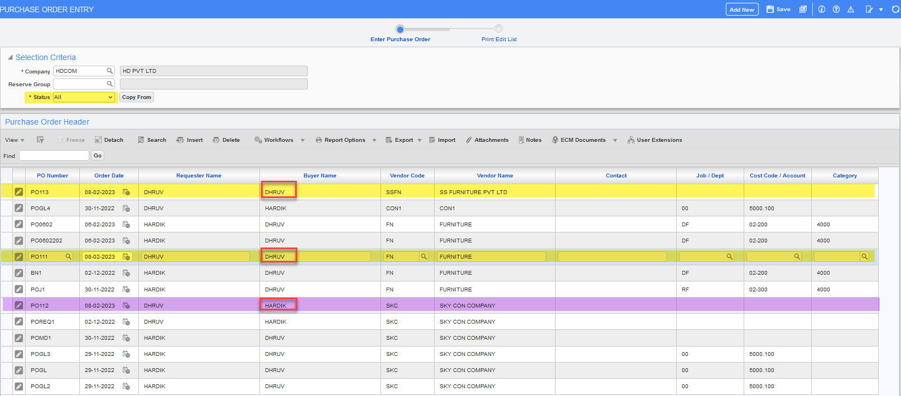
Create Purchase Order from Requisition when Buyer ID is set as NOT required:

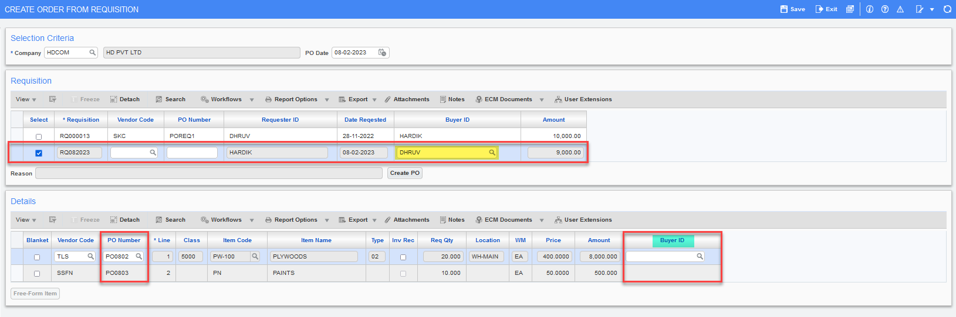

If buyer id is left blank and set as NOT required, then the purchase order is created with buyer id from the Requisition header.

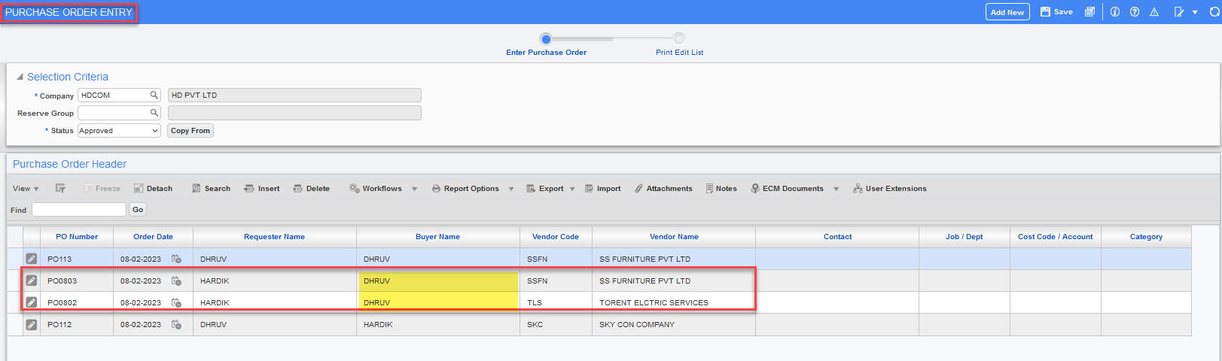

Validation for Buyer ID column:

Once Buyer ID field is flagged as required, user cannot create Standard/Blanket PO from Requisition without selecting a Buyer Id. System will throw an error message ‘Buyer Id is required’.

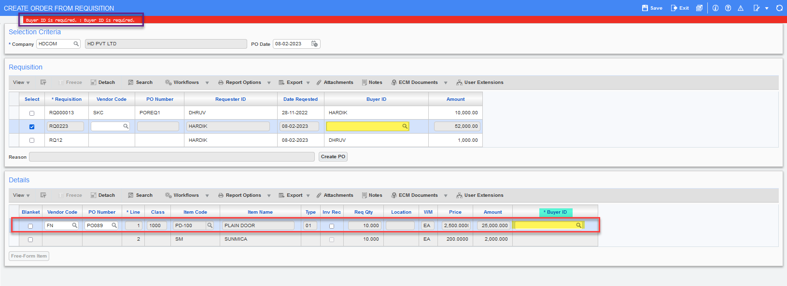

Subcontract Management

AP/SC Advance Payment functionality (20.34826) – Draft
Added the ability to record an Advance Payment (Deposit) against a specific vendor subcontract and then track the recovery/amortization of the Advance Payment through the RFP progress payments.
To accommodate the requirements, the Subcontract Request for Payment screen is enhanced to have capability for creating Advance Payment RFP and Amortization of the Advance Payment through the RFP progress payments.
This modification applies to Payment Requisition Entry from both Enterprise ADF and CMiC Filed applications.
Note: Advance Payment can be created against base Subcontracts and NOT on Change Orders.
Account Payable Control:
“Advanced Payment Control” account is added to AP Control. The account is used for creating the Voucher Distribution Line for the Deposit/Amortization Amount. The fields include:
- Deposit Payment Department Code
- Deposit Payment Account Code
- Deposit Payment Account Type Code
- Deposit Payment Account Name
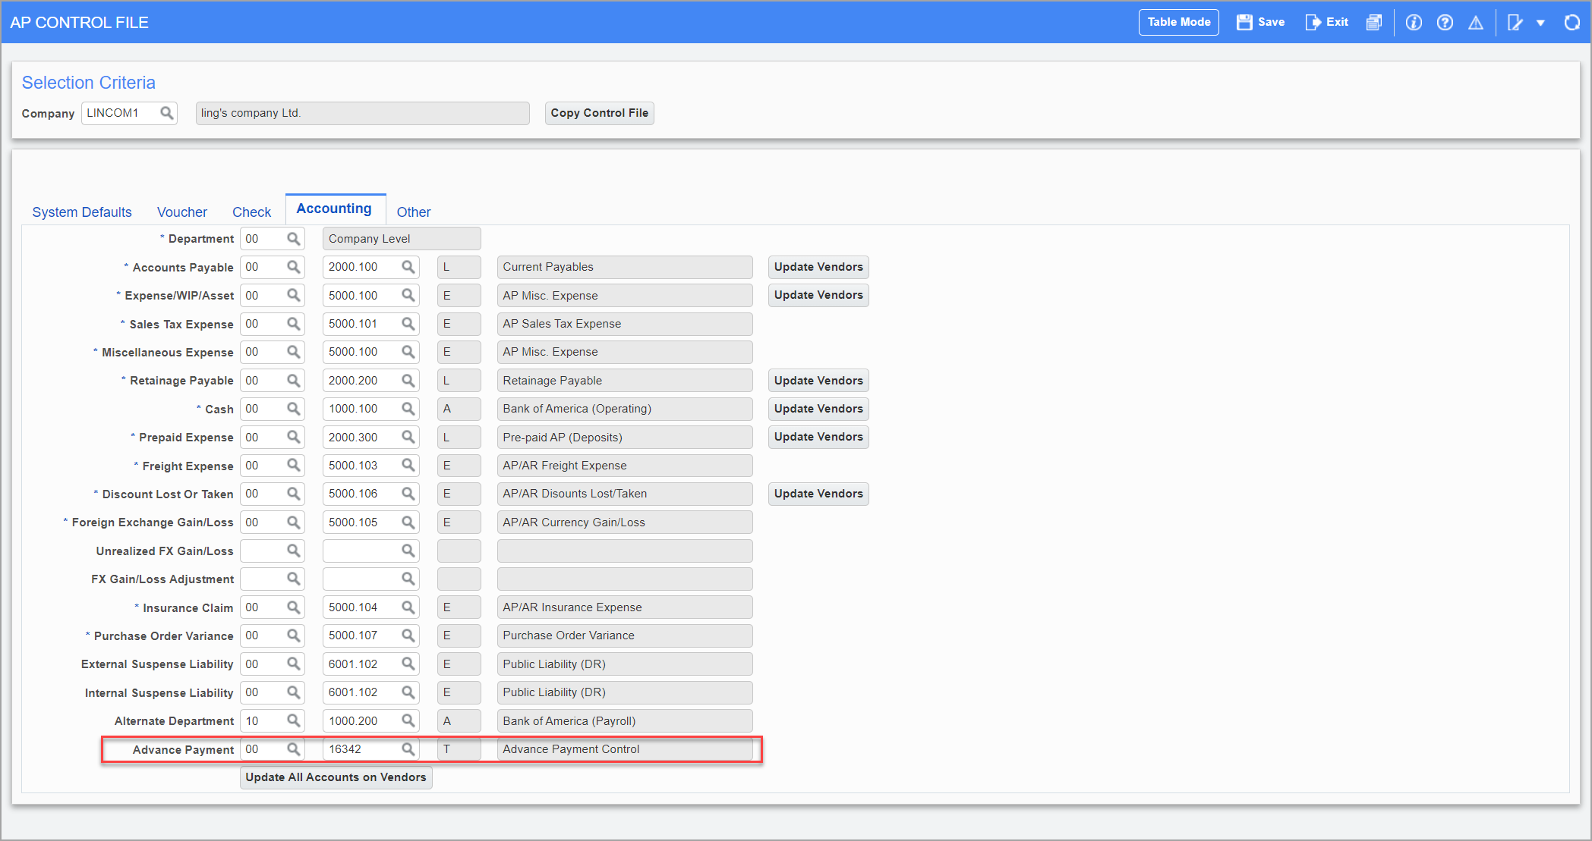
Please note, the above fields are not visible by default and can be made visible using the Lite Editor.

Subcontract Control:
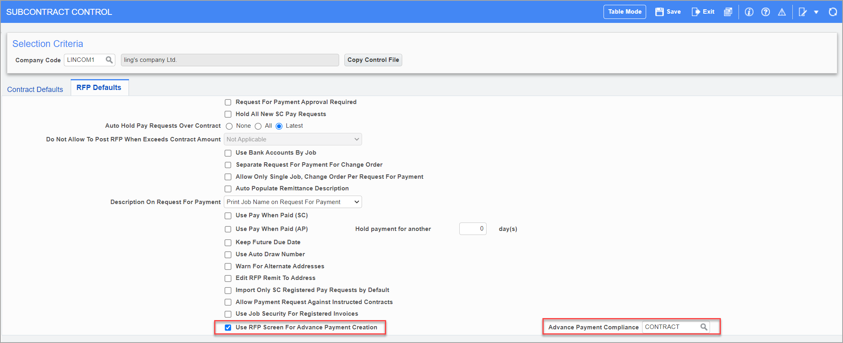
Added flag ‘Use RFP Screen for Advance Payment Creation’ to enable Advance Payment Creation/Amortization from SCPAYREQ from ADF & Field applications. When checked, the Advance Payment flag becomes visible on SCPAYREQ, otherwise it is not visible.
Added field ‘Advance Payment Compliance’. The LOV is bringing data from the Vendor by Company Compliance setup screen. This field can be left NULL as well.
When a compliance code is populated, and the Subcontract is assigned with the compliance code, then during RFP Posting the program validates that the code is fully compliant and then the posting is allowed. Otherwise posting will be stopped with a valid message.

Subcontract Request for Payment
Multiple new fields have been added to the Request for Payment screen (in both ADF and Field). In ADF, all these fields are not visible by default and can be made visible using Lite Editor.
Added flag ‘Advance Payment’ to create Advance Payment RFP.
- Visible only if “Use RFP Screen for Advance Payment Creation” is checked on SC Control.
- When checked, Advance Payment RFP is generated. When unchecked, regular RFP is generated with capability to amortize the Deposit/Advance Payment amount.
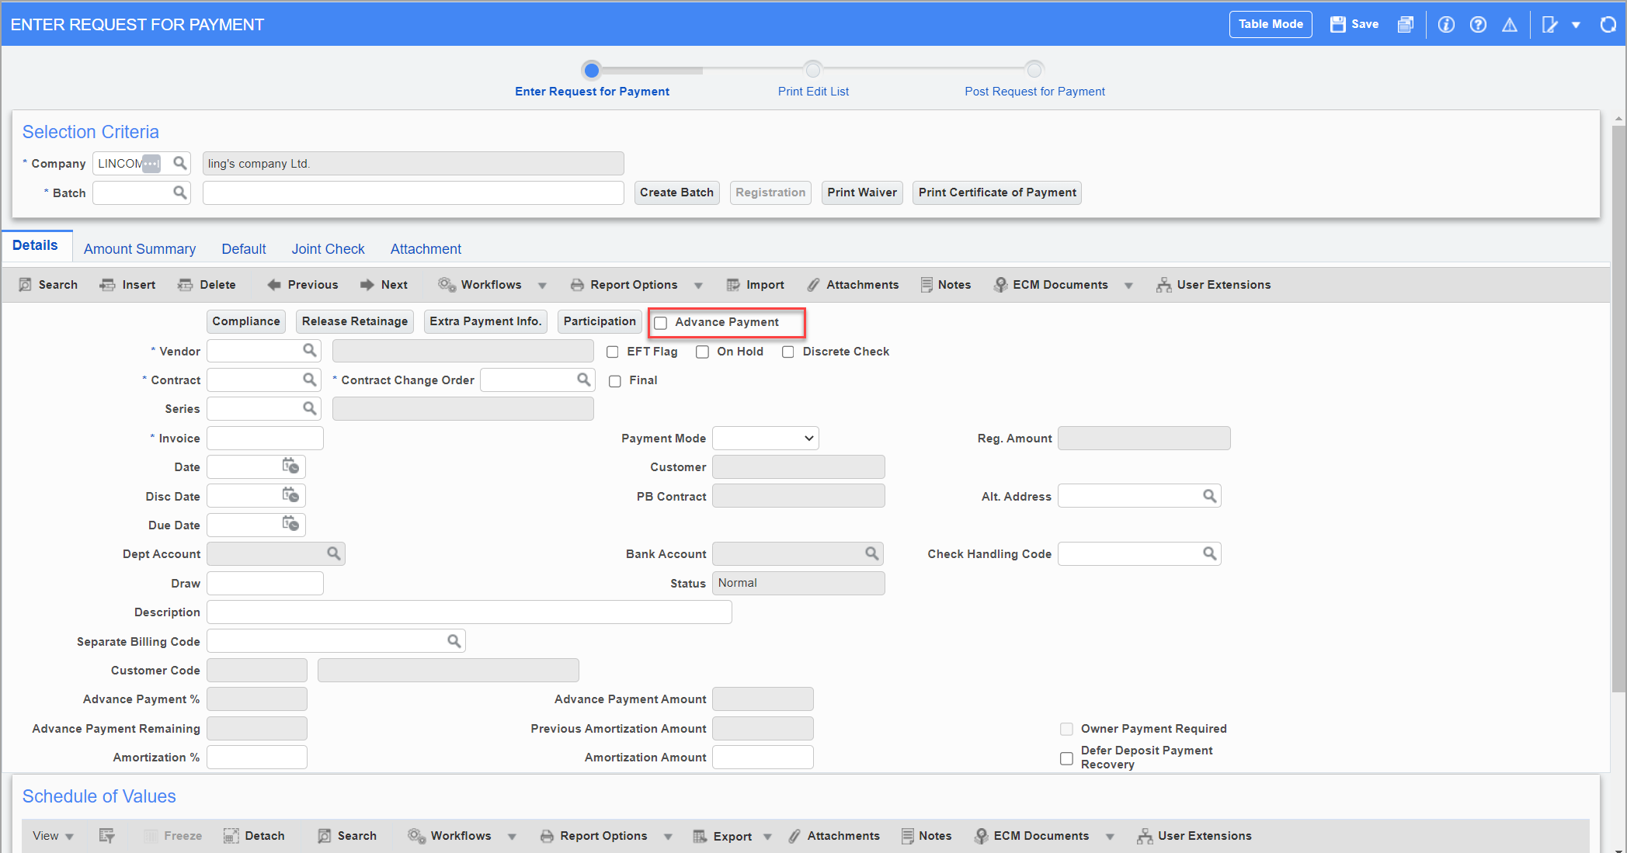
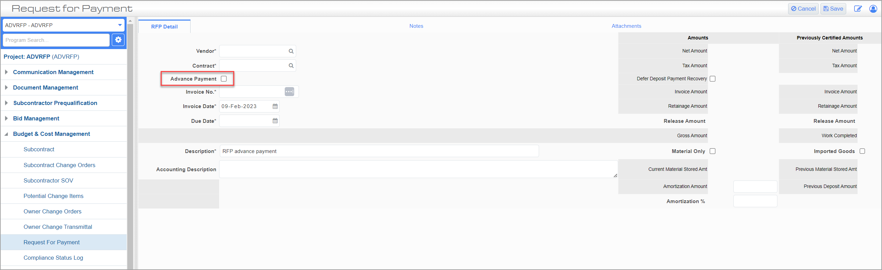
When ‘Advance Payment flag’ is checked, the following fields are enabled:
- SC Header
  - Owner Payment Required check box.
  - Advance Payment Amount field
  - Advance Payment % field
  - Remaining Deposit Amount field (Display only)
- SOV Columns
  - Current Deposit % (Advance Payment%)
  - Current Deposit Amount (Advance Payment Amount)
  - Remaining Deposit Amount (ADF only & Display only)
When Advance Payment flag is unchecked, the Advance Payment RFP related fields are disabled, and remaining fields of the screen are enabled, and regular RFPs can be created.
For amortization of Advance Payment, following fields are enabled:
- SC RFP Header
  - Defer Deposit Payment Recovery
  - Amortization %
  - Amortization Amount
  - Pervious Amortization Amount - ADF only
- SC RFP Details columns
  - Amortization %
  - Amortization Amount
  - Pervious Amortization Amount - ADF only
  - Pervious Amortization % - ADF only

Accounting Transactions
Advanced Payment creates separate transactions that are posted to accounts at separate stages. It is different than the current way CMiC handles deposits. The Advanced Payment is an invoice that does not impact job costing.
When Advanced Payment is posted
DR Advance Payment Control account
CR AP Subcontractor Liability account (Accounts Payable)
When Advanced Payment check is posted
DR AP Subcontractor Liability account (Accounts Payable)
CR Bank Cash account
When Amortization of Advanced Payment is posted
DR Job Cost Expenses
CR AP Subcontractor Liability account (Accounts Payable)
CR Advance Payment Control account
CR Retainage Payable
When Amortization of Advanced Payment check is posted
DR AP Subcontractor Liability account (Accounts Payable)
CR Bank Cash account

New Flag ‘Do Not Validate Total Contract Amount Against Control Contract Amount’ added (22.63192)

Overview:

A new flag ‘Do Not Validate Total Contract Amount Against Control Contract Amount When Modifying The Subcontract’ is added to the Subcontract control-ADF.

Modifications:

The Subcontract Control program is modified to include this new flag. This flag is hidden by default and user can add this flag using Lite Editor. The default value for this flag is unchecked.

- When this new flag is unchecked in SC control (ADF) and if a subcontract is modified via Modify Original Contract in ADF, then the system validates if the total amount of SOV matches the Control Contract Amount set in PMJSP. If the total amount of SOV does not match the Control Contract Amount, then an error message will be shown.
- When this new flag is checked in the SC control (ADF) and if a subcontract is modified via Modify Original Contract in ADF, then the system does not validate if the total amount of SOV matches the Control contract Amount. Even if the total amount of SOV does not match the Control contract amount, the subcontract can be posted successfully, if this new flag is checked.

Note that these validations apply only to the base contract and not to change orders.

Screenshots:

SC Control Flag unchecked:

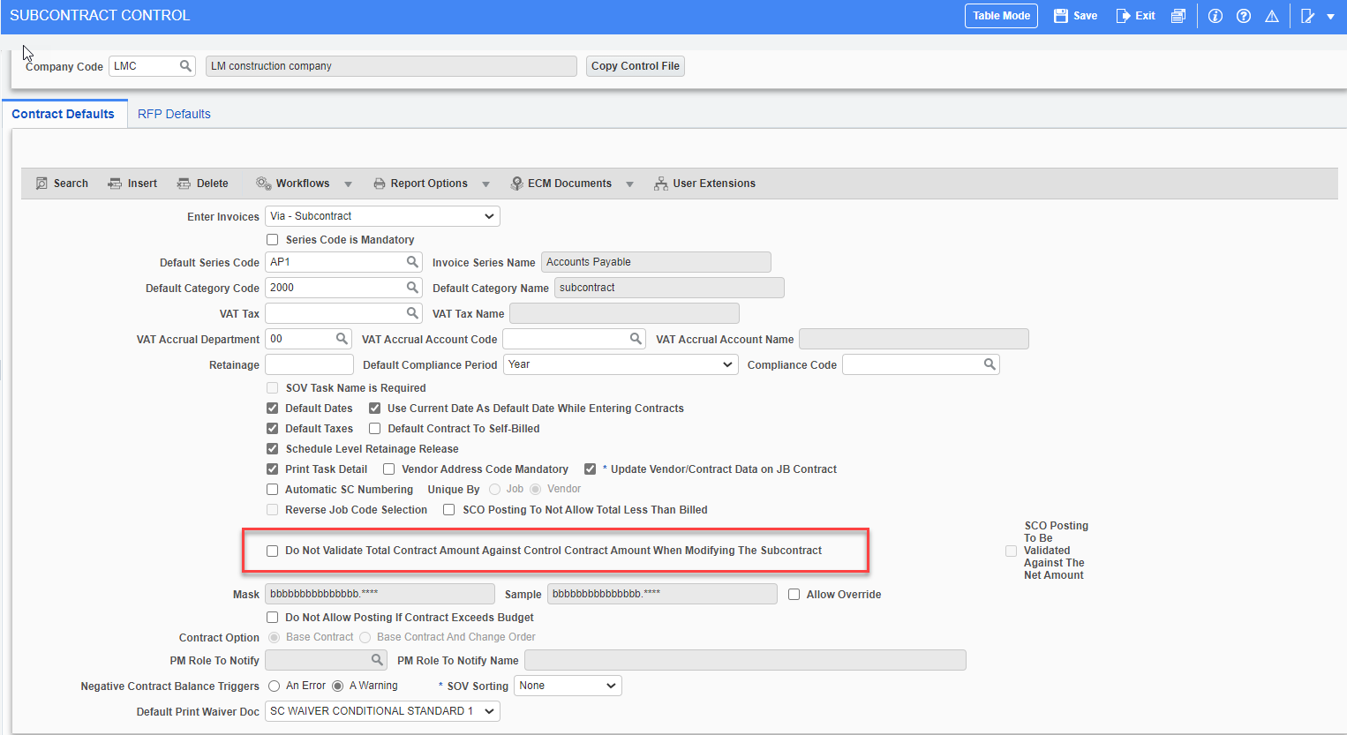

System validates if the total amount of SOV matches the control Contract Amount when modifying the original subcontract.

Contract Control amount set in CMIC field:

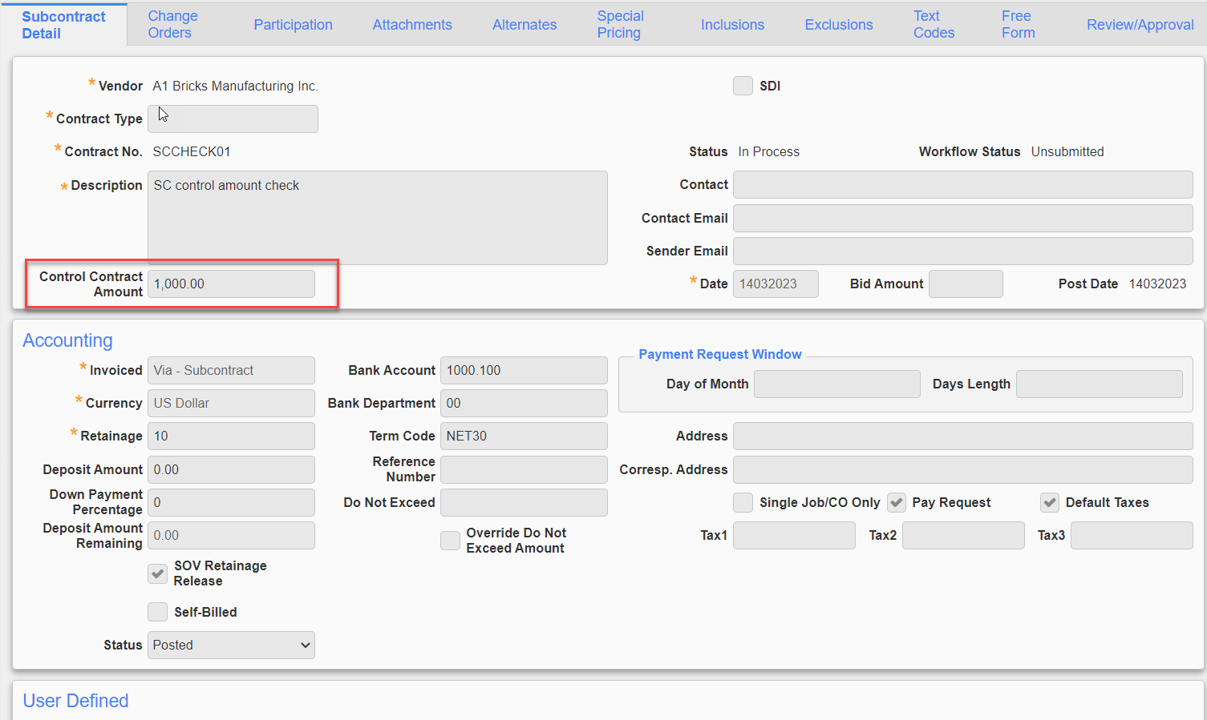

Modifying the Original contract in ADF via Utility
Since the SC control flag is unchecked, the system validates and gives an error message if the total amounts for all the SOV does not matches the Control contract amount.

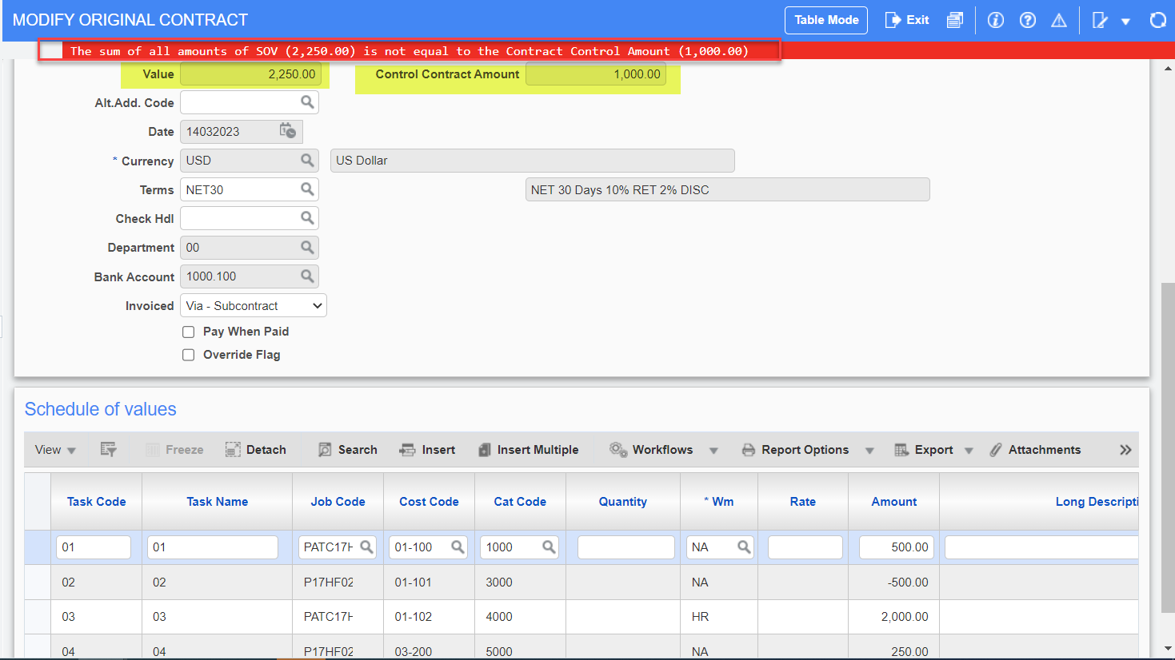

SC Control Flag Checked:
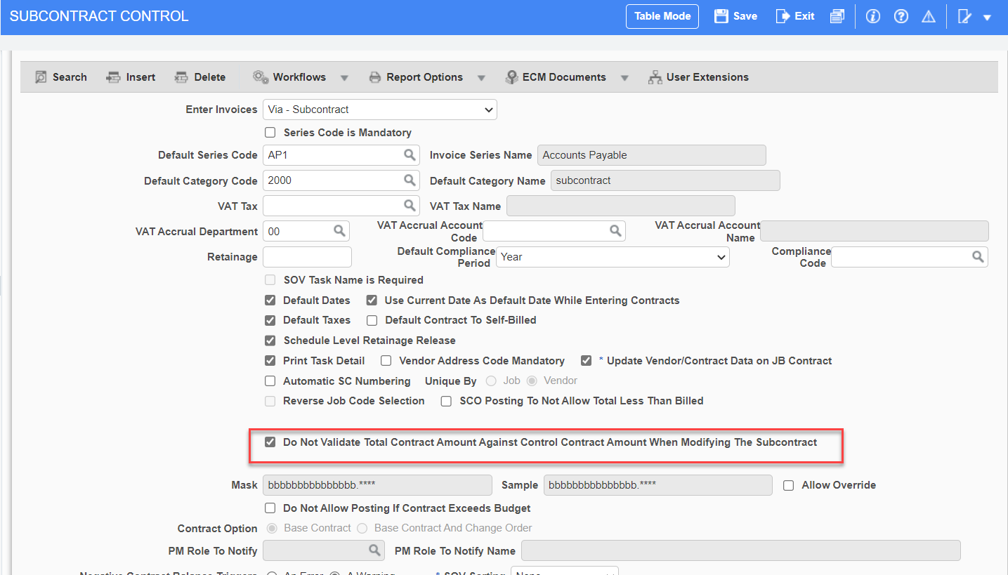

Modifying the Original contract in ADF via Utility
Since the SC control flag is checked, the system did not validate if the total amount of SOV matches the Control contract Amount and subcontract is posted successfully.
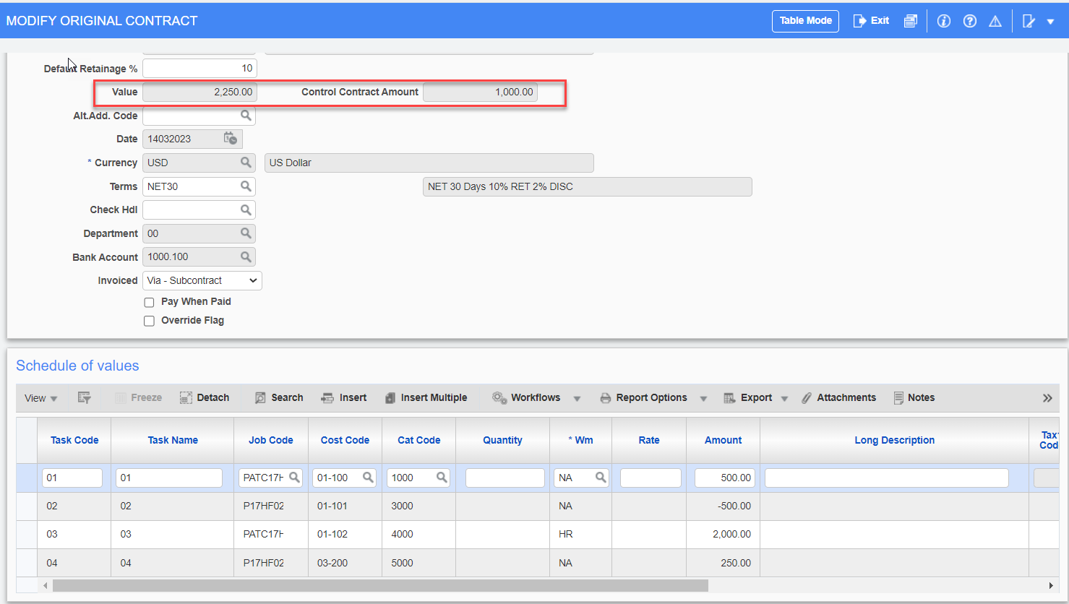

Posted Subcontract
