NEXUS_02 Release
New Functionality Contents
NEXUS_02 Release New Functionality Contents 1
Important Note 4
Accounts Payable 5
Modifications to “Paymode Wells Fargo” Third Party Payment file format (FIN-20502) 5
New Excel Version of AP1000D Report (FIN-19380) 7
EFT File Format for First Pacific Bank (FIN-22365) 10
Invoice Series button added to AP Select Payments (FIN-22724) 15
EFT File Format for Western Alliance Bank (FIN-20907) 16
Updated TPP Format for Wells Fargo 2 (FIN-22763) 37
New AP EFT File Format for PNC BANK (FIN-21897) 38
New AP EFT File Format for Burke & Herbert Bank (FIN-22520) 41
New AP EFT File Format for First Security Bank (FIN-22555) 50
Bank Reconciliation File format for First Pacific Bank (FIN-21940) 52
AI Agents 55
Assets AI Agents 55
Create Inventory Locations (CAM-12299) 55
Create Non-Stock Item (CAM-12301) 55
Create Purchase Orders Agent (CAM-12300) 55
Create Requisitions (CAM-11992) 56
Create Users (CAM-12254) 56
Financials AI Agents 57
General Ledger (GL) 57
Close GL Periods (FIN- 23800) 57
Maintain Consolidations (FIN-23777) 57
Maintain GL Accounts (FIN-23776) 57
Maintain GL Transactions (FIN-23798) 58
Perform Bank Reconciliation (FIN-24212) 58
Accounts Payable (AP) 59
Adjust AP Invoice Distributions (FIN-20175) 59
AP Void Invoices (FIN-20843) 59
Create Vendors AI Agent (FIN-23056) 60
Maintain AP Invoices (FIN-23027) 60
Select AP Invoices for Payment (FIN-23953) 60
Accounts Receivable (AR) 60
Adjust AR Invoice Distributions (FIN-22049) 60
Maintain AR Memos (FIN-23780) 61
Maintain AR Invoices (FIN-23778) 61
Maintain Customers (FIN-23058) 61
Equipment Costing (EC) 61
Create Equipment Locations (FIN-19957) 61
Create Equipment Transaction Codes (FIN-23763) 62
Maintain Equipment Classes (FIN-23892) 62
Maintain Equipment Transaction Codes (FIN-23782) 62
Project Controls AI Agents 62
Job Initiation Agent (JBJCPC-6222) 62
Create PCI Agent (JBJCPC-6317) 63
Create Subcontract Agent (JBJCPC-6851) 63
Subcontract Change Orders Agent (JBJCPC-6852) 63
OCO Agent (JBJCPC-6821) 63
Posting for JC transaction Agent (JBJCPC-7036) 64
Construct UAC 65
Construct UAC – Application Information added to Construct UAC (CAM-9701) 65
Construct UAC – Company Field removed from Permission Templates for Dynamic Company Mode (CAM-11667) 67
Construct UAC – Company Resolution Logic Introduced in User Creation Process (CAM-11670) 69
Construct UAC – New Field Added to Onboarding Error Log User Details (CAM-11671) 71
Construct UAC – New Fields Added to Dynamic Company Assignment Mode (CAM-11859) 74
Construct UAC – New Reset Azure Sync Button Added to Azure Integration (CAM-11022) 78
Construct UAC – Multi Select and Delete Functionality Added to Onboarding Error Log (CAM-11507) 80
Construct UAC – Two New Fields Added to Azure Integration Tab (CAM-10939) 83
Fixed Assets 87
New Hide Disposed Assets Flag for the FA3000 Report (FIN-22060) 87
General Ledger 88
Bank Reconciliation Format for Commerce Bank (FIN-19635) 88
General Ledger – New Text Field added to Maintain Companies (CAM-11752) 89
Enable Import Functionality on Transaction Allocation Values (FIN-22886) 91
New Report Parameter added to GL2000D (FIN-21155) 93
Inventory 96
Item Detail Program: Additional Fields Enabled in Item Header Import (CAM - 9594) 96
Inventory – New Error Validation on Inventory Locations Program Flag (CAM-10847) 100
Job Billing 102
New Alert Message for “Status” mass update in GC prepare Billing- Cost Transaction Popup (JBJCPC-6545) 102
New quantity and Total Material used columns in JBBILL and Retainage on Material stored Flag in JBBILL/JBILL2(PC-13189) 104
NEXUS UI-JBBILL OR JBBILL2-Color Highlights in System/Light and Dark Mode (JBJCPC-4566) 125
Material Stored Columns in Group Summary tabs made editable in JBBILL2 (JBJCPC-6659) 129
JOB COSTING 135
WIP Enhancement Copy Profit Override (JBJCPC-4731) 135
Add Cost Code Description to Job Cost Transaction Detail Log (JBJCPC-6042) 137
Import JC Foreign Batch Data File via API (JBJCPC-2824) 138
Expose Project Close Status Field to Enterprise Screen (JBJCPC-5441) 139
Import option on Needs Tab in Enter Project (JBJCPC-3287) 141
Import Functionality to Enter Cost Code Type (JBJCPC-3479) 145
Union Code field length extended in Project Controls screens (JBJCPC-6509) 148
Add “Import” button to "Assign Templates To Multiple Jobs" Program (JBJCPC-5265) 149
Added Posting Date Field in the Job Cost Unit Posting program (JBJCPC-3000) 153
Disable Overriding Cost Code Description (PC-18626) 161
WIP- Projected Profit and Projected Profit% Column Behavior Change-JBJCPC-4237 163
New Job Costing Report – Job Cost Comparison (JBJCPC-4083) 165
Material Sales 170
Material Sales – New LOV Columns and Preferred Contact Method added to Trucker Payroll Invoice (CAM-10237) 170
Opportunity Management 176
My Activities – Action Item Rebranding and New Alert Notifications (CAM-9368) 176
Opportunity Management – Hide Inactive Business Partner Privilege Added to OM Control File (CAM-11069) 185
Opportunity Management – New Flag introduced within OM System Options Program (CAM-11216) 187
Opportunity Management – New Top 5 Contacts Table Added to Organizations and Contacts (CAM-10782) 191
Opportunity Management – Opportunity Import Includes Two Renamed Columns (CAM-7134) 197
Payroll E-Time 200
Expense Management in Construct E-Time- (HCM-16926) (IN DEV) 200
Restrict Employee Visibility by Home Company and Home Department on the Payruns Tab (HCM–32731) 201
Payroll US 208
Unlink Employee (Employee Profile) - (HCM-20679) 208
Employee Mass Termination (HCM-21819) 212
Vertex – Internal Process Flag in Payroll Processing (HCM-22546) 218
Maintain SSN Masking Functionality – Extended to additional seven (7) ADF Programs across the Payroll and Human Resources modules (HCM-23190) 219
Dynamic Tax Override UI (Vertex-Aligned and Future-Proof) (HCM-27339) 227
Union Code field length extended in Payroll screens (HCM-29415 & JBJCPC-6509) 233
Expense – Deductible from Gross Pay (HCM-29806) 235
Vertex API Flag – Manual Check and Retro Pay Processing - NEXUS 1 Hotfix (HCM-33445) 237
Vertex API (not visible) – Manual Check and Retro Pay Processing (NEXUS 2) (HCM-33445) 243
Timesheet adjustment post void transaction (HCM-33365) 250
Tax Rate Override Enhancement – Zero Tax Rate Support (HCM-32850) 258
Consider OT Hours in Payroll Overtime Calculation (HCM-21932) 262
Preventive Maintenance 272
Work Item Close-Out: Last Serviced Reading Update (FIN-21206) 272
Project Management 274
Checklists – Mandatory fields / Responses (CF-31497) 274
Subcontract - Auto-populate IBAN from Business Partner setup and SWIFT code from Banks setup (PC-24144, PC-22361) 280
Vendor Prequalification – Added Free-form Email Notification to Subcontractor Record (CF-33793) 288
PCI – Field Security for Proposal Issued and Proposal Signed (PC-9046) 296
RFP - Field security added for ‘Amounts’ and ‘Previously Certified Amounts’ headers (PC-8764, PC-25433) 297
RFP - Field security added for RFP Due Date (PC-27353) 298
RFP - Field security added for ‘Payment Mode’ and ‘Paymode Type’ (PC-26155) 299
Checklist Templates - System Tags to Reflect at Project Level when Added/Removed (CF-37413) 301
Submittals - Update to CMiC Field Menu Names (CF-41043) 307
Phase Segmentation: Remove Security Restrictions on ‘Add Phase/Category on the fly’ (PC-25582) 315
PCI Details Import – Updated Import Layout (PC-25582) 331
PCI - Security on PCI Import Button (JBJCPC-6046) 332
New Projected Final Flag Type and Forecasting (PC-7126) 336
Enhancement to Percent Complete Projections popup in Contract Forecasting (JBJCPC-4964) – Beta Version 348
Purchase Order 354
Purchase Order – Allocation Distribution Fields Disabled on Change Order Entry Program (CAM-12132) 354
Business Partner Maintenance Company Tab: Vendor and Customer Active Status Enhancements (CAM-11533) 355
Purchase Order – Detail Block Column Names Updated (CAM-10862) 363
Enhancement to Support Item Price Lists by Vendor (CAM-8434) 365
Enter Job Receipt Program: Header Date Field Addition and Related Enhancements (CAM - 11079) 376
Job Shipment Receiving: Import Functionality for Received Items Section (CAM-11824) 381
Purchase Order Entry: Distribution Type LOV Description Change (CAM - 11190) 385
Purchase Order – New Mask Numbering Flags Added to Purchase Order Control File (CAM-10328) 386
Removal of Unused Import Functionality in Certain Purchase Order Programs (CAM - 12139) 392
Requisitions 395
Requisition Control File: Configuration Options for J-Type Detail Line Cost Code/Category Validation (CAM-9663) 395
Resource Planning 403
Modified filters and columns in the Resource Planning program – Detail View (TOOL-7602) 403
Subcontract Management 411
Modification for System Privilege “SCSEPRFPCO “and SCPAYREQ “Contract Change Order” LOV (PC-26561, PC-26360) 411
Warning message upon saving a Subcontract/Change Order when its amount exceeds Cost Budget (PC-19511) 419
Add Discount Information to Select Multiple RFP Batches Program (PC-25669) 425
System Data 430
IP Whitelisting feature – New IP Whitelisting maintenance screen and the "Enable IP Whitelisting" system option - Beta Version (CAM-11420) 430
System Data – Logo Banner added to System Options (CAM-11123) 432
System Data – Merge Options removed from LOV List (CAM-10505) 436
System Data – New Support Chat License Type Added (CAM-10455) 437
System Data – New UAC Dynamic Company Assignment Flag Added to System Options Program (CAM-11664) 439
System Data – Terms of Use Updated in System Options (CAM-11897) 441
System Data – Theme Selection Field Removed from System Options (CAM-11403) 443
System Data – Toolbar Options Disabled within Define Roles Program (CAM-12267) 444
System Data - User Deletion Restrictions for Active Workflow Submitters (CAM-10960) 446
TOOLS 449
Deprecation of Legacy XLS Output Format (TOOLS-8431) 449
Target Options for Construct PM & Nexus PC (UI Console Integration) (TOOL-9125) 450
Disable AI Button and Smart Search (TOOL-9561) 455

Important Note
Please be aware that some modifications and enhancements may require licensing, specific configurations, and setup, and may require involvement of CMiC Consulting to be utilized and further training may be required. Please contact your Account Manager/Project Manager for more information where needed.

Accounts Payable

Modifications to “Paymode Wells Fargo” Third Party Payment file format (FIN-20502)
Overview
Modifications to “Paymode Wells Fargo” Third Party Payment file format.
Modifications
Third Party Payment format “Paymode Wells Fargo” is modified to remove one digit from beginning for check type payments.
Implementation
Below screenshot shows selection code created for invoices with Third Party Payment mode as Paymode Wells Fargo.
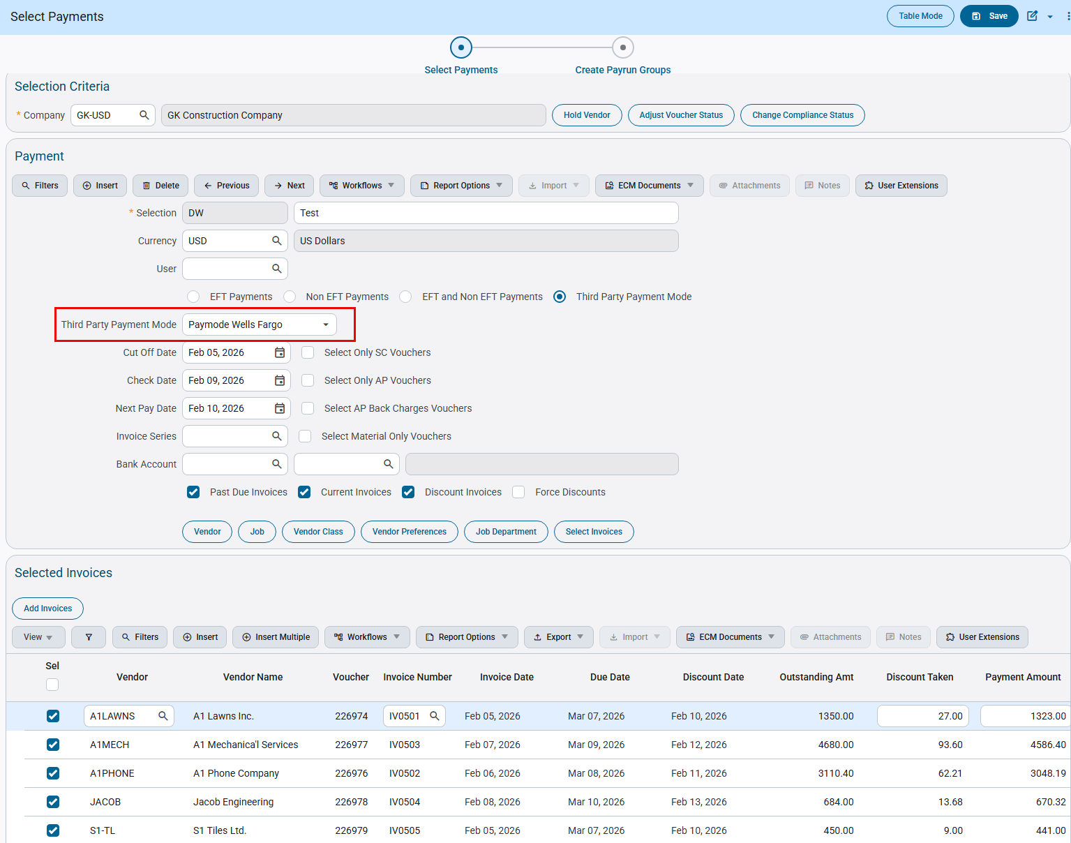
Accounts Payable > Payment > Select Payments
Below screenshot shows how to print Third Party Payment file for “Paymode Wells Fargo”:
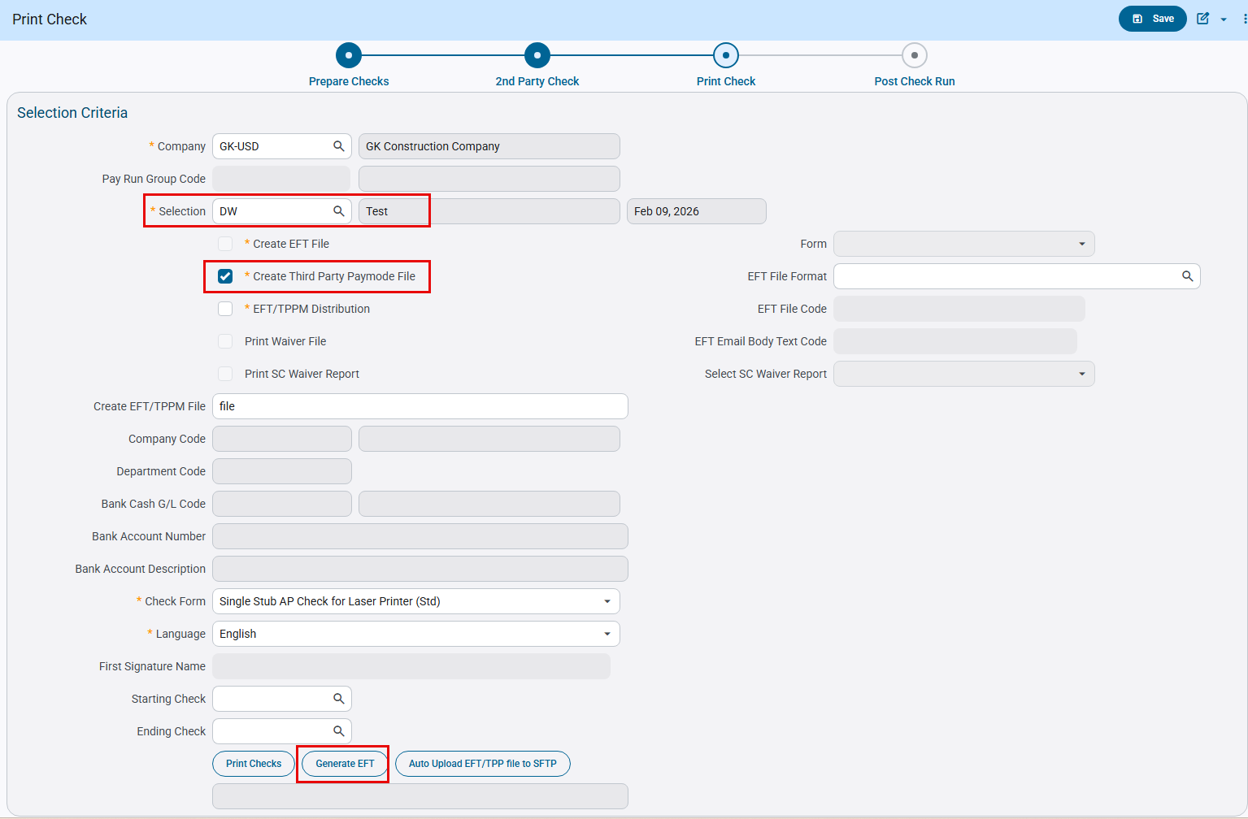
Accounts Payable > Check > Print Checks
Third Party payment file is generated as below:
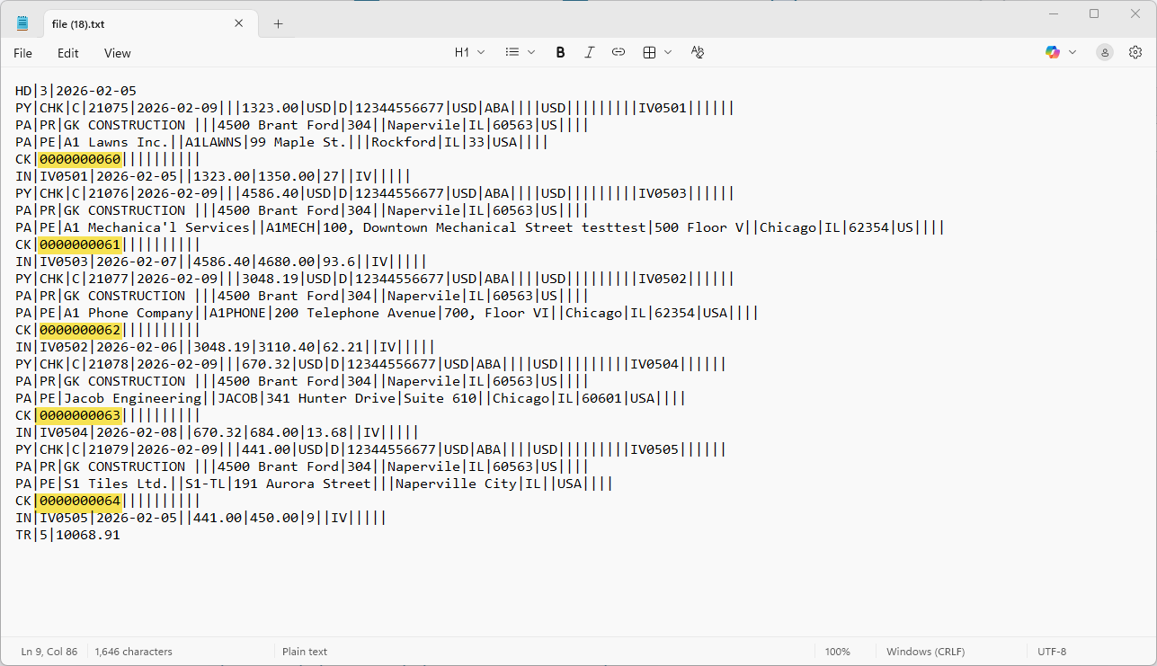

New Excel Version of AP1000D Report (FIN-19380)
Overview
Enhancement of AP1000D Excel Report
Modifications
An enhanced excel friendly version of standard aged report AP1000D is created, which is a flat file without any groupings and totals. Following additional changes are made:
- New columns added - Aging Days, Invoice Date, Post Date, Vendor Name, and Job Name.
- Flag “Print in Excel” is added to report parameter screen. When set as Y, report is generated in new excel version.
- Flag “Store Report Data” is added to report parameter screen. When set as Y, report data is saved to a database table each time. This new table stores all report columns data and all the existing data in the new table is deleted each time the report is run, regardless of the report parameters. It works with all output formats.
- A new database view “da.ap_1000d_report_data_v” is created to allow access to the stored report data.
Implementation
- When Group by Vendor, Print in Excel: Y, Store Report Data: Y, Output format: Excel
Vendor Name is visible when group by is set as Vendor
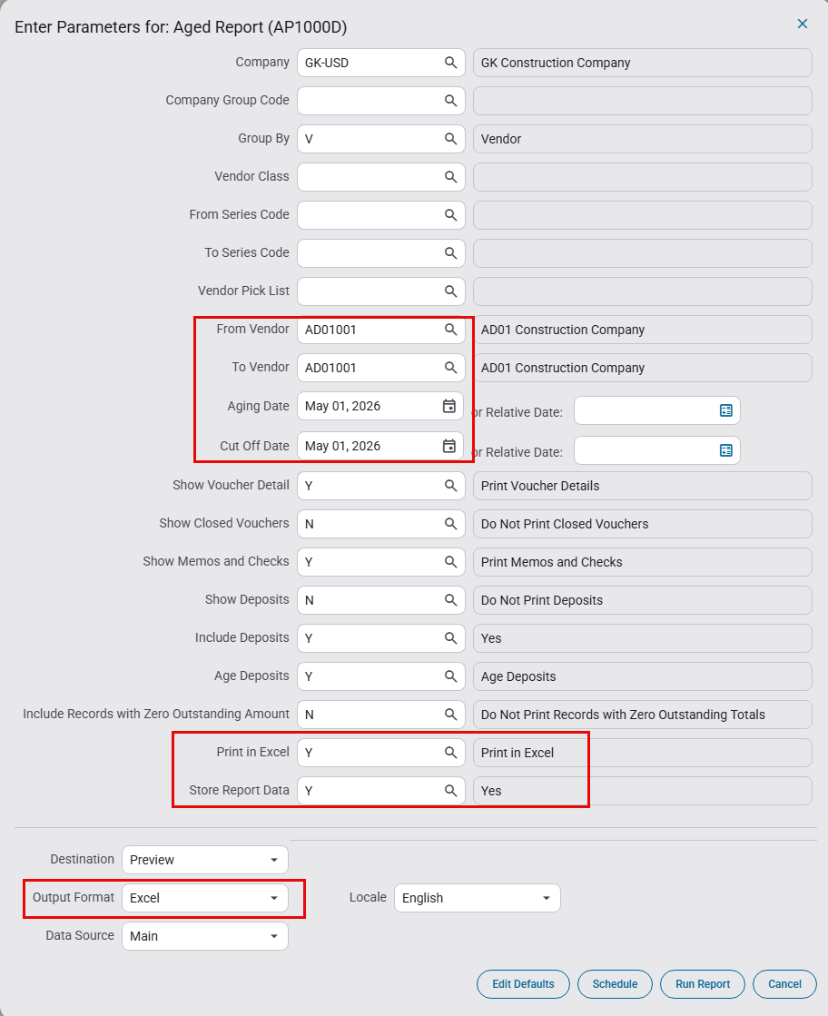
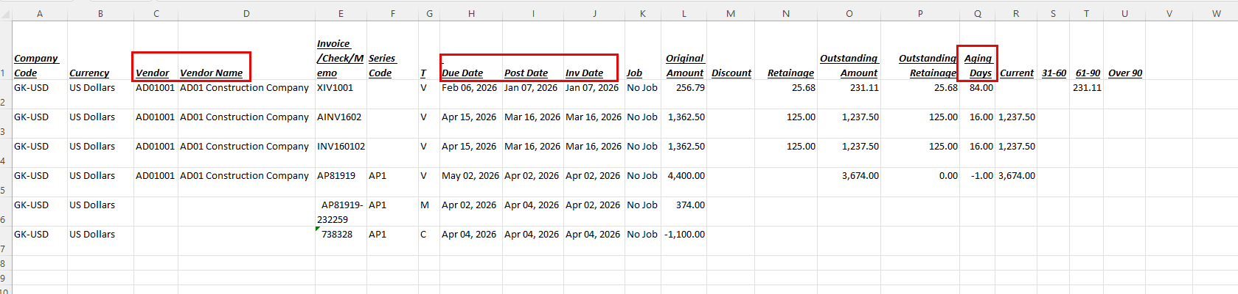

- When Group by Job, Print in Excel: Y, Store Report Data: Y, Output format: Excel
Job Name is visible when group by is set as Job
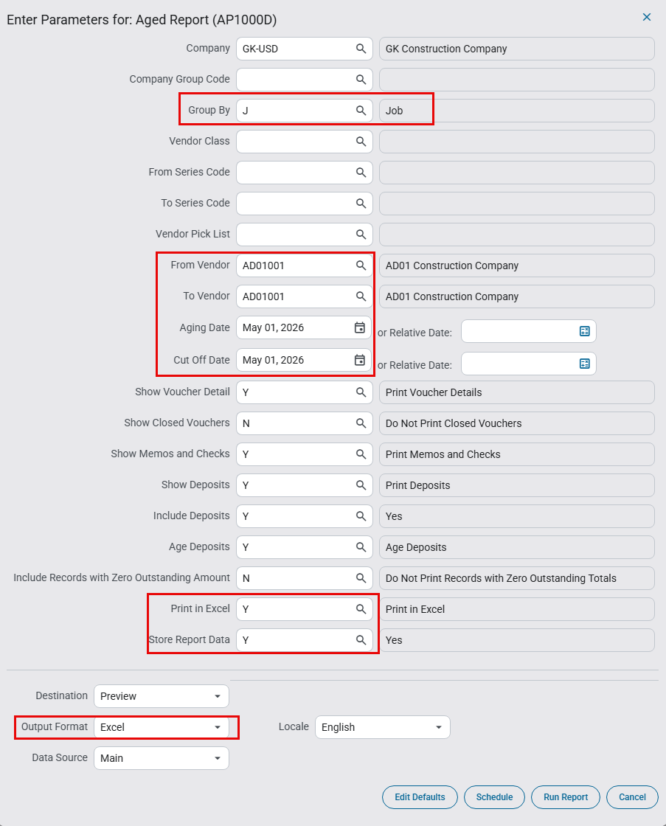
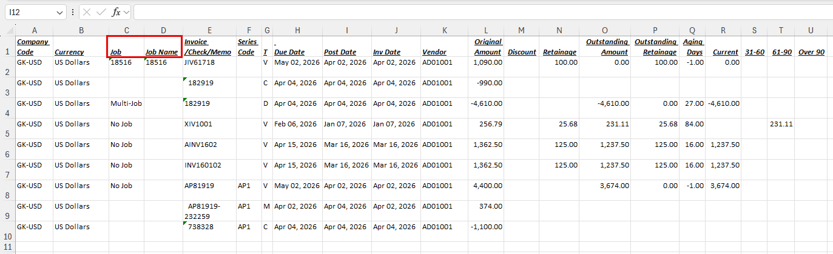

EFT File Format for First Pacific Bank (FIN-22365)
Overview
AP EFT Format “FIRSTPACBK” for First Pacific Bank.
Modifications
A new AP EFT file format “FIRSTPACBK: First Pacific Bank” has been added as per specification format shared.
Implementation
EFT Setup:
The screen below shows EFT format setup:
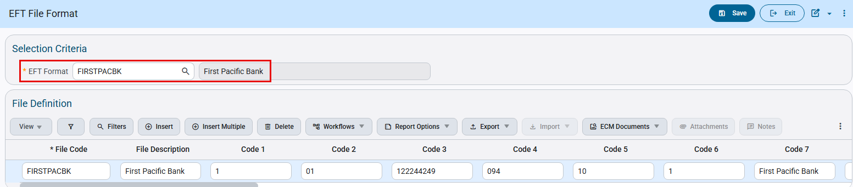
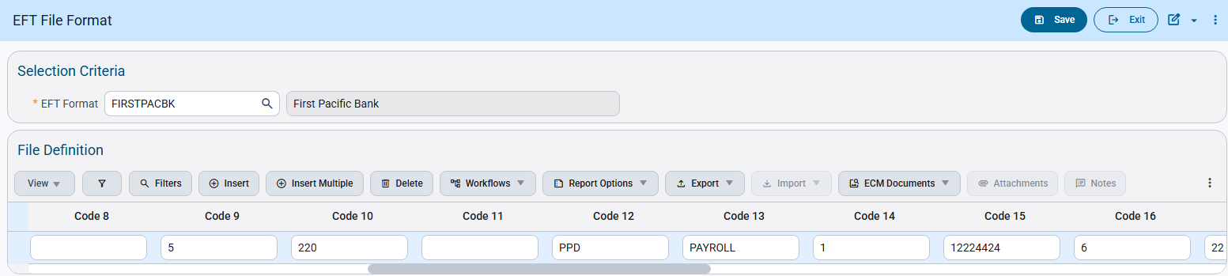
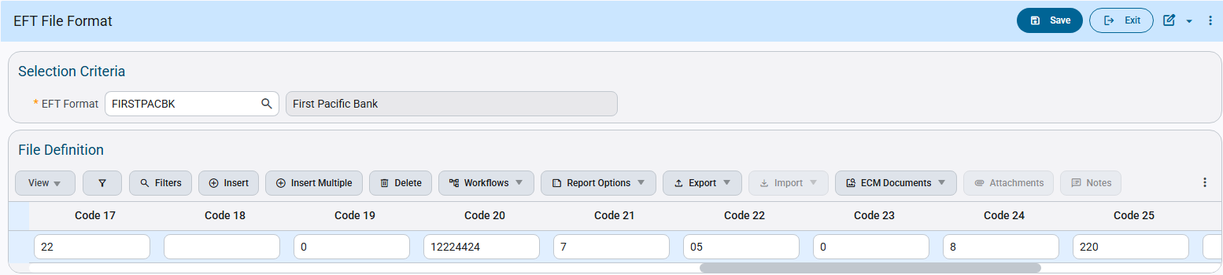
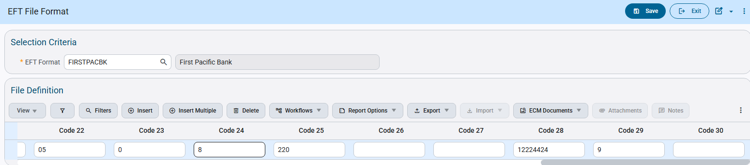

EFT File Format Mapping:

Code |  | Description | Sample Values
File Code |  | FIRSTPACBK | FIRSTPACBK
File Description |  | First Pacific Bank | First Pacific Bank
Code 1 |  | File Header Record Type Code | 1
Code 2 |  | Priority Code | 01
Code 3 |  | Immediate Destination | 122244249
Code 4 |  | Record Size | 094
Code 5 |  | Blocking Factor | 10
Code 6 |  | Format Code | 1
Code 7 |  | Immediate Destination Name | First Pacific Bank
Code 8 |  | Reference Code
Code 9 |  | Batch Header Record Type Code | 5
Code 10 |  | Service Class Code | 220
Code 11 |  | Company Discretionary Data
Code 12 |  | Standard Entry Class Code | PPD
Code 13 |  | Company Entry Description | PAYROLL
Code 14 |  | Originator Status Code | 1
Code 15 |  | Originating DFI Identification | 12224424
Code 16 |  | Entry Detail Record Type Code | 6
Code 17 |  | Transaction Code | 22
Code 18 |  | Discretionary Data
Code 19 |  | Addenda Record Indicator | 0
Code 20 |  | Trace Number | 12224424
Code 21 |  | Addenda Record Type Code | 7
Code 22 |  | Addenda Type Code | 05
Code 23 |  | Payment Related Information | 0
Code 24 |  | Batch Control Record Type Code | 8
Code 25 |  | Service Class Code | 220
Code 26 |  | Message Authentication Code
Code 27 |  | Reserved
Code 28 |  | Originating DFI Identification | 12224424
Code 29 |  | File Control Record Type Code | 9
Code 30 |  | Reserved

Check Printing:
The Check Printing program allows users to select the available EFT file codes. Users can select the code and generate EFT files as required.
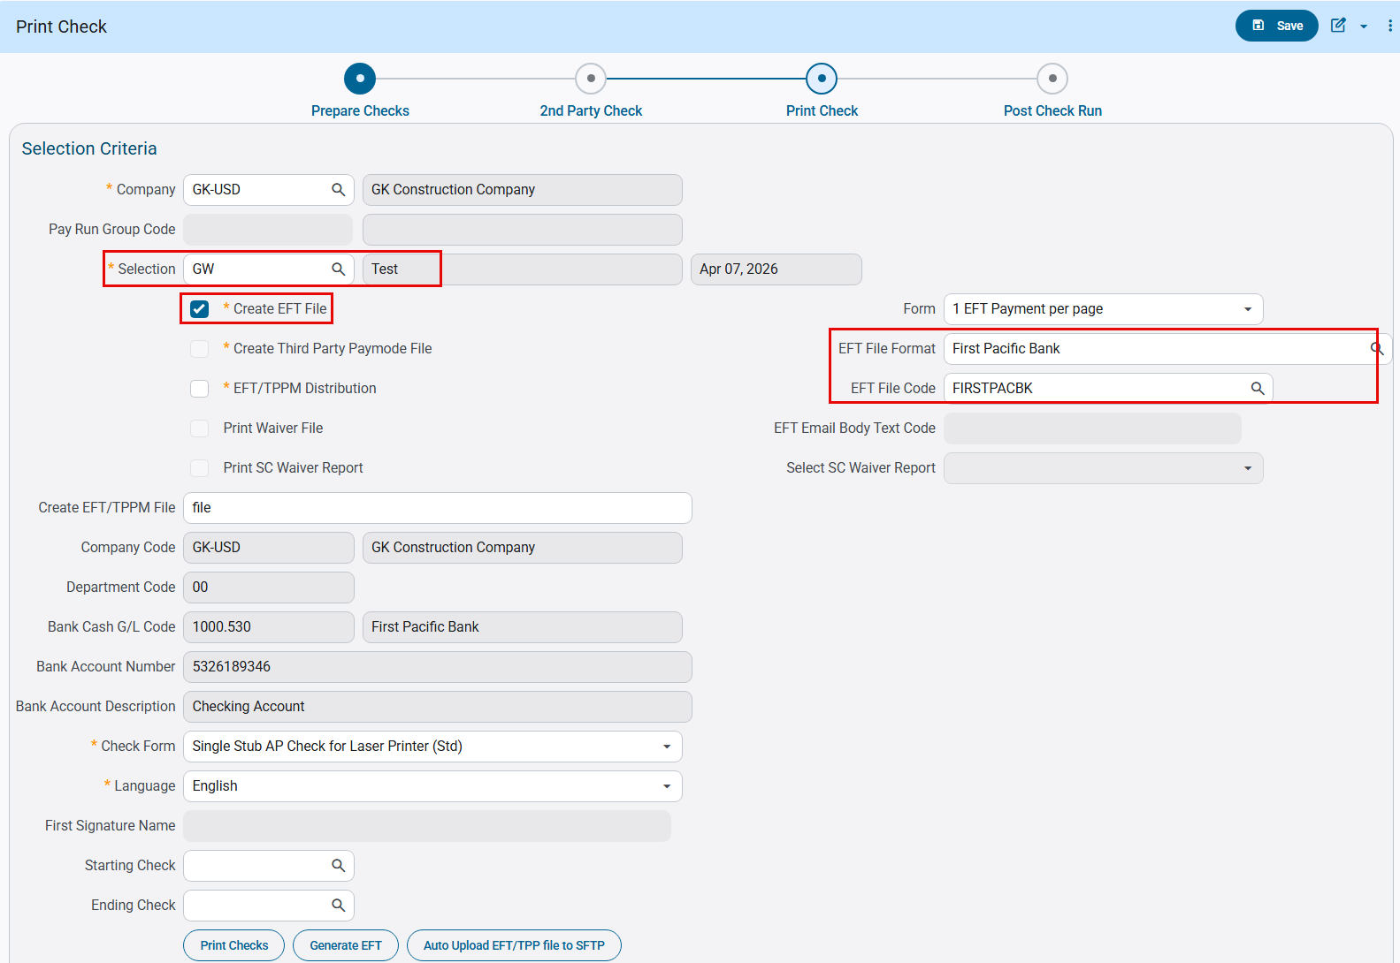
Following is the EFT File generated according to specifications:
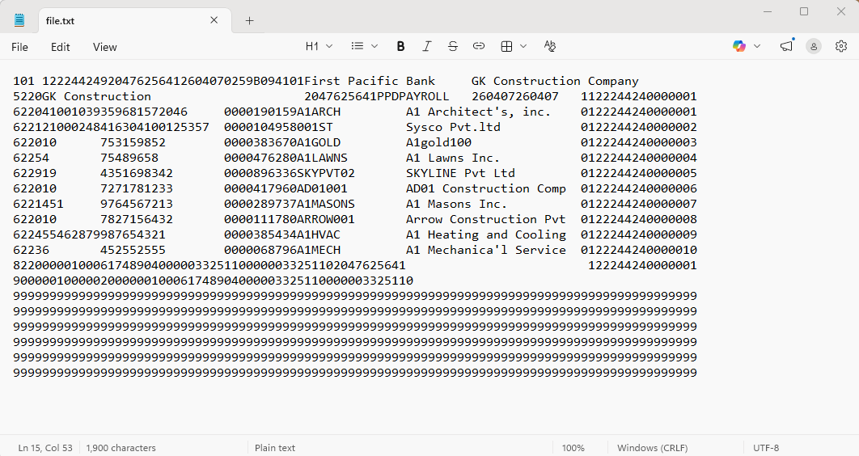

Below is the specification for the required EFT format:
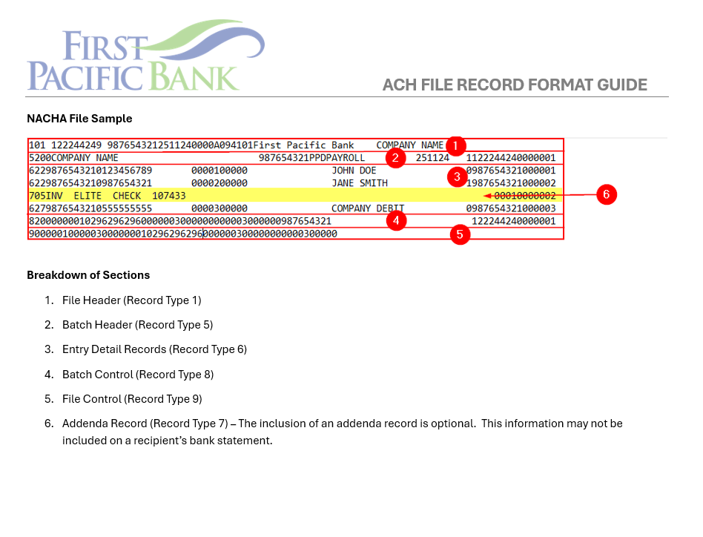
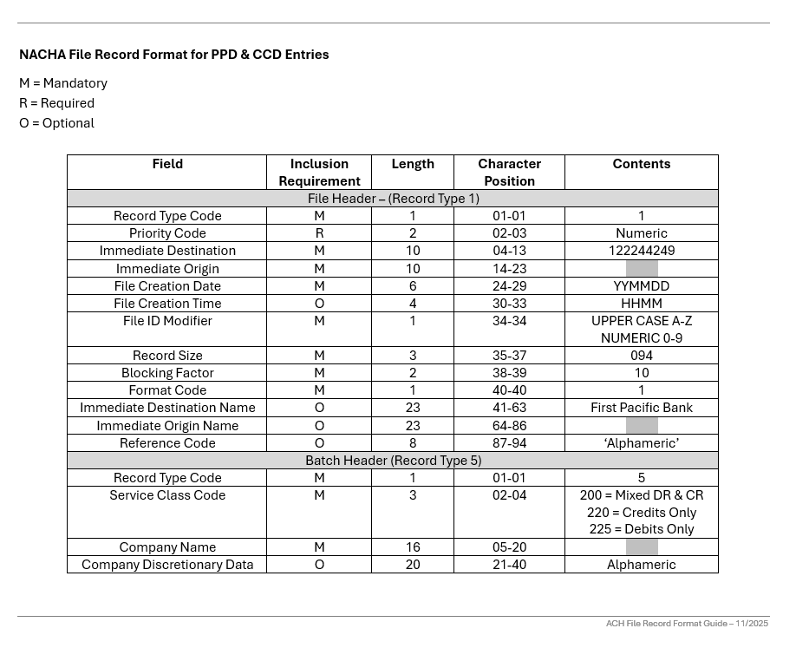
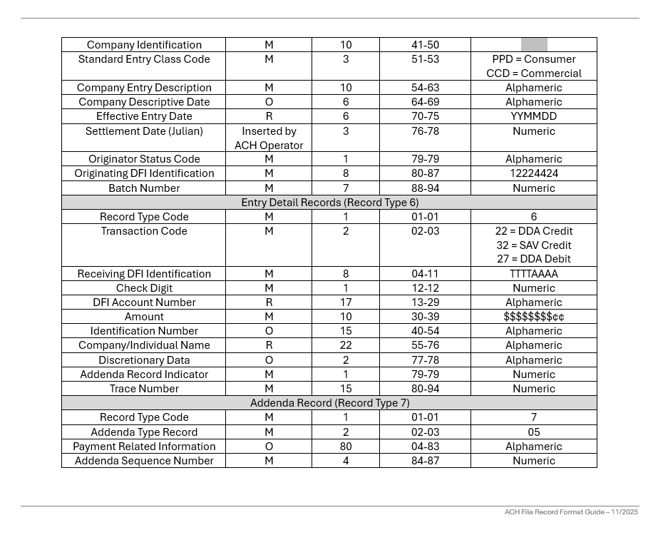
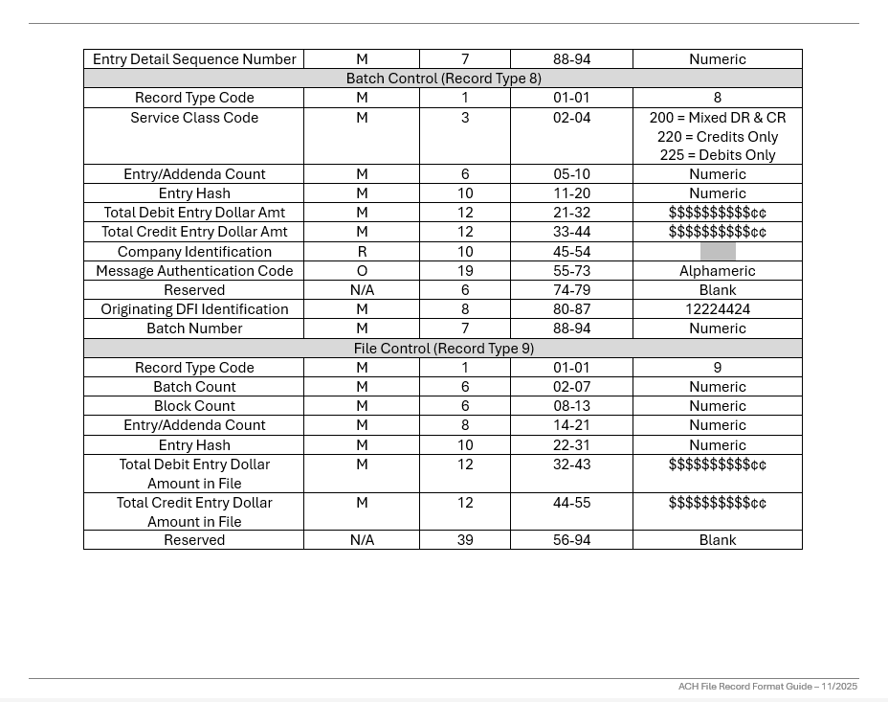

Invoice Series button added to AP Select Payments (FIN-22724)
Overview
New Invoice Series button added to AP Select Payments.
Modifications
A new Invoice Series button is added to Payment section of Select Payments program. When this button is clicked, a pop-up appears which allows inserting multiple invoice series code to filter vouchers associated with them. Only vouchers with invoice series code listed in this pop-up will be selected for payment.
Whenever Invoice Series pop-up contains one or more rows, existing single-value Invoice Series lookup field is disabled. Once all codes from pop-up are removed, single-value Invoice Series field returns to its normal enabled state.
When both Invoice Series pop-up and field are empty, no invoice series filter is applied and all invoices meeting other selection criteria are included.
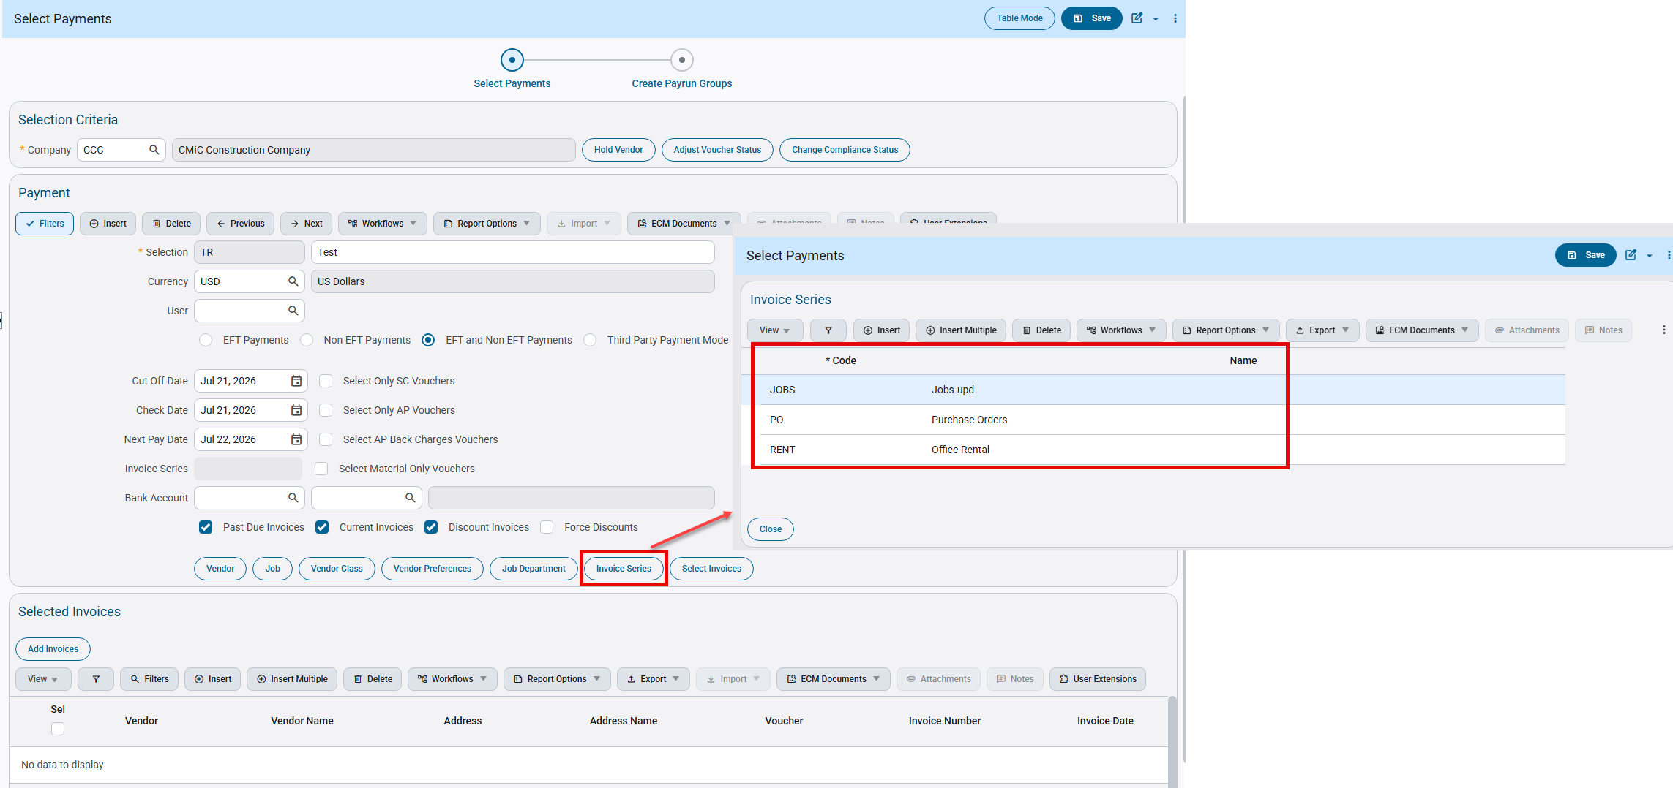
Accounts Payable > Payment > Select Payments

EFT File Format for Western Alliance Bank (FIN-20907)

Overview:
AP EFT file format for Western Alliance Bank is created.

Modifications:
New AP EFT file format ‘WESTALLBNK’ is created for Western Alliance Bank with the following changes

- Immediate Destination ('122105980' with a space before the number)
- Immediate Origin (Company Federal Tax ID from company setup)
- Immediate Destination Name ('WESTERN ALLIANCE BANK')
- Immediate Origin Name (Company Name)
- Service Class Code (200)
- Company Identification (Company Federal Tax ID from company setup)
- Standard Entry Class Code ('CCD')
- Company Entry Description ('PAYMENT')
- Effective Entry Date (Check Date)
- Originating DFI Identification ('12210598')
- Transaction Code (Always-22-Credit)
- Receiving DFI Identification (Bank Transit number from vendor setup)
- DFI Account Number (Bank Account number from vendor setup)
- Identification Number (Vendor Code)
- Receiving Company Name (Vendor name)
- Addenda Record Indicator ('0'-No addenda records)
- Transaction Code (Always - 27)
- Receiving DFI Identification (Cash Bank Transit number from bank account setup)
- DFI Account Number (Cash Bank Account number from bank account setup)
- Identification Number (Cash Company Code)
- Receiving Company Name (Cash Company name)
- Addenda Record Indicator ('0'-No addenda records)
- Service Class Code (200)
- Company Identification (Company Federal Tax ID from company setup)
- Originating DFI Identification ('12210598')

EFT Setup: 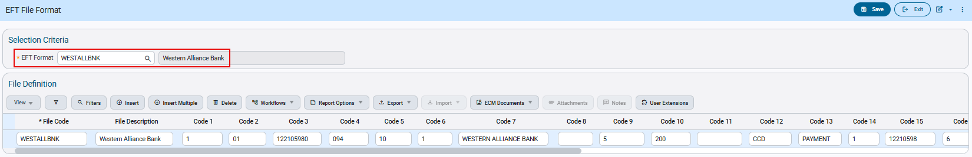AP > Setup > Global Tables > EFT Formats

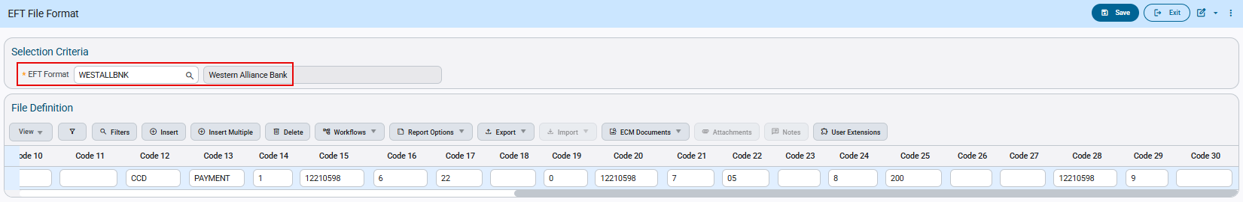
AP > Setup > Global Tables > EFT Formats

The following table outlines the required information for each column needed to complete EFT setup:

* File Code | WESTALLBNK
File Description | Western Alliance Bank
Code 1 | 1
Code 2 | 01
Code 3 | 122105980
Code 4 | 094
Code 5 | 10
Code 6 | 1
Code 7 | WESTERN ALLIANCE BANK
Code 8
Code 9 | 5
Code 10 | 200
Code 11
Code 12 | CCD
Code 13 | PAYMENT
Code 14 | 1
Code 15 | 12210598
Code 16 | 6
Code 17 | 22
Code 18
Code 19 | 0
Code 20 | 12210598
Code 21 | 7
Code 22 | 05
Code 23
Code 24 | 8
Code 25 | 200
Code 26
Code 27
Code 28 | 12210598
Code 29 | 9
Code 30

Check Printing:
The Check Printing program allows users to select the available EFT File Codes. Users can select the Code and Generate EFT Files as required.

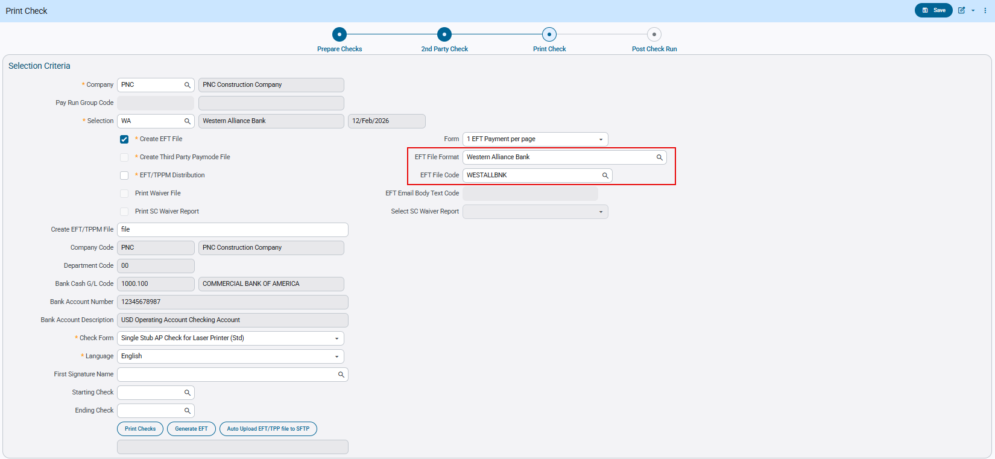

This is an example of the WESTALLBNK AP EFT file format:
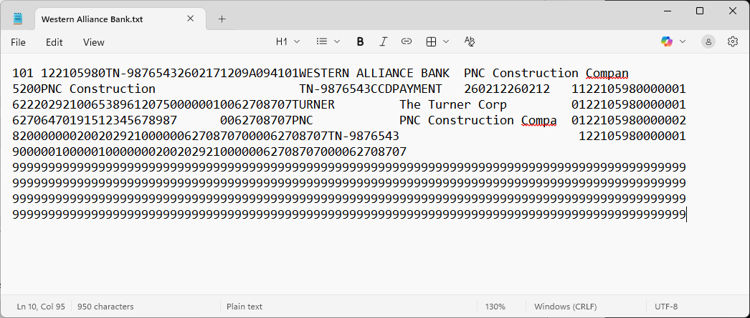

The above file generated follows the Format specifications:
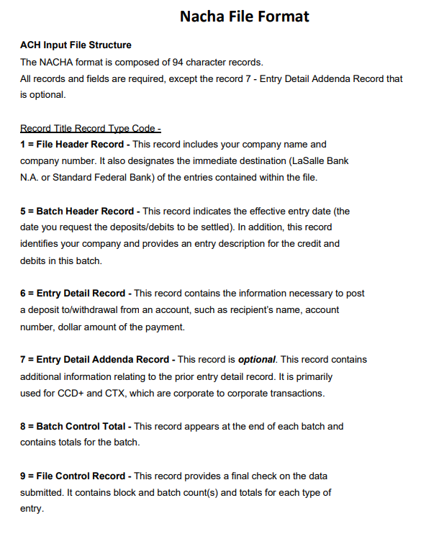
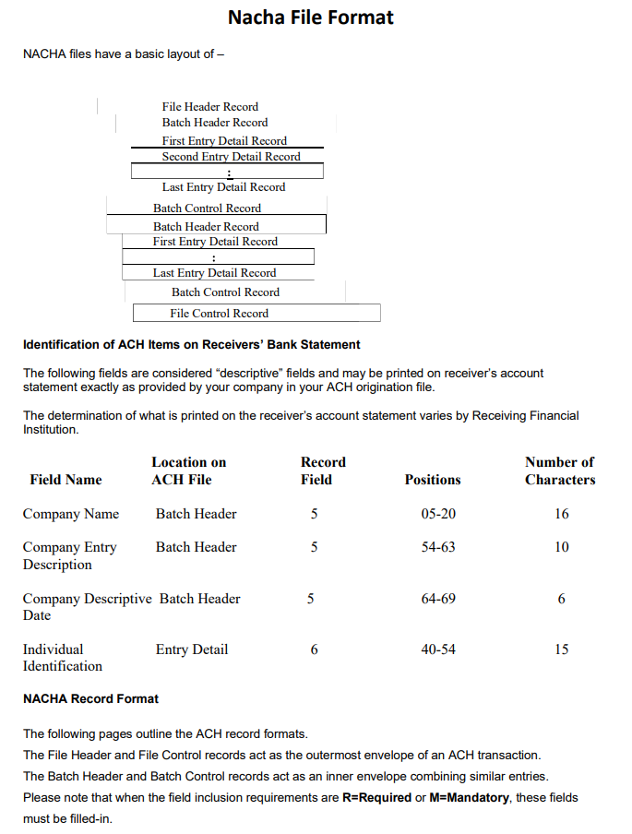
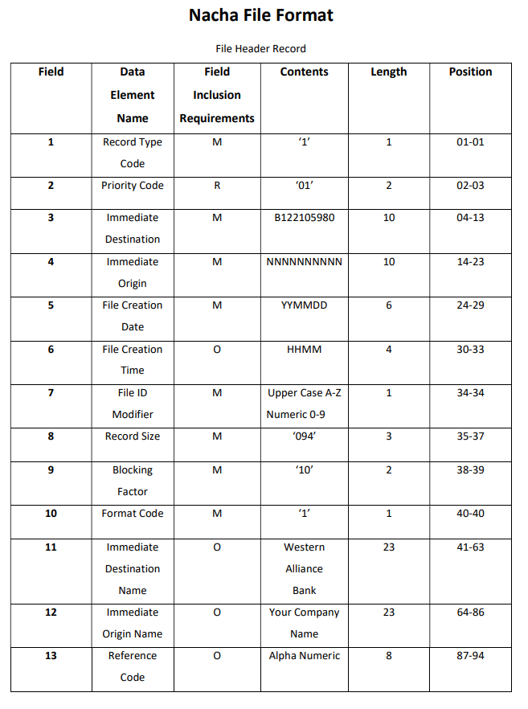
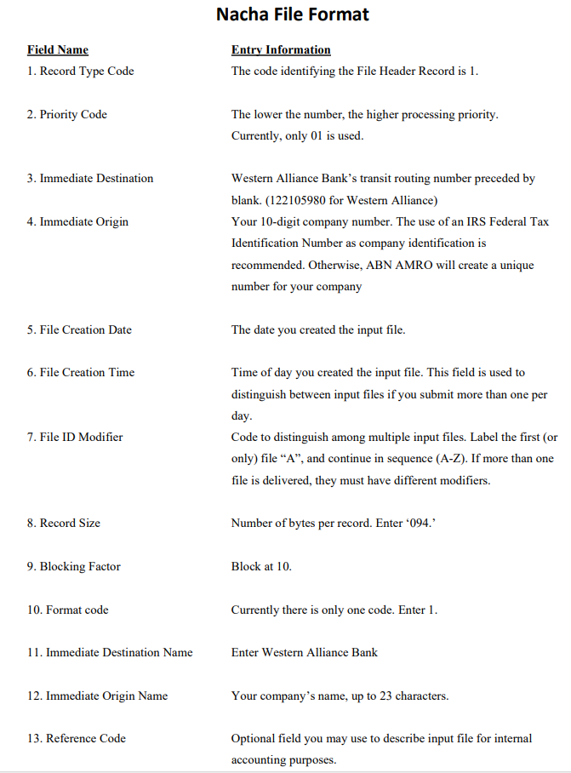
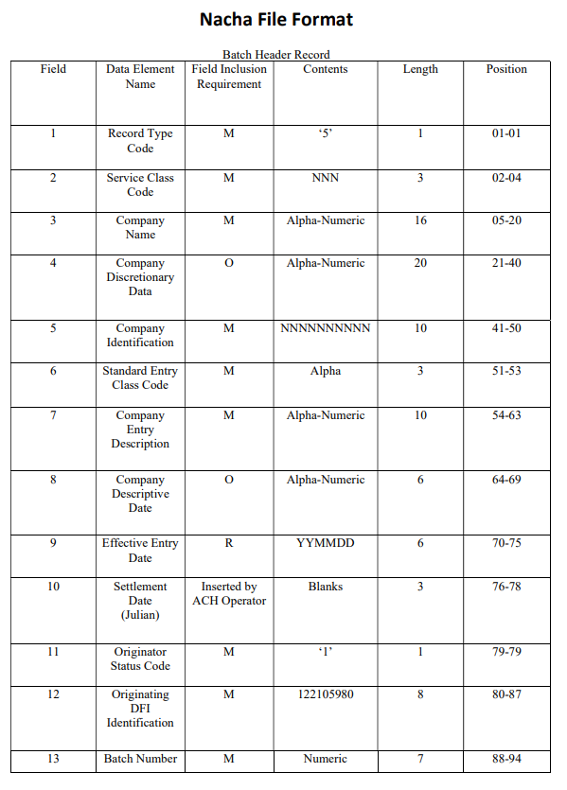
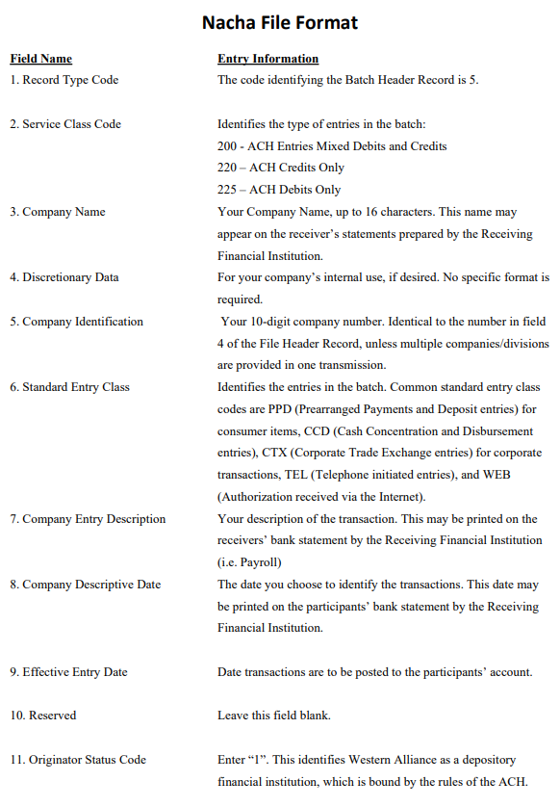
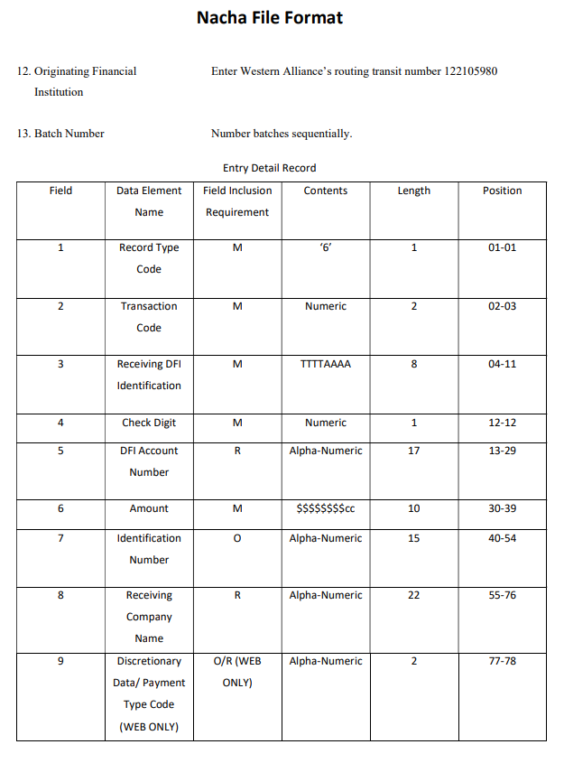
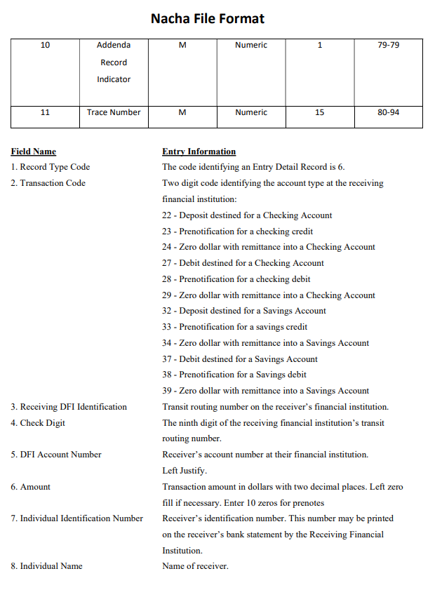
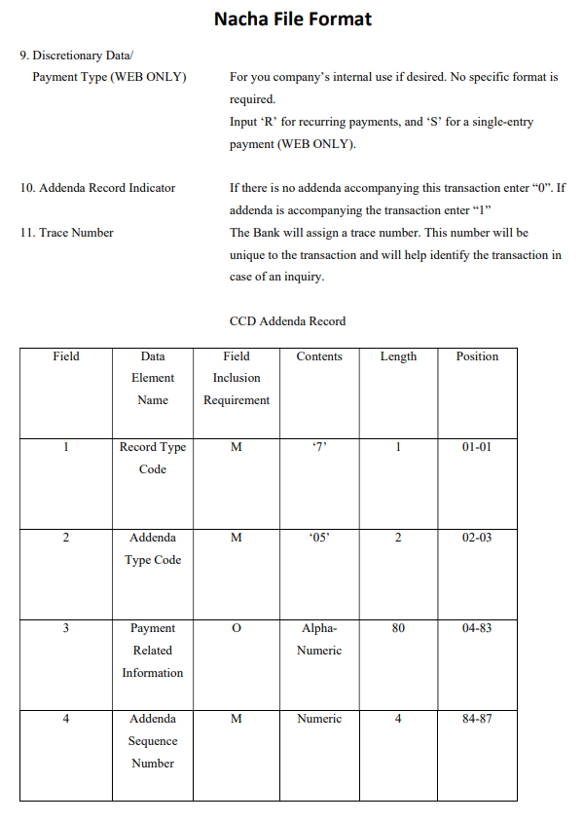
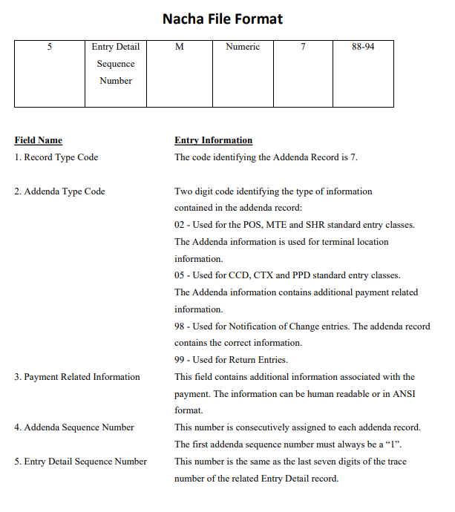
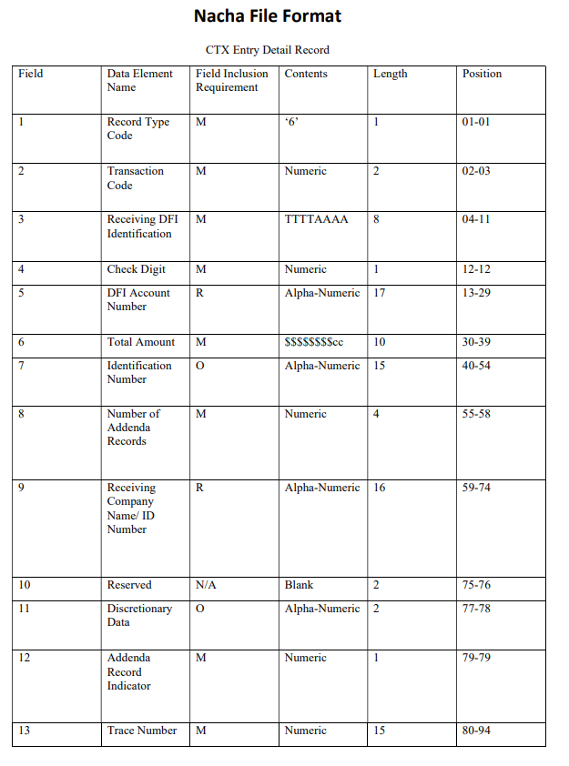
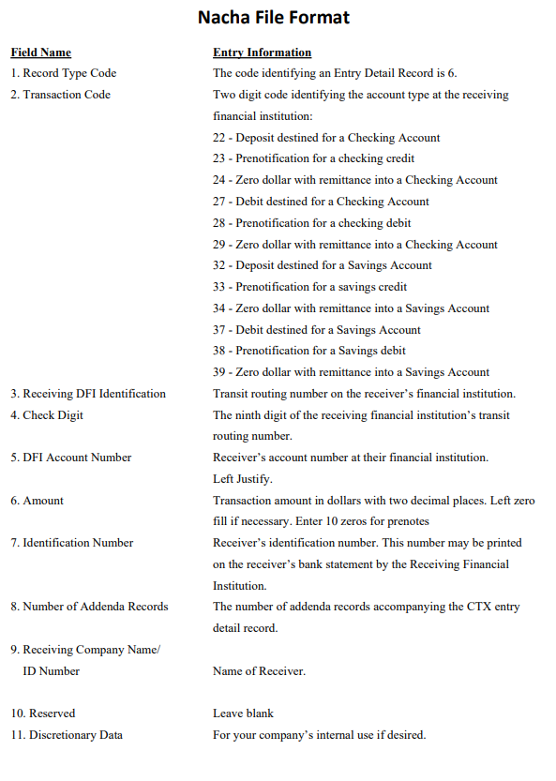
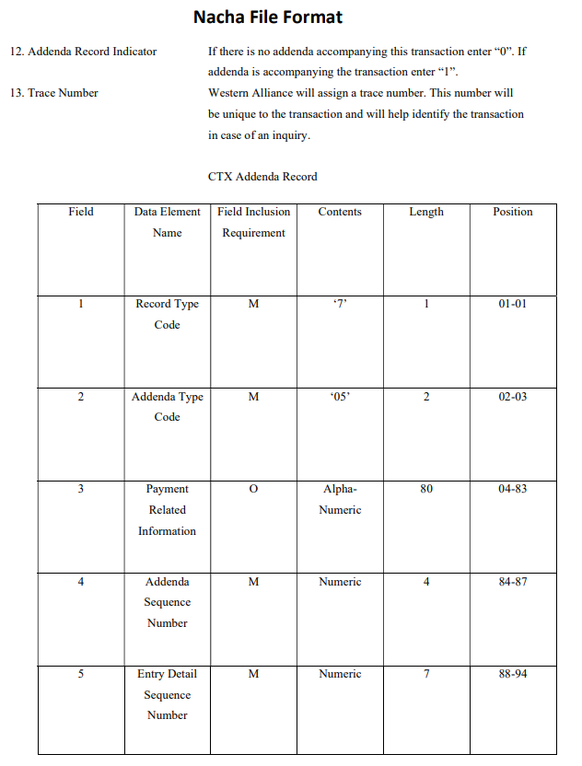
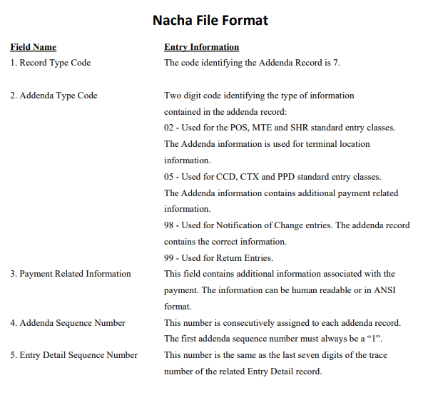
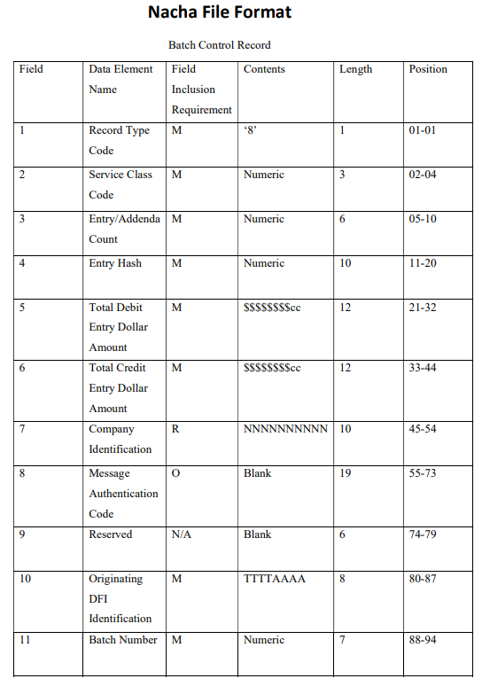
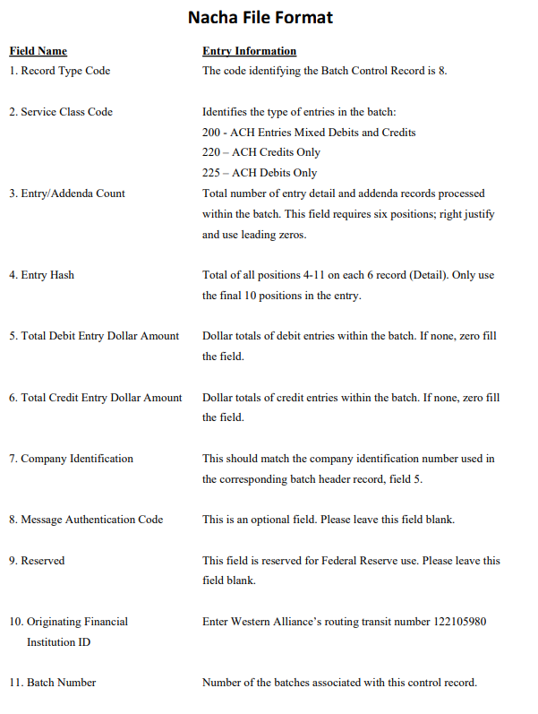
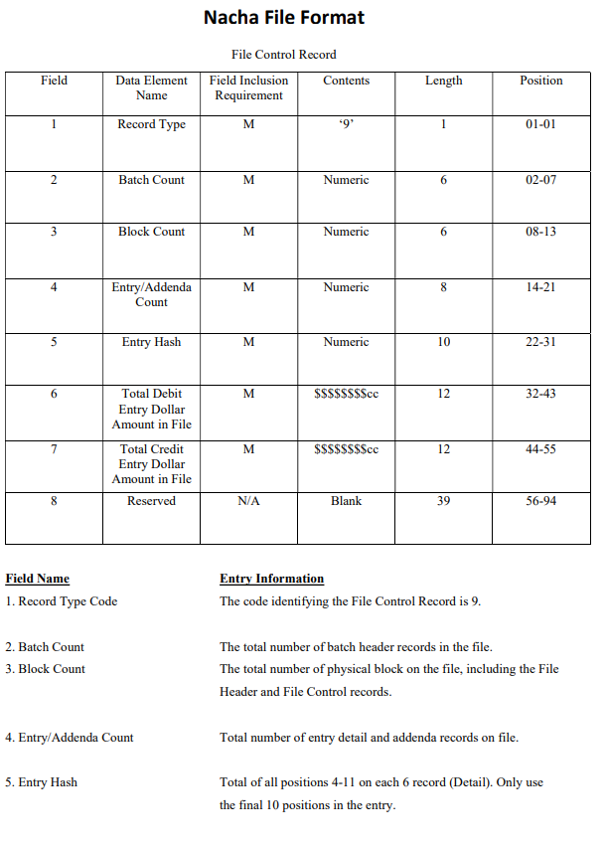
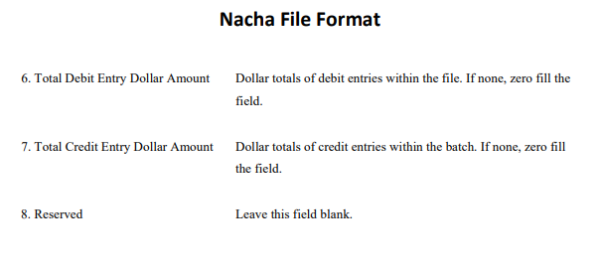

Updated TPP Format for Wells Fargo 2 (FIN-22763)
Overview:
The third party payment format for Wells Fargo 2 has been updated to remove special characters from the voucher description field..

Modifications:
CMiC has updated the TPP file format for Paymode Wells Fargo 2.
The following fields mapping and values are used in the file format.
CMIC has modified the Wells Fargo 2 third party payment file format to remove the special
characters from the voucher description field, where only these characters will be allowed ‘A-Z a-z 0-9 _ -‘.
This has been implemented in R12 (ADF) only.

Implementation:
Voucher example with description field containing special characters:

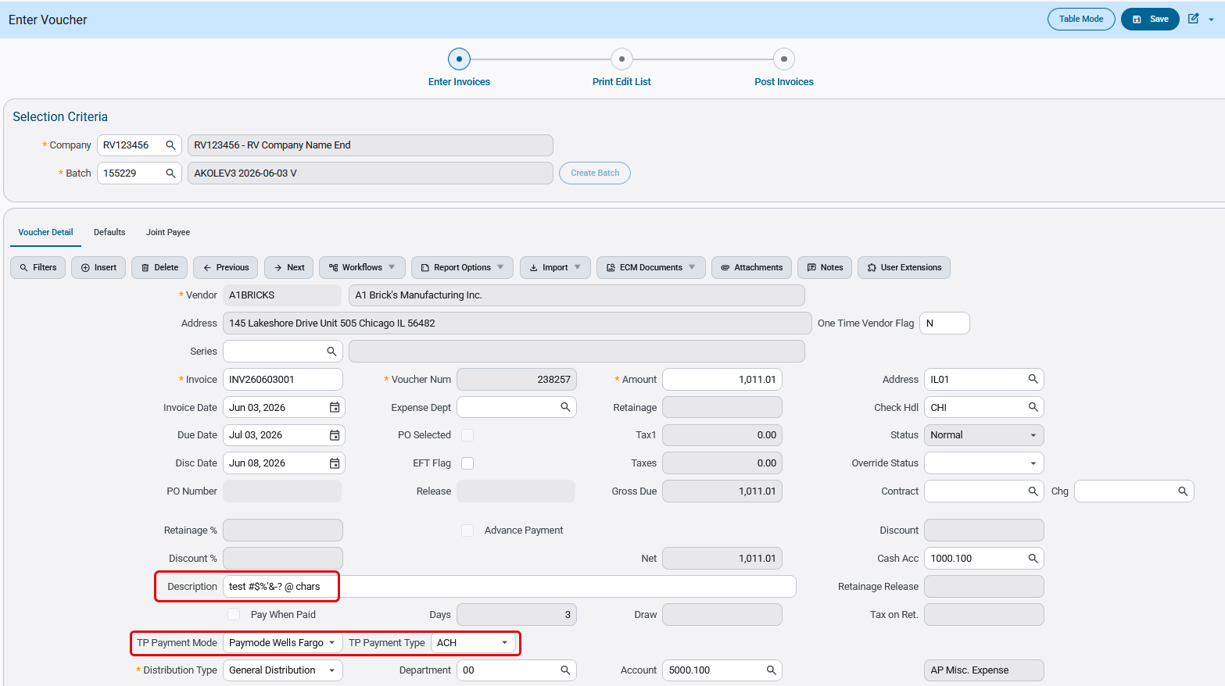

The generated file is shown below:
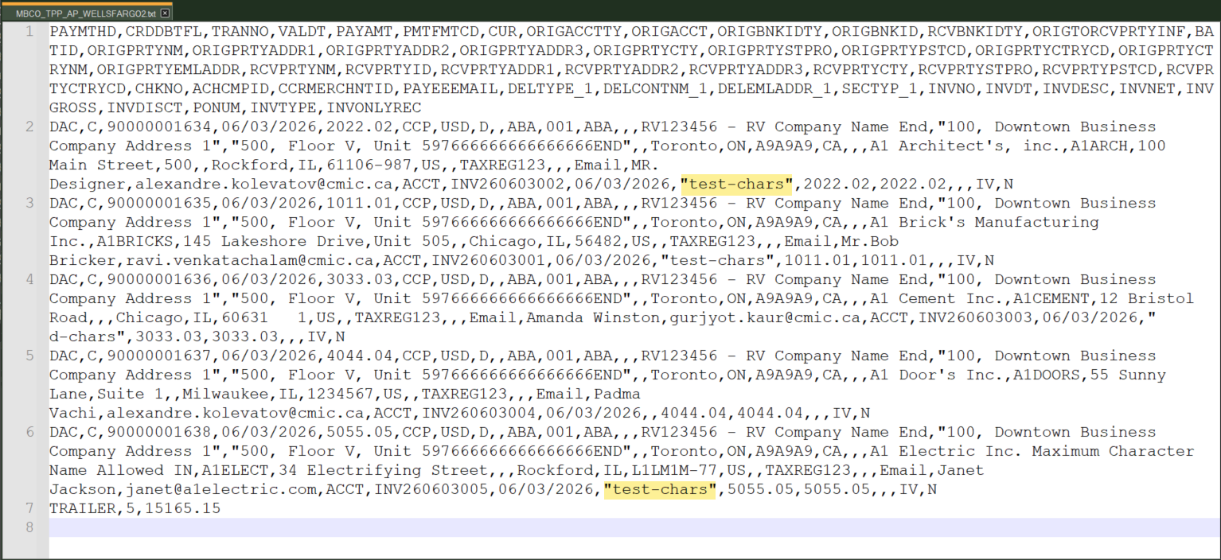

New AP EFT File Format for PNC BANK (FIN-21897)
Overview
A new AP EFT file format ‘PNCBANK4’ has been created for PNC Bank.
Prerequisites
N/A
Modifications
This uses an existing AP EFT format "CITIBANK" with the following changes only.
The constant value "2" will be printed on record (1, 5 and 8) for the field Company ID.
Implementation

The following screen shows the EFT file codes setup for PNCBANK4:

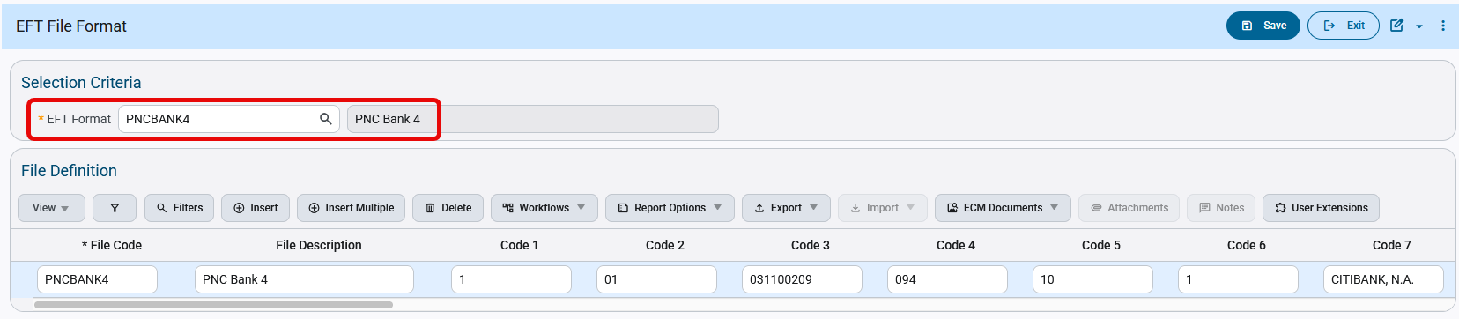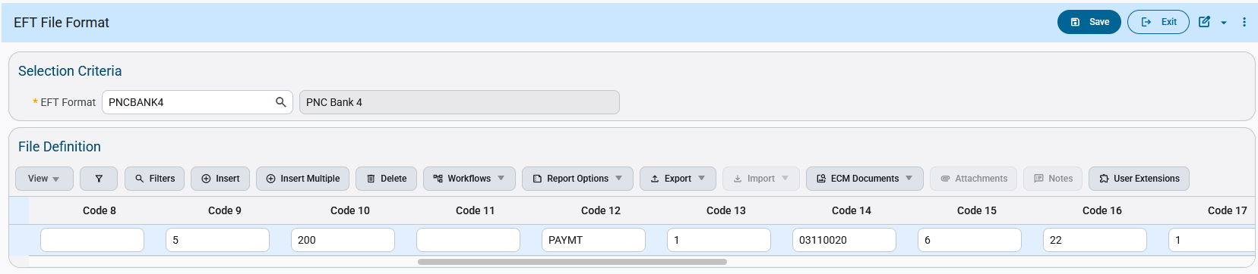
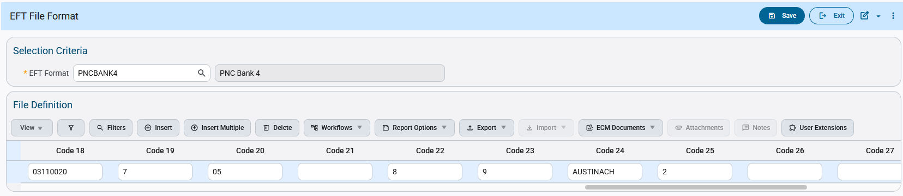

The Check Printing program allows users to select the available EFT file codes. Users can select the code and generate EFT files as required.
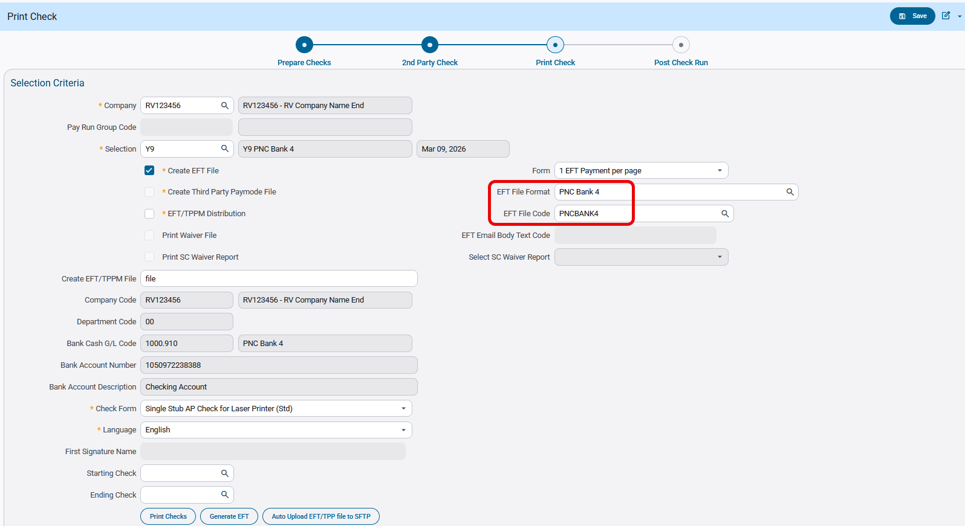

The following is the EFT file is generated:
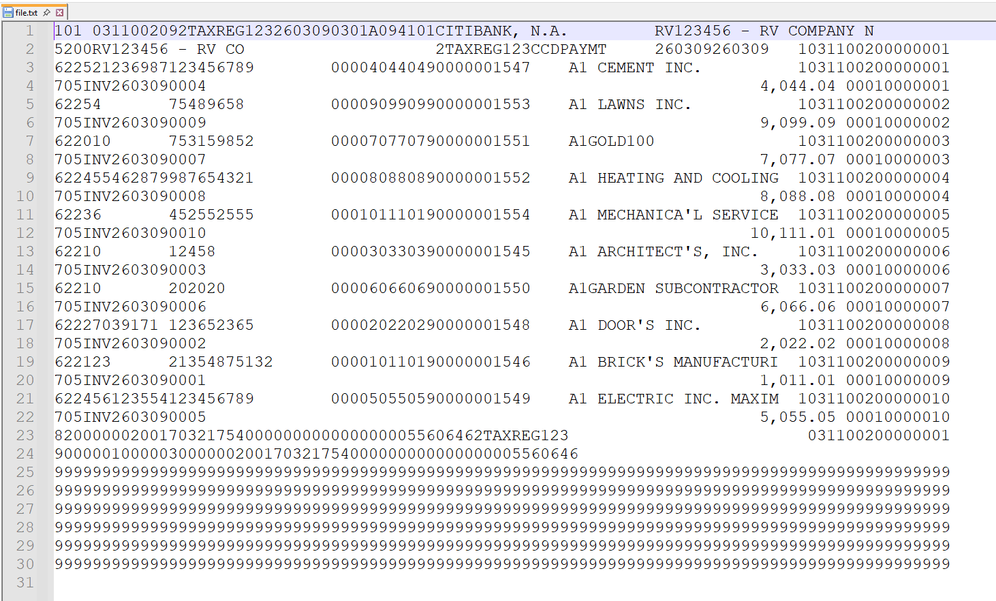

This corresponds with the modifications requested:
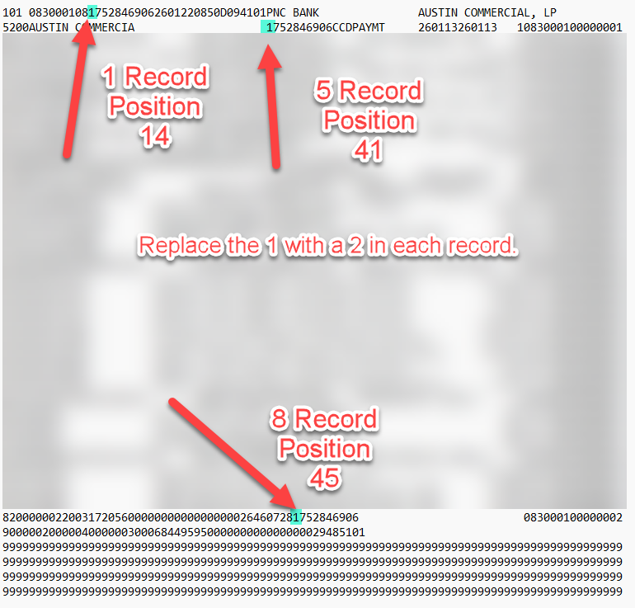

New AP EFT File Format for Burke & Herbert Bank (FIN-22520)
Overview
A new AP EFT file format ‘BURKEHERB' has been created for Burke & Herbert Bank.
Prerequisites
N/A
Modifications
A new EFT file BURKEHERB has been added for use.
CMIC has created a new AP EFT file format for BURKE & HERBERT BANK.
The following fields mapping and values are used in the file format.
File Header Record ( 1 )
Immediate Destination ( BURKE & HERBERT Bank routing number - APEFT setup - " 056001066"( Note: first position is blank ) )
Immediate Origin ( 10 digits ACH Company Federal Tax ID from company setup )
Immediate Destination Name ( "BURKE & HERBERT BANK" )
Batch Header Record ( 5 )
Service Class Code ( 200 )
Company Identification ( 10 digits ACH Company Federal Tax ID from company setup )
Standard Entry Class Code ( CCD )
Company Entry Description ( PAYMENT )
Effective Entry Date ( Check date )
Originating DFI ( BURKE & HERBERT Bank routing number 8 digits - APEFT setup - "05600106" )
Entry Detail Record ( 6 )
Transaction Code ( Always - 22 )
Receiving DFI Identification ( Bank Transit number from vendor setup )
DFI Account Number ( Bank Account number from vendor setup )
Individual Identification ( Vendor Code )
Receiving Company Name ( Vendor name )
Addenda Record Indicator ( 0 - No Addenda records )
Batch Header Trailer ( 8 )
Service Class Code ( 200 )
Company Identification ( 10 digits ACH Company Federal Tax ID from company setup )
Originating DFI ( BURKE & HERBERT Bank routing number 8 digits - APEFT setup - "05600106" )
This has been implemented in R12(ADF) only.
Implementation

EFT file format setup:

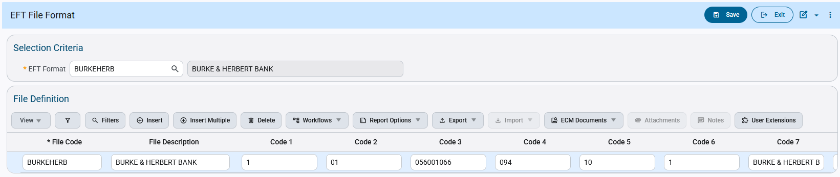
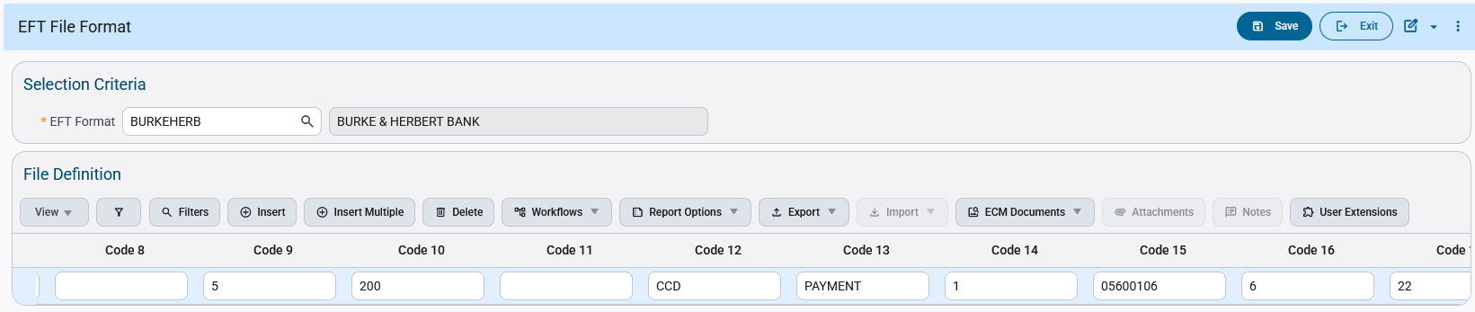
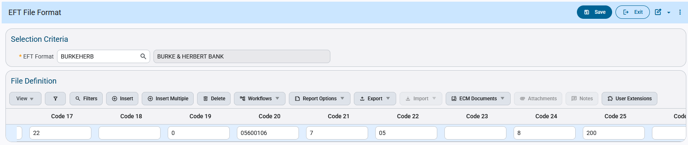
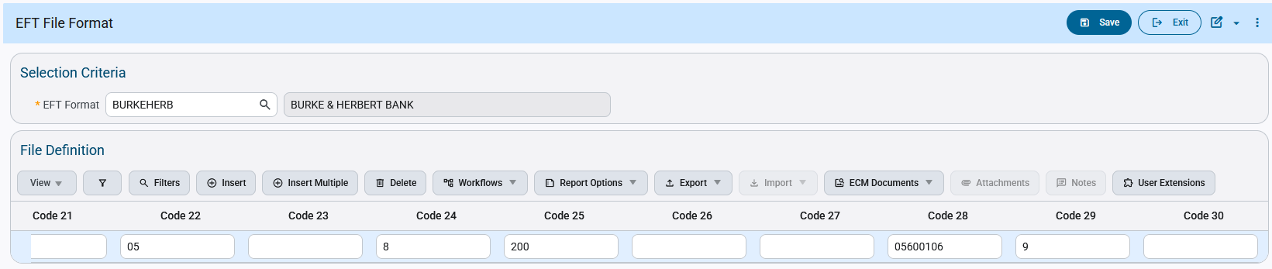

Creating a check payment selection under the Burke & Herbert EFT code:
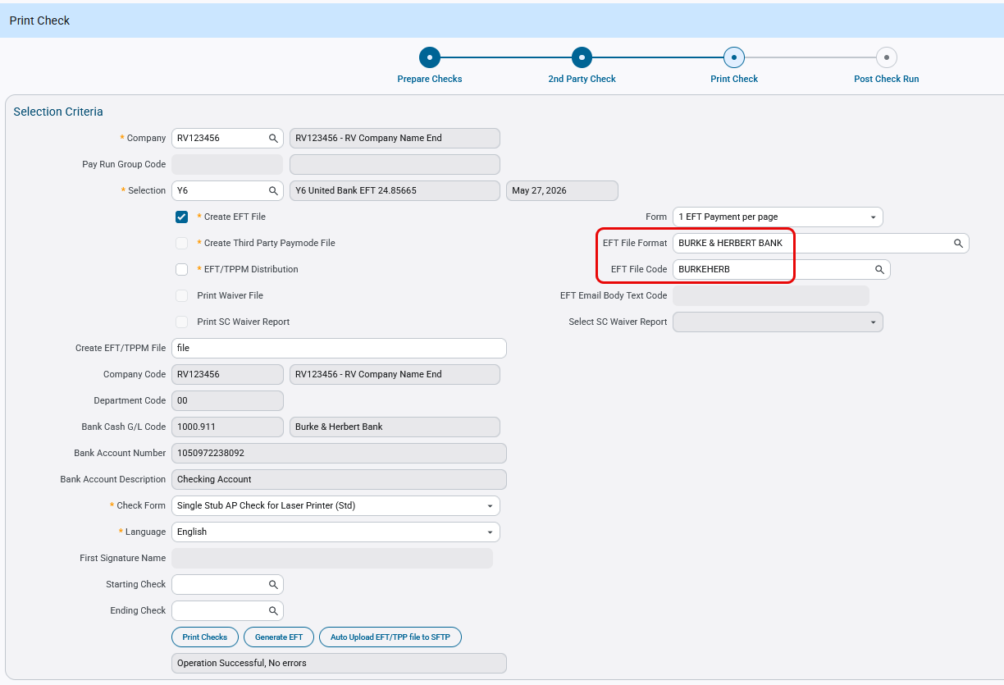

The generated EFT file is shown below:

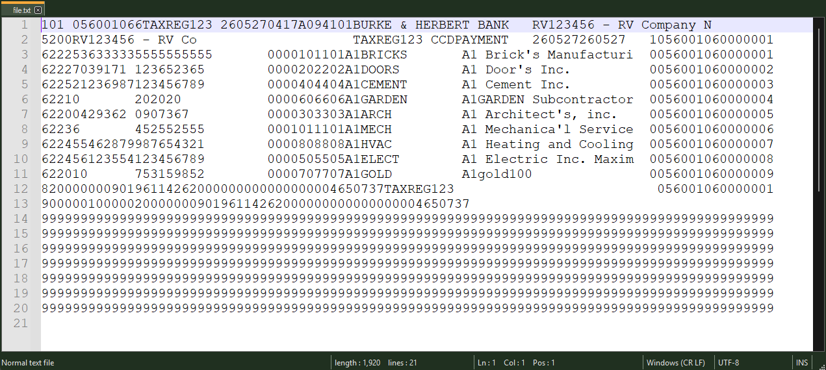

The file lines up with the following Burke & Herbert NACHA specs document.

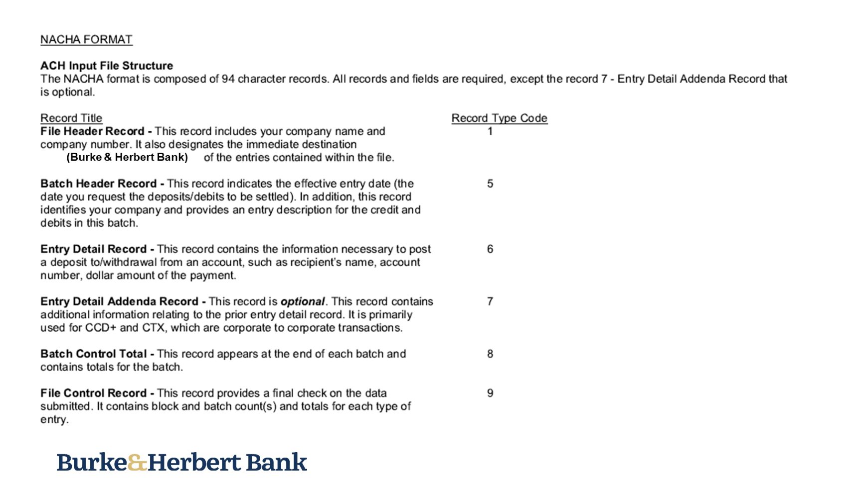
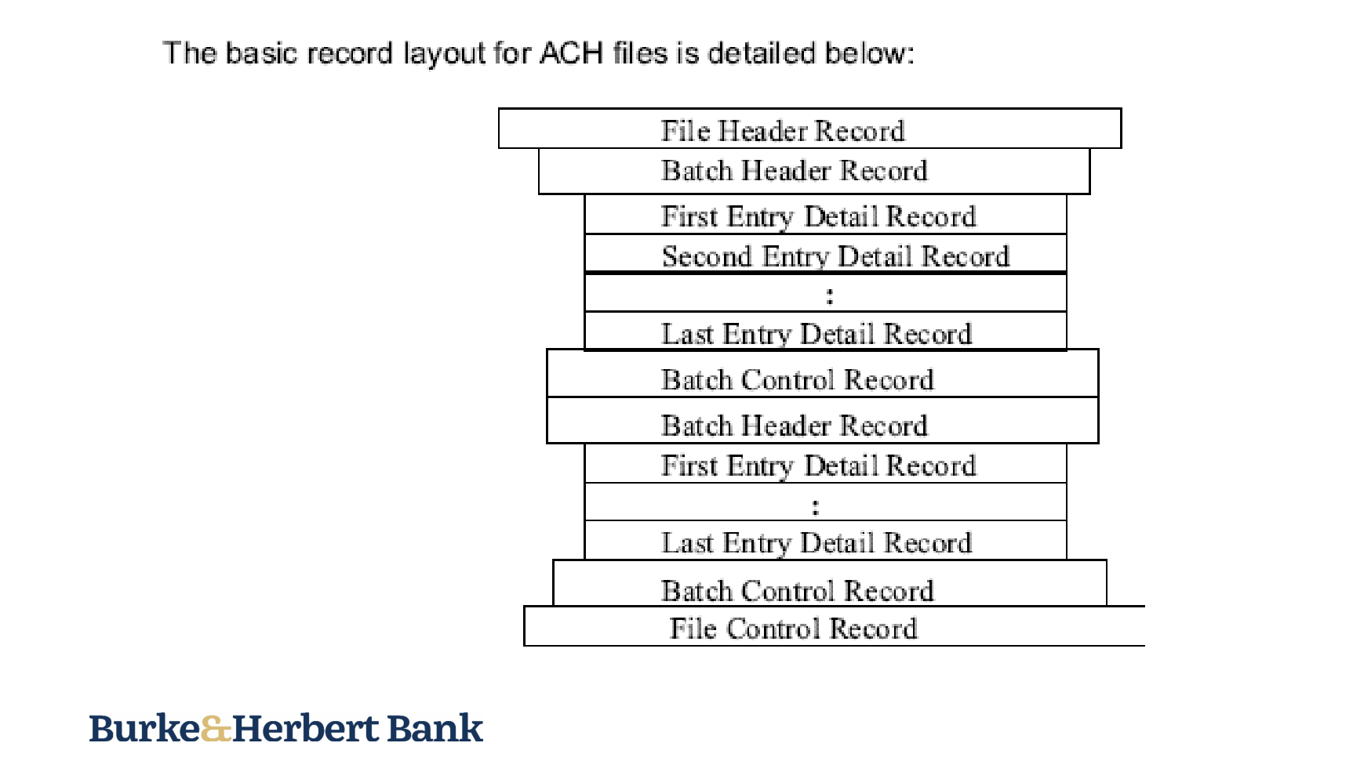
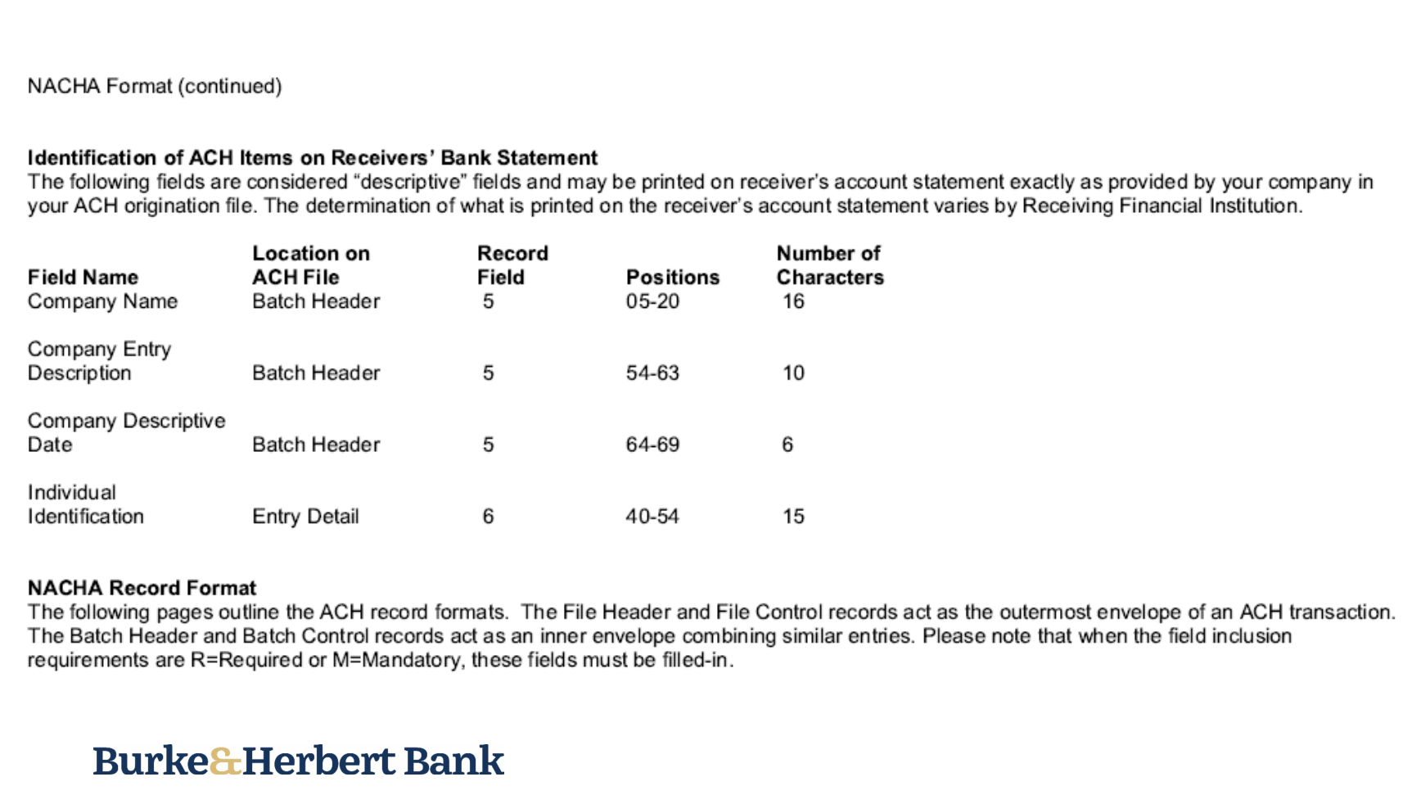
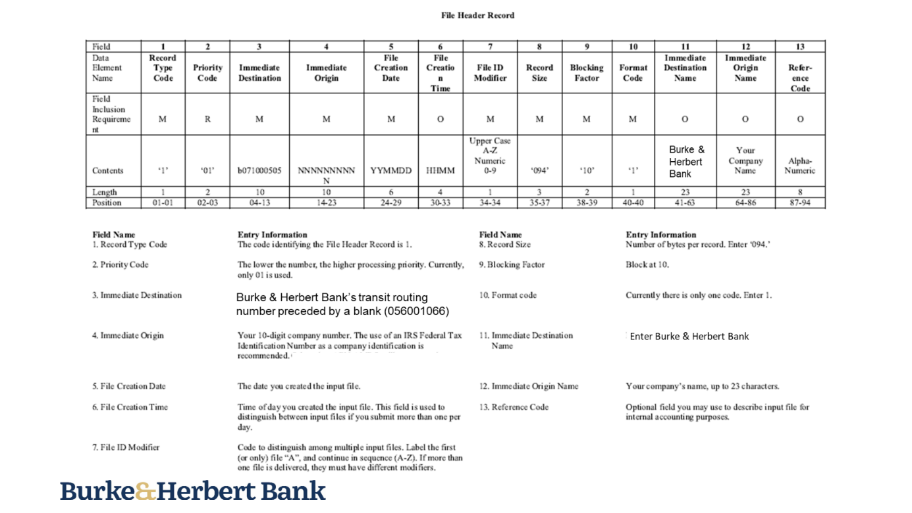
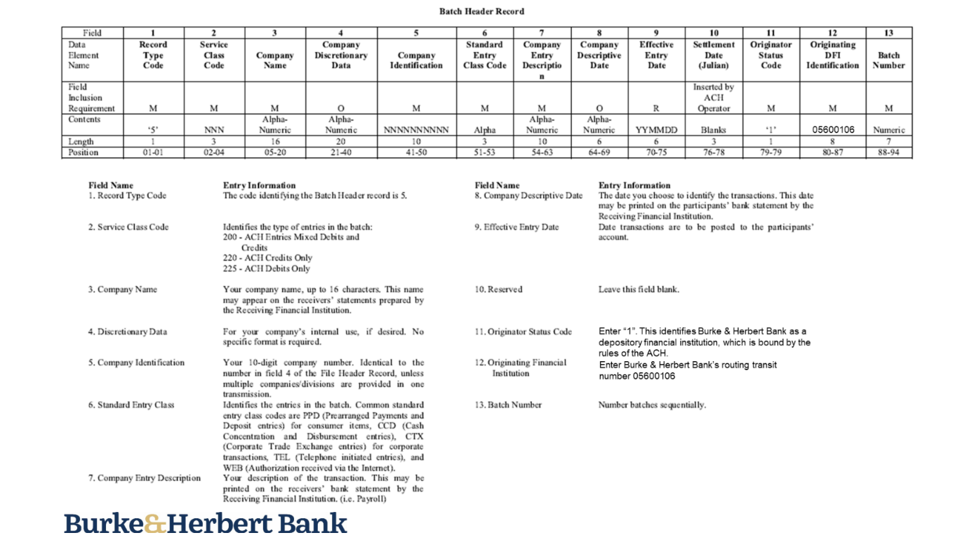
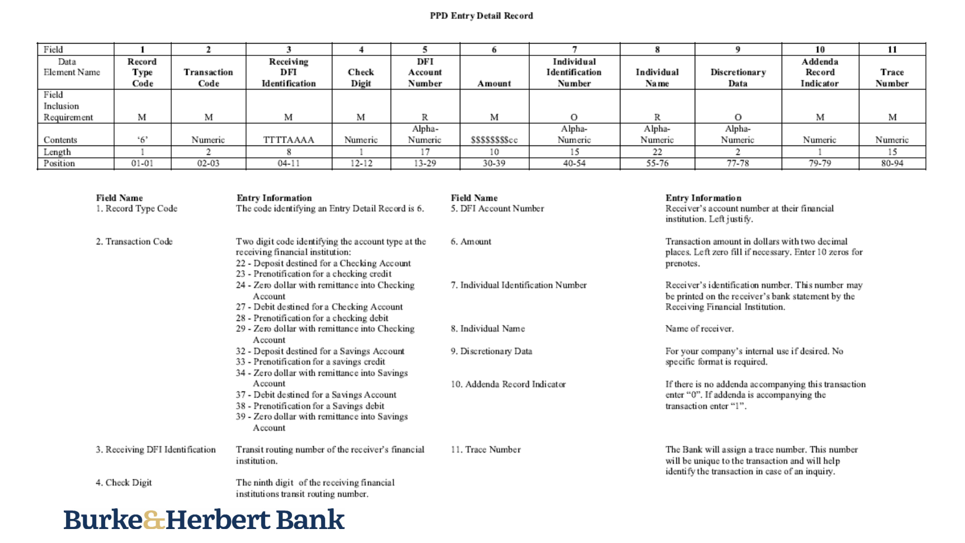
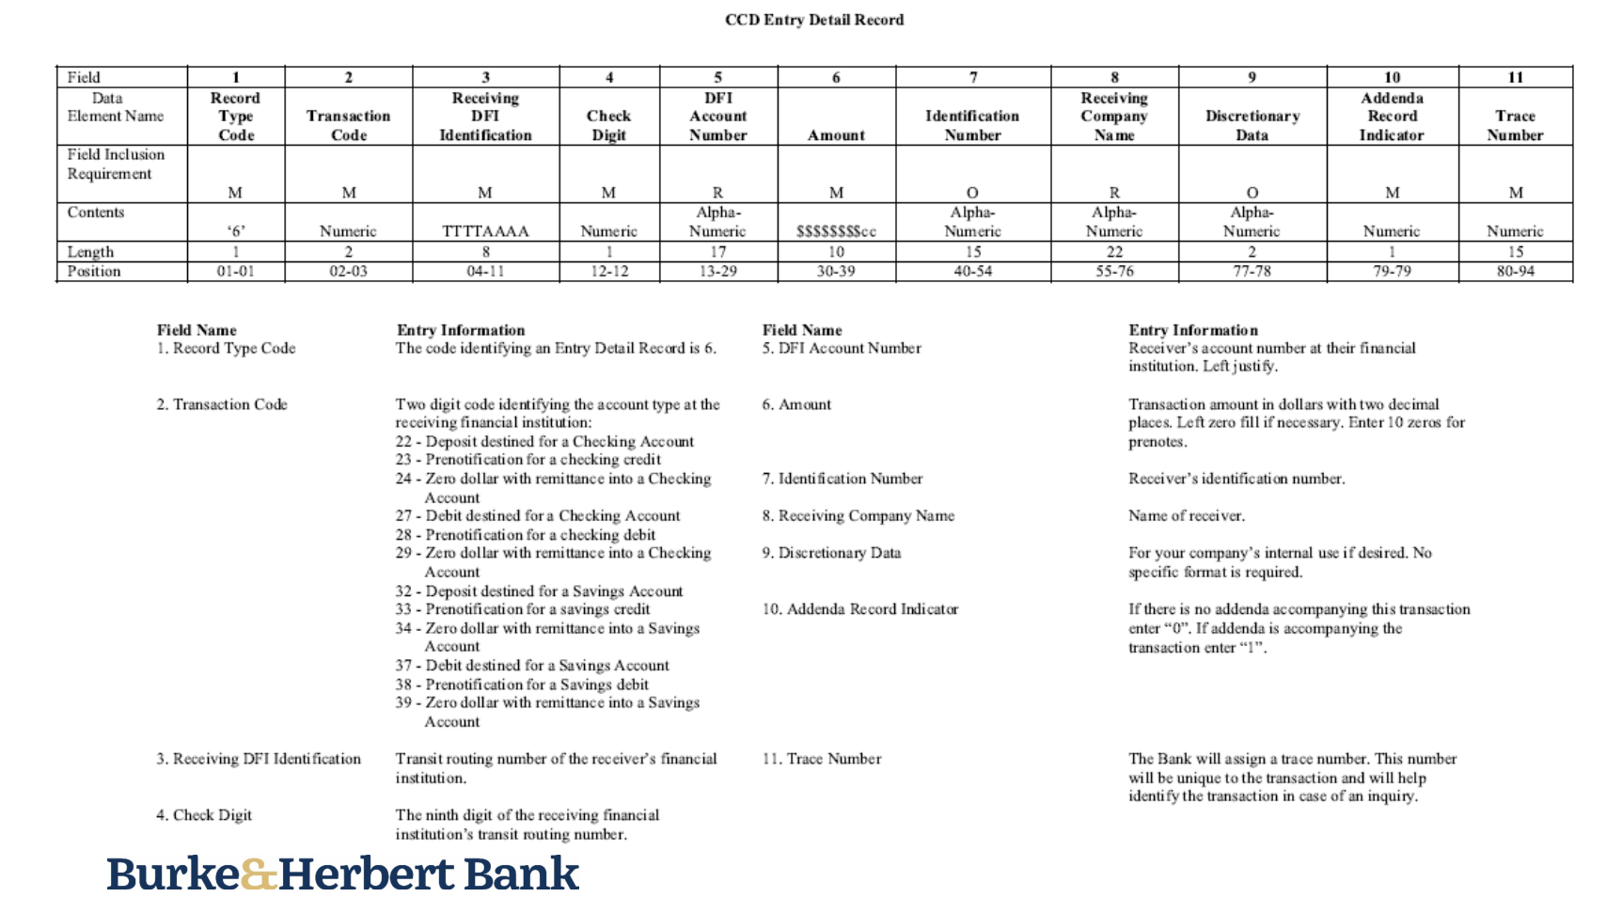
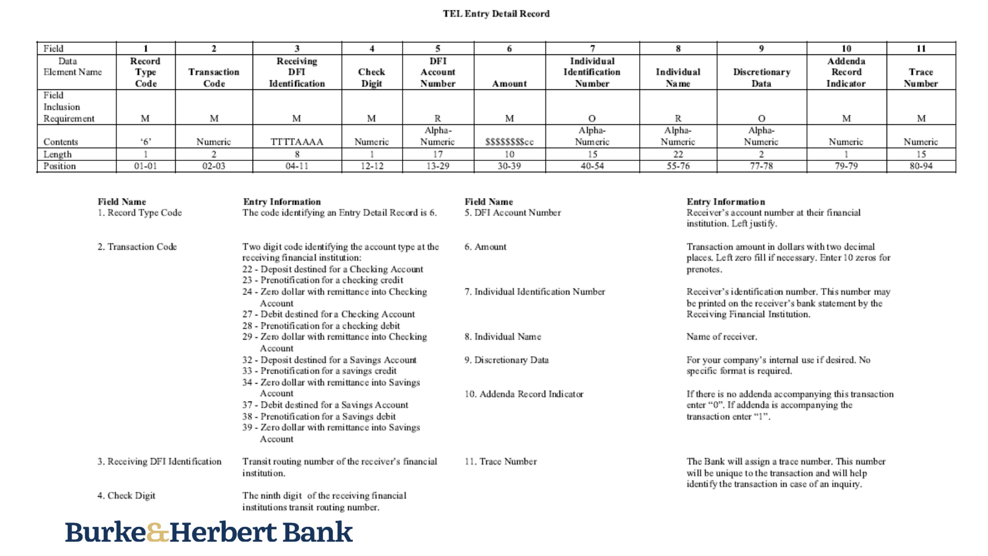
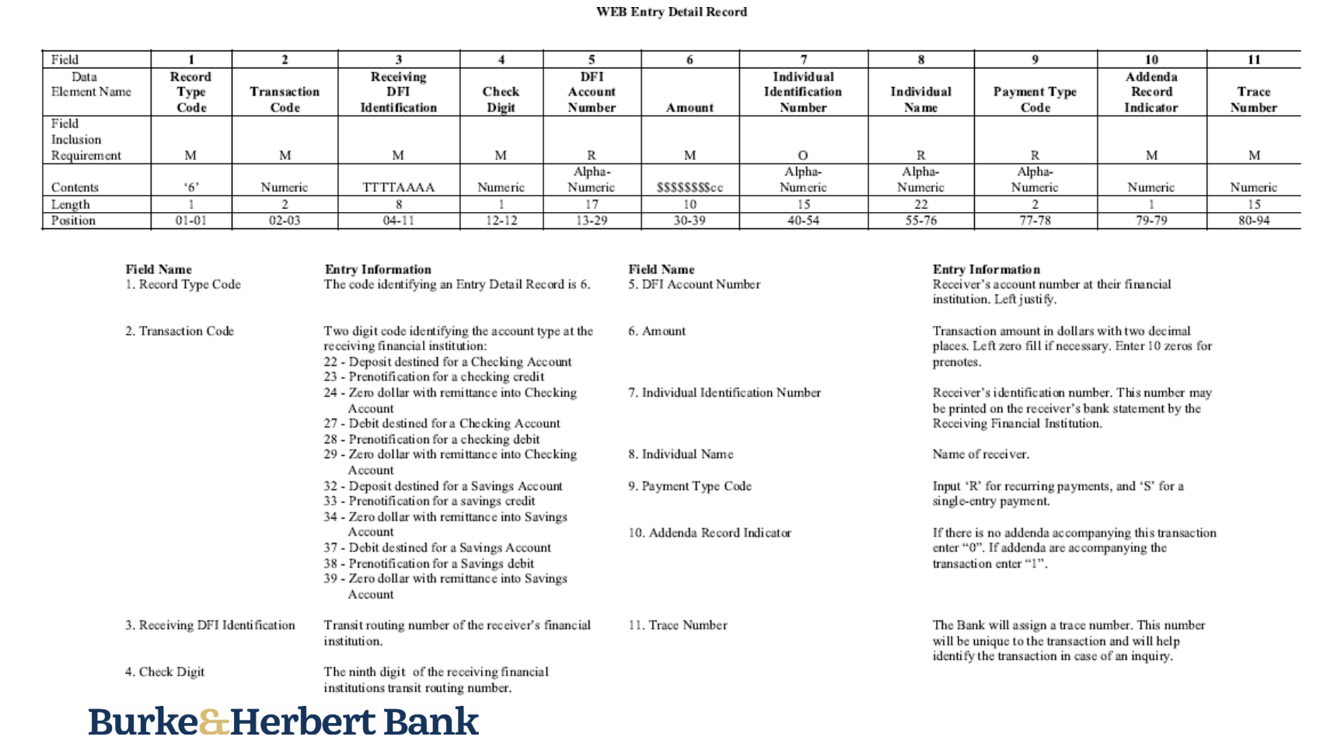
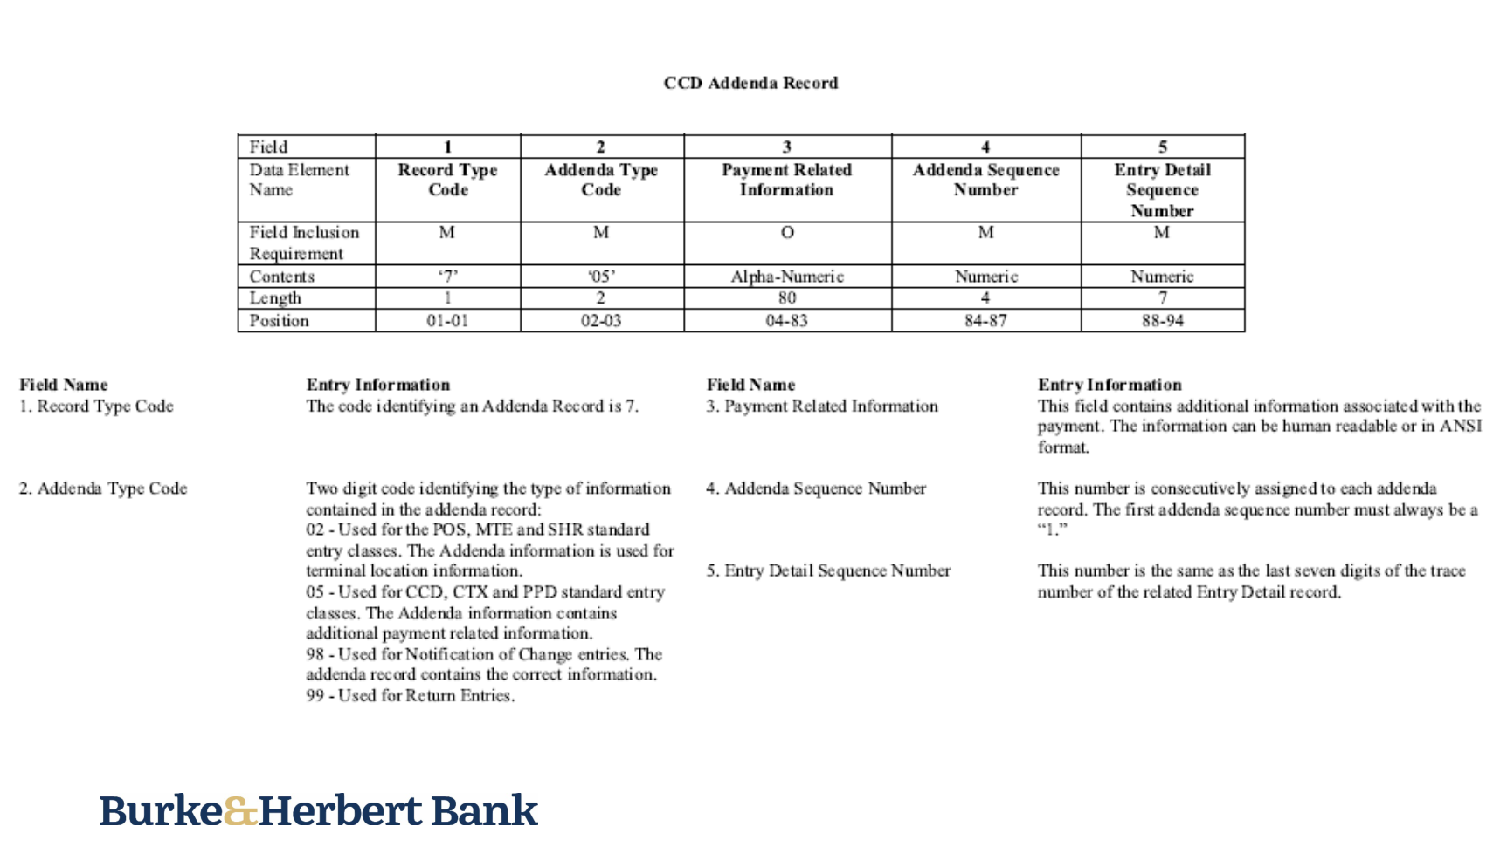
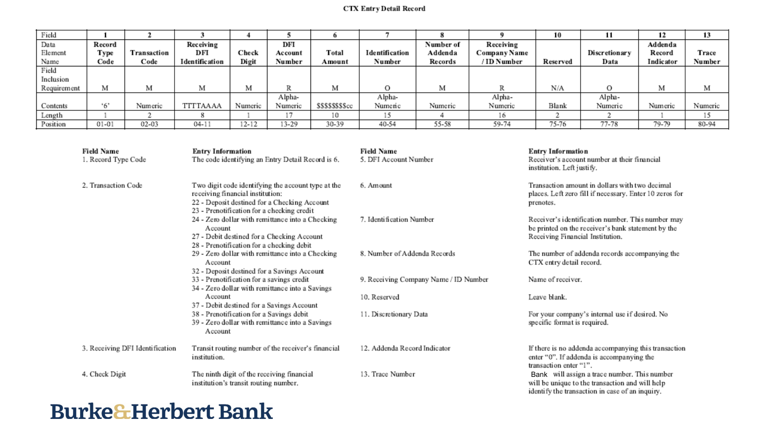
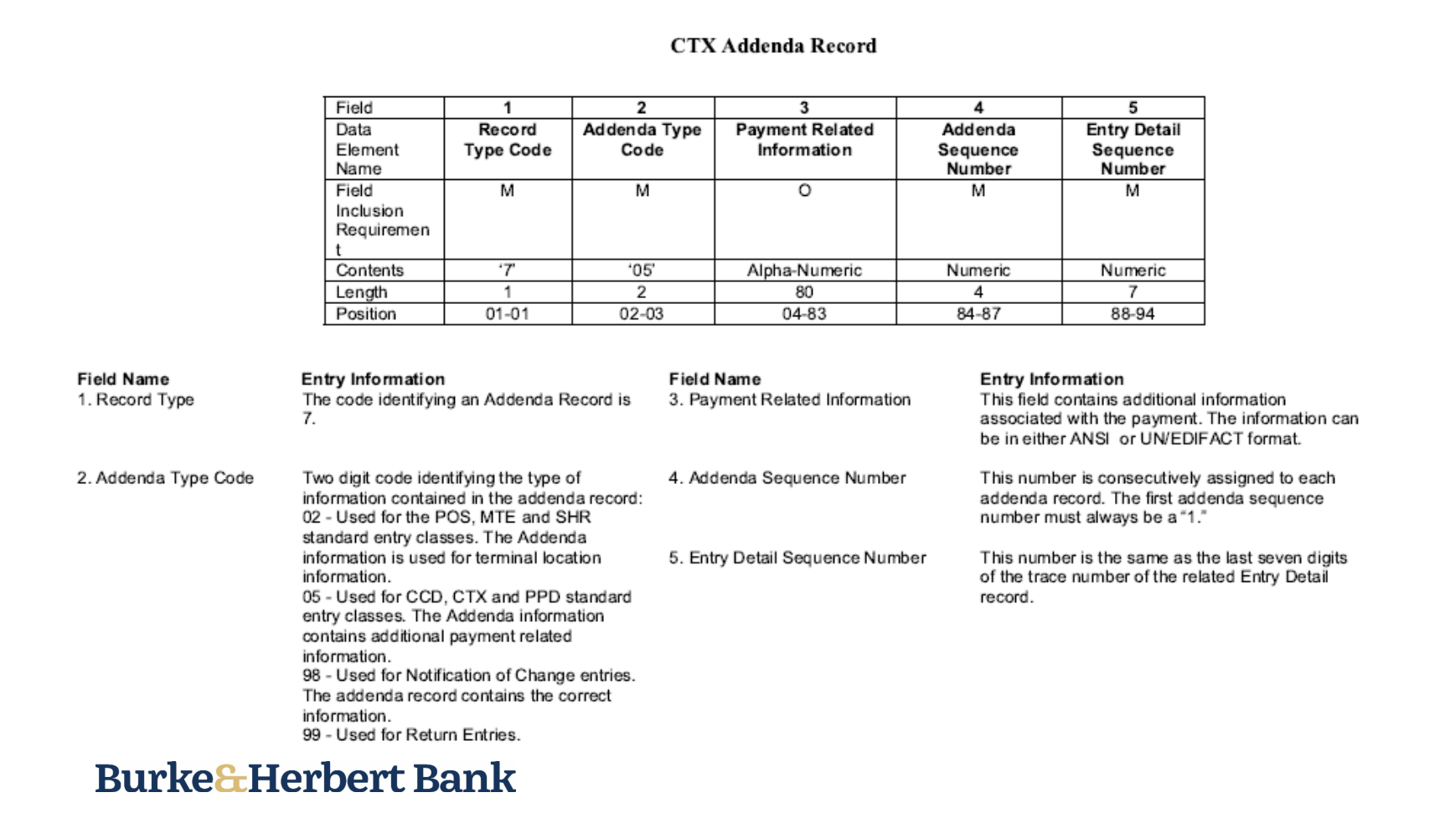
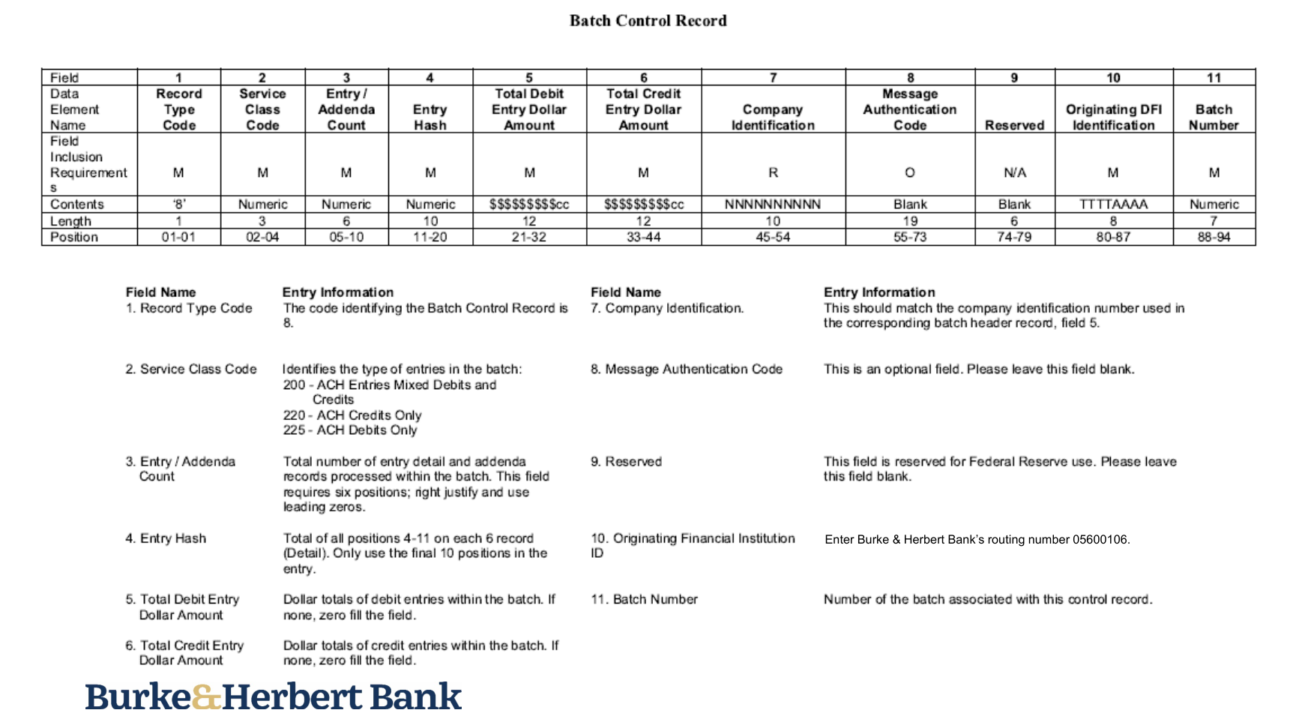
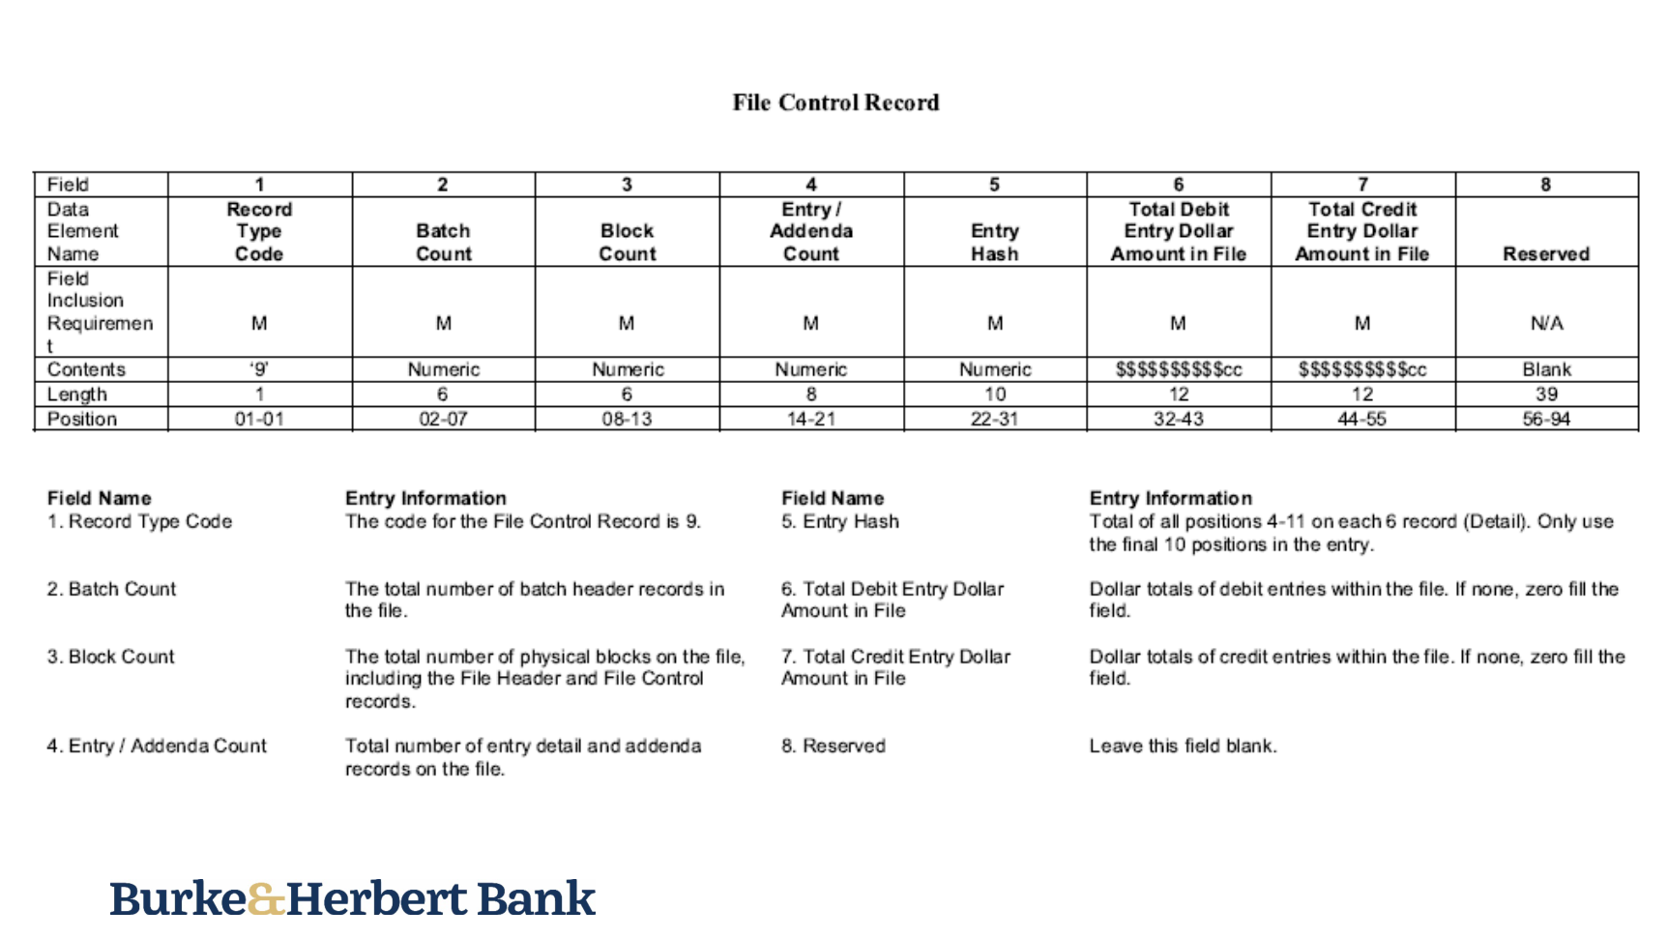

New AP EFT File Format for First Security Bank (FIN-22555)
Overview
A new AP EFT file format ‘FIRSTSECBK’ has been created for First Security Bank.

Implementation

The following screen shows the EFT file codes setup for FIRSTSECBK:

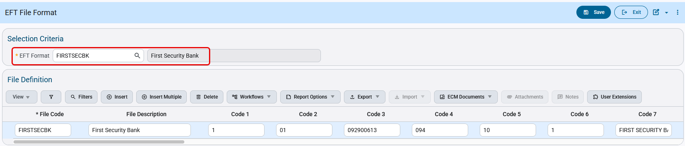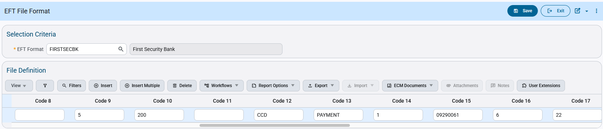
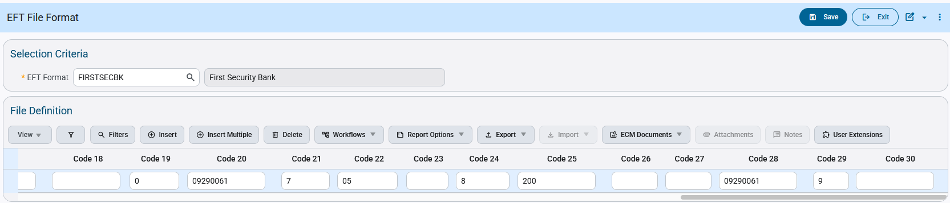

The Check Printing program allows users to select the available EFT file codes. Users can select the code and generate EFT files as required.

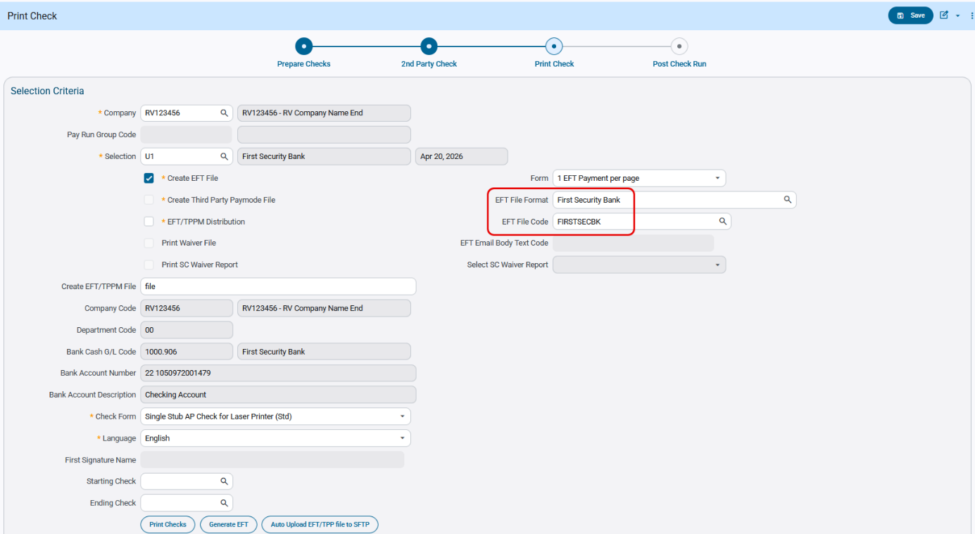

The following is the EFT file as generated:
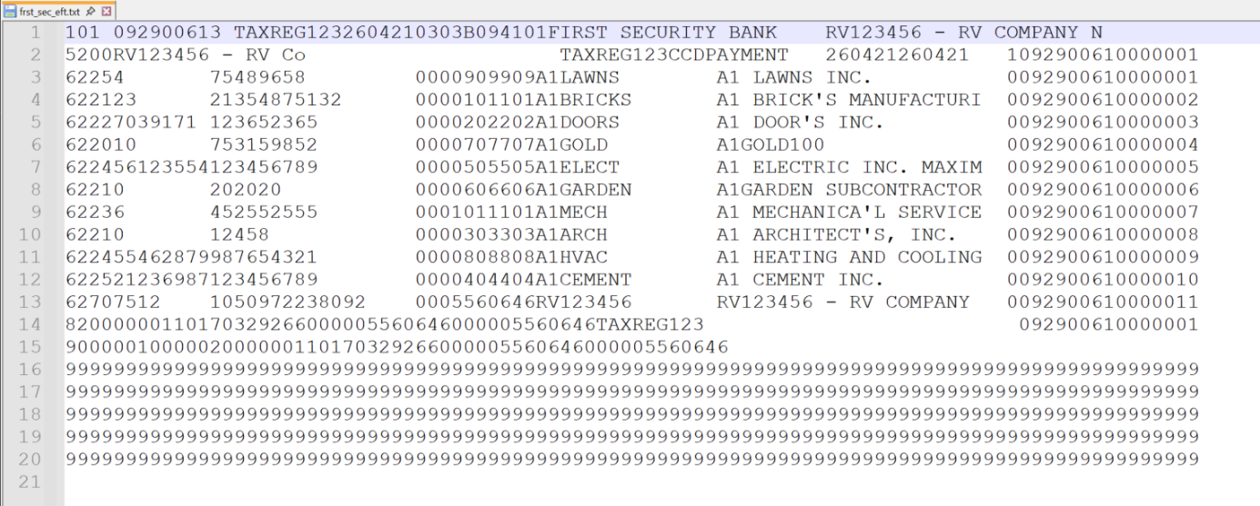

Bank Reconciliation File format for First Pacific Bank (FIN-21940)
Overview
Bank Reconciliation file format “FIRSTPACBK” for First Pacific Bank.
Modifications

A new Bank Reconciliation format “FIRSTPACBK” has been added as per specification format shared by client.
Following field mapping will be used in the file format :
- Account Number : Check reconciliation Account Number
- Post Date : Check reconciliation Date ( MM/DD/YYYY )
- Check : Check reconciliation Check Number
- Debit : Check reconciliation Amount
Note : Only "CHECK" type transactions will be used for reconciliation.

Implementation

Bank Setup :
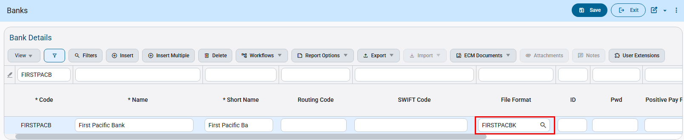
System Data > Global Tables > Banking > Banks
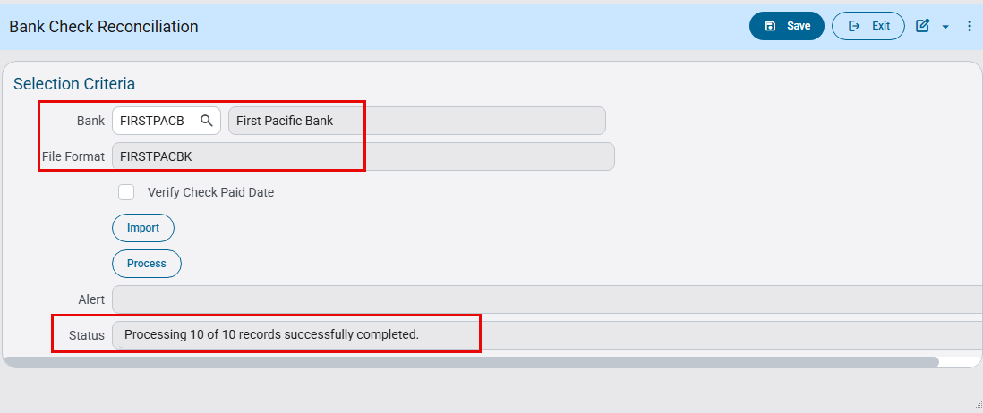
General Ledger > Utilities > Bank Reconciliation > Import pop-up

Following is the reconciliation file according to specifications:
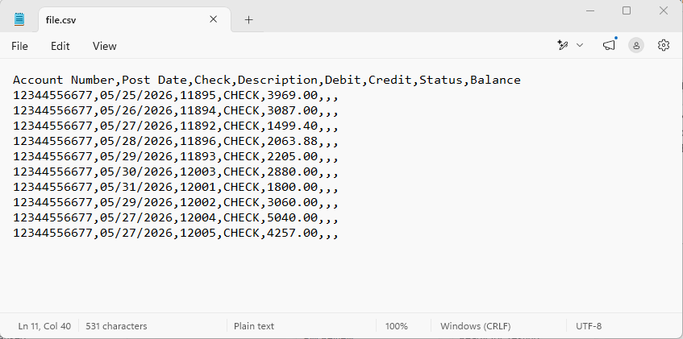

AI Agents

Assets AI Agents

Create Inventory Locations (CAM-12299)
Version 2 of this agent introduces significant enhancements:
The Create Inventory Locations assistant is used to create, update, and manage inventory locations in the CMiC Inventory (CI) module.
An inventory location is either a physical location where inventory items are stored or a tracking location used to allocate items that are stored elsewhere.
There are two types of inventory locations:
- Warehouse (W) – A physical or primary inventory location.
- Bin (B) – A sub-location that must be assigned to a controlling location. The controlling location must be a Warehouse.
In addition to creating inventory locations, it can now update an existing location's Name, and Department. It also allows you to reference departments by name and other locations (such as a controlling location) by description, instead of by code.

Create Non-Stock Item (CAM-12301)
Version 2 of this agent introduces significant enhancements:
The Create Non-Stock Items assistant is used to create non-stock items in the CMiC Purchase Order (PO) module through conversation or by importing a file.
A non-stock item is an item that is purchased or expensed directly without being tracked as inventory.
The assistant supports creating items individually through conversation, or in bulk by importing a file of item details. Supported import file types now include Excel, CSV, PDF, and image files — previously, importing a PDF would fail because all files were routed through the same Excel/CSV reader, regardless of type.
In addition to the import fix, the assistant now lets you refer to certain fields by name instead of by code, resolving them automatically:
- Account / Internal Sales Account — enter the account name and the assistant will look up the corresponding code.
- Cost Code — enter the cost code name and the assistant will resolve it.
- Category — enter the category name and the assistant will resolve it.
WM Code and Tax Code do not support name lookups; these must still be entered by their code

Create Purchase Orders Agent (CAM-12300)
Version 2 of this agent introduces significant enhancements:
The Purchase Order Entry assistant is used to create purchase orders in the CMiC Purchase Order (PO) module through conversation, including by reading an uploaded Excel, .CSV, PDF, .docx, invoice, or receipt to populate the order automatically.
The assistant now recognizes names instead of requiring exact codes across every major field on a purchase order, resolving each to the correct code automatically:
- Vendor — enter a vendor name (e.g., "Acme") and the assistant resolves it to the vendor code, auto-filling the associated terms and currency.
- Item, Job, Cost Code, Category, Department, Account, Equipment, Tran Code, and Item Location — each can now be entered by name and will be resolved to its code.
- Buyer and Approver — can be entered by full name; if more than one record matches, the assistant will ask which one you meant.
Reading an attached document is now the assistant's first action when a file is provided, rather than something it does only if asked.

Create Requisitions (CAM-11992)
Version 2 of this agent introduces significant enhancements:
The Requisition assistant is used to create a purchase requisition in the CMiC PO module through conversation, with one or more detail lines, and can optionally set up to 3 approver levels afterward.
Previously, the assistant required users to provide exact codes for every field on a requisition, such as item code, job code, cost code, category, department, account, equipment, component, and buyer/approver. This meant users had to look up or memorize system codes before they could interact with the assistant, and it wasn't well suited to natural, conversational (or eventually voice) input.
The assistant now recognizes names, descriptions, or partial matches for these fields, using fuzzy matching to find the right code:
- Matching by name or description — e.g., saying "Scotiabank Arena" resolves to the matching job code, and "copper pipe" can match an item named "copper piping."
This applies across all requisition header and detail-line fields, including Item Code, Item Type, Unit of Measure, Company, Job, Cost Code/Category, Department, Account, Equipment, Component, Transaction Code, Buyer, and Approver.

Create Users (CAM-12254)
Version 2 of this agent introduces significant enhancements:
The User Maintenance assistant is used to create new users and assign Permission Templates through conversation, in the CMiC Construct UAC module. When creating a user, it collects UserID, Login User, the Name, Email Address, and Permissions Template, and can optionally assign the user as a Project Contact on one or more projects. It can also assign a new Permission Template to an existing user.
Previously, the assistant required exact codes for the Internal Company, External Partner, Permission Template, and default Project fields, rather than accepting the names a user would naturally use for them.
The assistant now resolves each of these fields by name:
- Internal Company — enter the company name and the assistant resolves it to the company code.
- External Partner — enter the partner/vendor name and the assistant resolves it to the vendor code.
- Permission Template — enter the template name and the assistant matches it, also determining whether it's an Internal or External template and which company it belongs to.
- Default Project — enter the project name (instead of typing the project company and project code) and the assistant resolves it to the correct project.
If a name matches more than one record, the assistant presents a numbered list showing both the name and code for each option, and asks which one was meant. If nothing matches, it asks the user to try again rather than guessing.

Financials AI Agents

General Ledger (GL)

Close GL Periods (FIN- 23800)
Version 2 adds the following capabilities to the Close GL Periods agent:
- Refer to a company by name instead of code, with the agent asking which one was meant if more than one matches
- Multi-company period summary showing the current year and period for all accessible companies
- Drill into the individual transaction lines for an unposted batch
- Sequential multi-period close — close several consecutive periods in one operation (i.e. "close through period N")
- Clearer department prompt — if a department preliminary closure has not been run, the agent asks for confirmation before proceeding

Maintain Consolidations (FIN-23777)
Version 2 adds the following capabilities on top of the original Maintain Consolidations agent:
- Search and View Consolidations
- Update a consolidation code
- Update a component
- Bulk update of consolidation codes and components

Maintain GL Accounts (FIN-23776)
Version 2 adds the following capabilities on top of the original Create GL Accounts agent:
- Update an existing GL account: using only a chart code and account code a user can now update the name, account type, control code, and group codes
- Update multiple GL accounts at once: if any record fails, the whole batch is rolled back and nothing is modified
- Confirmation on every update: the agent checks that the account exists and displays the before and after values
- Reworked batch import for account creation, with a better workflow that maps your file's columns before submitting

Maintain GL Transactions (FIN-23798)
Version 2 of GL Transactions agent now covers the full journal entry lifecycle instead of just entry. You can search existing transactions and detail lines (by batch, journal code, company, account, or user), update unposted headers and lines with a confirmation step before saving, and post batches directly from the chat. File imports now follow a guided flow that maps your columns, validates debit/credit balance, and confirms before submitting.

Perform Bank Reconciliation (FIN-24212)
Month-end bank reconciliation is one of the most time-consuming, error-prone tasks in the accounting close cycle — hours spent matching bank statement lines to AP checks, AR deposits, and payroll disbursements by hand, then chasing down every mismatch. CMiC's Perform Bank Reconciliation AI Agent, built on CMiC's AI Agent Builder platform, automates this process from end to end, working directly inside the CMiC ERP system your finance team already uses.
What It Does
The agent reads a submitted bank statement file, extracts every transaction, and reconciles it automatically against your outstanding AP checks, AR deposits, and payroll checks — then presents a clear, complete reconciliation summary with a plain verdict: reconciled, or out of balance and by exactly how much.
How It Works
- Upload the statement. Supports industry-standard BAI2 (Cash Management Balance Reporting) bank statement files, the format used by most major financial institutions.
- Automatic extraction. Every transaction on the statement is identified, dated, and classified — deposits, cheques, electronic payments, and bank-originated items such as fees or interest.
- Intelligent matching. Cheques are matched by number, deposits are matched to AR receipts, and electronic payments are matched by amount and date against payroll and AP records — automatically, with no manual lookup required.
- Exception handling. Anything that doesn't match cleanly is grouped and explained in plain language — unknown cheque numbers, amount mismatches, or unmatched deposits — with a recommended next action for each.
- Reconciliation verdict. A full summary compares the adjusted bank balance to the adjusted book balance and states clearly whether the account reconciles, or the exact amount it's out of balance by.
Key Capabilities
- Straight-through processing of standard BAI2 bank statement files, with no manual data entry.
- Automatic transaction matching across AP, AR, and payroll — cheque-by-number, deposit-to-receipt, and amount/date matching for electronic payments.
- Categorized exception reporting that groups unmatched items by likely cause and recommended action, instead of a single undifferentiated list.
- Built-in file integrity checks that validate the statement's own control totals and record counts before anything is loaded.
- Full transparency — every match shows exactly what it was paired to and why, and every write to CMiC requires your confirmation.

Why It Matters

Benefit | What it means for your team
Faster close | Turns a multi-hour manual reconciliation into a guided, minutes-long review — freeing your accounting team for higher-value work.
Fewer errors | Removes manual transcription and look up mistakes by matching directly against your live CMiC records.
Clear accountability | Every match and every exception is documented and requires explicit sign-off before it's applied to your books.
Built for scale | Works the same way whether a statement carries a handful of transactions or several hundred.

Built on CMiC's AI Agent Builder
The Perform Bank Reconciliation Agent is one of a growing family of AI agents available through CMiC's AI Agent Builder — a platform for deploying AI directly against your CMiC data, under the same security and controls your ERP already relies on. Because the agent operates natively inside CMiC, there is no data export, no third-party integration, and no separate system of record to maintain.

Accounts Payable (AP)

Adjust AP Invoice Distributions (FIN-20175)
The Adjust AP Invoice Distributions assistant helps you correct or re-code the General Ledger and job-cost distributions of posted AP vouchers. You can reallocate an existing expense line to different coding or create adjustment distribution lines. These adjustments affect only the General Ledger and costing modules; they do not change the vendor's outstanding AP balance or the voucher total.

AP Void Invoices (FIN-20843)
Version 2 adds the following capabilities to the AP Void Invoices agent:
- List the posted AP invoices that are eligible to be voided, optionally filtered by vendor, job, or invoice number
- Void multiple invoices at once from an uploaded file (Excel, CSV, or text), previewed before posting and then posted as a single batch
- View the reversing GL distribution for a posted void batch
- List everything that prevents voiding e.g. attached memos, released retainage, invoices posted through the no GL/JC utility, and void dates earlier than the original post date
- Company code selection and defaulting logic, with a specified company always taking precedent

Create Vendors AI Agent (FIN-23056)
Version 2 of this agent introduces two significant enhancements:
- Ability to update existing vendors. Users can now maintain vendor master data directly through the agent by updating vendor information such as address, phone number, email, fax, website, and other contact details without navigating to the vendor maintenance screen.
- Vendor Contact Management. Users can now add new contacts to a vendor or update existing ones, including contact names, phone numbers, email addresses, and titles. The agent confirms all changes before applying them for accuracy.

Maintain AP Invoices (FIN-23027)
Version 2 of this agent introduces four significant enhancements
- The agent now supports Job Code, which allows AP invoices to be created against a specific
- Ability to update existing un-posted Invoices, including bulk updates across multiple invoices at once.
- Auto Suggestions Bar. When the ‘AP Enter Vouchers’ program is open in CMiC, the AI assistant now surfaces a contextual suggestion bar offering to help create or update invoices directly from that screen. This reduces the need to switch to a separate chat window.
- Added the ability to post AP batches directly from the agent, using a preview-before-post flow. Before permanently posting, the agent can simulate the post and display a GL distribution report. No data is committed during preview.

Select AP Invoices for Payment (FIN-23953)
Version 2 of Payment Selection agent can now modify a selection after it's created, so adjustments no longer require returning to the screen. You can edit header fields on an existing selection, add or remove filter items (vendors, jobs, classes, preferences, departments) including several at once, view the invoices attached or eligible to add, and add or remove invoices in bulk — including from an uploaded file. The agent also resolves vendors and other filters by name.

Accounts Receivable (AR)

Adjust AR Invoice Distributions (FIN-22049)
Adjust AR Invoice Distributions assistant helps you adjust the General Ledger and job/cost distributions of an Accounts Receivable invoice using natural language or by uploading a file of adjustment lines. Adjusting an invoice's distributions re-codes where the invoice's revenue is recorded — it does not change the customer's outstanding balance or the invoice total. Every adjustment net to zero: the amount you credit off the original coding is debited onto the new coding.

Maintain AR Memos (FIN-23780)
Version 2 adds the following capabilities on top of the original Create AR Memos agent:
- Update an existing unposted AR memo: description, amount, dates, customer reference, and distribution coding without leaving the chat for the AR memo entry screen
- Update multiple AR memos at once: including from an uploaded file, if any record fails, the whole batch is rolled back and nothing changes
- Search and view existing memos and their detail lines: user can confirm what's there before making a change
- Verification and confirmation on every update: the agent confirms the memo exists, displays the before and after values, and waits for user’s confirmation before updating
- Reworked batch import for memo creation: new workflow that maps user’s file's columns and validates them before submitting

Maintain AR Invoices (FIN-23778)
Version 2 adds the following capabilities on top of the original Create AR Invoices agent:
- Update a single AR invoice (description, amount, dates, and more)
- Update multiple AR invoices in bulk via a CSV file
- List unposted AR batches for your company
- Post an AR batch — with a mandatory confirmation gate before executing
- Cancel posting of the batch at the confirmation prompt

Maintain Customers (FIN-23058)
The Maintain Customers agent extends the Create Customers functionality by allowing users to update existing customer details. Users can update fields such as Address, Phone, Email, Fax, Attention and website. Only the specified fields are updated.
The agent also supports adding new contacts and updating existing contacts for a customer. Supported contact details include First name, Last Name, Email, Work Phone and Main Phone.

Equipment Costing (EC)

Create Equipment Locations (FIN-19957)
The Create Equipment Locations assistant helps you: create a single Actual Equipment Location; create multiple Actual Equipment Locations in bulk using a file (Excel, CSV, or text); create Actual Equipment Locations for all active, valid, in-process Jobs that don't already have one; update an existing Actual Equipment Location — for example its name, active status, job distribution details, or retire flag; update multiple existing Actual Equipment Locations in one bulk request, including from an uploaded file; preview and confirm details before any creation or update; and ensure company code security and correct company selection.

Create Equipment Transaction Codes (FIN-23763)
The Create Equipment Transaction Codes assistant helps you set up and maintain Equipment Transaction Codes — the codes used to record equipment charges such as rent, fuel, repairs, and revenue in the Equipment Management module. You can create codes one at a time through conversation, create many at once from a file or document, and update existing codes when details change.

Maintain Equipment Classes (FIN-23892)
The Create Equipment Classes assistant helps you set up and maintain Equipment Classes to organize your equipment records in the CMiC ERP system. The assistant guides you through each step, applies sensible defaults, and always confirms the details with you before making any change.
Version 2 adds the following capabilities on top of the original Create Equipment Classes agent:
- Update an existing Equipment Class using natural language
- Update a class accumulator, including changing its accumulator type code
- Automatic default description; when you change an accumulator to a new type code and don't supply a description, the assistant applies the default description for that new type code
- Bulk accumulator updates, so several accumulators can be changed in one request rather than one at a time

Maintain Equipment Transaction Codes (FIN-23782)
Version 2 - The agent now supports updating single or multiple existing equipment transaction codes. Users can modify selected fields while retaining all other existing values. Bulk updated are also supported through Excel, CSV or text files with validation applied before any changes are made.

Project Controls AI Agents

Job Initiation Agent (JBJCPC-6222)
Enhancements:
New AI Agent – JC_JOB_INITIATION – Combines Job Creation, Budget creation/import, and Billing Contract creation into one guided flow.
Guided hand-off – After a job is created, the agent offers to continue into budget or contract creation; after a budget is created, it offers to continue into contract creation.
Auto Job Numbering support – The agent supports the control selection for auto job numbering and proceeds accordingly.
Budget import preview – Preview uses a fixed, human-readable column layout.
Partial-success imports – A partially successful budget import includes the budget record link and offers to continue into Billing Contract creation.
Company defaulting – Default company is resolved from user/thread context, with an explicitly stated company or job code always taking precedence.
NOTE: This agent incorporates the capabilities of Job, Budget and Contract Creation. As a result, the standalone agents JC_JOB_CREATION, JC_BUDGET and JB_BILLING_CONTRACT have been retired and deprecated.

Create PCI Agent (JBJCPC-6317)
Enhancements:
- Agent ID – CM_ENTER_PCI (Create PCIs) – Creates PCI headers and detail lines.
- Batch detail-line creation – Multiple PCI detail rows can be created from a single prompt in one batch request, rather than one line at a time.
- PCI Type inference – The agent infers PCI Type/Class from context — transfer or balancing language maps to Transfer, billing or owner language to External, internal / no-billing to Internal, original budget to Original — and asks the user directly when there's no clear signal.
- Company / project context resolution – Will take an explicit user-provided value, or the page context / the JC default company.
- Clearer empty-result messaging – When a search returns nothing, the agent states that the record may not exist or that the company may not be accessible, rather than asserting the data doesn't exist.

Create Subcontract Agent (JBJCPC-6851)
The Create Subcontract agent is used to create, update, and post subcontracts in CMiC.
It can:
- Create a subcontract header and SOV lines together.
- Resolve the correct project, job, vendor, phase, and category codes.
- Apply CMiC default values like contract number, terms, currency, bank account, and holdback.
- Update unposted subcontract details and SOV lines.
- Verify saved updates before reporting success.
- Post a subcontract when explicitly requested and confirmed.

Subcontract Change Orders Agent (JBJCPC-6852)
The Subcontract Change Orders agent is used to manage change orders against existing subcontracts on construction jobs.
It can:
- Create subcontract change orders with Schedule of Values lines
- Update unposted change orders and their SOV details
- List and review subcontract change orders
- Post change orders when explicitly confirmed
- Void subcontract change orders when explicitly confirmed

OCO Agent (JBJCPC-6821)
The Create Owner Change Orders agent is used to manage Owner Change Orders for construction projects.
It can:
- Create and update Owner Change Orders
- Link or remove Potential Change Items (PCIs)
- Update PCI statuses for approval/posting
- Post Owner Change Orders when confirmed
- Show linked PCIs and posting results

Posting for JC transaction Agent (JBJCPC-7036)
The existing Enter Cost or Billing Transaction agent, which creates job cost and billing transactions on construction jobs, has been enhanced with posting functionality.
It can:
- Post a transaction batch it created, once explicitly confirmed
- Retrieve an existing transaction batch and post it
- Read an uploaded Excel or CSV import file and show it back as a readable table before creating the batch

Construct UAC

Construct UAC – Application Information added to Construct UAC (CAM-9701)
Overview
A new App information widget has been included within Construct UAC. This new enhancement will display the relevant Application information associated with the current version of Construct UAC. This new addition aims to keep the entire program consistent with the rest of the enterprise software.
Modifications
Construct UAC program:
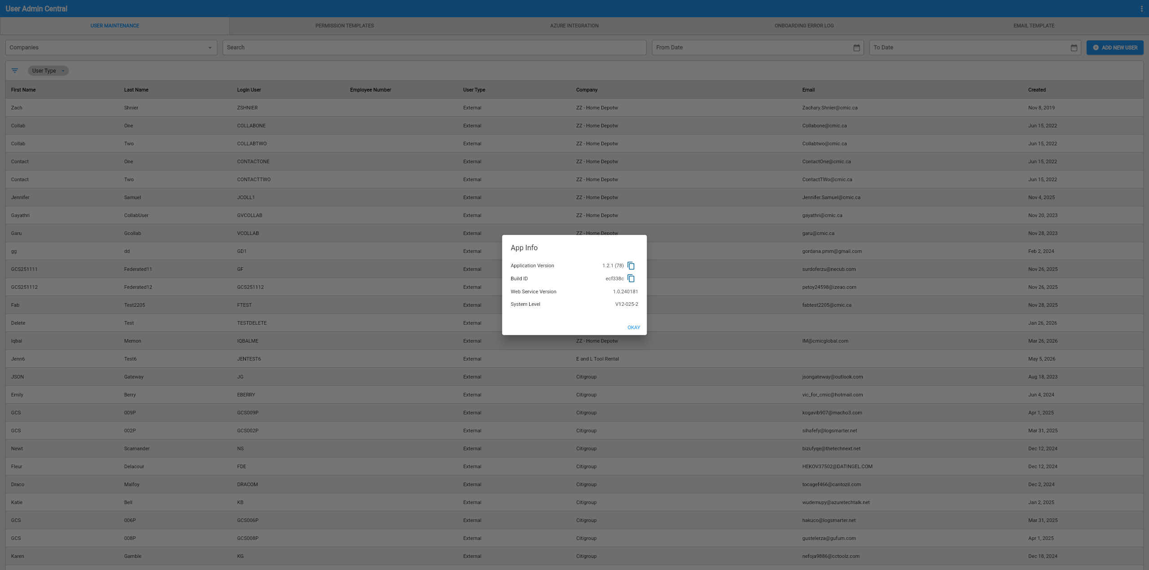
Implementation
The new App Info tab has been included within the Construct UAC program. When the user hovers over the 3 dot icon menu on the top right of the page, a notification “Show menu” will appear.
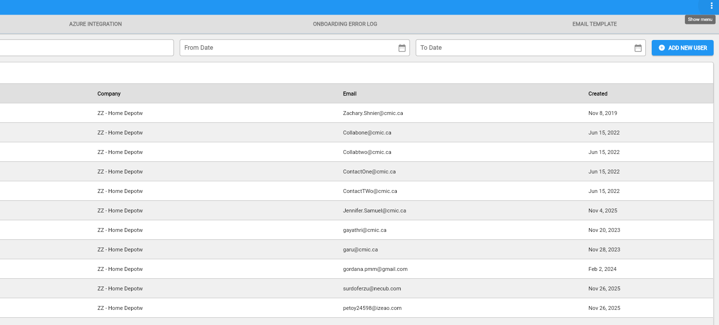
The user will then click the menu icon, and select the App Info option.
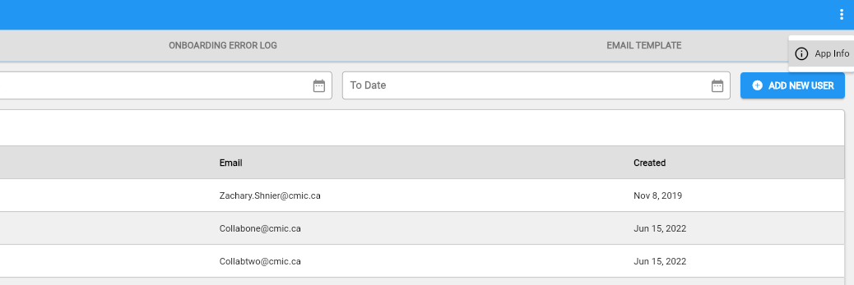
The Construct UAC program will then display the relevant information in regards to the Application Version, Build ID, Web Service Version, and System Level to the user.

Construct UAC – Company Field removed from Permission Templates for Dynamic Company Mode (CAM-11667)
Overview
The Company field has been removed from the Permission Template tab in Construct UAC when the “Enable Dynamic Company Assignment” flag is checked. This allows to select any company during the user creation process, rather than having one assigned immediately, improving the fluidity of the user creation workflow.

Pre-Requisites
System Options > Global Tables > UAC – “Enable Dynamic Company Assignment” must be checked (‘Y’).
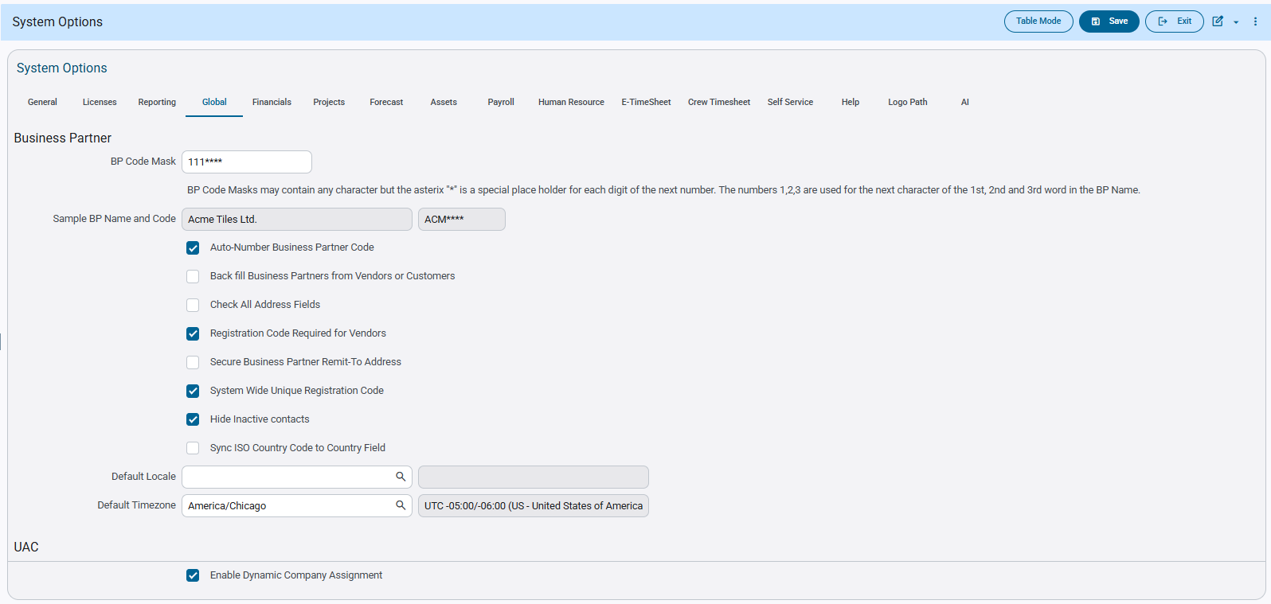
Implementation
The Company field has been removed from the Permission Template tab in Construct UAC when the “Enable Dynamic Company Assignment” flag is checked. You can still select a company but only during the user creation process.
First ensure that the ‘Enable Dynamic Company Assignment” flag within the System Options program is checked.
Then go to the Permission Template tab within Construct UAC to see that the Company Field on the screen has been removed.
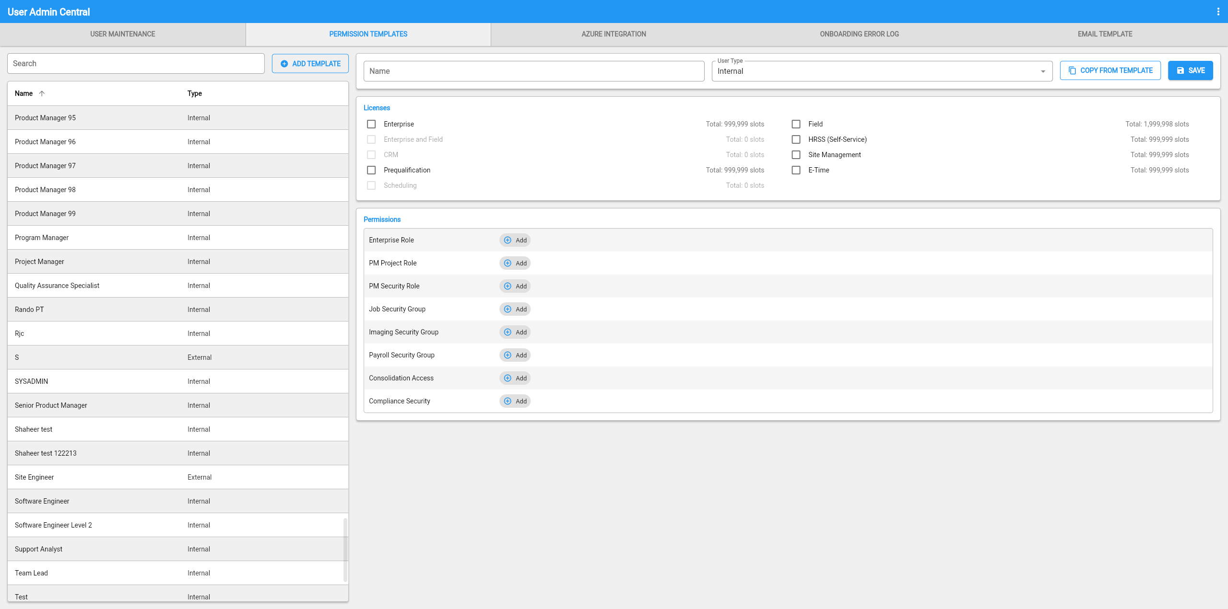
Navigate into the User Maintenance tab, click the [ADD NEW USER] button, enter the required details and select a Permission Template.
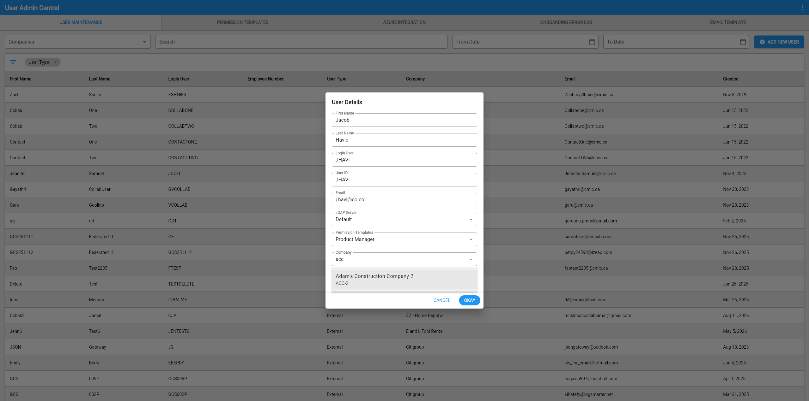
Any company can now be selected regardless whether if the Permission Template had a Company assigned to it.
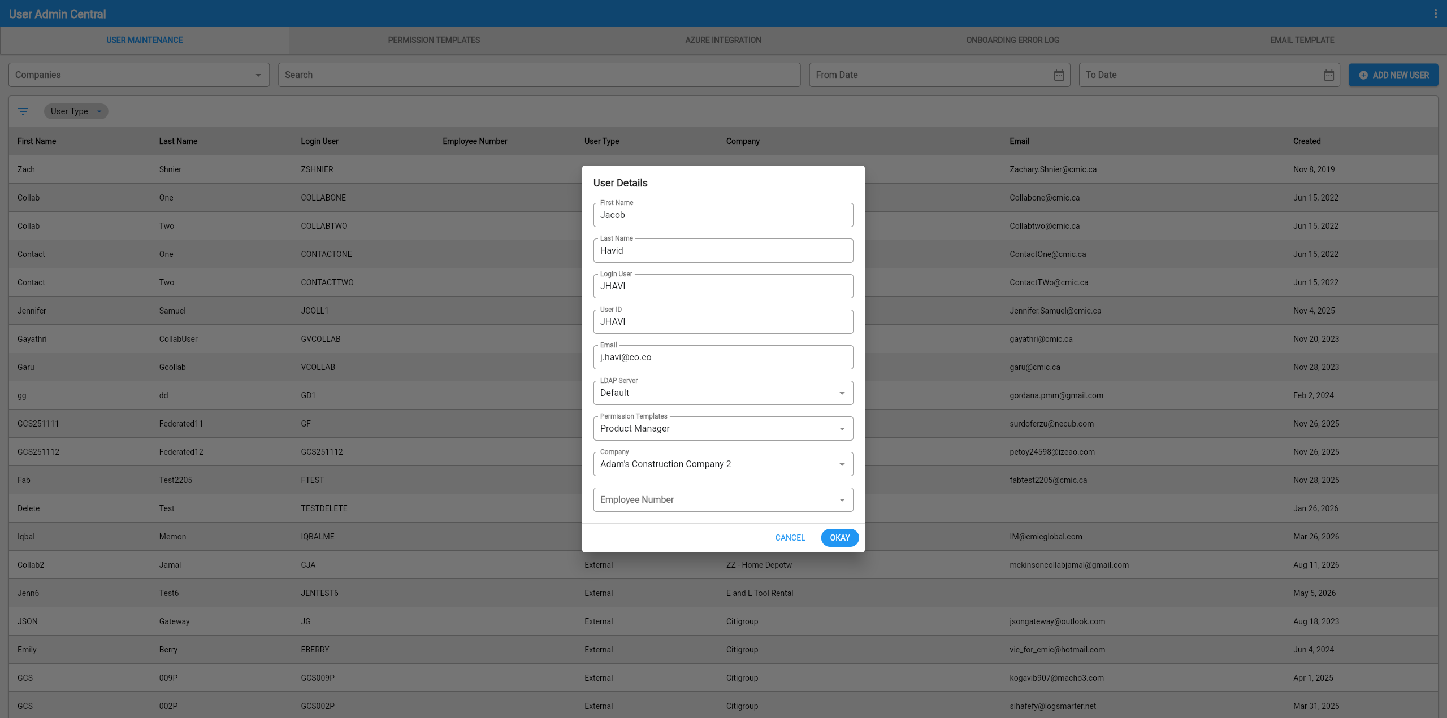

Construct UAC – Company Resolution Logic Introduced in User Creation Process (CAM-11670)
Overview
New Company Resolution Logic has been included in the User Creation Process for Construct UAC. When a user is created through Azure, the field involving the Company can now be administered in three possible ways: ‘Azure Company Name’ field, Company Name and Company Code. This configuration allows more flexibility when creating new users through the Azure Account Creation Process.
Pre-Requisites
System Options > Global Tables > UAC – “Enable Dynamic Company Assignment” must be checked (‘Y’).
Implementation
The new Company Resolution Logic now introduced, allows you to set one of three specific values (‘Azure Company Name’ field, Company Name and Company Code) within the Company Name field in Azure. Doing which during the user creation process will administer the company associated within the field, to the user upon creation.
As one example, first enter an Azure Company Name within the field in Maintain Companies program.
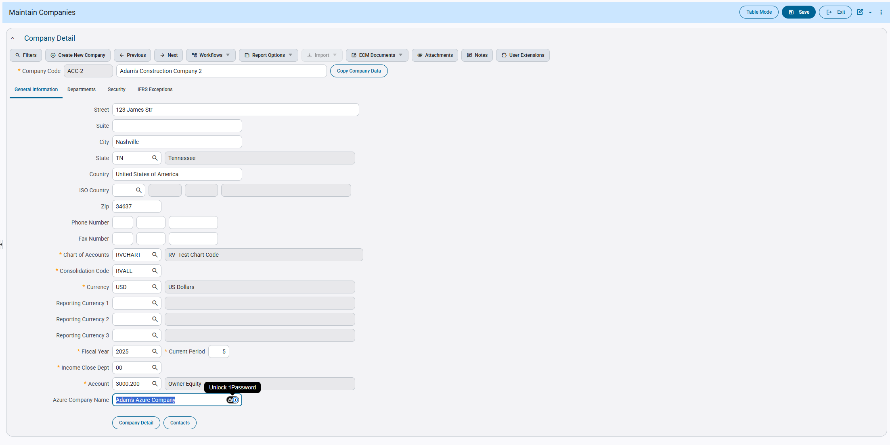
Use the value (case insensitive) within the Company Name field on Azure and continue the User Creation process.
Upon creating the new user record, the associated company will be displayed and connected to the user seen via UAC.
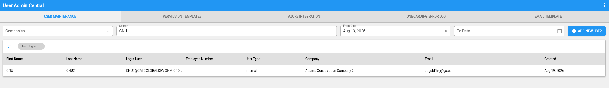

Construct UAC – New Field Added to Onboarding Error Log User Details (CAM-11671)
Overview
A new Company field has been added to the Onboarding Error Log User Details Popup within Construct UAC. This new field allows you to assign a company to the selected user when retrying user creation from the Onboarding Error Log. This new implementation only functions and effects records that have been created when the “Enable Dynamic Company Assigned” flag has been checked. The addition aims to assist when resolving Dynamic Company Assignment records.
Note: Dynamic Company Assignment allows an administrator, during user creation, to select which single company to assign a user to from a list of available companies. It does not mean that a single user can be assigned to multiple companies within Construct UAC.
Pre-Requisites
System Options > Global Tables > UAC – “Enable Dynamic Company Assignment” must be checked (‘Y’).
Modifications
Onboarding Error Log program:
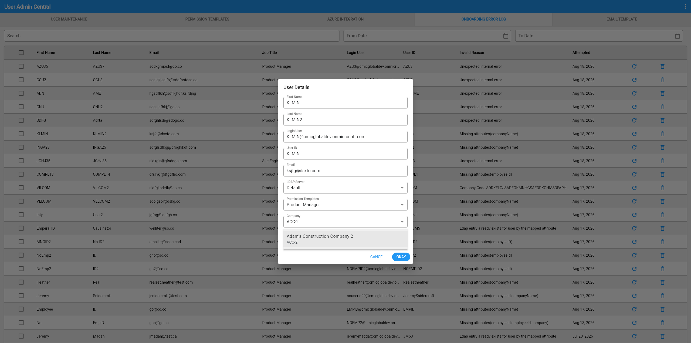
Implementation
The new field Company has been included within the Construct UAC – Onboarding Error Log User Details Popup. This new field allows you to set a company when attempting to resolve user creation via Onboard Error Log Retry.
You will first select the record on the Onboard Error Log that you wish to be resolved.
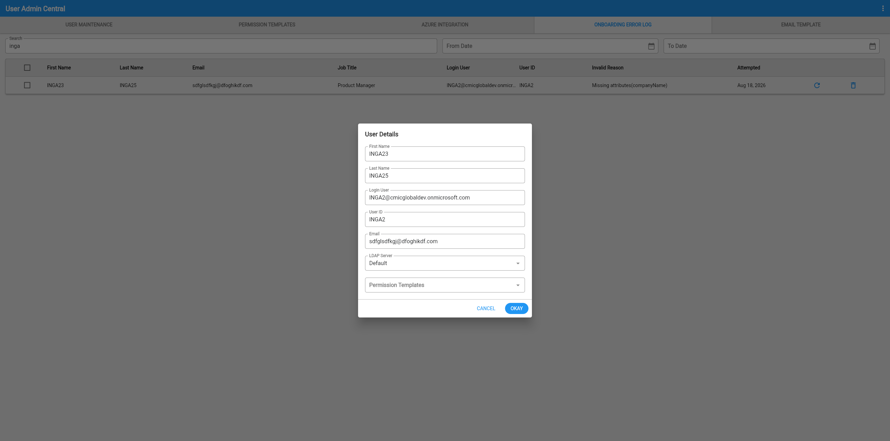
You will see the User Details popup open and then select an Internal Type Permission Template from the drop down List of Values.
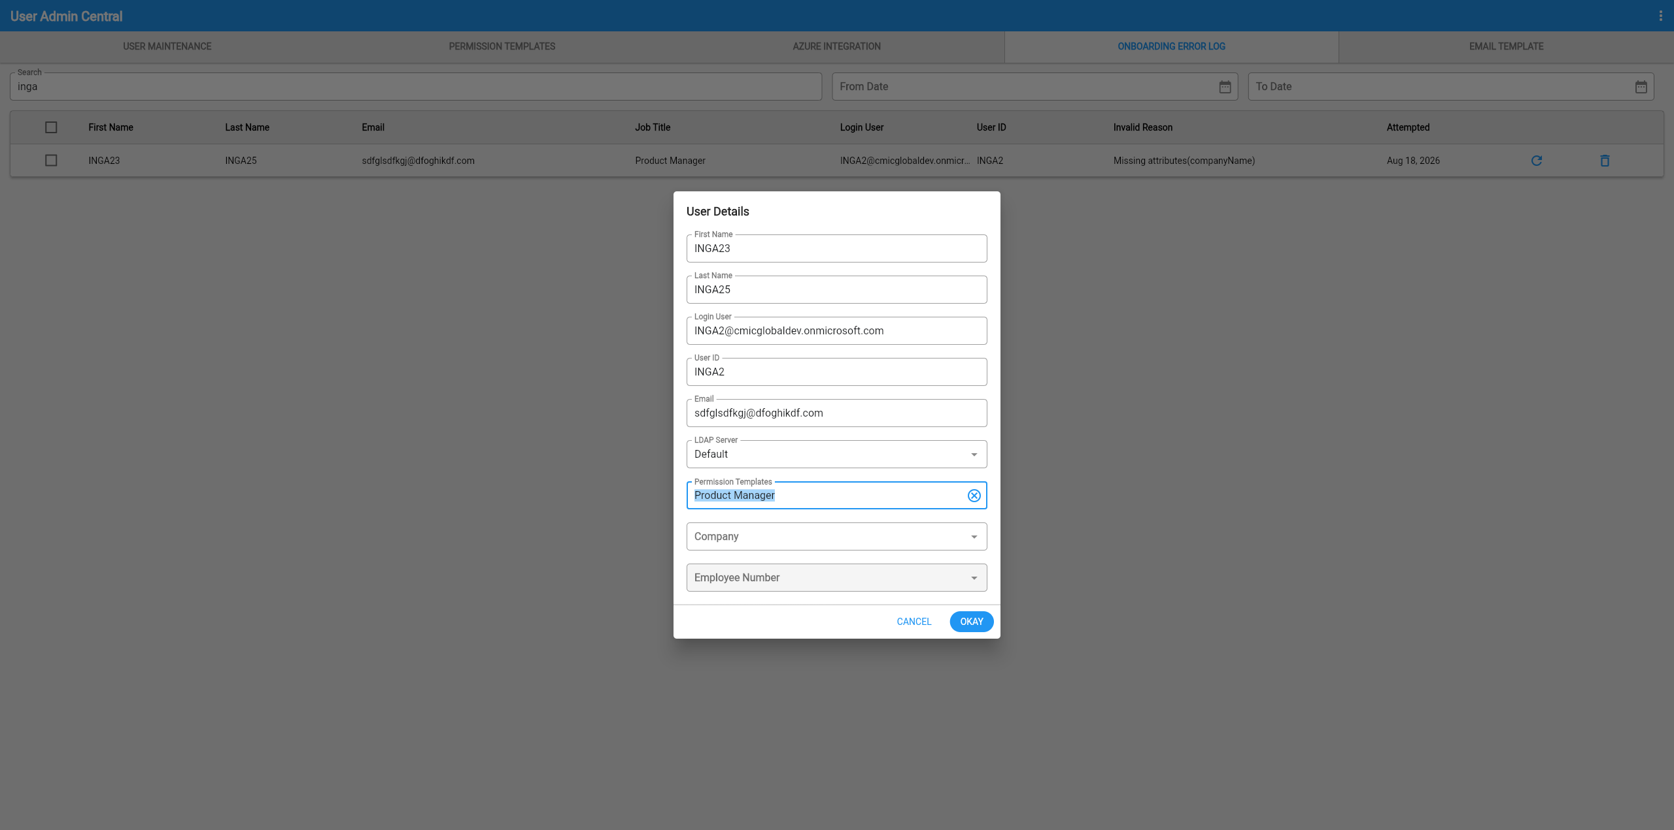
Once entered and selected, the program will then display the Company List of Values for you to then select the Company you wish to be assigned to the user.
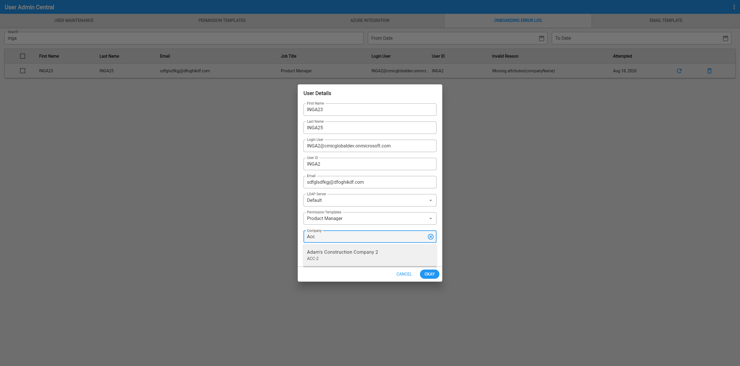
Once administered, you will then press the [OKAY] button. After which an additional indicator will appear for you to click to re-attempt the creation of the user.
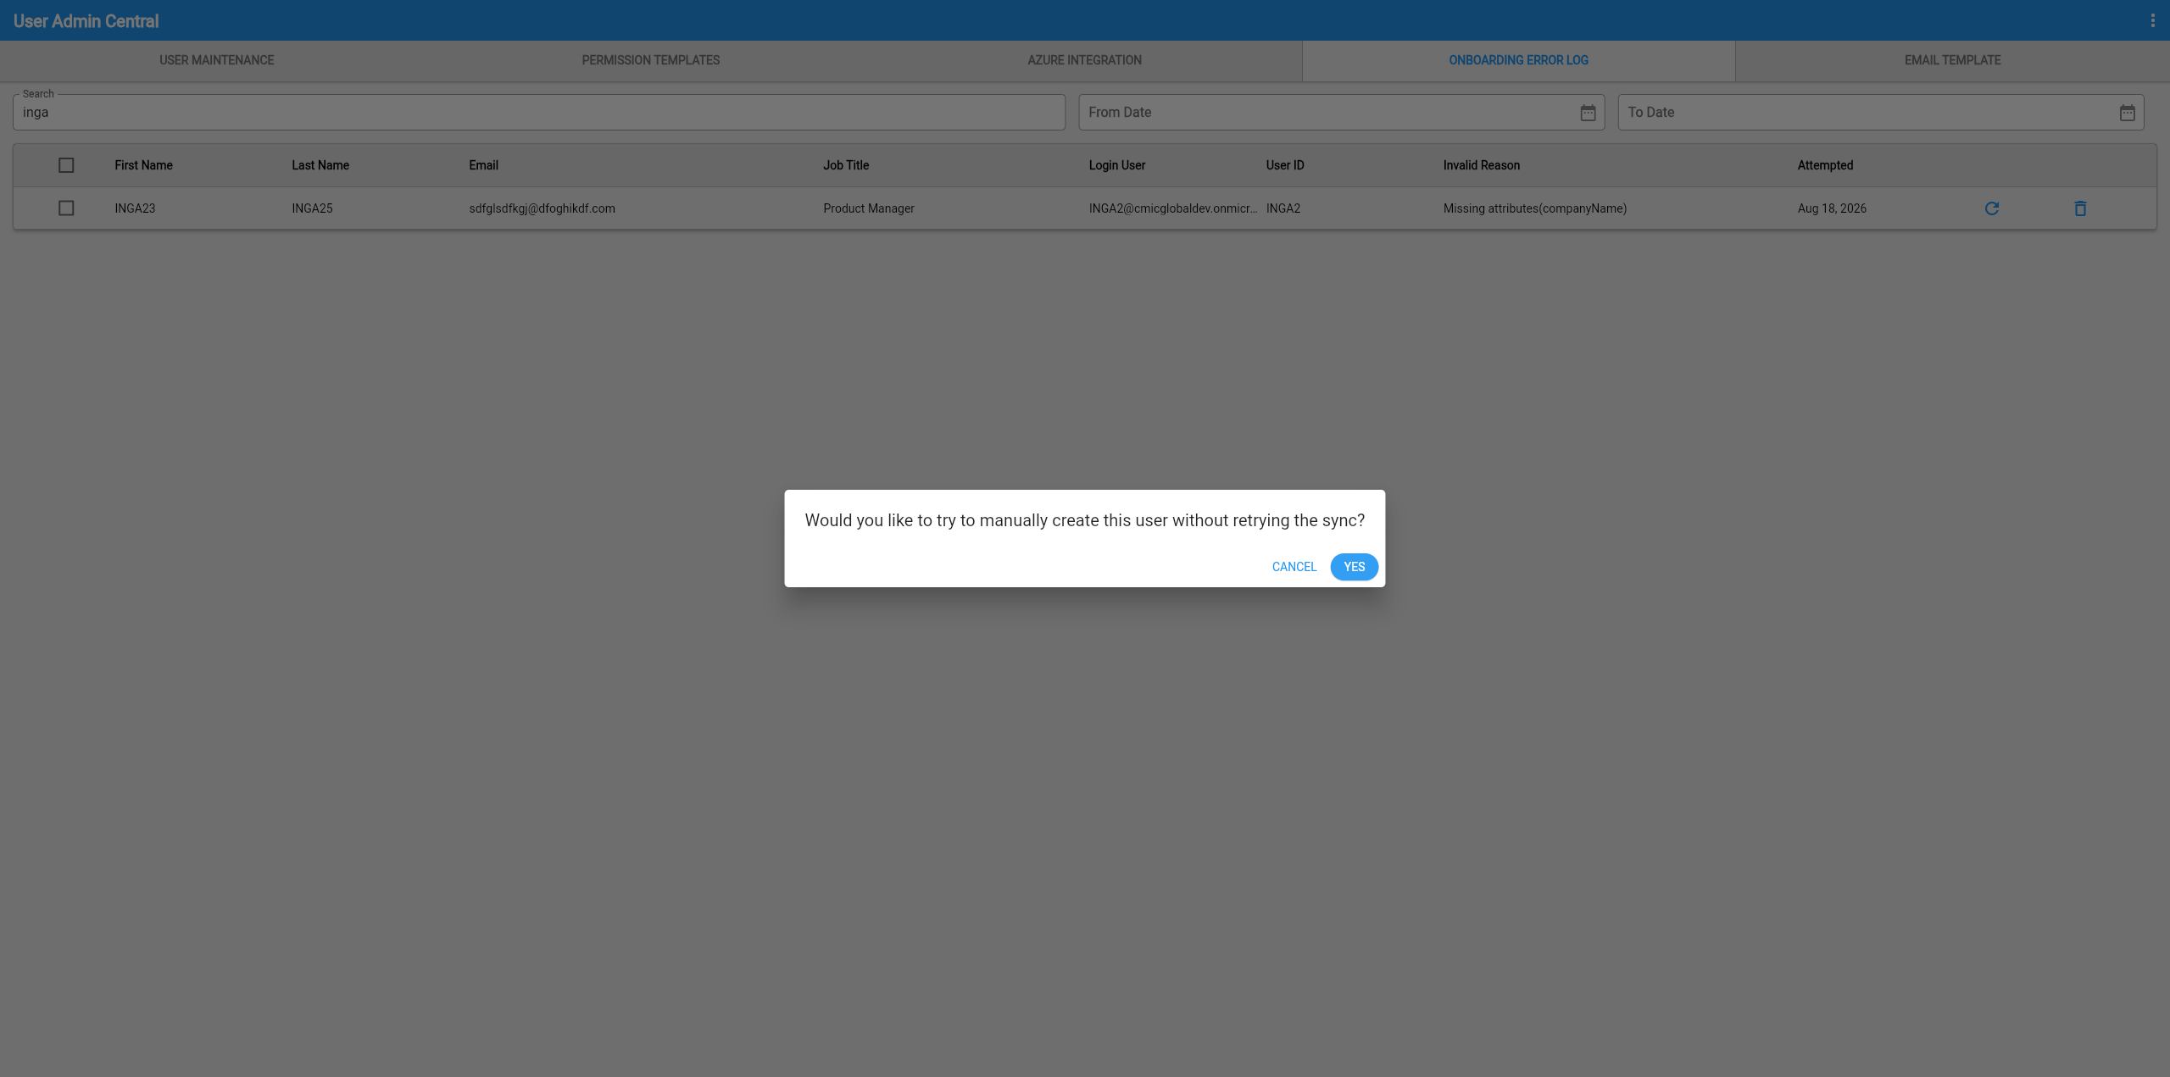
After clicking the [YES] button, the user will be created and visible under the User Maintenance tab.
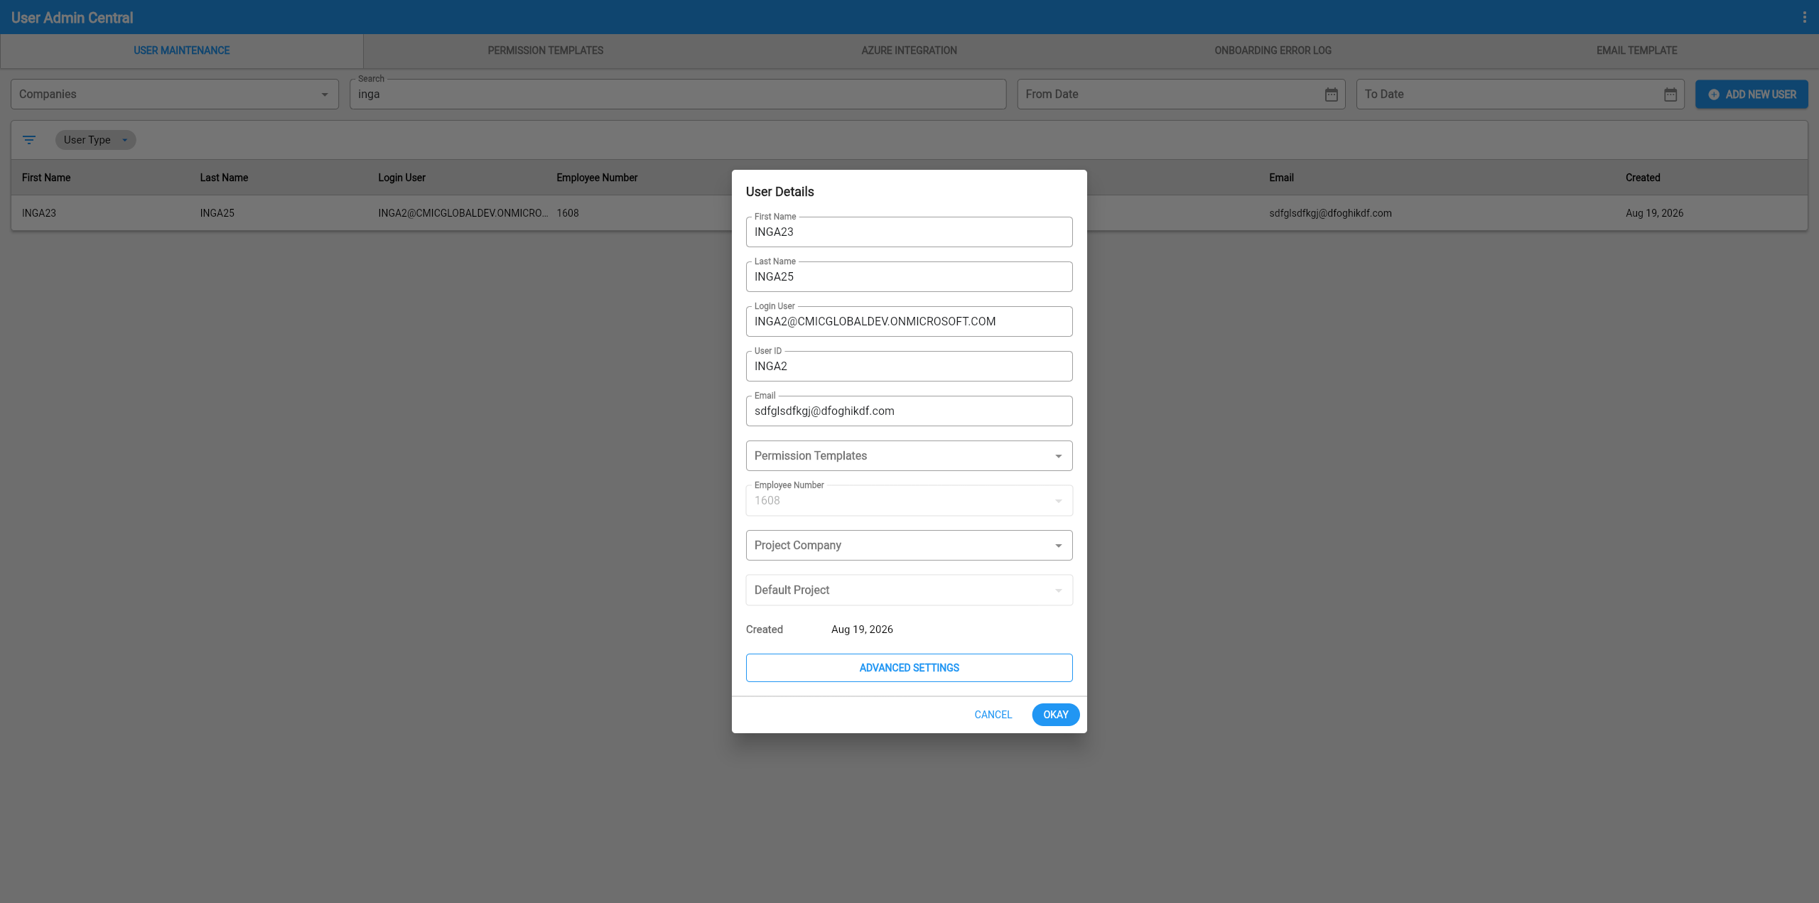

Construct UAC – New Fields Added to Dynamic Company Assignment Mode (CAM-11859)
Overview
The ‘Company’, ‘Project Company’, and ‘Assign Contact to Project’ fields have been added to the Construct UAC user creation process while the “Enable Dynamic Company Assignment” flag is checked. With the new implementation, the user can create a user with a specific company and update the default project for any existing user. This new addition aims to give more freedom and flexibility during the user creation process.
Pre-Requisites
System Options > Global Tables > UAC – “Enable Dynamic Company Assignment” must be checked (‘Y’).
Modifications
Construct UAC – User Creation:
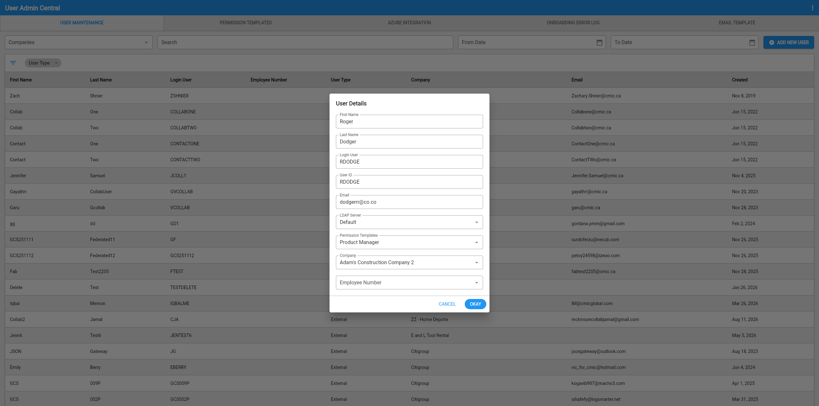
Construct UAC – User Edit:
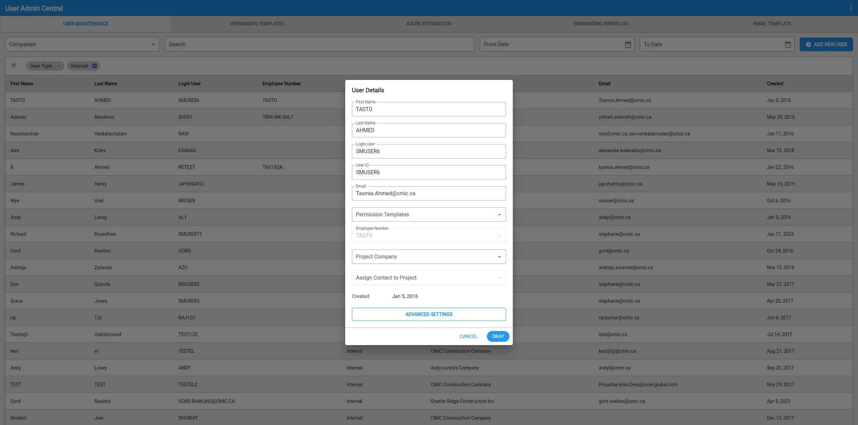
Implementation
The ‘Company’ field on user creation, and ‘Assign Contact to Project’ field on user edit, have been added to the Construct UAC user creation process while the “Enable Dynamic Company Assignment” flag is checked. This will allow the creation any new user with any specific company.
User Creation Process
On the User Maintenance tab within Construct UAC, click the [ADD NEW USER] button to display the User Creation pop-up.
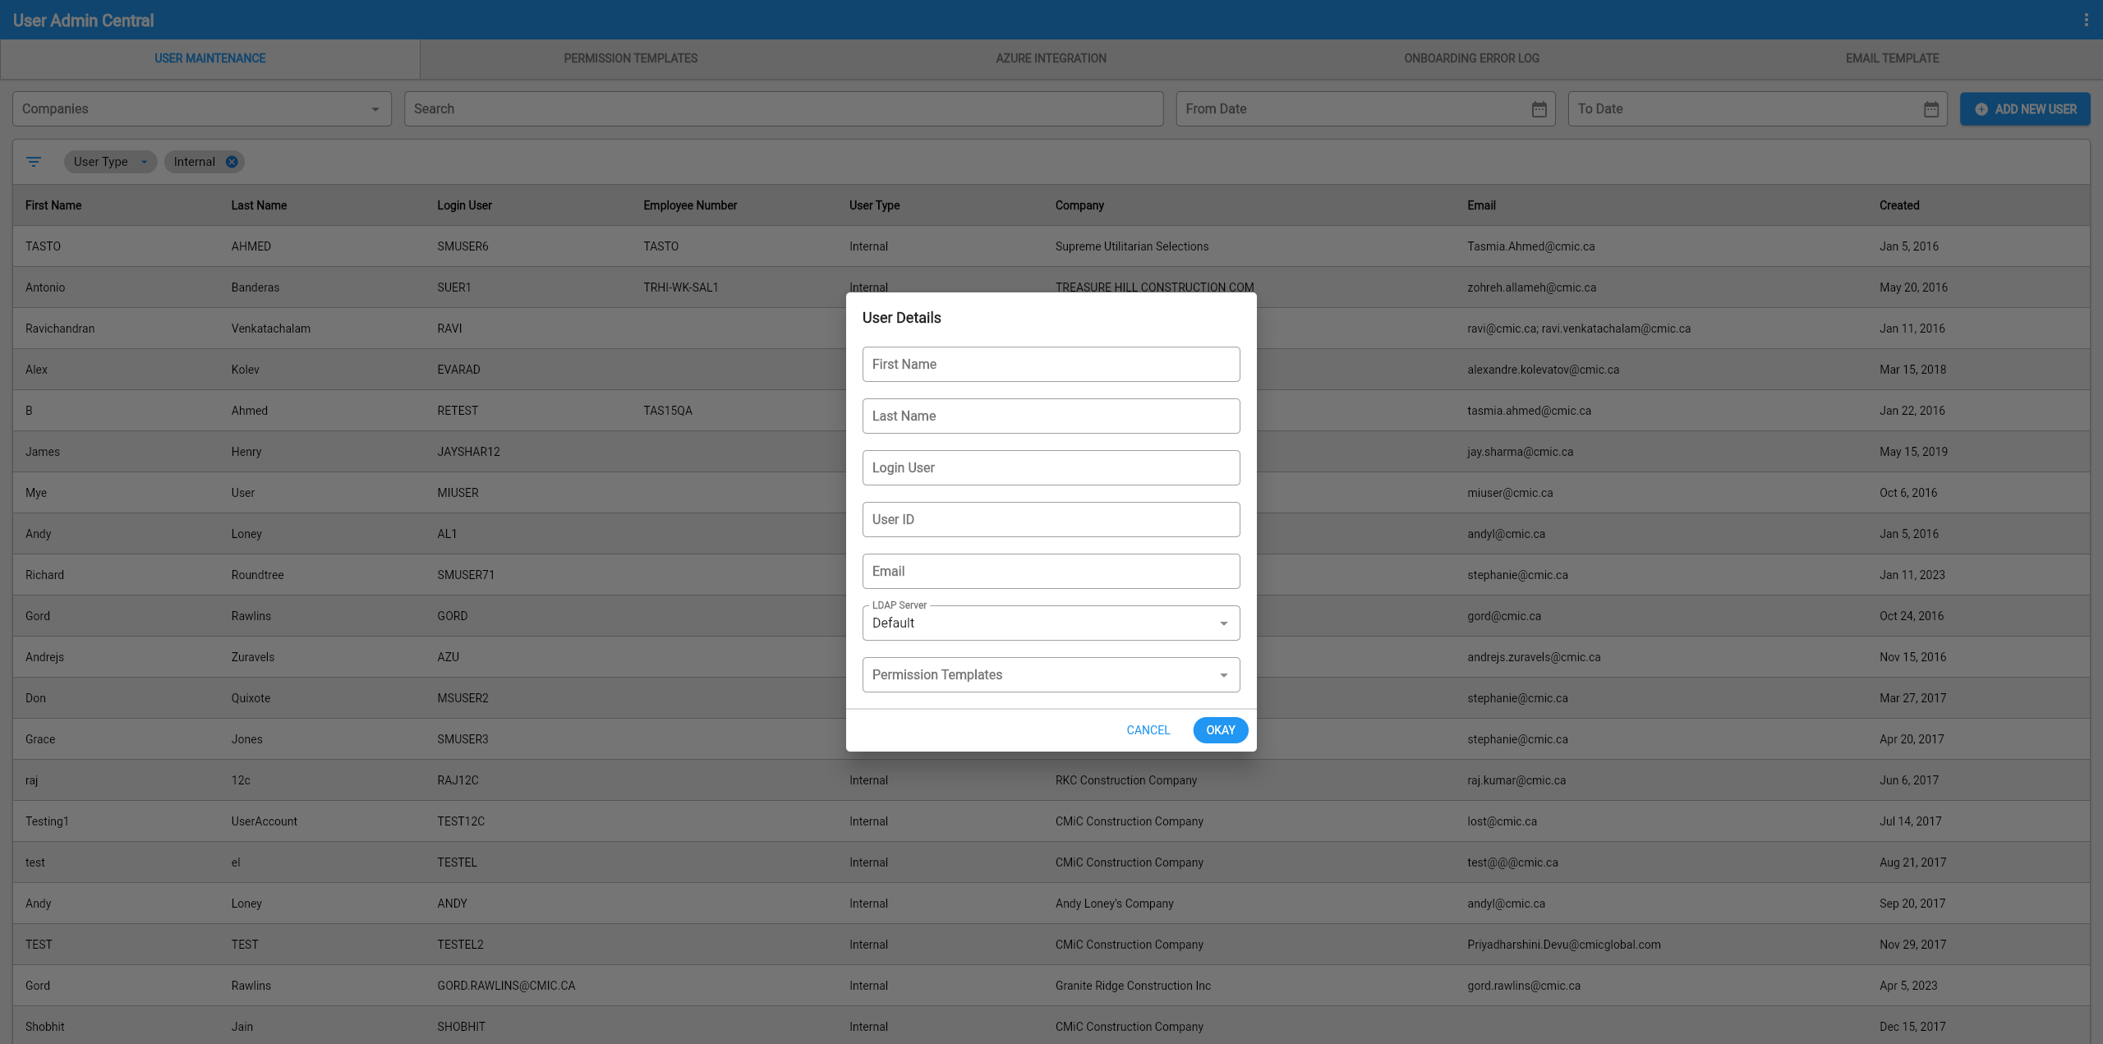
By then adding in the required details and permission template, the ‘Company’ field will become visible for selection of any company to be assigned to the user. Once completed, click [OKAY] to generate the new user with assigned company.
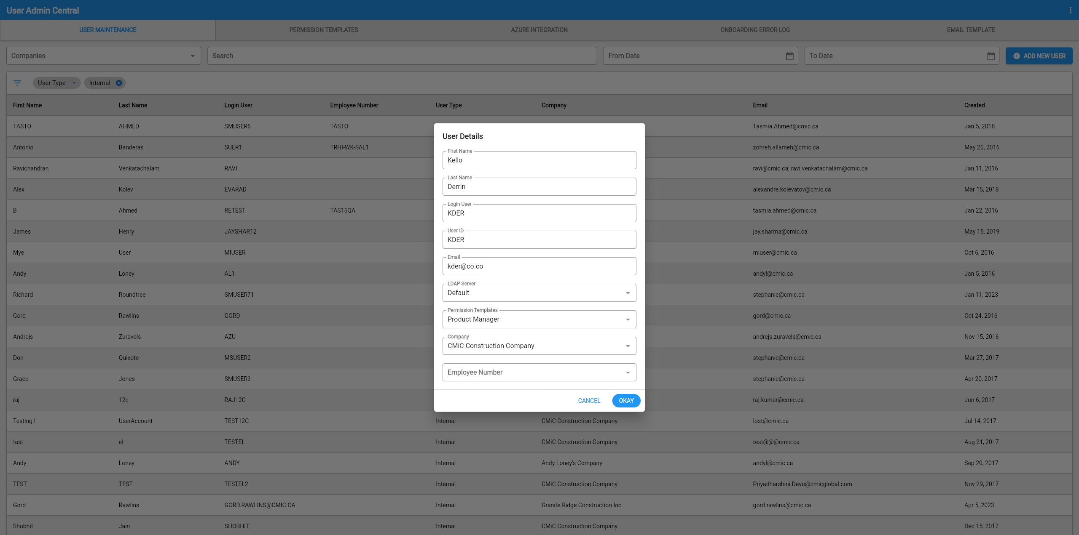
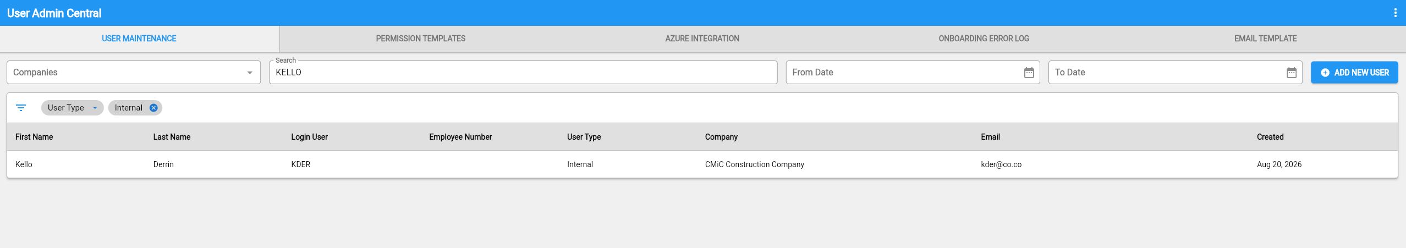

User Editing Process
On the User Maintenance tab within Construct UAC, clicking the user record to configure will display the User Editing pop-up.
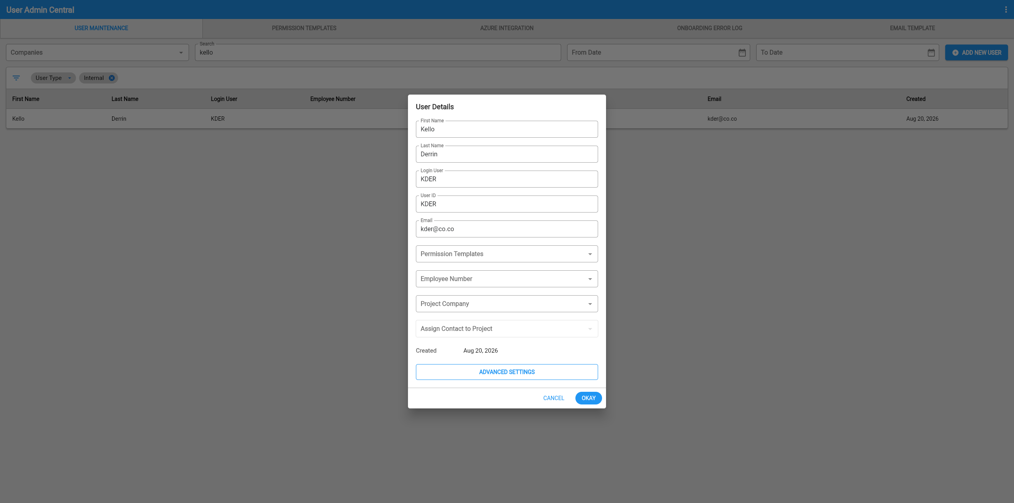
From this point, new sections for ‘Project Company’ and ‘Assign Contact to Project’ appear. The Project Company must be selected as required, and upon doing so, they will be able to select the project associated with the company.
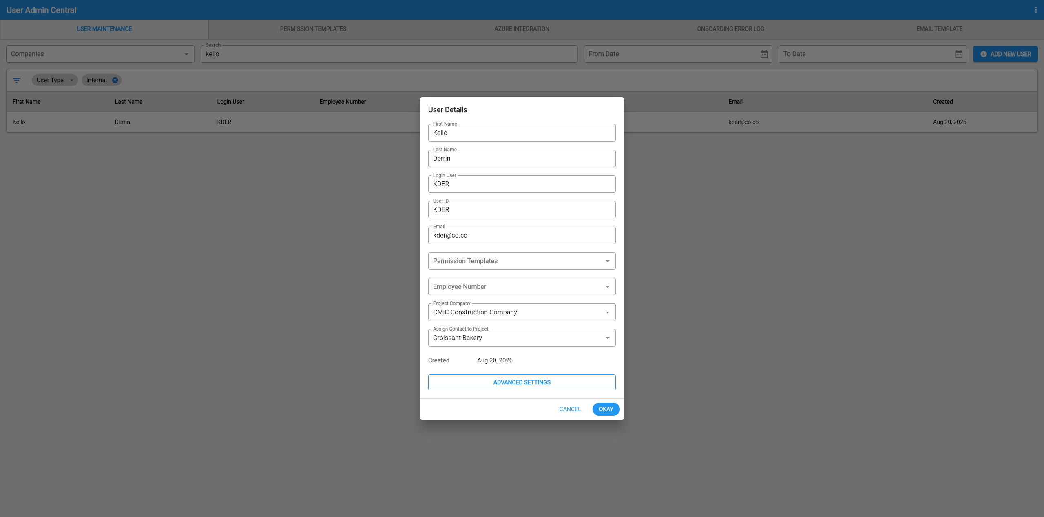
After clicking the [OKAY] button, the assigned project will then be assigned to the selected user.

Construct UAC – New Reset Azure Sync Button Added to Azure Integration (CAM-11022)
Overview
One new button named [Reset Azure Sync] has been added to the Construct UAC – Azure Integration Tab. This new button when pressed will pull Re-sync all pre-existing users that are currently present in the sync group once more, preventing any from being stuck within creation status.
Modifications
UAC Azure Integration Tab:
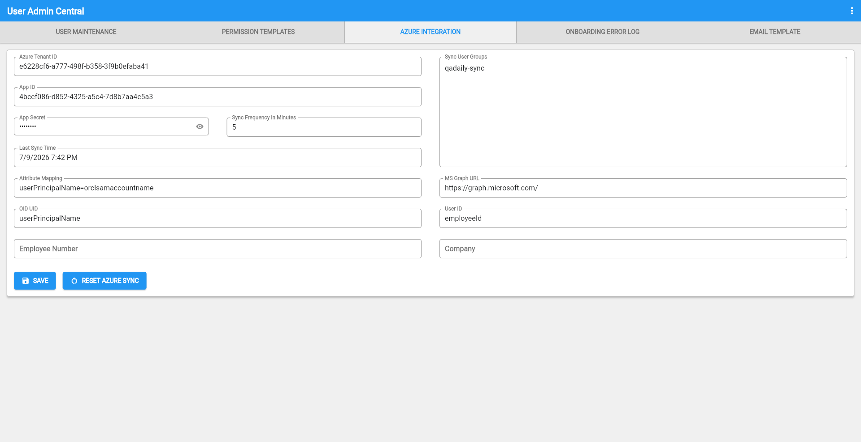
Implementation
The [Reset Azure Sync] button has been included within the Azure Integration page.
When the user clicks on the new button, the program will go into the sync group and pull all pre-existing users again to process and create all users generated from Azure. The use will first see a confirmation modal before proceeding.
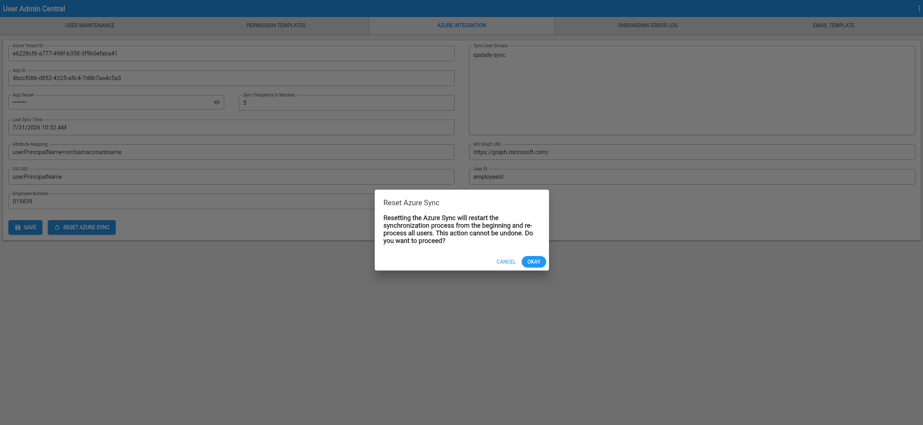

Construct UAC – Multi Select and Delete Functionality Added to Onboarding Error Log (CAM-11507)
Overview
Multiple Record Selection and a new Delete button have been introduced within the Construct UAC – Onboarding Error Log program. These new implementations will give the user the ability to select multiple records to re-attempt the sync process, as well as the option to delete them. This change will give you more options when managing failed sync records, reducing the time spent resolving errors one at a time.
Pre-Requisites
System Options > Global Tables > UAC – “Enable Dynamic Company Assignment” must be checked (‘Y’).

Modifications
Onboarding Error Log program:
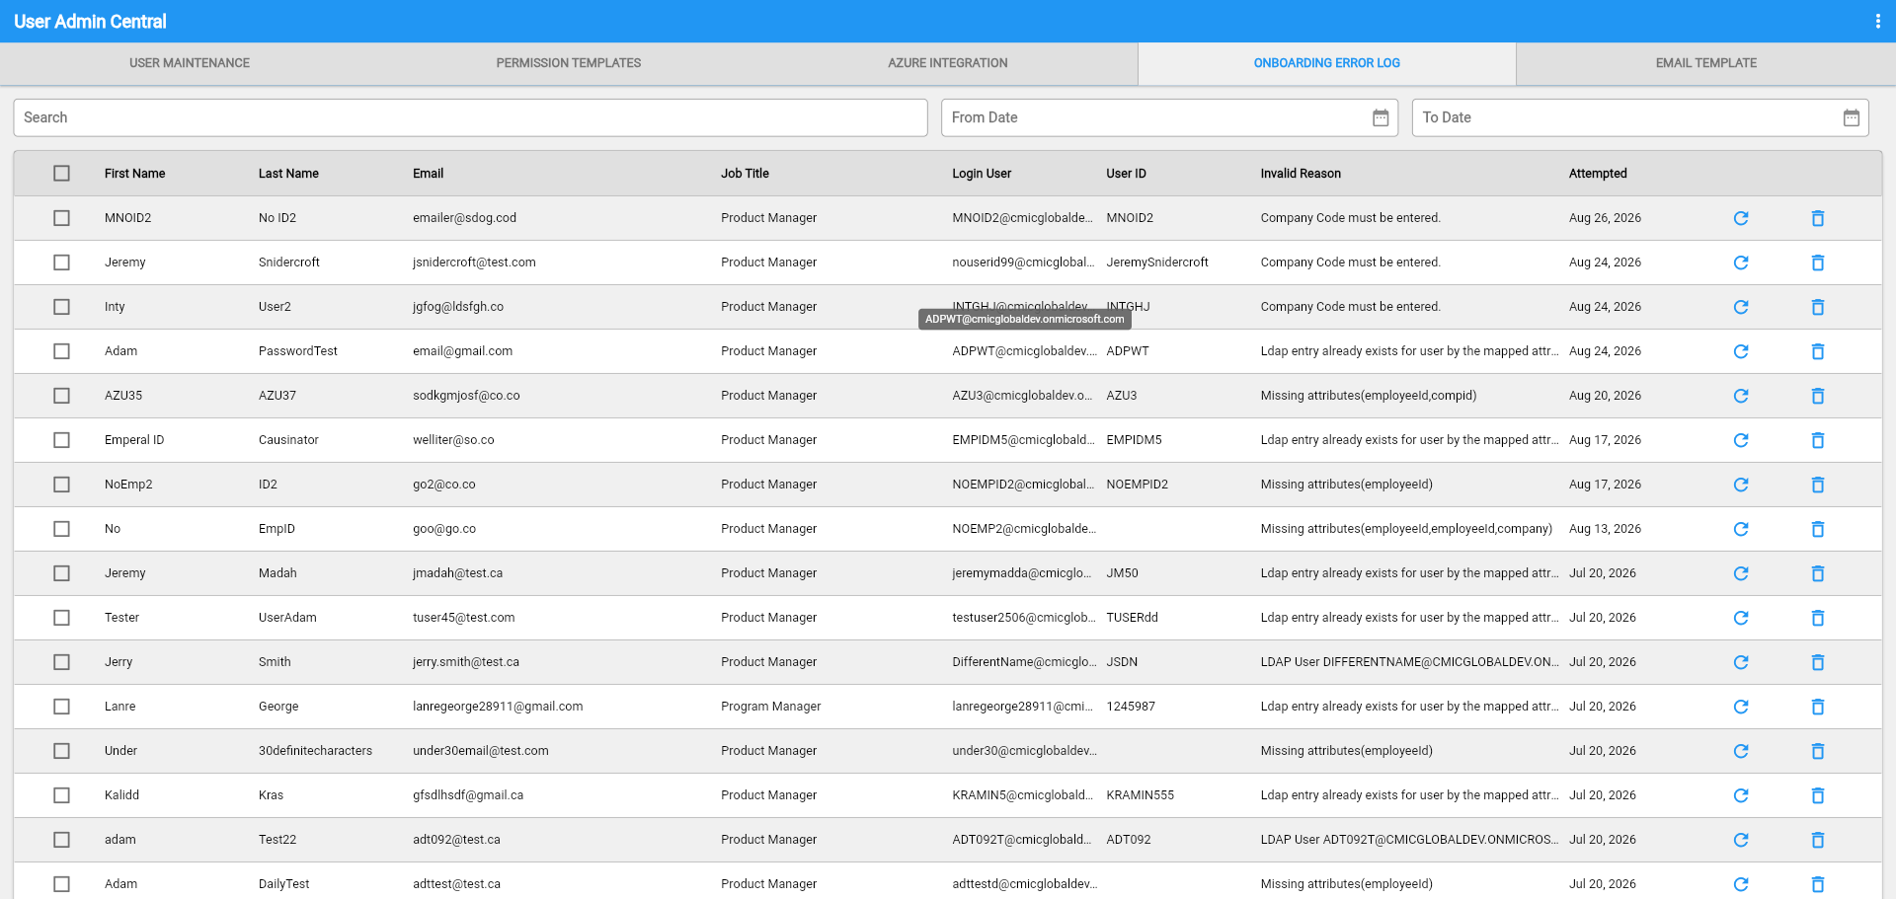
Implementation
Two new additions have been introduced to the Construct UAC – Onboarding Error Log program to give users greater control over failed sync records: Multiple Record Selection, which lets you select several records at once to retry or delete. And delete record functionality, which lets you permanently remove any record from the Onboarding Error Log.
Multiple Record Selection
Step 1: Navigate to the Onboarding Error Log tab.
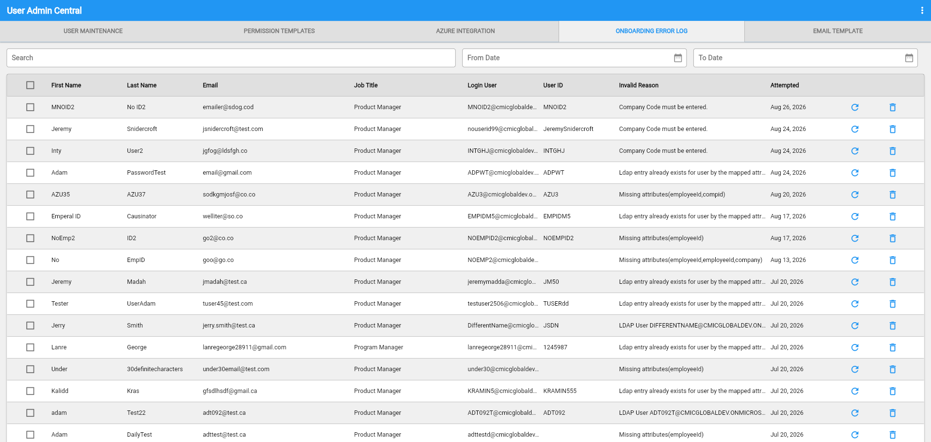
Step 2: Resolve the record's Invalid Reason on Azure, then select the checkbox beside each record you'd like to include.
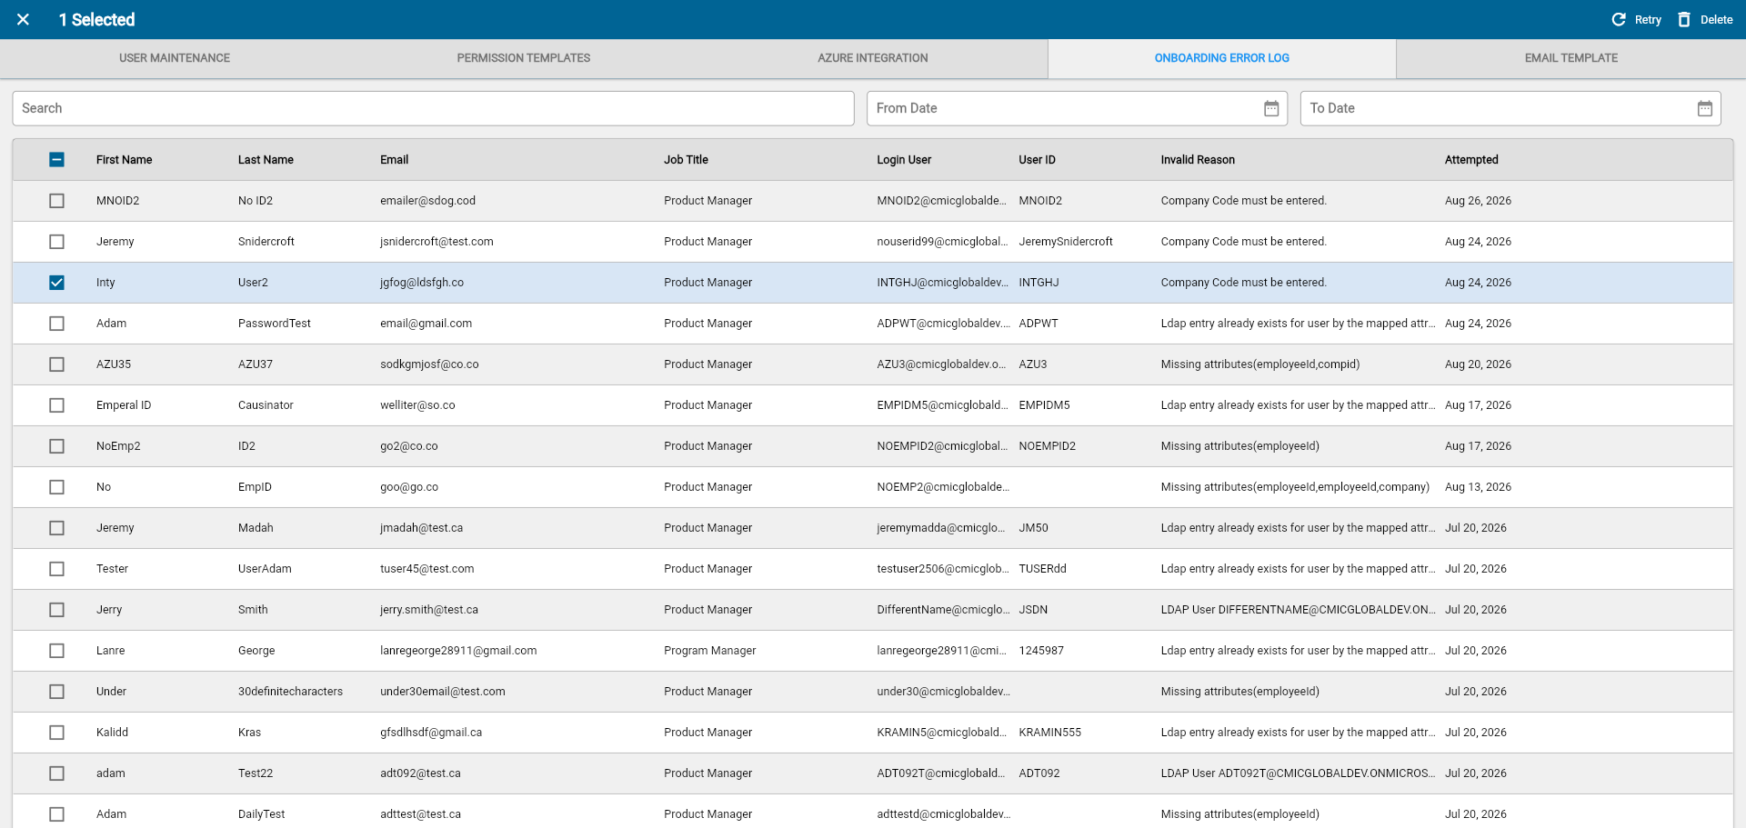
Step 3: Once a record is selected, Retry and Delete options appear in the program title banner. Click Retry in the title banner, to resync all selected records.
Tip: You can deselect a record at any time by clicking the [-] symbol in the table header.
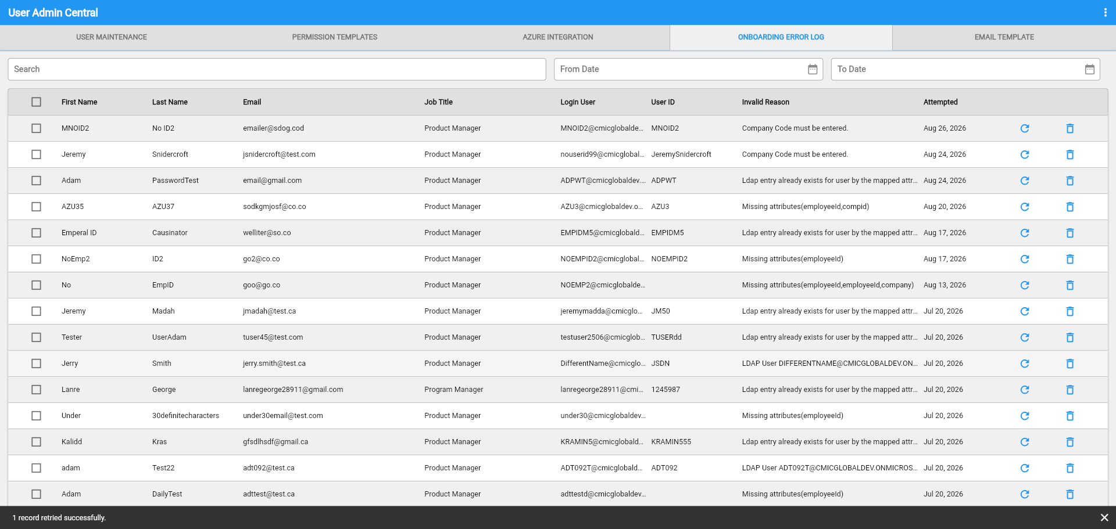
The selected records will then be resynced. To delete multiple records instead, follow the same steps and click Delete rather than Retry.

Delete Record by Row
Step 1: Navigate to the Onboarding Error Log tab.
Step 2: Locate the record you'd like to remove and click the trash bin icon on that row.
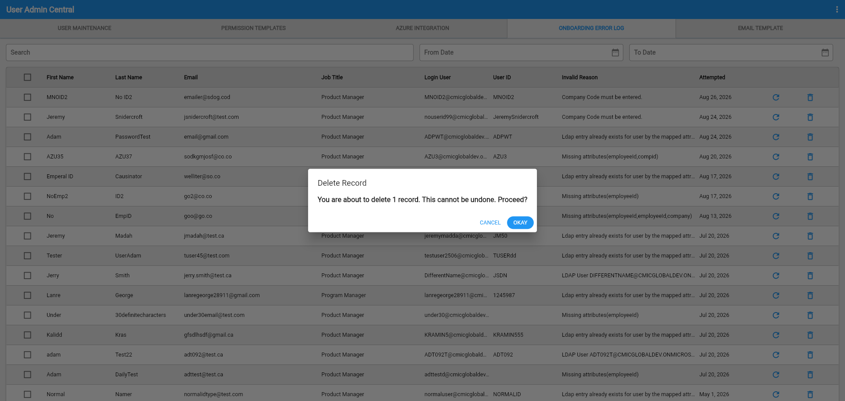
Step 3: Click OKAY on the confirmation message to permanently delete the record. Once confirmed, the record is removed immediately — to resync it later, delete the record in Azure and recreate it so it re-enters the sync process.

Construct UAC – Two New Fields Added to Azure Integration Tab (CAM-10939)
Overview
Two new fields ‘Employee Number’ and ‘Company’ have been added to the Construct UAC - Azure Integration Tab. These new fields allow the user to set their corresponding values into each field and save them. Both fields will be applied to the Azure Sync process once saved, and allow the user to add more details to the Azure user creation process. This change will streamline the Azure account creation process, and save time for the user when generating new users in the future.
Modifications
UAC Azure Integration Tab:

Implementation
The new fields Employee Number and Company have been added to the Azure Integration tab on Construct UAC. Effectively, both fields will be included in the Azure Sync process once filled and saved.
The user will be able to visibly see both new fields when the ‘Enable Dynamic Company Assignment’ flag is checked within the System Options program (‘SYSOPT’).
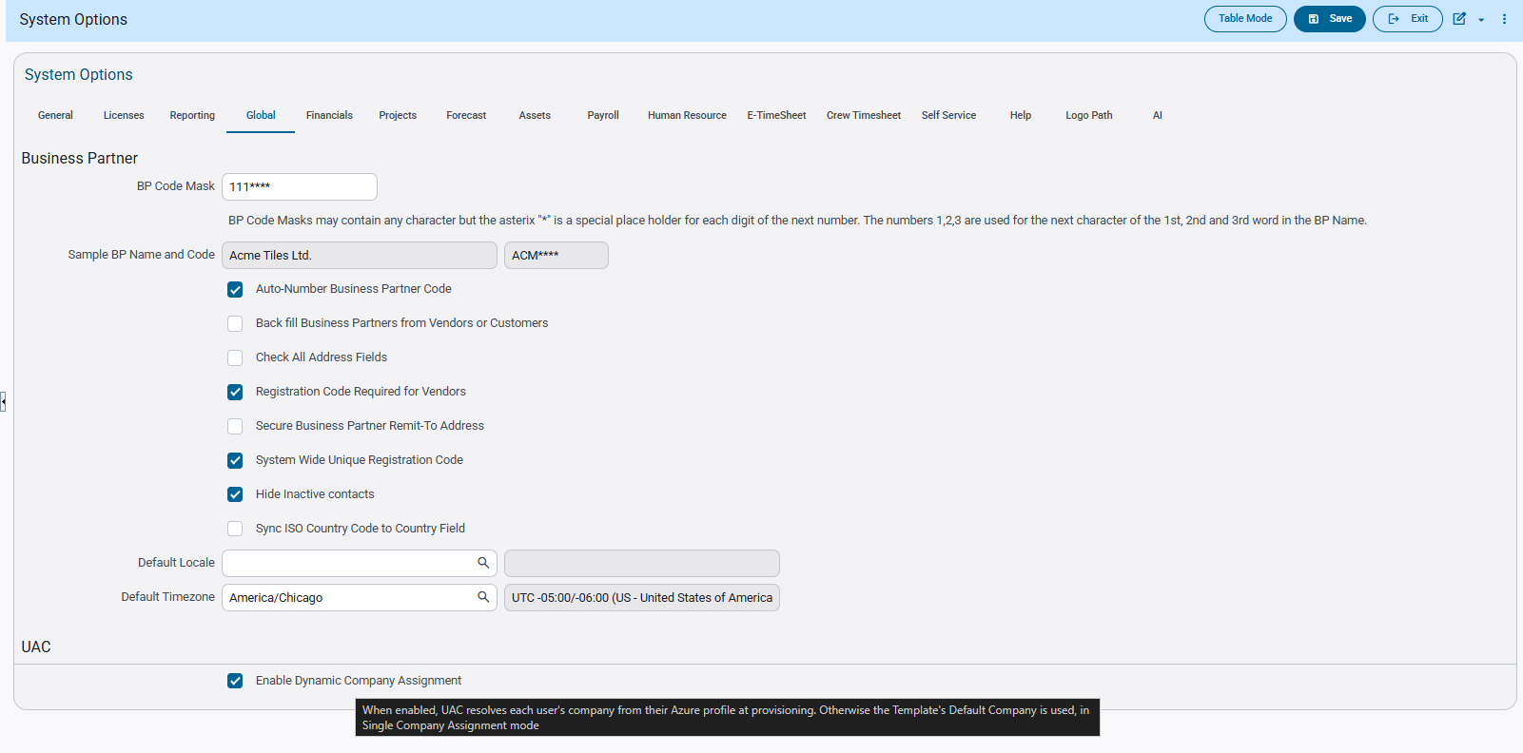
Construct UAC – Azure Integration Tab
The user is then able to write in the corresponding values into both fields and click save, saving them to the Azure Sync process/payload.
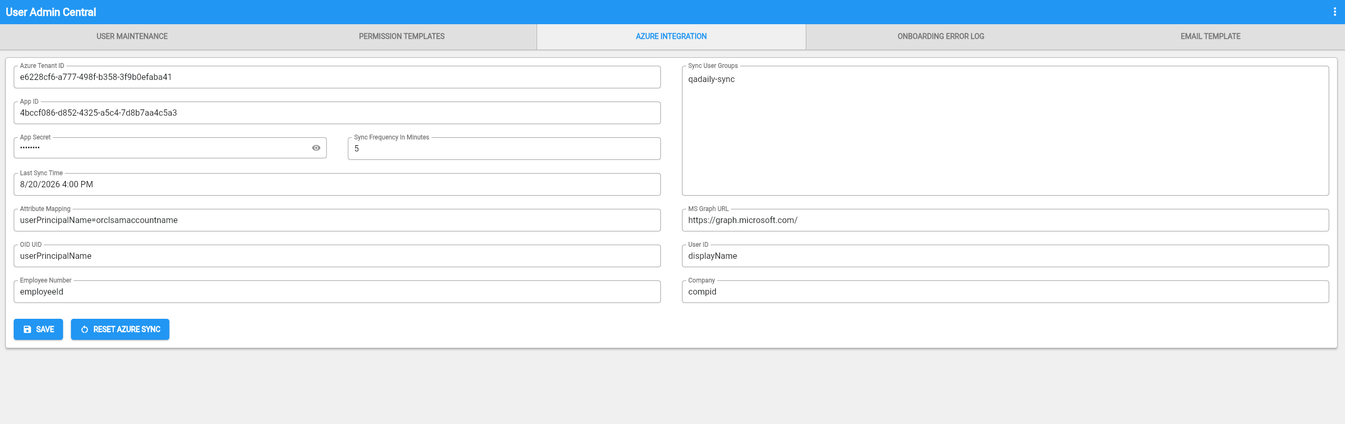
The values will persist when the user refreshes the program or swaps tabs.
Having these value enabled will allow the user to add an Employee ID and Company Name to their details through Azure, to add more detail to the user creation process.

When the ‘Enable Dynamic Company Assignment’ flag is unchecked within the System Options program (‘SYSOPT’), the user will only be able to see the Employee Number field instead of both.
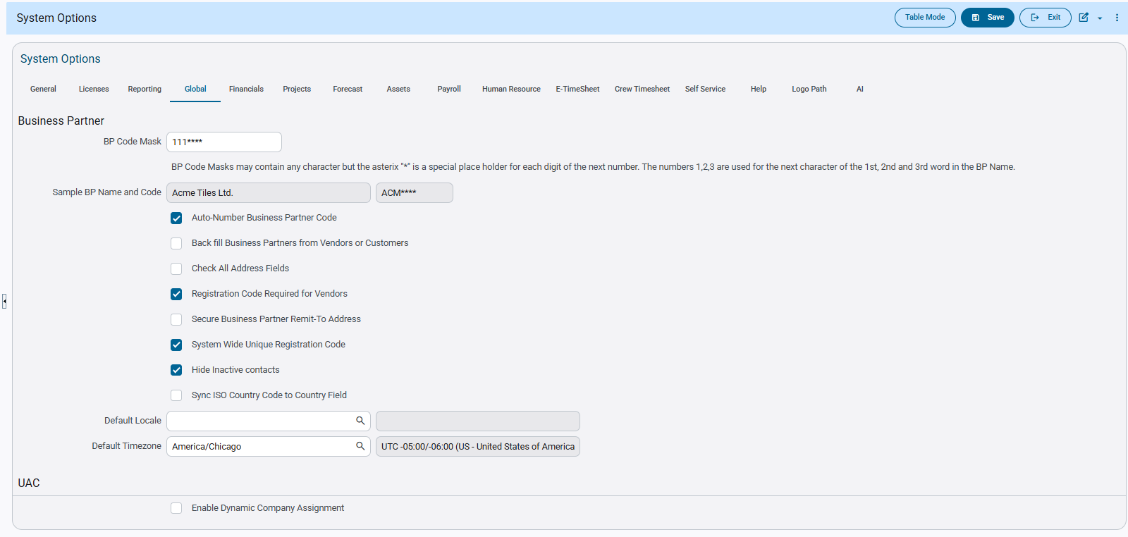
Construct UAC – Azure Integration Tab
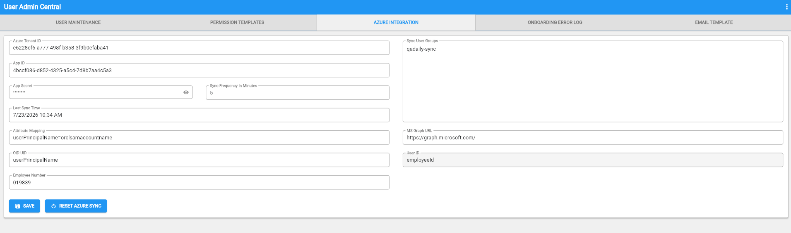

Fixed Assets

New Hide Disposed Assets Flag for the FA3000 Report (FIN-22060)
Overview
A new flag ‘Hide Dispose Assets’ flag for the Depreciation by Category report allows users to exclude assets from the period they are disposed, and all subsequent periods, when the report is generated.
- When unchecked (default): shows disposed assets through the end of the selected year — preserves same behavior as when before this flag was added
- When checked: hide disposed assets as of the period they are disposed of, the asset is excluded starting with its disposal period and in all subsequent periods
Modifications
A flag has been added to the FA3000 report preview popup.
Implementation
The new flag as shown below:
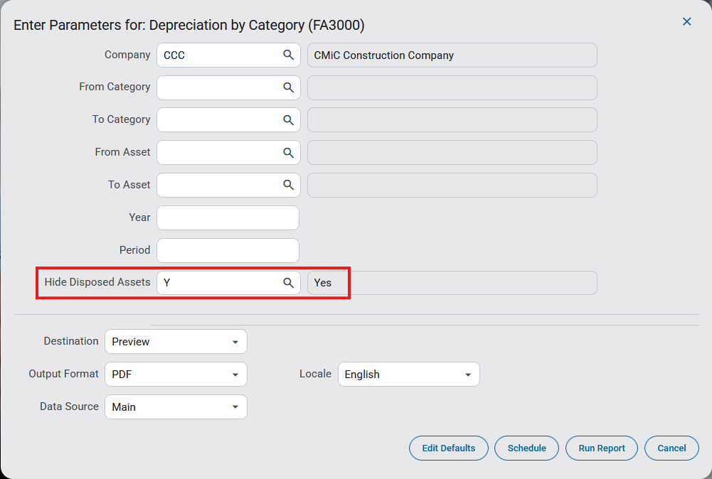
Fixed Assets > Report > Depreciation by Category (FA3000)

General Ledger

Bank Reconciliation Format for Commerce Bank (FIN-19635)

Overview:
Bank reconciliation format for Commerce Bank is created.

Modifications:
New bank reconciliation file format ‘COMMERCE_2’ is created for Commerce Bank with the following field mapping.
Column1: Account Number
Column2: Check Amount
Column3: Check Number
Column4: Paid Date (mm/dd/yyyy)

Bank Setup:
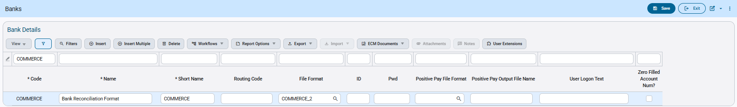System Data > Global Tables > Banking > Banks

This is an example of bank reconciliation format for COMMERCE_2:
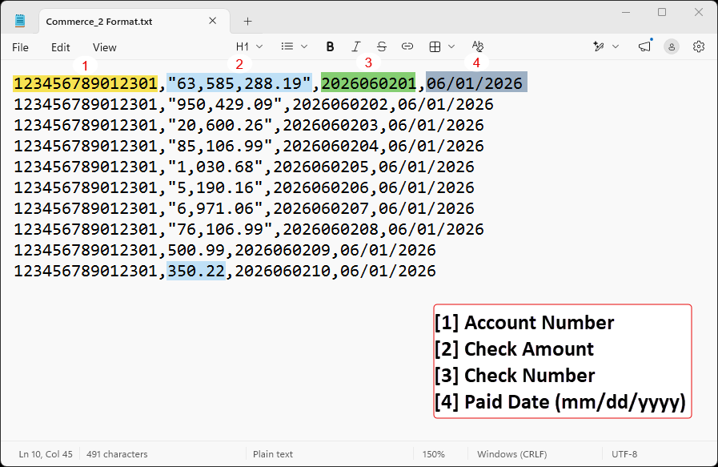

General Ledger – New Text Field added to Maintain Companies (CAM-11752)
Overview
A new text field named ‘Azure Company Name’ has been included within the Financials > General Ledger > Setup > Maintain Companies (COMPSETUP) program. This new addition serves as a pre-cursor and will be used later when new additional fields will be included to the UAC Azure Integration screen.
Pre-Requisites
Ensure that the Azure Company Name custom field is enabled within the Maintain Companies program beforehand:
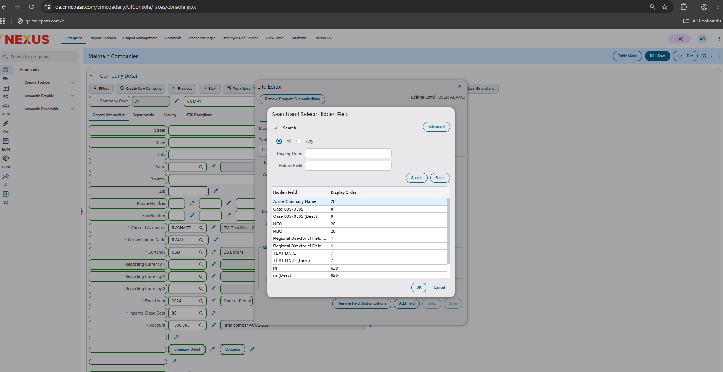
Modifications
Maintain Companies program:
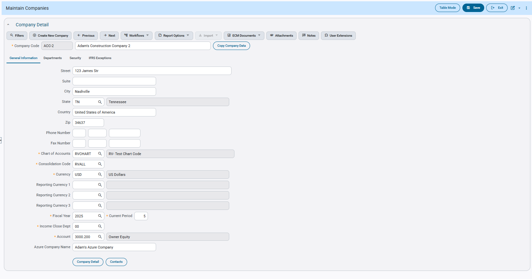
Implementation
The new field ‘Azure Company Name’ serves as a pre-cursor for further implementation of additional new fields to the Azure Integration screen. Once applied.. when a user’s Azure profile has a Company value that doesn’t match what is displayed on ADF, the logic will verify the value present within the new Azure Company Name field to confirm whether or not the value is an alias of a known company.

Enable Import Functionality on Transaction Allocation Values (FIN-22886)
Overview
Import option added to Transaction Allocation Values program.
Modifications
In Transaction Allocation Values program, import functionality is enabled.
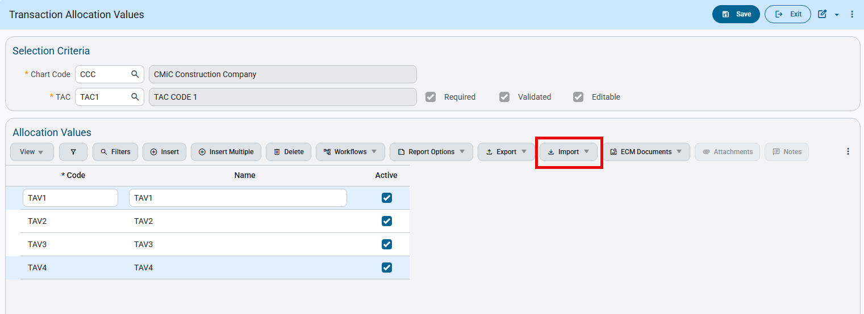
General Ledger > Setup > Global Tables> Transaction Allocations > Transaction Allocations > Transaction Allocation Values
Implementation
Use import format as below:
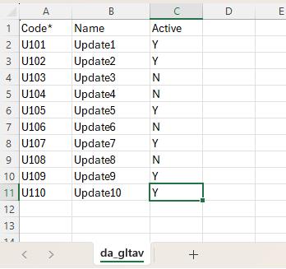
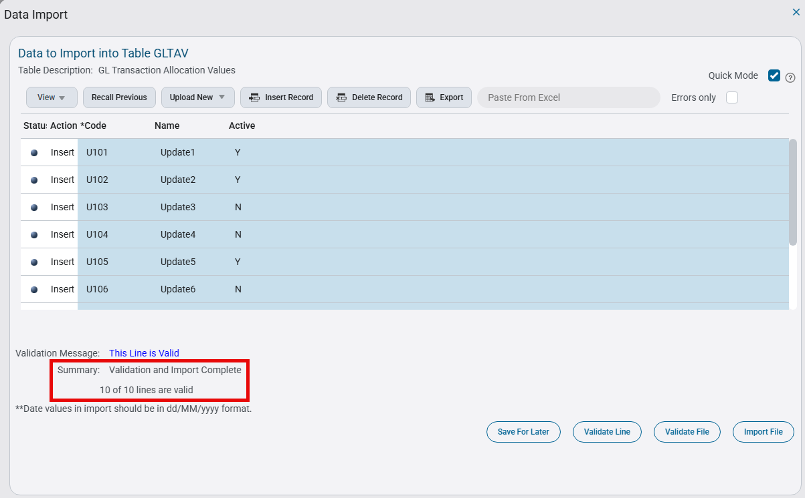
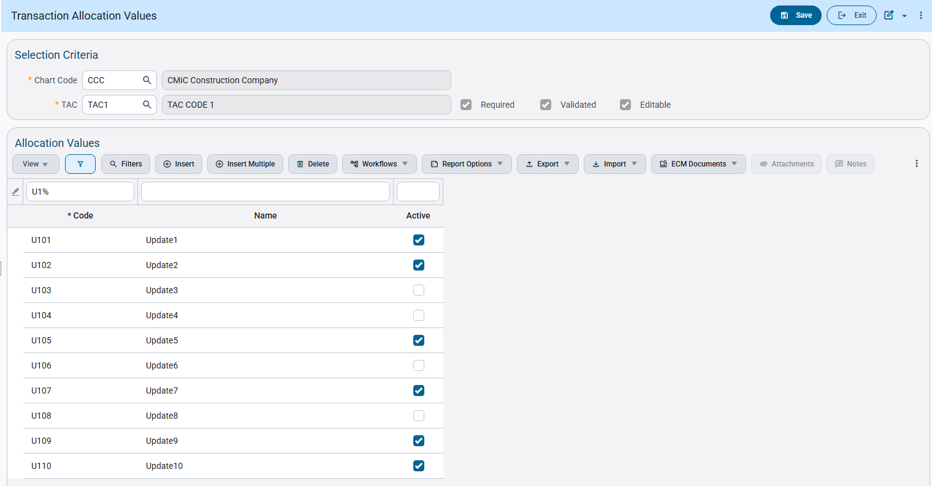

New Report Parameter added to GL2000D (FIN-21155)
Overview
“Validate Accounts by Department” parameter added to Trial Balance by Department Report (GL2000D)
Modifications

A new report parameter “Validate Accounts by Department” is added to Trial Balance by Department Report (GL2000D). It can have two types of values: Y(Yes) or N(No) and default value is N.
Its functionality is as below:
- Y(Yes) : Display only those accounts filtered by department
- N(No) : Display all accounts

Implementation

“Validate Accounts by Department” is visible both in parameter conditions and report generated.
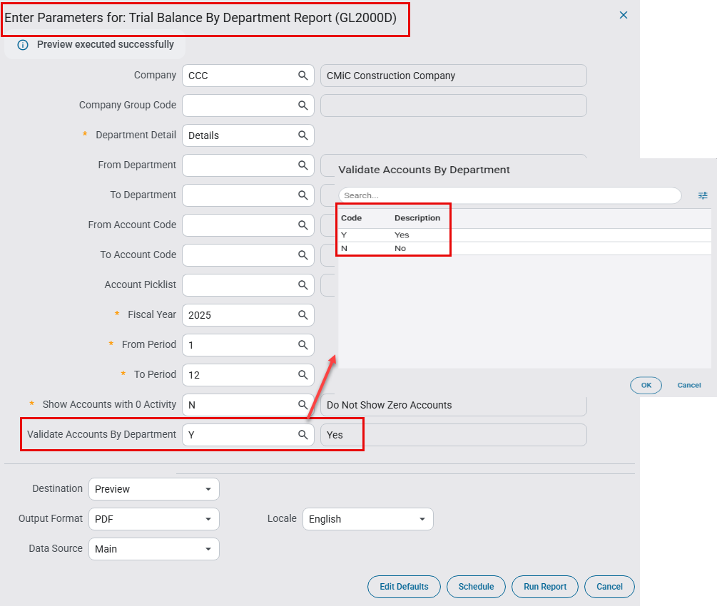
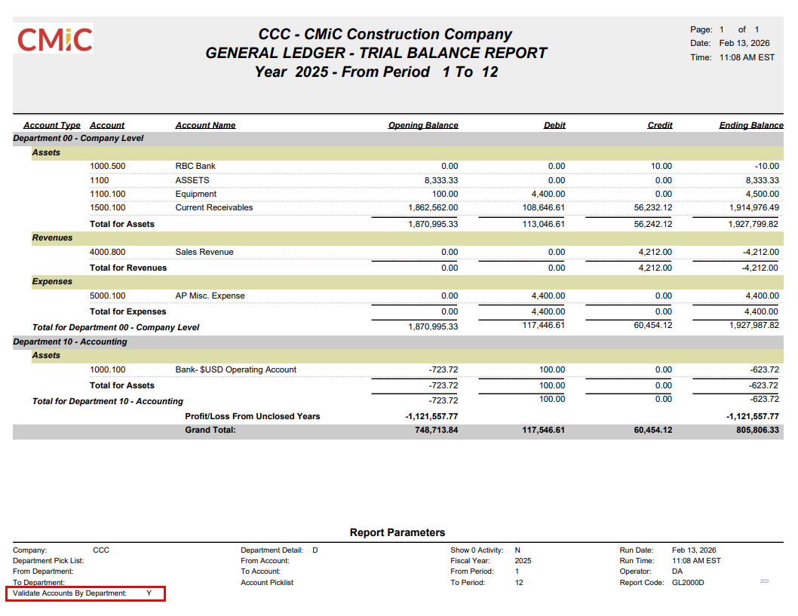

Inventory

Item Detail Program: Additional Fields Enabled in Item Header Import (CAM - 9594)
Overview
In the Item Detail program, the Item Header Import (CIITEMHDR) process has been enhanced to support additional fields for importing records. These enhancements allow users to import extended item configuration details.

Modifications
The following additional fields have been enabled for import via the CSV file:
- Issue At Type (Percentage/Price) *
- Buy Back Type (Percentage/Price) *
- Maximum Order
- Minimum Order
- Standard Order
- Maximum on Hand
- Minimum on Hand
- Standard on Hand

In addition to the “Item Type” field, the following fields are mandatory during record import:
- Issue At Type (Percentage/Price) *
- Buy Back Type (Percentage/Price) *

The following valid values are supported for both Issue At Type and Buy Back Type:
- C - Percentage
- P – Price

Data Import pop up window for Item Header in Item Detail program:
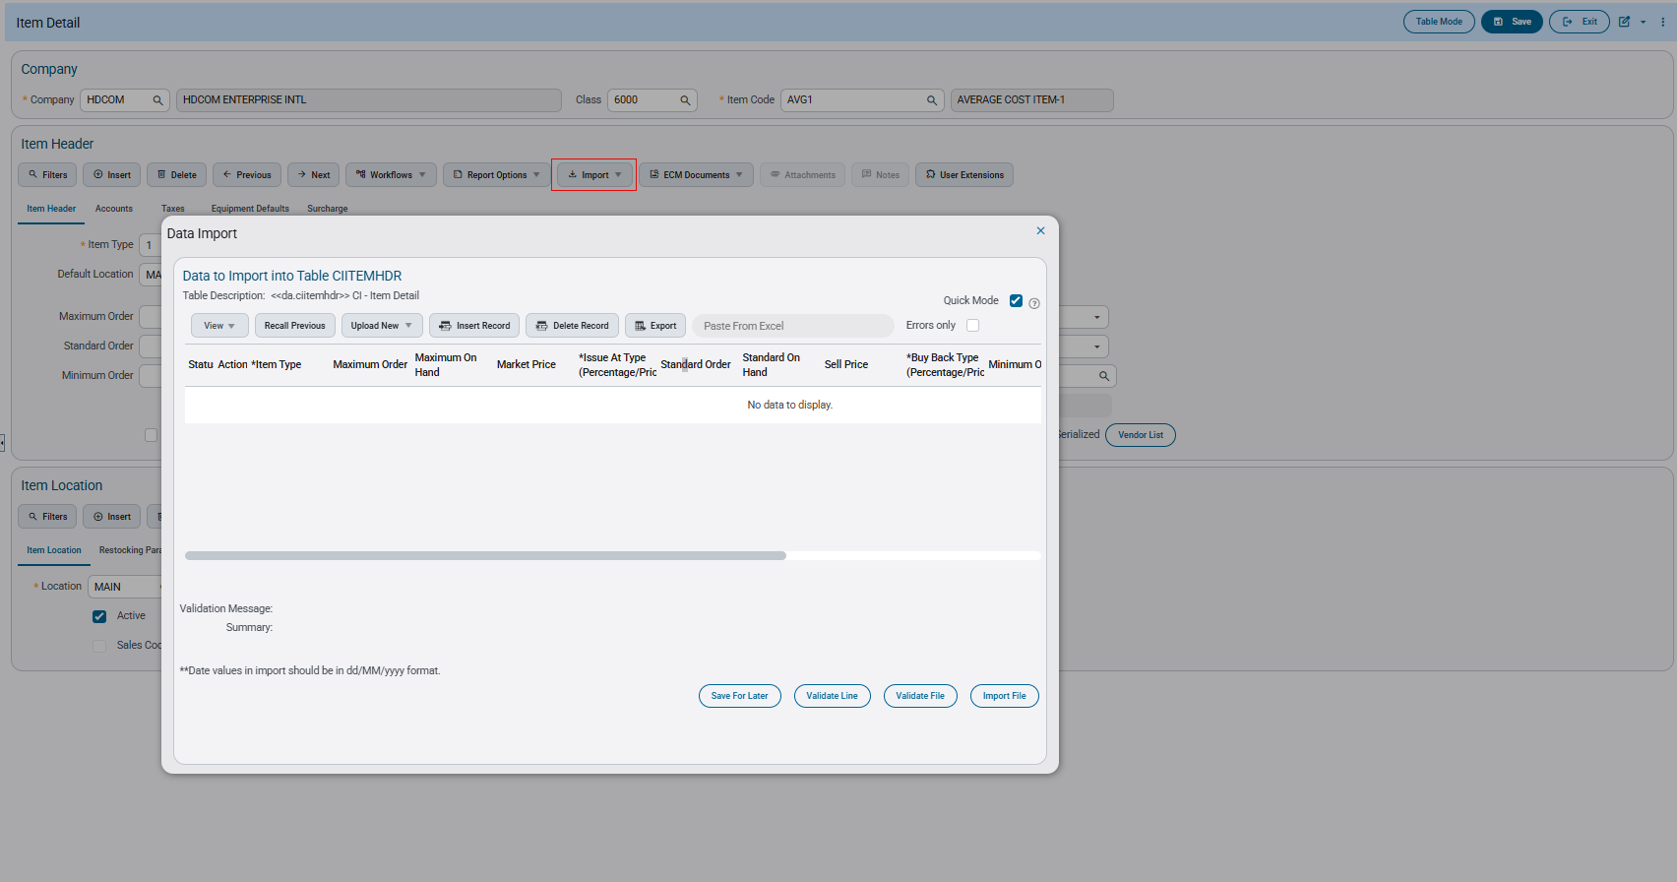
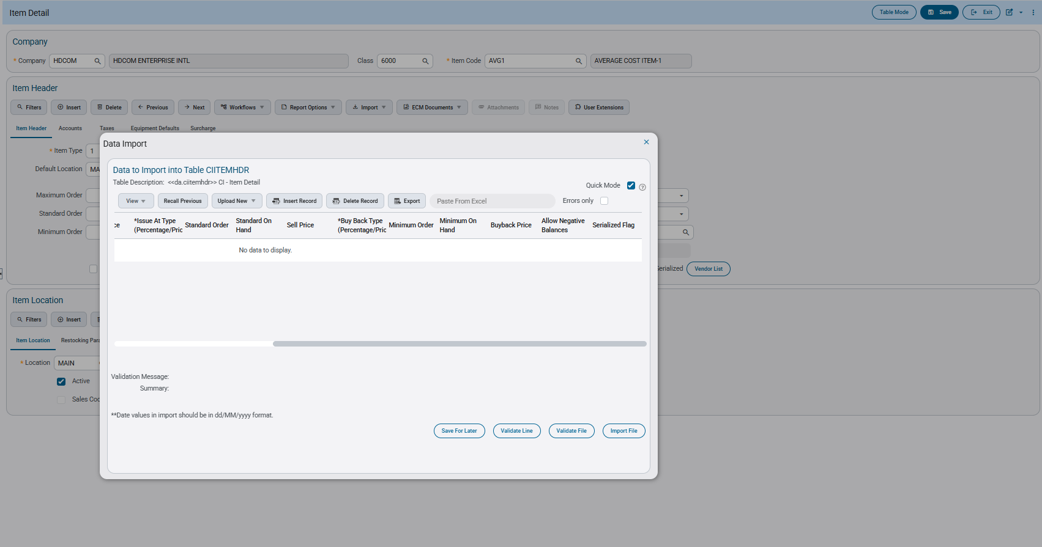

CSV file:

Implementations
The additional mandatory fields must be included in the CSV file during import where applicable.

Following CSV will be imported into the item header

Uploaded file
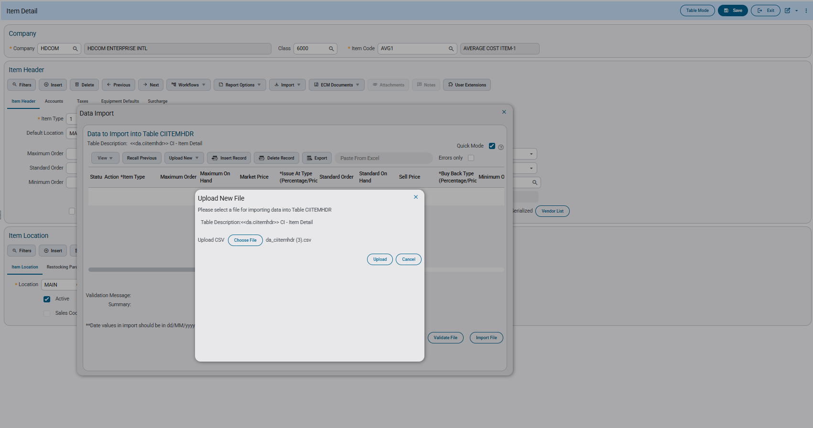

File has been validated
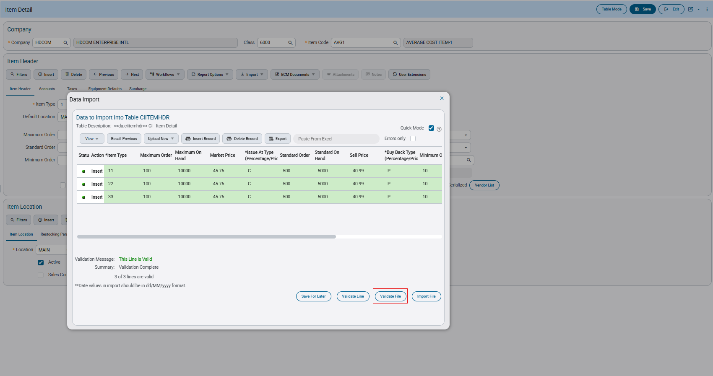

Records are imported successfully in the Item Header.
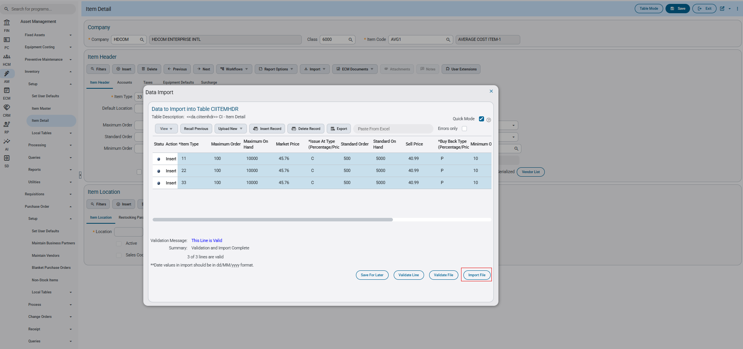
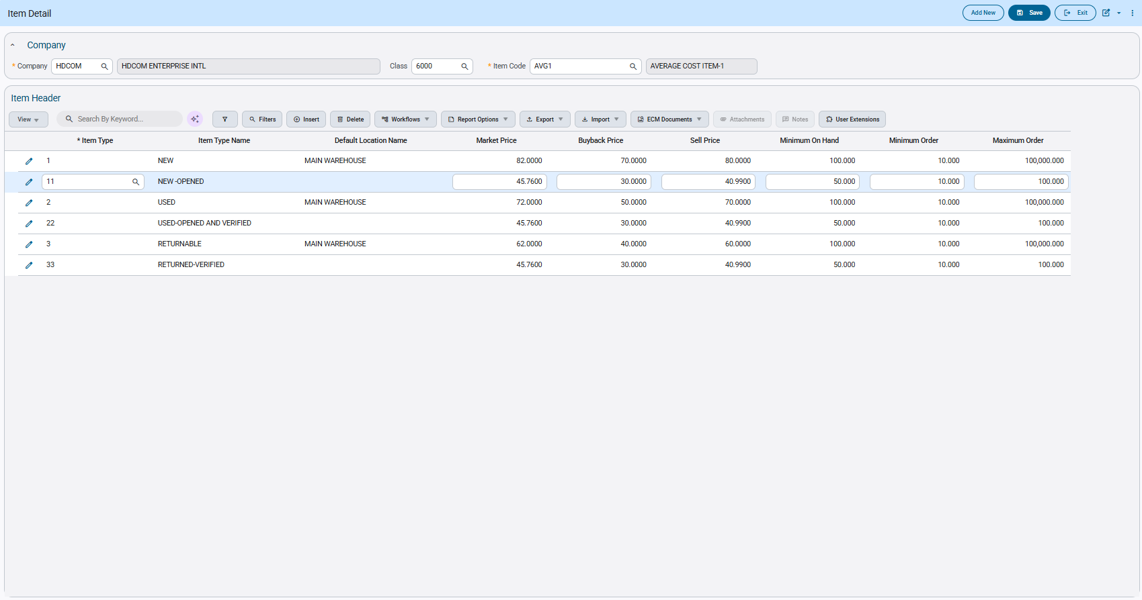

Inventory – New Error Validation on Inventory Locations Program Flag (CAM-10847)
Overview
The Inventory Locations program now includes an error validation when the user attempts to change the Expense Inventory Receipt flag status, while the location contains an item with book-on-hand or book reserved quantity is not zero.
This change limits the risks of bad data for the system.
Modifications
Runtime feature program:
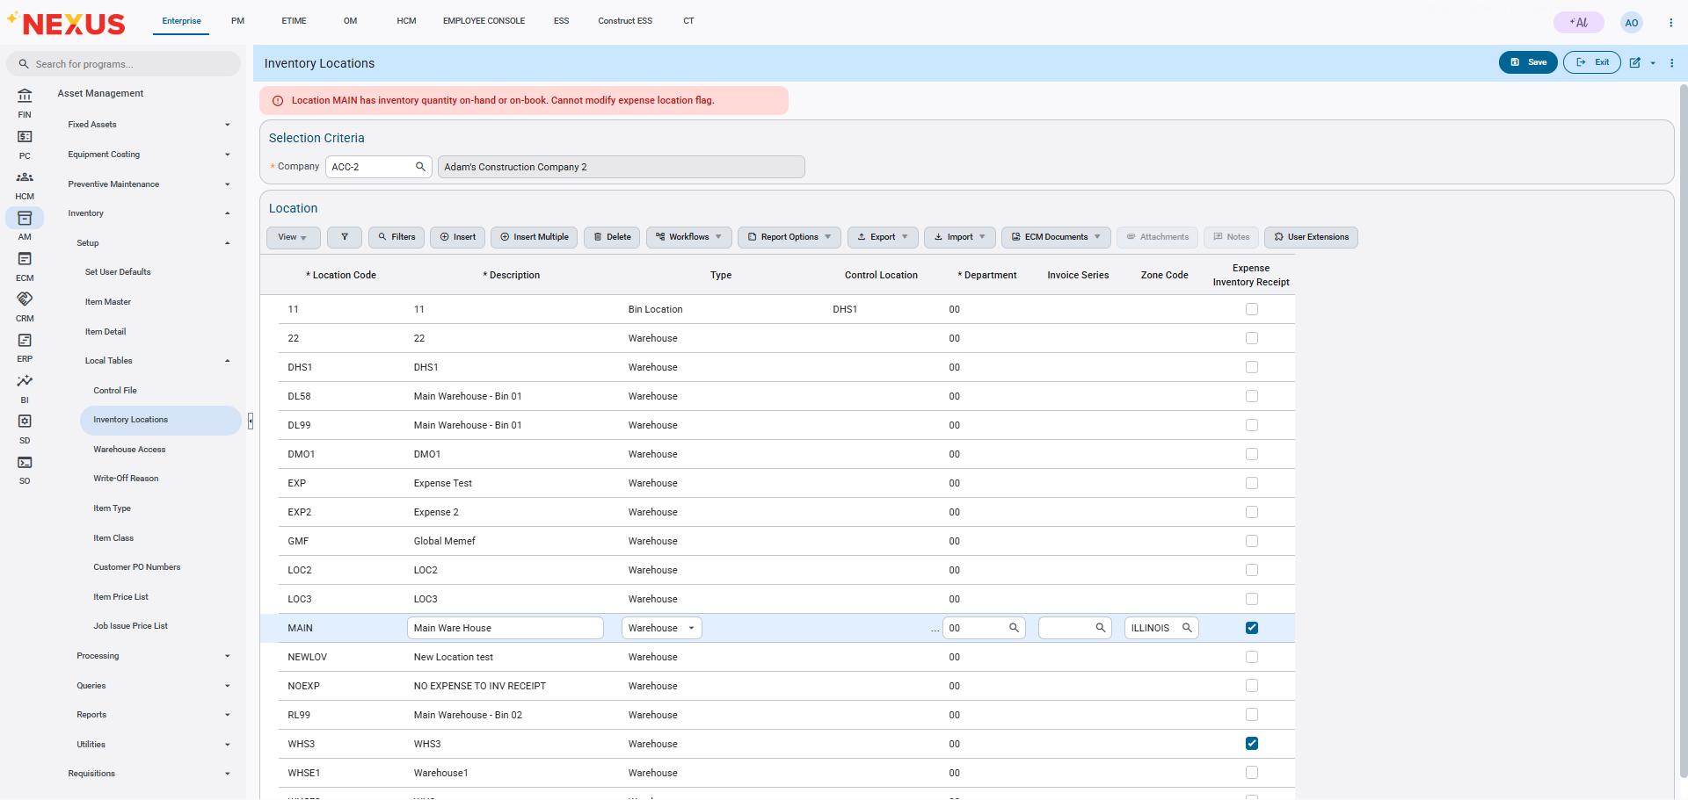
Implementation
This implementation will make it so the user will no longer be allowed to update the expense inventory receipt flag if on hand or on book quantity exists on the record. The following error validation will occur if the user attempts to save after changing the value:
“Location ____ has Inventory quantity on-hand or on-book. Cannot modify expense location flag.”

Job Billing

New Alert Message for “Status” mass update in GC prepare Billing- Cost Transaction Popup (JBJCPC-6545)
Overview
To improve the program performance, a new Alert message has been introduced in “Cost Transaction Popup” of GC Prepare Billing Program (JBBILL2), when user selects “Status” column’s radio button available in table header.
Alert Message: -
“This will update all records in this block with the selected value and save all pending changes you may have done in the screen. Do you want to proceed?”
Modifications

GC Prepare Billing Program (JBBILL2) has been modified to show following alert message when, to update the status of all the transaction record available in table, user selects “Status” column radio button available in table header.
Alert Message: -
“This will update all records in this block with the selected value and save all pending changes you may have done in the screen. Do you want to proceed?”
Upon Selecting “Yes” in the popup, users need to click on “Save” before existing the Popup window and then Recalculate the draw to see the impact of status change.
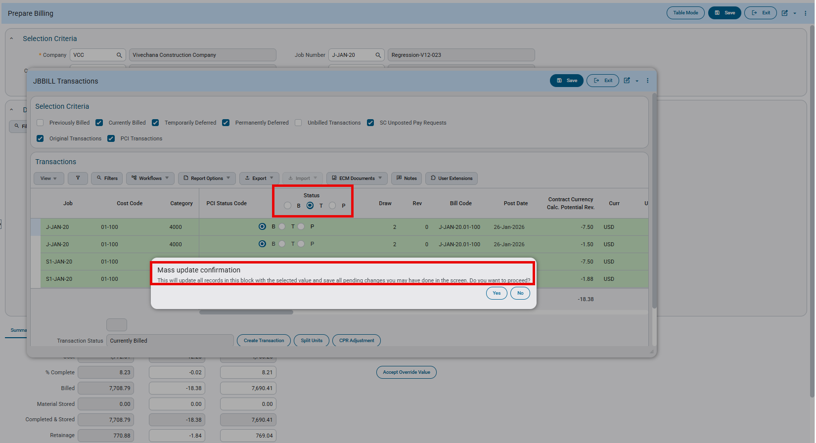
JobBilling>Billing>GC Prepare Billing>Cost Transaction popup
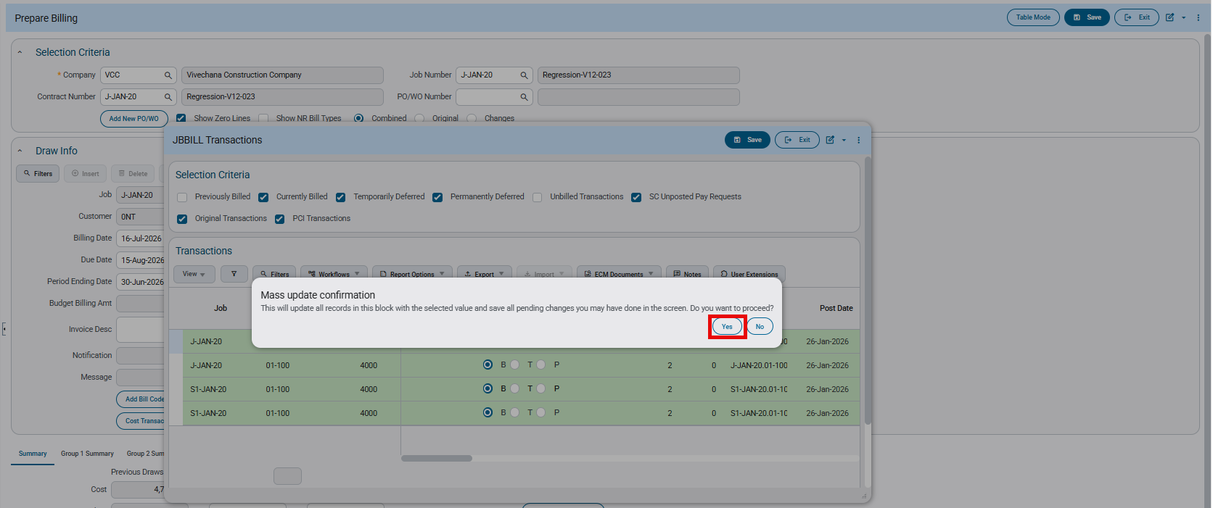
JobBilling>Billing>GC Prepare Billing>Cost Transaction popup
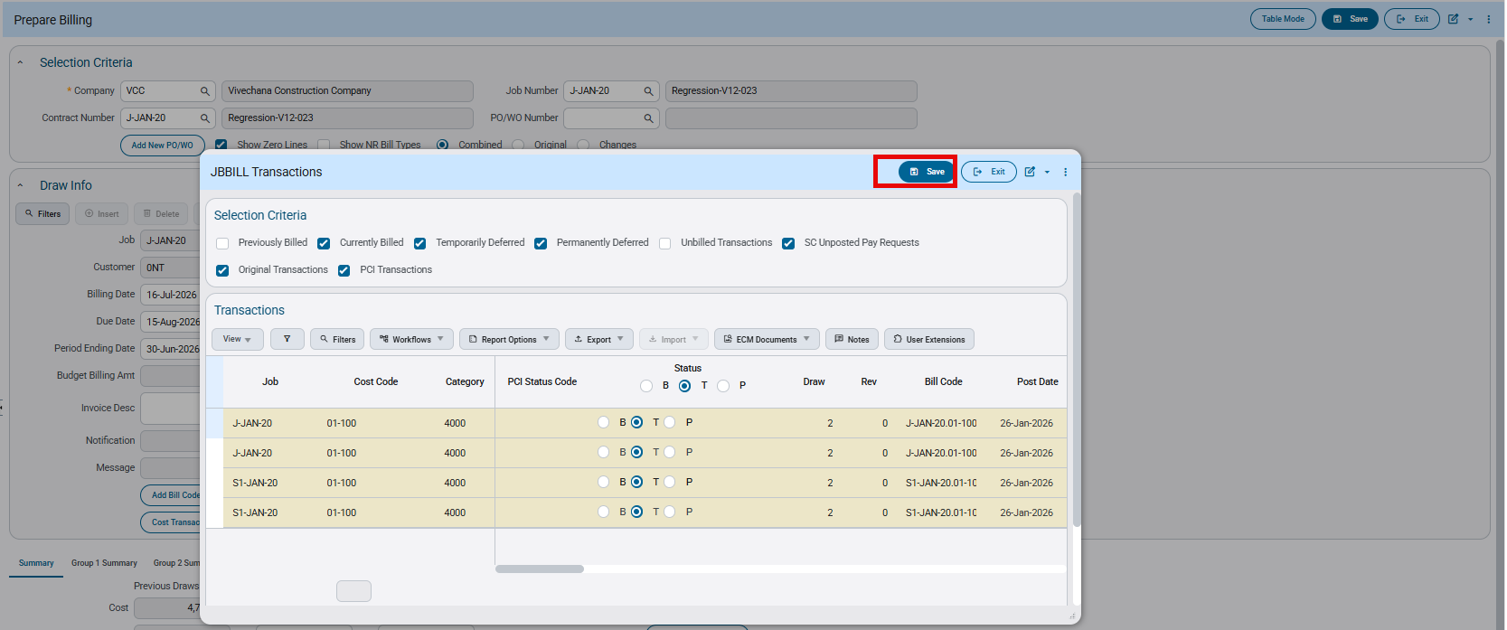
JobBilling>Billing>GC Prepare Billing>Cost Transaction popup

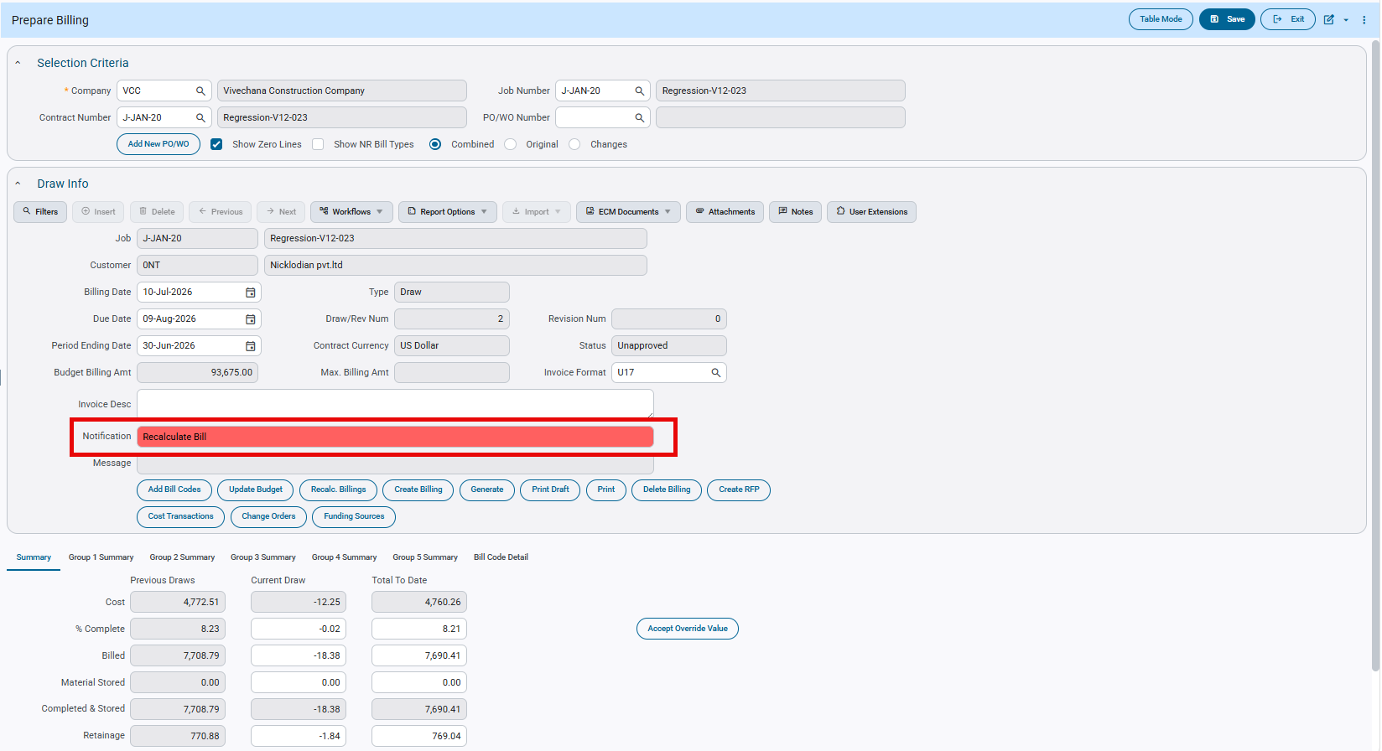
JobBilling>Billing>GC Prepare Billing

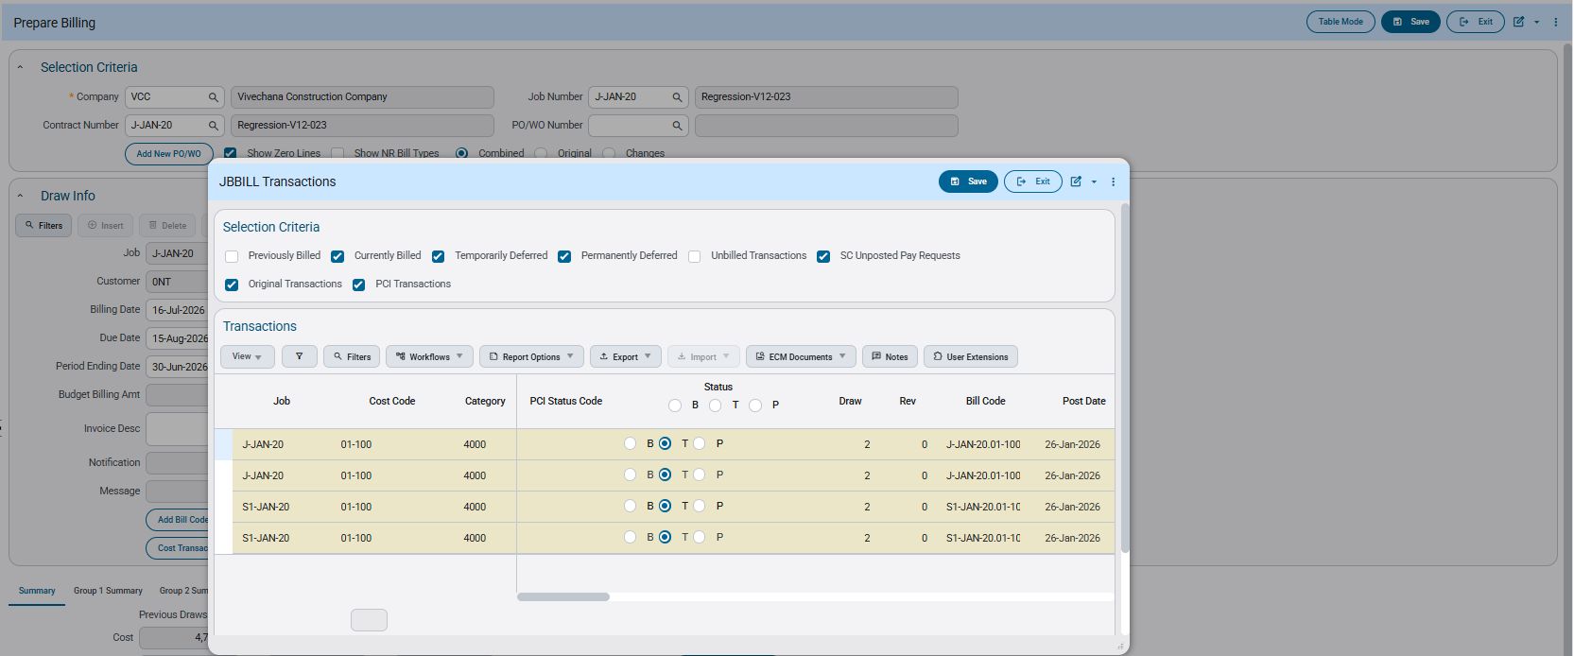
JobBilling>Billing>GC Prepare Billing>Cost Transaction popup

New quantity and Total Material used columns in JBBILL and Retainage on Material stored Flag in JBBILL/JBILL2(PC-13189)

Overview:

This enhancement improves the billing process by making quantity tracking more transparent and retainage calculation on Material Stored more efficient in the JBBILL Prepare Billing screen. To support this, four new quantity columns have been added: This Period Complete Qty, Override This Period Qty, Previous Period Billed Qty, and Total Qty Completed to Date. A new Total Material Used column has also been introduced to track the consumption of stored materials.
Additionally, a new Retainage on Material Stored flag has been added to JB Control and the Contract Entry screen to enable retainage calculation on Material Stored when it is configured as a surcharge. This flag is applicable to both JBBILL and JBBILL2.

Modifications:

- New Quantity Columns-JBBILL Prepare Billing Screen

The following four columns have been added to the JBBILL Prepare Billing screen:

- This Period Complete Qty: A read-only column that displays the quantity from transactions included in the current billing draw only. It does not show overrides or data from previous draws.
- Override This Period Qty: An editable column that allows users to override the transaction quantity for the current period. When an override is entered, the column is highlighted in red and recalculation is required for the changes to take effect.
- Previous Period Billed Qty: A read-only column that displays the cumulative quantity completed through the prior billing draw, including any overrides applied in previous draws.
- Total Qty Completed to Date: A read-only column that displays the total quantity billed up to and including the current draw. It is calculated as Override This Period Qty (if an override has been entered) or This Period Complete Qty, plus Previous Period Billed Qty.
- Total Material Used Column-JBBILL Screen

A new Total Material Used column has been added to the JBBILL screen (not applicable to JBBILL2). This column accepts positive values only and maintains a running total of material stored that has been consumed. When a value is entered, the corresponding amount is deducted from the Material Stored column.

Note: The system will not accept negative values in this column. If a negative value is entered, the following error message will appear: "Total Material Used cannot be less than Zero."

- Retainage On Material Stored Flag
A new Retainage on Material Stored flag has been added to the following programs:

- Billing tab-JB Control: Sets the company-level default for this flag.
- Defaults tab-Contract Entry screen: The flag defaults from the value from JB Control and can be applied at the contract level.
This flag is available for selection only when the existing Material Stored Included in Calculated Billing Amount flag is unchecked (i.e., Material Stored is treated as a surcharge). This flag is applicable for both JBBILL and JBBILL2.
Once a billing draw has been initiated, this flag cannot be changed at the contract level. To modify it, all existing billings must be deleted first.

- Checked(Y)-Retainage is calculated on the Material Stored amount.
- Unchecked(N)-Retainage is not calculated on Material Stored.

JB Control:

New ‘Retainage on Material Stored’ flag available in JB control
This flag is enabled only when the ‘Material Stored Included in Calculated Billing Amount’ is unchecked(N)

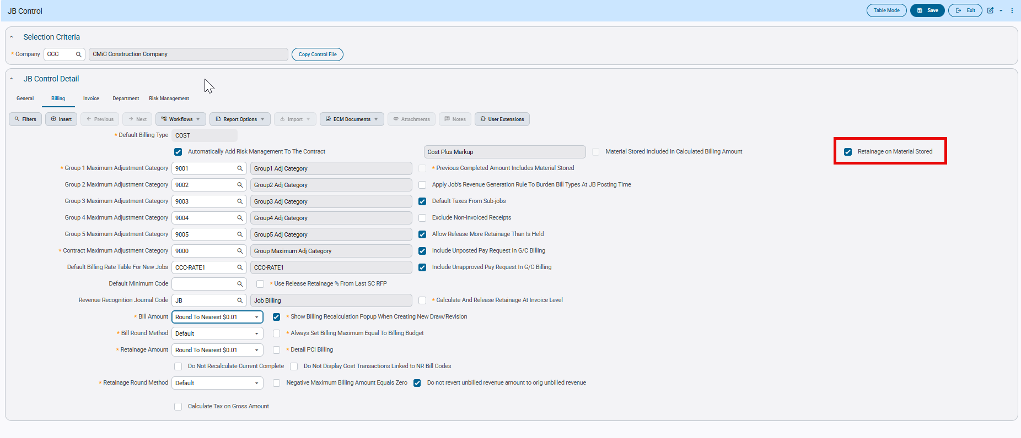
Job Billing>Setup>Local Tables>Control

Contract Entry screen:
The flag is available in the Contract entry screen, and the value is defaulted from JB Control.

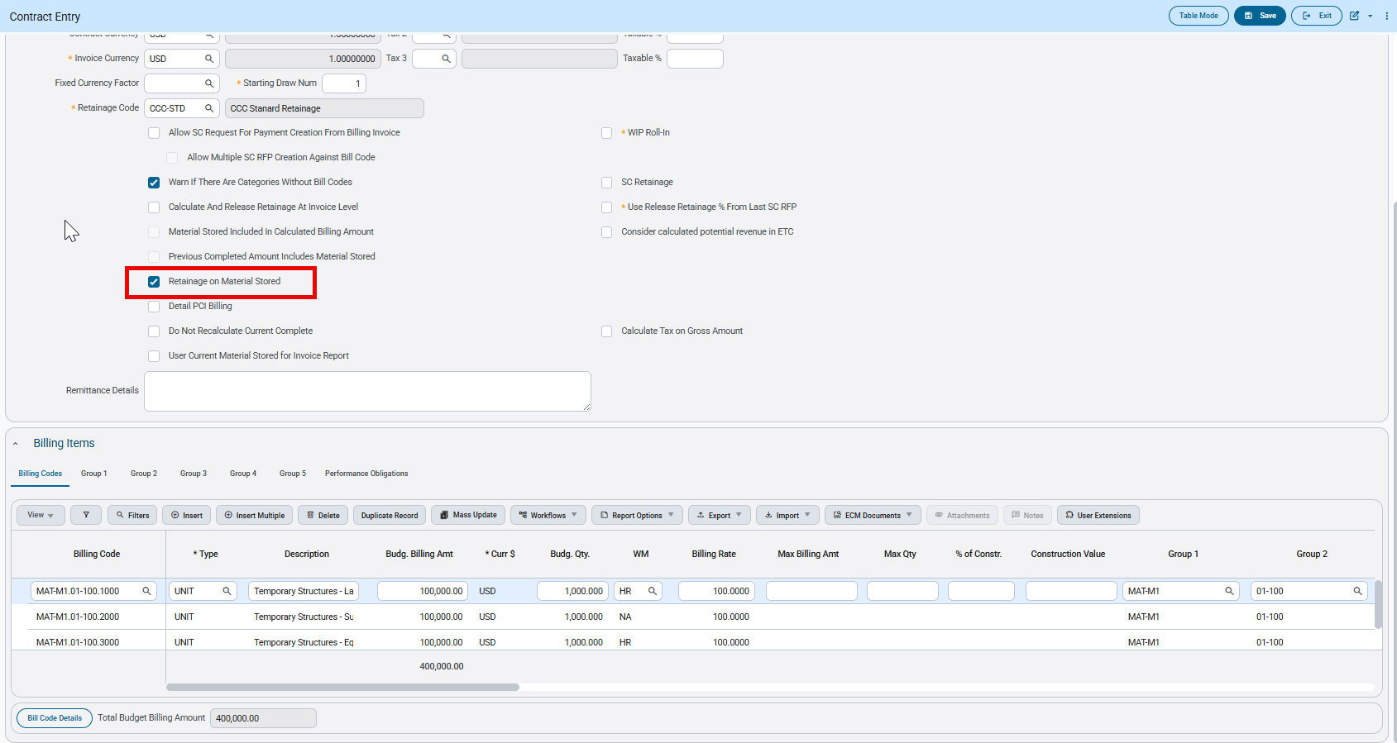
Job Billing>Contracts>Enter Contract

Examples
The following examples are illustrated with UNIT Billing type as a reference.

- New Quantity Columns-Prepare Billing screen (JBBILL)
The four new columns introduced in the JBBILL screen are:
- This period Complete Qty
- Override This Period Qty
- Previous Period Billed Qty
- Total Qty Completed to Date
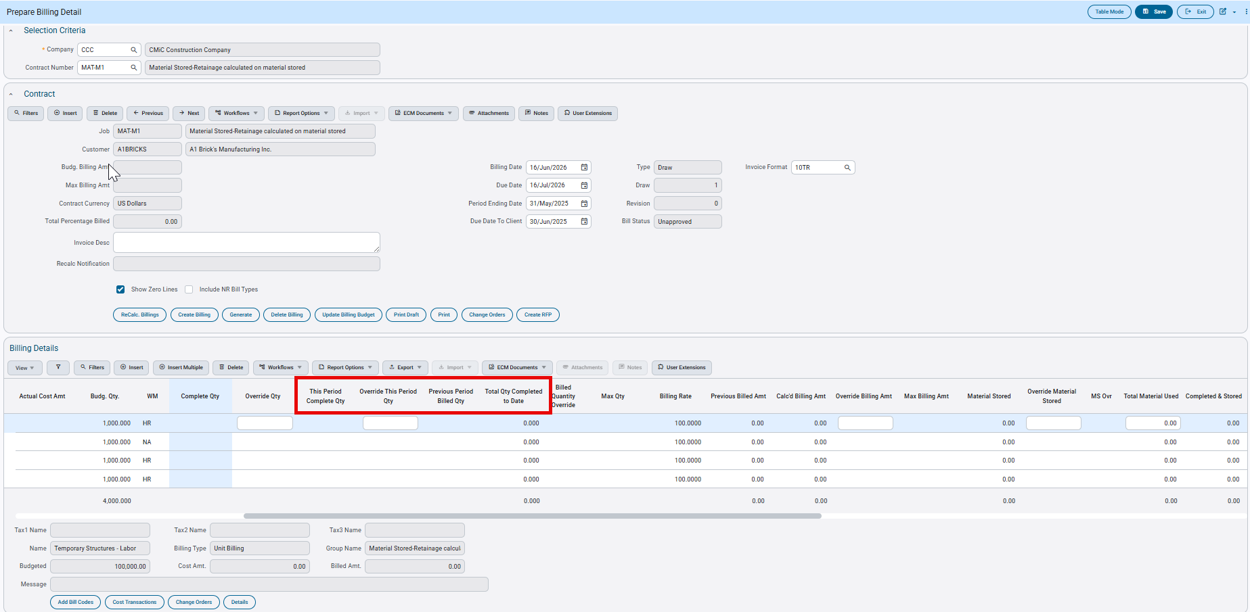
Job Billing>Billing>Prepare Billing

Draw1:
Draw1 is created and following transactions are included:
Actual Cost Amount=1000.00 (from JC Cost Transactions)
Quantity in Cost transaction=10.00
Completed and stored=Complete qty*Billing Rate=10*100=1000.00
Override Qty-None

‘This Period Complete Qty’ shows as 10.00. This is a read only column and reflects the quantity directly from transactions included in this draw only.

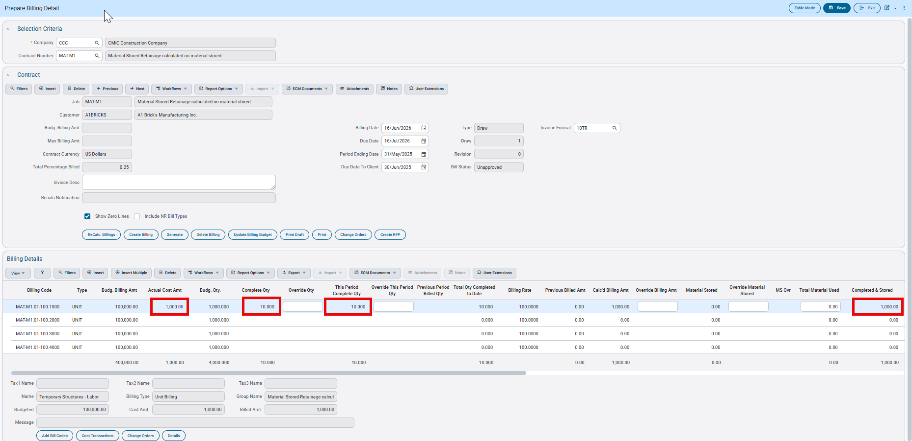

Draw2:
Scenario1: No overrides
Draw1 is posted and Draw2 is created with the following transactions:

Cost Transaction Amount (Draw2 only) =1500.00
Actual Cost Amount=2500.00 (This includes the previous draw)
Quantity in Cost transaction=15.00
No Overridden Quantity on draw.
‘This Period Complete Qty’ column displays 15.00, reflecting only the quantity from transactions included in Draw 2.

The Complete Qty column shows the total quantities completed up to and including the current draw. It does not include any overridden values.

The Total Qty Completed to date column is a read-only column that displays the total quantity billed up to and including the current draw. It is calculated as follows:

- Without overrides in any of the draws:
Total Qty Completed to Date will always match the Completed Qty column.
Total Qty Completed to Date=This Period Complete Qty + Previous Period Billed Qty

- With overrides:
Total Qty Completed to Date=Override This Period Qty + Previous Period Billed Qty

Note: When all quantity overrides are cleared, the Total Qty Completed to Date will always match the Completed Qty column.

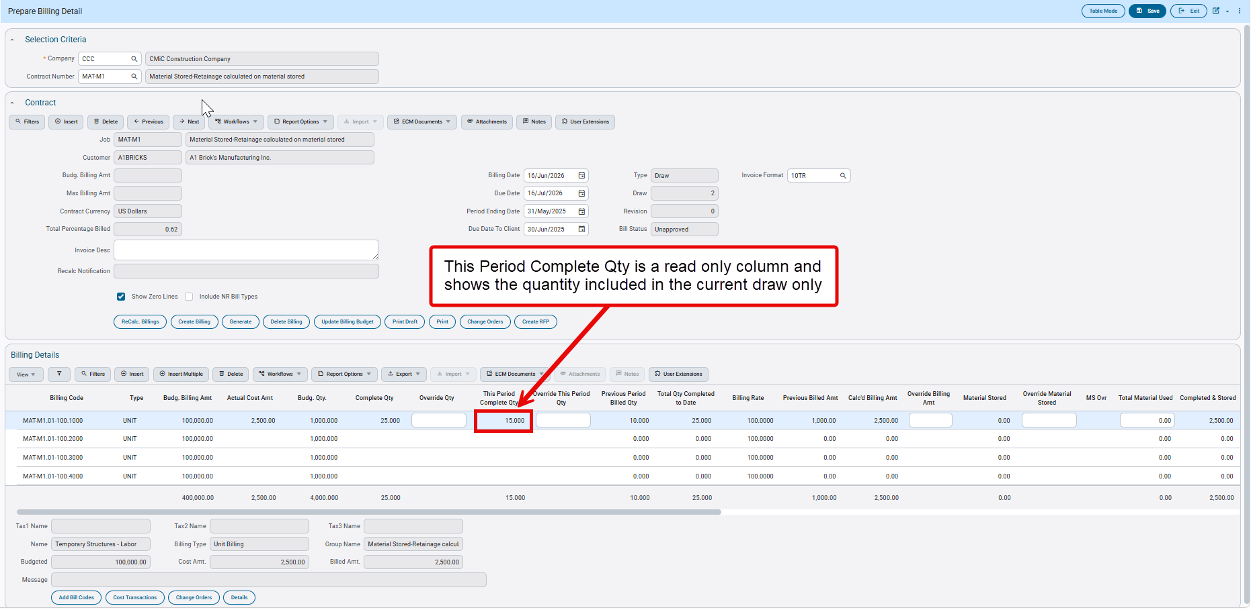

Scenario2: Overriding Quantity columns

In this scenario, the existing Override Qty column is overridden to 30.00.

When Override Qty is updated, the new Override This Period Qty column automatically recalculates:
Override This Period Qty = Override Qty − Previous Period Billed Qty = 30.00 − 10.00 = 20.00

The Complete Qty column displays 25.00, which represents the total quantities from transactions included in Draw1 (10.00) and Draw 2 (15.00). This column reflects transaction data only and is not affected by overrides.

Since Override Qty has been overridden in Draw 2, the Total Qty Completed to Date is calculated using the override value:

Total Qty Completed to Date = Override This Period Qty + Previous Period Billed Qty = 20.00 + 10.00 = 30.00

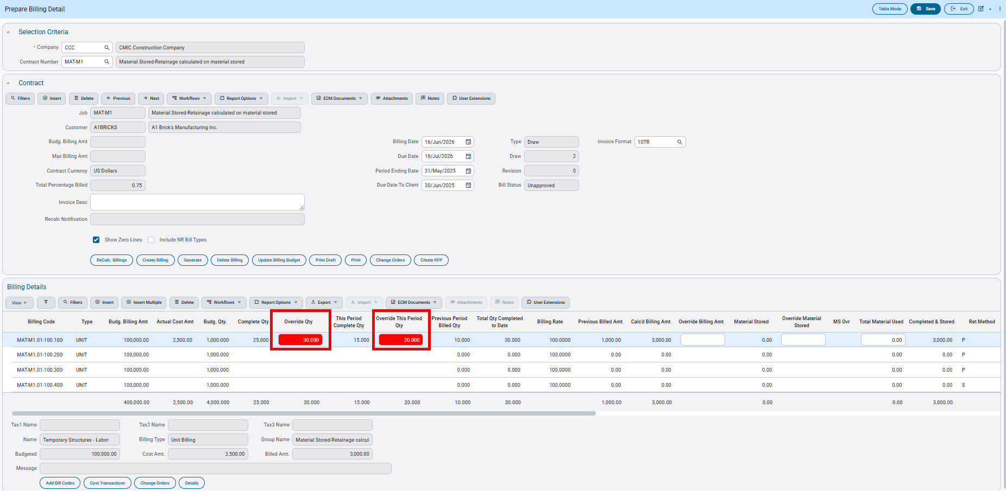

Now Overriding the new ‘Override This Period Qty’ column to 25.00.

When this column is updated, the Override Qty and Total Qty Completed to Date columns are automatically recalculated based on the formulas described above. The Complete Qty and This Period Complete Qty columns are not affected — they continue to display quantities from transactions only and do not reflect any overridden values.

Completed and stored=35.00*100.00=3500.00
Previously Billed=1000.00
Billed for this draw=2500.00

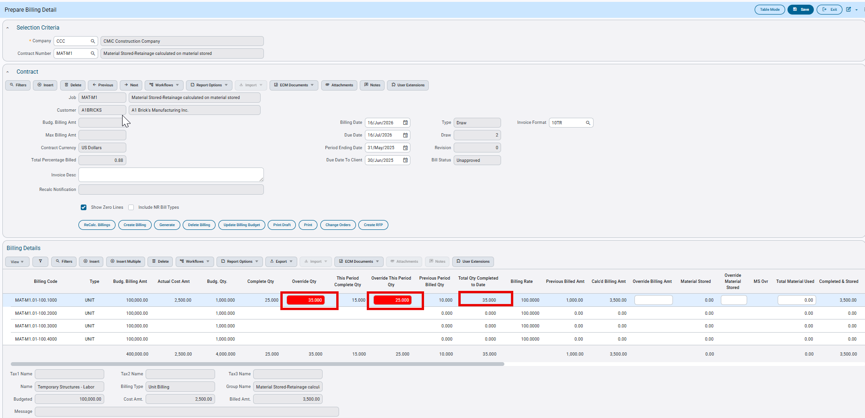

Draw3:

Draw2 is posted and Draw3 is created.

Scenario 1 — No Overrides or Transactions Included
When Draw 3 is opened, no transactions have been included yet. The columns display the carried-forward values from the previous draw.

Previous Period Billed Qty is a read-only column that shows the cumulative quantity completed through the prior billing draw, including any overrides that were applied in previous draws.

In this example, it displays 35.00 because quantities were overridden in Draw 2.
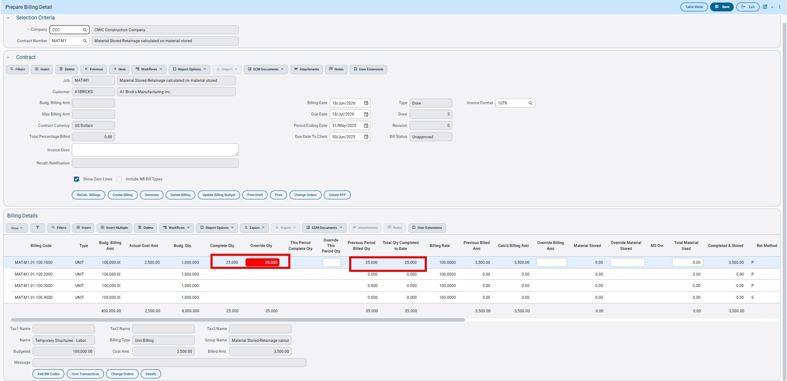

Scenario2: Posting Cost Transactions with Quantity

In this scenario, cost transactions are included in Draw 3 without clearing the overrides from the previous draw.

Cost Transaction Amount (Draw 3 only) = 2,500.00
Actual Cost Amount (cumulative, including previous draws) = 5,000.00
Quantity in Cost Transaction = 25.00
No overrides have been applied to quantities in this draw.

Since the cost transactions are now included, This Period Complete Qty displays 25.00. However, the invoice will not reflect 50.00 — it will continue to show 35.00, the value from the Total Qty Completed to Date column. This is because quantities were overridden in the previous period.

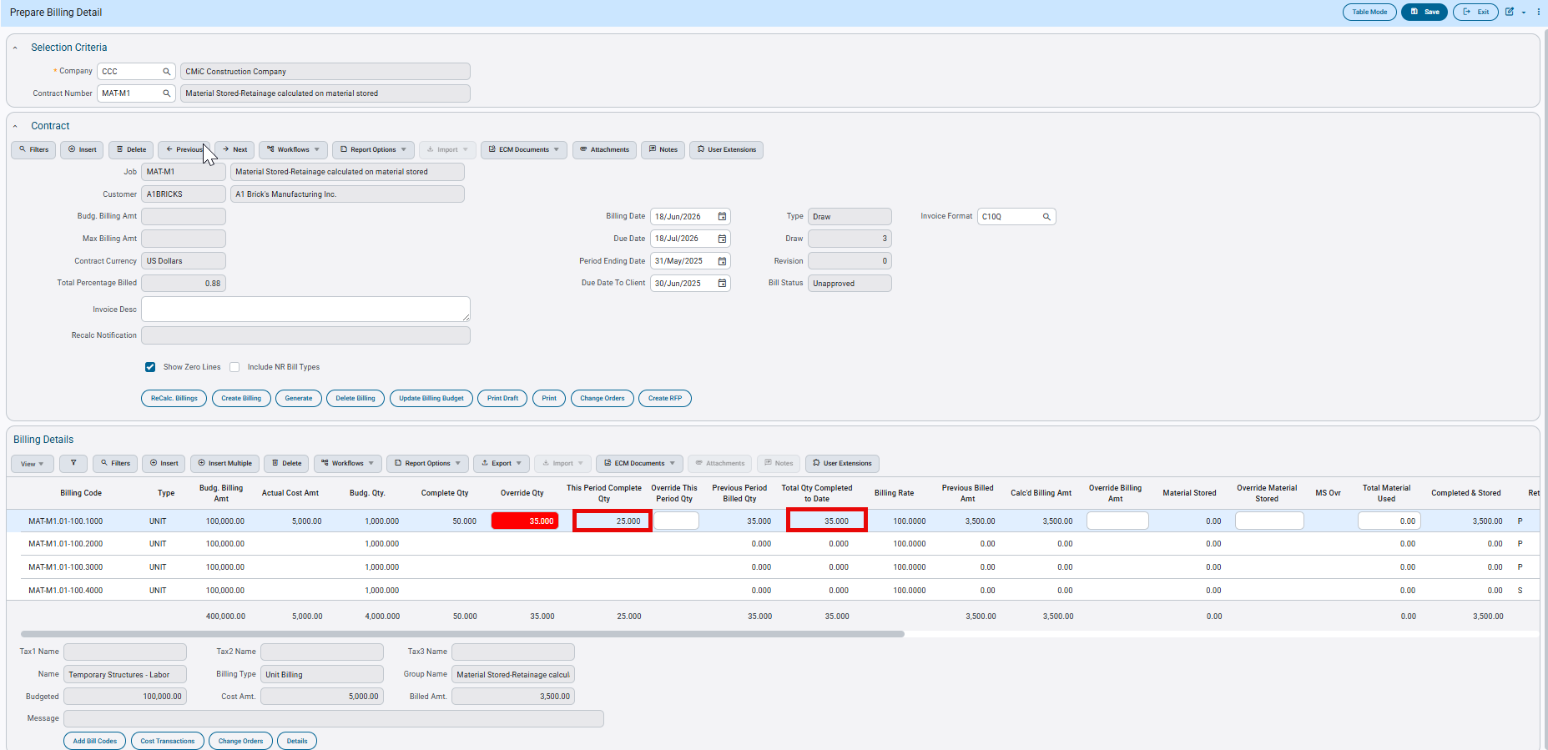

The invoice displays a quantity of 35.00, which is the overridden value from the Total Qty Completed to Date column.
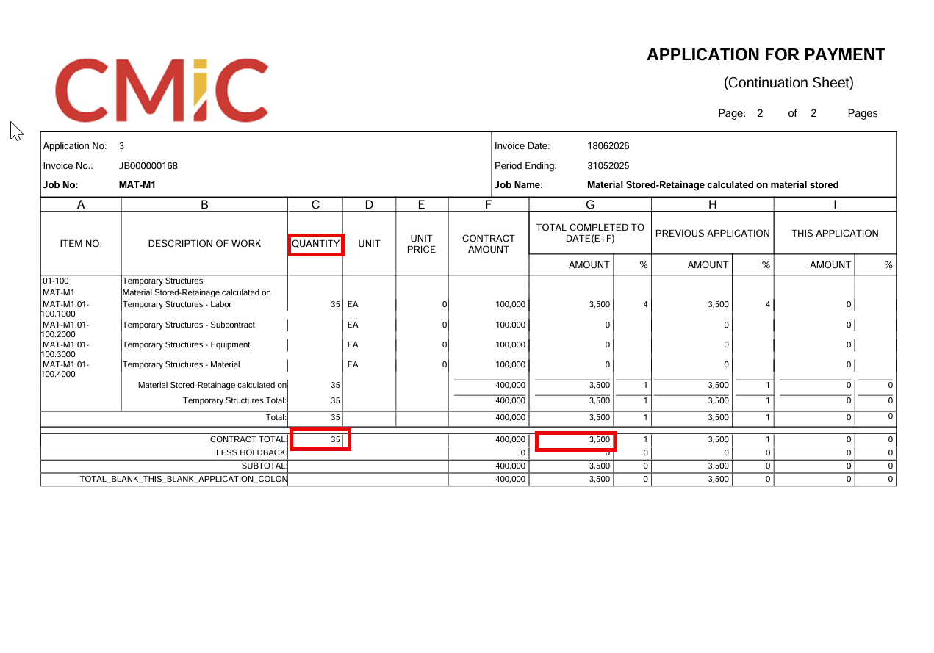

Scenario3: Clearing Overrides

When quantity overrides are cleared and recalculated, the system replaces the overridden values with the actual transaction quantities included in the draw.

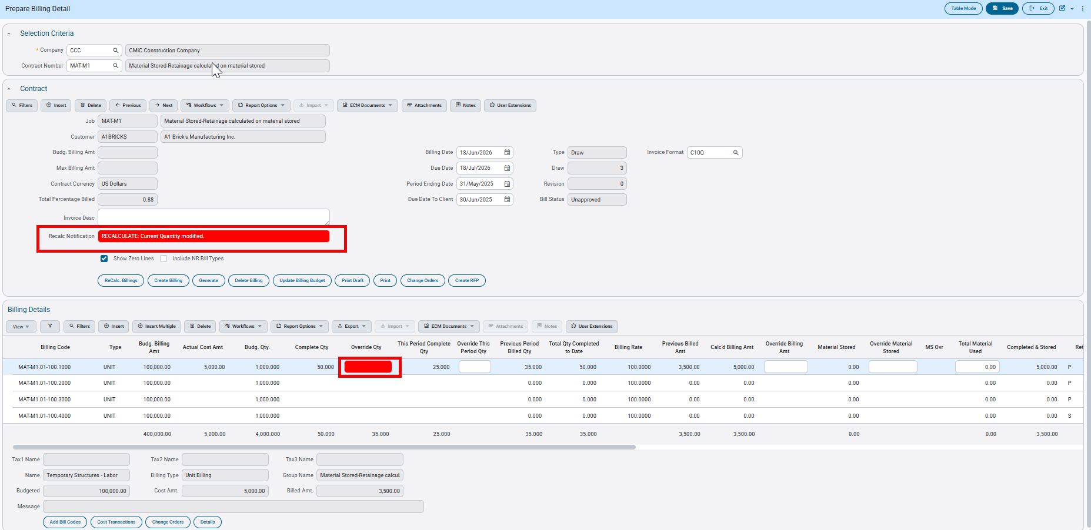

After clearing any overrides and recalculating, Total Qty Completed to Date will align with the Complete Qty and update to 50.00

Completed & Stored = 50.00 × 100.00 = 5,000.00
Previously Billed = 3,500.00
Billed This Draw = 1,500.00
Note: The Previous Period Billed Qty column continues to display the cumulative quantity completed through the prior billing draw, including any overrides that were applied in previous draws. Clearing overrides in the current draw does not change this value.

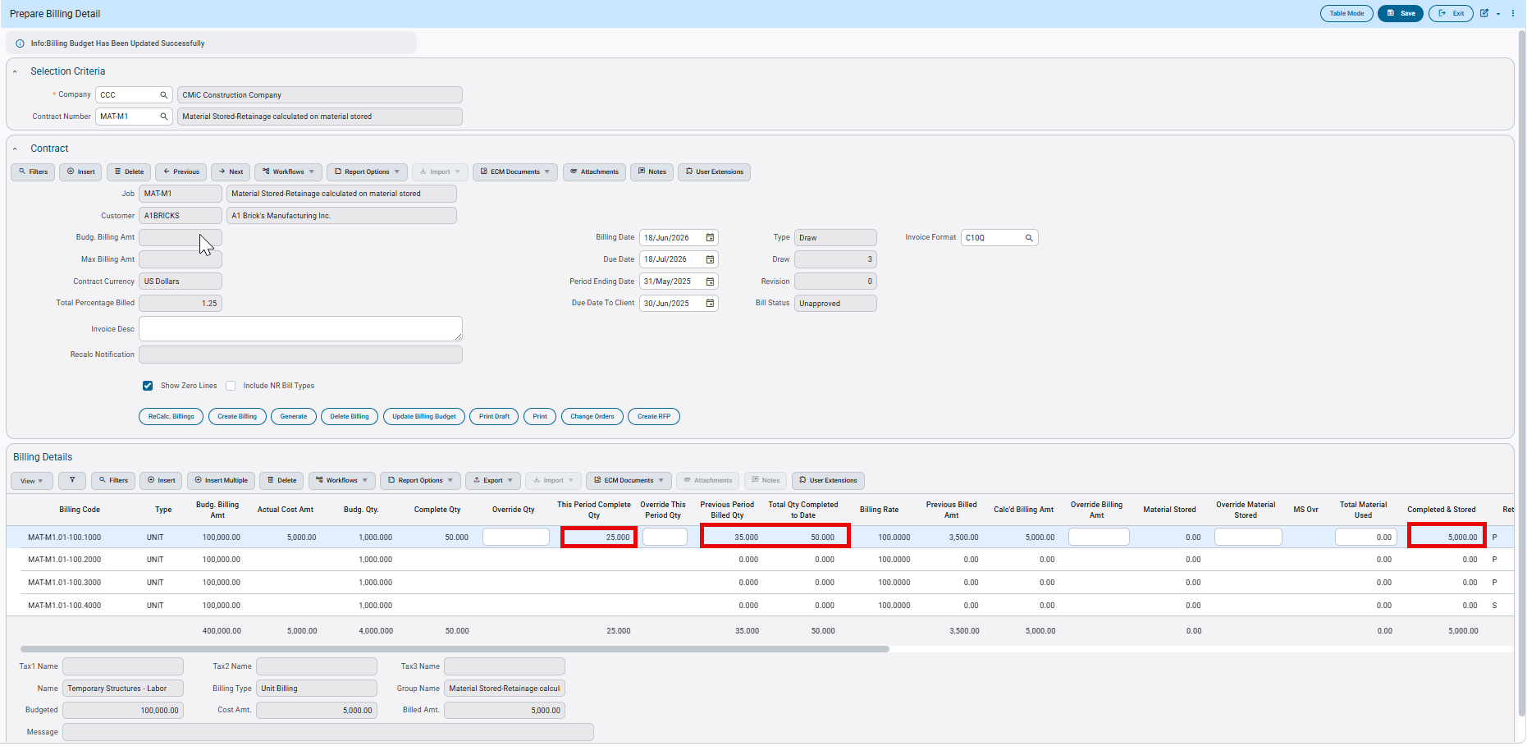

The invoice now shows a quantity of 50.00, which includes the quantities from all transactions included in the draws.

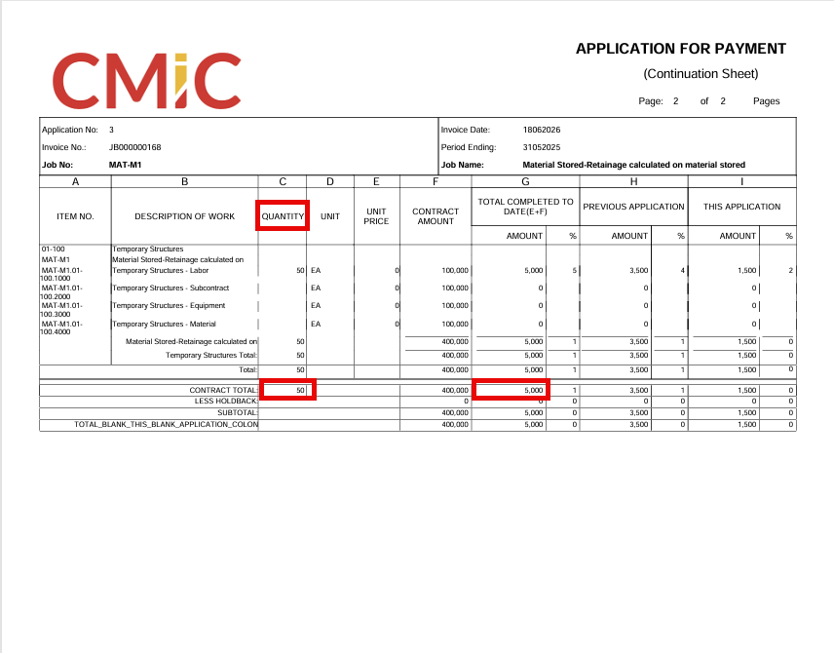

Scenario 4 — Clearing Overrides and Excluding Transactions

When overrides are cleared and transactions are excluded from the draw, the Total Qty Completed to Date becomes 25.00. The effective quantity for the current period is -5.00, since the Previous Period Billed Qty is 35.00 and Complete Qty is 25.00.

Completed & Stored = 2,500.00
Previously Billed = 3,500.00
Billed This Draw = -1,000.00

The invoice reflects a quantity of 25.00, resulting in a reduction of the billed amount for the current period.

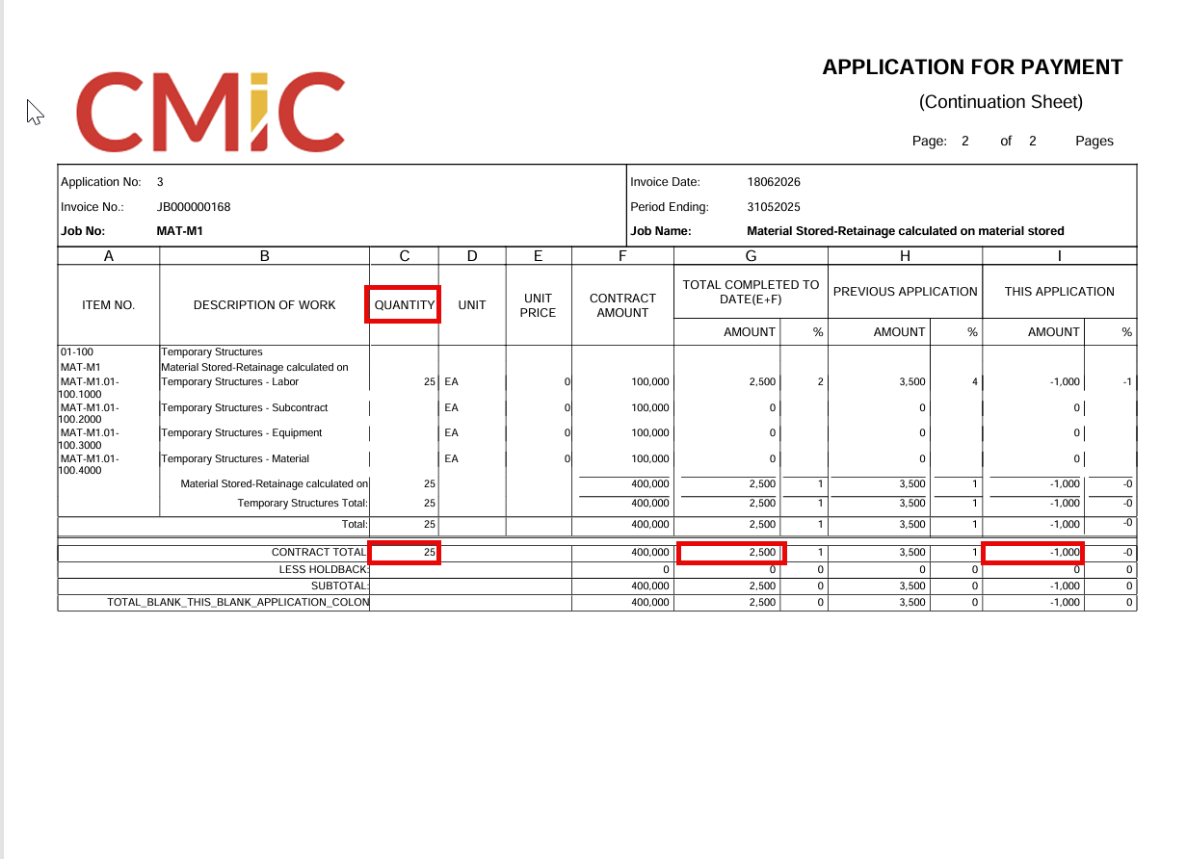

- New Total Material Used column-JBBILL screen

In this example below, Material stored is treated as a surcharge.

Contract Setup:

The flag ‘Material Stored Included in Calculated Billing Amount’ is unchecked(N). As a result, Material Stored is considered a surcharge.
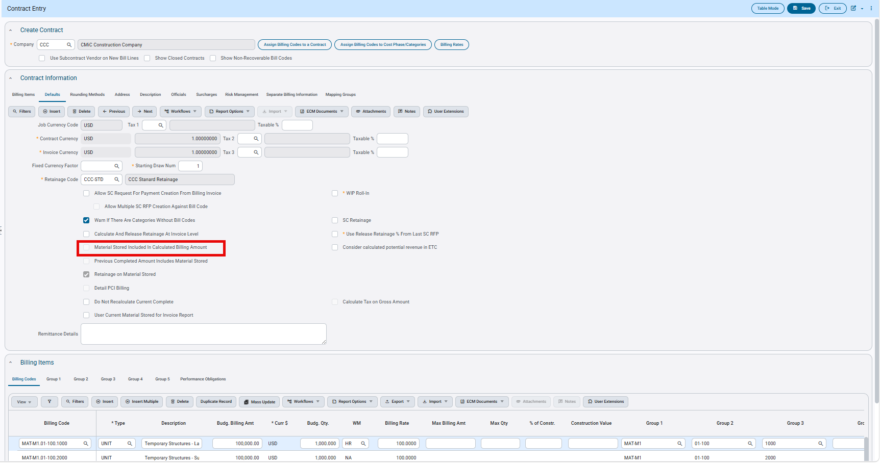

Draw1:

Draw1 is created and following transactions are included:

Complete Qty=150.00 (from JC Cost Transactions and RFP posting)
Calculated Billing Amt=150*200=30000.00
Material Stored=5000.00(from SCRFP posting)
Since Material Stored is a surcharge, Completed and Stored = 30000.00+5000.00=35000.00
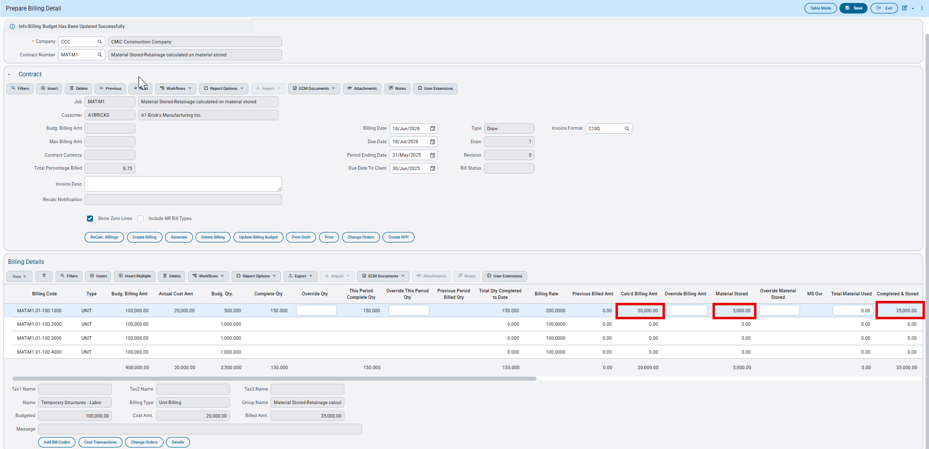

Draw2:

When Draw2 is opened, the columns display the values as shown below
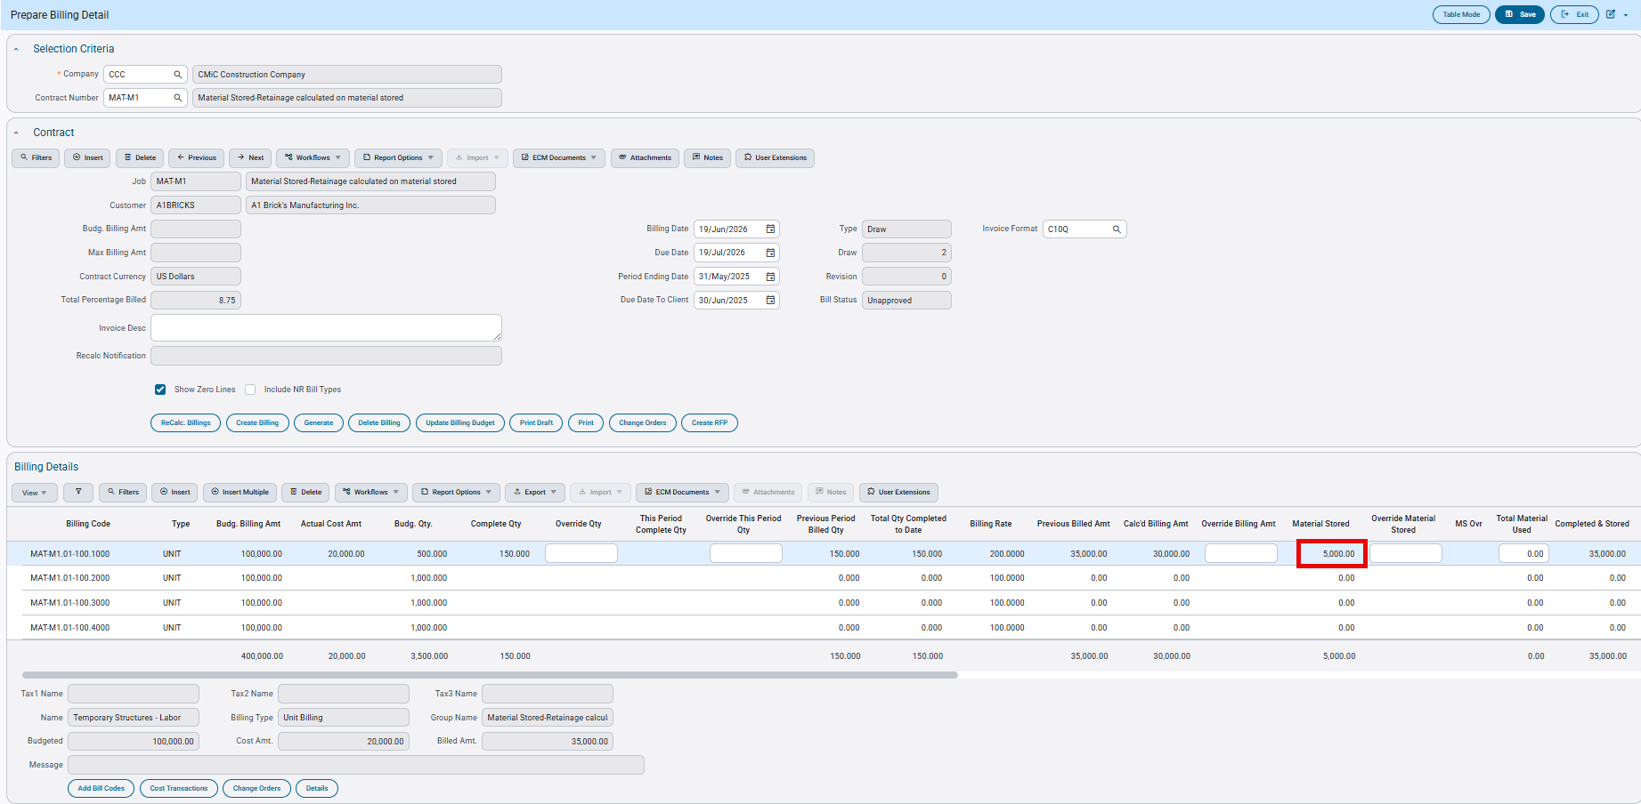

Scenario1:

Entering Total Material Used as 2000.00

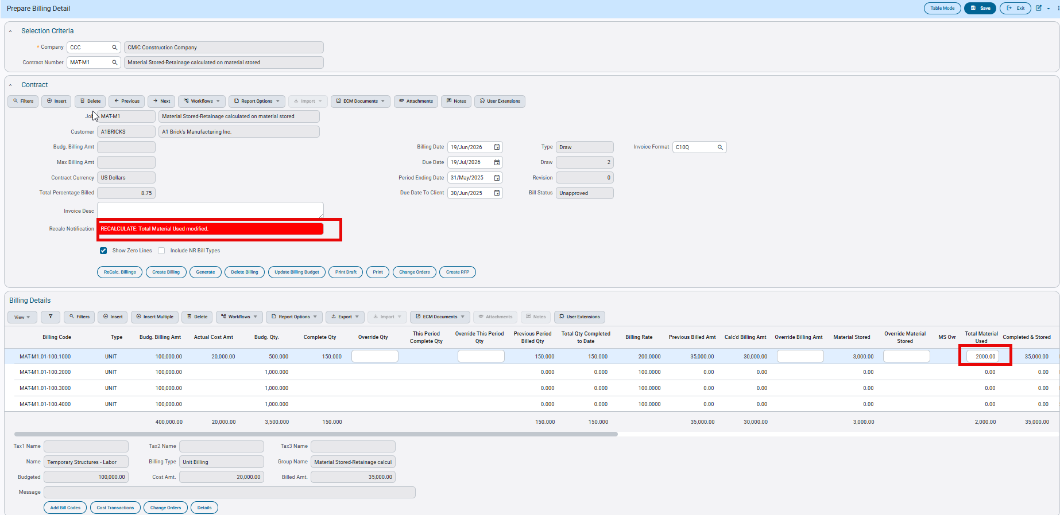

The system reduces the Material Stored column by the Total Material Used value:

Material Stored = Initial Material Stored - Total Material Used = 5,000.00 - 2,000.00 = 3,000.00
The Completed & Stored amount is not affected and remains unchanged.

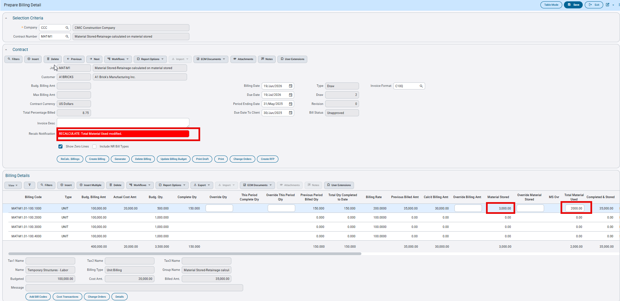

Scenario 2 — Including Transactions

On the same draw, the following transactions are included:

Complete Qty = 250.00 (from JC Cost Transactions, including Draw1)
Calculated Billing Amount = 250 × 200 = 50,000.00

There is no change to Material Stored or Total Material Used.

Since Material Stored is a surcharge:
Completed & Stored = 55,000.00

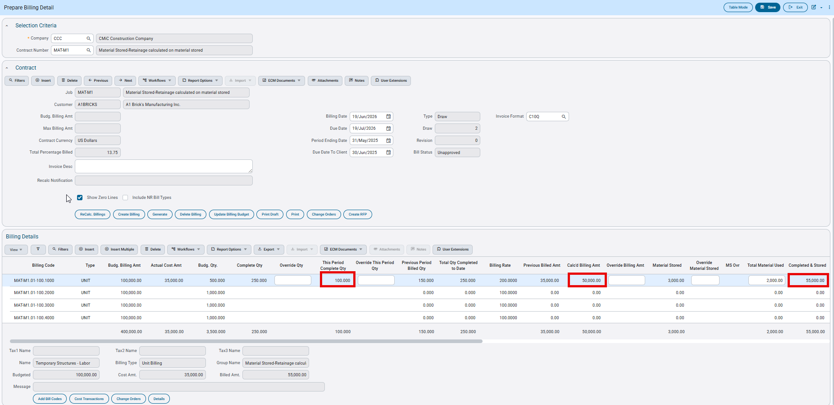

Draw3:

Draw 2 is posted and Draw 3 is created.

Scenario 1 — Additional Material Stored Included

The following transactions are included in Draw 3:

Complete Qty = 300.00 (from JC Cost Transactions and RFP posting, including previous draws)
Calculated Billing Amount = 300 × 200 = 60,000.00
Additional Material Stored (this draw) = 1,200.00 (from SCRFP posting)
Cumulative Material Stored (from SCRFP posting including all previous draws) = 6,200.00

Since Material Stored is a surcharge:

Completed & Stored = 60,000.00 + 6,200.00 = 66,200.00

Since Total Material Used to date is 2,000.00, the Material Stored column displays:
Material Stored = 6,200.00 - 2,000.00 = 4,200.00

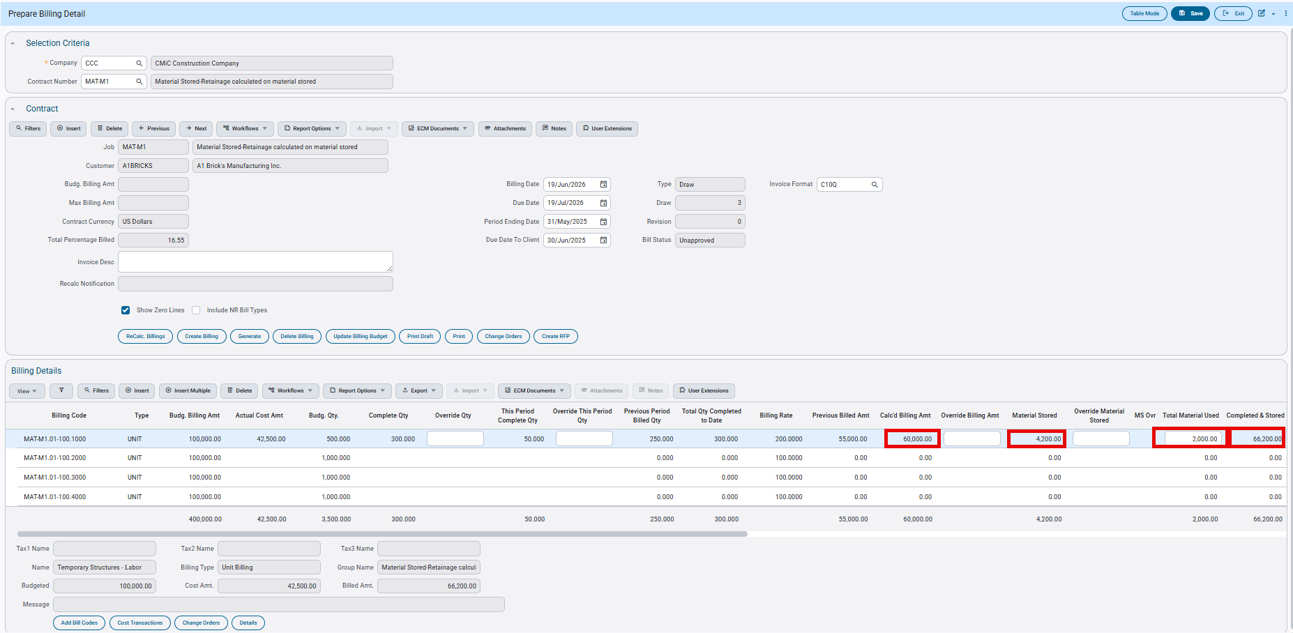

Scenario 2 — Updating Total Material Used

If Total Material Used is updated to 4,000.00, the system reduces the Material Stored column by the new value:

Material Stored = 6,200.00 - 4,000.00 = 2,200.00

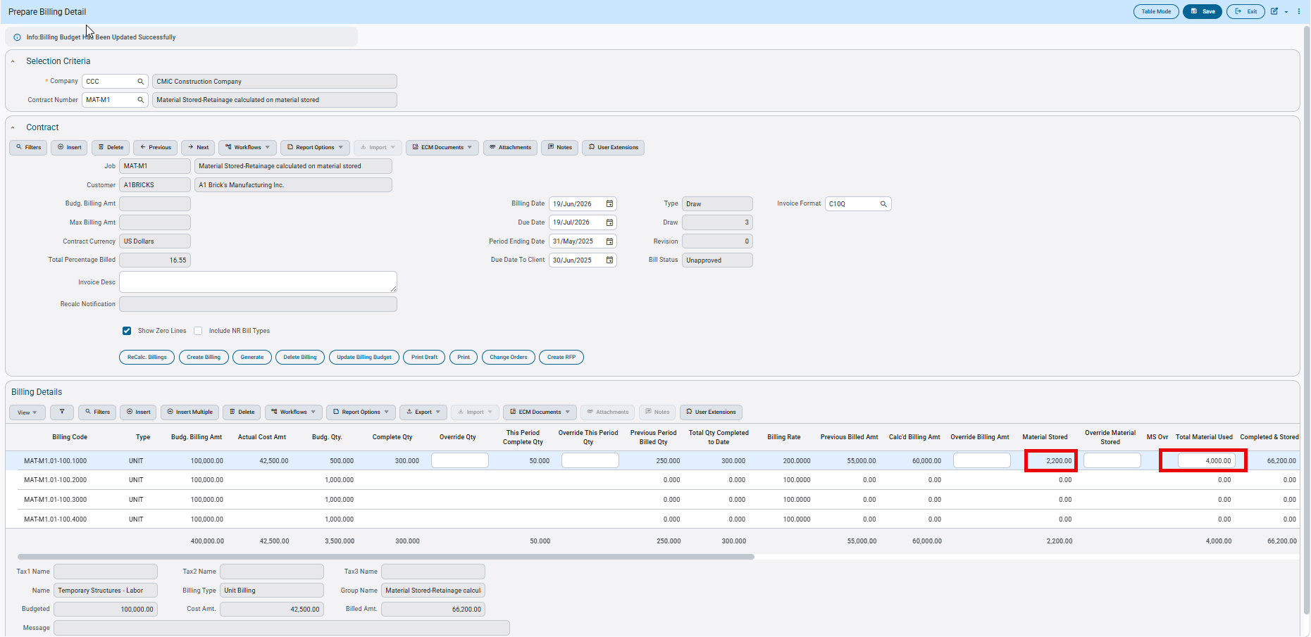

Scenario 3 — Overriding Material Stored
When a value is entered in the Override Material Stored column, the Material Stored column is reduced by the Total Material Used amount, based on the overridden value.
In this example, Material Stored is overridden to 7,800.00.

When an override is in place:

Material Stored = Override Material Stored − Total Material Used = 7,800.00 − 4,000.00 = 3,800.00
Completed & Stored = Calculated Billing Amount + Override Material Stored = 60,000.00 + 7,800.00 = 67,800.00

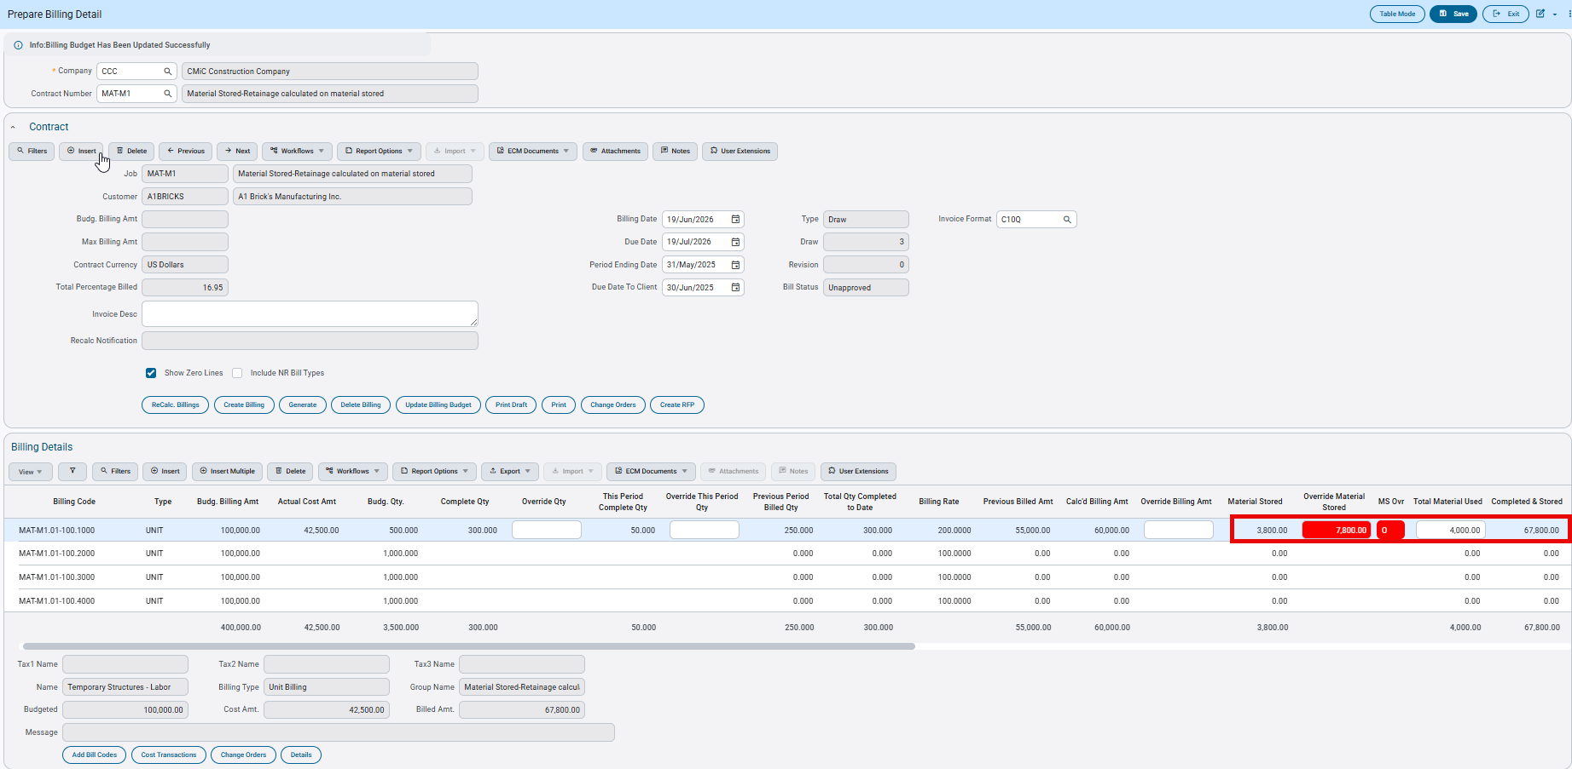

Draw 4 — Clearing Overrides and Total Material Used

Scenario 1 — Clearing Total Material Used

When Total Material Used is cleared and recalculated, the Material Stored column updates to match the Override Material Stored value. The Completed & Stored amount is not affected when Total Material Used is cleared.

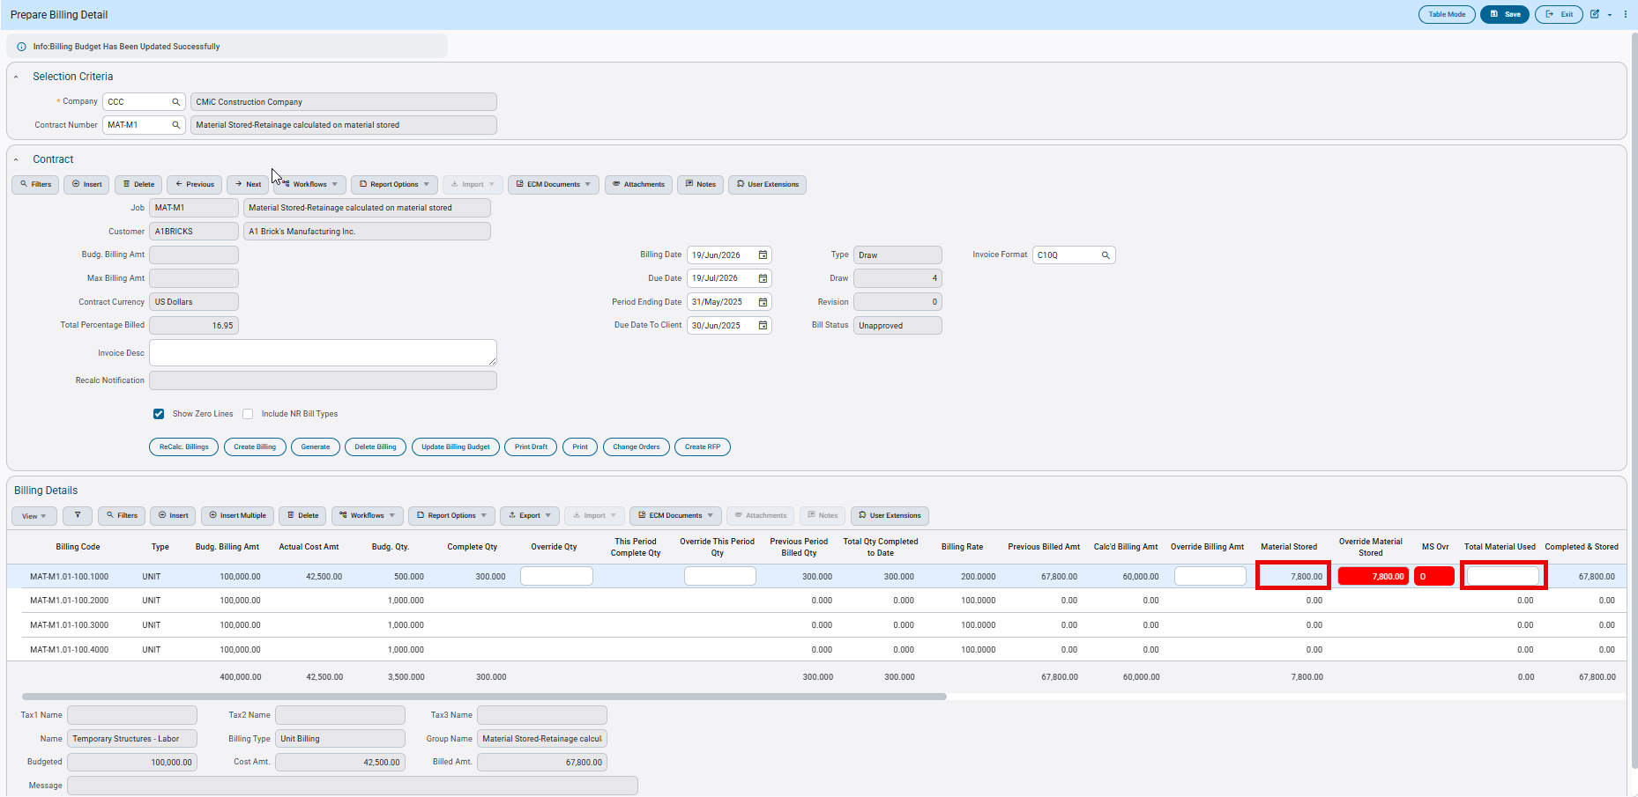

Scenario 2 — Updating Total Material Used

When Total Material Used is updated to a new value without clearing the overrides, the Material Stored column is reduced by the new Total Material Used value.

In this example, Total Material Used is updated to 5,500.00
Material Stored = 2,300.00
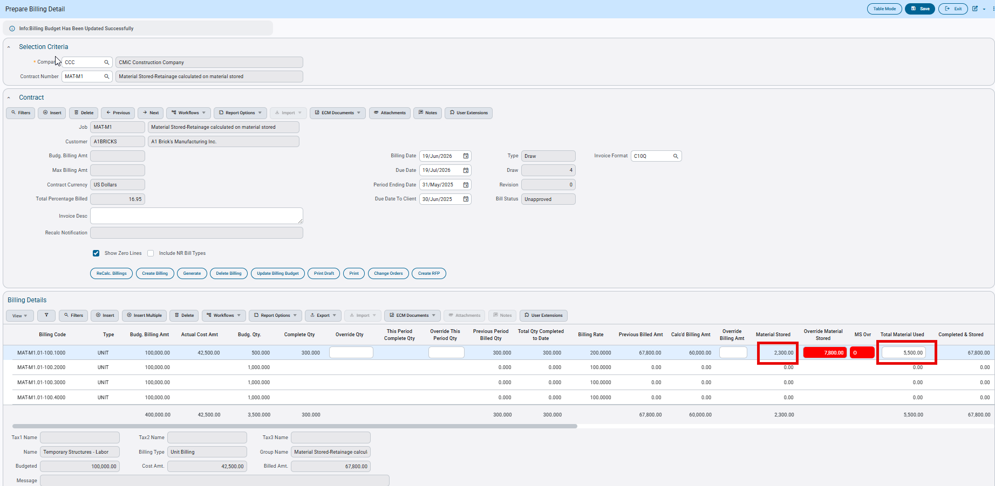

Scenario 3 — Override Material Stored Cleared, Total Material Used Retained

When Override Material Stored is cleared but Total Material Used remains, the Material Stored column is reduced by the Total Material Used value. Since the override has been cleared, this affects the Completed & Stored amount.

With no overrides in place and Material Stored treated as a surcharge, Completed & Stored is calculated as:
Completed & Stored = Calculated Billing Amount + Material Stored + Total Material Used = 60,000.00 + 700.00 + 5,500.00 = 66,200.00

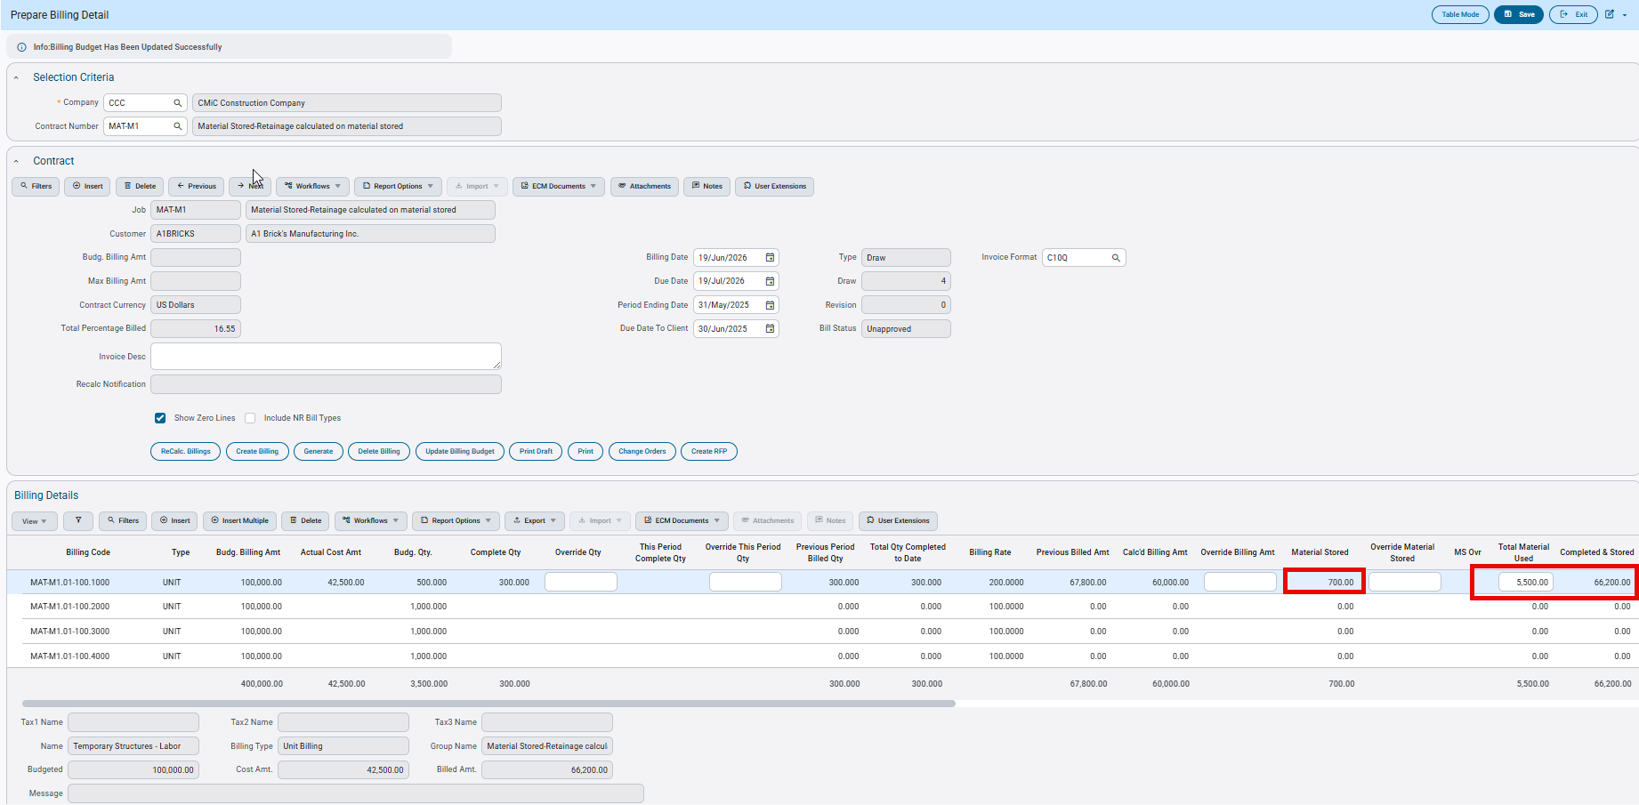

Note: The Total Material Used column does not accept negative values. If a negative value is entered, the system displays the following error message:
‘Total Material Used cannot be less than Zero’
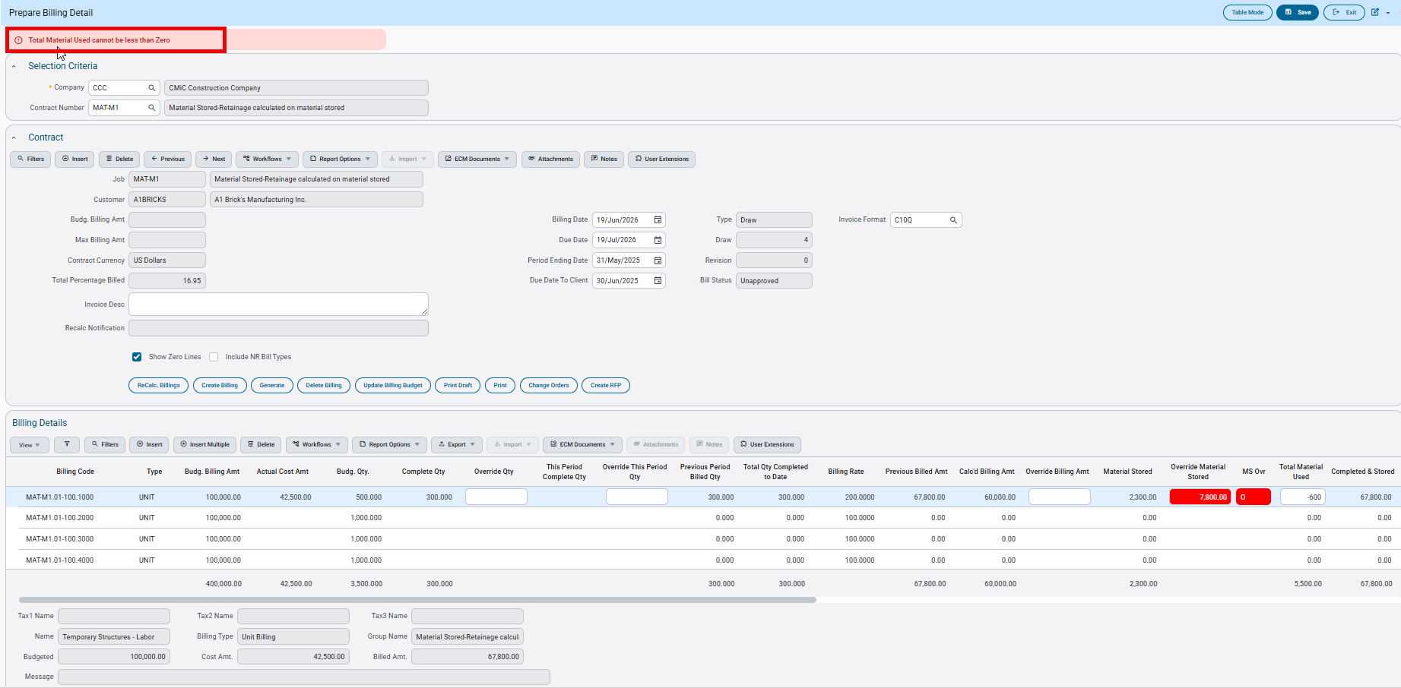

Scenario 4 — Material Stored Fully Consumed and Override Material Stored Cleared

When Total Material Used equals the Override Material Stored value, all stored material has been fully consumed. If Override Material Stored is cleared, the system places a negative value in the Material Stored column to balance the equation.

Total Material Used = Override Material Stored = 7,800.00
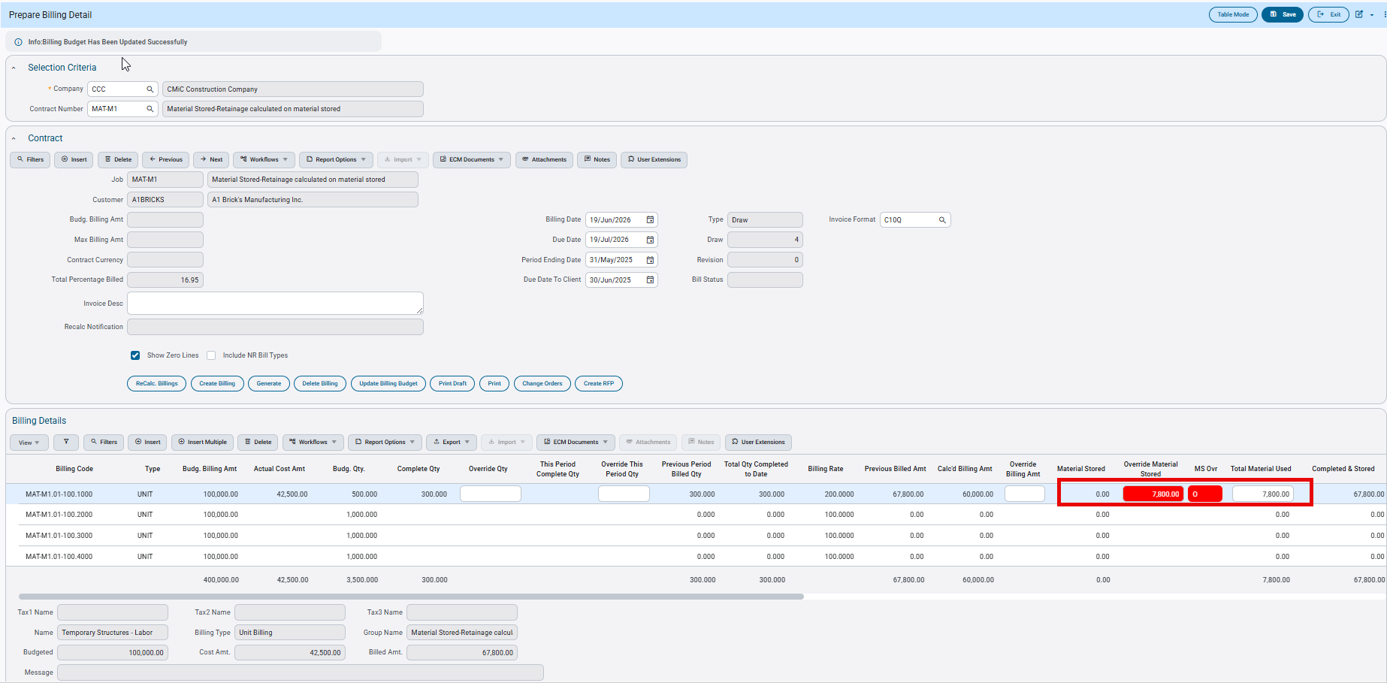

Clearing Material stored overrides will impact Completed & Stored column.
Since the override is cleared, the system uses the cumulative Material Stored from all transactions to date = 6,200.00

Total Material Used = 7,800.00
Material Stored = 6,200.00 - 7,800.00 = −1,600.00
Completed & Stored = Calculated Billing Amount + Material Stored + Total Material Used
= 60,000.00 + (-1,600.00) + 7,800.00 = 66,200.00

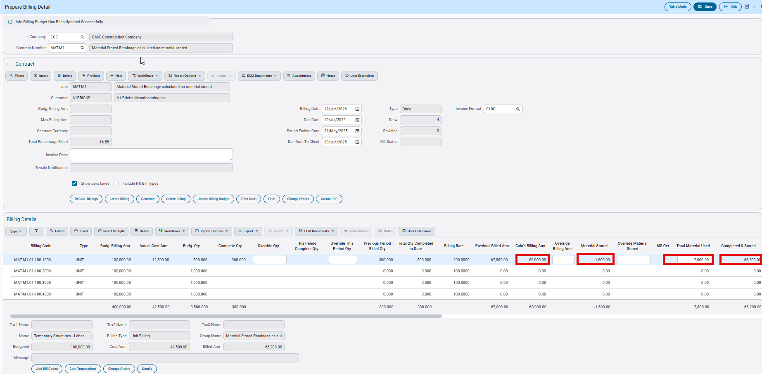

On Clearing Total Material Used, the Material Stored returns to 6200.00.
The Completed & Stored column is not affected.

The amount billed for Draw4 is calculated as:
Completed & Stored amount - Previous Billed Amt
=66200.00-67800.00= -1600.00

- Retainage On Material Stored Flag

The Retainage on Material Stored flag is enabled when the Material Stored Included in Calculated Billing Amount flag is unchecked (N). This flag applies to both JBBILL and JBBILL2.

Scenario 1 — Retainage on Material Stored: Checked (Y)

When this flag is checked, retainage is calculated on the Material Stored amount. Since Material Stored is treated as a surcharge, it is included in the Completed & Stored column, and retainage is calculated based on the full Completed & Stored amount.

Contract Setup:

Since Retainage on Material Stored is checked, retainage is calculated on the full Completed & Stored amount, which includes Material Stored.

Completed & Stored = 87,100.00
Retainage Rate = 10%
Calculated Retainage Amount = 8,710.00 (includes retainage on Material Stored)
JBBILL-Prepare Billing screen

JBBILL2 screen-G/C Prepare Billing Screen

Scenario 2 — Retainage on Material Stored: Unchecked (N)

When this flag is unchecked, retainage is not applied to Material Stored. Although Material Stored is a surcharge and is included in the Completed & Stored column, retainage is calculated only on the portion of the Completed & Stored amount that excludes Material Stored.
Contract Setup:

Since Retainage on Material Stored is unchecked, retainage is not calculated on Material Stored.
Completed & Stored = 87,100.00
Material Stored = 7,100.00
Retainage Rate = 10%
Retainage Base (excluding Material Stored) = 87,100.00 - 7,100.00 = 80,000.00
Retainage is calculated on 80,000.00 only. No retainage is applied to the Material Stored amount.
Calculated Retainage Amount = 8,000.00

JBBILL-Prepare Billing screen

JBBILL2 screen-G/C Prepare Billing Screen

NEXUS UI-JBBILL OR JBBILL2-Color Highlights in System/Light and Dark Mode (JBJCPC-4566)

Overview:

The Cost Transaction and Change Order pop-ups have been updated to use CSS colour variables, so the colors adjust to the active theme, including dark mode. Users will see colours that match their selected theme.

Modifications:

Modifications have been applied to the JBILL and JBILL2 programs for both the Change Order and Cost Transaction pop-ups. All color styling now uses CSS color variables, so the screens display correctly across all themes.

Cost Transactions Pop-up:
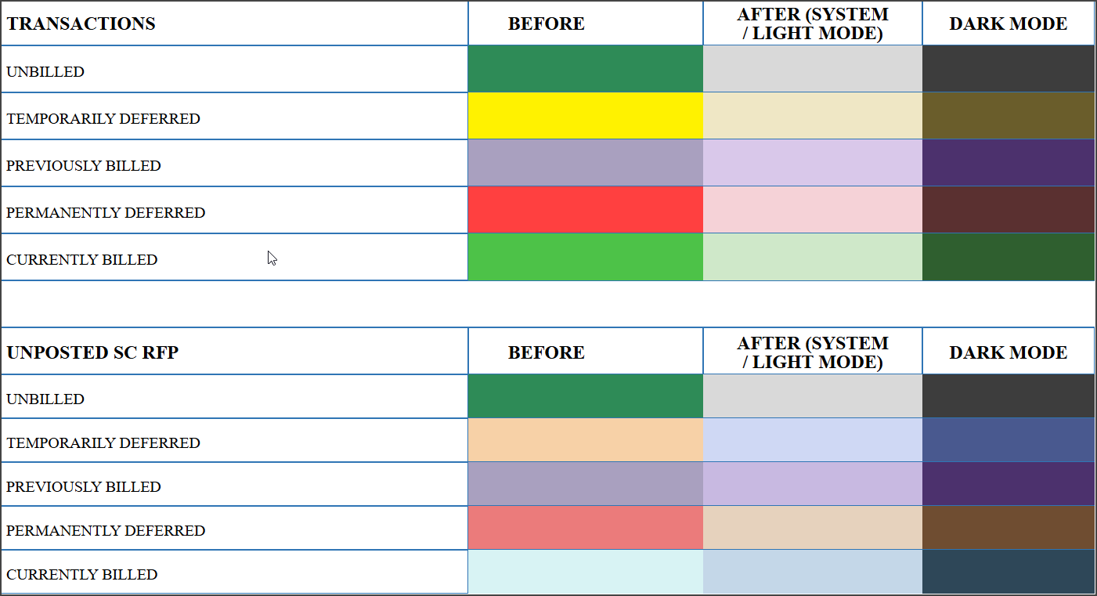

Change Order Pop-up:

Screenshots:

The screenshots below are from G/C Prepare Billing (JBBILL2). The same color highlights also apply to the Prepare Billing screen (JBBILL)

Cost Transactions Pop-up:

The screenshot below shows the color applied to each transaction status.

System/Light mode:

Job Billing>Billing>G/C Prepare Billing>Cost Transactions pop-up

Dark Mode:

Unposted SCRFP

The following screenshot displays the color used for Unposted SC RFP transactions.

System/Light mode:

Dark Mode:

Change Orders Pop-up:

The screenshot below shows the color applied to each change order status in the pop-up.

System/Light mode:

Job Billing>Billing>G/C Prepare Billing>Change Orders pop-up

Dark Mode:

Material Stored Columns in Group Summary tabs made editable in JBBILL2 (JBJCPC-6659)
Overview
The G/C Prepare Billing program (JBBILL2) currently displays three Material Stored columns across all Group Summary tabs and the Bill Code Detail tab: Previous Material Stored, Current Material Stored, and Total Material Stored.
Of these, the Current Material Stored and Total Material Stored columns can be used to override the Material Stored amount for a specific draw. However, this functionality was previously available only at the Bill Code Detail level, where these fields were editable. In the Group Summary tabs, the same columns were read-only, and users could not enable editing even through the Lite Editor because the corresponding option was disabled.
Modification
To address this limitation, an enhancement has been implemented that makes the Current Material Stored and Total Material Stored columns editable by default in the Group Summary tabs, consistent with the behavior in the Bill Code Detail tab. Users can now directly override Material Stored amounts from the Group Summary tabs without requiring additional configuration.
These overrides flow to the other tabs including Summary and Bill Code Detail as per the existing logic and functionality.
By design both these fields cannot be made read-only at the user level via Lite Editor since the Disabled property can no longer be modified.
Implementation
Both Current Material Stored and Total Material Stored amounts are editable in all the Group Summary tabs and allow user overrides by default.
If for example, user overrides the Current Material Stored amount in Group 3 Summary tab, then the amounts flow to the other tabs as per existing logic as shown below.

The user overrode the amounts in both the lines for a total of 60 and recalculated the billings.

The overrides are reflected across all the tabs including Summary and Bill Code Detail.

Users can also override the Total Material Stored amount in any Group Summary tab. In the scenario below, the user overrides the amount in the Group 1 Summary tab, and the override flows to the other tabs according to the existing billing logic.
Total Material Stored amount is overridden to 380 and then recalculated.

The overrides are also reflected across all the tabs.

Both these fields cannot be configured as read-only in any of the Group Summary tabs. This limitation exists because the Disabled property in the Lite Editor is not available for modification at the user level, preventing these fields from being enabled or disabled as required.

JOB COSTING

WIP Enhancement Copy Profit Override (JBJCPC-4731)

Overview
A new field “Copy Overrides” has been introduced under JC Control “WIP” tab.
This field is presented as a dropdown list with the following options:
• Projected Profit% Ovr
• Contract Amount Ovr/Projected Cost Ovr
Based on the user’s selection for this field, the system allows user to bring over “Projected Profit% Override “or “Contract Amount override/Projected Cost Override” in WIP from previous period when Copy Override button is used. Default Value for “Copy Overrides” Field is “Contract Amount Ovr/Projected Cost Ovr”.
Job Costing> Setup>Local Tables>Control File

Pre-requisites
Field is hidden by default, and user should use Lite Editor to unhide it.

Modification
New Field “Copy Overrides” has been added to the JC Control “WIP” tab. This Field contains 2 LOV values.
• Contract Amount Ovr/Projected Cost Ovr (Default value of Field)
• Projected Profit% Ovr
Modification to Behavior of Copy Overrides
- JC Control Copy Override field is set to: “Projected Profit% Ovr”
And if user Clicks “Copy Override” in WIP, Following Alert message will be displayed:
“This will bring the Proj Profit % Ovr from prior period. Would you like to copy previous period overrides to current periods for all jobs?”
If user confirms copying process by clicking on “Copy” in that case following is the behavior:
• Projected Profit % Override’ from previous period will populate the ‘Projected Profit % Override in the current period.
• Once WIP Projected Profit % Override is carried to the next period (say from period 5 to 6), all calculations in this period (period 6) will respect the new Projected Profit % Override. For example, the new Projected Profit %.
- JC Control Copy Override field is set to: “Contract Amount override/Projected Cost Override
And if user clicks “Copy Override” in WIP, following Alert Message will be displayed:
“This will bring the Contract Amt Ovr / Proj Cost Ovr override from prior period. Would you like to copy previous period overrides to current periods for all jobs?”
If user confirms copying process by clicking on “Copy” in that case following is the behavior:
• If only Contract Amount Override is populated in prior period, it will be copied to the current period.
• If only Projected Cost Override is populated in prior period, it will be copied to the current period
• If both Projected Cost Override and Contract Override is populated in prior period, both values are copied to current period.
In other words when Option “Contract Amount Ov/Projected Cost Ovr is selected system will follow the pre-existing functionality of “Copy Override”.

Add Cost Code Description to Job Cost Transaction Detail Log (JBJCPC-6042)

Overview
A new column for Cost code description (Phase Name) has been added in “JC-Transaction Detail Log” (JCDETAIL_LOG)

Modification
A new column “Phase Name” designated for Cost Code description has been added to JC- Transaction Detail Log, JC-Transaction Detail log- Exports and Data Filters. This column is Sortable and will show Cost Code description from” Assign Cost Code Program”.
Job Costing>Queries>Transaction Detail
Job Costing>Queries>Transaction Detail>Filters

Job Costing>Queries>Transaction Detail>Exported Excel

Import JC Foreign Batch Data File via API (JBJCPC-2824)

Overview
A new Jersey-based endpoint, POST /jc-rest-api/jersey/v1/jcForeignBatchDataFile, has been introduced for bulk-importing JC Foreign Batch Data File records. It replaces the legacy REST BC endpoint (/jc-rest-api/rest/1/jcforeignbatchdatafile) for batch posting and resolves the performance, request-timeout, and empty-response issues reported against that endpoint.

Modification
A new column The endpoint accepts a JSON body containing an “insert” array of one or more distribution lines and inserts them in a single batch operation. fbhJcCompCode is the only mandatory field; all other fields are optional and, if omitted, are left null.
Because the endpoint runs on the Jersey framework rather than the generic REST BC layer used by the legacy endpoint, every request parameter name must begin with a lowercase letter (e.g. fbhJcCompCode, not FbhJcCompCode) — Jersey will not recognize a parameter that starts with an uppercase letter, and REST BC “/describe” output is not a valid reference for this API. Unknown or misspelled parameter names are rejected with a structured “Invalid parameter: <name>” error rather than being silently ignored.
On success, the response returns every field that was set or generated during the insert — including the system-generated fbhVUuid and fbhJcLineNum — for each line, so the caller no longer needs a follow-up query to obtain these values.
Parameter | Description | Mandatory / Optional | Notes / Default Behavior
fbhJcCompCode | Job Company Code | Mandatory | Must be provided in the request
fbhJcJobCode | Job Code | Optional | Left null if not provided
fbhJcDistTypeCode | Distribution Type (e.g. “G” or “J” lines) | Optional | Left null if not provided
fbhJcSrcCode | Source Code | Optional | Left null if not provided
fbhJcSrcDesc | Source Description | Optional | Left null if not provided
fbhJcRefDate | Reference Date (yyyy-MM-dd) | Optional | Invalid format throws “Expected yyyy-MM-dd” error
fbhJcRefCode / fbhJcRefDesc | Reference Code / Reference Description | Optional | Left null if not provided
fbhJcDeptCode / fbhJcCatCode / fbhJcPhsCode | Department / Job Category / Phase Code | Optional | Left null if not provided
fbhJcAccCode | Account Code | Optional | Left null if not provided
fbhJcAmt / fbhJcUnit | Amount / Units | Optional | Left null if not provided
fbhJcWmCode | Work Measure Code (e.g. “HR”) | Optional | Left null if not provided
fbhPostDate | Post Date (yyyy-MM-dd) | Optional | Null-safe date conversion; left null if not provided
fbhJcValidFlag | Valid Flag | Optional | Defaults to “N” if not provided
fbhJcLineNum | Record Line Number | Read-only | Database-generated; returned in response, not set from input
fbhJcImpOraseq | Import Sequence | Read-only | Accepted in request but not written to the database on insert
fbhVUuid | Unique Row Identifier (UUID) | Read-only | Auto-generated on insert; used to retrieve the row afterward; not set from input
Records are inserted as a single batch per request; testing confirmed successful imports of 1,000 lines without timeout. Response field ordering is not guaranteed.
The API enforces the same Job and Company security policies as the CMiC UI and the legacy endpoint.

Expose Project Close Status Field to Enterprise Screen (JBJCPC-5441)
Overview
The enhancement introduced a Closed checkbox and a Re-Open Project button into the Enterprise Project Maintenance program (PMPROJFM) to align its functionality with the existing behavior in Field Project Maintenance. This ensured that users could clearly view and manage project closure status directly within the Enterprise interface, while maintaining consistent system behavior across both applications.
Modifications
The following changes were implemented:
- A Closed checkbox was added to the Enterprise Project Maintenance program (PMPROJFM).
- The checkbox was configured as read-only, preventing users from manually selecting or unselecting it.
- The checkbox became visible and checked when a project was closed using the Close Project button.
- The checkbox also reflected the correct status when a project was closed from Field Project Maintenance.
- The checkbox was added as a column in the Project Maintenance Table Mode.
- The checkbox became hidden when a project was reopened.
- A Re-Open Project button was added to the Enterprise Project Maintenance program (PMPROJFM).
- Once the project was reopened, the Closed checkbox become hidden from view in both Enterprise and Field Project Maintenance.
- No additional functional changes were made to other CMiC programs. The project closure behavior remained fully consistent with the existing Field-based process.
Implementation
The solution was implemented by extending the Enterprise Project Maintenance program (PMPROJFM) to include UI elements and logic already present in Field Project Maintenance.
- The system was updated to synchronize the project closure status between Enterprise and Field Project Maintenance.
- The Closed checkbox state was driven by system actions (Close Project / Re-Open Project buttons) rather than direct user input.
- Conditional UI logic was introduced to:
    - Display and check the checkbox when a project was closed.
Job Costing > Job > Enter Project

    - Hide the checkbox when a project was reopened.
Job Costing > Job > Enter Project
    - Enable or hide the Re-Open Project button based on the project’s status.
Job Costing > Job > Enter Project
- The Project Maintenance Table mode view was enhanced to include the Closed flag as a trackable column.
This implementation ensured consistency, prevented user error by restricting manual edits, and maintained the existing business rules for project closure.

Import option on Needs Tab in Enter Project (JBJCPC-3287)
Overview
This enhancement enables the Import functionality in the PMPROJFM Enter Project > Needs tab. Users can now import project needs using a CSV file or by copying and pasting data from Excel. The import follows the standard Enterprise import interface, including validation, error handling, and export options. Required fields and validation rules have been implemented, and a read-only Need Type column has been added to support the import process.
The Import functionality has also been enabled in the Opportunity Management module under the CRM application. Users can now import Need records directly into the Needs tab within Opportunities, using the same standard Enterprise import interface available in Enter Project (PMPROJFM).
The functionality, validation rules, and interface behavior are consistent with the Needs import in Enter Project.
Modifications

This enhancement enables the existing Import button in the Enter Project > Needs tab and Opportunities > Needs tab, allowing users to import need records using the standard Enterprise import functionality. As part of this update, a new Type column has been added to the Needs tab as a read-only field to support validation during the import process and ensure consistency with the configured Resource Type.
Job Costing > Job > Enter Project
Opportunity Management> Opportunities
Implementation
Go to Job Costing> Job > Enter Project > Needs Tab > Click on Import Button
Job Costing > Job > Enter Project
Job Costing > Job > Enter Project
The above Abbreviation should be used for “Need start Date Reference” and “Need End Date Reference” columns in import file.
Click on upload new button and upload the CSV file.
Job Costing > Job > Enter Project
Job Costing > Job > Enter Project
Validate and import the data.
Job Costing > Job > Enter Project

Job Costing > Job > Enter Project
Note: Same steps are followed to import data in Opportunities > Need Tab

Import Functionality to Enter Cost Code Type (JBJCPC-3479)
Overview
This enhancement enables the Import functionality in the Enter Cost Code Type Program (JCPHSTYPES), allowing users to bulk import Cost Code Type records through the standard Enterprise import interface. The import process supports data validation, error handling, and error export capabilities to ensure data accuracy and consistency. During import, both Code and Name fields are mandatory, and records missing these required values will fail validation and will not be processed.
Modifications

This enhancement activates the Import button in the Enter Cost Code Type Program (JCPHSTYPES), enabling users to import Cost Code Type records using the standard Enterprise import functionality. As part of this update, the system now enforces mandatory validation for both Code and Name fields during the import process.
Job Costing > Setup > local Tables > Enter Cost Code Types
Implementation
Go to Job Costing> Setup > Local Tables > Enter Cost Code Types > Click on Import Button
Job Costing > Setup > local Tables > Enter Cost Code Types
Click on upload new button and upload the CSV file.
Job Costing > Setup > local Tables > Enter Cost Code Types
Job Costing > Setup > local Tables > Enter Cost Code Types
Validate and import the data.
Job Costing > Setup > local Tables > Enter Cost Code Types

Job Costing > Setup > local Tables > Enter Cost Code Types

Union Code field length extended in Project Controls screens (JBJCPC-6509)
Overview

The Union Code columns already present in several Project Controls screens have had their maximum length extended to 30 characters, so the full union code can be entered and displayed. Each field is backed by the Union list-of-values (LOV) for selection.
Pre-requisites

Union codes must be set up before they can be selected in the Union LOV. Unions are defined under: HCM ▸ Setup ▸ Local Tables ▸ Payroll Unions ▸ Unions.
Modifications

CMiC extended the maximum length of the existing Union Code field/column to 30 characters in the following Project Controls programs: Cost Transaction pop-up (JBILL Transactions), Billing Rates (JBRATE), ETC Forecasts (JCFCASTETC), Escalators Maintenance (JCESCALATORMNT), GC Monitor (RPFCAST), and Enter Cost or Billing Transaction (JCTRNENT). The columns are backed by the Union LOV. No other behavior, layout, or calculation in these screens was changed.
Implementation

The Union field can be found in each screen as follows:
Program (screen) | Navigation path | Where the Union field appears
Cost Transaction pop-up (JBILL Transactions) | Project Controls ▸ Job Billing ▸ Billing ▸ G/C Prepare Bill ▸ Cost Transaction pop-up | “Union Code” / “Union Name” columns in the Transactions grid
Billing Rates (JBRATE) | Project Controls ▸ Job Billing ▸ Setup ▸ Local Tables ▸ Billing Rates | “Union” column in the Rate Detail and Subrate Detail tabs
ETC Forecasts (JCFCASTETC) | Project Controls ▸ Job Costing ▸ ETC Forecasts | “Union” field in the Labor and Non-Labor blocks (not shown in the Period-History blocks)
Escalators Maintenance (JCESCALATORMNT) | Project Controls ▸ Job Costing ▸ Setup ▸ Local Tables ▸ Contract Forecasting ▸ Escalators Maintenance | “Union” field in the Escalators block
GC Monitor (RPFCAST) | Project Controls ▸ Job Costing ▸ Forecasting ▸ GC Monitor | “Union” field in the Labor block (not shown in the Equipment or Period-History blocks)
Enter Cost or Billing Transaction (JCTRNENT) | Project Controls ▸ Job Costing ▸ Transaction Entry | Not displayed in the UI (column exists at the definition level only)

Add “Import” button to "Assign Templates To Multiple Jobs" Program (JBJCPC-5265)
Overview

The Assign Templates to Multiple Jobs program (JCDRIVEP) has been enhanced to support importing template assignments from a CSV file. This enhancement allows users to import multiple template assignments, validate the file contents, and process all valid records in a single operation.
Modifications

An “Import” button has been added to the toolbar of the “Assign Templates to Multiple Jobs” screen.
After importing a file, users can click “Validate File” to verify that the Company Code, Job Code, and Template Code values exist in the system. Once the file is successfully validated, users can import and process all records in bulk, eliminating the need to manually assign templates one job at a time.
Implementation

Navigate to Job Costing > Assign Templates to Multiple Jobs.
1) Open the “Assign Templates to Multiple Jobs” program and click the “Import” button from the toolbar.
2) Click “Download CSV Template” to download the sample CSV file.
3) Enter the required Company Code, Job Code, and Template Code details into the downloaded CSV template and save the file.
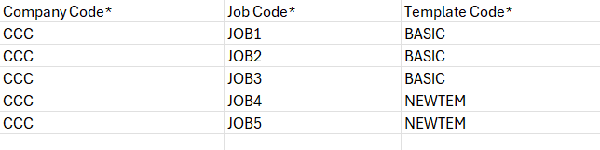
4) Choose the completed CSV file, and then click Upload.
5) Click Validate File.
The system validates all records in the uploaded file.
6) Click on Import File.
The validated records are imported successfully.
7) Close the Import window.
All imported records are displayed in the “Assign Templates to Multiple Jobs” screen.
8) Click on Process Button.
The system processes all imported records successfully.

Added Posting Date Field in the Job Cost Unit Posting program (JBJCPC-3000)

Overview:

A new Posting Date field has been added to the Job Cost Unit Posting program to provide greater flexibility when entering transactions. Previously, the system used the Transaction Date as the posting date, which restricted posting when the transaction date fell within a closed period.
With this enhancement, transactions are now posted using the user-entered Posting Date. The Posting Date defaults to the system date but remains editable; however, it must fall within an open JC and GL period for successful posting. The Batch Date and Transaction Date can also be edited and may fall within closed periods.

Modifications:

The following programs have been modified:

  - The Job Cost Unit Posting program (JCUPSTFM) has been modified to include a new ‘Posting Date’ field. The Posting Date defaults to the current system date and can be edited by the user; however, it must remain within an open JC and GL period. Batch Date and Transaction Date can be entered in closed periods.

  - The posting validation logic has been updated to use the user entered Posting Date instead of the Transaction Date when validating posting periods.
Screenshots:

The Posting Date field is now available in Job Cost Unit posting program. The Posting Date defaults to the current system date and can be edited by the user; however, it must remain within an open JC and GL period.

Project Controls>Transactions>Phase Quantity Completion>Job Unit Completion>Post Quantities Complete

The Batch Date also defaults to the current system date. Both the Batch Date and Transaction Date can be edited and may fall within closed periods.
Project Controls>Transactions>Phase Quantity Completion>Job Unit Completion

Setup Used:

For demonstration purposes, the following setup has been used.

The company period is set for 2026/4, and the JC period is set for 2026/5.

Company setup:
Current Year/Period:

Financials>General Ledger>Setup>Maintain Companies

JC Control:
The current Year/Period in JC control is set to 2026/5

Job Costing>Setup> Local Tables>Control File>Accounting Tab

Period Dates:
Financials>General Ledger>Setup>Global Tables>Period Dates

Validations:

Closed JC Period:

When Posting Date is in a closed JC period, the system will not allow posting and will display the following error message:

Current year and period in Job Costing for Company CCC is 2026-5. Posting is not allowed in prior period.

Closed GL Period:

When the Posting Date is in a closed GL period, the system will not allow posting and will display the following error message:

Posting date in closed period for company CCC

Globally Closed Period:

If the posting date is in a globally closed period, then the system will not allow posting and will display the following error message:

Posting period 2026-2 is closed globally. Posting is not allowed.

Future Periods:

When the Posting Date is in a future period and the JC control flag ‘Allow To Post To Future Periods’ is unchecked (‘N’), the system will not allow posting to future periods.

The system will display the following error message:

‘Current year and period in Job Costing for Company CCC are 2026-5. Posting is not allowed.

When the posting date is in a future period, and the JC control flag ‘Allow To Post to Future periods’ is checked(‘Y’), the batch will post successfully.

The Batch has been successfully posted to a future period.

Posting a batch with multiple transaction entries:
Batch 49168 includes transaction entries dated in closed GL and JC periods, as well as entries in current and future periods.

The Batch can only be posted if the posting date is in an open JC and GL period.
Posting the batch in an open period.

When posting the batch using a Posting Date in an open period, the posting report will display the Transaction Date. However, the transactions are posted using the date entered in the Posting Date field, as confirmed in the query showing the Posting Date for the transactions.

Query showing the post date for the transactions.

Disable Overriding Cost Code Description (PC-18626)
Overview
This enhancement introduces a Description Lock option in the Cost Code Template Maintenance program, allowing users to prevent the description of specific cost codes from being overridden once the template is assigned to a job. When Description Lock is enabled for a cost code, its description field becomes read-only in Assign Cost Codes, ensuring the description remains consistent with the template definition.
Modifications

This enhancement adds a new Description Lock checkbox column to the Cost Code Detail grid in Cost Code Template Maintenance. When this flag is checked and saved for a cost code, the Description field for that cost code becomes disabled (non-editable) in Assign Cost Codes for any job the template is assigned to. When the flag is left unchecked, the description remains editable as before.
Job Costing > Setup > Local Tables > Cost Code Template
Implementation
Go to Job Costing > Setup > Local tables > Cost Code Template.
Open or create a Cost Code Template and select the cost codes whose description should not be overridden. Check the Description Lock checkbox for each of these cost codes and save the template
Job Costing > Setup > Local Tables > Cost Code Template
Navigate to Assign Cost Codes for that job and Assign the Cost Code Template to a job. The Description field is disabled for the cost codes that have Description Lock enabled.
The locked cost codes display their description as read-only, as shown below. Cost code without Description Lock enabled remain fully editable.
Job Costing > Assign Cost Codes
Note:
- The Description Lock setting only takes effect for cost codes assigned to a job through the locked template. Cost codes added manually to a job (not via the template) are not affected by this restriction.
- The Description Lock restriction is enforced in the Assign Cost Codes UI only. If the description for a locked cost code is updated directly through the API, the update is accepted even though the field is locked in the UI. API based updates are not restricted by Description Lock.

WIP- Projected Profit and Projected Profit% Column Behavior Change-JBJCPC-4237

Overview
The behavior of the WIP columns “Projected Profit” and “Profit %.” Upon posting WIP has been changed. Now when WIP is posted, these columns will no longer be updated to reflect the values in the “Projected Profit Override” and “Projected Profit % Override” columns.
Modifications:
The “Projected Profit” and “Projected Profit %” columns will no longer be updated with values from the “Projected Profit Override” and “Projected Profit % Override” columns when WIP is posted.
Implementation:
Projected Profit and Projected Profit% column when Overrides are available for Projected Cost Override
Launch WIP and Store Forecast
Enter Overrides for Projected Cost override and savePost WIP
Projected Profit and Projected Profit% after posting WIP

New Job Costing Report – Job Cost Comparison (JBJCPC-4083)
Overview
CMiC has implemented a new standard report to show productivity on labor and material categories in the Job Costing module.
This report will be labelled as JC_JOB_COST_COMPARISON and displays the productivity for the above specified categories for each cost code in a job.
Setup
The report will be available in the Treeview menu under the Reports section in the Job Costing module.
If it’s not available by default, then users can add them via the Treeview Builder program by selecting the appropriate target.
Modification
Report Search Parameters
The report supports the following search filters to narrow down the information displayed.
Company
Enter/select the company code.
Year and Period
Enter/select the specific Year and Period (i.e. Month) against which the report is run.
Job Pick List
Enter/select a picklist to include a specific list of jobs.
From Job and To Job
Enter/select a range of job codes to include in the report or leave these fields blank to include all jobs in the report.
From Job Cost Code and To Job Cost Code
Enter/select a range of job cost codes to include in the report or leave these fields blank to include all job cost codes in the report.
Category Pick List
Enter/select a picklist to include a specific list of categories.
From Category and To Category
Enter/select a range of category codes to include in the report or leave these fields blank to include all category codes in the report.
NOTE: By default, the report is configured to only display information for category codes L and M. The report won’t display any information when using any other category and the same applies to the filters as well.
Roll-in Sub-Jobs
Enter/select whether or not to roll-in sub-jobs in the report. The default value is "N".
Suppress Zero Lines
Enter/select whether to suppress zero lines in the report. The default value is "Y".
Include Closed Jobs
Enter/select whether to include closed jobs in the report. The default value is "Y".

Report Columns and Layout
Report is grouped by the following fields in decreasing hierarchy – Job, Control Cost Code and Sub Cost Code.
The report displays the productivity data for each cost code in a job as follows:
Period to Date
- Labor Hours: Shows total posted hours for L category only, within the period. E.g. For year 2026 period 5, this column would show posted hours within May 01 and May 31 (as per period dates set up).
- Labor $: Shows total posted cost amount for L categories only, within the period. E.g. For year 2026 period 5, this column would show posted costs within May 01 and May 31 (as per period dates set up).
- Material: Shows total posted cost amount for M categories only, within the period. i.e. For year 2026 period 5, this column would show posted costs within May 01 and May 31 (as per period dates set up).
- Total: Calculated field = 2 + 3.

Job To Date
- Labor: Total cost amount for L categories, only up until the period date selected on the report parameter. E.g. For year 2026 period 5, this would show a sum of all posted C type transactions for category L on that cost code up until May 31st, 2026.
- Labor %: Calculated Field = 5 divided by 11.
- Material: Total cost amount for M categories, only up until the period date selected on the report parameter. E.g. For year 2026 period 5, this would show a sum of all posted C type transactions for category M on that cost code up until May 31st, 2026.
- Material %: Calculated field = 7 divided by 12.
- Total: Calculated field = 5 + 7.
- Total %: Calculated field = 9 divided by 13.

Estimate
- Labor: Budgeted Cost Amount for this cost code and category L combination.
- Material: Budgeted Cost Amount for this cost code and category M combination.
- Total: Calculated field = 11 + 12.

Production
- PTD Qty: Total posted cost code quantity for that cost code within the period selected on the parameter. E.g. For year 2026 period 5, this column would show total placed quantity withing May 1st and May 31st.
- JTD Qty: Total posted cost code quantity for that cost code up until the period selected on the parameter. E.g. For year 2026 period 5, this column would show total placed quantity up until May 31st, 2026.
- JTD $/Qty: Calculated field = Job to date cost code cost amount / Job to date posted cost code qty) = 9 divided by 15.
- Est Qty = Budgeted cost code quantity.
- Estimated $/Qty: Calculated field = Budgeted cost code amount / Budgeted cost code quantity = 13 divided by 17.
The report displays totals at the controlling cost code, job and overall report level.
Implementation
Report Search Parameters:

Material Sales

Material Sales – New LOV Columns and Preferred Contact Method added to Trucker Payroll Invoice (CAM-10237)
Overview
Three new fields and LOV pop-up columns have been introduced for the Material Sales Control File under the Trucker Payroll Invoice Header within the E-Invoice Tab.
The fields allow the user to generate an email to a specific address, with custom Subject and Body text after invoicing through Truckers Payroll – Preferred Contac Method.
The columns allow the user to view more detailed information when specifying batches for searching.
These changes aim to provide the user with additional customization options for invoicing.
Pre-requisites
In order to use the new functionality, the user must ensure that they have the MS-INV type text code details added for the subject and body of their email.
Modifications
Runtime feature program: E-Invoice
From/To Invoice List of Values:
Implementation
The user first will open Material Sales Control File through Asset Management > Material Sales > Setup > Local Tables > Control within the tree view.
The user will then navigate to the E-Invoice tab under the Options header.
Upon reaching this screen under the Trucker Payroll Invoice header, the user will be able to..
- Add an email address through the textbox Senders Email Address
- Add an Email Body Text Code through the first LOV
- Add an Email Subject Text Code through the second LOV
Once the details have been customized, the user will save the program.

After completing the setup, the user can will then traverse to the Print Truckers Payroll Invoice program and fill in the corresponding details they desire.
Once satisfied, the user will then click Print, and under the Destination LOV, scroll down to Preferred Contact Method.
The user can then click the Contacts button to ensure that their email address is set properly, and once satisfied click the Process button.
After clicking Process, the next Email Confirmation prompt will appear and the user will click Ok to generated the Email.

A prompt will appear on the next window stating that the email generated is successful, and the email will be displayed within the user’s inbox with the Subject and Body text customized from the previous steps.

For the List of Value columns, the following have been included..
- To and From Batch Number – Name
- To and From Invoice – Vendor Code, Voucher Date, and Amount

Opportunity Management

My Activities – Action Item Rebranding and New Alert Notifications (CAM-9368)
Overview
The first change consists of the Action Item module being fully renamed on every CRM program from the title of ‘Action Item’ to ‘Activities’ or some variant of such. For the full list, see below under Implementation.
The second change consists of Activities now having a third variant of alert notification now sent to company contacts of which are tagged to the activity. Meaning a user who has either created, listed as an additional contact, or is associated with the activity in the system, will receive a notification email.
These changes aim for consistency and will provide the user with improved clarity and greater understanding of the system.
Prerequisites
In order to receive the notification via email, the user must have the following setup for their user and contact:
User must have their default company and contact match identically on the Activity or else the notification email will not be sent:
Custom Alerts for Emails must be set for the user under Action Items:
Modifications
My Activities Program:
Implementation
Activities Rebranding
The first implementation consists of the rebranding of action items and actions to be now referred to as activities. The changes are included within the CRM programs: Organization, Contacts, Opportunities, and Action Items.
The full break down is as follows:
Organization
- Tab Name > Activities
- Column > Activity
- Detail Line > Activity
Activity – Pop Up Window
- Title > Activities
- Show all > Show All Activities
- Item Tab > Activity LOV
- Item Details > Activity Title
Opportunity
- Tab Title > Activities
- Add button > Add Activities
- Column > Activity
Contacts
- Tab Title > Activities
- Title > Activities
- Add button > Add Activities
- Column > Activity
My Activities
- Tree Menu Title > My Activities
- Program Title > Activities
- Show all flag > Show All Activities
- Item Tab LOV > Activity
- Activity LOV pop-up title > Activity List
- Item Details section title > Activity Title
- Activity error validation messages > ‘Activity is required’ + ‘Activity code __ does not exist’ + ‘Activity Title is required’
OM Application for Mobile
- Title > Activities
- Create Record > Create Activity
- Create Record Title > Activity*

Notification Alerts
The second change for Activities is now applied and will now send alert notification emails for users that have been updated and who are associated with the activity in the system.
First the user must have the prerequisites above set to receive an email notification alert for the created Activity.
The user will then first create an Activity by clicking the ‘Add New’ button in the My Activities program.
Next, the user must set the Alert Date and Activity Title.
Next the user will then set the same Company under Organization in the Item Details section below Activity Title and then set the contact they wish to receive the notification under.
The Contact set for the activity must be a Company contact or else no notification will be sent.
On the Additional Contacts tab, the user will insert one record of a company contact. This additional contact will also receive an email notification for the Activity.
Upon doing so, the user will then save the Activity record.
After saving a new Activity which contains additional contacts set, the main tab Item will now have an unalterable checkbox named Multiple Contacts appear beside the creator contact.
When the Activity is saved or Alert Time is triggered, the company contacts entered will receive an email notification email.
For the creator of the Activity the following format is received:
For the Additional contact, the following format is received:
For the Item Details set contact, the following format is received:

Opportunity Management – Hide Inactive Business Partner Privilege Added to OM Control File (CAM-11069)
Overview
A new Opportunity Management - System Options Flag has been introduced named “Hide Inactive Business Partners”. This new enhancement when activated will as the name states, hide all Inactive Business Partners from the Business Partner Maintenance program. This addition will overall speed up performance for users.
Modifications
Opportunity Management – System Options Program:
Implementation
A new Opportunity Management - System Options Flag has been introduced named ‘Hide Inactive Business Partners’. This addition when checked will hide all Inactive Business Partners from the ‘Business Partner Maintenance program’.
The user will first open the OM Control File and click the [System Options] button to reveal the flag within the pop-up window.
Once the flag is clicked, the user will navigate to the Business Partner Management program and see that inactive Business Partners no longer will be displayed within the table mode.
Example of Business Partner Inactivity –
Example of Program when flag is active –

Opportunity Management – New Flag introduced within OM System Options Program (CAM-11216)
Overview
A new flag called ‘Unrestrict list of Opportunities by Organization on Activity program’ has been added to the OM System Options (“OMOPT”) program. This flag will unrestrict the Opportunity list within any Activity entry program, allowing the user to select any Opportunity regardless of previously set Organization or Contact. This new addition aims to assist the user in record building and aims for improved user experience.
Note: By default, this new addition will be unchecked by default and hidden from the OM System Options program.
The following table describes several behaviour changes included when the new flag is checked:
Program | Field | Unchecked Behaviour | Checked Behaviour
Action Items | Opportunity | Filtered to Opportunities where selected Organization is the Customer, and selected Contact is tied to the Opportunity. | Wide open list — all Opportunities selectable regardless of Org/Contact relationship.
Opportunities | Organization | Defaults to Customer of the Opportunity; locked from editing. | Open list of Organizations tied to the Opportunity, not only the Customer.
Organizations | Opportunity | Filtered to Opportunities where Organization above is a Customer. | Wide open list — all Opportunities selectable.
Contacts | Opportunity | Filtered to Opportunities where Organization above is a Customer. | Wide open list — all Opportunities selectable.
Pre-Requisites
To use the new functionality, the user must enable the hidden flag-object via lite-editor in the top ‘System Option’ section.
Modifications
Opportunity Management System Option Program:
Implementation
The new flag ‘Unrestrict list of Opportunities by Organization on Activity program’ within the OM System Options (“OMOPT”) program, will now when checked, allow the user to select any Opportunity without restriction when the Organization and Contact field contain data.
To better understand this new functionality, the following steps will guide the user.

Flag Checked
The user will first check the new flag within the OM System Option program and save the settings to enable the feature.
The user will then traverse the tree view, open the Activities program, and click on the Opportunity LOV within the Item Details section.
The user can now visibly see and select any Opportunity listed that has data tied to the user.
Flag Unchecked
The user will ensure that the new flag within the OM System Option program is unchecked and save the settings.
The user will then traverse to the Activities program, insert a new record, and select the Opportunity LOV to view no records. This is to be expected because the list is no longer unrestricted to the Organization or Contact LOV values.
The user will enter an Organization and Contact, then once again view the records within the Opportunity LOV.

Opportunity Management – New Top 5 Contacts Table Added to Organizations and Contacts (CAM-10782)
Overview
A new table aptly named “Top 5 Contacts” have been introduced within the Organizations ‘OMORGANIZATION’ and Contacts ‘SYSCNTCT’ programs. These tables provide the user with information on which contact is the most active via other contacts. This addition aims for the goal of avoiding having to navigate through an abundance of activities.
Modifications
Organization Management Program:
Contacts Program:
Implementation
Two new tables have been added to the Organizations ‘OMORGANIZATION’ and Contacts ‘SYSCNTCT’ programs respectively. These additions provide an overview of which internal contact (Company Type) has the most “interactions” with the organization or contact based on a ranking system.
The count of interactions is based upon the number of Activities the C-Type user is defined in both the ‘For Contact’ field (OM#SYSACTIONITEMS>SYSAI_PMDIST_CONTACT_CODE) and the Additional Contacts table (OM#ACTIONITEMDIST>PMDIST_CONTACT_CODE). For the ranking, if there is a tie between several contacts, the program will prioritize the order based upon the most recent Last Date, and then by alphabetical order.
In both programs, the new table will immediately be displayed with the following columns:
Rank | Rank of user based upon the value of interactions with the organization
Name | First and Last Name of Contact
Interactions | Number of Activities the user is defined in
Last Date | Current last Activity Date user is defined in
Phone | Phone number of Company Contact
Email | Email of Company Contact
View Interactions | Button when clicked will display details on all Organization/Contact - Contact Interactions

Organization Management
For Organization Management, the Top 5 Contacts Table is displayed when a user opens an organization.
To insert a Contact into the table, the user will first enter a new Activity and ensure that the organization is listed within the Item Details section.
The user will then go to the second tab “Additional Contacts” and insert a Company Contact that they wish to display on the Top 5 Contacts table for the Organization then promptly save.
Upon saving, the table is updated and the user can refresh the Organization Management program to view the updated list with the new entry on the table.

Contacts
For Contacts Program specifically, the Top 5 Contacts Table is displayed when a user opens an external contact. The Top 5 Contacts table will not be displayed for a Company or Organization type contact.
To insert a Contact into the table, the user will first enter a new Activity and ensure that the desired contact is listed within the Item Details section.
The user will then go to the second tab “Additional Contacts” and insert the Company Contact that they wish to display on the Top 5 Contacts table for the Organization then promptly save.
Upon saving, the table is updated and the user can refresh the Organization Management program to view the updated list with the new entry on the table.

View Interactions
The user can view details of the contact interactions by clicking on the ‘View Interactions’ button beside any contact. Upon doing so, an additional program window will open displaying all interactions between the Organization/Contact with the Top 5 Contact.

Opportunity Management – Opportunity Import Includes Two Renamed Columns (CAM-7134)
Overview
Opportunity Management program now has name changes for two Columns within it’s Import record functionality.
Opportunity Company Name and Business Partner Name
This new addition aims to streamline the Import process, reducing the possibility of invalid data.
Modifications
Runtime feature program:
Implementation
The user must enter both the full exactly worded Company Name and Business Partner Name entirely, or else the Import program will not validate the new record.
Upon entering the data alongside the other mandatory values, the user will click [Validate Line] or [Validate File] if there are more than one record to validate, to ensure the record holds no errors.
Once the data has been validated, the user will click [Import File], and close the Import window to pull the data into the Opportunity Management data table.

Payroll E-Time

Expense Management in Construct E-Time- (HCM-16926) (IN DEV)
CMiC is currently developing a new Expense Management capability for Construct E-Time that will enhance how employee expenses are managed throughout the timesheet lifecycle. The objective of this enhancement is to provide a more streamlined and efficient process for recording, managing, and processing work-related expenses while improving visibility during timesheet approvals and reducing manual effort for payroll and project accounting teams. This functionality is currently under development and is planned for a future release.
The new solution introduces an Expense section within the Construct E-Time application that enables expense records to be managed alongside employee timesheet entries. Based on configurable employee and job-specific expense definitions, the system will automatically identify and generate applicable expense entries when time is entered against qualifying jobs or overhead activities. This approach reduces repetitive manual data entry, promotes consistency in expense allocation, and helps ensure that expenses are applied according to an organization's configured business rules.
To support this functionality, a new Expense by Employee maintenance screen will allow administrators to define default expense records based on employee, work location, company, job, phase, category, effective dates, and expense amounts. These predefined configurations will serve as the basis for automatically populating expense entries during the timesheet process, while providing organizations with centralized control over employee expense assignments.
Employees and timekeepers will be able to review expense information as part of the timesheet entry process, providing greater visibility into the expenses associated with each reporting period. Depending on an organization's security configuration and business requirements, users may be permitted to maintain expense entries manually, or expense information may be presented as read-only when it is generated automatically through predefined configurations or customer-specific business processes. New role-based security options will allow organizations to control access to the Expense tab as well as determine whether users are authorized to create or modify expense entries.
The enhancement also introduces additional configuration options within Payroll Expense Categories to support different expense calculation scenarios and customer-specific requirements. New expense configuration options and calculation rules provide organizations with greater flexibility in defining how expenses are processed, while maintaining consistency with existing Construct E-Time functionality. The overall design supports a wide variety of expense management scenarios without requiring extensive manual intervention.
Expense records generated through this feature remain synchronized with employee timesheet activity. As time entries are created, updated, or removed, the corresponding expense records are managed accordingly to help maintain consistency throughout the timesheet process. The feature also integrates with the existing timesheet approval workflow, allowing approvers to review expense information together with submitted timesheets, providing improved visibility into both labor and expense data during the approval process.
The Expense Management capability is designed with flexibility in mind, allowing organizations to support both automated expense generation and manual expense maintenance based on their operational requirements. By centralizing expense configuration and integrating expense records directly into the timesheet process, the solution is intended to improve data accuracy, simplify payroll processing, strengthen project cost allocation, and reduce administrative effort across payroll, project accounting, and operations teams.
Once released, this enhancement will provide organizations with a more efficient and transparent method for managing employee expenses within Construct E-Time while supporting a broad range of customer-specific business requirements through configurable rules and security options.
Status: This functionality is currently under development and is not included in this patch release. It will be made available in a future release following the completion of development, testing, and validation activities.

Restrict Employee Visibility by Home Company and Home Department on the Payruns Tab (HCM–32731)
Overview
In CMiC, a user who is assigned an access code that includes a Payroll Company and a Pay Run gains visibility to every employee within that Pay Run, and can enter timesheets on their behalf. Where a single payroll company spans several divisions, and those divisions are further split into departments, this is broader visibility than most organizations want: a Pay Run can contain employees from multiple home companies, and until now there was no way to narrow a user down to one of them.
This requirement adds two new fields – ‘Home Company’ and ‘Home Department’ – to the Payruns tab of the Access Code Administration screen. Each field acts as an additional validation layer stacked on top of the existing Company and Pay Run entries, using AND logic. An employee is only returned when they match every criterion configured on the access code, so employee filtering now runs Company → Home Company → Home Department → Pay Run.
Both new fields default to ‘*’ (All). When a field is left at ‘*’, no filtering is applied at that level and behavior is unchanged – the user continues to see every employee in the Pay Run exactly as before. The restriction applies wherever the employee list of values is driven by the access code, which includes E-Time Timesheet Entry, Crew Timesheet Entry, and the Timesheet Approval screen.
Pre-requisites
Employees must have ‘Home Company’ and ‘Home Dept’ populated on the Company tab of the Employee Profile screen. These two fields are the source of the values the new filter matches against. An employee with no Home Company on their profile will not be returned once a specific Home Company is set on the access code.
Pgm: PYEMPLOY – Employee Profile; standard Treeview path: US Payroll > Setup > Employees > Employee Profile – Company tab
The user must already have an access code whose Payruns tab targets the required Payroll Company and Pay Run. The Home Company and Home Department values are configured on that same Payruns row.
PYACSGRP – Assign Access Code; standard Treeview path: E-Time > E-Timesheet > Access Code Administration – Payruns tab
The Pay Run being restricted must contain employees from more than one Home Company – and, where department-level filtering is required, from more than one Home Department – otherwise there is nothing for the filter to exclude.
E-Time security must be in place so that the user can reach Timesheet Entry, Crew Timesheet Entry and, where approvals apply, the Timesheet Approval screen. Approvers must also be designated in E-Time Role Maintenance and linked to the access code on the Approver tab of Access Code Administration.
Modifications
Two new mandatory fields, ‘Home Company’ and ‘Home Department’, have been added to the Payruns tab of the Access Code Administration screen, positioned between ‘Company’ and ‘PayRun’. Each is backed by a searchable list of values and defaults to ‘*’ (All). The employee list of values used to enter time on behalf of other employees is now filtered by Company, Home Company, Home Department and Pay Run together, and all configured values must match. Both fields are mandatory and cannot be left empty; where no restriction is wanted they must be set to ‘*’, which is the default applied to existing access code records. Where both are left at ‘*’ the screens behave exactly as they did before. Setting a value does not change any employee record — the filter reads the Home Company and Home Dept already held on the Employee Profile.
Implementation
On the Payruns tab, the Home Company and Home Department fields appear immediately after Company. Each opens a searchable list of values – ‘Home Company List’ returns the company codes and names, and ‘Home Department List’ returns the department codes and names. Both lists include the ‘*’ entry (‘All Companies’ and ‘All Departments’ respectively), which leaves that level unfiltered.
Home Company List and Home Department List lookups on the Payruns tab
- Set a specific Home Company on the Payruns row and save. The value is retained when the access code is reopened, and the Company, PayRun and Pay Group values are unaffected.
PYACSGRP – Assign Access Code; standard Treeview path: E-Time > E-Timesheet > Access Code Administration – Payruns tab
- With a Home Company configured, the employee list of values in E-Time Timesheet Entry returns only the employees whose Employee Profile carries that Home Company. In the example below the access code is set to Home Company ZAUS: employee DKPYUS-200 is returned, while DKPYUS-300 and DKPYUS-333, which belong to other home companies, are not.
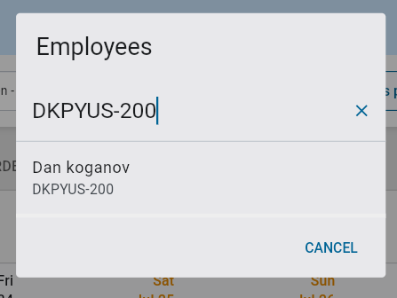
E-Time Timesheet Entry; standard Treeview path: E-Time > E-Timesheet > Timesheet Entry
- The same restriction is applied consistently in Crew Timesheet Entry – the ‘Crew Members’ lookup returns the same set of employees as E-Time.
Crew Time Entry; standard Treeview path: E-Time > E-Timesheet > Crew Timesheet Entry
- The Timesheet Approval screen is restricted in the same way. An approver whose access code carries a Home Company only sees the employees matching the configured Company, Pay Run and Home Company.
Timesheet Approval; standard Treeview path: E-Time > E-Timesheet > Timesheet Approval
- Adding a Home Department narrows the result further. With Home Company ZAUS and Home Department 10 configured on the access code, only employees in department 10 of ZAUS are returned. Employee DKPYUS-300, whose profile carries ZAUS and department 10, is returned; DKPYUS-200, which shares the same home company but sits in a different department, is now excluded, as is DKPYUS-333.
Access code configured with Home Company ZAUS and Home Department 10
E-Time Timesheet Entry – employee lookup restricted to Home Department 10
Crew Time Entry – Crew Members lookup restricted to Home Department 10
- If both fields are left at ‘*’, every employee in the Pay Run is returned, exactly as before the change. This is the default state of all existing access codes, so no current configuration changes behavior until a specific value is set.
- Employee visibility is the union of every access code the user holds, not the intersection. A second access code therefore widens what the user can see – it never narrows it.
IMPORTANT – a ‘*’ on any other access code overrides a specific value on yours. If the user is attached to any other access code that grants access to the same company and carries ‘*’ for Home Company and/or Home Department, that wildcard row prevails over the specific values set on their own access code. The user will see every employee in the Pay Run, across all Home Companies and Home Departments, and the restriction configured on the specific row will appear to have no effect.
This also applies through the Approver tab: if the user is named as an approver on an access code that carries ‘*’ for Pay Run, Home Company and Home Department, their employee list of values will display all employees across all Pay Runs, Home Companies and Home Departments. Before concluding that a restriction is not working, review every access code the user is attached to and confirm none of them carries ‘*’ at the level being restricted. This matches the existing behavior of the Pay Run and Pay Group fields.
A ‘*’ Payruns row alongside a restricted row
E-Time Timesheet Entry – the full employee list is returned because of the ‘*’ row
- The Home Company and Home Department restrictions apply to the employee lists of values used for time entry and approval. The ‘Select Responsible Person’ and Foreman lookups on the Crew Maintenance screen are not filtered by these fields and continue to return all employees.
Construct CT – Crew Maintenance; the Responsible Person lookup is not restricted by Home Company or Home Department

Payroll US

Unlink Employee (Employee Profile) - (HCM-20679)
Overview
This enhancement introduces a new "Unlink Employee" button on the Employee Profile screen. The button is visible only for Secondary Employee profiles and allows users to convert a secondary profile into a standalone primary profile or reassign it to a different primary employee.
Pre-requisites
- Employee must have linked profiles (Primary + Secondary) using the copy employee functionality on employee profile after the primary employee is created
- Selected employee must be a Secondary profile
Modifications
- New button: "Unlink Employee" (visible only on Secondary profiles)
- Converts secondary profile into a primary profile
- Allows reassignment to a different primary employee
- Impacted area: Employee Profile screen
Implementation
Steps
1. Navigate to Employee Profile
2. Select a Secondary Employee profile
3. Click "Unlink Employee"
4. Confirm the action
5. Proceed with required updates
Secondary employee has become primary now.

Employee Mass Termination (HCM-21819)
Overview
When working with employees copied across payroll companies (Primary and Secondary records), termination behavior differs depending on the screen used. This is important for users to understand to ensure the correct outcome when ending employment.

Primary vs. Secondary Employees
- Primary Employee: The original employee record
- Secondary Employee: A linked record created when the employee is copied to another payroll company
These records are connected, but the system does not treat them the same way in all processes.
Pre-requisites
Copy primary employee to different companies:
Modifications
Employee History Screen
The Employee History screen is relationship-aware and manages linked records together.
- Terminating the Primary employee:
  - Automatically terminates the Secondary employee
- Attempting to terminate the Secondary employee directly:
  - Results in an error
  - This is because the Secondary record depends on the Primary
Best used when:
- You want to terminate all linked employee records at once

Employee Termination Screen
The Employee Termination screen processes each record independently.
- Terminating the Secondary employee:
  - Is not Allowed
- Terminating the Primary employee:
  - Terminates the Secondary employee automatically
Best used when:
- You want to terminate a single employee record only

Implementation
  - Navigate to employee profile
  - Click copy employee button
  - Copy from employee to payroll company and click proceed
Primary employee is copied to two different companies:
- Navigate to employee history program and terminate the primary employee
All three employees primary and secondary terminated with the company showing as it was copied to.
Another set of employees using terminate employee utility program:
Created primary employee and copied to two different companies
Navigate to terminate employees program and terminated the primary employee resulting in all secondary employees to become terminated in their own companies that they were copied to.

Vertex – Internal Process Flag in Payroll Processing (HCM-22546)
Overview
The Internal Process flag on the Payroll Processing screen can now be hidden or by enabling the PYINTPRC privilege on System Privileges screen. This makes the screen tidy for customers that do not use the Internal Process option when processing payroll.
Pre-requisites
N/A
Modifications
User Maintenance > System Privileges tab changes
Added the new privilege:
- PYINTPRC
This privilege makes the Internal Process visible (checked), or hidden (unchecked),
Implementation
In this section, we will verify the behavior of the PYINTPRC flag when checked or unchecked under System Options.

Example #1: PYINTPRC is checked

Example #2: PYINTPRC is unchecked

Maintain SSN Masking Functionality – Extended to additional seven (7) ADF Programs across the Payroll and Human Resources modules (HCM-23190)
Overview
The ‘HRSSNSEC’ privilege within the CMiC system has been extended to control Social Security Number (SSN) visibility across an additional seven (7) ADF programs within the Payroll and Human Resources modules.
When this privilege is not assigned, SSNs will be masked in both List of Values (LOV) components and screen views to ensure data confidentiality and compliance with privacy standards.
Payroll Screens:
• Employment History Search
• Employee Deductions
• Loans and Advances
• Employee Direct Deposit
Human Resources Screens:
• Performance Review
• Employee/Applicant Documents
• Employee/Applicant Certification/Licenses
Pre-requisites
- If the user has the 'HRSSNSEC' privilege under User Maintenance > System Privileges:
→ Display the full SSN on the relevant screens and LOVs.
- The user has ability to unselect the 'HRSSNSEC' privilege.
→ The SSN should be masked (e.g., *) or not displayed at all, depending on screen requirements.
Modifications
Depending on individual screen requirements, the SSN will be masked when this privilege is unselected.

Employee History LOV:
The SSN should be masked in the Employee History screen search List of Values (LOV) when the privilege is not selected.
The SSN field should be masked in both the header and detail records, restricting users from viewing the SSN (before clicking Insert)
However, upon clicking Insert, SSN field should become Unrestricted allows the user to view and edit.
Clicking Process should mask it again.
If the privilege is selected; SSN should be unrestricted in the Employee History screen search List of Values (LOV) and Details sections.

Employee Deductions:
The SSN should be masked in the Employee Deductions/Employee List of Values (LOV) when the privilege is not selected.

Loan and Advances
The SSN should be masked in the Loan and Advances/Employee List of Values (LOV) when the privilege is not selected.
Employee Direct Deposit
The SSN should be masked in the Employee Direct Deposit/Employee List of Values (LOV) when the privilege is not selected.

Performance Review
The SSN field should be masked in the Performance Review screen when the privilege is not selected.
Employee/Applicant Documents
The SSN should be masked in the Employee/Applicant Documents - Employee List of Values (LOV) when the privilege is not selected.

Employee/Applicant Certification/Licenses
The SSN should be masked in the Employee/Applicant Certification/Licenses - Employee List of Values (LOV) when the privilege is not selected.

Dynamic Tax Override UI (Vertex-Aligned and Future-Proof) (HCM-27339)
Overview
This enhancement introduces a fully dynamic and future-proof Company Tax Override setup for Vertex Cloud integration.
The new design replaces the current static tax override structure with a dynamic tax override engine that supports:
- Federal, State, and Local employer tax overrides
- Effective-dated override management
- Dynamic Vertex Tax ID lookup
- Unlimited override rows without UI redesign
- Future Vertex tax additions without code changes
The enhancement allows customers to maintain company-wide tax overrides centrally instead of updating employee-level overrides individually.

Pre-requisites

• Vertex Cloud Payroll Tax integration configured and active.
• Company setup completed in Payroll Administration.
• Users have security access to Company Tax Override Setup screen.
• Payroll engine configured to consume tax override values during tax calculation.

Modifications

1. New Dynamic Company Tax Override Screen

A new Company-Level Tax Override Setup screen is introduced.

2. Dynamic Vertex Tax ID LOV Logic

The Vertex Tax ID LOV is dynamically populated based on the selected State Code.
State = ALL
Displays Federal-level taxes only:
• FUTA
• FICA Employer Taxes
• Federal SDI (if applicable)
• Federal Miscellaneous Taxes

State = CA
Displays all California employer taxes dynamically from Vertex Tax Master:
• CA-SUI
• CA-SDI
• CA-ETT
• CA-WC (if supported)
Any future California taxes added by Vertex automatically appear in the LOV.

3. Payroll Calculation Processing

During payroll calculation:
• System checks Company Tax Override table
• Matches Company
• Matches State or ALL
• Matches Vertex Tax ID
• Applies override rate if found
• Otherwise uses Vertex default rate

4. Notes

• The restored screen is not added to the standard tree-view menu.
• Customers can manually add the program to their menu structure if required.
• Existing legacy tax maintenance workflows remain supported.

5. Acceptance Criteria

- Dynamic tax override grid supports unlimited rows
- Vertex Tax ID LOV dynamically updates by State selection
- New Vertex taxes appear automatically without code changes
- Company-wide overrides apply correctly during payroll calculation
- PYTAXRATE enhancements store tax attributes separately by Tax Code
- Legacy Tax Rate screen restored successfully using py#taxrate
- QA validated Federal, State, and Local override scenarios

Implementation

Scenarios:

- Verify user can add a federal/company-wide override using State = ALL

- Verify Vertex Tax ID LOV for State = CA displays CA taxes dynamically

- Verify override rate applies company-wide to all employees

- Verify the Legacy screen works As -is.

Union Code field length extended in Payroll screens (HCM-29415 & JBJCPC-6509)
Overview

Expansion of Union Code Field from 4 to maximum length of 30 characters, so the full union code can be entered and displayed. Each field is backed by the Union list-of-values (LOV) for selection.
Pre-requisites

Union codes must be set up before they can be selected in the Union LOV. Unions are defined under: HCM ▸ Setup ▸ Local Tables ▸ Payroll Unions ▸ Unions.
Modifications

CMiC extended the maximum length of the existing Union Code field/column from 4 to 30 characters in the following HCM & Project Controls programs: The columns are backed by the Union LOV. No other behavior, layout, or calculation in these screens was changed.

Programs
PYEMPHIST
PYEMPLOY
PYHISADJ
PYEMPIMP
PYPAYADJ
PYEMPSALADJ_IMP
PYEPHIST
PYMANPRO
PYHOURSMAP
PYJOBRAT
PYLBRTR
PYLESET
HREMPQRY
PYMULCHK
PYREDIST_DET
PYRETROPAY
PYCERTREPBENPROG
PYUNIRECIP
PYUNIONS
PYUNIBEDE
PYUNIBEN
PYUNIDED
PYUNIRAT
PYTIMSTM
PYTIMIMP
PYTIMCER
PYIMPTIM
PYUNIDEDCTRL
PYUNIBENCTRL
PYUNILICINFO
PYTIMSHT_IMP
PYUNIONS
PYUNIONM
PYCOMHOLIDAYS
PYCERTREPBENPROG
PYCCQIMP
PYOVTMRU
PYRETROPAY
PYUNIRECIP
JBRATE
JBBILLTRANS
JCTRNENT
JCFCASTETC
JCESCALATORMNT
RPFCAST

Expense – Deductible from Gross Pay (HCM-29806)
Overview
Prior to this fix, any Expense configured ‘Deductible from Gross Pay’ and is inserted in the base element for a Deduction was not being included in the Gross Pay for the calculation of that Deduction. This covers the verification of the fix, confirming that Expenses entered via Expense Entry (not via Timesheet Entry) are correctly included in the Gross Pay base used for deduction calculations.
Pre-requisites
- An Expense is configured as 'Deductible from Gross Pay' in the Expense setup.
- A Deduction has the Expense above inserted as a base element.
Modifications
The system has been updated to ensure that Expenses flagged as 'Deductible from Gross Pay' are correctly factored into the Gross Pay when calculating deductions tied to base elements
Implementation
In this section, we will verify the behavior of an Expense when set as 'Deductible from Gross Pay' and inserted as a base element for a Deduction. Verification is done through Expense Entry, Payroll Processing, and reviewing the Mid-Year Pay History (MYPH).
Example:
Setup the Expense and base element for the Deduction.
Expense with ‘Deductible from Gross Pay’ checked.
Deduction used.

Expense (DA) has been added to Base Elements.

Base Code (DAW) has been configured to Company Deductions setup for (UDUP).

Expense claims entry (using DA).
Process payroll and view Mid-year Pay History.
NWHR + EX amounts = 4,200.
4,200 minus the total of Pay Amounts (negative values) = 3,084.76 (UDUP value)

Vertex API Flag – Manual Check and Retro Pay Processing - NEXUS 1 Hotfix (HCM-33445)
Overview
The Manual Check Processing and Retro Pay Processing programs previously operated against the legacy Vertex XML-based tax engine and were not aware of the Vertex API integration. In NEXUS 1, a Vertex API flag checkbox has been added to the Manual Check Processing screen. The JSP program has been updated to accept this flag as a parameter and route processing to either the Vertex API engine (flag = TRUE) or the legacy Vertex XML engine (flag = FALSE) for backward compatibility.
NOTE: As per programmer’s analysis, no changes are required for Retro Pay.
Pre-requisites
The Vertex API flag checkbox is present on the Manual Check Processing screen and defaults to ON
Modifications
Manual Check Processing Screen Changes
A Vertex API flag checkbox has been added to the Manual Check Processing screen. The checkbox defaults to ON. The flag value is passed to the JSP as a parameter when processing is invoked.

JSP Program Changes
The JSP program now accepts the Vertex API flag as an input parameter. When the flag is TRUE, processing is routed to the Vertex API engine. When the flag is FALSE, processing falls back to the legacy Vertex XML engine for backward compatibility. The same parameter and field name used in the main Payroll Processing screen is applied.
Implementation
In this section, we will verify the behavior of Manual Check Processing with the Vertex API flag visible and active on the screen, confirming correct routing to the Vertex API engine.

Example #1: Manual Check Processing and Vertex Report (Period 15) — Vertex API Flag Visible
The Vertex API flag is visible on the Manual Check Processing screen and is set to ON. Manual check is processed for Period 15.

Go to Next Block:

Verify Manual check processed Period 15 alongside processed Period 14:

Vertex Report is generated and reviewed (Federal, State, and Local Tax sections):

Clicked Processed to Print button:
Clicked Print Check button. Check is printed successfully:
Manual Check is processed correctly using the Vertex API engine when the flag is set to TRUE on the screen.

Vertex API (not visible) – Manual Check and Retro Pay Processing (NEXUS 2) (HCM-33445)
Overview
In NEXUS 2, the Vertex API flag is removed from the Manual Check Processing screen as it is no longer user-driven. The JSP program always invokes the Vertex API engine by passing the flag as TRUE (hardcoded), ensuring consistent use of the Vertex API engine across all payroll processing programs without requiring user intervention.
NOTE: As per programmer’s analysis, no changes are required for Retro Pay.
Pre-requisites
The Vertex API flag is not visible on the Manual Check Processing screen in NEXUS 2. The flag is always active by default (hardcoded TRUE in the JSP invocation).
Modifications
Manual Check Processing Screen Changes
The Vertex API flag has been removed from the Manual Check Processing screen. The JSP program always passes Vertex API flag = TRUE (hardcoded), ensuring all manual check processing routes to the Vertex API engine without user-facing control.
Implementation
In this section, we will verify that the Vertex API engine is always used for Manual Check Processing even when the Vertex API flag is not visible on screen.
Example #1: Manual Check Processing and Vertex Report — Vertex API Flag not visible (always active)
The Vertex API flag is not visible on the Manual Check Processing screen in NEXUS 2. Manual check is processed and the Vertex API engine is used by default:

Next Block:
Vertex Report is generated and reviewed (Federal, State, and Local Tax sections):
Manual Check is processed correctly using the Vertex API engine even when the flag is not visible on screen.
Example #2: Retro Pay Processing
Initial rate is set up for the employee:
Timesheet entry and posting with initial rate:
Process payroll and view MYPH:

Rate is updated for the employee:
Timesheet entry and posting with updated rate:
Manual Check Process is initiated. The Vertex API flag is not visible but is always active:
Mid-year Pay History verification:
Retro Pay processing is executed:
Retro Pay is processed correctly using the Vertex API engine.

Timesheet adjustment post void transaction (HCM-33365)
Overview
Updates have been made to improve accuracy in the Timesheet Adjustment process. Voided timesheet transactions are no longer displayed or available for adjustment, ensuring that only valid entries can be selected. Additionally, the “Posted Including Voided” option has been removed from the Edit Listing screen to prevent confusion and eliminate access to voided records.
Pre-requisites
Requires timesheet entry, timesheet posting, payroll processing, check processing and printing prior to void check with retain transaction flag ON.
Reposting of timesheet of the retained transaction.
Modifications
To improve data accuracy and avoid confusion during timesheet adjustments, the following updates have been implemented:
1. Exclusion of Voided Transactions
Voided timesheet lines are no longer available for selection in the Timesheet Adjustment (JC Detail) screen. Previously, void transactions could still appear and be adjusted, even though they were no longer valid. This change ensures that only active, valid transactions are eligible for adjustment.
2. Removal of “Posted Including Voided” Option
The “Posted Including Voided” filter option has been removed from the Timesheet Adjustment Edit Listing. This option previously allowed users to view voided transactions alongside posted ones, which could lead to unintended adjustments on voided records.
3. Improved Data Clarity
These updates address an issue where void transactions were displayed without any indication of their status. By removing them entirely from adjustment screens and filters, the system now prevents misinterpretation and ensures users are working with accurate and relevant data.
Note: This change is made for both US and International payroll.
Implementation
Example in US payroll for this change:
Step 1: Timesheet entry
Step 2: Timesheet posting, payroll processing, check processing and printing before voiding check. Also, retain input transactions flag needs to be checked
Step 3: Mid year pay history showing deducted amount

Step 4: Timesheet adjustment entry showing retained transaction only
Step 5: Timesheet edit listing report no longer have the posted including voided lines

Tax Rate Override Enhancement – Zero Tax Rate Support (HCM-32850)
Overview
This enhancement allows users to maintain a 0% tax rate on the Tax Rates screen for taxes that should not be calculated for a company. The requirement was identified when a customer attempted to enter a 0% SUI rate for Maine because the applicable SUI components were already included in the company's SUTA rate. Previously, entering a zero rate resulted in a validation error and prevented the company-level override from being saved.
With this change, a zero rate can be maintained as a valid company tax override. During payroll processing, the configured override is used for the applicable tax code while the remaining taxes continue to process normally.
Pre-requisites
- Payroll and Vertex tax processing setup has been completed for the company.
- The required State or Federal tax codes are available on the Tax Rates screen.
- Users have security access to maintain Tax Rates.
- A valid employee and pay period are available for payroll processing and verification.
Modifications
1. State Tax Override
The Tax Rates screen now accepts a zero value in the Rate field for a State tax override. This allows customers to suppress calculation of a tax that is not applicable to the company without receiving the previous validation error.
- Select the applicable State and Tax Code.
- Enter 0 in the Rate field.
- Enter the applicable Effective Date and save the record.
- The zero rate is retained as a valid company-level override.
State Tax Override setup
Zero rate entered and retained for the selected State tax code
2. Payroll Processing Validation
After the zero-rate override is saved, payroll can be processed normally. The payroll engine uses the configured company-level rate for the matching tax code. A zero override prevents a tax amount from being calculated for that tax while other applicable taxes continue to calculate.
Payroll processed successfully with the tax override
Payroll results used to verify the zero-rate tax outcome
3. Federal Tax Override
The same zero-rate behavior is supported for Federal tax override records where a company-level override is required. The Rate field can be set to 0 and saved for the applicable Federal tax code.
Federal Tax Override setup with zero-rate values
Implementation
Scenarios:
1. State Tax Override – 0% Rate
- Open the Tax Rates screen for the required company.
- Select the applicable State tax record (for example, SUI).
- Enter 0 in the Rate field and save the record.
- Process payroll for an employee subject to the selected state.
- Verify that the overridden tax is calculated at 0 while other applicable taxes remain unaffected.
2. Federal Tax Override – 0% Rate
- Open the Tax Rates screen for the required company.
- Select the applicable Federal tax record.
- Enter 0 in the Rate field and save the record.
- Process payroll for a test employee.
- Verify that the selected Federal tax uses the zero-rate override and payroll completes successfully.
Payroll processing validation
Tax results after processing

Consider OT Hours in Payroll Overtime Calculation (HCM-21932)
Overview
This enhancement applies to Payroll Control when Overtime Rule Method 5 (Expanded Method 3 to Include OT and DOT Hours for Overtime Rule Processing) is selected.
Payroll previously calculated overtime using regular hours only, and expected overtime to be identified at the job level before payroll was processed. Time entry and overtime rules are managed separately for billing, where hours are already distributed by job and phase for billing purposes. Overtime Rule Method 5 allows payroll to run its overtime calculation on the total hours entered, across all hour types and all jobs, while leaving that billing hours distribution unchanged.
The result is that billing and job costing remain aligned to the hours originally distributed by job and phase, while overtime is calculated against the employee’s complete timesheet for the pay period.
Pre-requisites
- Payroll Control is configured to use Overtime Rule Method 5.
- Overtime rules are configured.
- All time for the pay period has been entered and posted. Overtime is calculated on total hours, so hours missing from one job can change the result for the whole timesheet.
- Timesheets are processed and posted.
- User has access to Payroll and the JC Transaction Log.
Example environment used in this document: Company TRHI2, Overtime Rule Method 5, Overtime Rule JOBOVTRULE1 (Weekly 40 / Daily 8 / Saturday 8 / Sunday 8 / Holiday 0 hours, with Double Overtime at 12 hours/day) assigned to Job JB0007 – Google Construction Project, processed under Pay Run OTWK (TRHI2-WEEKLY OVERTIME).
Modifications
- Enhanced overtime processing for Overtime Rule Method 5. Overtime is calculated on the total hours entered across all hour types and jobs, rather than on regular hours only.
- Billing hours remain unchanged after overtime processing.
- Original billing hours will be displayed in the JC Transaction Log.
- Support for processing negative time entries after posted timesheets.
- Current overtime recalculation behavior has been reviewed, with a future enhancement planned to limit recalculation to only impacted dates or time entry lines.
The sequence below shows the enhanced processing in the QA environment (Company TRHI2, Pay Run OTWK, Year 2027, Period 49: 06-12-2027 to 12-12-2027, Document OT5, Employee OVWK-101 – Sali Overtime).

1. Insert the timesheet and enter hours for the pay period.
TimeSheet Entry – hours entered for Period 49, Document OT5 (NH Total 40, Other Total 24, Total Hours 64) across Jobs JB0007 and JB0008
2. Process Overtime Rule Method 5 for the pay run.
Overtime Rule Method 5 processing for Pay Run OTWK, Period 49
3. Post the timesheet, then adjust the hours for the same period. In this example, 5 normal hours are reversed on 07-12-2027 against Job JB0007, cost code 01-103.
TimeSheet Entry – negative adjustment of 5 normal hours entered against the posted timesheet for the same period (NH Total –5, Total Hours –5)
4. Process the overtime rule again. Overtime is recalculated on the total hours for the period, so the reversal is redistributed across the hour types rather than being taken from normal hours alone.
TimeSheet Entry – the negative adjustment before processing (top) and after the overtime rule is reprocessed (bottom): NH Total 0, OT Total 0, DOT Total –5, Other Total 16, Total Hours 11
Implementation
1. Navigate to Payroll Control.
2. Select ‘Overtime Rule Method 5 – Expanded Method 3 to Include OT and DOT Hours for Overtime Rule Processing’.
Payroll Control – Overtime Rule Method 5 selected (Company TRHI2)
3. Confirm that overtime rules are configured for the pay period being processed.
Job Overtime Rules – JOBOVTRULE1 and JOBOVTRULE2 thresholds
NOTE: DOT Weekly and DOT Daily must be explicitly set up for every overtime rule, even when double overtime is not expected to apply to that job. Leaving these fields blank produces incorrect calculation results. If double overtime should effectively never trigger, set DOT Weekly and DOT Daily to a high ceiling value (for example, 168 hours/week and 24 hours/day, as shown above) rather than leaving them blank.
Overtime Rules setup – Weekly, Daily, Saturday, Sunday and Holiday thresholds for the OT and DOT hour codes
Job Work Locations – Payroll Overtime Rule (JOBOVTRULE1) assigned to Job JB0007
4. Process and post employee timesheets.
Timesheet Entry – hours posted for the pay period (Employee OVWK-101)
5. Review the JC Transaction Log to verify billing hours. The original billing hours are displayed and are not altered by overtime processing.
6. Process negative time entries, if applicable, and verify overtime recalculation.
Timesheet Entry – a negative correction entered on a posted timesheet (Employee OVWK-101)
NOTE: If no posted hours exist for the processing period, negative time entries are ignored because there are no posted hours available to offset.
NOTE: Overtime hours reported by payroll will not always match the overtime distributed against an individual job. This is expected under Overtime Rule Method 5, because payroll evaluates the total hours for the pay period while billing retains its original job and phase distribution.

How Overtime Hours Are Allocated Across Multiple Jobs
When an employee enters hours against more than one job during a pay period, the overtime rule that governs the calculation is the rule assigned to whichever job has accumulated the most hours across the entire pay period — not the job with the most hours on any single day. Once that governing rule is determined, it is applied to allocate regular, OT and DOT hours back across the jobs worked each day, using the following formulas:
Job Hours Entered for the Day ÷ Total Hours Entered for the Day × OT Rule Value
Job OT Hours Available for the Day ÷ Total OT Hours Available for the Day × OT Rule Value
NOTE: Under Overtime Rule Method 5, all allocated hour values are rounded to the nearest whole hour (a value of exactly half an hour rounds up). Each job’s allocation is rounded independently, so the figures below are the rounded results actually used.
The two examples below illustrate how each formula is applied. Both use Employee OVWK-101 (Company TRHI2) working Job JB0007 and Job JB0008 on the same day, with a Daily OT threshold of 8 hours.

Example 1 – Formula 1: allocating the day’s regular hours by job share
5 hours are entered on JB0007 and 7 hours on JB0008 (12 hours total for the day). JB0008’s overtime rule is the one governing this pay period, with a Daily OT threshold of 8 hours, giving 8 regular hours and 4 OT hours for the day.

Job | Hours Entered | Share of Day | Regular Hours Allocated (Hours ÷ Total × 8) | OT Hours (Entered − Regular)
JB0007 | 5 | 5 ÷ 12 | 5 ÷ 12 × 8 = 3.33 → 3 | 5 − 3 = 2
JB0008 | 7 | 7 ÷ 12 | 7 ÷ 12 × 8 = 4.67 → 5 | 7 − 5 = 2
Total | 12 | 12 ÷ 12 | 8 | 4

Example 2 – Formula 2: allocating the day’s OT hours by OT-availability share
Continuing the same day, the 4 OT hours identified above need to be split between the two jobs. JB0007 has 2 OT hours available that day and JB0008 has 6 OT hours available (8 total).

Job | OT Hours Available | Share of OT Available | OT Hours Allocated (Available ÷ Total × 4)
JB0007 | 2 | 2 ÷ 8 | 2 ÷ 8 × 4 = 1
JB0008 | 6 | 6 ÷ 8 | 6 ÷ 8 × 4 = 3
Total | 8 | 8 ÷ 8 | 4
NOTE: These two examples are constructed to demonstrate the allocation formulas themselves and are independent of the JOBOVTRULE1 example used elsewhere in this document.

Example 3 – Formula 1 with three jobs in one day
Employee OVWK-101 enters hours against three jobs on the same day: JB0007 (3 hours), JB0008 (4 hours), and JB0009 (6 hours) — 13 hours total. JB0009’s overtime rule is the one governing this pay period, with a Daily OT threshold of 8 hours, giving 8 regular hours and 5 OT hours for the day.

Job | Hours Entered | Share of Day | Regular Hours Allocated (Hours ÷ Total × 8) | OT Hours (Entered − Regular)
JB0007 | 3 | 3 ÷ 13 | 3 ÷ 13 × 8 = 1.85 → 2 | 3 − 2 = 1
JB0008 | 4 | 4 ÷ 13 | 4 ÷ 13 × 8 = 2.46 → 2 | 4 − 2 = 2
JB0009 | 6 | 6 ÷ 13 | 6 ÷ 13 × 8 = 3.69 → 4 | 6 − 4 = 2
Total | 13 | 13 ÷ 13 | 8 | 5

Example 4 – Both formulas together, when a day triggers OT and DOT across two jobs
Employee OVWK-101 enters 7 hours on JB0007 and 11 hours on JB0008 on the same day (18 hours total). JB0008’s overtime rule (JOBOVTRULE1: Daily OT threshold = 8 hours, Daily DOT threshold = 12 hours) is the one governing this pay period: 8 regular hours, 4 OT hours (hours 9–12), and 6 DOT hours (hours over 12).
Step 1 — Formula 1 allocates the 8 regular hours by each job’s share of the day:
Job | Hours Entered | Regular Hours Allocated (Hours ÷ 18 × 8) | Remaining Hours (Entered − Regular)
JB0007 | 7 | 7 ÷ 18 × 8 = 3.11 → 3 | 7 − 3 = 4
JB0008 | 11 | 11 ÷ 18 × 8 = 4.89 → 5 | 11 − 5 = 6
Total | 18 | 8 | 10

Step 2 — Formula 2 allocates the day’s 4 OT hours and 6 DOT hours using each job’s share of the remaining hours (4 and 6, out of 10):
Job | Share of Remaining Hours | OT Hours Allocated (Share × 4) | DOT Hours Allocated (Share × 6) | Total (RG + OT + DOT)
JB0007 | 4 ÷ 10 | 4 ÷ 10 × 4 = 1.6 → 2 | 4 ÷ 10 × 6 = 2.4 → 2 | 3 + 2 + 2 = 7
JB0008 | 6 ÷ 10 | 6 ÷ 10 × 4 = 2.4 → 2 | 6 ÷ 10 × 6 = 3.6 → 4 | 5 + 2 + 4 = 11
Total | 10 ÷ 10 | 4 | 6 | 18

NOTE: In Example 4, each job’s totals (7 and 11) match the hours originally entered — confirming the allocation splits the day’s regular, OT and DOT hours across jobs without changing the total hours per job.
Worked Example – How a Correction Recalculates a Posted Timesheet
The following example illustrates, at a conceptual level, how entering a correction on an already-processed timesheet flows through to overtime recalculation. It uses a simple 8-hour daily / 40-hour weekly overtime rule so the mechanics are easy to follow; it is independent of the JOBOVTRULE1 thresholds shown above.
Scenario:
4 additional regular hours are entered on Friday, after the timesheet has already been through initial overtime rules processing.
Only the day the correction is entered for, and the weekly totals, are affected: Saturday changes from 2 regular / 8 overtime hours to 10 overtime hours, because the 40-hour weekly regular-hours threshold is now met earlier in the week.
Day | Entered | After Initial Processing | Correction Entered | After Recalculation
Mon | 8 RG / 2 OT | 8 RG / 2 OT | — | 8 RG / 2 OT
Tue | 8 RG / 2 OT | 8 RG / 2 OT | — | 8 RG / 2 OT
Wed | 8 RG / 2 OT | 8 RG / 2 OT | — | 8 RG / 2 OT
Thu | 8 RG / 2 OT | 8 RG / 2 OT | — | 8 RG / 2 OT
Fri | 6 RG / 0 OT | 6 RG / 0 OT | +4 RG | 8 RG / 2 OT
Sat | 0 RG / 10 OT | 2 RG / 8 OT | — | 0 RG / 10 OT
Sun | 0 RG / 10 OT | 0 RG / 10 OT | — | 0 RG / 10 OT
Weekly Total | 38 RG / 28 OT | 40 RG / 26 OT | +4 RG / 0 OT | 40 RG / 30 OT

Example 5 – A Full-Week Correction Across Multiple Jobs and Cost Codes
This example is taken directly from a QA test timesheet: Employee OVWK-101 (Company TRHI2), Pay Run OTWK, Period 50 (13-12-2027 to 19-12-2027), Document OT6, with hours entered against Job JB0007 (cost codes 01-102, 01-103, 02-100) and Job JB0008 (cost code 01-103).
Before the correction — posted hours for the week (Total Hours = 62):
Date | Job | Cost Code | RG | OT | DOT | Other
13-12-2027 | JB0007 | 01-103 | 4 | 2 | 0 | 0
13-12-2027 | JB0007 | 01-102 | 8 | 2 | 0 | 0
14-12-2027 | JB0007 | 02-100 | 10 | 0 | 0 | 0
14-12-2027 | JB0008 | 01-103 | 9 | 0 | 0 | 8
16-12-2027 | JB0007 | 01-103 | 8 | 2 | 0 | 0
17-12-2027 | JB0008 | 01-103 | 9 | 0 | 0 | 0
Total |  |  | 48 | 6 | 0 | 8

Correction entered — 5 regular hours are removed across two lines:
Date | Job | Cost Code | Correction (RG)
14-12-2027 | JB0007 | 02-100 | -3
13-12-2027 | JB0007 | 01-102 | -2
Total |  |  | -5

After overtime rules reprocess the whole week (Total Hours is still 62):
Date | Job | Cost Code | RG | OT | DOT | Other
13-12-2027 | JB0007 | 01-102 | 5 | 2 | 3 | 0
13-12-2027 | JB0007 | 01-103 | 3 | 2 | 1 | 0
14-12-2027 | JB0008 | 01-103 | 0 | 2 | 7 | 8
14-12-2027 | JB0007 | 02-100 | 0 | 2 | 8 | 0
16-12-2027 | JB0007 | 01-103 | 8 | 2 | 0 | 0
17-12-2027 | JB0008 | 01-103 | 8 | 1 | 0 | 0
Total |  |  | 24 | 11 | 19 | 8

The week’s total hours are unchanged (62 both before and after), but removing 5 regular hours mid-week shifts the split for every line that follows: regular hours drop from 48 to 24, OT rises from 6 to 11, and 19 hours now fall into DOT that were previously all regular or OT. This is the same recalculation behaviour described in the Modifications section above, now shown across multiple jobs and cost codes rather than a single job.

Preventive Maintenance

Work Item Close-Out: Last Serviced Reading Update (FIN-21206)
Issue Description:
In preventative maintenance, the last serviced reading for equipment will not update if the work item type is calendar day and the service reading is the same as the current reading. When the accumulator type for the work item is hour, the last serviced reading will update even if the service reading is the same as the current reading. If there is an update, then the last serviced reading used to update correctly.
The following screens show the current serviced reading as 3000 and NOT updated by the user. Upon ‘Save’ from the toolbar and ‘Close’ action in the pop-up, did not update the Last Serviced Reading in this scenario and the value was set as 0.
This happened in previous patch level Nexus_01.

Fix and the process flow change in Nexus_02 Patch Level:
The ‘Work Item Close Out’ is modified with Save & Cancel buttons.
Cancel: Closes the pop-up and does not save any changes that were made.
Save: The changes are saved and closes the pop-up with an alert message as follows:
‘The Service Reading Amount has been updated. This will impact all accumulators’
Users must accept with ‘OK’ button which closes pop-up and returns the previous Work Item Close screen, where users can close the work item.
Verify in Adjust Last Serviced Reading program that the Last serviced Meter Reading is updated correctly in line with the reading during the close out.

Project Management

Checklists – Mandatory fields / Responses (CF-31497)
This enhancement introduces required field support for checklist questions and header fields in both system and project-level templates.
Modifications
- A new "Required" toggle has been added to the Header fields and question section and is set to ON by default.
- On submitting a checklist, unanswered required fields are highlighted in red, a banner explains the issue, and the UI auto-scrolls to the first missing field.
- The progress bar tracks only required fields — optional ones don't affect completion percentage
Implementation
When user creates a new checklist template and selects some header fields. A ‘Required’ toggle is now added for each header field added. Default value of toggle is ON.

- The required checkbox has been added to the question section as well.
- Its default value is set to ON.

On saving the checklist template,

Assigned security role privileges to the global template.

Assigned the template to the project.

Now, go to Construct PM > Checklists > Click on [Create checklists].

Select the created template with required header fields and question.

The checklist record displays the header mandatory/ non-mandatory fields as per the setup in the template selected.

On submitting the checklist without entering the required fields, the fields are highlighted in red with a banner to complete the required fields and the screen auto-scrolls to the first such required field.

After entering the header required fields and again clicking on [Submit], it navigates the user to the Checklist tab > and highlights the required questions.

Users can enter data in the required fields and questions and then can Submit the Checklist.

NOTE: The progress bar tracks only required fields. Only required fields will affect the completion percentage.

Subcontract - Auto-populate IBAN from Business Partner setup and SWIFT code from Banks setup (PC-24144, PC-22361)
An enhancement has been made to the existing Subcontract program, so that IBAN and SWIFT code fields in the subcontract header auto-populate based on the Bank Code and Bank Account selected.
Pre-requisites
- Multiple banks should have been set up (with SWIFT code entered for some) in the System Data > Global Tables > Banks screen.

- Business Partner should have associated banks listed in the ‘Bank’ tab, in Maintain Business Partner program.

- Vendors should have bank account setup in the ‘Accounting’ tab in Maintain Vendors program.

Modifications
The subcontract program has been modified such that the existing ‘IBAN’ and ‘SWIFT code’ fields in the header auto-populates values from the Business Partner (BP) level (based on the selected bank/account combination) and Banks program, respectively.
Implementation
Following are the scenarios showing IBAN is defaulting from BP level, and SWIFT code is defaulting from Banks program:

Scenario 1:
- Maintain BP screen – BP has multiple bank accounts; 2 of them have IBAN number entered in Bank tab of Maintain BP screen.
- Maintain Vendor screen – Bank info is entered in ‘Accounting’ tab. IBAN code and Swift BIC Code are entered at Vendor level as well for the selected bank.
- Subcontract screen – Select the vendor. Bank Code, Bank Transit, Account number and Suffix in SC header populates from the Maintain Vendor setup. IBAN Number defaults from the Maintain BP setup; and Swift BIC Code defaults from Banks program.

Scenario 2:
- Maintain BP screen – IBAN number is not entered for the bank account. E.g. BMO in this case.
- Maintain Vendor screen – BMO bank is selected at the Vendor level, and no IBAN number is set up.
- Subcontract screen – On selecting the vendor, the IBAN field displays as blank and, SWIFT code field defaults value from Banks program.

Scenario 3:
- Maintain BP screen – IBAN is entered for the bank account. Eg. BOA in this case.
- Maintain Vendors screen – IBAN and SWIFT code are not entered.
- Banks screen – SWIFT code is not entered for the bank account.
- Subcontract screen – On selecting the vendor, IBAN defaults from Maintain BP screen and SWIFT code displays as blank.

Scenario 4:
- Maintain BP screen – IBAN is entered for the bank account. Eg. BOA in this case.
- Maintain Vendors screen – IBAN is not entered and, SWIFT code is entered.
- Banks screen – SWIFT code is not entered for the bank account.
- Subcontract screen – On selecting the vendor, IBAN defaults from Maintain BP screen and SWIFT code defaults from Maintain Vendor screen.

Vendor Prequalification – Added Free-form Email Notification to Subcontractor Record (CF-33793)
This enhancement introduced a configurable, free-form email notification feature that General Contractors can dispatch directly from the subcontractor record. The email specifies the outstanding requirements and provides a link enabling the subcontractor to re-access their questionnaire using their existing credentials, thereby eliminating the need for a password reset.
Modifications
- Two configurable text boxes have been incorporated into the Prequalifications Control screen, designated as 'Subcontractor Information Required Subject' and 'Subcontractor Information Required Body' – with prompt maintenance support for renaming.

- A new free-form email template called “Subcontractor Information Required Subject” has been added on the subcontractor prequal profile launching from the “Reset Self-Service Password” button.
- New prequal status “Additional Information Required” has been added.
- The email includes a link enabling the subcontractor to access their self-service form utilizing their current password, thereby eliminating the need for a password reset.
- Pages 1 through 5 are designated as read-only, whereas page 6 (attachments) is editable to allow users to upload any missing documents.
Implementation
When the new email template is selected from the drop-down menu, then the Subject and Body fields populate from the text entered for the fields in the Prequal control screen.

The subcontractor receives the email notification for additional information required, when user clicks on [Send Email] in the above pop-up.

At this point, the Prequal Status for the subcontractor appears as “Additional Information Required”.

Clicking on the link opens the subcontractor’s self-service form, and the sub can re-access it by entering their existing password.

NOTE: Pages 1-5 on the self-service questionnaire appears as read-only to the subcontractor. Only page 6 is unrestricted, and the sub can add any missing/ required documents and submit the form.

When the questionnaire is submitted, the subs’ Prequal status appears as ‘Received’.

PCI – Field Security for Proposal Issued and Proposal Signed (PC-9046)
New field security options have been added for “Proposal Signed” and “Proposal Issued” date fields, present in the ‘Key Dates’ section of the PCI screen.
Modifications
The following field security options have been added for the below-mentioned date fields in the PCI screen:
- Proposal Signed – Unrestricted, Read-Only, and Hidden.
- Proposal Issued - Unrestricted, Read-Only, and Hidden.

RFP - Field security added for ‘Amounts’ and ‘Previously Certified Amounts’ headers (PC-8764, PC-25433)
New field security options have been added for ‘Amounts’ and ‘Previously Certified Amounts’ headers in the RFP Detail screen.
Modifications
The following field security options have been added for the ‘Amounts’ and ‘Previously Certified Amounts’ headers in the RFP Detail tab:
Amounts -
- Unrestricted (Read-Only)
- Hidden
Previously Certified Amounts -
- Unrestricted (Read-Only)
- Hidden

RFP - Field security added for RFP Due Date (PC-27353)
New field security options have been added for ‘Due Date’ field in the RFP Detail screen.
Modifications
The following field security options have been added for Due Date field in the RFP Detail screen:
- Unrestricted
- Read-Only
- Hidden
These options are implemented for the Due Date field, when the RFP is in Add mode and in Edit mode.

RFP - Field security added for ‘Payment Mode’ and ‘Paymode Type’ (PC-26155)
New field security options have been added for ‘Payment Mode’ and ‘Paymode Type’ fields in the RFP Detail screen.
Modifications
The following field security options have been added for Payment Mode and Paymode Type fields in the RFP Detail tab:
Payment Mode -
- Unrestricted
- Hidden
Paymode Type -
- Unrestricted
- Hidden

NOTE: The 'Paymode Type' field is displayed on the RFP screen exclusively when the 'Allow to Use Payment Types with Third Party (Paymode) Option' flag is activated in the System Options screen under the Financials tab, irrespective of the field security configurations.

Checklist Templates - System Tags to Reflect at Project Level when Added/Removed (CF-37413)
Overview:
CMiC has made modifications to allow system-level tags to be automatically reflected across all linked project templates when added or removed.
This update ensures that tags, which are primarily for organization and categorization, sync immediately without manual intervention.
Maintaining Tags
- Tag Addition:
  - If a tag (e.g., 'SYS1') is added to a system template, it will be added to all linked project templates

- Tag Removal:
  - If an inherited tag is removed from the system template, it is automatically deleted from all linked project templates.

Submittals - Update to CMiC Field Menu Names (CF-41043)
Overview:
CMiC has made changes to update menu names and feature labels for Submittals within the CMiC Field application to ensure clarity between classic and current versions
  - Updated Submittals to Submittals (Classic).
  - Updated Submittals V2 to Submittals.

Note: The Construct PM URLs for Submittals will remain unchanged.
Key Changes:
- Menu Name Updates:

- Security → Role Maintenance Updates:

- Project Role Updates with Tooltips:

- Communication Management > Issues → Related Objects / Assign Objects

- Report Assignment Update:

Phase Segmentation: Remove Security Restrictions on ‘Add Phase/Category on the fly’ (PC-25582)
Overview
CMiC has made some enhancements to Phase Segmentation. The following outline summarizes the behavior of the UI Console > User Maintenance - JC privilege titled "Allows the user to create a new Phase/Category on the fly" under two conditions in relation to Phase Segmentation.
- When Segment Setup is enabled
- When Segment Setup is not enabled

- When Segment Setup is enabled

- UI Console> User Maintenance > System Privileges - JC: Allows the user to create a new Phase/Category on the fly privilege is ON

When Segment Setup is enabled and the privilege is ON, the system allows the user to create a new Phase/Category

  - Import:

When Segment Setup is enabled and this privilege is turned ON, the system allows users to create new Phase/Category values during import process with/without segment value.

- UI Console > User Maintenance > System Privileges - JC: Allows the user to create a new Phase/Category on the fly privilege is OFF

When Segment Setup is enabled and this privilege is turned OFF, the system enforces the validation flag in User Maintenance, preventing users from creating new Phase/Category values during manual entry. However, it can still create new Phase/Category values when a valid Segment Value is provided.

  - Import
When Segment Setup is enabled and this privilege is turned OFF, the system enforces the validation flag in User Maintenance, preventing users from creating new Phase/Category values during import process. However, the import process can still create new Phase/Category values when a valid Segment Value is provided in the import file.

When Segment Setup is not enabled

- UI Console > User Maintenance > System Privileges - JC: Allows the user to create a new Phase/Category on the fly privilege is ON

When Segment Setup is not enabled and this privilege is turned ON, the system accepts any new cost code entered by the user

  - Import:

When Segment Setup is not enabled and this privilege is turned ON, the system accepts any new cost code entered by the user in import file

- UI Console > User Maintenance > System Privileges JC: Allows the user to create a new Phase/Category on the fly privilege is OFF
When Segment Setup is not enabled and this privilege is turned OFF, the system enforces the validation flag in User Maintenance, preventing users from creating new Phase/Category values during manual entry.

  - Import:
When Segment Setup is not enabled and this privilege is turned OFF, the system enforces the validation flag in User Maintenance, preventing users from creating new Phase/Category while importing

PCI Details Import – Updated Import Layout (PC-25582)
The PCI Details Import file layout has been updated with the new column – Phase Name added:
Import File Format (cmdetail.ctl)

PCI - Security on PCI Import Button (JBJCPC-6046)
Overview:
CMiC has introduced enhanced security for the “Import” button within the PCI Details section for PCI. This feature will help to limit capabilities to specific groups.

- When Field Security is Hidden:

- With Endless: Import button is not visible when adding, editing, copying, or creating a revision. It is also not available in Detach mode of Detail lines.

- Without Endless: Import button is not visible when adding, editing, copying, or creating a revision

- When Link from another PM Object: Import button is not visible when linking PCI from another PM Object.

- When Field Security is Unrestricted:
- With Endless: Import button is visible and enabled when adding, editing, copying, or creating a revision. It is also not available in Detach mode of Detail lines.

- Without Endless: Import button is visible and enabled when adding, editing, copying, or creating a revision.

- When Link from another PM Object: Import button is visible and enabled when linking PCI from another PM Object

New Projected Final Flag Type and Forecasting (PC-7126)
Overview
CMiC has introduced a new Projected Final Flag type named as Projected Cost Forecast represented by the code – F. This new type can be set to default for the Company in the Job Cost Control file and can be overridden at the Budget level like the other existing types (Ex. C, S, L). Billing Codes with this type can also included in the Standard Contract Forecasting program and used to forecast cost and revenue based on the system defined rules and calculations.
In addition, new flags in Job Cost Control as well as new columns in Contract Forecasting have been introduced to provide the user with more control and detail when forecasting the Job/Contract.
Setup
- To view the newly added flags in the Job Cost Control, user needs to expose them using the Lite Editor. (Refer section on New Job Cost Control Flags for more information).
- To view the newly added columns in Contract Forecasting program, the respective column’s field security for the specific user role should be set to ‘Unrestricted (Read-Only)’. (Refer section on New Contract Forecasting Columns for more information).
Modifications
Projected Final Flag Type – Projected Cost Forecast (F)
The new Projected Final Flag Type – Projected Cost Forecast (F) is available for selection in the Job Cost Control file from the drop-down menu under the Job Setup tab.
Pgm: JCCTRLFM; Path: Project Controls > Job Costing > Setup > Local Tables > Control File
If selected, for any newly created Job the Cost Code and Category lines in the Enter Budget screen will have their Projected Final Type automatically set to F which can then again be overridden to other valid types on a case-by-case basis.
Pgm: JCBUDGET; Path: Project Controls > Job Costing > Job > Enter Budget
Billing Codes with the F Projected Final Type are also included in the Standard Contract Forecasting program (Both Sigma and Kendo versions) and follow the rules below:
- Projected Cost Forecast will always be in sync and matches the Projected Cost Forecast Including Pending CO as well as the WIP Projected Cost Forecast amounts.
NOTE: This is true even if the newly introduced flag in JC Control – “Sync Projected Cost and Projected Cost Including Pending PCI” is unchecked. (Refer section on New Job Cost Control Flags for more information.
- Projected Cost Forecast = Projected Cost Budget, unless there are overrides to the Forecast.
NOTE: This is true for all the budget methods – P/U/A, even if the Spent/Committed amount for the bill code becomes greater than its Current Cost Budget.
- Depending upon the following rules, for any given year and period, the Projected Cost Forecast amounts will be color coded upon launching the forecast without any other changes to the existing coloring scheme and remain even if the forecast is refreshed.
  - If amount is less than the Spent/Committed Total amount but not the Actual Costs, then it will be highlighted in yellow (Will be shaded orange in Kendo Forecasting program). Hovering the cursor on top of the highlighted amount will display the following message – “Projected Cost Forecast override is less than Spent/Committed Total amount”.
  - If the amount is less than both the Actual Costs and Spent/Committed Total amounts, then it will instead be highlighted in red. Hovering the cursor on top of the highlighted amount will display the following message – “Projected Cost Forecast override is less than both the Spent/Committed Total and Actual Cost amounts”.
NOTE: After launching the forecast, if the user overrides the Projected Cost Forecast amount, the values are immediately color-coded based on the above logic as soon as the user tabs out—without needing to save the changes. The amounts will remain color coded even after saving the changes and refreshing the forecast.
- For F type bill codes, forecast overrides can be either directly made via the main forecasting screen or via the popups (Productivity/Units/Cost Detail). Any overrides made to the Projected Cost Forecast / Cost to Complete also updates the Total Cost to Complete, Projected Cost Forecast Including Pending CO and also the WIP Projected Cost Forecast amounts (Once Forecast is refreshed).
- Once the amounts are overridden, they can neither be cleared manually (i.e. removing the Go Forward Overrides in the popup) nor via the Clear Overrides button in the header.
- The overrides remain even if the user later creates Pending or Posted Change Orders causing the Projected Cost Budget to change.
NOTE: Once Projected Cost Forecast is overridden, it will no longer be in sync with the Projected Cost Budget in that period.
- Clicking on Retrieve Overrides won’t update the override amounts in the current period.
- To carry the overrides into the future period, the forecast must be stored for the current period and the JC Control flag “Copy Last Stored Forecast” should be checked. Else, system will recalculate the forecast and other amounts for the upcoming period based on the normal rules and logic.
- There are no changes to the interactions with existing flags that affect forecast amounts such as “Include Pending PCI to P/U Line” in Project System Options, “Internal Change Orders Update Budget” in CM Control and PCI Status Codes flag (i.e. Only Pending PCIs with Forecast flag checked will be considered for calculations) etc.

New Contract Forecasting Columns
To enhance the Contract Forecasting program, five new columns have been added, and they are available for selection in the Configure View if not already present in the main screen.
When forecast for any given period is archived then the new columns are also included in the forecast archive table in the backend.
NOTE: If the newly added columns are still not visible in the main screen, then it is likely that the user does not have the required field security, and the necessary access must be given to view them. (Refer the Setup section for more information).
Projected Final Type
- This new read-only column displays the Projected Final Type code of the billing code defaulting from the corresponding Cost Code/Category record in the Enter Budget screen.
- Updating the Projected Final Type in Enter Budget program will also update the code in the forecasting program once the forecast is refreshed.
Budgeted Quantity
- This new read-only column shows the current budgeted quantity for P and U method bill codes, matching the Budgeted Input Quantity in the Productivity/Units popup.
- The column also considers the Pending PCI quantity if the Project System Options flag “Include Pending PCI to P/U Line” is checked. If unchecked, then only posted PCI quantity is considered.
- For A method, this column is not applicable, and quantity is always displayed as zero.
Incurred Quantity
- This new read-only column displays the actual total spent quantity for bill codes with P/U Budget Methods.
- For A method, this column is not applicable, and quantity is always displayed as zero.
Projected Margin
- This new read-only column displays the margin/profit percentage of the bill code in the current year and period.
- Calculated as (Projected Profit / Adjusted Revenue Forecast) * 100. If Adjusted Revenue Forecast is zero, then system uses the regular Revenue Forecast amount for calculations.
- Projected Profit in turn equals the difference between Adjusted Revenue Forecast and Projected Cost Forecast.
- For all the total rows, this value is calculated as an aggregate (i.e. Total Projected Profit / Total Adjusted Revenue Forecast * 100) rather than by summing the margins of the individual bill codes for the job/contract.
Productivity Index
- This new read-only column displays the Productivity Index of the P/U bill codes in the popup.
- Calculated as - (Output Complete Quantity / Budgeted Output Quantity) * (Budgeted Input Quantity / Input Complete Quantity).
  - If Input Complete Quantity (Same as Incurred Quantity) = 0, then Productivity Index will also be 0.
  - If Input Complete Quantity > 0 but Output Complete Quantity = 0, then Productivity Index = 0 - Input Complete Quantity/Budgeted Input Quantity.

New Job Cost Control Flags
In addition to the existing flags, two new flags have been added that impact the contract forecasting calculations as follows:
Sync Projected Cost and Projected Cost Including Pending PCI
- If this flag is checked, then Projected Cost Forecast will be synced with Projected Cost Forecast Including Pending Change Orders column, and the two amounts will always be equal even if there are Pending PCIs included in the current period.
- As a result, Projected Cost Forecast Including Pending Change Orders will not show any Pending PCIs for P/U budget methods if the Project System Options flag “Include Pending PCI to P/U Line” is unchecked while the JC Control flag is checked.
- This flag is only applicable for bill codes with the following Projected Final Types: C – Committed Costs, S – Spent to Date and L – Largest of Spent or Committed. As for F type, Projected Cost Forecast and Projected Cost Forecast Including Pending Change Orders will always be in sync irrespective of the state of the flag.
Include Pending Changes in Current Period Changes column
- If this flag is checked, then Pending Change Order amounts will be considered in the existing Current Period Changes column. Else, the column will continue to include only the posted Changes created in the current period.
- Column will include the Pending PCI’s for P and U Budget method even if the Project System Options flag “Include Pending PCI to P/U Line” is unchecked.

Implementation
Examples:
Billing Contract: P7126-1 has three billing codes with the same Projected Final Type – F and the following Budget Method and Initial Budget as follows:
Bill Code 1: P7126-1.01-100.L with P (Productivity) method, Initial Budgeted Amount and Quantity as 10,000 and 500 (Phase/Cost Code Budget – 50) respectively.
Bill Code 2: P7126-1.01-101.S with U (Units) method, Initial Budgeted Amount and Quantity as 10,000 and 500 (Phase/Cost Code Budget – 50) respectively.
Bill Code 3: P7126-1.01-102.M with A (Amounts) method, Initial Budgeted Amount and Quantity as 10,000 and 500 respectively.
The Project/Job/Contract has the following flags checked,
- “Include Pending PCI to P/U Line” in Project System Options in the Field application.
- “Internal Change Orders Update Budget” in Change Management Control file.
- “Include Pending Changes in Current Period Changes column”, “Copy Last Stored Forecast” and “Include Pending Commitments in Forecast” in Job Cost Control.

Then for all the P and U method Cost Code/Categories a cost amount of $1000 each was posted along with Phase Quantity Completion (The later only for P and U methods).
Later a Subcontract with each SOV line corresponding to the three Cost Code/Category combinations was posted in the same period for about $5000 each.

Forecast was generated for the Current Year and Current Period (E.g. Year – 2026, Period – 5).
The amounts and values for the selected columns are as follows:
 | P7126-1.01-100.L (P Method) | P7126-1.01-101.S (U Method) | P7126-1.01-102.M (A Method) | Remarks
Current Cost Budget | 10,000 | 10,000 | 10,000
Projected Cost Budget | 10,000 | 10,000 | 10,000 | Same as Current Budget because there are no PCIs
Pending Internal PCI | 0 | 0 | 0
Pending External PCI | 0 | 0 | 0
Actual Cost | 1,000 | 1,000 | 1,000 | Posted Job Cost transaction amounts
Total Committed Amount | 5,000 | 5,000 | 5,000 | Posted Subcontract
Spent/Committed (In Scope) | 6,000 | 6,000 | 6,000
Spent/Committed Total | 6,000 | 6,000 | 6,000
Current Period Changes | 0 | 0 | 0 | No Pending or Posted PCIs
Budgeted Quantity | 500 | 500 | 0 | Budgeted Input/Category Quantity for P/U methods
Incurred Quantity | 50 | 50 | 0 | Posted Job Cost transaction quantities for P/U methods
Output Complete Qty | 6 | 6 | 0 | Posted Phase Quantity Completion for P/U methods
Projected Margin | 33.33 | 33.33 | 33.33 | Projected Profit/Adjusted Revenue Forecast = 5000/15000 * 100
Productivity Index | 1.2 | 1.2 | 0 | For P and U Method, (Output Complete Quantity / Budgeted Output Quantity) * (Budgeted Input Quantity / Input Complete Quantity) = (6/50) * (500/50)
Projected Cost Forecast | 10,000 | 10,000 | 10,000 | Projected Cost Budget
Projected Cost Forecast (Incl Pending CO) | 10,000 | 10,000 | 10,000 | Projected Cost Forecast
Cost to Complete | 4,000 | 4,000 | 3,500 | Projected Cost Forecast – Spent/Committed (In Scope) = 10000 - 6000
Pending Internal PCI Cost to Complete | 0 | 0 | 0
Pending External PCI Cost to Complete | 0 | 0 | 0
Total Cost to Complete | 4,000 | 4,000 | 4,000 | Cost to Complete + Pending External PCI Cost to Complete + Pending Internal PCI Cost to Complete (For A Method)
Adjusted Revenue Forecast | 15,000 | 15,000 | 15,000
Projected Profit | 5,000 | 5,000 | 5,000 | Adjusted Revenue Forecast - Projected Cost Forecast = 15000 - 10000

Then created one External PCI and one Internal PCI with three lines corresponding to the three billing codes in the Contract with the “Forecast” flag checked and the Reference Date in the current year and period as follows:
Each line in the External PCI has the Quantity of 75 with Final and Billing amounts as 1,650 and 2,025 respectively.
Whereas each line in the Internal PCI has the Quantity of 30 with the Final amount as 660.

When the forecast is refreshed for the same year and period, the values are updated as follows:
 | P7126-1.01-100.L (P Method) | P7126-1.01-101.S (U Method) | P7126-1.01-102.M (A Method) | Remarks
Current Cost Budget | 10,000 | 10,000 | 10,000 | Remains same
Projected Cost Budget | 12,310 | 12,310 | 12,310 | Includes Pending Internal and External PCI
Pending Internal PCI | 660 | 660 | 660
Pending External PCI | 1,650 | 1,650 | 1,650
Actual Cost | 1,000 | 1,000 | 1,000
Committed Amount | 5,000 | 5,000 | 5,000
Spent/Committed (In Scope) | 6,000 | 6,000 | 6,000
Spent/Committed Total | 6,000 | 6,000 | 6,000
Current Period Changes | 2,310 | 2,310 | 2,310 | Pending PCIs
Budgeted Quantity | 605 | 605 | 0 | Includes Pending PCI quantity for P and U lines because the “Include Pending PCI to P/U Line” in Project System Options is checked.
Incurred Quantity | 50 | 50 | 0
Output Complete Qty | 6 | 6 | 0
Projected Margin | 41.21 | 41.21 | 41.21 | Projected Profit/Adjusted Revenue Forecast = 8630/20940 * 100
Productivity Index | 1.19 | 1.19 | 0
Projected Cost Forecast | 12,310 | 12,310 | 12,310 | Projected Cost Budget
Projected Cost Forecast (Incl Pending CO) | 12,310 | 12,310 | 12,310 | Projected Cost Forecast
Cost to Complete | 6,310 | 6,310 | 5,650 | Projected Cost Forecast – Spent/Committed (In Scope) – Pending Internal PCI Cost to Complete (For A method) = 12310 – 6500 – 660 (For A method)
Pending Internal PCI Cost to Complete | 660 | 660 | 660
Pending External PCI Cost to Complete | 1,650 | 1,650 | 1,650
Total Cost to Complete | 7,960 | 7,960 | 7,960 | Cost to Complete + Pending External PCI Cost to Complete + Pending Internal PCI Cost to Complete (For A Method)
Adjusted Revenue Forecast | 20,940 | 20,940 | 20,940
Projected Profit | 8,630 | 8,630 | 8,630 | Adjusted Revenue Forecast - Projected Cost Forecast = 20940 - 12310

Overrides were done to the Projected Cost Forecast for both the P and U method Billing Codes.
Once the user updates the Forecast Amount and tabs out, the system automatically updates the Projected Cost Amount Including Pending CO to match the overridden Forecast value. It also recalculates the Cost to Complete, and as a result, the Total Cost to Complete is updated accordingly.
Further the amounts are colour coded immediately upon tabbing even prior to saving the changes and the amounts are highlighted as follows:
- Amount is highlighted in yellow when it is only less than the Spent/Committed amount.
- Amount is highlighted in red when it is also less than the Actual Cost.
Hovering the cursor on top of the color-coded amount displays a tool tip mentioning the underlying color-coding rule.
The overrides remain even if the forecast is refreshed or clicking on Clear Overrides button or manually removing the Go Forward Overrides in the popup.

Then posted the previous two pending PCIs (1 External and 1 Internal) in the same year and period. Also posted another External PCI for the same amounts as the previous.

After forecast is refreshed for the current period, the Current Cost Budget for all three bill codes is updated to 13,960 and it matches the Projected Cost Budget.
For A method bill code (P7126-1.01-102.M), since there are no overrides, the amounts are updated as follows:
- Projected Cost Forecast to 13,960 to continue matching the Projected Cost Budget.
- Projected Cost Forecast (Including Pending CO) also to 13,960
- Cost to Complete to 7,960
However, for P and U method bill codes which have forecasting overrides, there are no change to the overridden amounts.

Finally, the forecast for the current period is stored with the overrides.

The overrides are not cleared when generating the forecast for future period and the colour highlights for the Projected Cost Forecast override amounts also remain.

Enhancement to Percent Complete Projections popup in Contract Forecasting (JBJCPC-4964) – Beta Version
Overview
The Percent Complete Projections popup in Contract Forecasting allows the user to manually enter percentage projections for the current and future periods for the job/contract which also flows directly to the % Complete popup in the Work In Process Adjustments (WIP) program in Enterprise.
But as per the existing functionality, when a user opens a previous period in Contract Forecasting (e.g., Period 10 while the current period is Period 12), the Percent Complete Projections popup displays the most recently entered values rather than the values that were entered and stored during that specific period. This means historical forecast records are not true point-in-time snapshots.
So, a new enhancement has been made to the Percent Complete Projections popup to store historical snapshots of projections made for that specific year and period. Viewing a prior period will display the snapshot values from that period's stored forecast, not the current values.
Setup
The enhanced functionality works in both the Sigma and the Kendo version of the standard Forecasting programs in CMiC Field.
To allow for this historical snapshot functionality to work, user should check both the following control flags in System Options: “Allow To Store Projected % Complete Value For Each Period Within A Year” and “Annual Forecast is Stored On A Period Basis”.
Pgm: SYSOPT; Path: System Data > Setup > System Options
Modification
As per existing functionality users can store the percent projections in a given forecasting year and period by clicking on the Save/Update Projections button in the popup.
The projections are stored for that year and period even if the actual forecast is not stored.

The enhanced Percent Completion Projections popup in Contract Forecasting satisfies the following criteria:
- A new period with no prior stored projections shows blank Percent Projection values.
- A new period with prior stored projections shows the carried-over values from the most recently stored period.
- Storing new/updated projections in a new period does not affect previously stored projections.
- Once projections are stored for the current period, later updates to projections in an earlier stored period do not affect the current period's values.
- Projections stored for the current period flow through to the % Complete and Monthly/Annual Forecast popups in WIP for the same year and period.
- Subsequent edits to stored projections in Contract Forecasting are also reflected in WIP for the same year and period.
- Blanking out all percent projections for a given year/period causes the system to repopulate them with the carried-over values from the most recent stored period. Blanking out only some fields is instead treated as an update, and the entered values are stored as-is.
- If any period in the Percent Complete Projection has a value set to 100% then the value propagates to all the subsequent periods.
NOTE: As per existing functionality system doesn’t allow the percent projection to exceed 100% on any period. Upon doing so, system immediately adjusts the value to 100%.
- Projections can be edited and updated in any prior period with stored projections provided the period is still open.
- The Percent Complete Projections popup becomes read-only once a period is closed via the JC Control file (by advancing to a future period) and users can only view it but not perform any edits. If the forecast period itself is closed within Contract Forecast, the popup is hidden entirely rather than shown as read-only.
NOTE: Period will be deemed closed if the Current Year and Period in the Forecasting tab of JC Control file is set to a future Year and Period. Instead, if the user actually closed the forecasting year and period in Contract Forecasting then the Percent Complete Projections popup itself will be hidden, and user cannot view the historical stored projections.

Implementation
The Percent Complete Projections popup can be launched in Contract Forecasting by clicking on the button in the toolbar at the top.
If there are no prior stored projections, then the popup displays blanks for all the periods.

Projections are stored in a given forecasting year and period by clicking on the Save/Update Projections button in the popup.
Stored projections automatically flow into WIP Forecast for the same year and period.
Previously stored projections are carried over to the next period.
New percent projections stored for the next period don’t affect the prior stored projections.
If for example, the values in period 2 were increased by 0.25 and stored. They won’t affect the stored projections for period 1.
Percent Complete Projections cannot be edited in a closed period and are read only (Set via the JC Control file).
For example, current period is changed from Period 1 to Period 2.
So, for forecasting year – 2026 and period – 1, the Percent Complete Projections popup is read-only.

Purchase Order

Purchase Order – Allocation Distribution Fields Disabled on Change Order Entry Program (CAM-12132)
Overview
The Change Order Program (‘POCOENT’) has been updated where distribution fields available for allocated items are now disabled for users. This change will prevent the user from changing the existing distribution details for a posted Purchase Order. This change aims to help
Modifications
Change Order Entry Program – Allocation Pop-up Window:
Implementation
The POCOENT – Change Order Entry Allocation Pop-up Program has been updated where the Distribution details are no longer alterable for existing detail lines.
To demonstrate, the user will first create a Multi-Distribution Type Purchase Order with Distribution details entered and saved for the detail line. The user will then post the Purchase Order.
After which, the user will then insert a new Change Order, click Populate Details, and then click the [Allocation] button to view the Distribution.
The user will notice that the Distribution Details for the available line are unalterable and otherwise disabled.
Note: The user will still be able to enter and edit other distribution lines for Detail Allocation as seen below, as long as they are newly inserted lines.

Business Partner Maintenance Company Tab: Vendor and Customer Active Status Enhancements (CAM-11533)
Overview
The Business Partner Maintenance Company tab has been enhanced to improve usability and provide direct visibility into vendor and customer active statuses. Existing column labels have been updated for clarity, and new Active status checkbox columns have been added to the Company tab table to allow users to maintain vendor and customer active statuses directly from the screen.

Modifications
In the company tab of the Business Partner Maintenance (BPBPFM) program, the existing “Vendor” and “Customer” column names have been updated to “Vendor Created” and “Customer Created” respectively. No functional changes were made to these columns.
Two new checkbox columns have also been added:
- “Vendor Active” checkbox column
- Positioned to the right of “Vendor Created” column
- “Customer Active” checkbox column
- Positioned to the right of “Customer Created” column

Additionally, Users can utilize the checkbox in the column header to select or deselect all corresponding records within the column.
To remove all selections, users must first select all records using the header checkbox and then deselect the same checkbox. Once the required changes are completed, users must click Process to apply the updates.

A new alert message pop-up has been added to the program. Whenever users create or update a vendor or customer, the system will display the following confirmation message:
“You are about to create or update the customer/vendor. Do you want to continue?”
The message includes ‘Yes’ and ‘No’ options.
Users can select an option based on their requirements:
- If Yes is selected, the changes will be saved and applied.
- If No is selected, the changes will be discarded, and no updates will be made.

Implementations
When the Vendor Created or Customer Created checkbox is selected and processed, the system automatically selects the corresponding Vendor Active or Customer Active checkbox. The respective vendor or customer record is then created and set to an active status by default.

Business Partner Maintenance:

Maintain Vendors:

Maintain Customers:

Users can manually uncheck the Vendor Active and Customer Active checkboxes as required. When these checkboxes are unchecked, the system will deactivate the corresponding vendor or customer for the relevant company.

Maintain Vendors:

Maintain Customers:

To remove selections, users must first select all records using the header checkbox and then deselect the same checkbox. Once the required changes are completed, users must click Process to apply the updates.
Select all records using the header checkbox.
Deselect the same checkbox
Users must click Process to apply the updates.

Purchase Order – Detail Block Column Names Updated (CAM-10862)
Overview
Two columns within the Detail Block in the Purchase Order Query By Job (“POJQRYC”) program have been renamed to provide more clarity to the user.
Columns have been renamed to ‘PO Valued Received Amount’ and ‘PO Unit Price’.
Modifications
Runtime feature program:
Implementation
The column name changes now provide the user with more clarity on the data, to prevent any discrepancies and misunderstandings.

Enhancement to Support Item Price Lists by Vendor (CAM-8434)
Overview
A new “Vendor Price List” program has been introduced, allowing users build price lists per vendor, including a valid date range and per-item pricing. Once a price list is populated or selected in a Purchase Order Entry, matching item lines populates price automatically based on vendor price list.
Modifications
The following programs are added or modified for this functionality:
- Vendor Price List (new program)
- Vendor Item Maintenance (VENITMFM)
- Purchase Order Entry
- Purchase Order Control
- Change Order Entry
- New Vendor Item REST API endpoint

- Vendor Price List Program (POVENPRLIST)
A new 'Vendor Price List' program allows users to view and create price lists and control which price list is active, or the default, for a vendor.

- Selection Criteria: Company Code defaults from Set User Defaults program. Vendor Code is an optional field; if entered, it will auto-populate the Vendor Code and Vendor Name into new records inserted in the Price List section.
- Price List Section:
- Vendor Code: A mandatory field in the Price List section that identifies for which vendor the current price list belongs to.
- Vendor Name: An optional field that auto-populates based on the Vendor Code entered.
- Price List Code: A mandatory field, up to 16 characters, used to uniquely identify the price list.
- Price List Name: An optional field, up to 200 characters, used to describe the price list.
- Default checkbox: An optional field. Checking this marks the price list as the default for the vendor. Only one price list per vendor may be marked Default, and the price list must be Active in order to be defaulted in Purchase Order Entry screen.
- Active checkbox: An optional field. Only price lists marked Active will appear in the Vendor Price List LOV in Purchase Order Entry for that vendor.

- Date Range section: Must be valid Start Date and End Date. A price list can carry more than one date range, each with its own set of item prices.
- Price Detail button: opens the Price Detail Pop-up Window Screen for the selected date range (see below). This button stays disabled until a valid Start Date (and End Date, if provided) has been entered for that date range.

Price Detail Pop-up Window Screen:
Clicking the Price Detail button launches the Price Detail pop-up window for the selected date range.

- Read-only header: Company Code, Vendor Code, Price List, and the selected Start and End Date carry over from the vendor price list screen, for reference only.

- Close button: closes the screen.

- Price List Period Details:
- Vendor Item Code: A free-form, required field, up to 100 characters. It must be unique across all item code and item type combinations within the price list.
- Vendor Item Description: A free-form, required field, up to 4,000 characters.
- Item Code: An optional field referencing the matching CMiC item code; it may point to either an inventory or a non-stock item. The Item Code look-up behaves like the standard Item Code selection. It also auto-populates from Vendor Item Maintenance if a matching Vendor Item Code is found there, since the Vendor Price List and Vendor Item Maintenance programs are kept in sync.
- Item Name: Populates automatically based on the selected Item Code.
- Item Type: applies to inventory items only. An entry can target a specific item type, or use "*" (All Inventory Item Types) to price the item regardless of type. A specific-type entry always takes precedence over a "*" entry for the same item code; the "*" entry is used only as a fallback where no type-specific price exists.
For non-stock items, the type defaults to "NA."
- WM Code: It is not mandatory field; users can select the WM Code based on the requirement and setup.
- Price: A required field defining the price for the item, specific to that vendor item code.

Duplicate Item Code / Item Type combinations are not permitted within the same price list.
An Import option lets users upload an Excel or CSV file of price list lines instead of entering them one at a time. Only the Vendor Item Code, Vendor Item Description, and Price are required for import and for the manual insert; the CMiC Item Code, Item Type, WM Code remain optional.
Note: While Item Code, Item Type and WM Code fields are optional, if they are not entered then system will not be able to populate the price from the price list. These fields are left optional for the ease of data entry.

Push to Vendor Item Maintenance: When a price list line is saved with a CMiC Item Code provided, the system creates the matching line in Vendor Item Maintenance, populating the Vendor Code, Item Code, Vendor Item Code, Item type and Vendor Item Description. Saving also validates the CMiC Item Code / Vendor Item Code pair against any existing Vendor Item Maintenance entry to flag a mismatch.

Note: 'Vendor Item Code' is the code the vendor assigns to an item; 'Item Code' is the code CMiC assigns to that same item, whether inventory or non-stock. The two may differ depending on how a customer has set up their system, and more than one Vendor Item Code (from different vendors) can point to the same CMiC Item Code.

- Vendor Item Maintenance (VENITMFM) Program:
Vendor Item Maintenance screen has been modified to additionally serve as the matching table between Vendor Item Maintenance and Vendor Price List program.
- A Vendor Code field (with Vendor Name displayed alongside it) has been added to the Selection Criteria. It is optional; leaving it blank returns items for all vendors.
- The Vendor Item Code column has been moved next to the Vendor Code column for easier review.
- The Vendor Item Description column has been added to the program.
- The Vendor Item Code field length has been increased from 16 to 100 characters to accommodate longer vendor assigned codes.

- Purchase Order Entry
A Vendor Price List field and an Apply Price List button have been added to the General tab of the Purchase Order header.
- The Vendor Price List look-up returns the active price lists set up for the vendor. If the vendor has a price list flagged Default, then it will be pre-selected automatically; otherwise, the field will be left blank.
- Selecting a price list on the Purchase Order overrides the "Default Item Price on PO” Purchase Order Control configuration.
- Automatic pricing on new lines: Once a price list is selected, entering a new line with an item code item type and WM code that matches an entry on the price list will populate the price automatically, provided the PO's order date falls within that price list's Start Date and End Date.
- Apply Price List button: Re-checks every line on the PO against the selected price list and fills in any matching price, including lines that already have a manually entered price. Running this will overwrite existing prices on matching lines.

If change vendor functionality is used, it will clear out the price list field, even though default price list is set up for the changed vendor. Users must select the appropriate price list if applicable after changing the vendor.

Note:
- The Vendor Price List look-up on the Purchase Order currently returns all Active price lists for the vendor; it does not filter the list by the price list's date range against the PO's order date, in order to avoid a performance impact. Confirm the correct date range applies before relying on the auto-populated price.
- Automatic price list pricing is available on standard Purchase Orders only, otherwise price list field will be disabled.
- When the Change Vendor functionality is used, the Price List field is cleared, even if a default price list is configured for the newly selected vendor. After changing the vendor, users must manually select the appropriate price list, if applicable.

- Purchase Order Control
The existing "Populate Item Description To Line Comment" checkbox on the Purchase Order Control file has been replaced with a single setting offering four options, giving users more control over what is copied into a PO detail line's item comments when an item is selected:

- None - nothing is populated.
- Populate Vendor Item Code To Line Comment – populates the vendor item code only
- Populate Item Description To Line Comment - same behavior as the previous checkbox when checked (item description only)
- Populate Both Vendor Item Code and Item Description To Line Comment - the vendor item code is listed first, followed by the item description.

This applies to both Purchase Order Entry and Change Order Entry.

- Change Order Entry
Similar to Purchase Order Entry, the Change Order Entry screen has been updated to support vendor price lists.
A new Vendor Price List field has been added to the screen as read-only, displaying the price list associated with the selected purchase order.
Automatic pricing on new lines works the same as in Purchase Order Entry.

- New Vendor Item REST API endpoint
po-rest-api/rest/1/vendorItem endpoint (GET, POST, and PATCH) has been added, mirroring the columns on the Vendor Item Maintenance screen.

Implementation
Entered item code with different types in vendor price list program.

In purchase order control, “Populate Both Vendor Item Code and Item Description To Line Comment” radio button option is selected.

The vendor's default price list is automatically populated on the Purchase Order header.
For inventory items, when a new line is entered, the system matches the item code and item type against the selected price list and populates the price automatically.
For non-stock items, the same automatic pricing applies based on item code and price populates accordingly.

Based on the Purchase Order Control line comment setting, the vendor item code and item description are successfully populated into the printed POLASER report's line comments.

Purchase Order Entry comments field:
Purchase Order Posted:

In Change Order Entry, price list successfully populated based on purchase order

Line comments also populated with appropriate vendor item code and item description.

Enter Job Receipt Program: Header Date Field Addition and Related Enhancements (CAM - 11079)
Overview
The Enter Job Receipt program has been enhanced with the addition of a Date field in the header section. This enhancement enables date population during PO retrieval in the Received Items section. The Date field has also been added to the import functionality. Additionally, the Save button has been removed from the Copy pop-up window as part of usability improvements.

Modifications
In the Job Shipment Receiving screen, a Date field has been added to the header section to support shipment receipt processing. The field is automatically populated with the current system date by default upon clicking on Insert button.
Additionally, during PO retrieval, the same date value is automatically carried forward and populated in the Received Items section.

The Date field has also been included in the import functionality and is an optional field. The supported format for the date is dd/mm/yyyy.
CSV file

Additionally, the Save button has been removed from the Copy pop-up window as part of usability improvements.

Implementations
Upon inserting new record in the Job Shipment Receiving screen, system auto populates the date field as per the current system date.

Date field automatically populates the date from header.

Users cannot save the records if the date field is empty in the Received Items section.

In the Import pop up for header, date field is optional.

Job Shipment Receiving: Import Functionality for Received Items Section (CAM-11824)
Overview
The Job Shipment Receiving screen has been enhanced to support the import of job receipt details through data import.

Modifications
In the Enter Job Receipt Program (POJOBREC), import functionality has been added to the Received Items section. An Import button is available within the Received Items section. When selected, the system displays a Data Import pop-up window that allows users to import records containing job receipt information. The import process follows the standard CMiC import functionality.

Users can import job receipt details using a .csv file. The following fields are mandatory in the import file:
- Line Number
- PO Number
- Rel
- PO Line
- Item
- Shipment Number
- Shiplist Number
- Received Quantity

A sample .csv file is provided to assist users in preparing import data in the required format.

Implementations
The Job Shipment Receiving screen has been updated to support the import of receipt records through data import pop up window.

Upon clicking on import button in Receiced items section , data import pop window will be displaye.

Following CSV will be imported into the received items section.

After clicking on upload file button, upload new file pop-up will be displayed.

File has been validated

Records are imported successfully.

Purchase Order Entry: Distribution Type LOV Description Change (CAM - 11190)
Overview
The list of values (LOV) descriptions for Distribution Type has been updated in the Purchase Order Entry (POENTRYC) screen.

Modifications
Previously, the Distribution Type list of values displayed the following options: Equipment Line, General Ledger Line, Inventory Line, Job Line, Work Order Line, and Multi Distribution.
These have now been updated for consistency and standardization. The updated values are:
- Standard Equipment Line
- Standard General Ledger Line
- Standard Inventory Line
- Standard Job Line
- Standard Multi Distribution Line
- Standard Work Order Line

Purchase Order – New Mask Numbering Flags Added to Purchase Order Control File (CAM-10328)
Overview
Two new flags ‘Apply Same PO Number Mask to Job PO’ and ‘Apply Same Blanket PO Number Mask to Job Blanket PO’ have been added to the Purchase Order Defaults tab in the PO Control File module. This implementation will allow the user, while autonumbering is active, to use the same Purchase Order Mask number for normal and Job Type Distribution Blanket and Purchase Orders. This addition aims to improve the product and gives the users the ability to assign similar Purchase Order numbering mask to a regular purchase order and a job type purchase order.
Modifications
Purchase Order Control File:
Implementation
The Purchase Order Control File has been modified with the addition of two new flags:
- Apply Same PO Number Mask to Job PO
  - Checked: The Job PO Number mask field will be wiped out and become disabled. At this point, Job PO number mask field will utilize a similar mask of which is provided in the PO Number Mask field.
  - Unchecked: Both PO Number and Job PO Number mask fields are enabled. The fields utilize their own unique mask numbers accordingly.
- Apply Same Blanket PO Number Mask to Job Blanket PO
  - Checked: The Job Blanket PO Number mask field will be wiped out and become disabled. The Job Blanket PO number mask field will utilize a similar mask of which is provided in the Blanket PO Number Mask field.
  - Unchecked: Both Blanket PO Number and Job Blanket PO Number mask fields are enabled. The fields utilize their own unique mask numbers accordingly.
These flags serve the purpose of allowing the user to use the same Purchase Order Mask number for normal and Job Type Distribution Blanket and Purchase Orders while auto numbering is active. The extension of this addition allows the numbering to increment normally between the two types of orders.
Note: Using the ‘J’ type mask character will separate the incrementing for non-job and job distributed purchase orders. ‘J’ type mask character is only applicable to job type purchase orders. Using a ‘J’ mask character for non-job purchase orders will result into skipping the mask for ‘J’ characters.
To demonstrate, ensure that the two flags and Auto Numbering are active on the PO Control File.
Mask Flags:
PO Auto Numbering:
Purchase Order Numbering – ‘POENTRYC’ Purchase Order Entry Program
The user will begin by creating a new Purchase Order, filling in required details, and saving to generate a PO Mask number.
Next the user will insert another Purchase Order, enter required details but include Job Code, and save to generate a Job Mask number.
The Auto Numbering condition has now appropriately generated for a normal Purchase Order and Job Purchase Order while the flag is active.
Blanket Order Numbering – ‘POBLENTC’ Blanket Order Entry Program
The user will begin by creating a new Blanket Order, filling in required details, and saving to generate a Blanket PO Mask number.
Next the user will insert another Blanket Order Order, enter required details but include Job Company and Job Code, and save to generate a Job Mask number.
In this case, the Auto Numbering condition has now appropriately generated for a normal Blanket Order and Job Blanket Order while the flag is active.
Sample Without Using ‘j’ Character in Mask - ‘POENTRYC’ Purchase Order Entry Program
The user ensures that data is entered within the PO Number Mask field without the use of the character ‘j’ and that the new flag is active.
The user then enters a new Purchase Order in the POENTRYC program, filling in required header details, and then saving the record to generate a PO Mask number.
The user then inserts a new Purchase Order, filling in required header details including Job Code, and then saving the record to generate a Job PO Mask number that is incremented by one from the previous generated PO.

Removal of Unused Import Functionality in Certain Purchase Order Programs (CAM - 12139)
Overview
The Import button has been removed from POREL, POUNREL, POPSTVOC, and POCLOSE programs, as import functionality is not required for these programs and the underlying tables do not support insert or delete operations.

Modifications
Users The Import option has been removed from the following programs:

- Purchase Order Release (POREL)
- Unapprove Purchase Order (POUNREL)
- Void Purchase Order (POPSTVOC)
- Close/Re-Open Purchase Order (POCLOSE)

Users will no longer see the Import option in these programs. No other business processes or existing program functionality have been affected.

- Purchase Order Release (POREL)

- Unapprove Purchase Order (POUNREL)

- Void Purchase Order (POPSTVOC)

- Close/Re-Open Purchase Order (POCLOSE)

Requisitions

Requisition Control File: Configuration Options for J-Type Detail Line Cost Code/Category Validation (CAM-9663)
Overview
The existing Cost Code/Category For J-type Detail Lines Is Not Mandatory flag in the Requisition Control File has been replaced with a drop-down selector. This enhancement provides additional validation options for J-type detail lines and allows users to control when Cost Code/Category validation is enforced.
Modifications
In Requisition Control (RQCTRLFM), The existing flag has been replaced with the following options:
- Cost Code/Category For J-type Detail Lines Are Not Mandatory
- Cost Code/Category For J-type Detail Lines Required On Approval
- Cost Code/Category For J-type Detail Lines Required On Save & Approval
By default, “cost code/category for J-type detail lines are not mandatory” option will be selected automatically, and this is a mandatory drop-down field.

When “cost code/category for J-type detail lines are not mandatory” is selected, users can save and approve requisitions without entering Cost Code or Category values for J-type detail lines.
When “cost code/category for J-type detail lines required on approval” is selected, users can save the requisition without cost code and category values. Cost code/category validation will perform during requisition approval. Validation applies to all requisitions regardless of origin.
When “cost code/category for J-type detail lines required on save & approval” is selected, validation will be triggered during requisition saving regardless of origin (i.e., created through UI, API, or Create Requisition Agent).
Implementation
The Requisition Control screen has been updated to replace the existing flag with a drop-down selector containing three validation options. Users can select the desired validation behavior based on their business requirements.
When “Cost Code/Category for J-type detail lines are not mandatory” is selected, the system does not apply any validation, allowing requisitions to be saved and approved without Cost Code or Category values.
Requisition Control:
Requisition Entry, Requisition has been saved without cost code and category.
Approve Requisition:
Create order from Requisition:

When “Cost Code/Category for J-type detail lines required on approval” is selected, users can save requisitions without entering Cost Code or Category values, but validation is enforced during the approval process for all requisitions regardless of origin.

Requisition Control:

Requisition Entry, Requisition has been saved without cost code and category.

Approve Requisition:

Validation triggered upon approval.

When “Cost Code/Category for J-type detail lines required on save & approval” is selected, the system enforces validation during requisition saving across all channels, including UI, API, and Create Requisition Agent.
Requisition Control:

Requisition Entry, Requisition cannot be saved without cost code and category. Validation raised upon saving Requisition.

Resource Planning

Modified filters and columns in the Resource Planning program – Detail View (TOOL-7602)
Overview
Multiple resources (Both Labor and Equipment types) can have the same name while the code is unique for each Resource Type. Currently both the Resource Type LOV filters and the columns only display the Resource Type Name and if users also need to see the Resource Type Code, then it can only be done by opening the LOV filter popup. So, an enhancement has been made to both the Resource Type filter and the respective columns across both the Needs and the Resources section to display both the Name and the Code to improve the user’s efficiency and workflow.
Enterprise Resource Planning > Detail View
In addition, a new multi-select filter has also been added to both the Needs as well as the Resources section labelled as Equipment Home Location that allows the users to filter Equipment type resources based on their home location, whereas previously users can only choose them broadly based on geographic locations via their respective region codes.
Modifications
Resource Type Code:
Upon selecting the resource types via the Resource Type lov filter in the Needs and/or Resources sections, both the Resource Type Name and its corresponding Code will be displayed as concatenated text with a single space separating the two in the following format:
Resource Type Name (Resource Type Code)
Since this filter allows selection of multiple resources, then for all selections both the Name and Code are displayed with each selection separated by a semi-colon as per existing functionality.
Additionally, the Resource Type column in the Needs and Resources sections also displays both the Resource Type Name and Code for all the resources displayed based on the selection filters.
Equipment Home Location:
This new multi-select lov filter is located in both the Needs as well as the Resources section and upon expanding, the popup displays the Equipment Home Locations and Codes for each equipment in a company when the Type is set to Equipment or Both (For the filter in the Needs section).
By default, the popup associated with this filter only displays the equipment home locations for the company selected in the respective Company filter in the Needs/Resources section. But user can directly modify it in the popup’s selection criteria to view locations for other companies as needed.
NOTE: Equipment Home Locations are displayed only if the Type is set to Equipment/Both. In case it is set to Labor, then the popup doesn’t display any records.
Like the existing functionality in the Resource Type filter, system allows multi-select for this filter and upon selecting the home location(s) and clicking OK, the popup is closed and the Equipment Home Location Name(s) of the selection(s) are displayed in the lov field separated by a semi-colon if multiple selections have been made.
The filter works in conjunction with the other existing filters to display the needs/resources based on the selection.
NOTE: If user changes the Type after the selection has been made then the selected Equipment Home Locations are removed similar to how Equipment related Resource Type and Resources filters behave as per existing functionality. This is the case even when switching between Equipment Type to Both or vice-versa in the Needs section.
Implementation
Resource Type Code:
Resource Type Name and Code are displayed in both the filters and respective columns in Needs and Resources section.
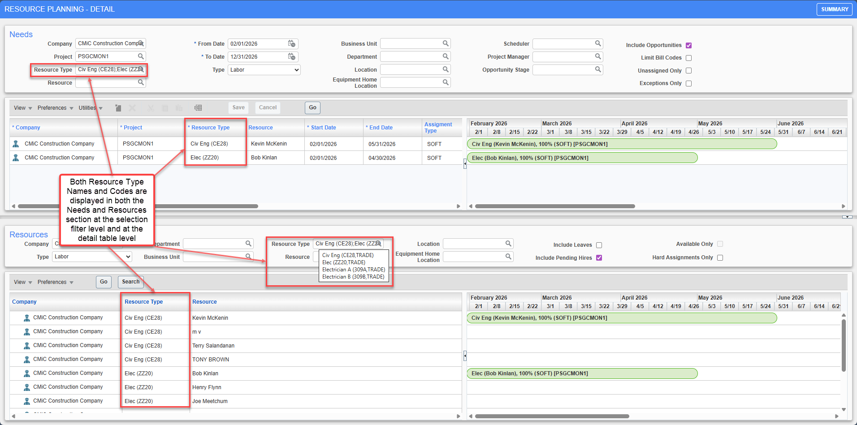
Equipment Home Location:
Clicking on the magnifying glass icon in the Equipment Home Location lov filter in either the Needs or the Resources section launches a popup which displays the available list of home location name and code under a company if the Type filter is either set to Equipment or Both.
In the Needs section, Equipment Home Locations are also displayed and available for selection if the Type is set to Both.
Instead, if its set to Labor, then no records are displayed.
Home locations for each equipment in a company are fetched from the Equipment Maintenance program under Equipment Costing section in Asset Management module.
Asset Management > Equipment Costing > Setup > Enter Equipment
The locations themselves are maintained in the Home Locations program.
Asset Management > Equipment Costing > Setup > Local Tables > Home Locations
Similar to the existing functionality in the Resource Type lov filters, system supports multi-select functionality which can be done by left-clicking the mouse/touchpad on the desired entries while holding either Ctrl or Shift keys in the keyboard.
Upon making the selections, the selected home location name(s) are displayed in the lov filter. Users can also view the location code of all the selection(s) by hovering the cursor on top of the filter which brings up a non-editable display only text box.
If Type is changed after the selections have been made, then system clears out all the Equipment Home Locations similar to existing functionality in the Resource filters.
NOTE: If the Type is changed to either Both or Equipment, even if the existing selections are cleared the user can still make new selections via the popup. However, if it is changed to Labor then no selections can be made as seen in the illustrations earlier.

Subcontract Management

Modification for System Privilege “SCSEPRFPCO “and SCPAYREQ “Contract Change Order” LOV (PC-26561, PC-26360)
Overview
Under this, first enhancement has been made for, system privilege “SCSEPRFPCO”.
This privilege has been modified to include both Unposted and Posted Subcontract.
This modification has been done to prevent users from checking/unchecking the flag “Separate Request for Payment for Change order “on the subcontract at the time of creation as well for Saved unposted subcontract and posted Subcontract.
The privilege name has also been updated to: SC: Allows user to modify "Separate Request for Payment for Change Order" on posted and unposted SC.
Second enhancement has been made for “Contract Change order “LOV available in program “Enter Request for Payment “.
This LOV has been modified to respect the subcontract flag “Separate Request for Payment for Change Order “when flag is unchecked for Subcontract.
When Flag is unchecked, the “Contract Change Order” field would be disable and show value “000” This has been done to prevents users from changing the Change Code (VouChgCode) from 000.
Modifications
1.Name of privilege” SCSEPRFPCO” has been modified to “SC: Allows user to modify "Separate Request for Payment for Change Order" on posted and unposted SC”.
2.When this privilege is granted, for both unposted and posted subcontract, as well as while inserting a new subcontract, users can modify the value of flag “Separate Request for Change order” at subcontract.
On Subcontract, flag value would be defaulted from SC control and check box status would be editable.
When this privilege is not granted, for both unposted and posted subcontract, as well as while inserting a new subcontract, users can not modify the value of flag “Separate Request for Change order” at subcontract.
On Subcontract, flag value would be defaulted from SC control and check box status would be disabled/read-only.
3. Contract Change order “LOV in Enter RFP program has been modified to respect the flag “Separate Request for Payment for Change Order “at Subcontract.
If the flag is unchecked (N) for the subcontract, the “Contract Change Order” field is disabled and displays 000.
If the flag is checked (Y), the “Contract Change Order” is enable and list displays all available change orders.
Implementation
1.When Privilege “SCSEPRFPCO” is granted to user.
System Data>Security>Users>User Maintenance>System Privileges
Flag in SC Control
Subcontract Management>Local Tables>SC Control
Subcontract during insert
Subcontract Management>Contracts>Enter Subcontract/Change Order
Unposted Subcontract
Subcontract Management>Contracts>Enter Subcontract/Change Order
Posted Subcontract
Subcontract Management>Contracts>Enter Subcontract/Change Order

Subcontract Management>Contracts>Enter Subcontract/Change Order
2.When Privilege “SCSEPRFPCO” is not granted to user.
System Data>Security>Users>User Maintenance>System Privileges
Subcontract during insert
Subcontract Management>Contracts>Enter Subcontract/Change Order

Subcontract -Unposted
Subcontract Management>Contracts>Enter Subcontract/Change Order
Subcontract-Posted
Subcontract Management>Contracts>Enter Subcontract/Change Order

Subcontract Management>Contracts>Enter Subcontract/Change Order
3.Contract Change Order LOV when “Separate Request for Payment for Change order” is Unchecked for Subcontract. Subcontract Management>Contracts>Enter Subcontract/Change Order

Subcontract Change Order
Subcontract Management>Contracts>Enter Subcontract/Change Order>Change Orders
RFP
Subcontract Management>Payments>Enter Request for Payments

4.Contract Change Order LOV when “Separate Request for Payment for Change order” is Checked for Subcontract.
Subcontract Management>Contracts>Enter Subcontract/Change Order
Change orders
Subcontract Management>Contracts>Enter Subcontract/Change Order>Change Orders
RFP
Subcontract Management>Payments>Enter Request for Payments
Subcontract Management>Payments>Enter Request for Payments

Warning message upon saving a Subcontract/Change Order when its amount exceeds Cost Budget (PC-19511)
Overview:
Currently users can prevent Subcontract/Change Order from being posted if the amount against any of its schedules of value exceeds the cost budget amount set for the corresponding cost code and category in the Enter Budget program for the specific job.
This can be done by checking the Do Not Allow Posting If Contract Exceeds Budget flag in Subcontract Control and can further be set to applicable only on the base subcontract or on both the subcontract and change order combined.
Project Controls > Subcontract Management > Local Tables > Control
This control flag works in conjunction with the system privilege: SCEBAPST defined at the user level. When this flag is checked, system allows the user to post the subcontract/change order even if the subcontract control flag is checked and the amount exceeds the budget.
System Data > Security > Users > User Maintenance

Modifications:
Now a new enhancement has been made to the functionality specifically in Enterprise application, whereby system will also display a warning message immediately upon saving a subcontract/change order when its amount exceeds the budget amount while the Do Not Allow Posting If Contract Exceeds Budget control flag is checked.
This warning message will be displayed irrespective of whether the user has the SCEBAPST system privilege and is worded similarly to the error message displayed upon posting as per current functionality.
Project Controls > Subcontract Management > Contracts > Enter Subcontract/Change Order
When the Contract Option in the subcontract control is set to Both Contract and Change Order instead of the default Base Contract then similar warning message is also displayed while saving the change order when the total amount of a schedule of value across both the base subcontract and the change order(s) exceeds the cost budget.
Project Controls > Subcontract Management > Contracts > Enter Subcontract/Change Order
NOTE: If the Contract Option is set to Base Contract, then no warning message will be displayed upon saving the change order even if the total amount including the base subcontract exceeds the budget. This is as per the current functionality when it comes to posting the change order.

Implementation:
This warning message is only displayed once initially upon saving the subcontract/change order and clicking on save subsequently won’t display the warning message.
Project Controls > Subcontract Management > Contracts > Enter Subcontract/Change Order
But if the user either modifies the existing schedule of values again (e.g. Adding description, taxes or modifying job/cost code/category) or inserts a new schedule of value, then upon saving system once again displays the warning message. Saving again without further modifications won’t trigger the warning message anymore.
Project Controls > Subcontract Management > Contracts > Enter Subcontract/Change Order
In case there are multiple schedules of value with amounts exceeding the budget, system will only display the warning message for the very first line inserted in the subcontract/change order whose amount exceeds the budget.
Project Controls > Subcontract Management > Contracts > Enter Subcontract/Change Order
NOTE: If user again modifies the subcontract amount of this very first line to be less than or equal to the budget, then upon saving system will now display the warning message for the next line whose amount exceeds the budget.
Project Controls > Subcontract Management > Contracts > Enter Subcontract/Change Order
Even if the warning message is not dependent on the SCEBAPST user privilege, system continues to consider this system flag when user attempts to post the subcontract/change order as per the existing functionality.
When user does not have the privilege, then system displays an error message and prevents the subcontract/change order from being posted.
Project Controls > Subcontract Management > Contracts > Enter Subcontract/Change Order
Project Controls > Subcontract Management > Contracts > Enter Subcontract/Change Order
NOTE: As per current functionality, if user checks the Override Do Not Exceed Amount flag in the Summary tab of the Subcontract, then system won’t consider the subcontract control flag Do Not Allow Posting if Contract Exceeds Budget flag for this specific contract and hence no warning or error message is displayed upon saving or posting the subcontract/change order even if the amount exceeds the budget and the control flag is checked.
Project Controls > Subcontract Management > Contracts > Enter Subcontract/Change Order

Add Discount Information to Select Multiple RFP Batches Program (PC-25669)
Overview
Three new discount columns, “Discount %”, “Discount Amount”, and “Discount Date” have been added to the Select Multiple RFP Batches program for viewing and filtering purposes only.
These fields are non-editable and are available to help users review and filter RFP data more efficiently.
Modifications
1.Added three new columns in Select Multiple RFP Batches program.
- Discount %
- Discount Amount
- Discount Date
2. Fields are read-only (view-only)
3.Columns are hidden by default; User must add them through Lite editor.
Implementation
Scenario1:
- Create an RFP with discount information through Image Manager.
- Save and Submit RFP.
- Navigate to Select Multiple RFP Voucher program.
4) Open Lite Editor and add the following fields.
- Discount %
- Discount Amount
- Discount Date

5) Create a new batch.
RFP is displayed with Discount Amount, Discount Date and Discount Percentage.
Scenario2:
1) Go to Subcontract Management- Enter Request for Payment program.
2) Create an RFP with Discount details.

3) Navigate to Select Multiple RFP Batches program
4) Open Lite Editor and add the following fields.
- Discount %
- Discount Amount
- Discount Date
5) Create a new batch.
RFP is displayed with Discount Amount and Discount Date.

System Data

IP Whitelisting feature – New IP Whitelisting maintenance screen and the "Enable IP Whitelisting" system option - Beta Version (CAM-11420)
Overview
CMiC now provides an IP-based access control layer that restricts which client IP addresses are allowed to reach the system. Two related changes deliver this capability:
- Enable IP Whitelisting Checkbox - New security option in the System Options program that switches the feature on or off for the clients.
- IP Whitelisting - New maintenance program (SYSIPWHITELIST) where administrators record the individual IP addresses that are permitted, each with a description and a disabled checkbox.

Important: This functionality is still under development. Access is currently granted only when internal company private VPN IP Address is whitelisted; all the users connecting through VPN will have access to APIs and dependent applications that use APIs calls. If this configuration is not suitable for your organization, do NOT set "Enable IP Whitelisting" checkbox to 'Y'. Refer to known limitations and current status of this enhancement before using.
Note: This enhancement does not control access to CMiC Software ADF, BI and Analytics and CMiC Legacy JSP Programs such as Project Management.

Modifications
The following programs are added or modified for this functionality:
- System Options (SYSOPT) modified
- IP Whitelisting (SYSIPWHITELIST) new program

- System Options:
A new security option, "Enable IP Whitelisting", has been added to the General tab of the System Options screen.

Behavior of the option:
- Unchecked (by default): IP whitelisting is not enforced. The system behaves exactly as it did before this enhancement, and any entries recorded in the IP Whitelisting program are ignored.
- Checked: IP whitelisting enforcement is activated. The client IP address of each incoming request is compared against the enabled entries in the IP Whitelisting program. If a matching entry is found, access is allowed; if no match is found, access is denied.

- IP Whitelisting:
A new maintenance program named "IP Whitelisting" has been added. It is used to record and maintain the list of IP addresses that are permitted to access the system when IP whitelisting is enabled. This program is not available by default in the tree view, users must add as required.
These are fields present in the IP Whitelisting screen.
- IP Network
- Description
- Disabled checkbox column

IP Network: The IP address to be whitelisted must be entered in this column. Both IPv4 and IPv6 values are supported, and a value may be entered either as a single IP address or in CIDR notation (an IP address followed by a prefix length) for example, 1.2.3.4 or 1.2.3.4/32. The value is validated when the record is saved. This is a mandatory field with a maximum length of 45 characters, and duplicate entries are not permitted.
Description: A free-text description of the entry, used to identify what the rule covers. The maximum length is 200 characters.
Disabled: Controls whether the entry participates in the whitelist check. The checkbox is unchecked by default upon entry. This means the entry is active and access requests from matching addresses are allowed.
When the checkbox is checked, the entry is disabled and is ignored during the whitelist check, without having to delete the record.
If the system option is enabled, while the IP Whitelisting table holds no entries, access to the APIs and to every application that depends on API calls is denied for all users. The whitelist must therefore be populated and verified before the option is enabled.
Known limitations and current status
This functionality is still under development and is not yet ready for production use. Enforcement has been verified to work in one configuration only when whitelisting company private VPN IP Address. The following observations must be noted before using this feature.
- What does the whitelist currently permit?
When this feature is turned ON and an entry of company private IP address exists, then users connecting through this address will only be allowed to access the programs such as APIs, construct-pm, nexus-pc, nexus-im, nexus-ai-builder, construct-uac, etc.
Access to CMiC Software ADF UI, Business intelligence and Analytics and Project Management legacy program are always allowed and not controlled by IP Whitelisting.
- What does the whitelist not currently permit?
- External users of the company cannot be whitelisted if not using company’s VPN
Recording the public IP address of a user does not allow access to APIs and programs using API calls.

Note: Released in Nexus_02-HF2

System Data – Logo Banner added to System Options (CAM-11123)
Overview
A new Text Box field “Logo Banner” has been included within the Logo Path tab of System Options, as well as the Console Properties in Edit Mode. This addition allows the user to set an optional text-ribbon across the logo on the top left of the page and provide more customization.
Modifications
Runtime feature program:
Implementation
The user will first open the System Options program module and enter the Logo Path tab. The text box Logo Banner will be visible and ready to be modified.
The user will then enter any message within the field, save, and then refresh the page to view the changes to the ribbon on the top left of the console.

Additionally, the user will be able to change the ribbon text via the Console Properties by first accessing the ‘Edit More Options….’ Module. The user will first click the top three dot icon for menu access and select Edit Mode from the dropdown list.
The user will then click the Edit More Options… tab alongside the top header menu to access the Console Properties.
The user will enter text within the Logo Banner text box, click save on the top right of the page, select the Level Type and Level Name of user they wish to change, and then click OK to make the final change.
By adding text here and saving, the Logo Banner ribbon will be overwritten, and the Console Properties text will be prioritized over the System Options version.

System Data – Merge Options removed from LOV List (CAM-10505)
Overview
The Merge Partner/Contact Utility ‘SDPARTNERCONTACTMERGE’ has been configured to where the options Project Partner and Project Contact within the Merge LOV drop down have been removed.
This change removes the possibility of the user causing errors within the program.
Modifications
Runtime feature program:
Implementation
The Merge options Project Partner and Project Contact have been removed from the program. They are no longer available to be selected within the Merge LOV dropdown list.

System Data – New Support Chat License Type Added (CAM-10455)
Overview
A new license type named “Named User – Support Chat” has been included within Maintain License Pools program (‘SYSLICPOOLMAINT’). This new license when assigned for a user, will enable a Chat icon on the ADF toolbar and once clicked will launch the Salesforce Support Chat window. This functionality aims to improve the quality of life and resourcefulness for users.
Note: For any inquiries, please contact your Account Manager or our Services team regarding licensing
Modifications
Maintain License Pools Program:
Implementation
A new License Pool type has been added to the Maintain License Pool program called “Named User – Support Chat”. Once assigned to a user, the Support Chat icon and functionality will be enabled.
The user must first assign a user to the new License Pool to see the resulting functionality. The user will select the “Named User-Support Chat” License Type.
The user will then insert and save a user of their choice to assign the License Type.
On the top header toolbar, the user will see the Support Chat icon then enabled once they start up a new browser and log in. Upon clicking the icon, the Salesforce Support Chat will open. This Support Chat functionality mirrors the functionality on Cloud.

System Data – New UAC Dynamic Company Assignment Flag Added to System Options Program (CAM-11664)
Overview
A new flag labeled ‘Enable Dynamic Company Assignment’ has been added to the System Options Program – Global Tab (‘SYSOPT’). This new flag will allow the user to change the Construct UAC program from Single Company Assignment Mode to Dynamic Company Assignment Mode. This will assist the user in the user creation process.
Modifications
System Options Program:
Implementation
A new flag has been added to the System Options program under the Global tab. This new flag named ‘Enable Dynamic Company Assignment’ when checked will swap the user into Dynamic Company Assignment mode, enabling workflows and allowing the creation of new users across different companies. While unchecked, you will be within Single Company Assignment Mode, restricting the user creation process to the company assigned to each specific Permission Template.
Single Company Assignment Mode
While the new flag ‘Enable Dynamic Company Assignment’ is unchecked, you are restricted to setting one company only when creating a new user.
Dynamic Company Assignment Mode
While the new flag ‘Enable Dynamic Company Assignment’ is checked, you will be able to select any company within a new LOV dropdown list ‘Company’ and assign it during the user creation process.

System Data – Terms of Use Updated in System Options (CAM-11897)
Overview
The Terms of Use and Privacy Policies along with two linked buttons have been updated within the System Options – AI Tab. This change improves the quality and overall look of the section to meet higher standards.
Modifications
Runtime feature program:
Implementation
The Terms of Use and Privacy Policies section within the AI tab of System Options has been updated. The text and links are now clearer and simpler for the user to engage on.
The user can click on the ‘View Services Agreement’ or ‘View Privacy Page’ buttons which will open up the official OpenAI Services Agreement and Enterprise Privacy web pages respectively.

System Data – Theme Selection Field Removed from System Options (CAM-11403)
Overview
The Default Theme selection field LOV drop down within System Options User Settings and User Preferences has been removed. Since the Classic theme no longer exists within Nexus 02, the option has been removed from both locations.
Modifications
Runtime feature program:
Implementation
The Default Theme and Theme drop down LOV lists have been removed from System Data > Setup > System Options – User Settings and System Data > Preferences > User Preferences programs. Since Classic theme has been removed as of Nexus 02, the option is no longer required.
System Options:
User Preferences:

System Data – Toolbar Options Disabled within Define Roles Program (CAM-12267)
Overview
Three Toolbar buttons (Insert, Insert Multiple, and Delete) are now disabled within the Define Roles ‘ROLES’ program, in both the System Privileges and Configuration Privileges pop-up windows. This intended change will prevent the user from experiencing any unnecessary errors.
Modifications
Define Roles program:
Implementation
The Insert, Insert Multiple, and Delete options in the System Privileges and Configuration Privileges button pop-up windows have been greyed out and are now inaccessible to prevent the user from triggering any unnecessary errors.
System Privileges Pop-up:

Configuration Privileges Pop-up:

System Data - User Deletion Restrictions for Active Workflow Submitters (CAM-10960)
Overview
The user deletion process has been enhanced to validate whether a user is associated with any outstanding workflow transactions as a submitter.
Modifications
In User Maintenance (SDUSRMNT), when a user is selected for deletion, the system will evaluate the user's involvement in any outstanding workflow transactions.
If the user is the submitter of one or more outstanding workflow transactions, the system will prevent the user from being deleted and display the following alert message:
“User [USERCODE] cannot be deleted due to outstanding workflow currently assigned”
Implementation
The user deletion process has been updated to validate outstanding workflow assignments before completing the deletion. When a user deletion is initiated, the system checks whether the user is the submitter of any active workflow transaction. If active workflow transactions exist, the system prevents the deletion and displays an alert message. Otherwise, the user deletion proceeds successfully.

TOOLS

Deprecation of Legacy XLS Output Format (TOOLS-8431)
Overview
As part of system updates, the legacy XLS export format has been deprecated within CMiC. The "Excel" export option has been updated to generate output in XLSX format (with the .xlsx file extension) instead of the older XLS format.
Since the "Excel" option now produces XLSX files directly, the separate "XLSX" option in the export drop-down was redundant and has been removed. This change simplifies the export options while ensuring XLSX, the current standard spreadsheet format, remains fully supported.
Refer to the screenshot below showing the current export window with only the Excel option available.
Modifications
The export functionality has been updated as follows:
Before Change
Previously, users were presented with two export options:
- Excel (produced files in the legacy XLS format)
- XLSX
This allowed users to select between two similar spreadsheet formats, with "Excel" producing the older XLS format and "XLSX" producing the newer XLSX format.
After Change
With this update:
- The legacy XLS format has been deprecated, and the "Excel" option now produces XLSX output instead.
- The separate "XLSX" option has been removed from all screens, since it is no longer needed.
No other functionality has been modified.
Summary of Change
- Removed: Legacy XLS export option
- Retained: Excel export option
- Scope: All modules and screens where export functionality is available
- Impact: Minimal – no change to user workflow aside from option visibility
Impact Analysis
This is a low-impact change. Users can continue exporting data using the Excel option as before. The files produced will now be in XLSX format rather than XLS. There is no impact on file usability or downstream processes.

Target Options for Construct PM & Nexus PC (UI Console Integration) (TOOL-9125)
This CMiC enhancement adds new NEXUS Treeview target options for launching Construct PM and Nexus PC modules directly. It supports direct navigation, project-aware context, and improved UI behavior.
Pre-requisites
- UI Console / Enterprise is configured
- Treeview Builder access is available
- Required roles are configured
- Construct PM and Nexus PC are enabled
- Project data is available
Modifications
1. New Target Integration: Adds Treeview target options to launch Construct PM and Nexus PC modules directly.
2. Navigation Optimization: Uses the ?hideMenu parameter to hide the navigation rail for a cleaner launch experience.
3. Project Context Handling:
- If Project Sensitive = Y, the projectUUID is passed in the URL.
- If Project Sensitive = N, the projectUUID is not passed.
4. Available Targets: Supports Construct PM targets such as Contacts, RFIs, and Issues, and Nexus PC targets such as PCIs, Subcontracts, and OCOs.
5. Enterprise reloads the entire screen, when project sensitive is ON and the project changes.
Implementation
Step 1: Open the Treeview Builder.
Step 2: Add a menu item.
Step 3: Set the target type to Construct PM or Nexus PC.

Step 4: Assign roles.
Step 5: Select the target window.
Step 6: Save your changes.
UI Console Setup:
Step 7: Enable Edit Mode.
Step 8: Add Treeview to the menu.

Step 9: Save the console.

Disable AI Button and Smart Search (TOOL-9561)
Overview
Customers who do not have an active AI license can disable AI functionality within CMiC. Once disabled, AI-related buttons, prompts, and options, including the Smart Search option, will no longer be available to the user.
Modifications
Pgm: SDUSRMNT – User Maintenance; standard Treeview path: System > Security > User Maintenance – System Privileges tab
The ‘AIASKAL - Allows the user to use “AI” functionality’ privilege was available in the system prior to this change. Following the modification, users without this privilege enabled will not be able to see the [AI] button or Smart Search option.
Before Change
Previously, users without the AIASKAL privilege could see the [AI] button and the Smart Search option.

After Change
With this update, when the AIASKAL privilege is unchecked, the [AI] button and Smart Search option will no longer be displayed.
To update a user’s privileges:
- Log in to the CMiC application using an account with administrative privileges.
- Navigate to the User Maintenance screen in the System Data module.
- Open the User record and select the System Privileges tab.
- Search for the following privilege: AIASKAL - Allows the user to use "AI" functionality.
- Check or uncheck the box to enable or disable the privilege.
- Click [Save] to apply the changes.
- Log out, then log in again.
Impact Analysis
This is a low-impact configuration change. Standard business processes and non-AI functionality remain unaffected.

