NEXUS_01 Release
New Functionality Contents
NEXUS_01 Release New Functionality Contents 1
Important Note 4
Accounts Payable 4
Reconcile Checks – Include Voided Checks (FIN-20457) 4
Positive Pay File Format for Regions Bank (FIN-17480) 5
Auto upload Positive Pay File to SFTP Server (FIN-18397) 7
EFT File Format for Liberty Bank (FIN-18537) 11
EFT File Format for Bankers Trust (FIN-19408) 18
Modifications to USBANK_2 Positive Pay format (FIN-19752) 23
EFT File Format for Huntington National Bank (FIN-19949) 23
Modifications to Manual Check Program (FIN-20053) 29
EFT File Format for Key Bank (FIN-20358) 31
Modifications to AP Prepare Vouchers Program (FIN-20445) 35
SWIFT, Currency and IBAN field added to Maintain Business Partner and Banks (FIN-20889) 36
EFT File Format for AvidXchange (FIN-20628) 38
EFT CCD file format for Atlantic Union Bank (FIN-18010) 40
EFT CTX file format for JPMorgan Chase Bank (FIN-18227) 44
PO Detail Invoice Select List (Variance pop-up): “Save” button is removed (FIN-19431) 49
Positive Pay File Format for United Bank (FIN-18779) 50
Added a new column ‘Selection Code’ to Adjust Voucher Status program (FIN-19275) 54
Incorporate Third-Party Payment process into Bank reconciliation process (FIN-19499) 55
Modified Third-Party Payment mode file for Wells Fargo 2 (FIN-19558) 60
Third-Party Payment file format (Card Type Payment) for Wells Fargo (FIN-19868) 61
EFT file format for US Bank (FIN-20332) 74
Modified EFT CTX file format for JPMorgan Chase Bank (FIN-20270) 78
Vendor Address Handling for Wells Fargo 2 Third-Party payment (FIN-20906) 83
Modified EFT File Format for National Bank (FIN-18897) 84
EFT File Format for UPIC Bank (FIN-15965) 86
Positive Pay Format for Bank of America (FIN-18956) 87
Check XML File for HSBC Bank and UAE (FIN-18763) 90
Preferred Contact Method for AR MCC Custom Invoice Report (FIN-19773) 95
Third Party Payment File Format for Bank of America (FIN-18761) 96
EFT File Format for TD Bank (FIN-19186) 109
T5018 xml file updates as per CRA requirements (FIN-21938) 114
AI Agents 115
Overview 115
Create AP Invoices 117
Create Vendors 117
Create AP Memos 117
Select AP Invoices for Payment 117
Create AR Invoices 117
Create Customers 117
Create AR Memos 117
Create Inventory Locations 117
CMIC CHATGPT 118
Create Equipment Locations 118
Create Financial Documents 118
Create Consolidations 118
Create GL Transactions 118
Create GL Accounts 118
Close GL Periods 118
Create Billing Contract 118
Maintain Cost Codes and Categories – Master 118
Create and Store Contract Forecast 119
Create Job Costing Transactions 119
Create Job 119
Create Project 119
Post Journal Entries 119
Create Requisitions 119
Create Users 119
Analyze Batch Posting Impact 119
Perform Bank Reconciliation 119
Accounts Receivable 120
Enhancement to arpayment API (FIN-19363) 120
Analytics 121
Combined Bar/Line Chart Visualization in Dashboard Builder (BI-1814) 121
Analytics Dark Mode Support (BI-1657) 121
Dynamic Autofit Columns (BI-1602) 122
Enable Pagination “Off” by Default (BI-1641) 123
Panel Background Color Customization (BI-1733) 123
Equipment Costing 125
Import functionality is added to the EC Category Codes and Transaction Codes program (FIN-19471) 125
Employee Self Service 126
ESS User: Password Reset Required After User Creation 126
ESS Leave Request Enhancement - Insert Salaried Employee Leave into Adjustment Table (HCM-22729) 132
General Ledger 137
Modifications to Maintain Budget (FIN-18073) 137
Job picklist added to Cost Pool Allocation (FIN-20385) 137
Modified Bank Reconciliation File Format (US-BANK2) (FIN-19834) 139
Human Resources 139
Human Resources & Payroll Modules Mask SSN (HCM-23190) 139
International Payroll 147
Emailing T4s & RL1.P- Preferred Contact Method destination option added to T4 forms program (HCM-3586) 147
CRA T619 header modifications for T4/T4A XML Format of 2026 Electronic Transmittal changes (HCM-25480) 159
Imaging 164
Imaging Control – Enforce SOV Line Amount Limit (Voucher RFP) (ECMDEV-12840/ECMDEV-11956) 164
Vendor Primary and Alternate Address Enhancement (ECMDEV-5397) 165
Job Billing 167
JBPB_U11CW- US Progress Bill Inv (Ret) Invoice format. (JBJCPC-3963) 167
Create job contract via API (JBJCPC-4182) 169
Job Costing 170
WIP New Columns for Profit% and Profit Override%(PC-17635) 170
Modifications 171
Controlling Category Auto-Assignment in Cost Codes (JBJCPC-2433) 173
Job Cost transactions created via API endpoint to consider Payroll Security set for the User (JBJCPC-2572) 178
Department Code added to Automatic Job Numbering Mask (JBJCPC-2289) 191
New Coloring Scheme in WIP Adjustment screen (JBJCPC-4516) 199
Do Not Allow Copying Inactive Cost Codes or Cost Codes Not on the Master flags functionalities (PC-13077) 201
GC Monitor: Update GC Monitor Period Details to Read Sub rate tables using effective periods (PC-21811) 203
Material Sales 213
Material Sales – New Point of Sale and Print Billing Invoice Programs (CAM-7464) 213
Opportunity Management 220
Opportunity Management – Add New button Introduced in Contacts, Organization, Company LOV pop-up (CAM-9389) 220
Payroll US 225
Extended Holiday Setup and Overtime Processing by Company, Pay Group, and Union (HCM-18081) 225
Payroll Processing Validation Feature Enhancement - Phase 2 (HCM-18745) 245
New enhancement to populate sector and schedule when cost allocated on equipment work order feature is ON (HCM-19605) 272
New Positive Pay Wells Fargo Bank Format (ARP) (HCM-21493) 289
New Employee Profile Change Tracking and Reporting (HCM-22574) 295
Addition of Wells Fargo SFTP Integration for ACH and Positive Pay - Payroll Module (HCM-23179) 300
Inclusion of Safe Hours on Pay & Check Stubs (HCM-23945) 306
Delaware Parent Leave – PFML File (HCM-24519) 310
Integration of Vertex Address Cleansing into CMiC Payroll for Improved Tax Jurisdiction Accuracy (HCM-24954) 314
Arizona AZA4V Form Signed (HCM-25305) 319
New Qualified Overtime Compensation (QOC Reporting) (HCM-25390) 323
Payroll History Enhancement – Store Vertex Subject Earnings for Reporting (HCM-25593) 329
Prevailing Wage Benefit Enhancement – OT/DOT Rate Override (HCM-25730) 332
Nebraska Health Families Workplace Act (HCM-26176) 336
Project Management 345
Request for Payment - Payment Mode and Paymode Type (FIN-19656) 345
Checklist Templates - Warnings for Removing Tags (CF-27855) 346
Punch List Report (PMPL02) Enhancements (CF-31239) 349
New Projected Final Flag Type and Forecasting (Beta Version) (PC-7126) 350
Forecasting Productivity Pop Up - Additional Decimal Request (PC-19021) 371
Contract Forecasting-New Columns for Archive Forecast (JBJCPC-1982) 372
Specifications Upload – Extract with AI (CF-33530) 376
Purchase Order 383
Blanket Order Entry: Updated Expiry Date Validation (CAM-9802) 383
Blanket Order – Control File Text Codes now default on Blanket Order Entry (CAM-9147) 384
Blanket Order – New description fields added to Blanket Purchase Order (CAM-8763) 386
Change Order – Three new columns added to Purchase Order Lookup (CAM-8118) 388
Construct PM – New Column Title and Calculation for Receiving Shipments (CAM-9321) 389
Control File – New Flag setting included for Receipt posting (CAM-9166) 391
Purchase Order – New Enhancement for Job Line Distribution Type introduced (CAM-9857) 396
POMaster API – Advanced Payment fields added to GET Request (CAM-9619) 398
LEM Maintenance Program (Beta Version) (CAM-6390) 400
Requisitions 403
Construct PM Requisitions – Buyer Field introduced to Requisition Entry (CAM-5234) 403
Subcontract Management 406
Print multiple SCCHGDOC reports from Print Document (SCPRINT) Program (PC-15640) 406
Missing Advance-Related Fields in RFP API (PC-20246) 411
Subcontractor Prequalification 414
Prequalification Control - Add Free-Form Email Notification (CF-33793) 414
System Data 422
Added System Privilege to prevent posting to Inactive Departments (FIN-16105) 422
Construct UAC – Permission Templates renamed across entire program (CAM-10255) 423
Enterprise Role Security to access AI Agents Implementation (CAM-9732) 425
Merge Partner/Contact - New Enhancements to Merge Utility (CAM-7693) 434
Print Posting Reports Program (SYSRUN): Added “Query Data” Button (CAM-9523) 437
Subscription URL Definitions (SDWEBHOOKDFN): URL Field Length Enhanced to 4,000 Characters (CAM-9695) 439
System Data – New UIRuntime Feature added to All Programs (TOOL-8107) 439
System Data – SDROLETOAPI is replaced with SDAPITOROLE (CAM-8910) 443
System Options – New LOV added within the SYSOPT AI tab (CAM-8568) 446
UIRuntime Error – Window now includes a close button (TOOL-5109) 448
Updated Descriptions for UACCREATE and UACMODIFY System Privileges (CAM-8949) 449
User Maintenance – Change Order privilege renamed and readjusted (CAM-7166) 450
User Password Management and Security Enhancements – (CAM-9505) 452
User Preferences – Mass Update feature (CAM-10730) 470
New API Endpoint for User Assignment to Job Security Group (JBJCPC-2959) 479
New API Endpoint for creation of Job/Project Security Groups (JBJCPC-3765) 485
New API Endpoint for Job Assignment to Security Group (JBJCPC-3766) 492
New API Endpoint for Project Assignment to Security Group (JBJCPC-3766) 498
Enhancement to sysrelateddocquery API (FIN-20956) 505

Important Note
Please be aware that some modifications and enhancements may require licensing, specific configurations, and setup, and may require involvement of CMiC Consulting to be utilized and further training may be required. Please contact your Account Manager/Project Manager for more information where needed.

Accounts Payable

Reconcile Checks – Include Voided Checks (FIN-20457)
Reconcile Checks program has a check box ‘Include Voided After Statement Date’ to display voided checks. This is modified to read as ‘Include Voided On and After Statement Date’
Implementation:
Checks Voided on the same date as statement date were not available in this program prior to this fix.
With this modification, the checks that were voided on the same date as statement date are available for audit/reconciliation purposes.

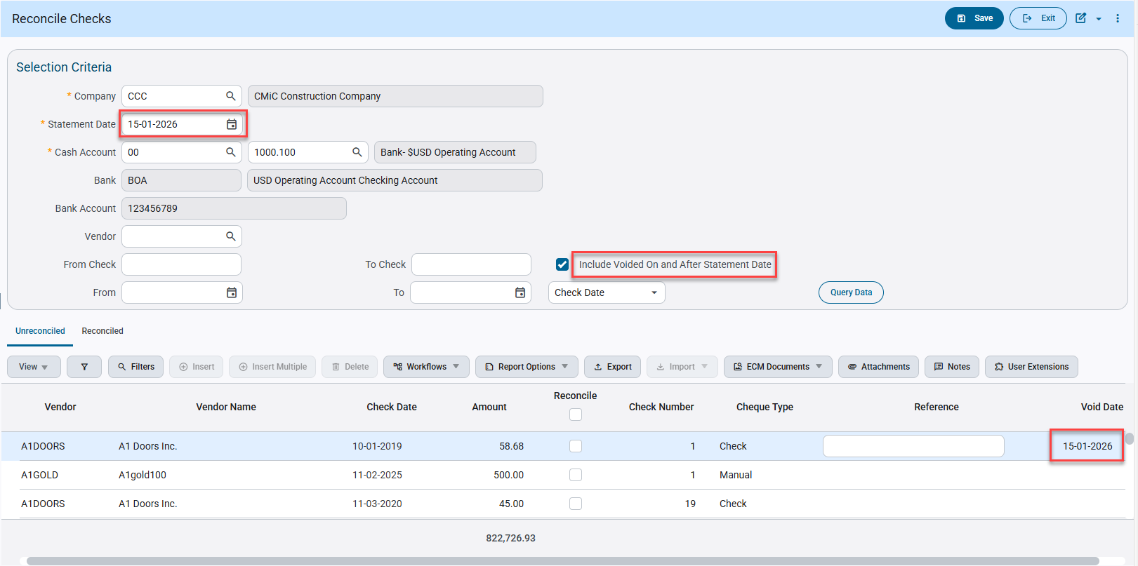

Positive Pay File Format for Regions Bank (FIN-17480)
Overview:
AP Positive Pay File Format “REGIONSBNK” for Regions Bank.
Modifications:
A new AP positive pay file format “REGIONSBNK: Regions Bank” has been added as per specification format shared by client.
Following fields mapping and values will be used in the file format:

Account Number | Cash Account Number - leading zero’s (Total of 10 digits)
Check Amount | Check Amount – format: 100.00
Check Number | Check Number
Date | Check Date/Void Date – format: MM/DD/YYYY
Issue or Void Indicator | I-Issue, V-Void
Payee Name | Payee Name on the check

Implementation:
Create Bank Group:
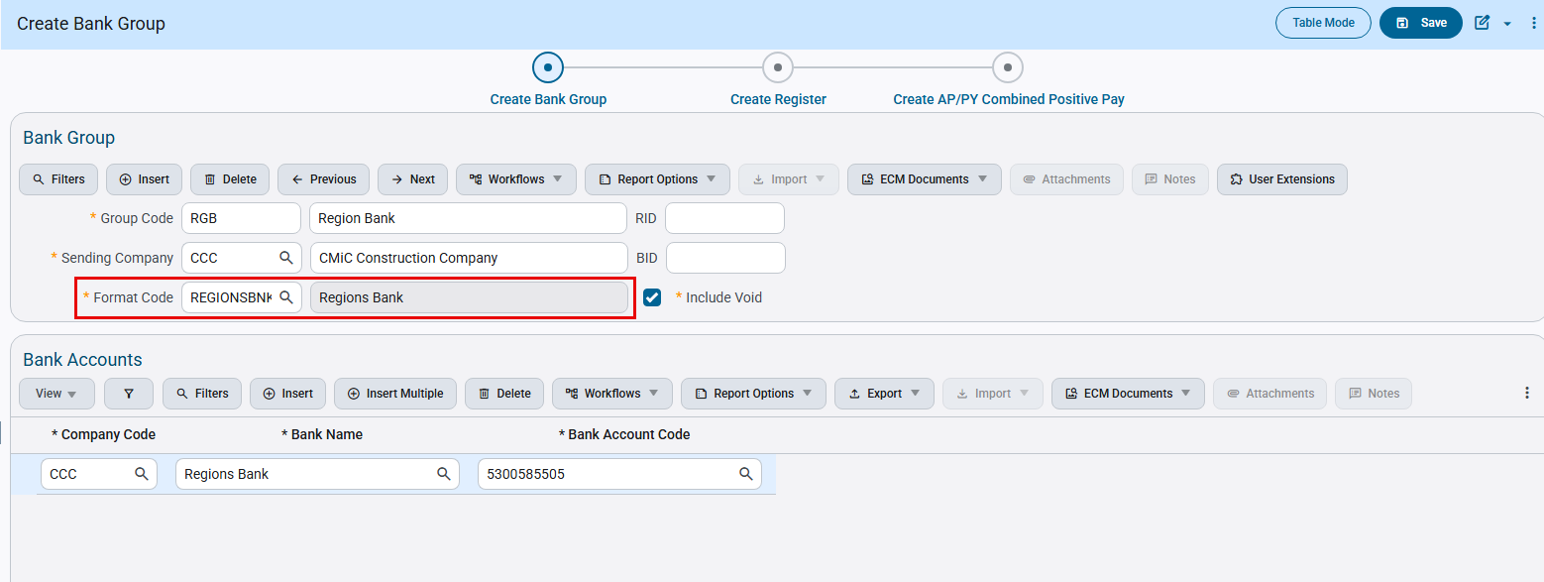
Accounts Payable > Check > Positive Pay Register
Create Register under Regions Bank Group Code :
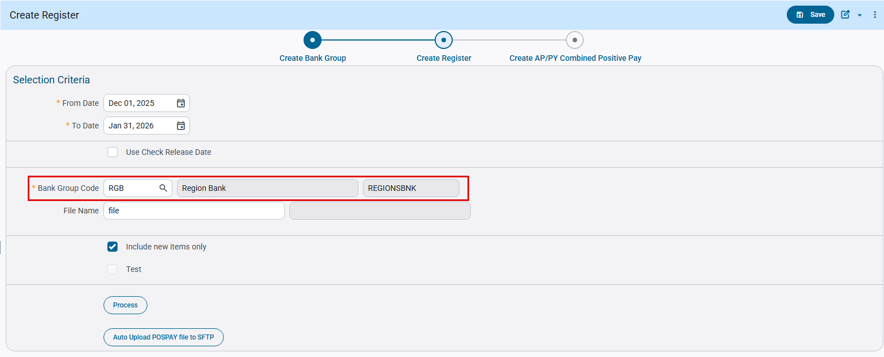
Positive pay file is generated as below:
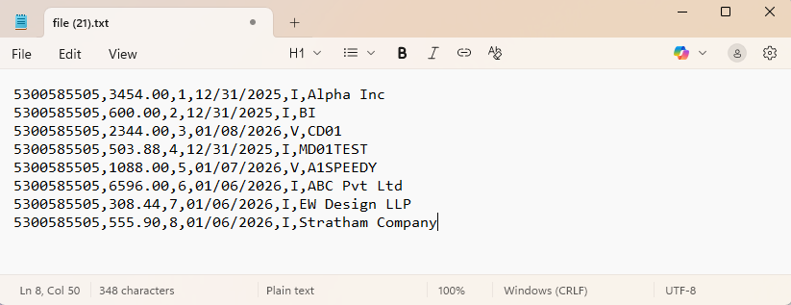
Specification format:
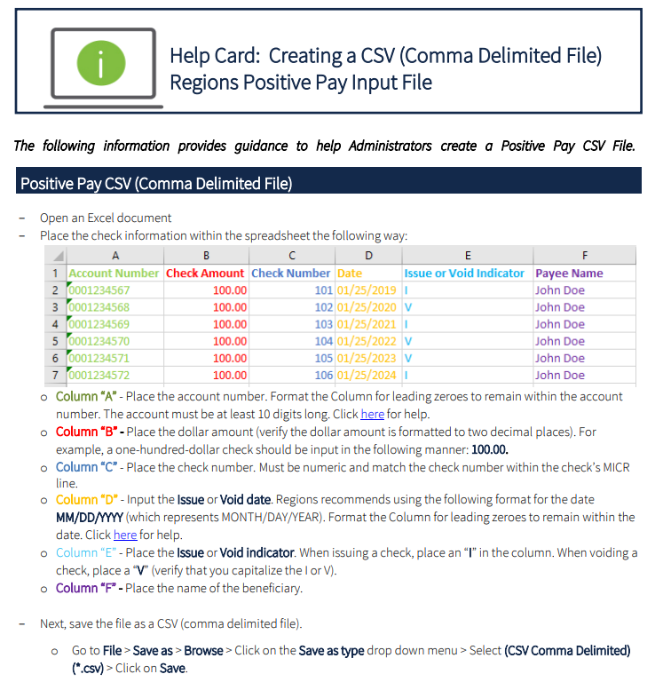

Auto upload Positive Pay File to SFTP Server (FIN-18397)
Overview:
AP Positive pay program has been modified to add a new button [Auto Upload POSPAY file to SFTP]. This button is visible once the SFTP server details are added in System Options. When user clicks on this button, positive pay file will be generated and automatically uploaded to SFTP Server. The file is encrypted if Encryption and Public Key File information is provided in SFTP server setup.
Modifications:
Server setup for Positive pay file is highlighted in the screen below:
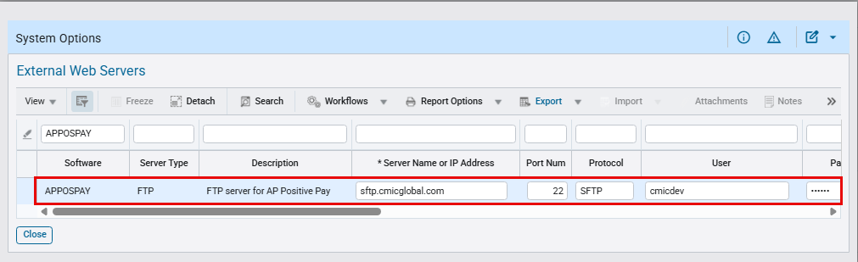
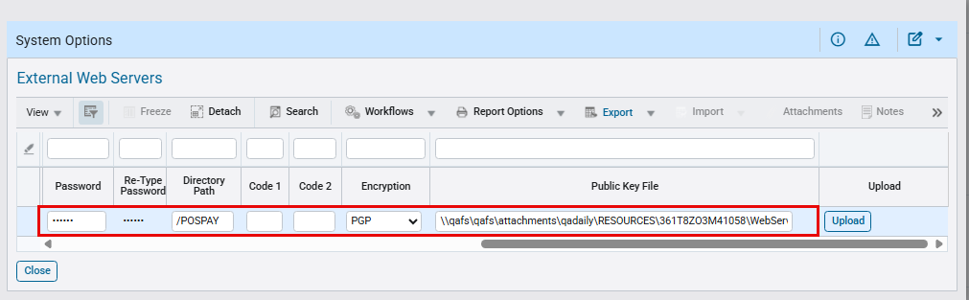
System Data > Setup > System Options > General tab

Once Server setup is complete, [Auto Upload POSPAY file to SFTP] button is visible in the screen below: 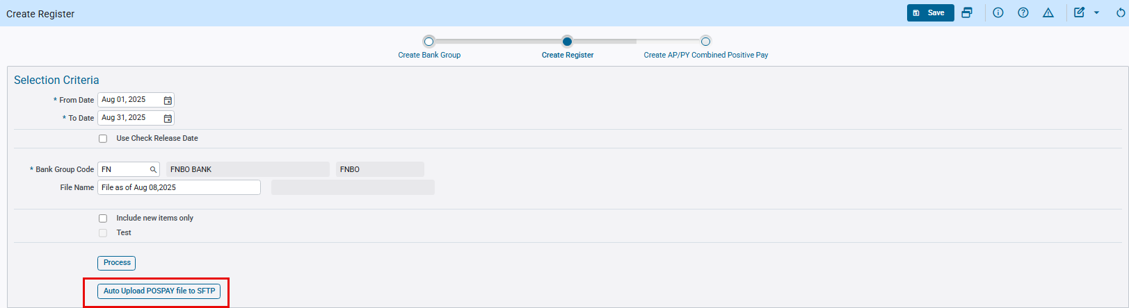
Accounts Payable > Check > Positive Pay Register > Create Register node

Below screenshots show Positive Pay file generated and saved in SFTP server:
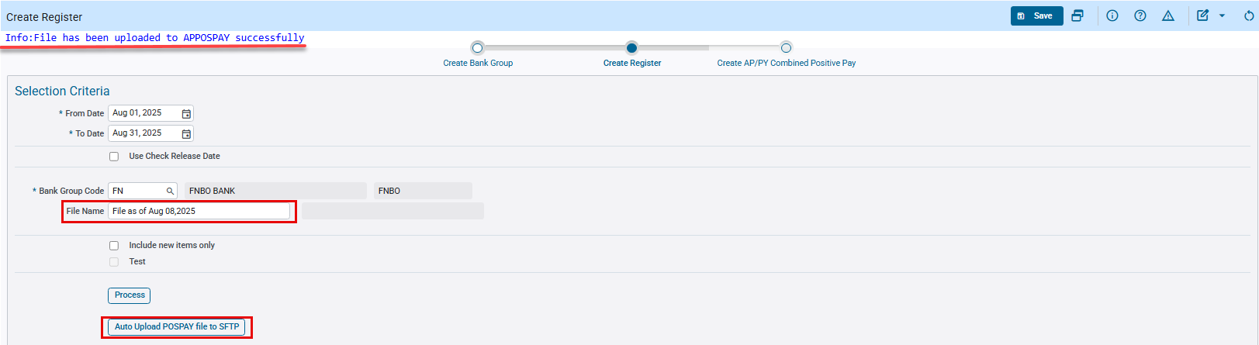
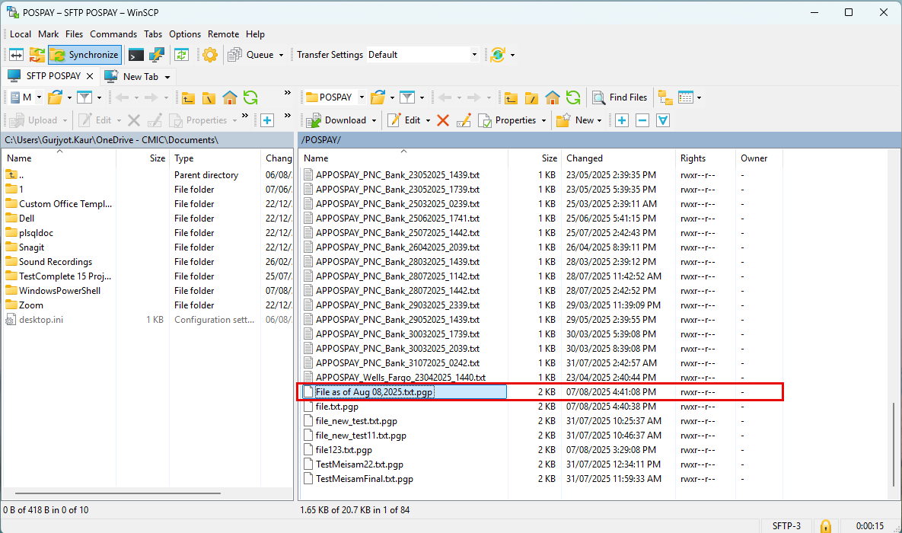
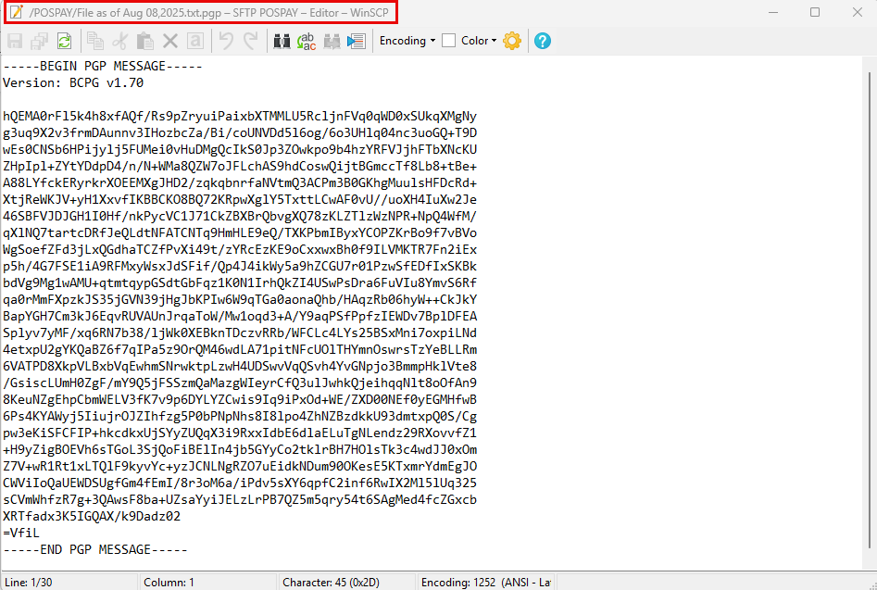

If encryption details are not provided in Server setup, Positive pay file will not be encrypted.
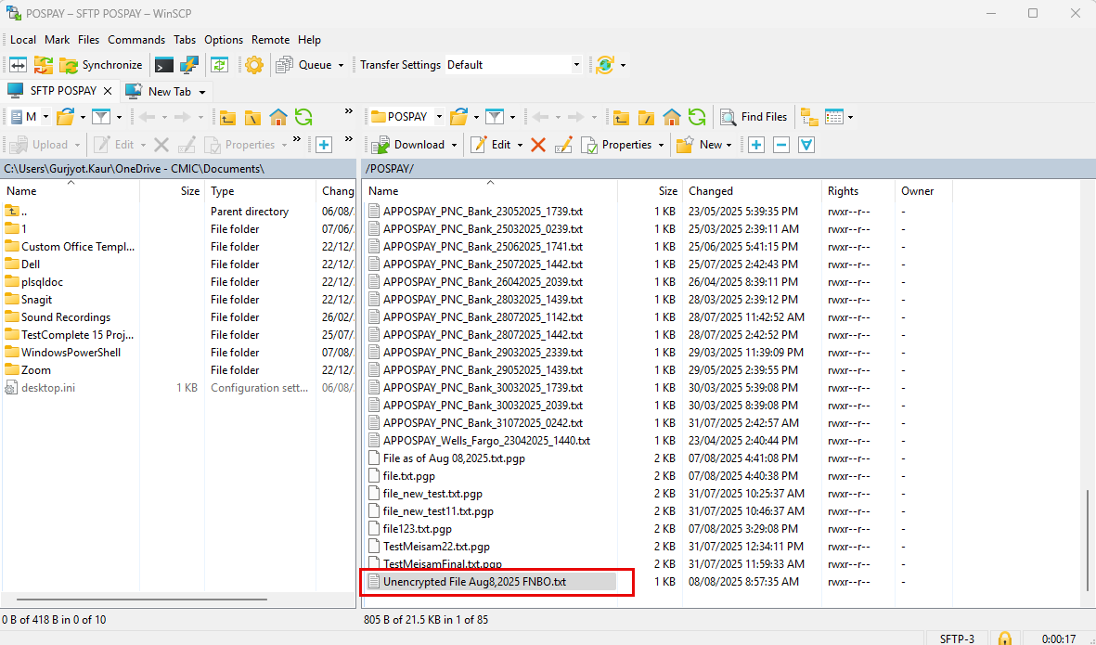
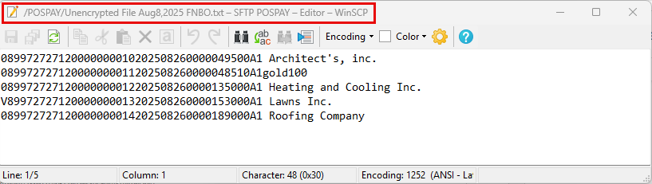

EFT File Format for Liberty Bank (FIN-18537)
Overview:
AP EFT Format “LIBERTYBNK” for Liberty Bank.
Modifications:
A new AP EFT file format “LIBERTYBNK: Liberty Bank” has been added as per specification format shared by client.
Following fields mapping and values will be used in the file format:
- File Header Record (1)
Immediate Destination – Bank Routing Number (211170282)
Immediate Origin (1 and EIN of the Company Name tied to the ACH origination account - no spaces/ dashes or punctuation in between)
Immediate Origin Name - Company that ACH has been set up for
Immediate Destination Name – Bank Name (Liberty Bank)
- Batch Header Record (5)
Service Class Code (220)
Company Name - Company that ACH has been set up for
Company Identification (1 and EIN of the Company Name tied to the ACH origination account - no spaces/ dashes or punctuation in between)
Standard Entry Class Code (CCD)
Company Entry Description (PAYMENT)
Trace Number (02100002 followed by entry sequence number)
- Entry Detail Record (6)
Receiving DFI Identification (Bank Transit number from vendor setup)
DFI Account Number (Bank Account number from vendor setup)
Identification Number (Vendor Code)
Receiving Company Name (Vendor name)
Addenda Record Indicator (0 - No addenda records)
- Batch Header Trailer (8)
Company Identification (1 and EIN of the Company Name tied to the ACH origination account - no spaces/ dashes or punctuation in between)
Originating DFI Identification (02100002)
EFT Setup:
The screen below shows EFT format setup for “LIBERTYBNK”.
- Code 10: Company Discretionary Data (Record 5)

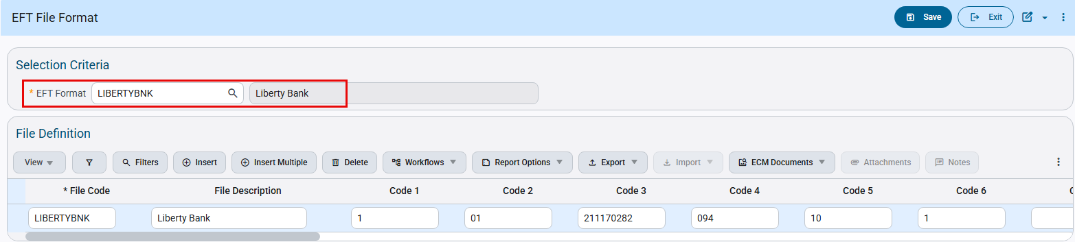
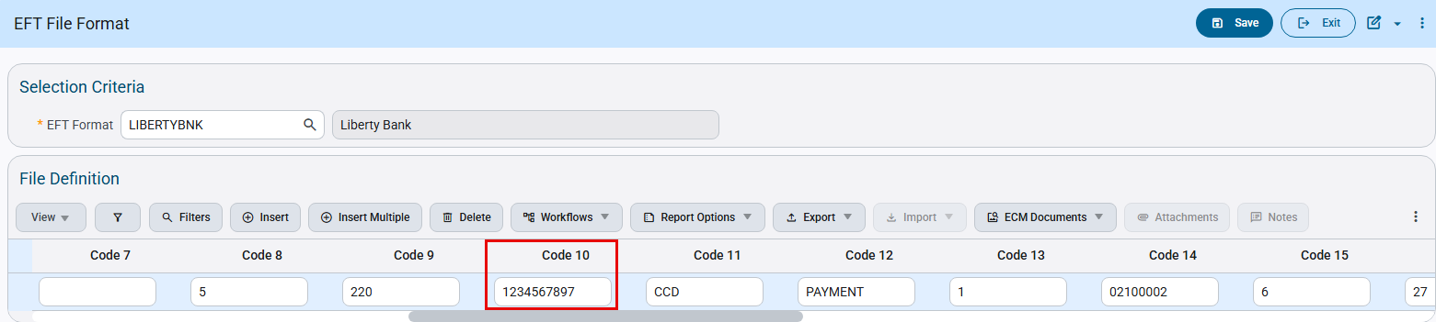
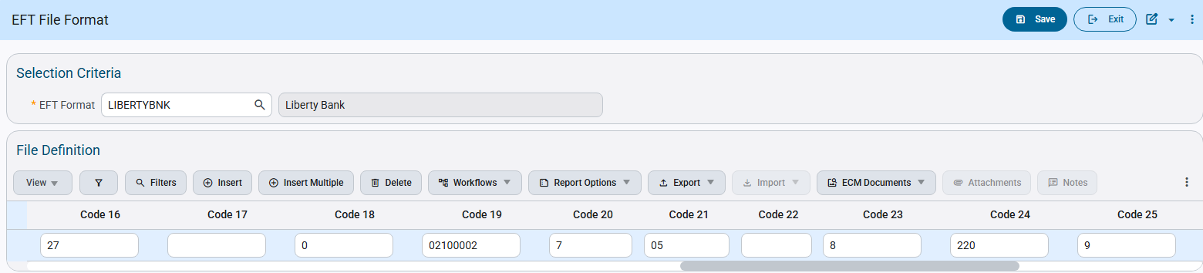
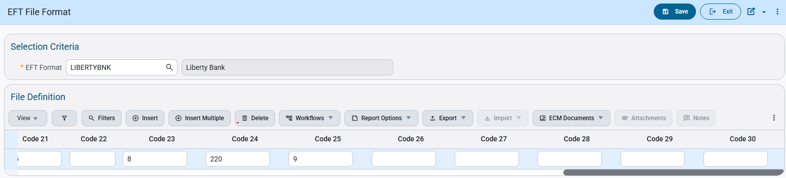
Check Printing:
The Check Printing program allows users to select the available EFT file codes. Users can select the code and generate EFT files as required.
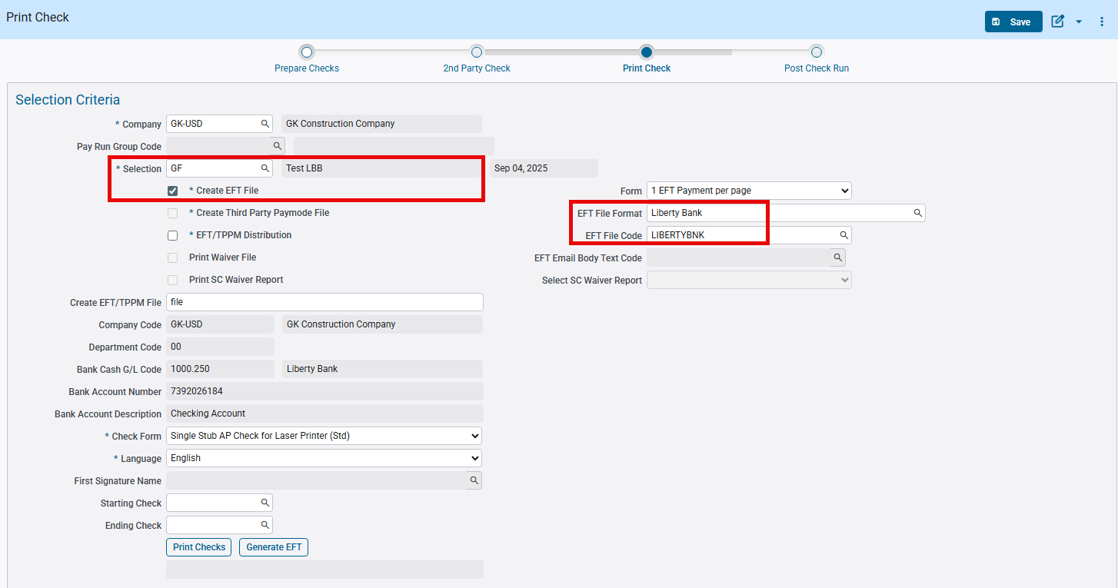

Following is the EFT File generated according to specifications:
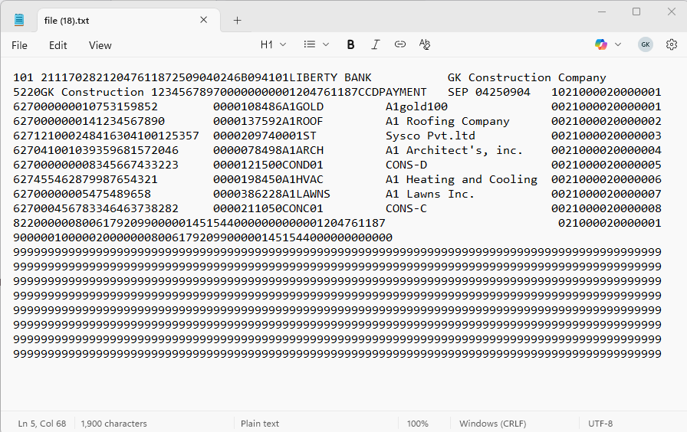

Below is the specification for the required EFT format:
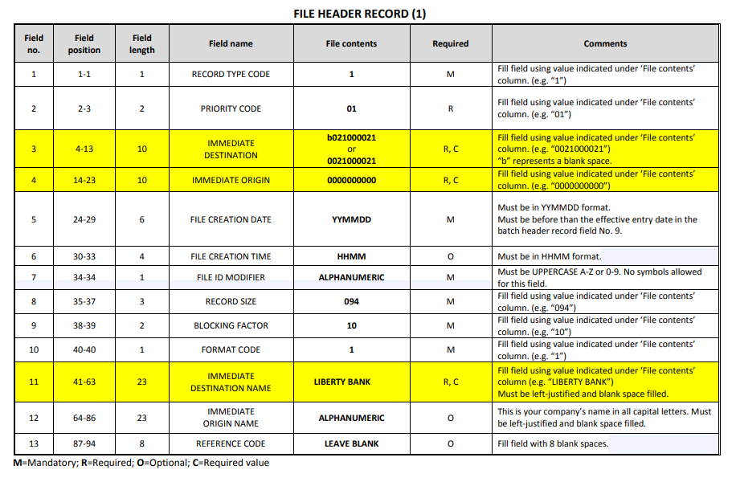
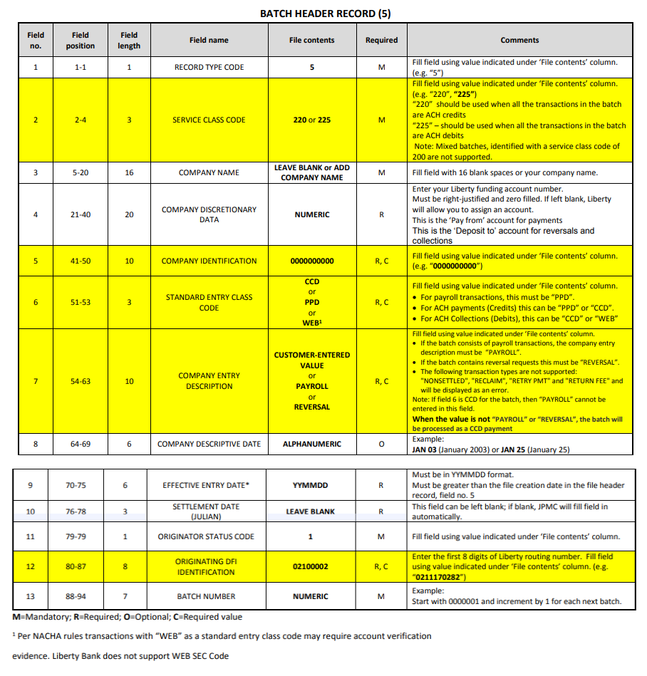
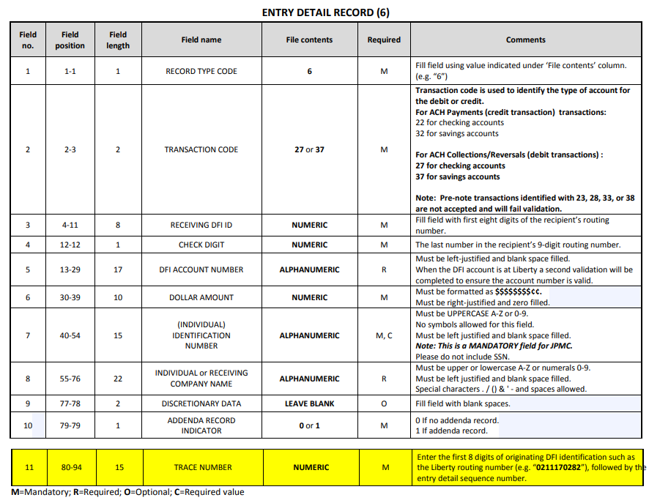
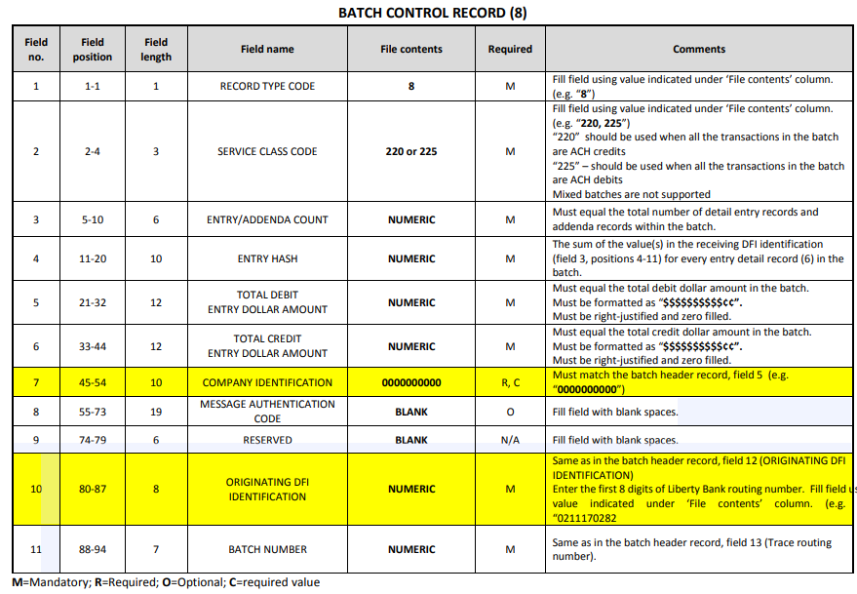
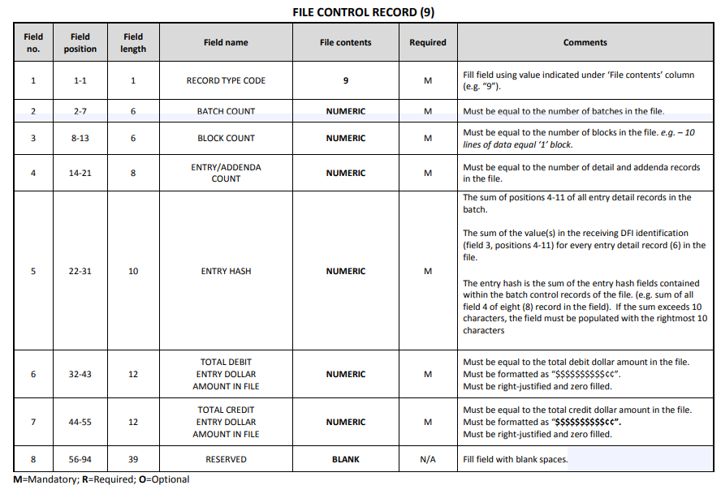

EFT File Format for Bankers Trust (FIN-19408)
Overview:
AP EFT Format “BANKSTRUST” for Bankers Trust.
Modifications:
A new AP EFT file format “BANKSTRUST: Bankers Trust – NACHA CCD Format” has been added as per specification format shared by client.
Following fields mapping and values will be used in the file format:
- File Header Record (1)
Immediate Destination (Bankers Trust Bank routing number - APEFT setup)
Immediate Origin (Your 10-digit ACH Company Federal Tax ID from company setup)
Immediate Destination Name (Bankers Trust)
- Batch Header Record (5)
Service Class Code (200)
Company Identification (Your 10-digit ACH Company Federal Tax ID from company setup)
Standard Entry Class Code (CCD)
Company Entry Description (Payment)
Effective Entry Date (Check date)
Originating DFI (First 8 digits of Bankers Trust Bank routing number - Bank Account setup transit field)
- Entry Detail Record (6)
Transaction Code (Always - 22)
Receiving DFI Identification (Bank Transit number from vendor setup)
DFI Account Number (Bank Account number from vendor setup)
Individual Identification (Vendor Code)
Receiving Company Name (Vendor name)
Addenda Record Indicator (0 - No Addenda records)
- Batch Header Trailer (8)
Service Class Code (200)
Company Identification (Your 10-digit ACH Company Federal Tax ID from company setup)
Originating DFI (First 8 digits of Bankers Trust Bank routing number - Bank Account setup transit field
EFT Setup:
The screen below shows EFT format setup for “BANKSTRUST”.
- Code 3: Immediate Destination (Record 1)
- Code 19: First 8 digits of Trace Number (Record 6)
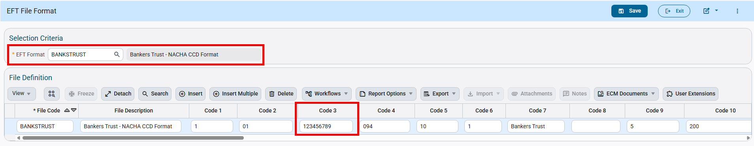
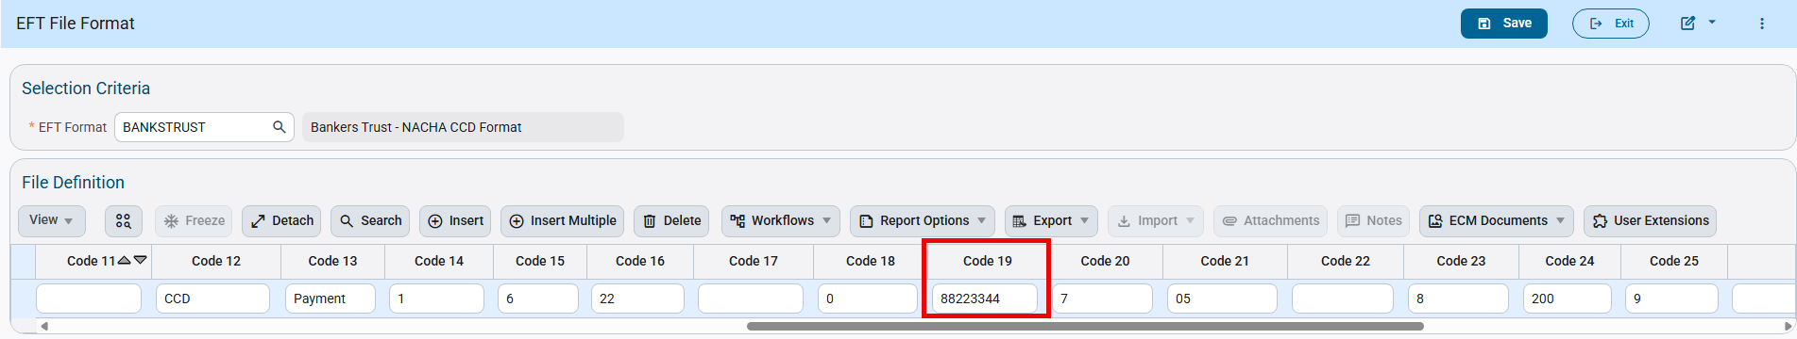
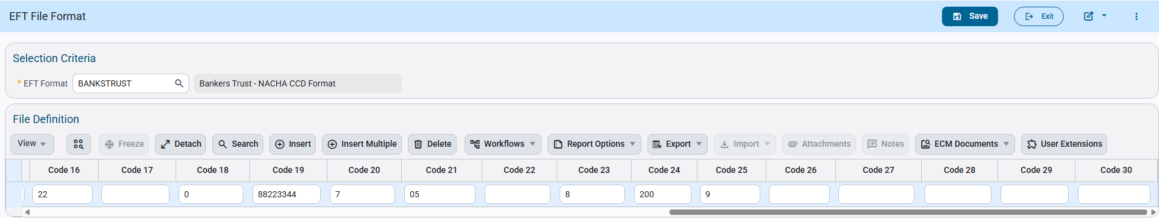
Check Printing:
The Check Printing program allows users to select the available EFT file codes. Users can select the code and generate EFT files as required.
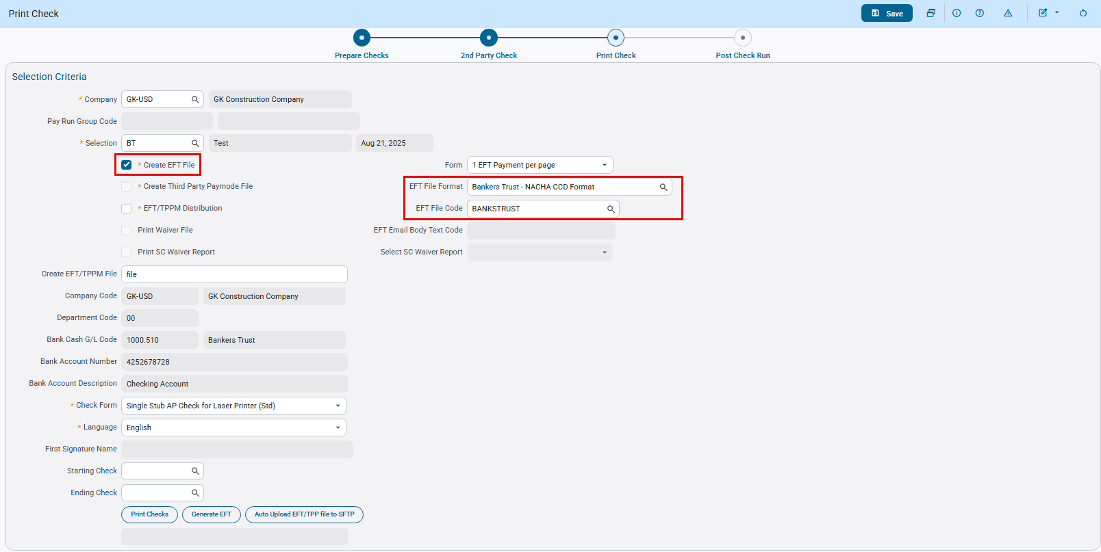

Following is the EFT File generated according to specifications:
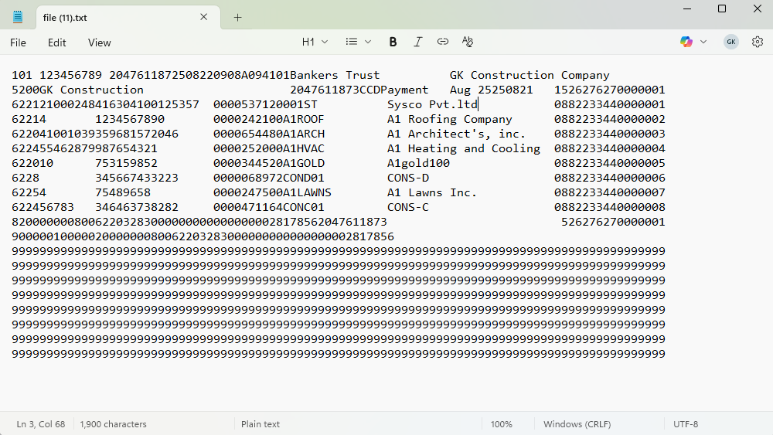

Below is the specifications for the required EFT format:
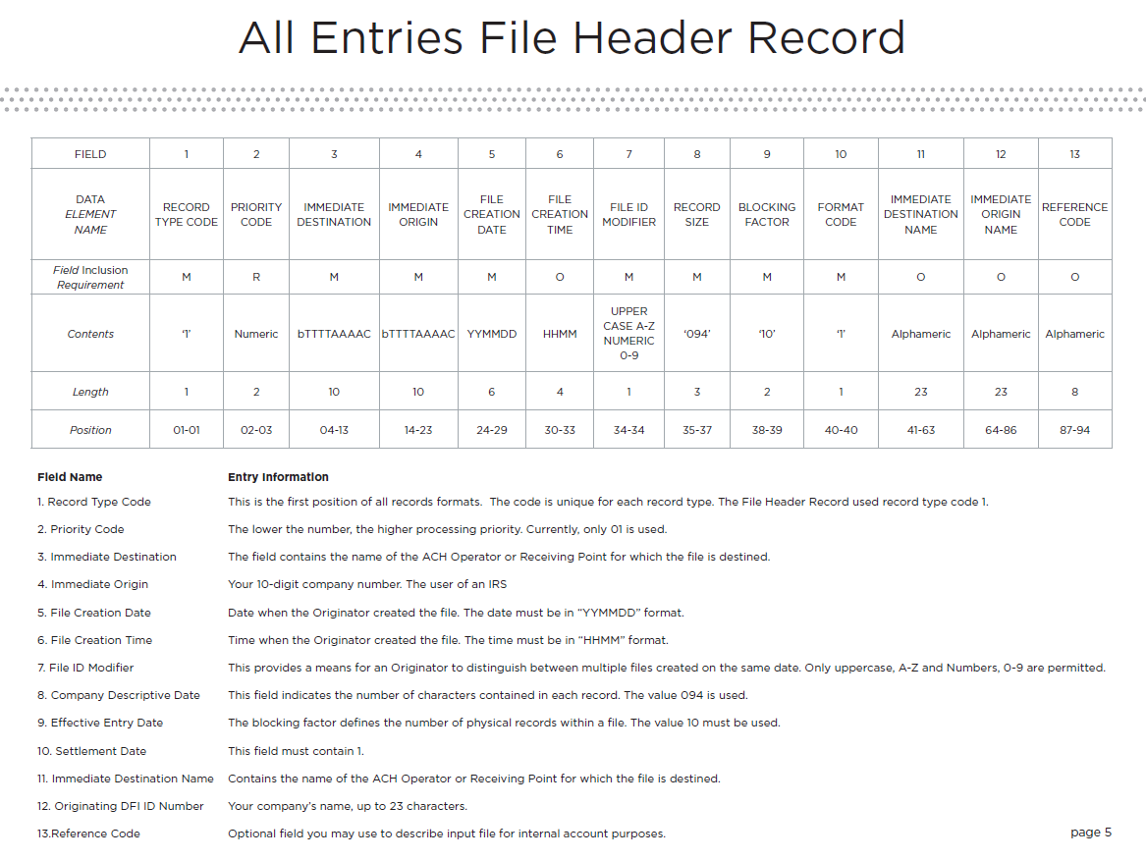
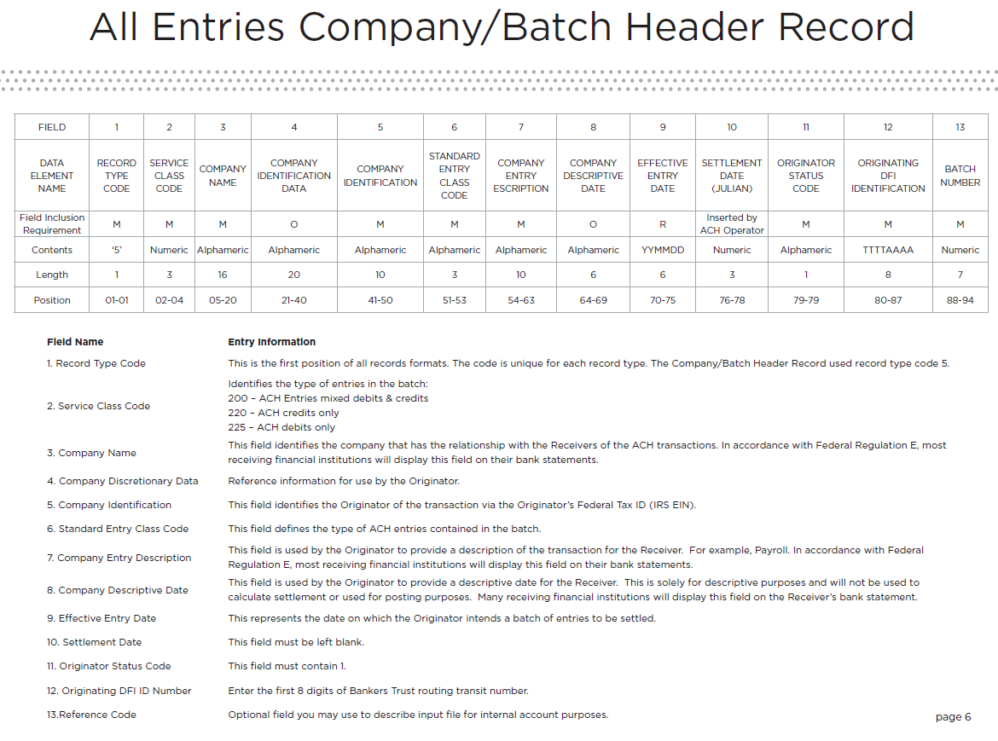
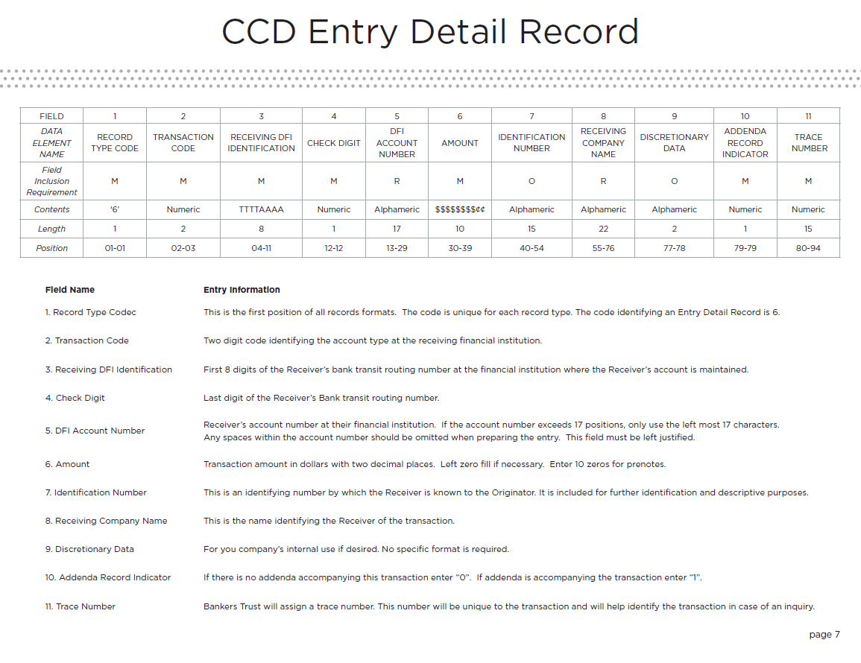
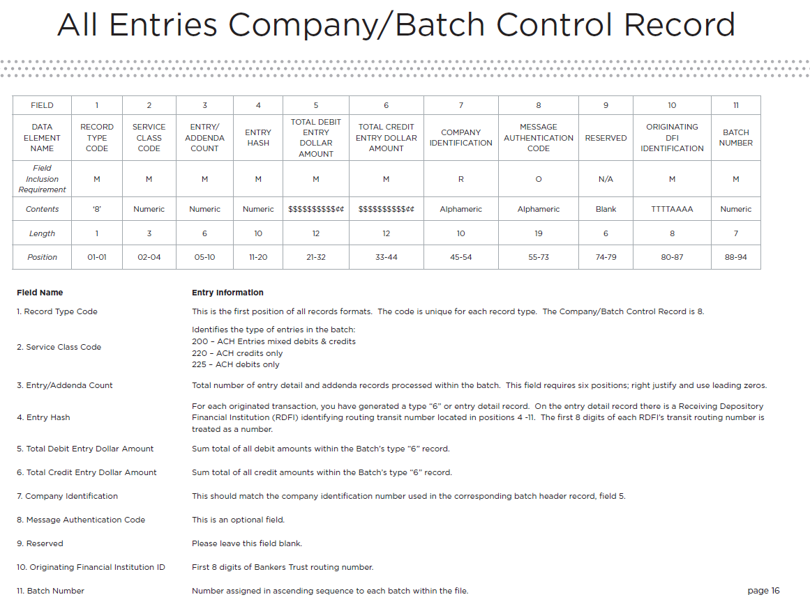
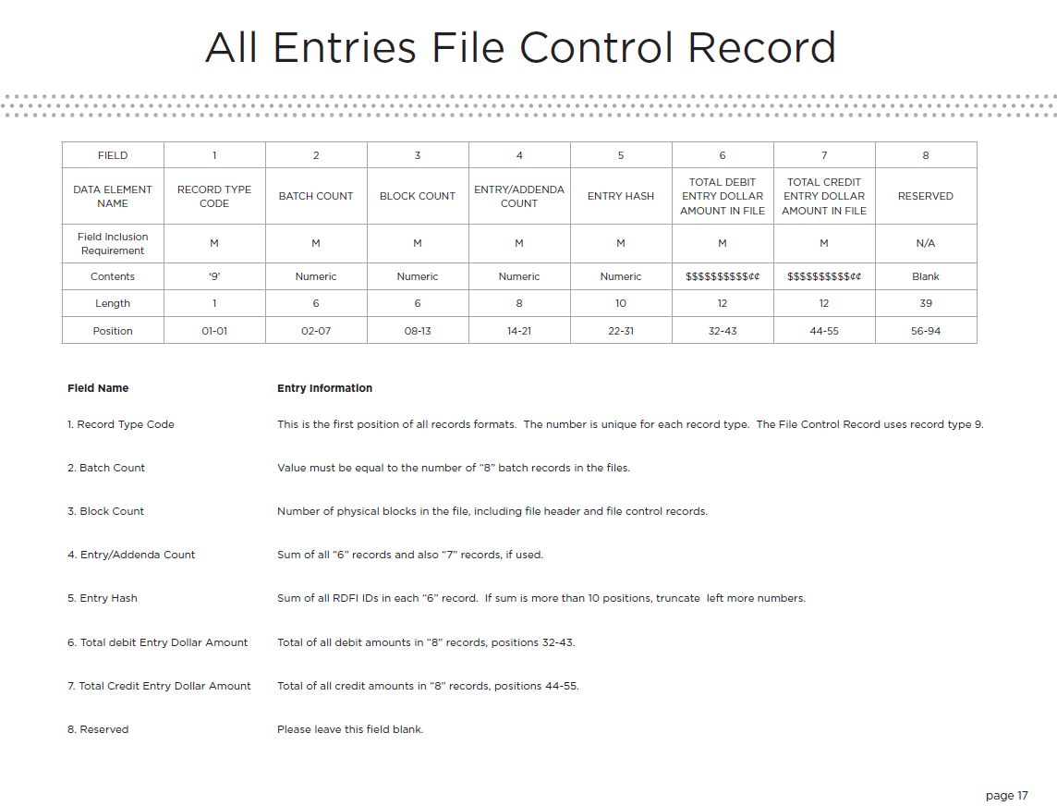

Modifications to USBANK_2 Positive Pay format (FIN-19752)
Overview:
Modifications to USBANK_2 Positive Pay format.
Modifications:
Positive Pay format “USBANK_2: US Bank” has been modified to exclude Third Party Credit Card payments type only.
The following positive pay file is generated using the same format.
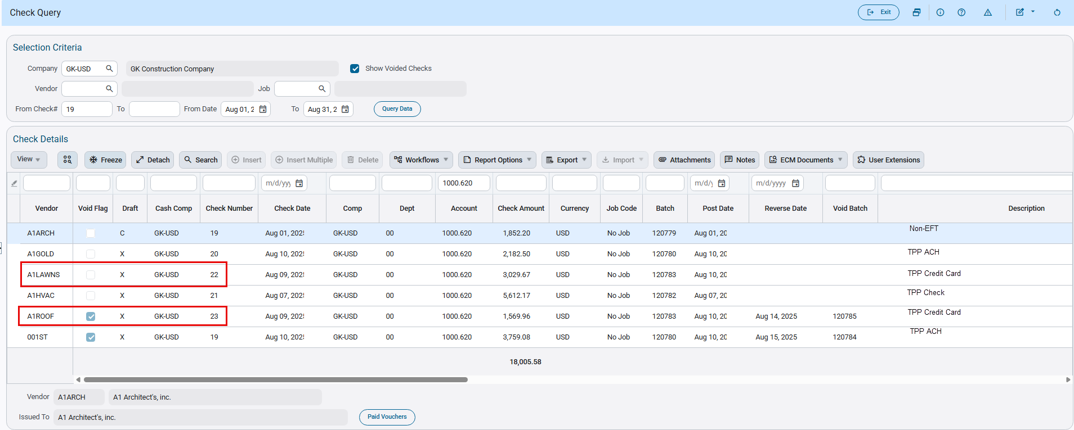
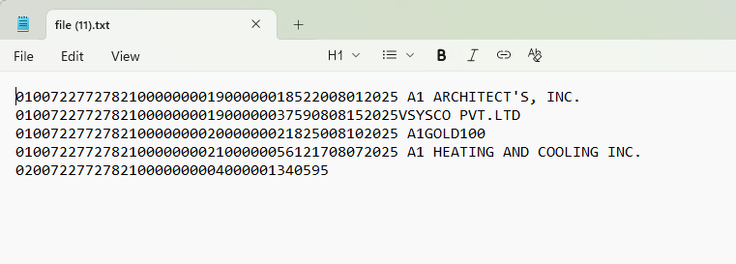

EFT File Format for Huntington National Bank (FIN-19949)
Overview:
AP EFT Format “HUNTNATBKS” for Huntington National Bank.
Modifications:
A new AP EFT file format “HUNTNATBKS: Huntington National BKS” has been added as per specification format shared by client.
Following fields mapping and values will be used in the file format:
- File Header Record (1)
Immediate Destination (Huntington National Bank routing number - APEFT setup - " 044000024" (Note: first position is blank))
Immediate Origin (9 digits ACH Company Federal Tax ID from company setup - First position is blank)
Immediate Destination Name (“HUNTINGTON NATIONAL BKS”)
- Batch Header Record (5)
Service Class Code (220 - Credit only)
Company Identification (“1" constant value + 9 digits ACH Company Federal Tax ID from company setup)
Standard Entry Class Code (CCD)
Company Entry Description (PAYMENT)
Effective Entry Date (Check date)
Originating DFI (Huntington National Bank routing number 8 digits - APEFT setup - "04400002”)
- Entry Detail Record (6)
Transaction Code (Always - 22)
Receiving DFI Identification (Bank Transit number from vendor setup)
DFI Account Number (Bank Account number from vendor setup)
Individual Identification (Vendor Code)
Receiving Company Name (Vendor name)
Addenda Record Indicator (0 - No Addenda records)
- Batch Header Trailer (8)
Service Class Code (220 - Credit only)
Company Identification ("1" constant value + 9 digits ACH Company Federal Tax ID from company setup)
Originating DFI (Huntington National Bank routing number 8 digits - APEFT setup - "04400002" )
EFT Setup:
The screen below shows EFT format setup for “HUNTNATBKS”.
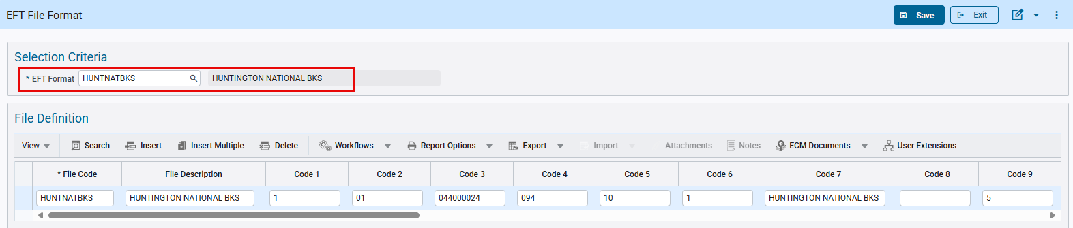
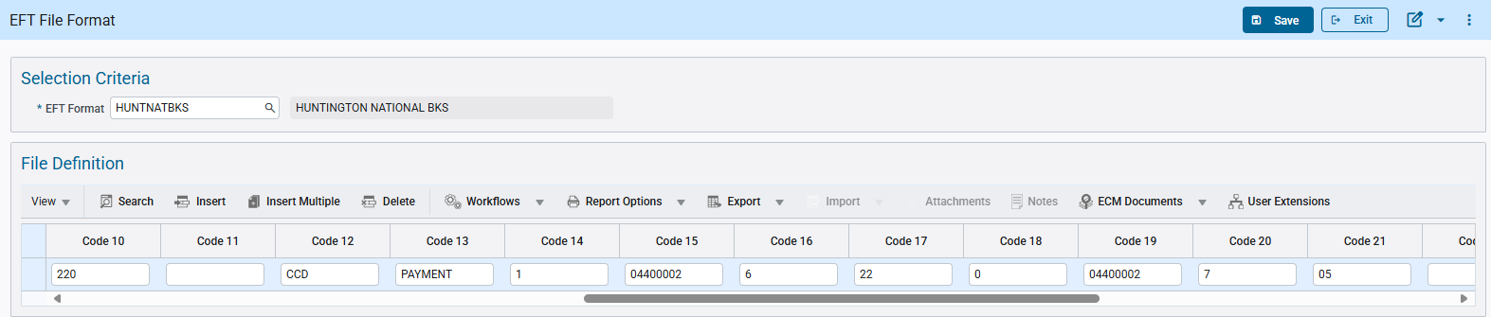
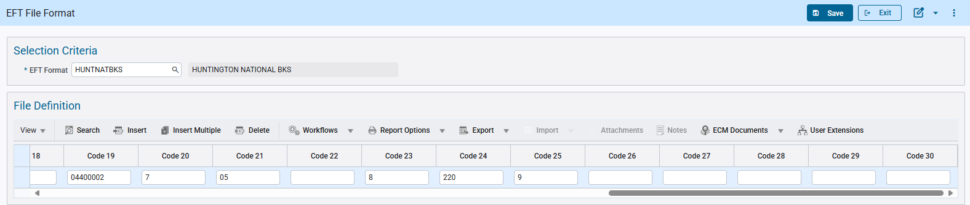
Check Printing:
The Check Printing program allows users to select the available EFT file codes. Users can select the code and generate EFT files as required.
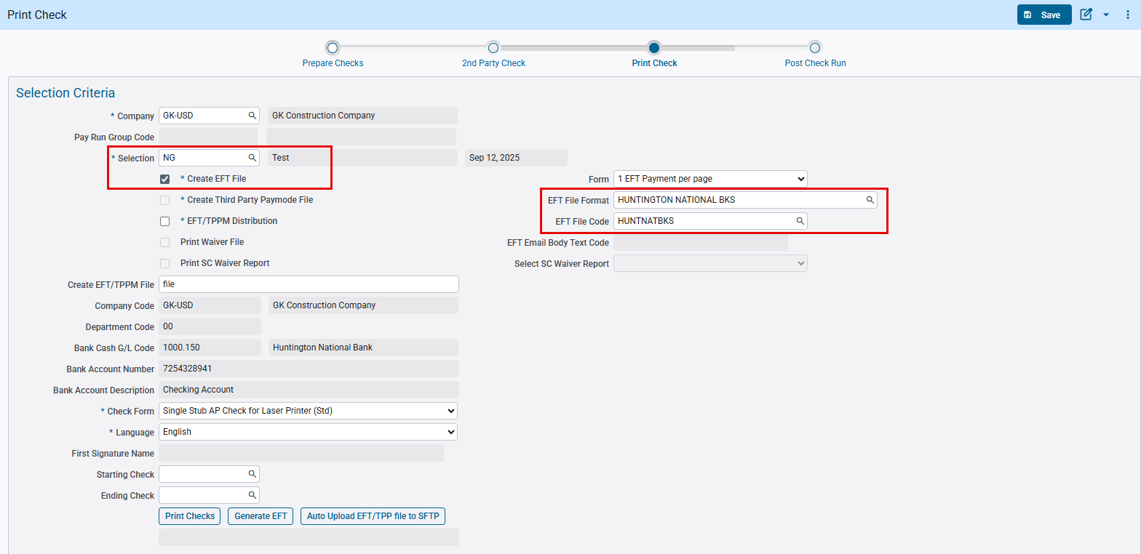
Following is the EFT File generated according to specifications:
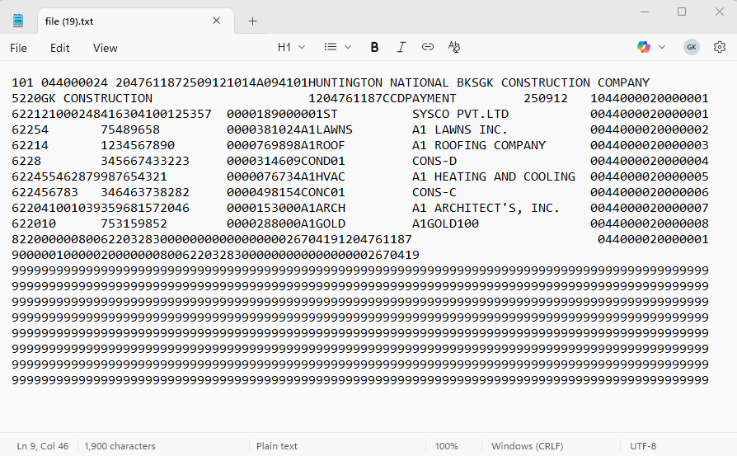
Below is the specifications for the required EFT format:
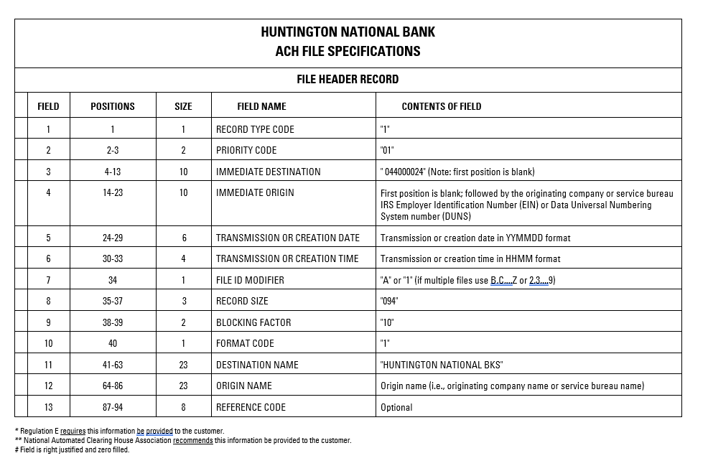
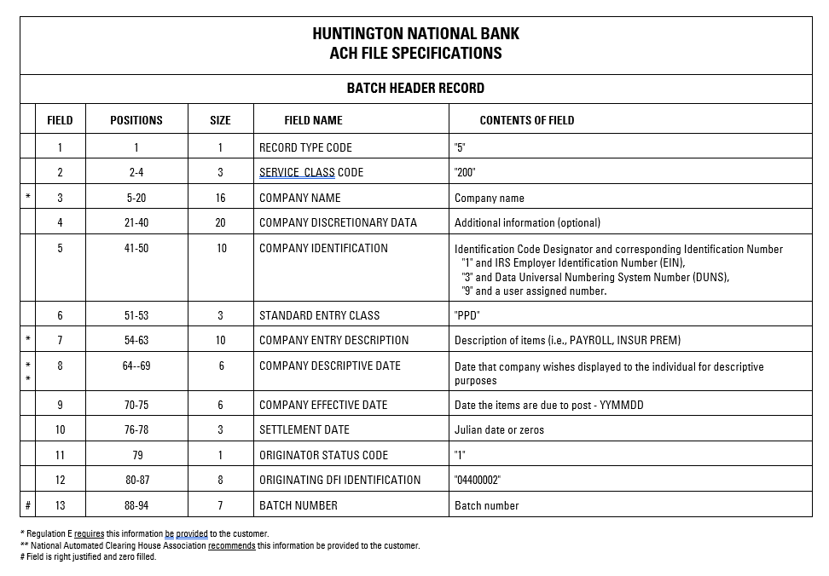
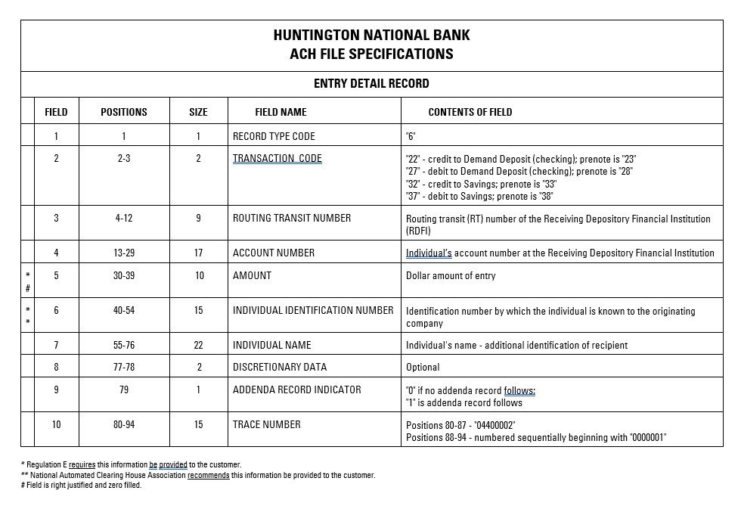
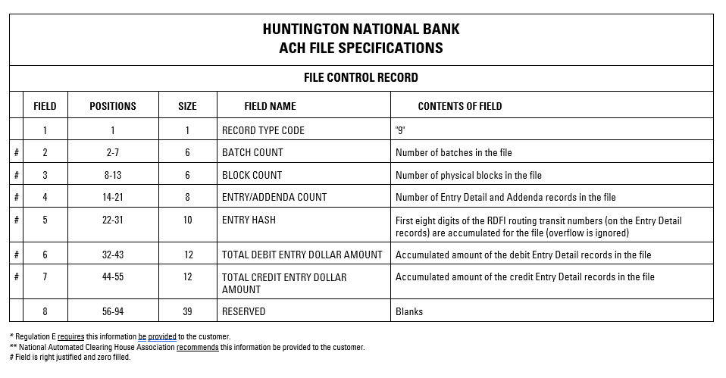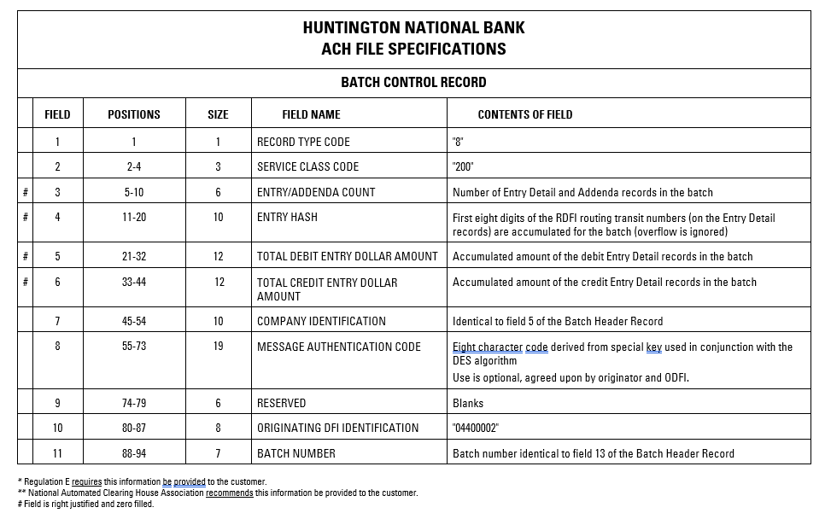

Modifications to Manual Check Program (FIN-20053)
Overview:
Modifications to Manual Check Program.
Modifications:
Following changes have been made to Distribution pop-up in AP Enter Manual Check Program:
- Import button is completely removed.
- When Invoice Related checkbox is checked:
- Insert and Insert Multiple buttons are disabled
- Company/Department/Account/Category-Transaction Code fields are disabled
- When Invoice Related checkbox is unchecked:
- Insert and Insert Multiple buttons are enabled
- Company/Department/Account/Category-Transaction Code fields are enabled
- For distribution line with Cash Account, user is unable to modify Company/Department/Account/Category-Transaction Code fields and will receive an error message when trying to do so.
Implementation:
- When Invoice Related checkbox is checked
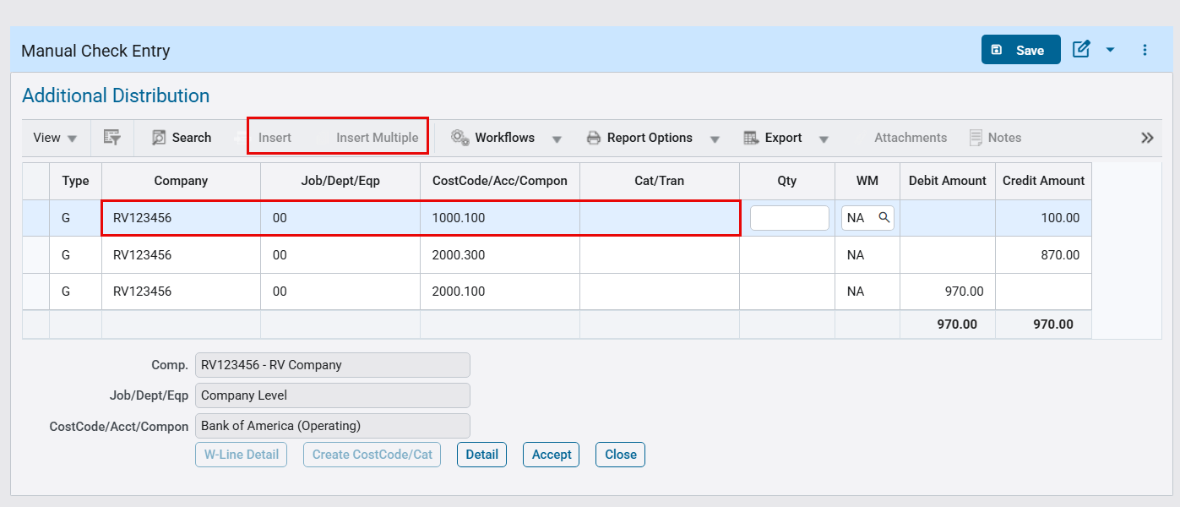
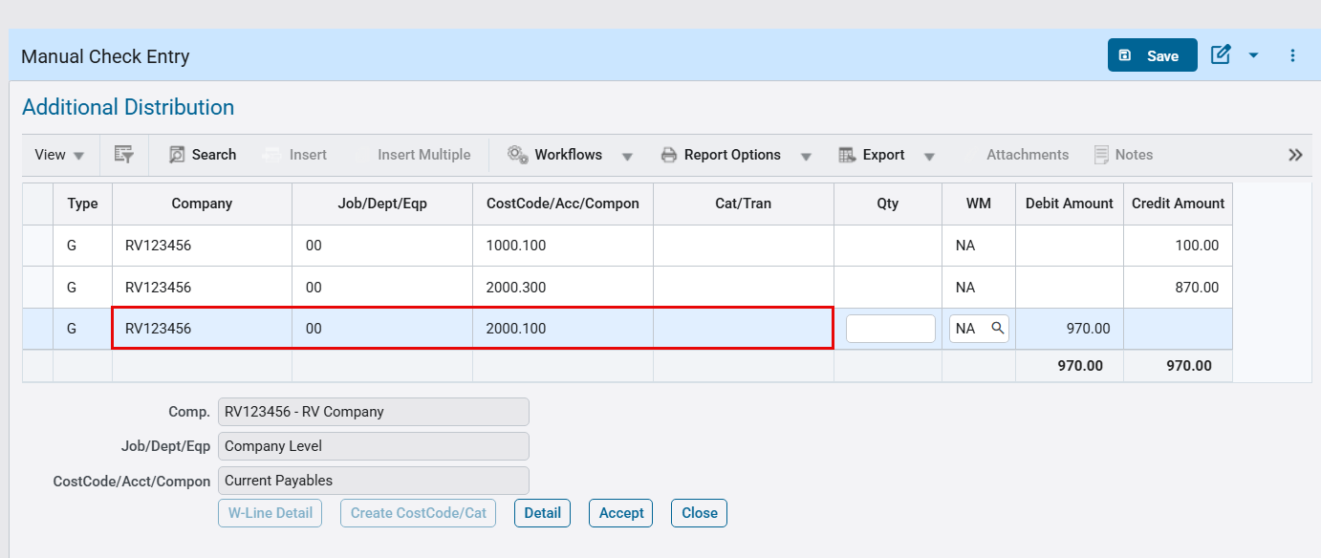
Accounts Payable > Check > Enter Manual Checks > Distribution pop-up
- When Invoice Related checkbox is unchecked
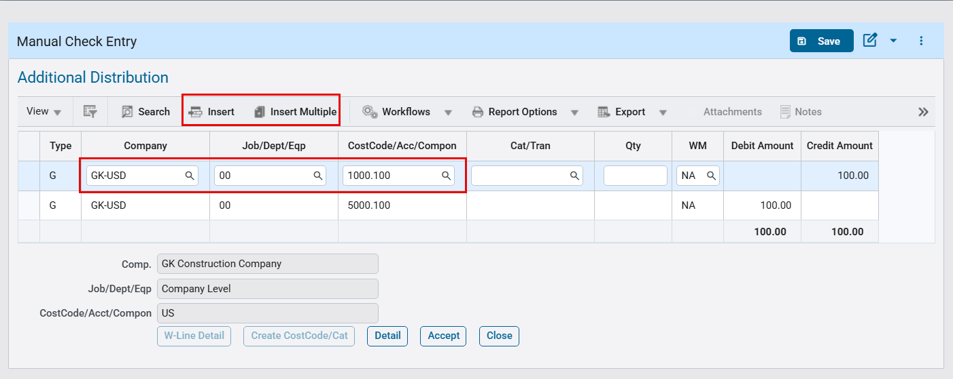
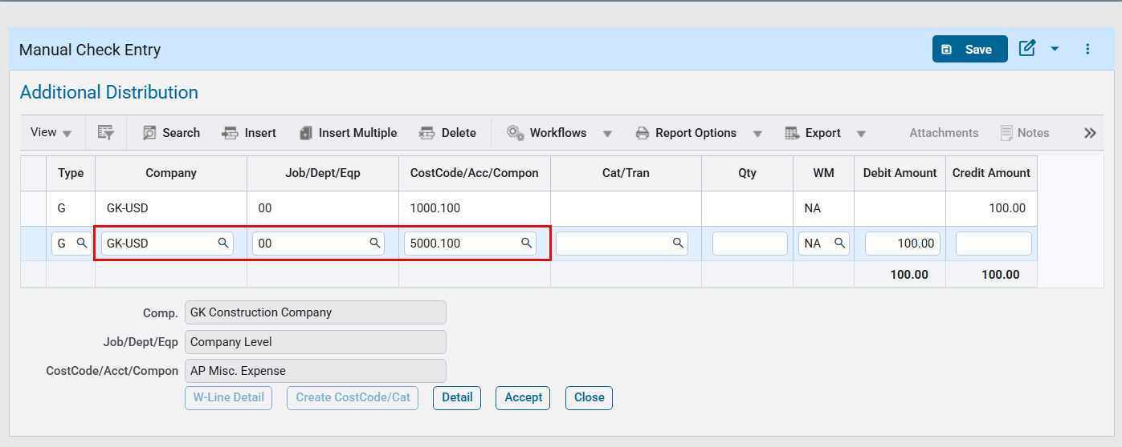

When trying to modify Company/Department/Account for distribution line with Cash Account, an error appears.
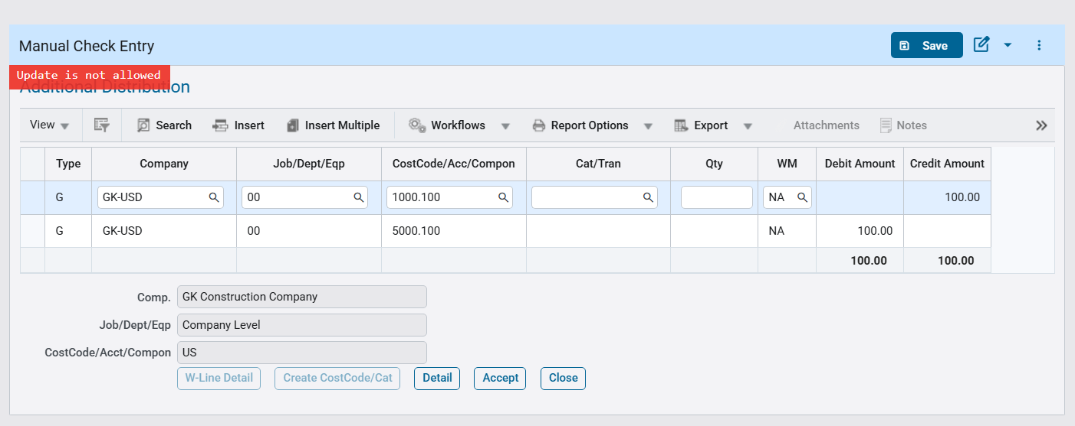

EFT File Format for Key Bank (FIN-20358)
Overview:
AP EFT Format “KEYBANK_2” for Key Bank.
Modifications:
A new AP EFT file format “KEYBANK_2: Key Bank ACH format 2” has been added as per specification format shared by client.
Following fields mapping and values will be used in the file format:
- File Header Record (1)
Immediate Destination (Key Bank routing number - APEFT setup - "041001039” (Note: first position is blank)
Immediate Origin (9 digits ACH Company Federal Tax ID from company setup - First position is blank)
Immediate Destination Name (“KEY BANK”)
- Batch Header Record (5)
Service Class Code (200)
Company Identification (10 digits ACH Company ID from bank account setup field "bab_bank_customer_id”)
Standard Entry Class Code (CCD)
Company Entry Description (ELEC PAYMT)
Effective Entry Date (Check date)
Originating DFI (Key Bank routing number 8 digits - APEFT setup - "04100103”)
- Entry Detail Record (6)
Transaction Code (Always - 22)
Receiving DFI Identification (Bank Transit number from vendor setup)
DFI Account Number (Bank Account number from vendor setup)
Individual Identification (Vendor Code)
Receiving Company Name (Vendor name)
Addenda Record Indicator (0 - No Addenda records)
- Batch Header Trailer (8)
Service Class Code (200)
Company Identification (10 digits ACH Company ID from bank account setup field "bab_bank_customer_id”)
Originating DFI (Key Bank routing number 8 digits - APEFT setup - "04100103”)

EFT Setup:
The screen below shows EFT format setup for “KEYBANK_2”.
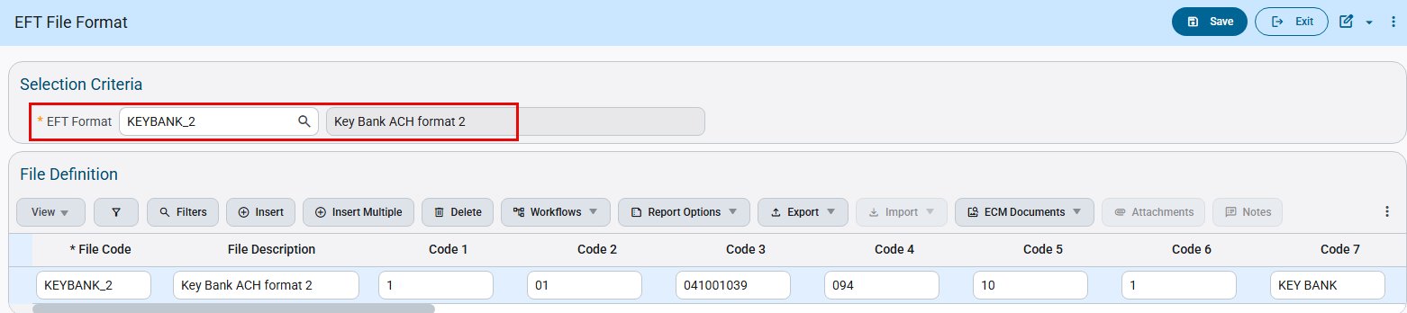
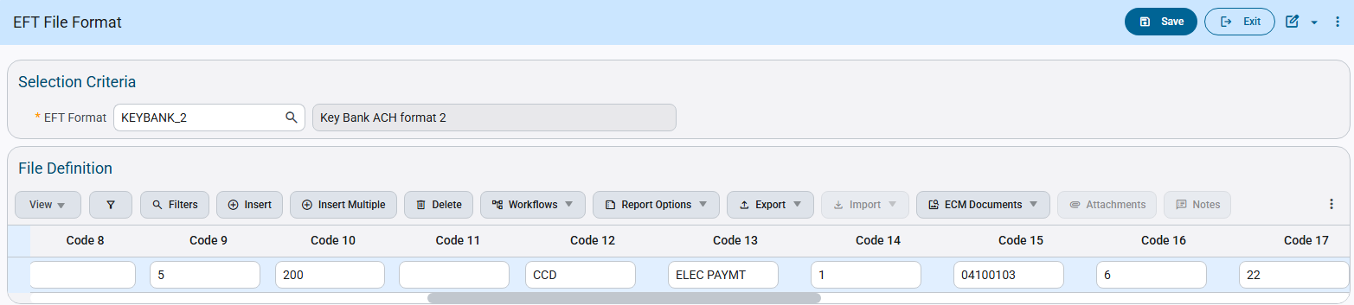
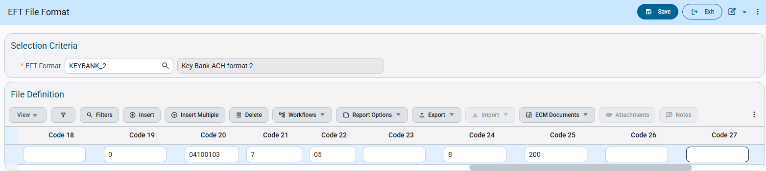
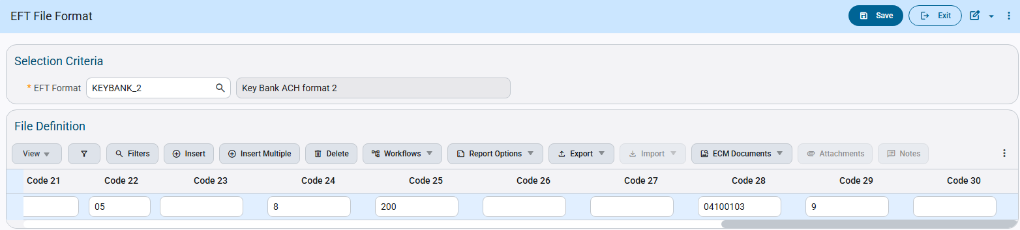
Check Printing:
The Check Printing program allows users to select the available EFT file codes. Users can select the code and generate EFT files as required.
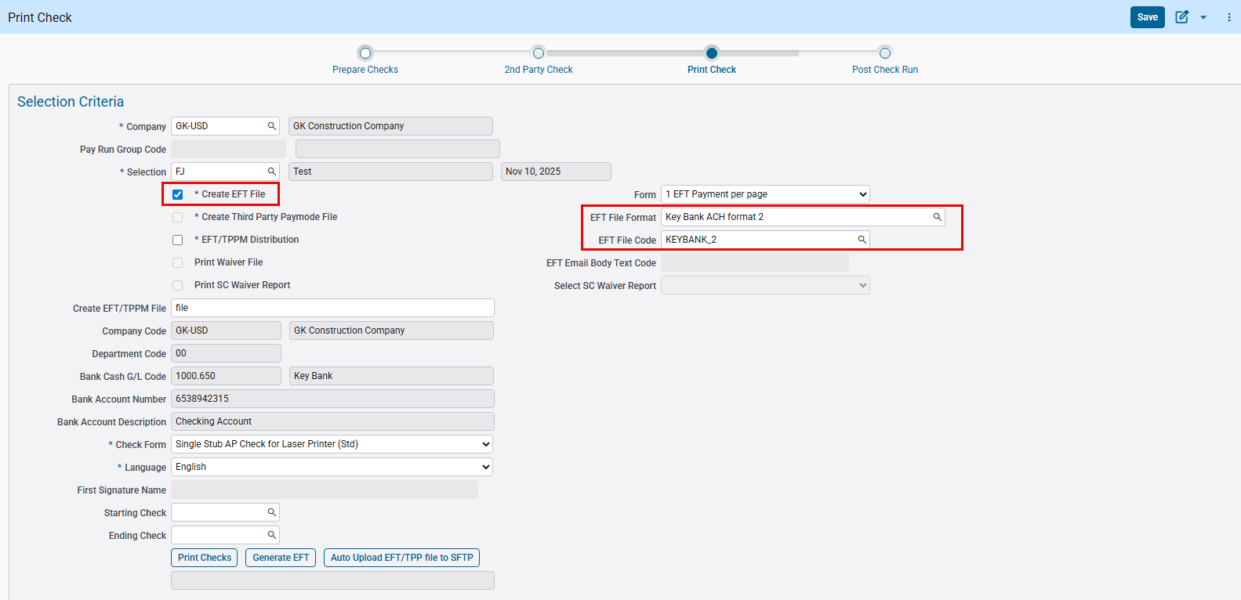

Following is the EFT File generated according to specifications:
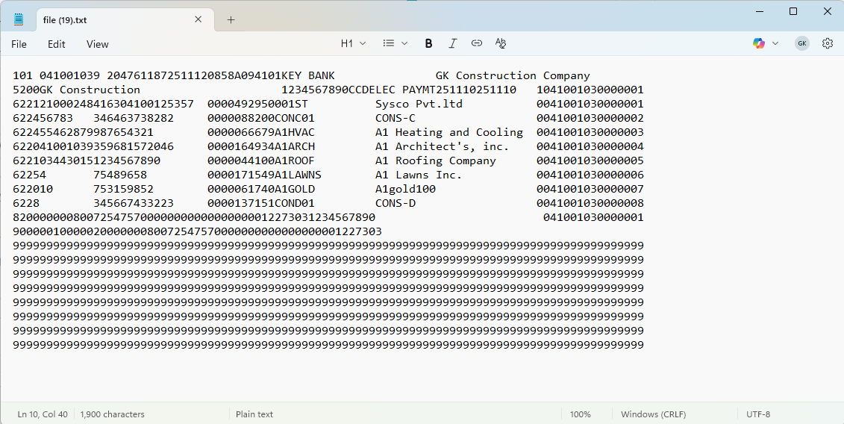

Below is the specifications for required EFT format:
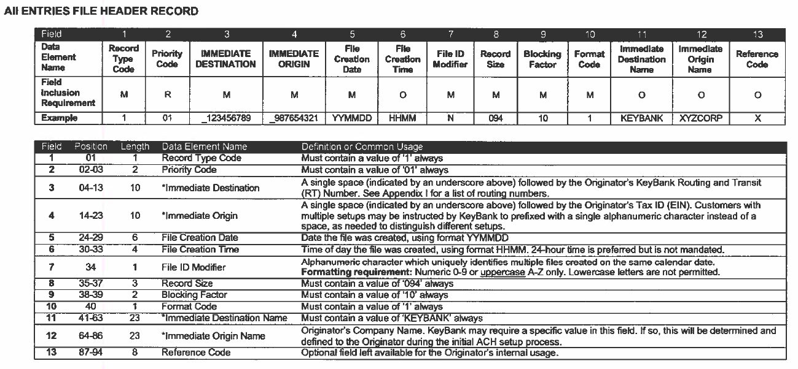
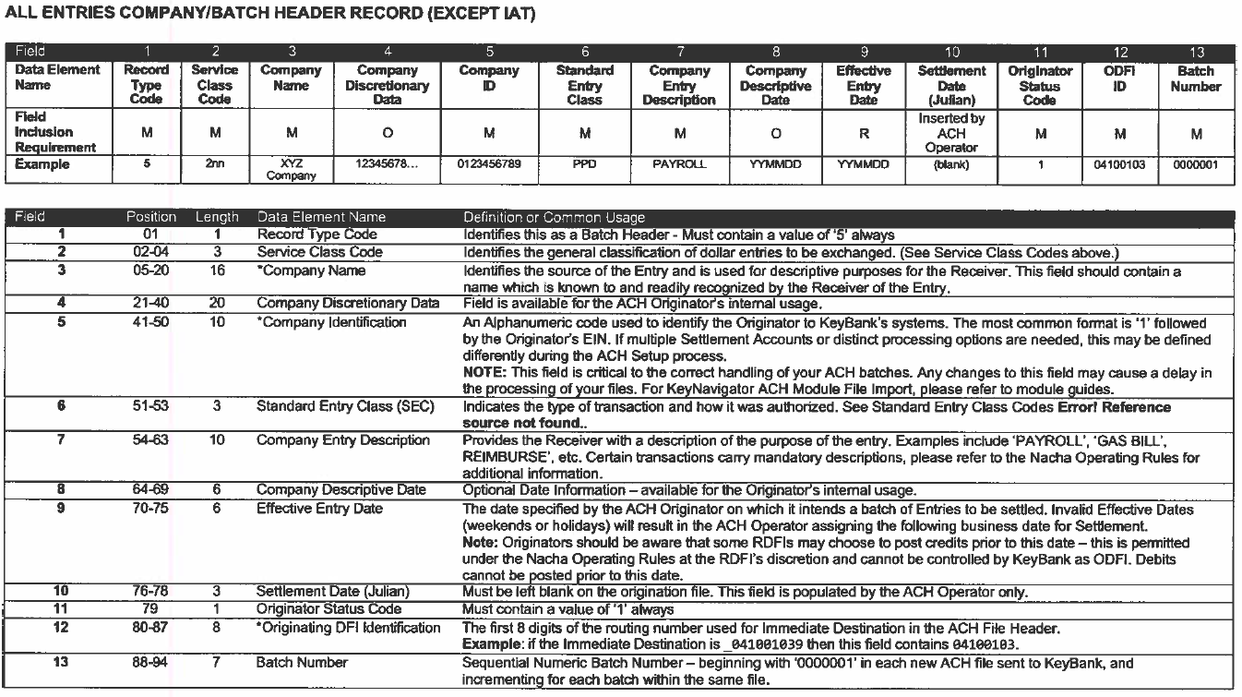
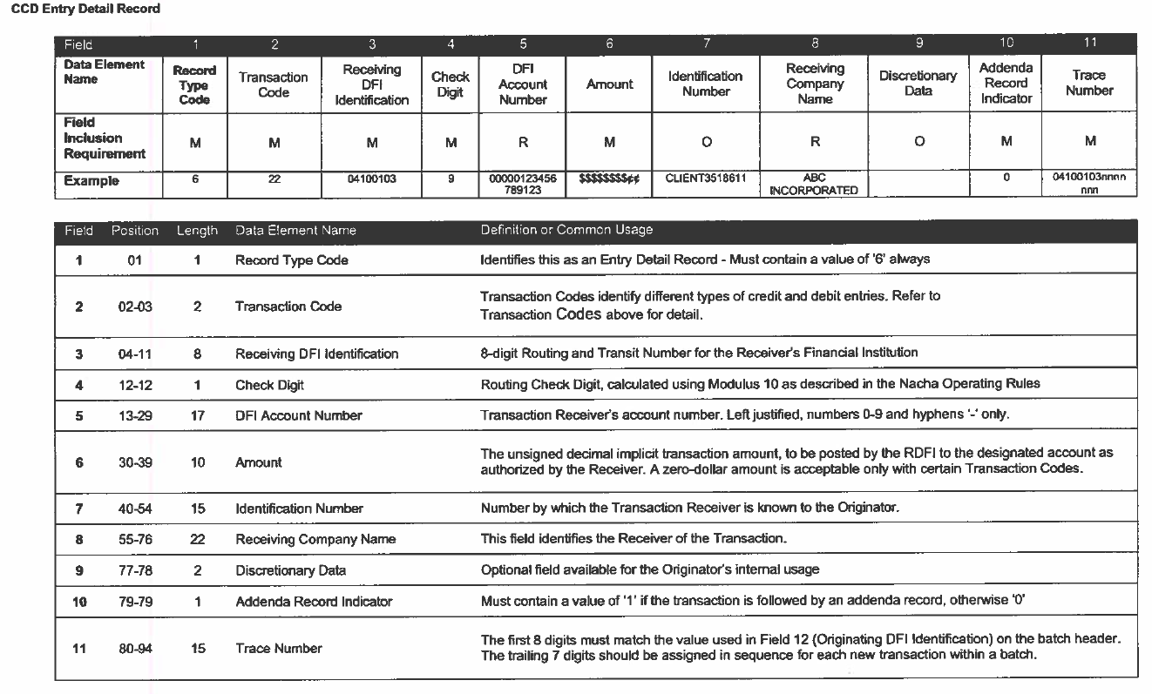
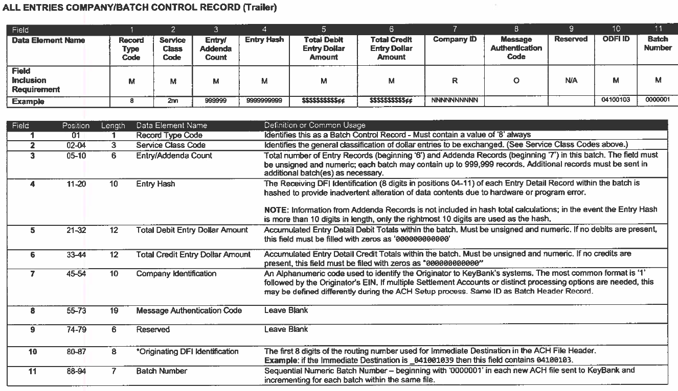
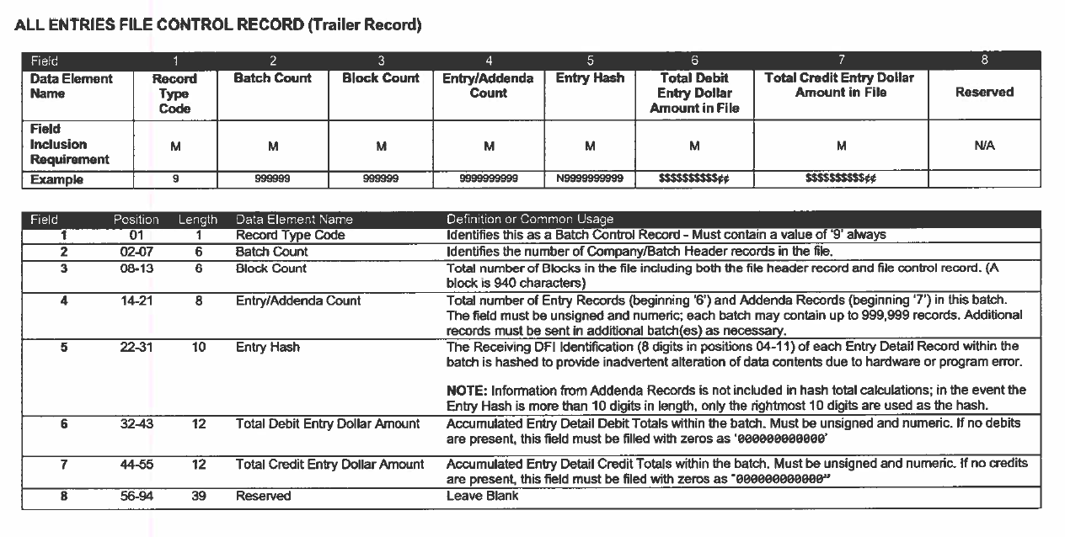

Modifications to AP Prepare Vouchers Program (FIN-20445)
Overview:
Modifications to AP Prepare Vouchers.
Modifications:
In AP Prepare Vouchers, existing “Controlling Job Code” field is renamed to “Job Code”. The Job Code LOV is enhanced to display both controlling jobs and sub-jobs.
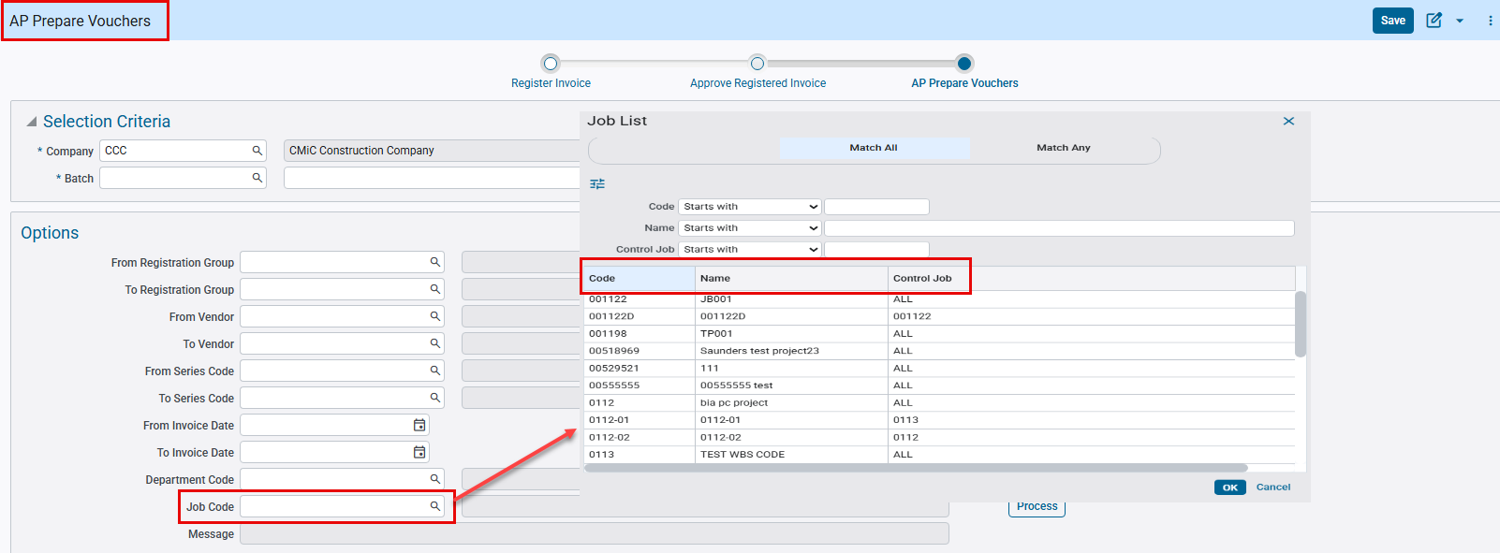
Accounts Payable > Voucher > Register Invoices > AP Prepare Vouchers

SWIFT, Currency and IBAN field added to Maintain Business Partner and Banks (FIN-20889)
Overview:
SWIFT, Currency and IBAN field added to Maintain Business Partner and Banks.
Modifications:
SWIFT, Currency and IBAN field are added to following programs.
- SWIFT: added to Banks
- Currency and IBAN: added to Maintain Business Partner (Bank Tab)
These fields are hidden by default and can be added using Lite Editor. Values in these fields will not be copied over to vendor or any other level.
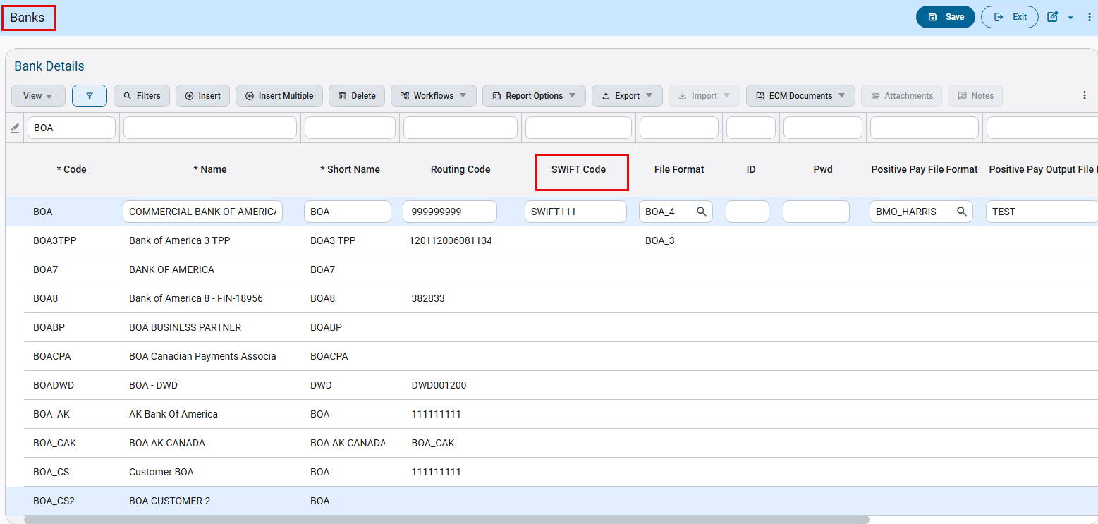
System Data > Global Tables > Banking > Banks
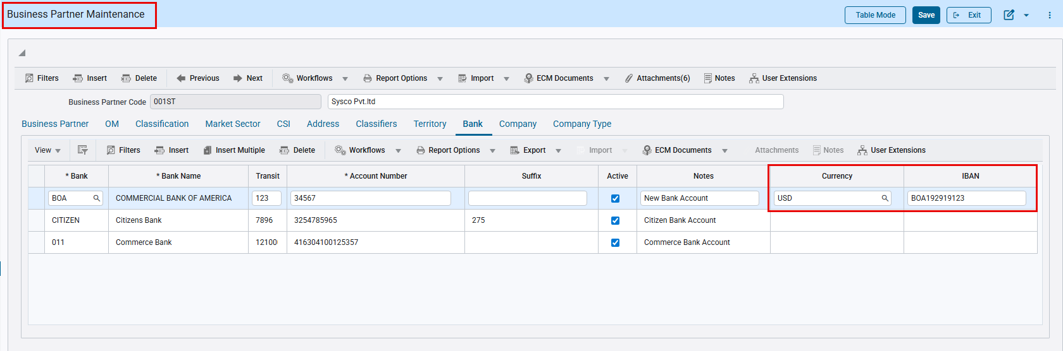
Account Payable > Setup > Maintain Business Partners > Bank Tab
Implementation:
- Add SWIFT field to Banks program.
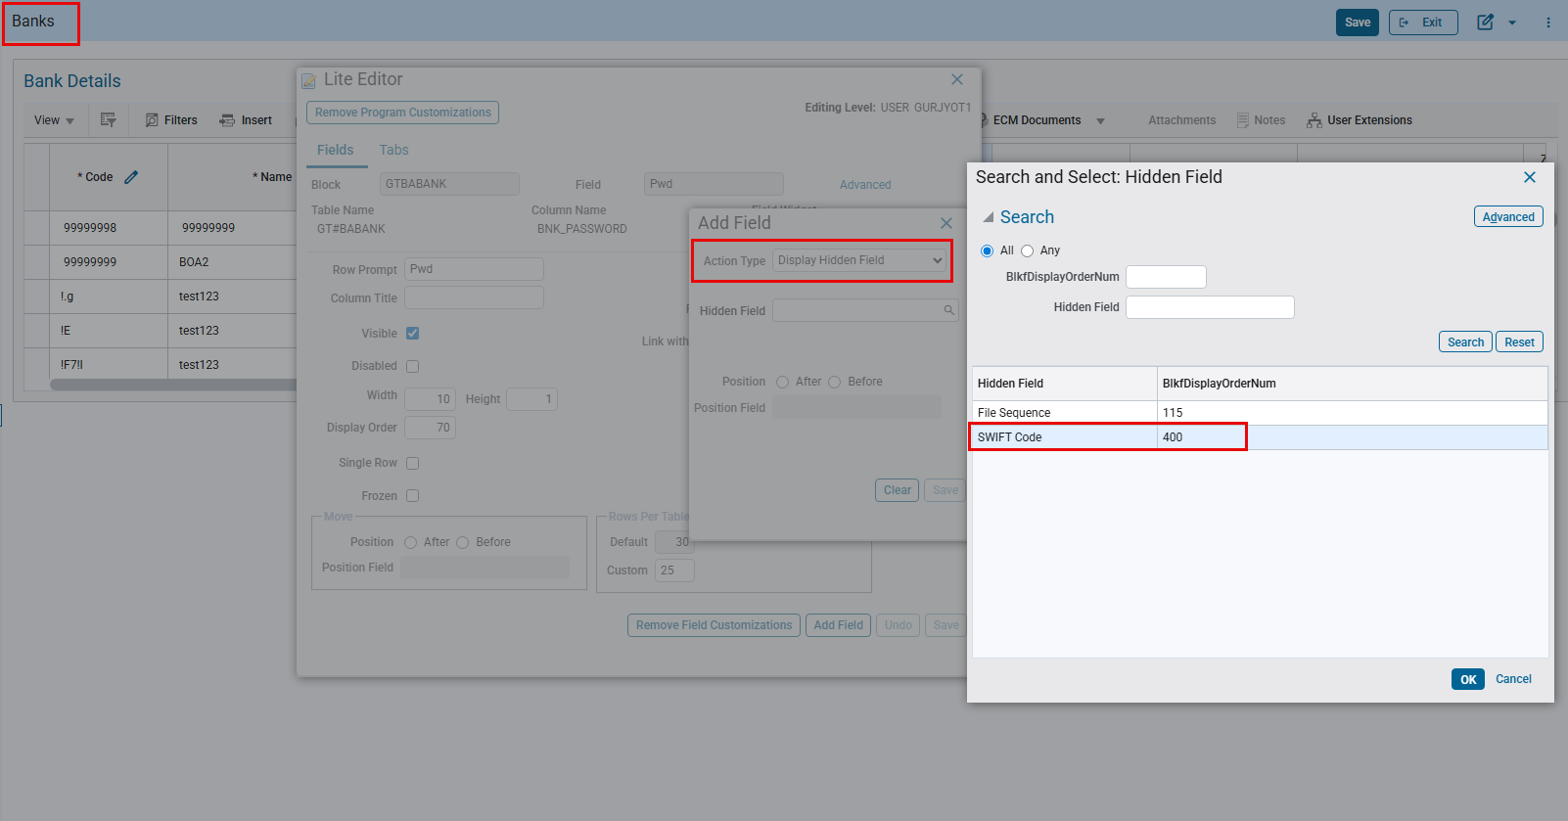
- Add Currency and IBAN fields to Maintain Business Partners program.
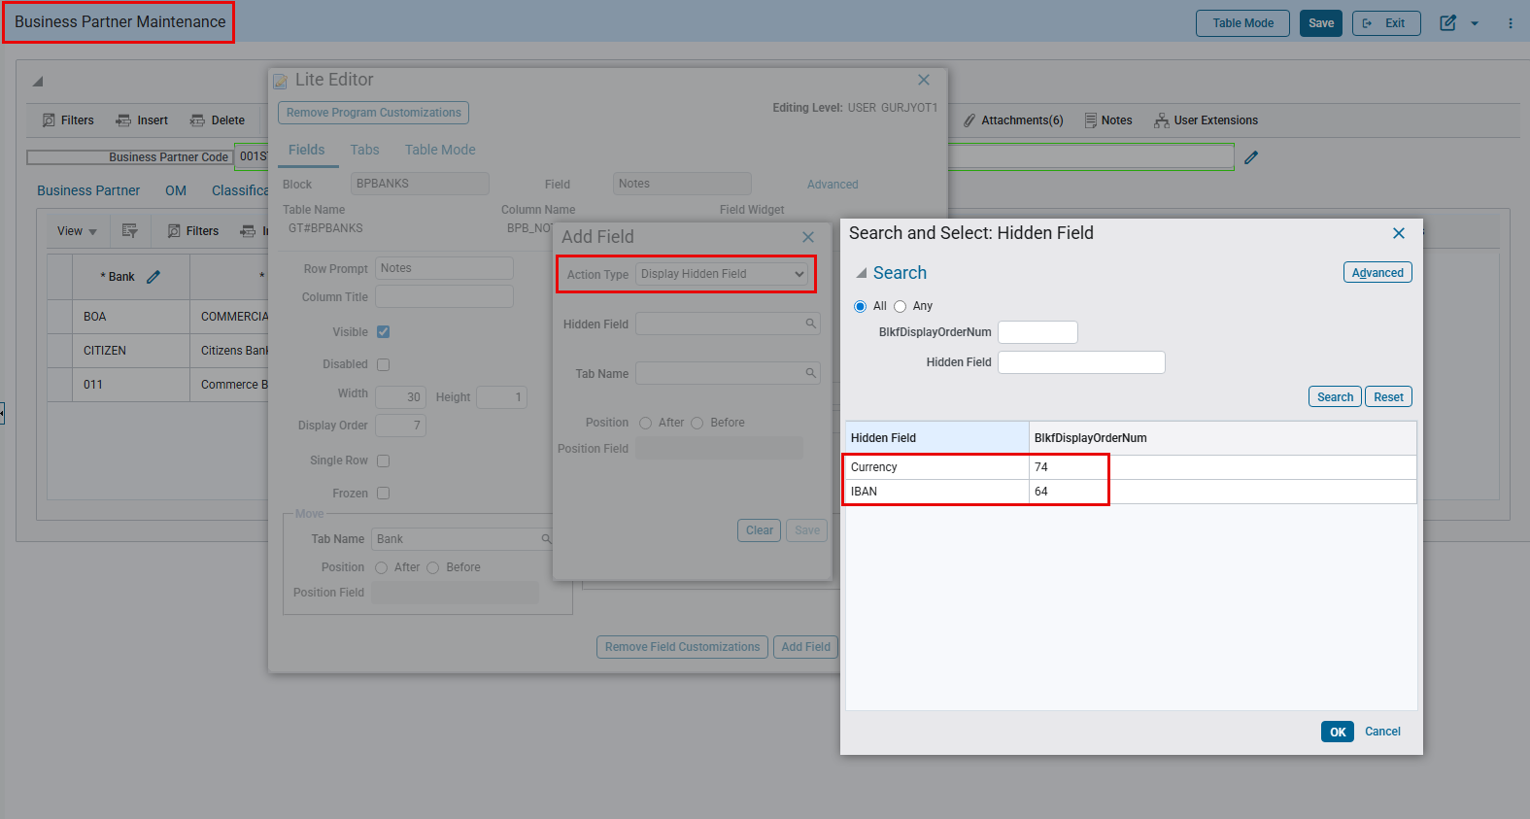

EFT File Format for AvidXchange (FIN-20628)
Overview:
AP EFT Format “AVIDPAY” for AvidXchange.
Modifications:
A new AP EFT pipe delimited file format “AVIDPAY: Avid Pay File Format” has been added as per field mapping and specific format conditions shared by client.
Following conditions are implemented in the file:
- File will contain headers.
- Columns are not fixed length and do not need to meet the max length.
- If there is no discount amount, pass 0.00 for the field value.
- Cheque number field max length in the file is 10 digits, so auto-generated eft cheque number is truncated one value to make it 10 digits like this 0000058406.
- Remit to Address field value will be included only if an alternative address has been entered for a vendor with the remit to address flag is checked. If somehow more than one address has been checked for the remit to address, only the first one will be considered.
Check Printing:
The Check Printing program allows users to select the available EFT file codes. Users can select the code and generate EFT files as required.
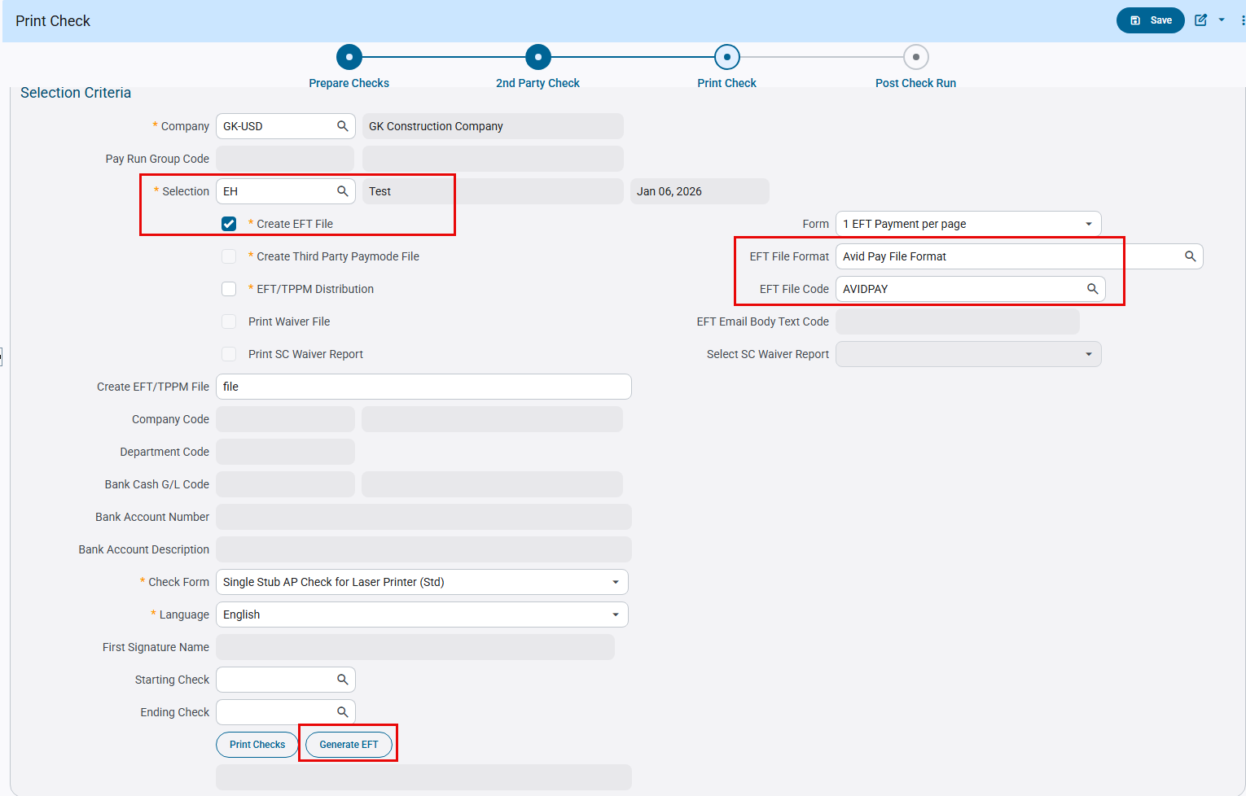

Following is the EFT File generated according to specifications:
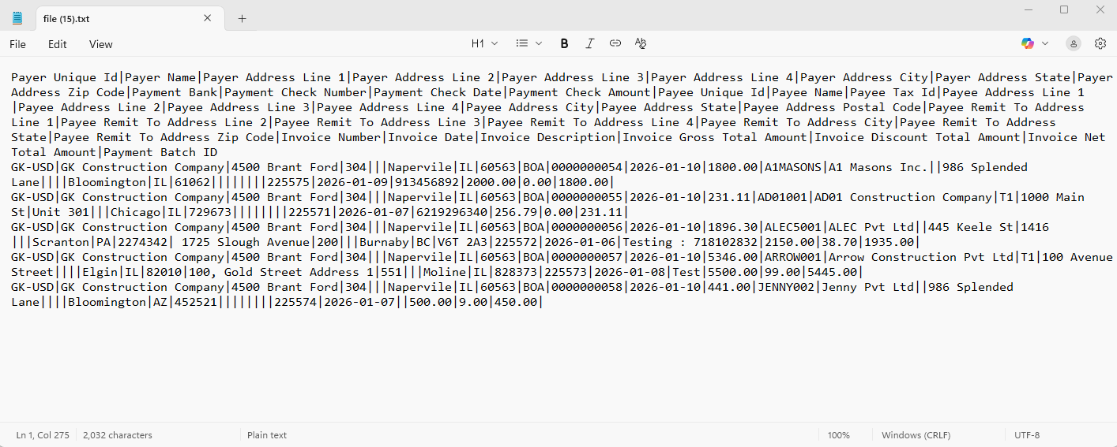
Below is the field mapping for the required EFT format:
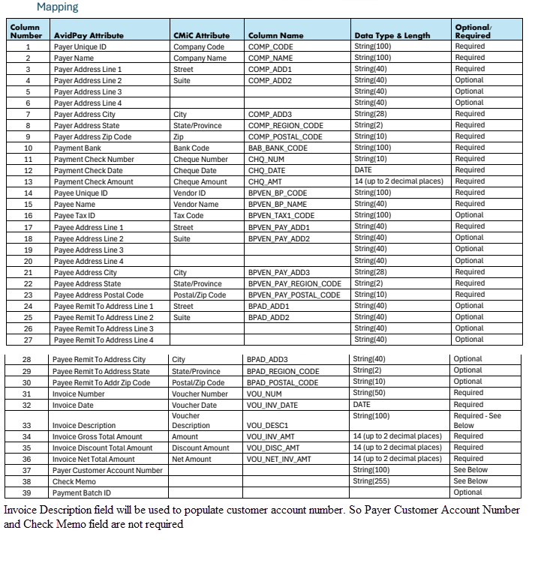

EFT CCD file format for Atlantic Union Bank (FIN-18010)
Overview:
AP EFT CCD file format for Atlantic Union Bank is created.
Modifications:
New AP EFT CCD file format ‘ATLUNION’ is created for Atlantic Union Bank with the following changes
- Immediate Destination ('051403164' with a space before the number)
- Immediate Origin ('051403164' with a space before the number)
- Immediate Destination Name (‘ATLANTIC UNION BANK')
- Service Class Code (200 - Mixed Debits and Credits)
- Company Identification (10 digits ACH Company Federal Tax ID from company setup)
- Standard Entry Class Code ('CCD')
- Company Entry Description ('ELEC PAYMT')
- Effective Entry Date (Check Date)
- Originating DFI Identification (‘05140316’)
- Transaction Code (Always – ‘22’)
- Receiving DFI Identification (Bank Transit number from vendor setup)
- DFI Account Number (Bank Account number from vendor setup)
- Individual Identification (Vendor Code)
- Receiving Company Name (Vendor name)
- Addenda Record Indicator ('0' - No addenda records)
- Transaction Code (Always – ‘27’ (Balancing Line))
- Receiving DFI Identification (Cash Bank Transit number from company setup)
- DFI Account Number (Cash Bank Account number from Company setup)
- Individual Identification (Company Code)
- Receiving Company Name (Company name)
- Service Class Code (‘200’)
- Company Identification (10 digits ACH Company Federal Tax ID from company setup)
- Originating Financial Institution ID (‘05140316’)

EFT Setup: 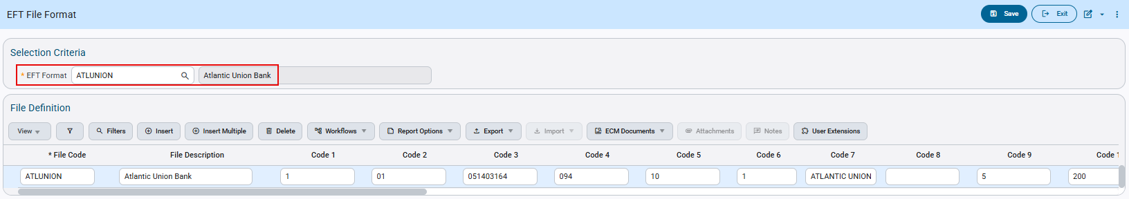Accounts Payable > Setup > Global Tables > EFT Formats

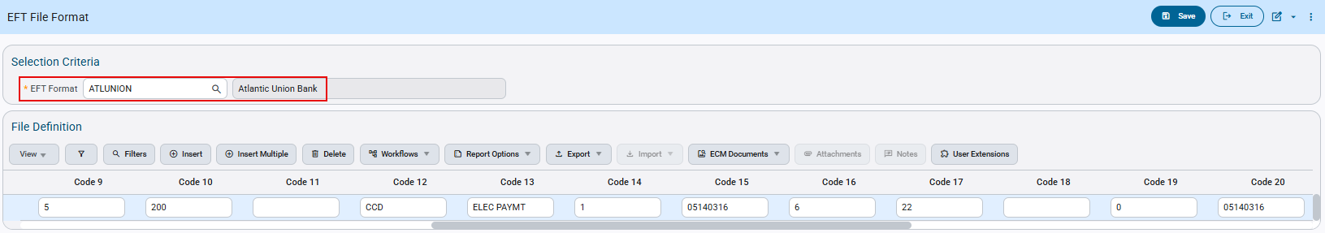Accounts Payable > Setup > Global Tables > EFT Formats

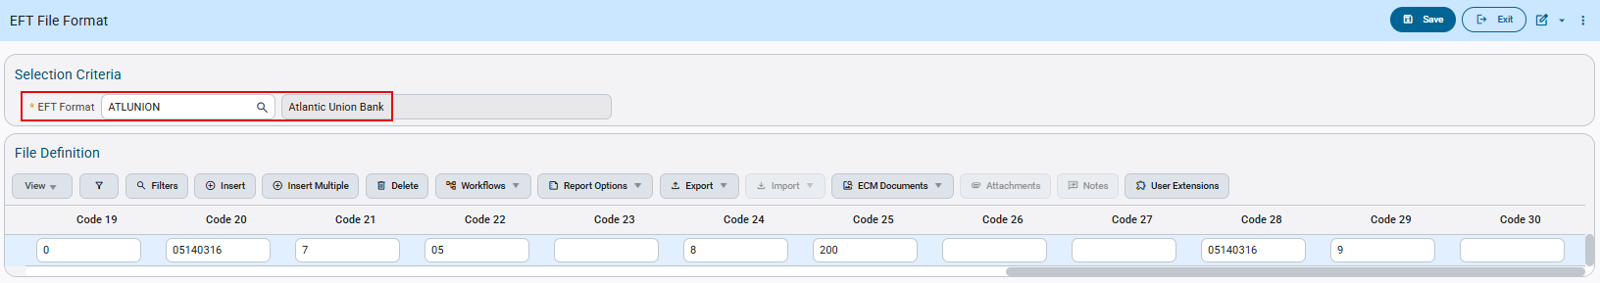Accounts Payable > Setup > Global Tables > EFT Formats

Check Printing:
The Check Printing program allows users to select the available EFT File Codes. Users can select the Code and Generate EFT Files as required.
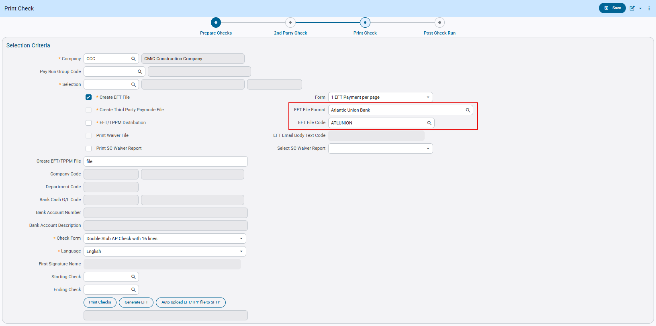
Accounts Payable > Check > Print Checks > ‘Print Check’ node
This is an example of the ‘ATLUNION’ AP EFT CCD file format: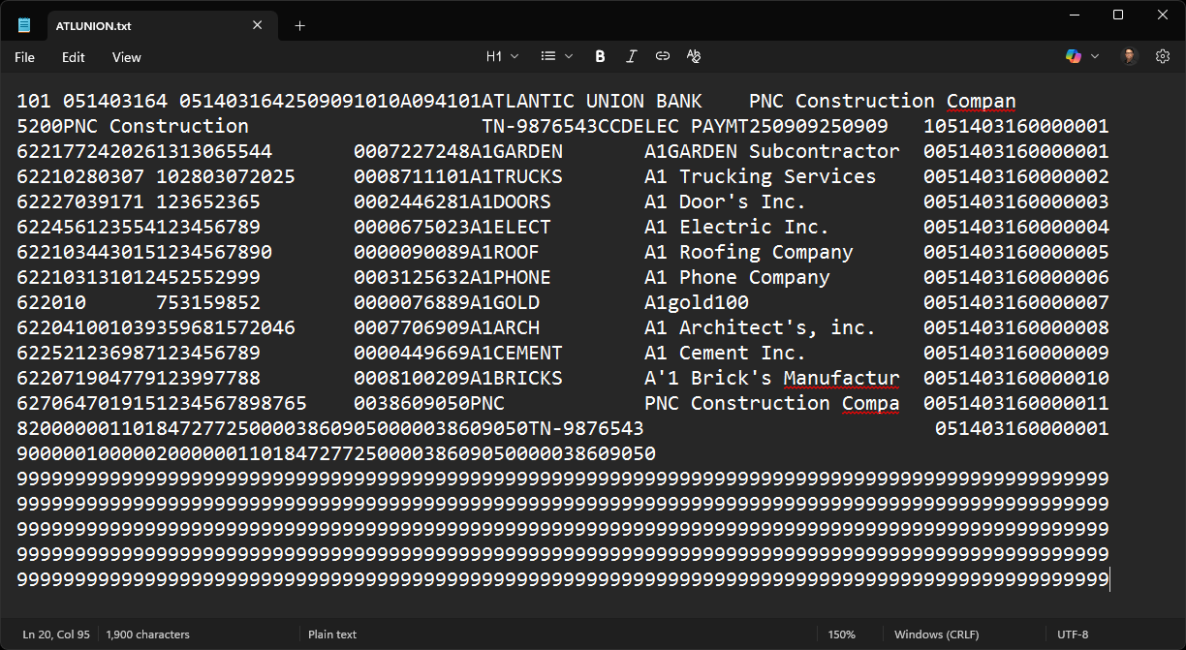

The above file generated follows the Format specifications:
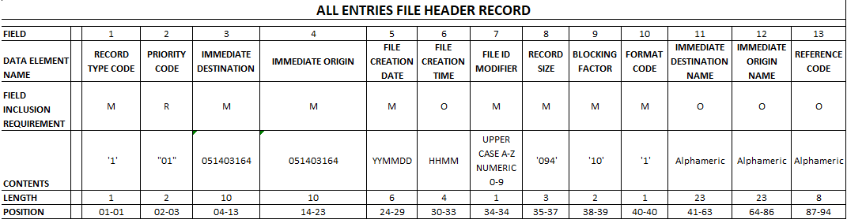
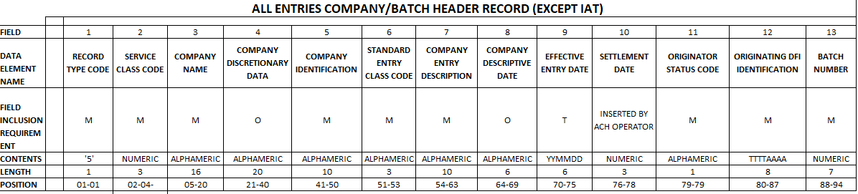
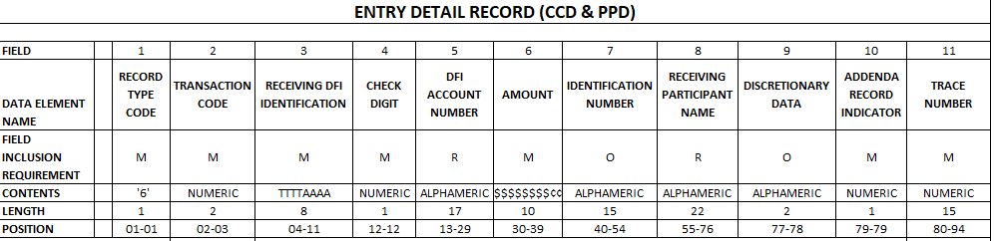
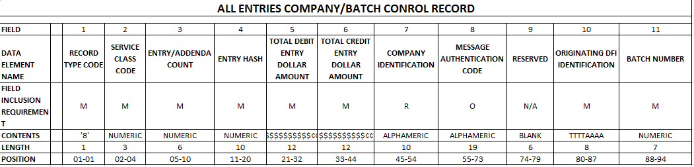
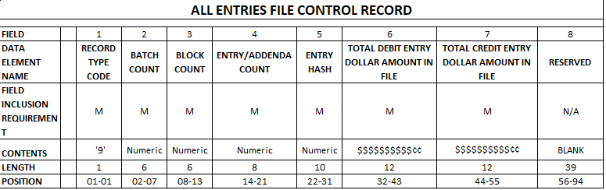

EFT CTX file format for JPMorgan Chase Bank (FIN-18227)
Overview:
AP EFT CTX file format for JPMorgan Chase Bank is created.

Modifications:
New AP EFT CTX file format ‘JPCTXNACHA’ is created for JPMorgan Chase Bank with the following changes:
- Immediate Destination (‘021000021’ with a space before the number)
- Immediate Origin (‘0000000000’)
- Immediate Destination Name (‘JPMORGAN CHASE’)
- Service Class Code (‘200’)
- Company Identification (10 digits ACH Company Federal Tax ID from company setup)
- Standard Entry Class Code (‘CTX’)
- Company Entry Description (‘PAYMENT’)
- Effective Entry Date (‘Check date’)
- Originating DFI (First 8 digits of Immediate Origin)
- Transaction Code (Always - '22')
- Receiving DFI Identification (Bank Transit number from vendor setup)
- DFI Account Number (Bank Account number from vendor setup)
- Individual Identification (Vendor Code)
- Receiving Company Name (Vendor name)
- Addenda Record Indicator ('1' - addenda records)
- Addenda Type Code (‘05’)
- Payment Related Information (separate line for each invoice, 16 digits from voucher description** and payment amount for the invoice\)
- Service Class Code (‘200’)
- Company Identification (10 digits ACH Company Federal Tax ID from company setup)
- Originating DFI ('First 8 digits of Immediate Origin)

EFT Setup:
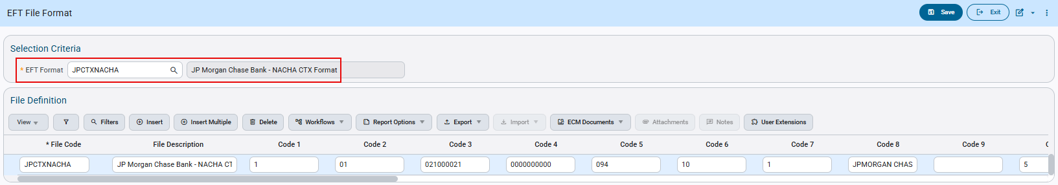Accounts Payable > Setup > Global Tables > EFT Formats
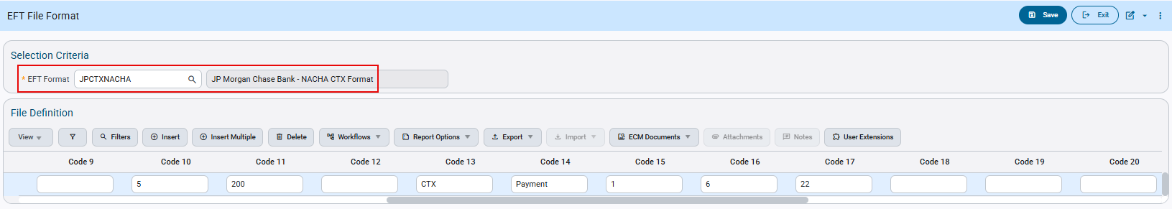Accounts Payable > Setup > Global Tables > EFT Formats
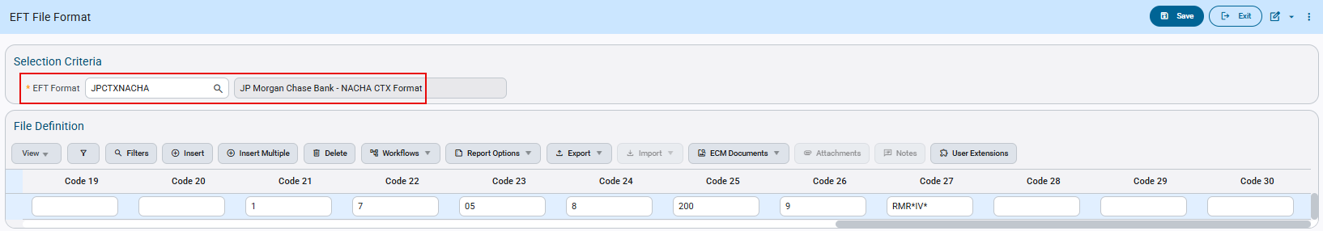Accounts Payable > Setup > Global Tables > EFT Formats

Check Printing:
The Check Printing program allows users to select the available EFT CTX File Codes. Users can select the Code and Generate EFT CTX Files as required.
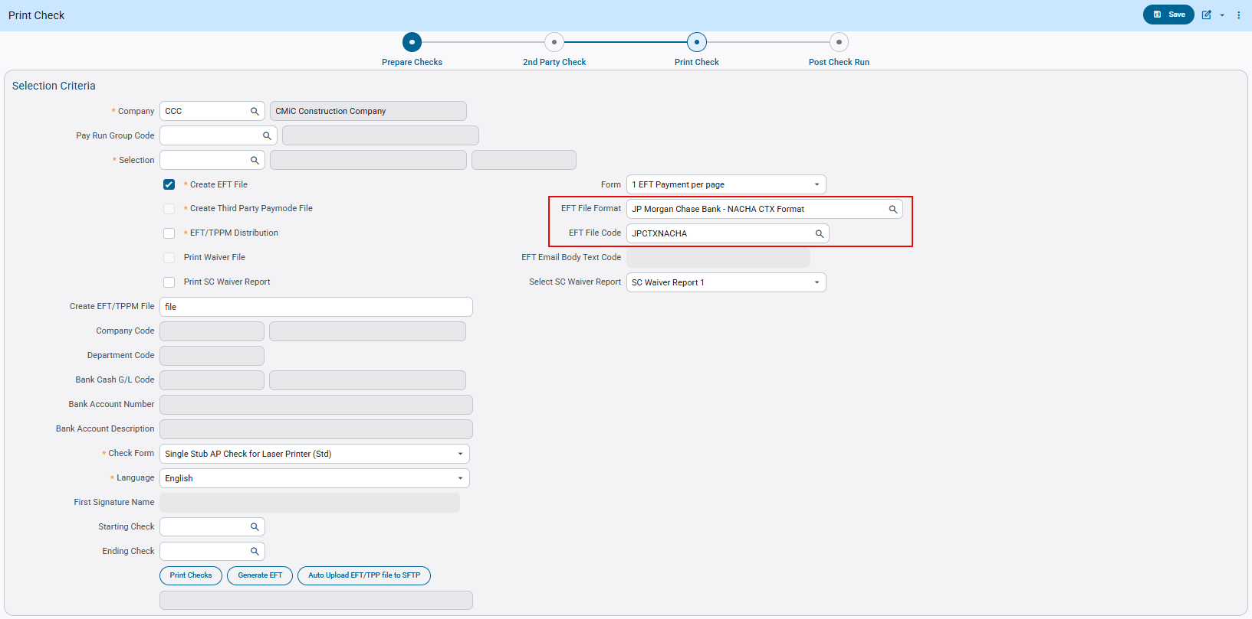
Accounts Payable > Check > Print Checks > ‘Print Check’ node

This is an example of the ‘JPCTXNACHA’ AP EFT CTX file format:
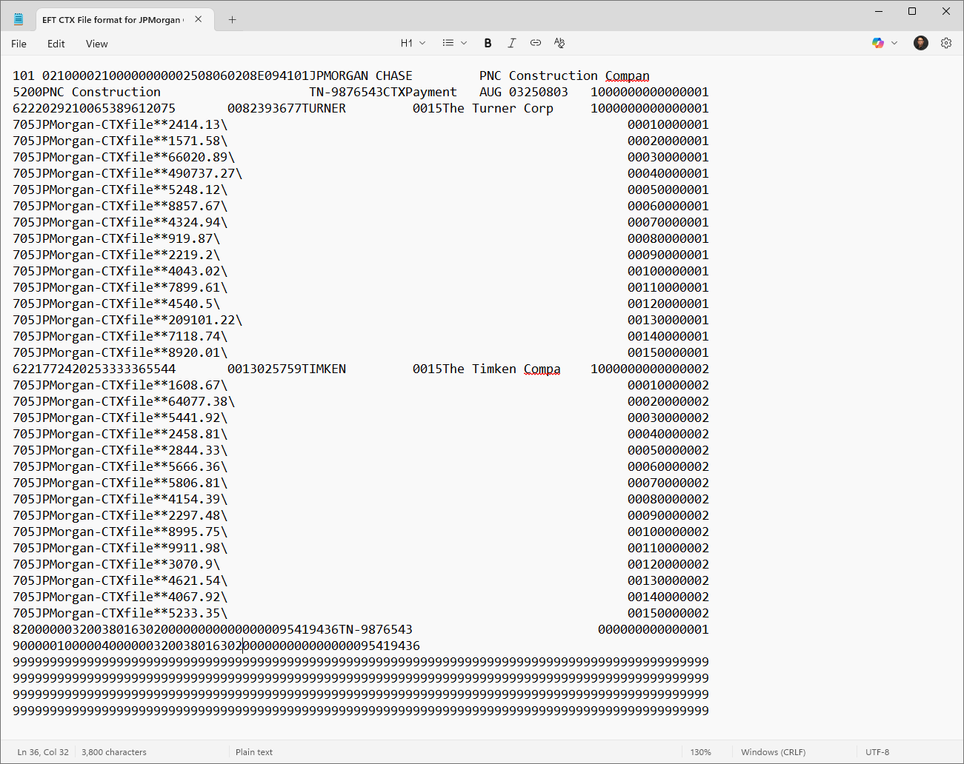

The above file generated follows the Format specifications:
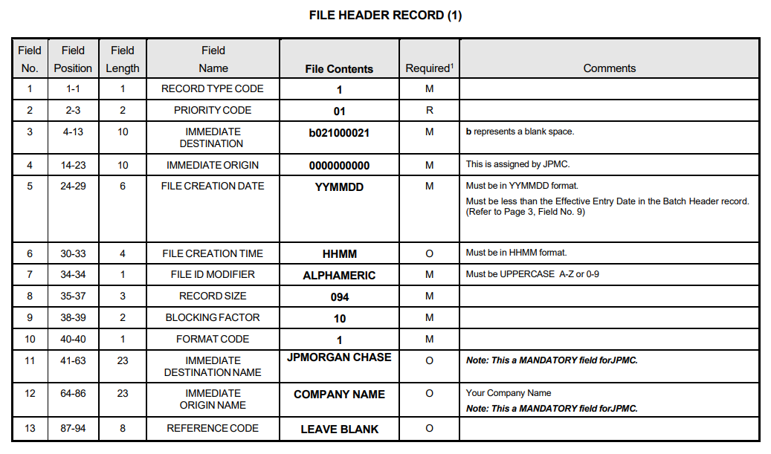
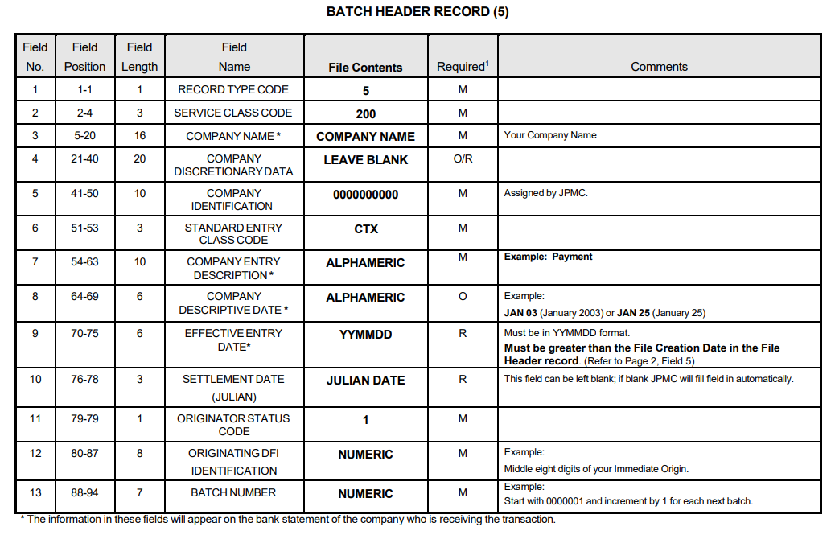
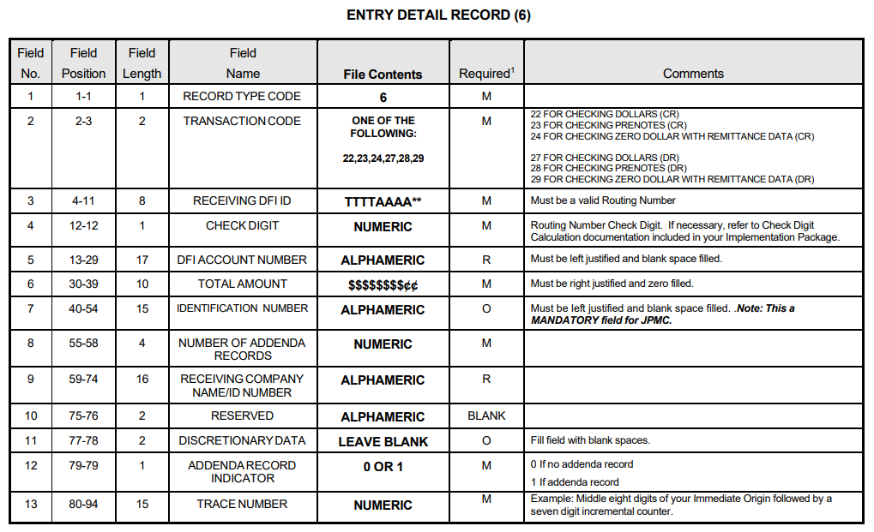
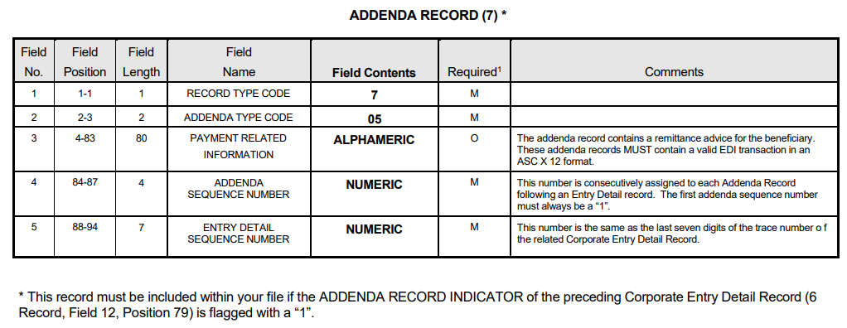
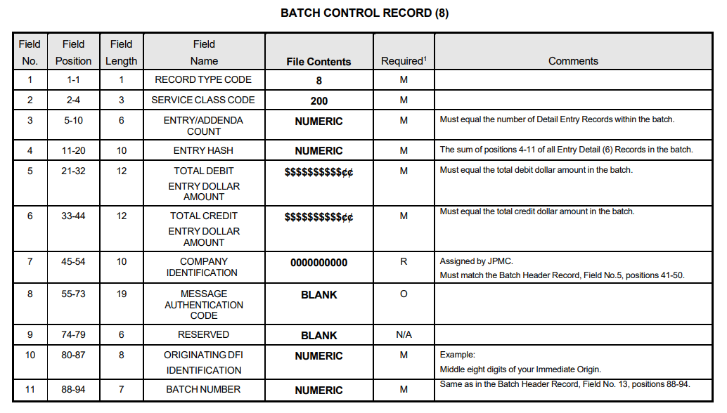
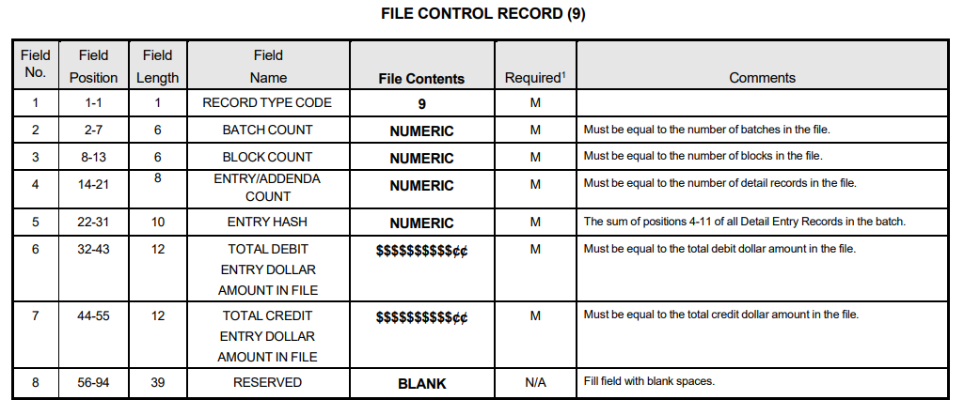

PO Detail Invoice Select List (Variance pop-up): “Save” button is removed (FIN-19431)
Overview:
The “Save” button has been removed from the PO Detail Invoice Select List (Variance pop-up window)

Modifications:
To eliminate redundancy, the “Save” button has been removed from the PO Detail Invoice Select List (Variance pop-up window). The “Accept” button fulfills the save function.
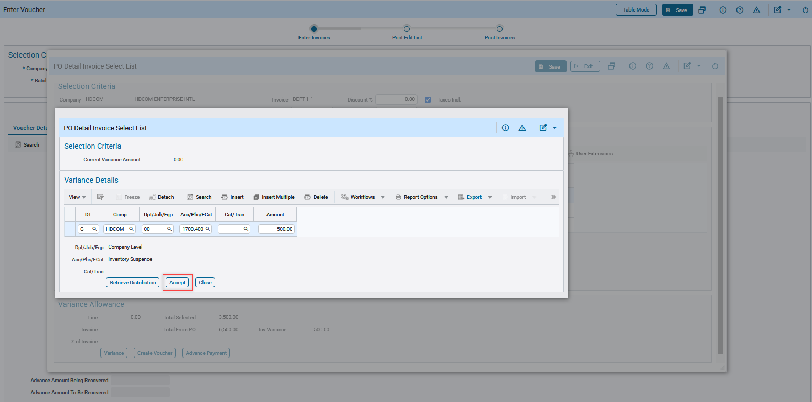

Positive Pay File Format for United Bank (FIN-18779)
Overview:
A Positive Pay File Format for United Bank is created.
Modifications:
The Positive Pay File Format: UNITEDBNK2’ is created for United Bank with the date format as ‘YYYYMMDD’.
Note: ‘UNITEDBNK2’ is created only for the required fields.
Below screenshot shows the new Positive Pay Format added: UNITEDBNK2
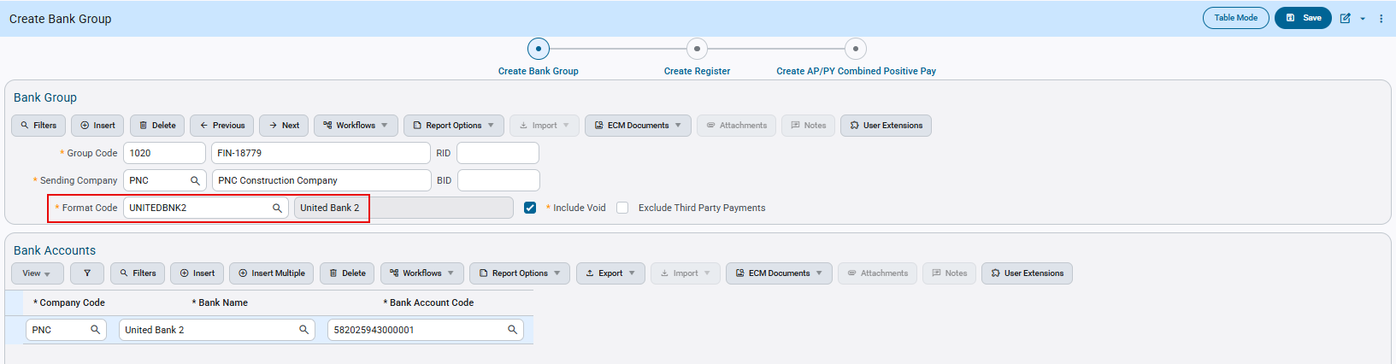Accounts Payable > Check > Positive Pay Register > Create Bank Group

Create Positive Pay Register:
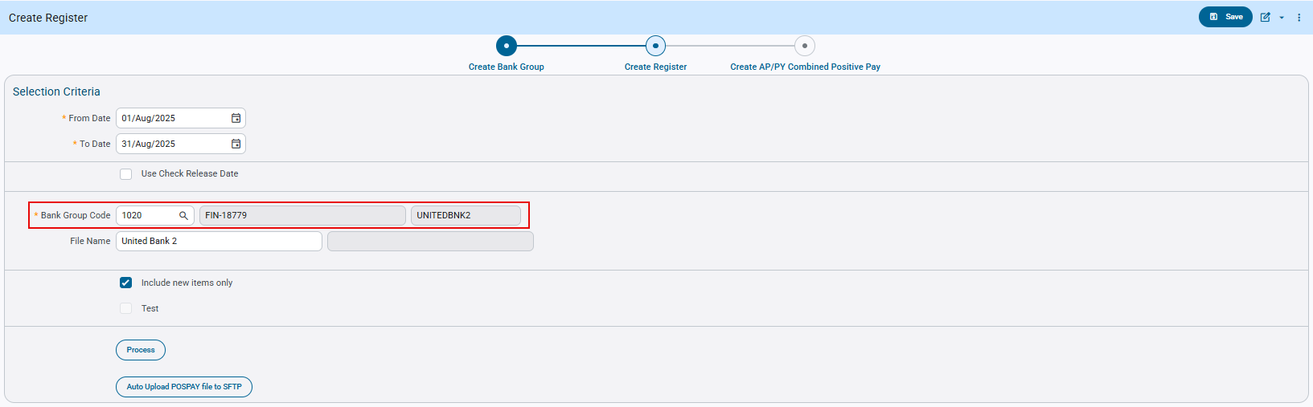Accounts Payable > Check > Positive Pay Register > Create Register
United Bank Positive Pay File generated: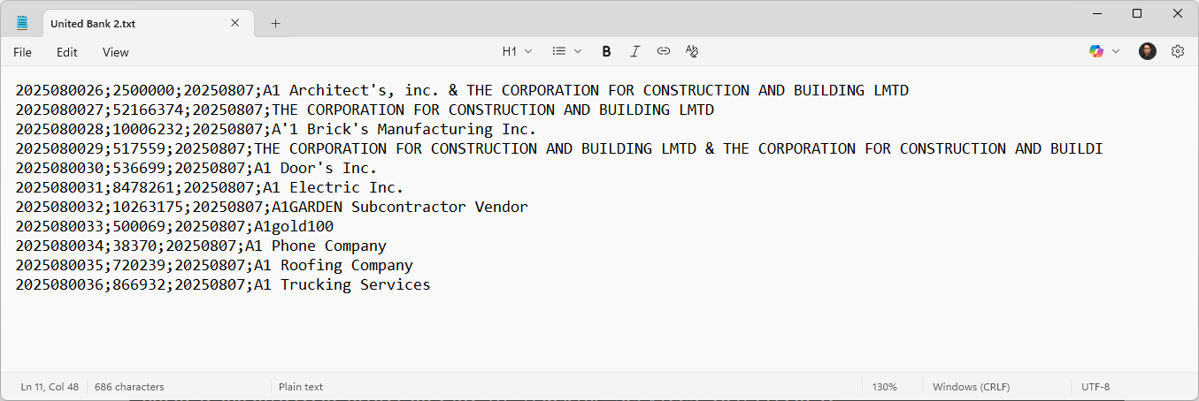

The above file generated follows the Format specifications provided by United Bank as shown in the next screen print.
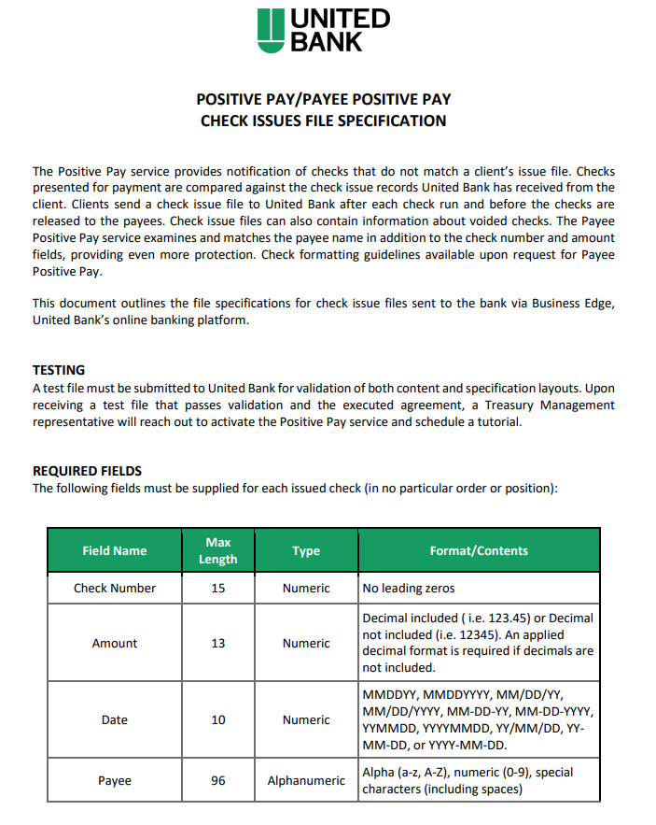
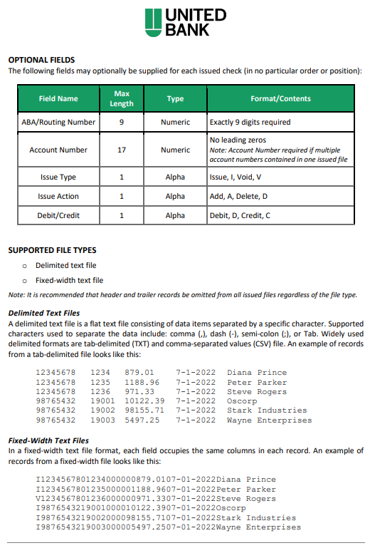

Added a new column ‘Selection Code’ to Adjust Voucher Status program (FIN-19275)
Overview:
A new column ‘Selection Code’ has been added in Adjust Voucher Status program table (VOUSTAT). Voucher records will continue to appear in the Adjust Voucher Status table. If a voucher is linked to a selection code, the corresponding code will be displayed in the new ‘Selection Code’ column. These records will be disabled and cannot be modified, as they are part of an active payment selection. It can be added through Lite Editor.
Modifications:
‘Selection Code’ column highlighted in the screen below:
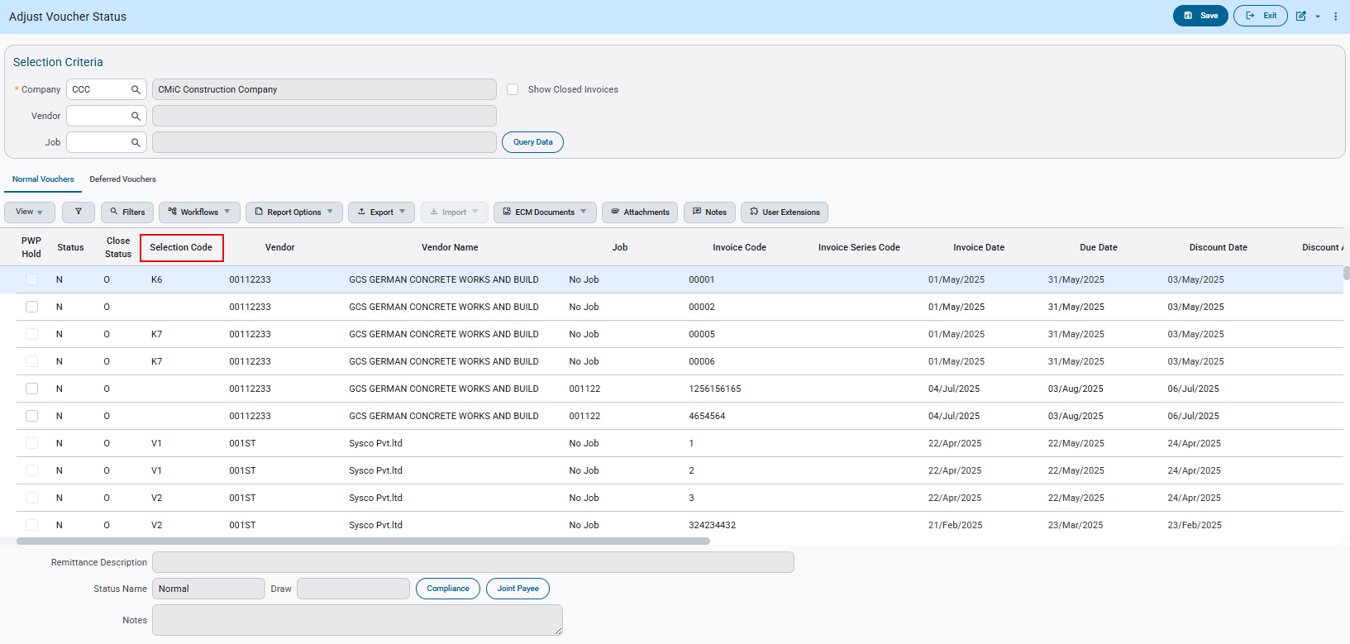

Incorporate Third-Party Payment process into Bank reconciliation process (FIN-19499)
Overview:
This design modifies the configuration logic for third-party payments, transitioning from a vendor-level setup to a registered invoice or voucher-level setup. This enhancement enables users to select the appropriate third-party payment type within the programs.
Modifications:
- The following programs are modified to default the third-party payment type from vendor to registered invoice level:

- AP Registered Invoice.
- AP Invoice Header - RAD_APREGINV_V (Flysheet).
- AP Invoice with PO Header - RAD_APREGINV_PO_V (Flysheet).
- Std Registered RFP Header - RAD_SC_APREGINV_V (Flysheet).
- RFP (Request for Payment) Entry – to filter the invoices based on payment types.
- Adjust Voucher Status.
- RFP (Request for Payment) in Field.

- AP Create Voucher from Registered Invoice program is modified to copy over the third-party payment type in voucher.

- Modified the bank reconciliation program (Outstanding AP Checks) pop-up to incorporate third-party payment types for check and credit card payment types. Users will be able to view the third-party check number and payment type in brackets as ‘TPP’ for check and credit card type.

- The following routines have been modified to do the following Third-party payment types:

- ACH – These transactions will be auto reconciled based on the standard control file flag option “Automatically Populate Check Reconciliation Date” in the check tab of AP Control File Settings.
- Check – These transactions will be reconciled manually through the bank reconciliation file as per changes in #3.
- Credit Card – These transactions will be reconciled manually through the bank reconciliation file as per changes in #3.
Note: The user will need to import the bank reconciliation file manually, for the changes to be processed.

Added new fields Third Party Payment Mode and Payment Type as shown in the following screens:

- AP Registered Invoice:
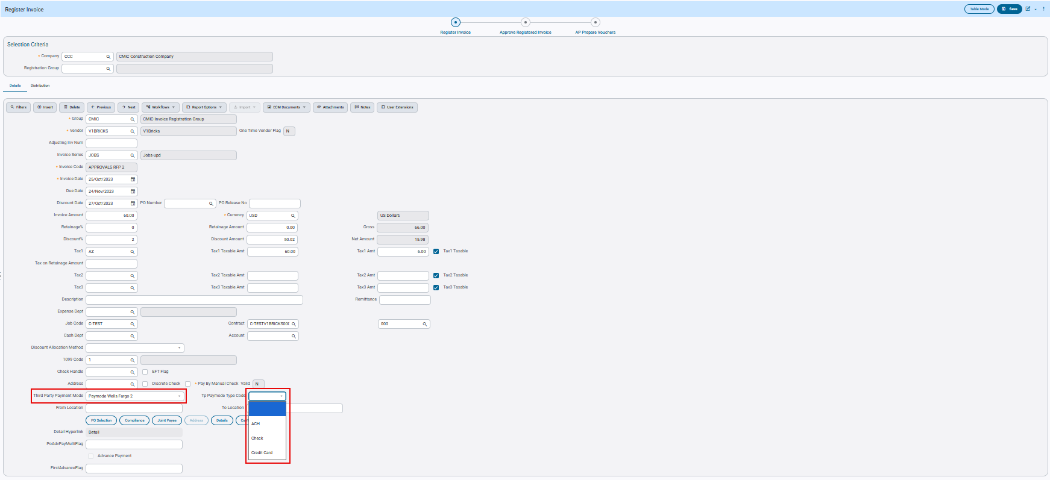Accounts Payable > Voucher > Register Invoices

- AP Invoice Header - RAD_APREGINV_V (Flysheet):
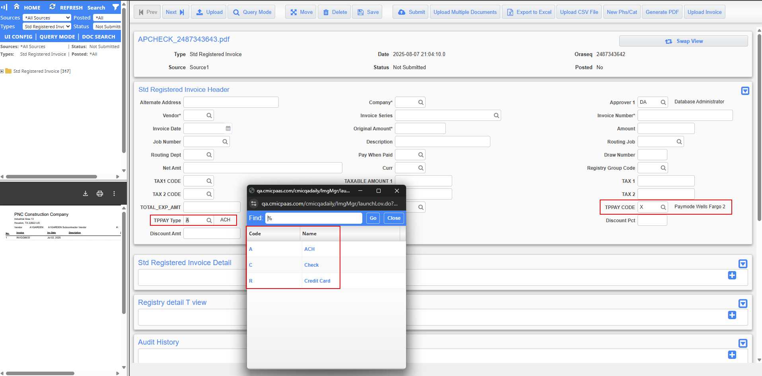

- AP Invoice with PO Header - RAD_APREGINV_PO_V (Flysheet):
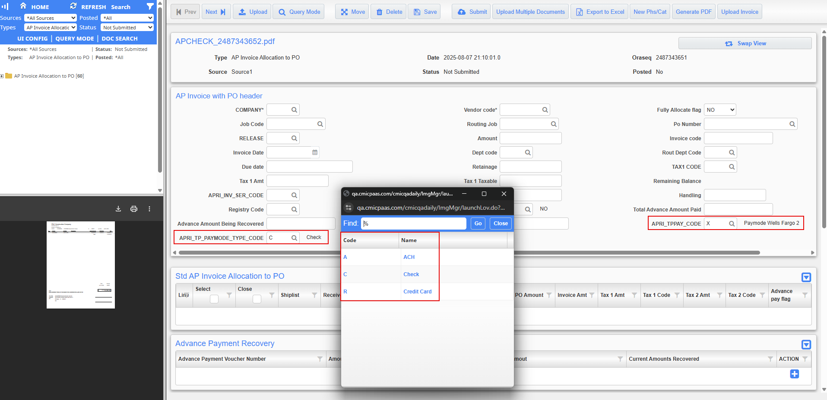

- Std Registered RFP Header - RAD_SC_APREGINV_V (Flysheet):
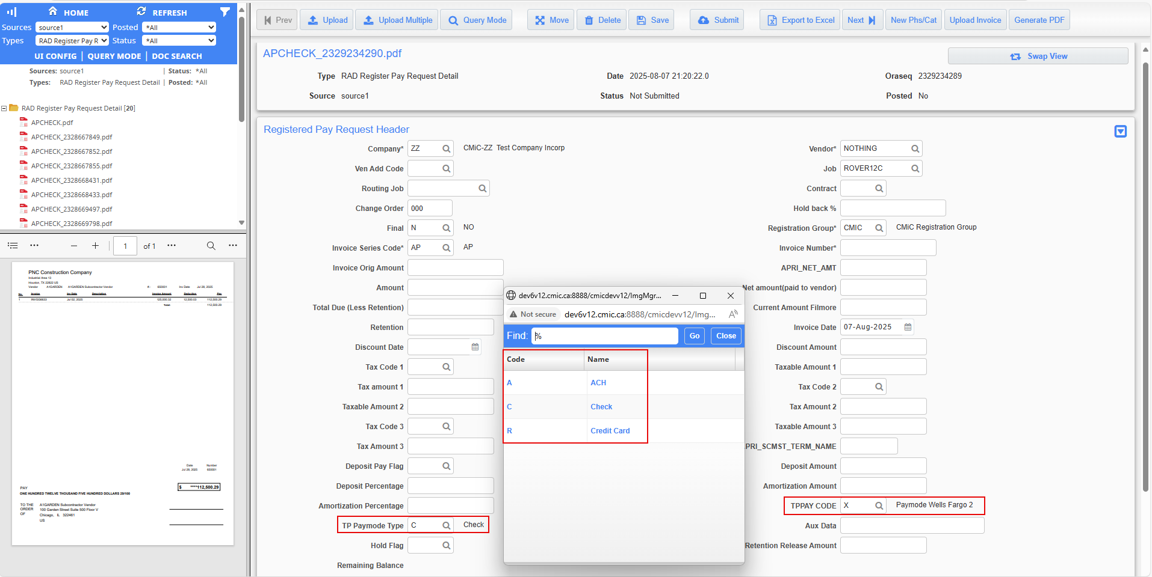

- RFP (Request for Payment) Entry:
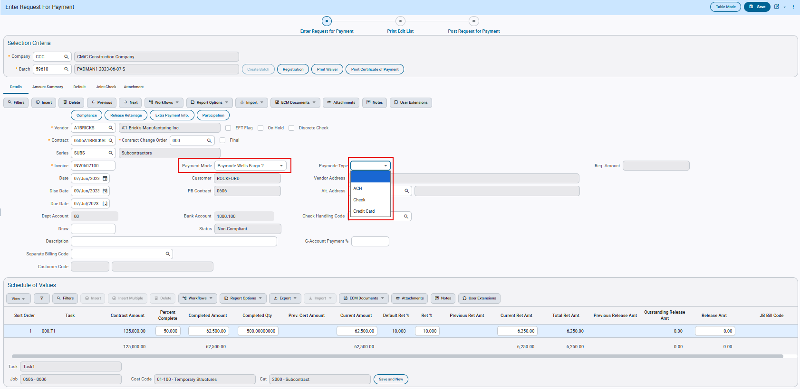

- Adjust Voucher Status:
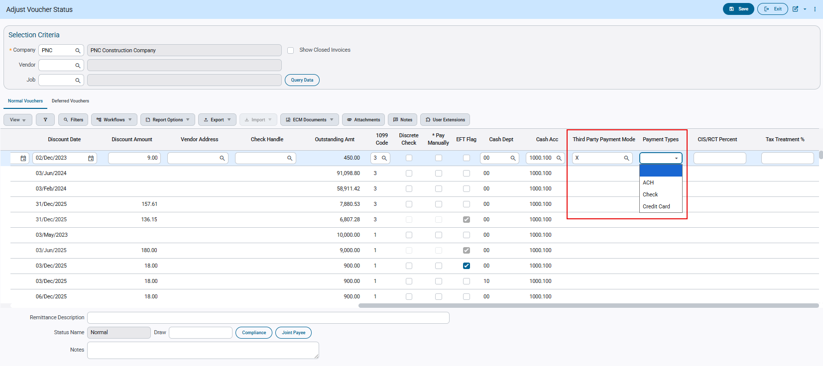

- RFP (Request for Payment) in Field:
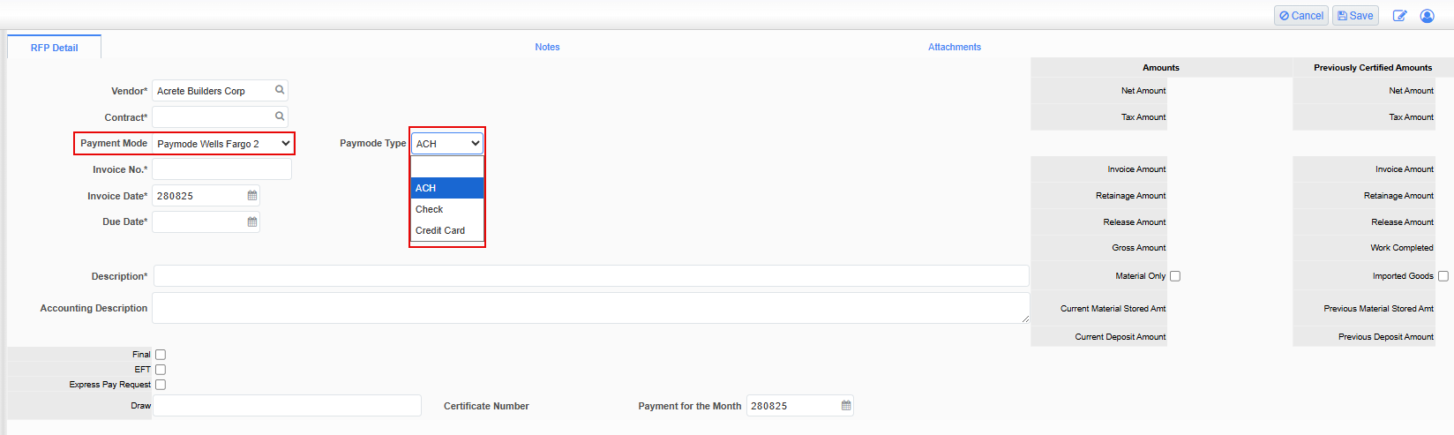

The below screen shows the modification on the bank reconciliation program (Outstanding AP Checks) pop-up:
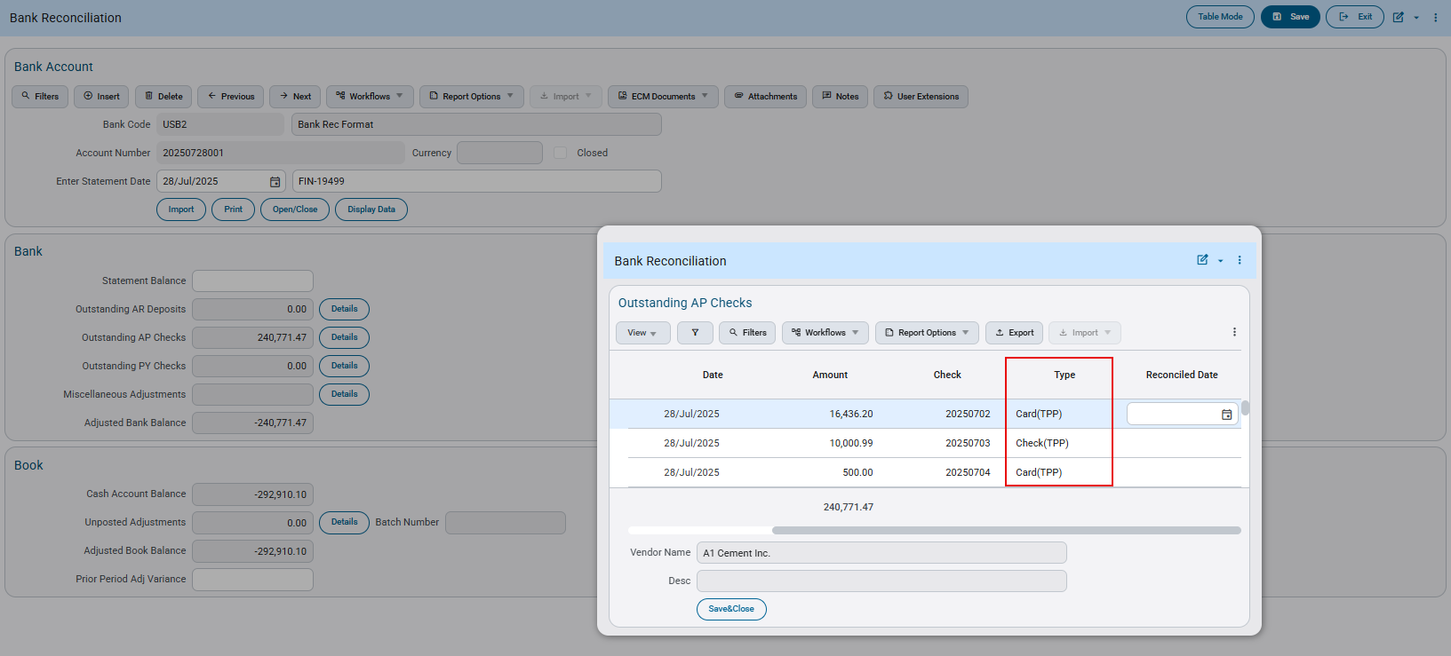

Modified Third-Party Payment mode file for Wells Fargo 2 (FIN-19558)
Overview:
AP Third Party Payment mode file for Wells Fargo (Paymode Wells Fargo 2) is updated. A new standard field, named ‘Site ID’ is added to the Maintain Vendors program. The value entered in the ‘Site ID’ field will carry over to the Third-Party Payment File Design.
In the following fields where the Vendor Code is currently used within the Third-Party Payment File Design, it is replaced with the value from the newly created Site ID field.
- ORIGTORCVPRTYINF
- RCVPRTYID
- CCRMERCHNTID
Note: If the Site ID is blank, the vendor code will be used.

ORIGTORCVPRTYINF | RCVPRTYID | CCRMERCHNTID
CCR (Card) - Site ID / Vendor Code | CCR (Card) - Site ID / Vendor Code | CCR (Card) - Site ID / Vendor Code
CHK (Check) - Blank | CHK (Check) - Site ID / Vendor Code | CHK (Check) - Blank
DAC (ACH) - Blank | DAC (ACH) - Site ID / Vendor Code | DAC (ACH) - Blank

‘Site ID’ field highlighted in the screen below: 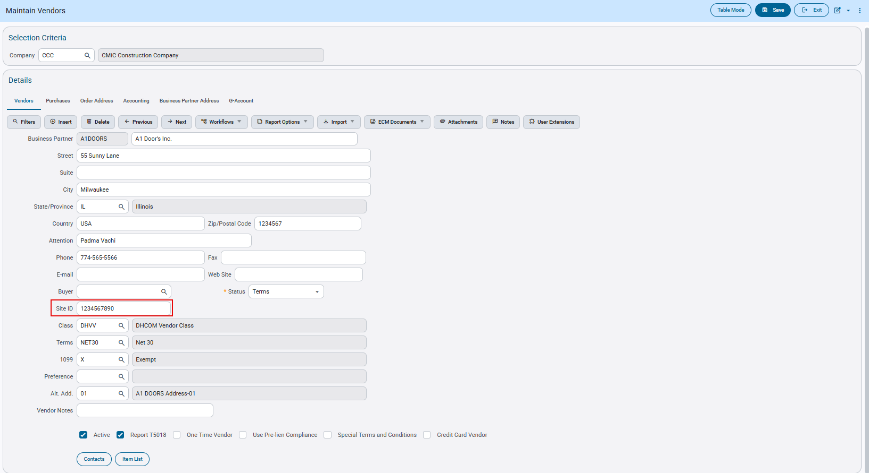Accounts Payable > Setup > Maintain Vendors > ‘Vendors’ tab.

Updated TPPM file showing Site ID for the payment options as shown on the screen below:
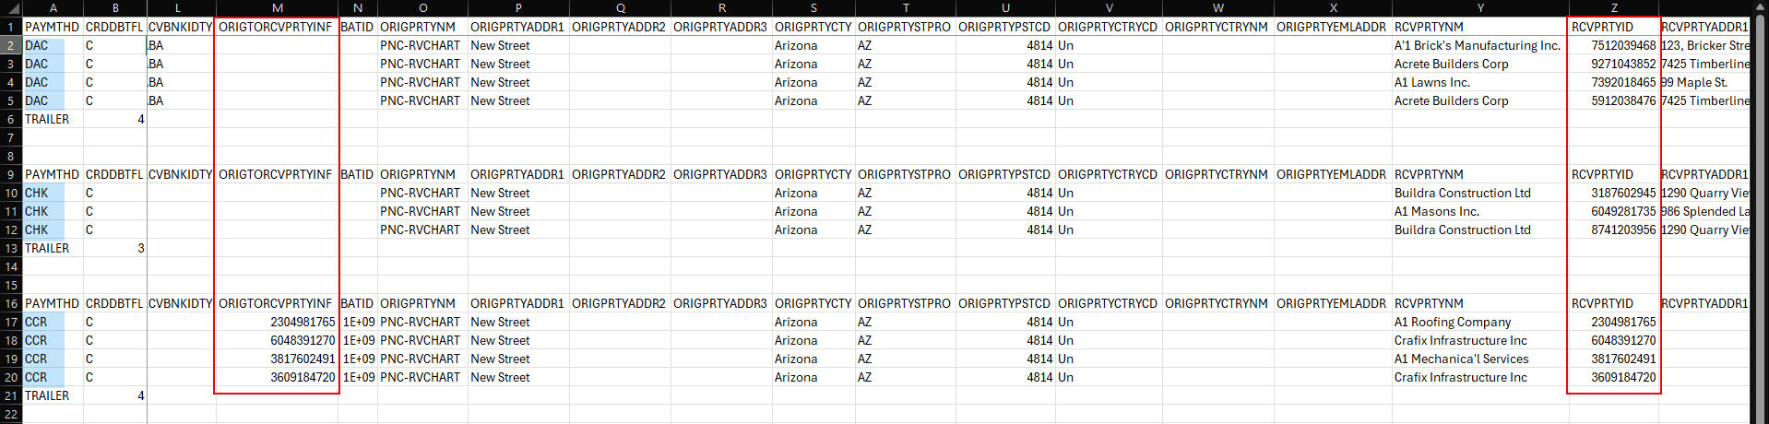
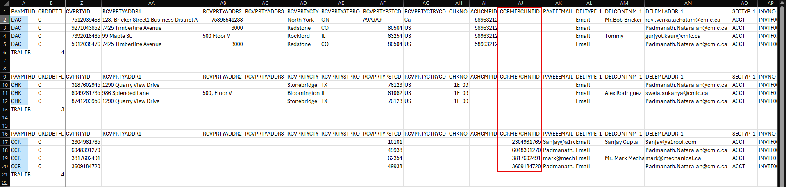

Third-Party Payment file format (Card Type Payment) for Wells Fargo (FIN-19868)
Overview:
AP Third Party Payment file format (CCR – Card Type Payment) for Wells Fargo (Paymode Wells Fargo 3) is created.
Modifications:
There is a new entry (‘Paymode Wells Fargo 3’) added to the Drop-Down list for the ‘Third Party Payment’ field in the following screens:
- Third Party Payment Setup:
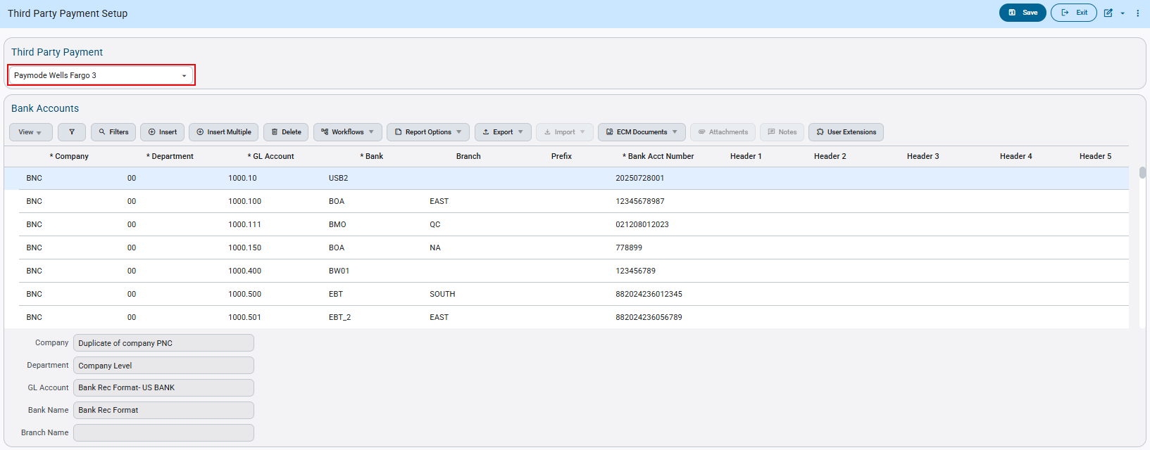
System Data > Global Tables > Banking > Third Party Payment Setup

- Maintain Vendors Program under ‘Accouting’ tab:
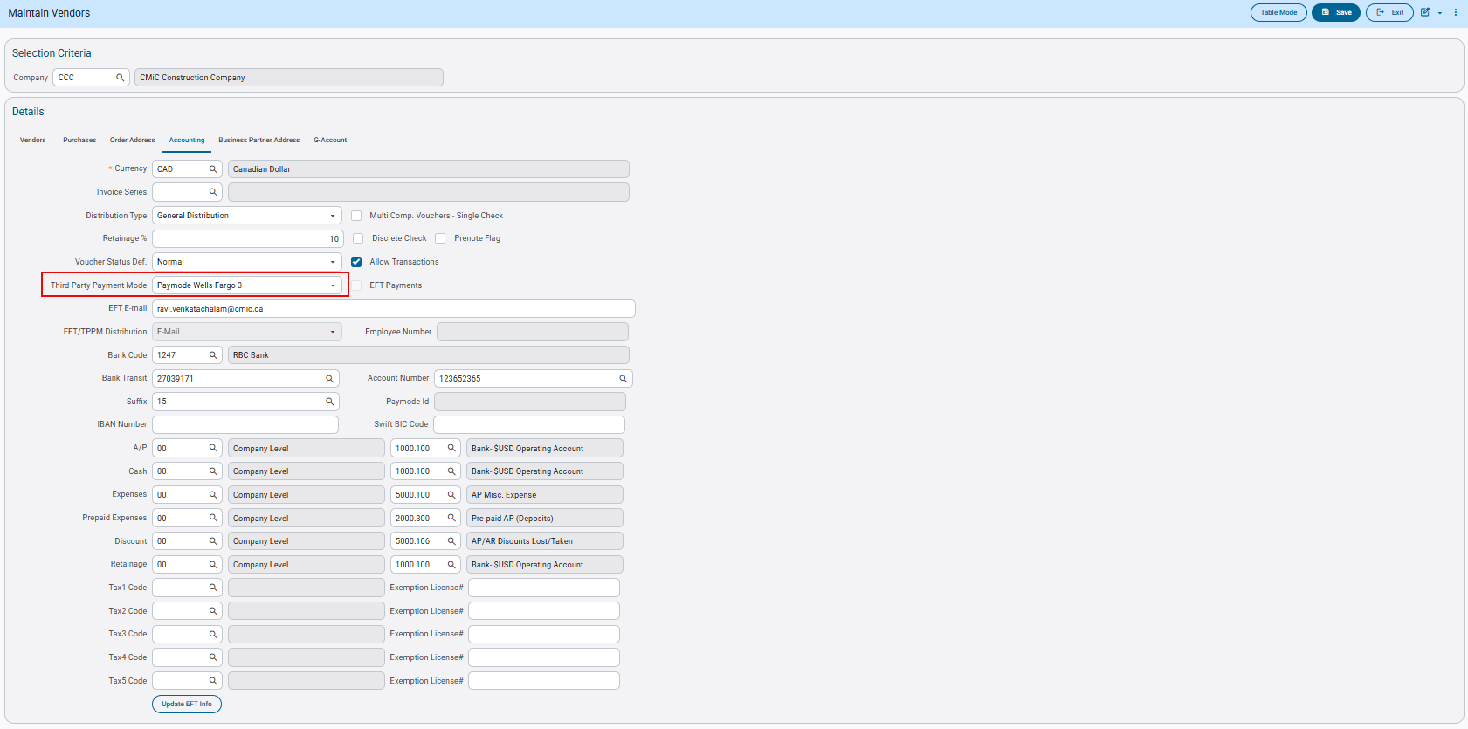Accounts Payable > Setup > Maintain Vendors > ‘Accounting’ tab

- AP Enter Voucher screen:
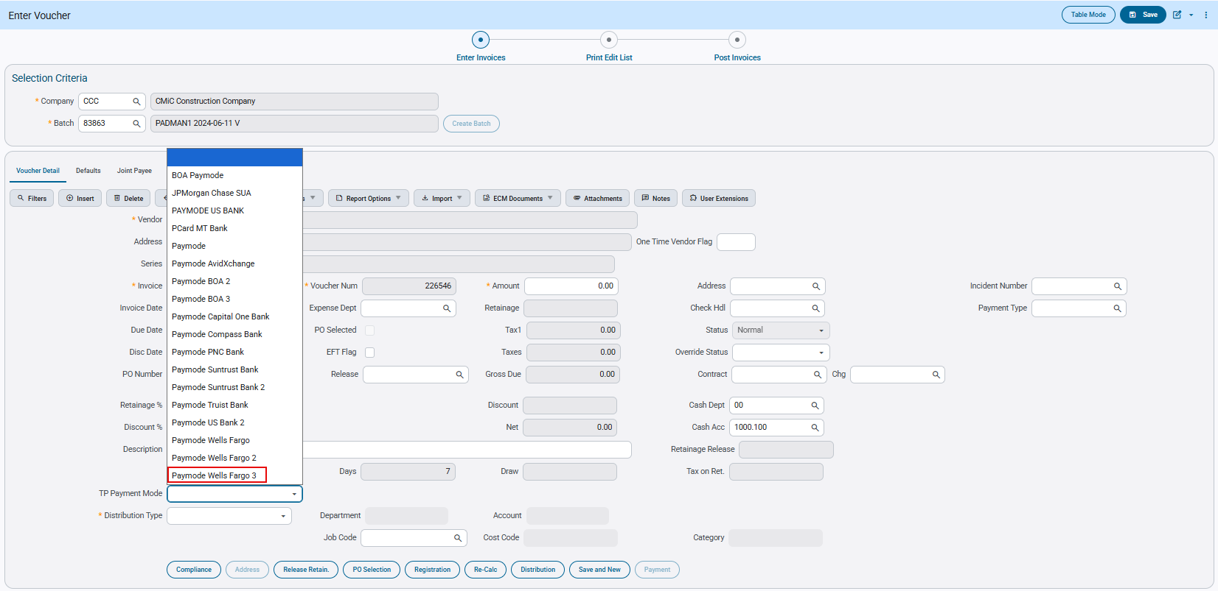Accounts Payable > Voucher > Enter Vouchers

- Select Payments program:
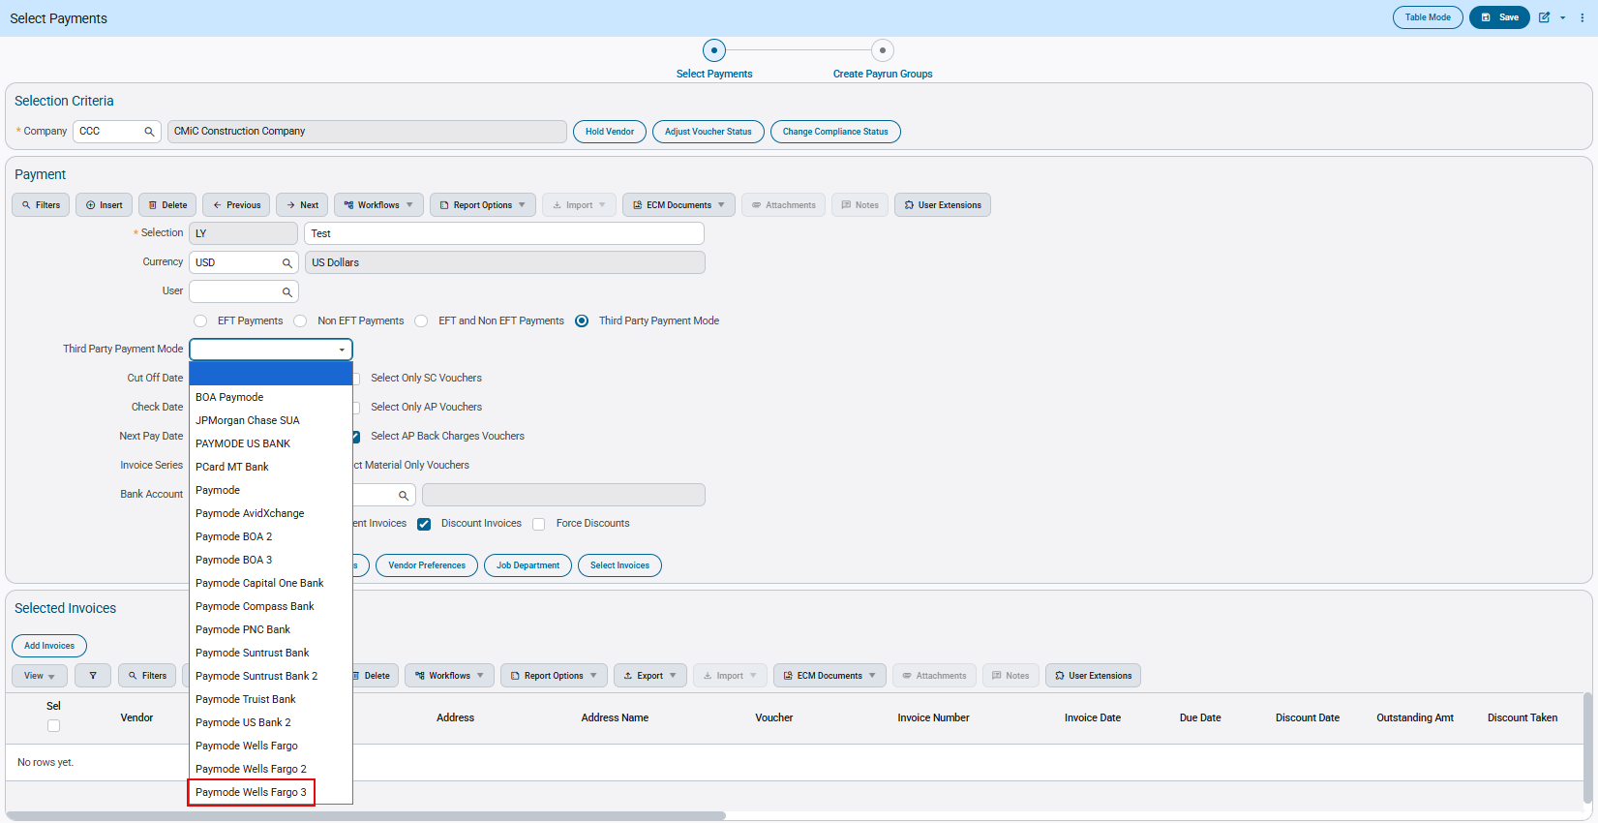Accounts Payable > Payment > Select Payments

Check Printing:
In the Print Check screen, the ‘Create TPP File’ checkbox should be checked by default. The user can create the Third-Party Payment file by clicking on the [Generate EFT] button.
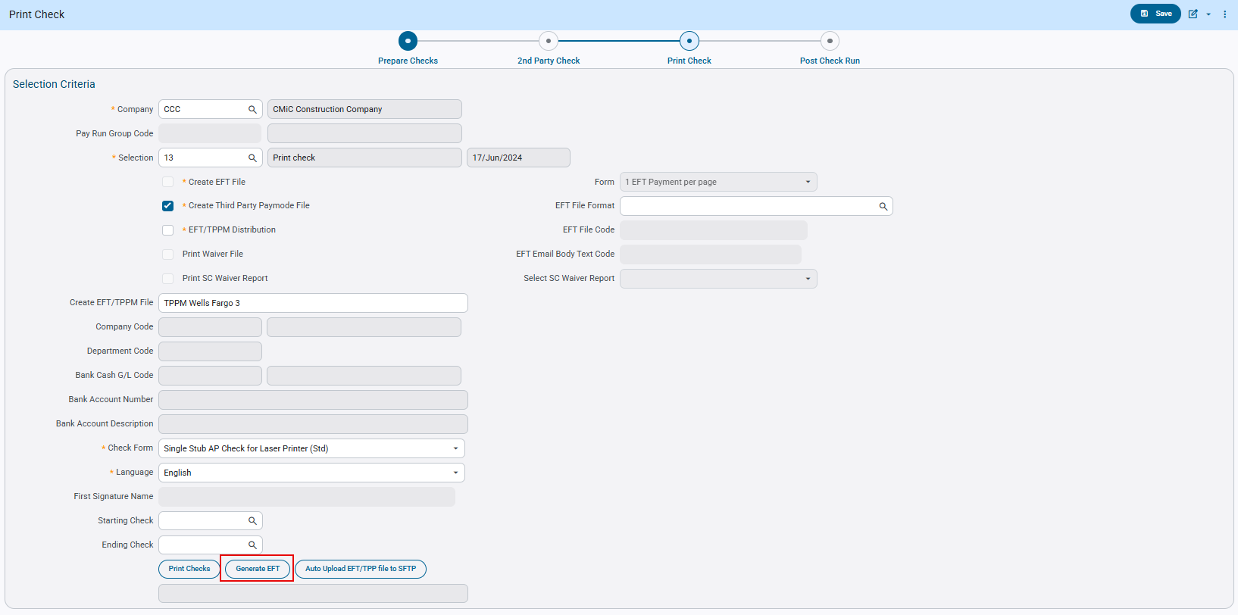

This is an example of the ‘Paymode Wells Fargo 3’ Third-Party Payment file format: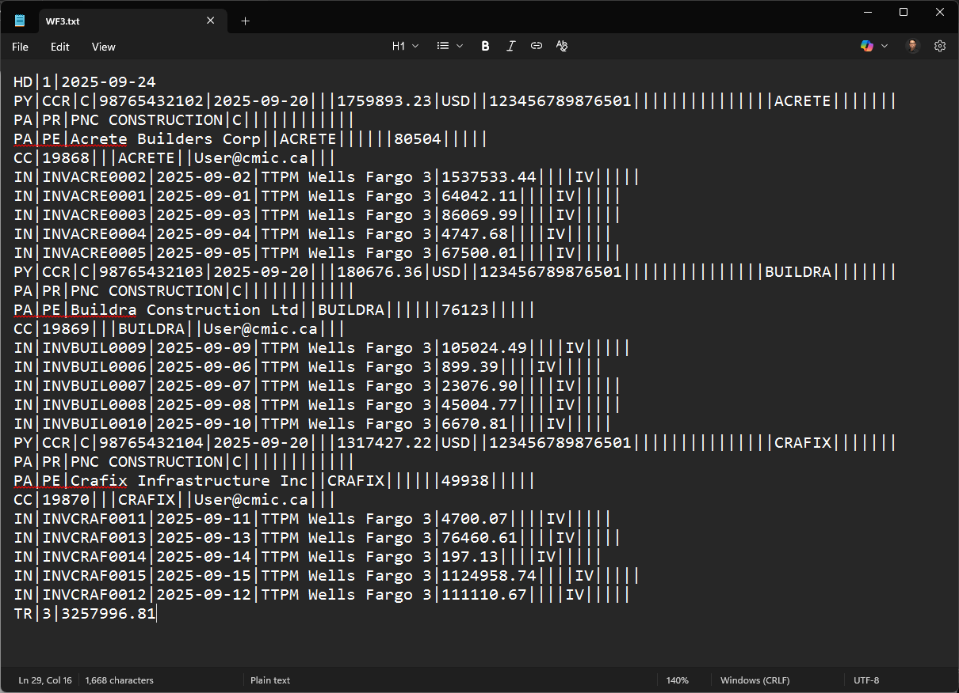

The above file generated follows the Format specifications:
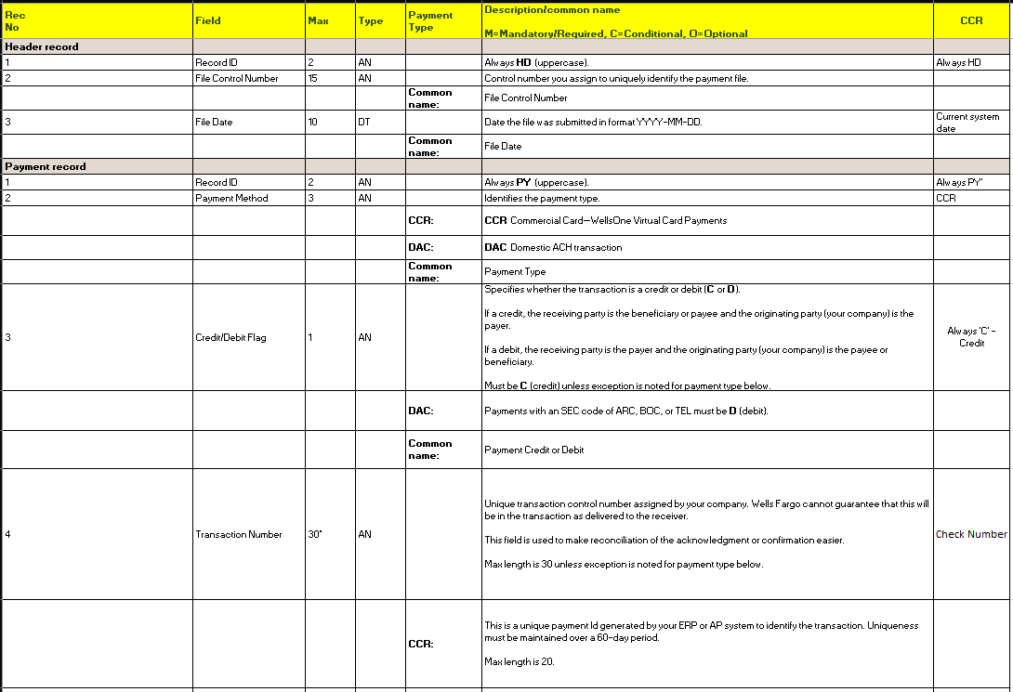
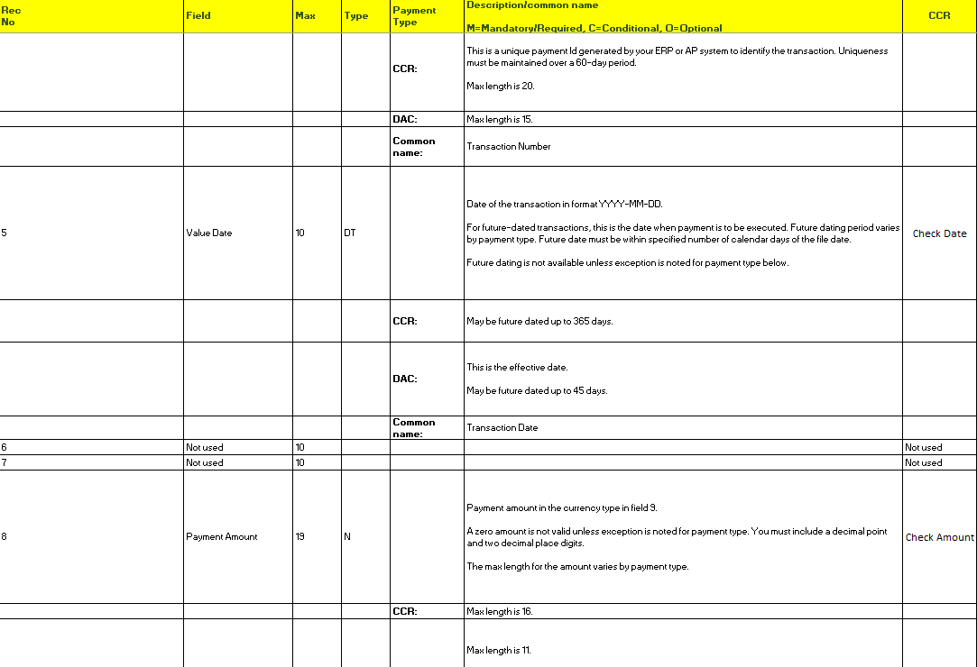
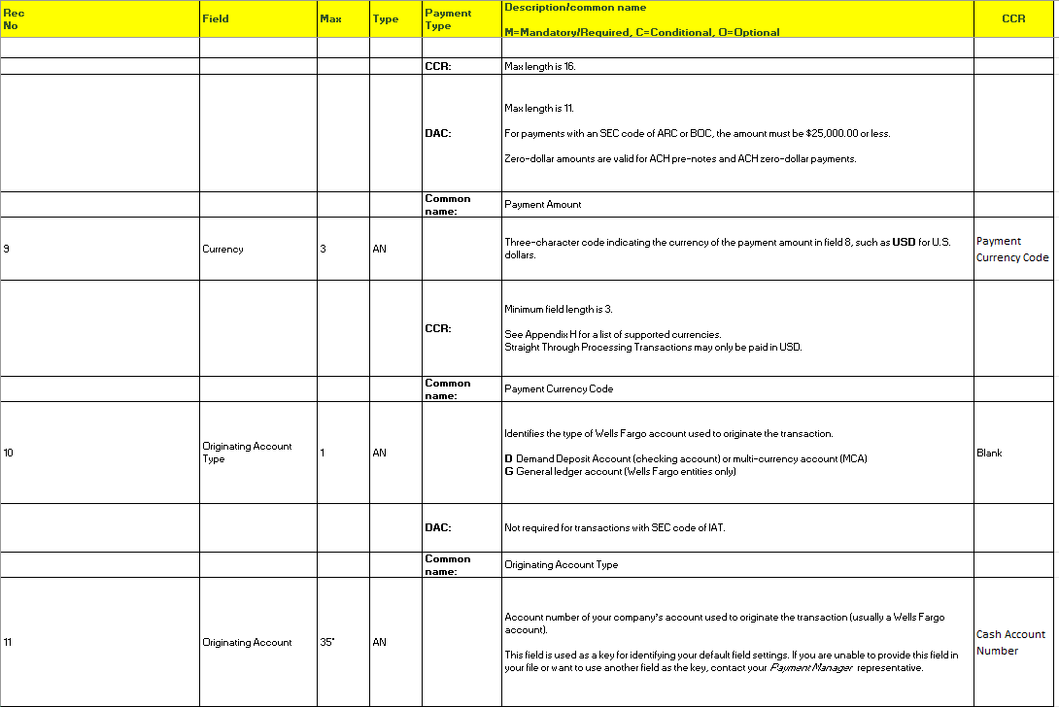
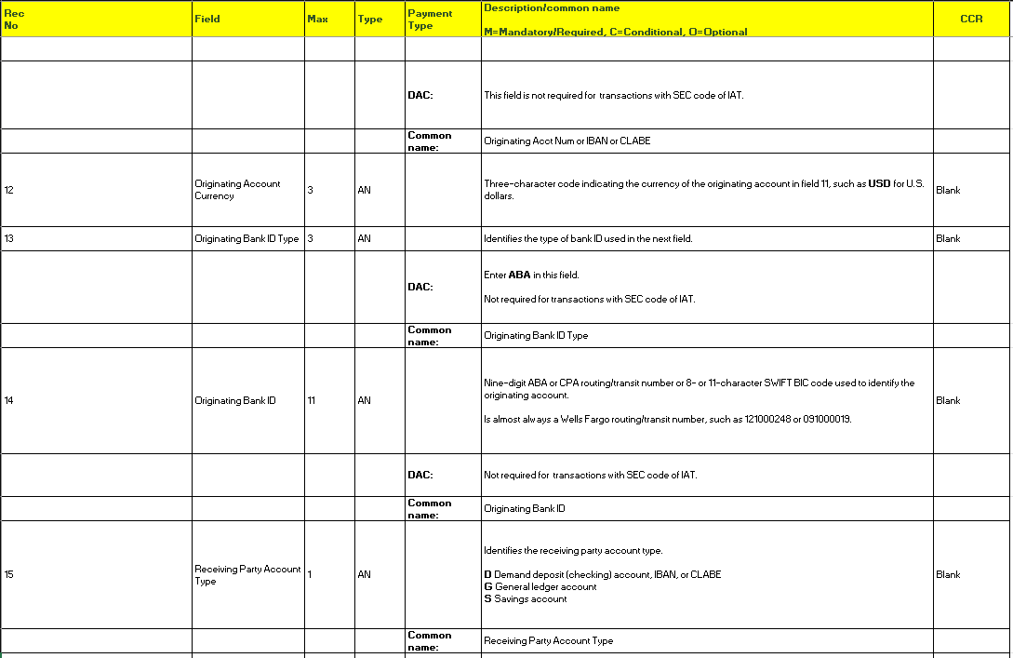
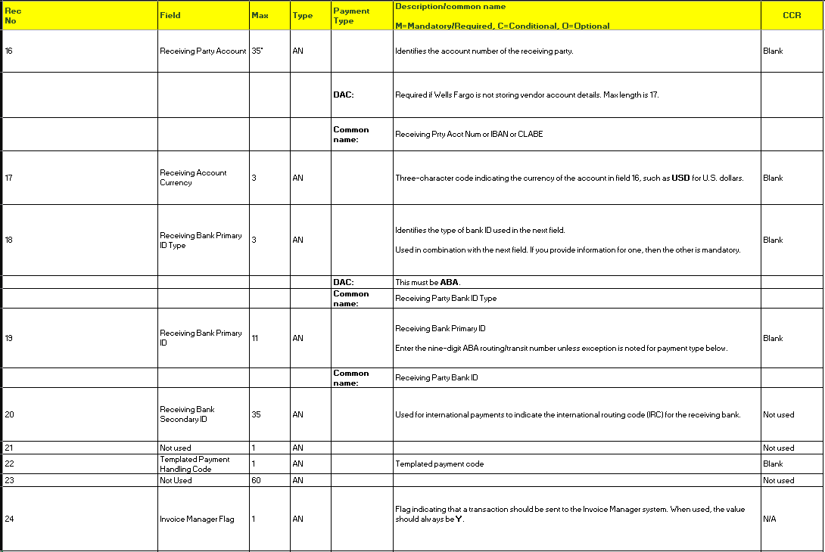
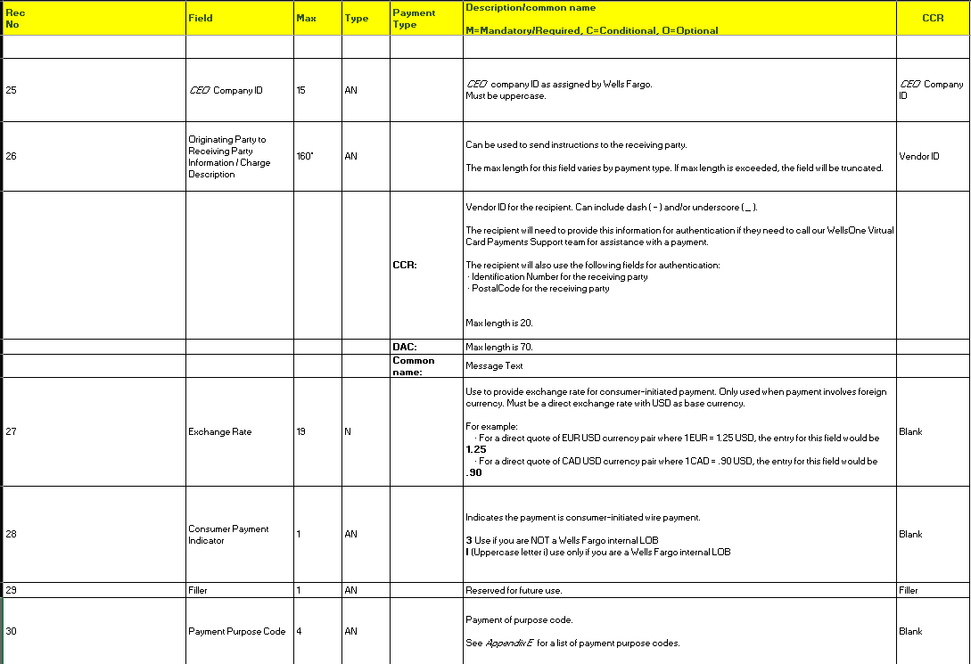
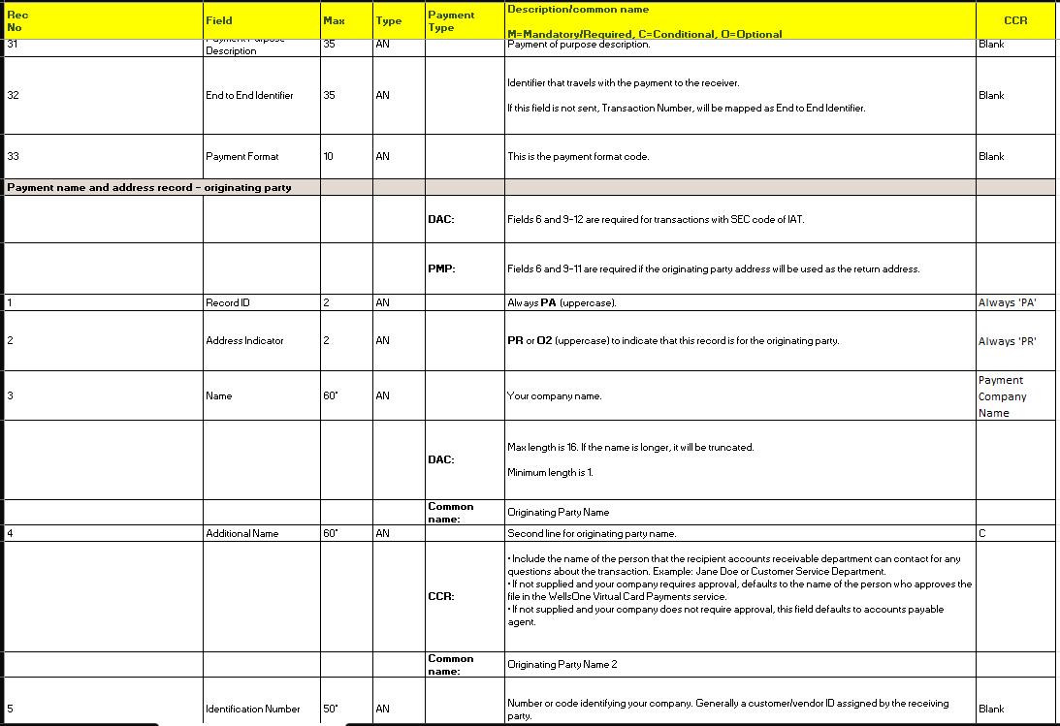
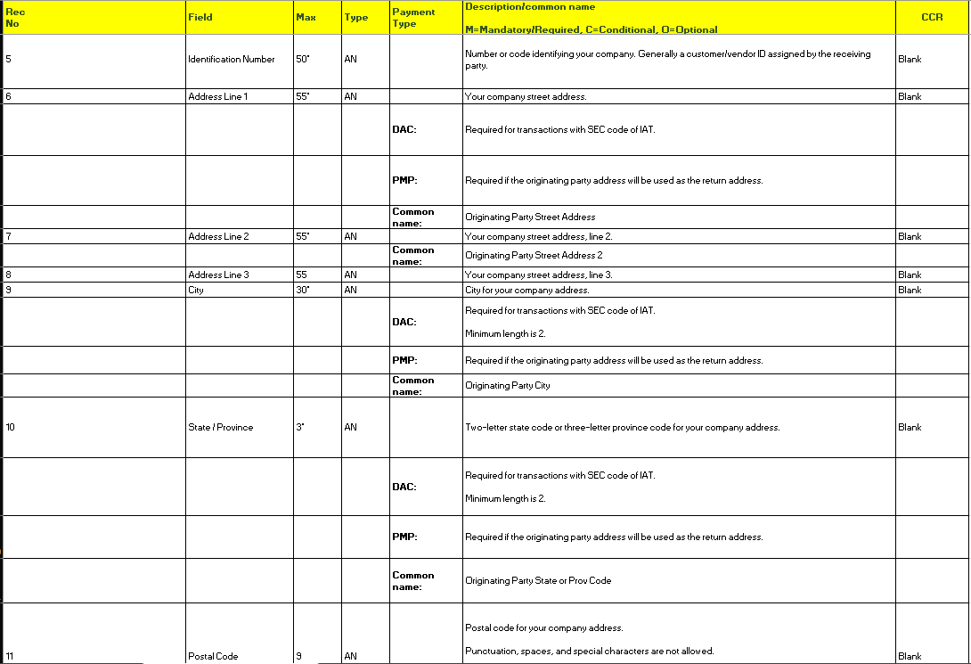
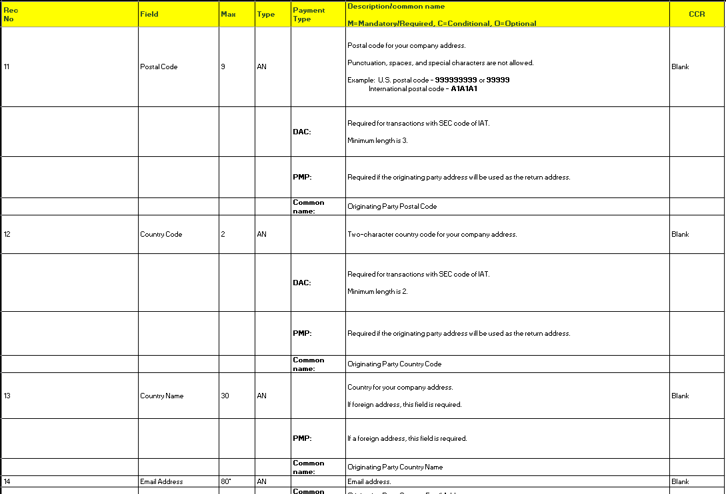
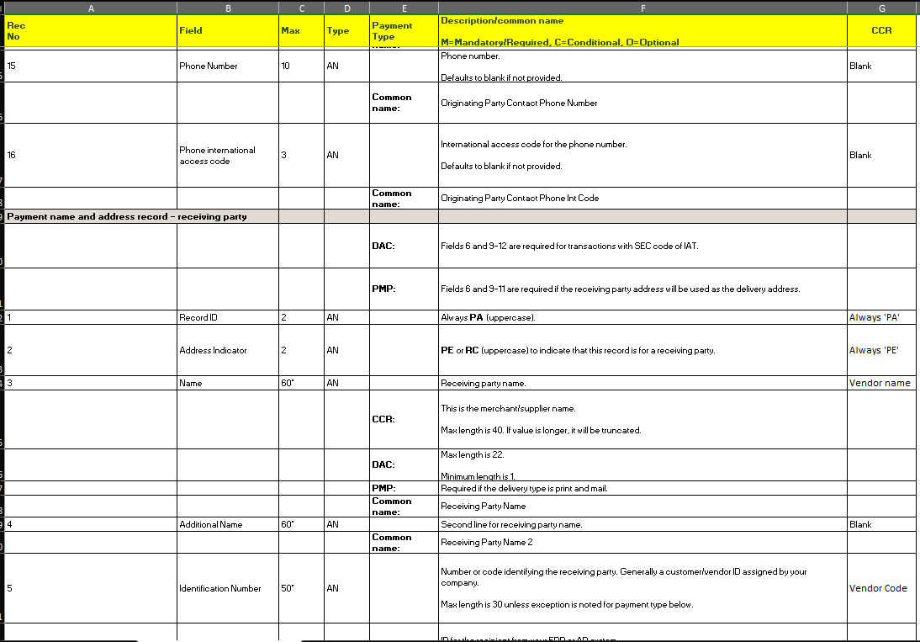
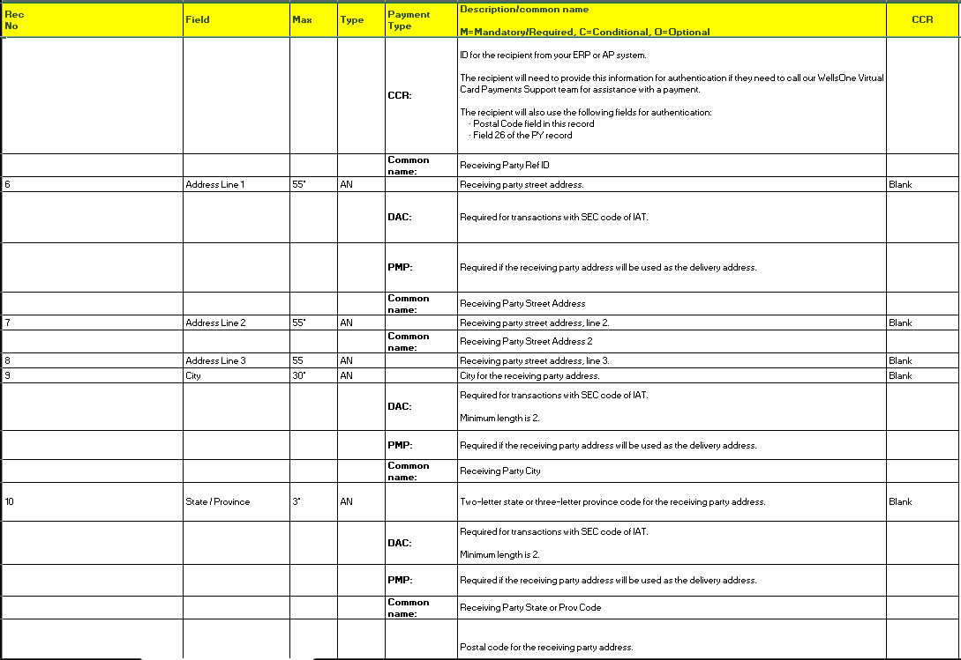
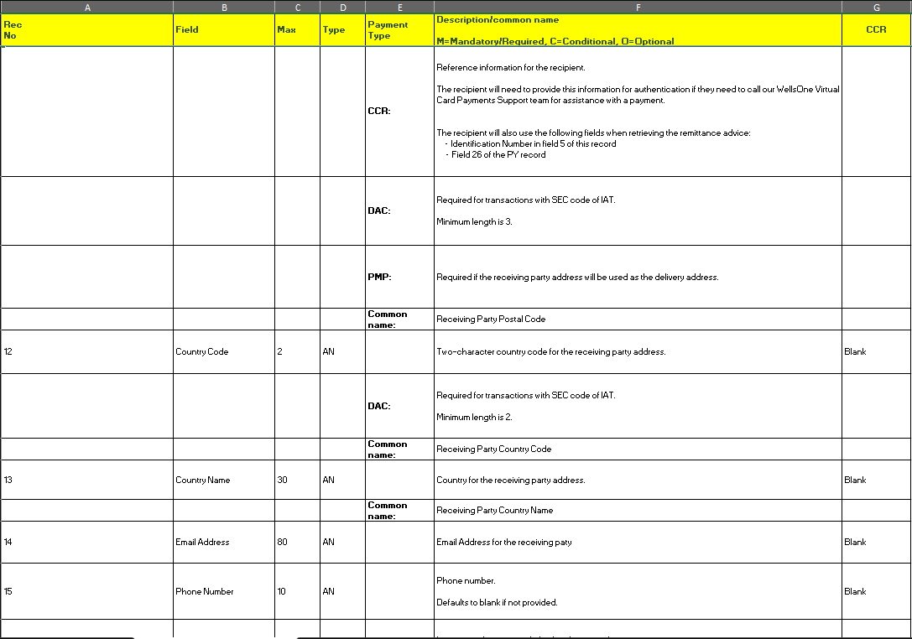
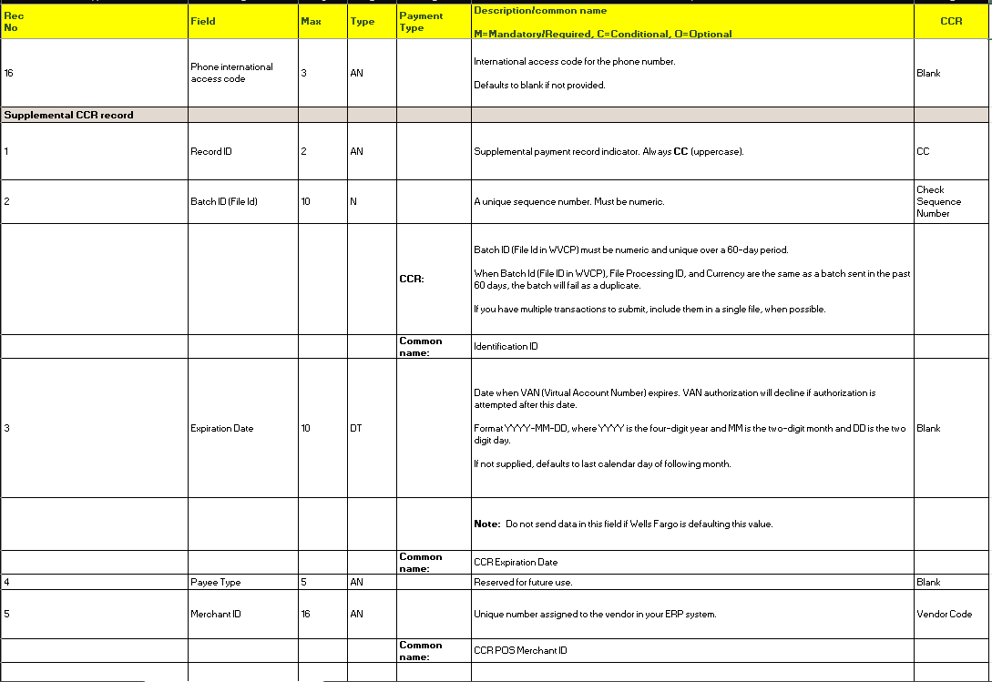
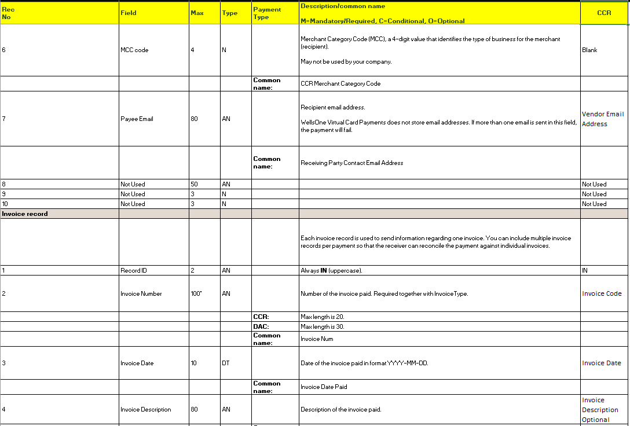
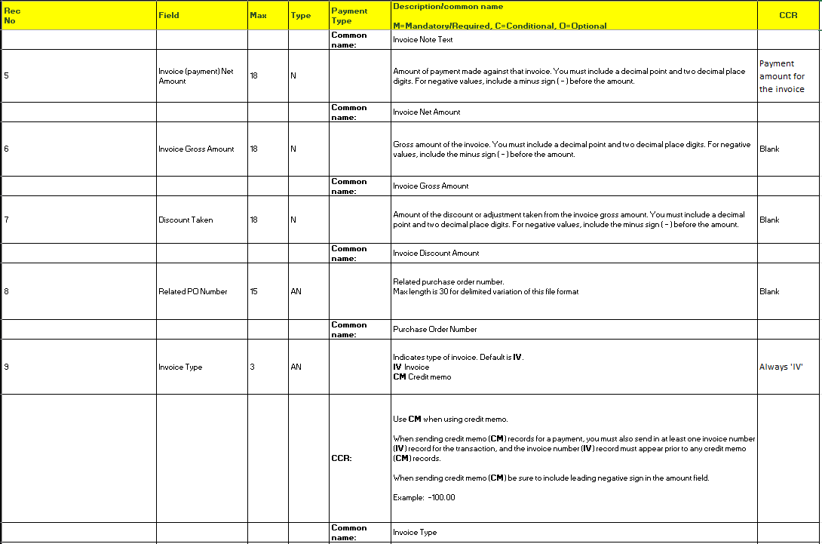
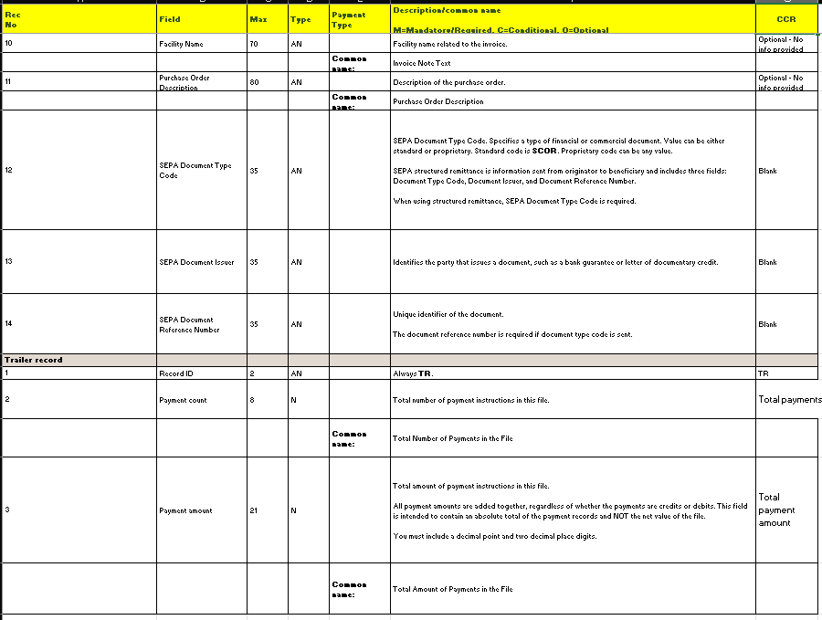

EFT file format for US Bank (FIN-20332)
Overview:
AP EFT file format for US Bank is created.
Modifications:
New AP EFT file format ‘USBANK is created for US Bank with the following changes

- Receiver Name – Vendor’s Name
- Amount – Payment Amount
- Routing Number – Vendor’s Bank Transit Number
- Account Number – Vendor’s Bank Account Number
- Receiver ID – Vendor’s Code
- Transaction Code – Always “22”
- Addenda – Blank
- Email Address – Vendor's Email
- Discretionary Data – Blank
- Hold/Prenote – Blank
- Lock – “N” Default

EFT Setup:
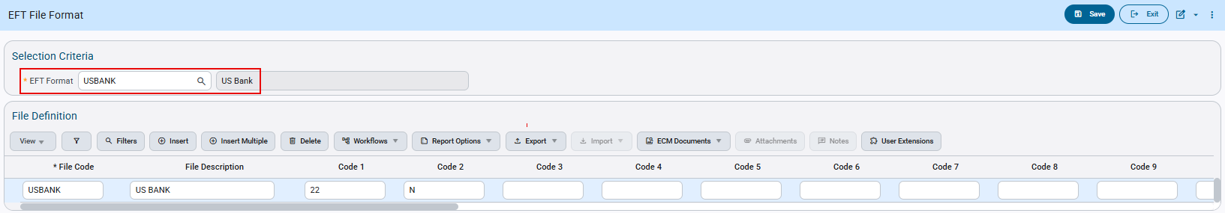AP > Setup > Global Tables > EFT Formats

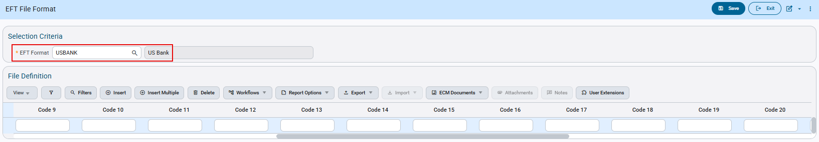AP > Setup > Global Tables > EFT Formats

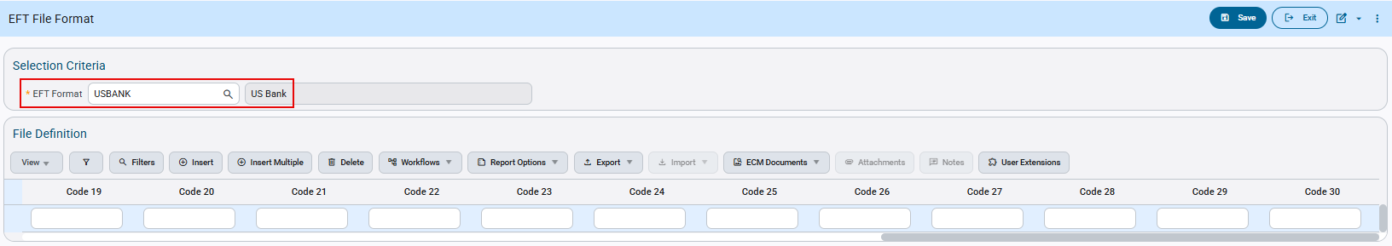AP > Setup > Global Tables > EFT Formats

Check Printing:
The Check Printing program allows users to select the available EFT File Codes. Users can select the Code and Generate EFT Files as required.
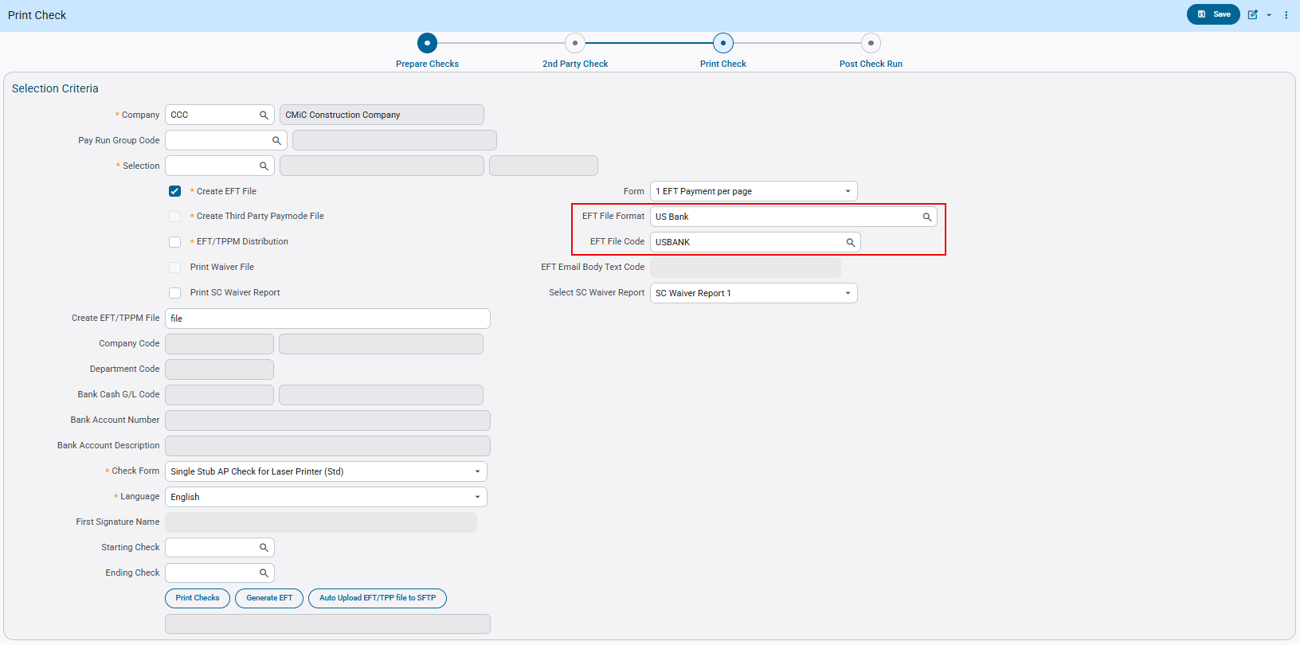

This is an example of the ‘USBANK’ AP EFT file format:
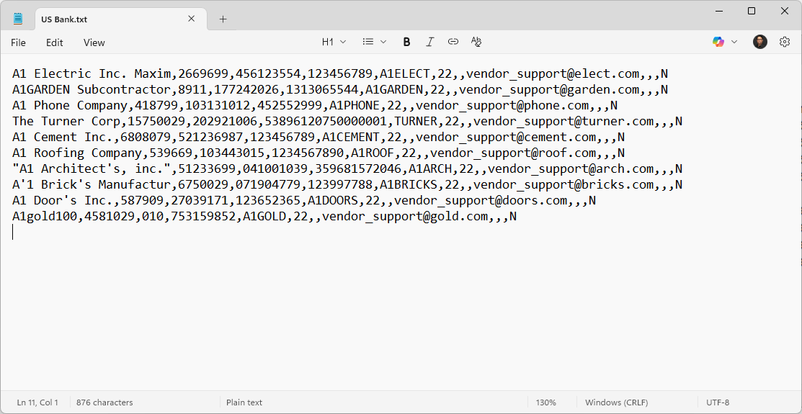

The above file generated follows the Format specifications:
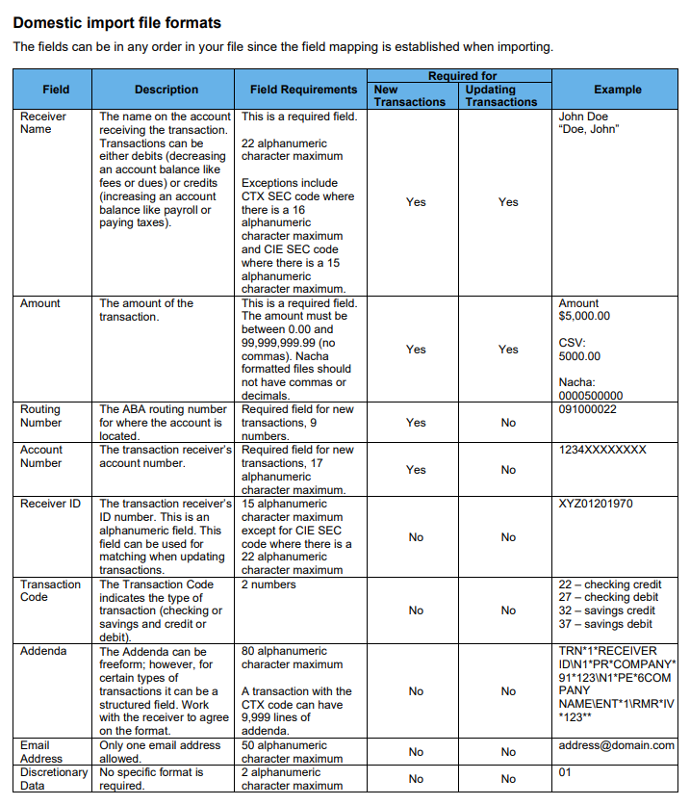

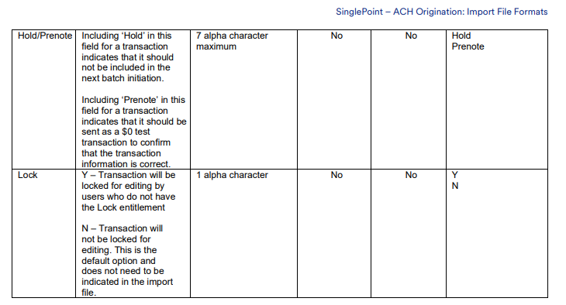

Modified EFT CTX file format for JPMorgan Chase Bank (FIN-20270)
Overview:
AP EFT CTX file format for JPMorgan Chase Bank is modified.
Modifications:
Payment Related Information – Separate line for each invoice. After 705 segment, the "RMR*IV*####**” is inserted, where ##### represents the 16 digits card number from voucher description followed by payment amount for the invoice\.

EFT Setup:
Accounts Payable > Setup > Global Tables > EFT Formats

Accounts Payable > Setup > Global Tables > EFT Formats

Accounts Payable > Setup > Global Tables > EFT Formats

Check Printing:
The Check Printing program allows users to select the available EFT CTX File Codes. Users can select the Code and Generate EFT CTX Files as required.
Accounts Payable > Check > Print Checks > ‘Print Check’ node

This is an example of the modified ‘JPCTXNACHA’ AP EFT CTX file format:
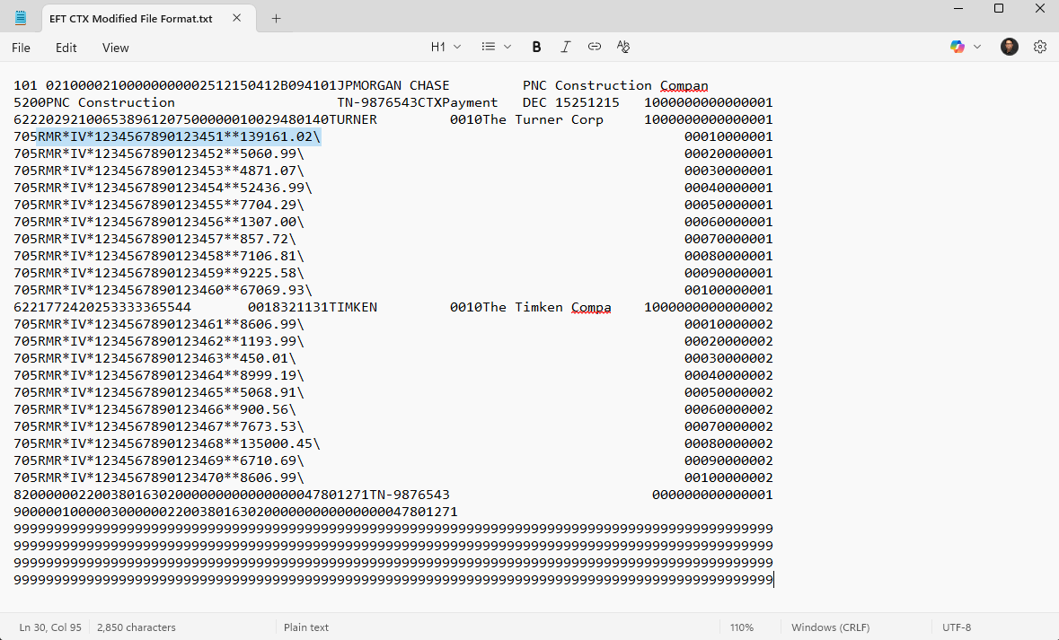

The above file generated follows the Format specifications:

Vendor Address Handling for Wells Fargo 2 Third-Party payment (FIN-20906)
Overview:
AP Third Party Payment mode for Wells Fargo (Paymode Wells Fargo 2) is modified. The selected vendor address is used on the invoice when generating the Wells Fargo 2 Third-Party Payments (TPP) file. This applies to supported payment types (ACH, Check & Card).
How the address is determined:

- If an alternative vendor address is selected on the payable, that address is used in the TPP file.
- If no alternative vendor address is selected, the TPP file automatically uses the vendor’s primary address.

This is an example of ‘Paymode Wells Fargo 2’ Third Party Payment file generated (Alternative Address):
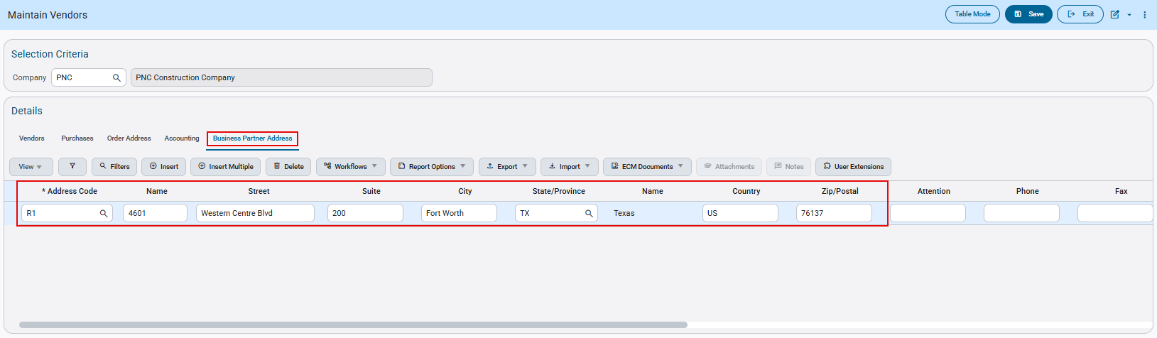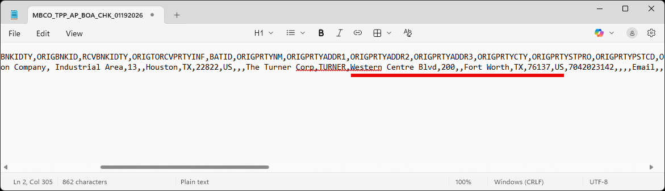

This is an example of ‘Paymode Wells Fargo 2’ Third Party Payment file generated (Vendor Address):
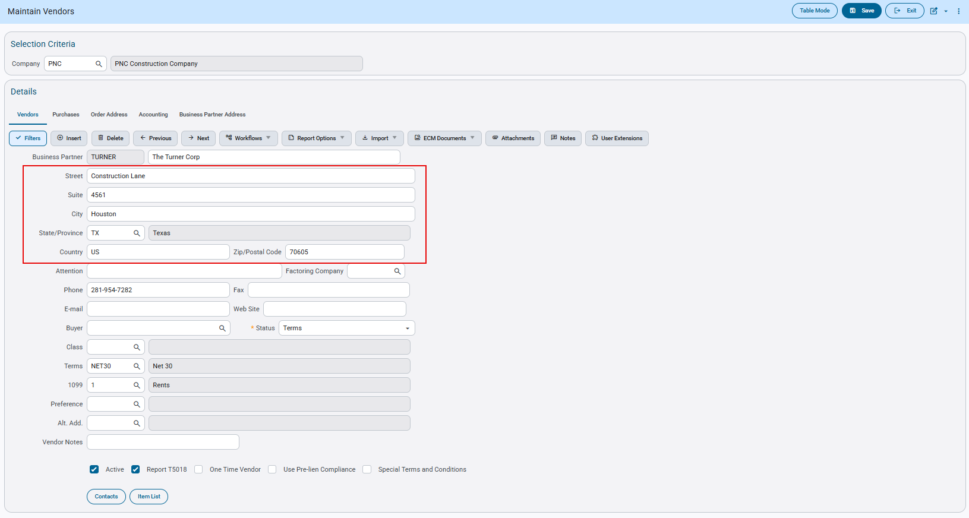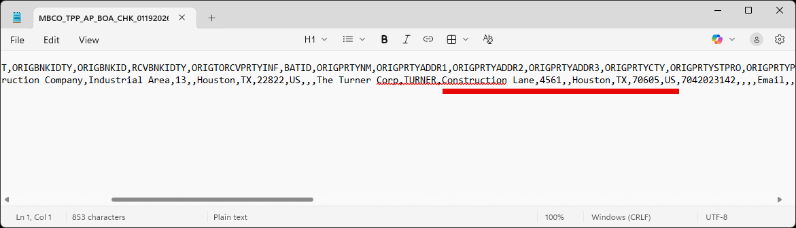

Modified EFT File Format for National Bank (FIN-18897)
Overview:
The AP EFT file format ‘NATIONAL’ for National Bank has been modified.
Modifications:
If the code 3 field is set to ‘Y’ in the EFT setup then the system will generate the file with a space between each line. If the value is null (default) or ‘N’ then it will continue working as is.
Implementation:
The following screen shows the EFT file codes setup for NATIONAL with Code 3 changed to Y:

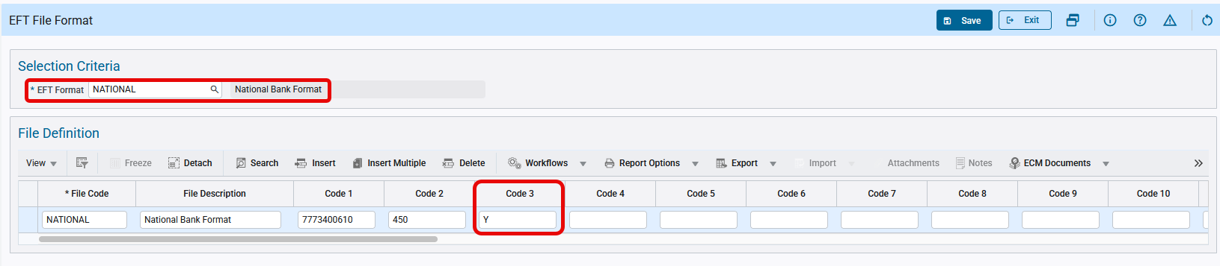
AP > Setup > Global Tables > EFT Formats

The Print Checks program allows users to select the available EFT file codes. Users can select the ‘NATIONAL’ code and generate the EFT files as required.

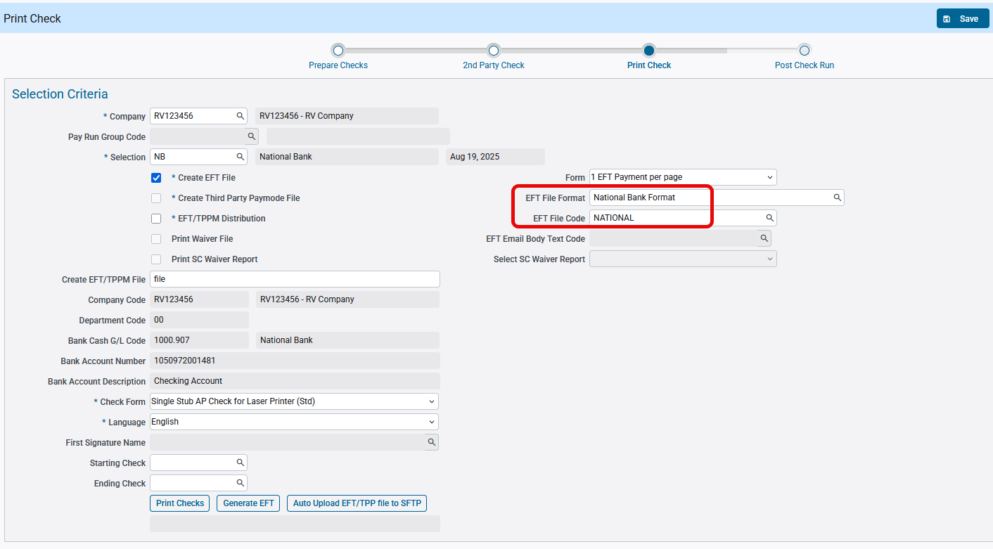
AP > Check > Print Checks

The following is the EFT file as generated:

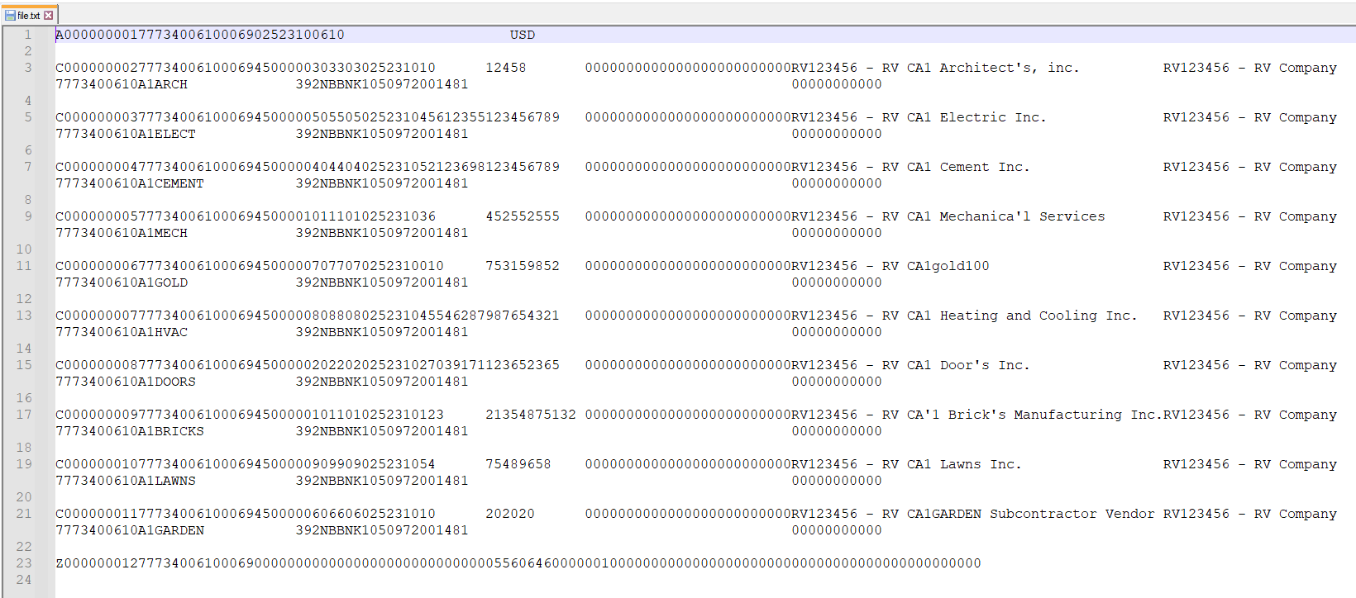

EFT File Format for UPIC Bank (FIN-15965)
Overview:
The AP EFT file format ‘UPICBANK’ has been created for UPIC Bank.
Implementation:
The following screen shows the EFT file codes setup for UPICBANK:

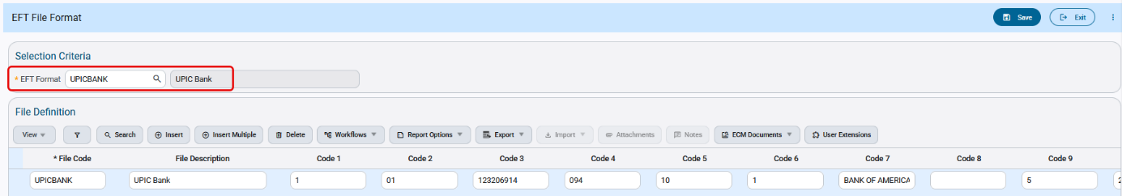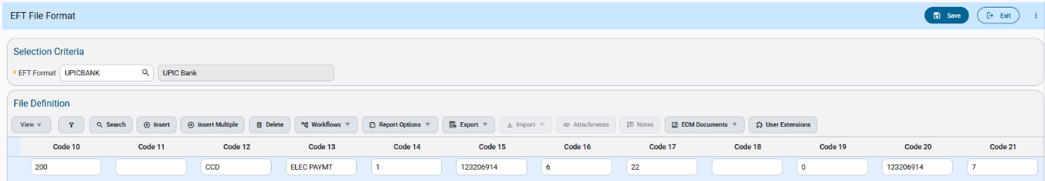
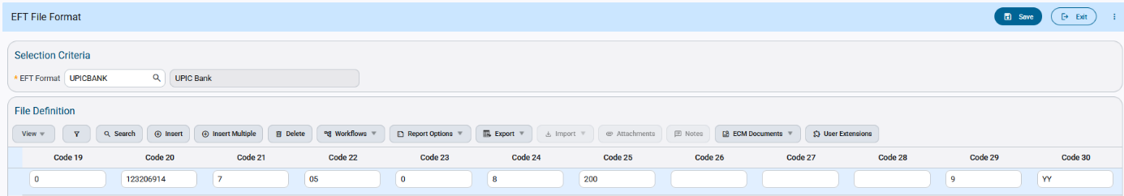
AP > Check > Print Checks

The Check Printing program allows users to select the available EFT file codes. Users can select the code and generate EFT files as required.

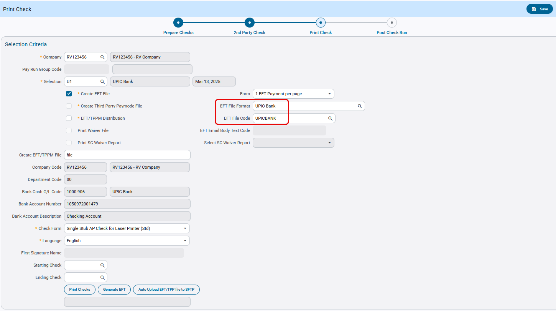AP > Check > Print Checks
The following is the EFT file as generated:
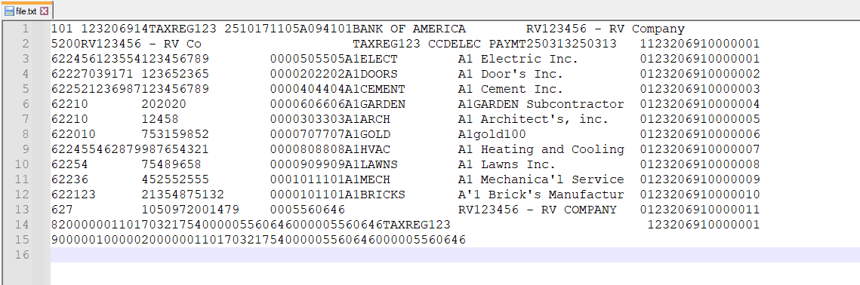

Positive Pay Format for Bank of America (FIN-18956)
Overview:
A new AP Positive Pay format has been created for Bank of America named BOA_8.
Modifications:
CMIC has created a new AP Positive pay file format for Bank of America with the following format.
The payee name(s):
- Should start on the first line of the payee address block.
- May include multiple lines of the payee address block.
- May include up to 256 characters
Implementation:
Creating a bank group:
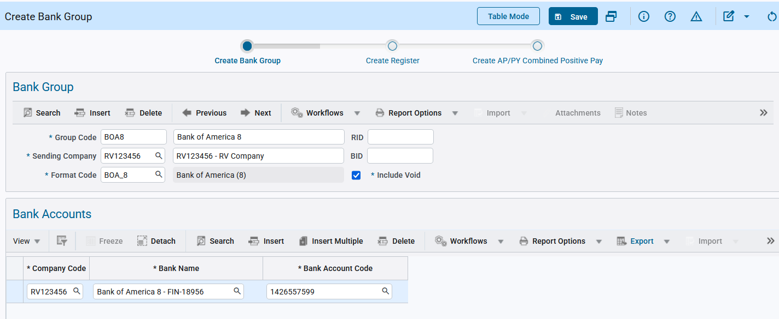
AP > Check > Positive Pay Register
Creating a register under the bank group code:
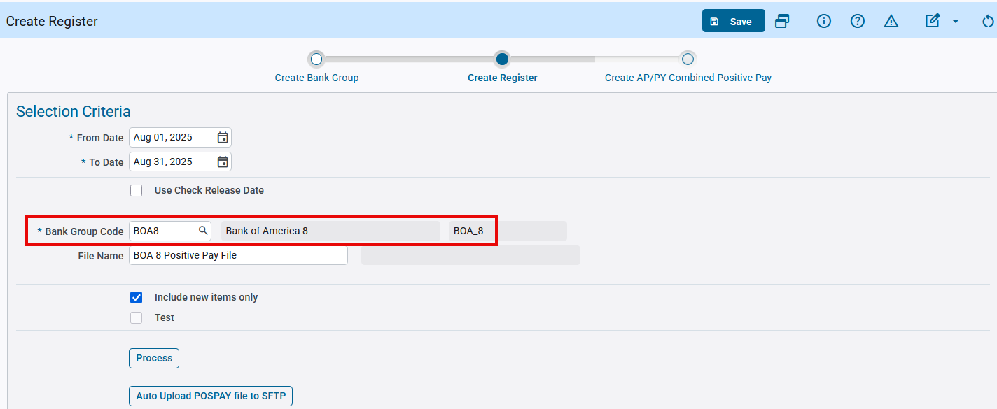
AP > Check > Positive Pay Register
The positive pay format is generated as seen below:

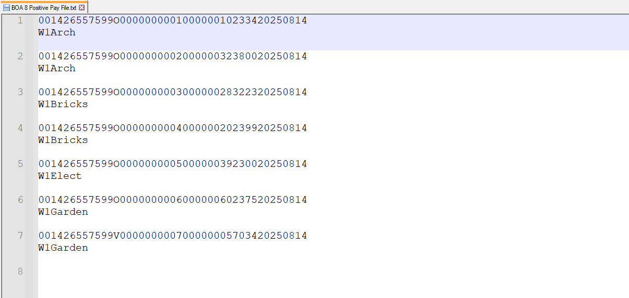

This aligns with the specs from Bank of America:

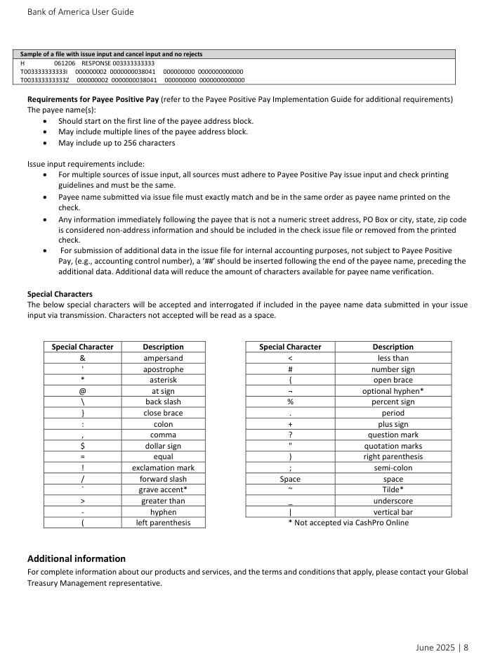

Check XML File for HSBC Bank and UAE (FIN-18763)
Overview:
The AP Check XML file for HSBC Bank for the country of UAE has been created.
Prerequisites:
To generate this check file and for it to be valid, both the country of the company and vendor must be set to “UAE”, and the user must go through the workflow created under FIN-18673 (note that this workflow is custom and the relevant fields/programs are hidden by default).
Implementation:
The following Posted Payments screen (hidden by default) shows the posted AP checks that went through the custom workflow mentioned above. The user can select a record to generate the check file:

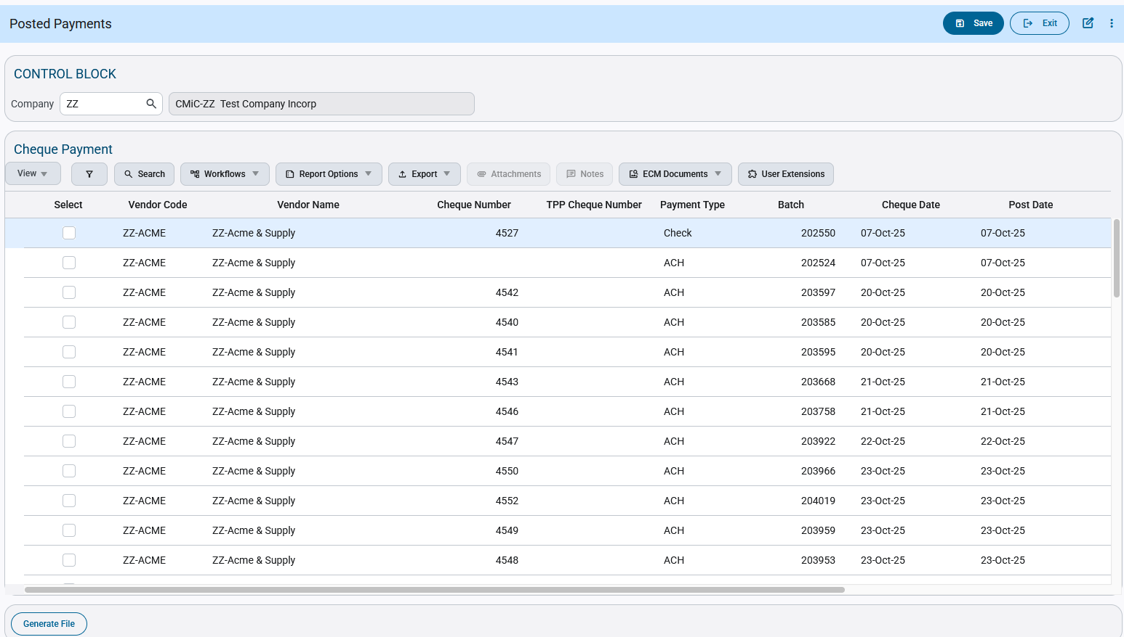

The generated file for the UAE check payment is shown below:

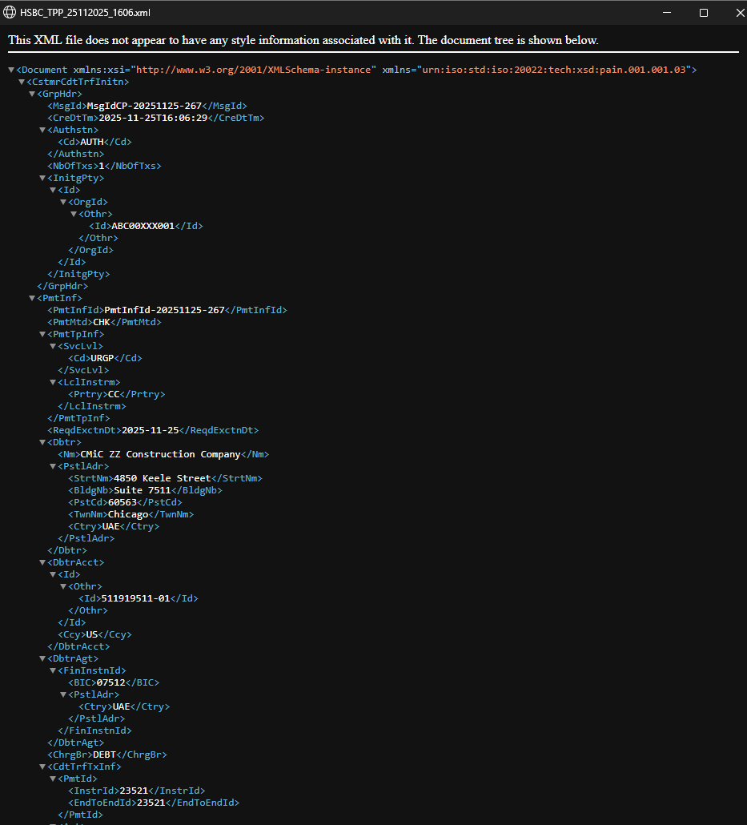

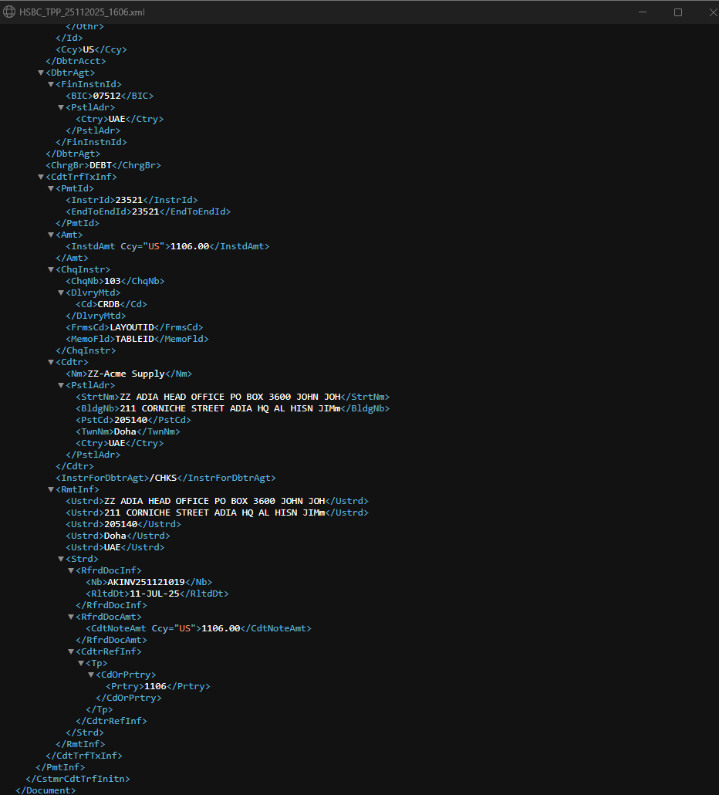

The XML file lines up with the specifications:
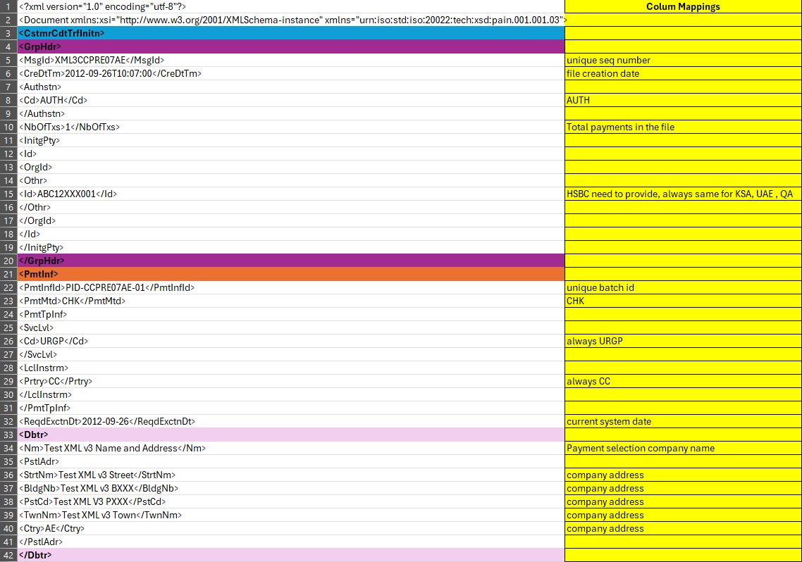
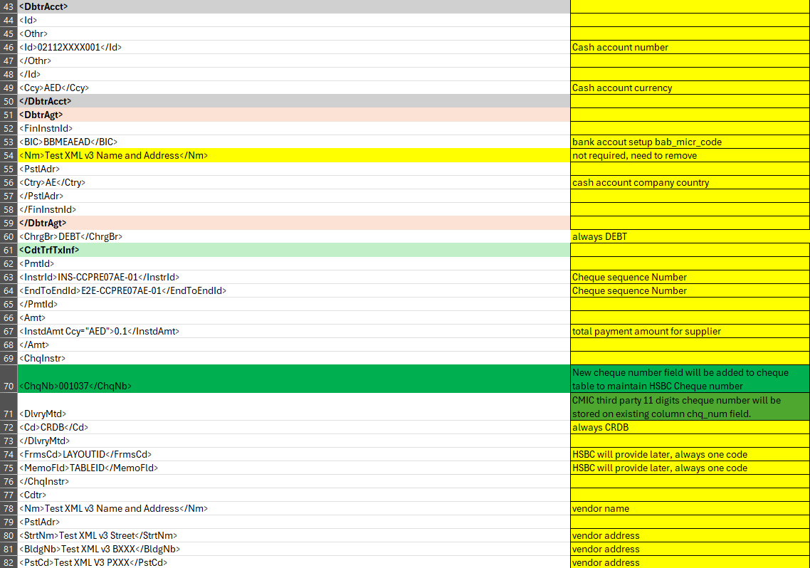

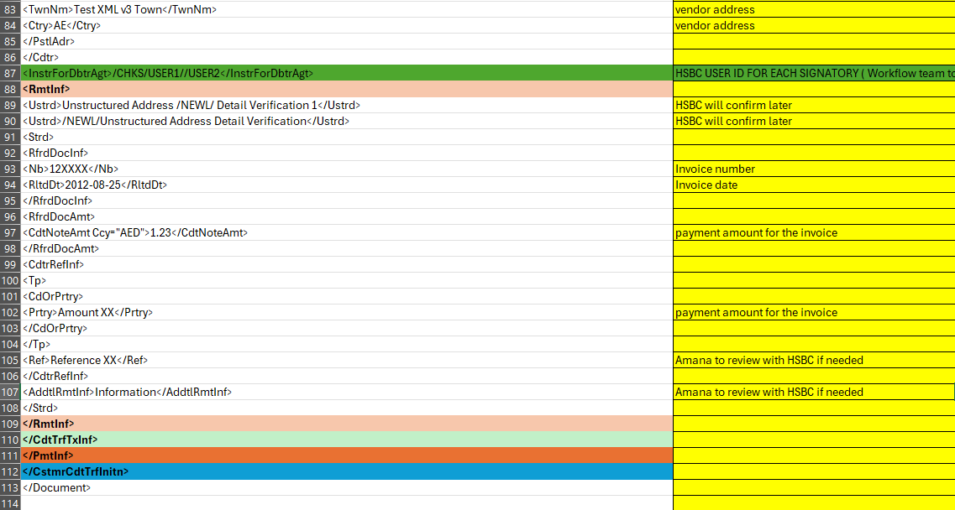

Preferred Contact Method for AR MCC Custom Invoice Report (FIN-19773)
Overview:
The Preferred Contact Method option has been enabled for the McCarthy custom AR invoice report ‘MCC_ARINVPRT’. This will allow the user to directly e-mail or fax this report to the selected contacts.
Implementation:
The selected option for Preferred Contact Method is shown below. The Contacts button will become visible as well:

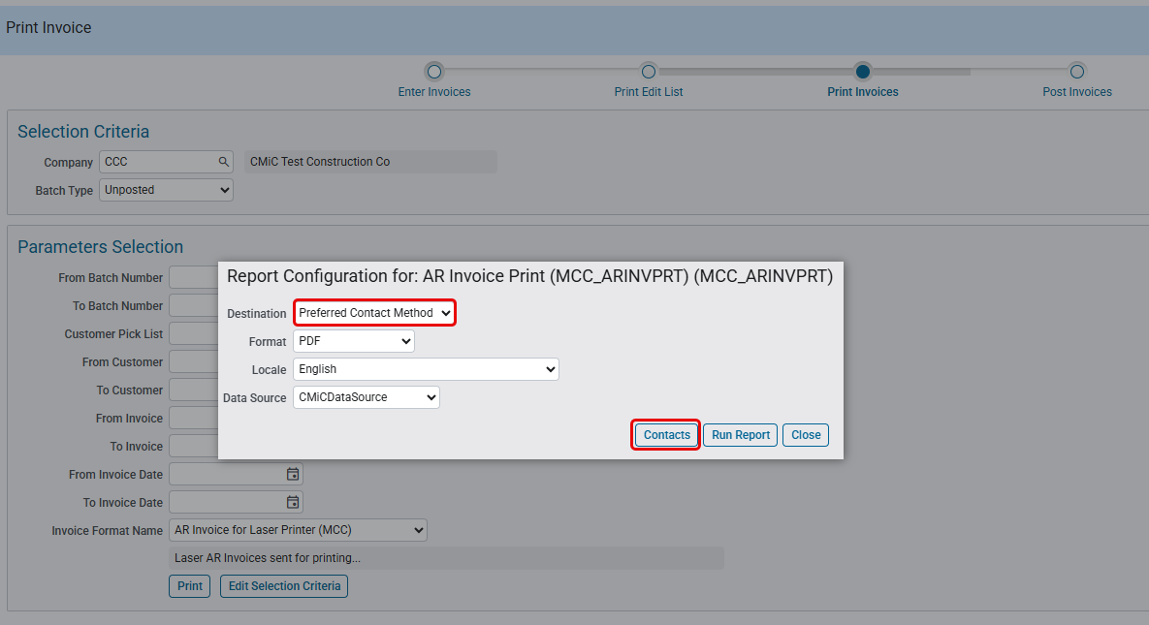
AR > Invoice > Enter Invoices > Print Invoices

Third Party Payment File Format for Bank of America (FIN-18761)
Overview:
A new AP Third Party Payment file format has been created for Bank of America named “Paymode BOA 3”.
Modifications:
The new AP Third Party Payment file format and code for Bank of America is now available for selection and configuration to process (both checks and ACH).
CMiC has created a new third party payment (pipe delimited) file format for BOA bank
with 2 type of payments ( CHECK and ACH ). When user select the third party payment format on vendor setup, another field will be enabled to select the payment type (ACH, CHECK), when generating the file, payment type will taken from vendor setup to let the bank know that this vendor payment will be made through either ACH or CHECK.
File will contain the following type of records.
P - Payment Data
R - Remittance Data (one or more per Payment record)
C - Control Total Data (one per file)
** File format column mapping within CMIC will be used.
Record Type P
Payment Type ACH or CHK
Disbursing Paymode-X Account ID **NEED CLARIFICATION ( Is this unique ID is for both types (ACH, CHECK) of payments ? )
Disbursing Routing Transit Number **NEED CLARIFICATION ( Is this BOA cash account transit number ? )
Disbursing Bank Account Number **NEED CLARIFICATION ( Is this BOA cash account number ? )
Collecting Paymode-X Account ID Read from vendor setup paymode ID field
Note ( This field will only applicable for ACH type payments )
Payment Reference Number For type 'ACH' will use CMIC Check Number, For type 'CHK' will use CMIC Check sequence number
Payment Amount Total payment amount for the check
Vendor Number Vendor Code
Vendor Site/Remit Code Blank
Vendor Name Vendor BP name
Vendor Address Line 1 Vendor Address 1
Vendor Address Line 2 Vendor Address 2
Vendor Address Line 3 Blank
Vendor City Vendor Address 3
Vendor State Vendor Address Region code
Vendor Zip Vendor Address Postal Code
Vendor Country Vendor Address Country
Divert Code **NEED CLARIFICATION ( Optional for CHECK payments, what to put for ACH ?)
Payment Currency Check currency
Debit Release Date Optional (BLANK)
Record Type R
Payment Reference Number For type 'ACH' will use CMIC Check Number, For type 'CHK' will use CMIC Check sequence number
Invoice Number Voucher invoice code
Invoice Date Voucher invoice date
Paid Invoice Amount Amount is being paid for this invoice
Original Invoice Amount Voucher entered amount
Discount Amount Always zero
Discount Percentage Always zero
Buyer Account Number Optional (BLANK)
Comment Voucher description
Voucher Number Voucher unique number
Purchase Order Number Optional (BLANK)
Contract Number Optional (BLANK)
Tax Amount Optional (BLANK)
Tax Rate Optional (BLANK)
Record Type C
Total Payment Amount in File Total payment amount
Total Number of Payments in File Total P records in file
Total Number of Remittances in File Total R records in file

Implementation:

Bank setup:
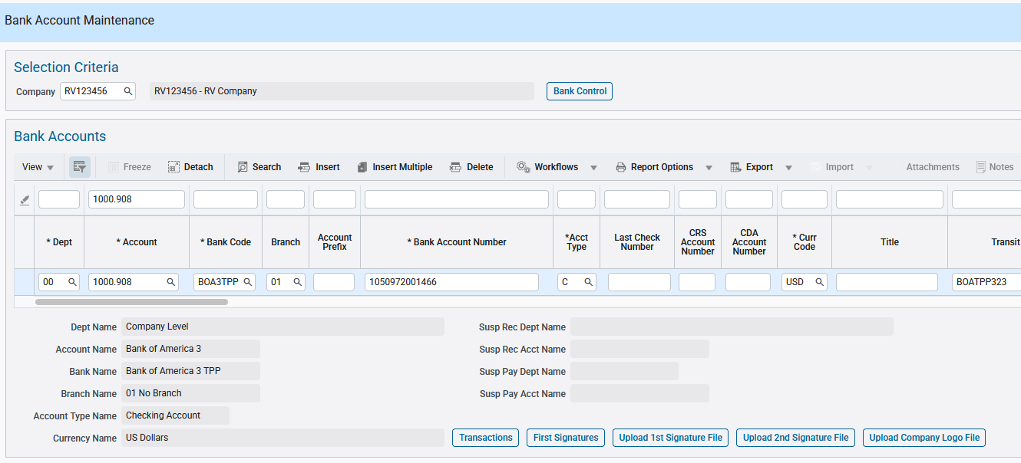
SD > Global Tables > Banking > Bank Account

This bank account is available under ‘Paymode BOA 3’ list of bank accounts in Third Party Payment Setup.

The following Business Partners are being used to show this functionality. The BP codes indicate whether alternate addresses and/or Third-Party Payment have been set up.

For instance, AX1A1T1 has both setup:

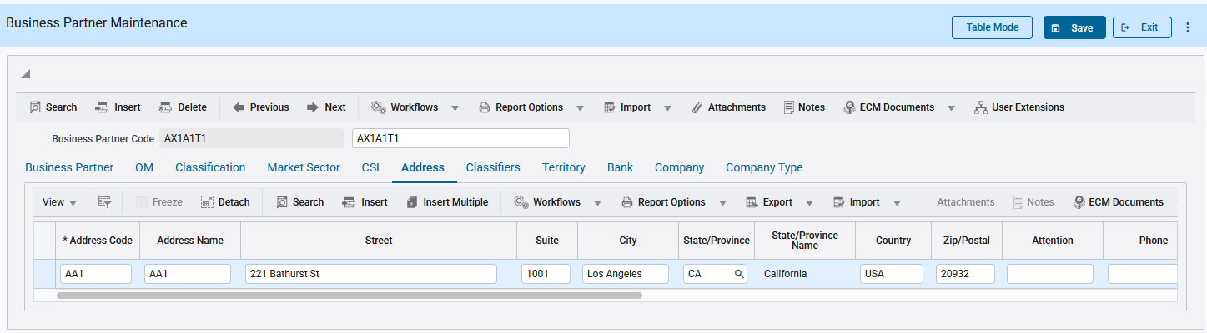
AP > Setup > Maintain Business Partners

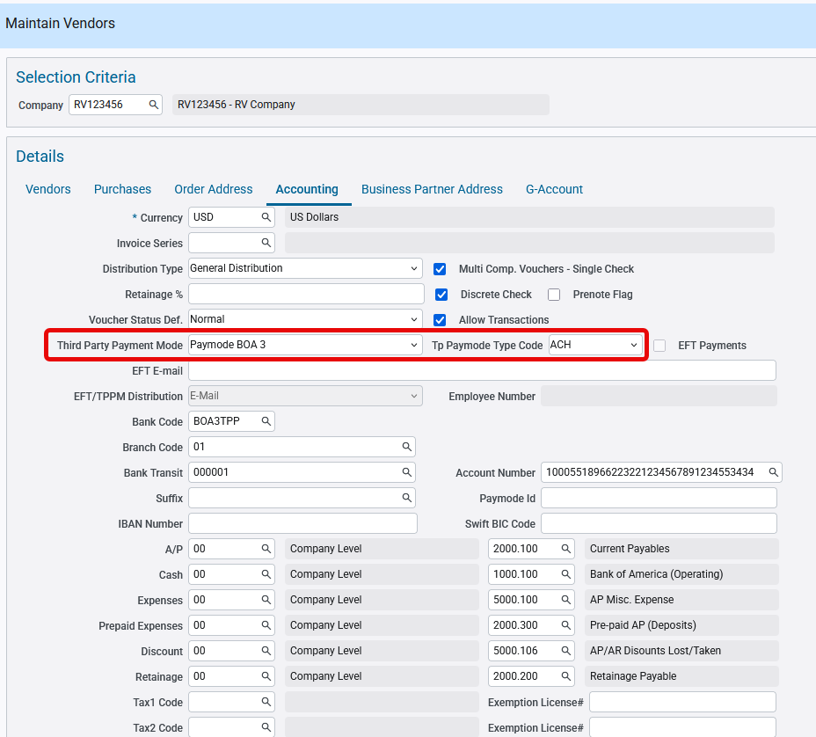
AP > Setup > Maintain Vendors

In the Enter Voucher screen, the Third-Party Payment Mode dropdown defaults with the ‘Paymode BOA 3’ option, as well as the selected payment type, if it is defined in the Maintain Vendors program:
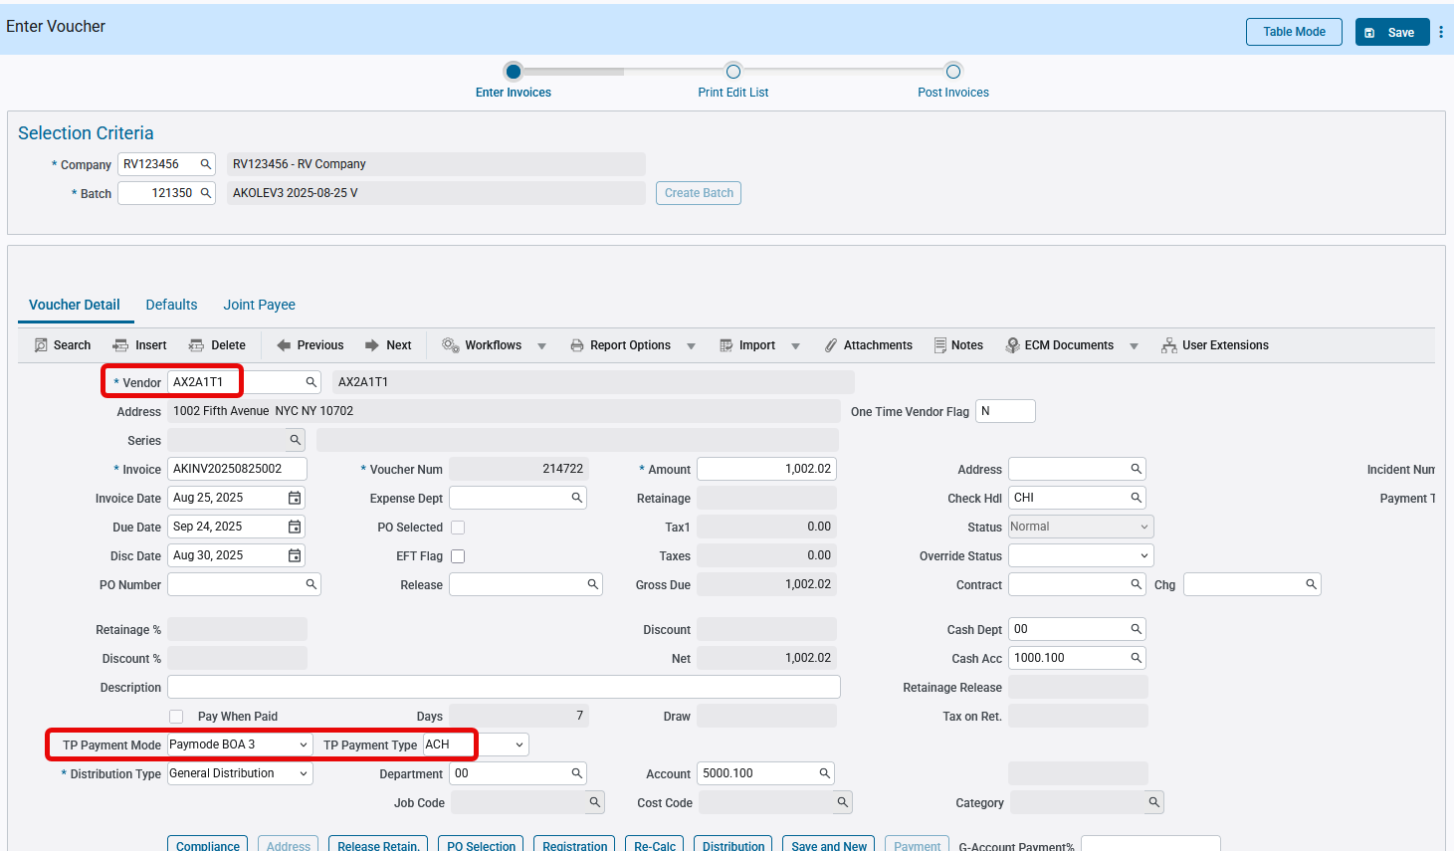
AP > Voucher > Enter Vouchers

For a vendor where TPP is not setup in Maintain Vendors, this defaults to blank. The user still can select the TPP option:

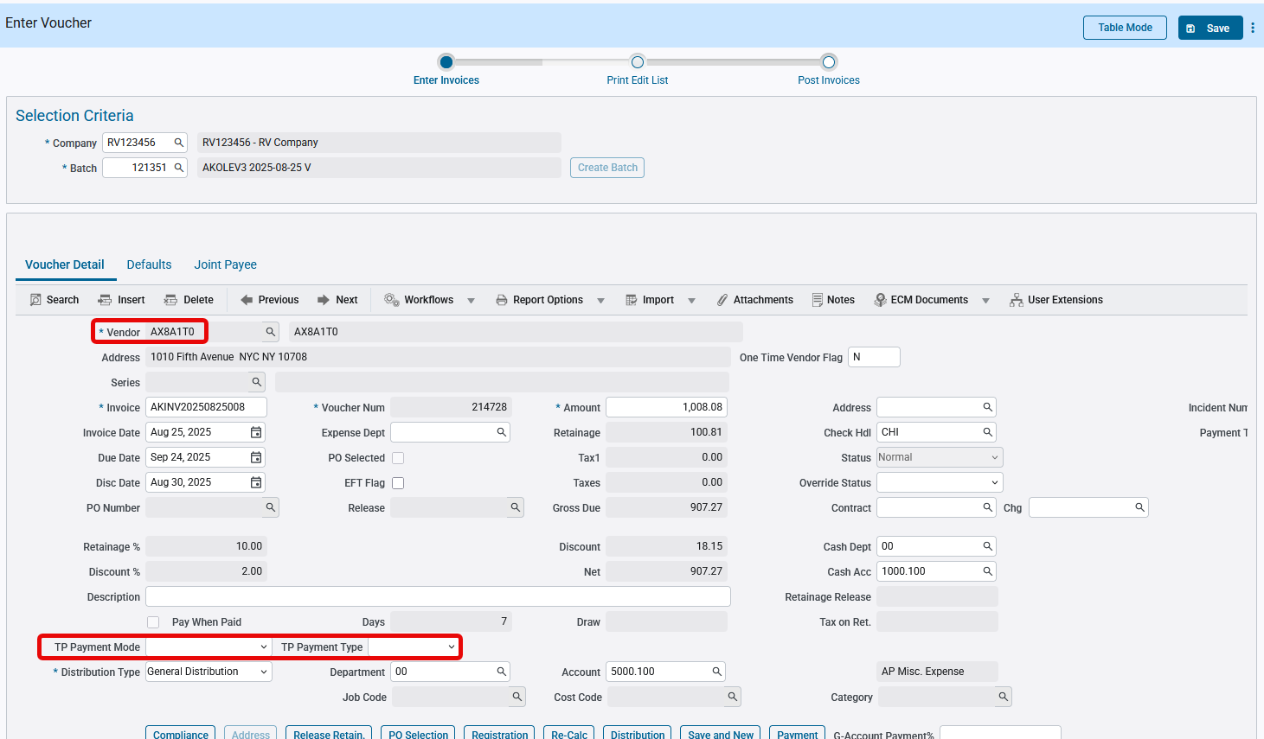

In the Select Payments screen, user should select the Third Party Payment mode radio button and select Third Party Payment Mode dropdown option as ‘Paymode BOA 3’:

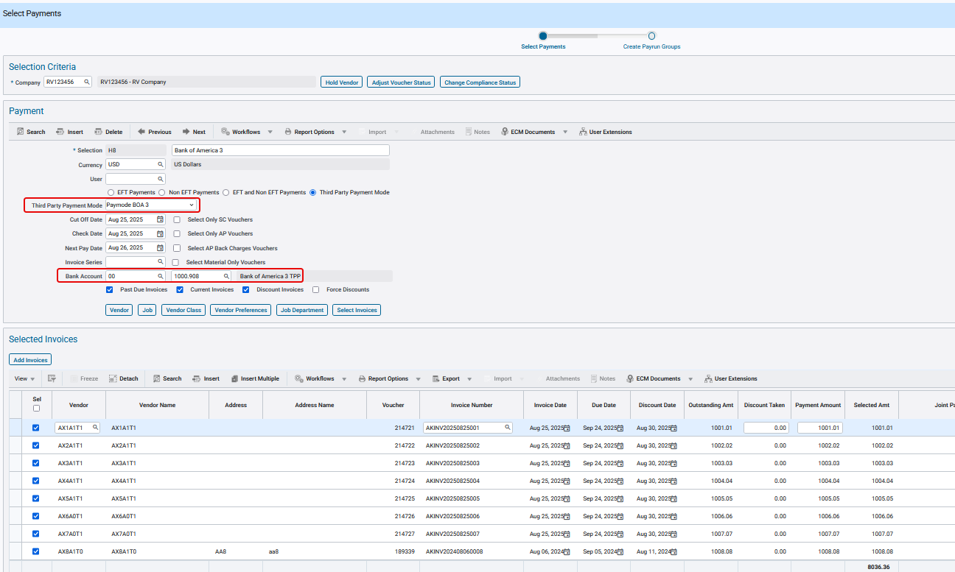
AP > Checks > Select Payments

In the Print Check screen, the ‘Create TPP File’ checkbox should be checked by default.

The user can create the Third Party Payment file by clicking on the ‘Print Checks’ button.
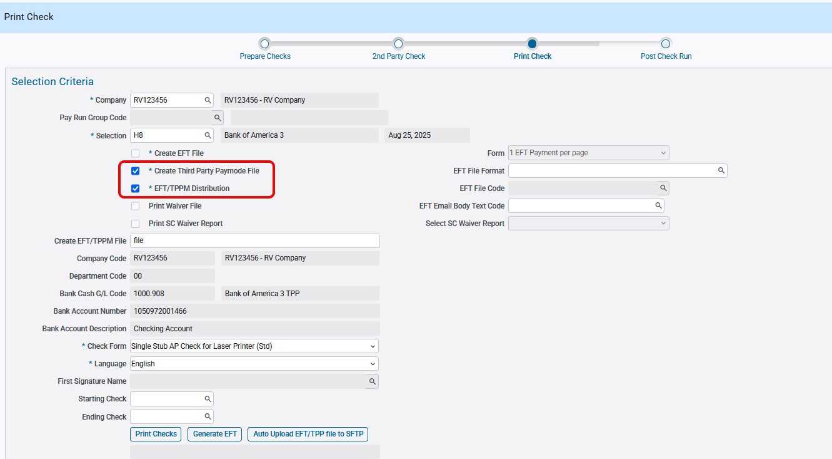
AP > Checks > Print Checks

The following is the Third Party Payment file generated as per the specs:
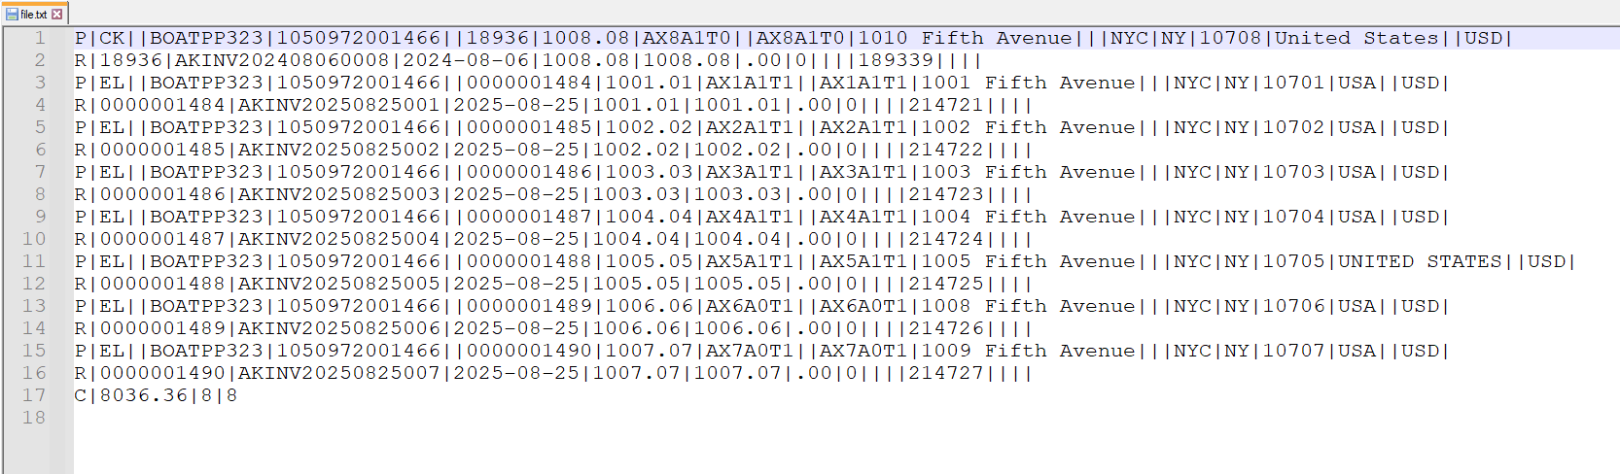

The TPP file lines up with file specification document:

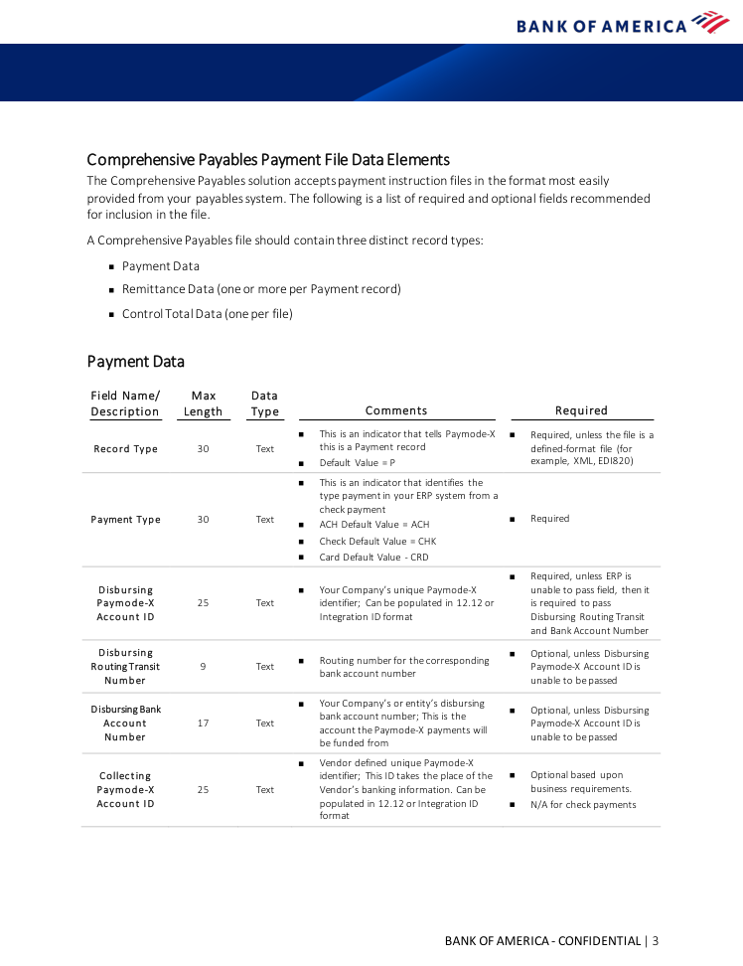
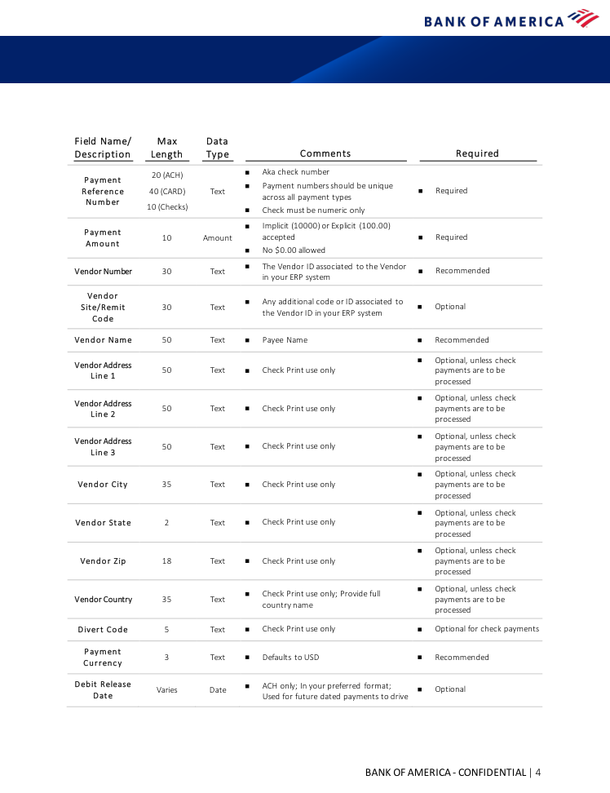
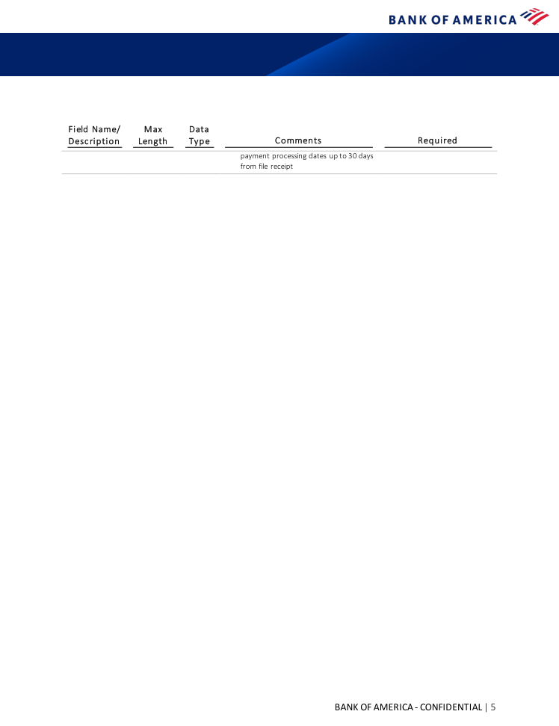
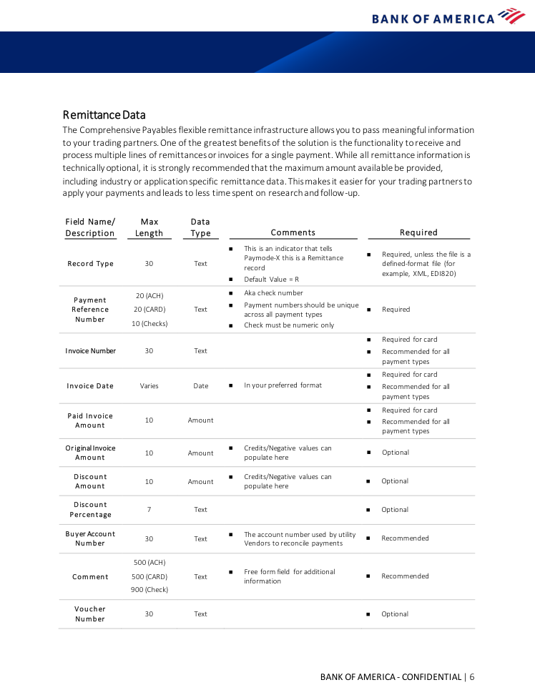
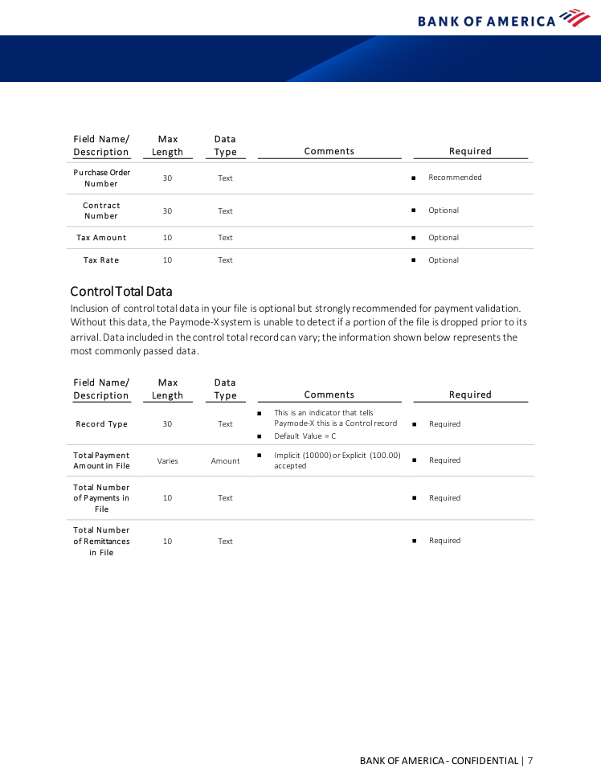
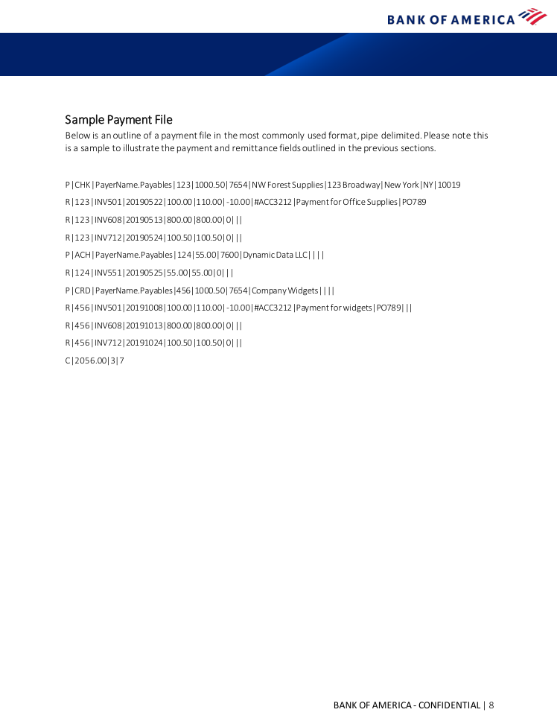

EFT File Format for TD Bank (FIN-19186)
Overview:
A new AP EFT ACH file format ‘TD_3’ has been created for TD Bank.
Implementation:
The following screen shows the EFT file codes setup for TD_3:

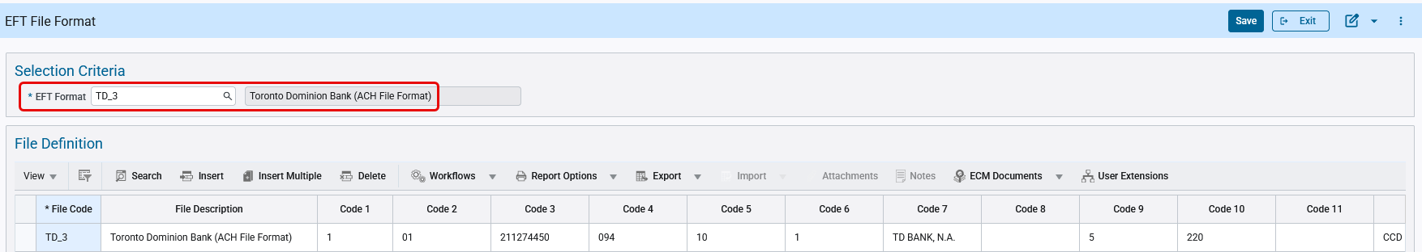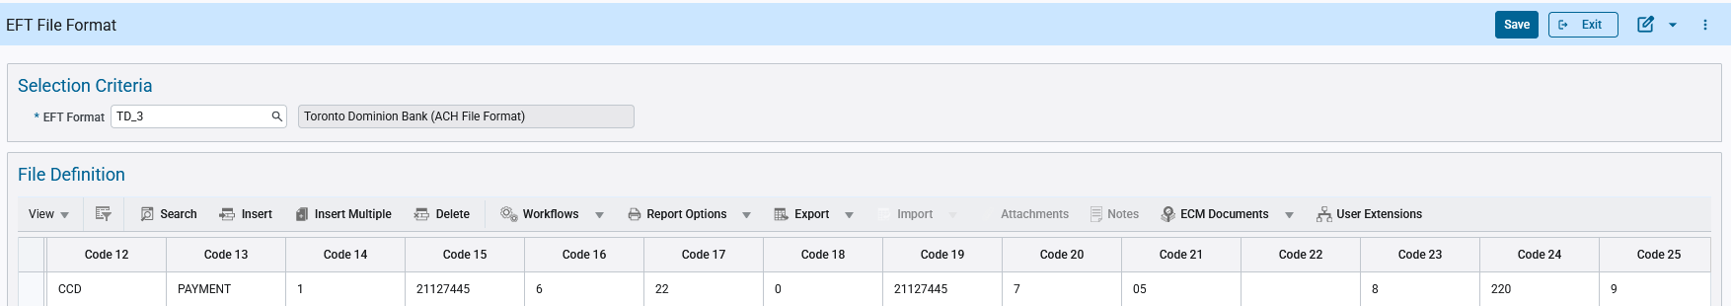
AP > Global Tables > EFT Formats

The Check Printing program allows users to select the available EFT file codes. Users can select the code and generate EFT files as required.

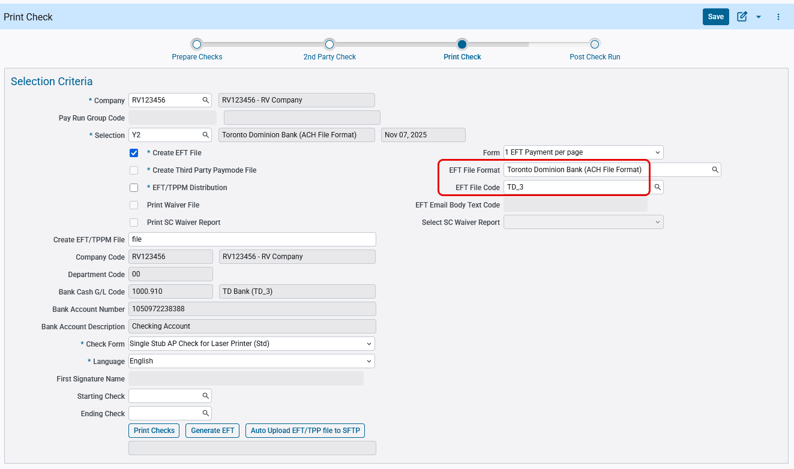
AP > Checks > Print Checks

The following is the EFT file is generated:
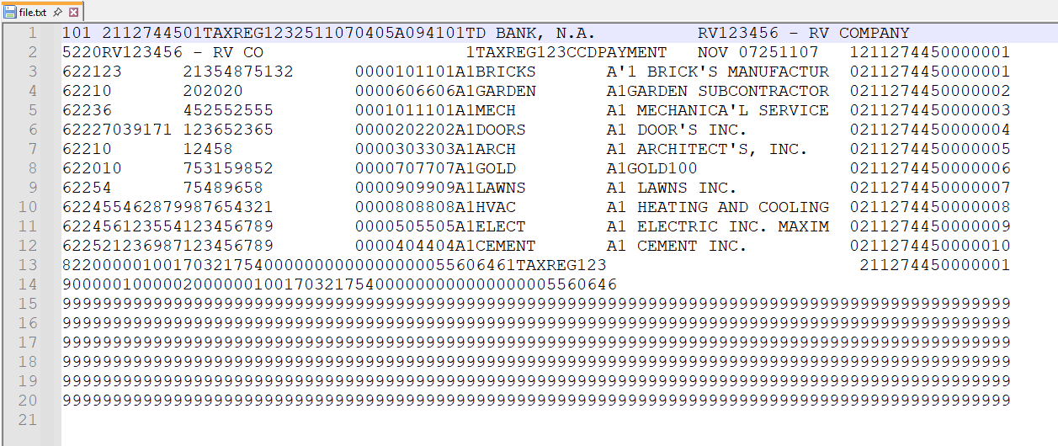

The EFT file lines up with the Toronto Dominion Bank specification document:
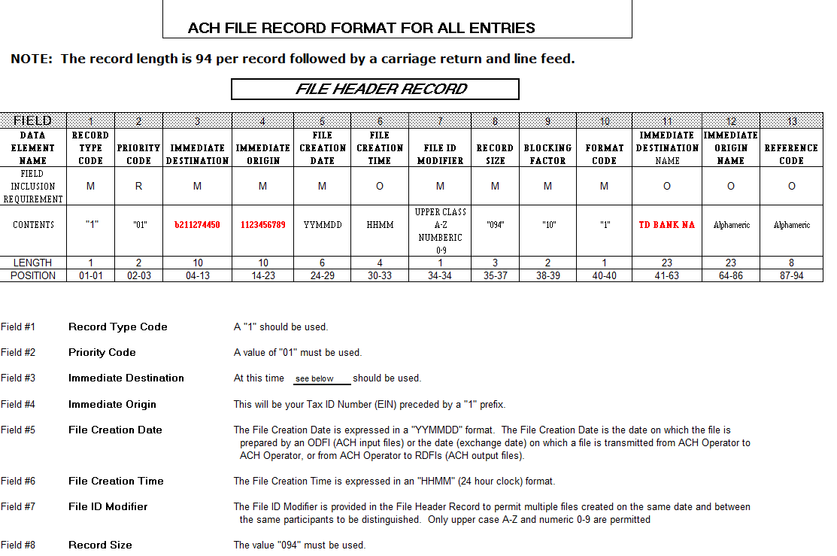

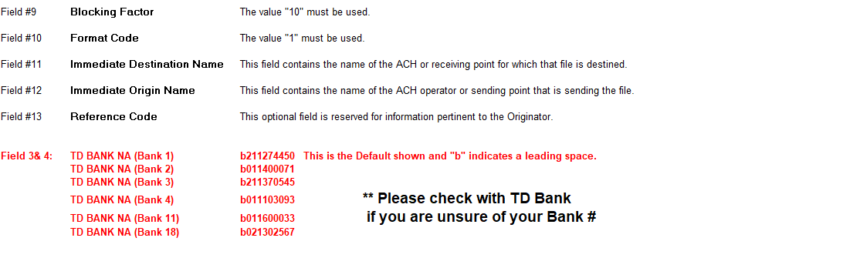

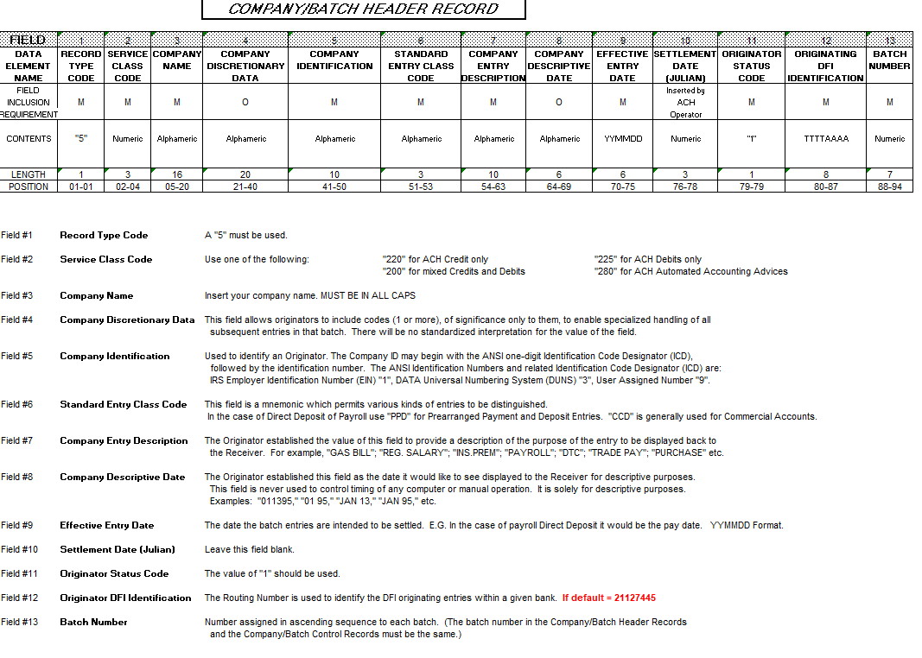

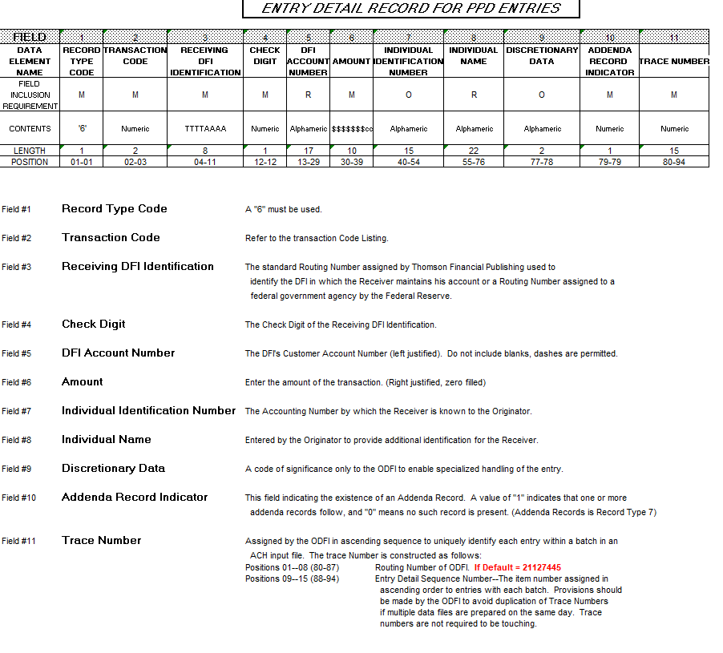
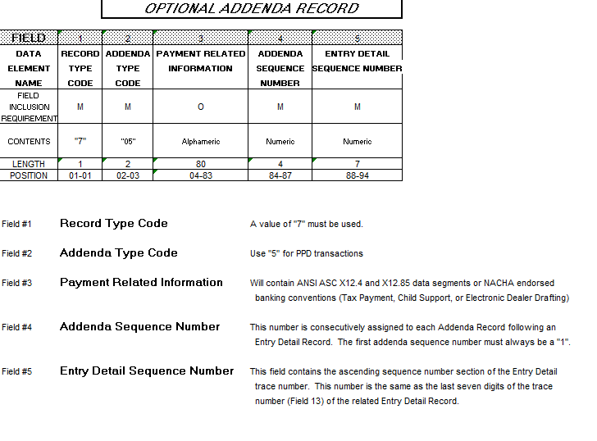
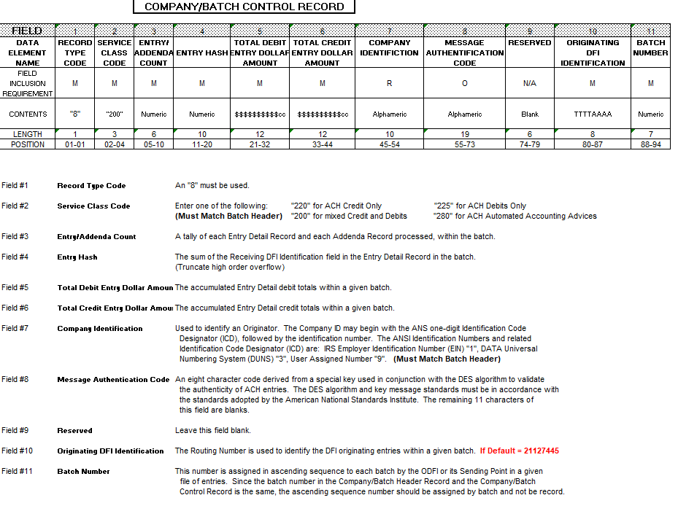
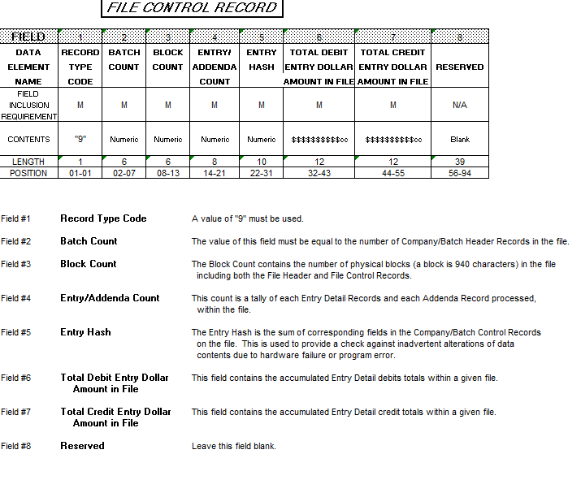
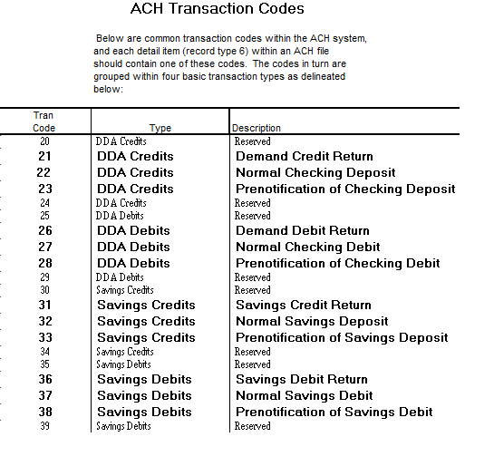

T5018 xml file updates as per CRA requirements (FIN-21938)
Overview:
CMiC T5018 .xml file output is updated to follow the Canada Revenue Agency (CRA) for Statement of Contract Payments update version ‘2026V3 – updated 2026-01-30’. The reference URL is given below.
T5018, Statement of Contract Payments - Canada.ca
Summary of Changes to <T5018Slip> section:
- For all Optional fields, when there is no value available, then empty tags will NOT be printed. This is to prevent system rejections.
- Under the Section </RCPNT_NM>, the initials tag <init>a</init> is removed. Previously printing a hard coded value ‘a’.
- The Telephone Extension Number Tag <cntc_extn_nbr>0</cntc_extn_nbr> under Contact Information <CNTC>, in both <T619> & </T5018Summary> is removed. Previously was printing a hard coded value ‘0’.
- Only one of the following will be printed This is a required field.
  - SIN Number
    - <sin>123456789</sin>
    - 9 Numeric.
    - CMiC >Business Partner > Registration Code > SIN flag checked (Y)
  - Recipient Account Number
    - <rcpnt_bn></rcpnt_bn>
    - 15 alphanumeric
    - CMiC >Business Partner >SIN Flag Un-Checked (N)
Additional fixes:
- Corrected US country code from "US" (with trailing space) to "USA".
  - <cntry_cd></cntry_cd>
Recipient country code
- 3 alpha
- the country in which the recipient is located. Use only the 3 alphabetic country codes as outlined in the International Standard (ISO) 3166 Codes for the Representation of Names of Countries. Always CAN for Canada, and USA for the United States of America
- A trailing blank space for the following tags is removed.
  - <snm></snm>
  - <l1_nm></l1_nm>
  - <addr_l1_txt></addr_l1_txt>
  - <addr_l2_txt></addr_l2_txt>
  - <cty_nm></cty_nm>

AI Agents

Overview
CMiC's AI Task Agents are smart, conversational tool designed to help you interact with the system more efficiently, just by using plain language. It's like having a built-in assistant that can automate complex tasks and guide you through actions such as creating new records, simply by asking for what you need.
Currently, AI Task Agents are available across the software, where they can answer questions, complete tasks, and suggest next steps.
Whether you are new to CMiC or a seasoned user, the AI Task Agent is designed to support you. New users can get started quickly by creating records with ease. Experienced users can boost productivity by streamlining routine tasks.

Note: For detailed information on the AI Agents, please follow the following links:
Nexus 01 Highlight - Task Agents
AI & Analytics - Getting Started with Task Agents

Following are the AI Agents Released in the Patch Nexus_01:
Sl No | Agent Name
1 | Create AP Invoices
2 | Create Vendors
3 | Create AP Memos
4 | Select AP Invoices for Payment
5 | Create AR Invoices
6 | Create Customers
7 | Create AR Memos
8 | Create Inventory Locations
9 | CMIC_CHATGPT
10 | Create Equipment Locations
11 | Create Financial Documents
12 | Create Consolidations
13 | Create GL Transactions
14 | Create GL Accounts
15 | Close GL Periods
16 | Create Billing Contract
17 | Maintain Cost Codes and Categories – Master
18 | Create and Store Contract Forecast
19 | Create Job Costing Transactions
20 | Create Job
21 | Create Project
22 | Post Journal Entries
23 | Create Requisitions
24 | Create Users
25 | Analyze Batch Posting Impact
26 | **Perform Bank Reconciliation **To be Released in HF2

Create AP Invoices
The Create AP Invoices agent helps you create Accounts Payable (AP) vouchers (invoices) in the CMIC ERP system. You can create single or multiple vouchers by entering details directly, uploading structured files (such as Excel, CSV, or text), or uploading unstructured files (such as PDF invoices).

Create Vendors
The Create Vendors agent helps you create vendor records in CMIC ERP, either one at a time or in batches using structured files (such as Excel, CSV, or text).

Create AP Memos
The Create AP Memos agent is designed to help you create single or multiple AP memo records quickly and accurately. You can enter memo details directly in the chat or upload files (Excel, CSV, or text) containing multiple memos for batch processing.

Select AP Invoices for Payment
Select AP Invoices for Payment agent helps you create new AP Select Payment codes, apply invoice selection filters, and prepare for the check run process. You cannot use this assistant to edit or delete existing payment selections.

Create AR Invoices
The Create AR Invoices agent allows you to generate single or multiple AR invoices either by entering details in chat or uploading a structured file (Excel, CSV, or text), lets you preview the first 50 records before submission, and alerts you to system limitations like restrictions on retainage or discount values during invoice creation.

Create Customers
The Create Customers agent is designed to help you create and manage customer records in the CMIC ERP system. You can create single customers or upload multiple customers in batches using files. The agent ensures that all required information is collected, validated, and processed according to your company’s business rules.

Create AR Memos
The Create AR Memos agent is designed to help you create AR invoice memos, either one at a time or in bulk using files. The assistant guides you through the process, ensures all required information is collected, and submits your requests securely and accurately.

Create Inventory Locations
Create Inventory Locations agent can create a single inventory location (CI Location) interactively or generate multiple inventory locations in bulk from an uploaded Excel or CSV file.

CMIC CHATGPT
CMIC CHATGPT agent provides the Users the ability to use CHATGPT from within CMiC.

Create Equipment Locations
Create Equipment Locations agent creates a single Actual Equipment Location, create multiple Actual Equipment Locations in bulk using a file (Excel, CSV, or text), or create Actual Equipment Locations for all active, valid, in-process Jobs that don’t already have one.

Create Financial Documents
Create Financial Documents Agent can create new financial documents such as Income Statements and Balance Sheets, as well as modify existing documents by updating headers or adjusting rows and columns. Additionally, it retrieves lists of accounts, charts, consolidations, and budgets.

Create Consolidations
Create Consolidations agent creates a consolidation code and add components to it, either individually or in batches. Batch creation can be done for both consolidation codes and components using CSV, Excel, or text files.

Create GL Transactions
The Create GL Transactions agent helps you create manual GL journal entries that cannot be generated through other CMIC modules. You can interact with the assistant using natural language or by uploading a document (such as a spreadsheet) containing transaction details.

Create GL Accounts
The Create GL Accounts agent, can create a single GL account through conversation or create multiple GL accounts by uploading a CSV, Excel, or text file. User can also view and confirm account details before finalizing their creation.

Close GL Periods
The Close GL Periods agent, can view available companies along with their period information, retrieve and download unposted transactions and batch details as a CSV file, and perform month-end period close by updating the period.

Create Billing Contract
The Create Billing Contract agent is designed to help you, set up and review Job Billing Contracts while ensuring proper permissions, thorough data validation, and minimizing errors throughout the entire process.

Maintain Cost Codes and Categories – Master
Maintain Cost Codes and Categories – Master agent’s key functionalities are creating and retrieving both master categories (cost categories) and master phases/cost codes are supported functionalities. This includes the ability to add new entries and access existing ones for both types.

Create and Store Contract Forecast
The Create and Store Contract Forecast agent allows you to create, store and archive the current period’s Contract Forecast for one or more jobs or contracts—without navigating the Contract Forecasting screen.

Create Job Costing Transactions
The Create Job Costing Transactions agent assists you in creating, validating, and managing Job Costing transactions in CMiC ERP. It enables the creation of new JC transactions, including batch uploads, and provides the ability to retrieve valid codes such as companies, jobs, and accounts. It also validates codes and values before transaction entry and allows for the creation of phase (cost) and category codes.

Create Job
Create Job Agent can create new JC jobs, retrieve existing JC job records, duplicate jobs, and display lists of LOVs (Lists of Values).

Create Project
Create Project Agent can create new PM projects, retrieve project details, search for projects by code, customer, or job, view security groups, and retrieve the default security group.

Post Journal Entries
The Post Journal Entries agent is your assistant for posting and managing General Ledger (GL), Accounts Payable (AP), and Accounts Receivable (AR) batches in the CMIC ERP Software System.

Create Requisitions
Create Requisitions agent can create a new requisition with one or multiple lines, entering and validating all necessary header and line information. The system guides you through specifying the charge method for each line (Job, GL, Inventory, or Equipment) and allows you to assign or update approvers after creation.

Create Users
Create Users agent is designed to create a new user in CMiC. Users can provide Name, Email Address & Permissions Template to create a new user in the system. Users can also provide a Project or List of Projects to assign the new users to Project Contact.

Analyze Batch Posting Impact
Analyze Batch Posting Impact agent’s purpose is to assess and identify any discrepancies or notable results in the budget, cost, and forecast amounts of project-related transactions.

Perform Bank Reconciliation

Perform Bank Reconciliation agent uploads the bank statement and verify the account details for accuracy, calculates the bank code and creates the necessary bank file header, organize transaction details and process them appropriately, handle any unreconciled transactions and view their details as needed and creates a statement header, retrieves reconciliation results, and finalize by deleting the current session work. To be released in HF2.

Accounts Receivable

Enhancement to arpayment API (FIN-19363)
Overview:
Enhancement to API endpoint: ar-rest-api/rest/1/arpayment
Modifications:
ar-rest-api/rest/1/arpayment endpoint is modified to include payment reversal code and reversal date. API Response shows these values in PayRevCode and PayRevDate parameters.
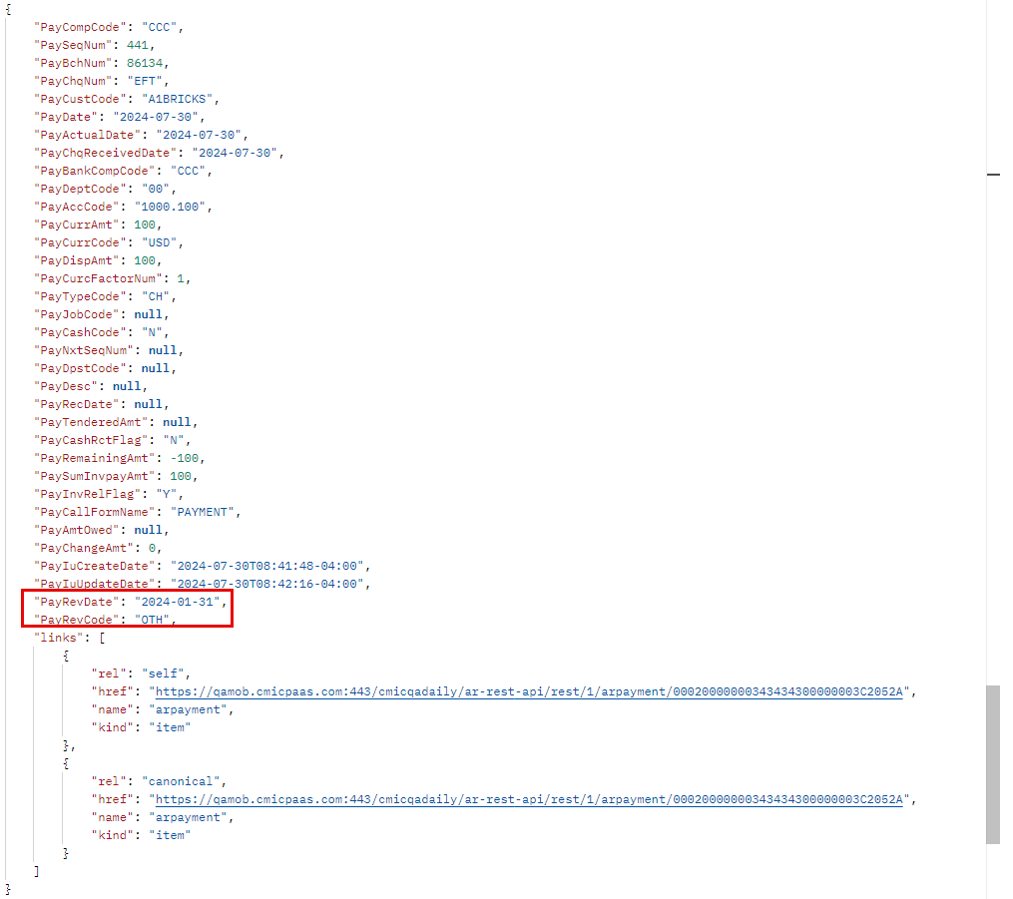
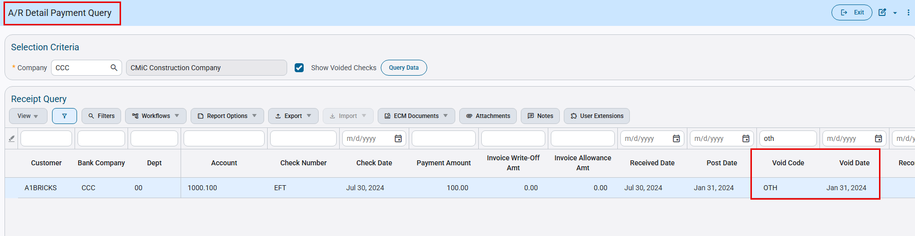

Analytics

Combined Bar/Line Chart Visualization in Dashboard Builder (BI-1814)
CMiC Analytics now includes a combined Bar and Line chart in Dashboard Builder, giving users a powerful new way to visualize related data sets together. This visualization makes it easier to compare trends and values in a single view, helping key insights stand out at a glance. It is especially effective for dashboards that track performance metrics over time.
How it works
In Dashboard Builder, users can choose the combined Bar and Line chart visualization type and assign fields to be displayed as either bars or a line. The chart includes two vertical axes, allowing different data points to be shown on separate scales with customizable axis labels. Users can also define custom numeric ranges for each axis within Visualization Settings.

Analytics Dark Mode Support (BI-1657)
CMiC Analytics now supports Dark Mode, giving users a more comfortable and modern way to work with their data. Designed for extended analysis sessions and low-light environments, Dark Mode helps reduce eye strain while aligning with individual viewing preferences.
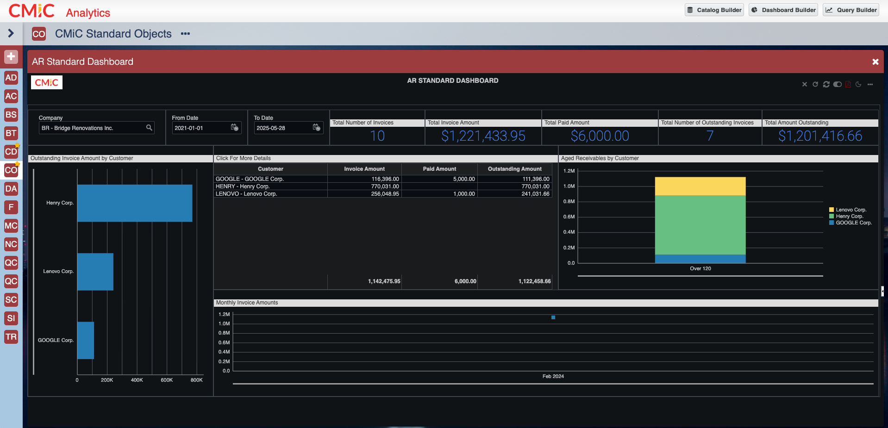

How it works
CMiC Analytics automatically follows your browser’s colour theme by default. Users can easily switch between Dark, Light, or Browser mode using the theme toggle in the top-right corner. Once selected, your preference is saved and remains in effect until you choose to change it, while Browser mode continues to reflect your system setting.
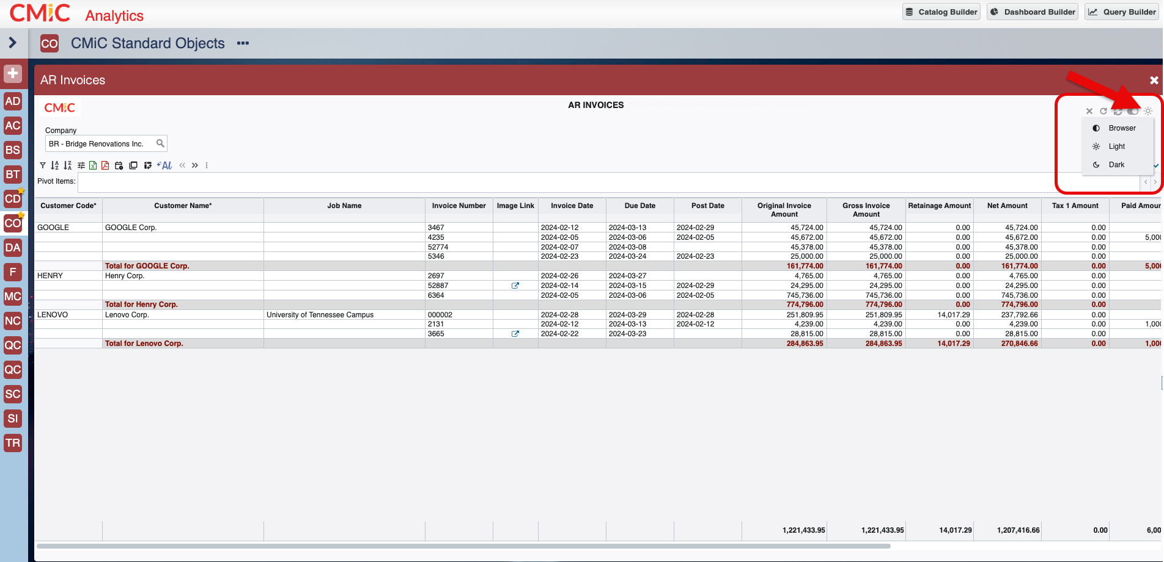

Dynamic Autofit Columns (BI-1602)
CMiC Analytics now automatically sizes column widths when building reports and dashboards, eliminating the need for manual resizing. By adapting column widths to the expected content length, reports are cleaner and easier to read right from the start. This enhancement makes report creation faster, more efficient, and far more intuitive for users.
How it works
When you add a field in Query Builder or Dashboard Builder, CMiC Analytics intelligently sets the column width based on the character limits defined in the database. Each column is sized appropriately as it is added, rather than using a single default width. Users can still adjust column widths manually if needed, but most reports should now require far less resizing.
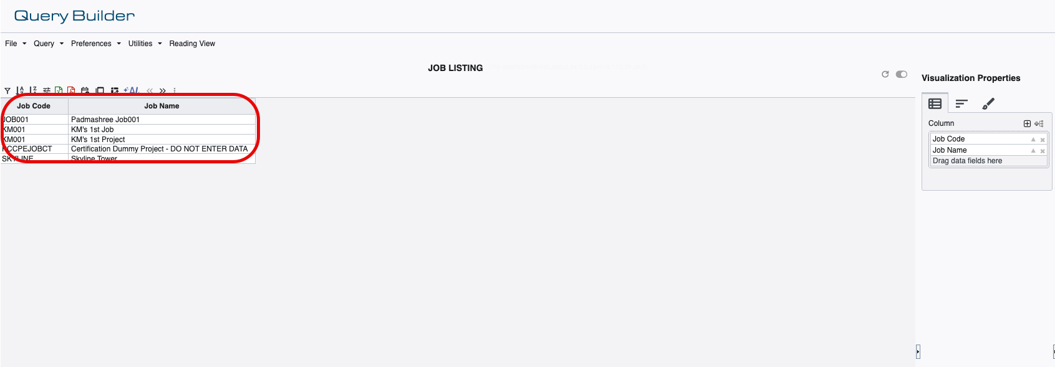

Enable Pagination “Off” by Default (BI-1641)
CMiC Analytics now displays queries and tables without pagination by default, allowing users to view entire reports in a single, continuous scroll. This change creates a more fluid and intuitive viewing experience. It is especially beneficial on mobile devices, where scrolling is more natural than navigating between pages.
How it works
Pagination is automatically turned off when you create a query in Query Builder or a table in Dashboard Builder. All results are displayed in a single scrollable view without requiring any configuration. Users can still enable pagination if needed, but no action is required to benefit from the new default behavior.
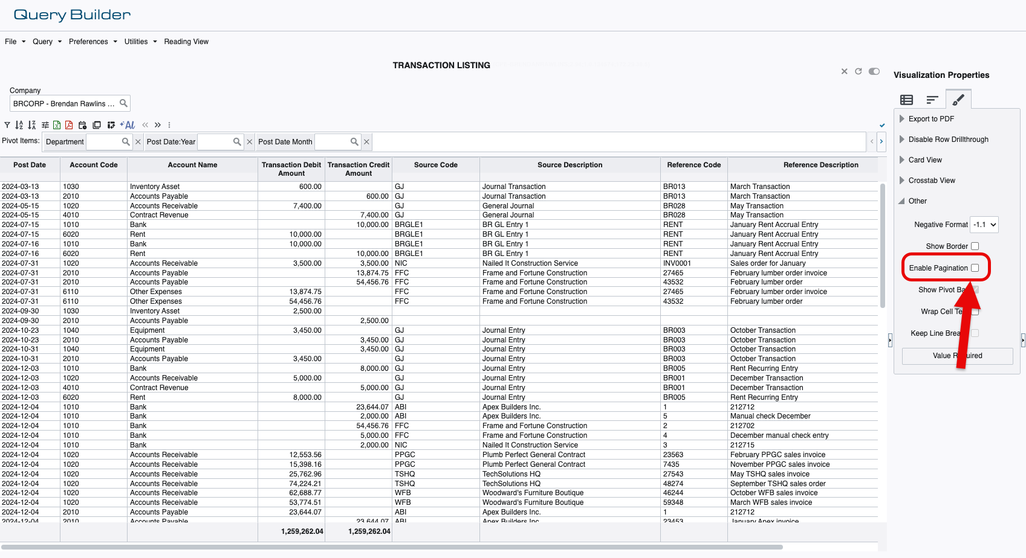

Panel Background Color Customization (BI-1733)
CMiC Analytics now offers expanded color customization in Dashboard Builder, giving users greater control over the look and feel of their dashboards. Visualizations can be styled to stand out, highlight key insights, or align with company branding and logo colors. This makes dashboards more engaging, polished, and tailored to each organization.
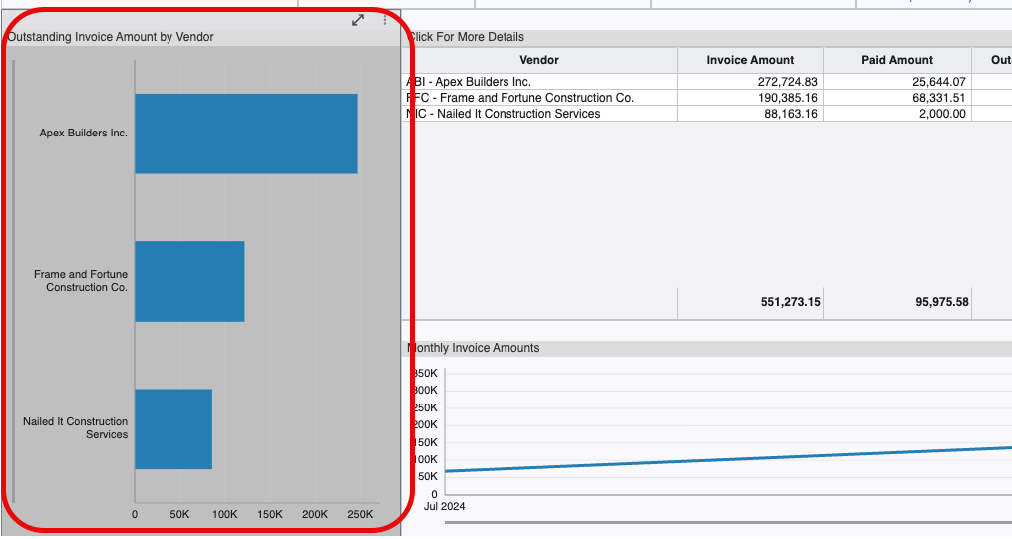
How it works
Within Visualization Settings, users can now change the background colour of all visualizations (excluding tables). The overall dashboard appearance can also be updated by adjusting the panel background color. At any time, users can instantly revert back to the default color scheme with a single click.
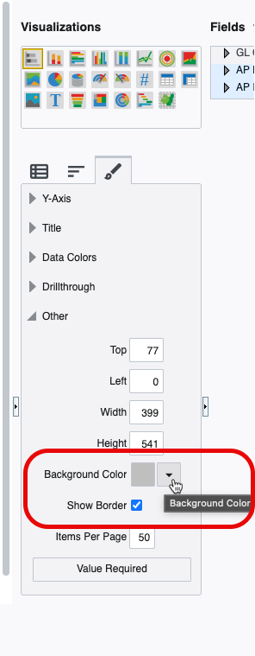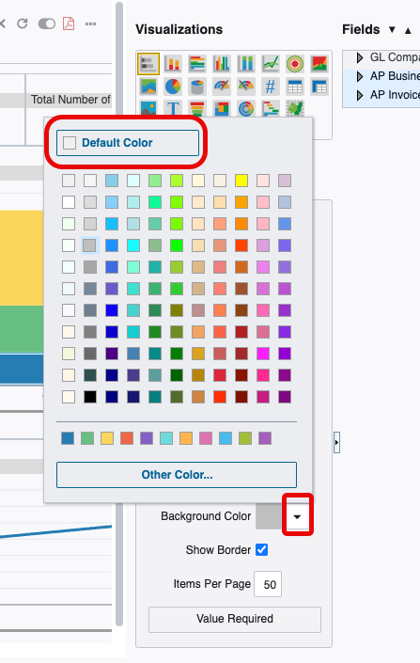

Equipment Costing

Import functionality is added to the EC Category Codes and Transaction Codes program (FIN-19471)
Overview:
Import functionality is added to
[1] Equipment costing > Setup > Local Tables > Category Codes
[2] Equipment costing > Setup > Local Tables > Transaction Codes

Modifications:
The following screens shows the new functionality:
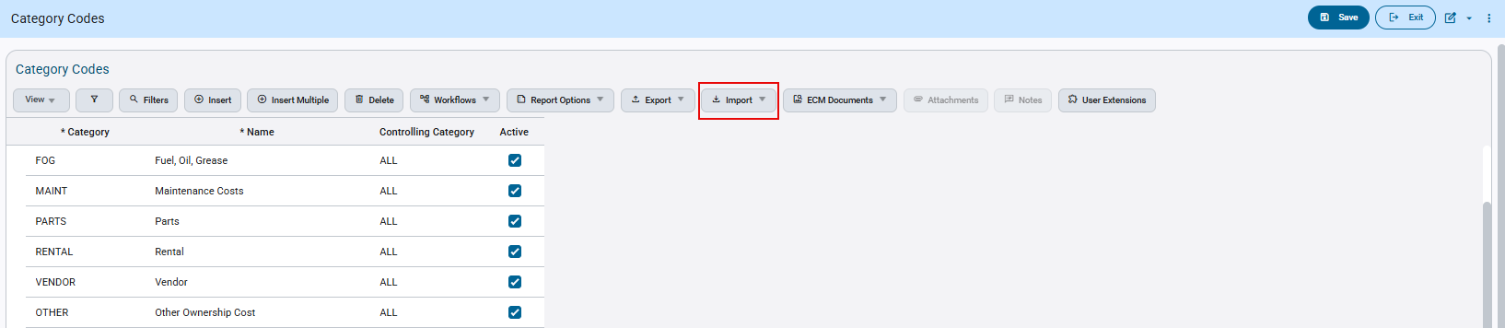
Equipment costing > Setup > Local Tables > Category Codes

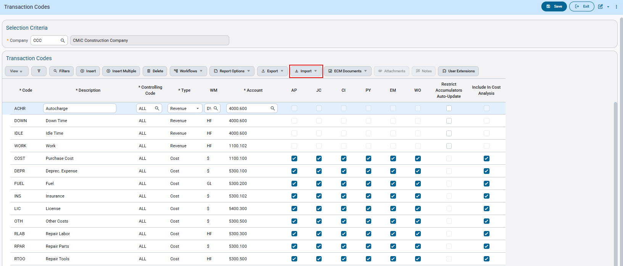
Equipment costing > Setup > Local Tables > Transaction Codes

Employee Self Service

ESS User: Password Reset Required After User Creation
Overview
This document outlines the process and system behavior when a newly created ESS user must reset their password, even though a password was provided during user creation.
In certain cases, after completing the ESS registration process and successfully creating the user account, the system returns “Authentication Failed” or “Invalid Credentials” during login.
To ensure proper authentication and access synchronization, the user must complete a Password Reset before successfully logging in. This is due to the security enhancements implemented under CAM-9505.
This will be enhanced in Nexus 2.0.
Pre-requisites
An employee must exist in Employee Profile. 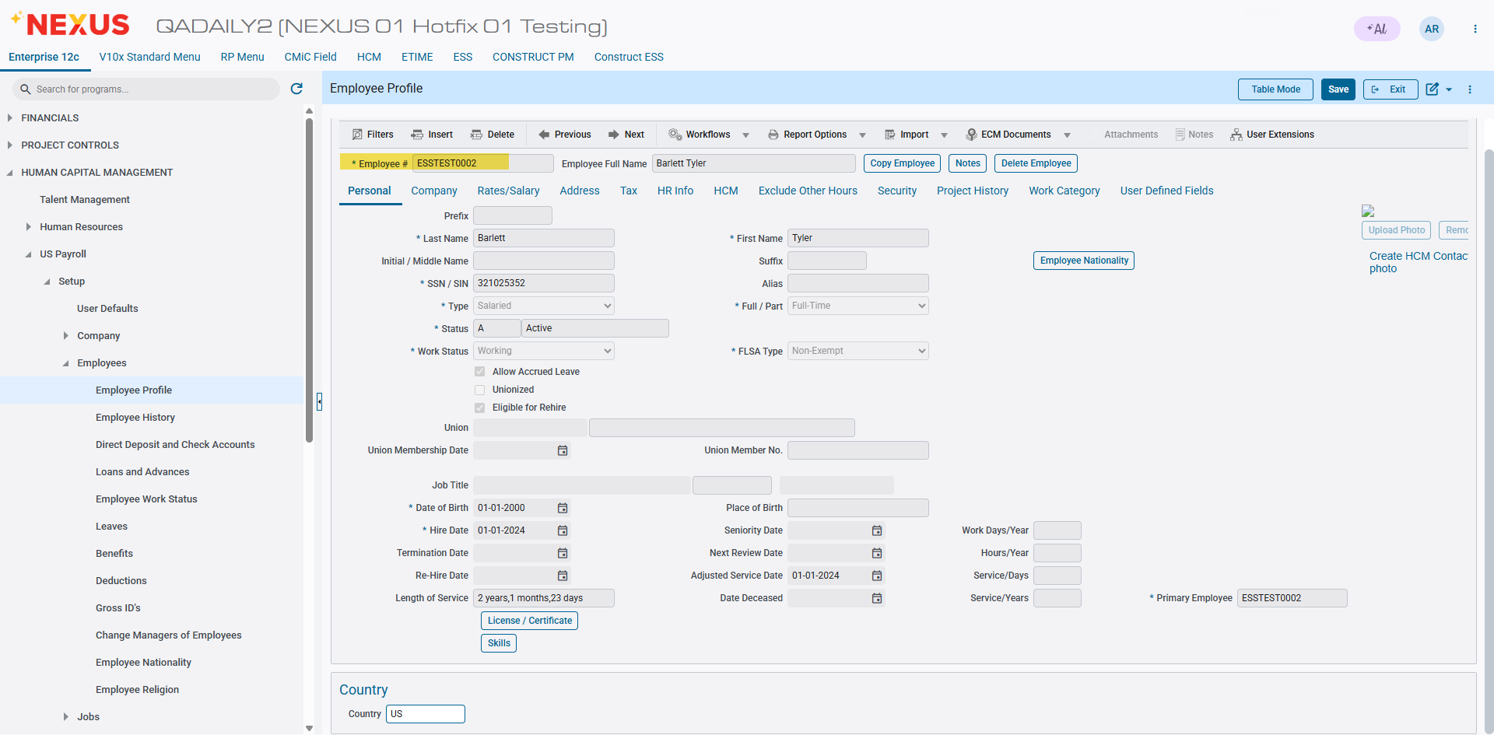
Pgm: PYEMPLOY – Employee Profile; Treeview path: US Payroll > Setup > Employees > Employee Profile
- ESS Access must be enabled in Employee Maintenance.
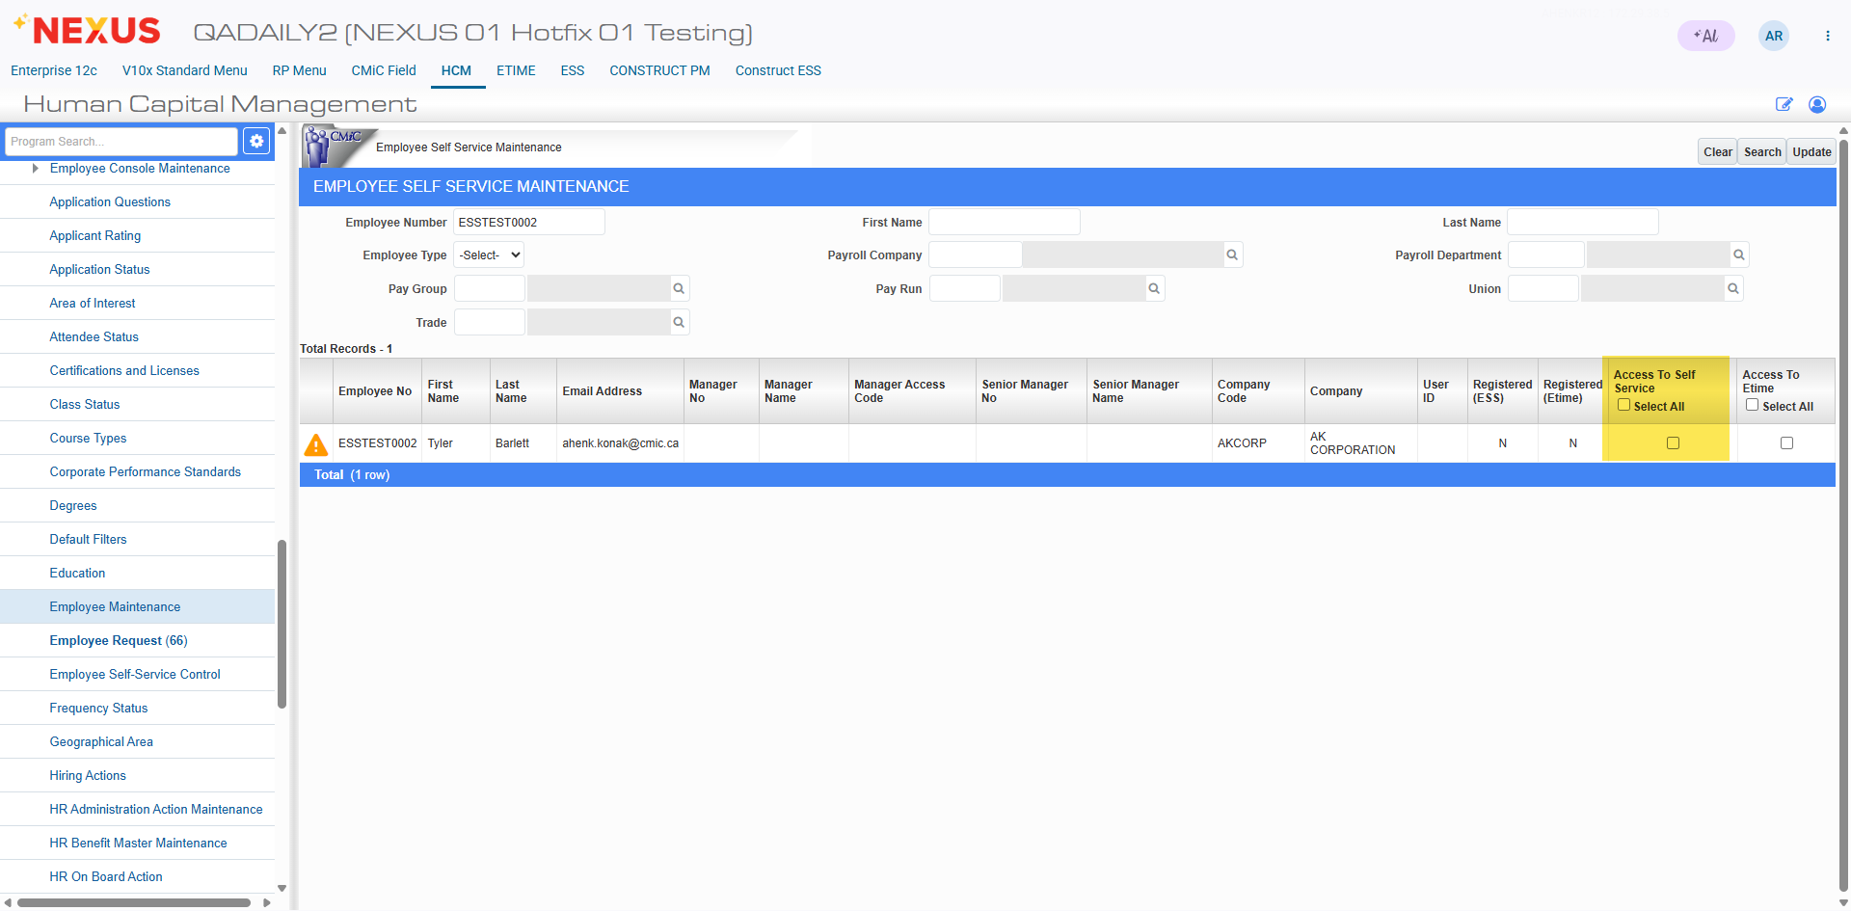
- Valid email address must be configured against the employee profile.
- Required ESS security roles must be assigned.
Modifications
The current behavior is that after successful ESS user registration and password creation, the user needs to perform “Have trouble signing in” process flow, so that a password reset action is performed prior to first login authentication and the user can login successfully.
User Registration Flow
- ESS Access
Update “ESS Access” of the employee through HCM.
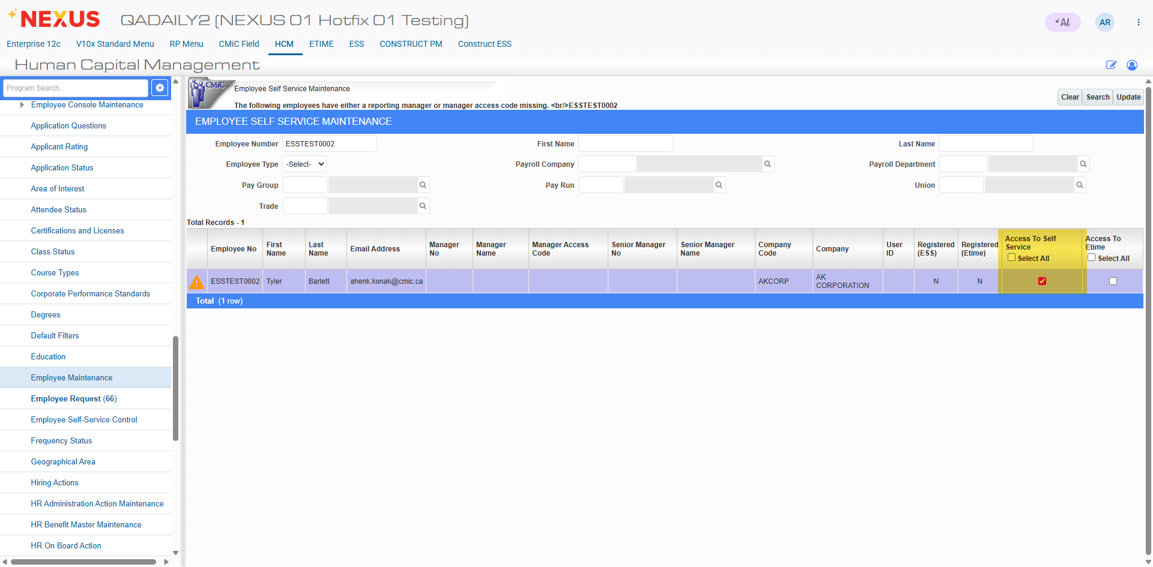 HCM-Employee Maintenance.

- Registration Email
Employee receives registration email and click the Register link.
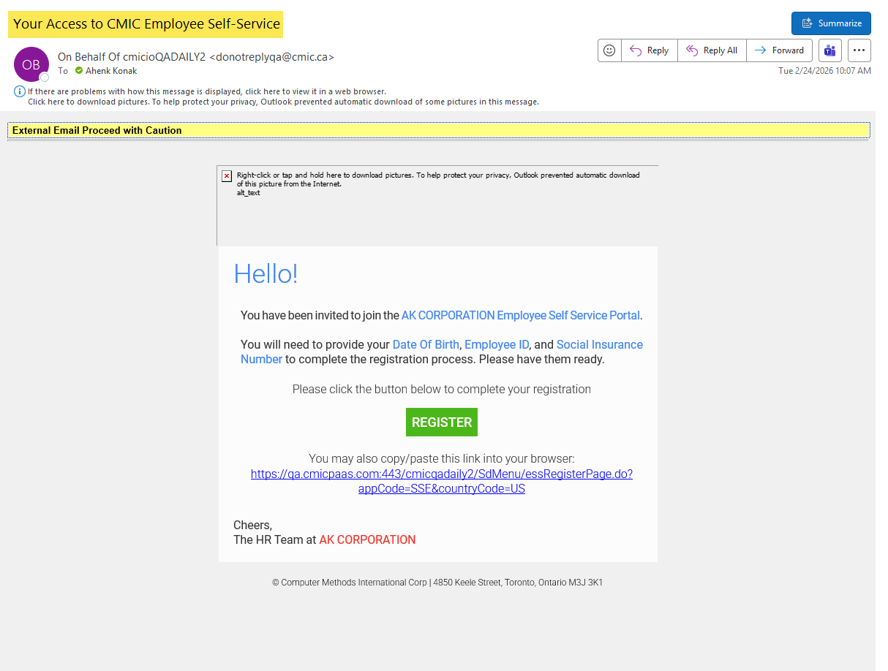
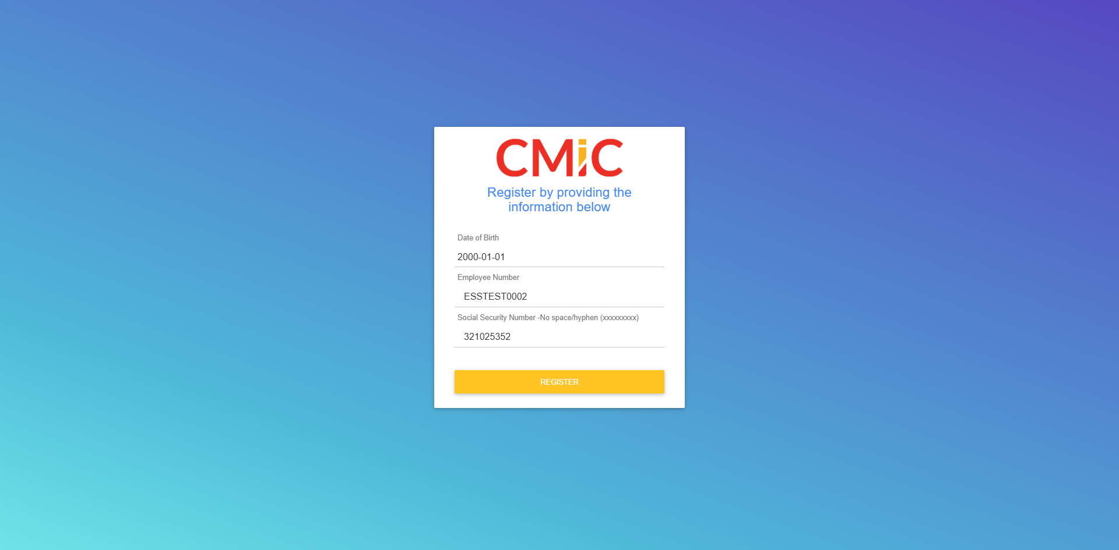 Register User
- Create a new user.
- Click “Don’t have an account? Sign up” link.
- User enters User ID and Password.
- Account creation completes successfully.
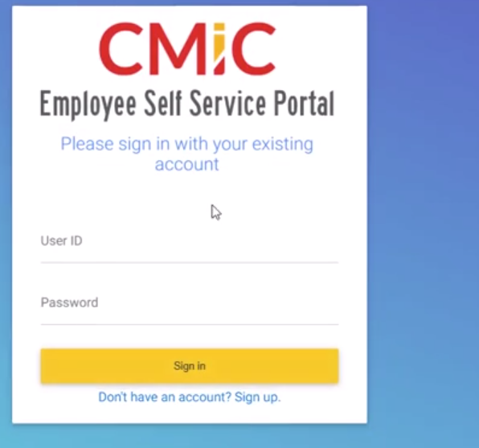
Login Screen
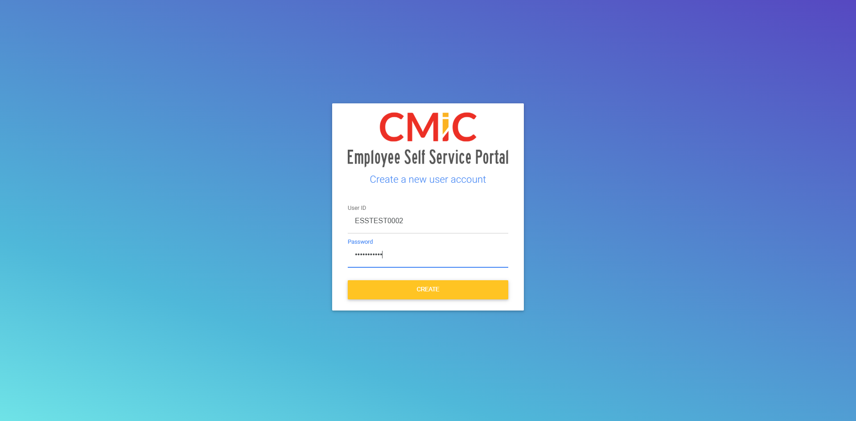 Create User
- Login Attempt
- • User enters credentials.
- • System returns 'Authentication Failed' or 'Invalid Credentials'.
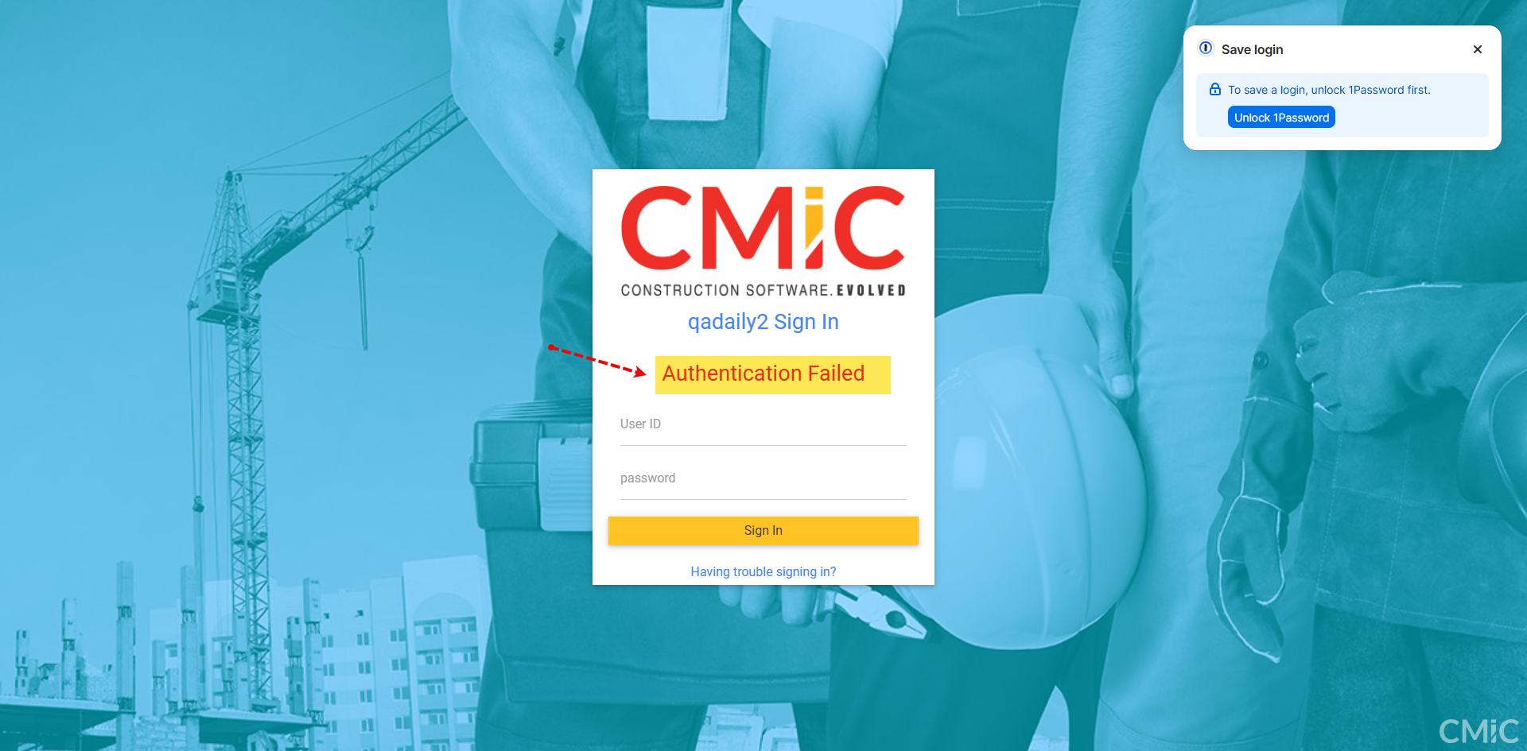 Login Screen
- Reset Password
- Click on “Having Trouble Signing in”
- Click on the email received for resetting the password
- Provide new credentials
- User can log in with the new reset password.
 Forgot Password Screen
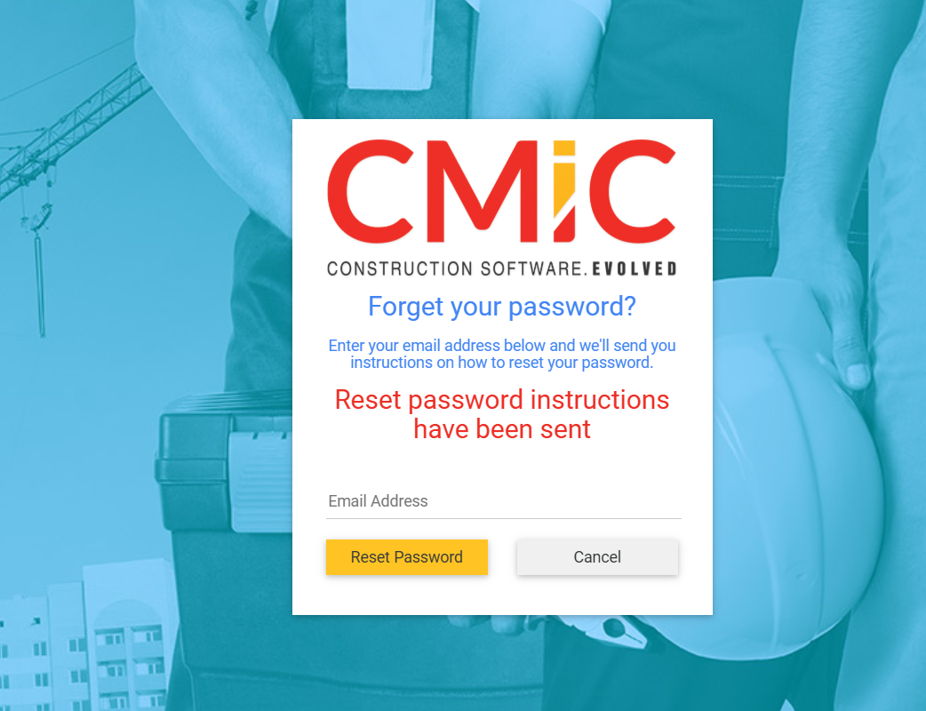

 ResetPassword Screen

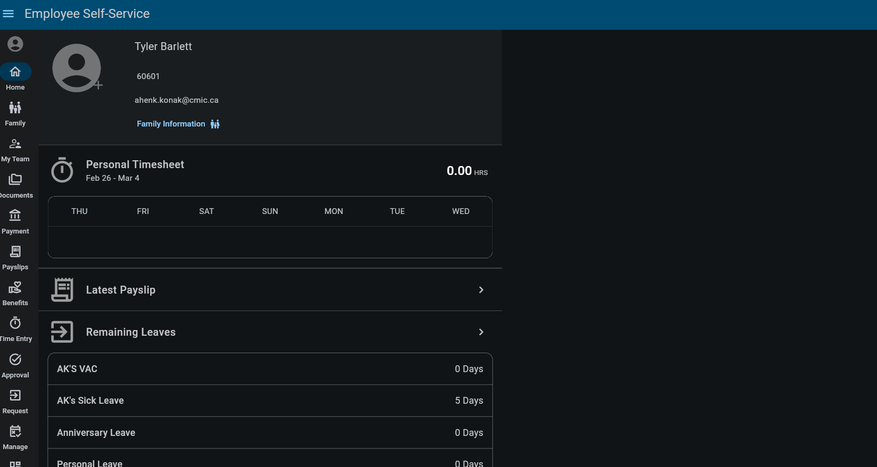 Login Successful

ESS Leave Request Enhancement - Insert Salaried Employee Leave into Adjustment Table (HCM-22729)
Overview
This requirement updates how approved leave requests for Salaried employees are handled when the System Option checkbox ‘Create Adjustment For Salaried Employee Leave’ is enabled. Instead of inserting approved leave into the Timesheet Table, the system will insert it into the Adjustment Table (so that Payroll picks it up correctly), as long as the payroll period is still open and no regular paycheck has been processed for that period.
If the leave is approved after the payroll cutoff (i.e., the period is closed) or after a regular check is processed, the leave will be treated as a late approval; the system will mark the request as “Used”, record it in Leave History Table, update the employee’s leave balance, and display a clear on-screen message to the manager.
This logic applies only to Salaried employees with the flag ON. Hourly employees continue following the existing process (Timesheet insertion). The process must remain auditable with approval details and validation outcomes.
Pre-requisites
The System Option ‘Create Adjustment For Salaried Employee Leave’ must exist and be turned ON for this logic to apply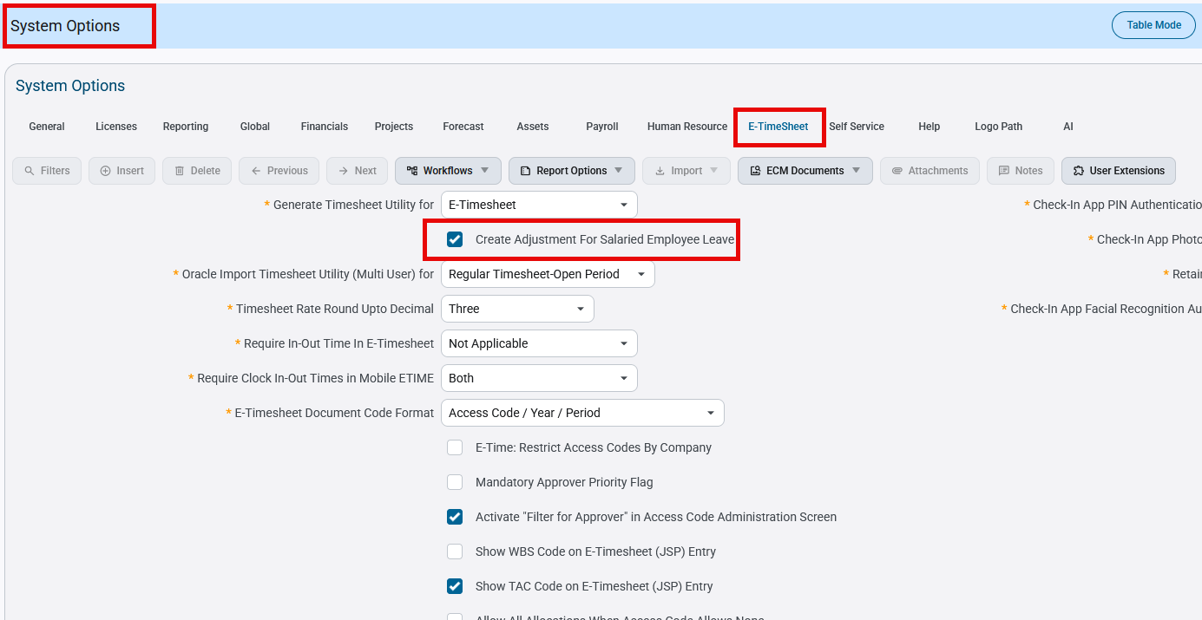
Pgm: SYSOPT – System Options; standard Treeview path: System > Setup > System Options – E-TimeSheet tab

The employee must be correctly set up as Salaried (Hourly employees keep the current Timesheet process) and have a valid leave plan/balance.
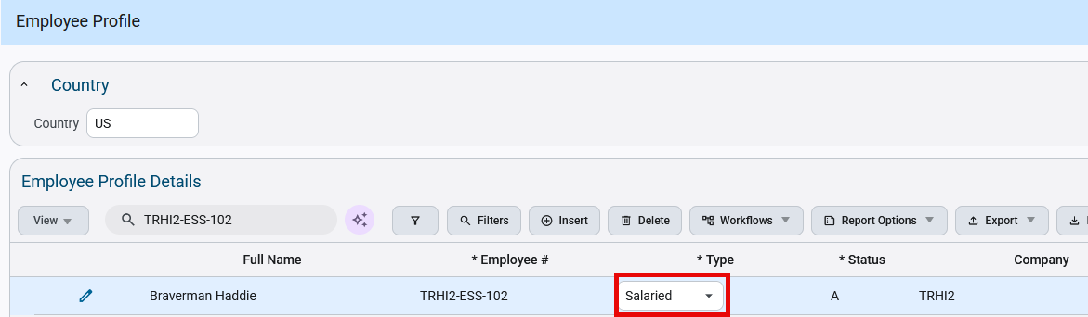
Pgm: PYEMPLOY – Employee Profile; standard Treeview path: US Payroll > Setup > Employees > Employee Profile
ESS access must be in place such that employees can submit leave requests, and managers can approve them in the Construct ESS Leave Request screen with proper security.
Payroll must be configured so the system can validate open vs closed payroll periods, detect whether a regular check was processed, and ignore checks with user_assigned_check_number.
Required processing/tables must be available: Adjustment Table, Leave History Table, and immediate leave balance update logic (including late approvals for salaried).
Manager email notifications and required audit logging (approval timestamp, approver ID, validation outcome) must be enabled.
Modifications
The modification is that Salaried leave approvals (when the System Option is ON) will no longer create Timesheet entries. Instead, after approval, the system will check pay period status and whether a regular check was processed. If both are OK, it inserts the leave into the Adjustment Table for payroll pickup. If the period is closed or a regular check exists, it’s treated as a late approval. The request is marked “Used”, recorded in Leave History, the leave balance is updated, and the manager sees a message. Hourly employees (and Salaried when the option is OFF) follow the existing Timesheet process.
Implementation
When a manager approves a leave request in ESS, the system will first check the System Option and the employee type. If the option is ON and the employee is Salaried, the system runs two validations: (1) whether the payroll period is open, and (2) whether a regular check has already been processed for that period (ignoring checks with user_assigned_check_number).
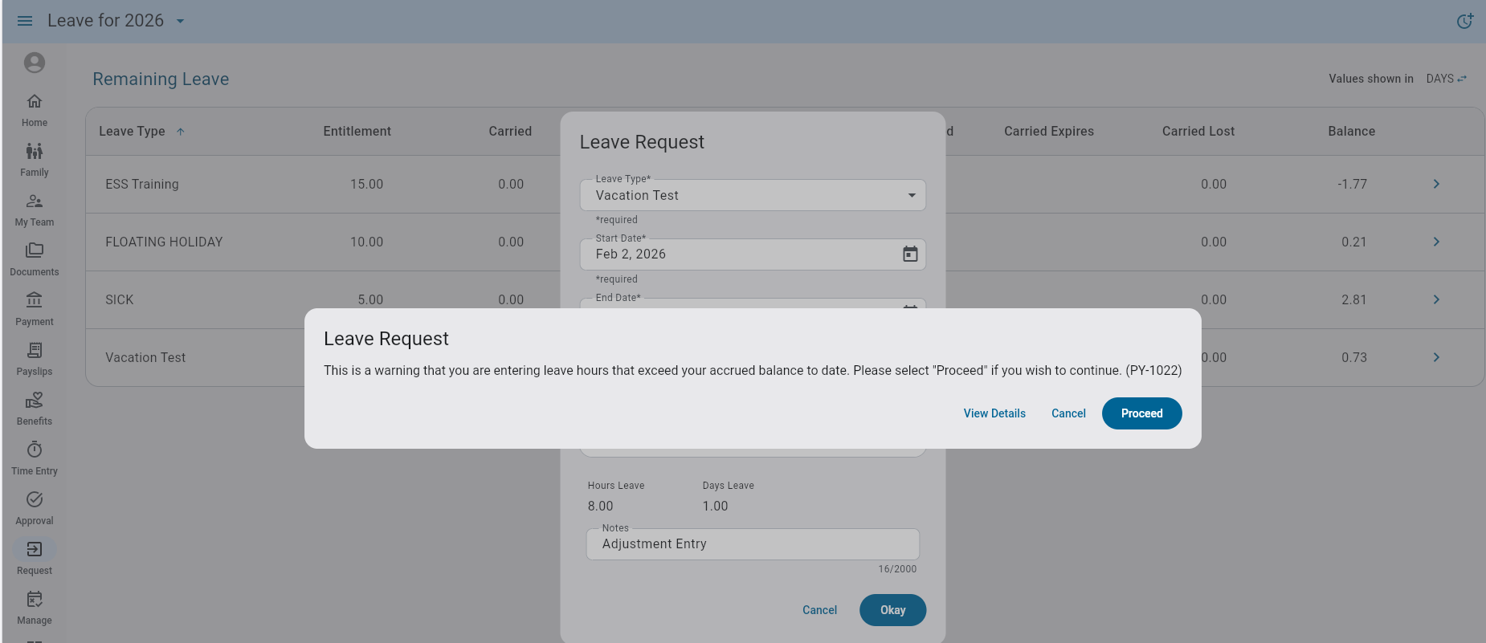
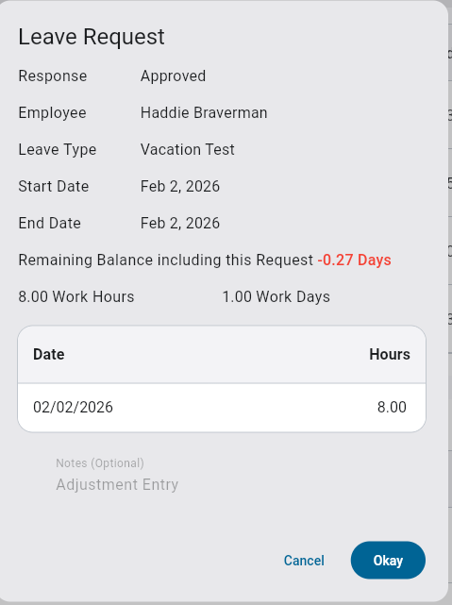
Leave Request entered and approved in Construct ESS

- If the period is open and no regular check exists, the approved leave is inserted into the Adjustment Table (and not the Timesheet Table), and the employee’s leave balance is deducted immediately so Payroll can pick it up in the next run.
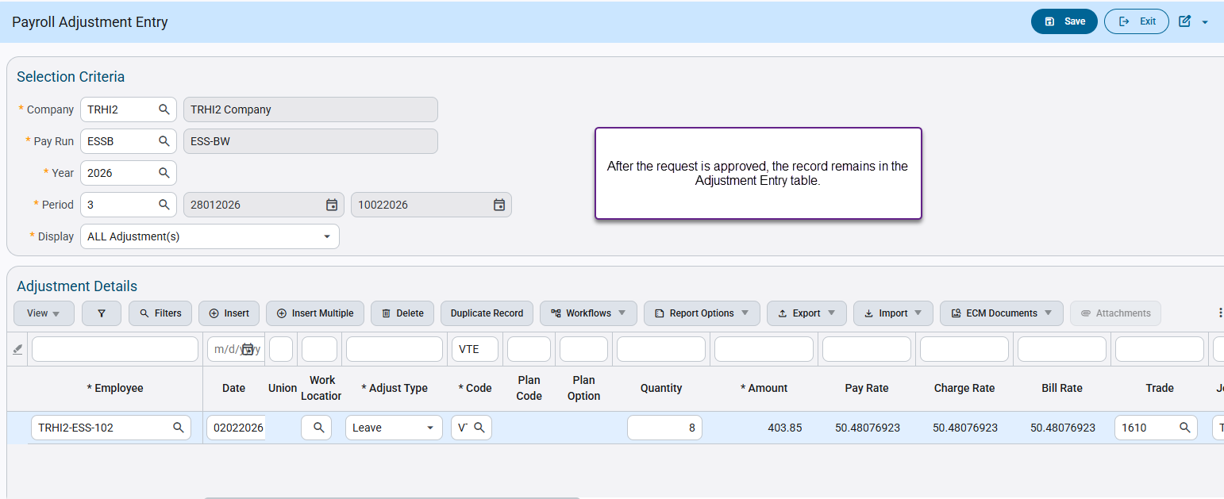
Pgm: PYPAYADJ – Payroll Adjustment Entry; standard Treeview path: US Payroll > Processing > Adjustments > Adjustment Entry

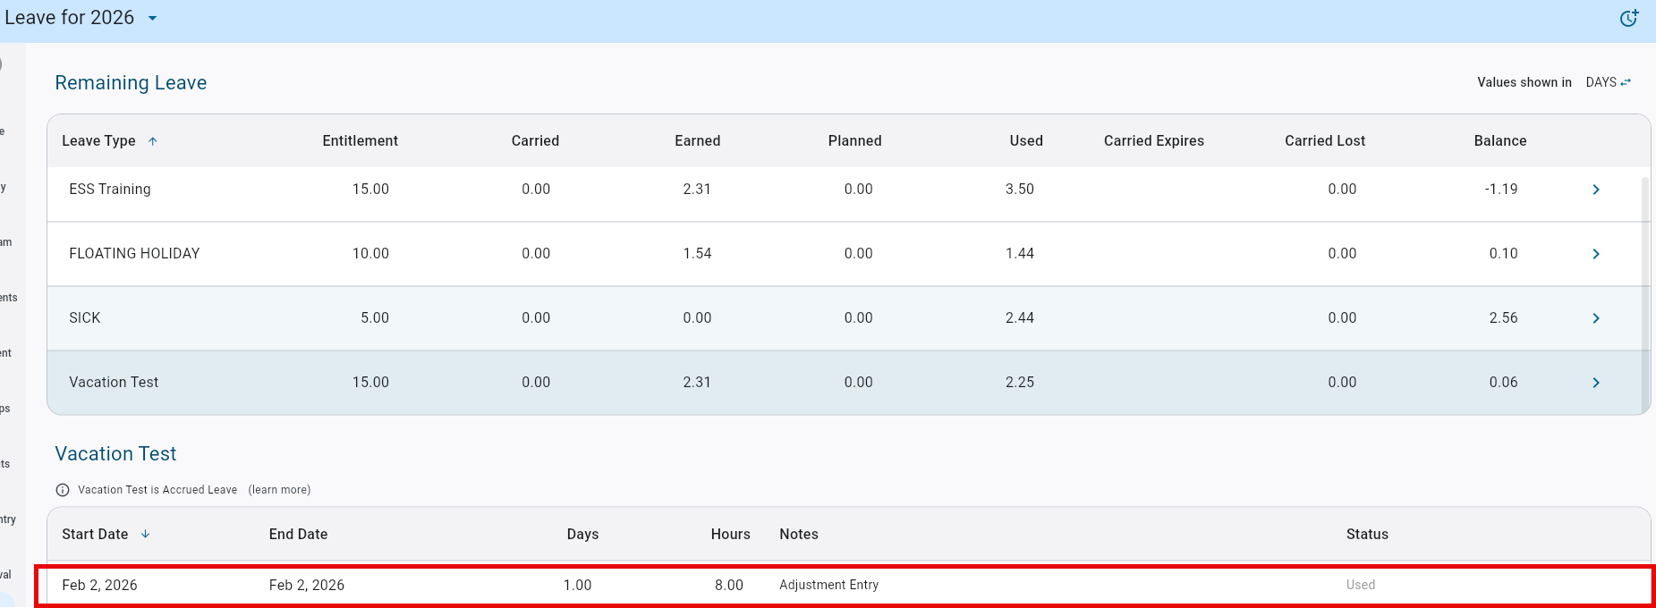
Construct ESS - Leaves
- If the option is OFF or the employee is Hourly, the system follows the current Timesheet-based process with no changes.

General Ledger

Modifications to Maintain Budget (FIN-18073)
Overview:
Modifications to Maintain Budget.
Modifications:
Maintain Budget Program has been modified to Relabel Buttons and Account Type, From Dept, From Account and To Account fields have been made hidden. User can add these fields again using Lite Editor.
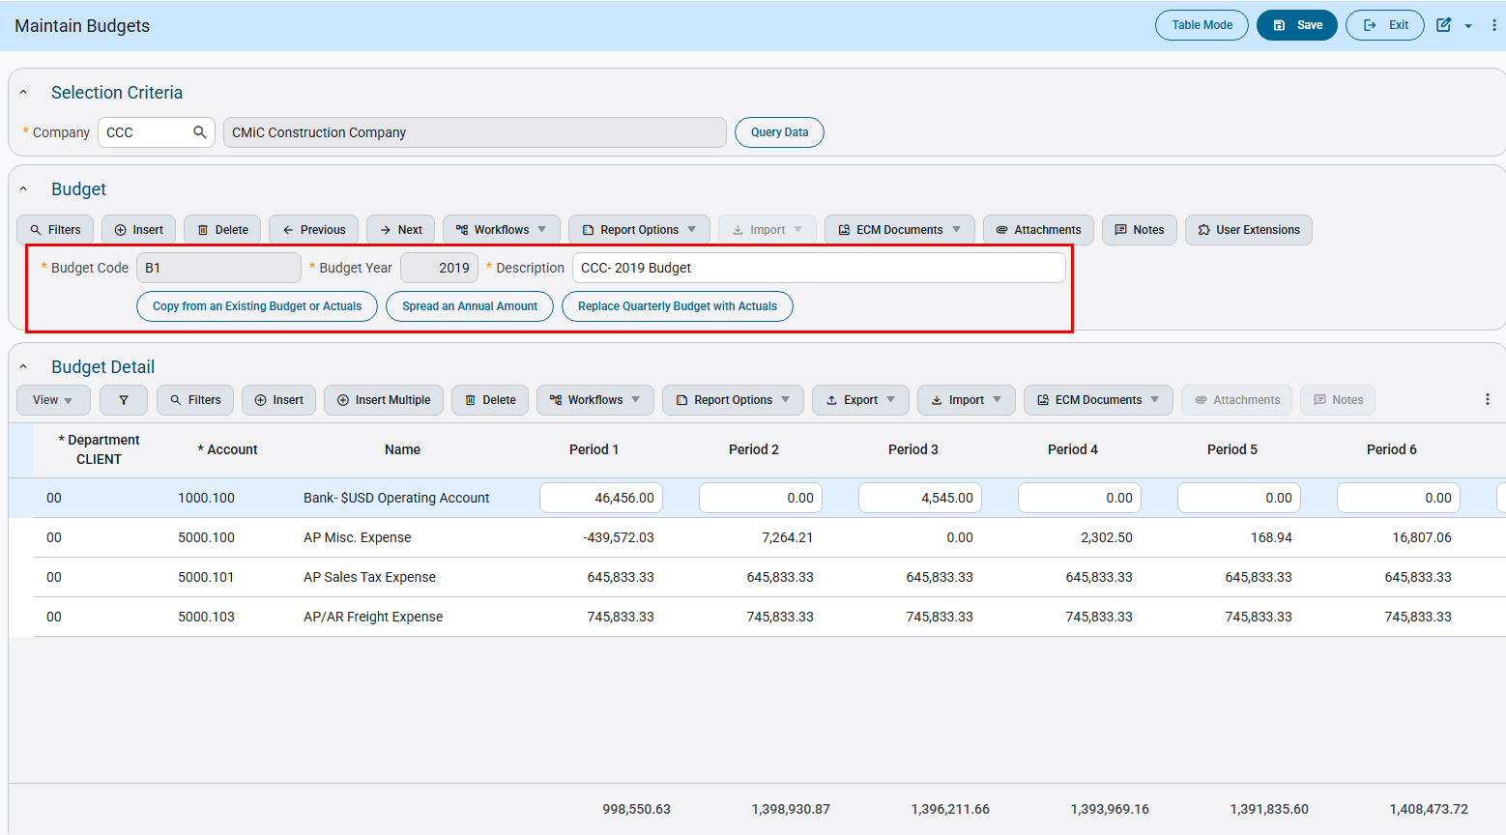
General Ledger > Setup > Maintain Budgets

Job picklist added to Cost Pool Allocation (FIN-20385)
Overview:
Job picklist added to Cost Pool Allocation program.
Modifications:
Allocate Section in Cost Pool Allocation program is modified to add Job picklist in Job LOV in both Prorated by and Prorated To data. When a transaction record is classified as type ‘J’ in Allocate Section, Job/Dept LOV’s will show both Job and Job picklist. Modification is reflected on all types of prorate methods (Amount, Corporate Levy, Percentage, and Quantity).
When Job LOV is selected with Dynamic Job Picklist, in this case, Cost Code and Category LOV’s will populate ‘ALL’ and the Master list of the Active Cost Code and Category respectively. Users will have to select the Cost Code and Category wisely depending upon their Job’s Cost Code and Category setup. For Static Job Picklist, Cost Code and Category will be populated according to the jobs that are present in the picklist.
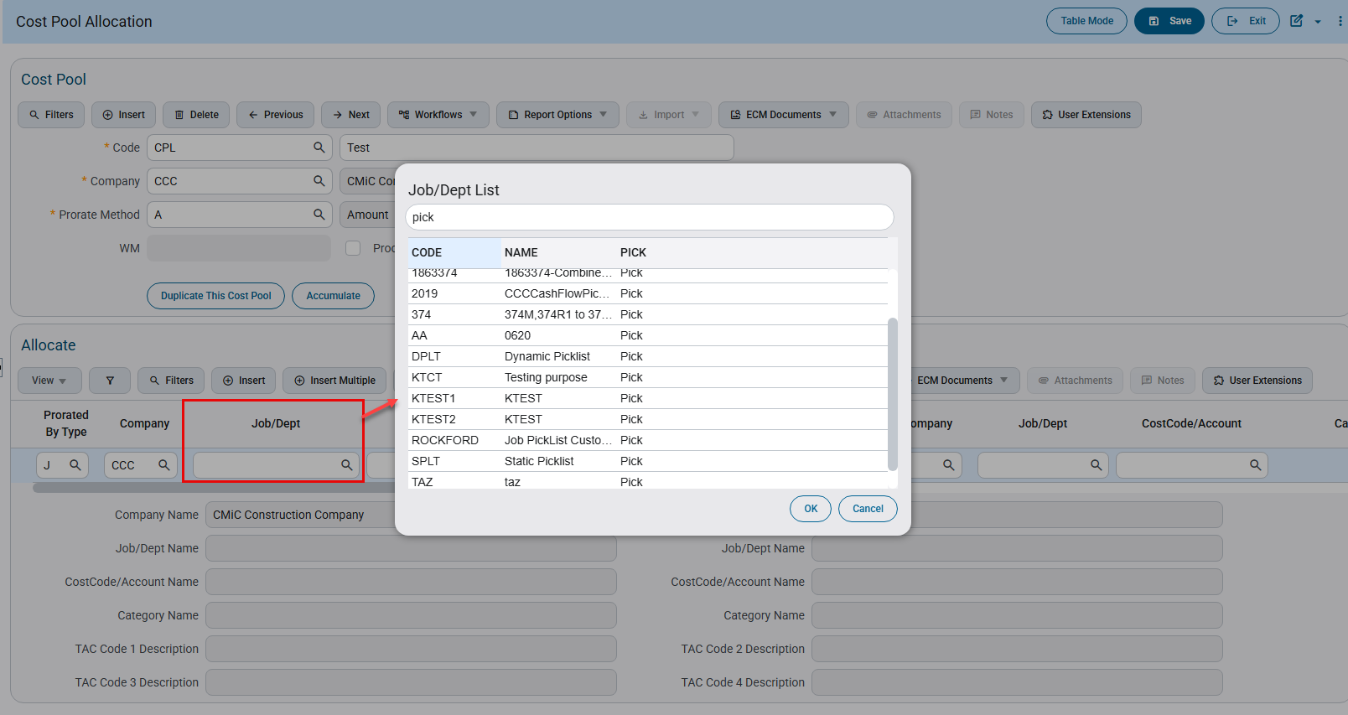
Financials > General Ledger > Local Tables > Cost Pool Allocation

Modified Bank Reconciliation File Format (US-BANK2) (FIN-19834)
Overview:
Bank Reconciliation File Format (US-BANK2) is modified.
Modifications:
‘US-BANK2’ Bank Reconciliation File Format has been modified with the following changes only:
- On record type ‘16’ (Transaction Detail) - Only transaction with code ‘475’ will be processed. Transactions with any other code will be ignored.
- On record type ‘03’ (Account Identifier and Summary/Status) - The processing routines have been updated to support reconciliation of multiple accounts within the same file.

This is an example of the modified bank reconciliation file format ‘US-BANK2’: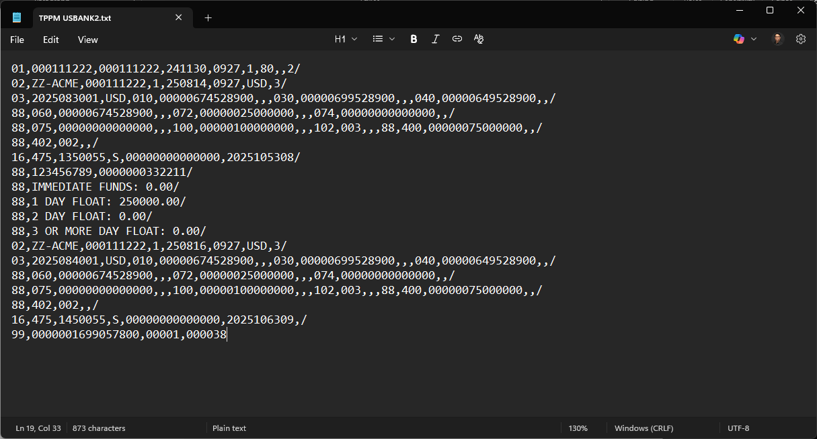

Human Resources

Human Resources & Payroll Modules Mask SSN (HCM-23190)
Maintain SSN Masking Functionality – Extended to additional seven (7) enterprise programs across the Payroll and Human Resources modules.
Overview
The ‘HRSSNSEC’ privilege within the CMiC system has been extended to control Social Security Number (SSN) visibility across an additional seven (7) enterprise programs within the Payroll and Human Resources modules.
When this privilege is not assigned, SSNs will be masked in both List of Values (LOV) components and screen views to ensure data confidentiality and compliance with privacy standards.
Payroll Screens:
• Employment History Search
• Employee Deductions
• Loans and Advances
• Employee Direct Deposit
Human Resources Screens:
• Performance Review
• Employee/Applicant Documents
• Employee/Applicant Certification/Licenses
Pre-requisites
- If the user has the 'HRSSNSEC' privilege under User Maintenance > System Privileges:
→ Display the full SSN on the relevant screens and LOVs.
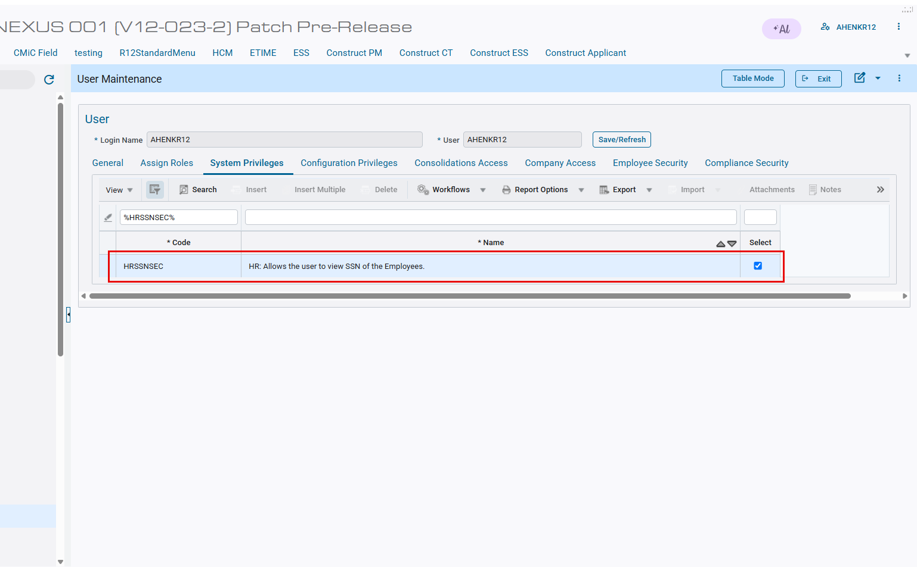
- The user has ability to unselect the 'HRSSNSEC' privilege.
→ The SSN should be masked (e.g., *) or not displayed at all, depending on screen requirements.
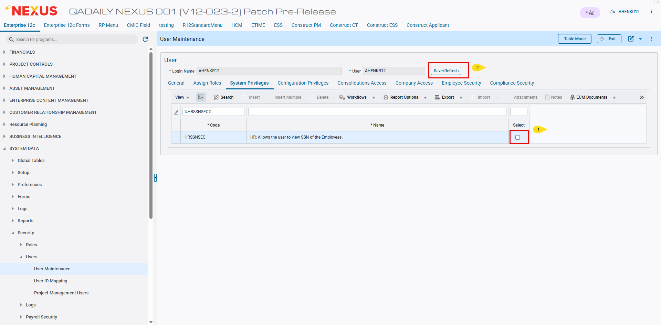
Modifications
Depending on individual screen requirements, the SSN will be masked when this privilege is unselected.
Employee History/Employee LOV:
The SSN should be masked in the Employee History screen and Employee List of Values (LOV) when the privilege is not selected.
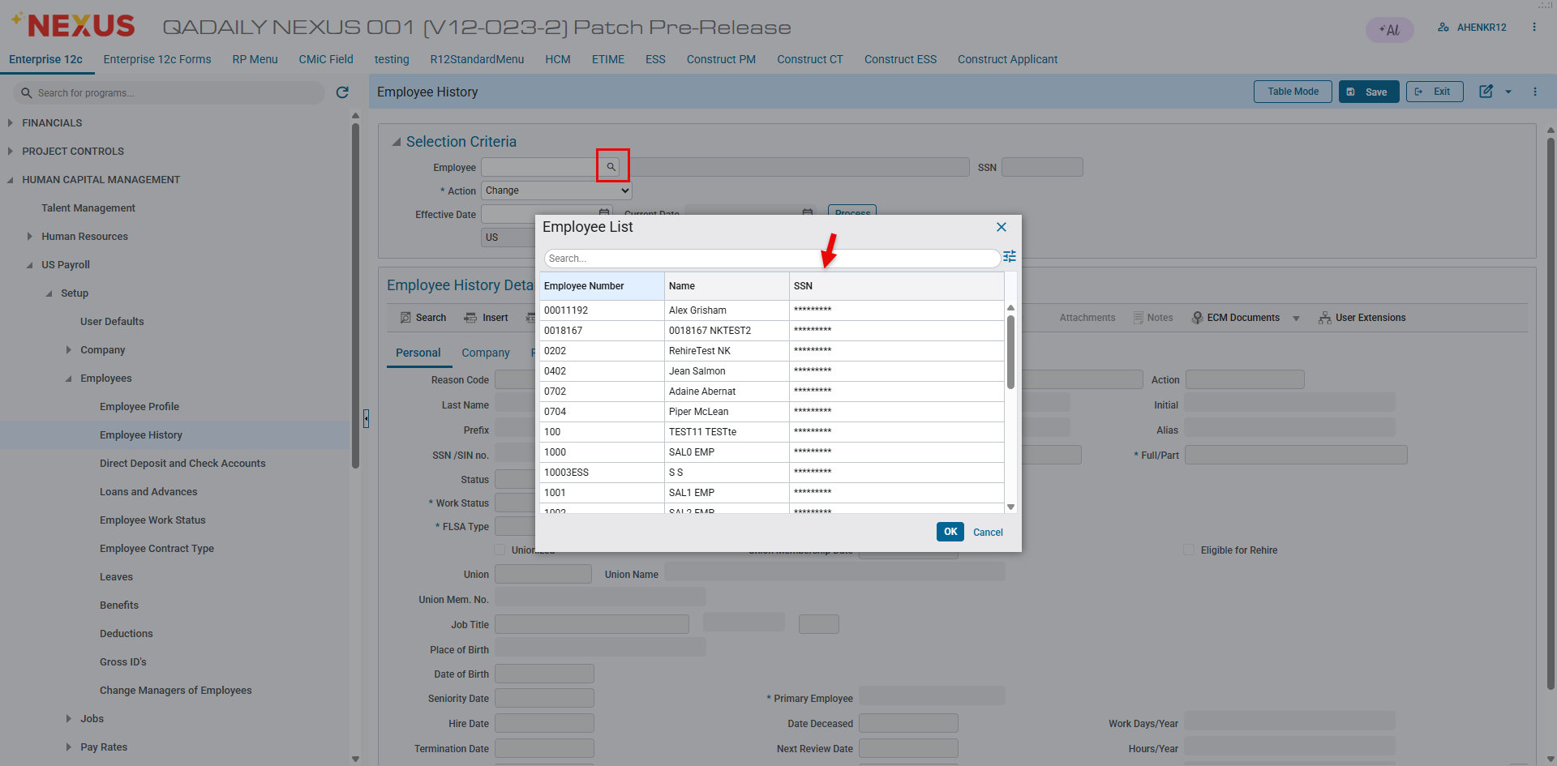

The SSN field should be masked and set to read-only in the Employee History screen when the associated privilege is not selected. This restriction prevents the user from entering or editing any value in the SSN field.
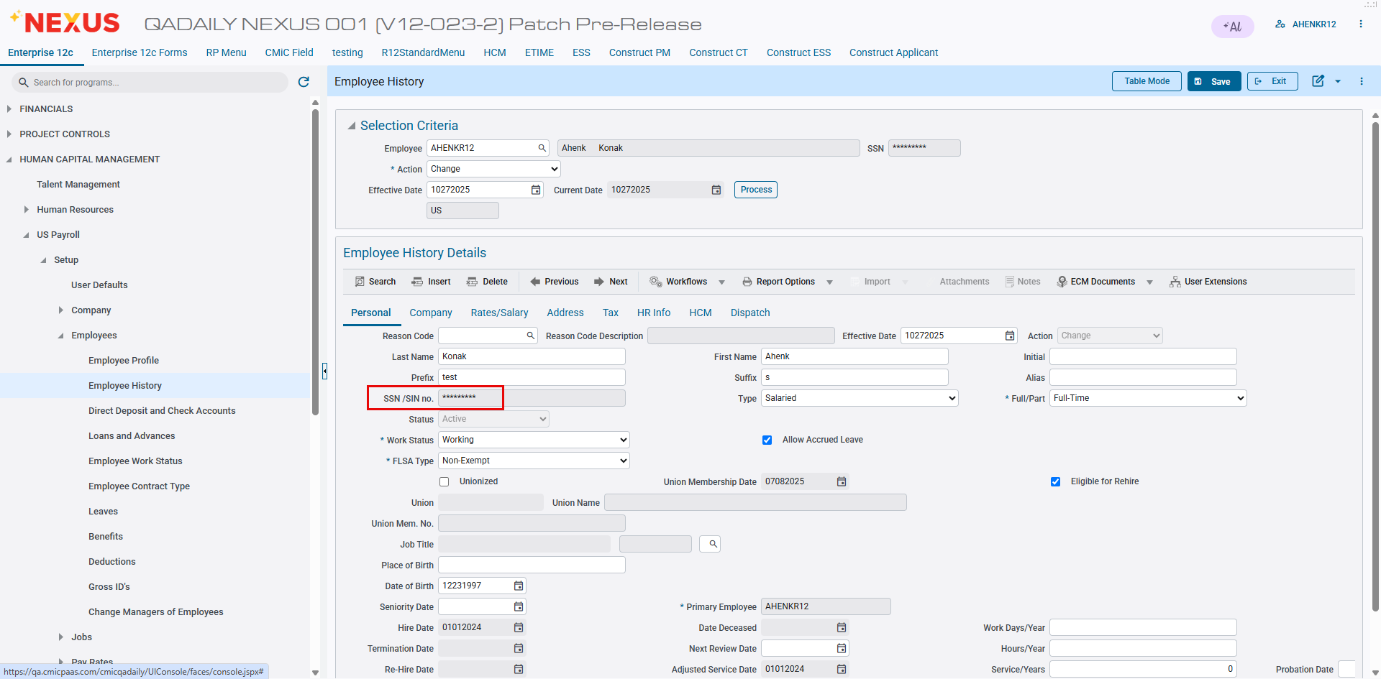

The SSN field should be visible and set to unrestricted in the Employee History screen when the HRSSNSEC privilege is selected allowing the user to view and edit it.
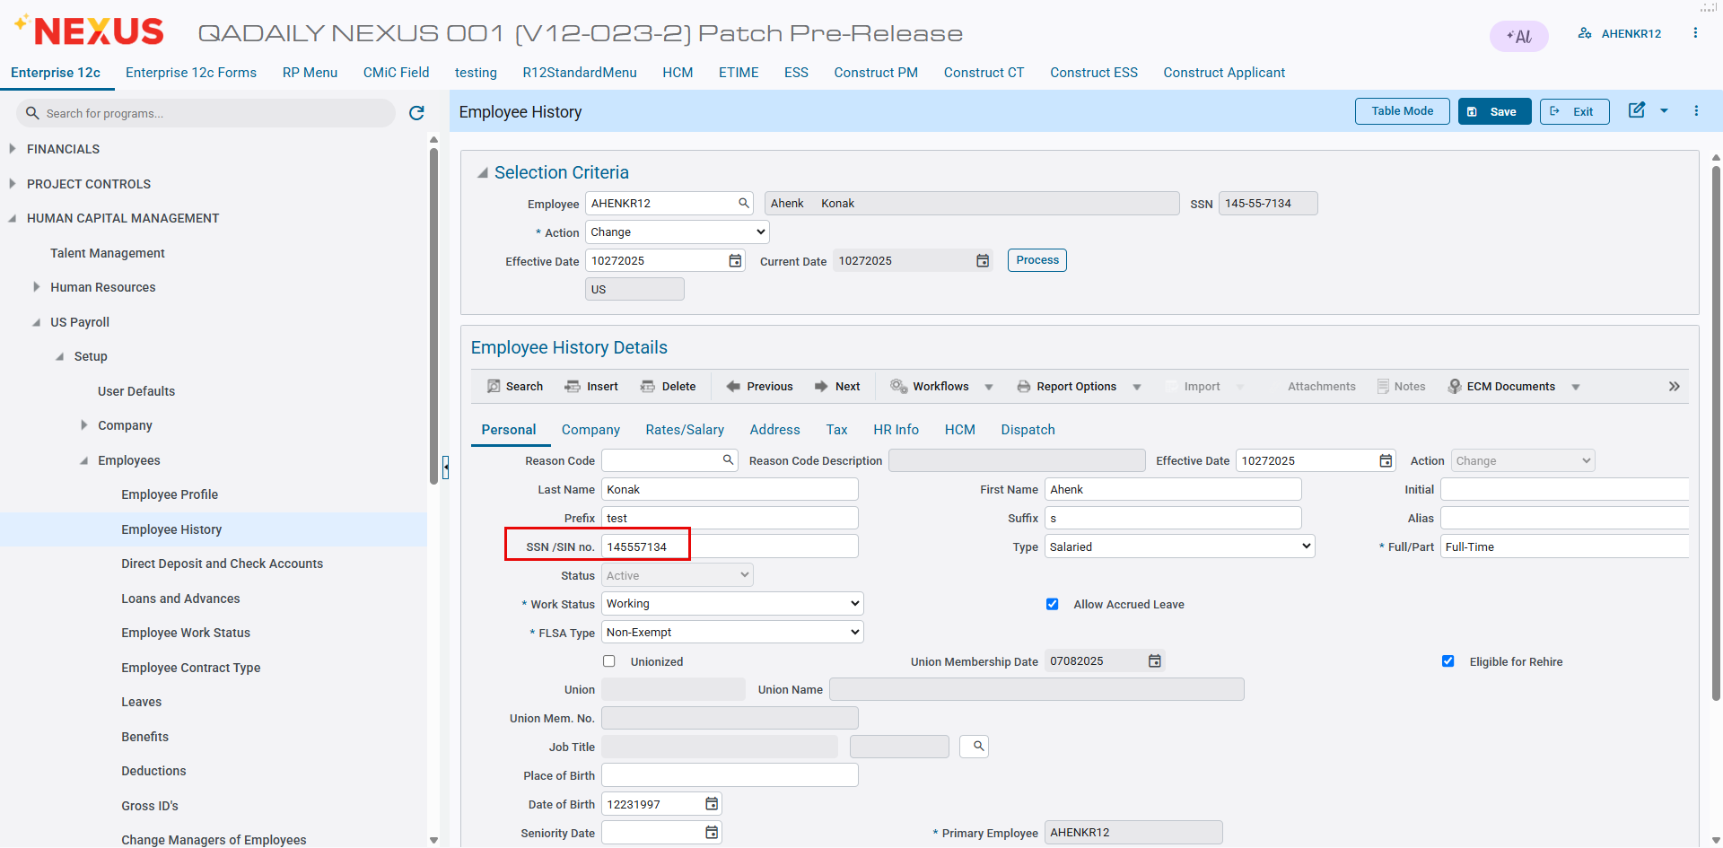

Employee Deductions:
The SSN should be masked in the Employee Deductions/Employee List of Values (LOV) when the privilege is not selected.
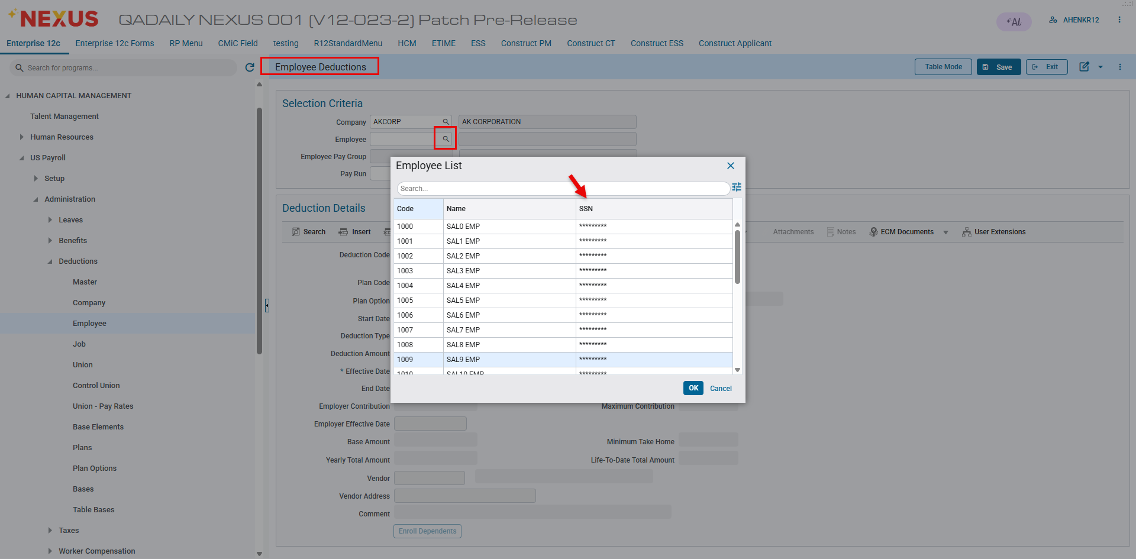

Loan and Advances
The SSN should be masked in the Loan and Advances/Employee List of Values (LOV) when the privilege is not selected.
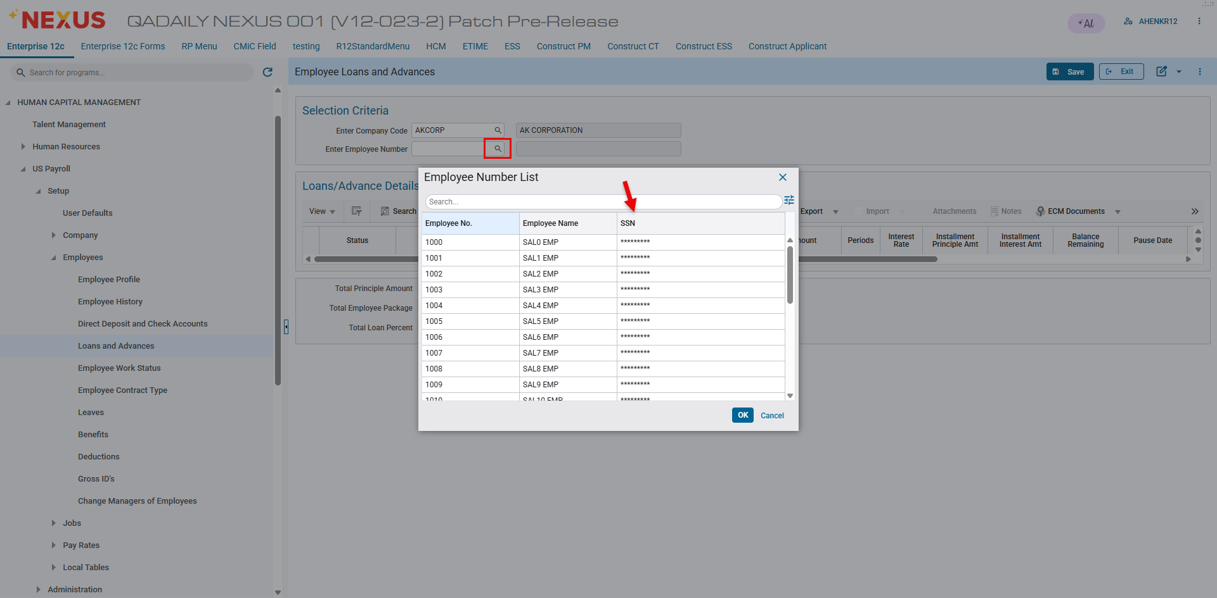
Employee Direct Deposit
The SSN should be masked in the Employee Direct Deposit/Employee List of Values (LOV) when the privilege is not selected.
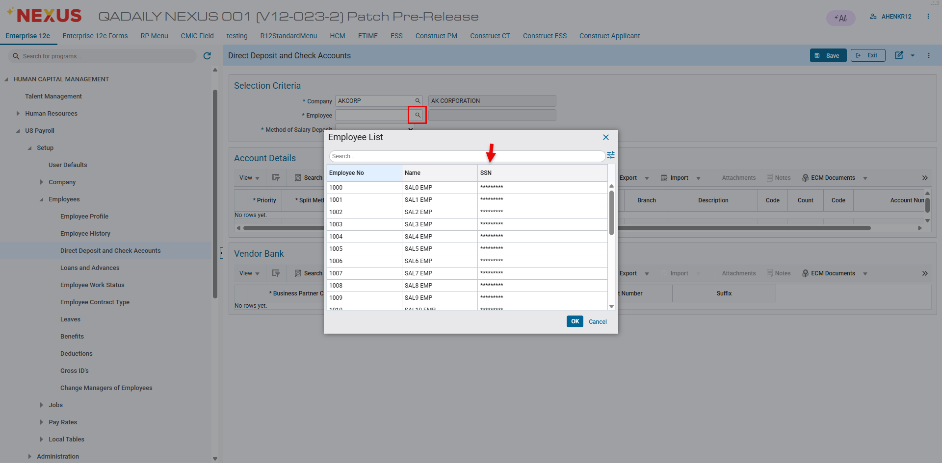

Performance Review
The SSN field should be masked in the Performance Review screen when the privilege is not selected.
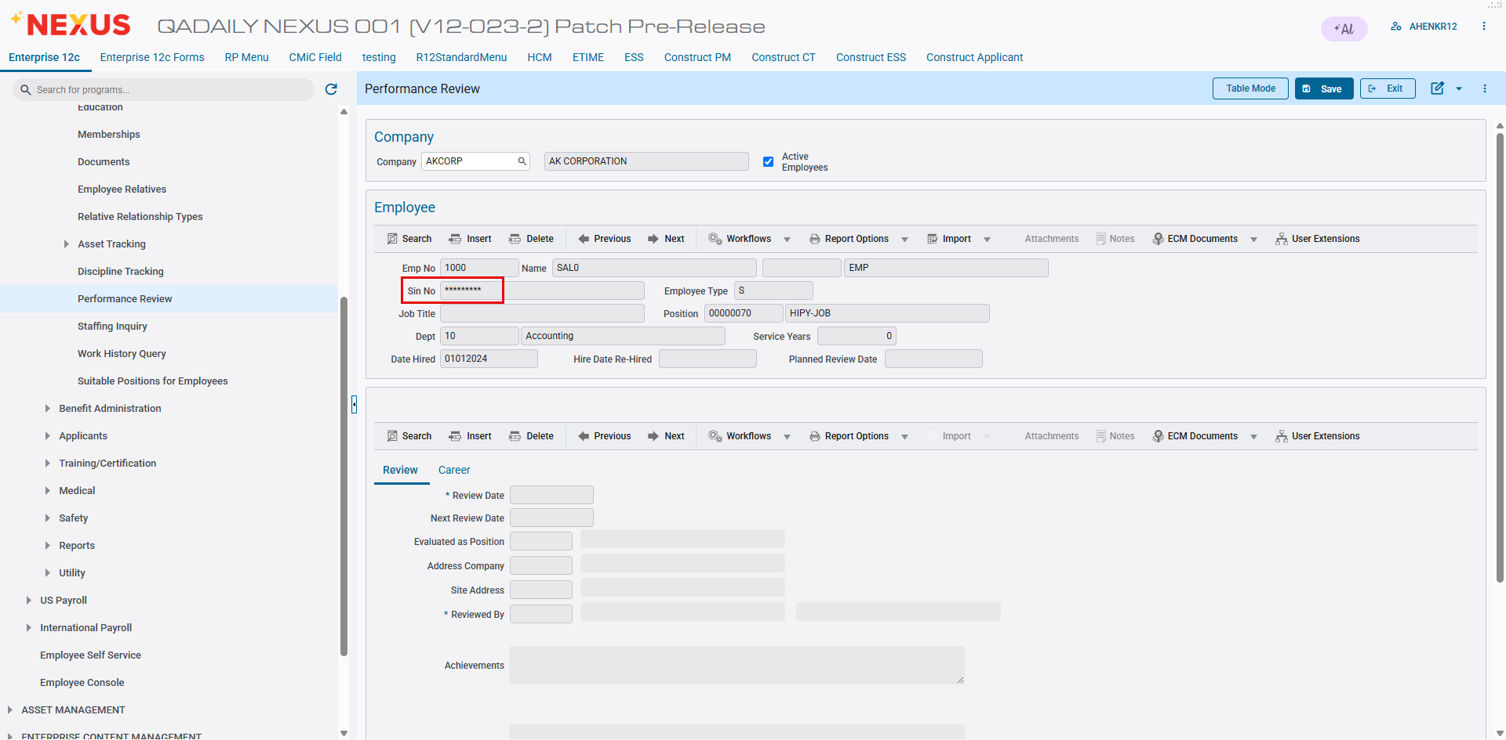

Employee/Applicant Documents
The SSN should be masked in the Employee/Applicant Documents - Employee List of Values (LOV) when the privilege is not selected.
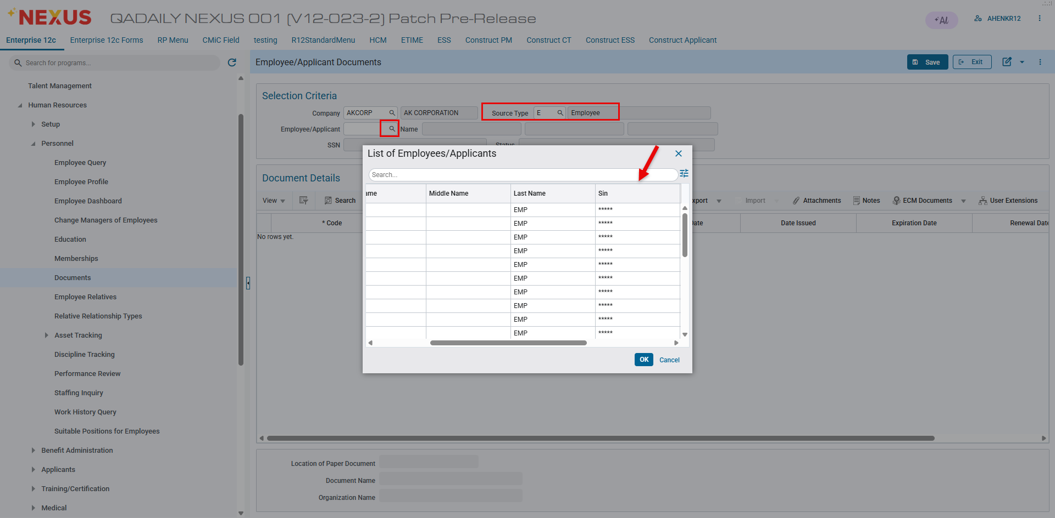

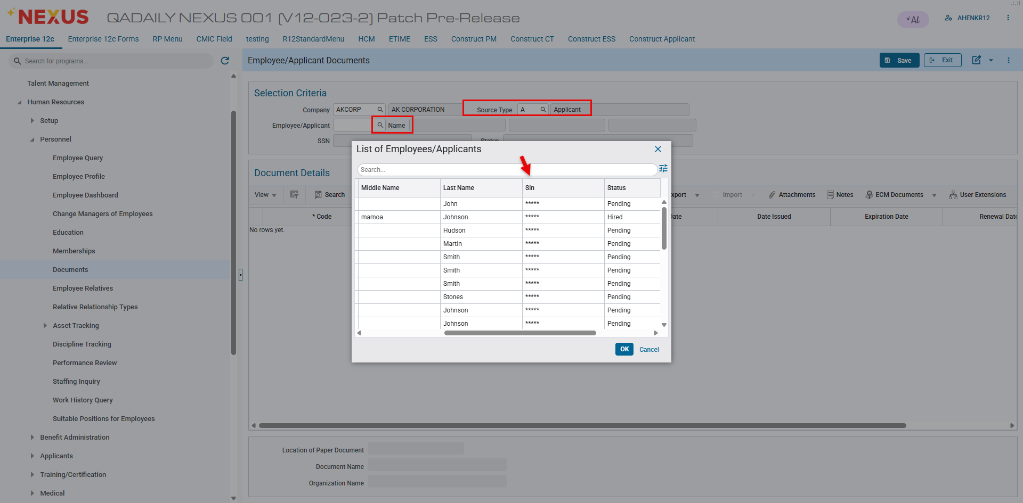

Employee/Applicant Certification/Licenses
The SSN should be masked in the Employee/Applicant Certification/Licenses - Employee List of Values (LOV) when the privilege is not selected.
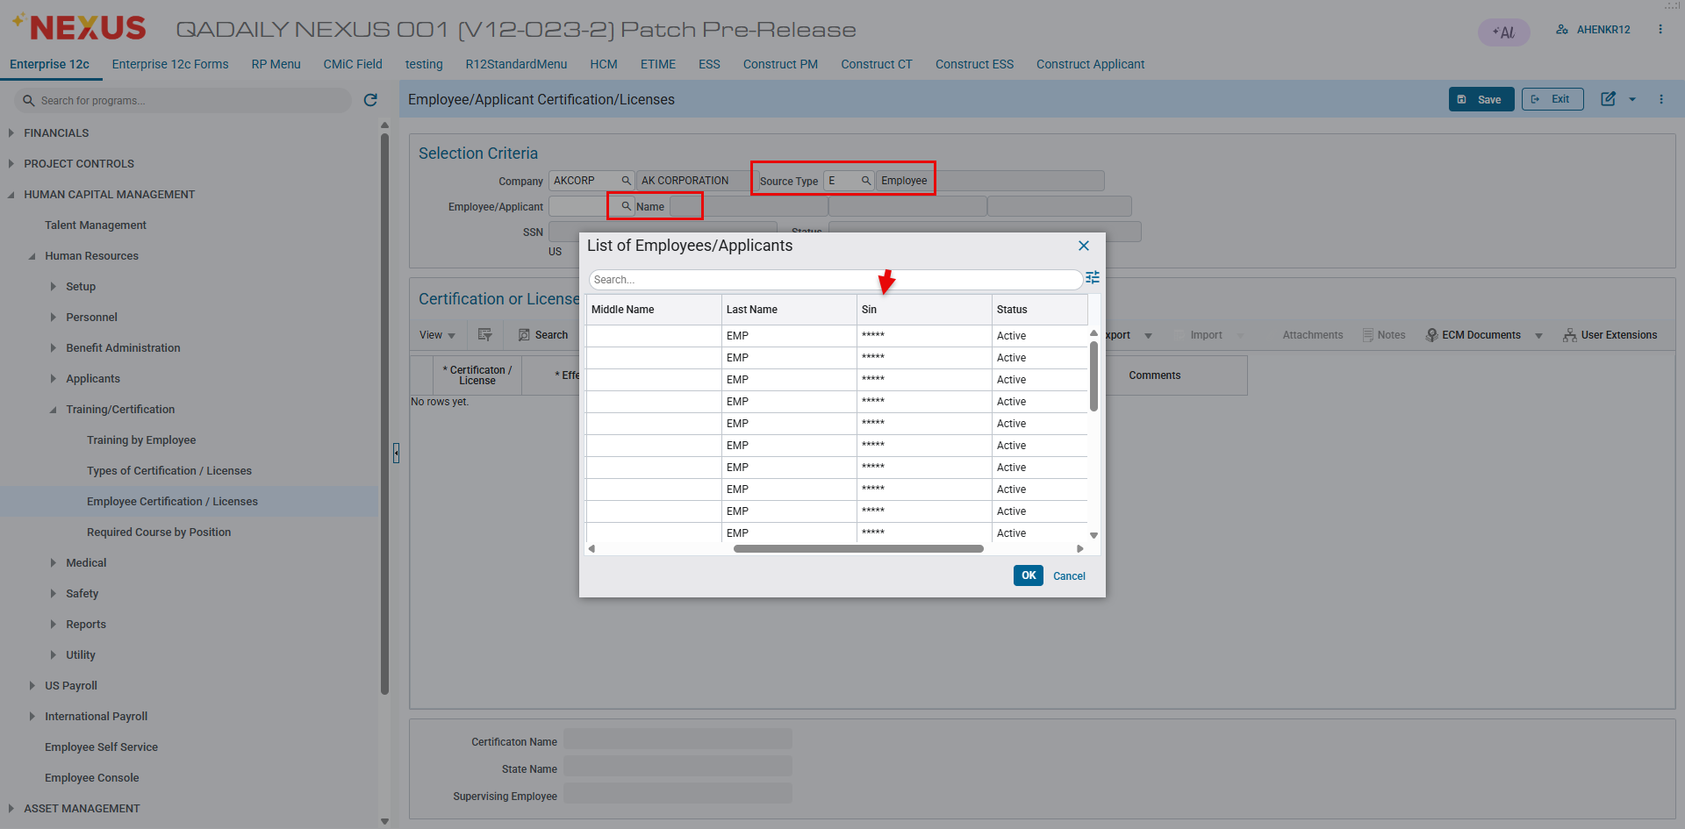

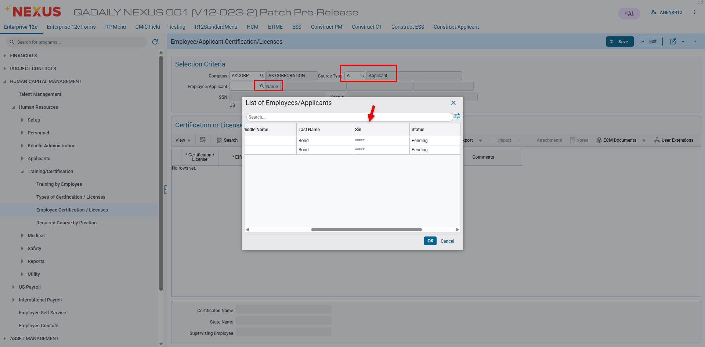

International Payroll

Emailing T4s & RL1.P- Preferred Contact Method destination option added to T4 forms program (HCM-3586)
Overview
The Preferred Contact Method (PCM) functionality has been integrated into T4 forms, similar to the Pay Stub Printing program. When users generate and send T4s, a confirmation email or summary notification can be sent to the user’s email address indicating that the T4s were successfully dispatched.
Pre-requisites
Fill the required parameters on the T4 forms and click on Print button and select PCM as the destination option. Once selected the E-Mail option populates similarly to paystub printing program with schedule option of Run Now or Run On.
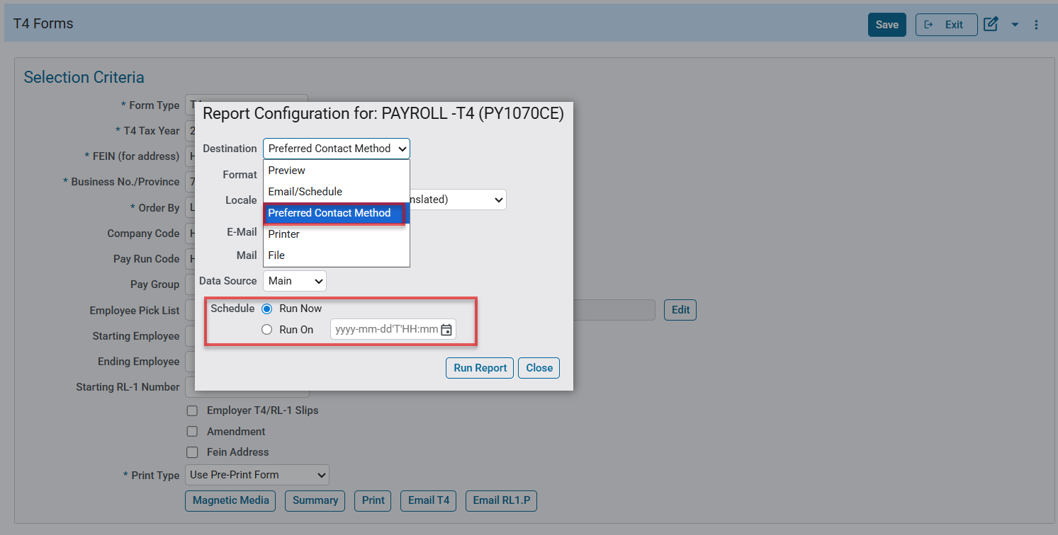
Path: International Payroll> Government Forms> T-4 Forms
Modifications
*Note: PCM Functionality has been added to Form Type of T4, RL1.P and RL1 similar to PYSTUB.
PCM is not added to T4A.

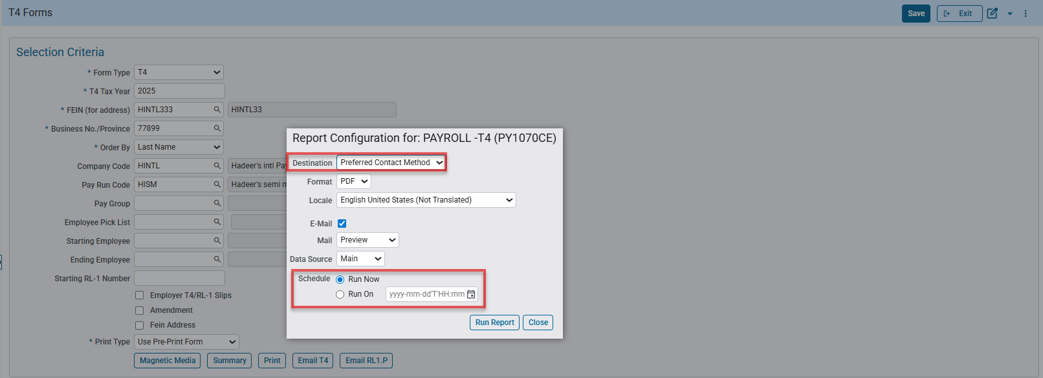
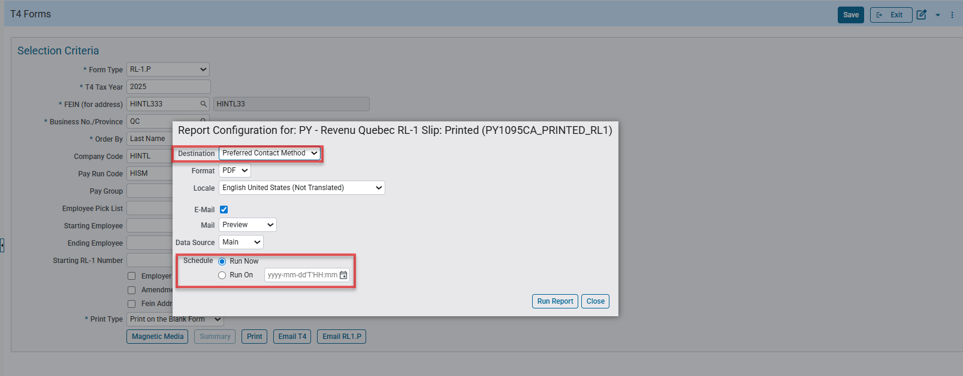Path: International Payroll> Government Forms> T-4 Forms
Implementation
The new Preferred Contact Method have been implemented into T4 Forms program as shown below is an example:
- Select T4 as the form type and fill in the required parameters such as *T4 Tax Year, *FEIN (for address), *Business No./Province, *Order By and optional parameters for more specified data fill in Company Code, Pay Run Code, etc.
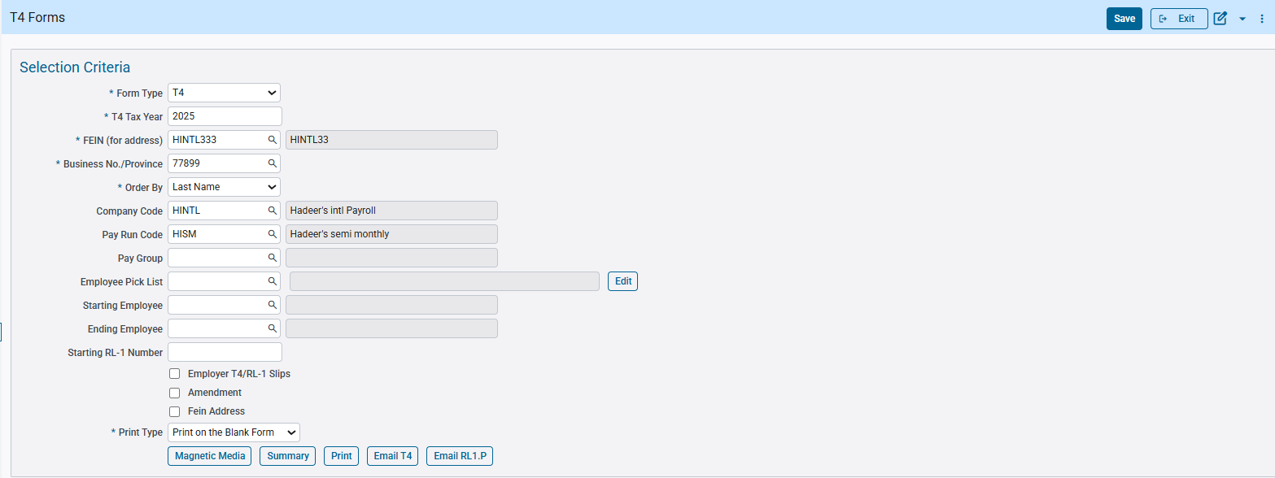
- Click on Print and select Destination as Preferred Contact Method.
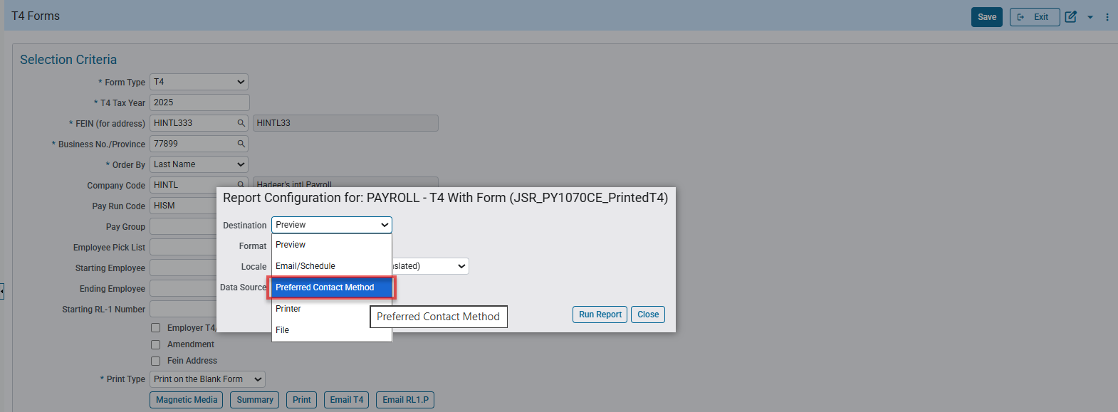
- Select one of two options for scheduling T4 either by (Run Now or Run On) a specified date and time.
- Click on Run Report and Ok button on the Email Confirmation popup message.
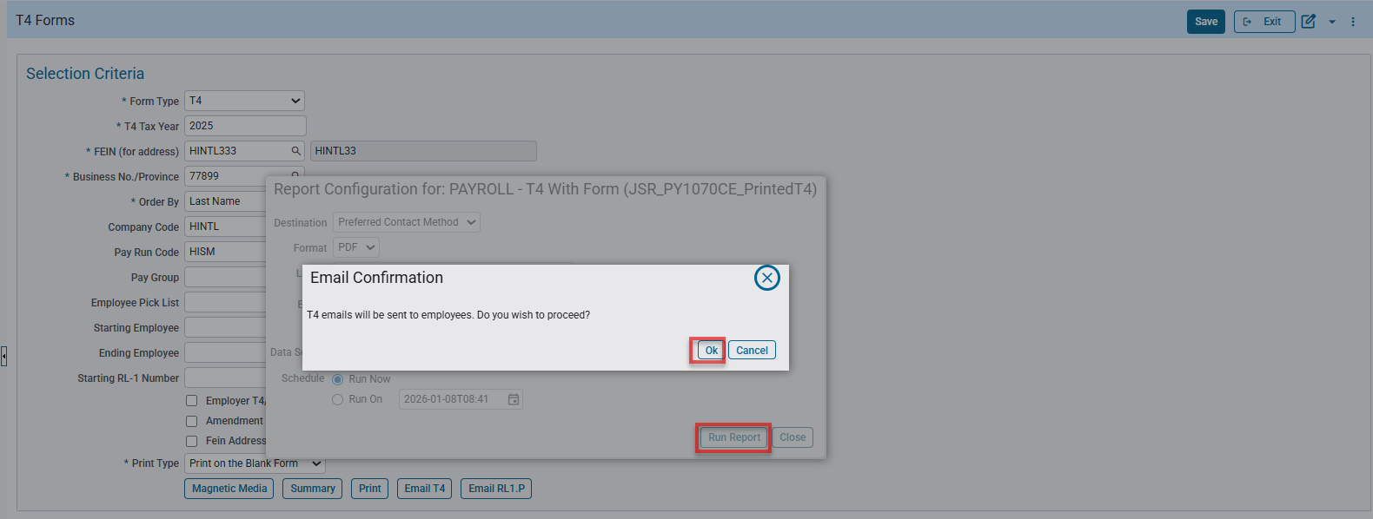
- A new page for T4 printing opens loading/processing reports ending up in a message to show how many T4 reports successfully scheduled and sent to the destination email.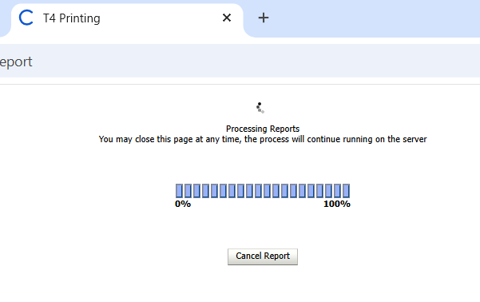
- 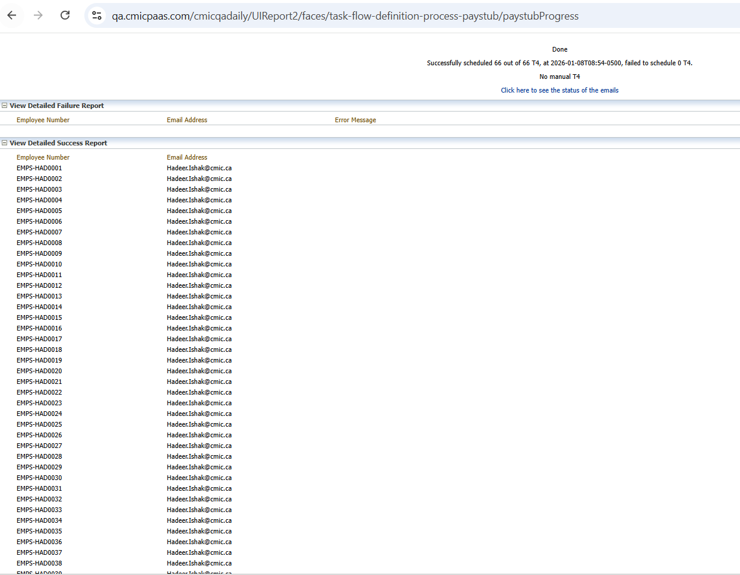
- Email Reception – Received (66) T4 reports on Outlook Email.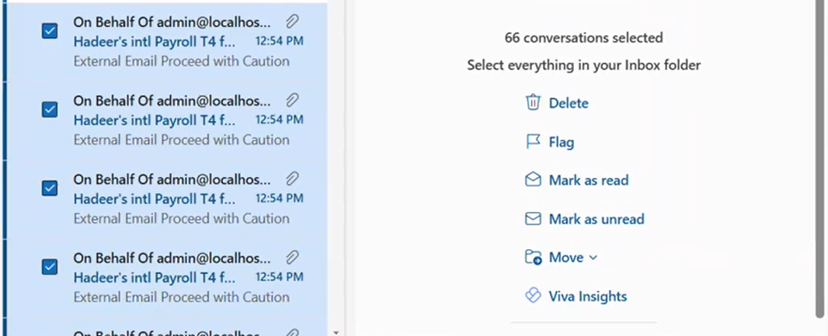
- Verify T4 report email with password encryption by entering the first 3 characters of your last name followed by the last four digits of your SIN number.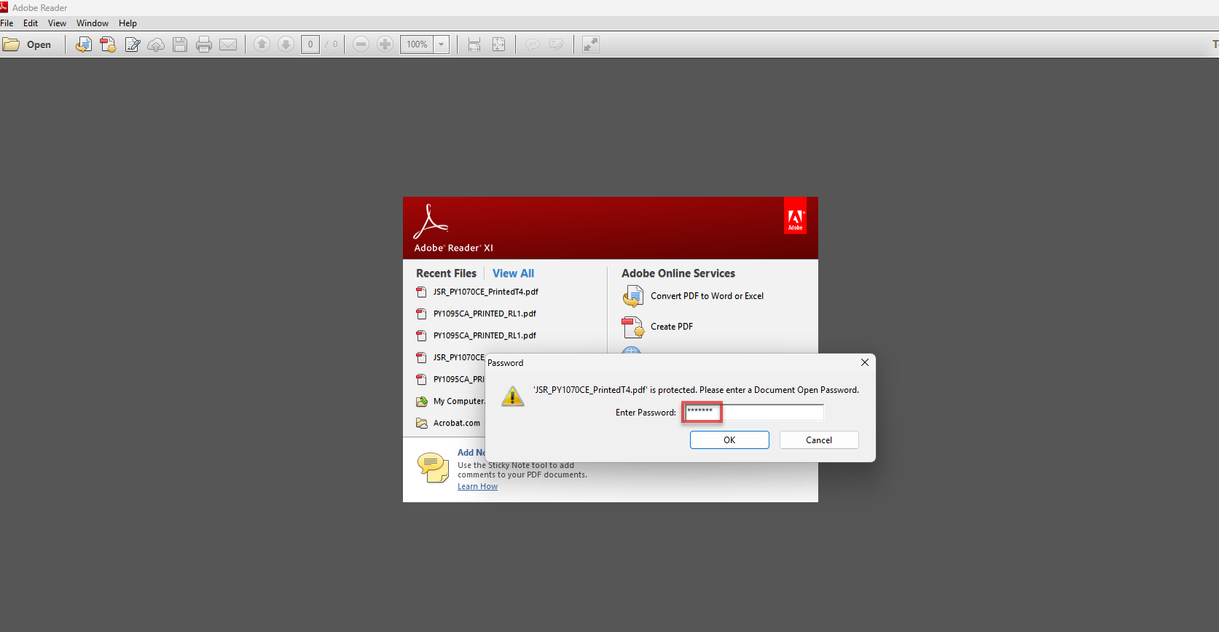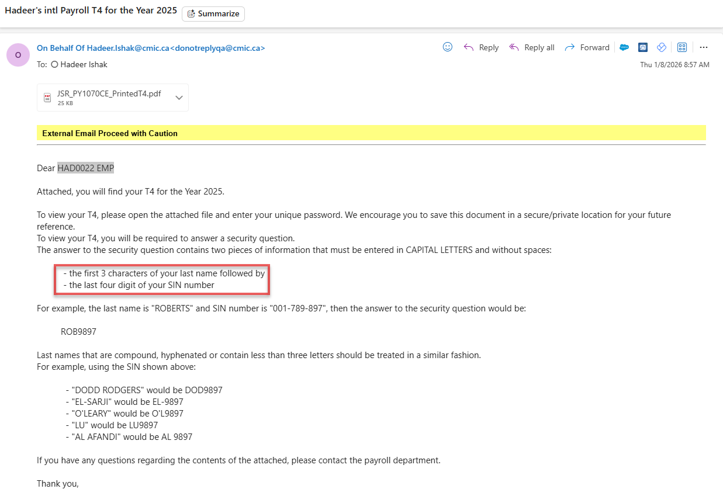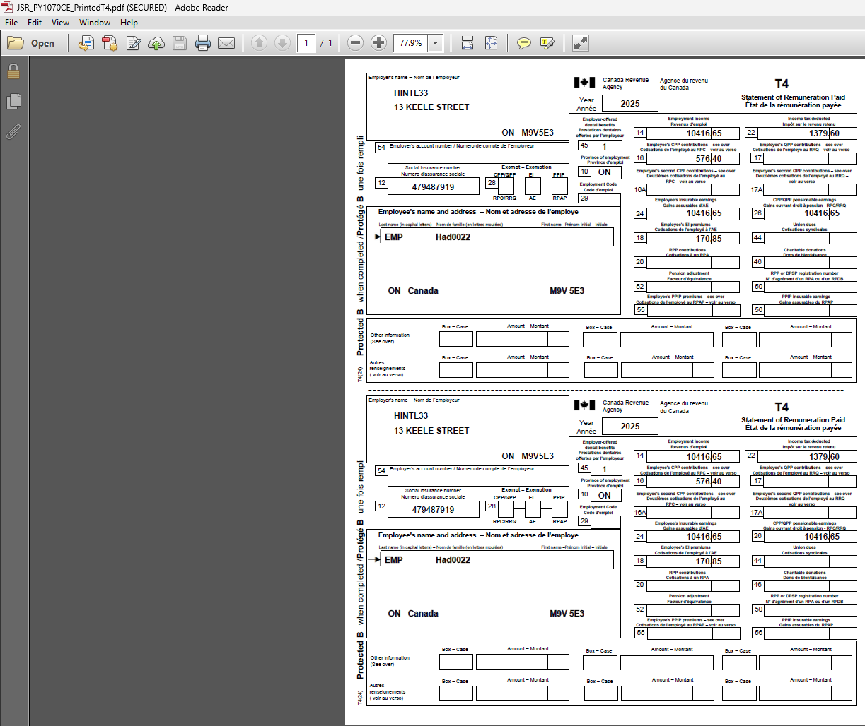
The new Preferred Contact Method is also implemented into T4 Forms program for RL-1.P as shown in the example below:
Steps are similar to the example above for T4 Form Type except for RL-1.P the parameters differ:
- Enter the parameters for RL-1.P and click on Print.
- Select PCM as the destination and Run On with the specified date and time.
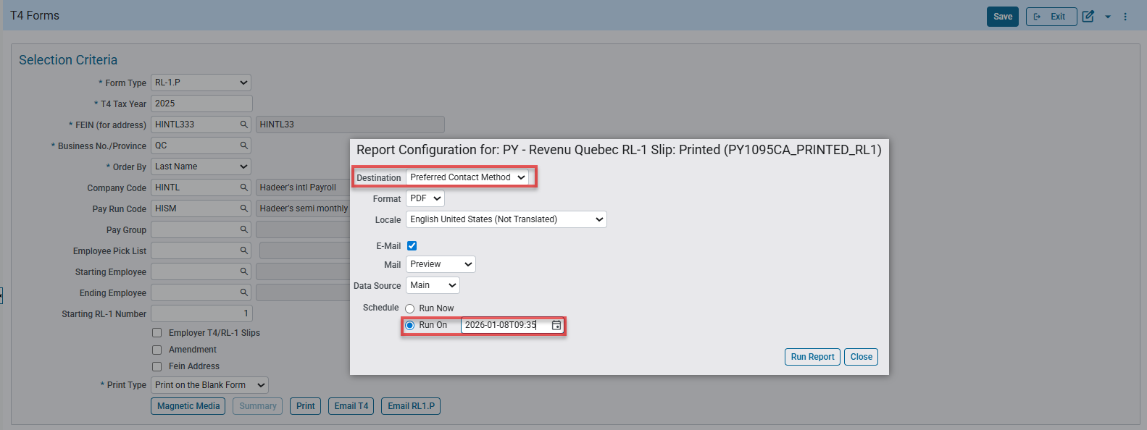
- Click Run Report then press Ok on the popup Email Confirmation message.
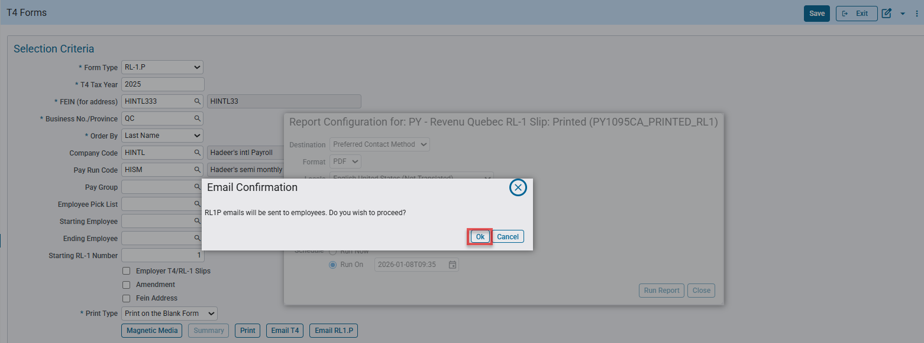
- A new page for RL1P printing opens loading/processing reports ending up in a message to show how many RL1P reports successfully scheduled and sent to the destination email.
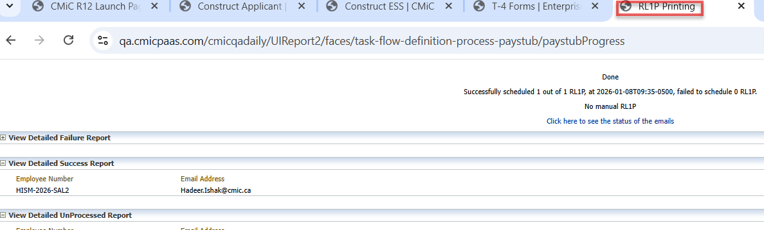

- Email Reception – Received (1) RL1-P reports on Outlook Email.

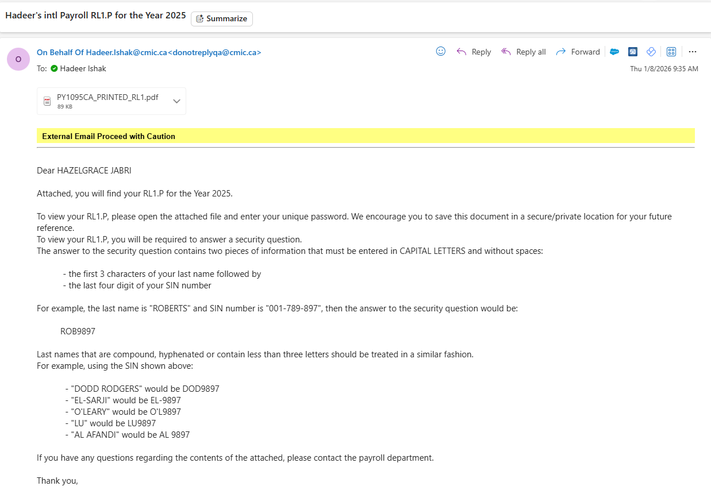
- Verify RL1P-P report email with password encryption by entering the first 3 characters of your last name followed by the last four digits of your SIN number.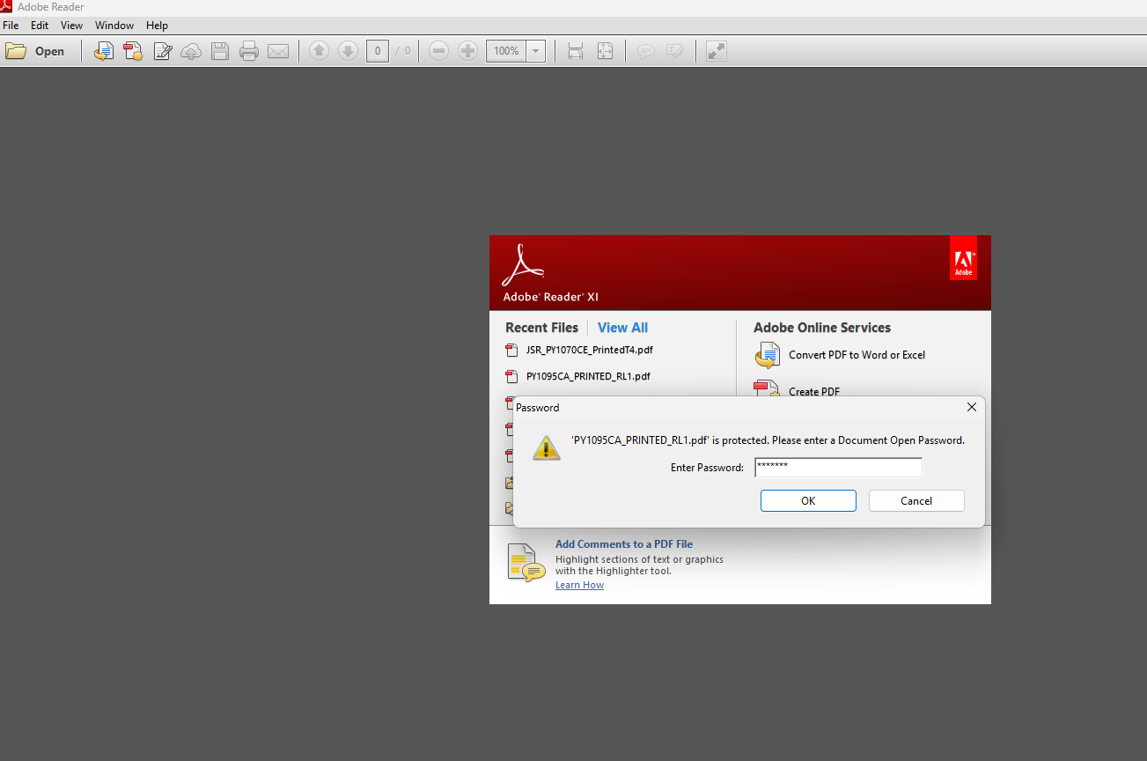
- 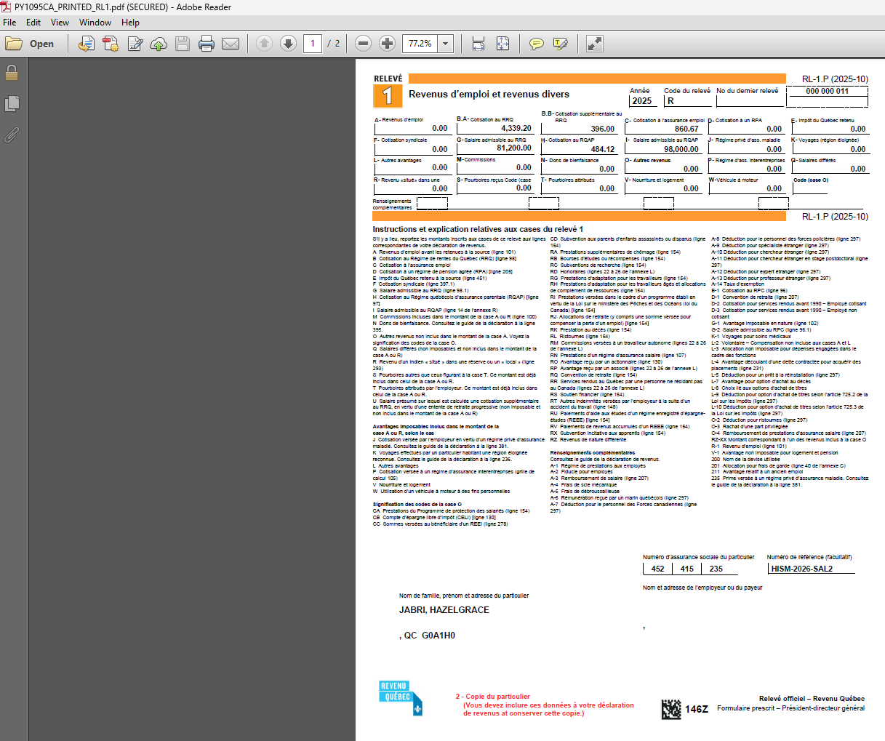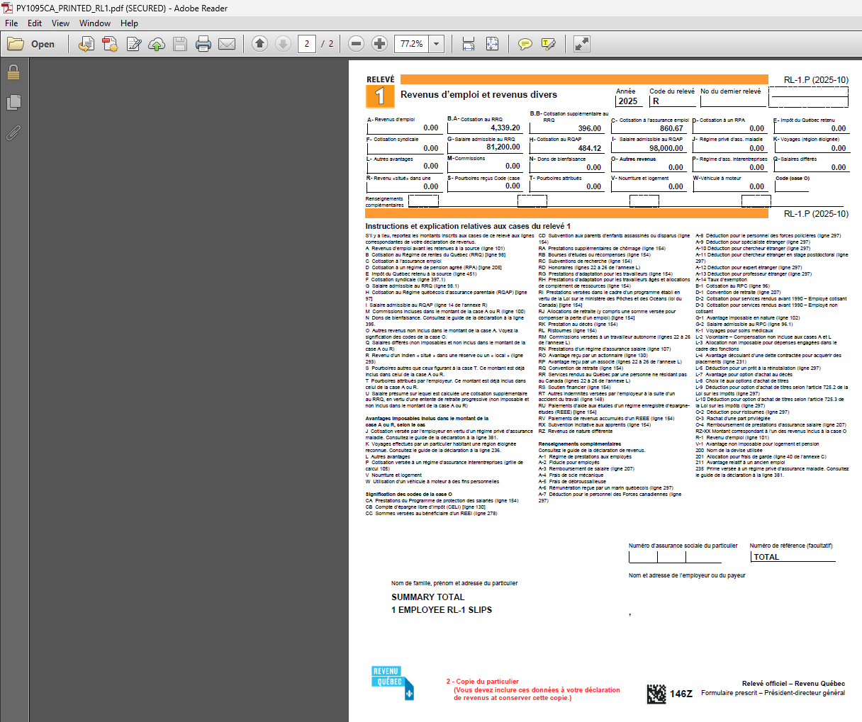

CRA T619 header modifications for T4/T4A XML Format of 2026 Electronic Transmittal changes (HCM-25480)
Overview
For 2026, the T619 XML specification has been updated to improve data accuracy and prevent submission errors. The language code (<lang_cd>) is now mandatory and must be set to either English (E) or French (F). Rules for acceptable characters have been tightened, including a restriction on spaces, hyphens, and special characters in the Submission Reference ID (<sbmt_ref_id>). Additionally, optional fields without values must be removed from the XML file to avoid system rejections.
Pre-requisites
Required Fields for T619 –
- TransmitterAccountNumber Required
- TransmitterRepID Required
- Language code Required
- Transmitter Country Code Required
- Transmitter Contact Name Required
- Transmitter Contact Area Code Required
- Transmitter Contact Telephone Number Required
- Transmitter Contact Email Required
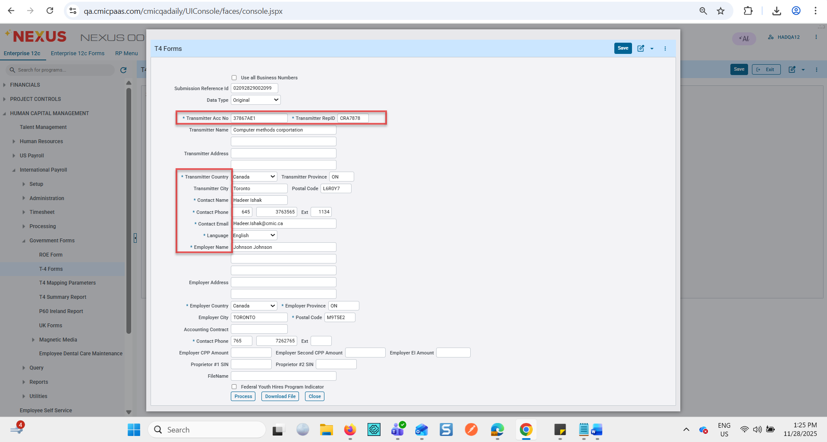
Modifications
T4/TA header has changed with the following modifications:
- Transmitter Account Number (<TransmitterAccountNumber>)
  - Required if signed in via MyBA or WAC.
  - Options:
    - <bn9>: 9 numeric (MyBA only)
    - <bn15>: 15 alphanumeric (BN15 format, e.g., 000000000RP0000)
    - <trust>: 1 alpha + 8 numeric (e.g., T00000000)
    - <nr4>: 3 alpha + 6 numeric (e.g., AAA000000)
- Transmitter RepID (<RepID>)
  - Required if logged in via RAC.
  - Up to 7 alphanumeric.
- Submission Reference ID (<sbmt_ref_id>)
- Up to 8 alphanumeric.
- No spaces, hyphens, or special characters.
- Unique per submission.
Summary Count (<summ_cnt>)
- Up to 6 numeric (total summary records).
Language Code (<lang_cd>)
- Required, 1 alpha:
  - E = English
  - F = French
Transmitter Name (<l1_nm>)
- Up to 35 alphanumeric.
Country Code (<TransmitterCountryCode>)
- Required, 3 alpha (ISO 3166 codes, e.g., CAN, USA).
Contact Information (<CNTC>)
- Name (<cntc_nm>): Up to 35 alphanumeric.
- Area Code (<cntc_area_cd>): 3 numeric.
- Phone (<cntc_phn_nbr>): 3 numeric + hyphen + 4 numeric.
- Extension (<cntc_extn_nbr>): Up to 12 numeric.
- Email (<cntc_email_area> and <sec_cntc_email_area>): Up to 60 alphanumeric.

Implementation
The following are examples of the new changes in T4/4A header based on the new modifications:
  - Click on Magnetic Media.
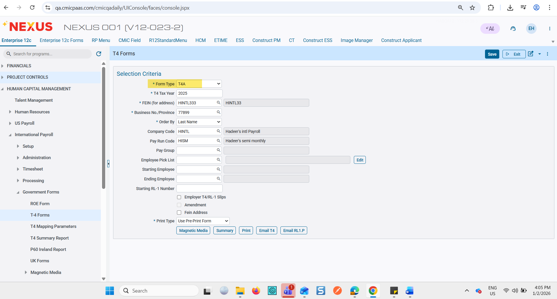

2- Fill all the required fields (*) based on the given specification on the CRA changes and click Process button followed by clicking Download File.
- The following screenshots showing Transmitter Account Number (<TransmitterAccountNumber>)
With the following 4 Options:
    - <bn9>: 9 numeric (MyBA only)
    - <bn15>: 15 alphanumeric (BN15 format, e.g., 000000000RP0000)
    - <trust>: 1 alpha + 8 numeric (e.g., T00000000)
    - <nr4>: 3 alpha + 6 numeric (e.g., AAA000000)
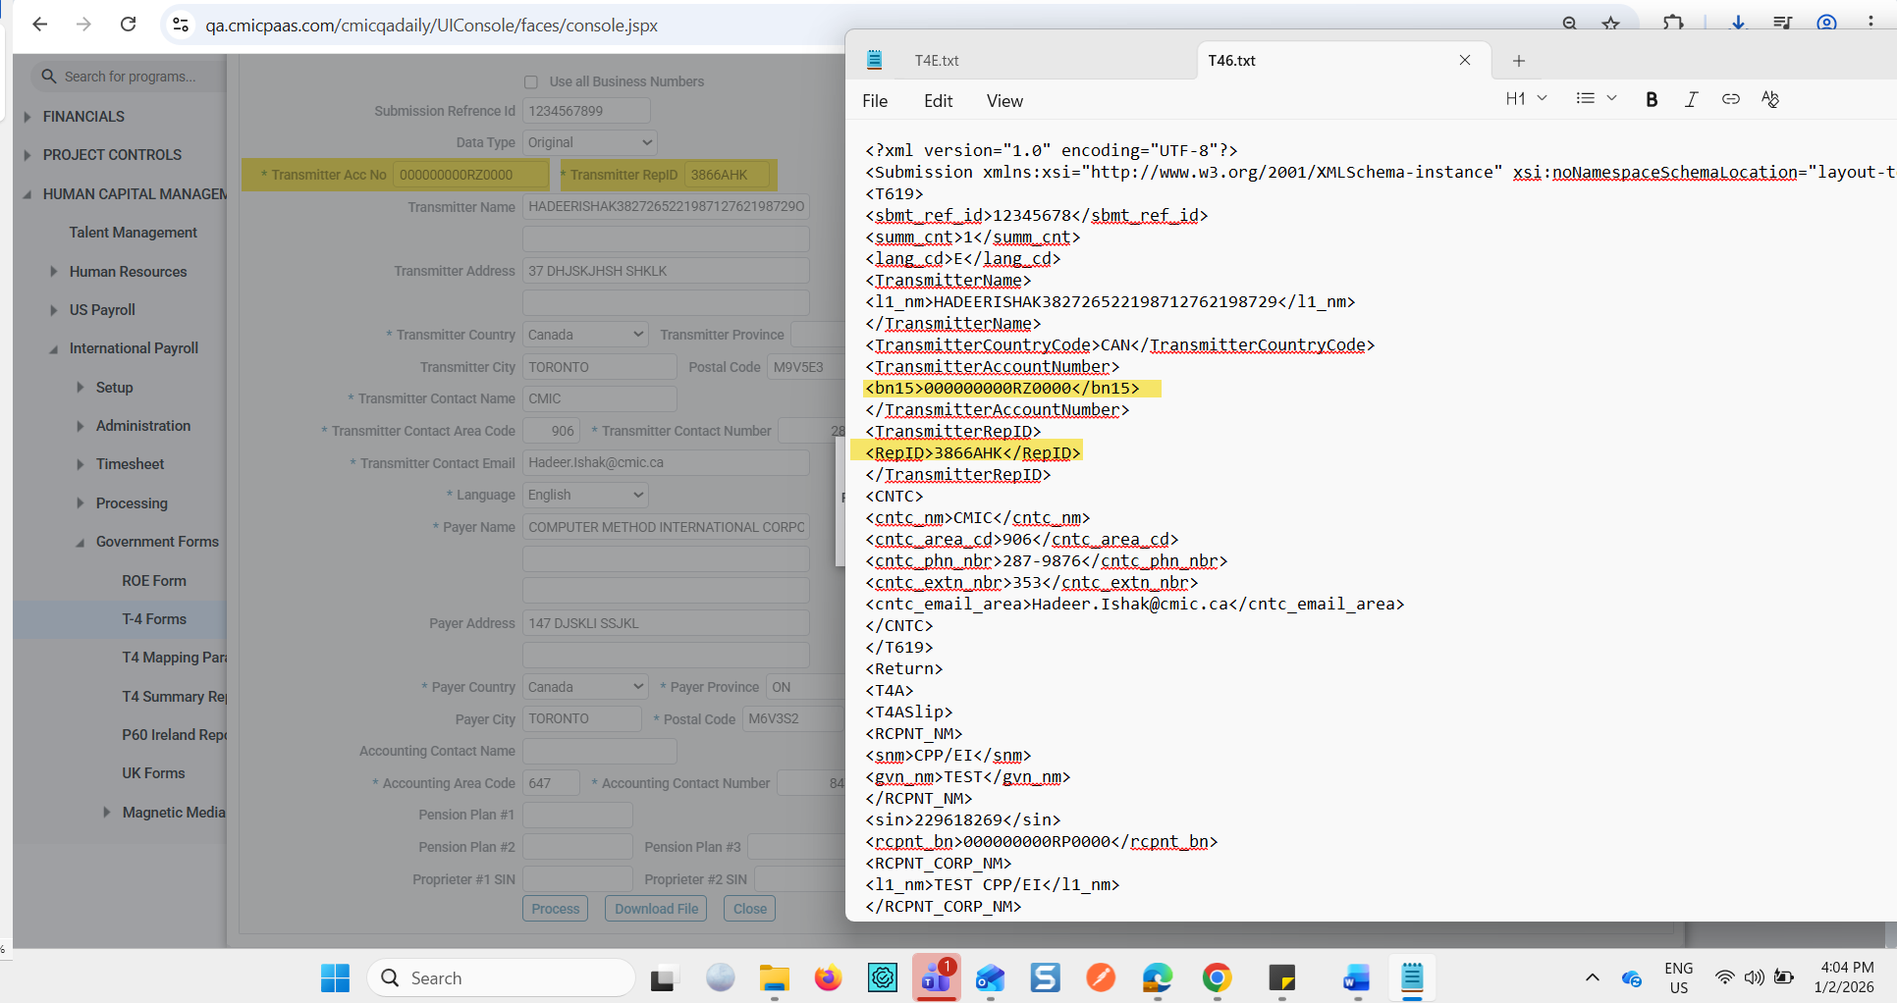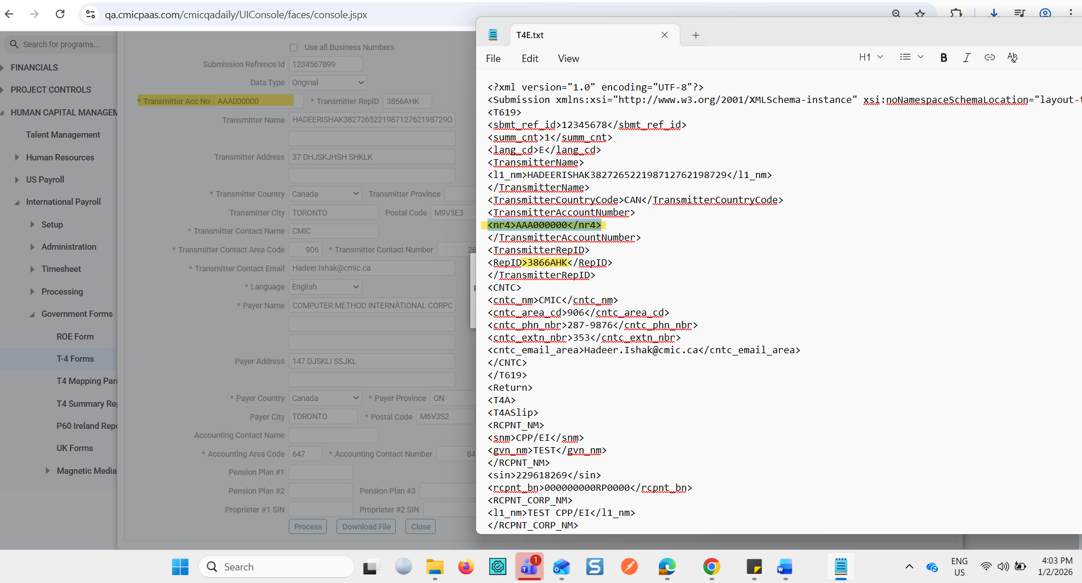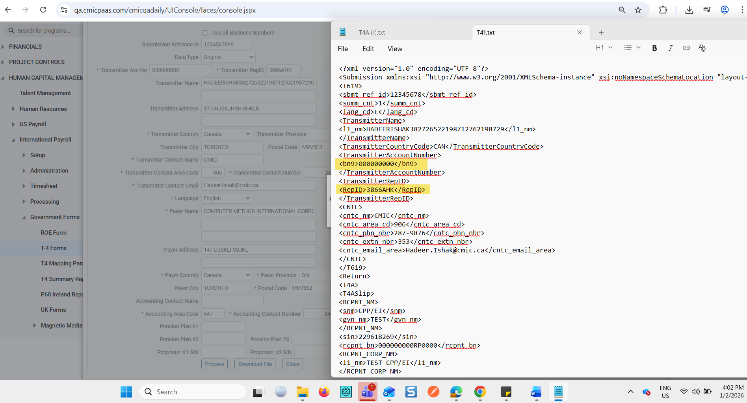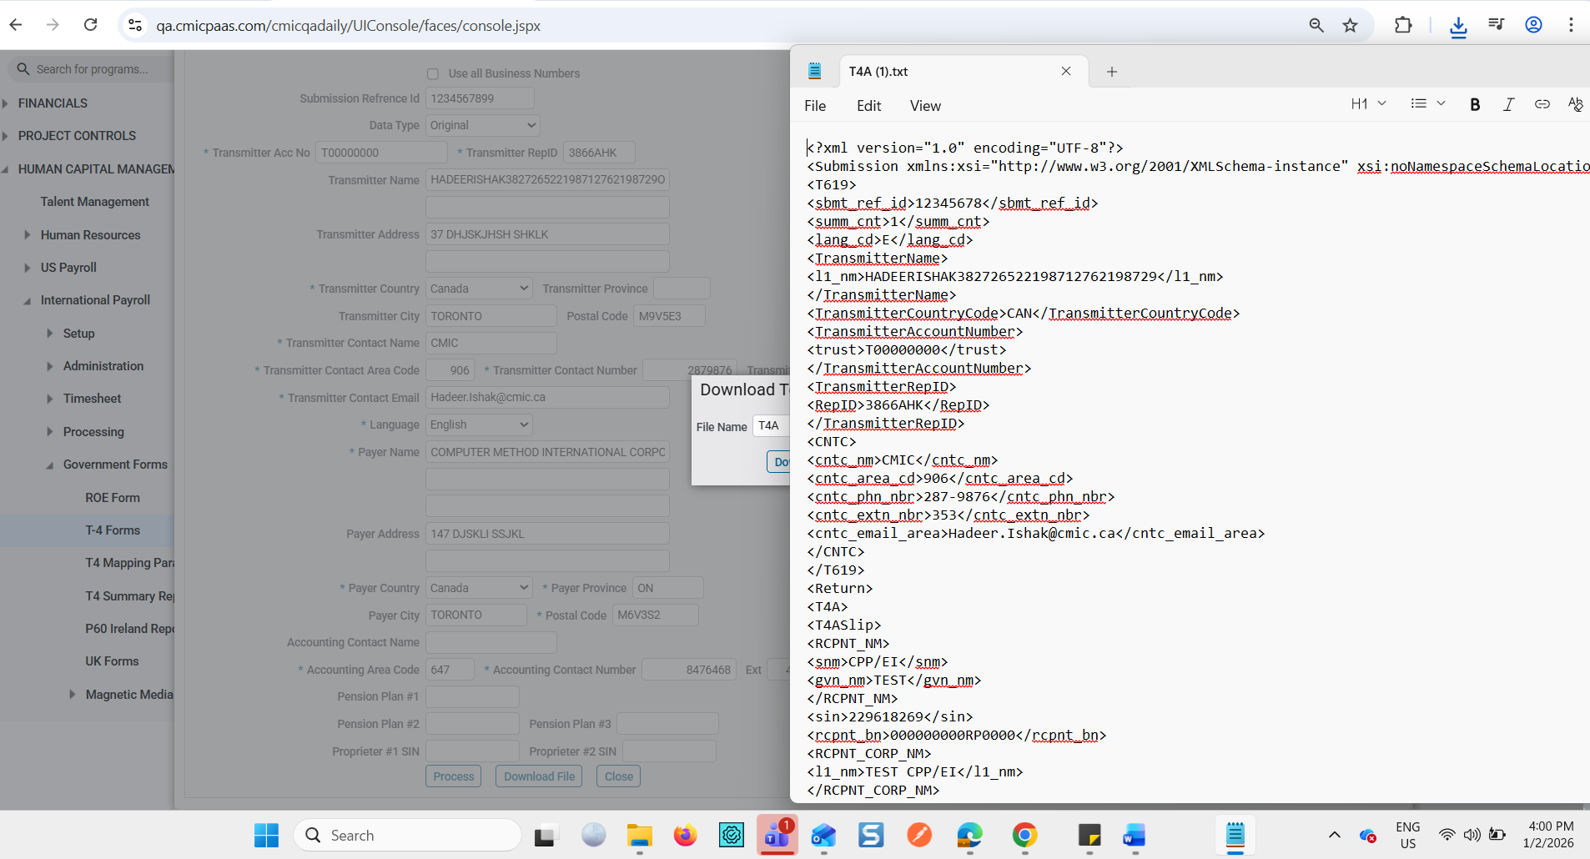

Imaging

Imaging Control – Enforce SOV Line Amount Limit (Voucher RFP) (ECMDEV-12840/ECMDEV-11956)
The Enforce SOV line amount limit (Voucher RFP)” flag is a newly introduced configuration flag within the Image Control module, specifically designed to support voucher-based Request for Payment (RFP). This flag activates enhanced validation logic in the Image Manager to ensure that Schedule of Values (SOV) lines adhere to subcontract-defined financial limits.
When enabled, the flag prevents users from entering or modifying any SOV line in a way that causes the total amount to exceed the amount allocated to that line in the associated subcontract.
Pre-requisites
- Subcontract SOV line amounts must be defined and available for validation.
Modifications
The following modification has been introduced:
Imaging Control
- A new column/flag named Enforce SOV line amount limit (Voucher RFP)” has been added to the Imaging Control screen.
- When enabled:
  - The Image Manager enforces SOV line amount validation for Voucher RFPs.
  - Users are restricted from entering or modifying SOV line amounts that exceed the subcontract-defined limit.
- When disabled:
  - Standard behavior applies, and no additional SOV validation is performed for Voucher RFPs. No other screens or modules were modified as part of this change.
Implementation
Below are examples of how the new flag affects system behavior:
Example 1: Enabling the Flag
- Navigate to Imaging Control in system configuration.
- Locate the new option “Enforce SOV line amount limit (Voucher RFP)” and set it to Enabled.
- Save the configuration.
Once enabled, the system immediately begins enforcing SOV line amount limits for all Voucher-based RFPs.
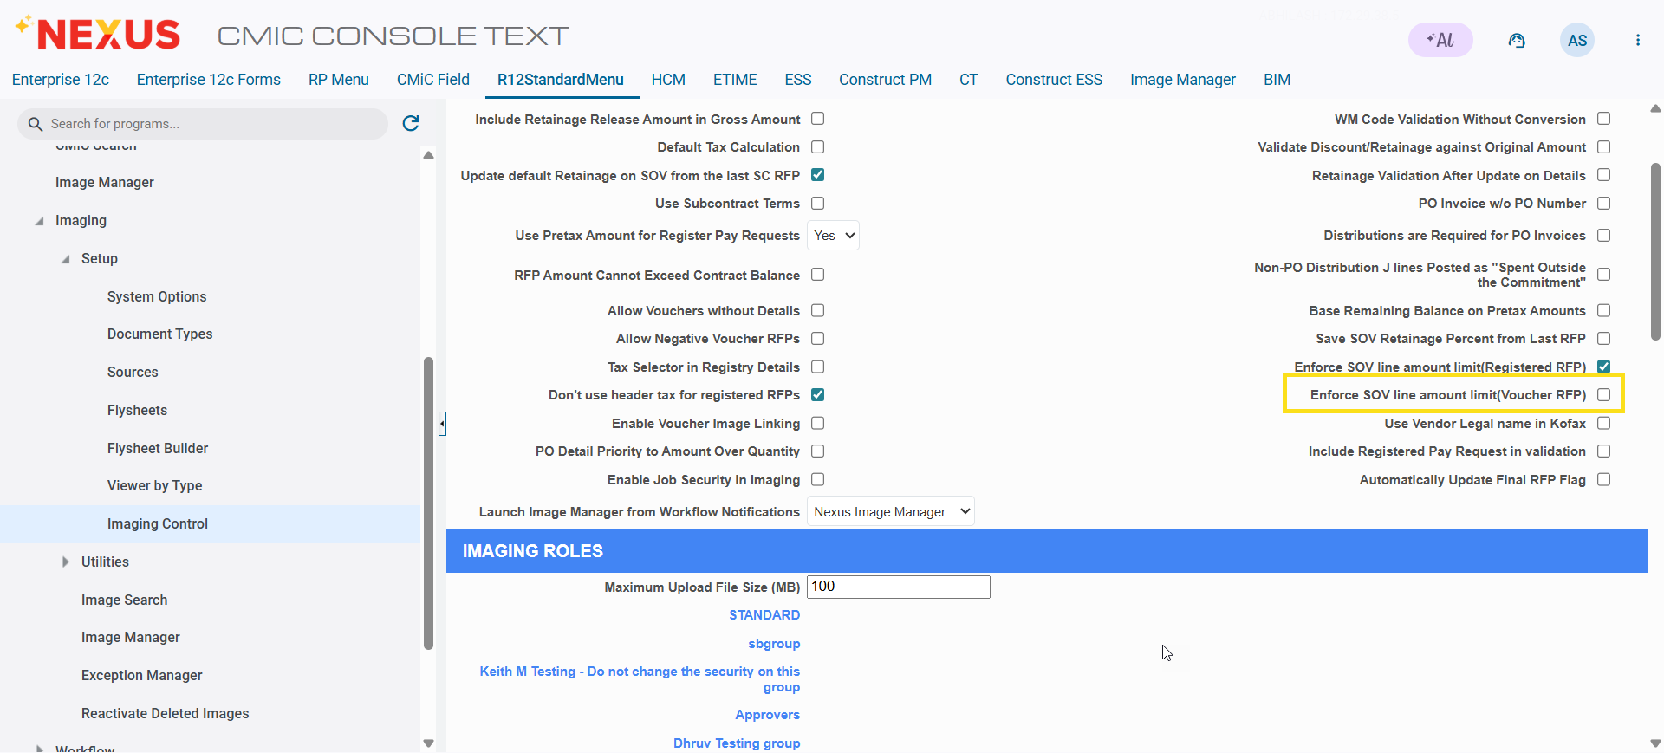

Example 2: User Attempts to Exceed SOV Limit
- A user enters a Voucher RFP and attempts to add an SOV line with an amount greater than the subcontract’s allocated value.
- The system displays a validation message preventing the entry.
- The user must adjust the amount to fall within the allowed limit before proceeding.

Example 3: Editing an Existing SOV Line
- A user attempts to modify an existing SOV line to increase the amount.
- If the new amount exceeds the subcontract limit, the system blocks the update and prompts the user to correct the value.

Vendor Primary and Alternate Address Enhancement (ECMDEV-5397)
This patch delivers an enhancement to the Imaging – Standard SC Pay Request (RFP) to ensure correct sourcing and display of vendor address information. The change addresses two address fields: the Primary Vendor Address and the Alternate (Remit-To) Address. The Primary Address is now sourced exclusively from Maintain Vendors > Vendors tab, while the Alternate Address is populated from the Kofax invoice integration when provided and left blank when not specified.
Pre-requisites
- CMiC Accounts Payable and Imaging modules must be enabled.
- Kofax invoice integration must be active and configured.
- Vendor records must exist in Maintain Vendors.
- User must have access to AP Imaging RFP screens.
Modifications
1. Primary Vendor Address (VOU_VEN_PRI_ADD_NAME)
The Primary Vendor Address field is corrected to source data exclusively from Maintain Vendors > Vendors tab. The address is displayed as a single concatenated string with no address code or LOV.
Format: Address Line 1, Address Line 2, City, State Code, Zip/Postal Code, Country.
2. Alternate Address (Remit-To Address)
The Alternate Address field is now populated when an alternate address is provided by the Kofax invoice. The address corresponds to one of the address codes defined in Maintain Vendors > Business Partner Address. If no alternate address is supplied by Kofax, the field remains blank.
Implementation
Primary Address: When creating or viewing an AP Imaging RFP, the Primary Address field displays the concatenated vendor address from Maintain Vendors > Vendors tab.
Alternate Address: When the Kofax invoice includes an alternate remit-to address, the Remit Address field on the RFP displays the corresponding Business Partner Address. If no alternate address is supplied by Kofax, the field remains blank.

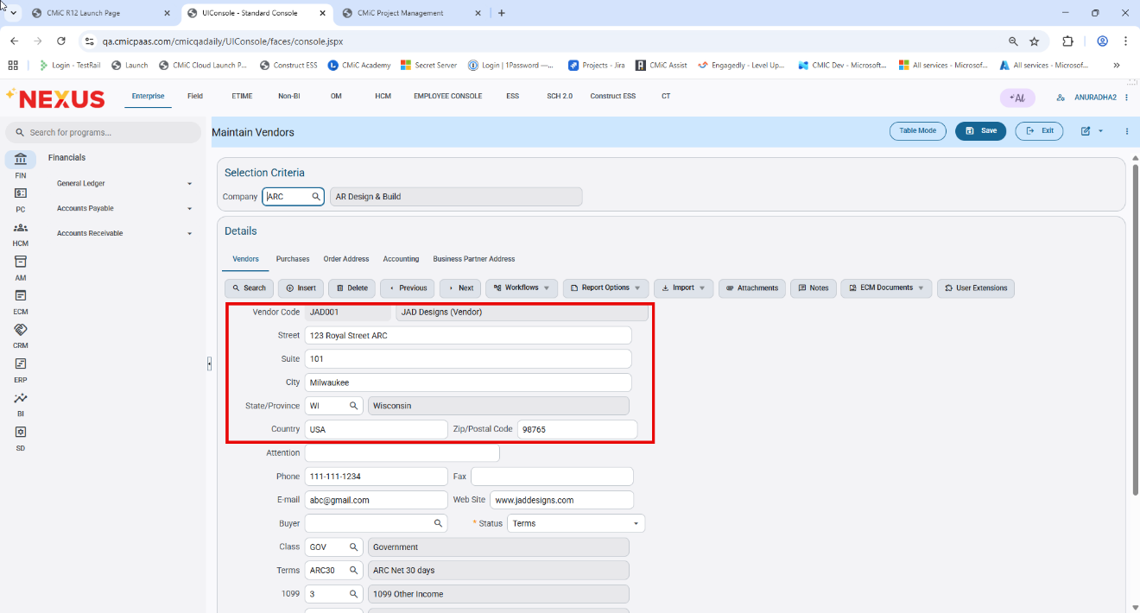
Pgm: Maintain Vendors; Standard Tree view path: Accounts Payable > Setup > Maintain Vendors
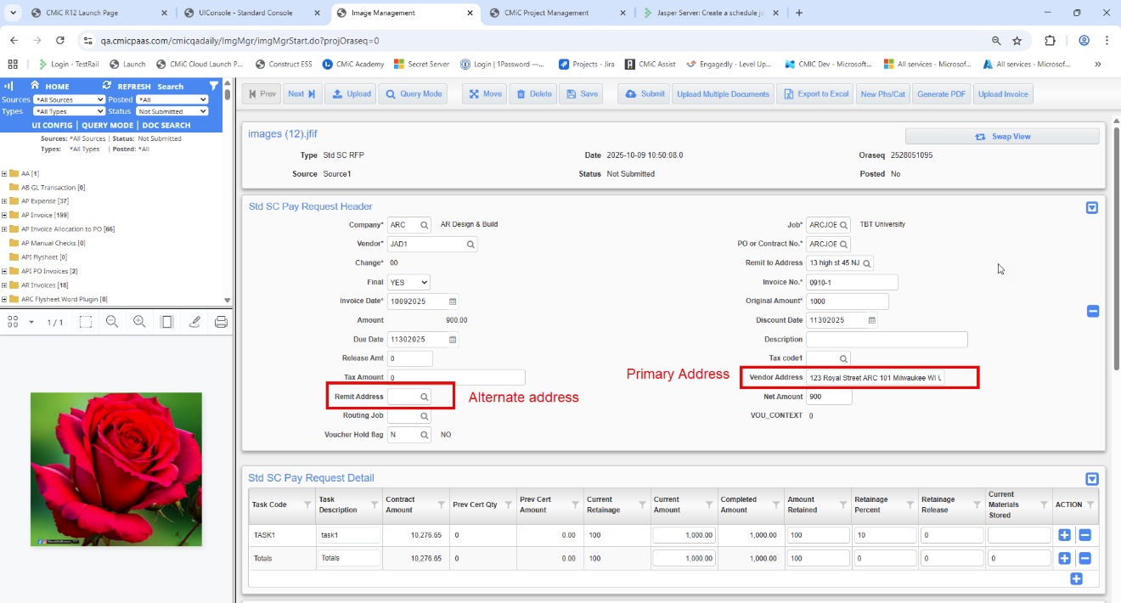

Job Billing

JBPB_U11CW- US Progress Bill Inv (Ret) Invoice format. (JBJCPC-3963)
Overview
A new standard report, JBPB_U11CW, has been created based on JBPB_U11 with updated formatting, revised text, and a detailed retainage breakdown for Completed Work and Stored Material.
Modifications
The JBPB_U11CW invoice format has been introduced as a new standard report based on JBPB_U11. The retainage section has been enhanced to display retainage percentage and amounts separately for Completed Work and Stored Material, using a single calculated retainage percentage derived from net retainage. The same percentage is applied consistently to both Completed Work (Columns D + E) and Stored Material (Column F), while ensuring the total retainage continues to match Column I of the G703CW report.
Additional formatting updates include revised header text, updated item descriptions, enhanced Schedule of Values column structure, and added calculation references for improved clarity. No calculation logic has changed except for the retainage breakdown presentation.
Implementation
Go to Job Billing > G/c Prepare Billing > Select contract > Select “JBPC_U11CW” invoice format and print the report.
1. Updated report header text to “Application and Certificate for Payment for Cost of the Work Projects with a Guaranteed Maximum Price”.
2. Updated Item 1 description to “ORIGINAL GUARANTEED MAXIMUM PRICE”.
3. Updated Item 3 description to “GUARANTEED MAXIMUM PRICE TO DATE (Line 1 ± 2)”.
4. Item 5 (Retainage) is enhanced to display retainage percentage and amount separately for Completed Work and Stored Material.
5. Retainage percentage is calculated as (Total Retainage Held– Total Retainage Released) / Completed & Stored and displayed up to two decimal places.
NOTE: Refer to Total Ret % column in G/c Prepare billing-Bill code details
6. Applied the same retainage percentage to Completed Work (Columns D + E) and Stored Material (Column F) from the G703CW Schedule of Values.
7. Ensured the Total Retainage continues to match Column I of the G703CW report.
8. Added column references under retainage items 5.a and 5.b for clarity.
9. Updated Item 9 description to “GUARANTEED MAXIMUM PRICE BALANCE, INCLUDING RETAINAGE”.
10. Added the text “for Cost of the Work Projects” to the Continuation Sheet header.
11. Updated the certification text to include revised wording.
12. Broke down Column C into C1 (Original), C2 (Change from Previous Applications), C3 (Change This Period), and C4 (Current Total) under the Scheduled Value umbrella.
13. Added calculation details under the column titles for Material Presently Stored (NOT IN D OR E), Total Completed and Stored (D+E+F), Percent Complete (G/C4), and Balance to Finish (C4-G).
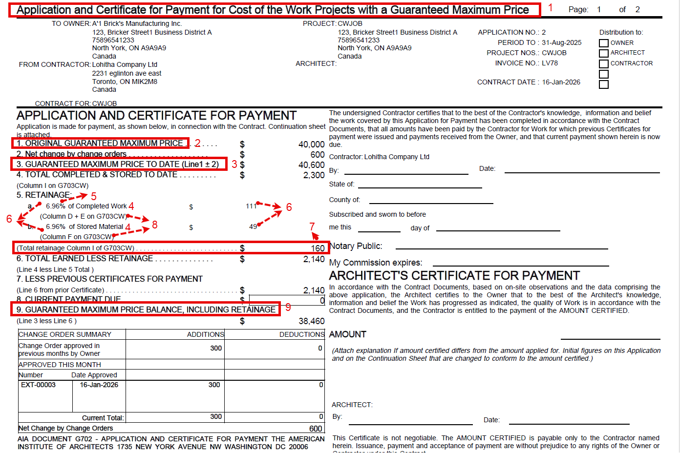
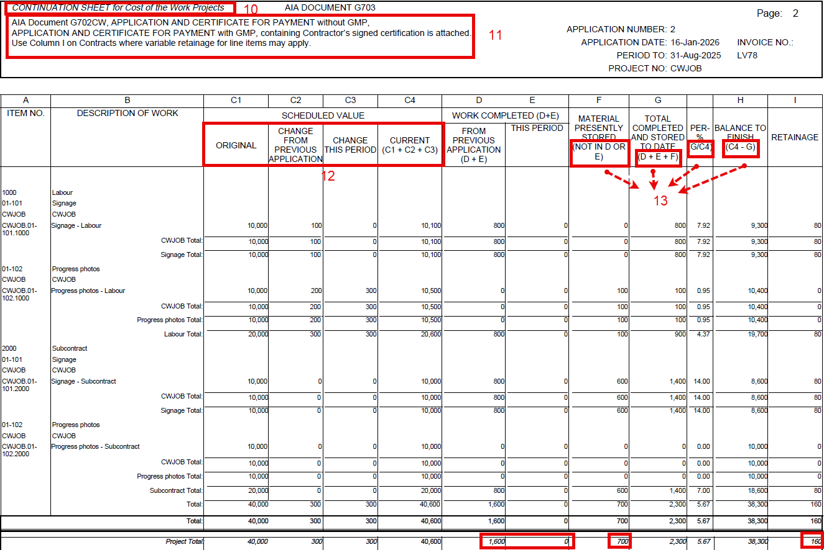
NOTE: There are no calculation changes for any item except the retainage breakdown (compared with JBPB_U11).

Create job contract via API (JBJCPC-4182)
The “/jb-rest-api/rest/1/jbcont” now allows creating JB Contract Headers. Contract creation, naming, and default field population follow the similar to rules as the CMiC UI.
Implementation:
The JB REST API provides the POST /jb-rest-api/rest/1/jbcont endpoint to create a new JB Contract Header. When sending a request, five fields are mandatory: JbcCompCode, JbcJobCode, JbcCurrCode, JbcInvoiceCurrCode, and JbcStartingDrawNum. All other fields are optional and, if not provided, the system automatically populates them based on job setup, customer data, and control file configurations.

Parameter | Description | Mandatory / Optional | Notes / Default Behavior
JbcCompCode | Company code for the contract | Mandatory | Must be provided in the request
JbcJobCode | Job code associated with the contract | Mandatory | Must be provided in the request
JbcCurrCode | Contract Currency | Mandatory | Must be provided; used for contract billing
JbcInvoiceCurrCode | Invoice currency for the contract | Mandatory | Must be provided
JbcStartingDrawNum | Starting draw number | Mandatory | Must be provided
JbcName | Same as Description Tab=> Name Field in UI | Optional | Automatically set to Job Name if not provided; It will be used for JbcContractName population
JbcContractName | Contract name field | Read-only | Derived automatically from JbcName
JbcContCode | Contract code | Optional | Populated automatically from job setup
JbcCustCode | Customer code | Optional | Populated automatically from job setup if not provided
JbcContDate | Contract date | Optional | Defaults to current system date if not provided
JbcRetCode | Retainage code | Optional | Populated automatically from job setup if not provided
JbcRoundHldbkAmtTo | Round Retainage Amount to | Optional | Populated from JB Control File if not provided
JbcRoundBillAmtTo | Round Billing Amount to | Optional | Populated from JB Control File if not provided
JbcRoundHldbkMethod | Retainage Round Method | Optional | Populated from JB Control File if not provided
JbcRoundBillMethod | Bill Round Method | Optional | Populated from JB Control File if not provided
JbcScRfpCostFlag | “Allow SC Request For Payment Creation From Billing Invoice” flag | Optional | Populated from JB Control File Invoice tab if not provided
JbcMatStoredInternal | “Material Stored Included In Calculated Billing Amount” flag | Optional | Populated from JB Control File Billing tab if not provided
JbcWipRollInFlag | “Roll in by JB-Contract” flag | Optional | Populated from JC Control File WIP tab if not provided
JbcUseScrfpHldbkRelFlag | “Use Release Retainage % From Last SC RFP” flag | Optional | Populated from JB Control File Billing tab if not provided
JbcExclNoninvReceipts | “Exclude Non-Invoiced Receipts” | Optional | Populated from JB Control File Billing tab if not provided

The API enforces all CMiC Job and Company security policies. Access to create or modify a JB Contract Header is controlled by the same permissions as in the CMiC UI

Job Costing

WIP New Columns for Profit% and Profit Override%(PC-17635)
Overview
Under this enhancement new columns are introduced in Enter WIP Program screen. These columns relate to Profit% calculation and their overrides in WIP. The new columns will enable users to see the profit / override profit from a previous period, the %age of profit calculation in the current period, as well as use Projected Profit %Override to drive WIP.
Pre-requisites
All new fields are hidden by default and user should use Lite Editor to unhide them

Modifications
Following new columns are introduced in JC WIP screen
- Previous Period Profit %:
- Read Only Column
- This column is intended to show the Projected Profit % from the previous period.
- In the first period that a job is opened, this column will show null / blank since no forecast exists in the previous period.
- For next periods (after first) the column will show the ‘Projected Profit %’ from the previous period. If the previous period has a value in the ‘Projected Profit % Override’ column, then column will show the override value. (The period prior to current period is the Previous Period.)
- The previous period forecast needs to be stored for this column to show value.
For example, in 2025 – 1, ‘Projected Profit %’ shows 20. User stores WIP Forecast and moves to 2025 – 2. For period 2, the ‘Previous Period Profit %’ column will show ‘20’. However, if forecast is not stored for period 2, and user moves to period 3, the ‘Previous Period Profit % will show null because a forecast was not stored in Period 2.
- Projected Profit %:
- A Read only, auto-calculated column
- Calculation: (Projected Profit / Contract Amount) * 100
example:
Projected Profit = 127,532.15
Contract Amount = 650,745.00
Projected Profit % = (127,532.15 / 650,745.00) * 100
= 0.1957986 * 100
= 19.58
- Projected Profit % Override:
- Column is editable and available for Override.
- System will auto-calculate value for this column when Users provide value for ‘Contract override’, Projected Cost override’ and ‘Projected Profit Override’ column
- If user overrides ‘Projected Profit % Override’, system will auto-calculate Projected Profit Override and Projected Cost Override.
- Calculation:
Projected Profit % Override = Projected Profit Override / Contract Amount*100 (when there is no Contract Amount override)
Projected Profit % Override = Projected Profit Override / Contract Amount Override *100(when there is a Contract Amount override)
example:
Contract Amount Override = 12,500
Projected Cost Override = 10,000
Projected Profit override = 2,500 (Contract Amount override – Projected Cost override)
Projected Profit % Override = 2500/12500*100= 20%
IF User enters a value in Projected Profit % Override = 25 %
WIP calculates the following
Contract Amount = 13500
Projected Profit Override = 3,375 (25% of 13,500) (25% of contract amount)
Projected Cost Override = 10,125 (13,500 – 3,375) (Contract - Projected Profit Override)
- Gross Profit Job to Date (GPJTD)
A read-only, auto calculated column
Tooltip for this (when mouse pointer hovers over column name) will say ‘Gross Profit Job to Date’.
Calculation:
If Projected Profit < 0, GP JTD = Projected Profit
Else, GP JTD = Projected Profit * % Complete
For example,
Projected Profit = 75,347.46
% Compl = 24.85 (%)
GP JTD = (24.85 / 100) * 75,347.46
= 18723.84381
~= 18,723.84
Note: If a Projected Profit Override or a % Complete Override is present (or both), that will be used for calculation.

- Gross Profit Previous Years (GP Prev Yrs)
A read-only column with a calculated value.
Tooltip for this (when mouse pointer hovers over column name) will say ‘Gross Profit Previous Years’.
Calculation = Gross Profit for the job from all years prior to current year.
Example:
If a job runs for years 2023, 2024, 2025.
And Gross Profit for job until Dec 31st, 2024, is 6200.
And WIP is opened for 2025 – 3 (2025 - March).
GP Prev Yrs will show 6200.
- Gross Profit Year to Date (GPYTD)
A read-only column with a calculated value.
Tooltip for this (when mouse pointer hovers over column name) will say ‘Gross Profit Year to Date’.
Calculation: GP JTD – GP Prev Yrs
Example:
If GP JTD = 18,723.84
GP Prev Yrs = 6200
GP YTD = 18,723.84 – 6200
= 12,523.84
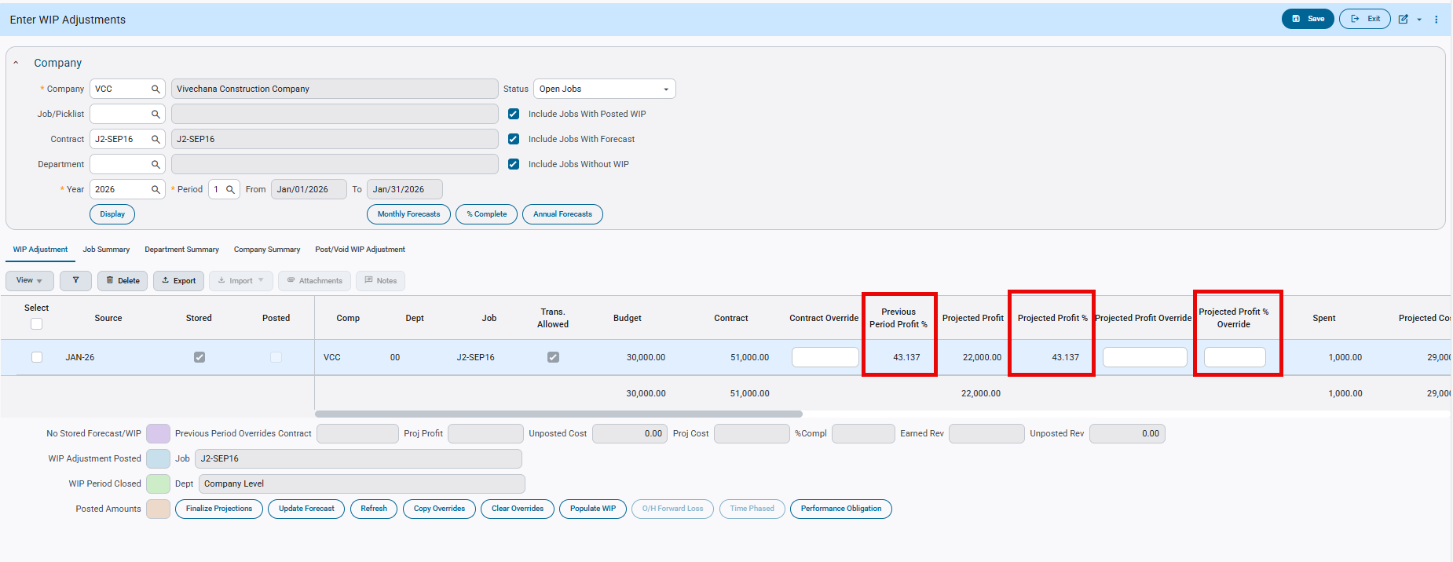
Job Costing>Forecasting>Work-In-process Adjustments>Enter and Post Adjustment
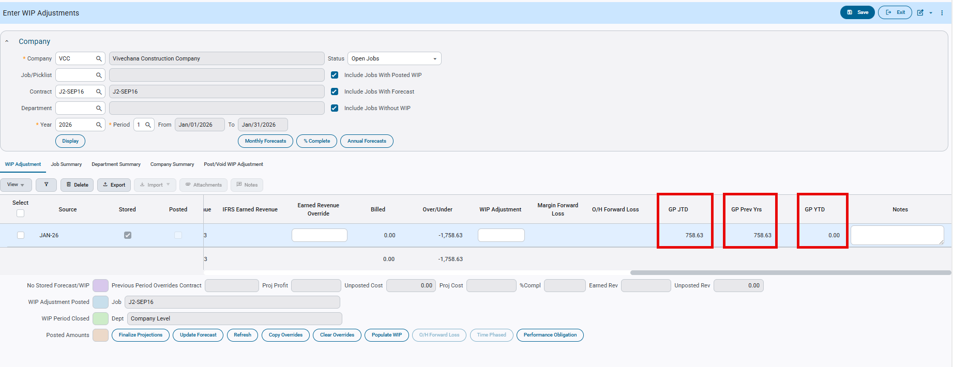
Job Costing>Forecasting>Work-In-process Adjustments>Enter and Post Adjustment

Controlling Category Auto-Assignment in Cost Codes (JBJCPC-2433)
Overview
This enhancement introduces new controls that give organizations greater flexibility when assigning cost codes to jobs. Previously, categories linked to Master Cost Codes were automatically assigned whenever a cost code was added to a job, with no option to disable this behavior. This enhancement adds new system-level and category-level settings that allow users to control whether categories are auto-assigned or manually selected.
Modifications
1. New System Option: Prevent Auto-Assignment of Categories
- A new control flag— “Do not auto-assign categories linked to master cost code to the job”—has been added to System Options and by default it is unchecked.
- When this option is checked, categories linked to the Master Cost Code will not be automatically assigned when the cost code is added to a job.
- Users must manually select and assign categories within the job cost code.
- When the option is unchecked, the system follows the legacy behavior, automatically assigning all categories linked to the Master Cost Code.
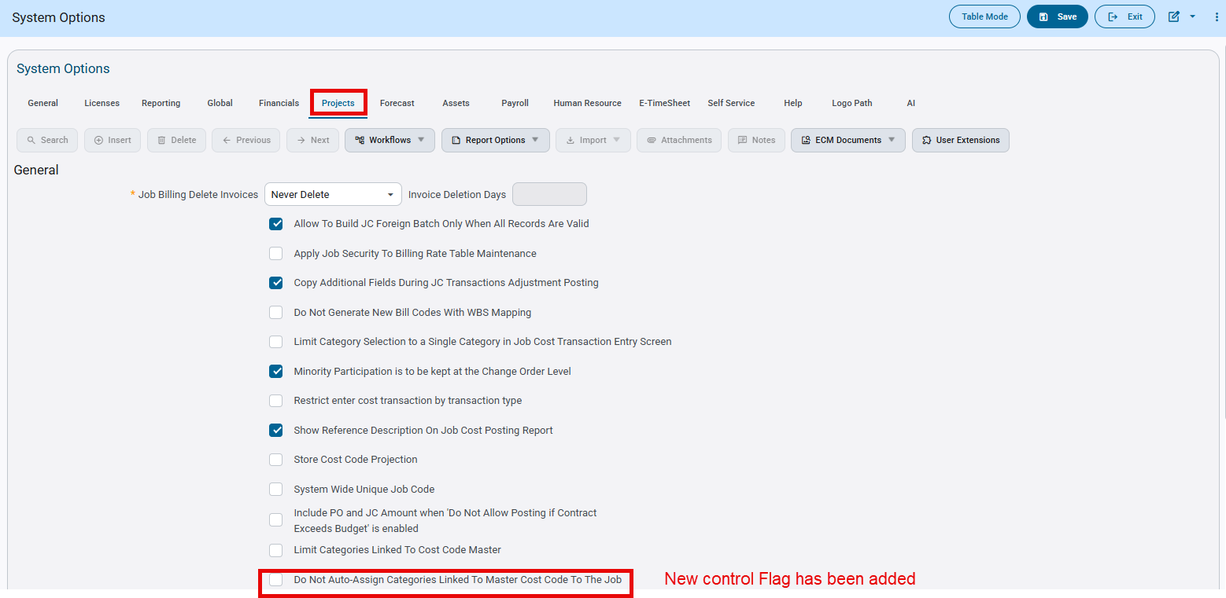
System Data > Setup > System Options
2. New Category-Level Override: “Auto-Assign” Flag
- Within the Cost Code Master → Category Detail popup, a new “Auto-Assign” checkbox has been added.
- The Auto-Assign flag becomes available only when the system-level “Do not auto-assign” option is checked, and “Auto-Assign” column will be unchecked by default.
- When Auto-Assign is checked for a category, then the category will automatically be assigned to the job when the cost code is added.
- When Auto-Assign is unchecked, the category will not be assigned automatically.
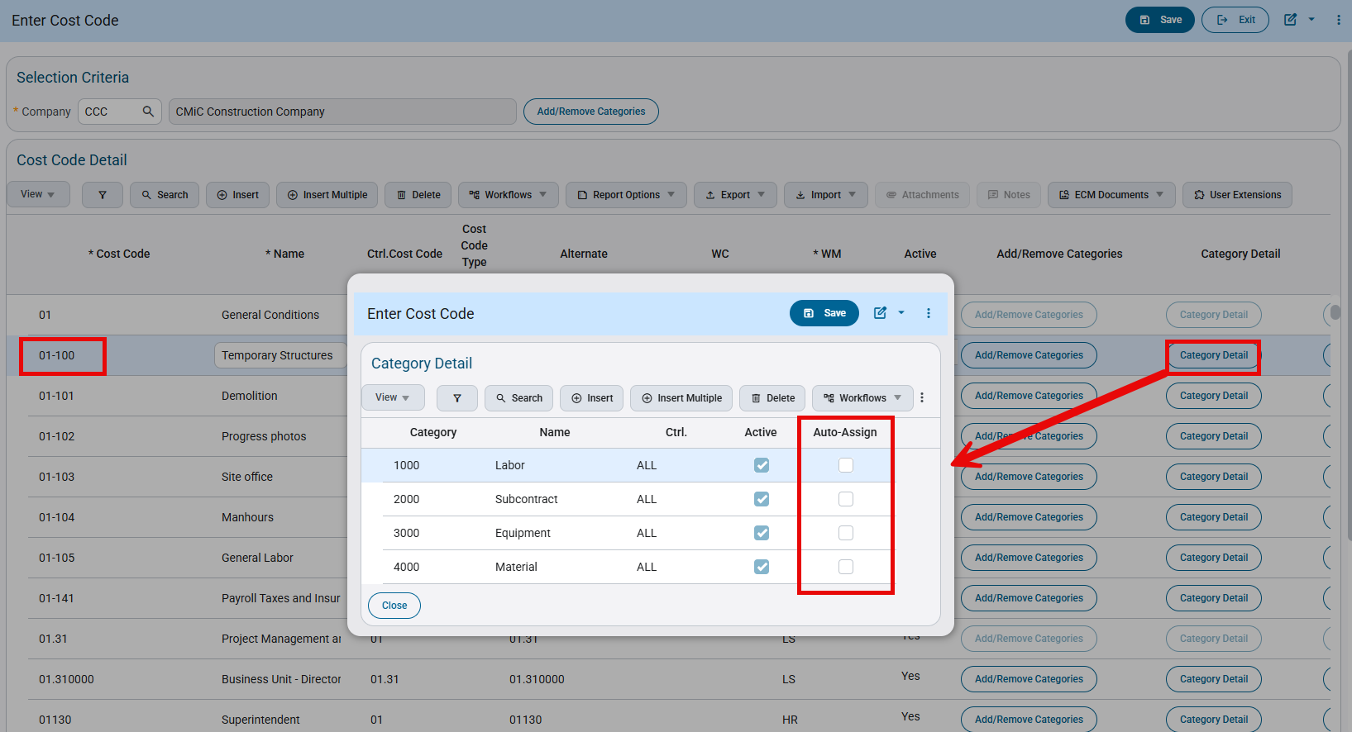
Job Costing > Setup > Local Tables > Enter Cost Code
Implementation
Scenario 1:
Go to System Data > Setup > System Options and check the “Do Not Auto-Assign Categories Linked To Master Cost Code To The Job” Flag
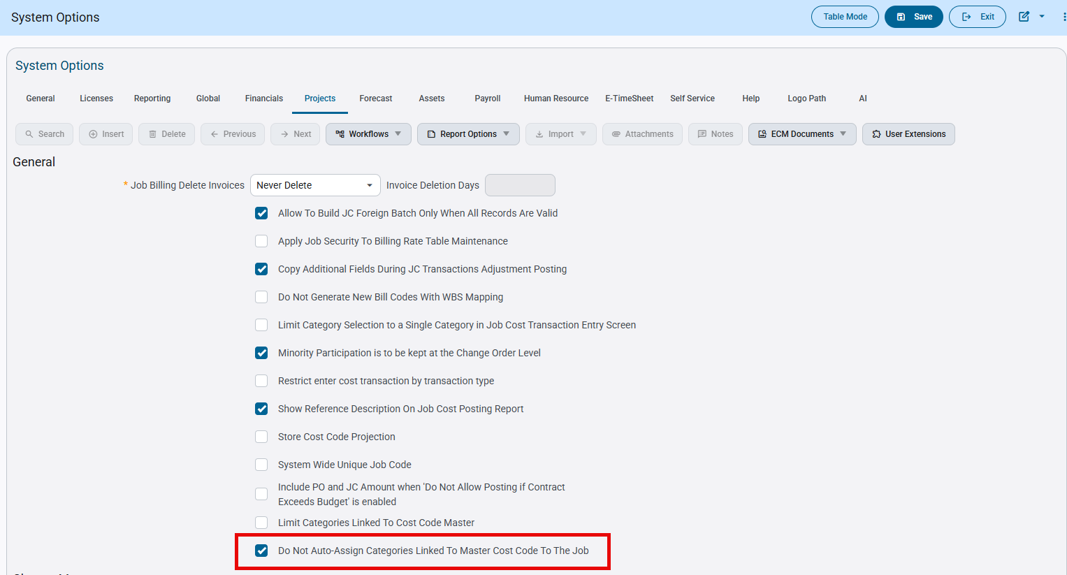
System Data > Setup > System Options
Go to Enter Cost Code program and assign categories to any of the cost code.
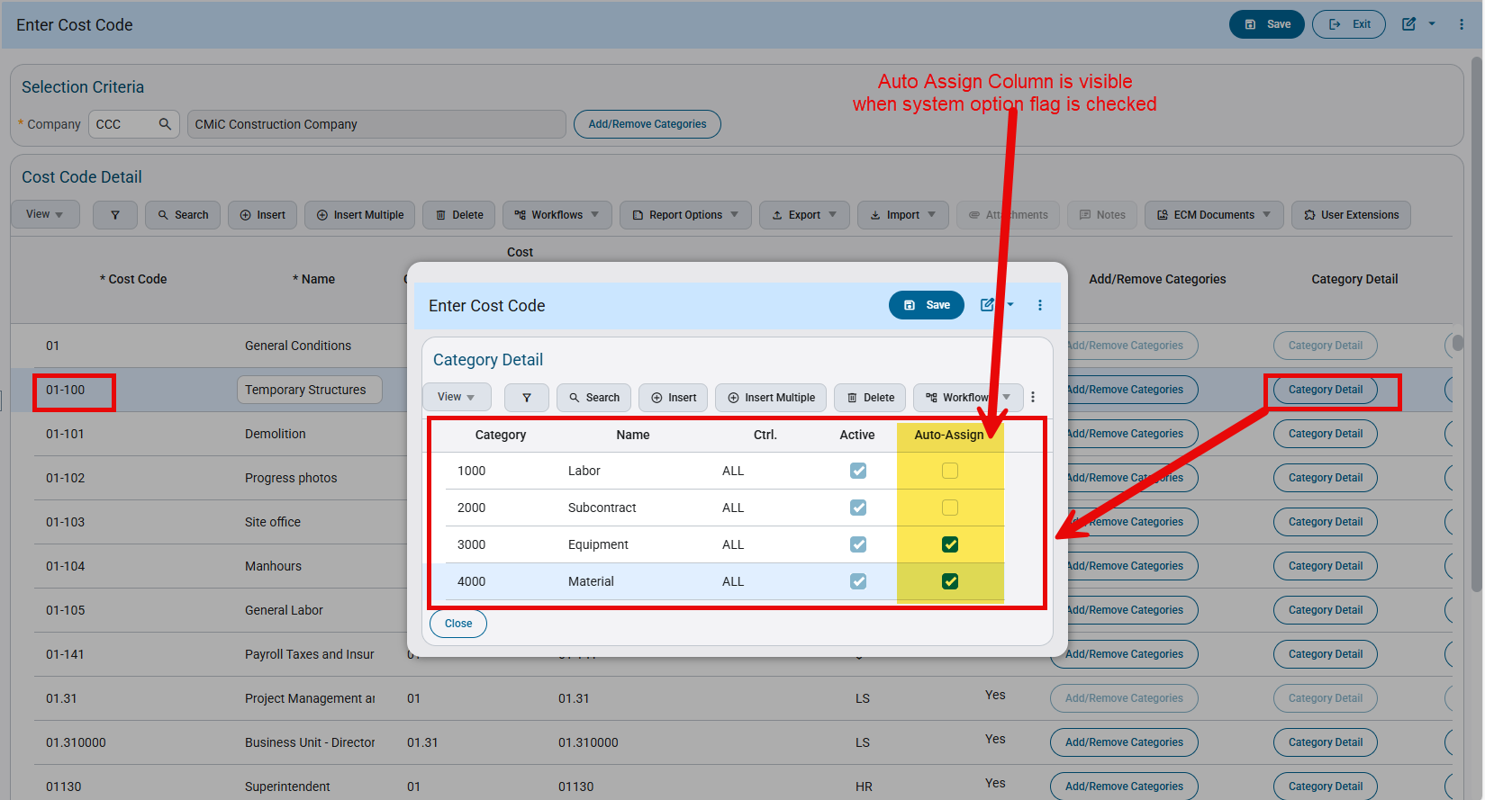
Job Costing > Setup > Local Tables > Enter Cost Code
Assign the cost code to the job. Only the categories whose “Auto-Assign” check box is checked will be auto populated for the cost code in the Assign Job Cost Code Program.
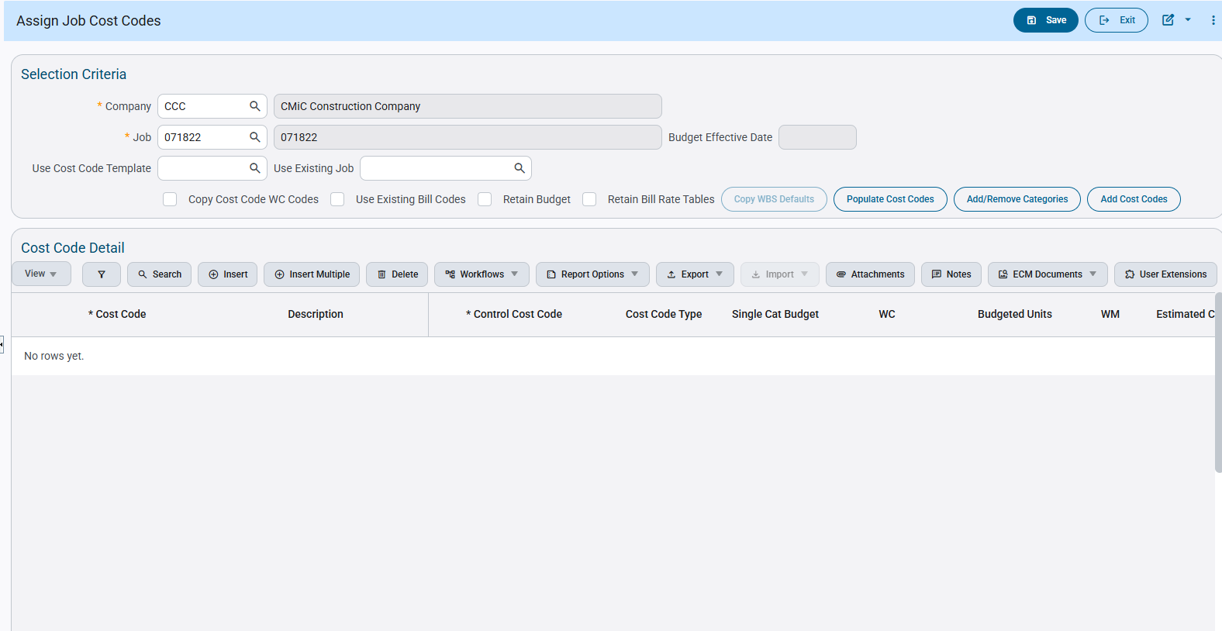
Job Costing > Job > Assign Cost Codes

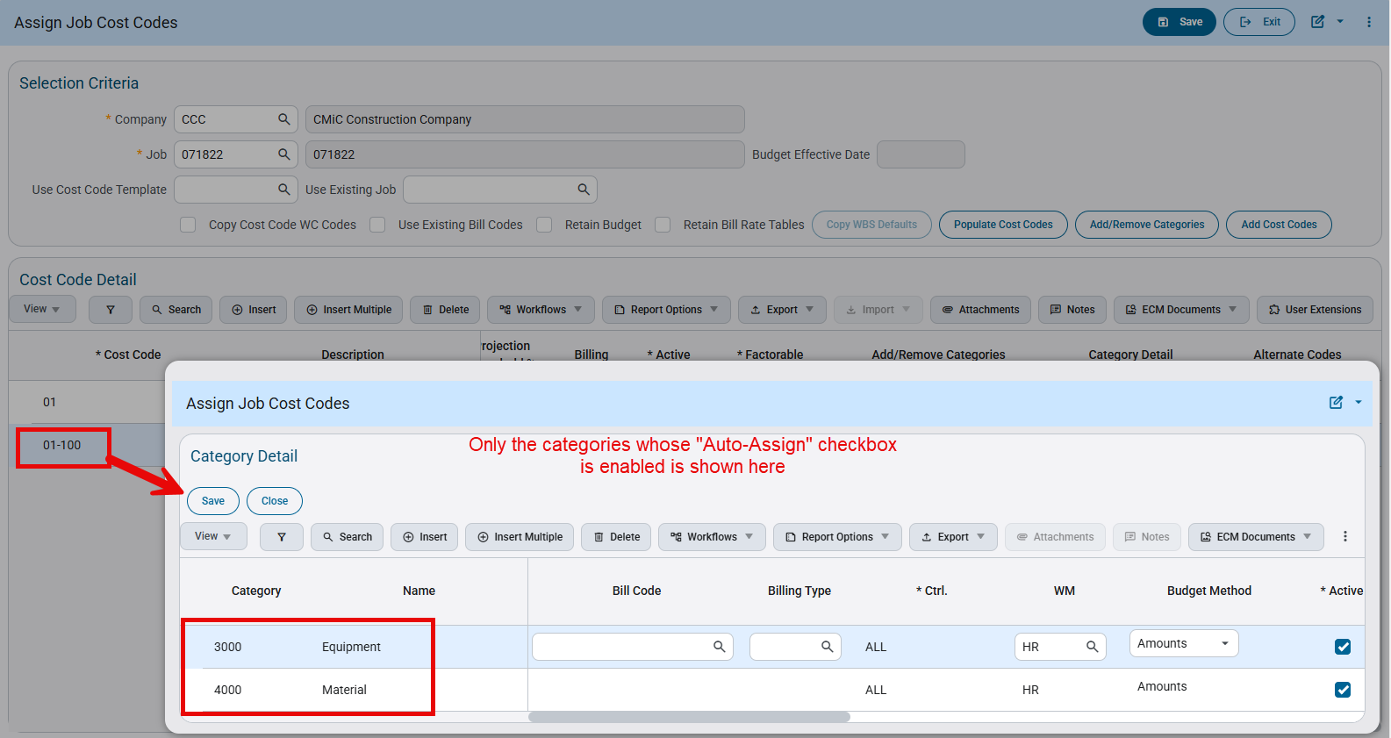
Job Costing > Job > Assign Cost Codes
Scenario 2:
Go to System Data > Setup > System Options and uncheck the “Do Not Auto-Assign Categories Linked To Master Cost Code To The Job” Flag
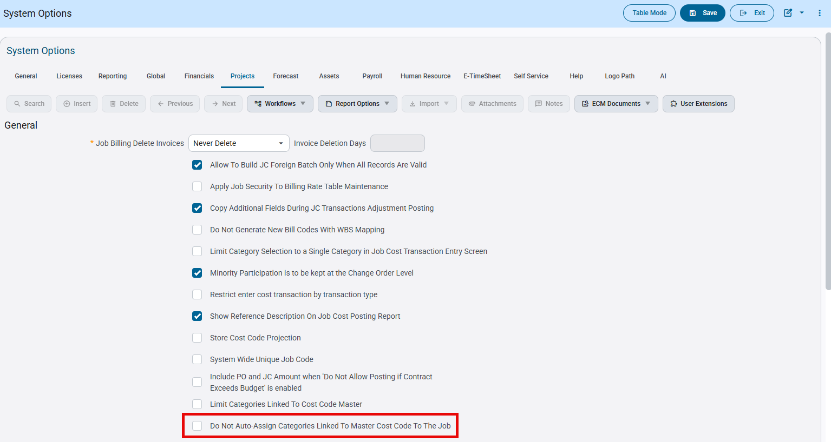
System Data > Setup > System Options
When this system option flag is unchecked, the “Auto-Assign” column will not be shown in the category detail pop up screen of Enter Cost Code Program
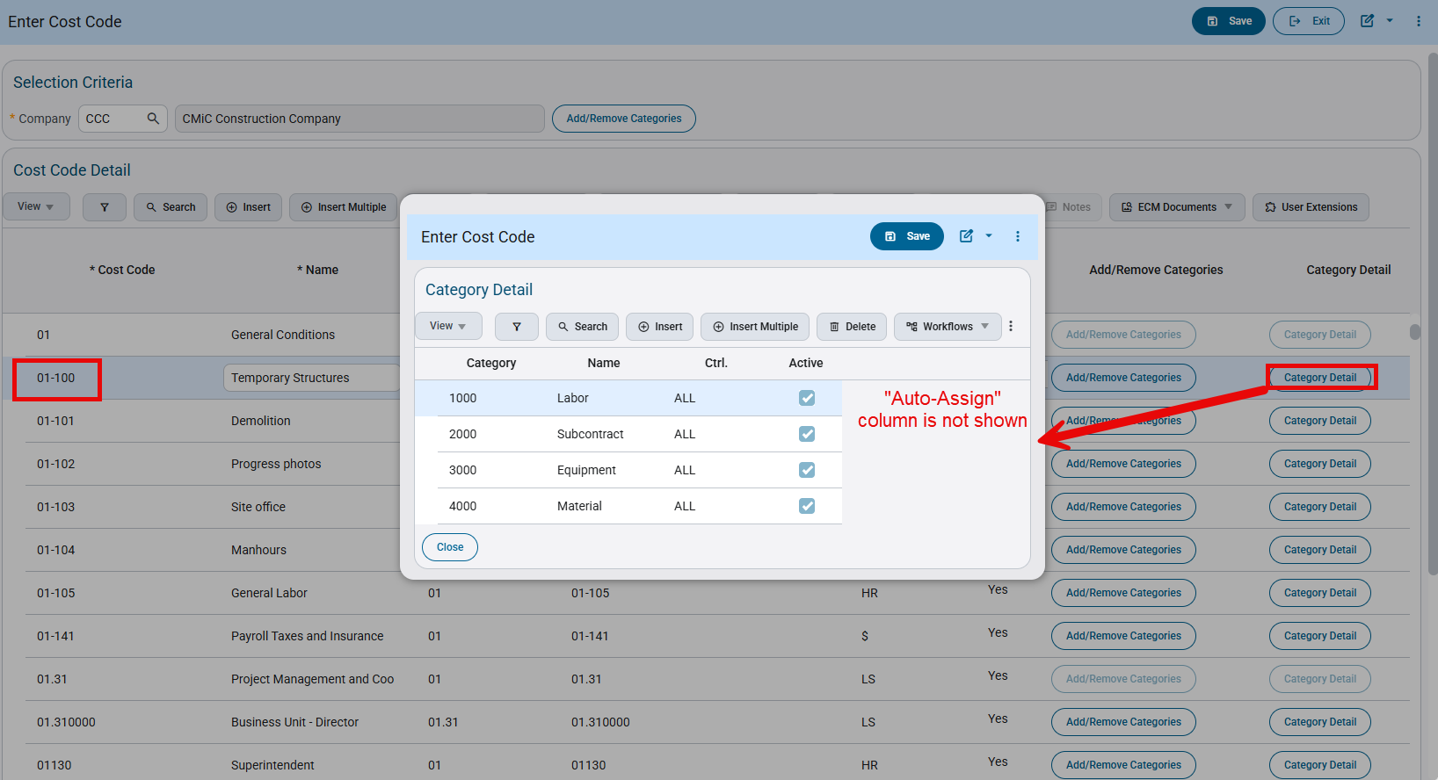
Job Costing > Setup > Local Tables > Enter Cost Code
Assign the cost code 01-100 to the Job. All the categories which are associated to the cost code 01-100 in the Master Cost code program will be auto populated to the cost code 01-100 when it is assigned to a job in Assign Job Cost Code program as the System option control flag “Do Not Auto-Assign Categories Linked To Master Cost Code To The Job” is unchecked.
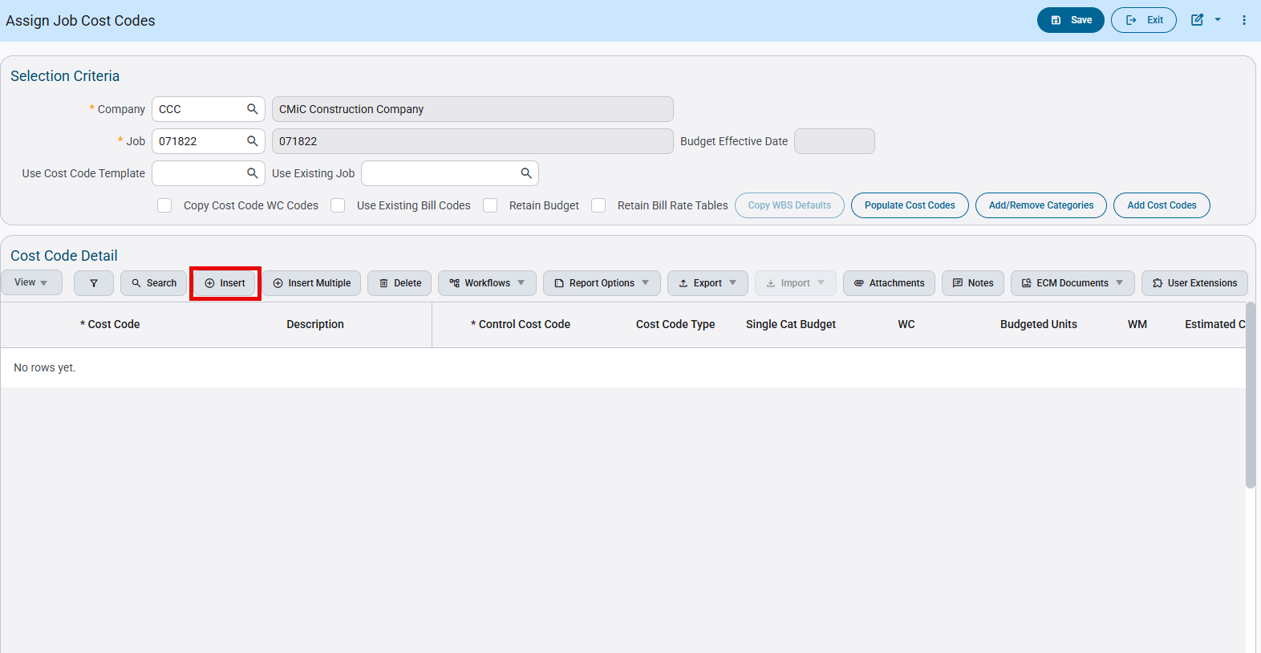
Job Costing > Job > Assign Cost Codes

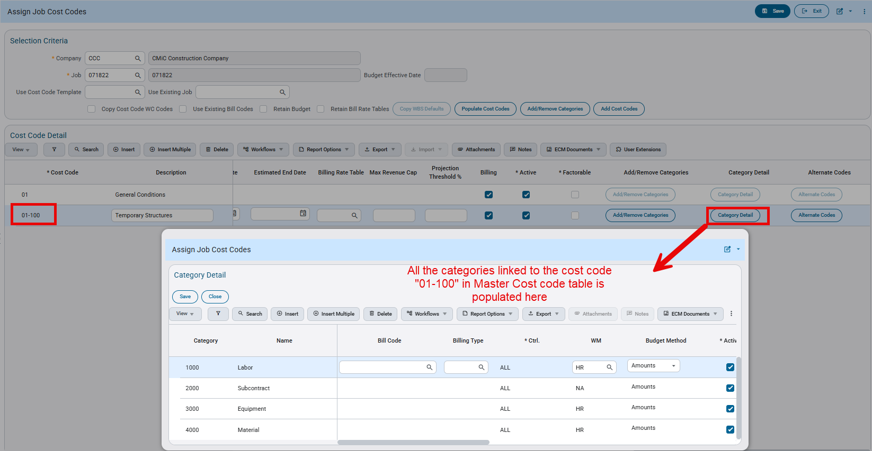
Job Costing > Job > Assign Cost Codes

Job Cost transactions created via API endpoint to consider Payroll Security set for the User (JBJCPC-2572)
The system allows privileges to be defined at a user level to view Job Cost transaction related information such as Cost amount, Source Code, Unbilled Revenue amount etc. for an employee that is part of a secured pay group.
A new enhancement has been made to the API endpoint used for creating Job Cost transactions: jctran to allow the records created by it to respect the security privileges of employee’s pay group if it’s secured.
Setup
System currently provides the following payroll transaction related privileges for the user:
- JCPYAMT – Allows the user to see pay amount in JC for secure pay groups
- JCPYINFO – Allows the user to see PY info in JC for Secure Pay Groups
- JCPYSECTOT – Allows the user to See Un-Secure Totals in JC for Secure Pay Groups
- JCPYSRC – Allows the user to see Source Code in JC for Secure Pay Groups
- JCPYUNBREV – Allows the user to See Unbilled Revenue Amount in JC for Secure Pay Groups

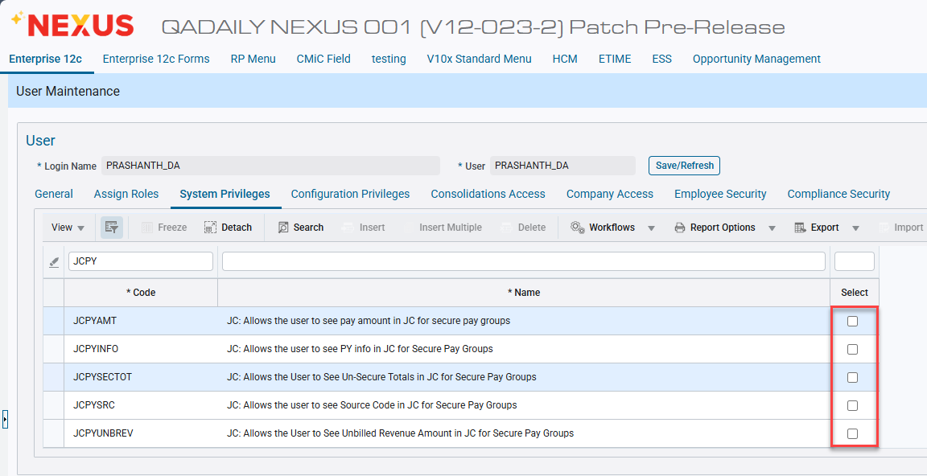
System Data > Security > Users > User Maintenance

Checking the above privileges grant the flexibility to hide appropriate sensitive information from payroll related Job Cost transactions that are posted to be hidden in the JCDETAIL table and its related programs from other users with insufficient security privileges.
A pay group is deemed secure if the “Secure” flag is checked and it can be updated via the Pay Groups program under US Payroll > Setup > Company in Human Capital Management.

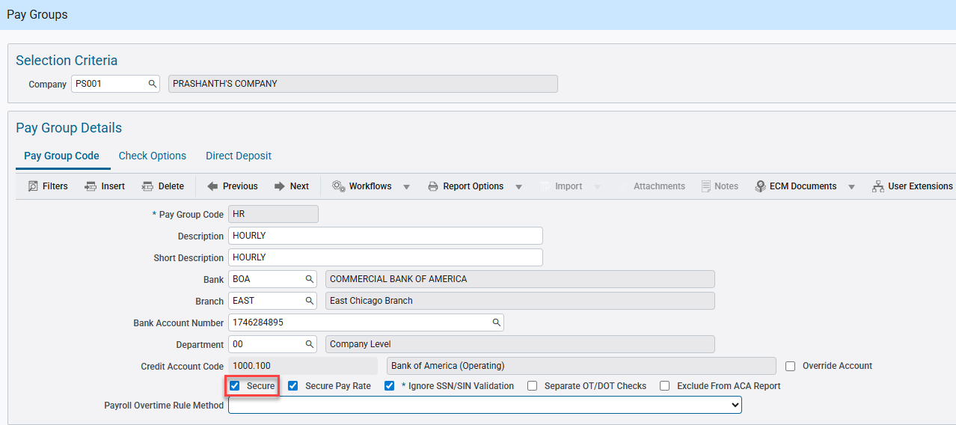
Human Capital Management > US Payroll > Setup > Company > Pay Groups

Employees associated with the Pay Group inherit its security.

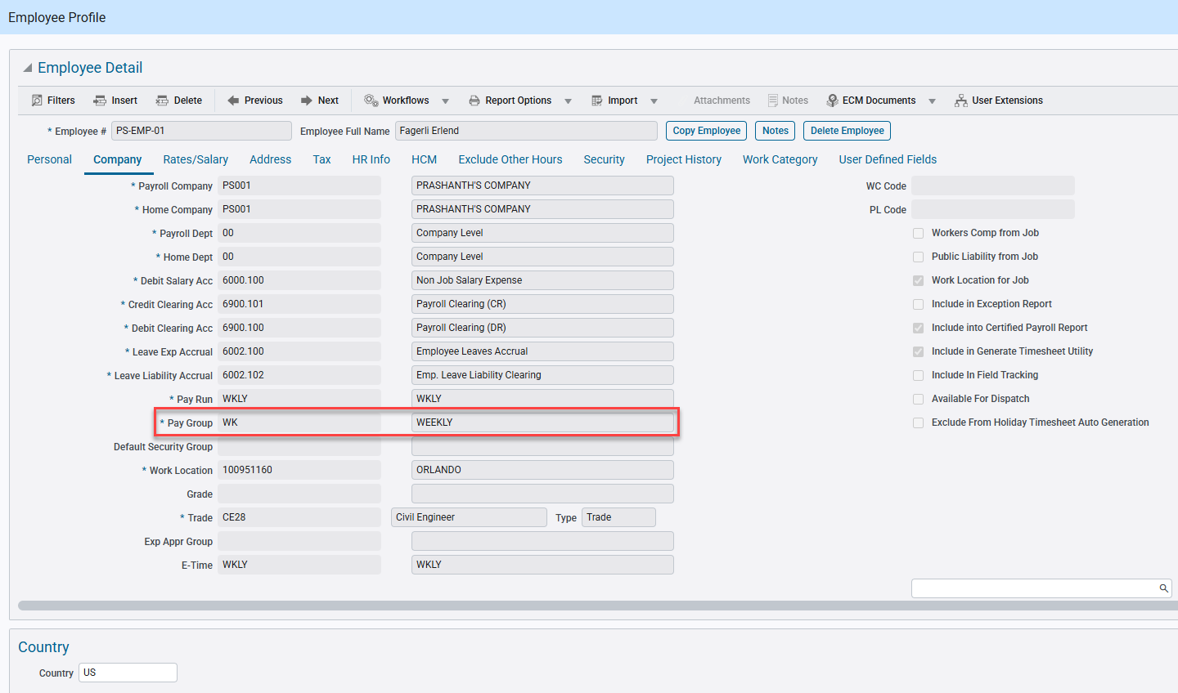
Human Capital Management > US Payroll > Setup > Employees > Employee Profile
Implementation
CMiC will modify the database logic for any transactions created from the /jc-rest-api/rest/jctran API endpoint so that when an employee number is provided in the payload, the record in CMiC would inherit the employee’s pay group secure setting.
The Employee Code can be sent in the payload via the ‘JctdSrcCode’ parameter as shown below using a sample payload for a POST request to create Job Cost transactions.

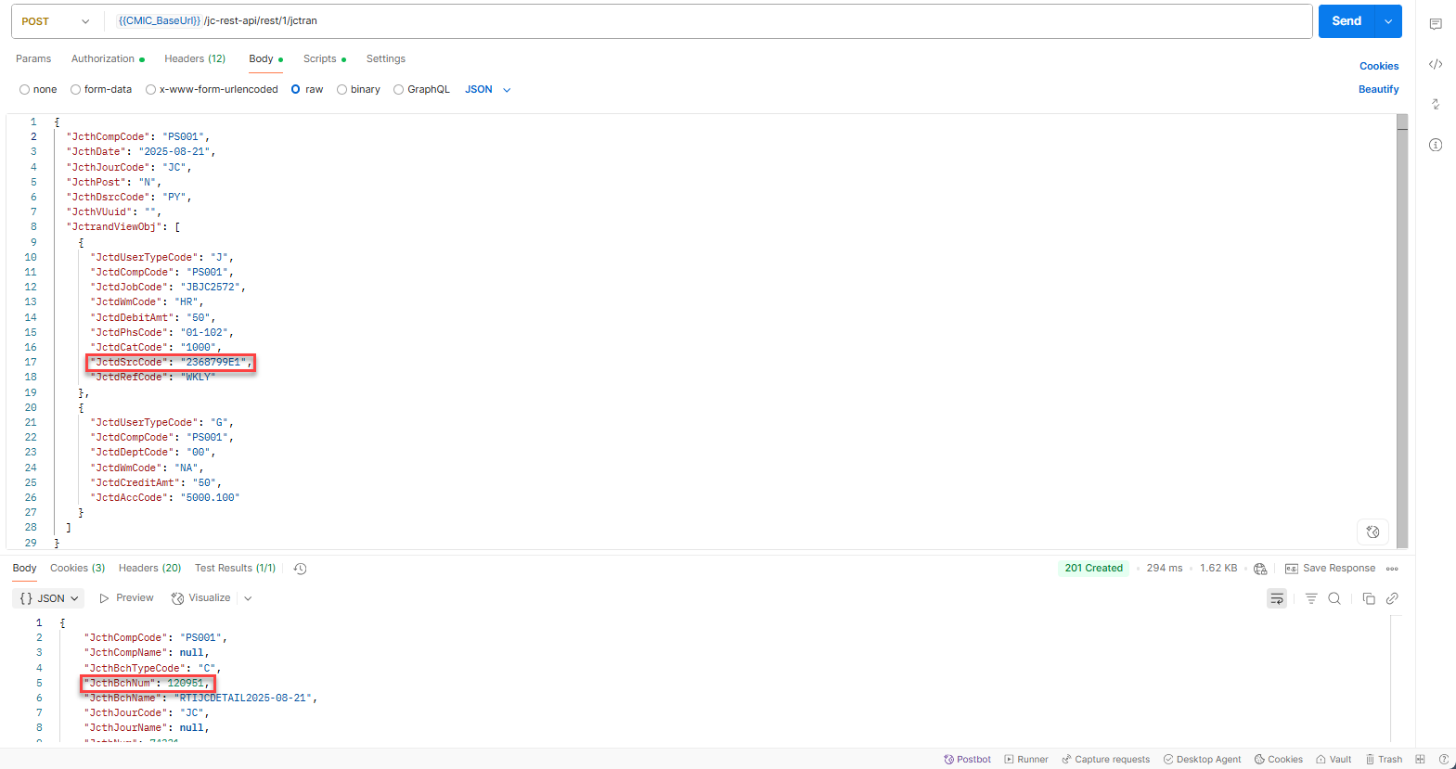

If the above employee has a secure pay group assigned, then for any such JC transaction with the employee the database logic will insert a value – Y in the JCTD_SEC_PAY_RUN column in both the JCTRAND_TN and the POSTED_JCTRAND_TN tables.
Once the JCTD_SEC_PAY_RUN column is set to Y in the POSTED_JCTRAND_TN then any logs or programs using the table in the UI will display the specific payroll related information only if the user has the required security privileges.
NOTE: The payroll security won’t impact on the unposted Job Cost transactions and only affect the posted ones
Examples
The following example highlights the interaction between the System Privileges for the user and the nature of the Payroll Group in determining whether the user can view the payroll related information.
SCENARIO 1: User doesn’t have JCPY System Privileges and Employee’s Pay Group is Unsecure
In the User Maintenance program, user has all the following JCPY System Privileges unchecked: JCPYAMT, JCPYINFO, JCPYSECTOT, JCPYSRC, JCPYUNBREV

System Data > Security > Users > User Maintenance

Employee: PS-EMP-01 is part of the Pay Group: WK and this Pay Group is Unsecure.

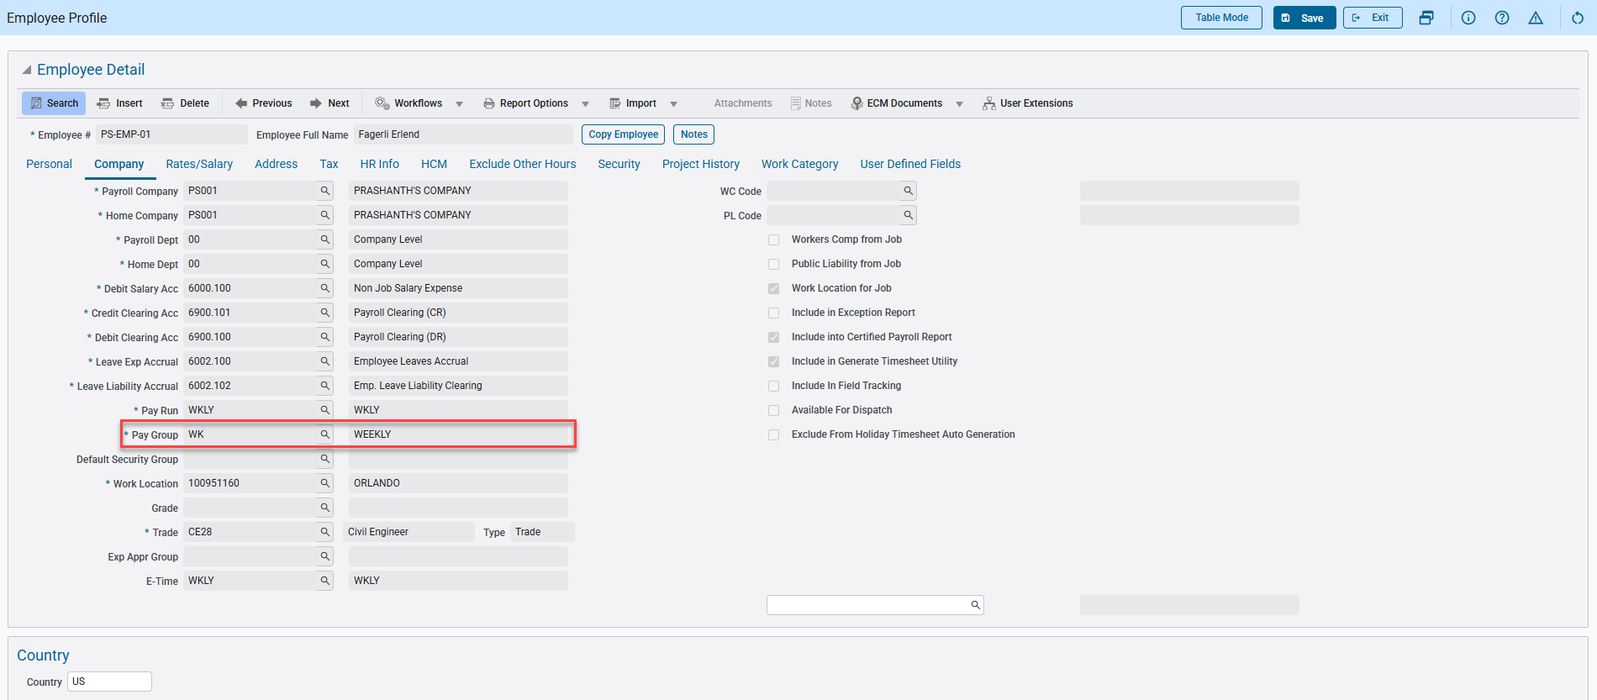 Human Capital Management > US Payroll > Setup > Employees > Employee Profile

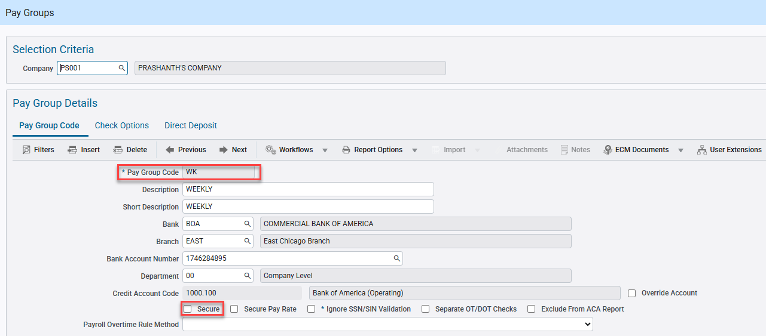 Human Capital Management > US Payroll > Setup > Company > Pay Groups

Sent a POST request for the API endpoint: /jc-rest-api/rest/1/jctran for the Company/Job/Cost Code/Category: PS001/JBJC2572/01-100/1000 with Employee ID provided under the ‘JctdSrcCode’ parameter.
A 201 Created response was received with the JcthBchNum as 120926.

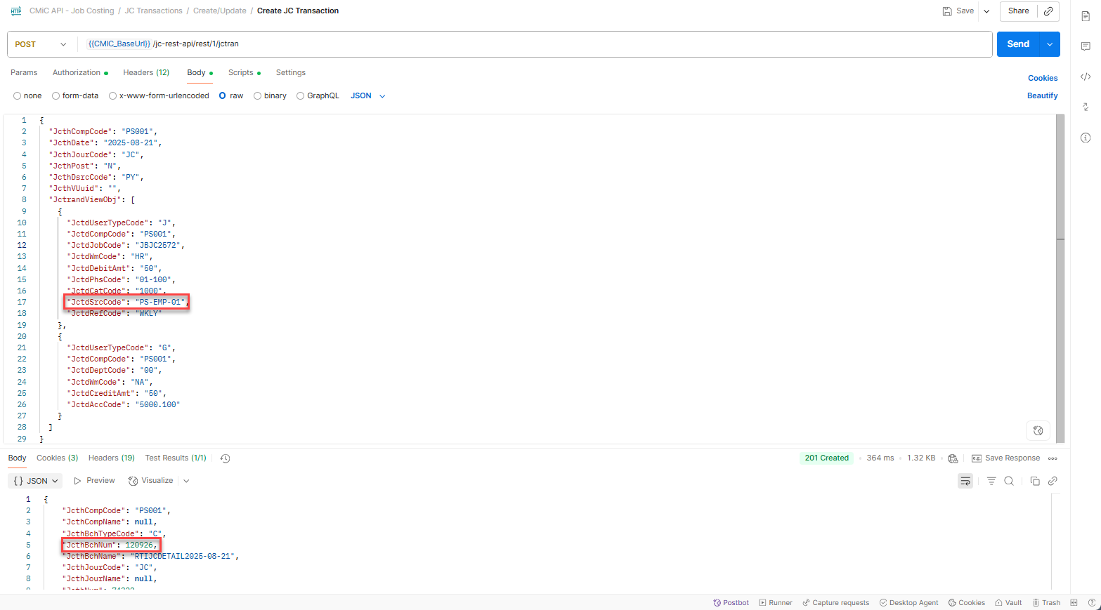

Querying for this batch number in the Cost Transaction program, displays both the J and G line transactions.

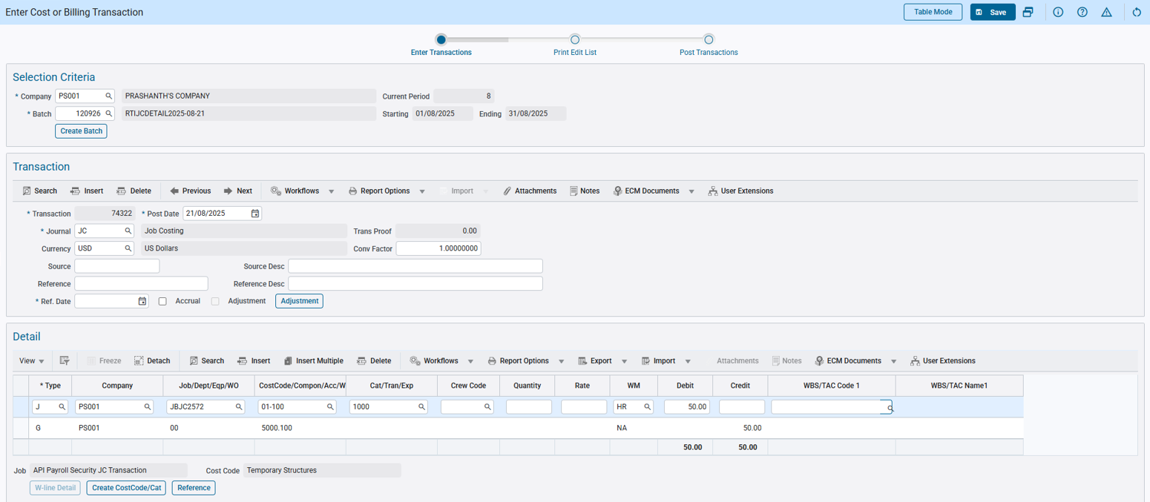 Project Controls > Job Costing > Transactions > Enter Cost Transaction

Querying the JCTRAND_TN table in the DB populates the JCTD_SEC_PAY_RUN field with ‘N’.
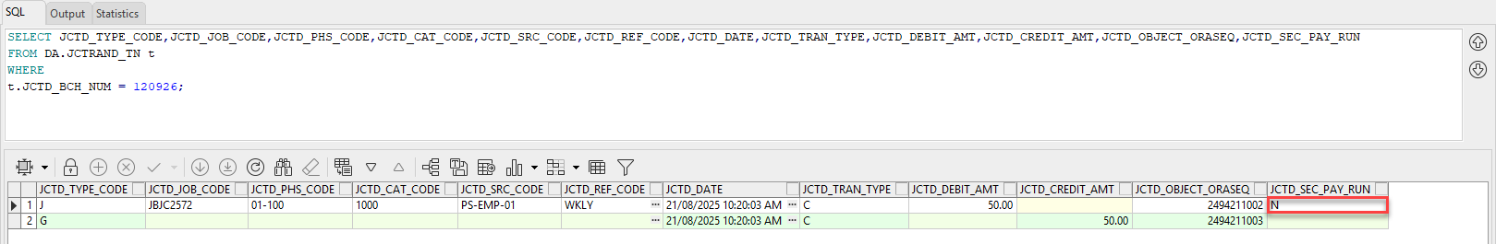

Then the cost transaction is posted and the JCTD_SEC_PAY_RUN field in the POSTED_JCTRAND_TN table continues to display ‘N’.

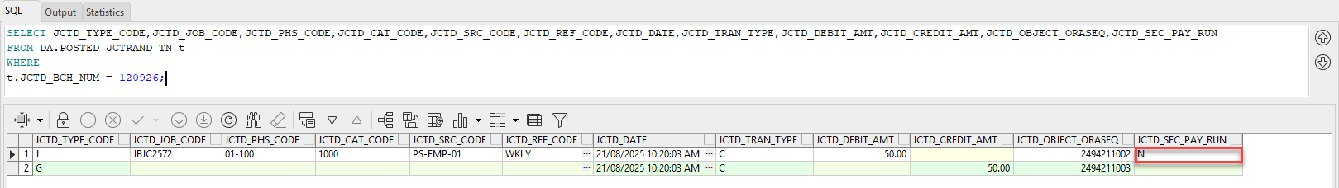

In the JCDETAIL Transaction Log in UI Console, the Amount and Payroll information is displayed as the user has security privileges.

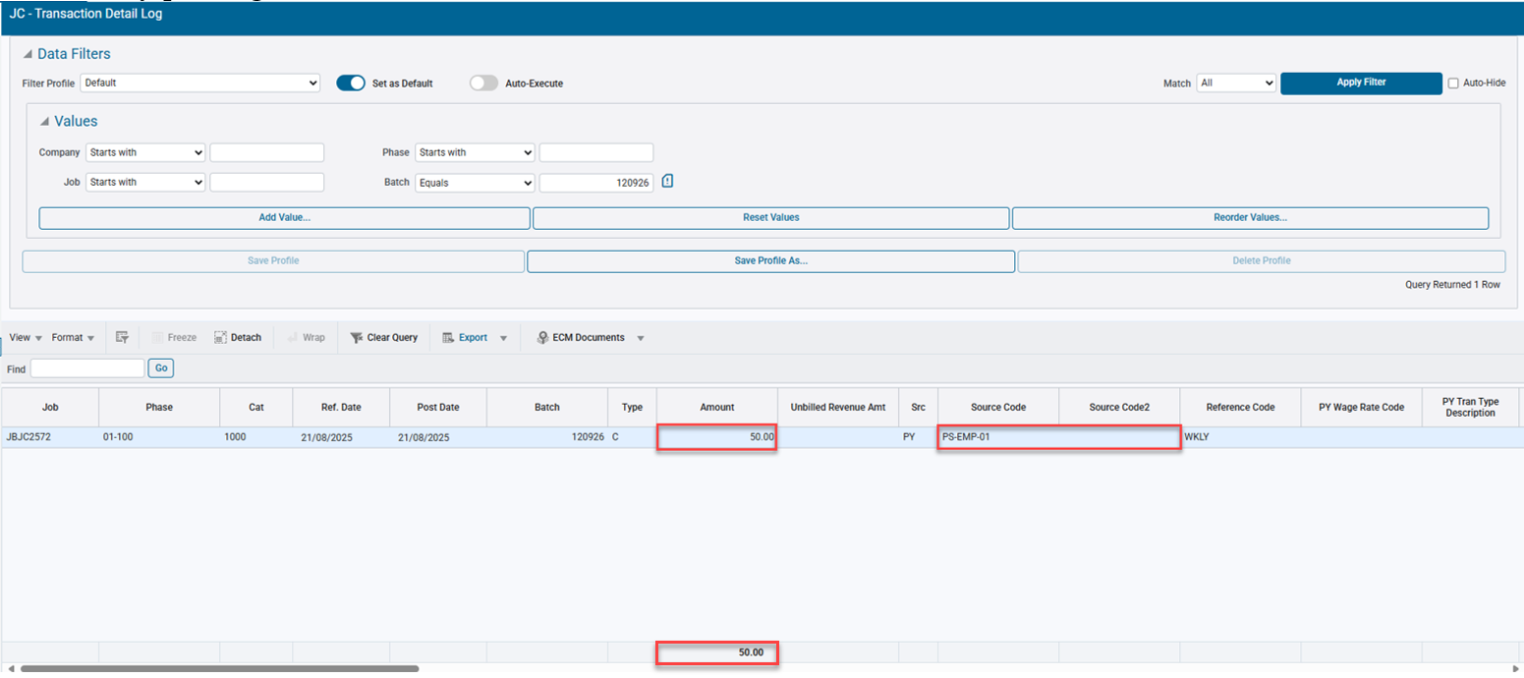 Project Controls > Job Costing > Queries > Transaction Detail

SCENARIO 2: User doesn’t have JCPY System Privileges and Employee’s Pay Group is Secure
In the User Maintenance program, unchecked the following JCPY System Privileges for the user: JCPYAMT, JCPYINFO, JCPYSECTOT, JCPYSRC, JCPYUNBREV

System Data > Security > Users > User Maintenance

Employee: 2368799E1 is part of the Pay Group: HR.

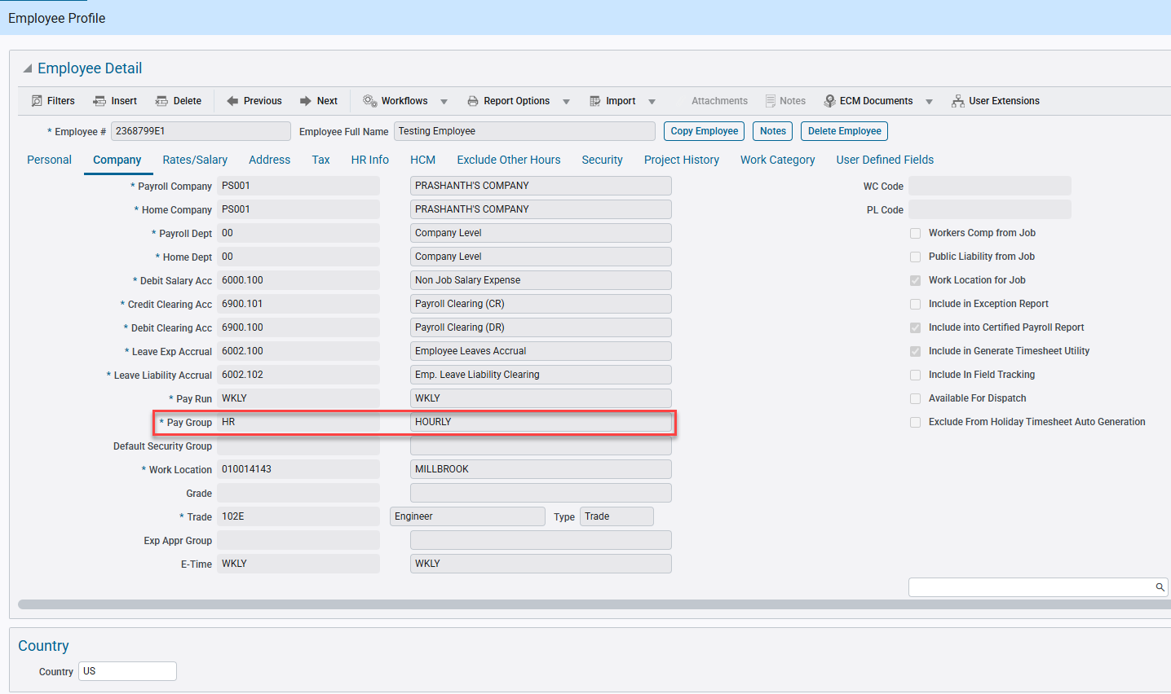 Human Capital Management > US Payroll > Setup > Employees > Employee Profile

This Pay Group has the Secure flags checked, meaning it is a Secure Pay Group.

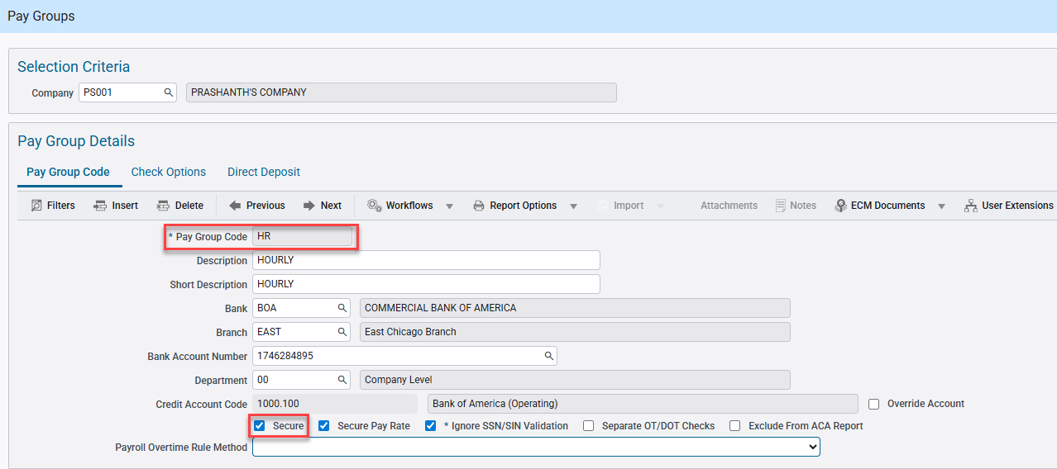 Human Capital Management > US Payroll > Setup > Company > Pay Groups

Sent a POST request for the API endpoint: /jc-rest-api/rest/1/jctran for the Company/Job/Cost Code/Category: PS001/JBJC2572/01-102/1000 with Employee ID provided under the ‘JctdSrcCode’ parameter.
A 201 Created response was received with the JcthBchNum as 120951.

Querying for this batch number in the Cost Transaction program, displays both the J and G line transactions.

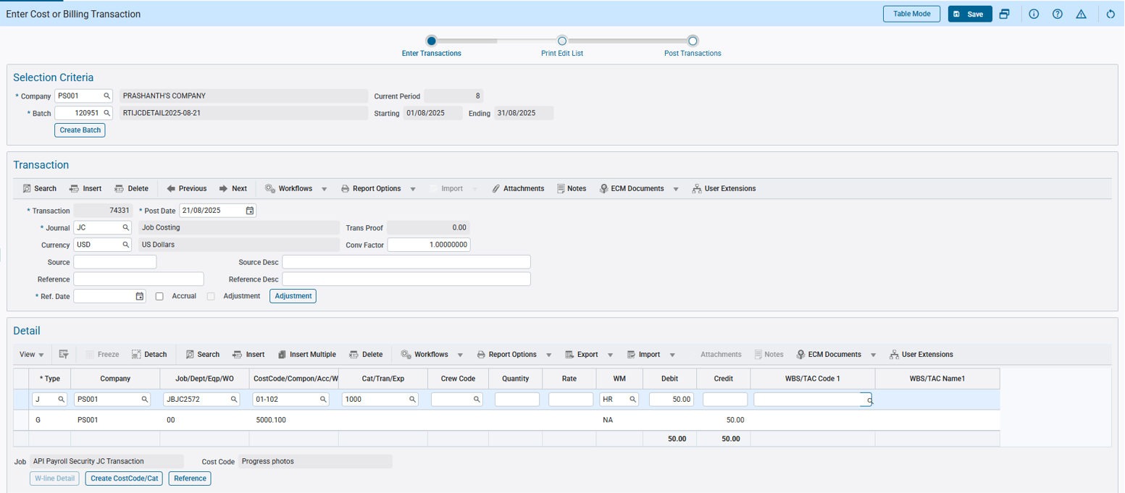 Project Controls > Job Costing > Transactions > Enter Cost Transaction

Querying the JCTRAND_TN table in the DB populates the JCTD_SEC_PAY_RUN field with ‘Y’.

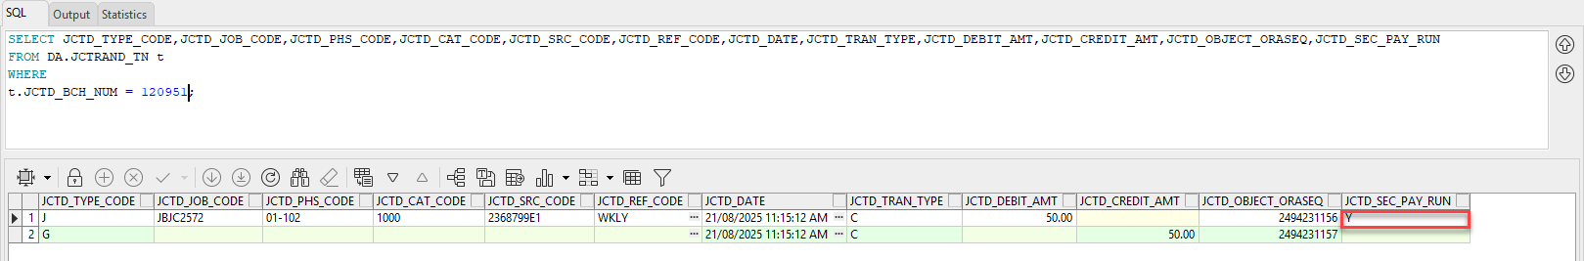

Then the cost transaction is posted and the JCTD_SEC_PAY_RUN field in the POSTED_JCTRAND_TN table continues to display ‘Y’.

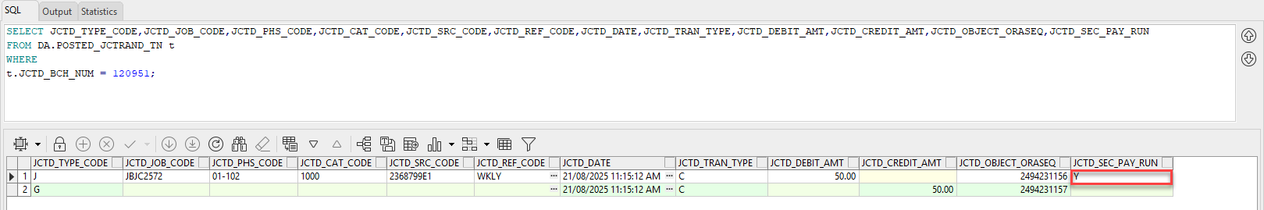

In the JCDETAIL Transaction Log in UI Console, the Payroll Secure information such as the Amount, Amount total, Source Code and Source Code 2 fields are blank or hidden as the user doesn’t have security privileges.

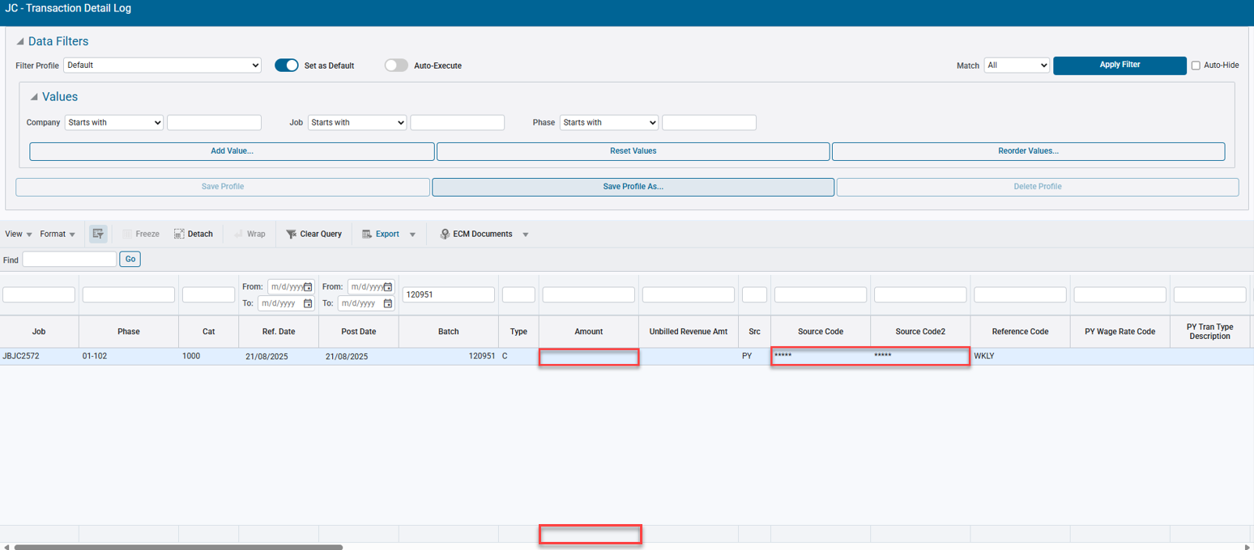 Project Controls > Job Costing > Queries > Transaction Detail

SCENARIO 3: User has JCPY System Privileges and Employee’s Pay Group is Secure
In the User Maintenance program, checked the following JCPY System Privileges for the user: JCPYAMT, JCPYINFO, JCPYSECTOT, JCPYSRC, JCPYUNBREV

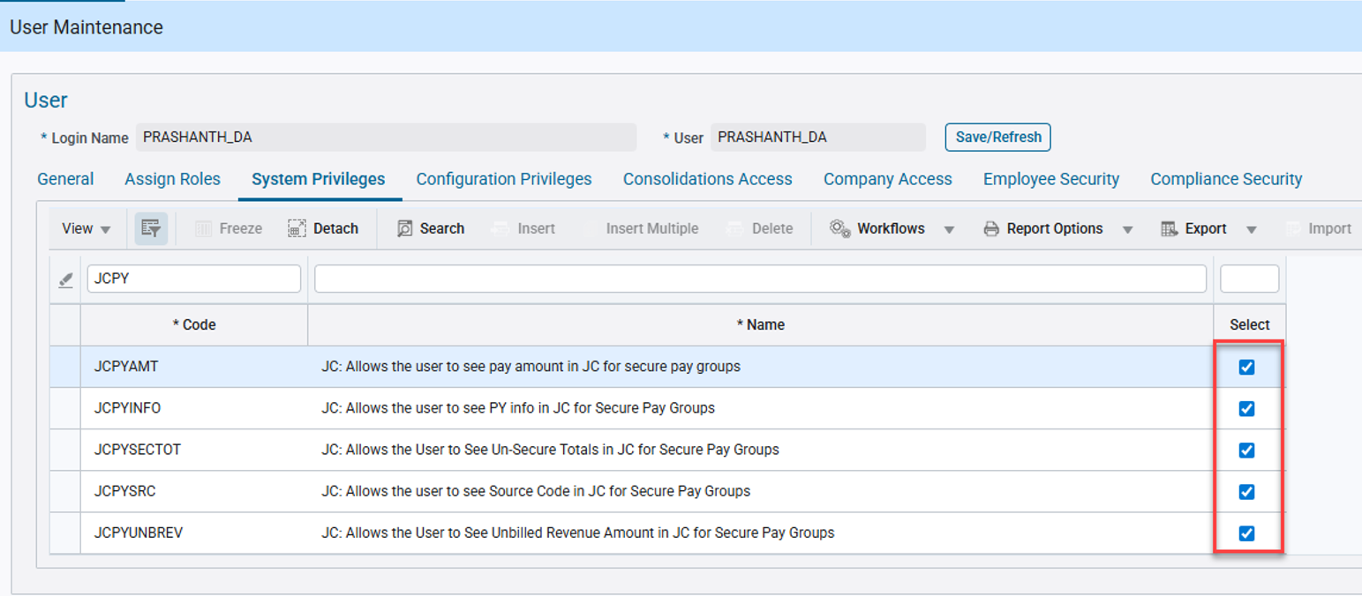 System Data > Security > Users > User Maintenance

Employee: 2368799E1 is part of the Pay Group: HR.
Human Capital Management > US Payroll > Setup > Employees > Employee Profile

This Pay Group has the Secure flag checked, meaning it is a Secure Pay Group.

Human Capital Management > US Payroll > Setup > Company > Pay Groups

Sent a POST request for the API endpoint: /jc-rest-api/rest/1/jctran for the Company/Job/Cost Code/Category: PS001/JBJC2572/01-103/1000 with Employee ID provided under the ‘JctdSrcCode’ parameter.
A 201 Created response was received with the JcthBchNum as 120952.
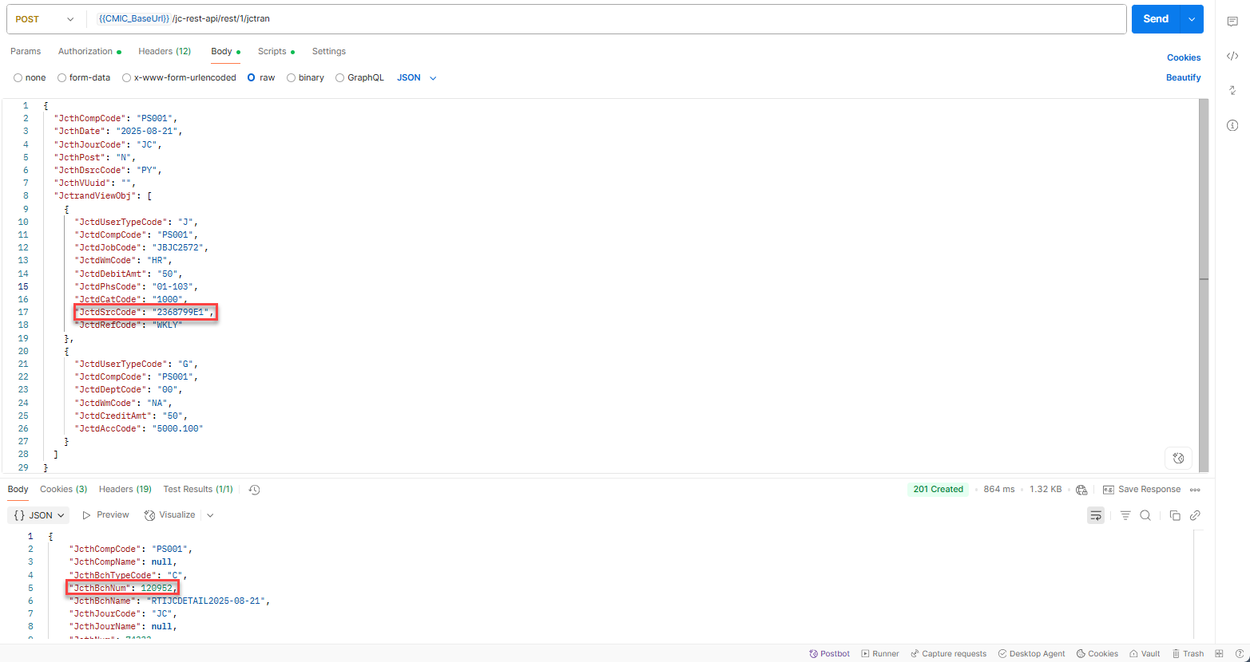

Querying for this batch number in the Cost Transaction program, displays both the J and G line transactions.

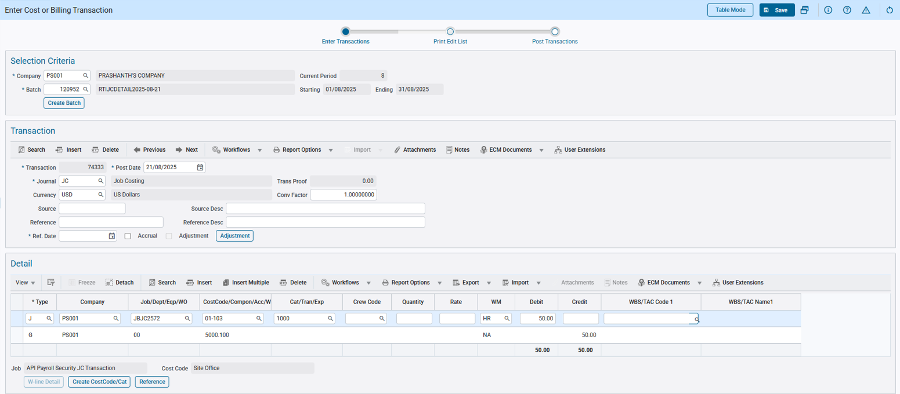 Project Controls > Job Costing > Transactions > Enter Cost Transaction

Querying the JCTRAND_TN table in the DB correctly populates the JCTD_SEC_PAY_RUN field with ‘Y’.

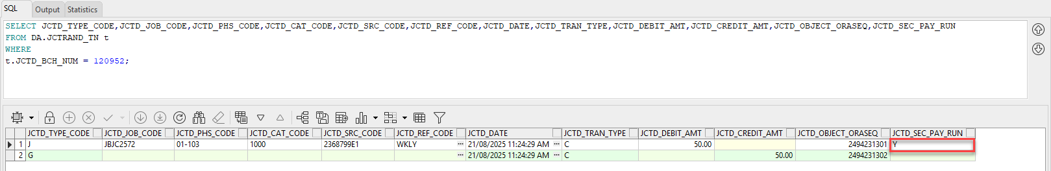

Then the cost transaction is posted and the JCTD_SEC_PAY_RUN field in the POSTED_JCTRAND_TN table continues to correctly display ‘Y’.
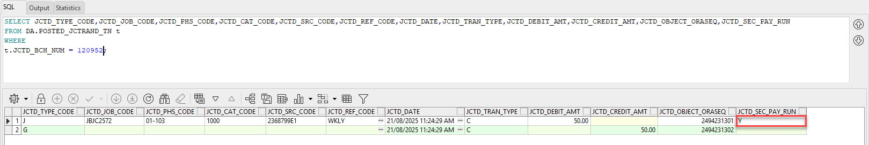

In the JCDETAIL Transaction Log in UI Console, the Payroll Secure information such as the Amount, Amount total, Source Code and Source Code 2 fields are displayed as the user has security privileges.

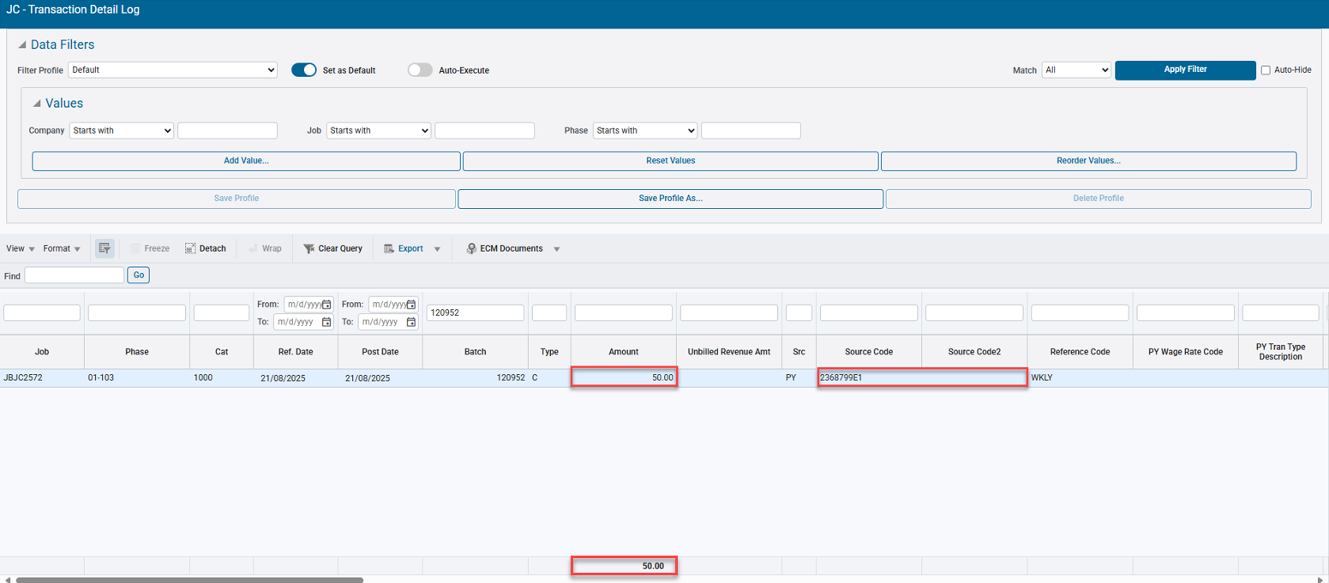 Project Controls > Job Costing > Queries > Transaction Detail

Department Code added to Automatic Job Numbering Mask (JBJCPC-2289)
Overview:
An enhancement has been made to the CMiC application to support the inclusion of the Department Code for automatic numbering of jobs.
Existing Functionality:
Currently, the system supports the following characters (lower case alphabets) in the Auto-Job mask:
- b – Business Partner / Customer Code
- c – Company Code
- y – Year
- m – Month
- d – Day
- * – Next available number
- # – Duplicate control job code
- s – Next available sub job Sequence number
New Department parameter:
A new parameter represented by the letter ‘x’, will use the Department Code assigned to the Job to populate the Job Code when autonumbering is enabled for the Company.
Implementation:
The Job Mask is set up at the Company level in the Job Cost Control File. To enable this field, the ‘Automatic Numbering of Jobs’ check box must be checked (Y). Upon Creation of a new job with a department code, system will use the department code and create the job code.

Since, the new Department parameter will use the Default Department at the Job level, it is recommended that the flag ‘Mandatory Default Job Department’ is checked. If not, system will use generic next available sequence number.
Validation:
The department mask may contain up to a maximum of 5 characters for the department code. If exceeding, then a validation message is issued upon Save.
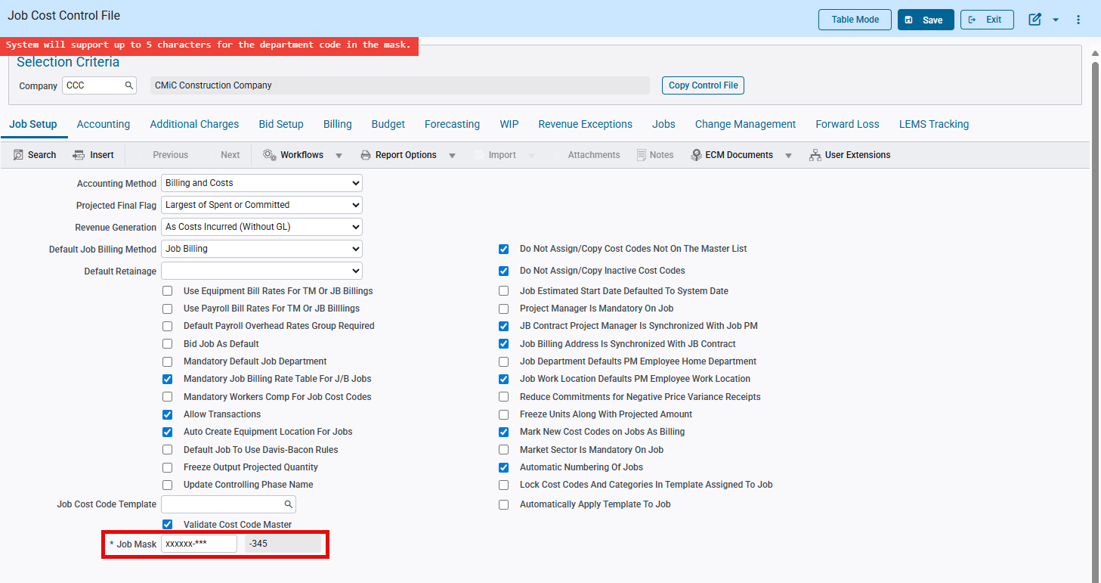
Project Controls > Job Costing > Setup > Local Tables > Control File

Job Cost Control Program:
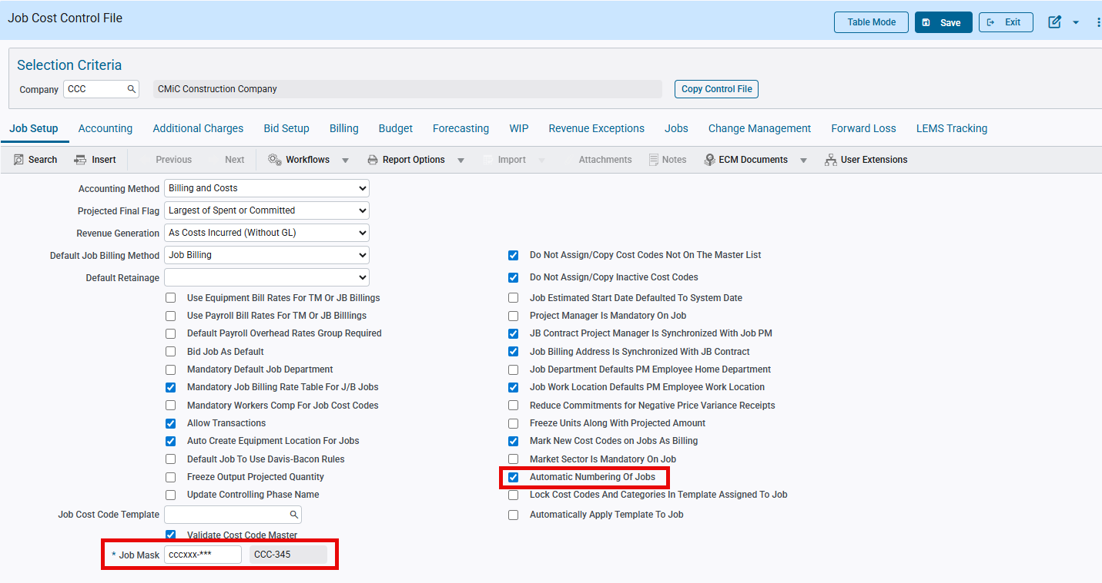
Project Controls > Job Costing > Setup > Local Tables > Control File

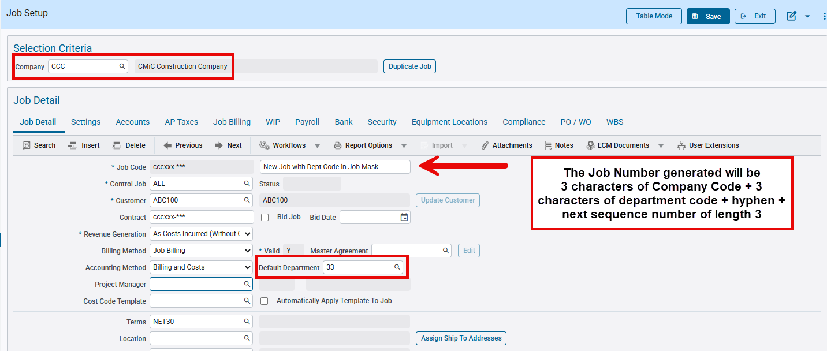
Project Controls > Job Costing > Job > Enter Job

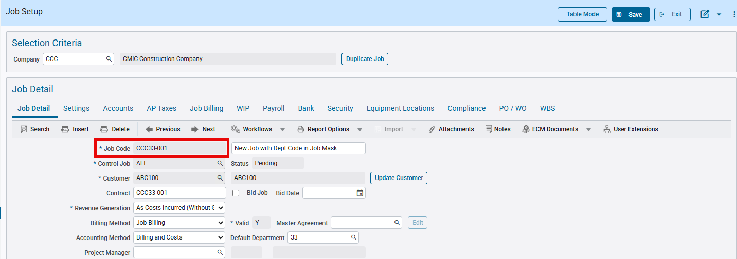
Project Controls > Job Costing > Job > Enter Job

In the above example, the mask has 3 characters for department code, but the actual department assigned to the job is of two characters. The job number is generated with the available department code length. If the department code is much longer, then only the first 3 characters will be utilized. This is the standard logic for auto number generation of codes from a defined mask.

Automatic Creation of a Project when a new Job is created (System Options)
If the ‘Auto Create Project for Jobs’ and ‘Auto Create Project for Sub Jobs’ are checked in System Options program in UI Console, then the system will automatically create the Project at the time of Job creation.
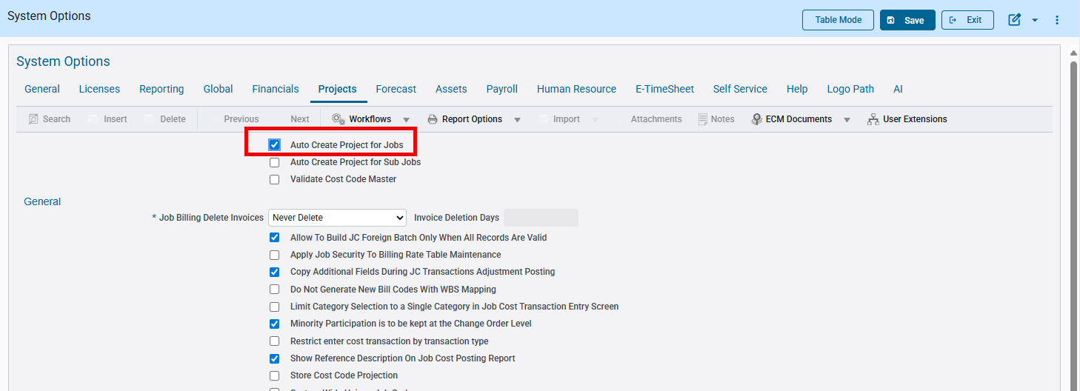 System Data > Setup > System Options

If Job Mask is also defined at the JC Control File for the Company, then system will use the same mask to populate both the Job and the Project with the same code in enterprise program.
This is the existing system functionality, and the new Department parameter will also work with this functionality.

Example:
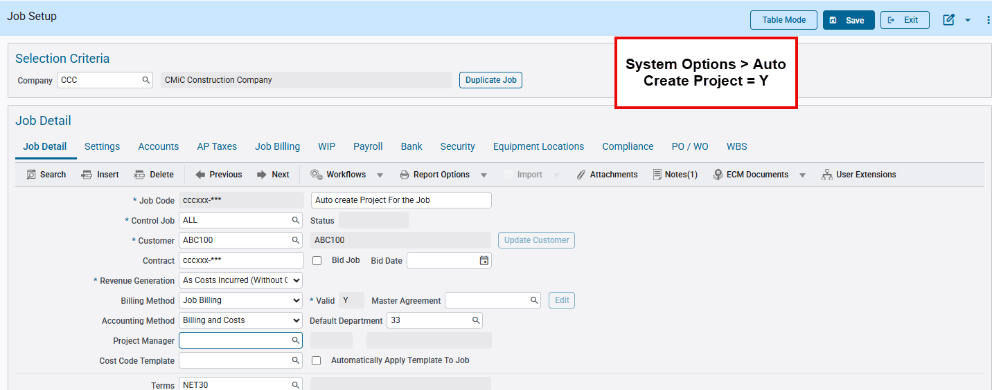
Project Controls > Job Costing > Job > Enter Job

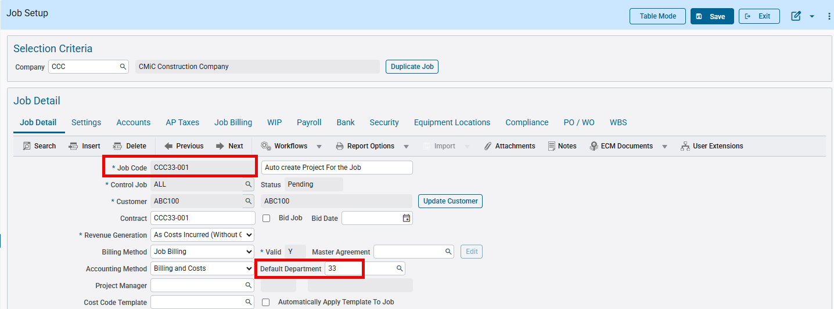 Project Controls > Job Costing > Job > Enter Job

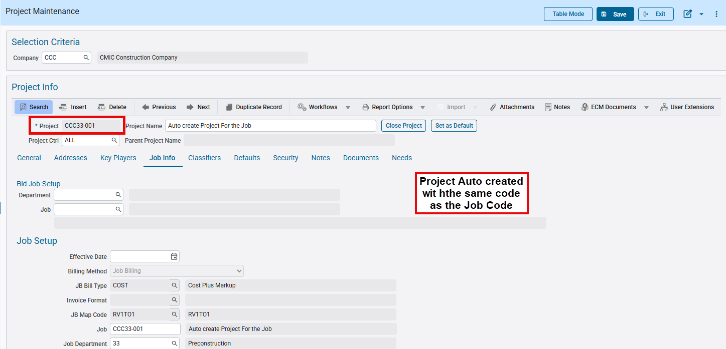 Project Controls > Job Costing > Job > Enter Project

Similarly, if a Bid Job is created with the System Options flag checked, then the Project is auto created with the same code.

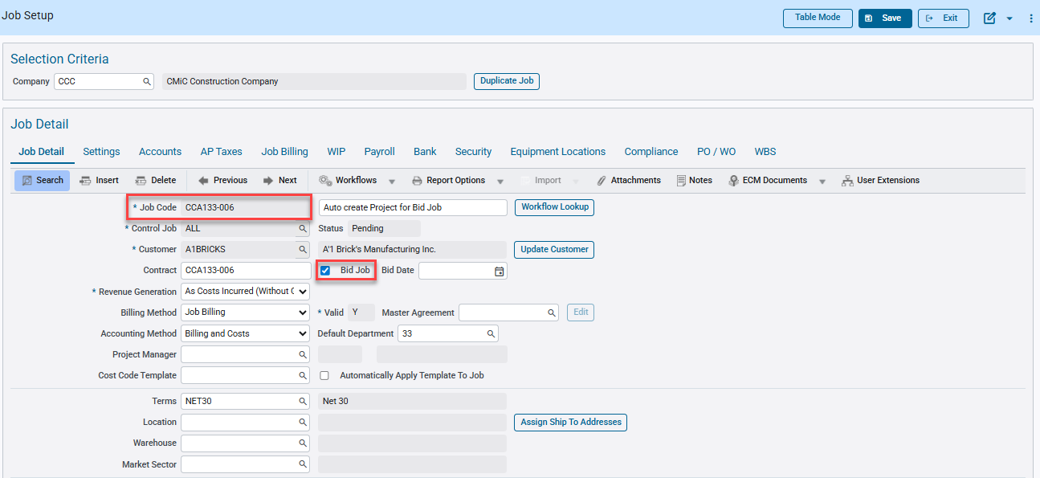 Project Controls > Job Costing > Job > Enter Job

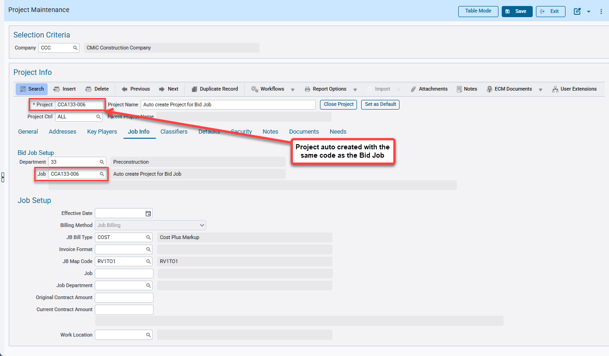 Project Controls > Job Costing > Job > Enter Project

Automatic Creation of Jobs when Creating a Project (JC Control)
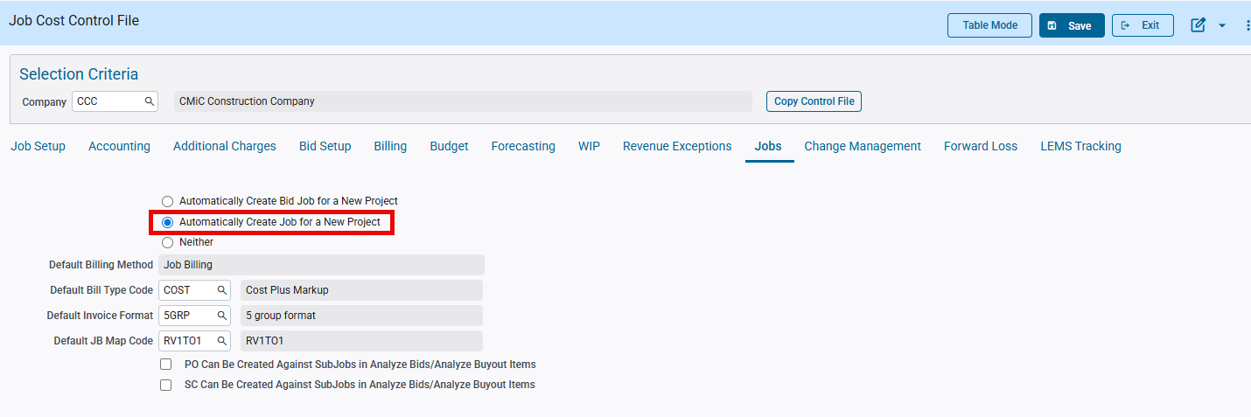
Job Cost Control > Jobs > Automatically create jobs for a new project

When the ‘Automatically Create Job for a New Project’ flag is checked in JC Control, then the system will automatically create the Job at the time of Project creation in the Enterprise application.
If a Job Code mask is also applied in JC Control, then the system will use this mask to populate the Job.
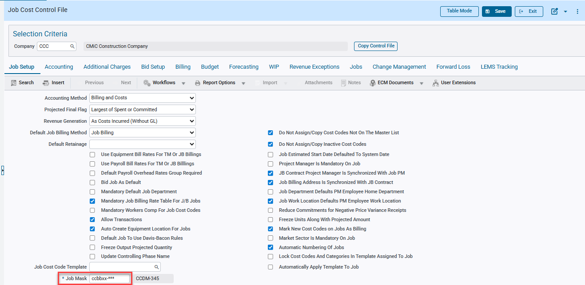 Job Cost Control > Jobs > Automatically create jobs for a new project

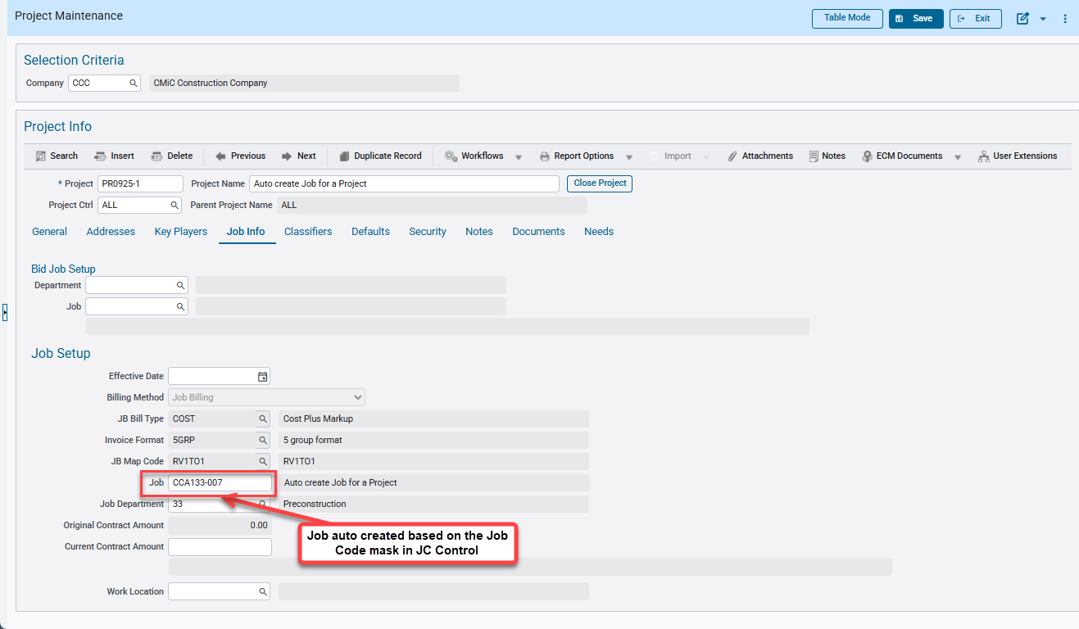 Project Controls > Job Costing > Job > Enter Project

Limitations while creating Project with Job Code mask
When both the ‘Automatic Project Numbering’ and ‘Use JC Job Number Mask’ flags are also checked in Company Control in the CMiC Field application, then for a new Project, the Project Code will be auto populated based on the Job Code mask defaulting from JC Control.
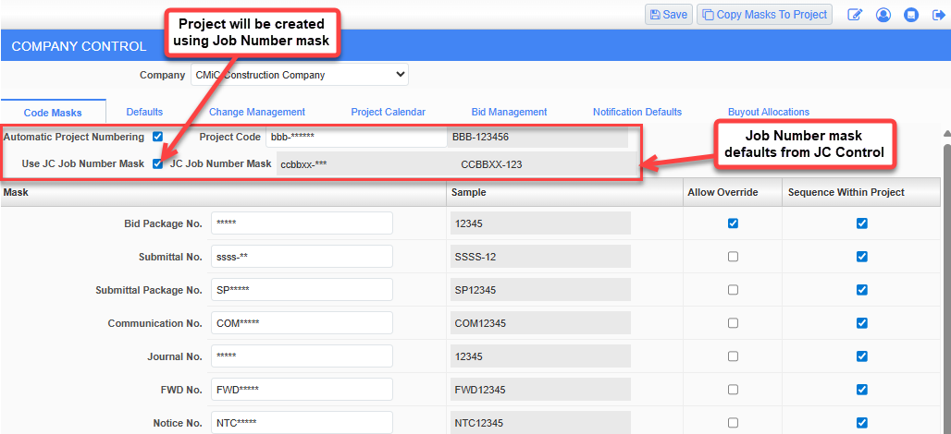
CMiC Field > Company Control > Code Masks > Automatic Project Numbering; Use JC Job Number Mask

However, if the Job Code mask contains the Department Code parameter, then only the Project Code created in Enterprise application will be auto populated with the Department Code.

New Coloring Scheme in WIP Adjustment screen (JBJCPC-4516)
Overview:
The coloring scheme of the forecasting line in the Work-In-Process Adjustment program has been overhauled to make it more consistent and reader friendly with sufficient contrast to view the amounts and other information.

Implementation:
The forecast line in the WIP Adjustment tab will follow the color scheme below:
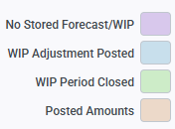

When the forecast for Job/Contract is not stored, then the WIP Adjustment line is displayed in the Lavender color.
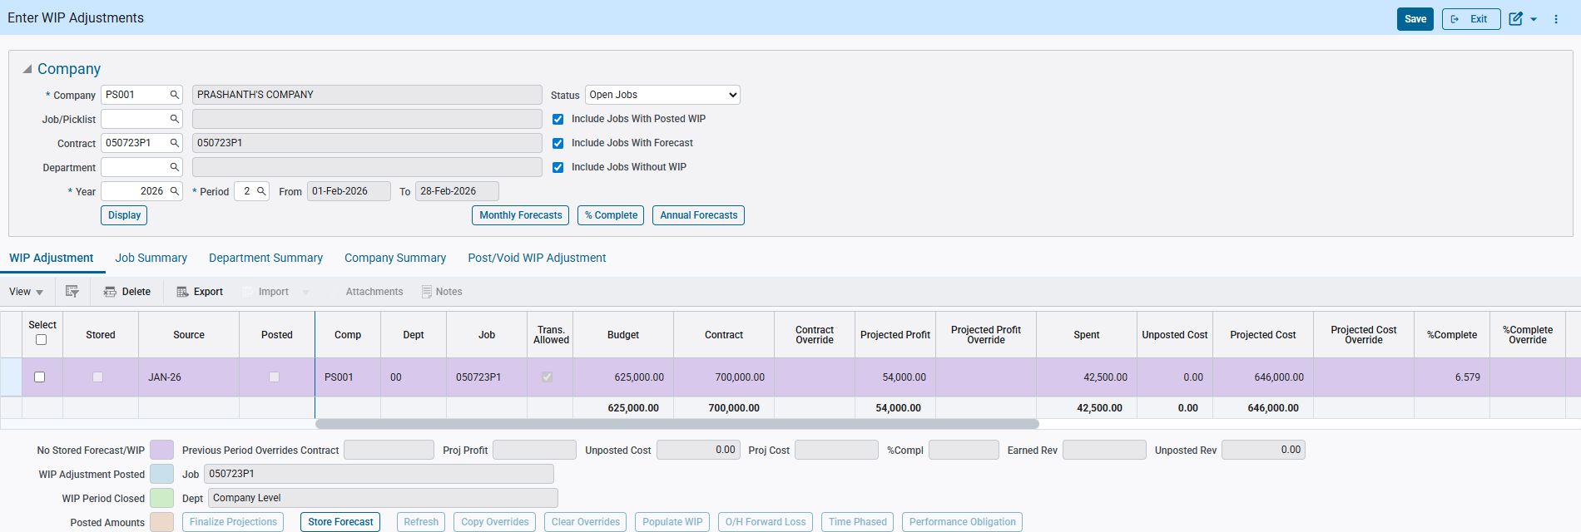
Project Controls > Job Costing > Forecasting > Work-In-Process Adjustments > Enter and Post Adjustments

When Unposted Cost/Billings are posted, then the amounts are displayed in orange color.
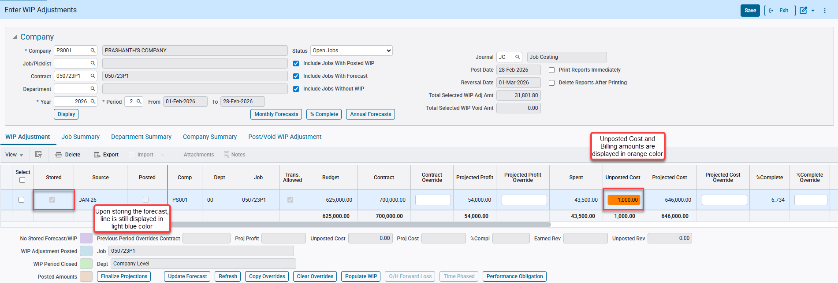
NOTE: There is no change to the color scheme upon storing the forecast and the line is still displayed in light blue color. Same is also reflected in the Post/Void WIP Adjustment tab.

Upon posting the WIP Adjustment line, then it is displayed in blue color.
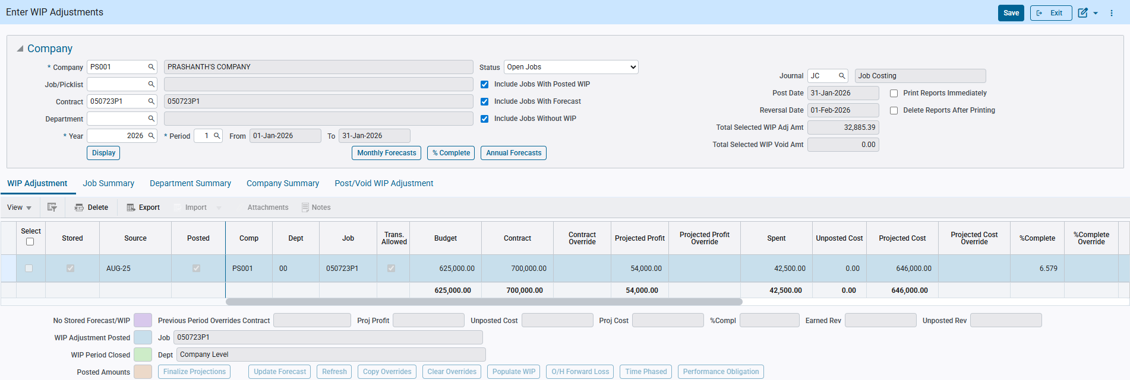

The same color is reflected in the Post/Void WIP Adjustment tab as well.
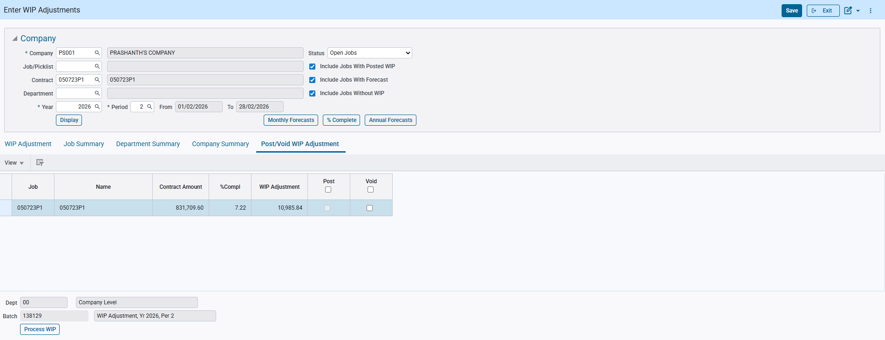

Unposted WIP Adjustment lines for closed period are displayed in green color.
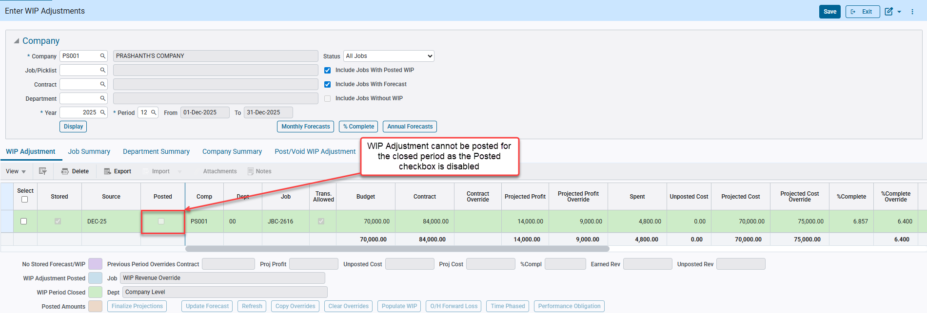

Do Not Allow Copying Inactive Cost Codes or Cost Codes Not on the Master flags functionalities (PC-13077)
CMiC modified the system to prevent inactive cost codes and cost codes not on the master from being copied from job to job. Two control options, "Do Not Assign/Copy Inactive Cost Codes” and "Do Not Assign/Copy Cost Codes Not on Master” were added to JC Control at the company level.
Pre-requisites
To use this functionality, the required flag(s) must be enabled under JC → Control File → Job Setup Tab.
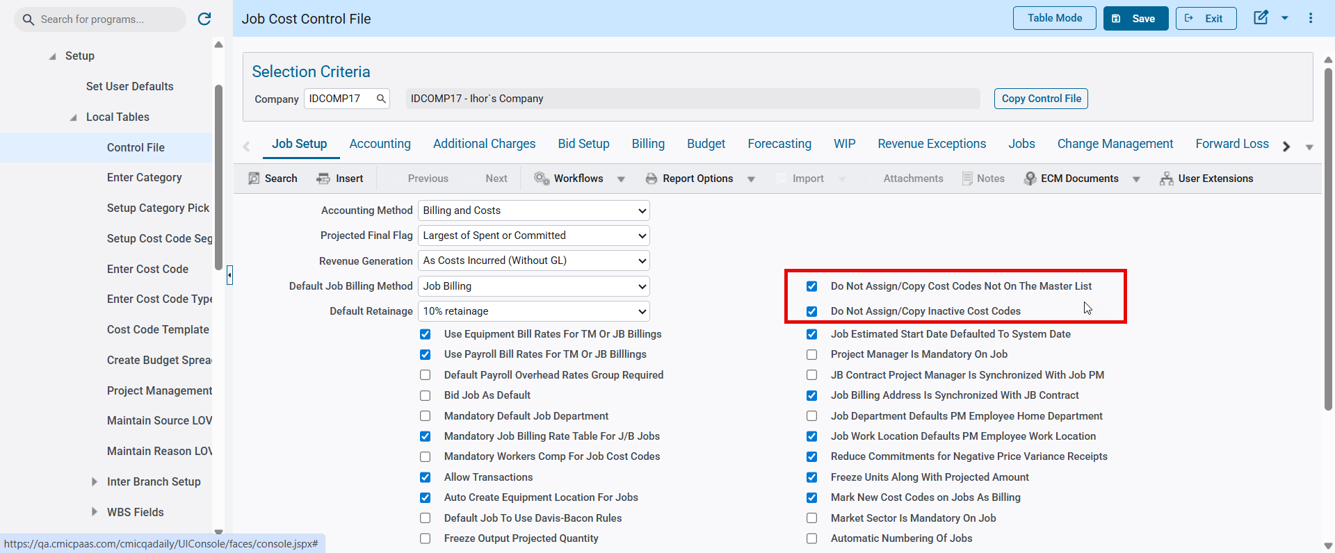
Modifications
The following apps and screens have been modified to support this functionality:
- Assign Cost Codes (JCPRODSU)
- Assign Templates to Multiple Jobs (JCDRIVEP)
- Win/Lose Bid (JCBIDPRO)
Implementation
“Do Not Assign/Copy Cost Codes Not On The Master List” flag functionality
---------
When enabled, cost codes not on the master list (Enter Cost Code app) will not be assigned when using JC → Assign Cost Codes → “Use Existing Job” to assign cost codes from one job to another. If the source job has cost codes not on the master list, those codes will be ignored, and the process will continue with assigning the cost codes that are on the master. The following message will be shown: “Info: Some Cost Codes Will Not Be Assigned Because Are Not On The Master List.”
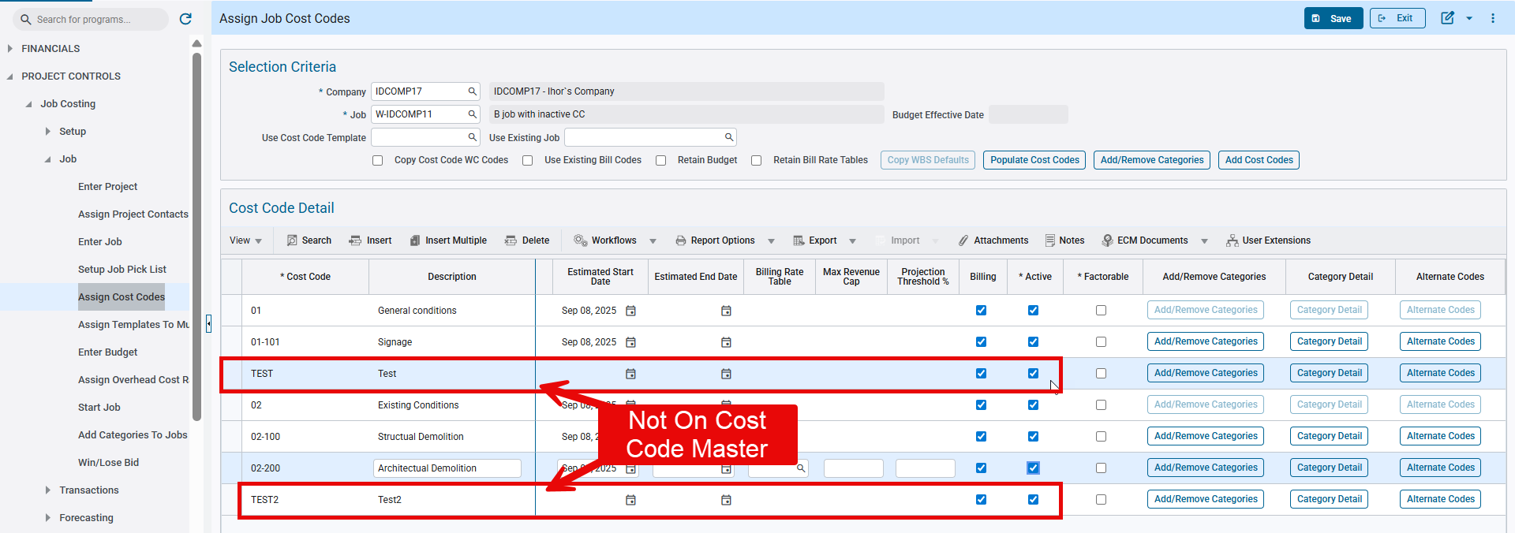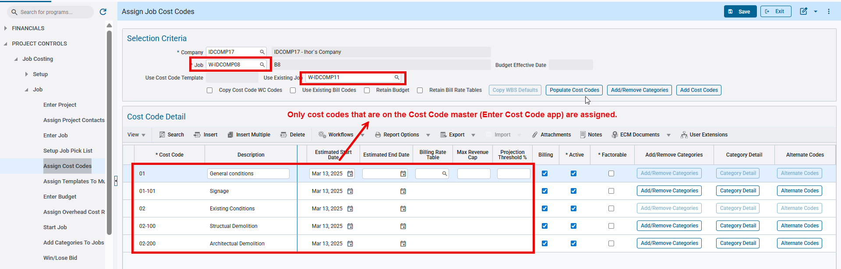
Note: This flag will not prevent cost code assignment when using any “Template”. For this purpose, use JC → Control File → Job Setup tab → “Validate Cost Code Master” flag, which will prevent creating a template with cost codes that are not on the master list. Similarly, this functionality will not work when copying Bid Job Cost Codes to the Win job.
“Do Not Assign/Copy Cost Codes Not On The Master List” flag functionality
---------
When enabled, inactive cost codes will not be assigned when using:
- JC → Assign Cost Codes app
  - “Use Existing Job” feature to assign cost codes from one job to another. If the source job has inactive cost codes, those codes will be ignored and the process will continue with assigning the active codes. The following message will be shown upon data selection: “Info: Some Cost Codes will not be assigned because they are not active.”
  - “Cost Code Templates.” If an inactive cost code is assigned to a template and the template is applied to a job, those inactive codes will be ignored and only the active codes will be assigned to the job. 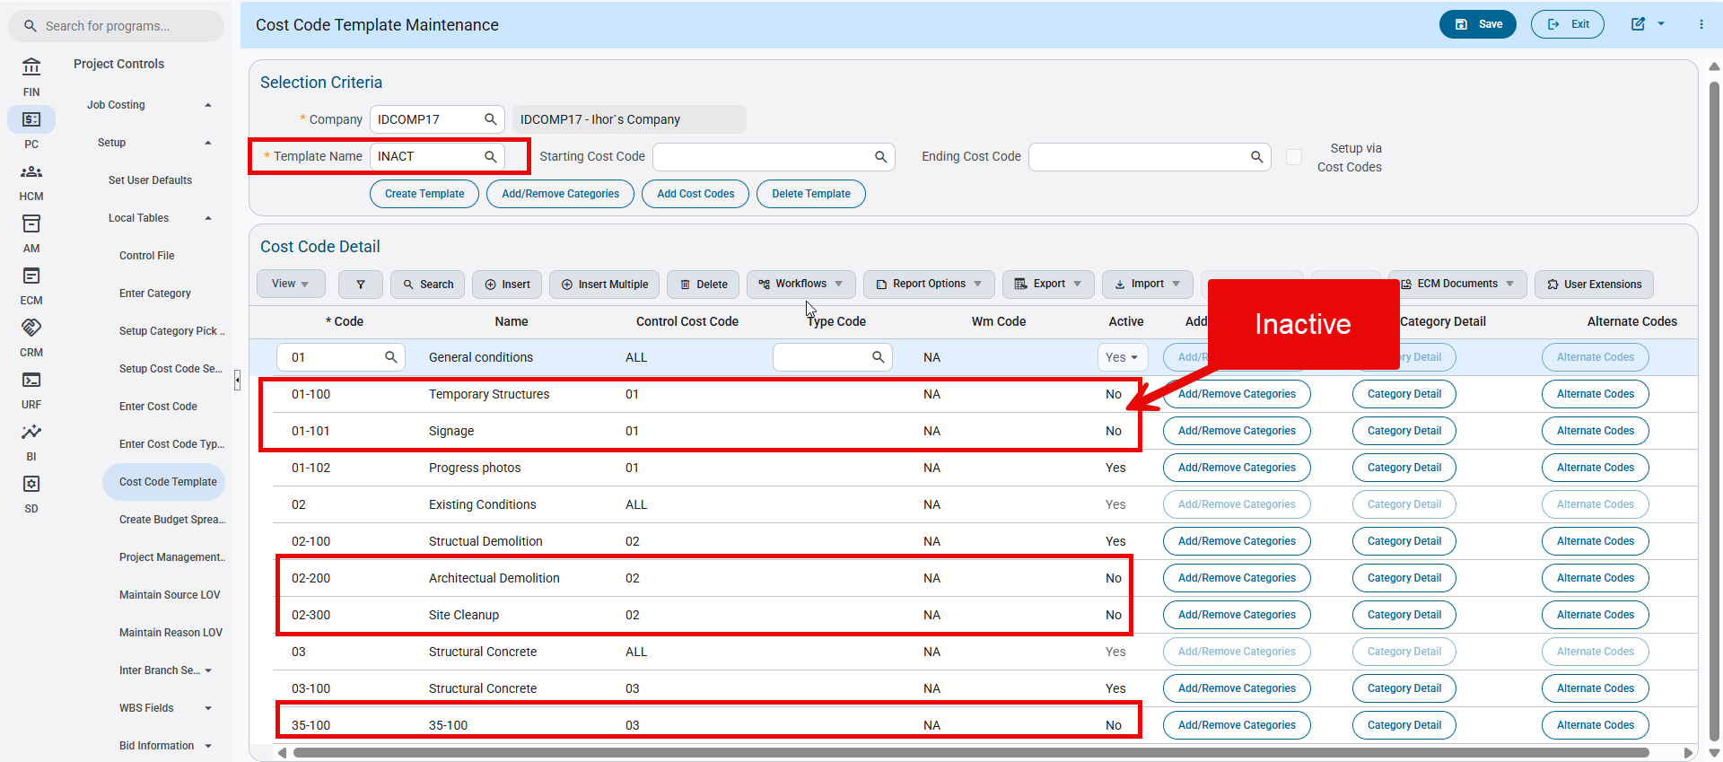
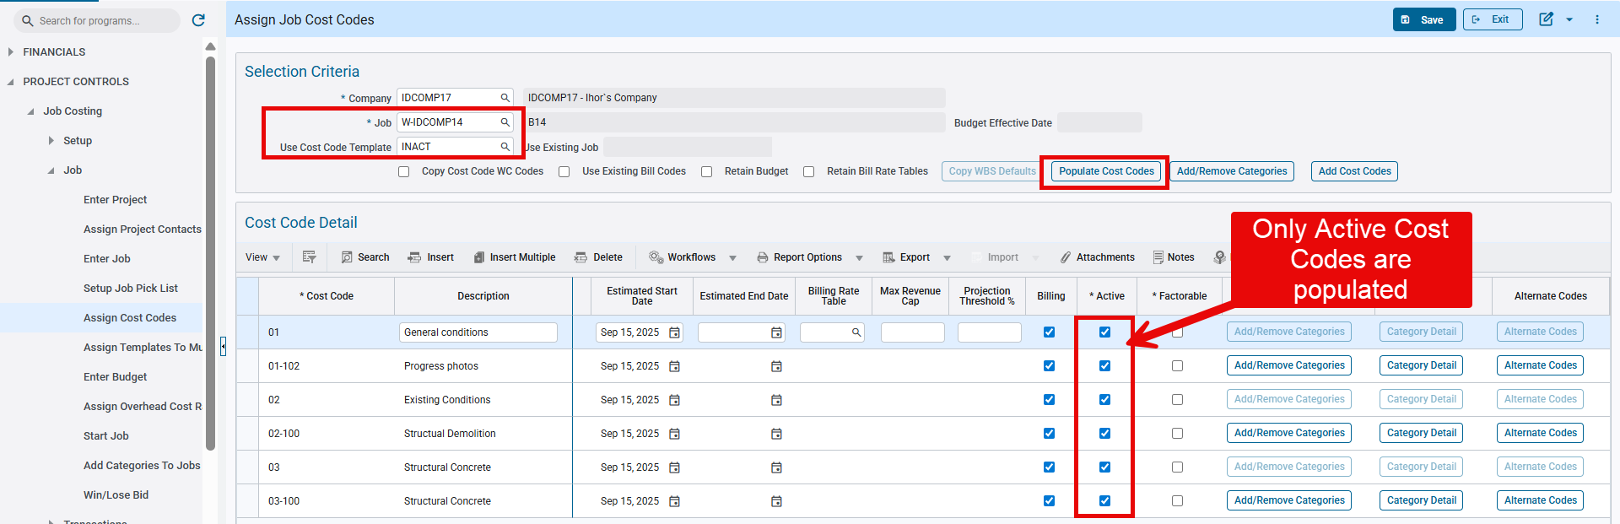
Note: Do not make a controlling cost code inactive while keeping a sub cost code active. This is an incorrect use of the app and may lead to data loss.
- Assign Templates to Multiple Jobs app
Works similarly to the Assign Cost Codes app, and only active cost codes will be assigned.
- Win/Lose Bid app
  - When a template is used to assign cost codes for a Bid or Win job, only active cost codes will be copied.
  - However, when inactive cost codes are assigned to a Bid job and then copied to a Win job using the “Copy Cost Codes” flag/functionality, those inactive cost codes will be copied as inactive despite the “Do Not Assign/Copy Inactive Cost Codes” flag settings.

GC Monitor: Update GC Monitor Period Details to Read Sub rate tables using effective periods (PC-21811)
This enhancement improves the Bill Rate Escalation functionality in GC Monitor so billing rates escalate correctly by period using sub-rate effective start dates defined for each job. Currently, GC Monitor > Period Details does not read the correct rate for each period, applying the same sub-rate code to all months instead of adjusting by period. With this update, the Period Details popup will default each period’s billing rate based on the applicable sub-rate start date. While the main GC Monitor screen will continue to display the first billing rate from the sub-rate code, the Total Projected Billing Amount will accurately reflect all rates that fall within the selected start and end dates.

Modifications:

The program GC Monitor has been enhanced to correctly apply sub-rate codes by period, ensuring accurate billing and revenue projections. GC Monitor rows now include the start dates of all sub-rate codes assigned to a job. This allows the Projected Billing Amount to automatically reflect the correct sub-rate for each period, rather than applying a single rate across multiple periods.

Total Projected Billing Amount:

- Calculated using the start dates of all applicable sub-rate codes
- Each sub-rate is applied only during its effective period, providing accurate period-based billing and revenue forecasts.
Period Details Popup:

- Default billing rates for each period are determined by the applicable sub-rate start date.
- The main GC Monitor screen will continue to display the first rate from the sub-rate code based on start dates, while the Total Projected Billing Amount reflects all rates that apply within the selected periods.
Notes: To use this functionality, please ensure that the following flags are unchecked

- Always Restrict to Current Rate in GC Monitor in System options under Forecast tab is set to ‘N’
- Use Payroll Bill Rates in Job Setup under Payroll tab is set to ‘N’
Examples with Screenshots:
Setup:
Always Restrict to Current Rate in GC Monitor in System options under Forecast tab is set to ‘N’
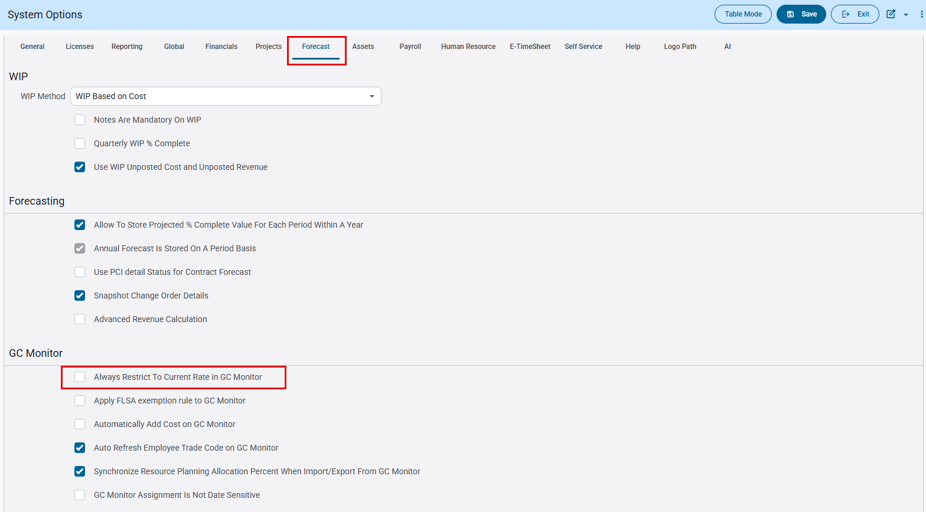
System Data > Setup > System Options>Forecast tab

JC Control file setup:

The company used in this example uses Company Level Cost cutoff option

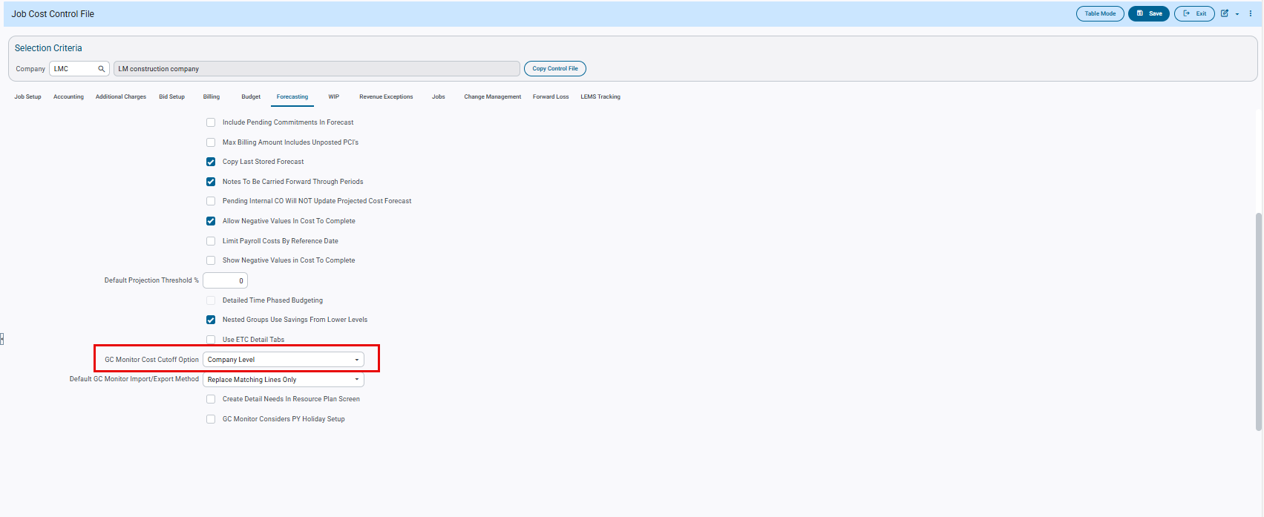
Job Costing > Setup> Local Tables> Control File

Job Setup:
The job shown in this example uses the sub rate ‘GCSUBRATE’
The flag ‘Use Billing Rate Table for Revenue Forecast’ is checked(‘Y’) and ‘Use Payroll Bill Rates’ flag is unchecked(‘N’)
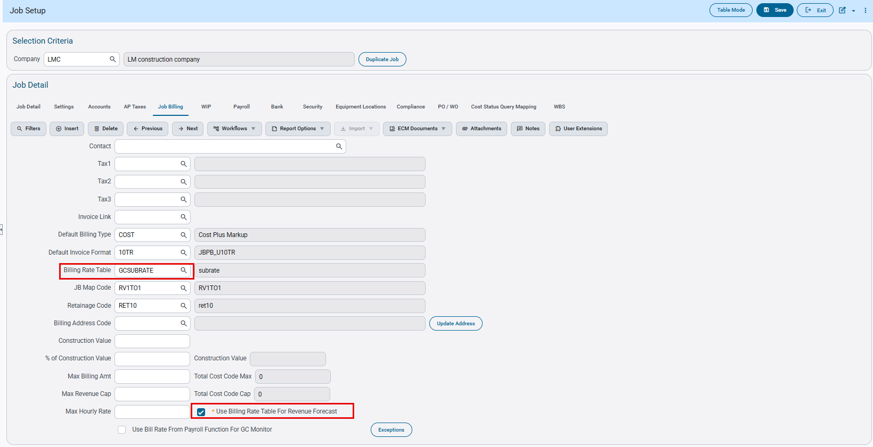 Job Costing>Job>Enter Job>Job Setup> Job Billing

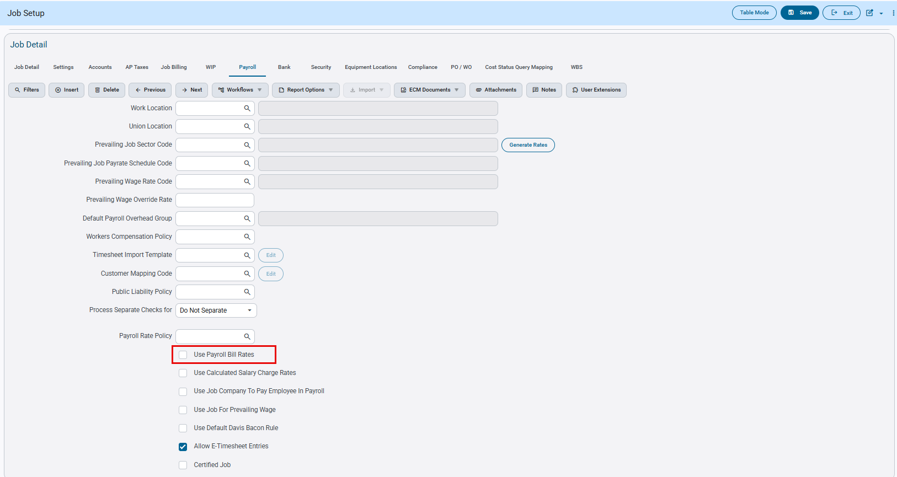
Job Costing>Job>Enter Job>Job Setup> Payroll

Billing Rate setup:

The sub rate code ‘GCSUBRATE’ used in this example has the following setup.
The sub rate tables are referenced by trade codes and sub rate exists for three years: 2024,2025 and 2026

2024 rates: Trade205@$75/HR-SR01
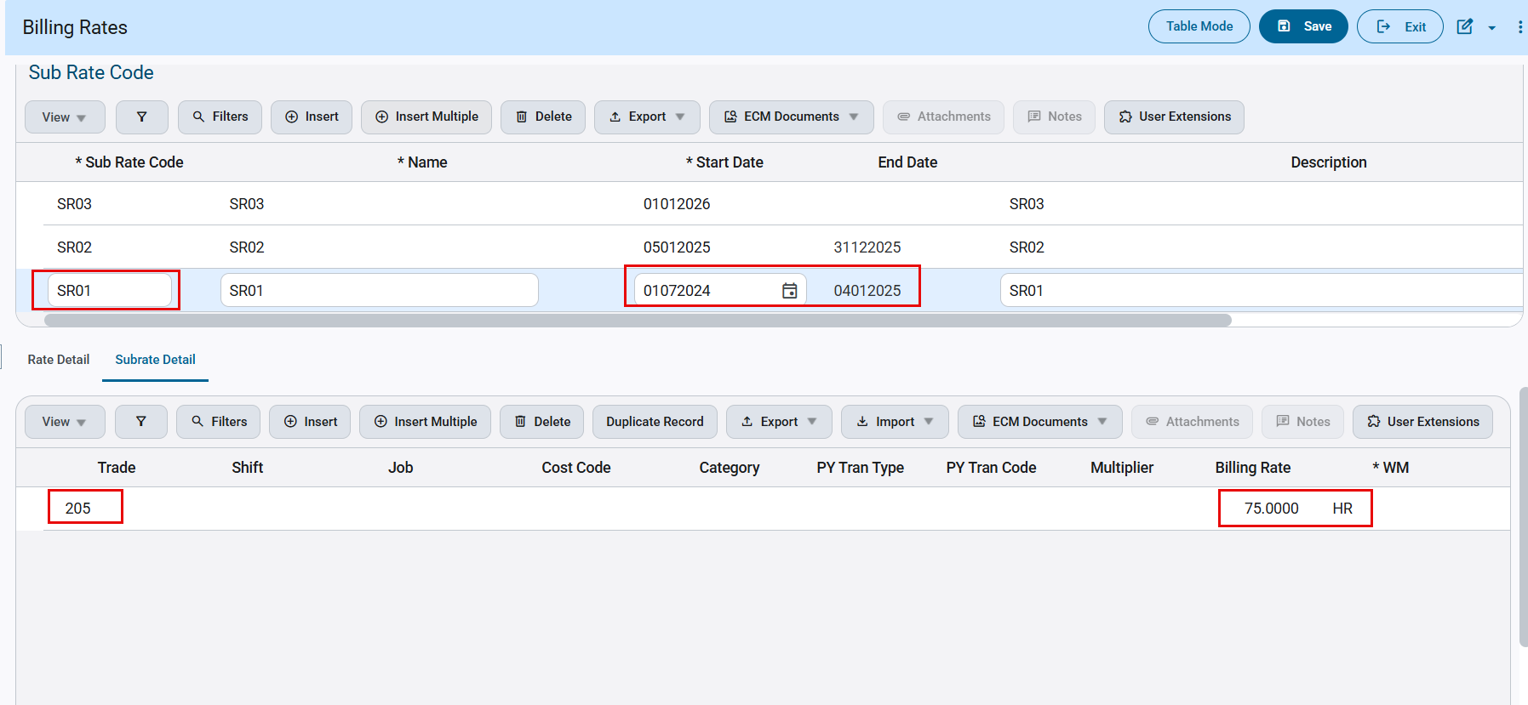

2025 rates: Trade205@100/HR-SR02
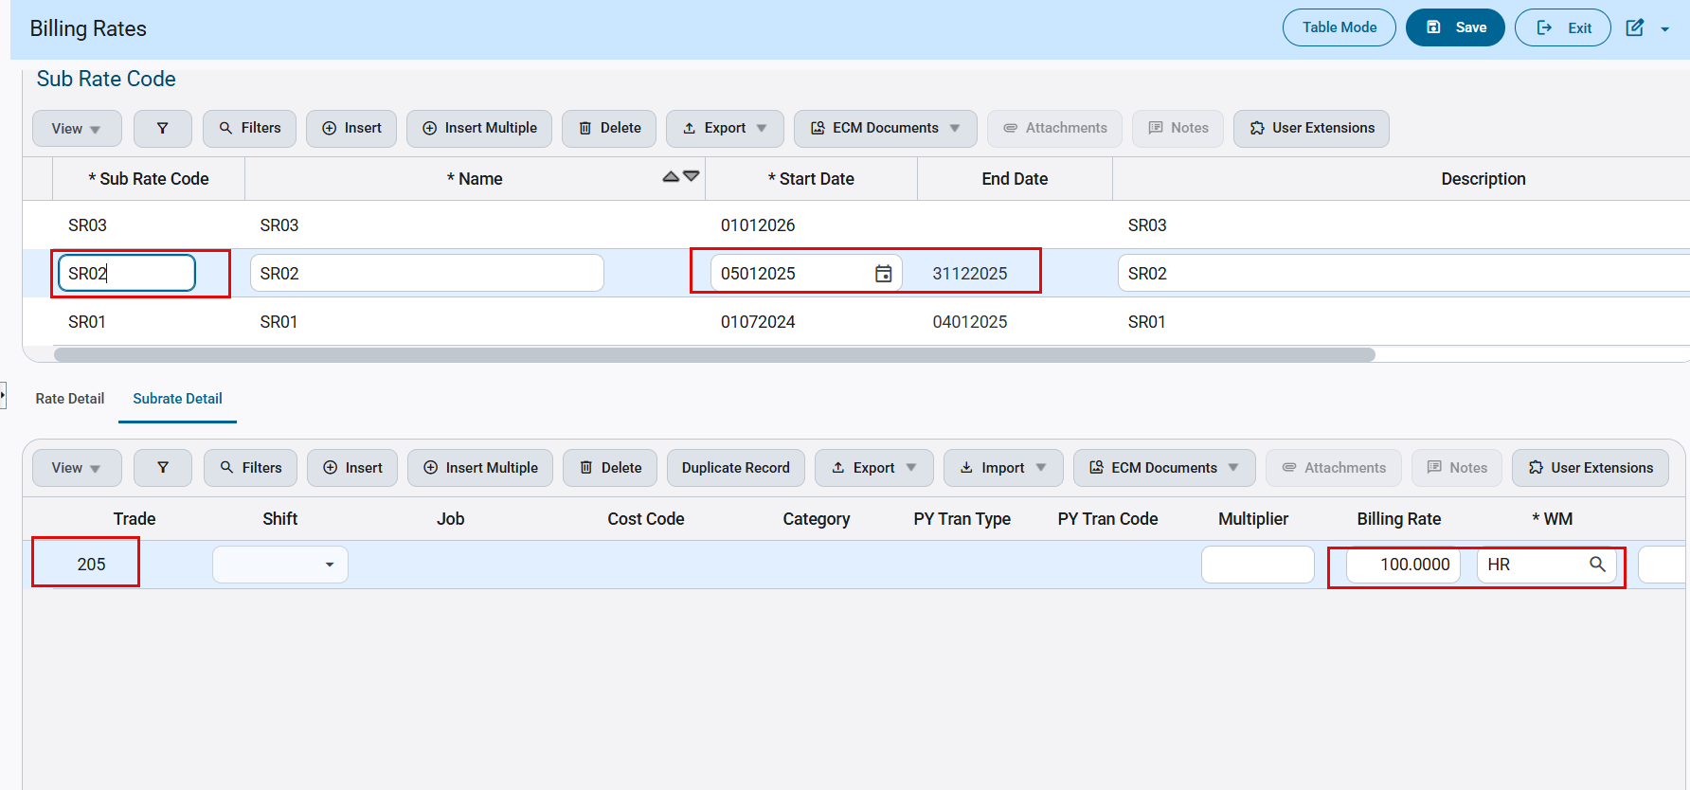
2026 rates: Trade205@105/HR-SR03

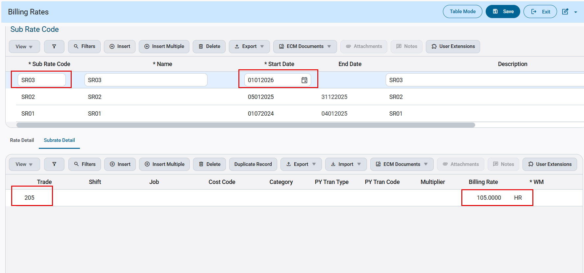
Job Billing>Local Tables>Billing Rates

Labor Cut-Off Date Setup:
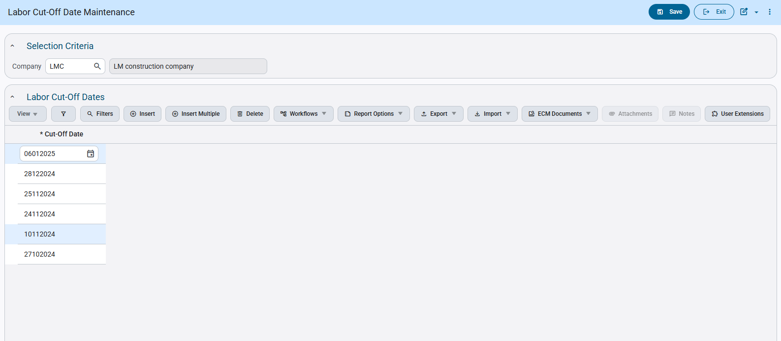
Job Costing> Local Tables>Contract Forecasting> Labor Cut-Off Date Maintenance

GC Monitor:
Example1:
A detail line is added for Period 2024/9 with Trade 205 in GC Monitor with Start and End dates as July/01/2024 to Dec/31/2026. There is no labor cut-off date for Period 9 in Labor Cut-off Date Maintenance.

Default Hourly billing rate on the main screen is defaulted to 75.0000 from the billing rate table-Sub Rates for the Trade 205, Year 2024 based on Start Date (July/01/2024)

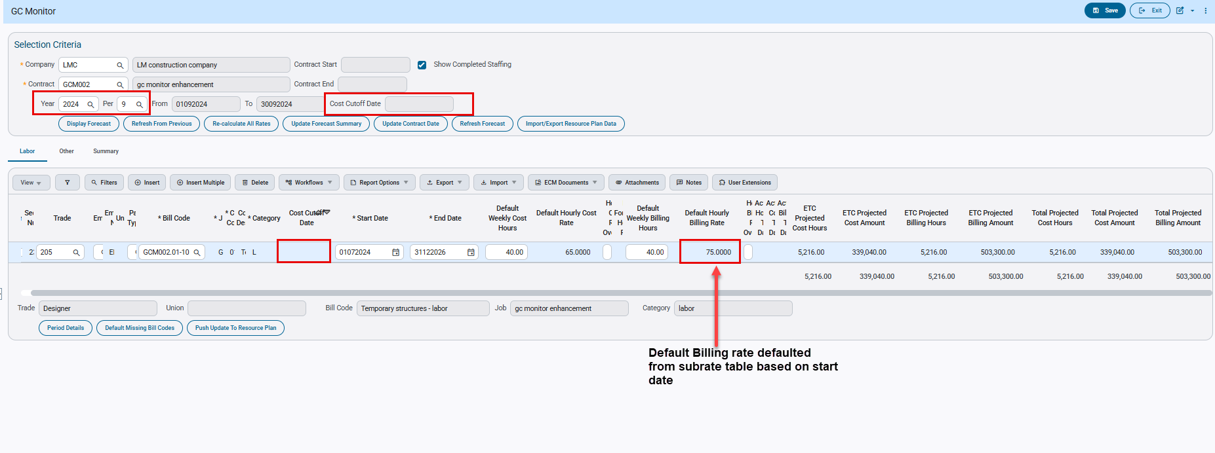
Job Costing>Forecasting>GC Monitor

For the above setup, the period details will span the effective dates of the sub rate table.
- For 2024(Period 7 -12):
Rate = $75/HR
Projected Cost Hours=1056.00
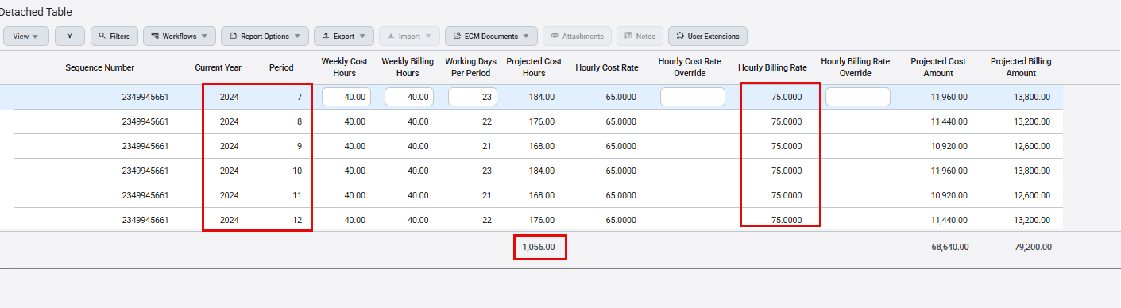
Job Costing>Forecasting>GC Monitor>Period Details

- For 2025(Period1) has two sub rates:
Jan/01/2025 to Jan/04/2025 Rate=$75/HR
Jan/05/2025 to Jan/31/2025 Rate=$100/HR
If there are two sub rates for the same Period, then average will be calculated. The hourly Billing rate for Period1 is 87.5 and Projected Cost hours is 184.00
- For 2025 (Periods 2–12):
Rate = $100/HR
Remaining Projected Cost hours = 2080-184=1896.00
- For 2026 (Periods 1–12):
Rate = $105/HR
Projected Cost hours=2080.00
Total Projected Billing Amount= (2024 GC Monitor Projected cost Hours * Sub Rate) + (2025 GC Monitor Projected cost Hours * Sub Rate) + (2026 GC Monitor Projected cost Hours * Sub Rate)
= (1056*75) +(184*87.5) +(1896*100) +(2080*105)
=79200+16100+189600+218400
=503300.00
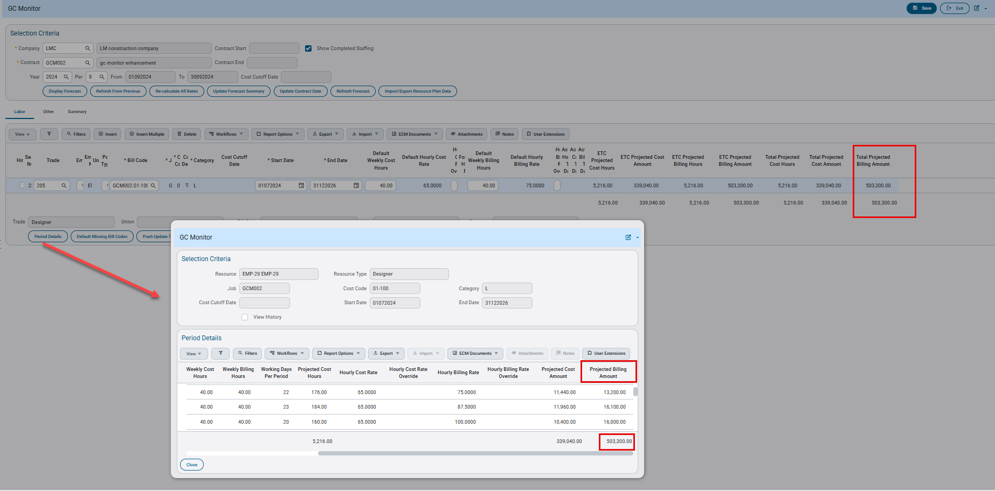

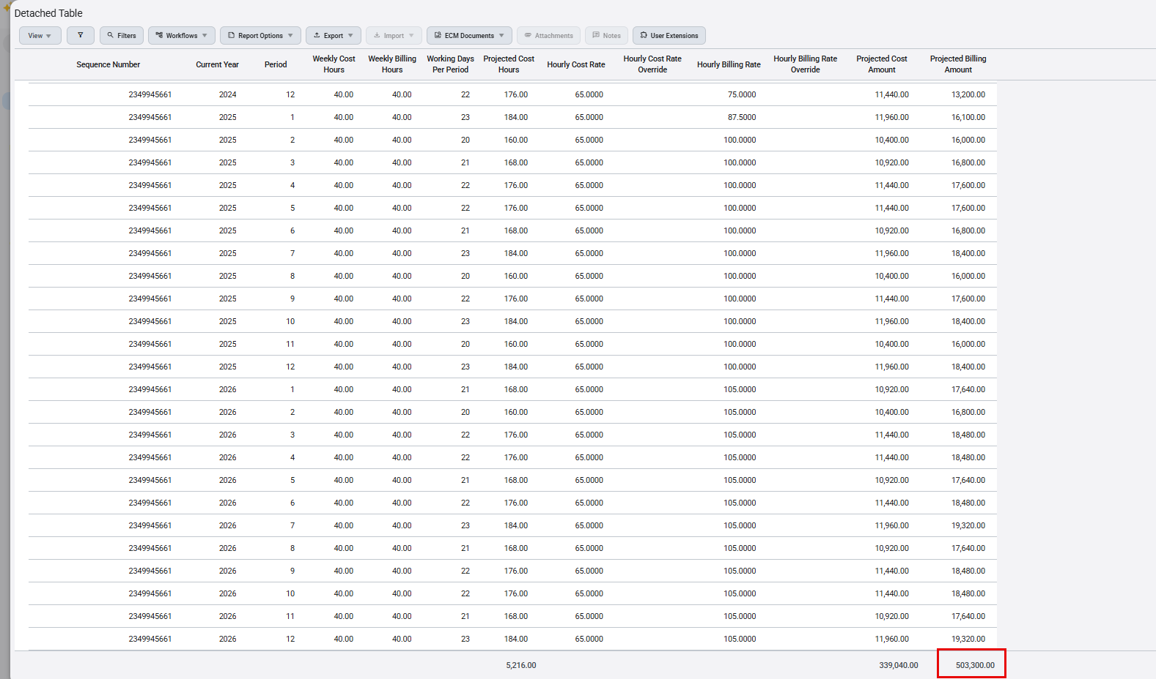
Example2:
A detail line is added for Period 2025/1 with Trade 205 in GC Monitor with Start and End dates as July/01/2024 to Dec/31/2026. For Period 2025/1, the labor cut-off date is Jan/06/2025.
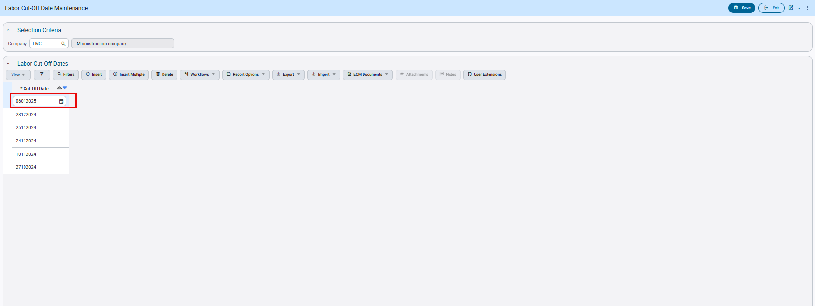

Default Hourly billing rate is defaulted from sub rate table and will be based on Cost Cut-off Date

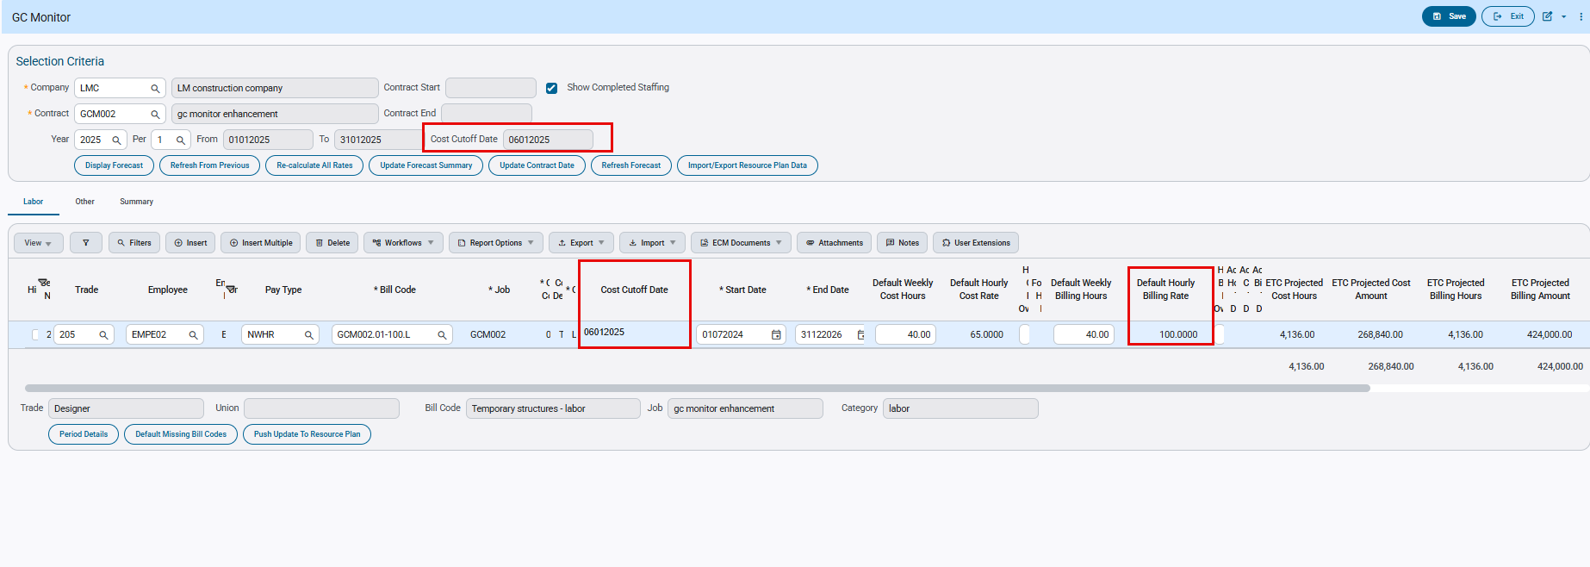

Period details will be displayed from the cut-off date (Jan 6, 2025), covering Period 1 through Period 12.

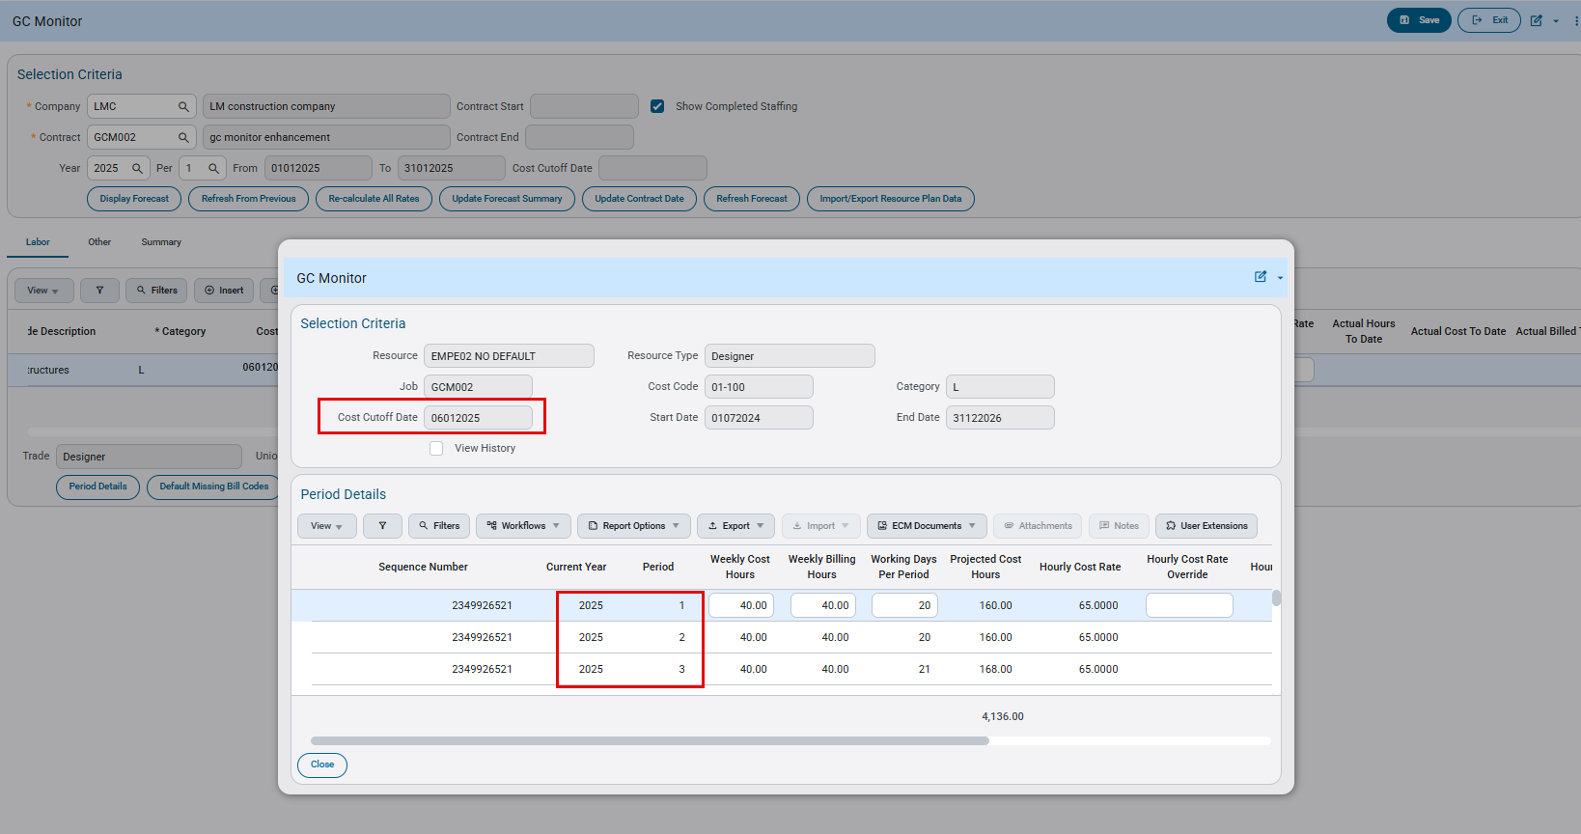

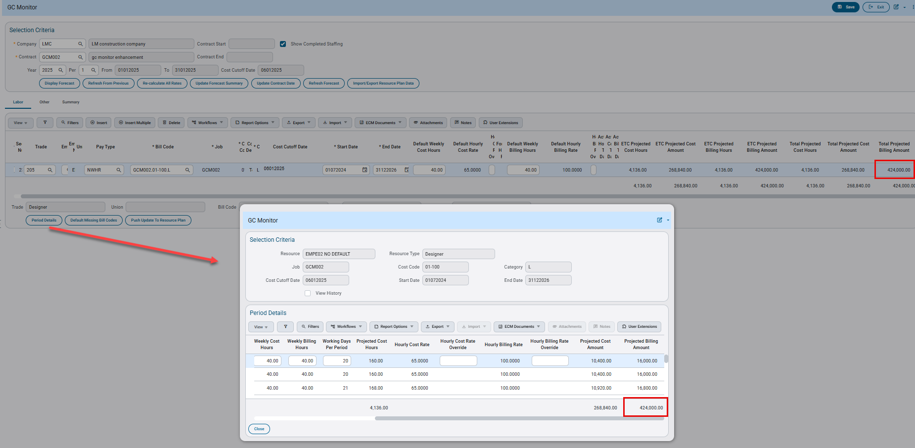

Based on sub rate table the hourly billing rate for year 2025 is $100/HR and for year 2026 is $105/HR
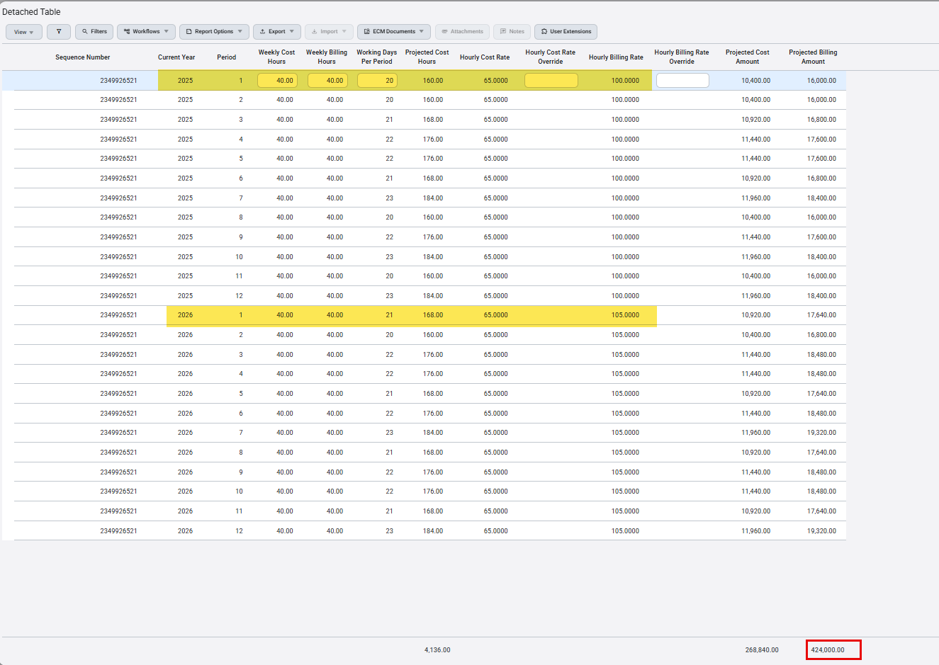

Material Sales

Material Sales – New Point of Sale and Print Billing Invoice Programs (CAM-7464)
Overview
Two new programs Point of Sale Entry and Print MS Billing Invoice have been added to the system.
- The first Point of Sale Entry program allows a user to quickly convert and translate a full sales order straight into posted inventory invoices and fully operable tickets.
- The second Print MS Billing Invoice (MS_STD_INV) allows the user to reprint the report/invoice generated during the Point of Sale program.
These inclusions allow the user to create tickets at the click of a button, without having to manually enter details one by one. Reducing the speed and time it takes to complete posting.
Modifications
Runtime feature program:
Point of Sale Entry -
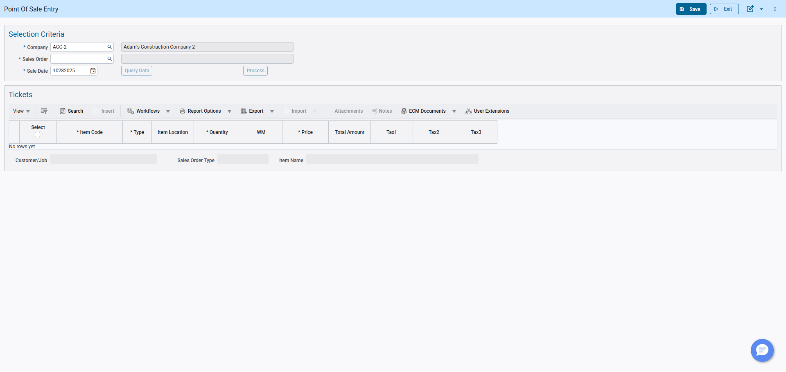
Print MS Billing Invoice (MS_STD_INV) –

Implementation
Point of Sale Entry:
The Point of Sale Entry program has been added to allow the user to quickly move from a completed sales order to a set of processed inventory movements at the click of a button.
Note: This process can only be completed using the simplified versions of Sales Order/Ticket Entry programs.
- The user begins the process by creating a Sales Order through short form, to be used as a base in the Point of Sale Entry program.
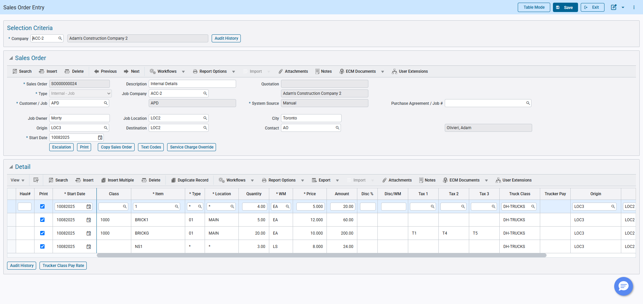
- Once the Sales Order has been saved, the user can open the Point of Sale Entry program, and query the data by filling in the header with the appropriate information then clicking the Query Data button.
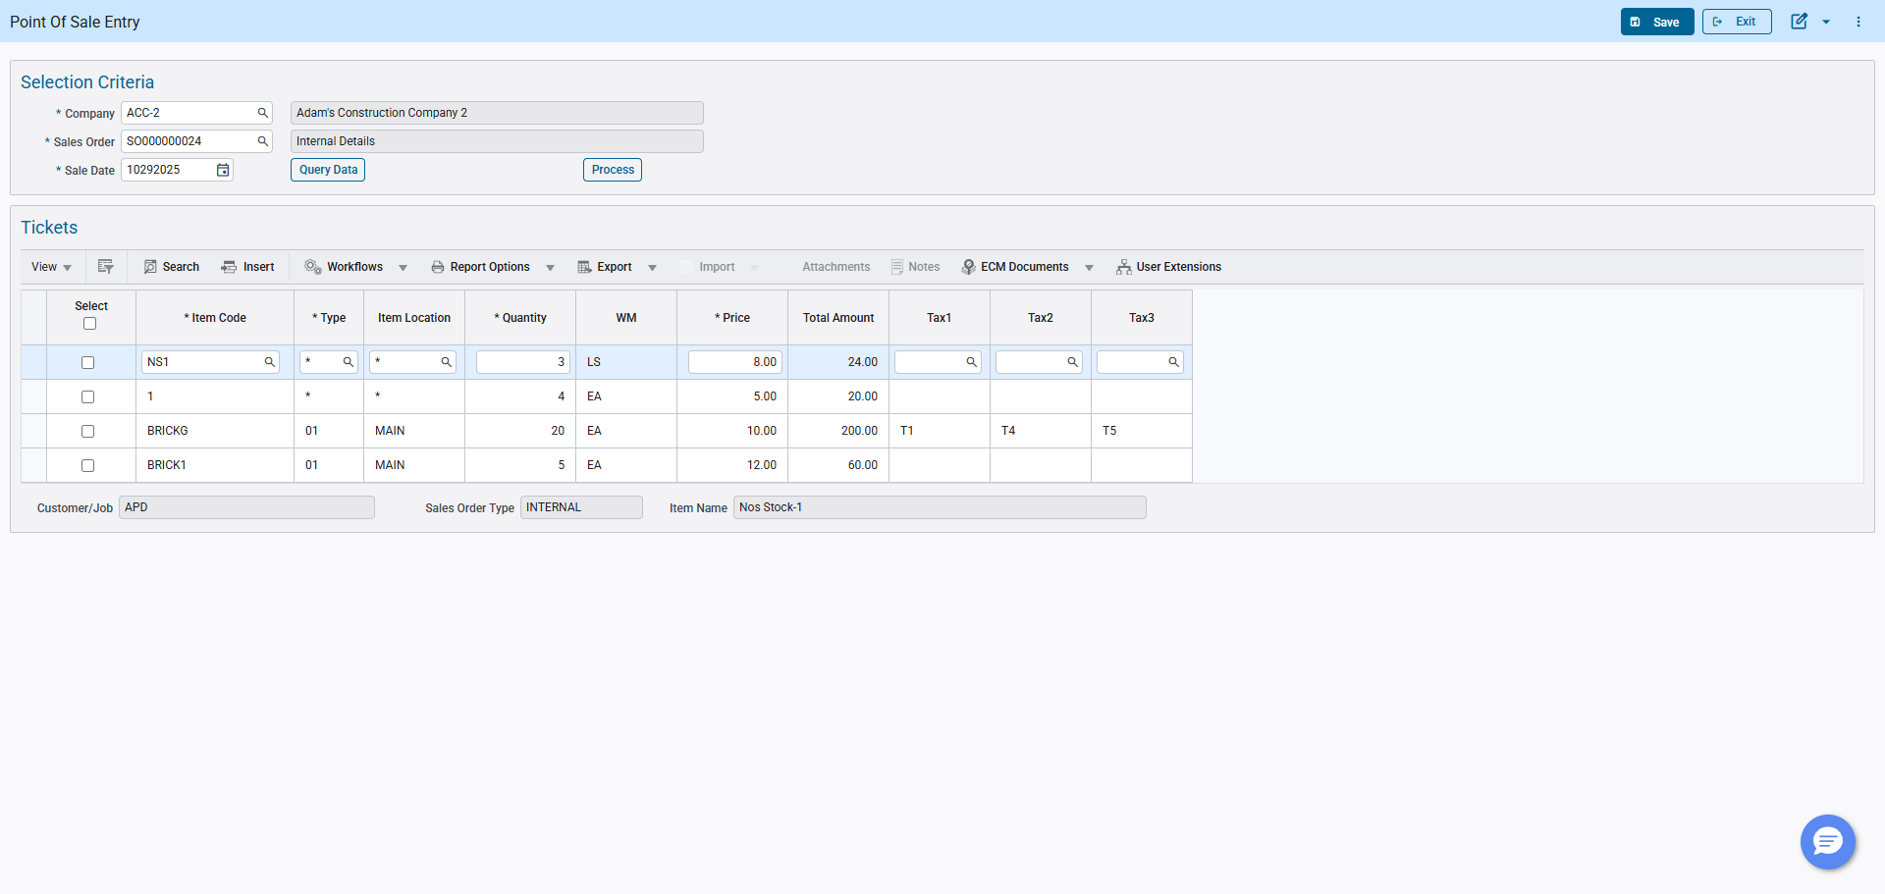
- Upon querying the data, all detail lines from within the sales order will be auto populated within the Tickets table for further processing. The user at this time can make changes to the tickets, and use the left most column Select to select which detail lines to process and invoice. By selecting the checkbox within the column header, the program will select and ready every detail line.
Note: Non-Stock items Location is auto populated from the Sales Order Entry as *. The Point of Sales Entry program will not proceed until the locations for each detail line is changed accordingly.
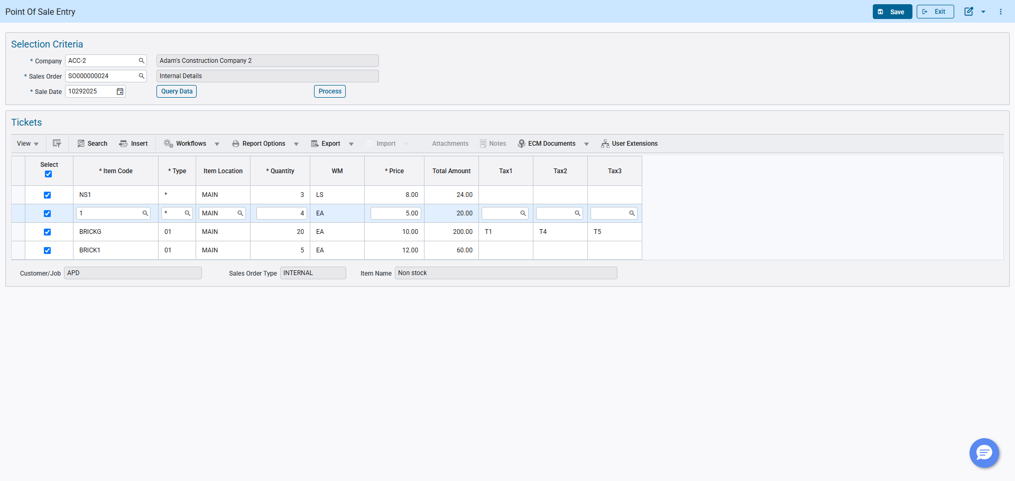
- When the user is satisfied with their alterations, they can then save the program and click the Process button to begin the invoicing process.
There will be an Alert stating that tickets are about to be generated. The user will then click Ok to continue the process.
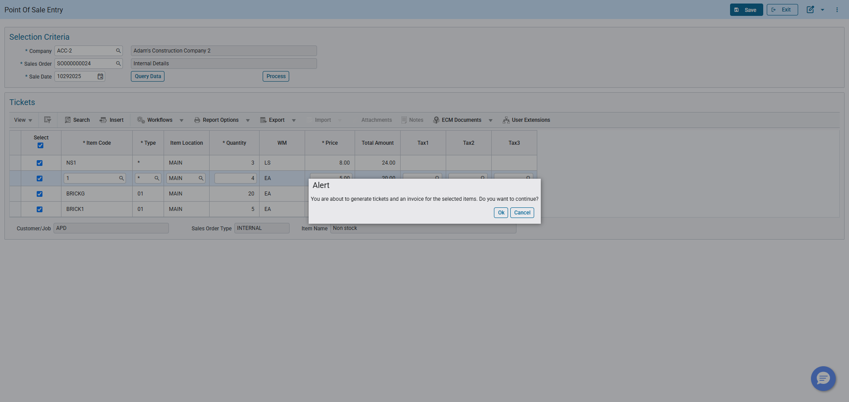
- From this point unposted tickets have now been generated and the user will be prompted to enter the ship-to-address information to be included in the MS_STD_INV report.
This report information is auto populated from the customer billing address for external or job address for internal.
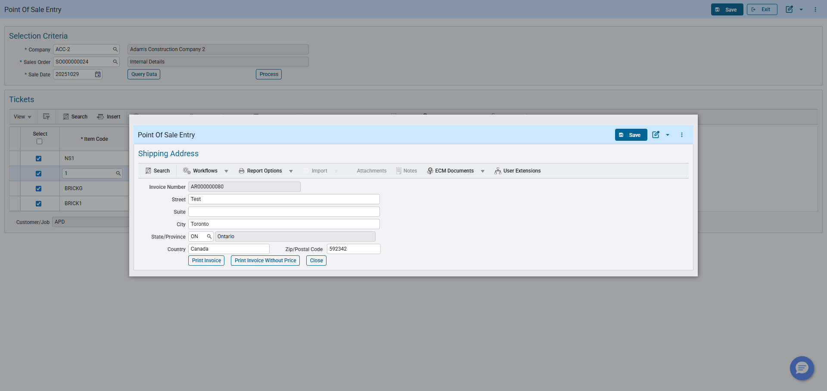
- The user can alter the ship-to-address at this point before an MS_STD_INV is generated, to have the details updated on the report.
The user can click the Print Invoice button to print the MS_STD_INV with totals and prices, or they can click the Print Invoice Without Price button to print without them.
Print Invoice:
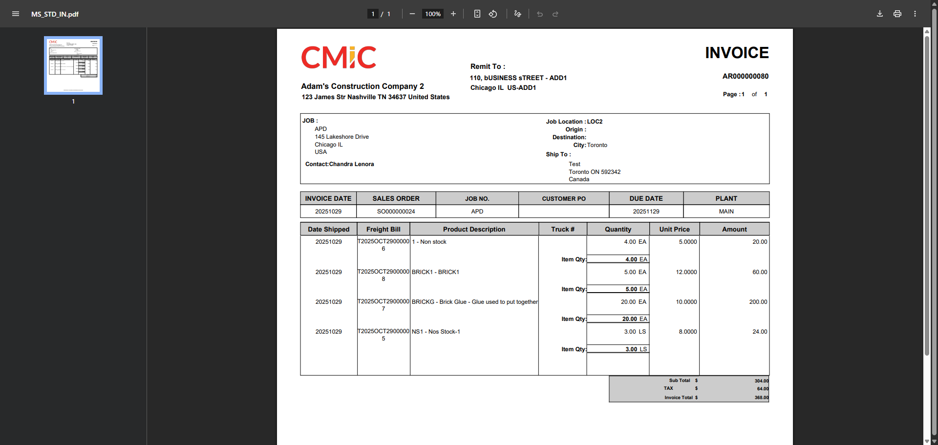
Print Invoice Without Price:
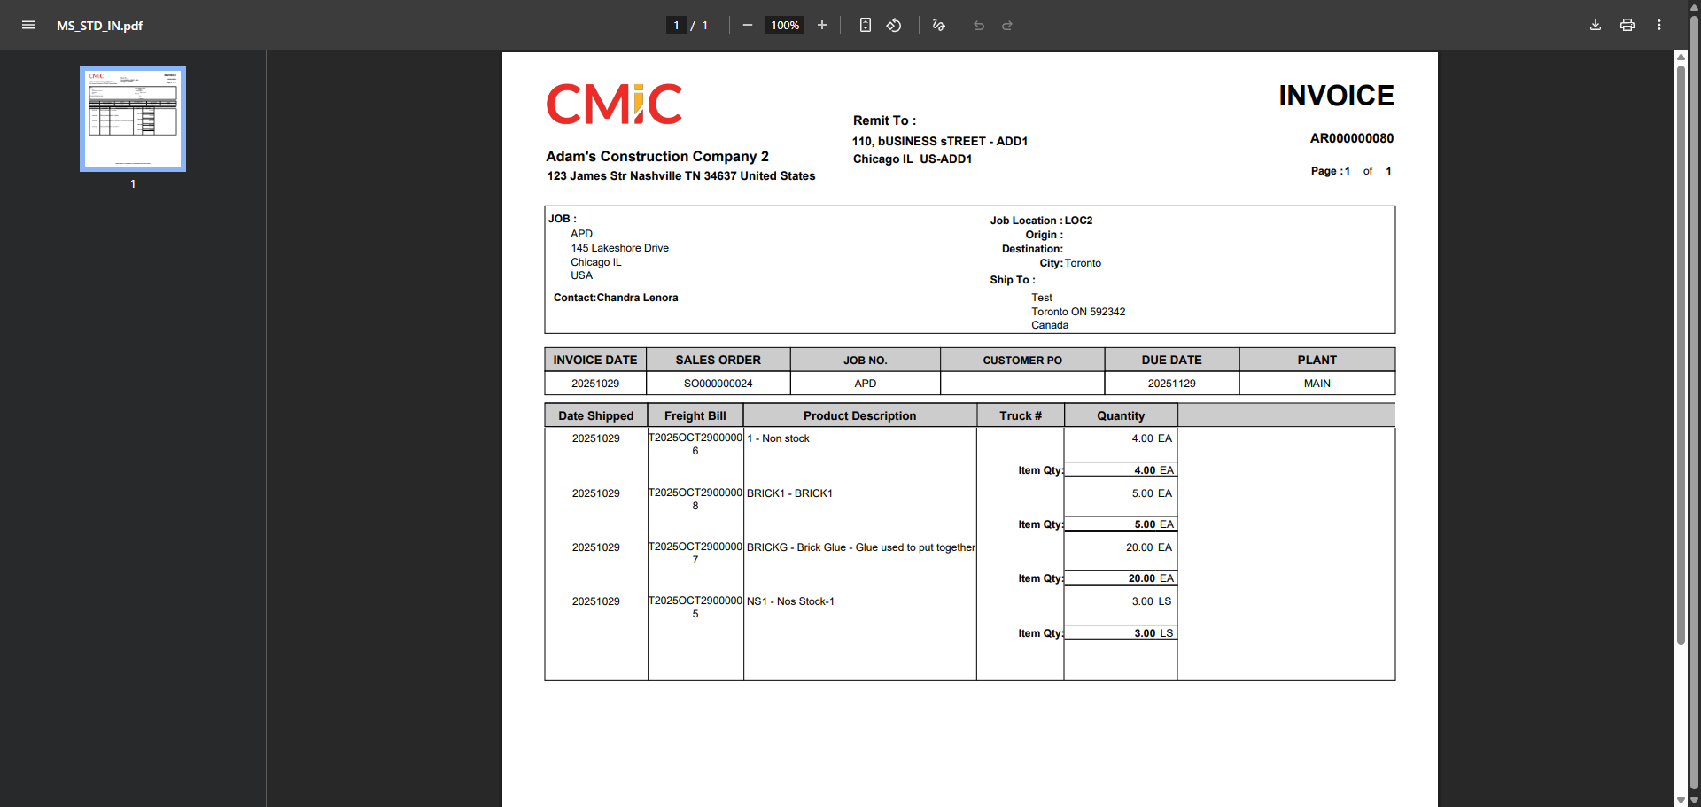
Optional Steps to Processing Tickets:
- After the user has created tickets within the Point of Sale Entry program, the details can be found and further processed using the Ticket Entry Short form program (Asset Management > Material Sales > Tickets > Ticket Entry – Short Form).
Ensuring that the user inputs the Sales Order and Unposted Invoice Checkbox is checked before clicking Query Data.
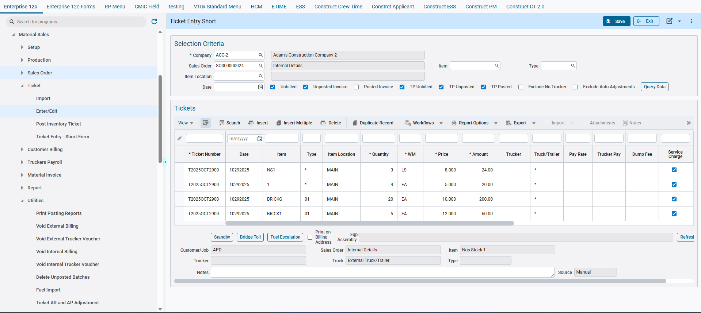
- From this point, the user can immediately post the invoice created under Customer Billing – Review and Post
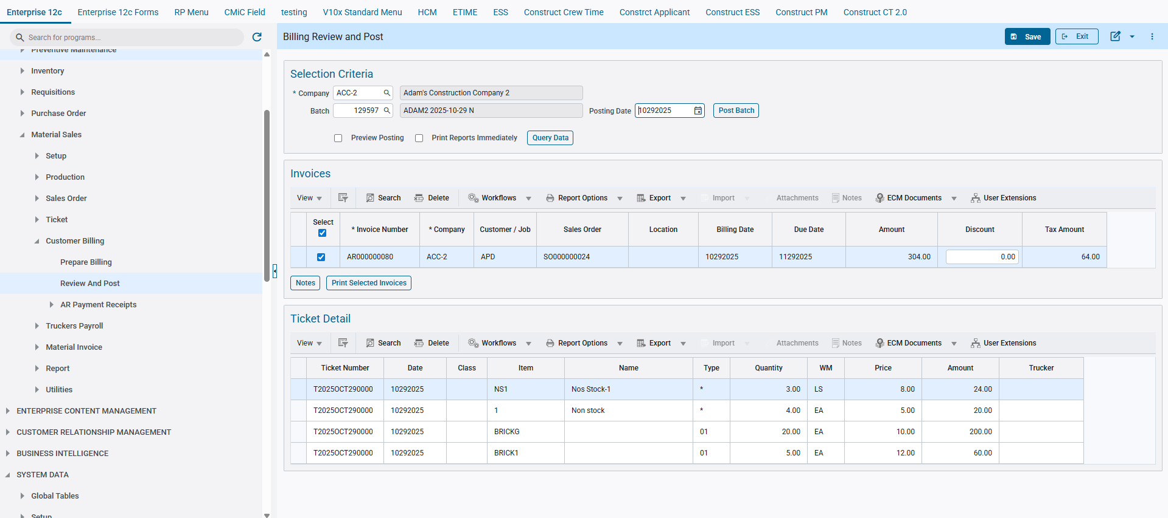

Print MS Billing Invoice:
The second program introduced and added to the system will allow the user the opportunity to print the Point of Sale invoice (MS_STD_INV) once more.
(The same logic and functionality is applied to step 5 in the previous program Point of Sale Entry)
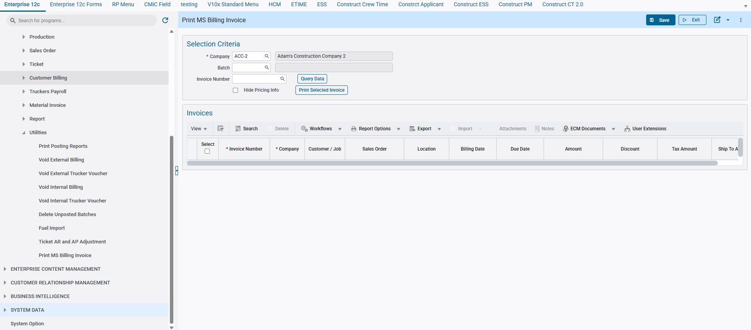
Upon opening the program, the user will enter the Batch and Invoice Number within the selection Criteria, and then press the Query Data button to view the respected Invoices within the table below.
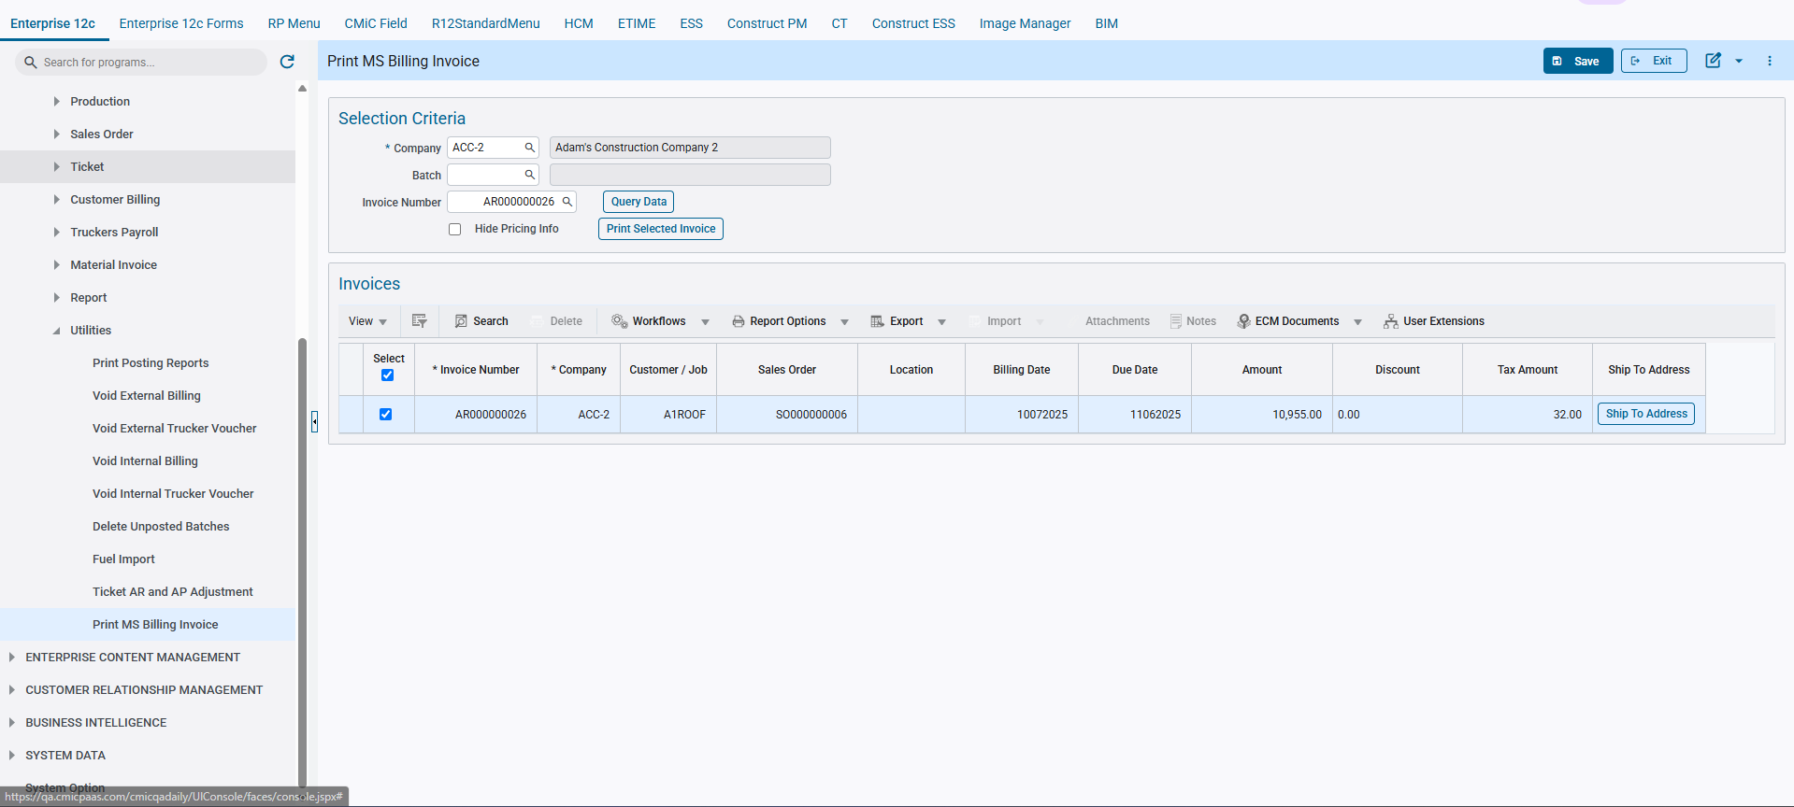
The user can edit, once more the ship-to-address information by using the Ship To Address button located in the final column on the invoice table. The Address will be updated permanently for that specific invoice after saving.
The user will then close the program pop up to continue.
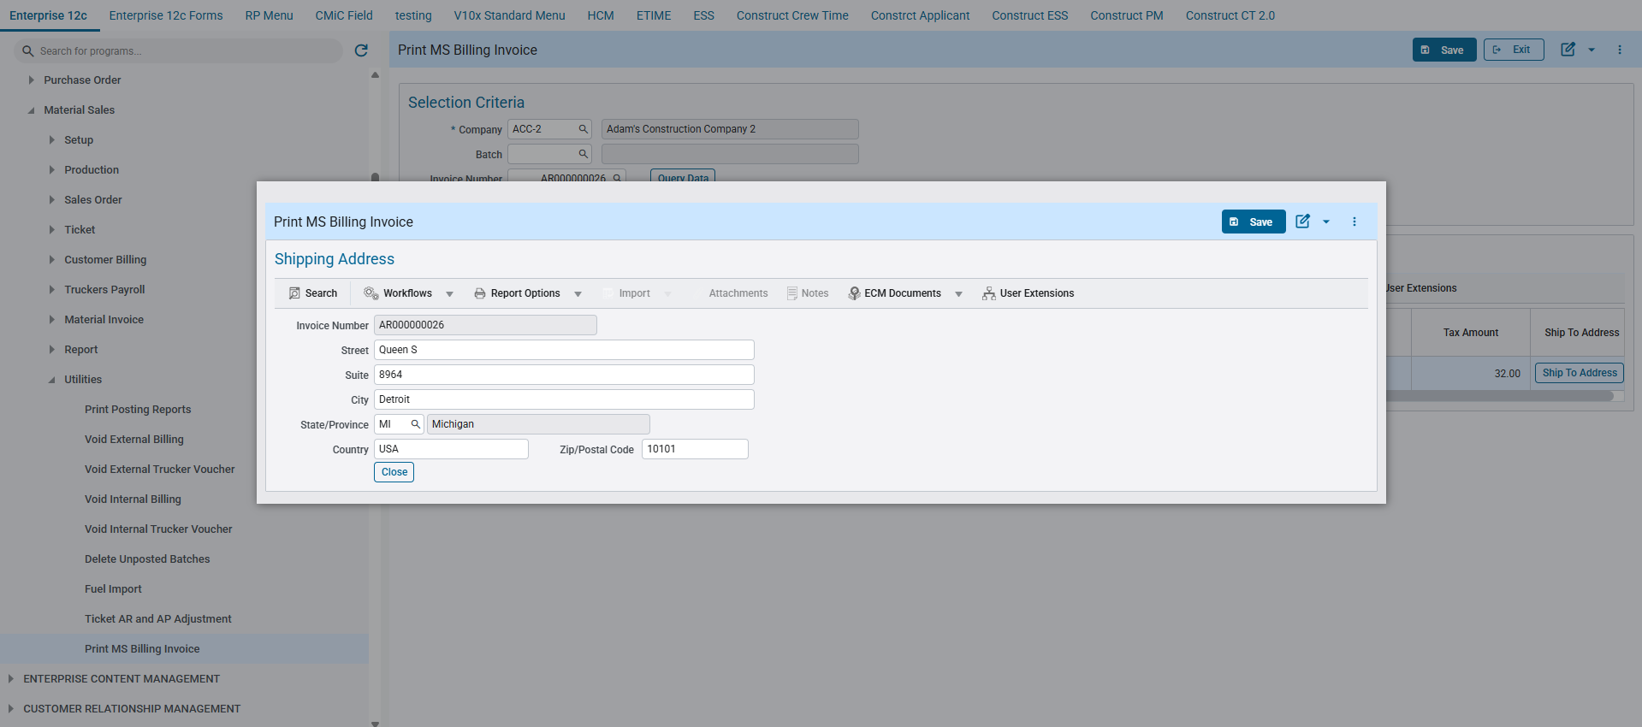
After all adjustments have been made the user will then select the Invoice via Select checkbox, then either print the invoice once more with or without the price and totals.
With Prices:
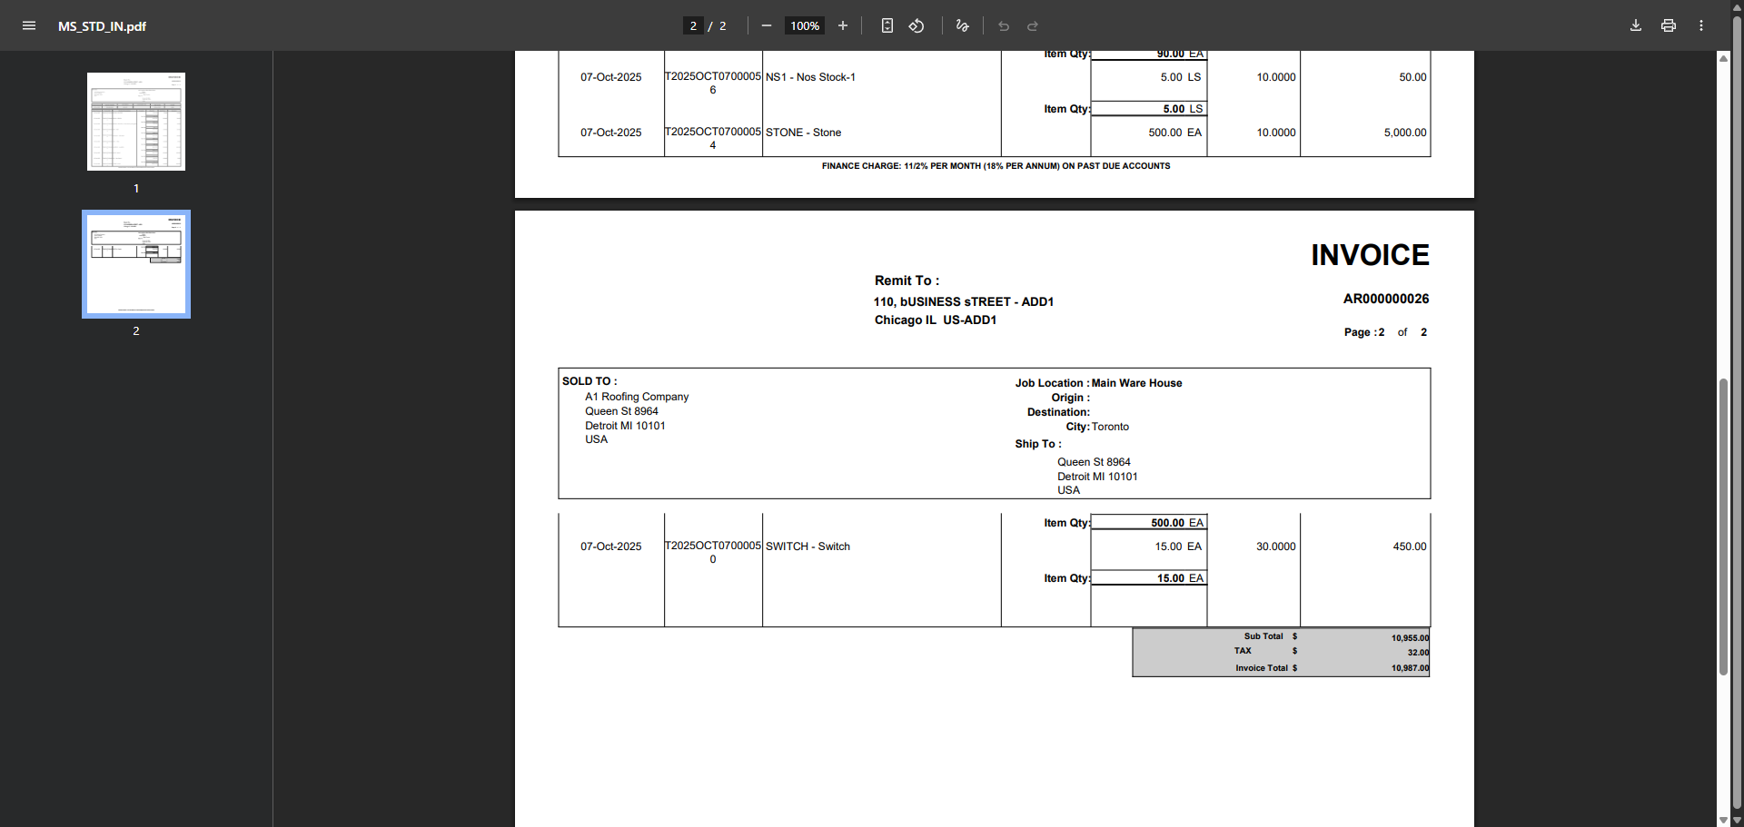
Without Prices:
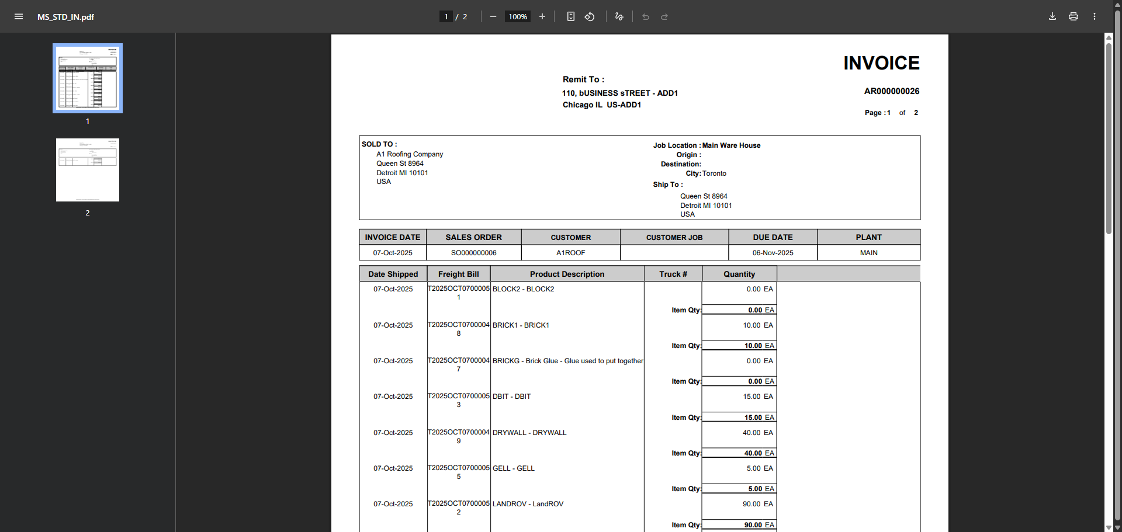

Opportunity Management

Opportunity Management – Add New button Introduced in Contacts, Organization, Company LOV pop-up (CAM-9389)
New additional ‘Add New’ buttons for Action Items and Opportunities have been included. These buttons allow the user to create Contacts, Organizations, and Opportunities in select LOV’s across the forementioned programs.
This new addition aims to streamline the process of reducing the number of programs the user must navigate while adding an action item.
Modifications
Runtime feature program:
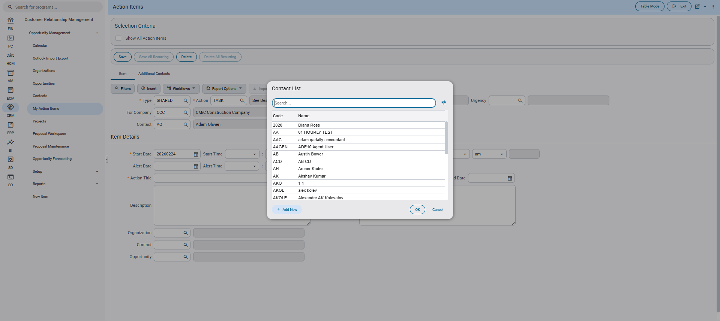
Implementation
The ‘Add New’ button has been added to the LOV pop-up of contacts, organization, company fields, in the following programs:
- My Action Items (“OMSYSACTIONITEMS”)
- Opportunity Management (“OMOPPORTUNITIES”)

The LOV’s with new buttons are as follows..
Add New Contact – Action Items > Contact LOV
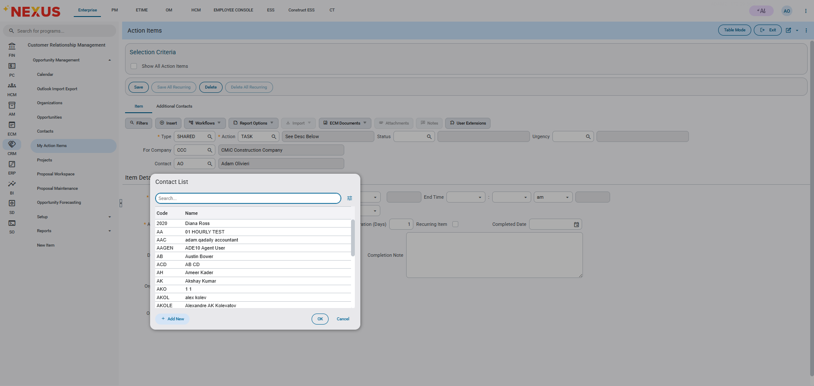
Add New Organization – Action Items > Organization LOV
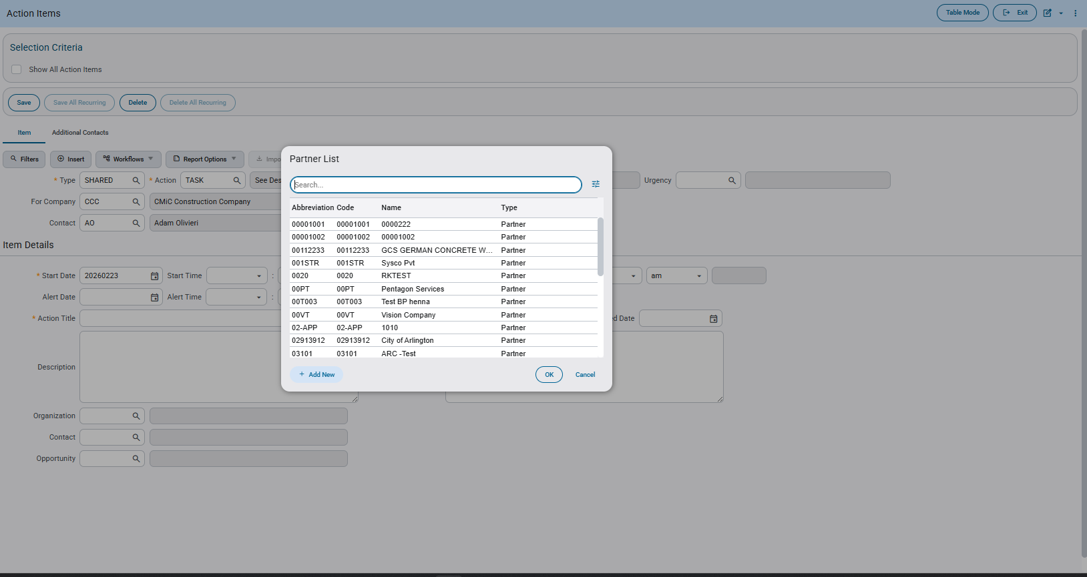
Add New Organization – Action Items > For Company LOV
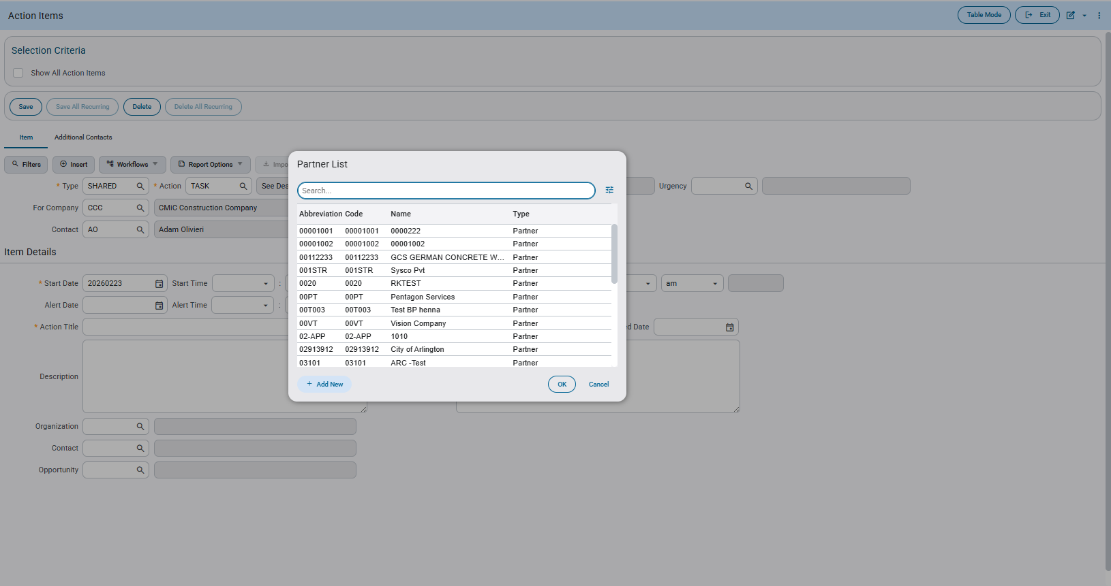
Add New Opportunity – Action Items > Opportunity LOV
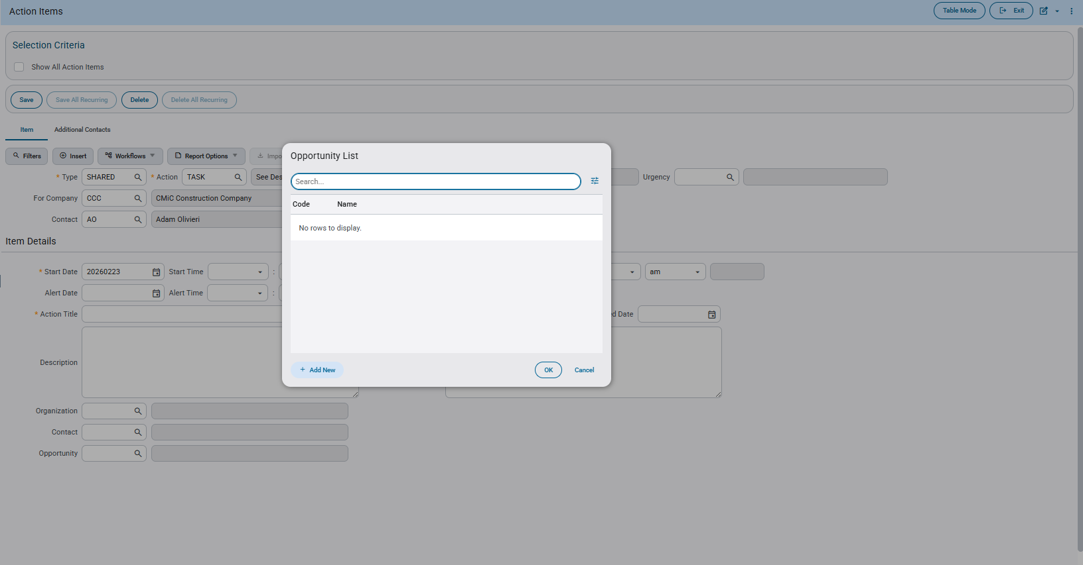
Add New Contact to Action Item – Action Items > Additional Contacts tab > Contact LOV
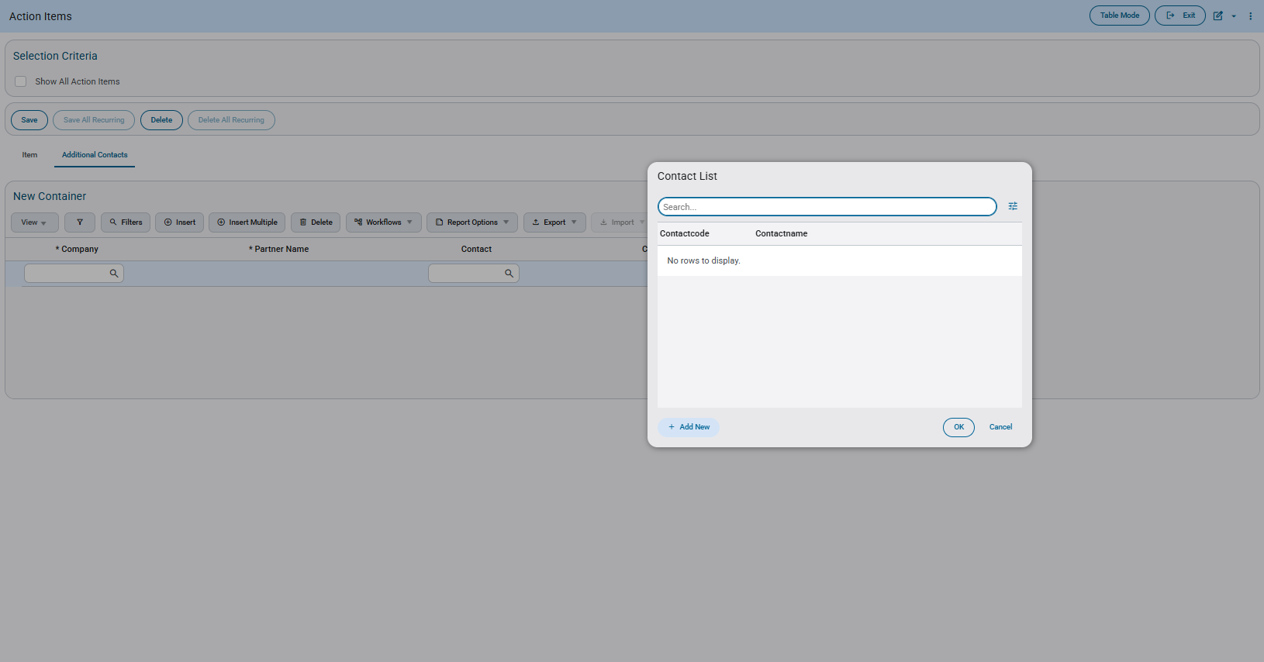
Add New Organization to Action Item – Action Items > Additional Contacts tab > Company LOV
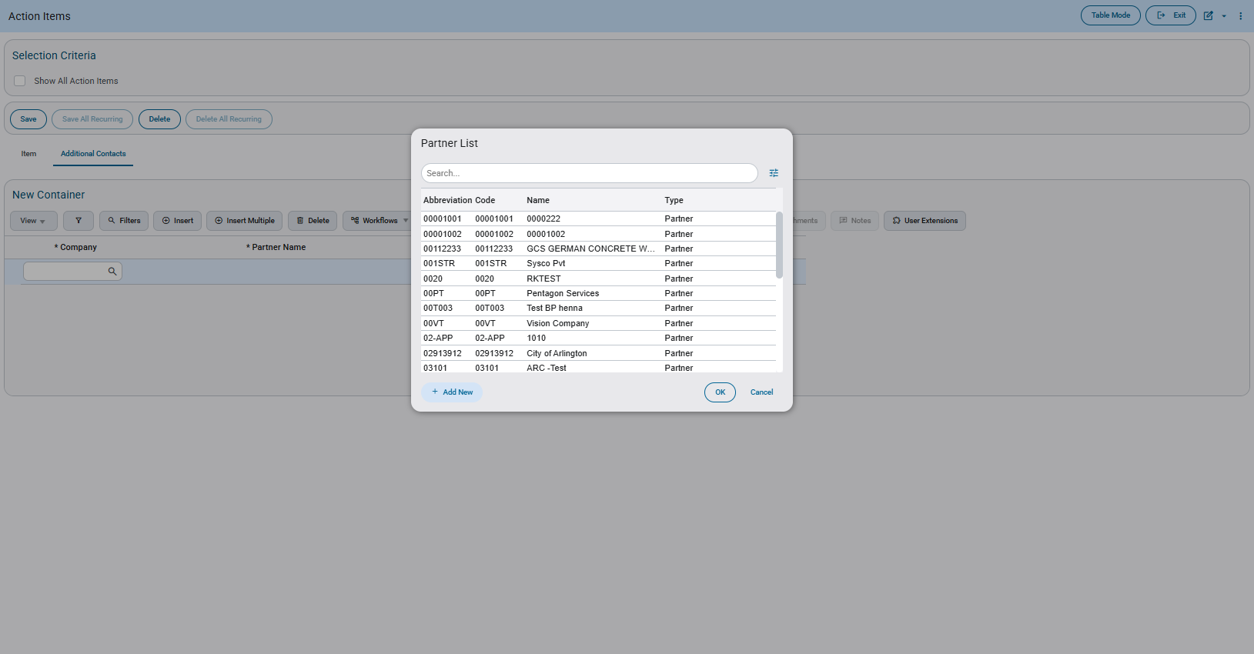
Add New Organization to Opportunities – Opportunities > Team > Partner Name LOV
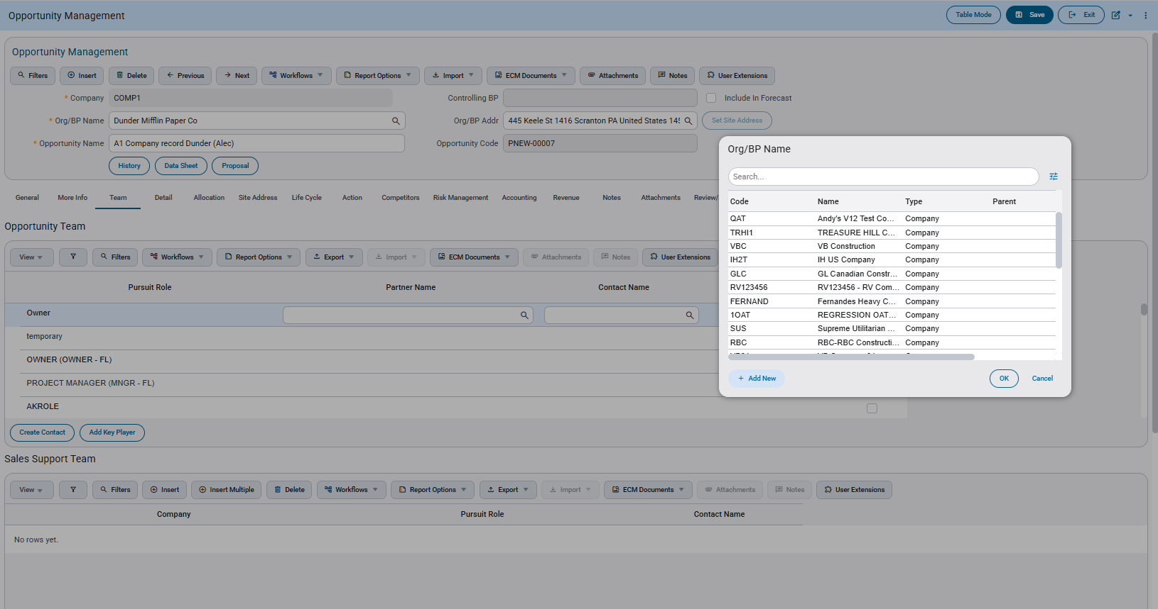
Add New Contact to Opportunities - Opportunities > Team > Contact LOV
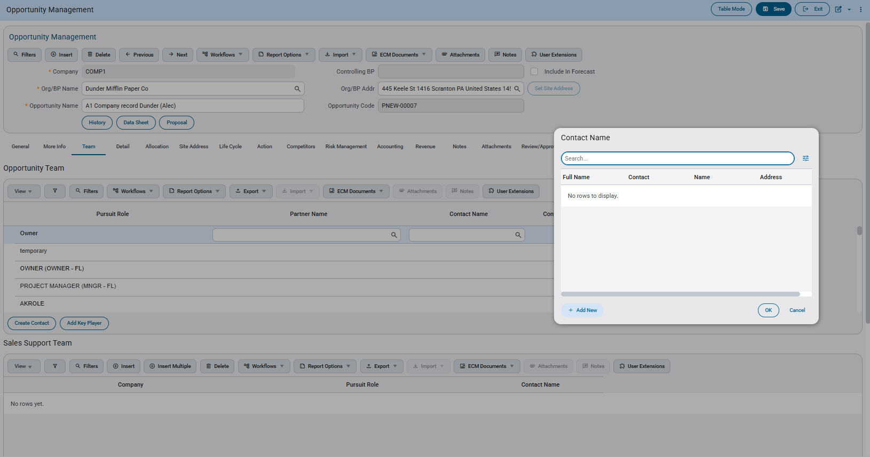

Payroll US

Extended Holiday Setup and Overtime Processing by Company, Pay Group, and Union (HCM-18081)
Overview
This enhancement extends the existing holiday management functionality to allow organizations with multiple companies, unions, and pay groups operating across different regions to define additional holidays beyond the global holiday table. The new capability enables granular holiday configuration at the company, union, and pay group levels while maintaining the existing global holiday table as the baseline. This provides flexibility for organizations that require different holiday schedules for various operational units while ensuring compliance with regional statutory requirements.
Pre-requisites
- User must have appropriate security permissions to access holiday setup functions
- Global holiday table must be properly configured for relevant countries and states/provinces
- Company, union, and pay group master data must be established in the system
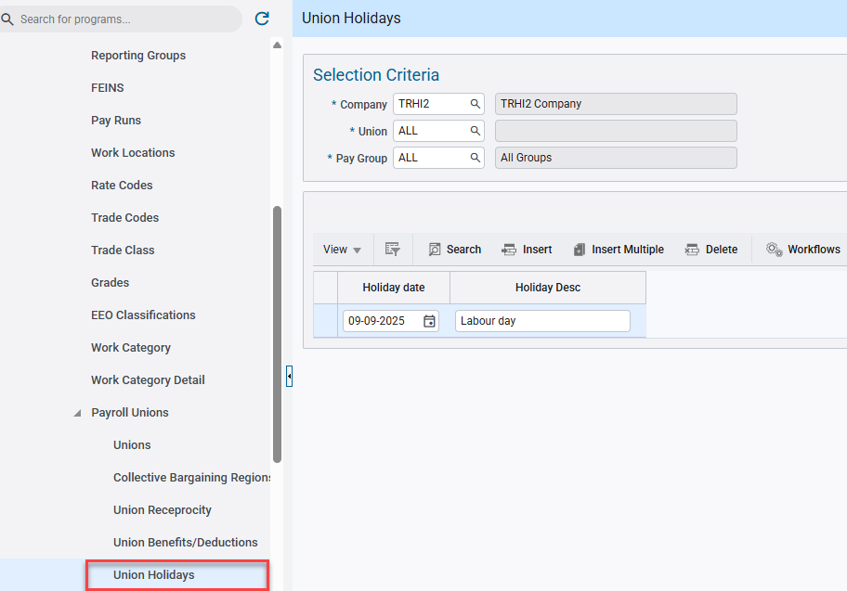
Pgm: PYCOMHOLIDAYS – Union Holidays; standard Treeview path: US Payroll > Setup > Local Tables > Payroll Unions > Union Holidays

Modifications
New Screens Created
- Union Holiday Setup Screen
  - Allows configuration of holidays by company, union (including union locals), and pay group.
  - Fields include Company, Union, Pay Group selection, Holiday Date, and Holiday Description.
Existing Screens Updated
- Overtime Rule Processing Module
  - Enhanced to merge global holidays with company/union/pay group holidays.
  - Updated calculation logic to apply precedence rules (union-level holidays override global holidays for same dates).
- Time Entry Program
  - Modified to auto-populate holiday timesheets based on merged holiday list.
  - Enhanced to display holiday source indicators (global vs. union-level).
- Employee Self-Service (ESS) Vacation Requests
  - Updated to exclude holidays from merged holiday list during vacation period calculations.
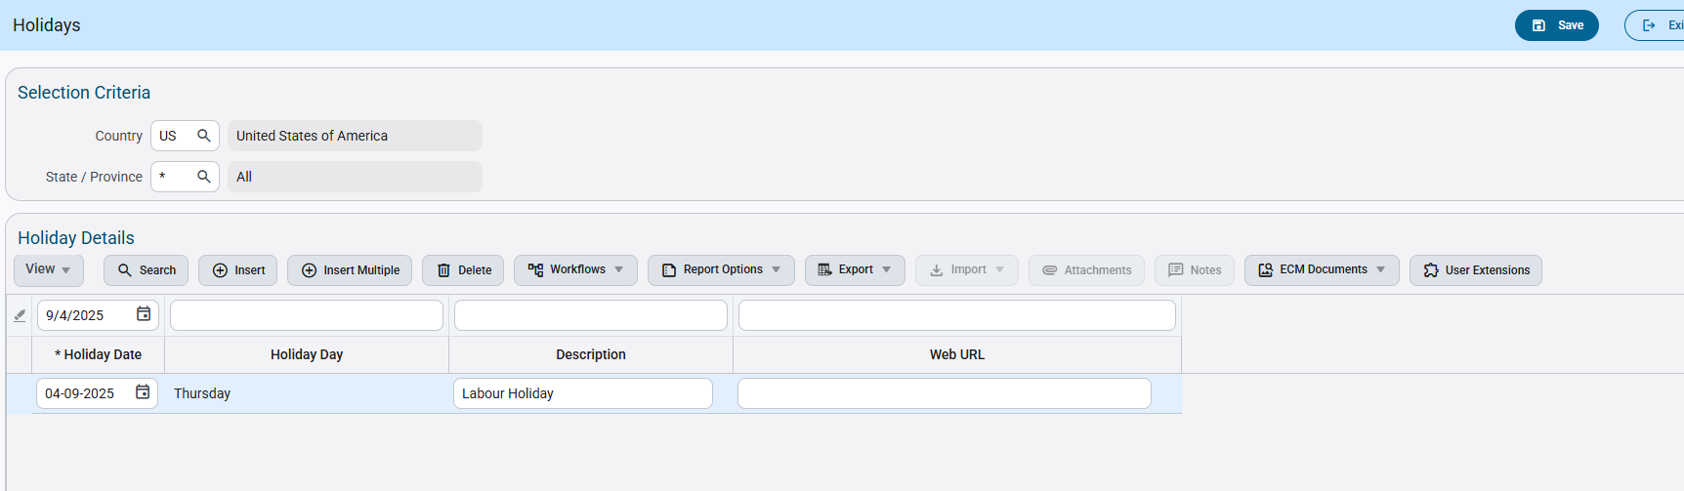
Pgm: PYHOLIDY – Holidays; standard Treeview path: US Payroll > Setup > Local Tables > Holidays

  - Enhanced calendar display to differentiate between global and extended holidays.
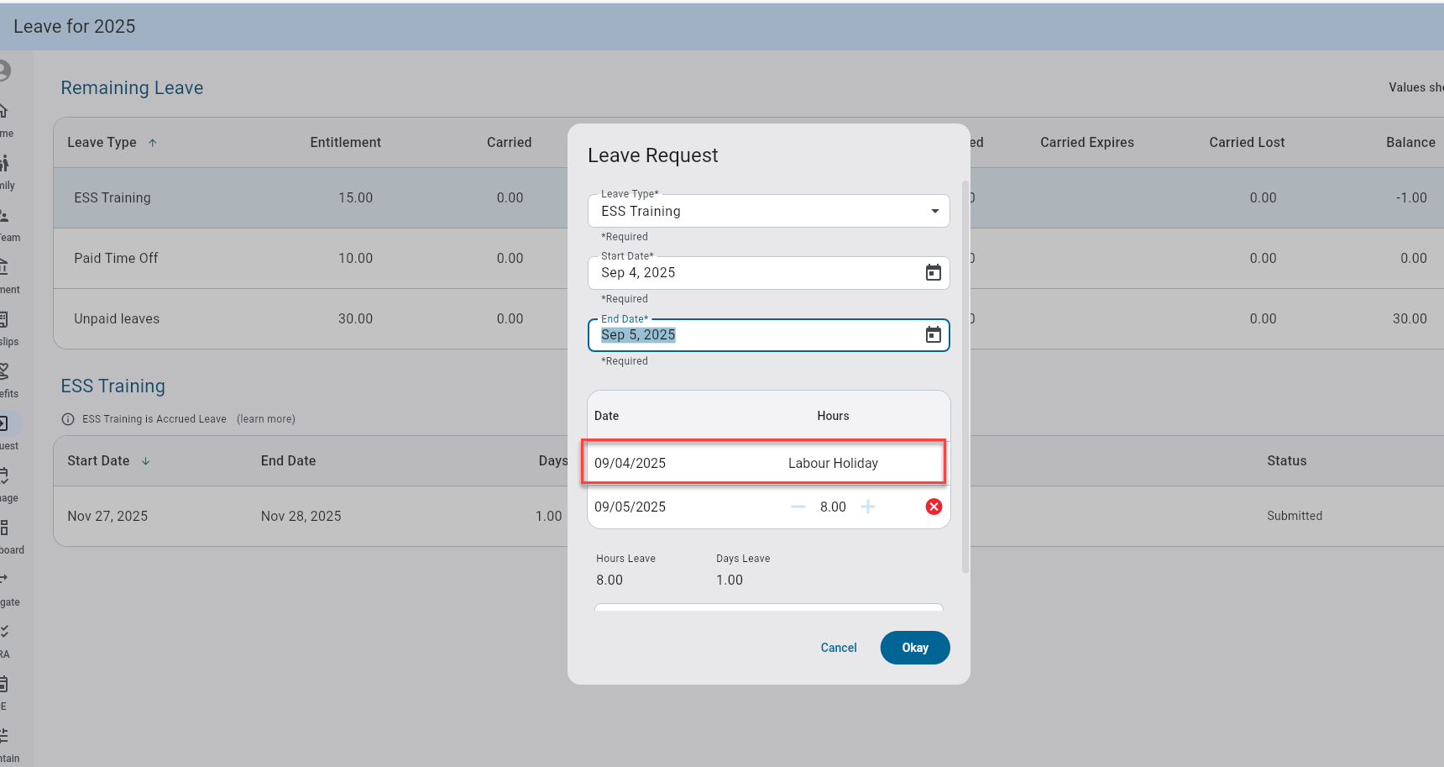
Leave Request; standard Treeview path: Employee Self-Service > Payment Administration > Request and Review Vacation Balances

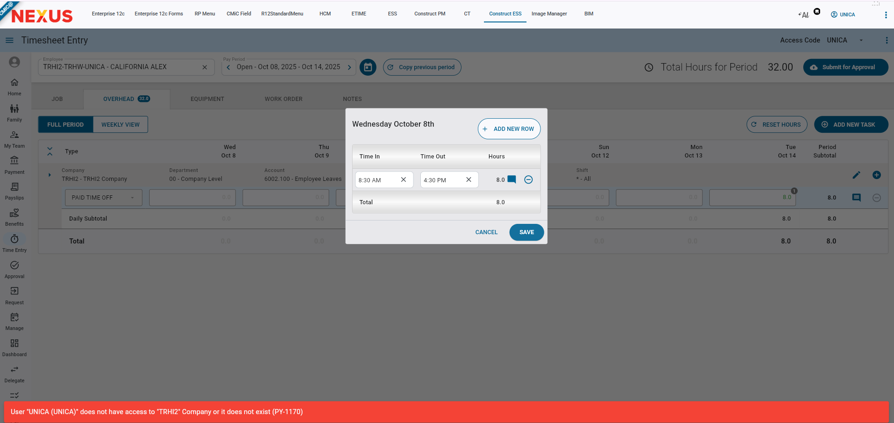
Time Entry; standard Treeview path: Employee Self-Service > Time Entry > Timesheet Entry
Implementation
Holiday Processing Examples
.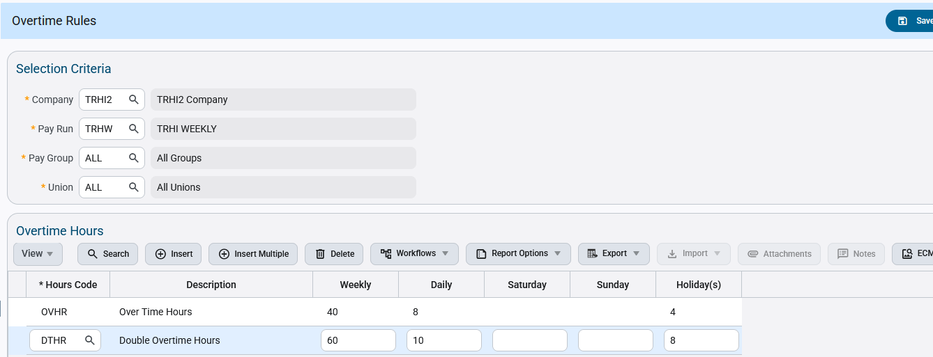
Pgm: PYOVTMRU – Overtime Rules; standard Treeview path: US Payroll > Setup > Company > Overtime Rules
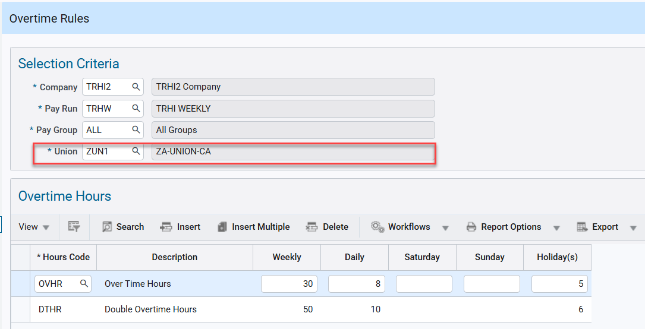
Pgm: PYCOMHOLIDAYS – Union Holidays; standard Treeview path: US Payroll > Setup > Local Tables > Payroll Unions > Union Holidays

Scenario 1: Global Holiday Only
Employee has no company/union/pay group holiday setup.

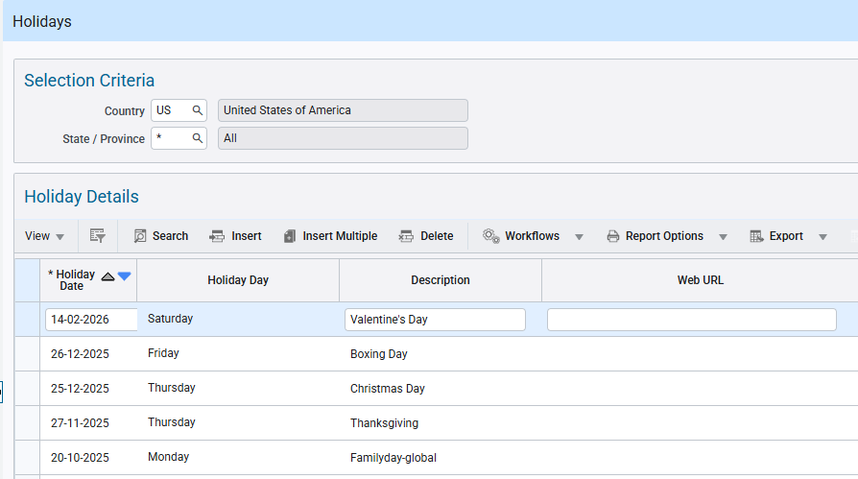
Pgm: PYHOLIDY – Holidays; standard Treeview path: US Payroll > Setup > Local Tables > Holidays

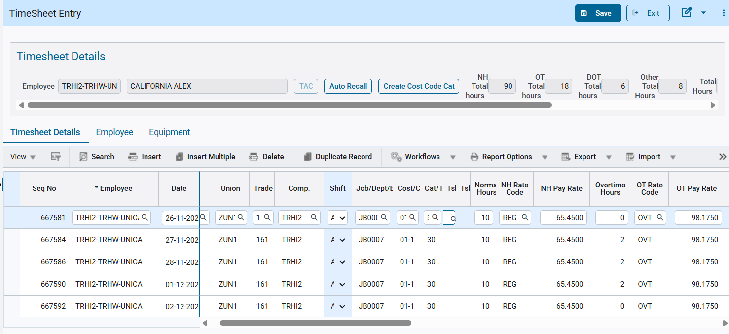
Pgm: PYTIMSTM – Timesheet Entry; standard Treeview path: US Payroll > Timesheet > Timesheet Entry

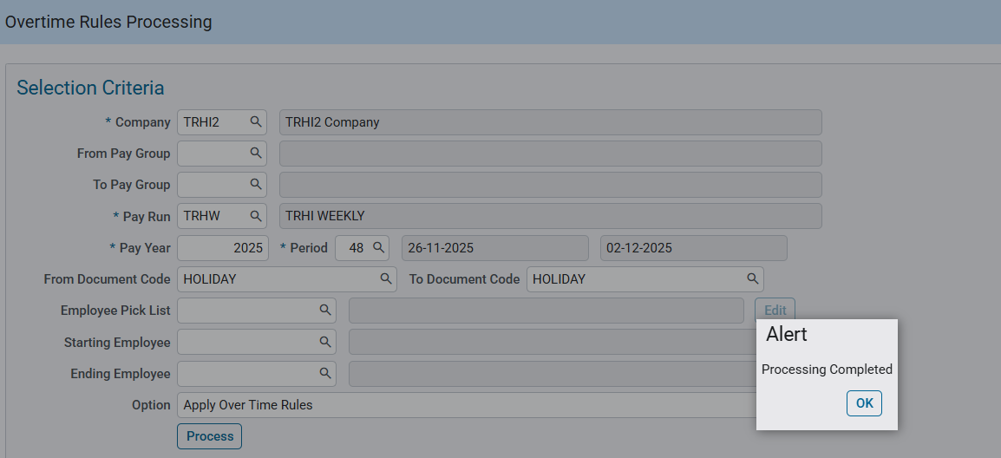
Pgm: PYOVTMPR – Overtime Rules Processing; standard Treeview path: US Payroll > Timesheet > Overtime Rules Processing

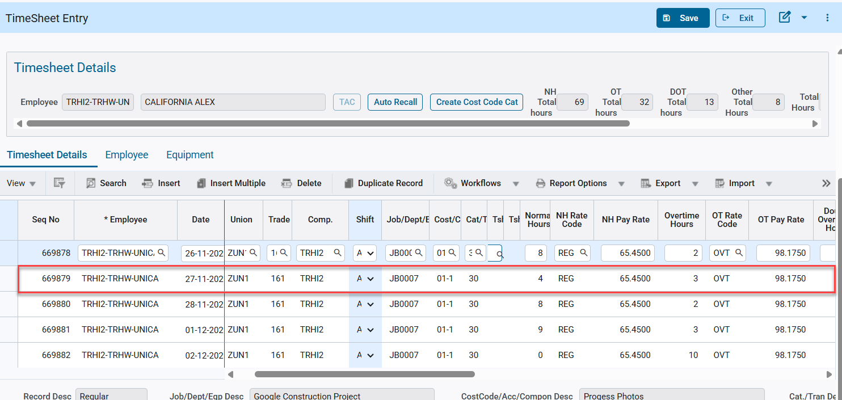
Pgm: PYTIMSTM – Timesheet Entry; standard Treeview path: US Payroll > Timesheet > Timesheet Entry
Scenario 2: Extended Holiday Only
No global holiday:
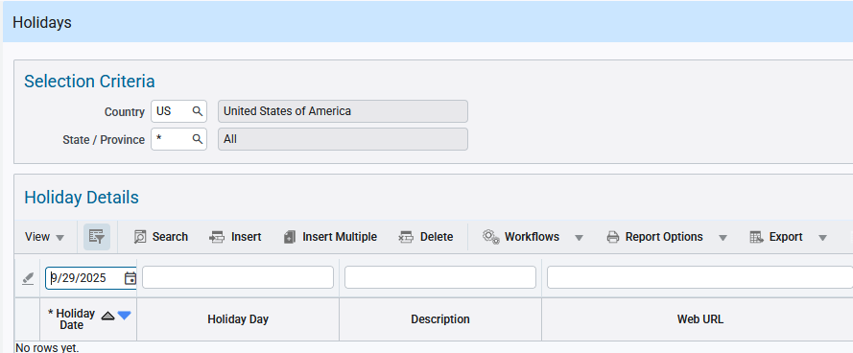
Pgm: PYHOLIDY – Holidays; standard Treeview path: US Payroll > Setup > Local Tables > Holidays

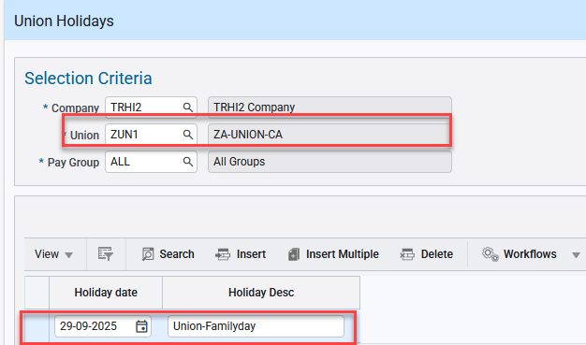
Pgm: PYCOMHOLIDAYS – Union Holidays; standard Treeview path: US Payroll > Setup > Local Tables > Payroll Unions > Union Holidays

Result: Only employees that have a union setup will be included in the Overtime Rule Processing.

Unionized employee:
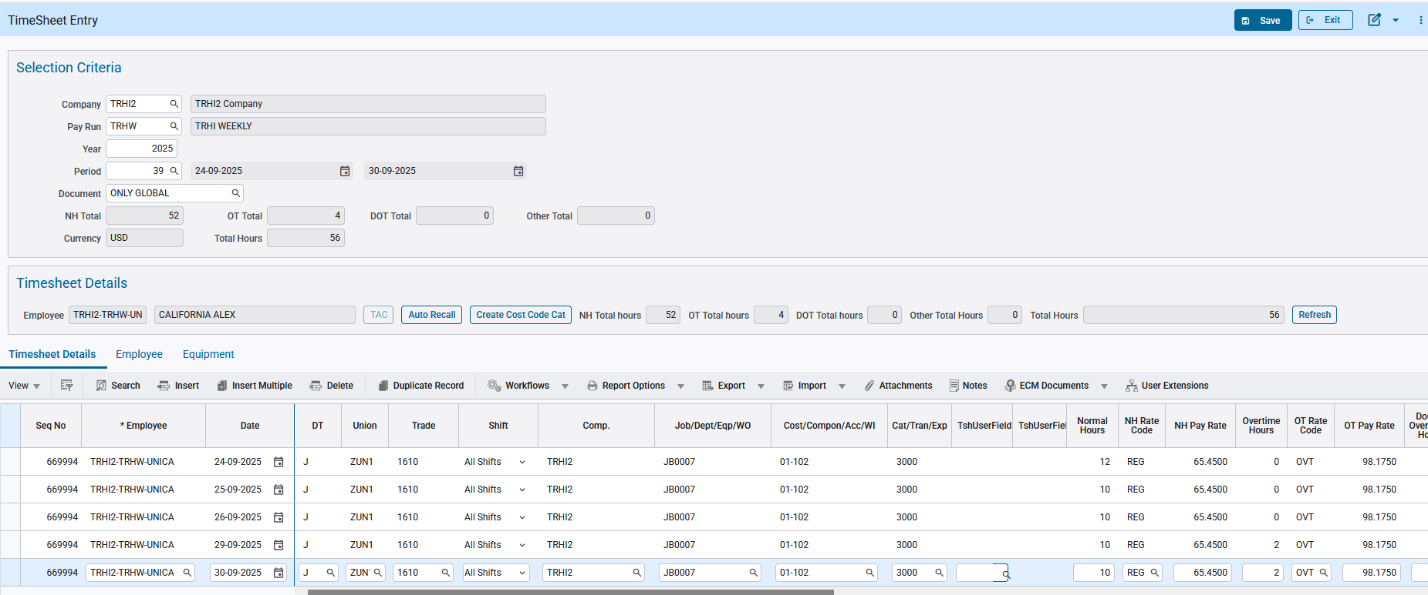
Pgm: PYTIMSTM – Timesheet Entry; standard Treeview path: US Payroll > Timesheet > Timesheet Entry

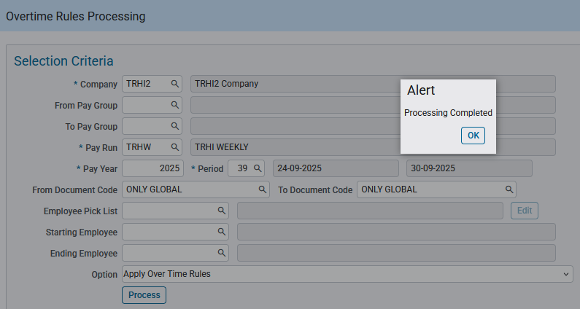
Pgm: PYOVTMPR – Overtime Rules Processing; standard Treeview path: US Payroll > Timesheet > Overtime Rules Processing

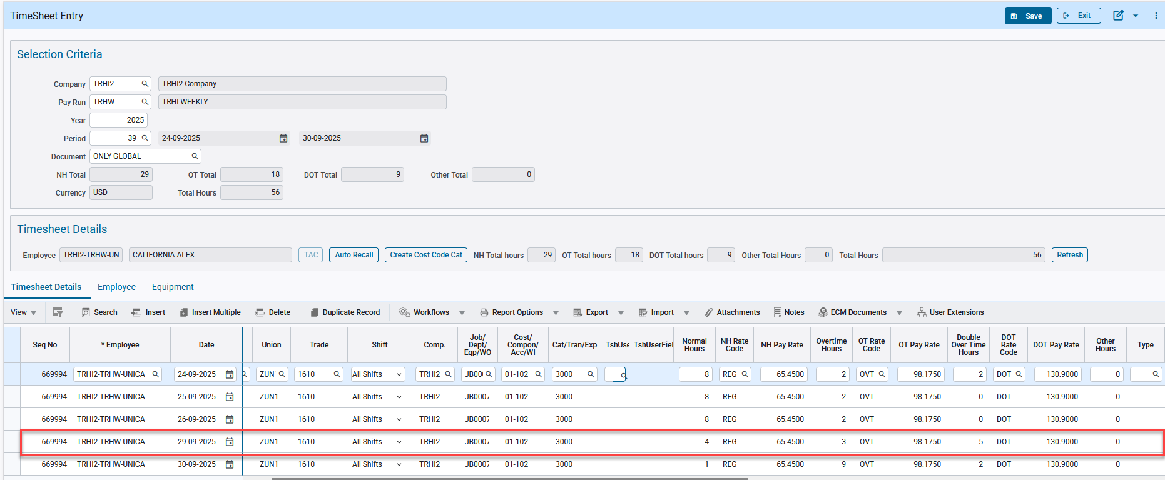
Pgm: PYTIMSTM – Timesheet Entry; standard Treeview path: US Payroll > Timesheet > Timesheet Entry

Non-unionized employee:
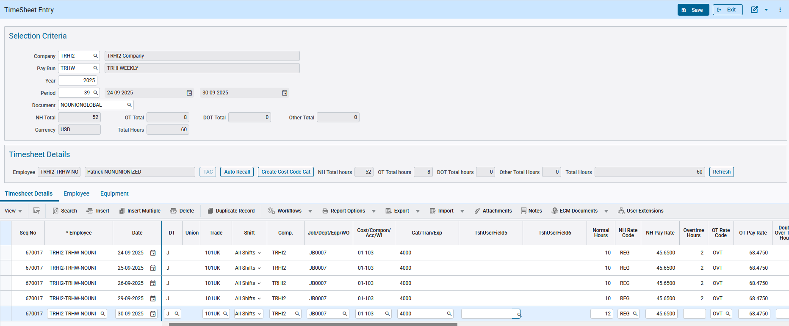
Pgm: PYTIMSTM – Timesheet Entry; standard Treeview path: US Payroll > Timesheet > Timesheet Entry

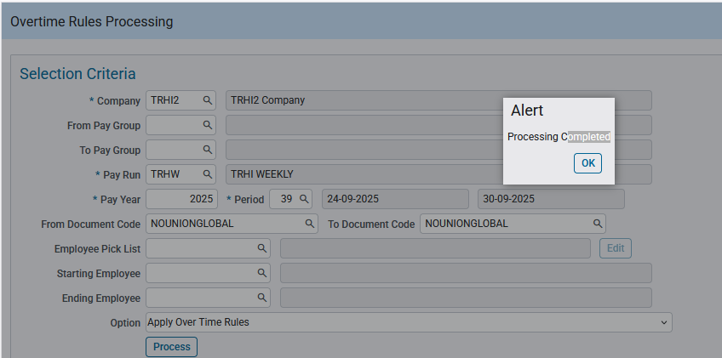
Pgm: PYOVTMPR – Overtime Rules Processing; standard Treeview path: US Payroll > Timesheet > Overtime Rules Processing

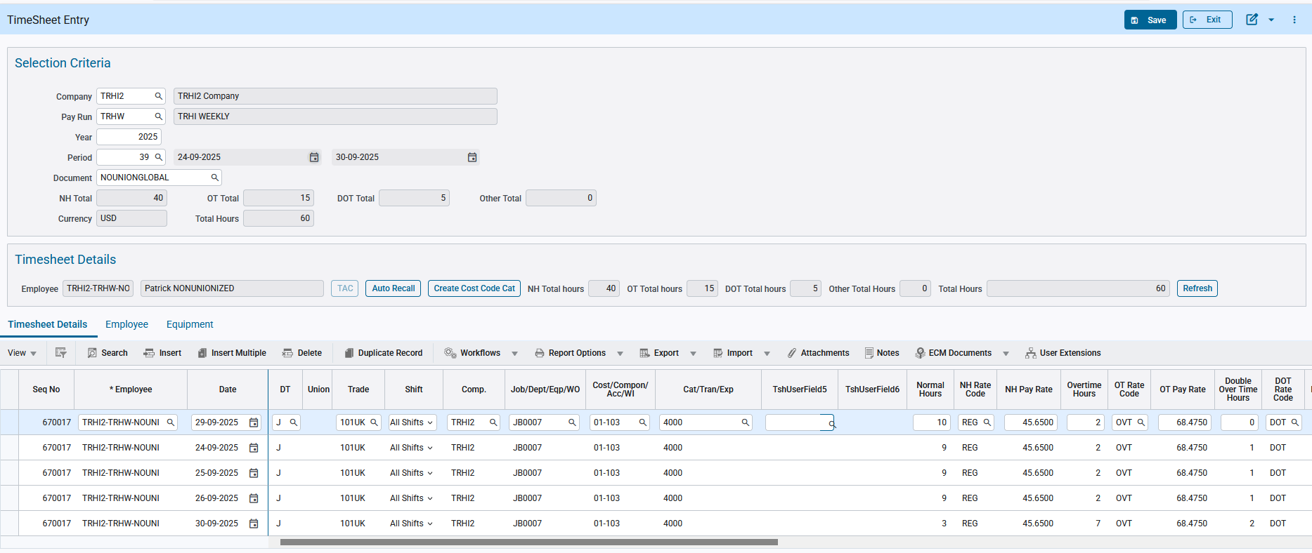
Pgm: PYTIMSTM – Timesheet Entry; standard Treeview path: US Payroll > Timesheet > Timesheet Entry

Scenario 3: Conflicting Holidays (Same Date)
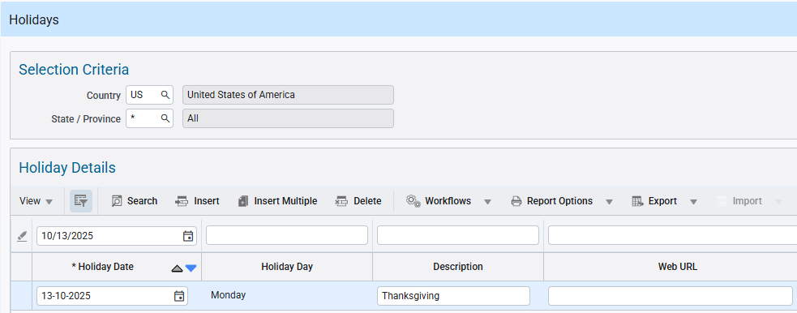
Pgm: PYHOLIDY – Holidays; standard Treeview path: US Payroll > Setup > Local Tables > Holidays
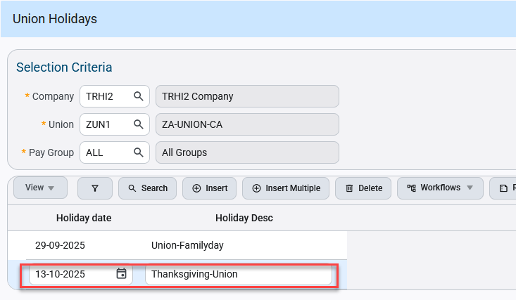
Pgm: PYCOMHOLIDAYS – Union Holidays; standard Treeview path: US Payroll > Setup > Local Tables > Payroll Unions > Union Holidays

- Global Holiday: Thanksgiving
- Union Holiday: Thanksgiving-Union
Result: For a unionized employee, the system will look at the setup for the company in Overtime Rules for the specific union. And for a non-unionized employee, the system will look at the setup for “ALL” unions.

Non-unionized employee:
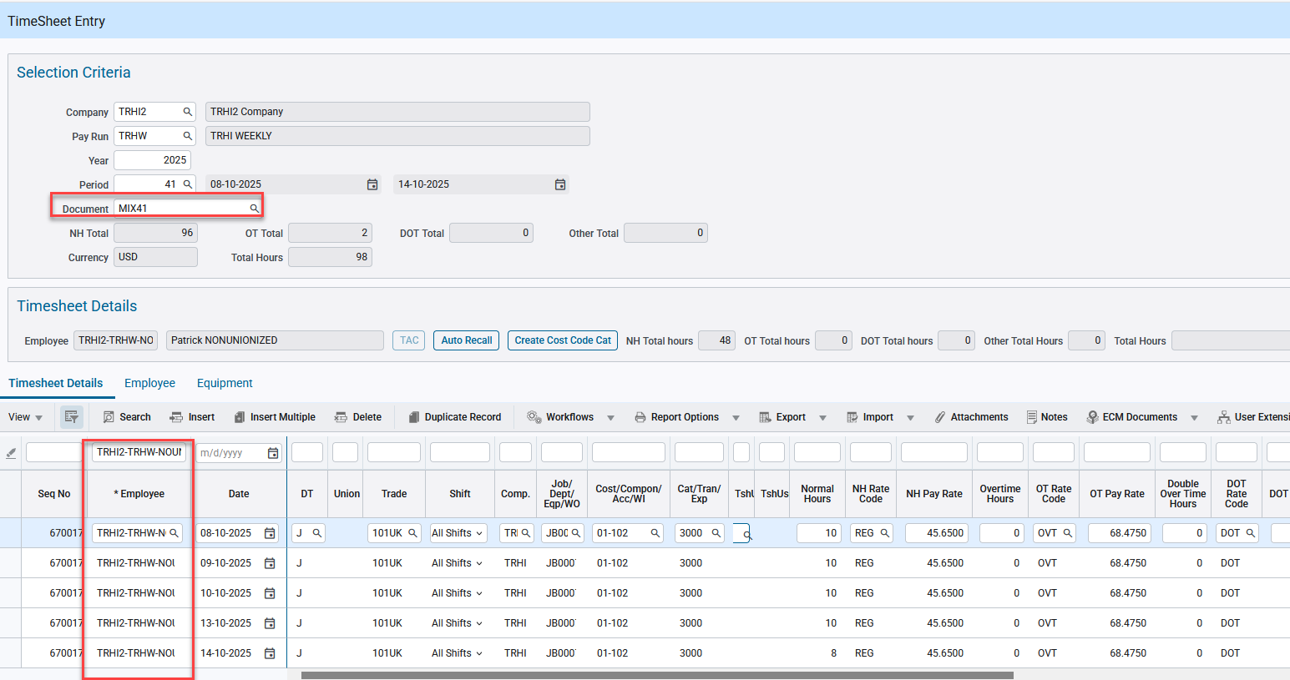
Pgm: PYTIMSTM – Timesheet Entry; standard Treeview path: US Payroll > Timesheet > Timesheet Entry

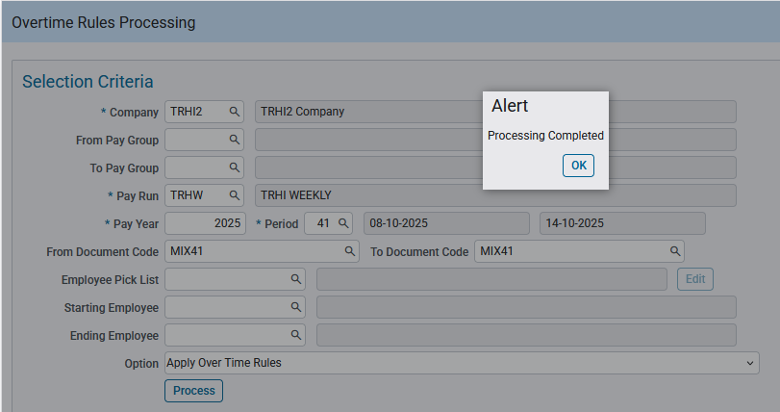
Pgm: PYOVTMPR – Overtime Rules Processing; standard Treeview path: US Payroll > Timesheet > Overtime Rules Processing

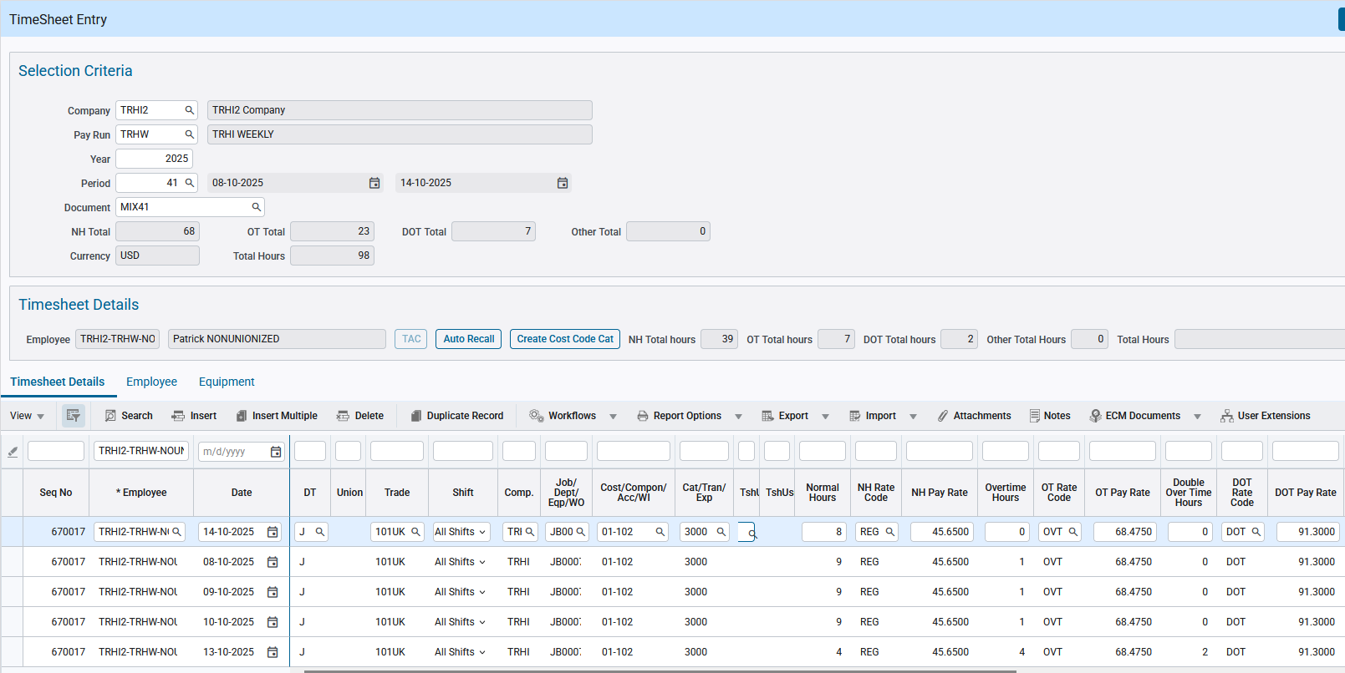
Pgm: PYTIMSTM – Timesheet Entry; standard Treeview path: US Payroll > Timesheet > Timesheet Entry

And for unionized employee:
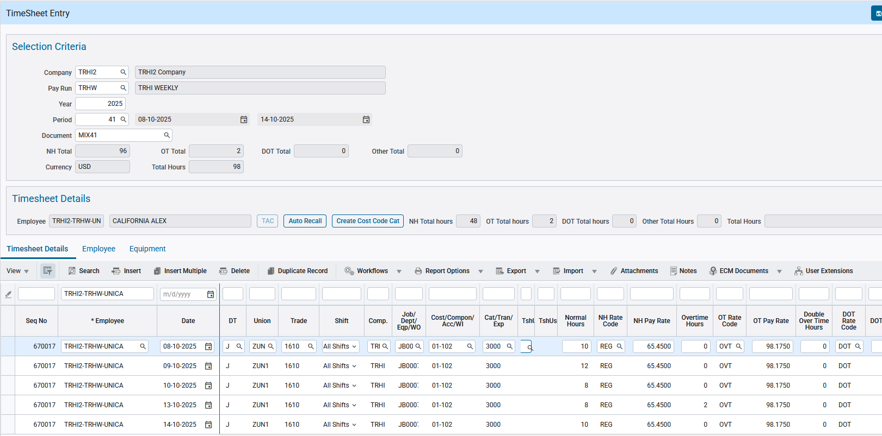
Pgm: PYTIMSTM – Timesheet Entry; standard Treeview path: US Payroll > Timesheet > Timesheet Entry

Apply the Rule Processing:
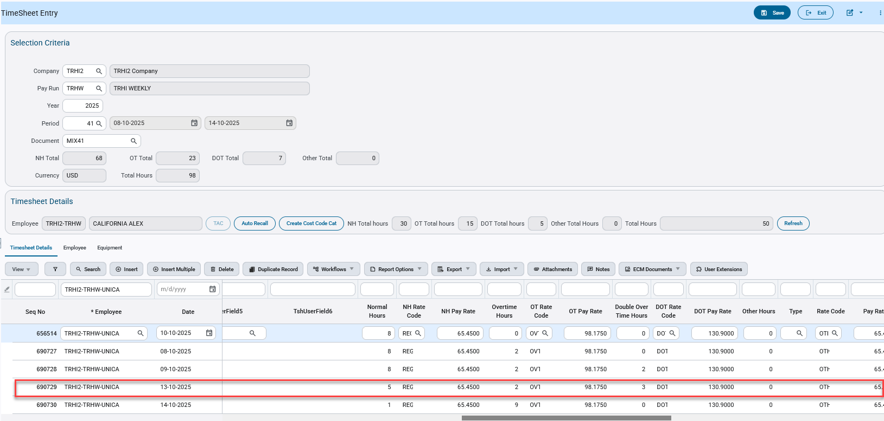
Pgm: PYTIMSTM – Timesheet Entry; standard Treeview path: US Payroll > Timesheet > Timesheet Entry
Construct ESS: For unionized employees, the holiday display will appear as shown in the screenshot
Below.
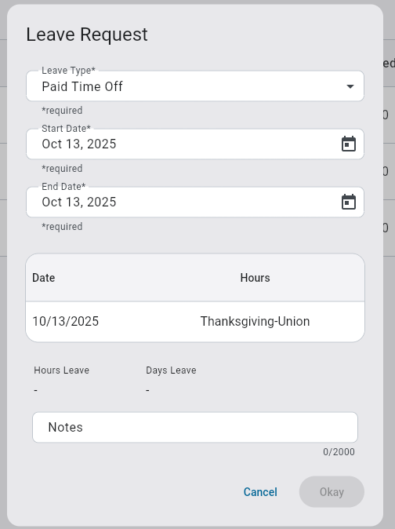
Construct ESS: For non-union employees will appear as shown in the screenshot below;
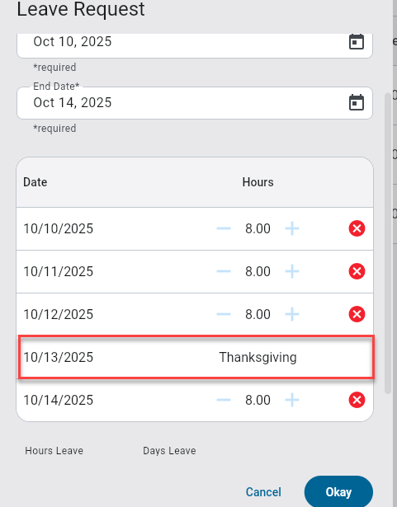

Scenario 4: Mixed timesheet of two work locations and unions L182 in Ontario and L92 in Alberta
- Both having holidays on union level
- Union L92 Alberta union holiday on 10th of September
- Union L183 Ontario union holiday on 11th of September
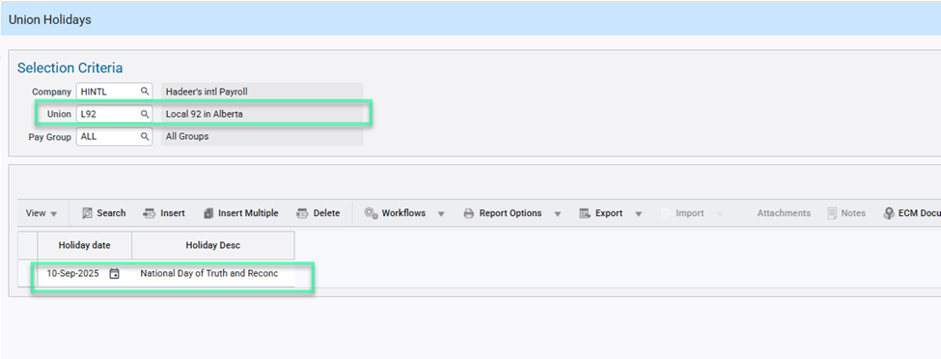
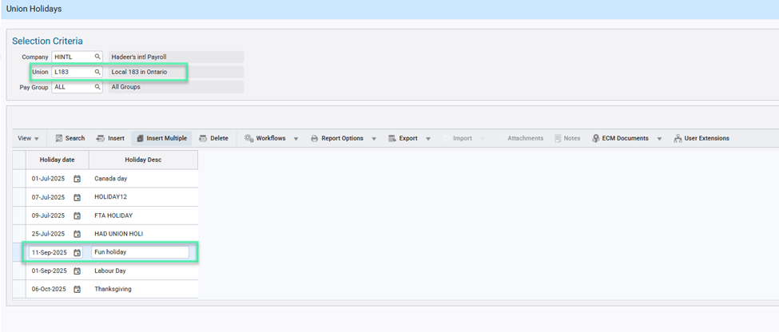
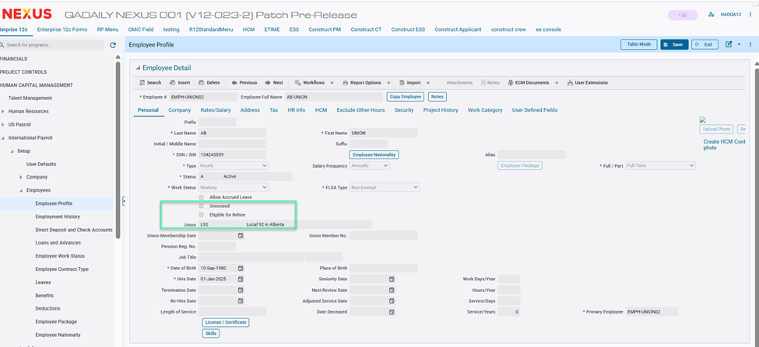
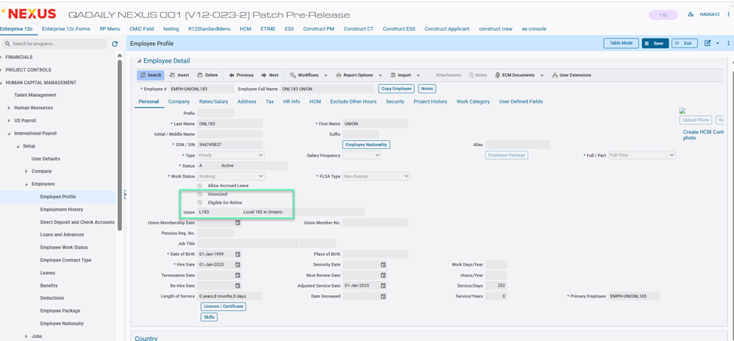

overtime rule setup
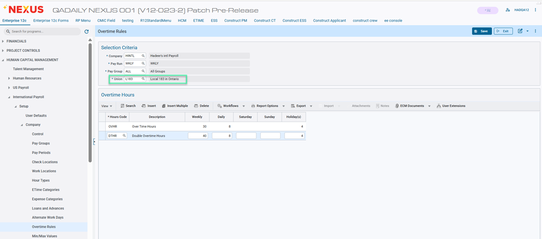
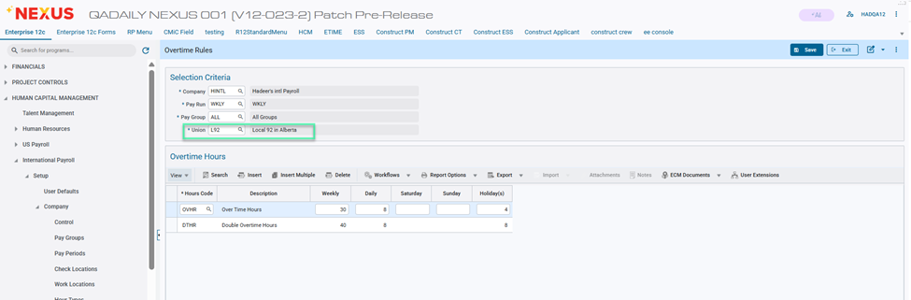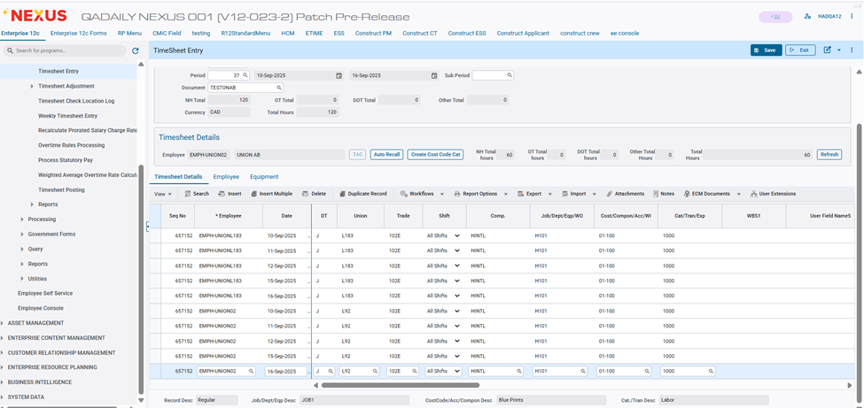
Pgm: PYTIMSTM – Timesheet Entry; standard Treeview path: US Payroll > Timesheet > Timesheet Entry

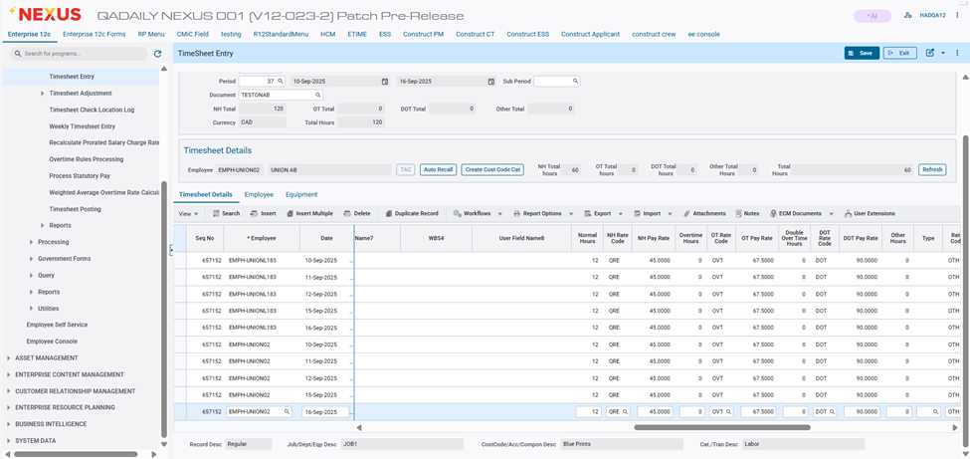
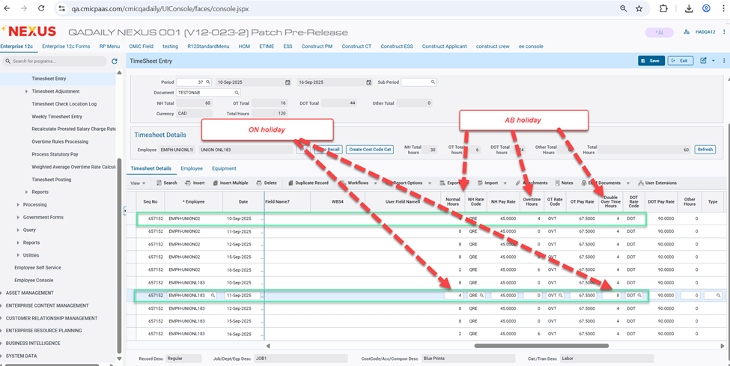
Scenario 5: Mixed timesheet of two work locations and unions L182 in Ontario and L92 in Alberta
- Both having holidays on Global and union level
- Union L92 ALBERTA union holiday on 5th of September
- Union L183 Ontario union holiday on 3rd of September
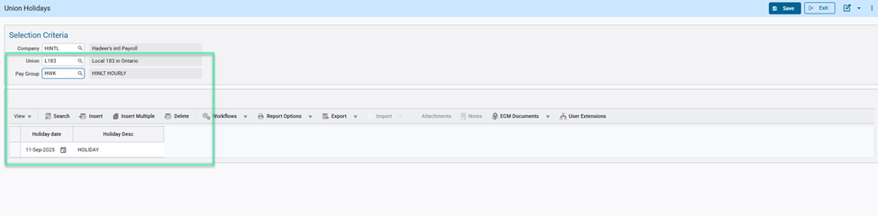
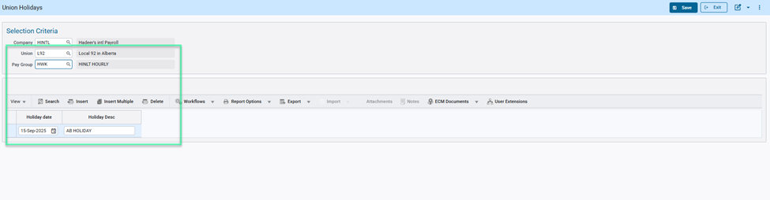
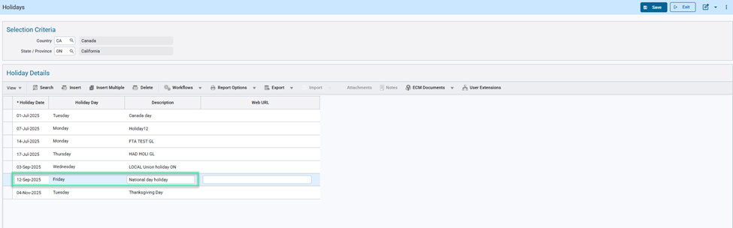
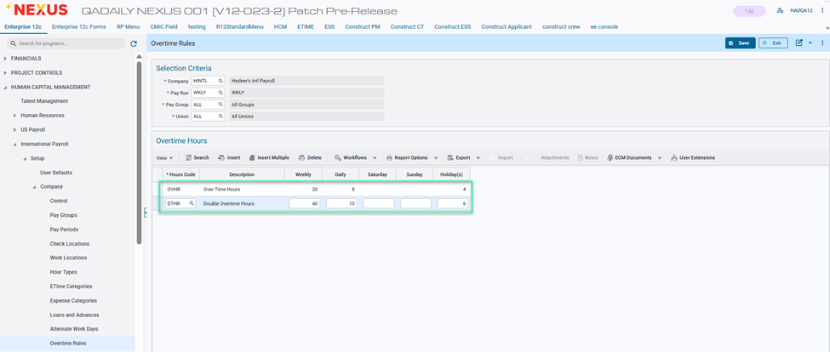
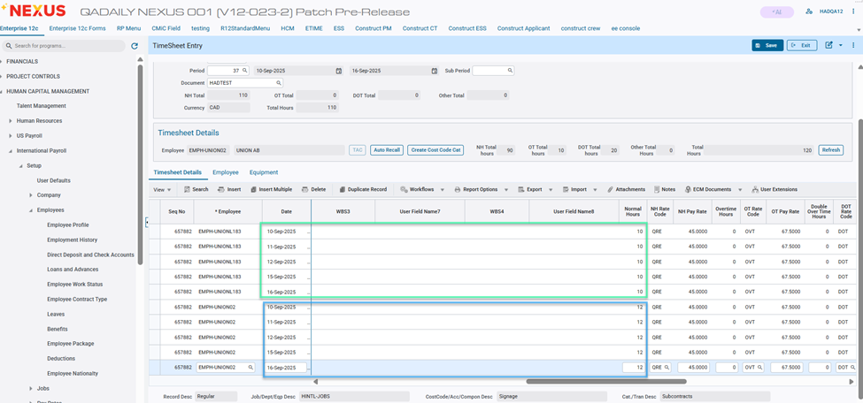
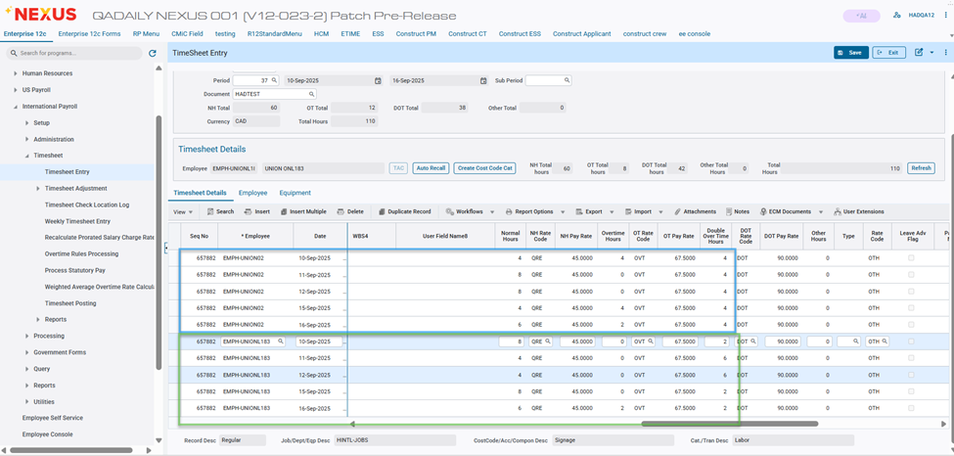

Payroll Processing Validation Feature Enhancement - Phase 2 (HCM-18745)
Overview
The Payroll Processing Validation Enhancement Phase 2 improves the accuracy and reliability of payroll data by adding new validation checks to the payroll processing system. These checks help identify potential issues with job information or access privileges without stopping the payroll from running.
This feature can be turned on or off by using the “Validate Inactive Cost Code/Category in Payroll” flag in System Options > Payroll > Other section, giving users control over when to enable the enhanced validations.
Instead of halting payroll processing when an issue is found, the system will now display and log warning messages at the end of the process. This ensures payroll can continue smoothly while still alerting the user to any exception or errors that need attention afterward.
The new validations will check for the following:
- When a Job does not have a Category assigned.
- When a Phase is marked as inactive and the user does not have the necessary access to ARJBINPHPS privilege.
- When a Phase or Category used in a transaction is inactive.
- When a Phase or Category is inactive in the JCJOBCAT file.
These improvements enhance data validation while maintaining the existing payroll posting flow, ensuring payroll operations remain uninterrupted.
NOTE: When the ARJBINPHPS privilege flag is off, it is not mentioned in the exception message during payroll processing.
Pre-requisites
To intentionally trigger exceptions, specific conditions must be set up before payroll processing. For example, the Phase or Category should be inactive, or there should be a missing or non-existent entry in the JCJOBCAT file. Examples of these setups are provided in the Implementation section.

Modifications
User Interface Changes
A new flag has been added to System Options > Payroll > Other section:
- Validate Inactive Cost Code/Category in Payroll
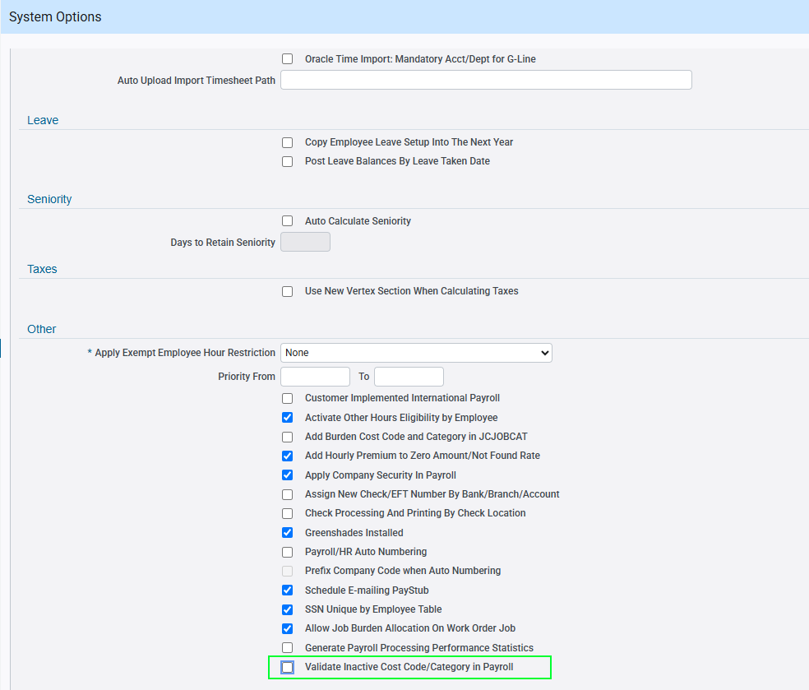
Implementation
In this section, we will validate the system’s behavior under different configurations to ensure the correct warnings are generated when the “Validate Inactive Cost Code/Category in Payroll” flag is enabled in System Options. The testing will confirm that the appropriate validation checks are triggered for inactive or missing Phase and Category elements, and that warning messages are logged and displayed without interrupting the payroll processing flow.
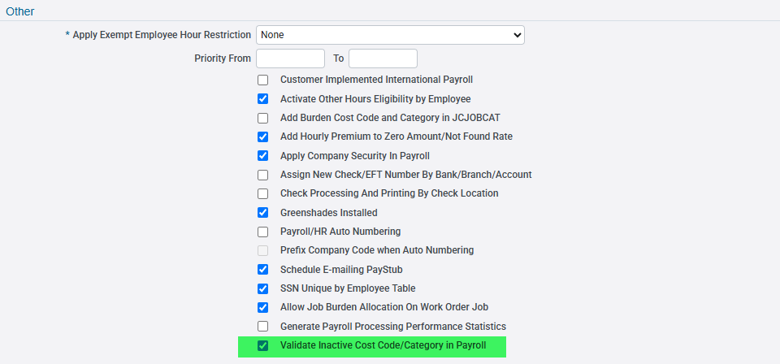
The flag is checked for the succeeding examples, unless otherwise stated.

Example #1: Phase/Cost Code is inactive.
Enter timesheet hours using an active Phase/Cost Code and post it:
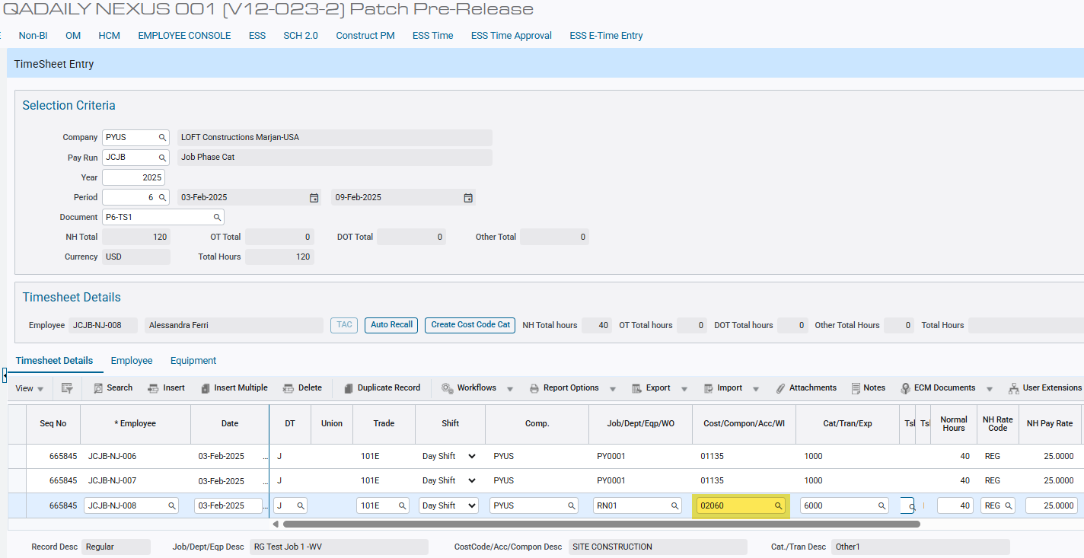
Phase/Cost Code 02060 is still available on timesheet entry.

Set the Phase/Cost Code to inactive:
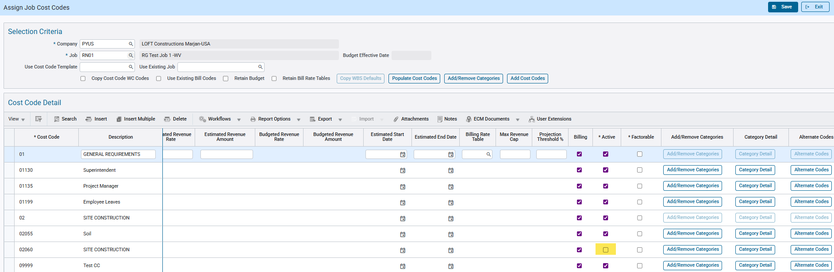

Process Payroll:
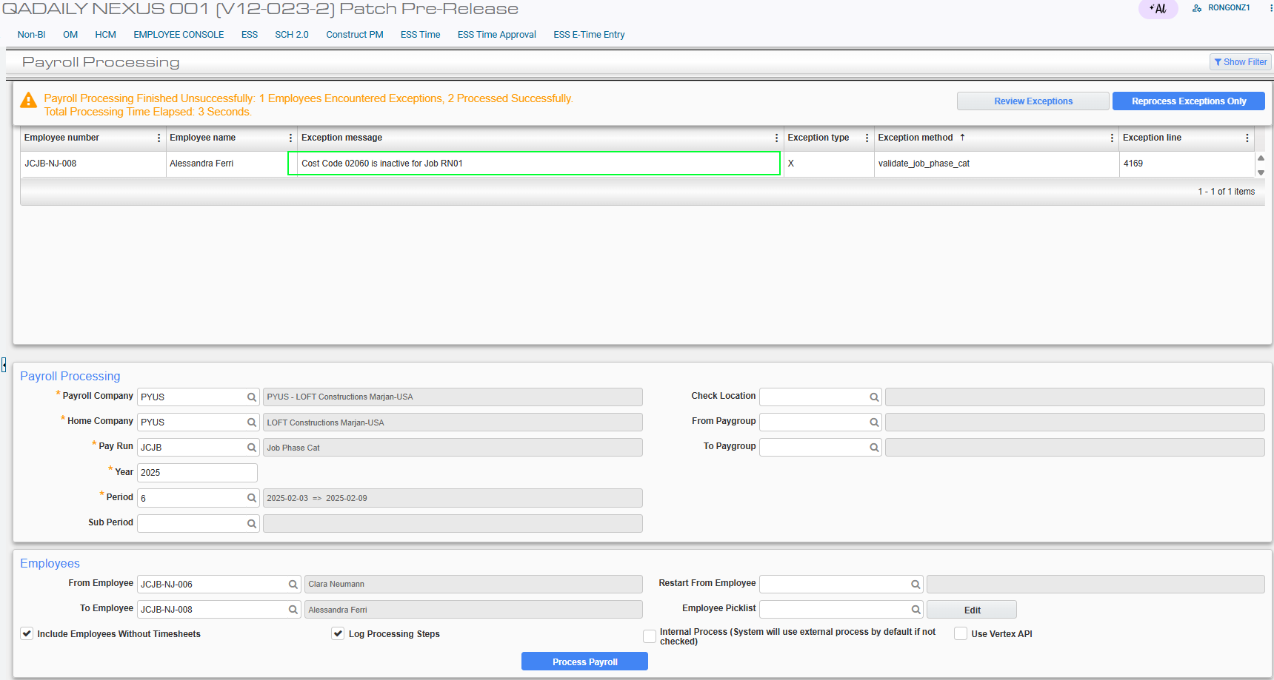
With the flag checked, the inactive Phase/Cost Code is validated and an exception message is displayed indicating the inactive Cost Code for the Job.

Attempt to process and print checks:
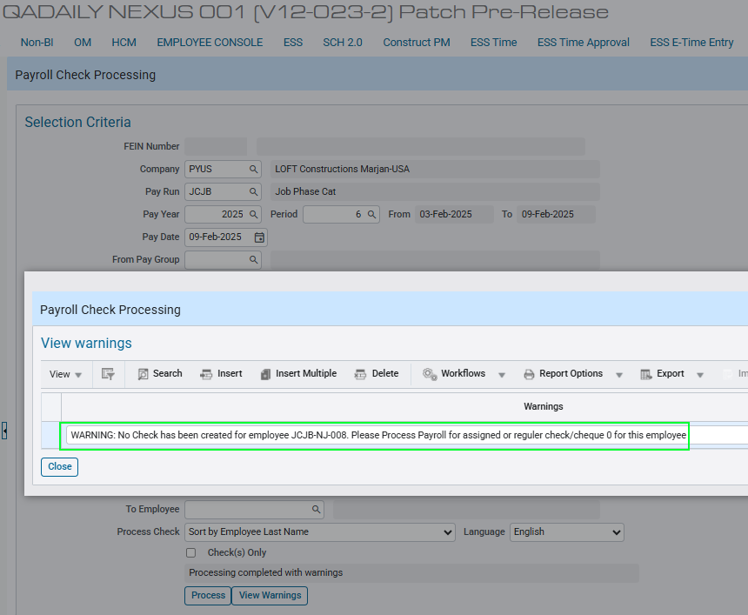
Since payroll processing has an exception, the check for the employee cannot be created.
Attempt to final post the period:
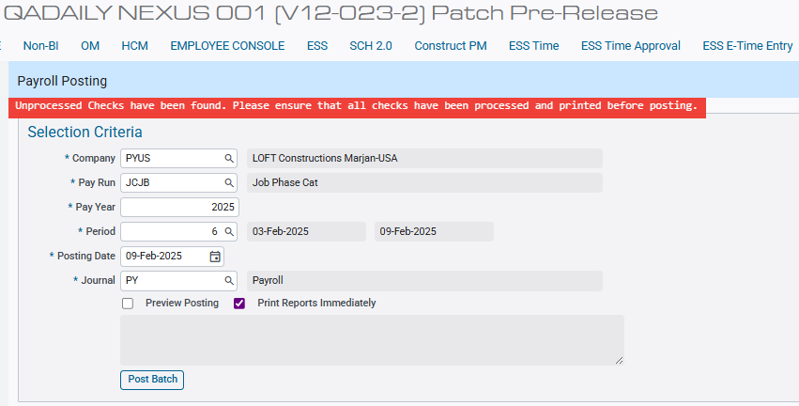
Since there is an unprocessed check due to payroll exception, the period cannot be final posted.

Example #2: Phase/Cost Code is inactive and the flag is unchecked. Validation feature is off.
Turn off the validation by unchecking the flag and saving the configuration:

Reprocess the previous payroll period from Example #1:
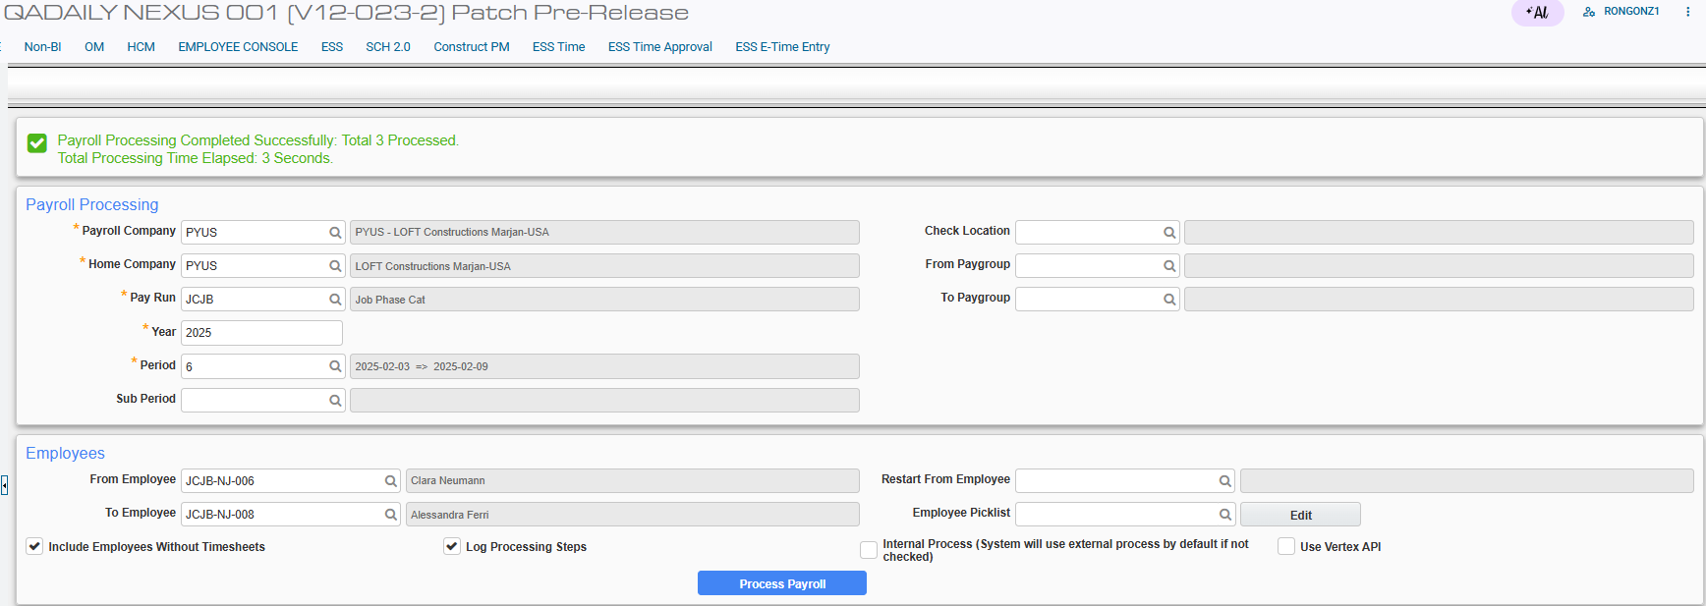
With the flag unchecked, the inactive Phase/Cost Code is not validated and payroll processing is successful.

Attempt to process and print checks:
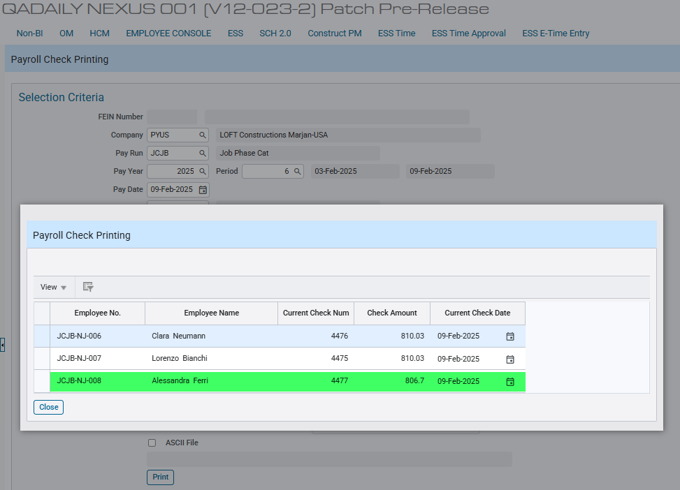
Since payroll processing is a success, the check for the employee previously skipped is now created.
Attempt to final post the period:
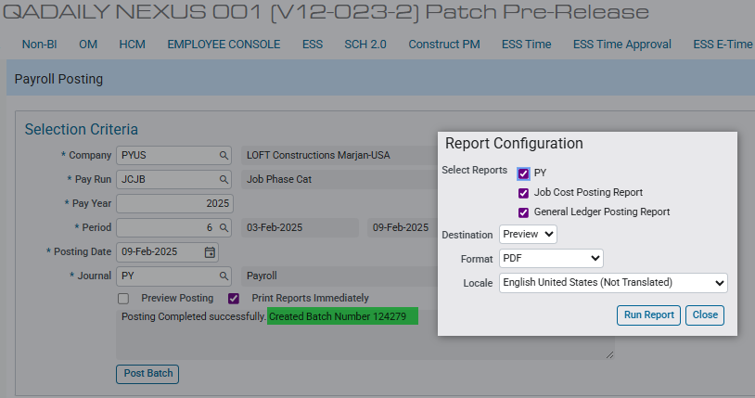
The payroll period can be final posted.
Example #3: Category is inactive.
Enter timesheet hours using an active Category and post it:
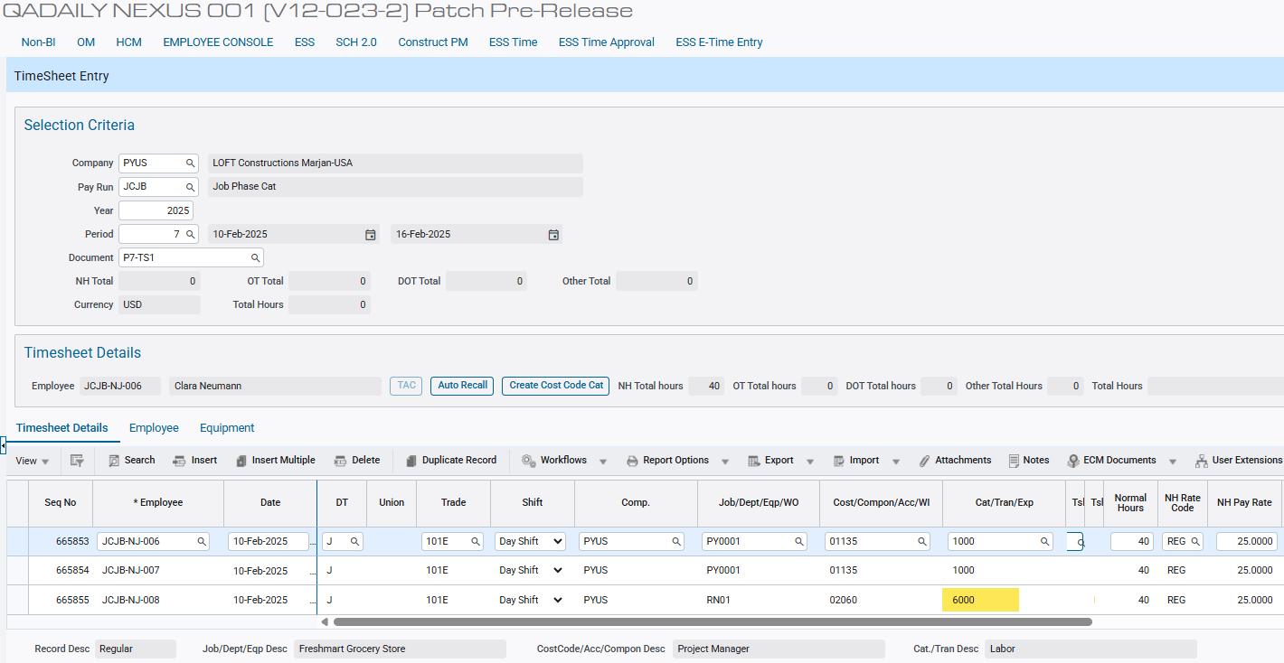
Category 6000 is still available on timesheet entry.

Set the Category to inactive:
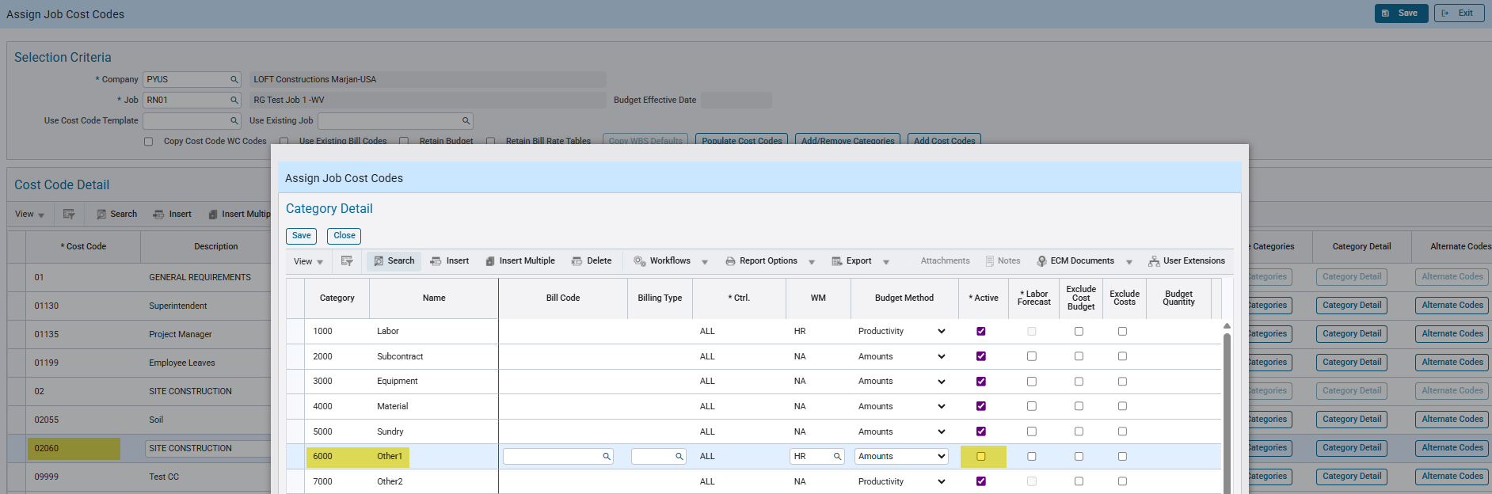
Process Payroll:
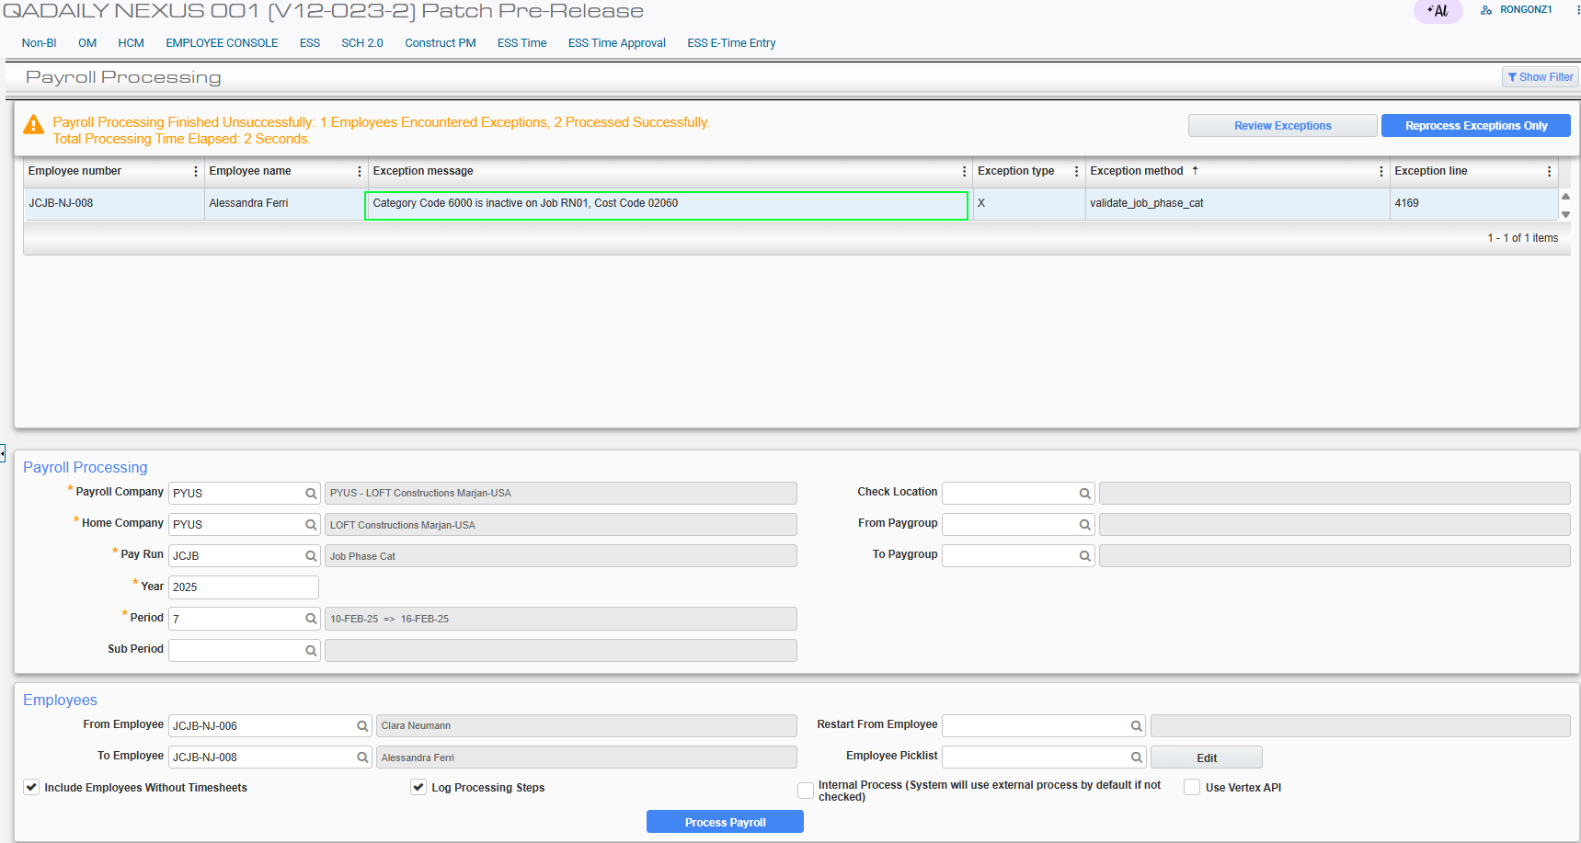
With the flag checked, the inactive Category is validated and an exception message is displayed indicating the inactive Category for the Job and Cost Code.

Attempt to process and print checks:
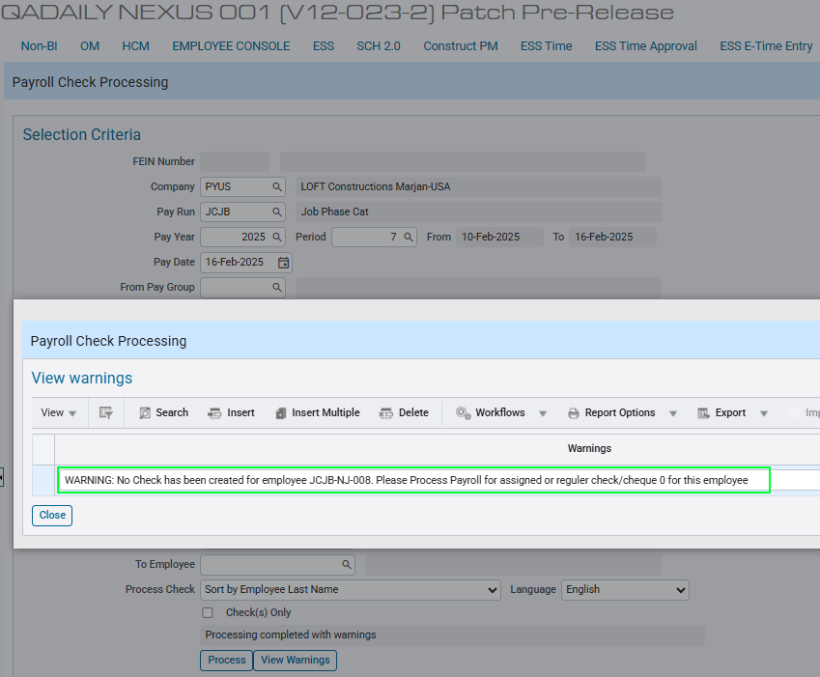
Since payroll processing has an exception, the check for the employee cannot be created.
Attempt to final post the period:
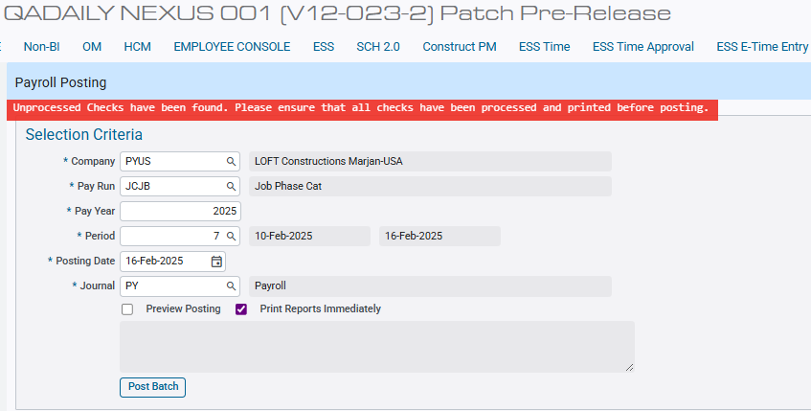
Since there is an unprocessed check due to payroll exception, the period cannot be final posted.

Example #4: Category is inactive and the flag is unchecked. Validation feature is off.
Turn off the validation by unchecking the flag and saving the configuration:

Reprocess the previous payroll period from Example #3:
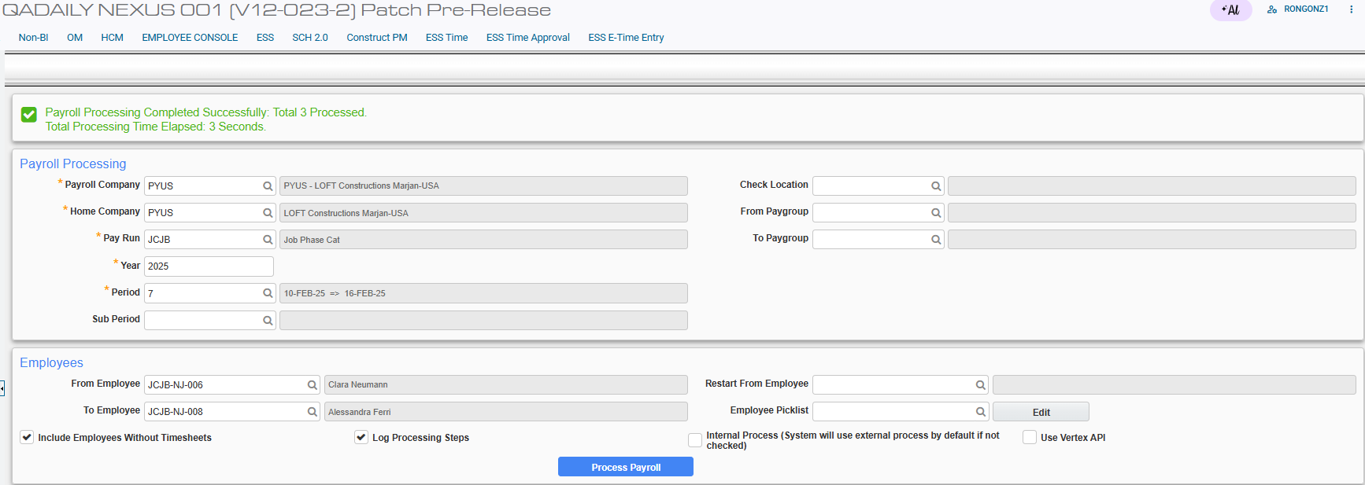
With the flag unchecked, the inactive Category is not validated and payroll processing is successful.

Attempt to process and print checks:
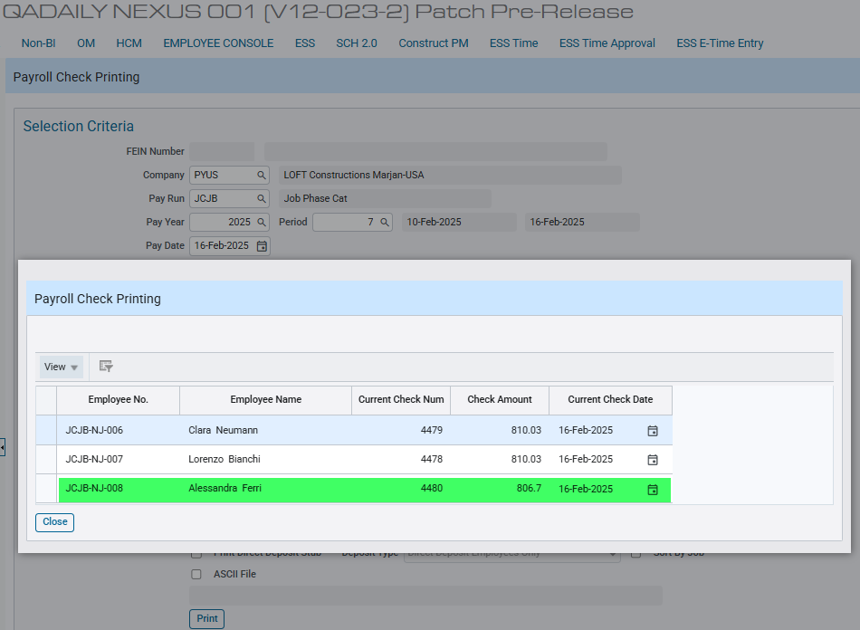
Since payroll processing is a success, the check for the employee previously skipped is now created.

Attempt to final post the period:
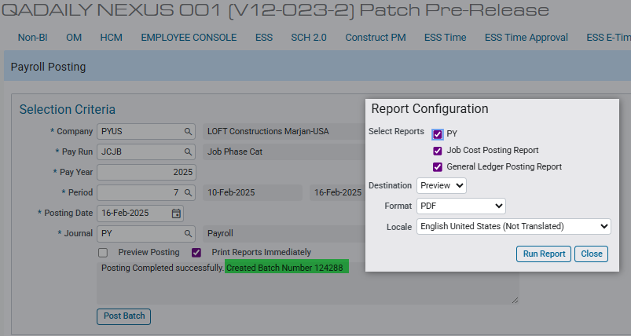
The payroll period can be final posted.

Example #5: Phase/Cost Code in Job Burden is not on JCJOBCAT file. The JCJOBCAT flag is unchecked.
Turn off the JCJOBCAT auto creation by unchecking the flag (System Options > Payroll > Other) and saving the configuration:

Setup the Job Benefit:
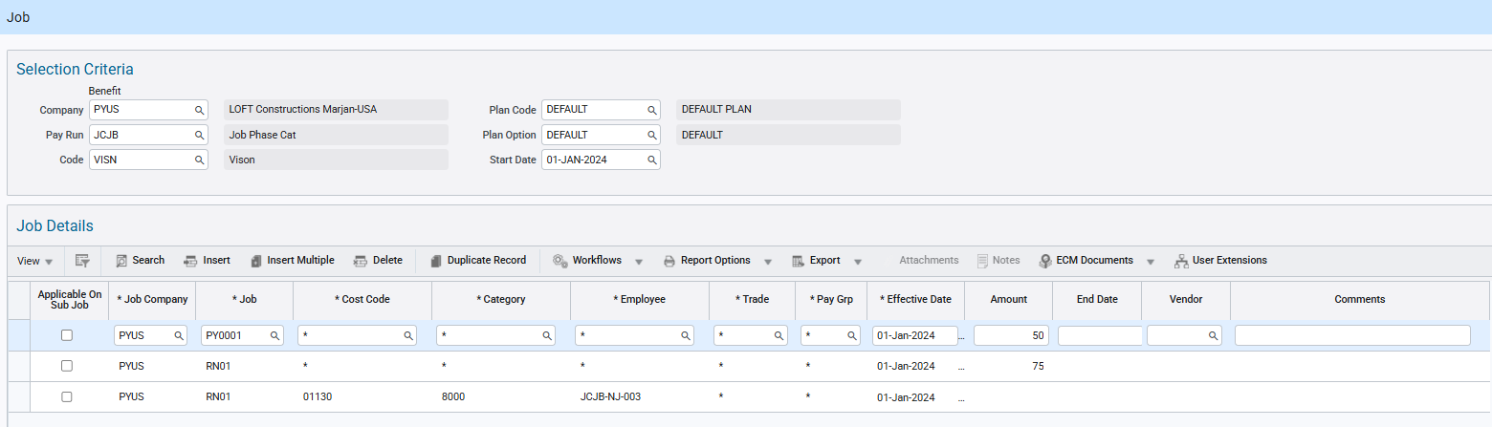
The Job RN01 with an amount of 75 is available for all Cost Code, Category, Trade and Employee.

Setup the Job Burden Allocation:
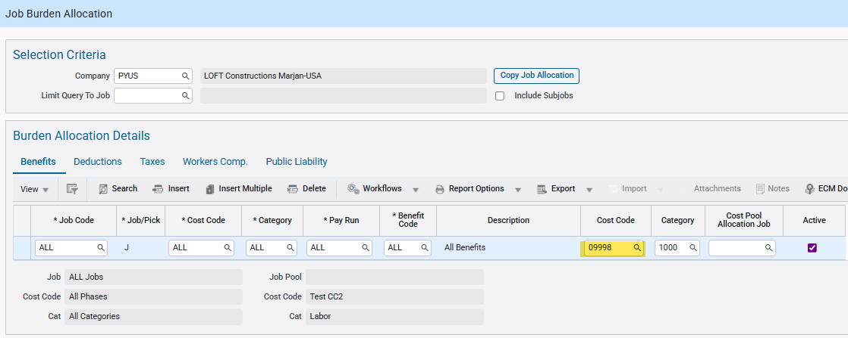
Burdens for All Job is allocated to Cost Code 09998, which does not exist on Assign Job Cost Codes.

Enter timesheet hours using an active Phase/Cost Code and post it:
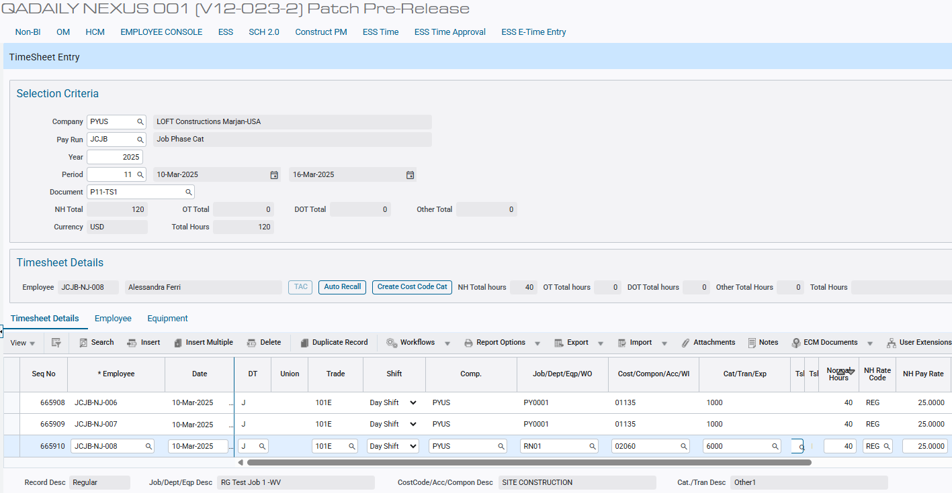
Verify Phase 09998 is not created yet in Job RN01:
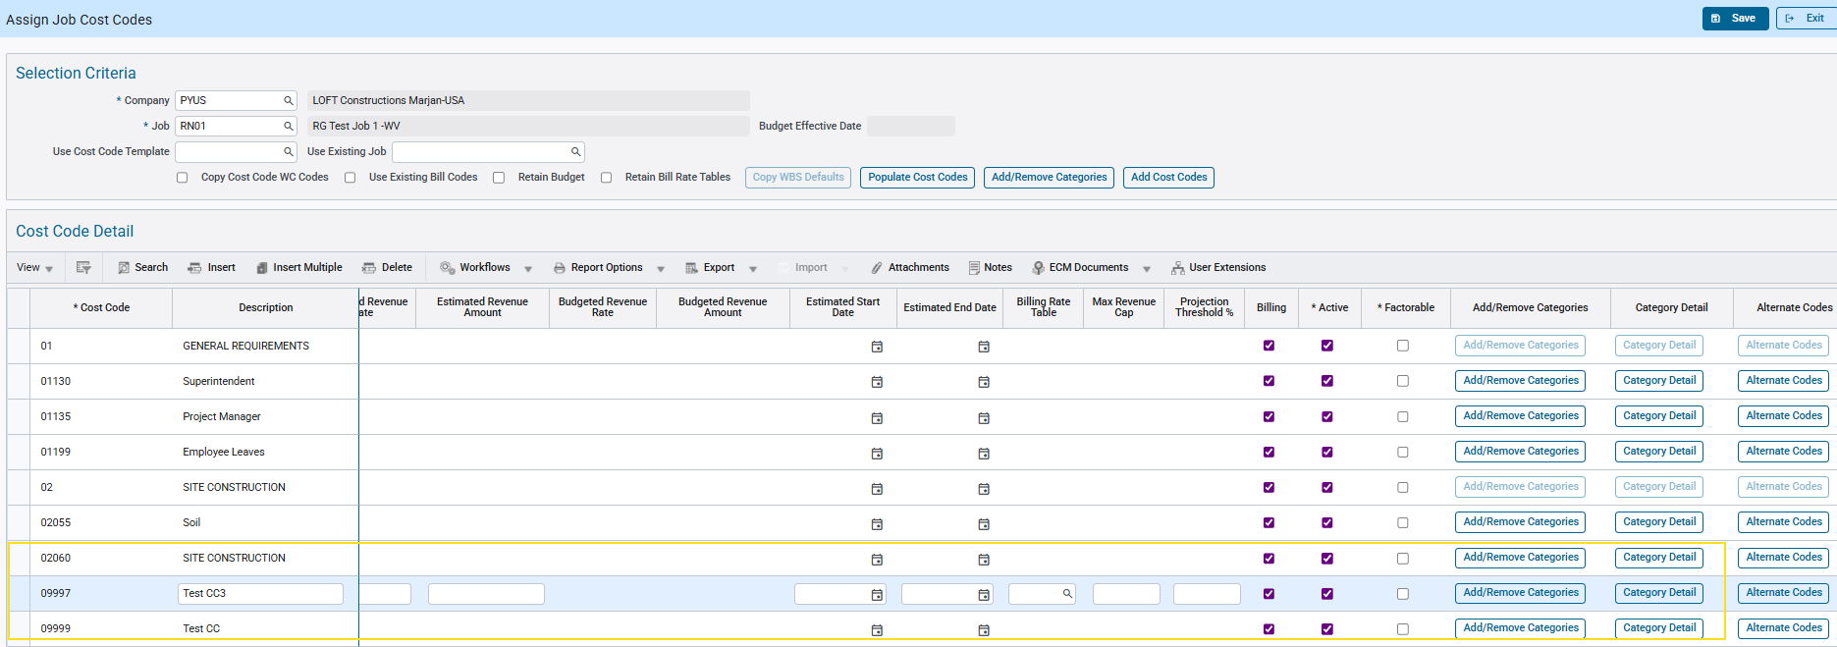

Process Payroll:
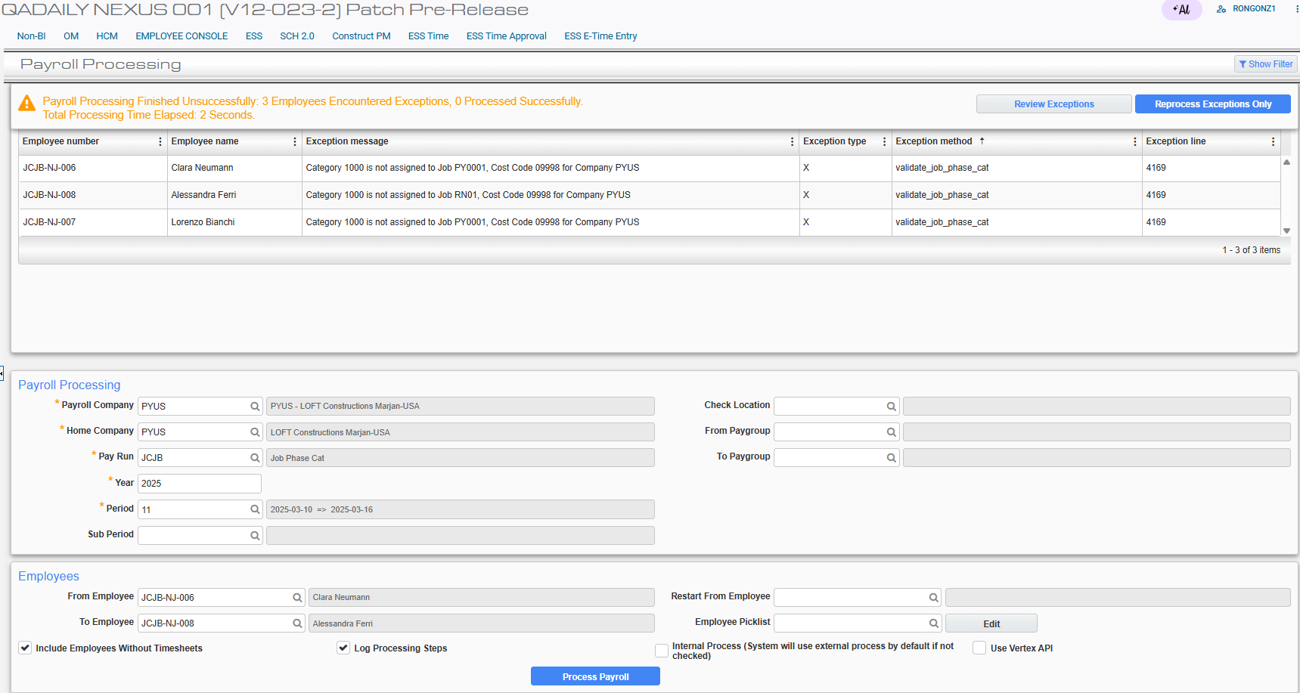
The allocation setup of Category 1000 to Phase/Cost Code 09998 is not possible because Cost Code 09998 is not created due to the JCJOBCAT flag turned off. It is validated as inactive. An exception message is displayed.

Example #6: Phase/Cost Code in Job Burden is not on JCJOBCAT file. The JCJOBCAT flag is unchecked AND validation feature flag is off.
Turn off the JCJOBCAT auto creation by unchecking the flag (System Options > Payroll > Other) and saving the configuration:

Turn off the validation by unchecking the flag and saving the configuration:

Reprocess the previous payroll period from Example #5:
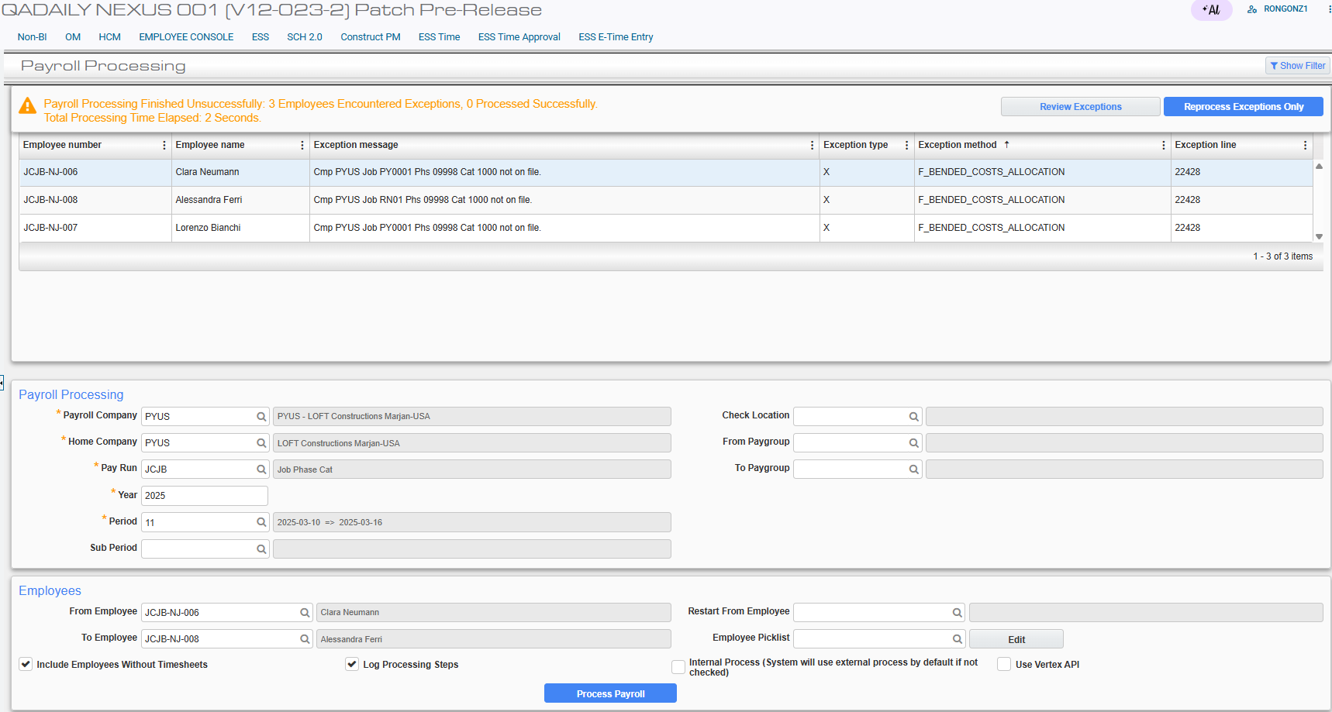
The Phase/Cost Code 09998 is not created due to the JCJOBCAT flag turned off. An exception message is displayed.

Example #7: Category in Job Burden is not on JCJOBCAT file. The JCJOBCAT flag is unchecked.
Turn off the JCJOBCAT auto creation by unchecking the flag (System Options > Payroll > Other) and saving the configuration:

Setup the Job Benefit:
The Job RN01 with an amount of 75 is available for all Cost Code, Category, Trade and Employee.

Setup the Job Burden Allocation:
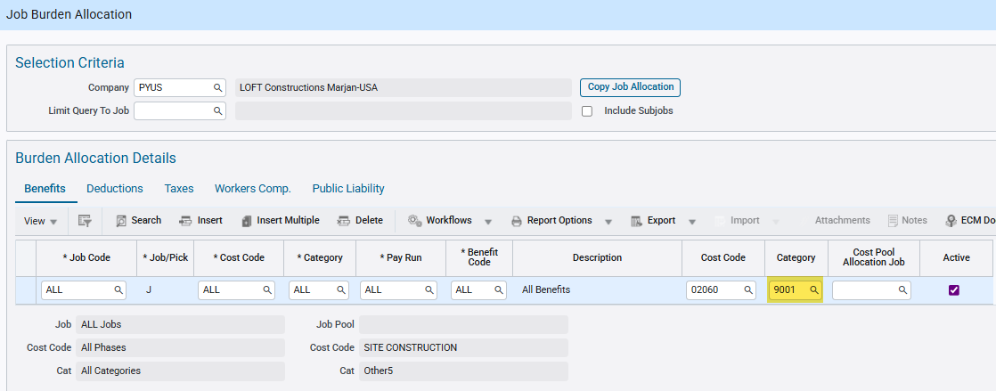
Burdens for All Job is allocated to Category 9001, which does not exist on Assign Job Cost Codes.

Enter timesheet hours using an active Phase/Cost Code and post it:
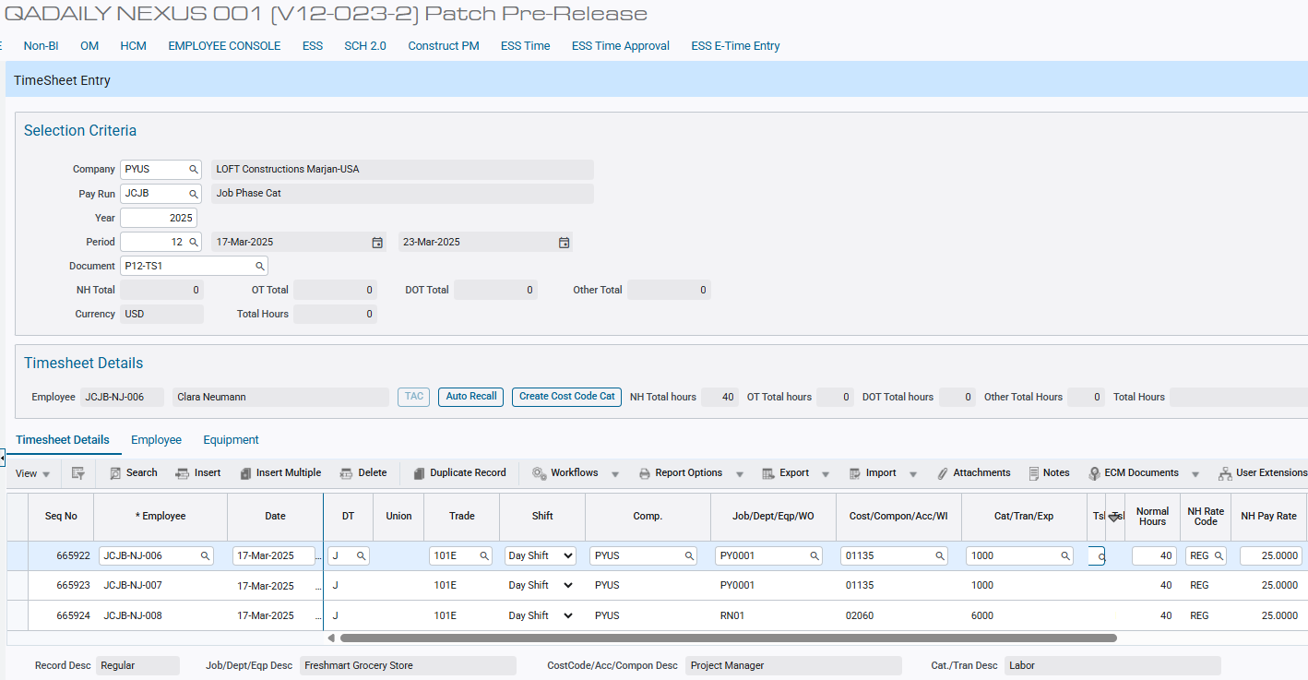

Verify Category 9001 is not available in Phase 02060:
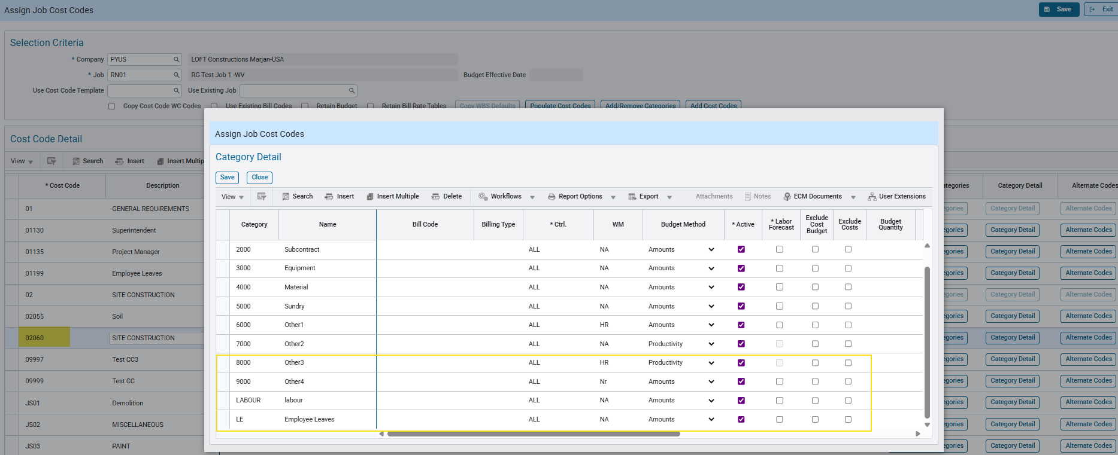

Process Payroll:
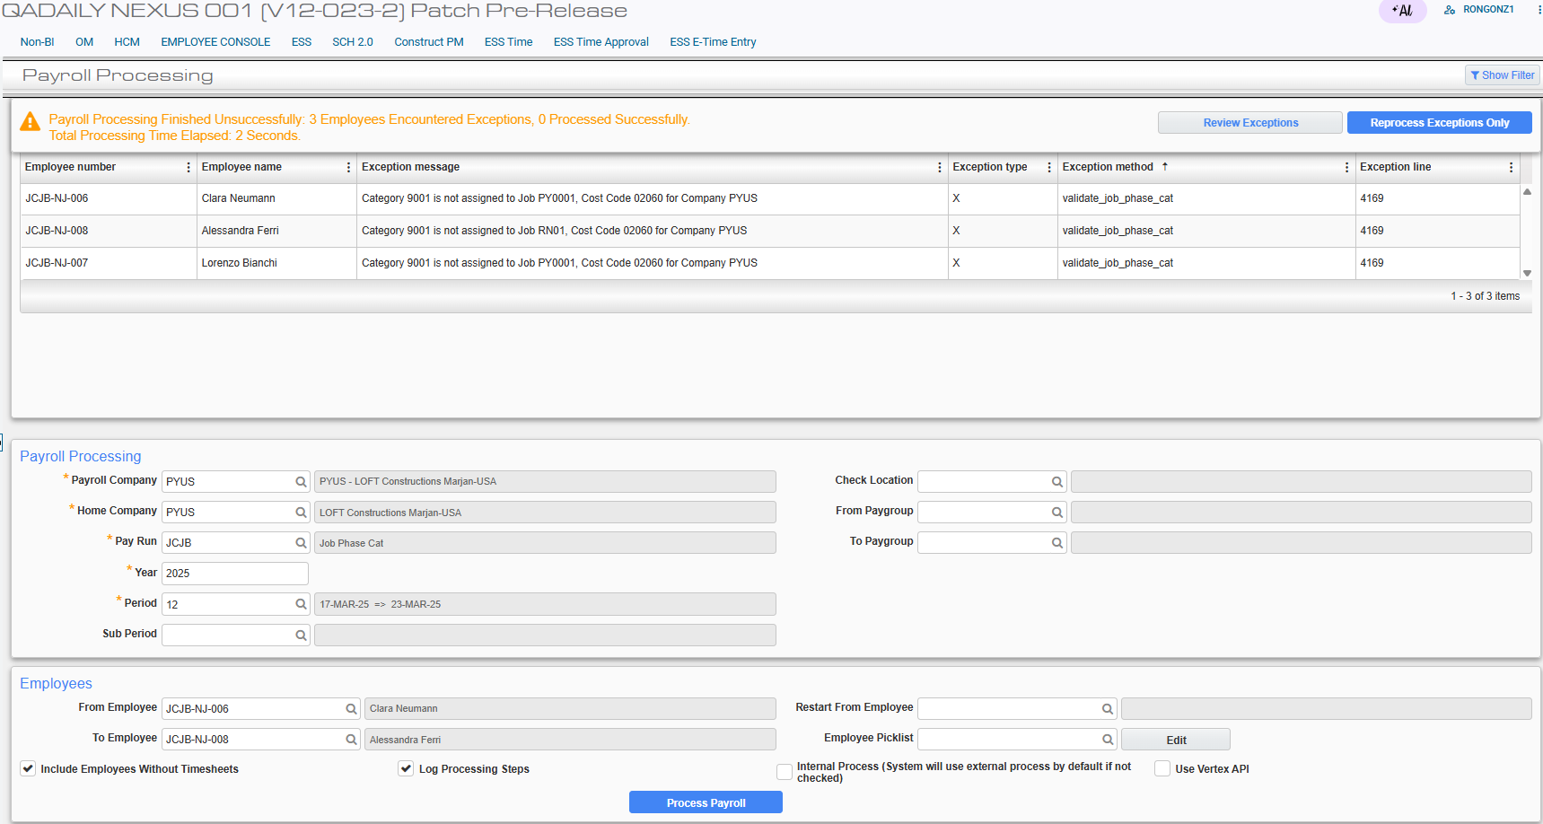
The allocation setup of Category 9001 to Phase/Cost Code 02060 is not possible because Category 9001 is not created due to the JCJOBCAT flag turned off. It is validated as inactive. An exception message is displayed.

Example #8: Category in Job Burden is not on JCJOBCAT file. The JCJOBCAT flag is unchecked AND validation feature flag is off.
Turn off the JCJOBCAT auto creation by unchecking the flag (System Options > Payroll > Other) and saving the configuration:

Turn off the validation by unchecking the flag and saving the configuration:

Reprocess the previous payroll period from Example #7:
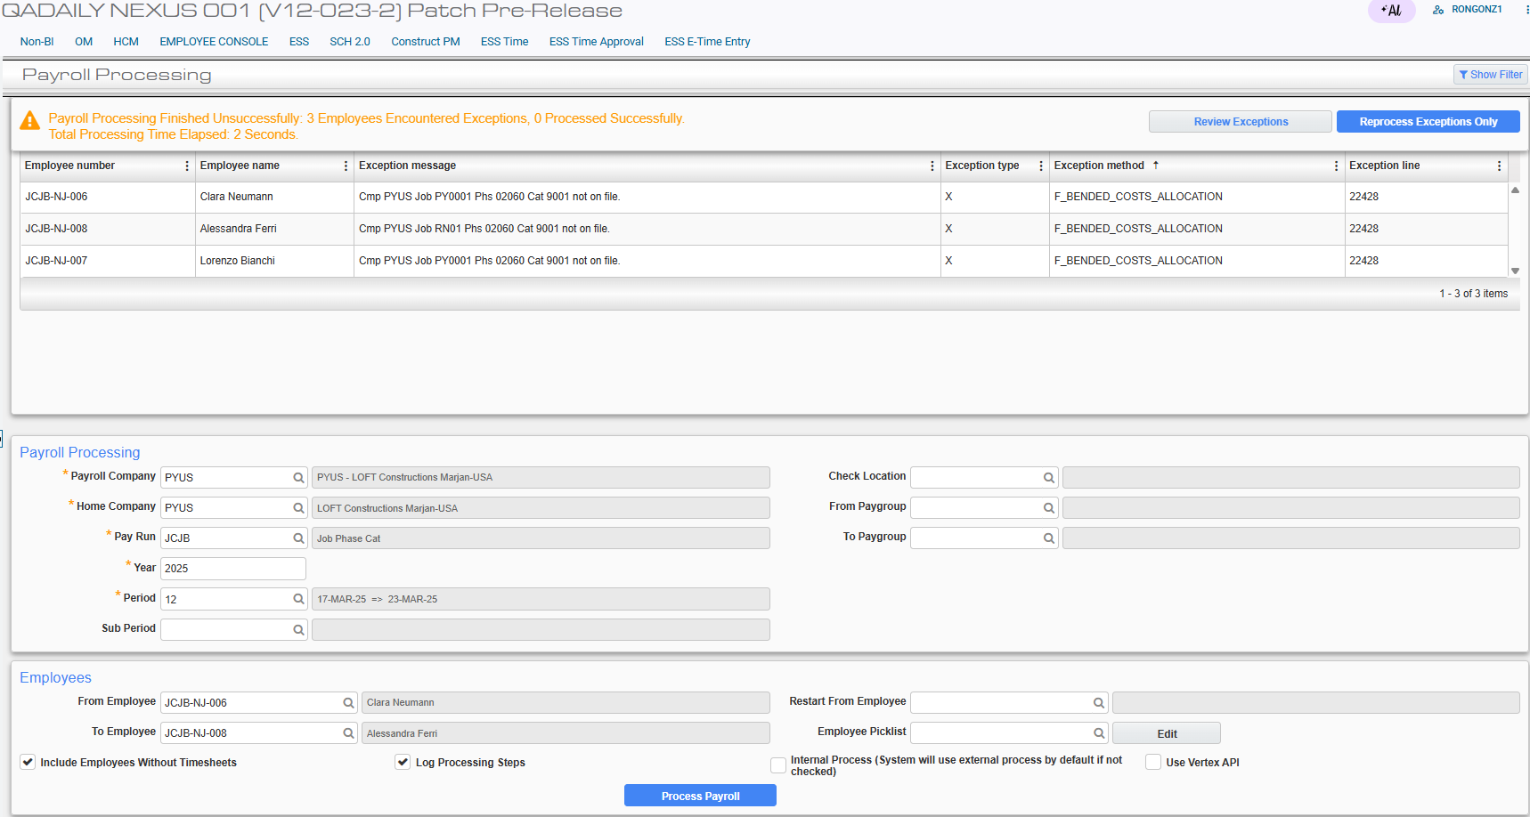
The Category 9001 for Phase 02060 is not created due to the JCJOBCAT flag turned off. An exception message is displayed.

Example #9: Phase/Cost Code in Job Burden is not on JCJOBCAT file. The JCJOBCAT flag is checked and another Phase/Cost Code is inactive.
Turn on the JCJOBCAT auto creation by checking the flag (System Options > Payroll > Other) and saving the configuration:

Setup the Job Benefit:
The Job RN01 with an amount of 75 is available for all Cost Code, Category, Trade and Employee.

Setup the Job Burden Allocation:
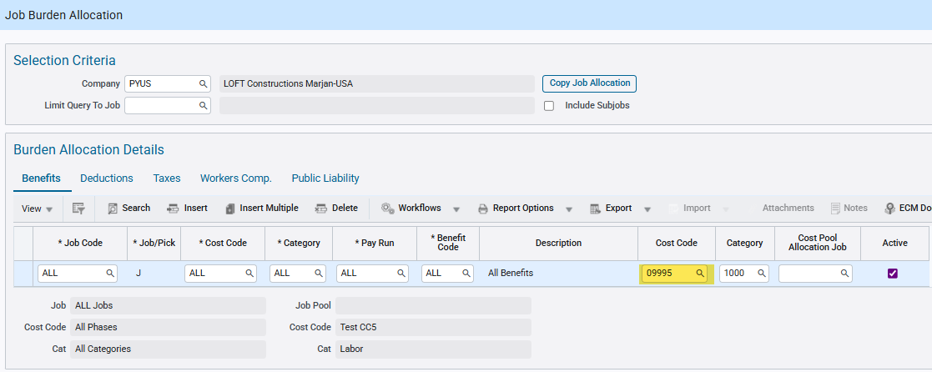
Burdens for All Job is allocated to Cost Code 09995, which does not exist on Assign Job Cost Codes.

Enter timesheet hours using an active Phase/Cost Code and post it:
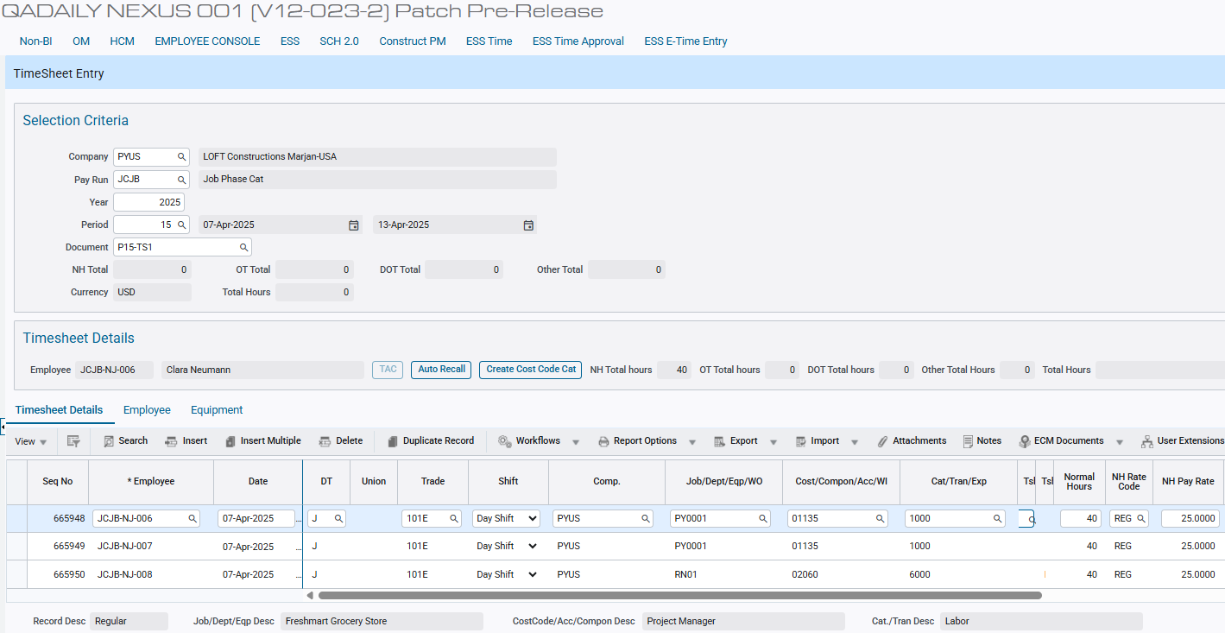

Verify Phase/Cost Code 09995 is not available in Job RN01:
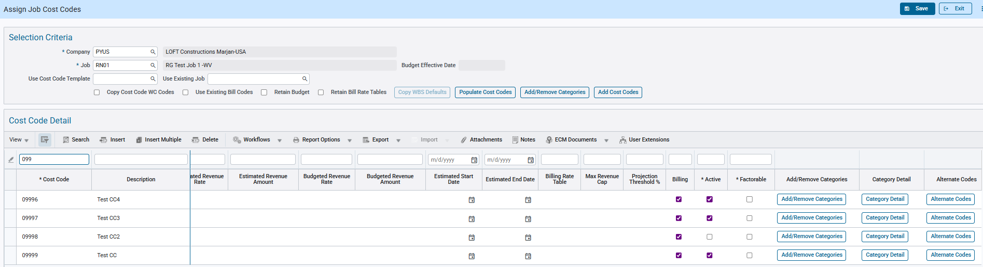

Set another Phase/Cost Code from another Job to inactive:
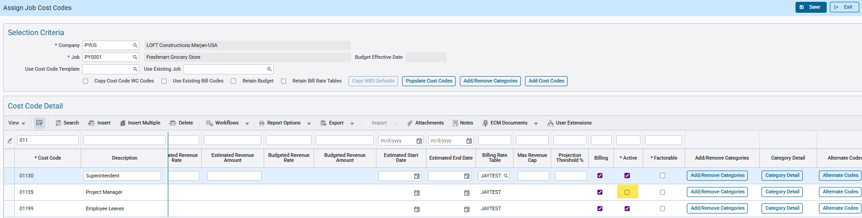

Process Payroll:
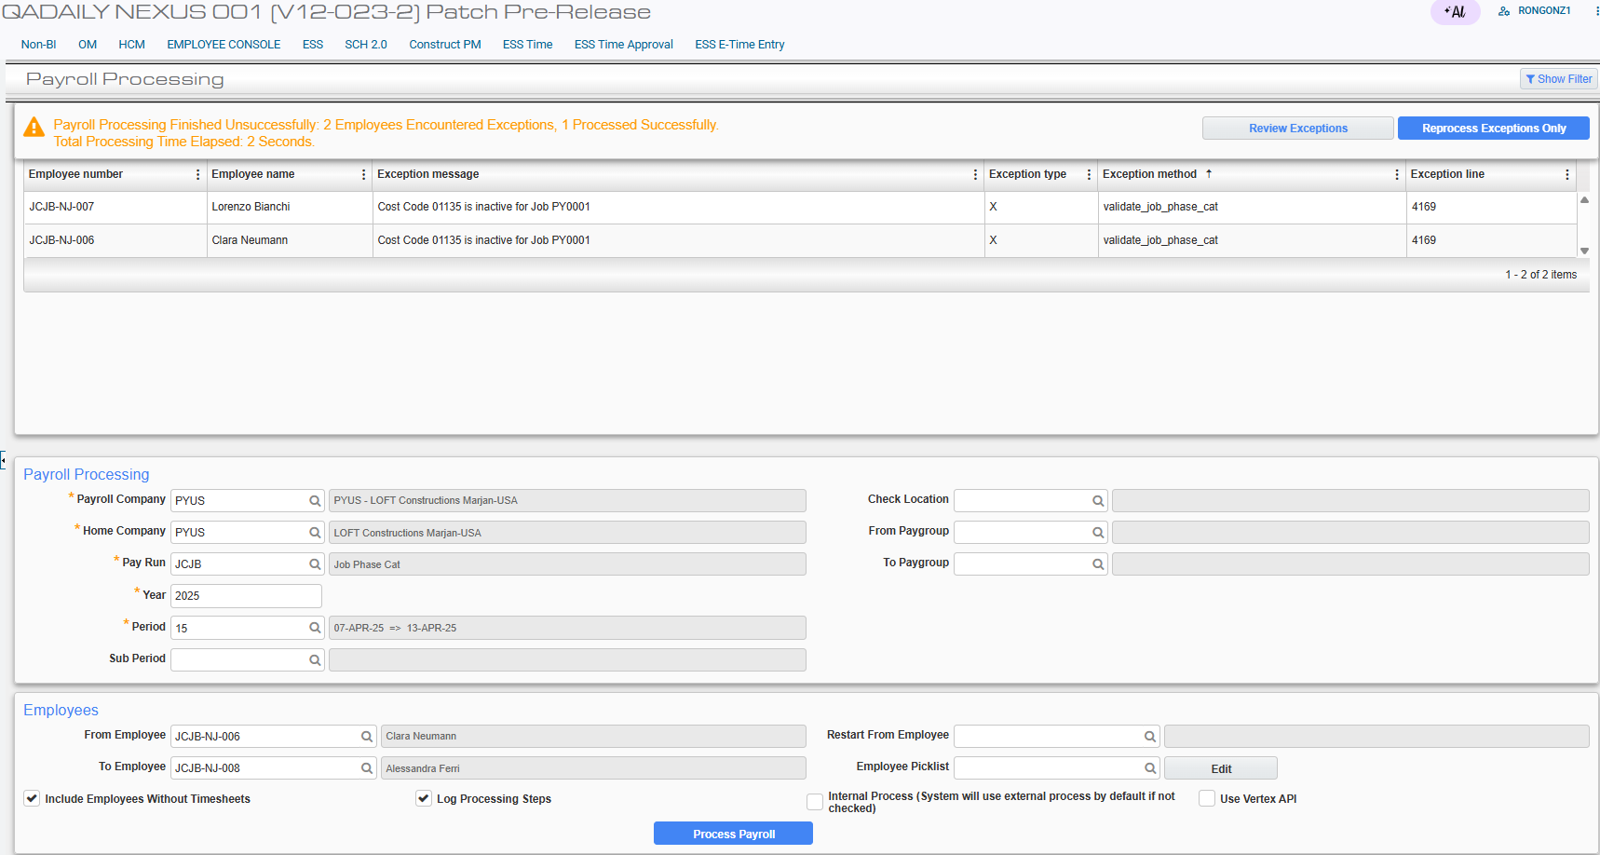
The other inactive Phase/Cost Code is validated and an exception message is displayed indicating the inactive Cost Code for the Job.

Verify Phase/Cost Code 09995 is added to Jobs RN01 and PY0001:
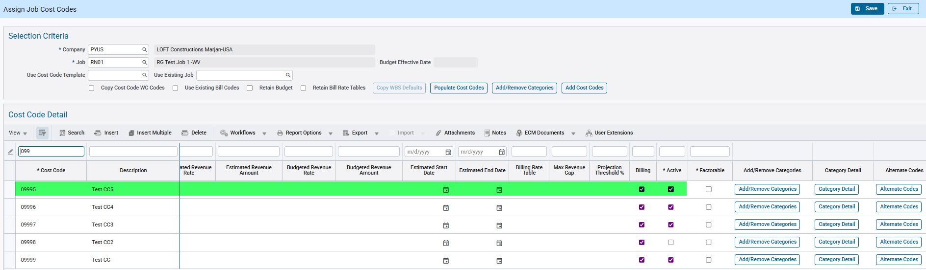
The Phase/Cost Code 09995 is created to the Jobs because the JCJOBCAT flag is checked.

Example #10: Phase/Cost Code in Job Burden is not on JCJOBCAT file. The JCJOBCAT flag is checked and another Phase/Cost Code is inactive. Validate feature is turned off.
Turn on the JCJOBCAT auto creation by checking the flag (System Options > Payroll > Other) and saving the configuration:

Turn off the validation by unchecking the flag and saving the configuration:

Setup the Job Burden Allocation:
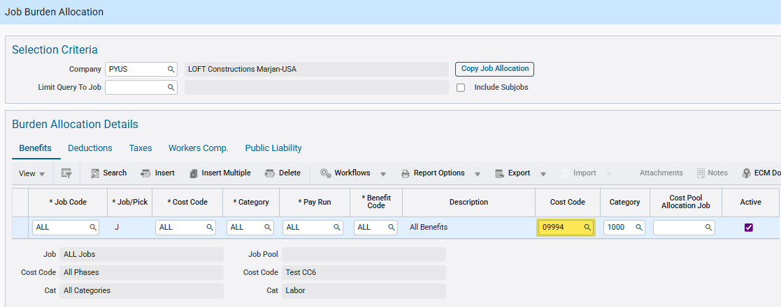
Burdens for All Job is allocated to Cost Code 09994, which does not exist on Assign Job Cost Codes.

Enter timesheet hours using an active Phase/Cost Code and post it:
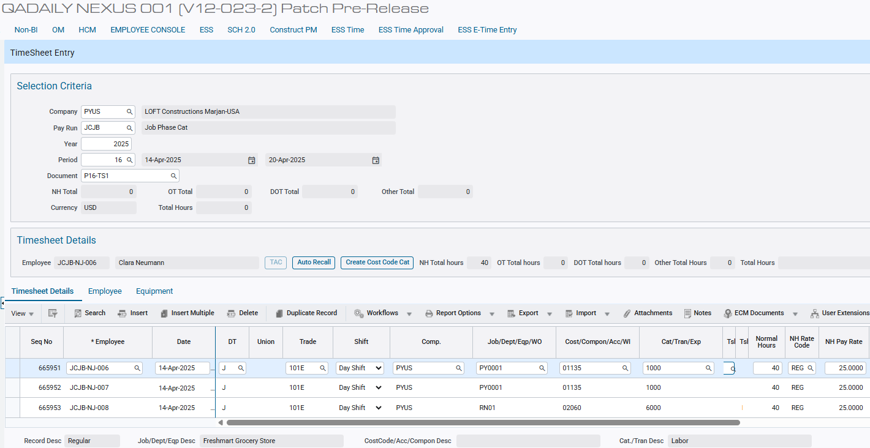

Verify Phase/Cost Code 09994 is not available in Job RN01:

Set another Phase/Cost Code from another Job to inactive:
Process Payroll:
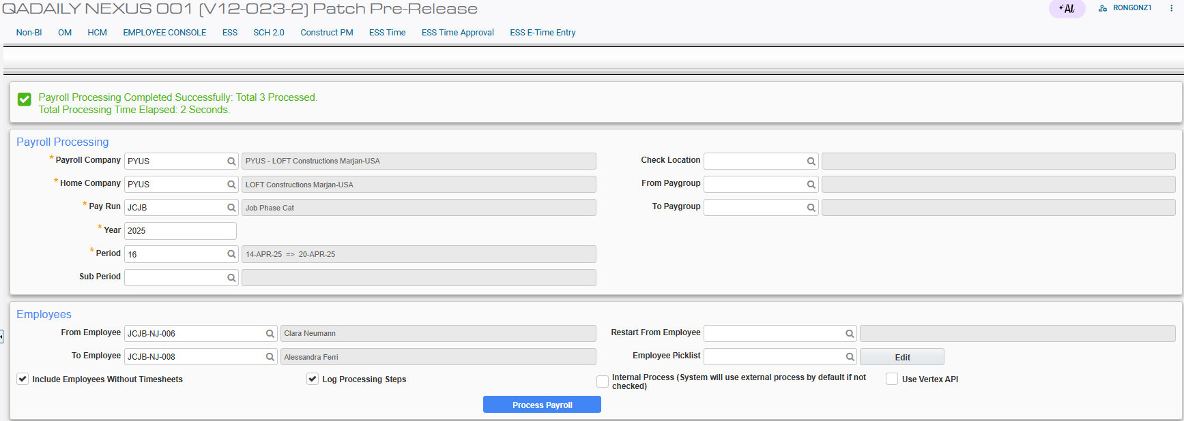
The other inactive Phase/Cost Code is not validated and payroll processing is successful.

Verify Phase/Cost Code 09994 is added to Jobs RN01 and PY0001:
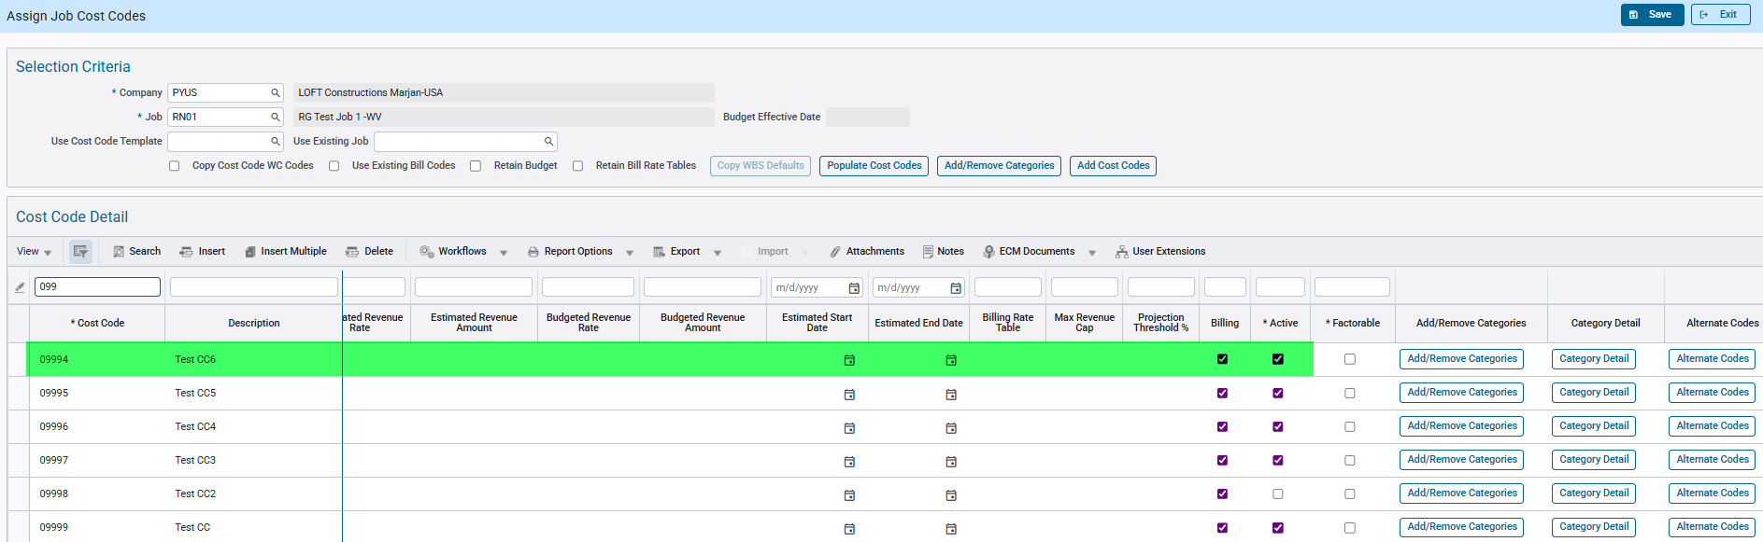
The Phase/Cost Code 09994 is created to the Jobs because the JCJOBCAT flag is checked.

Example #11: Category in Job Burden is not on JCJOBCAT file. The JCJOBCAT flag is checked and another Category is inactive.
Turn on the JCJOBCAT auto creation by checking the flag (System Options > Payroll > Other) and saving the configuration:

Setup the Job Benefit:
The Job RN01 with an amount of 75 is available for all Cost Code, Category, Trade and Employee.

Setup the Job Burden Allocation:
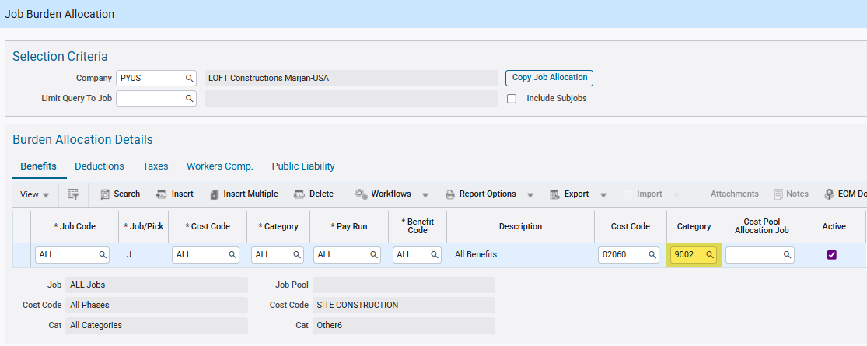
Burdens for All Job is allocated to Category 9002, which does not exist on Cost Code 02060.

Enter timesheet hours using an active Phase/Cost Code and post it:
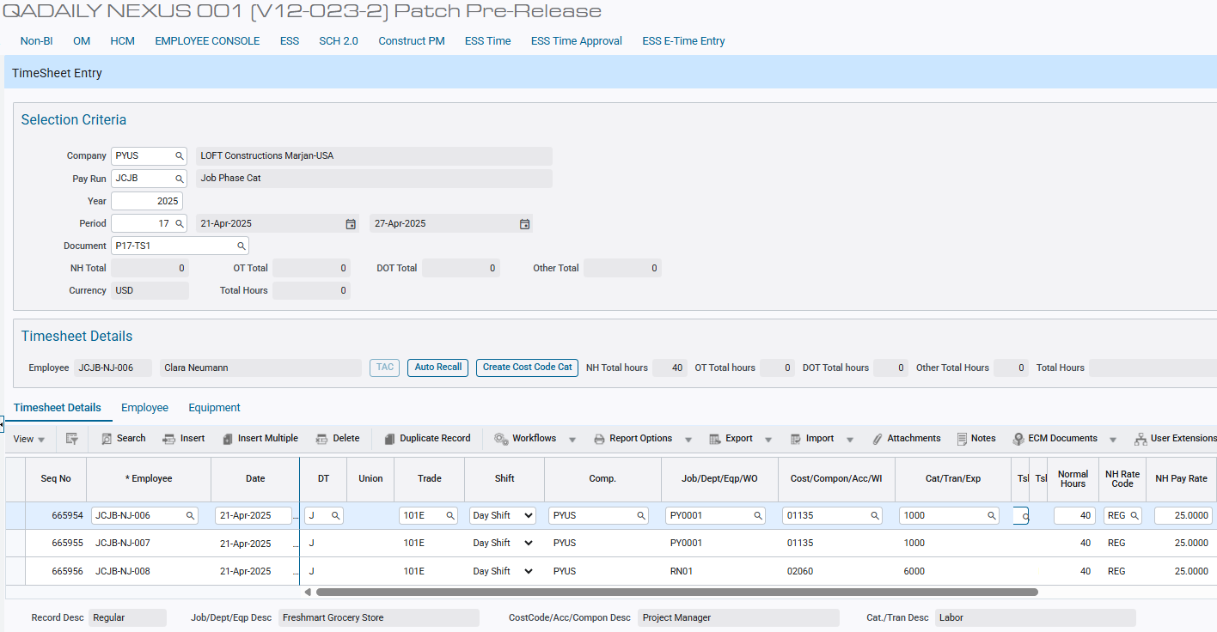

Verify Category 9002 is not available in Phase 02060:
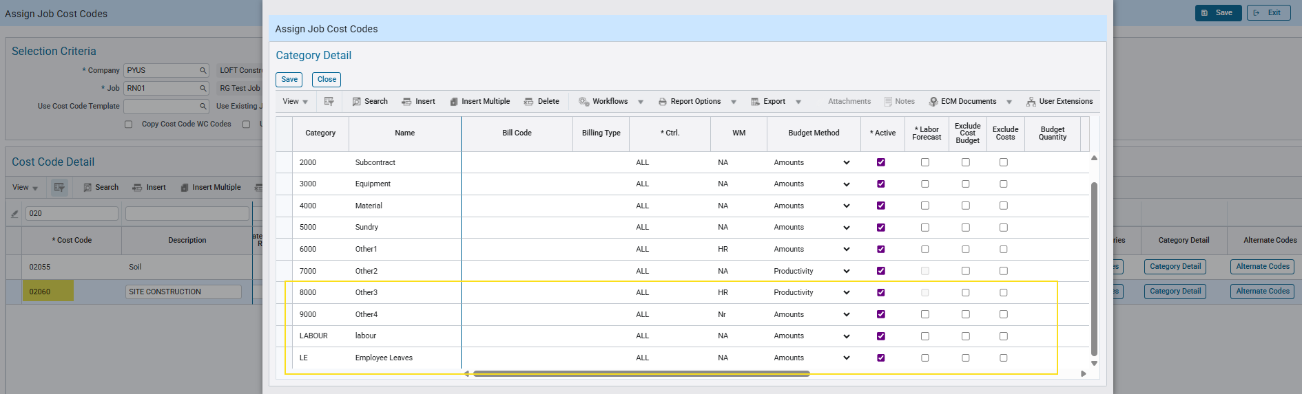

Set another Category from another Job to inactive:
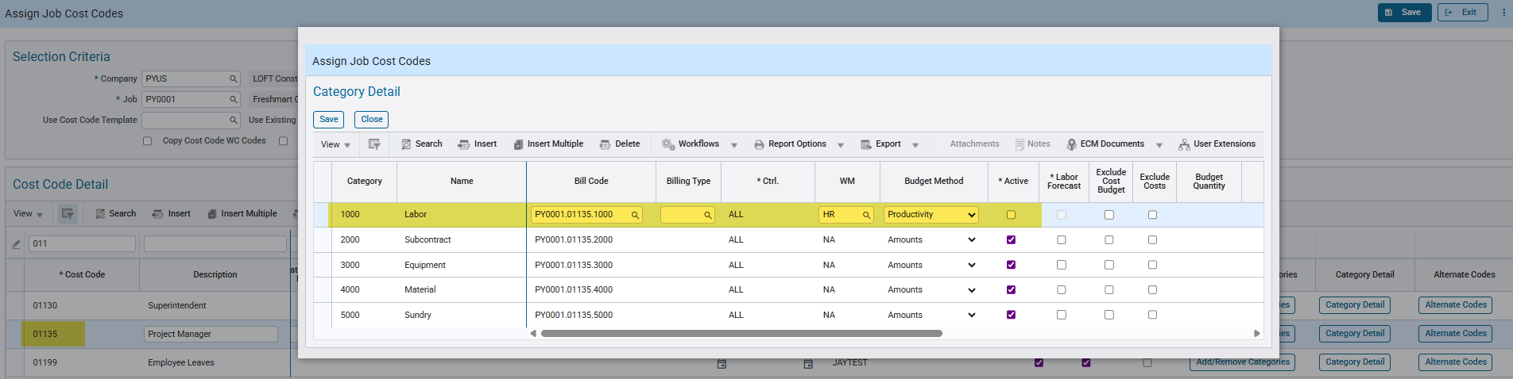

Process Payroll:
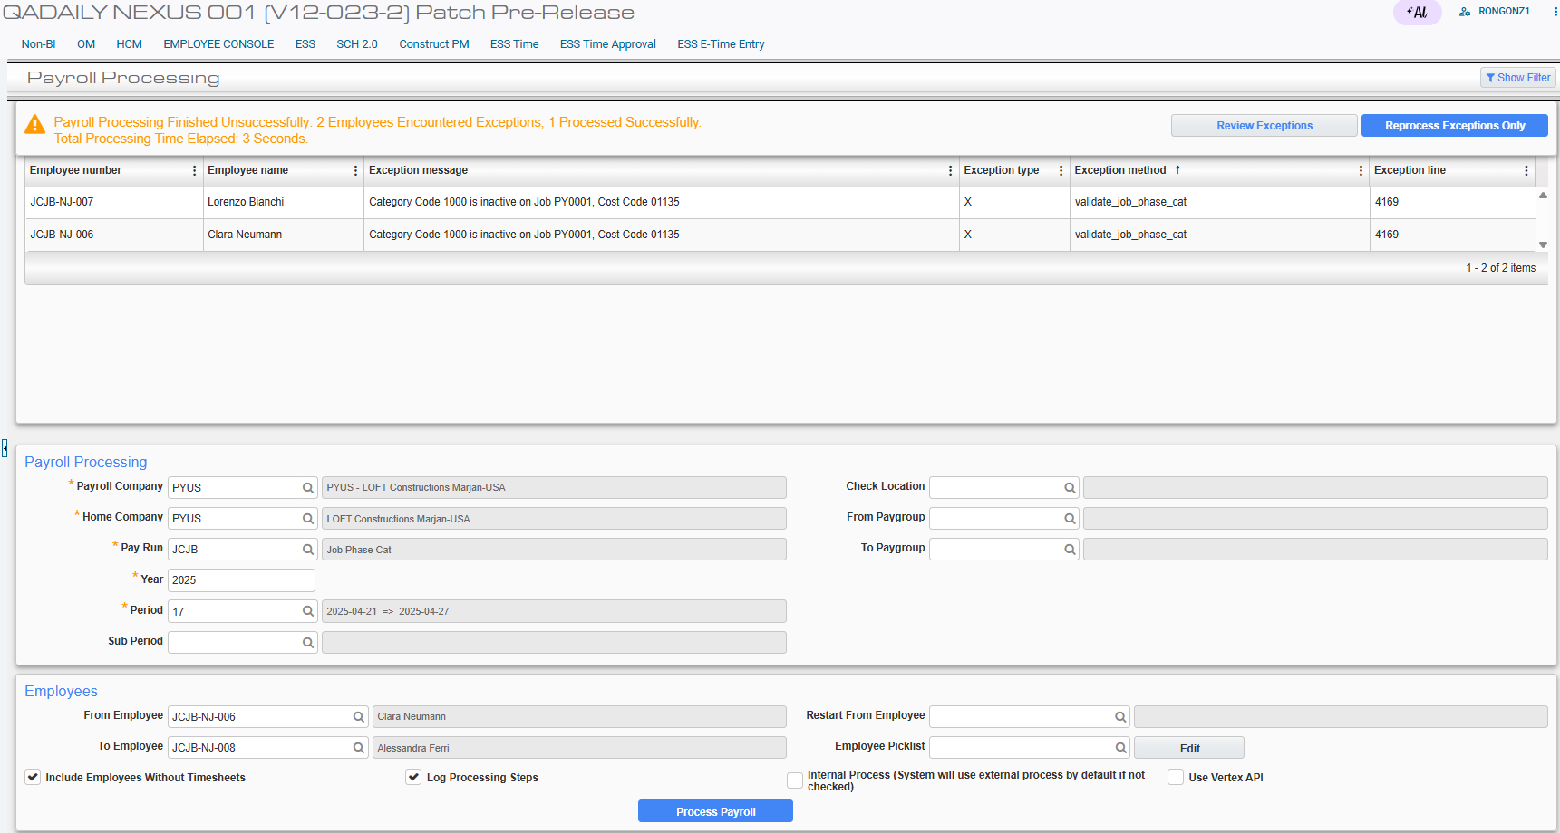
The other inactive Category is validated and an exception message is displayed indicating the inactive Category for the Job.

Verify Category 9002 is added to Phase 02060:
The Category 9002 is created to the Phase because the JCJOBCAT flag is checked.

Example #12: Category in Job Burden is not on JCJOBCAT file. The JCJOBCAT flag is checked and another Category is inactive. Validate feature is turned off.
Turn on the JCJOBCAT auto creation by checking the flag (System Options > Payroll > Other) and saving the configuration:

Turn off the validation by unchecking the flag and saving the configuration:

Setup the Job Burden Allocation:
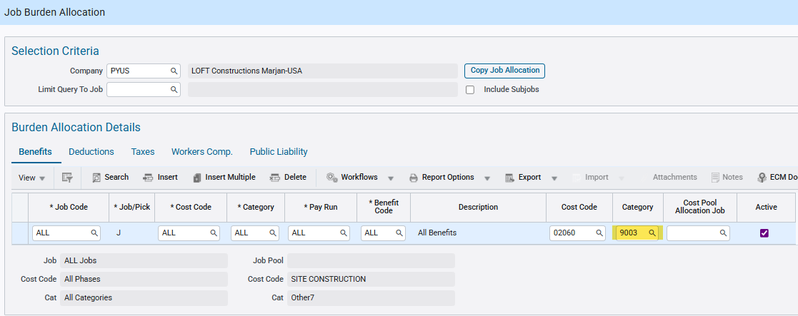
Burdens for All Job is allocated to Category 9003, which does not exist on Assign Job Cost Codes.

Enter timesheet hours using an active Phase/Cost Code and post it:

Verify Category 9003 is not available in Phase 02060:
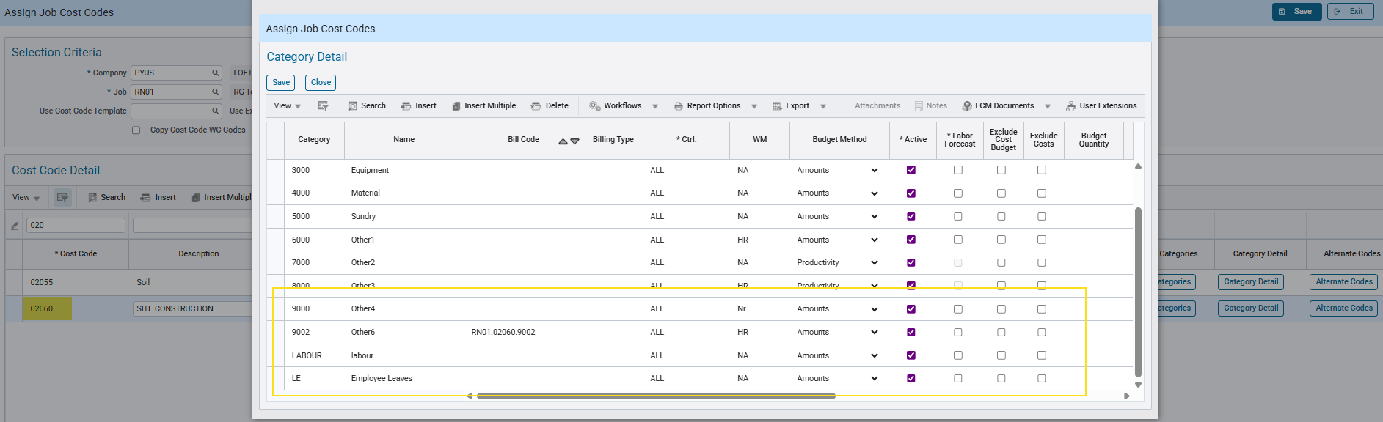

Set another Category from another Job to inactive:

Process Payroll:
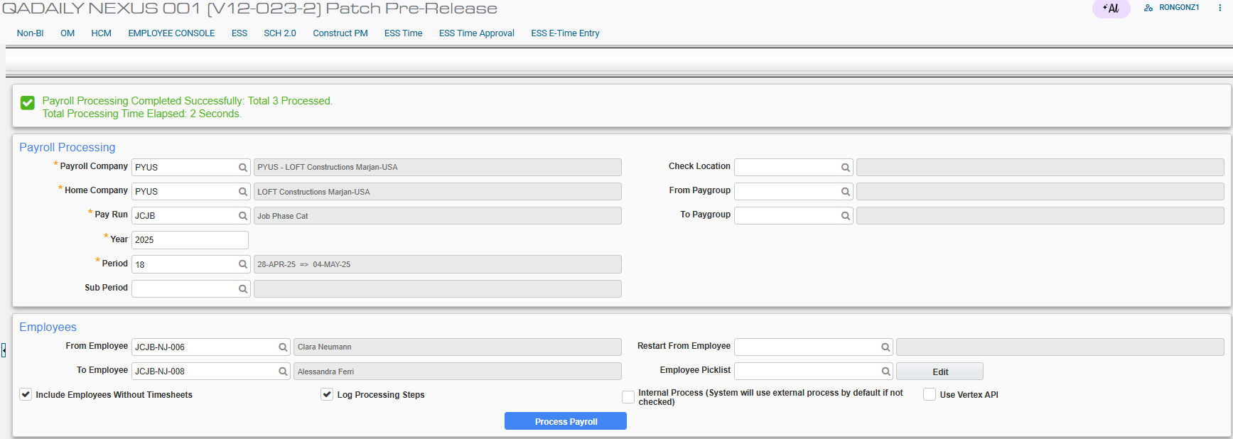
The other inactive Category is not validated and payroll processing is successful.

Verify Category 9003 is added to Phase 02060:
The Phase/Cost Code 09994 is created to the Jobs because the JCJOBCAT flag is checked.

Example #14: Phase is inactive. The ARJBINPHPS privilege is off and the Validate feature is turned on.
Turn off the ARJBINPHPS privilege by unchecking the flag (System > Security > Users > User Maintenance > (User) > System Privileges
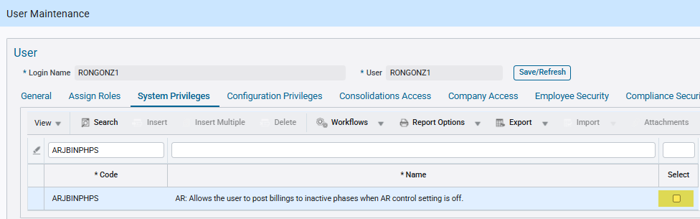

Enter timesheet hours using an active Phase/Cost Code and post it:
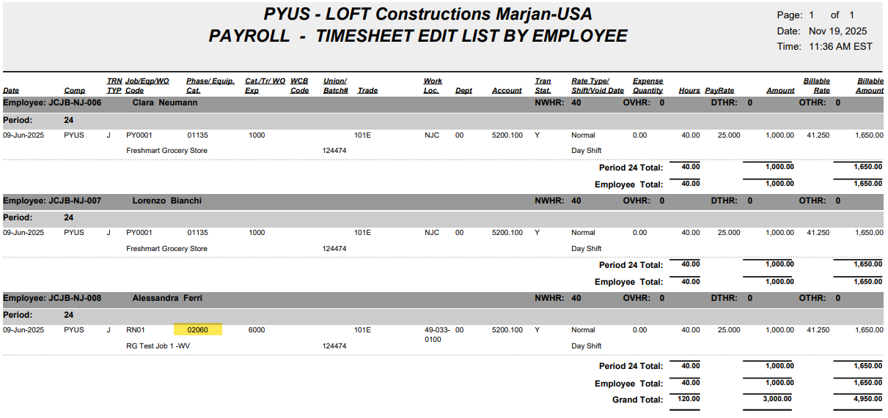

Set a Phase to inactive:

Process Payroll:
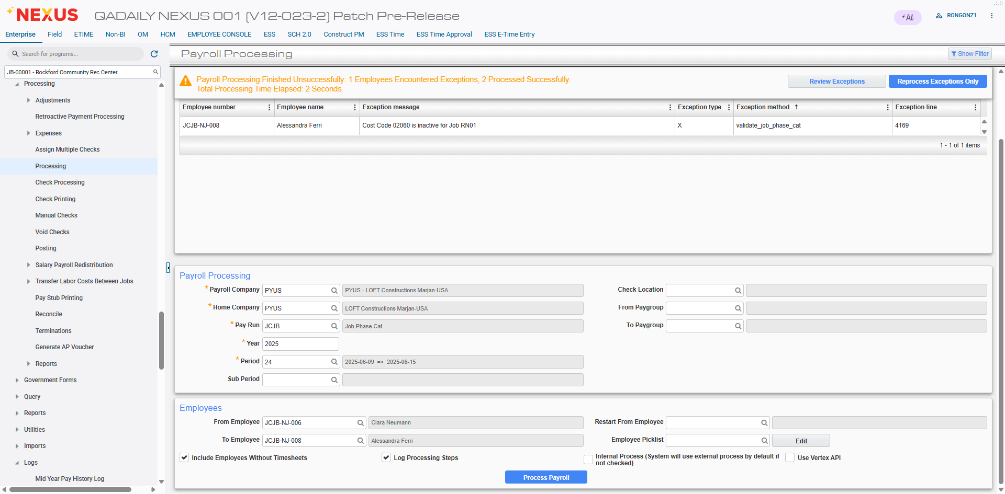
The inactive Phase is validated and payroll processing is not successful.

Example #15: Phase is inactive. The ARJBINPHPS privilege is on and the Validate feature is turned off.
Turn on the ARJBINPHPS privilege by checking the flag (System > Security > Users > User Maintenance > (User) > System Privileges
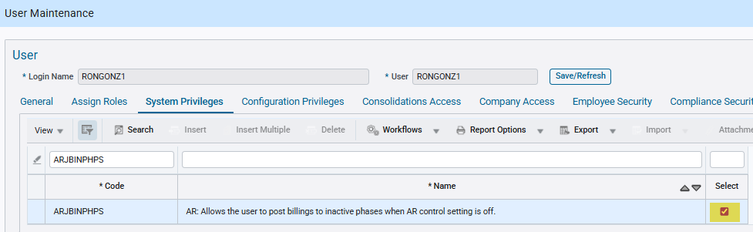

Turn off the validation by unchecking the flag and saving the configuration:

Reprocess the previous payroll period from Example #14:
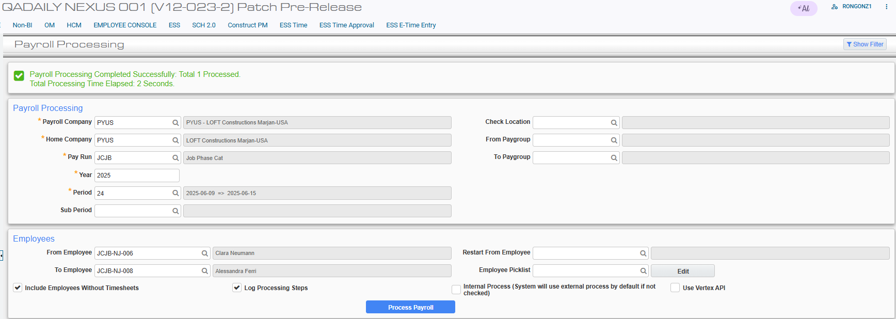
The payroll processing is successful.

New enhancement to populate sector and schedule when cost allocated on equipment work order feature is ON (HCM-19605)
Overview
When the “Cost Allocated on Equipment Work Order” feature is turned on and checked on company control file, CMiC is converting W lines into J lines at timesheet posting. A new enhancement is now added to populate sector and schedule fields during timesheet posting for W lines converted to J lines in mid year pay history.
Note: This feature is only available for International Payroll.
Pre-requisites
Alternate feature of Cost Allocated on Equipment Work Order should be ON/Activated in company Control file in International Payroll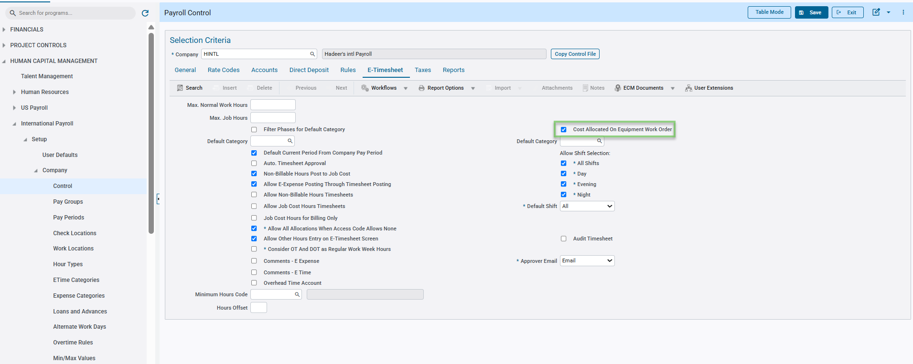Work order must be set under
Asset Management> Preventive maintenance > work orders > Enter/Edit Work Orders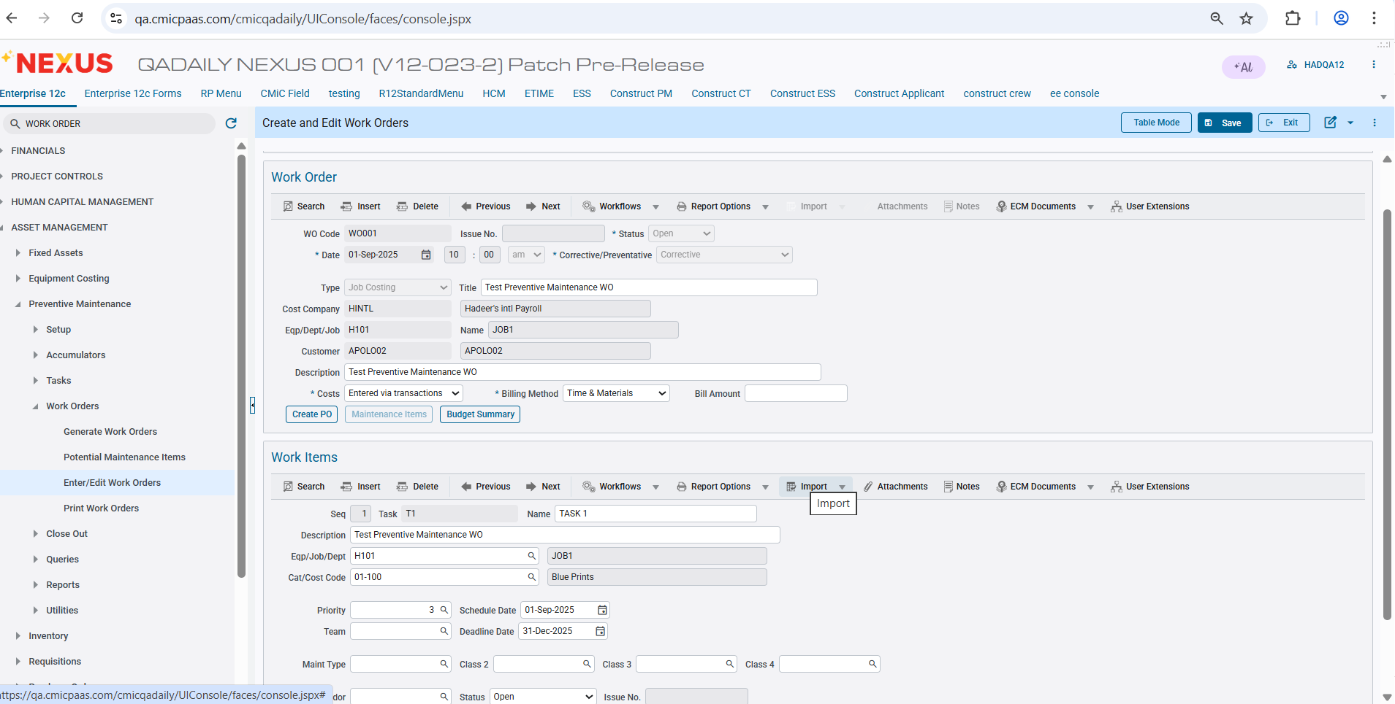
Sector and schedule setup on the job > Payroll Tab: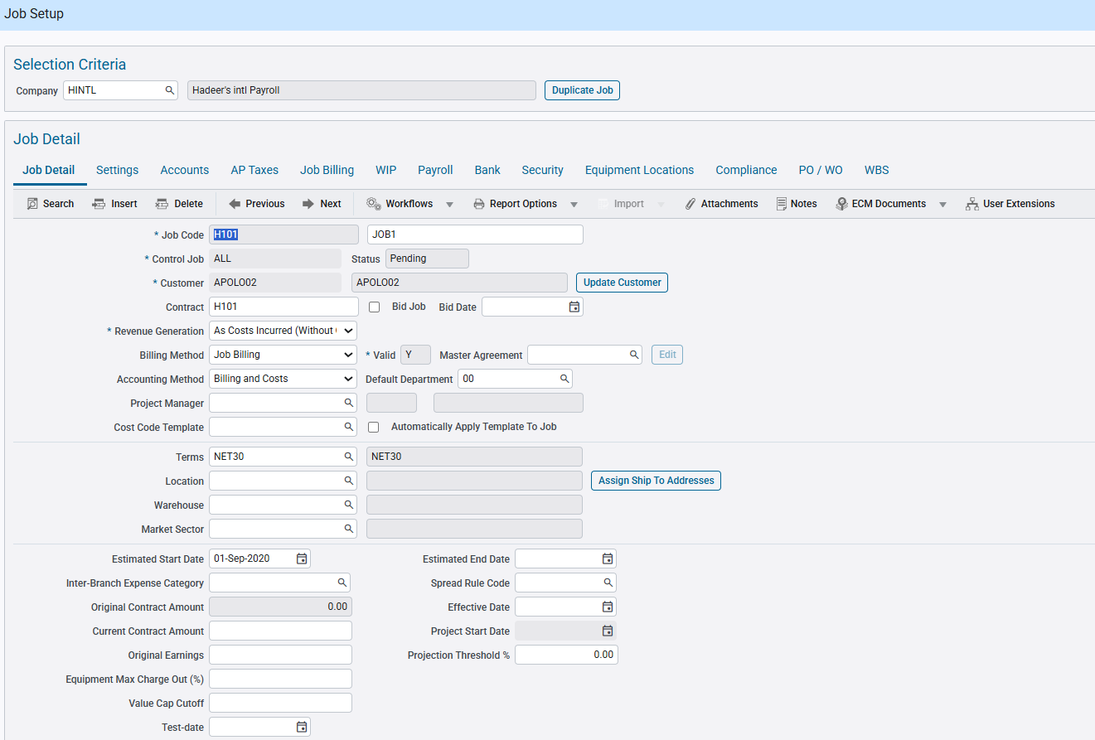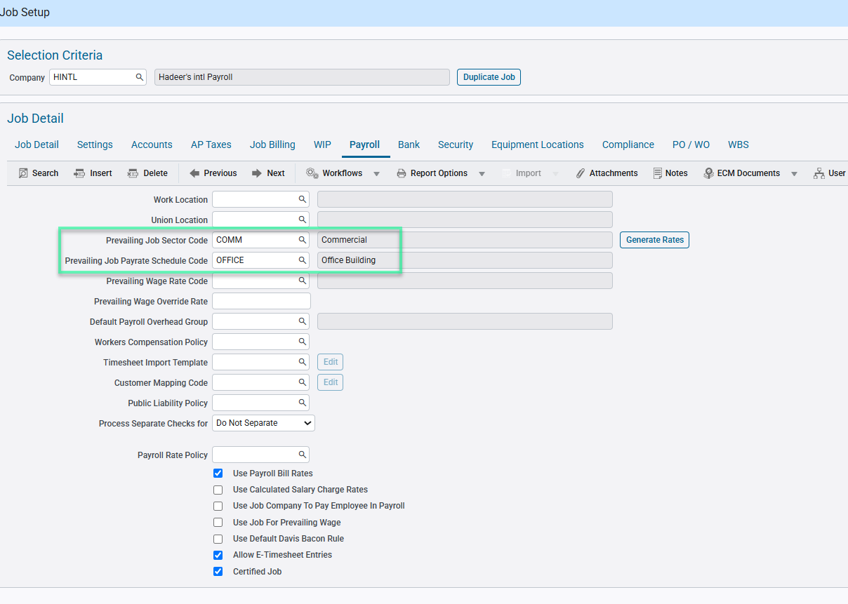Verify that sector and schedule code populated on the job in international payroll > Setup > Jobs > Job Work Locations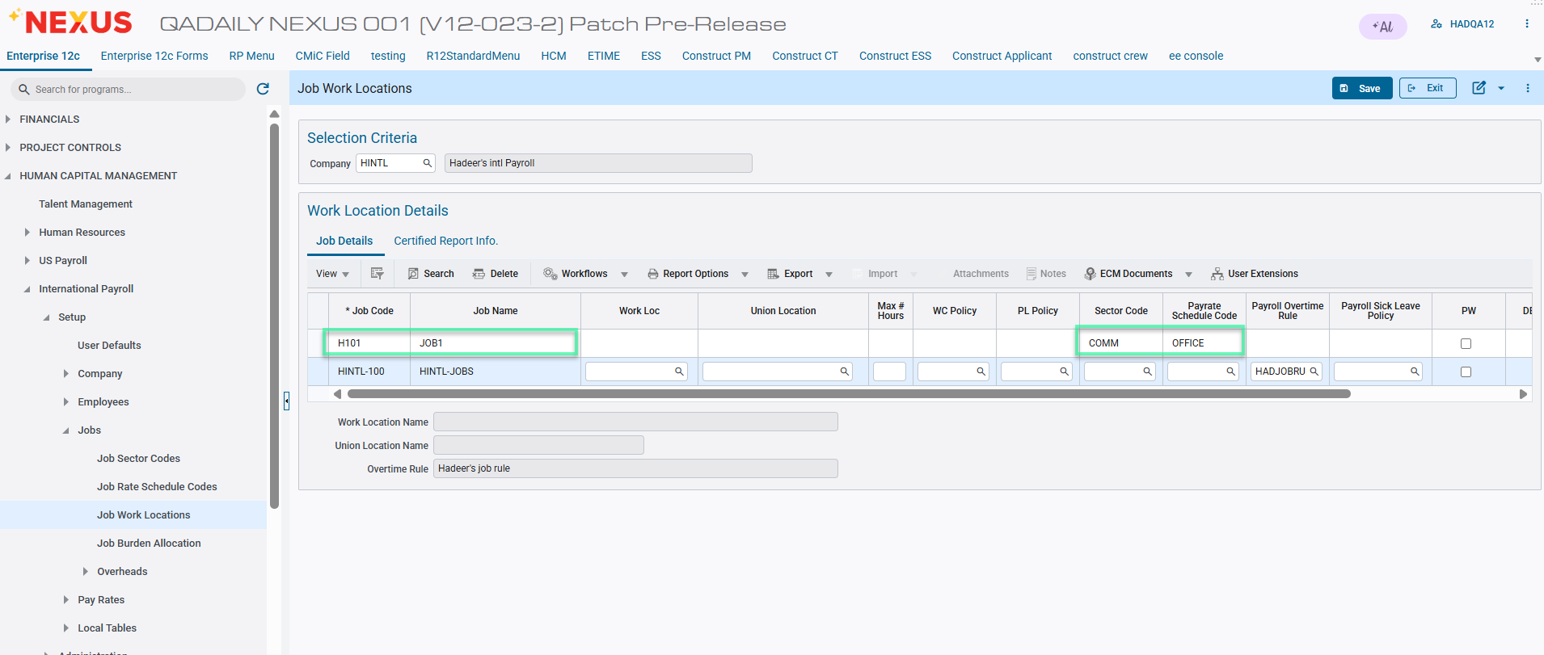Expense allocation setup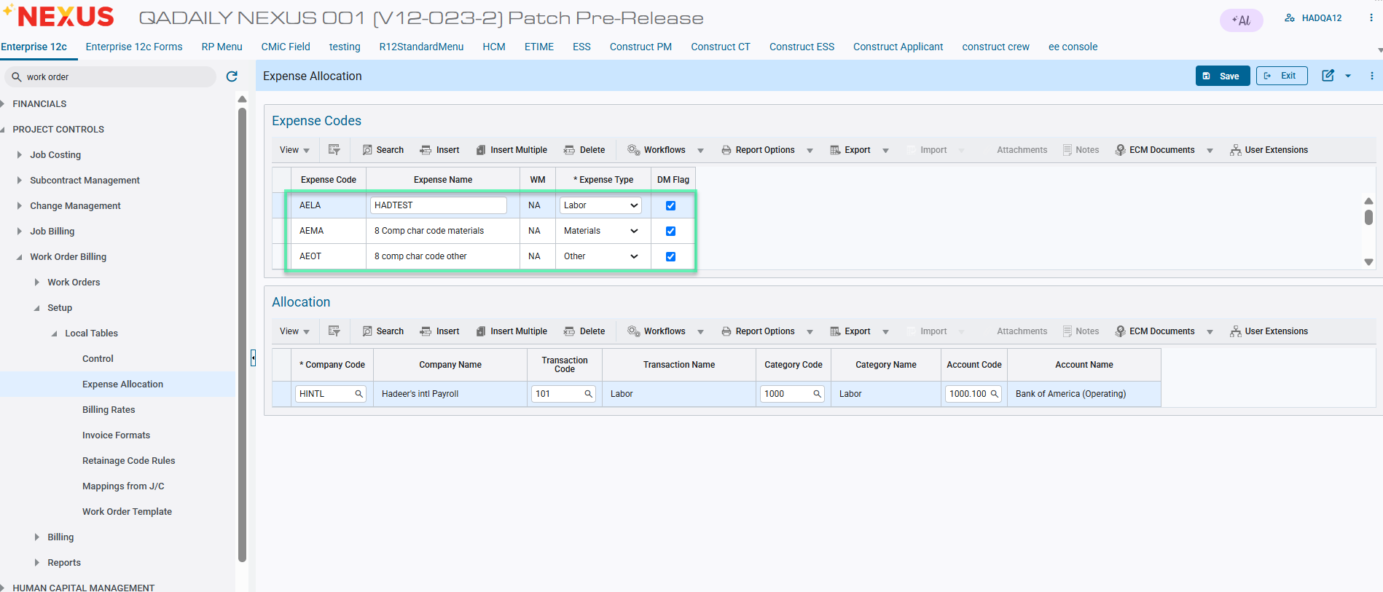
Program: Project controls > Work order Billing > Setup > Local tables > Expense Allocation
Transaction codes setup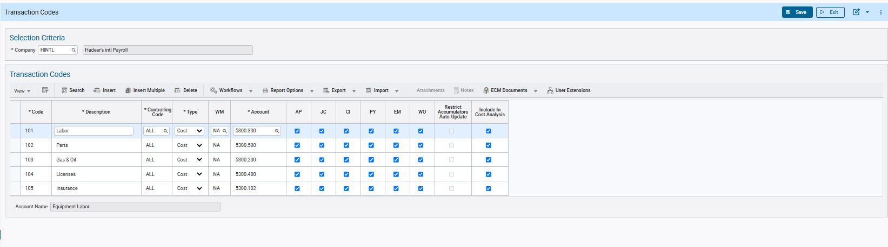Program: Asset Management > Preventative Maintenance > Setup > Equipment Tables > Transaction codes
Union Pay Rates setup
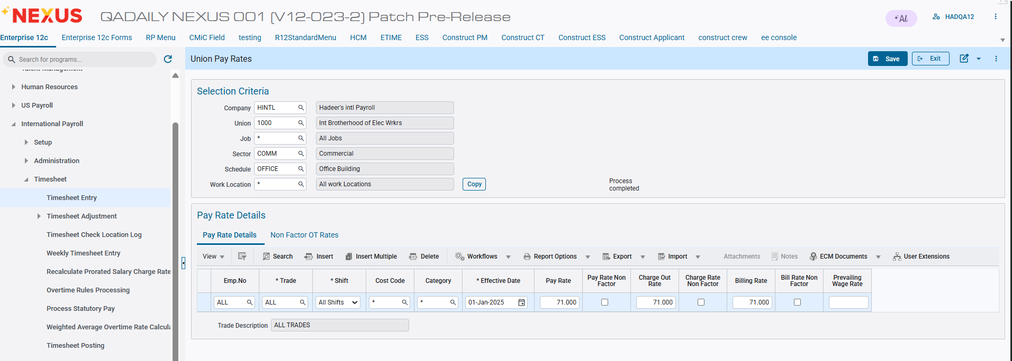
Modifications
Mid year pay history setup/log program now populates sector and schedule when W line entries in timesheet entry get converted to J line. 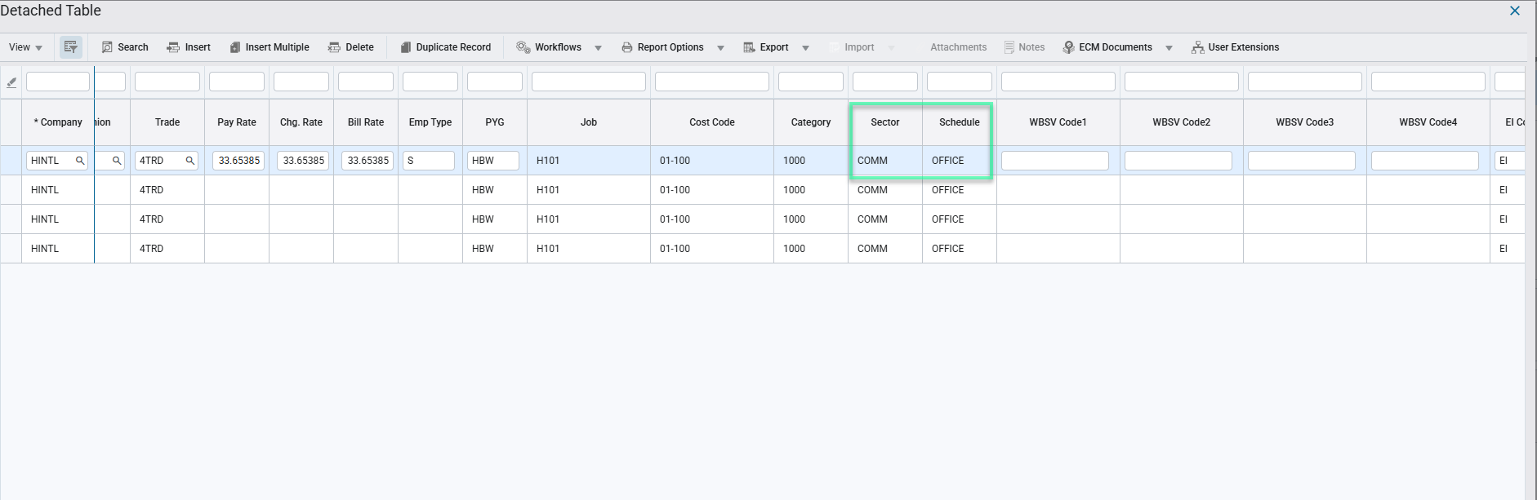
Implementation
This section provides examples of using the new enhancement.
Scenario 1: During timesheet entry and saving
Job costing, WO mapped with job
For data type W,
Sector and Schedule code should be populated and saved for Work Order mapped with job, phase, category.
Timesheet entry with W lines:
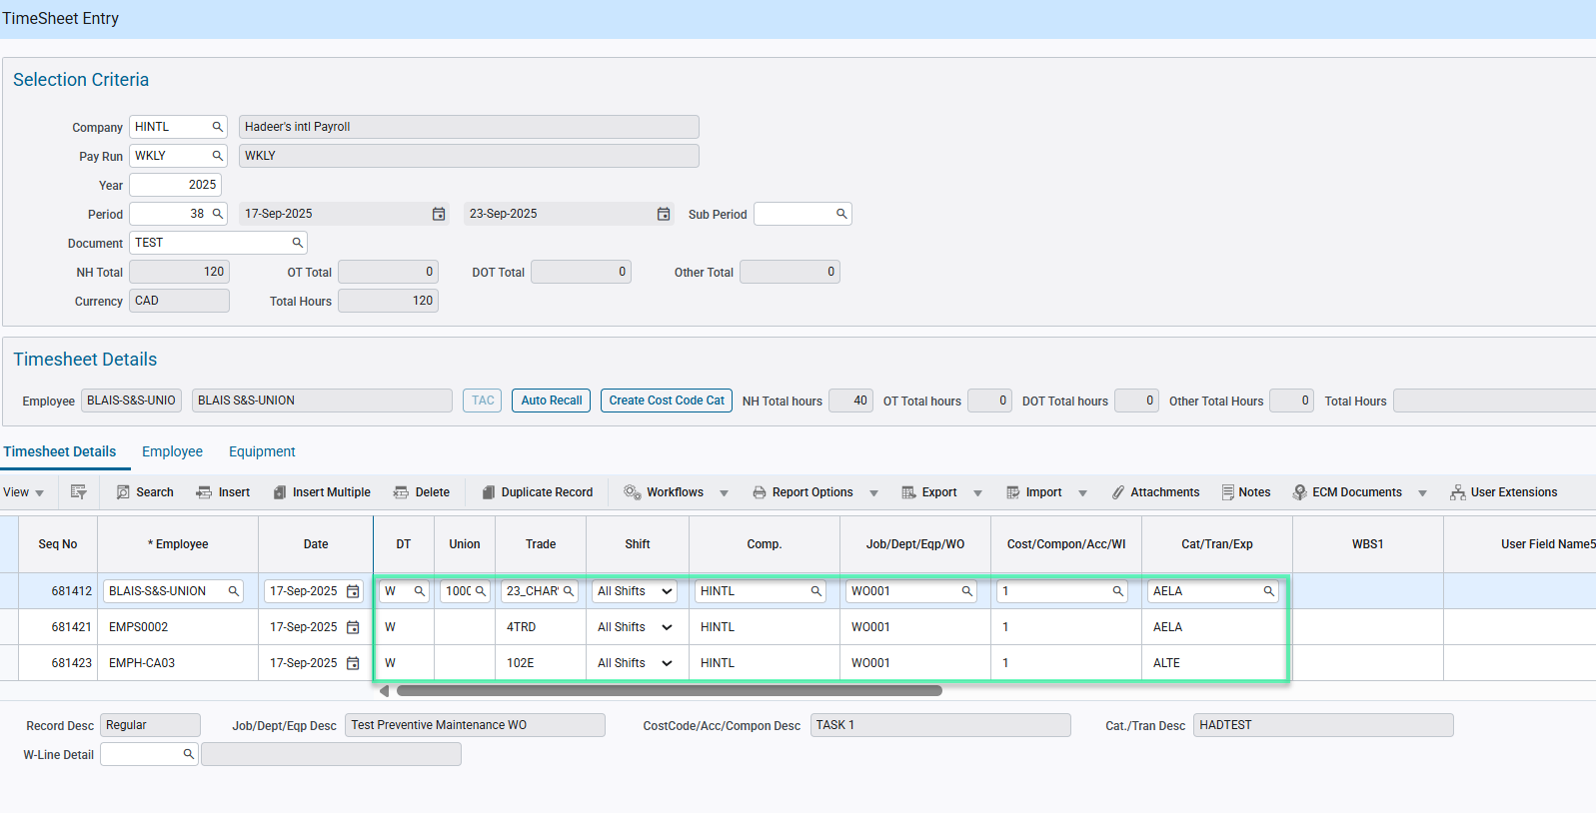
Sector and schedule populating in timesheet entry for the employees:
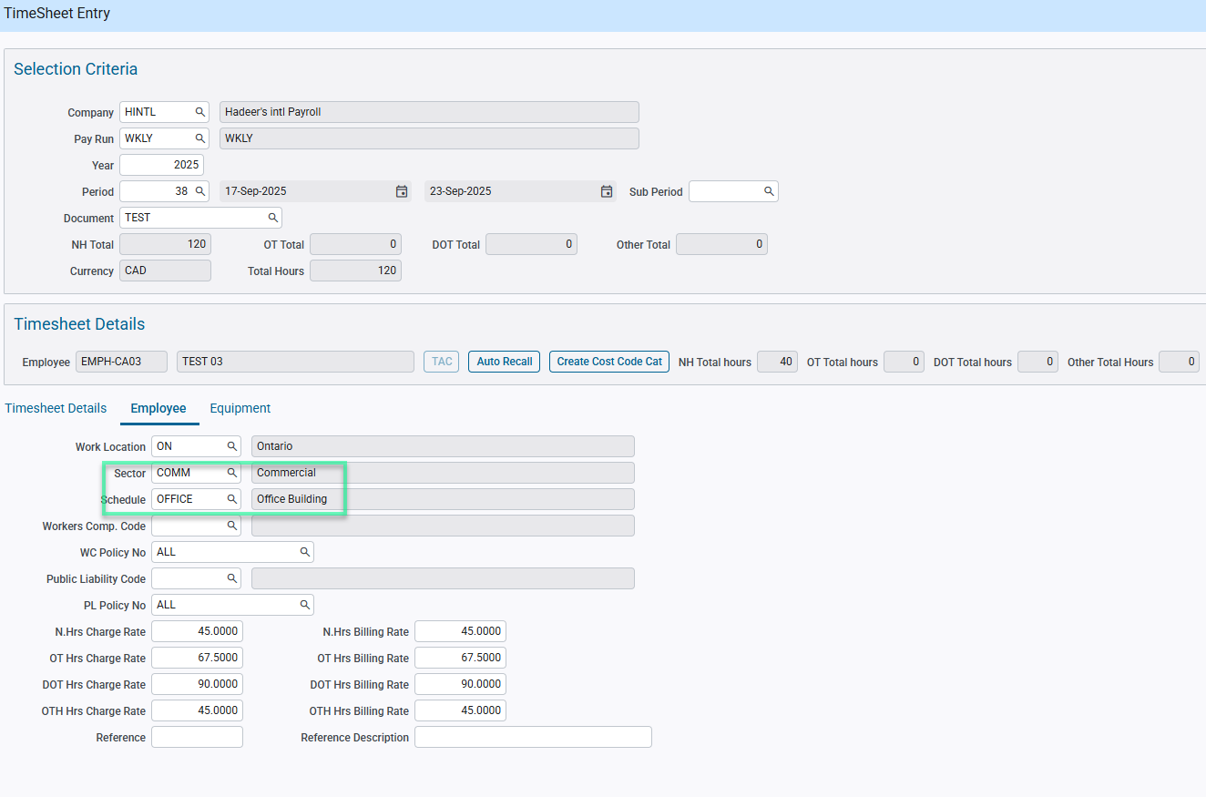
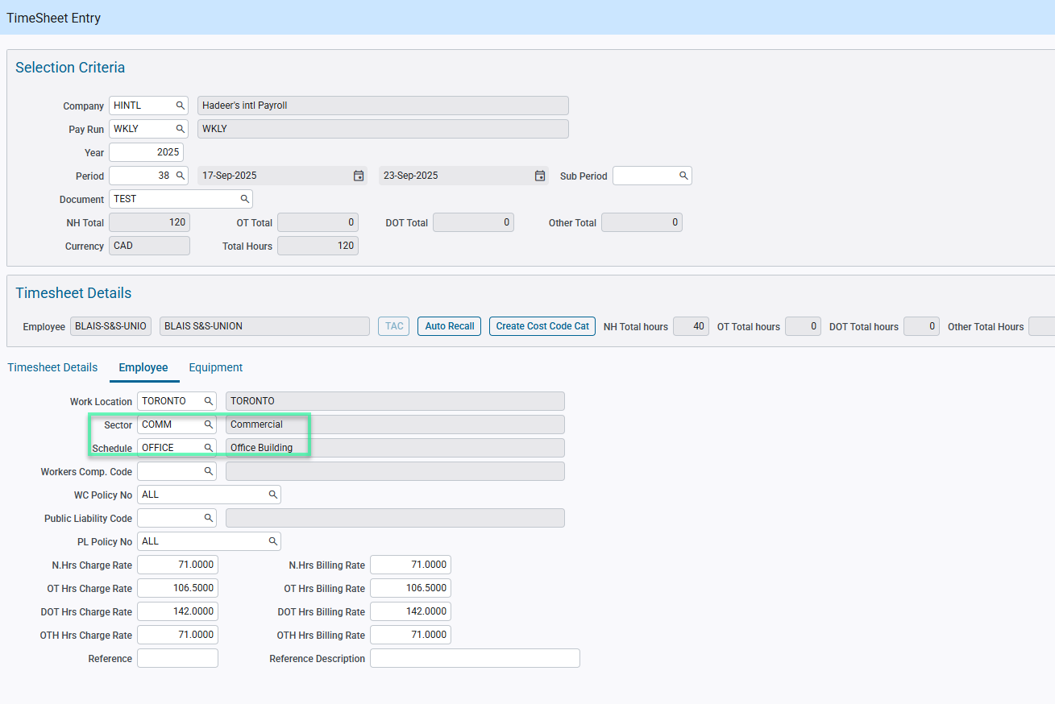
Timesheet posting report:
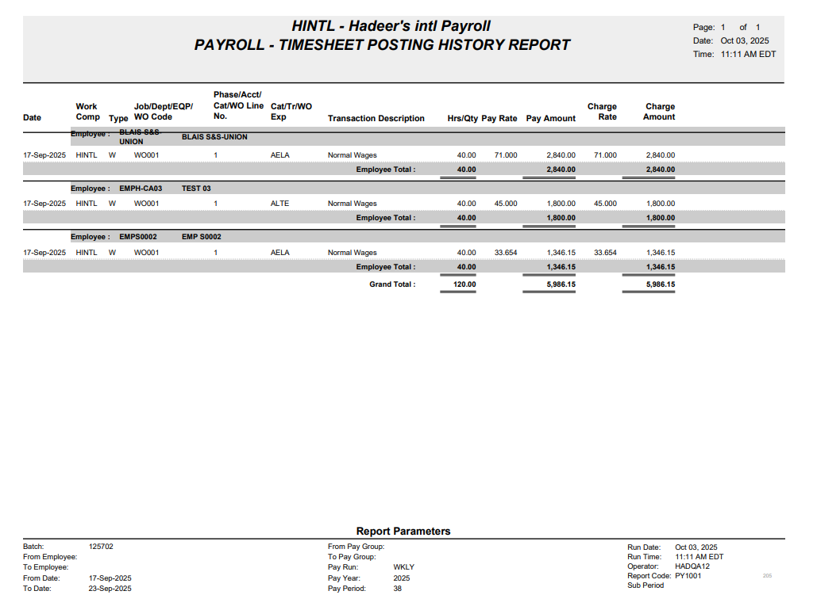
Mid year pay history:
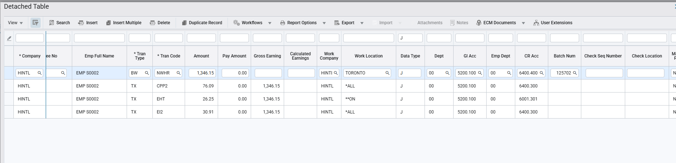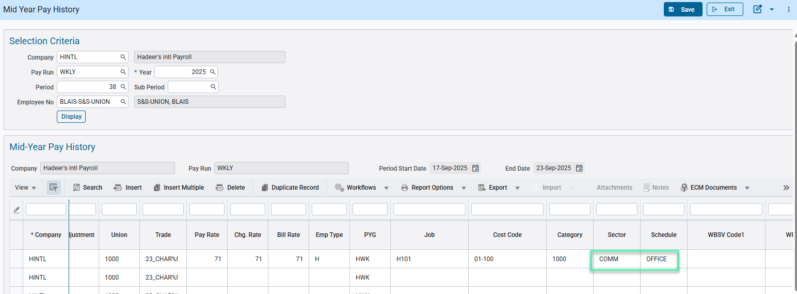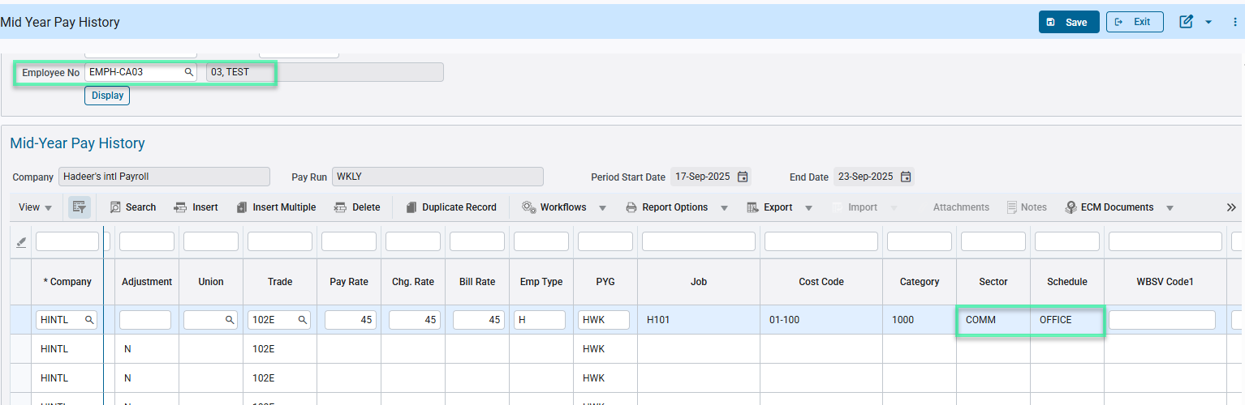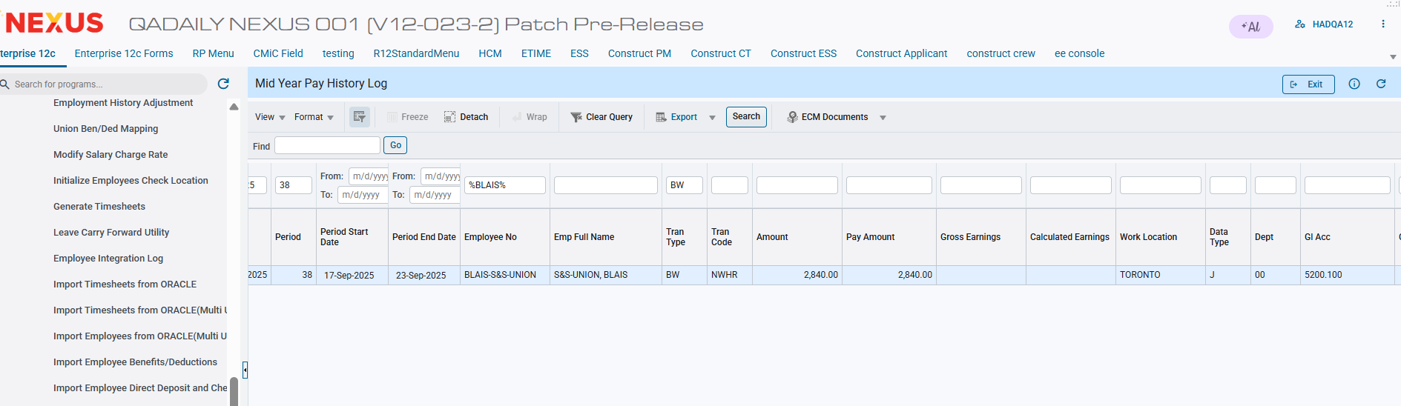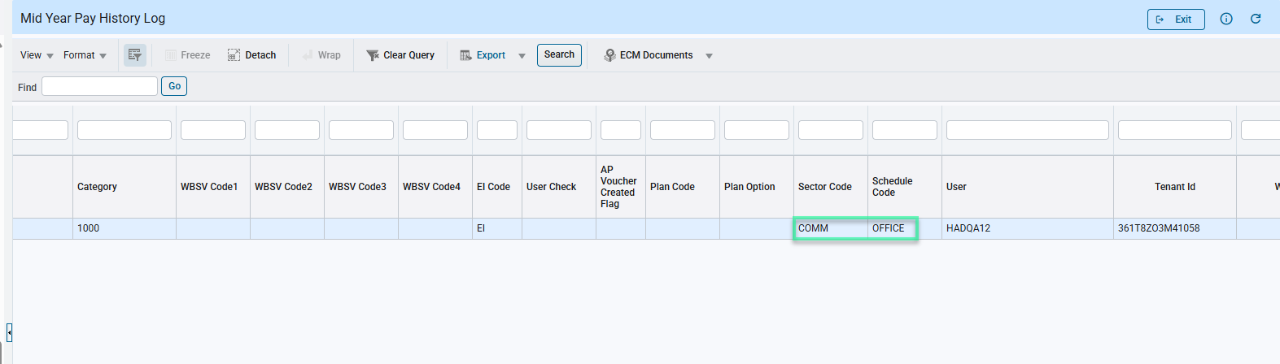

Scenario 2: During timesheet entry
For data type W, sector and schedule should be populated upon entering job, phase, category
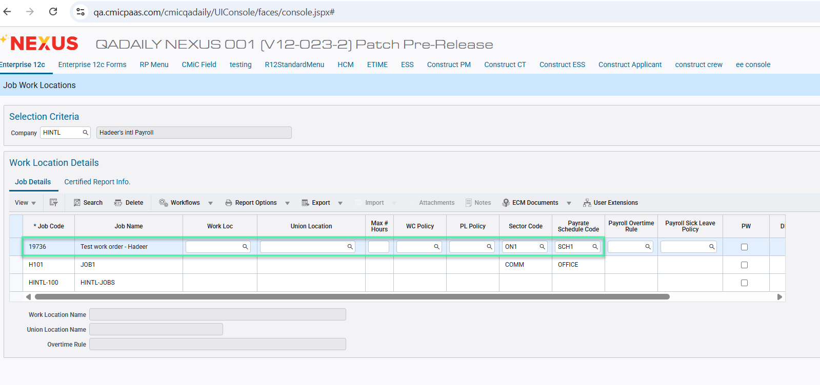Setup in job billing project controls > work order billing > enter/edit work order 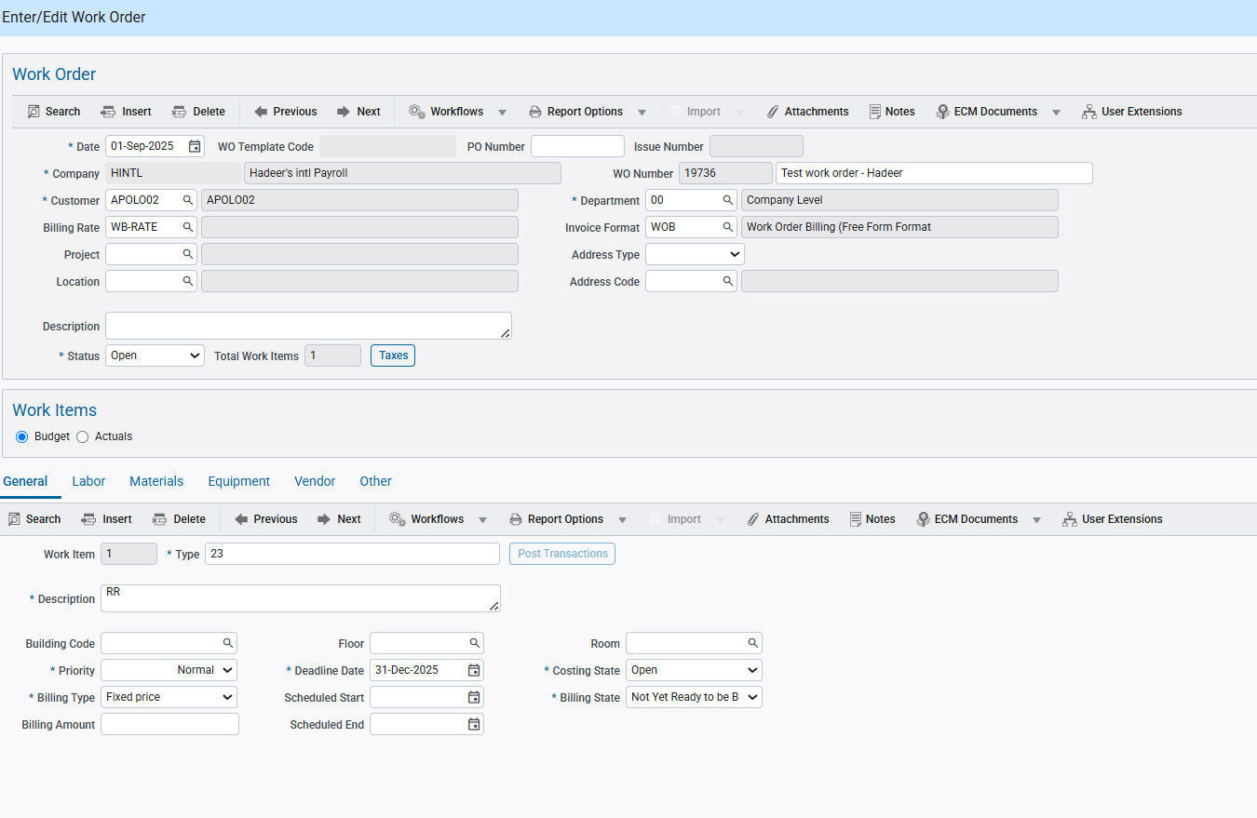 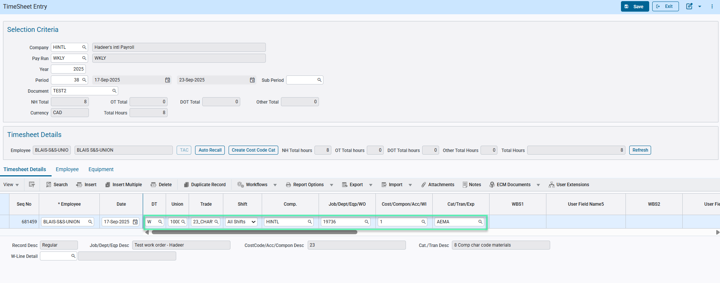 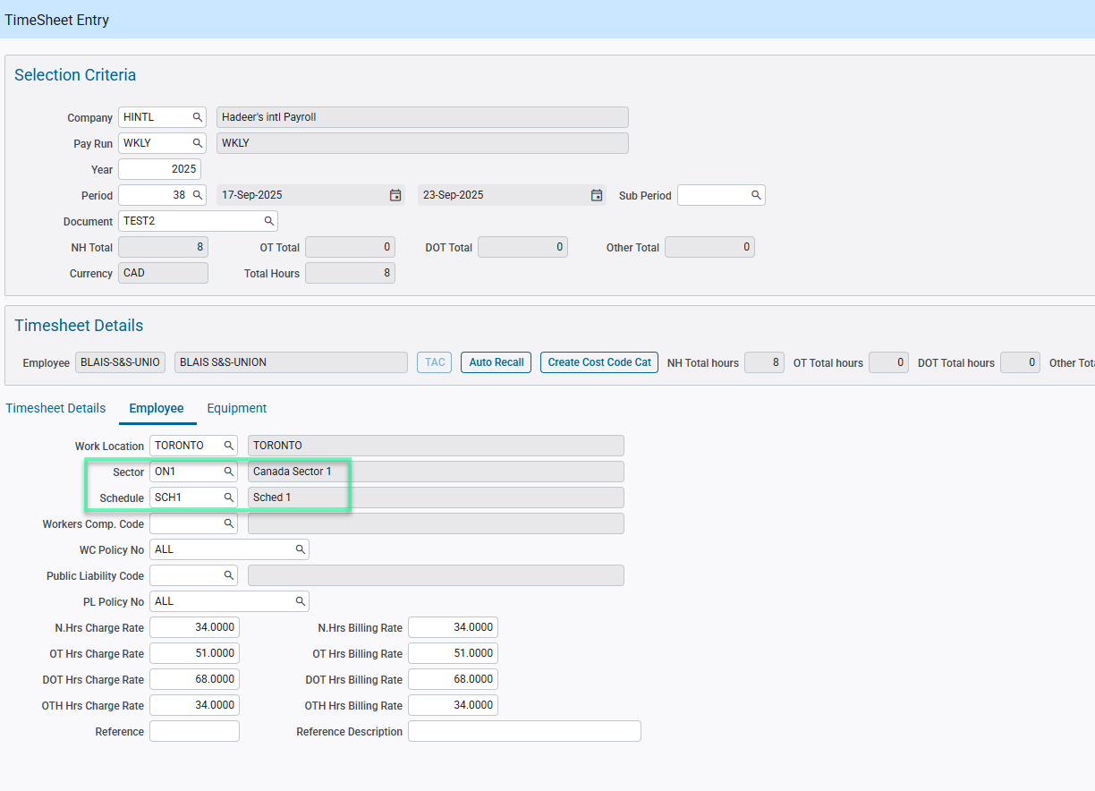 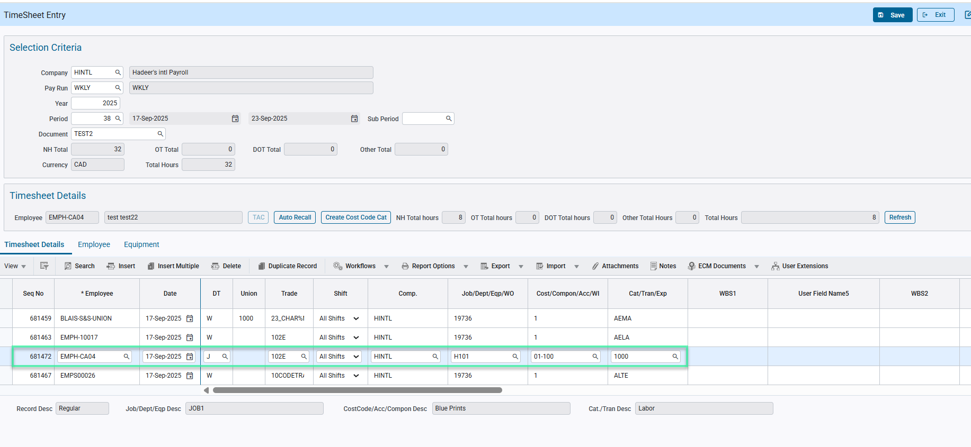 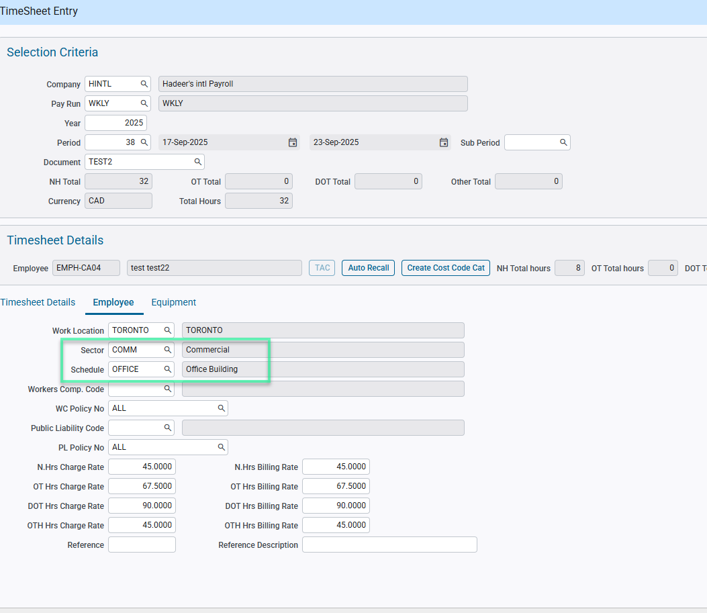
Timsheet Posting Report: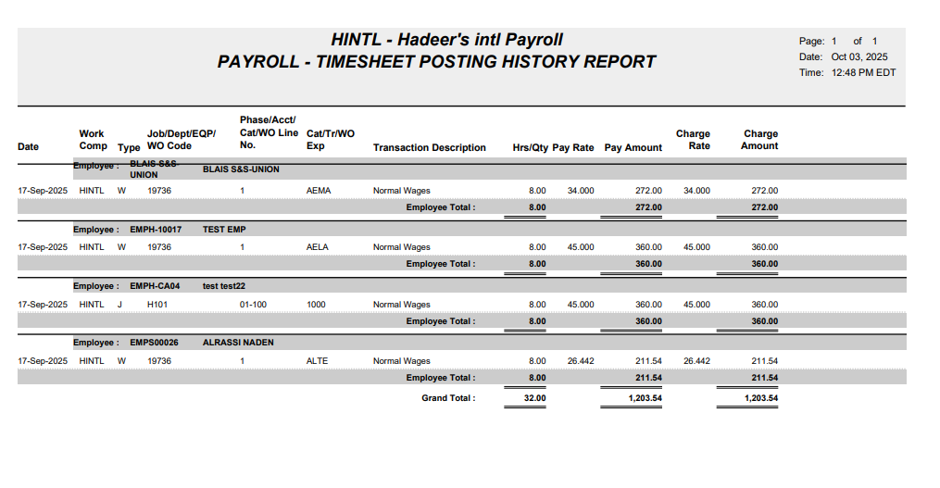 Mid year pay history:
Sector and schedule populating: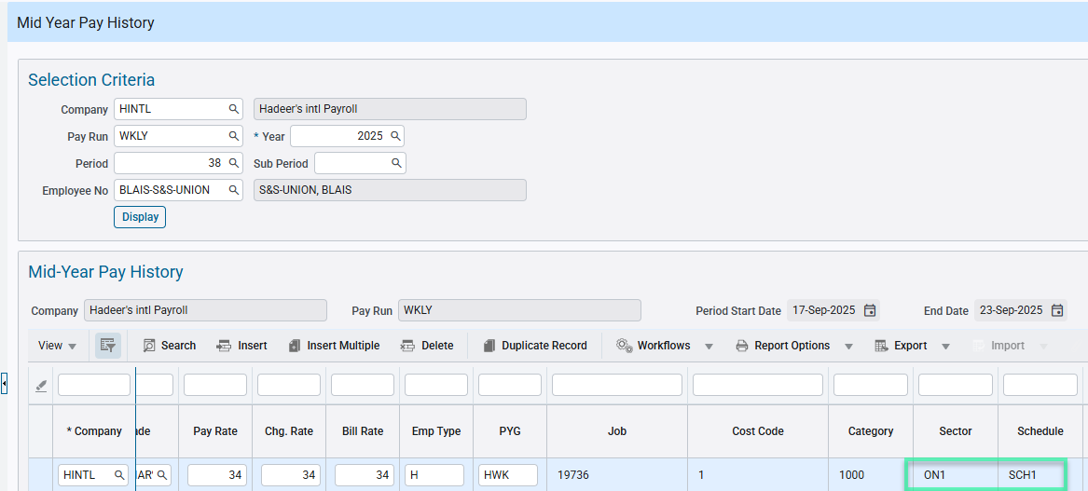 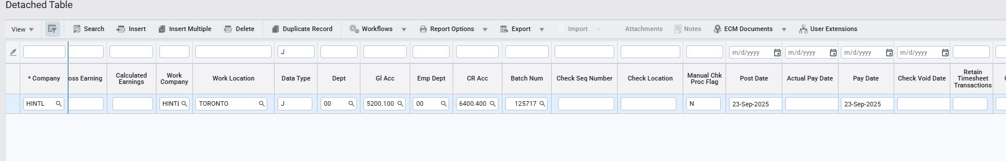 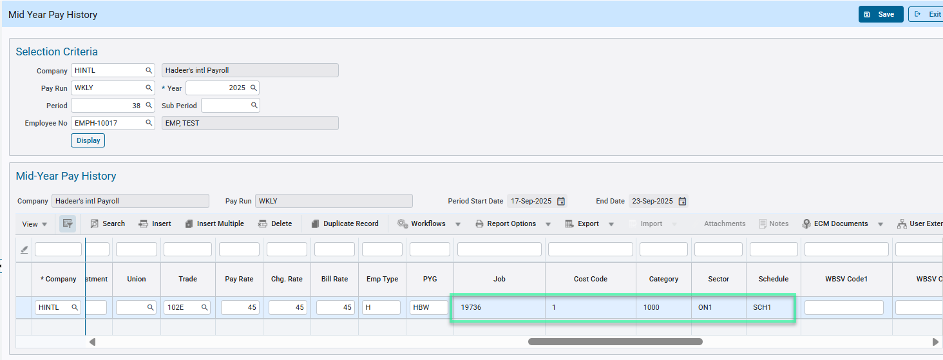 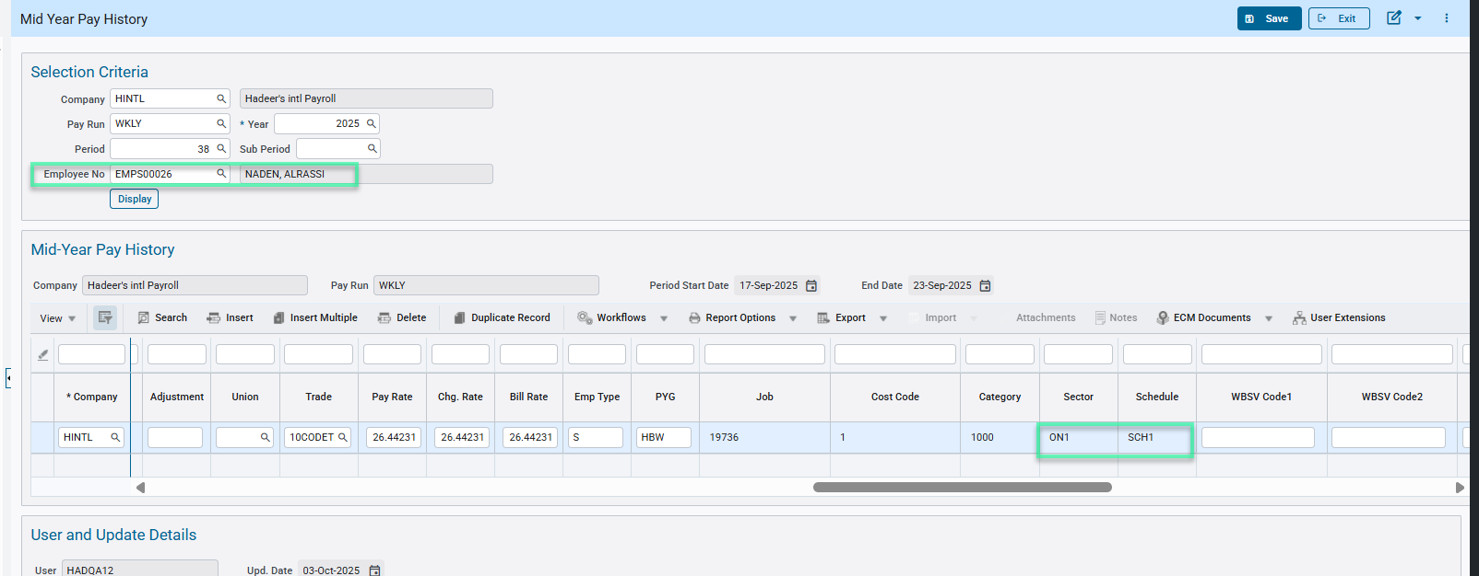

Scenario 3: During timesheet posting
Equipment Costing Mapping with Job, Phase, category
Data type = W
Sector and schedule code should be updated in the pyemptimsht table, upon timesheet posting. 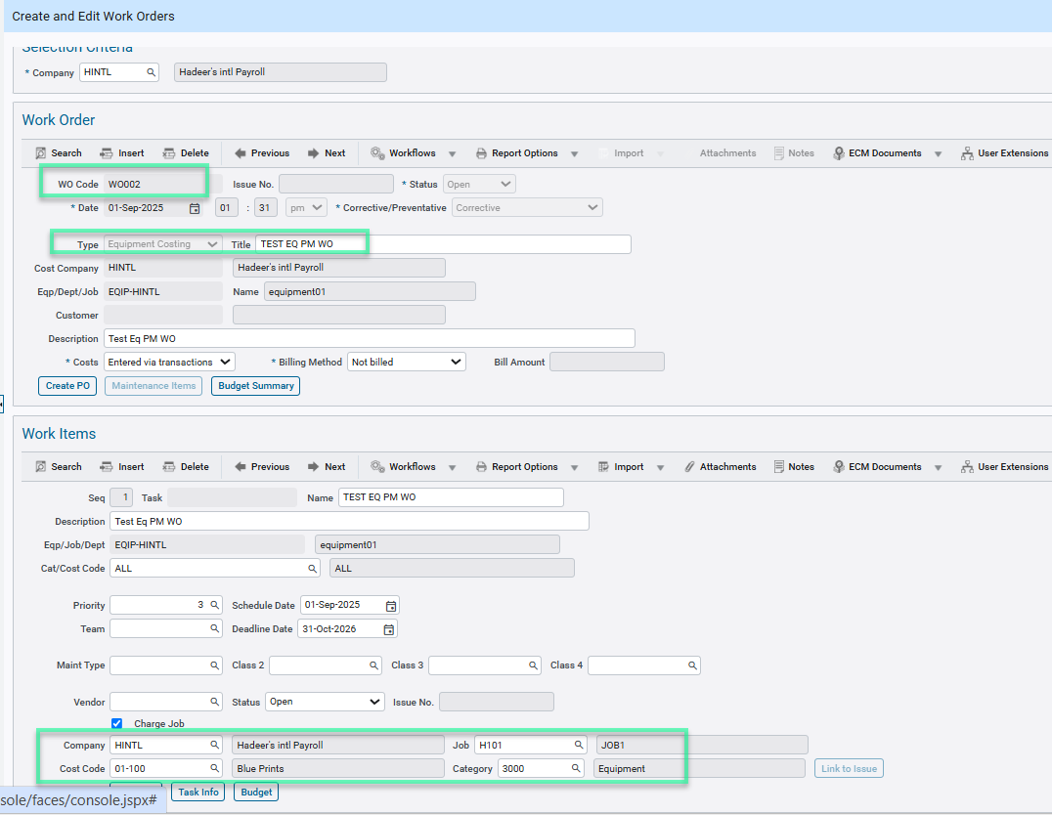
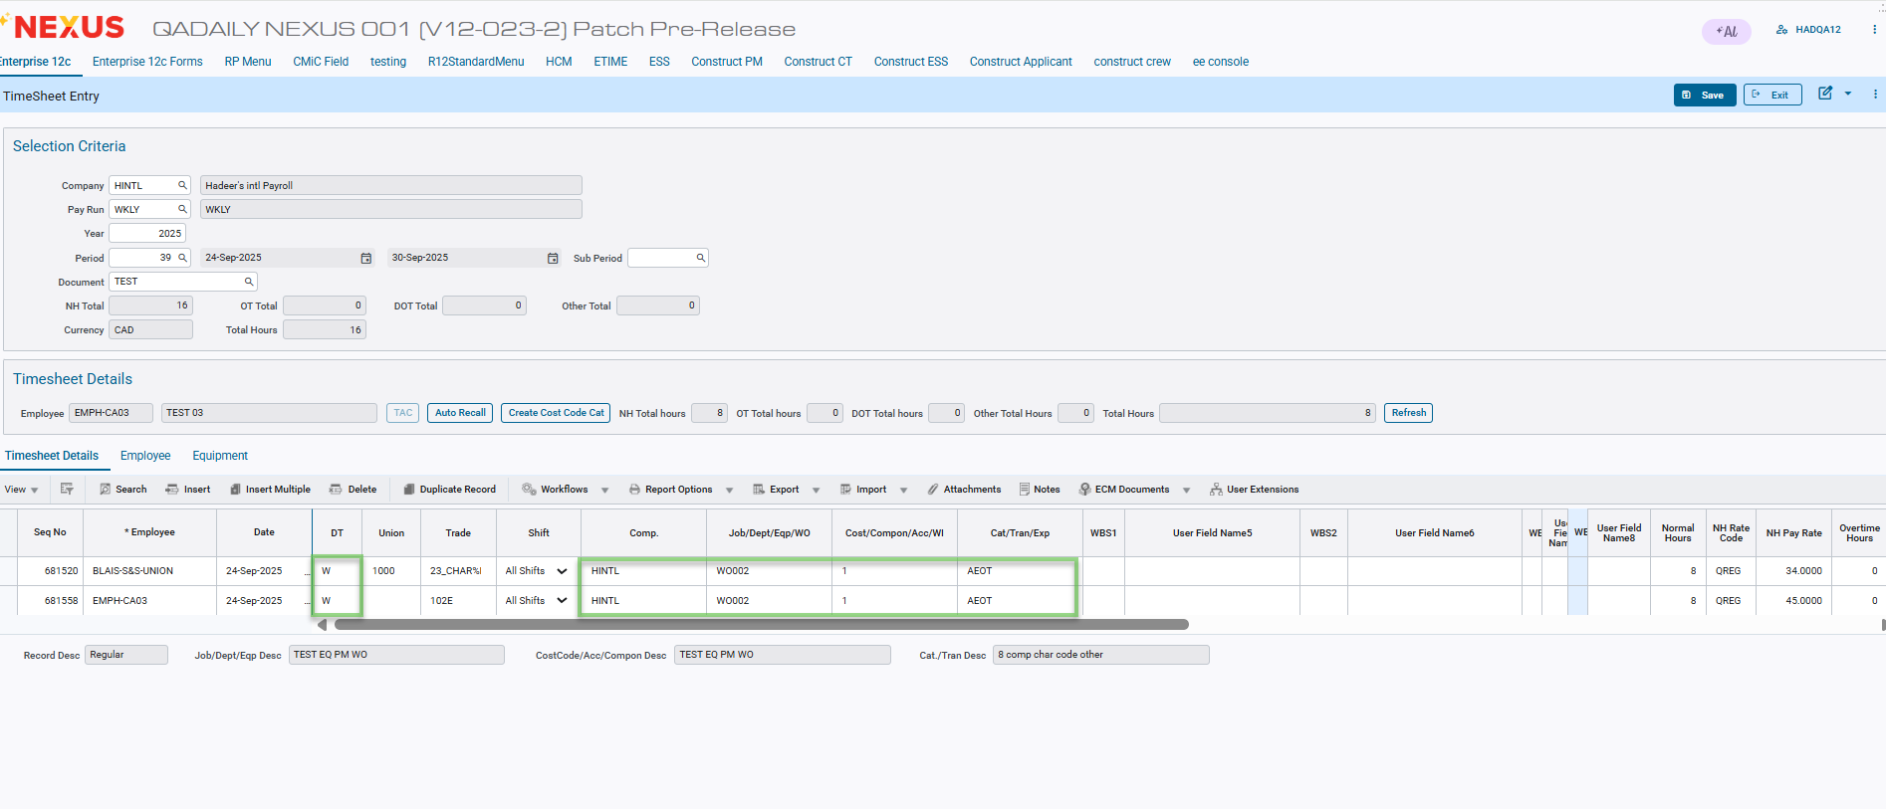
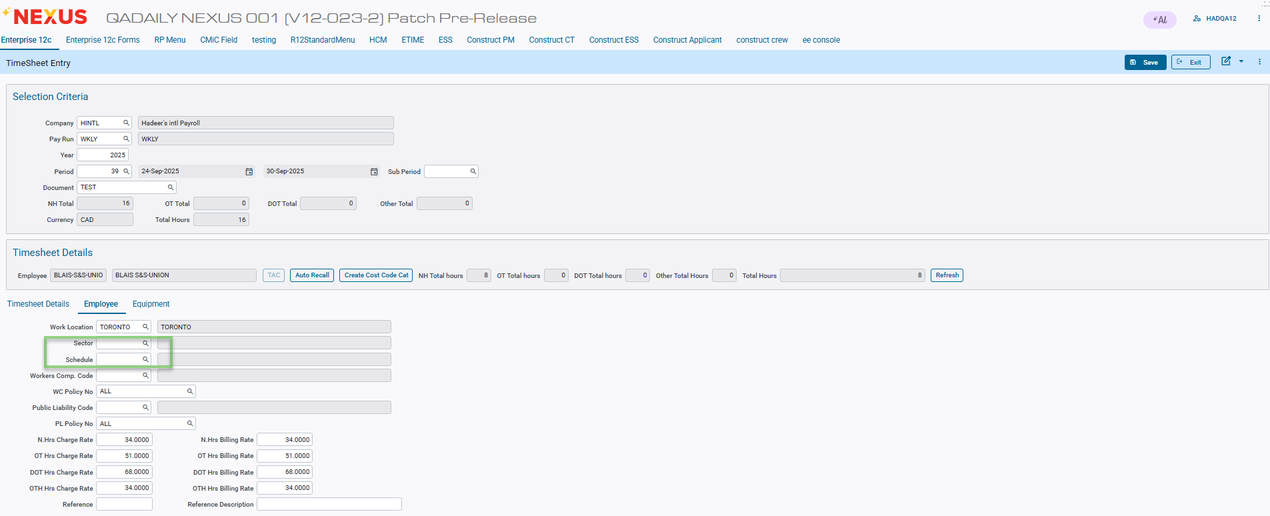
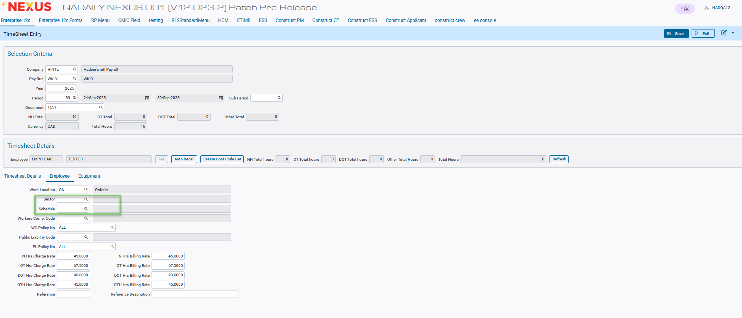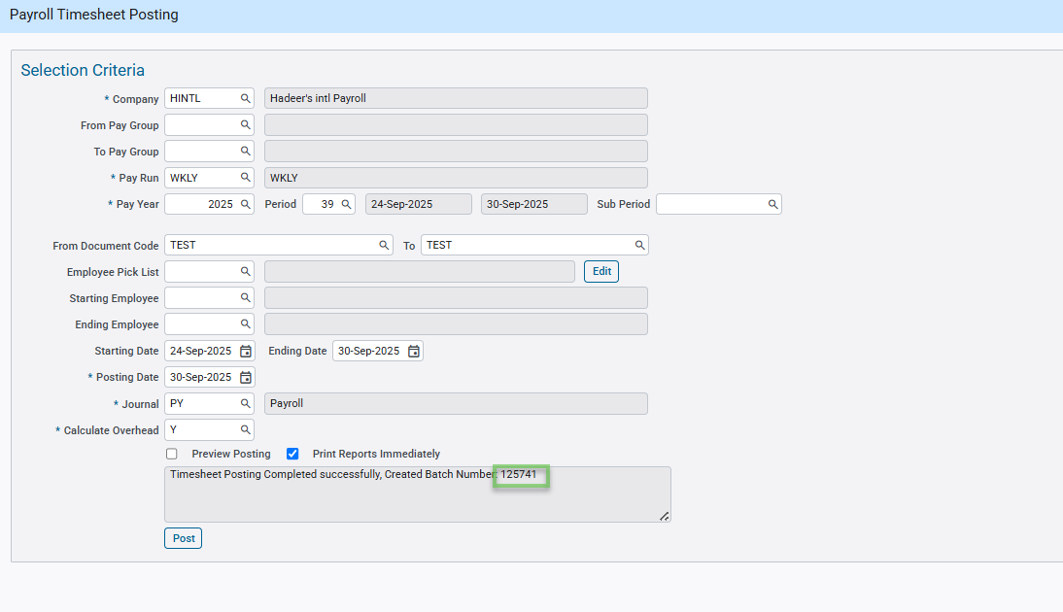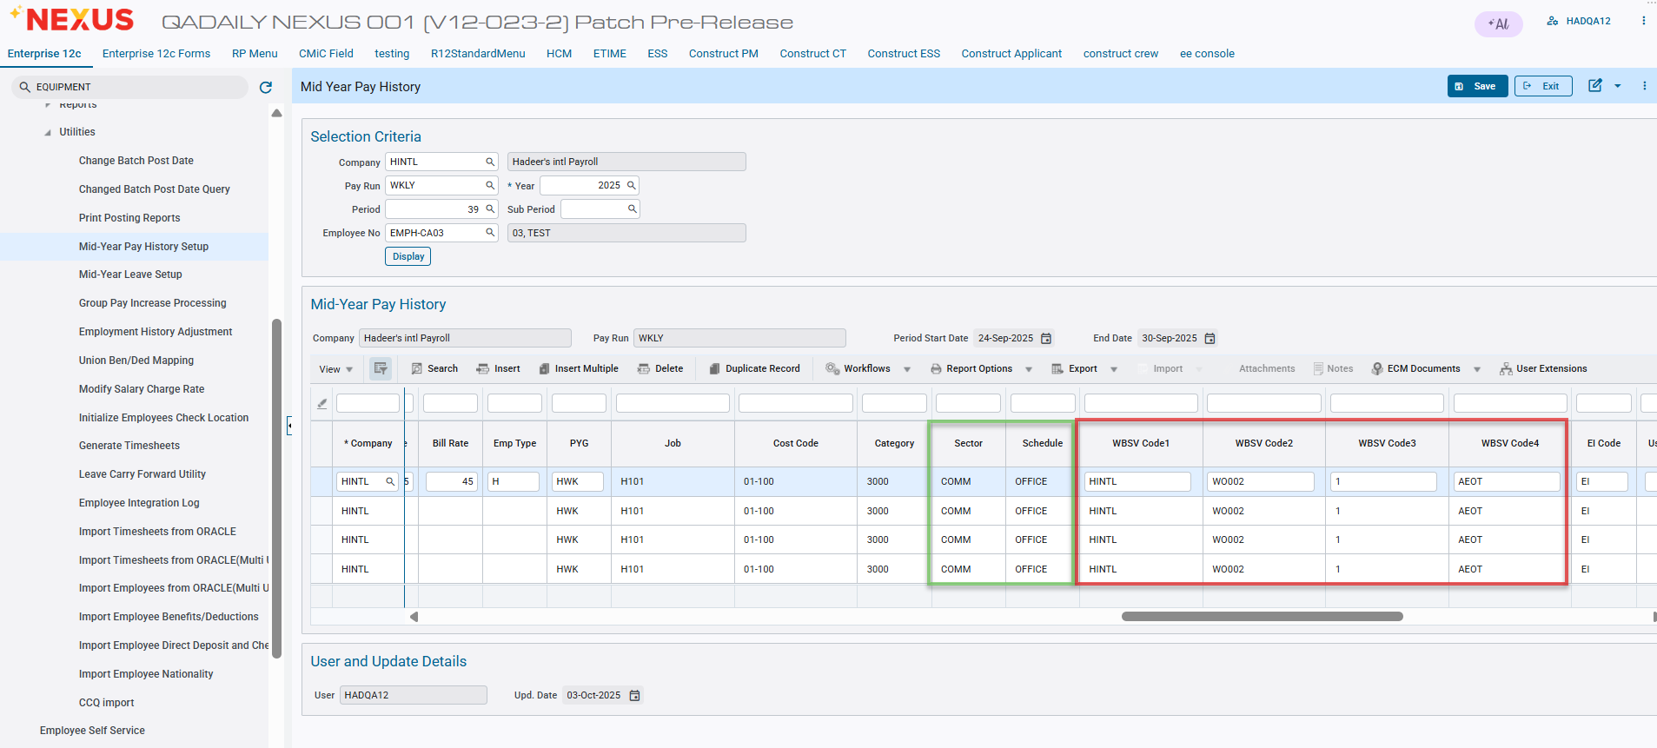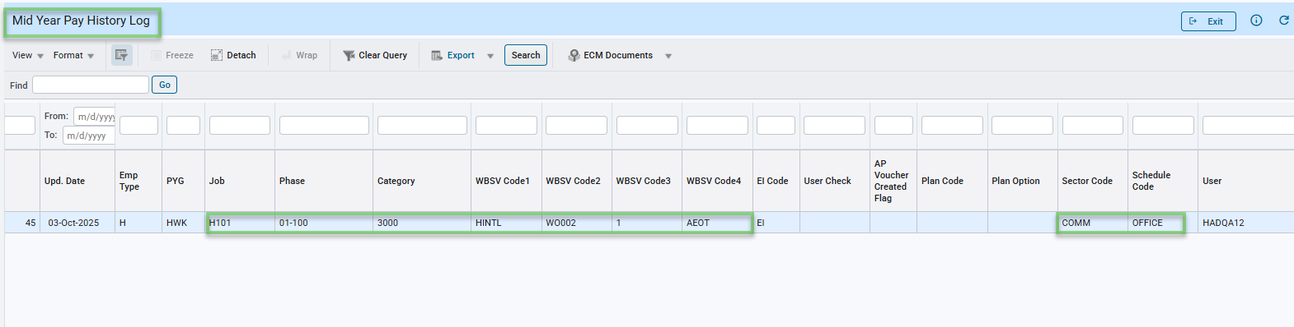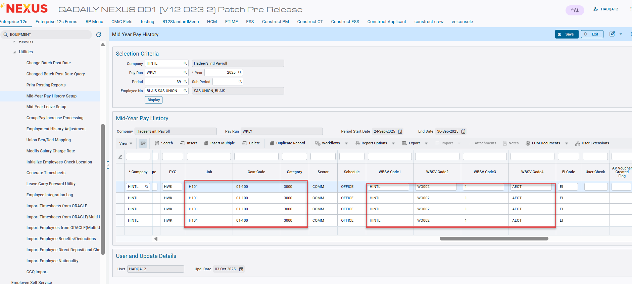

New Positive Pay Wells Fargo Bank Format (ARP) (HCM-21493)
WORK DESCRIPTION:
CMiC has added a new Positive Pay format for Wells Fargo Bank (ARP) in PY Check/EFT program. The ASCII File was created as per Wells Fargo Bank Positive Pay Specifications. This format will only work with the alternat feature enabled in the database. The Standard format is a header (top 2 lines) from Positive Pay – Wells Fargo Bank (DSG) and Positive Pay – Wells Fargo Bank (ARP) should also include Employee Name after.
So, the file header and employee name will look like the following:

$$ADD ID=22255 BID='36666'
*030000000080099000
00000001320520250000000080099003200000138259OC EMP-SAL-106
00000001330520250000000080099003200000087950OC EMP-SAL-107
Pre-Requisites
Customer should ensure to have their Banking Information and setup completed in CMiC System under Global Tables Banking Maintenance.
This format will function properly only if below 'alternate' feature is active in the database.
SYSAF_FEATURE_CODE = 'PRINT HEADER ON EFT FILE FOR WELLS FARGO ARP FORMAT'
PROGRAM MODIFICATIONS:
CMiC has added a new option/format in Check EFT Register (PY1081) Program to generate Positive Pay - Wells Fargo Bank (ARP).
Process Payroll and print checks. Under Processing > Reports > Check/EFT Register, select bank format: Positive Pay – Wells Fargo Bank (ARP) to prepare the data and download the file in Notepad.

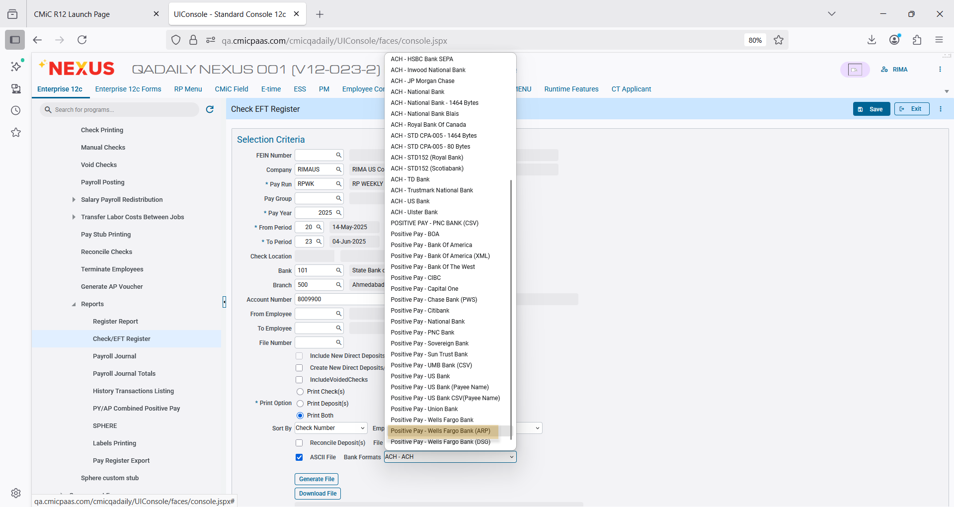

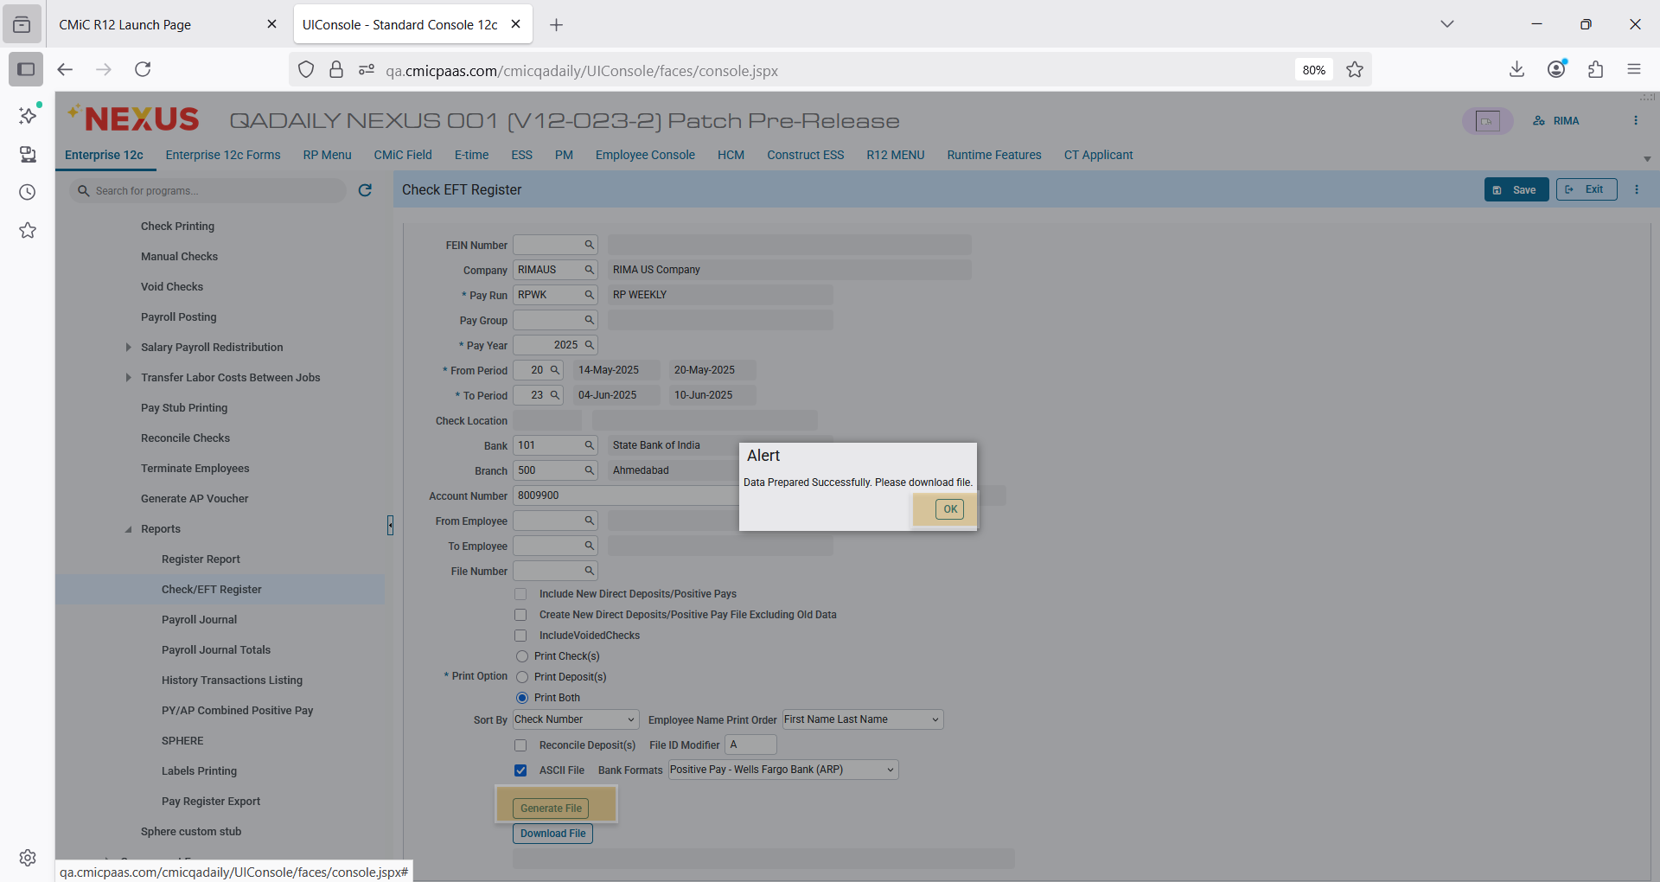

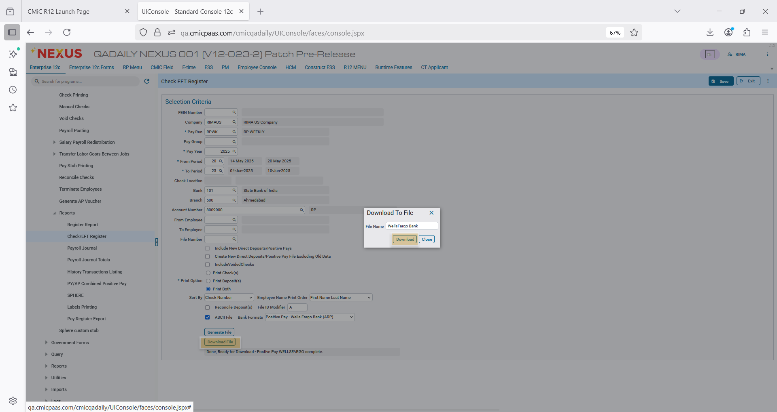

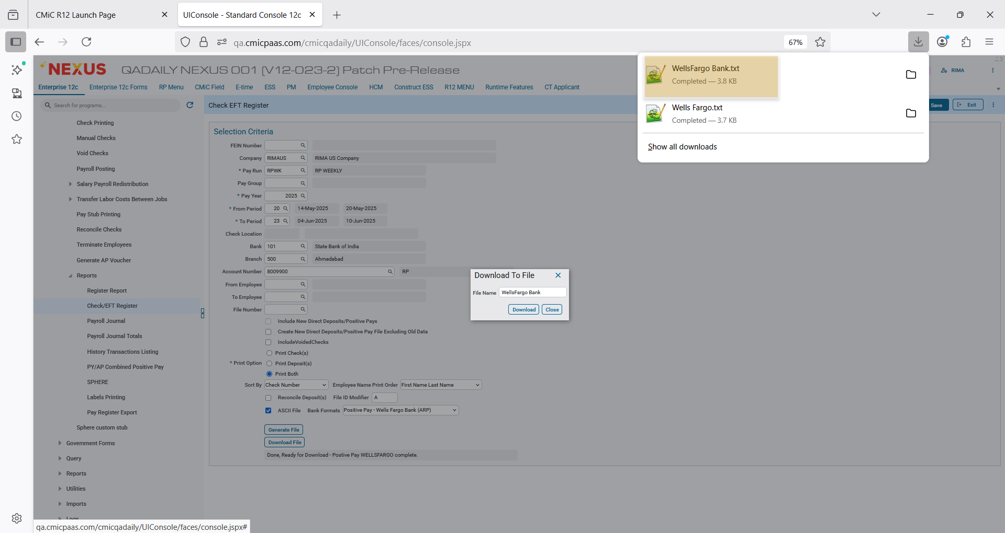

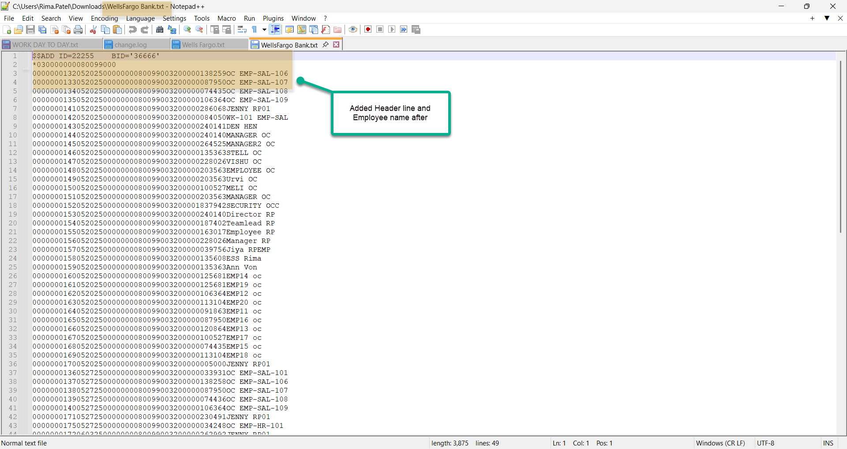

Check/EFT Register Program – PY1081
The Check / EFT Register will print a listing of all checks printed on a particular Pay Run for a given period and employee range. The Paychecks listing for Employee Report will print a listing of the checks and direct deposit payments made on a particular check run.

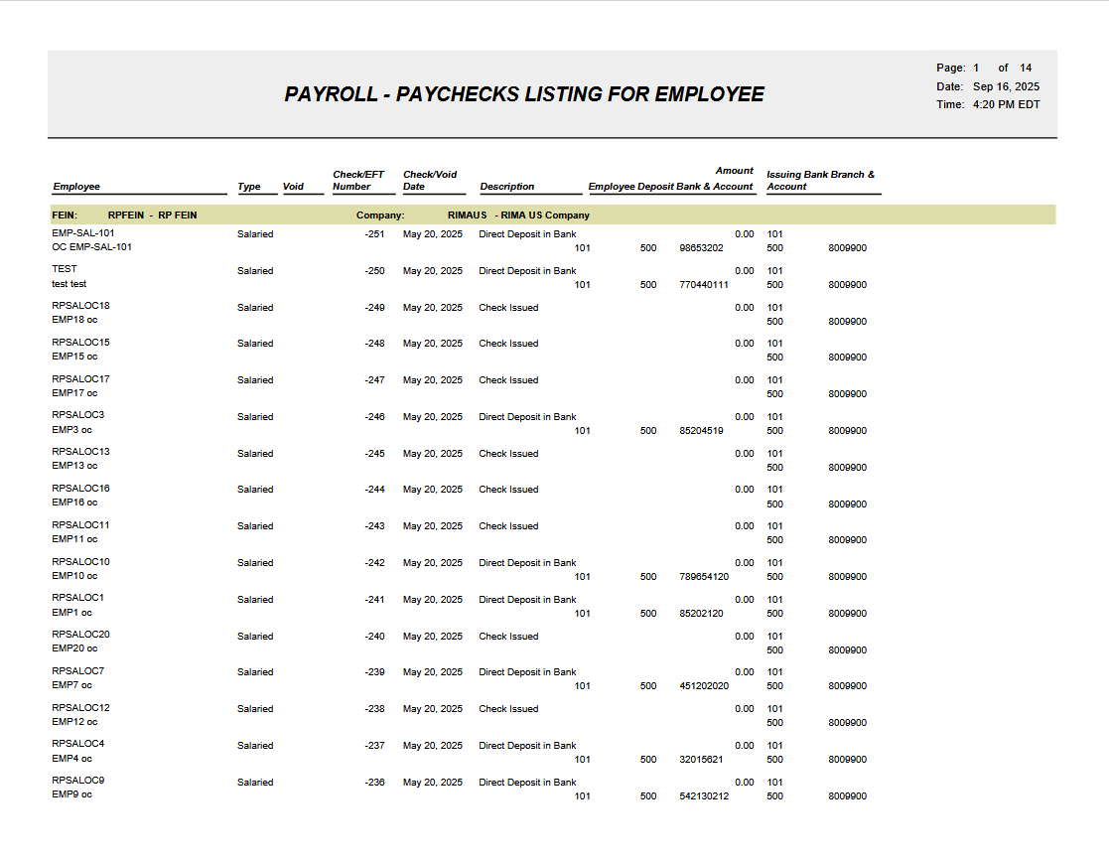

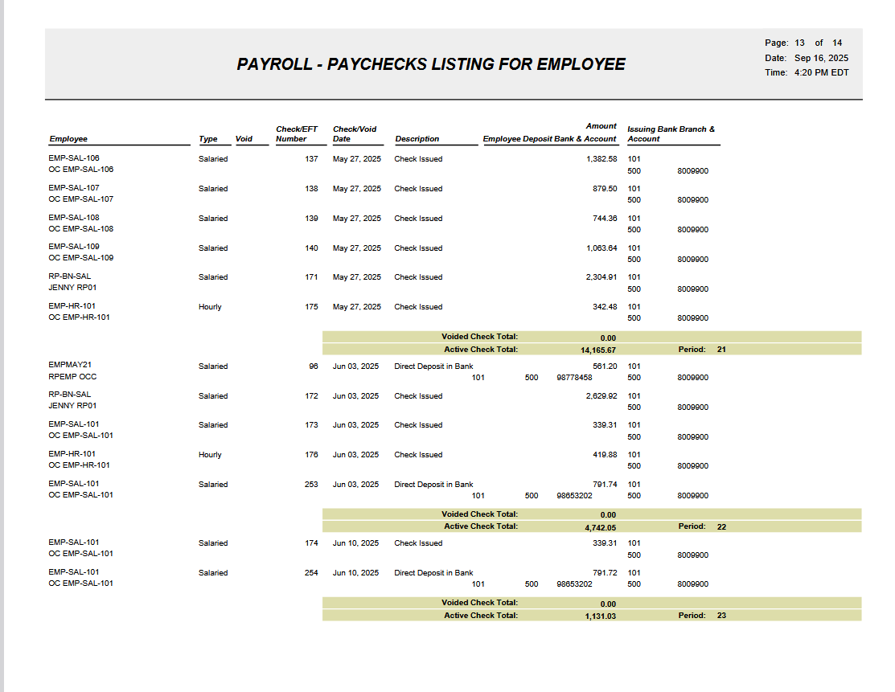

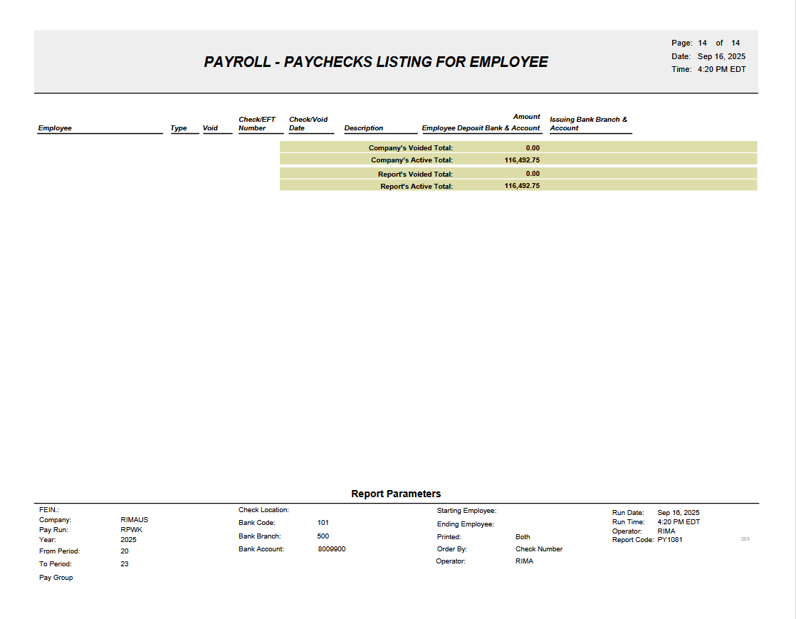

New Employee Profile Change Tracking and Reporting (HCM-22574)
Overview

The Employee Profile Change Tracking and Reporting feature provides a standardized and user-friendly way to identify and report on actual changes made to employee profile data in CMiC.
Although employee history data is stored for each effective date, all fields are currently recorded redundantly, making it difficult for HR and audit users to determine what values truly changed between updates. This enhancement introduces backend comparison logic and a standard report that isolates and clearly presents only the fields that changed, along with their prior and updated values.
Pre-requisites
The following conditions must be met before Employee Profile Change Tracking and Reporting can be used:

- CMiC environment upgraded to a build that includes the Employee Profile Change Tracking enhancement
- Employee Profile and Employee History data configured and actively maintained
- User has appropriate security access to:
  - Employee Profile and Employee History screens
  - HR Reports menu
  - Standard Jasper reporting functionality
- Historical employee data exists to support comparison across effective dates

Modifications
1. Standard Jasper Report

A standard Jasper report is built on top of the backend view to present employee profile changes in a clear and audit-friendly format.
Report Location

Available under the Reports menu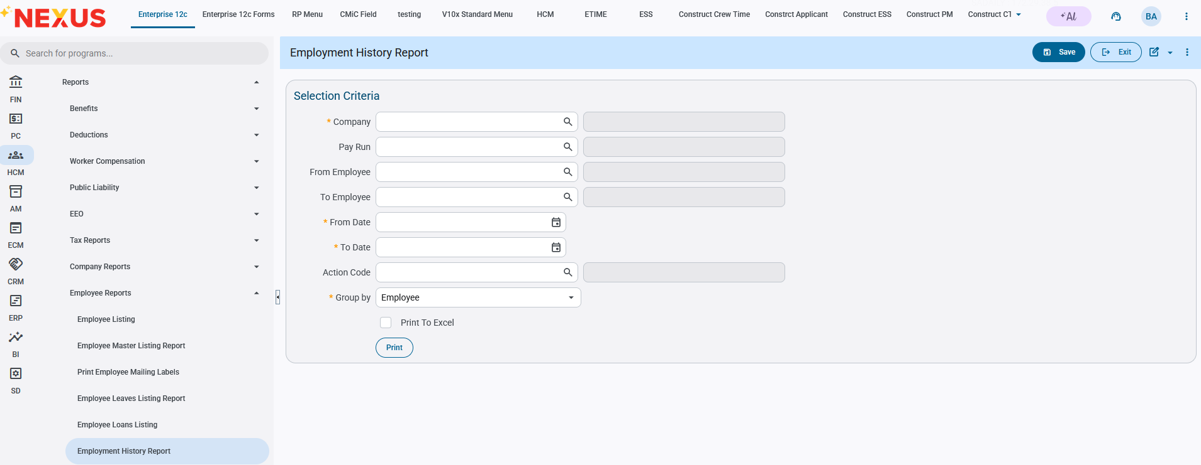
2. Business Purpose
This feature enables HR, Payroll, and Audit teams to:

Quickly identify changes to employee profile information
Eliminate manual comparison of historical records
Support internal audits, compliance reviews, and troubleshooting
Improve transparency and confidence in employee data management

3. Report Parameters
The report supports the following user-selectable parameters:
- Employee ID
- Date Range
- Action Code (optional)
These parameters allow users to narrow results for targeted analysis or audits.
4. Report Output

The report displays all changes detected with the following columns:
- Employee ID
- Employee Name
- Field Name Changed
- Old Value
- New Value
- Effective Date of Change
- Action Code
The layout follows CMiC reporting UI/UX standards, ensuring readability and consistency.
Implementation

Scenarios:
- Generate Employment History Report with mandatory Selection Criteria

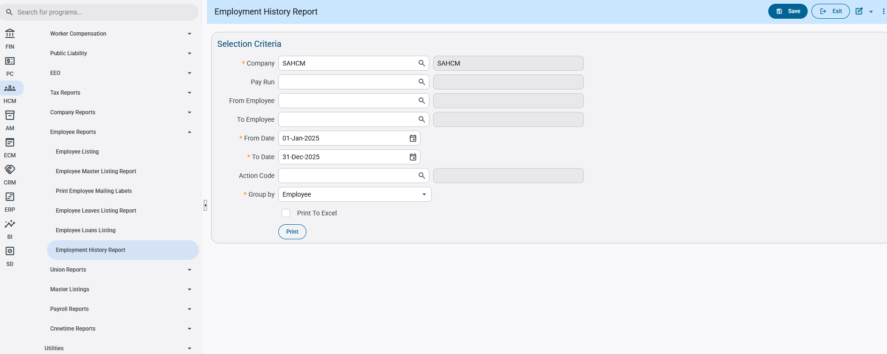

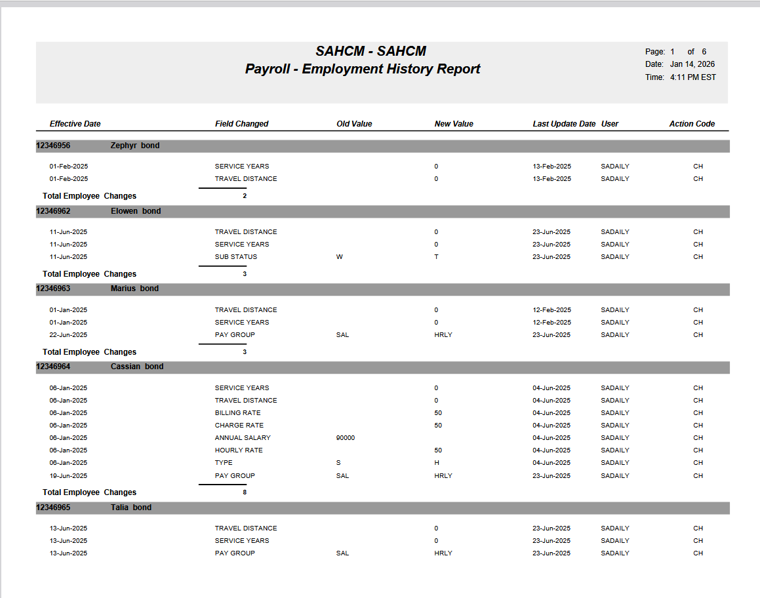

- Generate Employment History Report with mandatory Selection Criteria along with Action Code as CH (change)

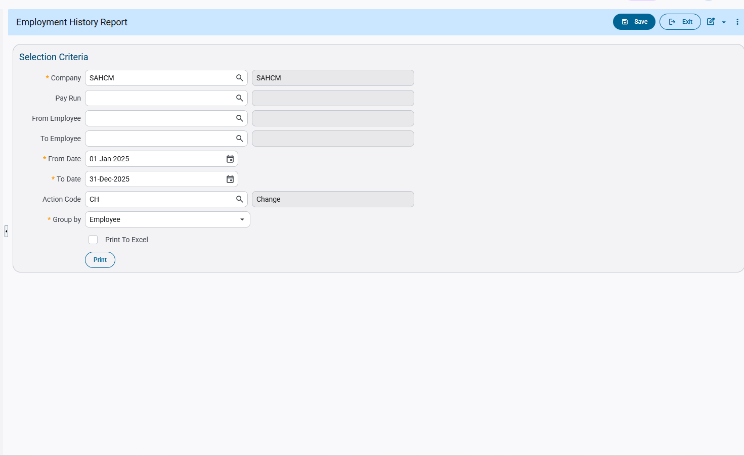
.

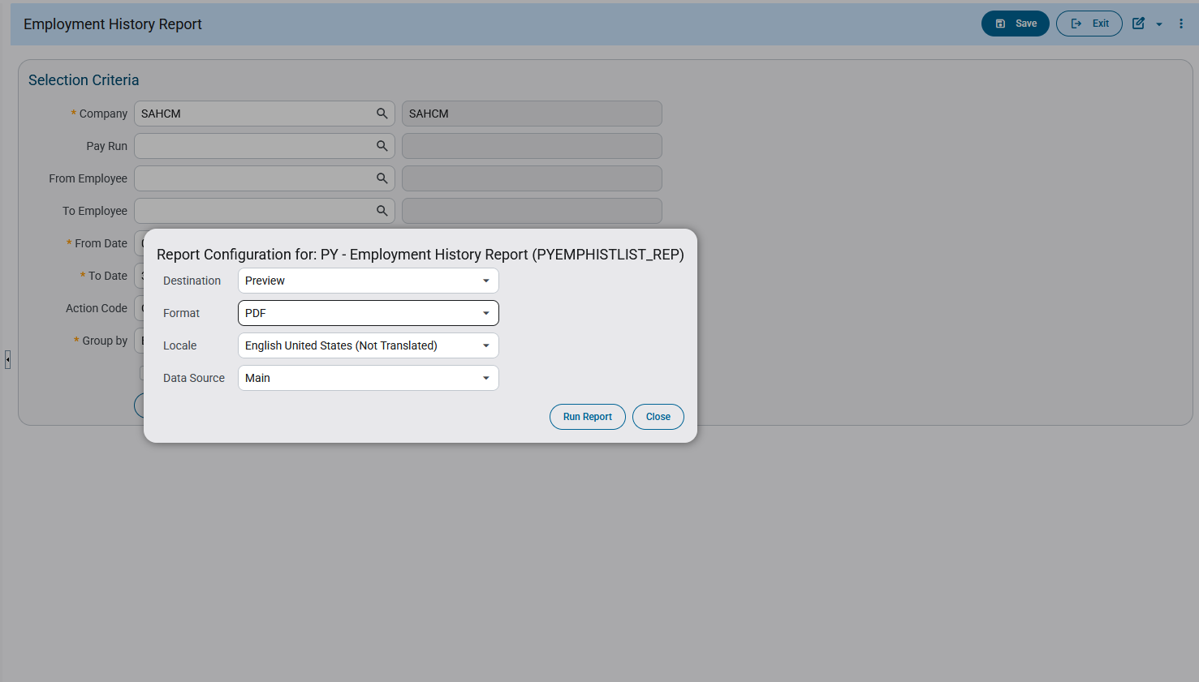

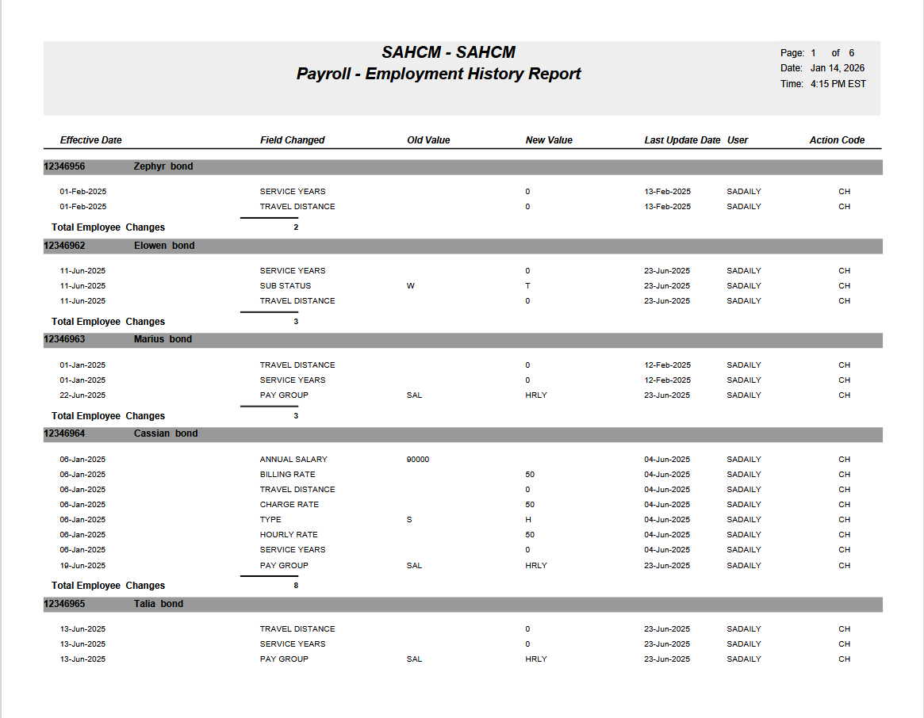

Addition of Wells Fargo SFTP Integration for ACH and Positive Pay - Payroll Module (HCM-23179)
WORK DESCRIPTION:
CMIC has added features like the Bank-Specific SFTP Integration feature that allows Payroll users to automatically transmit payroll-related files—such as ACH and Positive Pay files to a bank using secure SFTP immediately after payroll processing.
This enhancement connects existing global SFTP server profiles with individual bank accounts used in Payroll, allowing each bank to have its own transmission rules while maintaining centralized security and configuration.
Pre-Requisites
Before using this feature, ensure the following are already configured:
External Web Server (SFTP) Profile
Configured under System Options > External Web Servers
Includes:
Hostname or IP address
Port
Protocol (SFTP)
- Bank Account Setup
  - Bank accounts must already exist in the payroll banking module
And Enable Auto SFTP
- Checkbox: Enable Auto SFTP
  - Payroll files generated for this bank account will automatically be sent via SFTP after processing

External Server setup for Wells Fargo ACH is highlighted in the screens below:
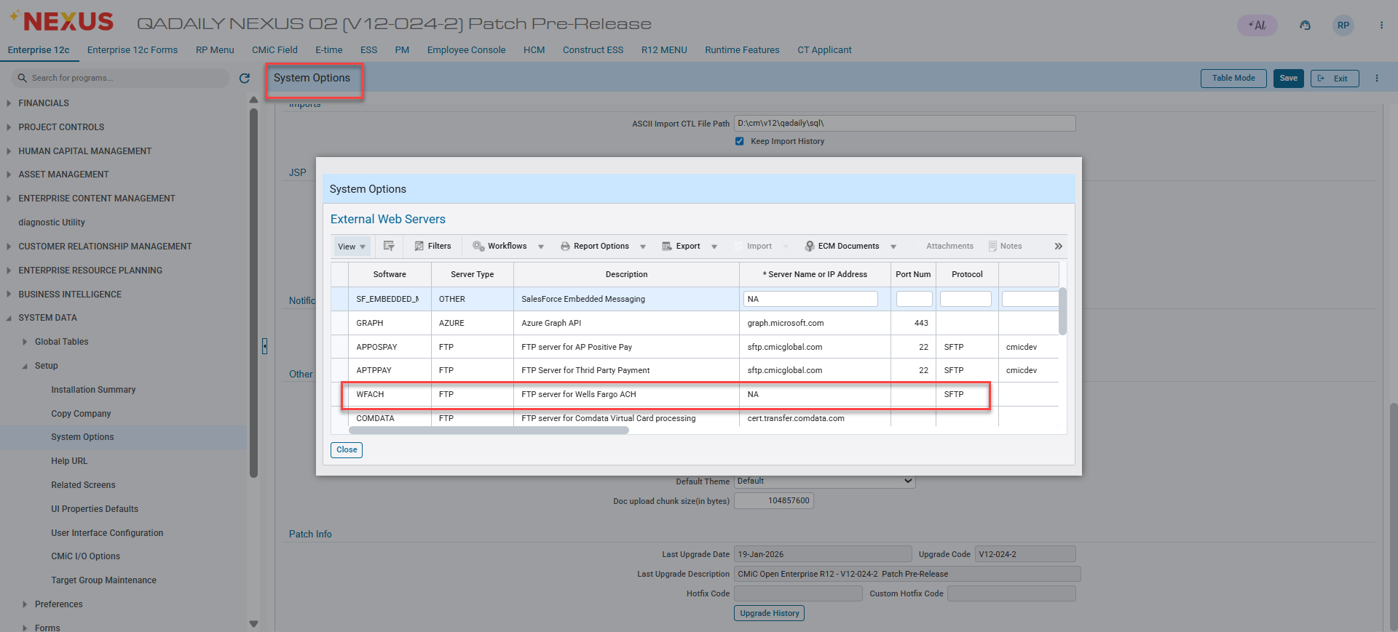
System Data > Setup > System Options > General tab – [External Web Servers]

Bank Setup for WFACH external Webserver highlighted in the screens below: 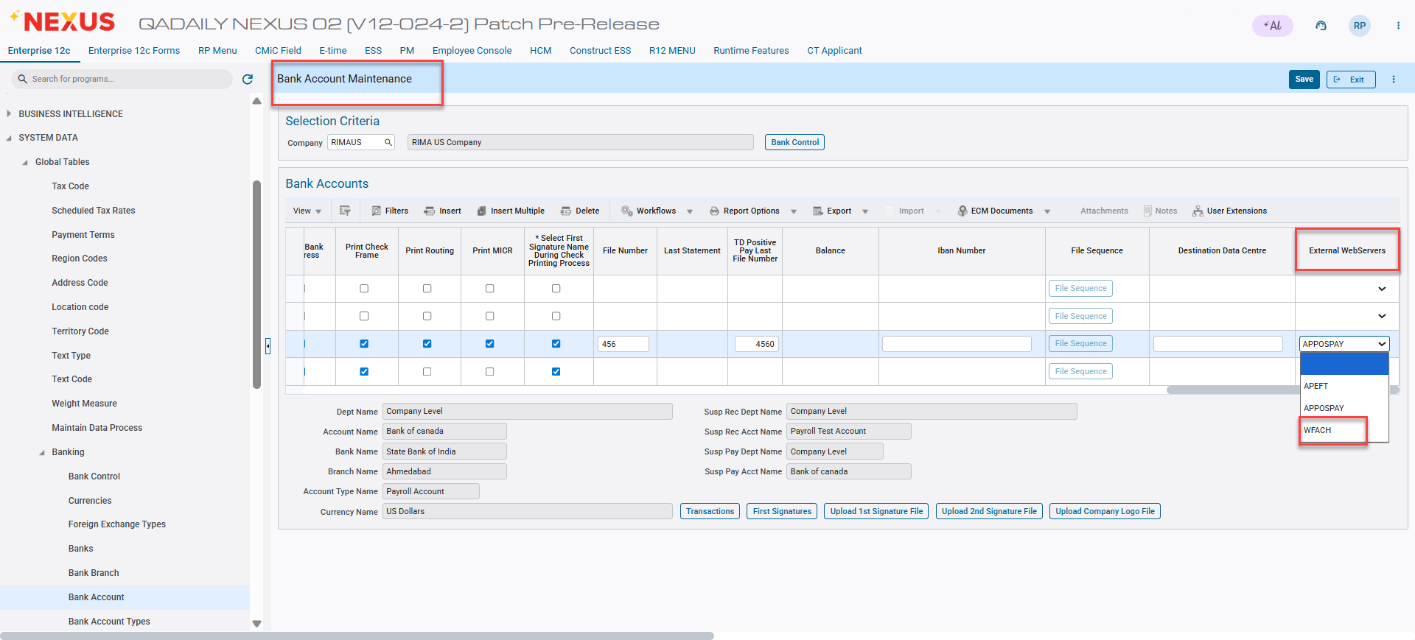
System Data > Global Tables > Banking > Bank Account

Server setup for AP Positive Pay is highlighted in the screens below:
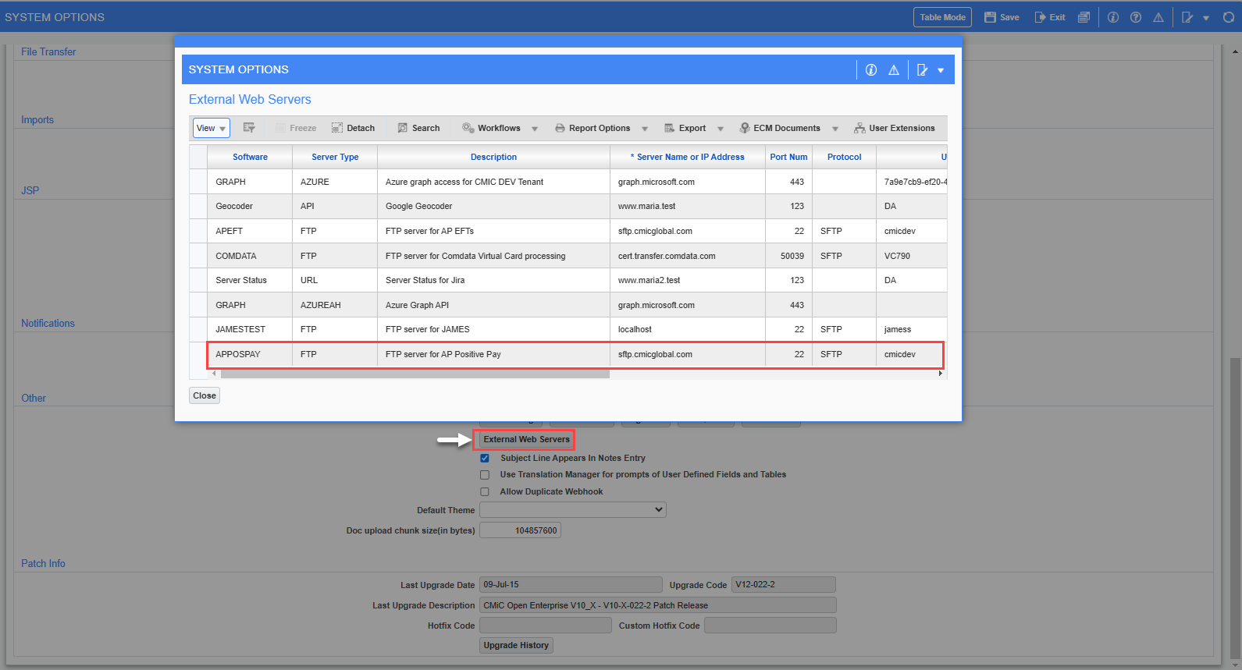
System Data > Setup > System Options > General tab – [External Web Servers]

Bank Setup and enable Auto SFTP is highlighted in the screens below:
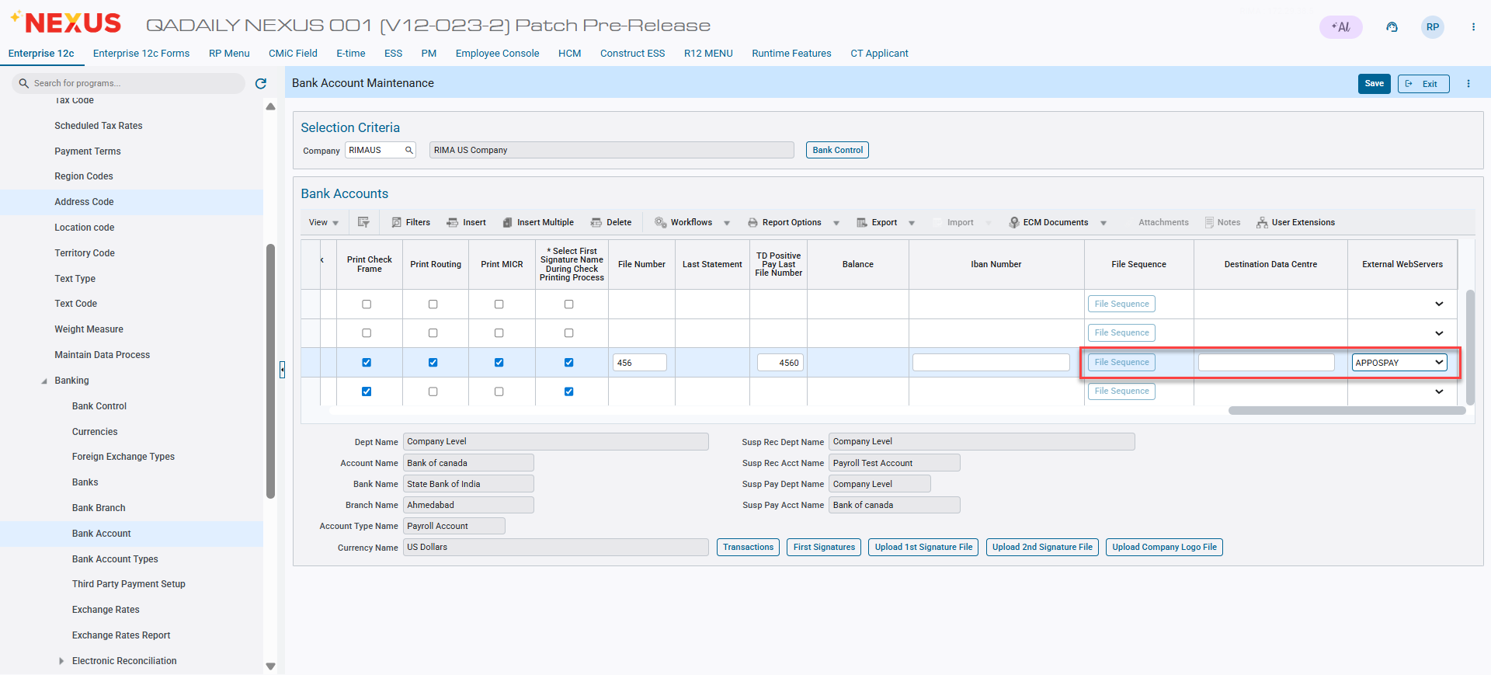
System Data > Global Tables > Banking > Bank Account

PROGRAM MODIFICATIONS:
CMIC has added features like the Bank-Specific SFTP Integration feature that allows Payroll users to automatically transmit payroll-related files in Check EFT Register (PY1081) Program to generate Positive Pay - Wells Fargo Bank (ARP).
Process Payroll and print checks.
Under Processing > Reports > Check/EFT Register, select bank format: Positive Pay – Wells Fargo Bank (ARP) to prepare the data and upload to the SFTP Server.

Below screenshot to check ASCII file and select Bank Format:
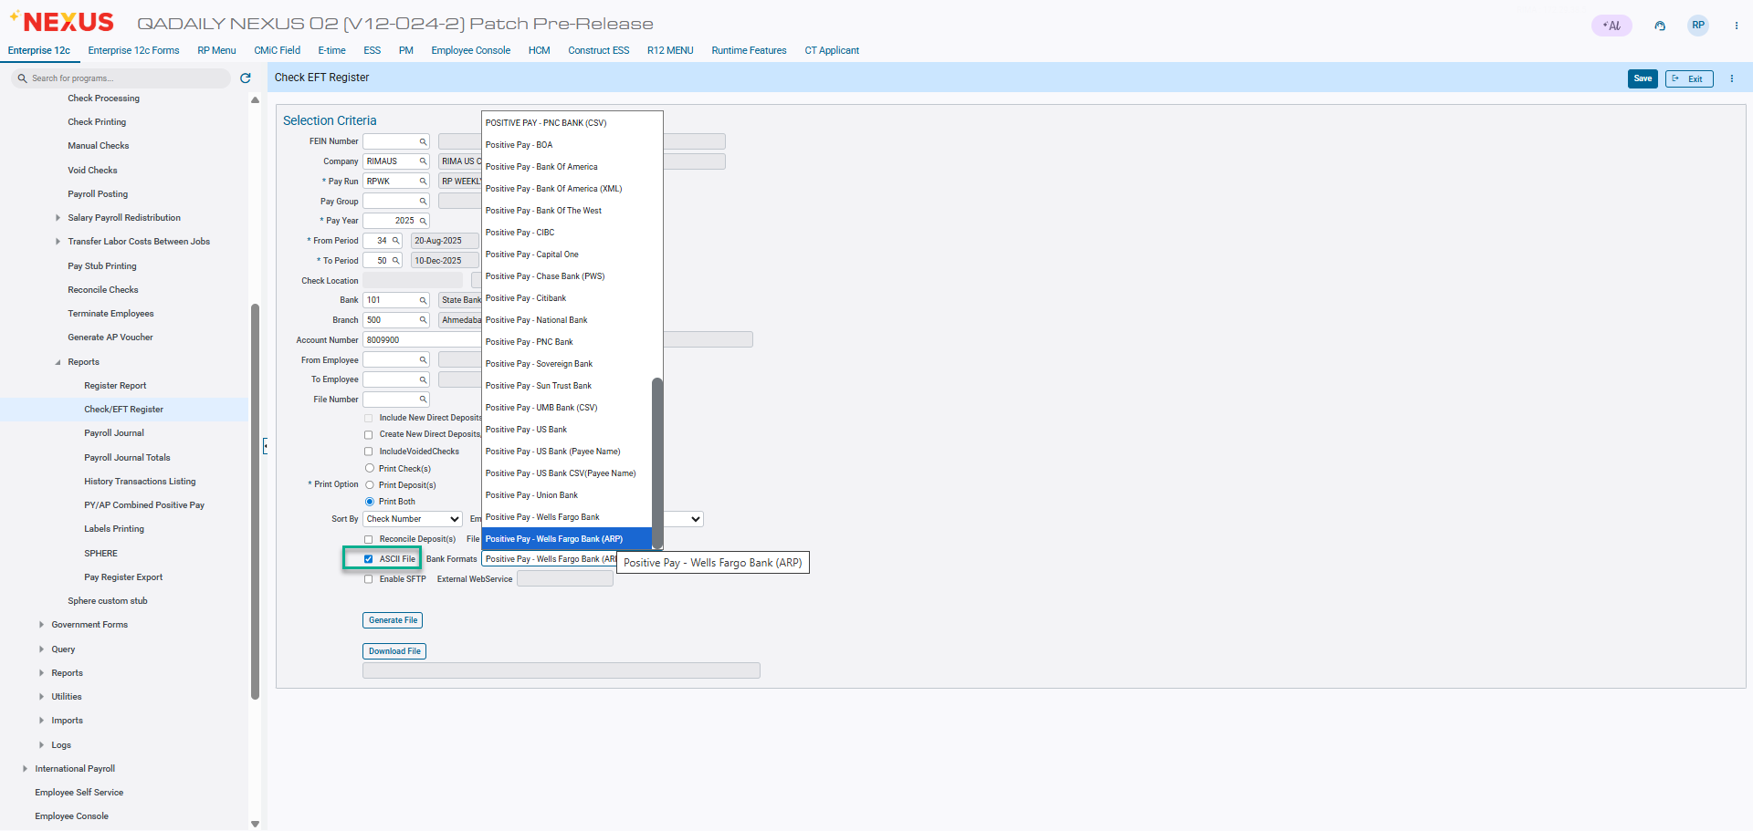

Below screen shows to check enable SFTP and give file name to generate:
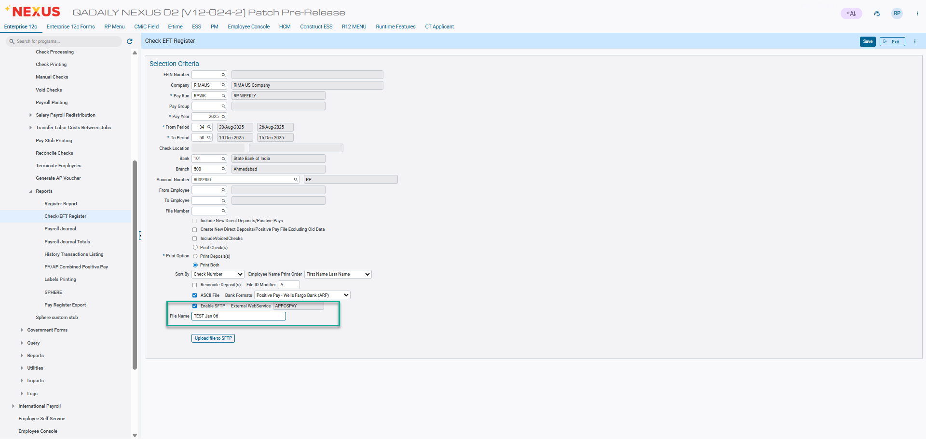

Screen shows to Upload generated file to SFTP Server:
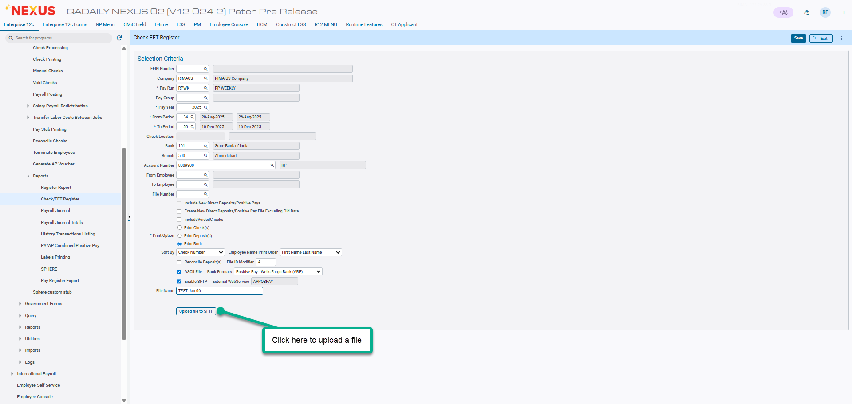

Below screenshots show the successful Message that APPOSPAY file upload to the SFTP server:
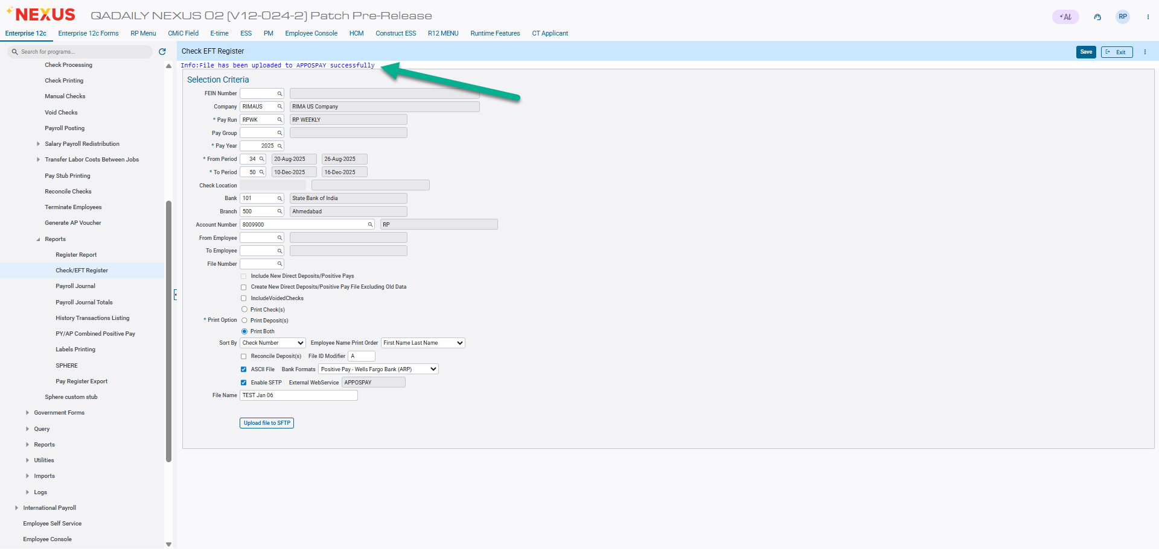

Below screenshots show the PY Positive Pay file generated and saved in server through SFTP:
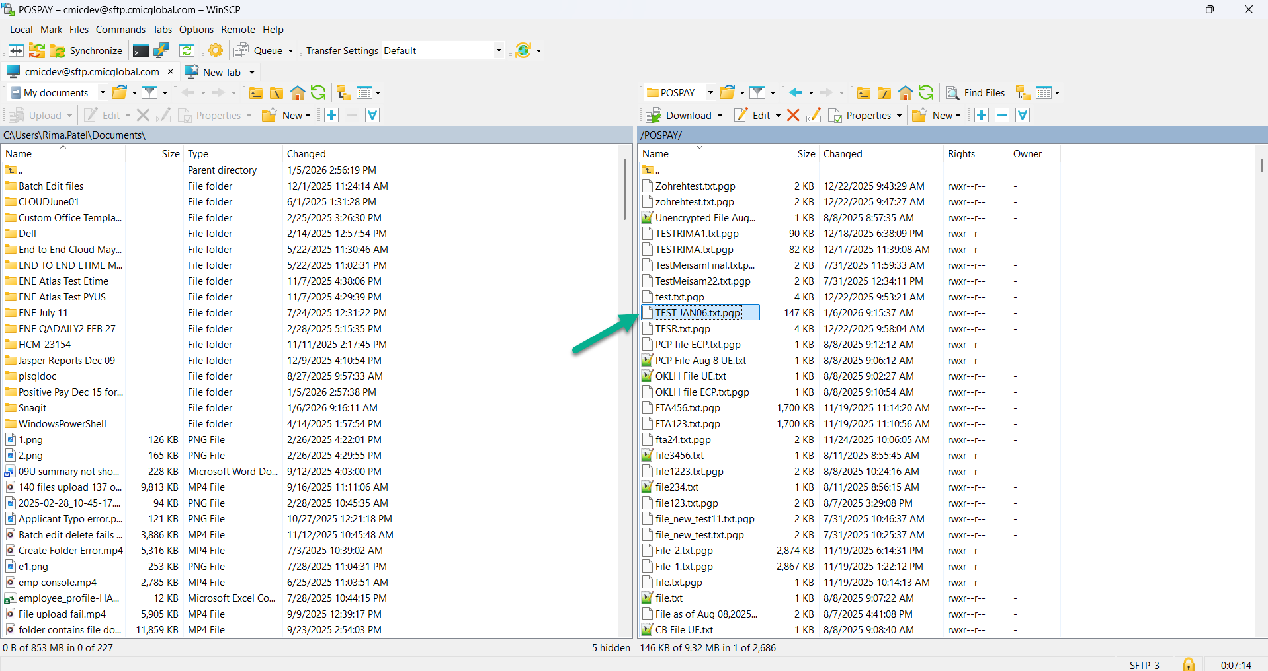

Screen shows that uploaded file in notepad format is encrypted as per client requirement:
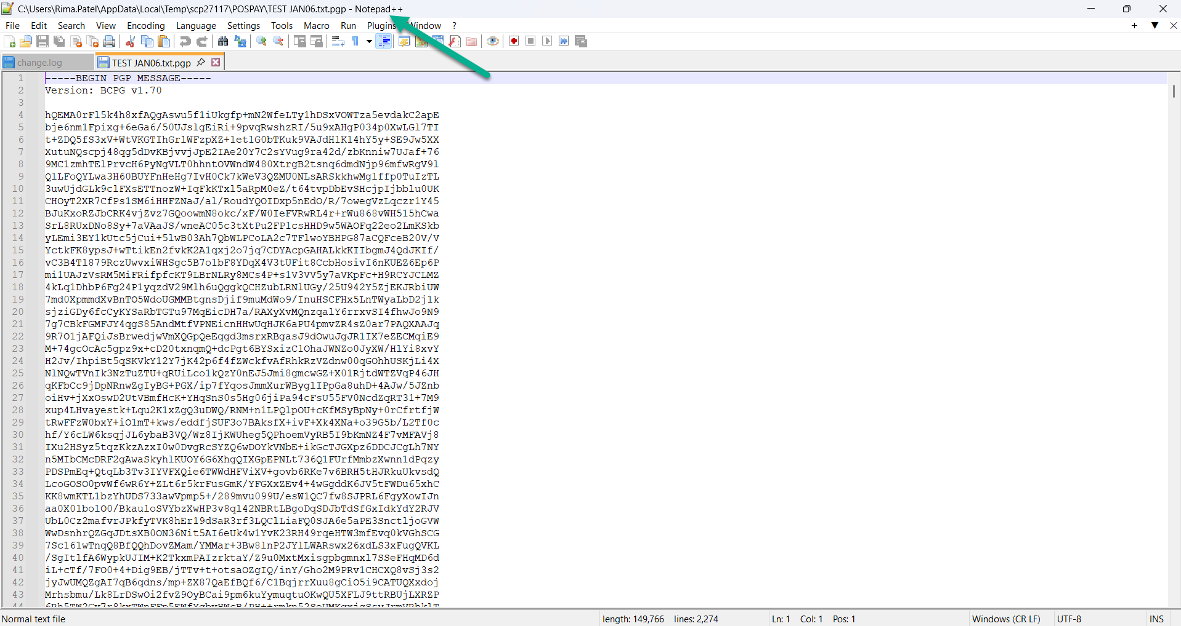

Inclusion of Safe Hours on Pay & Check Stubs (HCM-23945)
Overview
This document outlines the enhancement to include Safe Hours on the Pay Stub (PYSTB12C) and Check Stub (PYCHK12C) layouts.
The Safe Hours column will display only when Safe Hours exist for the employee in the HR Employee Query screen. If no Safe Hours are defined, the column and its values will not appear on the stub.

This enhancement ensures accurate and conditional display of Safe Hours without affecting the existing layout or data integrity.

Pre-requisites

- The HR Employee Query screen must include the designated Safe Hours field where Safe Hours values are stored.
- The existing pay and check stub layouts (PYSTB12C and PYCHK12C) must be available for modification.

Modifications

1. Pay Stub Layout (PYSTB12C)

• New Column Added: Safe Hours
• Conditional Display:
- The Safe Hours column and its values appear only if Safe Hours exist for the employee.
- If no Safe Hours exist, the column and values are not displayed.
• Data Source: Pulled directly from the Safe Hours field in the HR Employee Query screen.
• Accuracy: The value must match the source data exactly, including any decimals.
• Layout Alignment:
- The column is positioned to align with existing fields.
- No existing fields are shifted or resized.
• Formatting:
Font, size, and style match existing stub formatting standards.
2. Check Stub Layout (PYCHK12C)

• New Column Added: Safe Hours
• Conditional Display:
- The Safe Hours column and values are displayed only if Safe Hours exist for the employee.
- If Safe Hours do not exist, the column and values will not appear.
• Data Source:
Pulled from the same Safe Hours field in the HR Employee Query screen.
• Accuracy:
Displayed value must reflect the exact data from the source field.
• Layout & Formatting:
- Must align with existing layout design.
- Formatting (font, size, and alignment) follows stub standards.
Implementation

Scenarios
- Employee with Safe Hours
  - Safe Hours column and value are displayed on both Pay Stub (PYSTB12C) and Check Stub (PYCHK12C).
  - The value displayed matches exactly with the HR Employee Query screen.

Entering Safe Hours for Employee

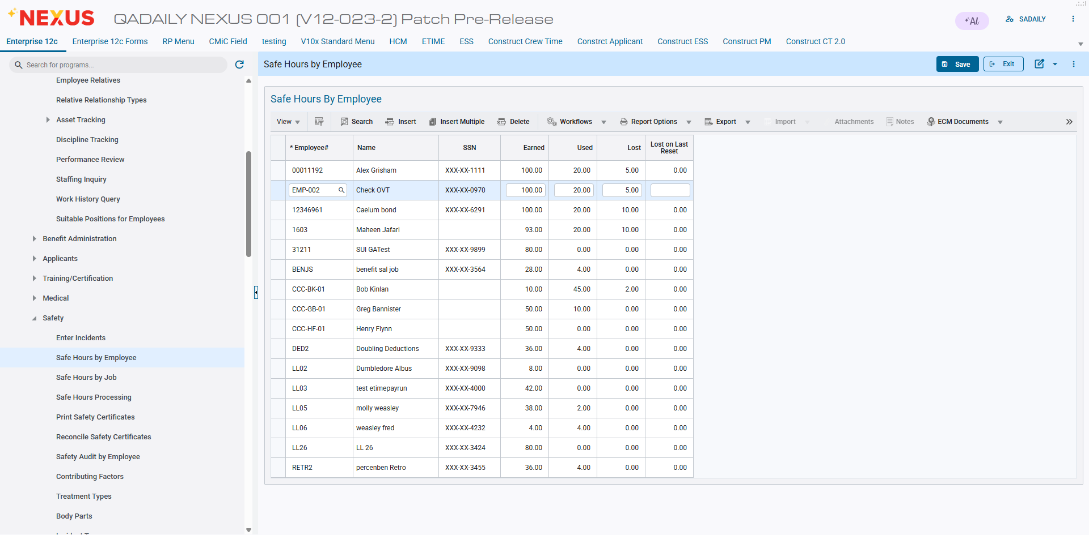

Employee Query Screen

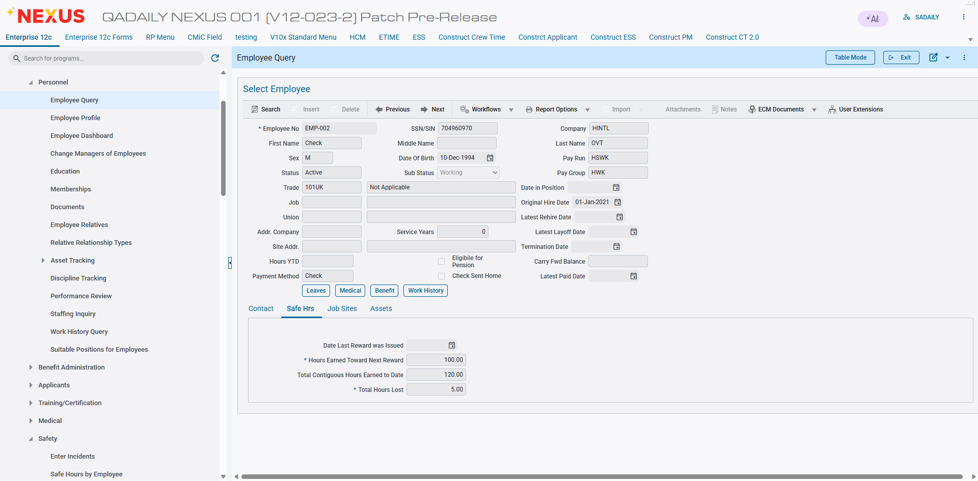

Check

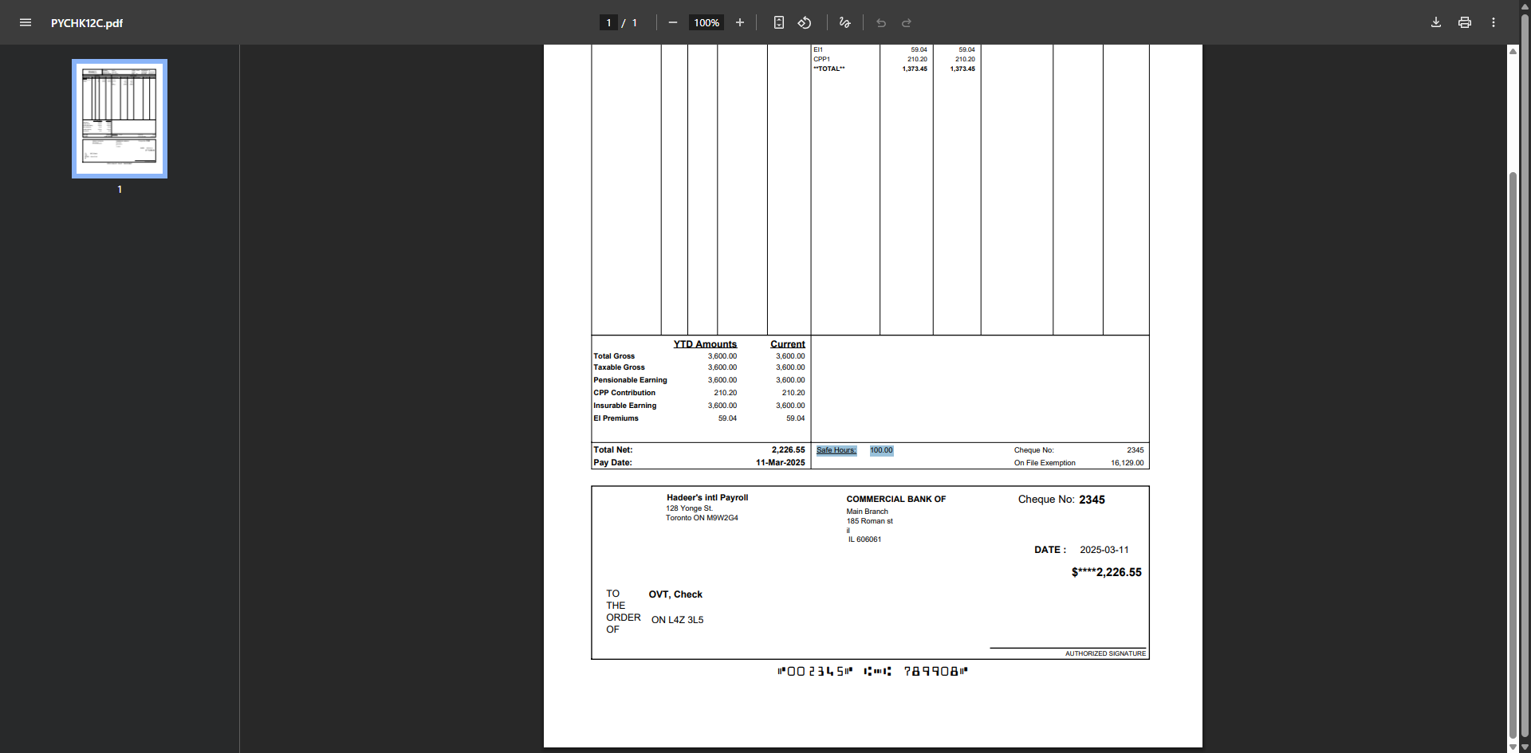

PayStub

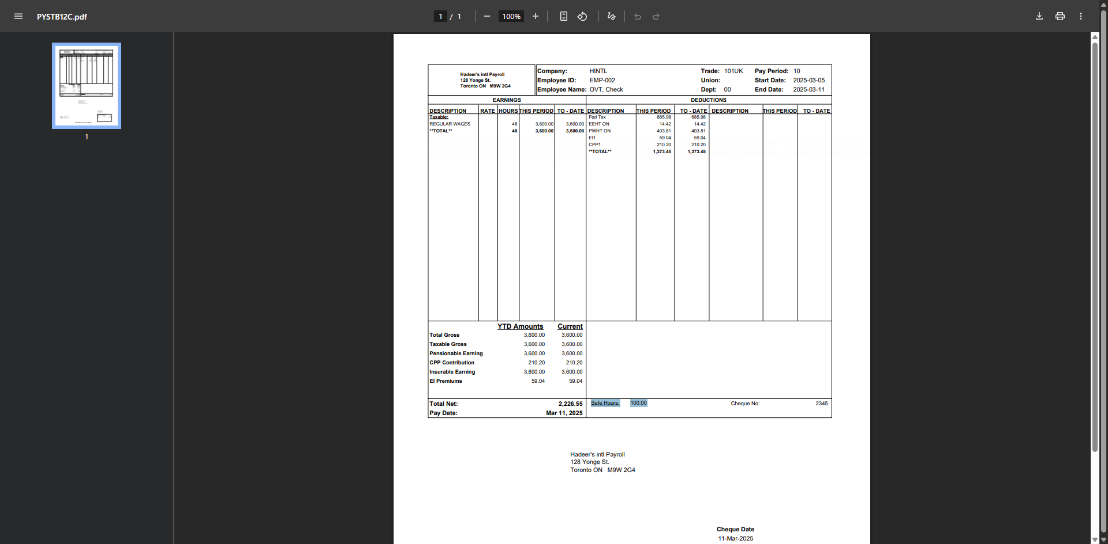

Delaware Parent Leave – PFML File (HCM-24519)
Overview
This enhancement introduces a new utility program to generate the Delaware Paid Family and Medical Leave (PFML) file. The program allows users to extract eligible Delaware PFML wage data for specified quarters and generate an output file for statutory reporting and submission purposes.

Pre-requisites

• CMiC environment upgraded to the build containing HCM-24519 changes.
• Payroll processed for the selected Company, Year, and Quarter(s).
• User has access to US Payroll Utilities menu.
Modifications
1. Delaware PFML Calculation Logic

Eligibility Criteria:
• Employee must work at least 60% of their time in Delaware.
• Employees working 100% in Delaware are fully eligible.
• Employees subject to another state’s PFML program are excluded.
• Eligibility and reclassification forms (if applicable) must be passed correctly for calculation.

Calculation Basis:
• PFML taxable wages are determined by Vertex during payroll processing.
• Wage limits and tax percentages are applied per Delaware statutory rules.
• Both employee (EE) and employer (ER) portions are calculated where applicable.
• Only calculated PFML wages stored in payroll history are included in the generated file.

2. Utility Processing Logic

The utility extracts payroll history records for the selected Company and Quarter range.
• Includes only employees with calculated Delaware PFML wages.
• Supports multiple employees and multiple quarters.
• Consolidates results into a single output file.
• If no PFML data exists for the selected parameters, the file generates with no employee rows.
Implementation

- Work Location - 100% in Delaware

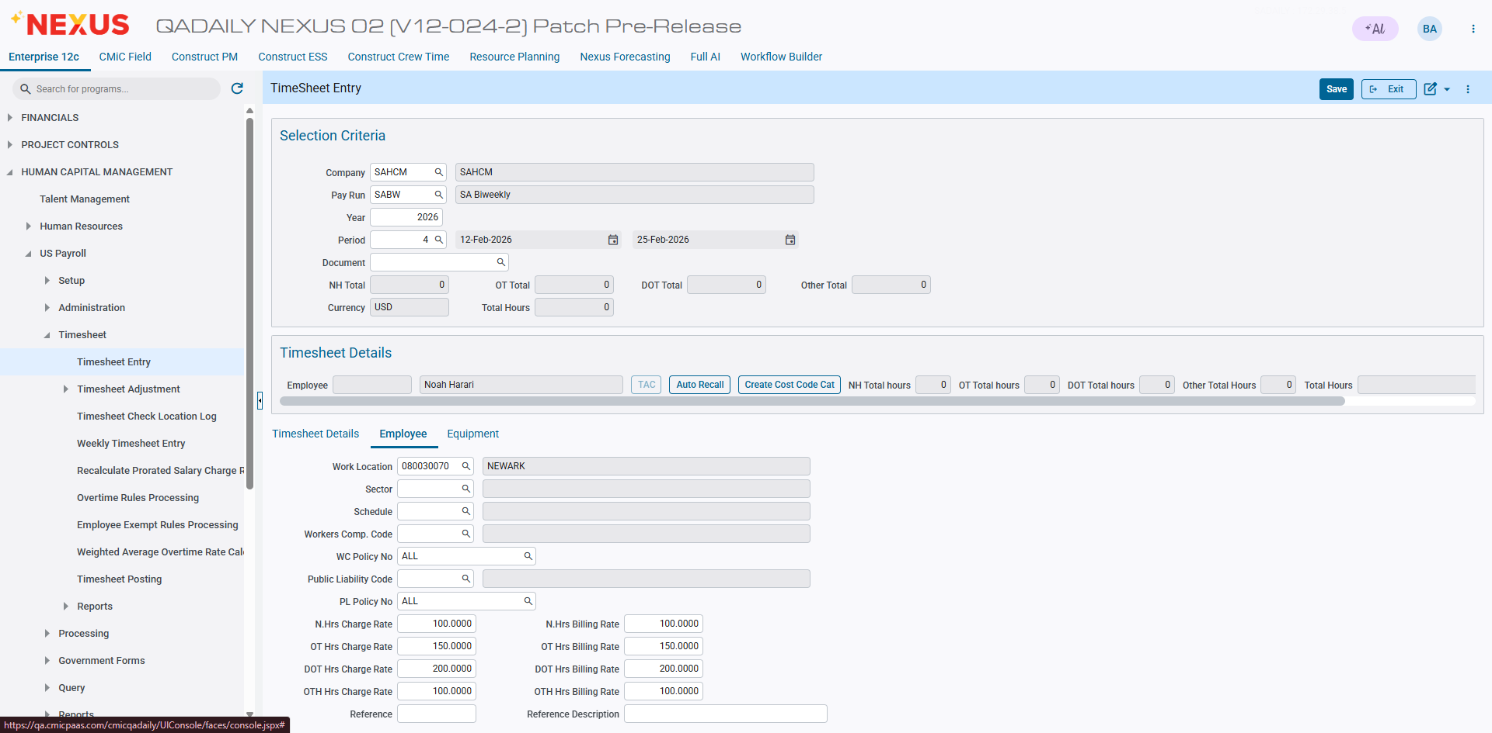

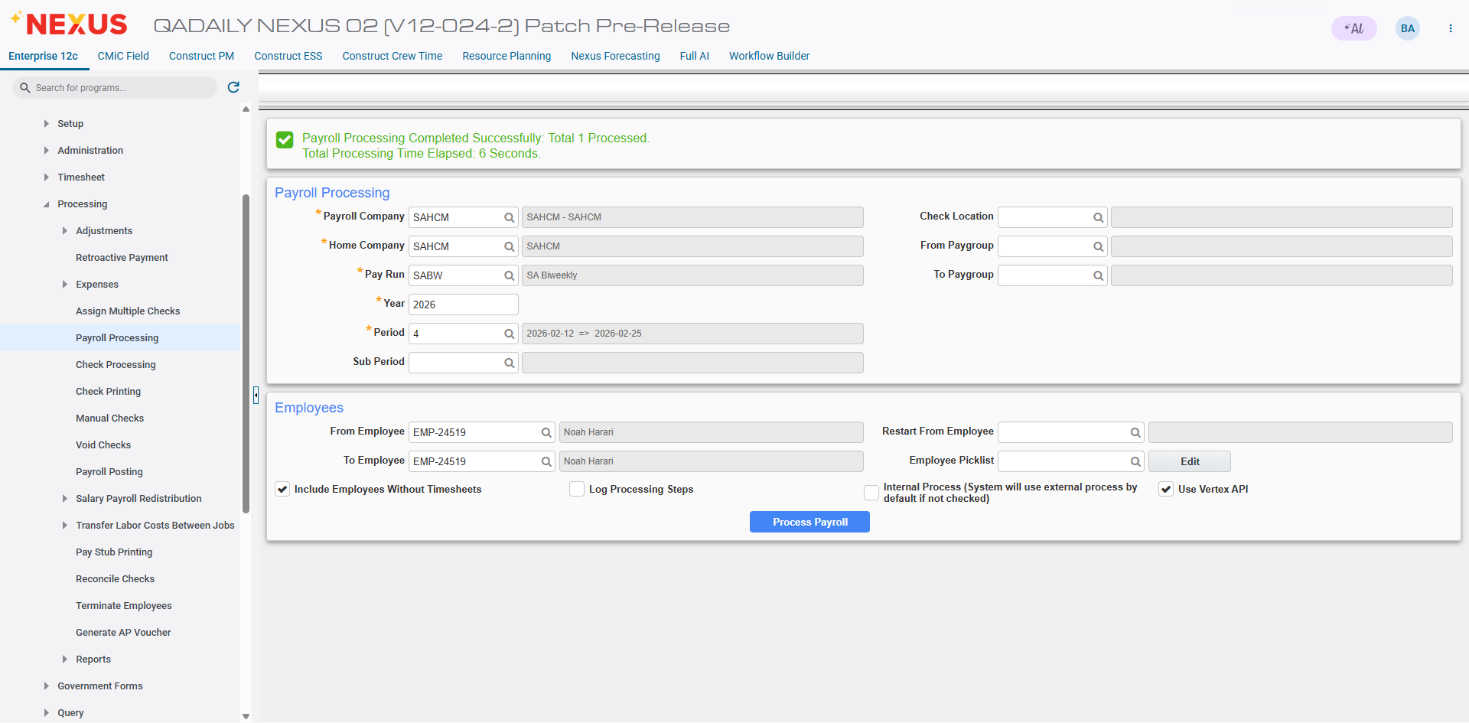

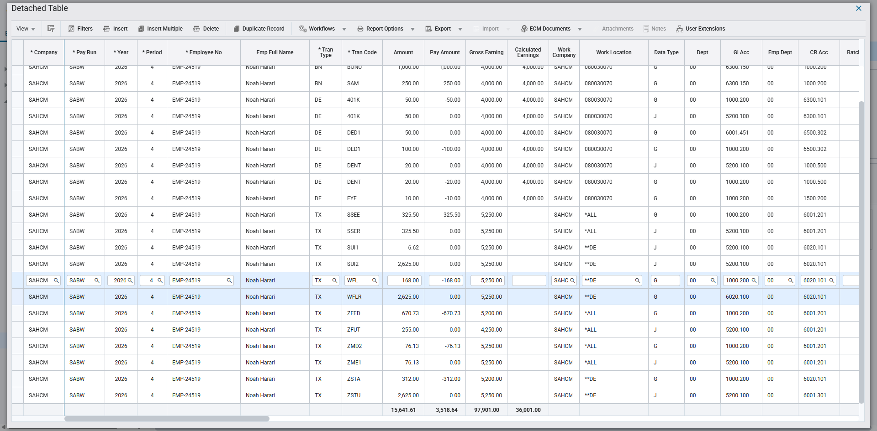

- Utility – File Generation

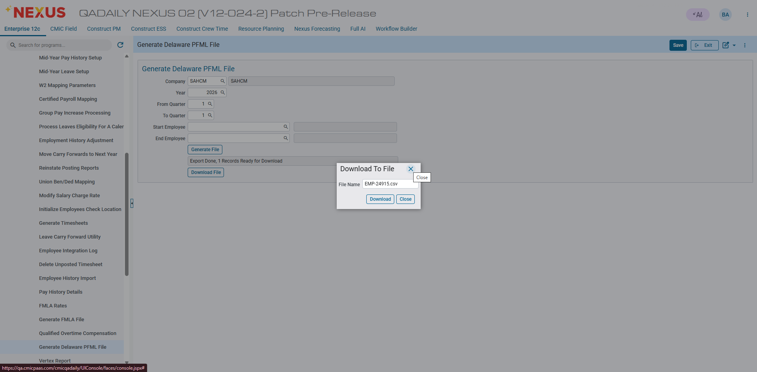
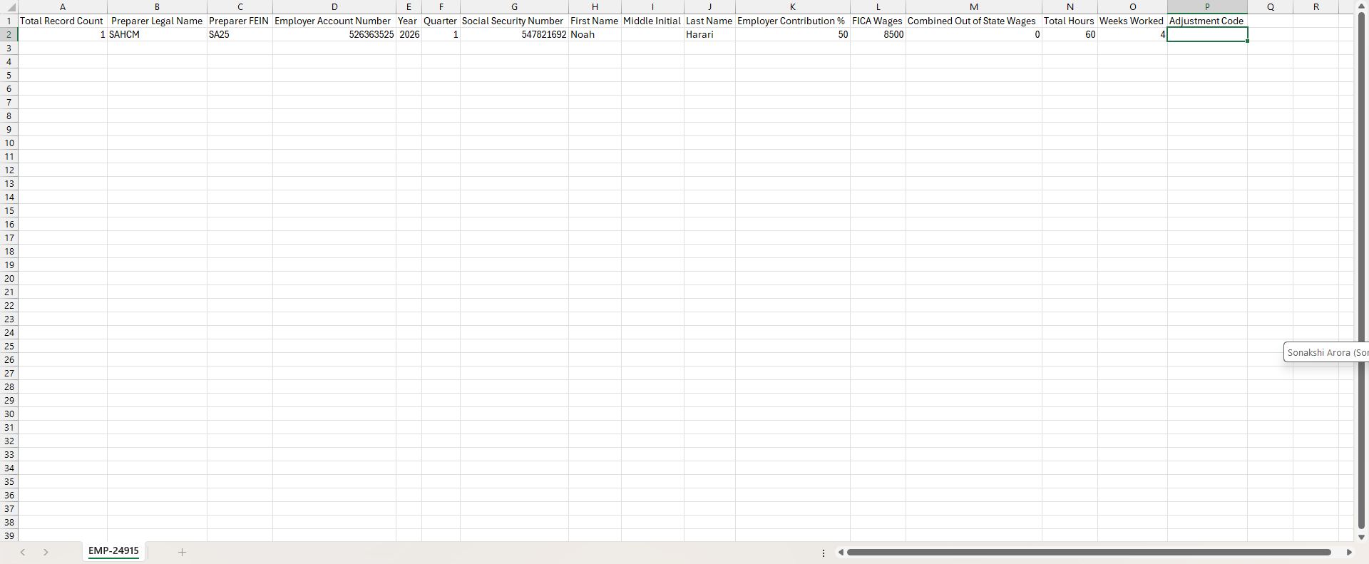

Multiple Employees and quarters

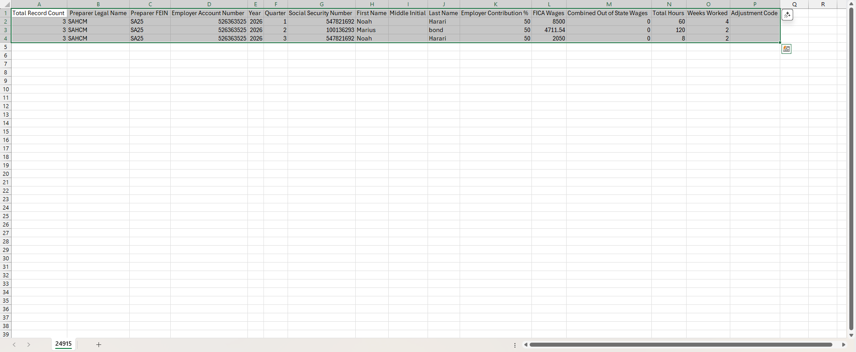

Integration of Vertex Address Cleansing into CMiC Payroll for Improved Tax Jurisdiction Accuracy (HCM-24954)
Overview
The Lookup Address Search functionality enables users to validate and cleanse employee addresses using the Vertex Address Cleansing Payroll Tax API. This feature allows users to review standardized address results and apply accurate taxation-related information directly within Employee Profile and Employee History screens.
This enhancement improves address accuracy, ensures correct Geocode assignment, and reduces payroll tax calculation errors.

Pre-requisites
• Vertex Payroll Tax integration enabled in CMiC
• Separate client credential and licensing for Address Cleansing
• Valid U.S. address data available
• System upgraded to build supporting Vertex Address Cleansing and Geocodes

Modifications
1. Address Cleansing

Address Cleansing converts street addresses into USPS-standard formats. It corrects spelling, applies standard abbreviations, and assigns ZIP+4 codes. This process is required before Geocode assignment.

Availability

The Lookup Address Search button will be available on the following screens:
- Employee Profile
- Employee History
The button is enabled only when valid Vertex Address Cleansing credentials exist in DA.syswebservers_cmic_table

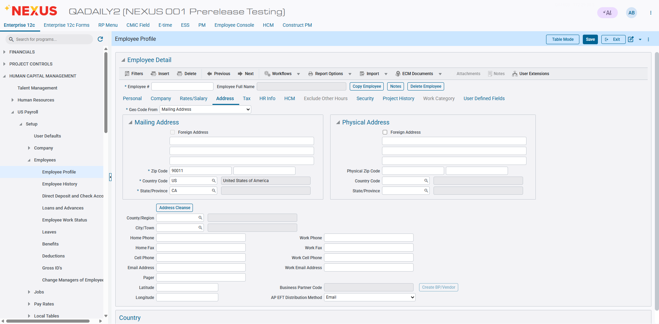

2. User Selection and Field Population

Once the user selects a record from the popup screen, the system automatically updates the following fields:

Address Tab
- Address Line 1
- Address Line 2
- City
- State
- ZIP Code
- ZIP + 4
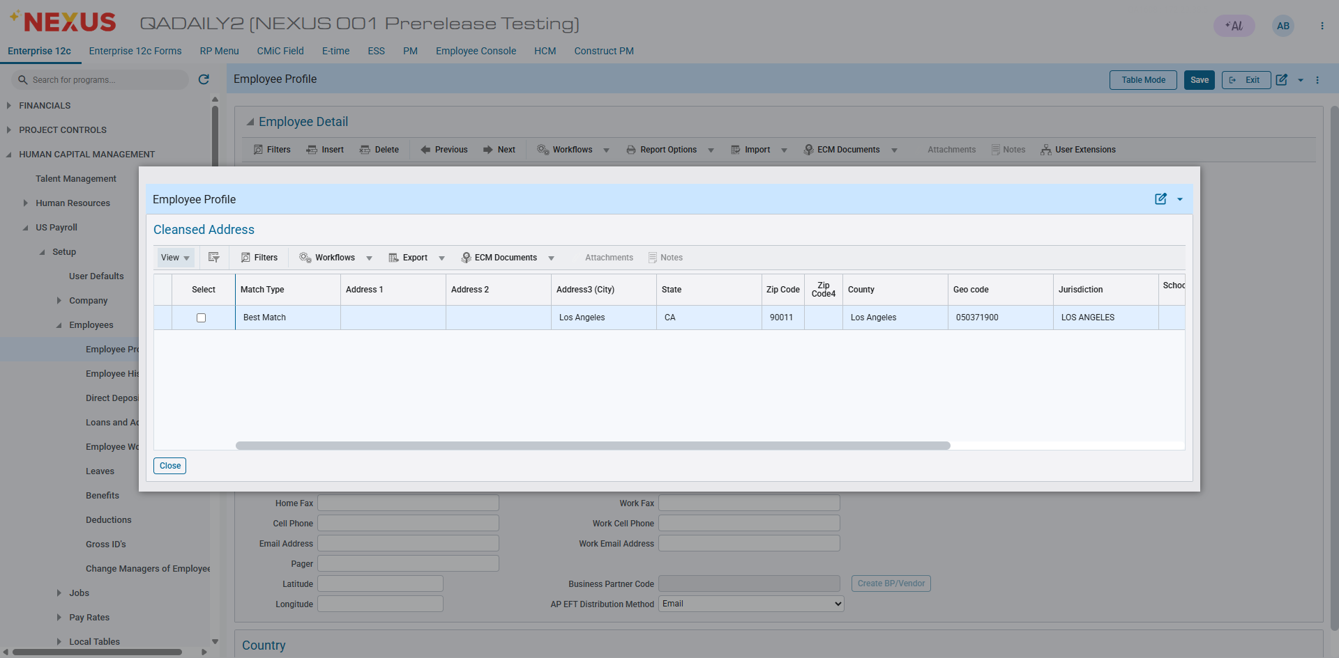

3. Business Outcome

With this enhancement, users can:

- Validate employee addresses against Vertex in real time
- Review and select cleansed address results
- Apply accurate GeoCodes and jurisdiction data
- Ensure compliant and precise payroll tax calculations directly from Employee Profile or History

4. Processing Logic

• Single match: Returned as Best Match
• Multiple matches: Best Match highlighted, others as Possible Matches
• Special handling applies for Pennsylvania and Ohio subdivisions
4. Error Handling

Invalid addresses return warning codes. GeoCode assignment is skipped if Address Cleansing fails.
Employee Address → Address Cleansing → GeoCodes → Vertex Payroll Tax Calculation
Implementation

Scenarios:
- Select Address via address cleansing functionality
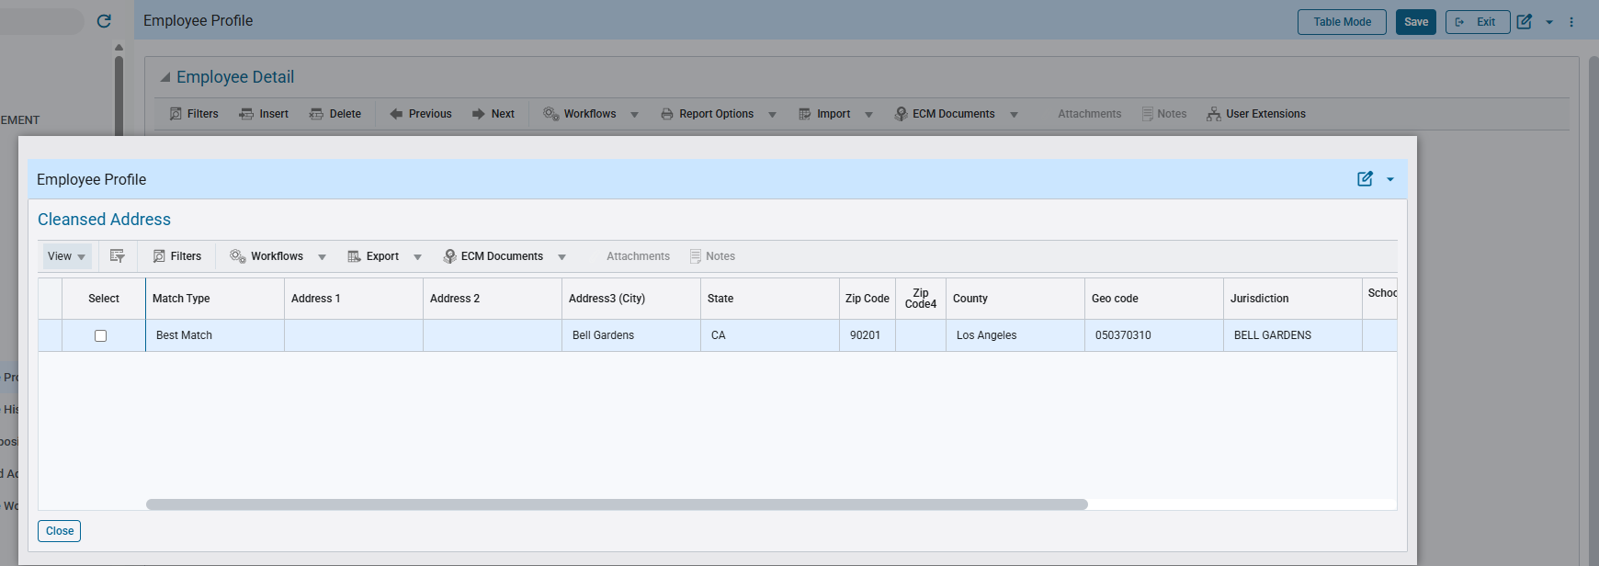

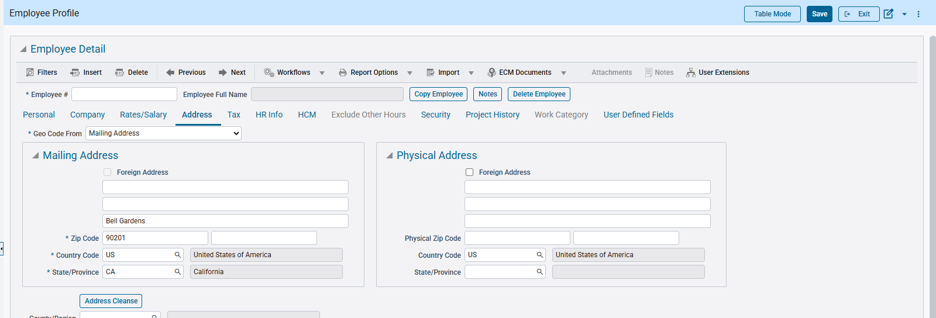

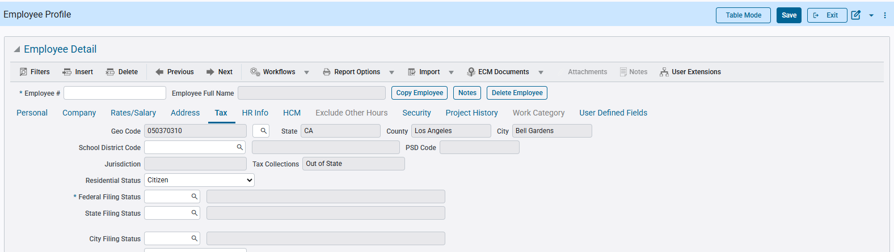

- Select Address with + 4 zip code via address cleansing functionality

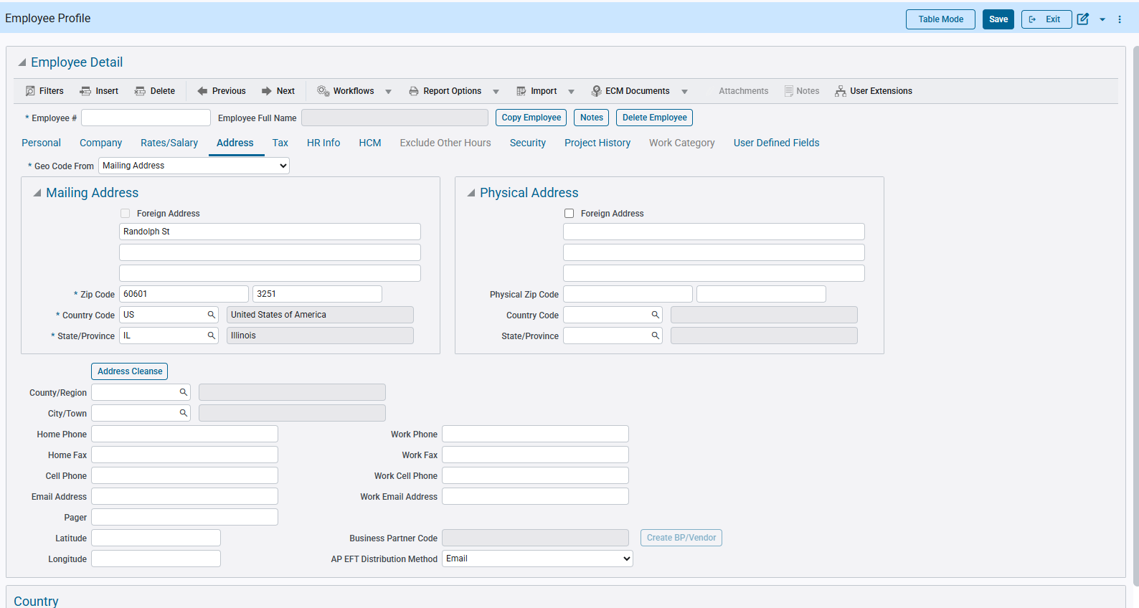

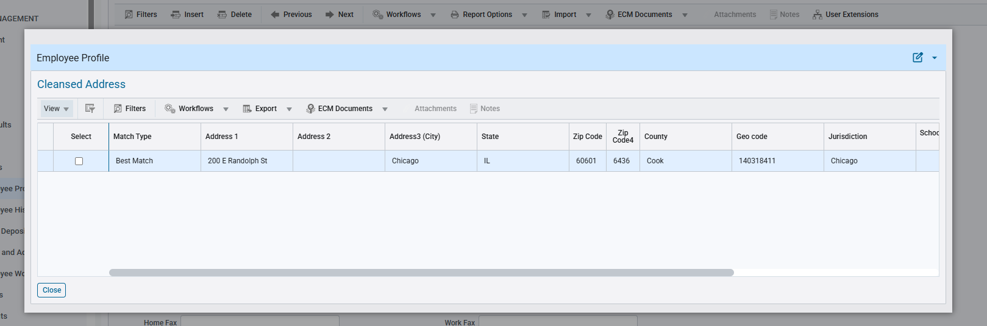

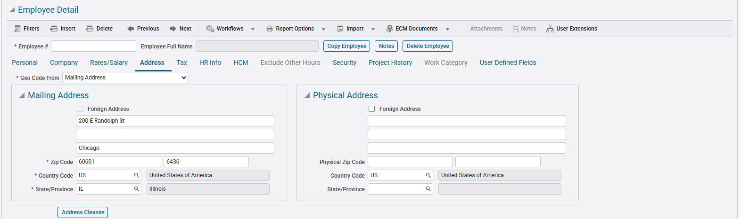

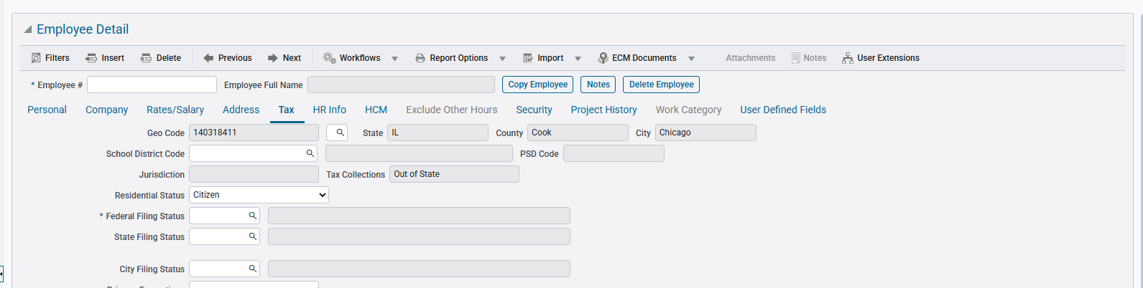

Arizona AZA4V Form Signed (HCM-25305)
Overview
If an employee is an Arizona resident working outside the state and has submitted Arizona Form A-4V (Voluntary Withholding Request), you can enable Arizona state tax withholding by checking the corresponding “AZA4V Form Signed” flag in the system.
Once selected, the system will automatically calculate and withhold the appropriate Arizona state tax. The withholding details will be recorded and included in the employee’s W-2 file.
Pre-requisites
This flag is available on employee level, via Employee Profile > Tax tab > Overrides button.
Modifications
AZA4V Form Signed flag is available on employee level override.
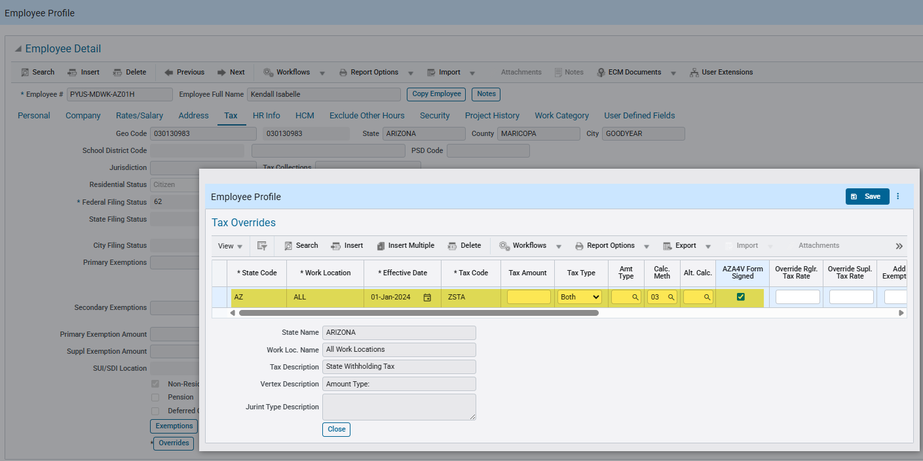
Implementation
In this section, we will verify the behavior of AZ state income tax for an employee who resides in Arizona (AZ) and is working in Washington (WA).
Employee override is added and AZA4V Form Signed flag is checked:

Example #1: Processed in CMPARRAY mode (New Vertex flag in System Options > Payroll is checked)
When viewed in Mid-year Pay History after payroll processing:
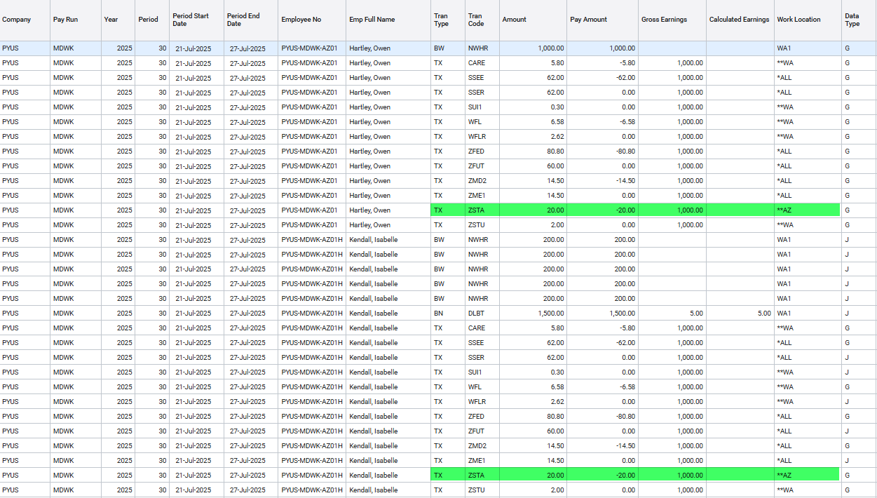
The State Income Tax for AZ is calculated.
View Employee Vertex Report and check State Tax section:
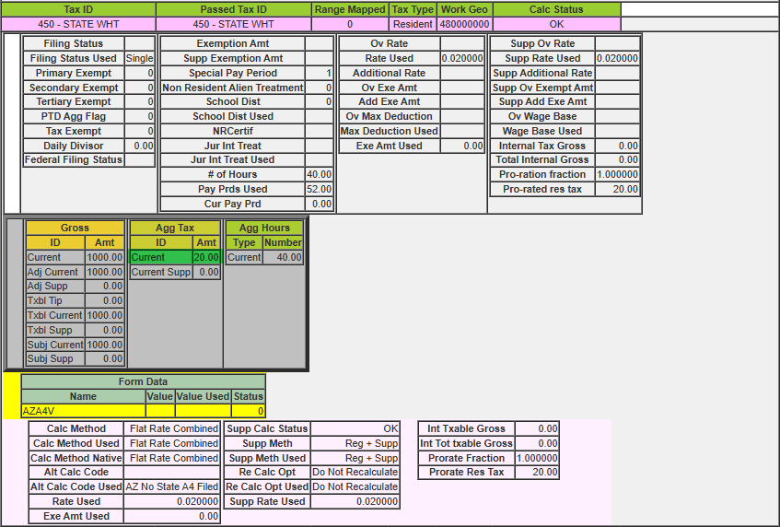
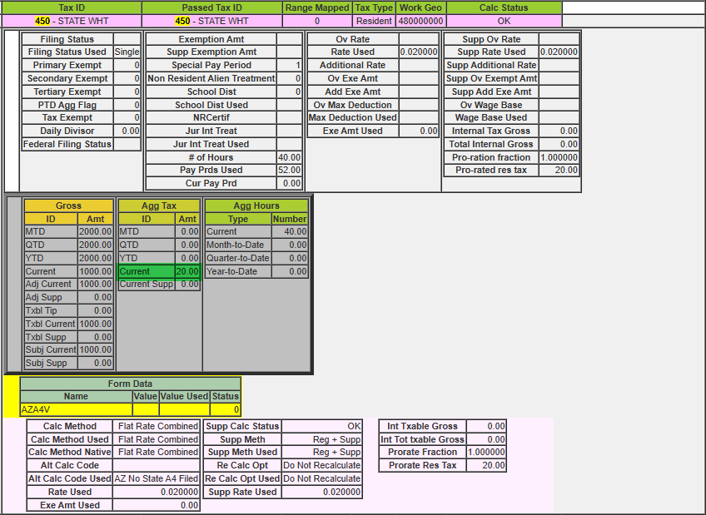
The State Income Tax for AZ is reflected in the Vertex report in CMPARRAY mode.

Example #2: Processed in Vertex API mode (Vertex API flag is checked in Payroll Processing)
When viewed in Mid-year Pay History after payroll processing:
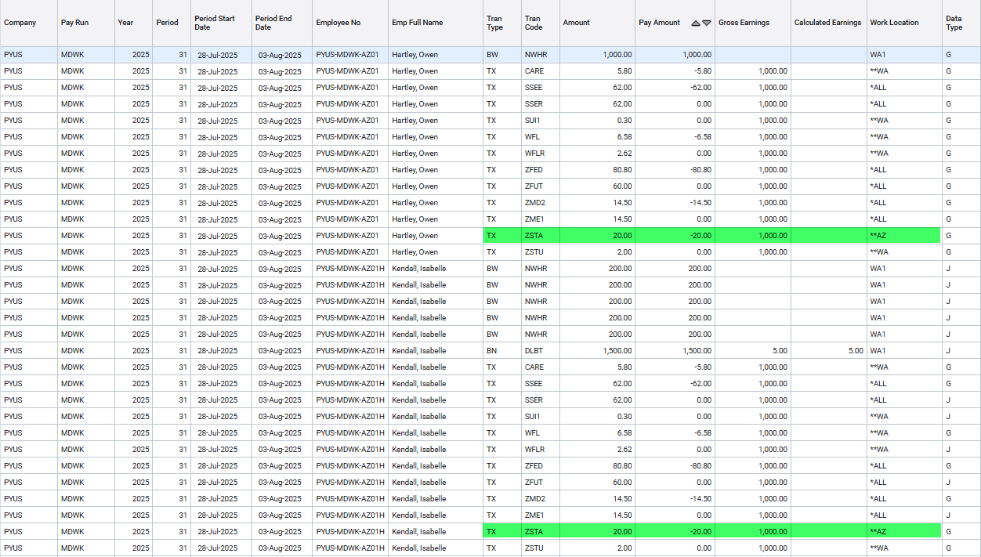
The State Income Tax for AZ is calculated.
View Employee Vertex Report and check State Tax section:
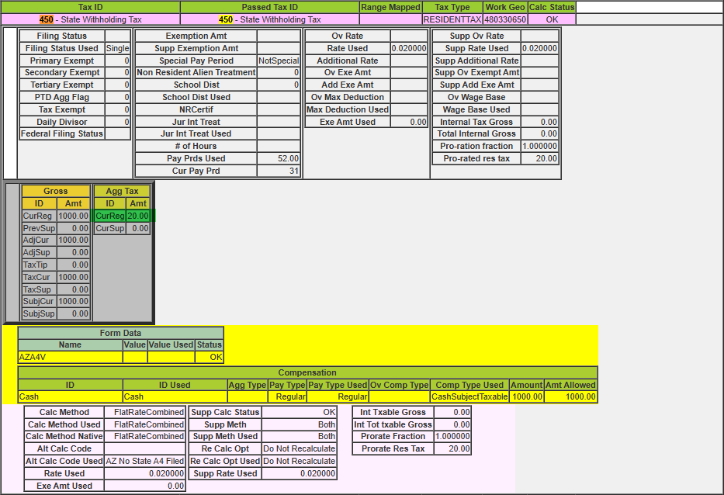
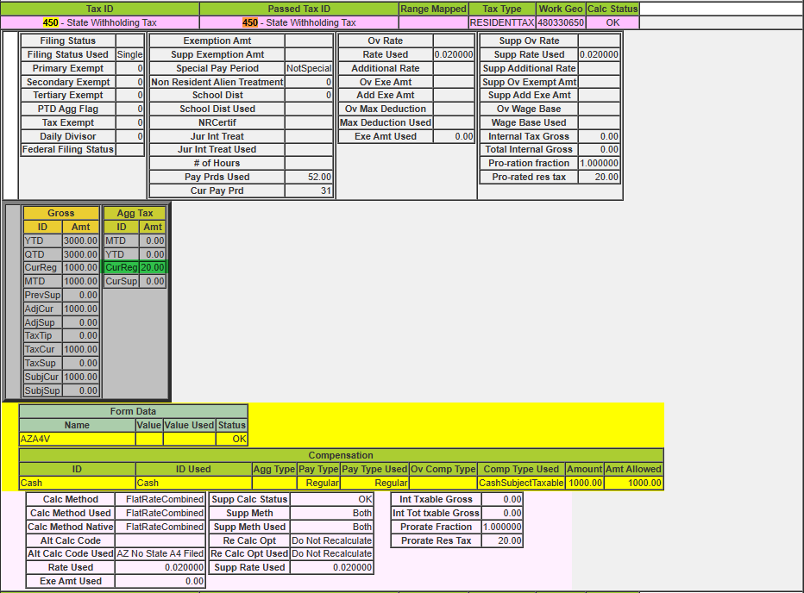
The State Income Tax for AZ is reflected in the Vertex report in Vertex API mode.

New Qualified Overtime Compensation (QOC Reporting) (HCM-25390)
Overview
CMiC has introduced an enhancement to support IRS guidance for reporting Qualified Overtime Compensation (QOC) on Form W-2. This enhancement helps employers prepare for the IRS transitional reporting guidance applicable to the 2025 tax year and ensures compliance with mandatory reporting requirements beginning in the 2026 tax year.
For tax year 2025, the IRS is providing transitional guidance and penalty relief as employers adapt to the new reporting expectations. During this period, employers are encouraged but not required to report qualified overtime compensation. If reported, the information may be included in Box 14 of Form W-2 using employer-defined descriptions or provided through a separate written statement. If no separate amount is reported, employees may rely on pay stubs or other payroll records, and employers may use a reasonable method to determine qualified overtime compensation.
Beginning with the 2026 tax year, reporting becomes mandatory. Employers must report the total amount of qualified overtime compensation on Form W-2, Box 12, using the new IRS code “TT,” which represents Total Qualified Overtime Compensation.
To support these requirements, CMiC has delivered system enhancements that enable W-2 Box 12 reporting using Code TT and the new Qualified Overtime Compensation screen.
Below provides step-by-step instructions for using the CMiC Qualified Overtime Compensation (QOC) screen. The QOC screen helps payroll administrators review and adjust overtime records, determine QOC eligibility, and prepare data for IRS compliance and W-2 reporting. The QOC screen enables payroll administrators to validate and report the FLSA-required 0.5× overtime premium. It is designed to support mandatory QOC reporting starting in 2026 (Box 12TT).

Pre-requisites
- If the new Qualified Overtime Compensation screen does not appear under US Payroll > Utilities, it can be added in the treeview menu by adding:
  - New program: PY_QOC_INFO
  - Target Name: PY – Qualified Overtime Compensation
- W2 Mapping Parameters setup for box codes 12 and 14 should be configured before generating the W2 XML file. (refer to the Modifications section)
Modifications
Using the QOC Screen
The QOC screen displays employee-level payroll data for a selected pay period, including:
Normal and Other Hours
Overtime (OT) and Double Time (DOT) amounts
OT Premium (FLSA-required 0.5× portion)
Eligibility for QOC
Editable fields for Total Overtime and Premium
Remarks explaining eligibility logic
This screen is populated once:
Timesheets are entered with Normal and Overtime hours, or
Time is entered only for Normal hours, and the Overtime Rule Processing is run to allocate OT based on the overtime rule setup threshold
Timesheets are posted, and payroll is processed

The QOC screen reads from the PYEMPPAHIST (Payroll History) table and displays the Total Overtime and calculates the 0.5× FLSA Premiums based on eligible overtime hours. This data becomes available after timesheets are posted and payroll is processed.
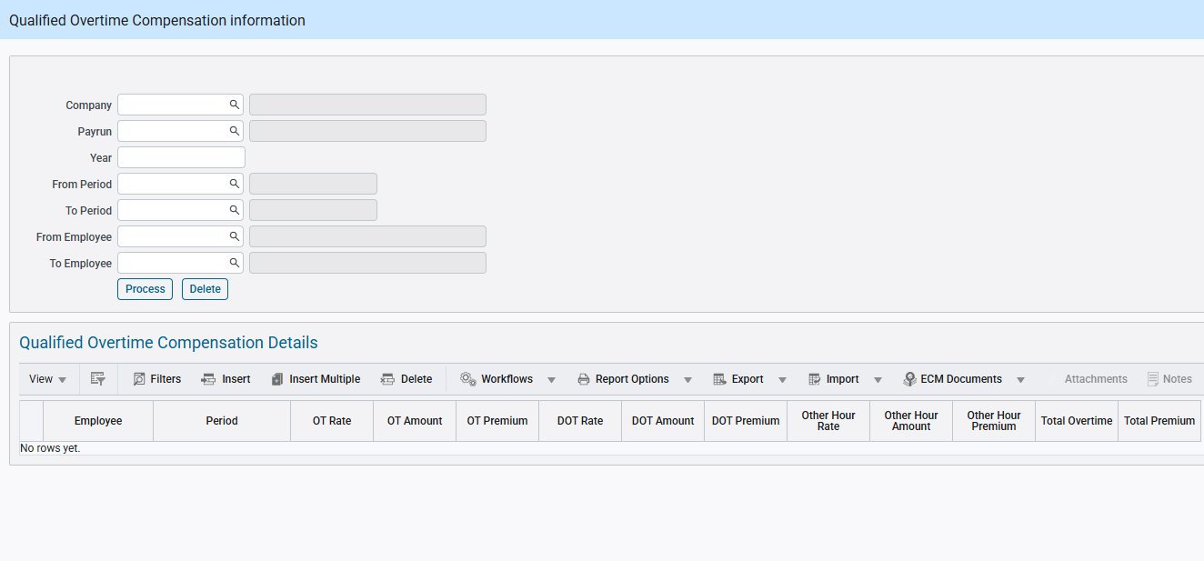
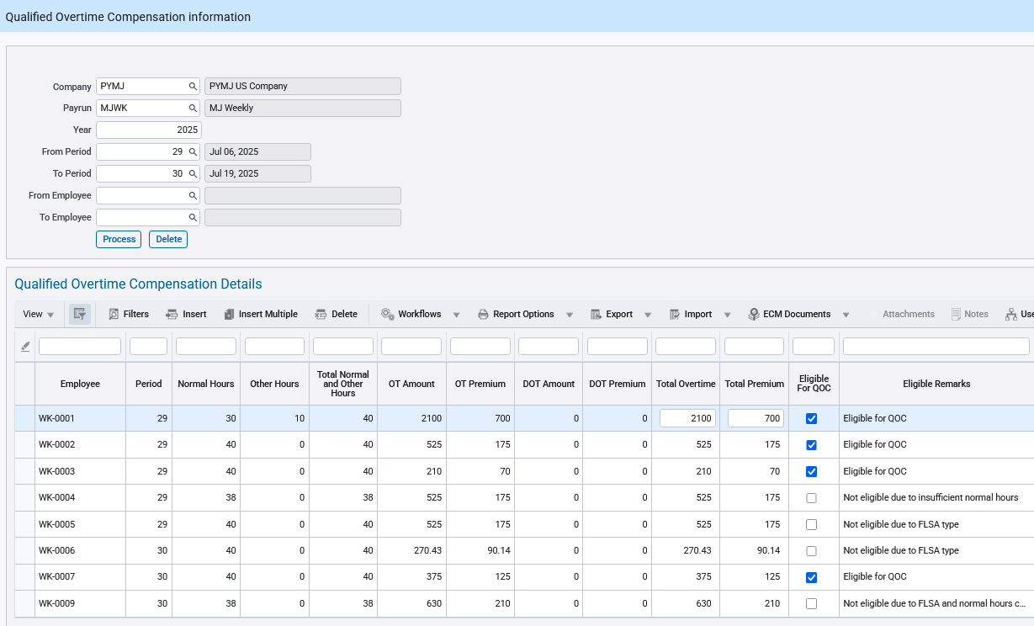

QOC Eligibility Logic
To be eligible for QOC, an employee must:
- Be classified as non-exempt
- Have worked Normal 40 hours in a week
- Have at least one overtime hour recorded in the same week
- Be paid an FLSA-mandated 0.5× premium as part of their overtime compensation
Functionality
Payroll administrators can:
- Review employee QOC calculations
- Modify Total Overtime and Premium values if needed
- Override system eligibility flags

Example Scenarios
Example 1: Eligible Employee with Standard OT
Employee ID: WK-0001
Pay Rate: $70/hour
Normal Hours: 30
Other Hours: 10
Total Regular Hours: 40
Overtime Hours: 20
QOC Premium: 20 × 0.5 × $70 = $700
QOC Eligible: Yes

System Behavior
The system automatically checks the QOC Eligibility box and calculates the premium amount because:
The employee’s combined Normal + Other Hours reach the 40-hour FLSA threshold
Overtime hours are above that threshold and thus eligible
The system multiplies 20 hours × 0.5 × $70 = $700
Note on "Other Hours" and the “Overtime Rule” Flag
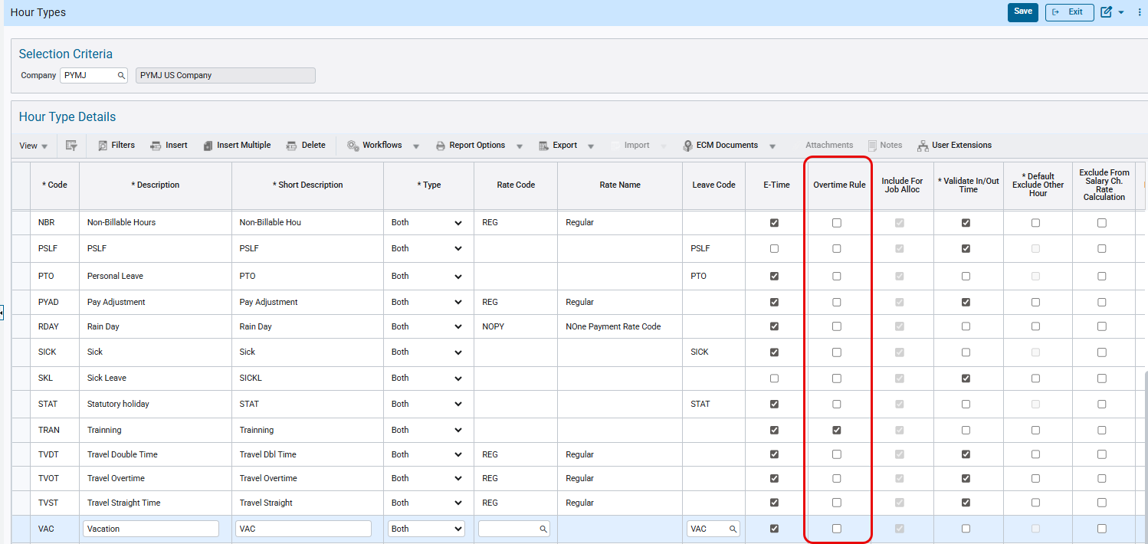
In CMiC, “Other Hours” refer to hours that are not coded as standard Normal Time, but may still be treated as part of the 40-hour FLSA base—if they are flagged appropriately.
This is controlled by the “Overtime Rule” checkbox located under the Hour Type Setup screen in CMiC.
If the “Overtime Rule” flag is checked for an hour type, those hours will be counted toward the normal hour threshold in overtime processing.
If the flag is not checked, those hours will be excluded from FLSA overtime eligibility.
This distinction is essential because under IRS rules, only overtime that qualifies under the FLSA standard (over 40 hours/week for non-exempt workers) is eligible for QOC.
Therefore, only hours that are part of the 40-hour base using the “Overtime Rule” setup can trigger valid QOC premiums.
Example 2: Not Eligible – FLSA Type
Employee: WK-0005
Normal Hours: 40, OT Hours: 5
Employee flagged as Exempt in FLSA setup.
System unchecked 'Eligible for QOC' and remark states: 'Not eligible due to FLSA type'.
User can override and check the box manually if necessary.
Example 3: Not Eligible – Insufficient Normal Hours
Employee: WK-0004
Normal Hours: 38, OT Hours: 5
System deems employee ineligible because regular hours did not meet 40-hour FLSA threshold.
Eligible for QOC: No (unchecked)
Remark: 'Not eligible due to insufficient normal hours'
W-2 Reporting Integration
Employees marked as eligible for QOC will be included in W-2 processing for the applicable tax year. The OT Premium amount will be used as part of the Box 12 reporting logic as per IRS QOC compliance rules.
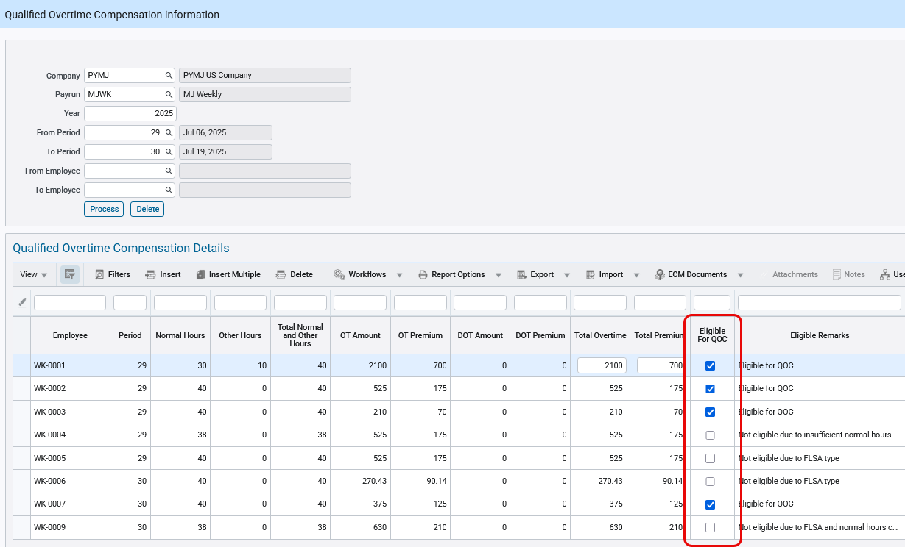
W-2 Mapping – Total Overtime
Mapping Configuration:
Tran Type: QC (Only visible for 12 and 14 box)
Tran Code: QOC (Only visible for 12 and 14 box)
Amount Type: Total Overtime
Clarification:
If "Total Overtime" is selected as the Amount Type, the system will report the entire overtime amount paid (including the regular pay portion plus the FLSA premium) on the employee’s W-2 under the selected box code (either 14O for 2025 or 12TT for 2026).
This does not isolate just the FLSA 0.5× premium — it includes the full amount paid for overtime hours.
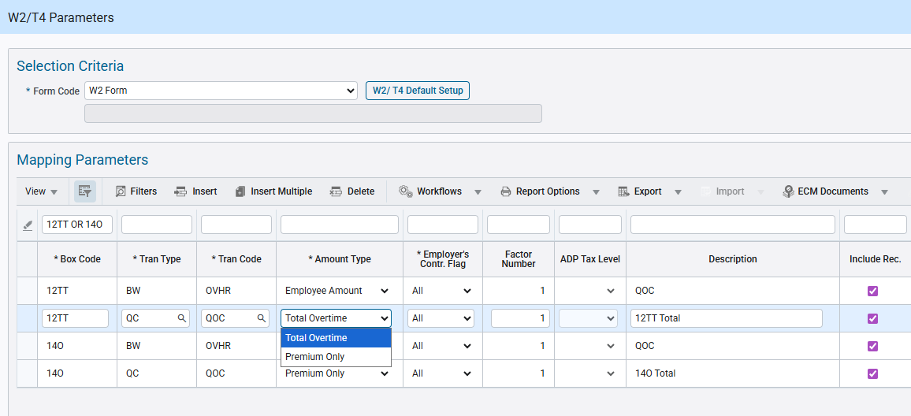

W-2 Mapping – Premium Only
Mapping Configuration:
Tran Type: QC (Only visible for 12 and 14 box)
Tran Code: QOC (Only visible for 12 and 14 box)
Amount Type: Premium Only
Clarification:
If “Premium Only” is selected as the Amount Type, the system will report only the FLSA-required overtime premium (0.5× of the regular rate) on the employee’s W-2.
This amount represents Qualified Overtime Compensation (QOC) as defined by the IRS and excludes:
The regular (1.0×) portion of overtime pay
Any additional contractual, union, or double-time premiums beyond the FLSA requirement
Only the calculated QOC premium amount displayed on the Qualified Overtime Compensation screen will be printed on the W-2 under the selected box code (14O for 2025 or 12TT for 2026).
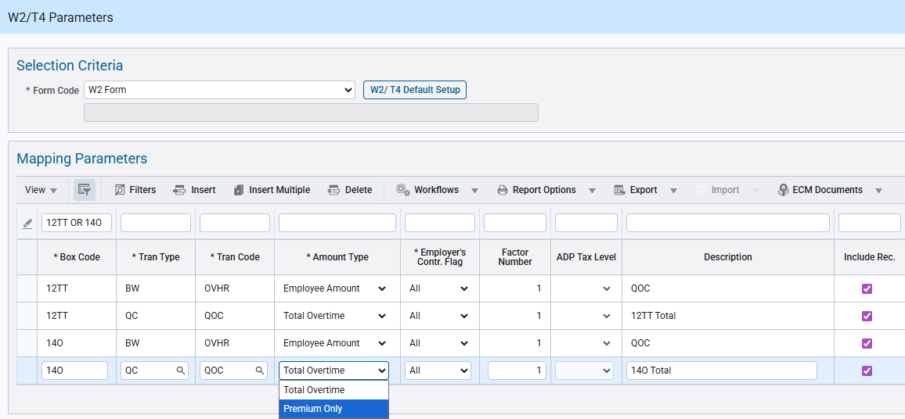
W-2 Mapping Rule – Important
Under W-2 Mapping Parameters, only one Amount Type may be mapped per W-2 box code (12TT for 2026 or 14O for 2025).
Employers must choose either:
Total Overtime – to report the full overtime amount paid, or
Premium Only – to report only the FLSA-required 0.5× Qualified Overtime Compensation (QOC)
Do not map both “Total Overtime” and “Premium Only” for the same W-2 box code.
Mapping both will result in duplicate or incorrect reporting on the employee’s W-2.
CMiC does not enforce this restriction at setup time; it is the employer’s responsibility to ensure that only one mapping exists per box code.
Frequency Limitations
Currently, this screen supports only employees on weekly pay frequency. Bi-weekly frequency is not supported at this time, as the system cannot yet break biweekly totals into weekly segments for FLSA-based OT calculations.
Data Source
All values are pulled from the Payroll History table, where overtime and double-time are stored either through manual time entry or calculated automatically by the CMiC Overtime Rule Processing engine.

Payroll History Enhancement – Store Vertex Subject Earnings for Reporting (HCM-25593)
Payroll Processing Enhancement
Overview

This enhancement updates payroll processing logic to ensure CMiC stores the correct Vertex earnings basis for statutory reporting. Currently, CMiC stores the Vertex Taxable Earnings value in payroll history (PHY_GROSS_EARNING). However, Vertex has clarified that Subject Earnings represent the correct statutory wage base value for reporting such as W-2 Boxes 3 and 5, FUTA, and SUI.
Pre-requisites
• Vertex Payroll Tax PTX integration enabled and active.
• Payroll processing setup is completed for applicable companies.
• Users have access to payroll processing and payroll history inquiry.
• Test data exists with Compensation IDs configured such that Taxable Earnings and Subject Earnings differ.

Modifications
1. Background

Under the legacy PTQ implementation, CMiC consistently assigned Compensation ID as '00'. In that scenario, Vertex Taxable Earnings and Subject Earnings values were identical. With PTX implementation, Compensation IDs are enforced, resulting in cases where Taxable Earnings and Subject Earnings differ due to jurisdictional taxability rules.

2. Issue Description

CMiC currently stores the Vertex Taxable Earnings value into PHY_GROSS_EARNING for all payroll runs. This is incorrect for statutory wage base reporting. Vertex has clarified that Subject Earnings must be used for statutory reporting (Social Security, Medicare, FUTA, SUI, etc.).

3. New Payroll History Column

A new column PHY_TAXABLE_EARNING may be added to the payroll history table (PYEMPPAYHIST). This field stores Vertex Taxable Earnings for audit and reporting reference.

Implementation

Column added in DB under table pyemppayhist

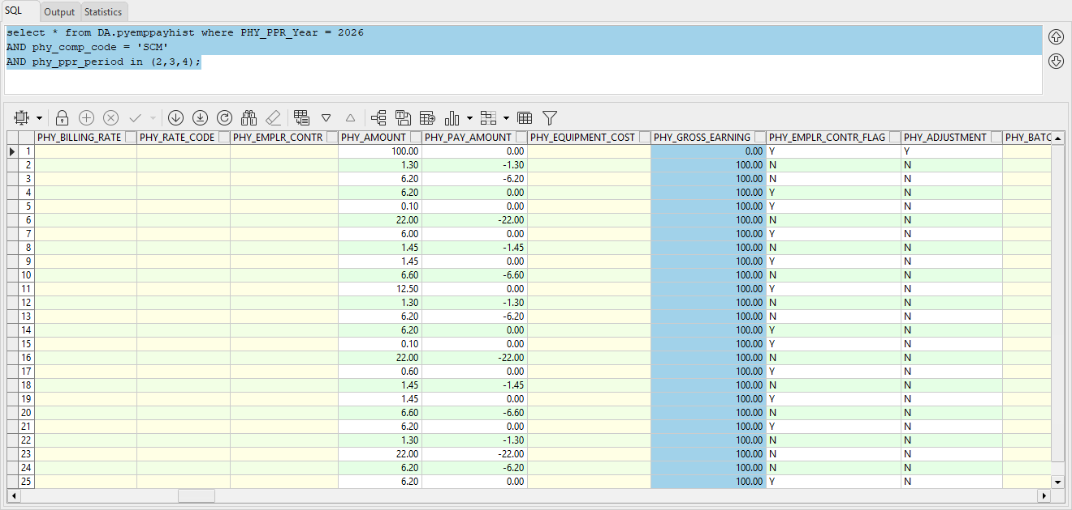

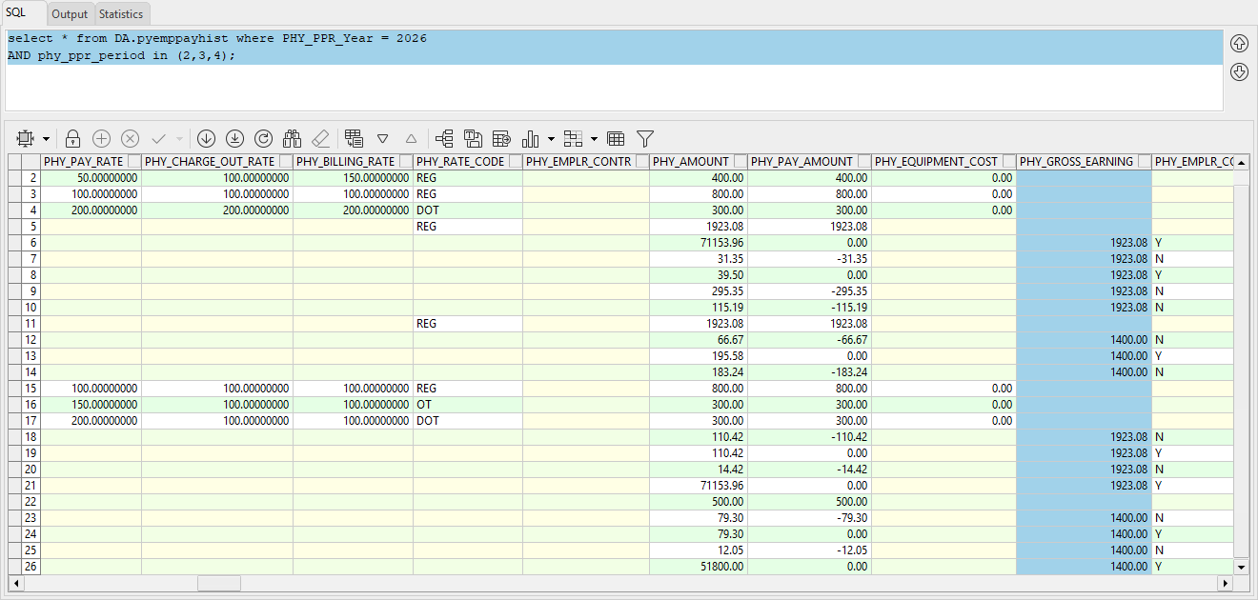

Mid-Year Pay History

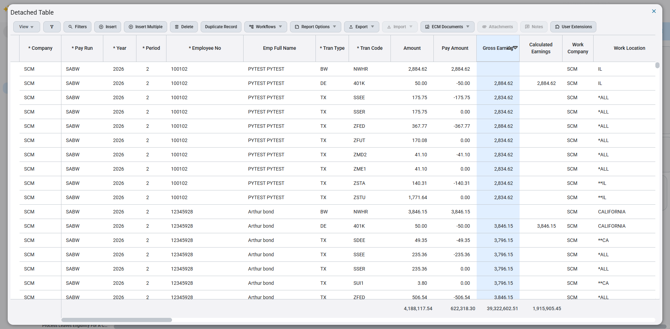

Prevailing Wage Benefit Enhancement – OT/DOT Rate Override (HCM-25730)
Overview
This enhancement introduces an option to override the prevailing wage benefit calculation for overtime (OT) and double overtime (DOT) hours. Three new fields are added to the Benefits by Trade screen: OT/DOT Multi Flag, OT Pay Rate, and DOT Pay Rate. When enabled, the system uses the user-entered OT and DOT pay rates to calculate Prevailing Wage Benefit for OT/DOT lines instead of using the multiplier-based method.

Pre-requisites

• Prevailing Wage setup is completed (Benefit Master, Job Work Locations, Prevailing Wage Differential Destination).
• Benefits by Trade records exist for applicable trades.
• Users have security access to update Benefits by Trade configuration.
• Payroll processing configured to generate NWHR, OVHR, and DTHR benefit wage lines.

Modifications

1. Benefits by Trade Screen Enhancements

The Benefits by Trade screen now includes the following new columns:
• OT DOT Multi Flag
• OT Pay Rate
• DOT Pay Rate
If OT DOT Multi Flag is selected, OT Pay Rate and DOT Pay Rate become mandatory and must be entered.

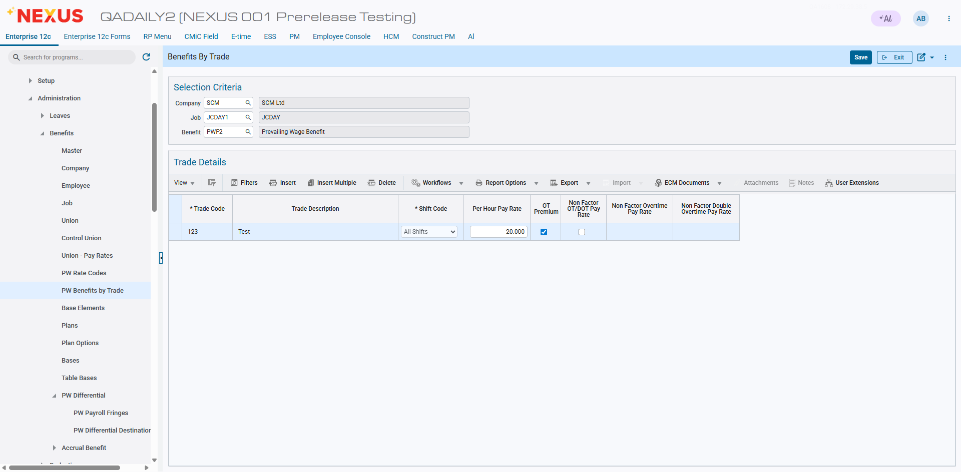

2. Prevailing Wage Benefit Calculation Logic

When OT DOT Multi Flag is enabled and OT/DOT rates are entered:
• OVHR wage benefit lines use OT Pay Rate.
• DTHR wage benefit lines use DOT Pay Rate.
• The multiplier method is bypassed for OT/DOT calculation.
If OT DOT Multi Flag is not enabled or rates are not provided, the system continues using the existing multiplier method.

Implementation

Scenarios:

Non-Factor OT Rate as 25

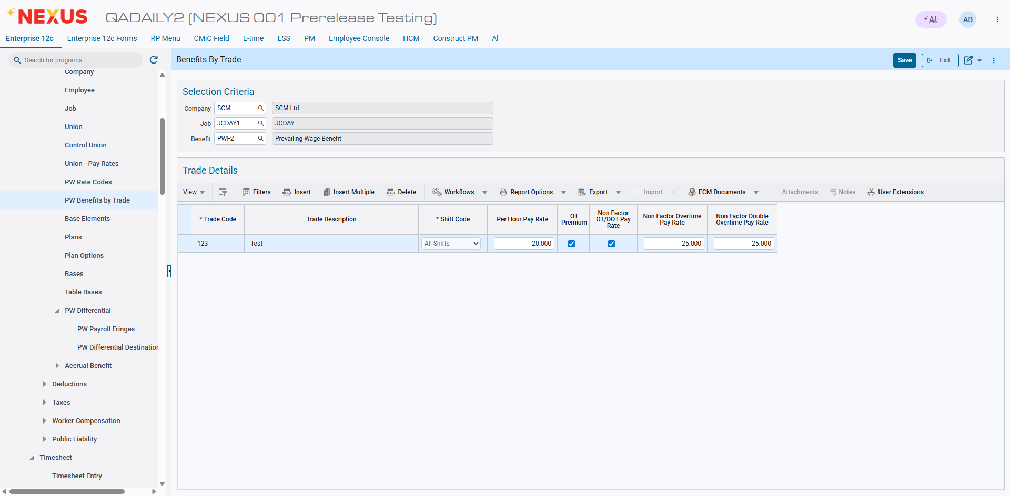

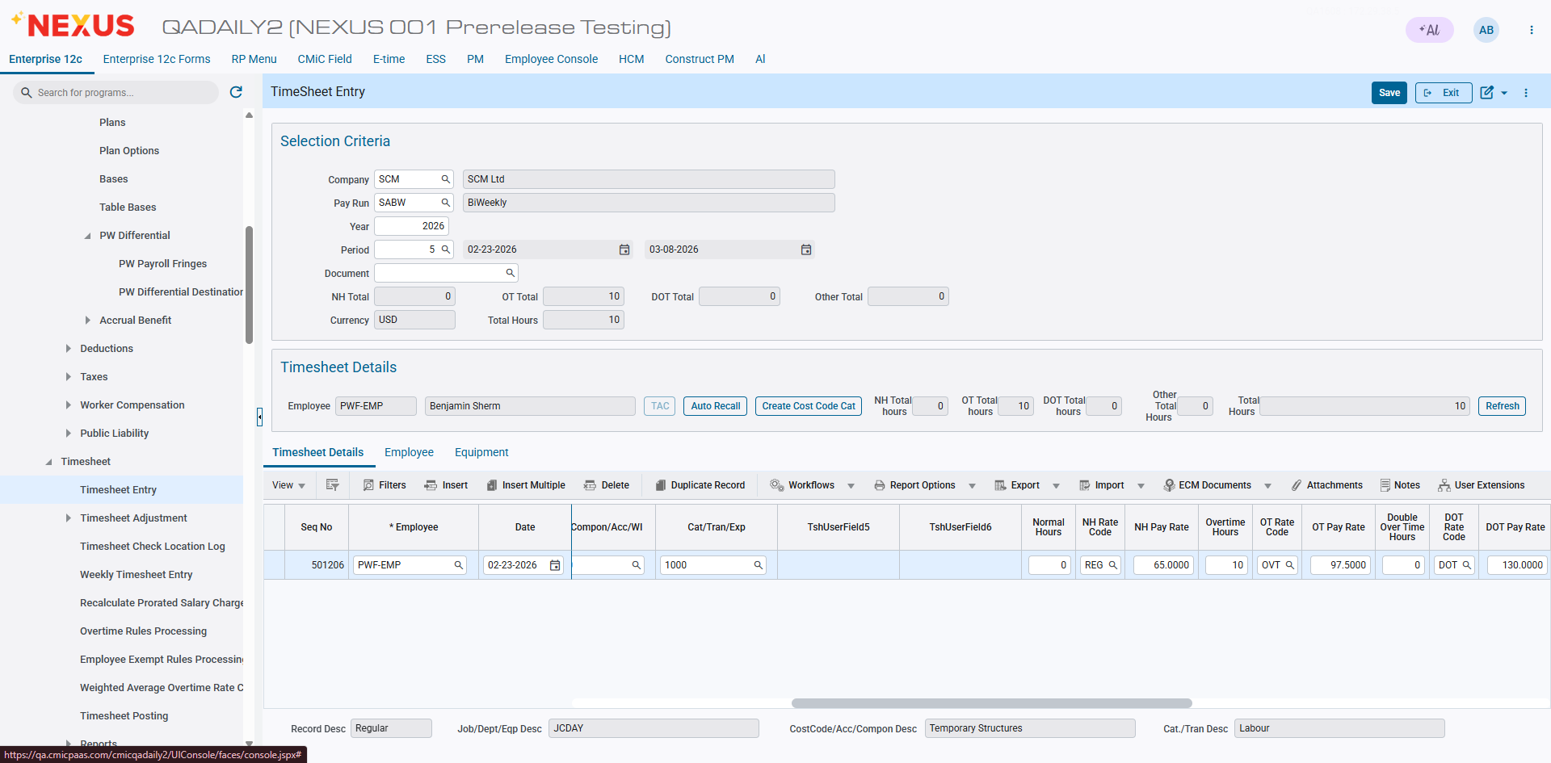

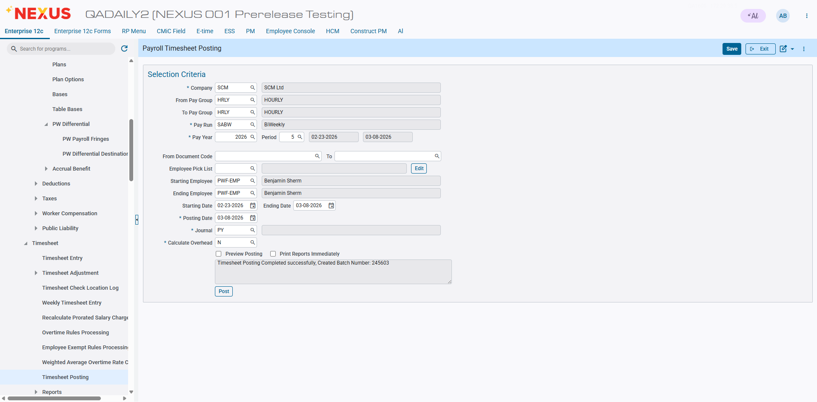

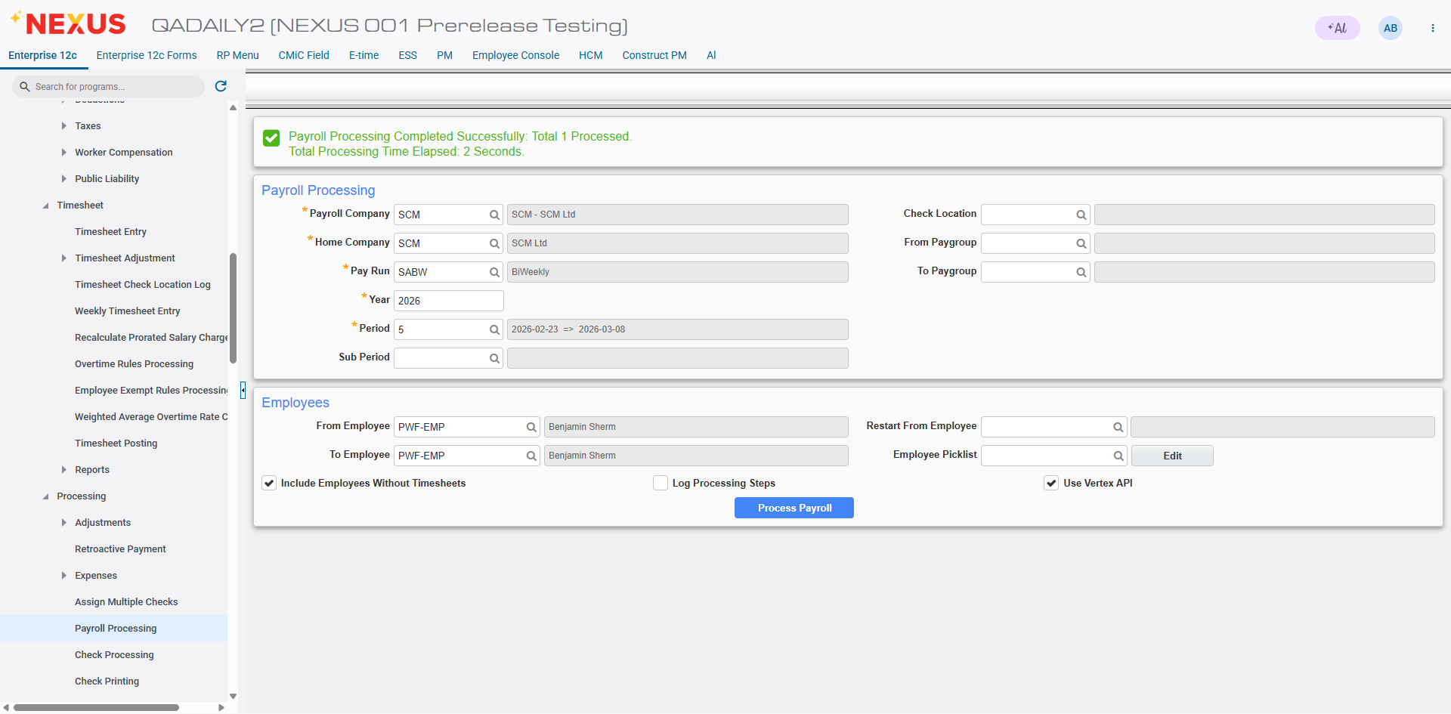

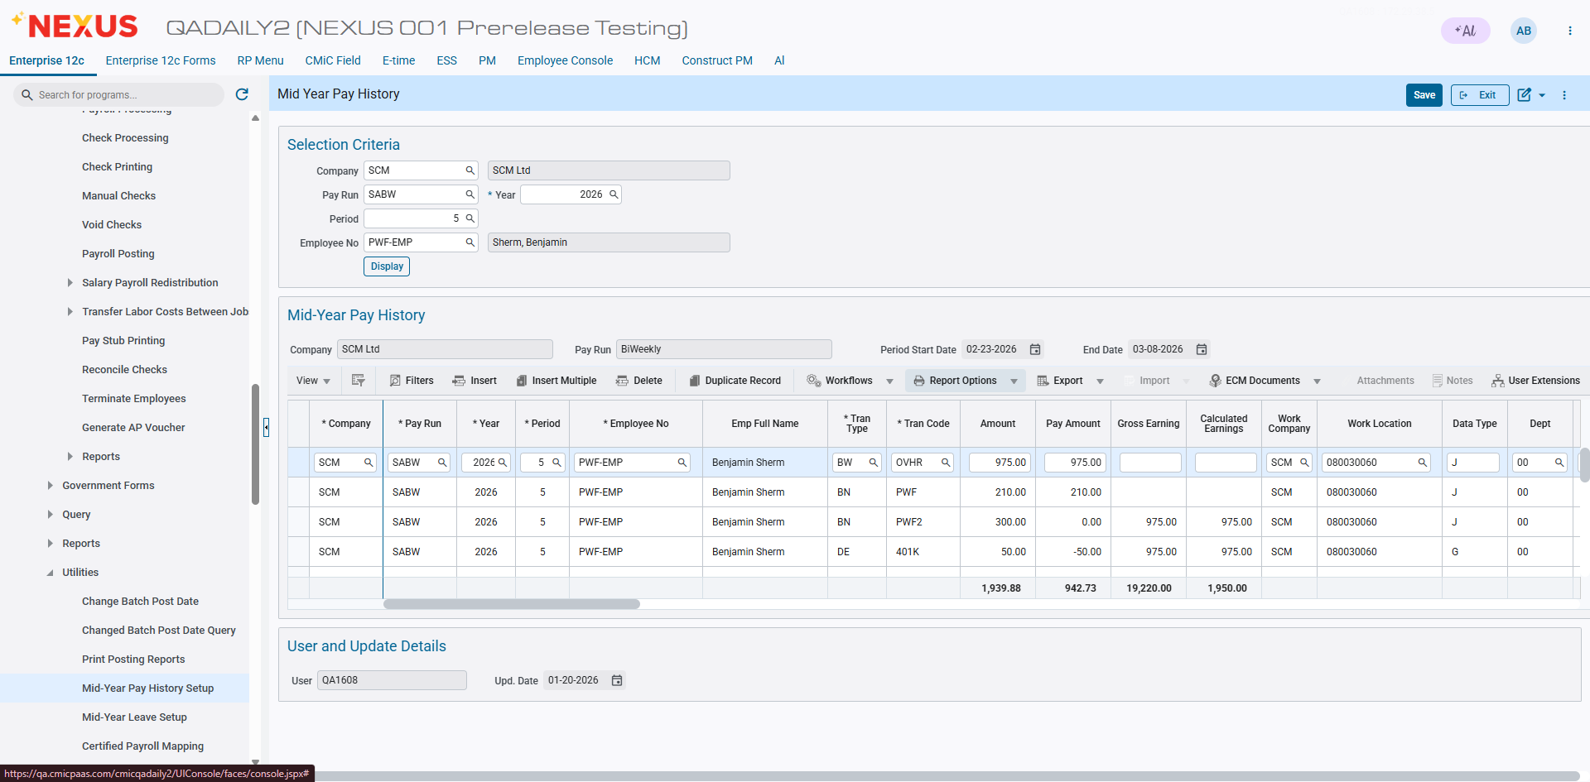

Nebraska Health Families Workplace Act (HCM-26176)
Overview
This enhancement introduces flexibility in the Sick Leave Policy wait period calculation. Currently, the system calculates the accrual start date using a fixed number of wait days after the greater of Hire Date or Sick Policy Start Date. The new enhancement adds the ability to calculate the wait period either by Days or by Hours worked.

Pre-requisites

• Sick Leave Policy setup exists.
• Payroll processing configured to calculate leave accrual.
• Users have access to maintain Leave Policy configuration.
• Historical payroll data available in PYEMPPAYHIST for hour validation.
Modifications

1. Leave Policy Screen Enhancement

A new LOV field 'Wait Method' is added next to 'New Hire Wait Period Accrue Starts'.
Options:
• By Days (Default)
• By Hours
The text '(days)' is removed from the display label to support both calculation methods.

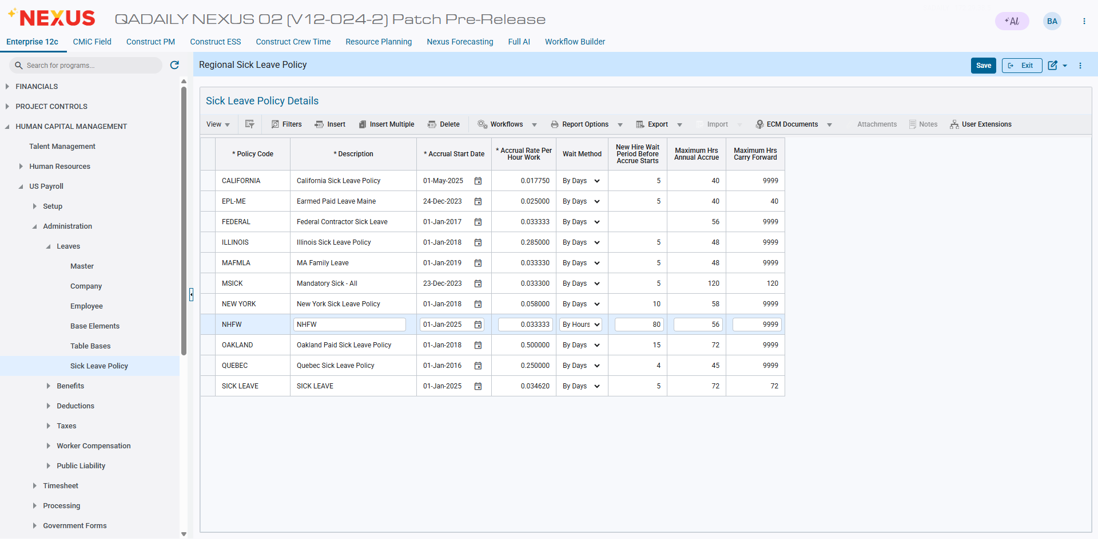

2. Wait Period Calculation Logic

The accrual start date (p_accrue_start_date) continues to be passed to F_GET_SICK_LEAVE_POLICY_HRS during payroll processing.

When Wait Method = By Days

• System calculates accrual start date using:
GREATEST(Hire Date + Wait Period, Policy Start Date)
• Accrual begins after the defined number of calendar days.

When Wait Method = By Hours

• System calculates total hours worked by the employee.
• Hours are derived from BW lines in PYEMPPAYHIST.
• Accrual begins only after the employee has worked the defined wait period hours.
Implementation
Scenario:

- Wait Period by Hours

Accrued Leave Calculation:
Accrued Leave = Accrual Rate × Hours Worked
= 0.033333 × 16
= 0.53 (rounded)
Accrued Amount Calculation:
Total wages for Period 7 (16 hours) = 1600
Hourly rate = 1600 ÷ 16 = 100
Accrued Amount = Accrued Leave × Hourly Rate
= 0.53 × 100
= 53

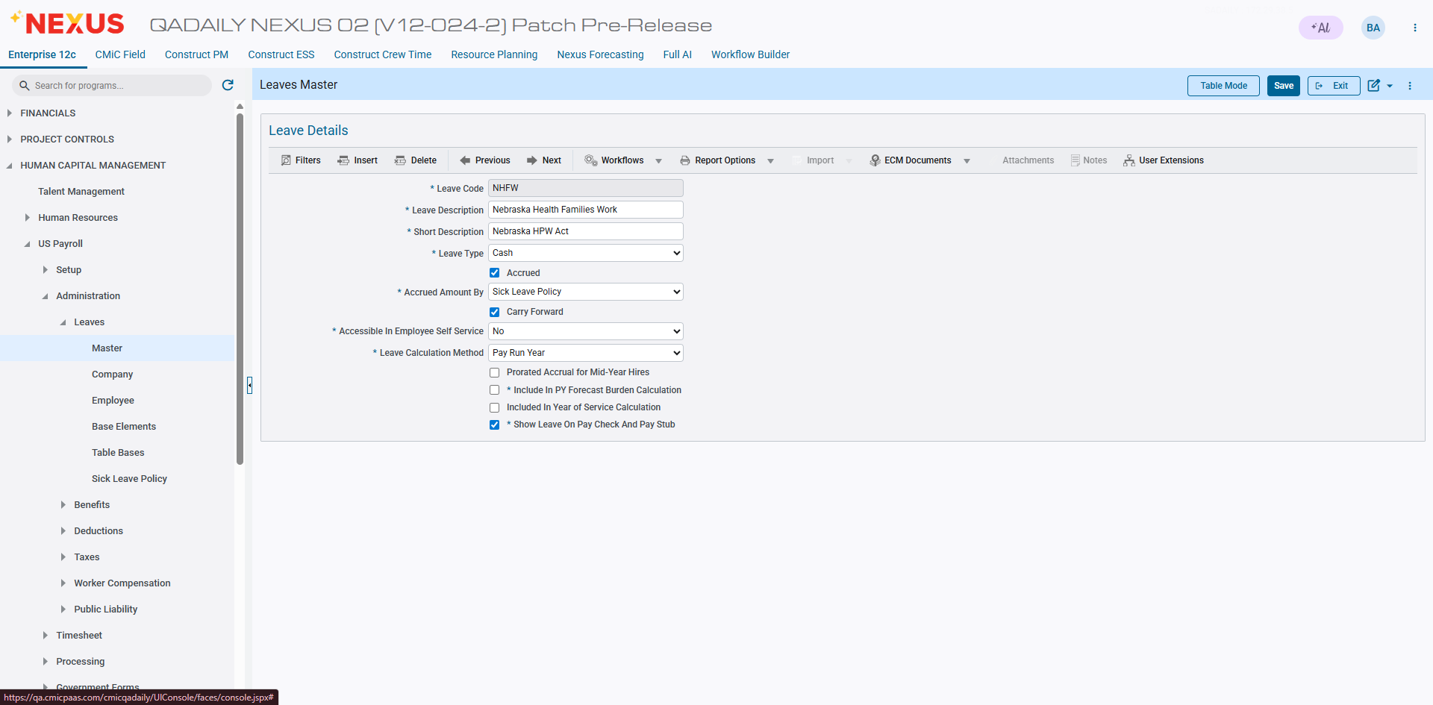

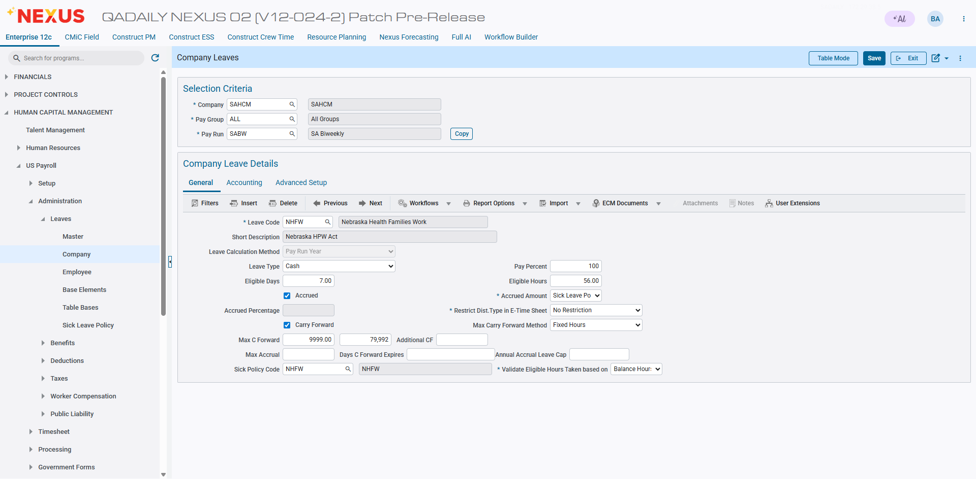

EMP3-26176
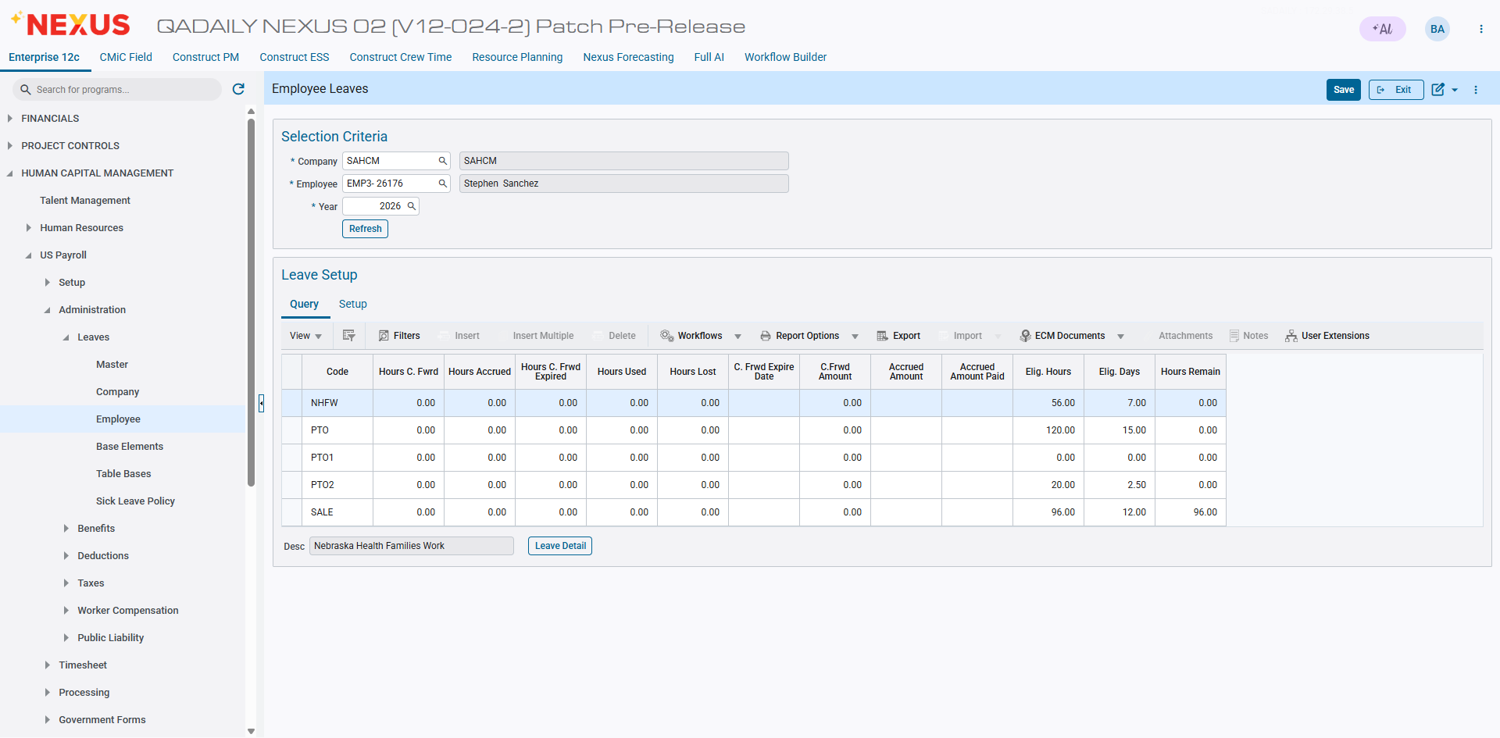

Period 4 - 4 hours each day

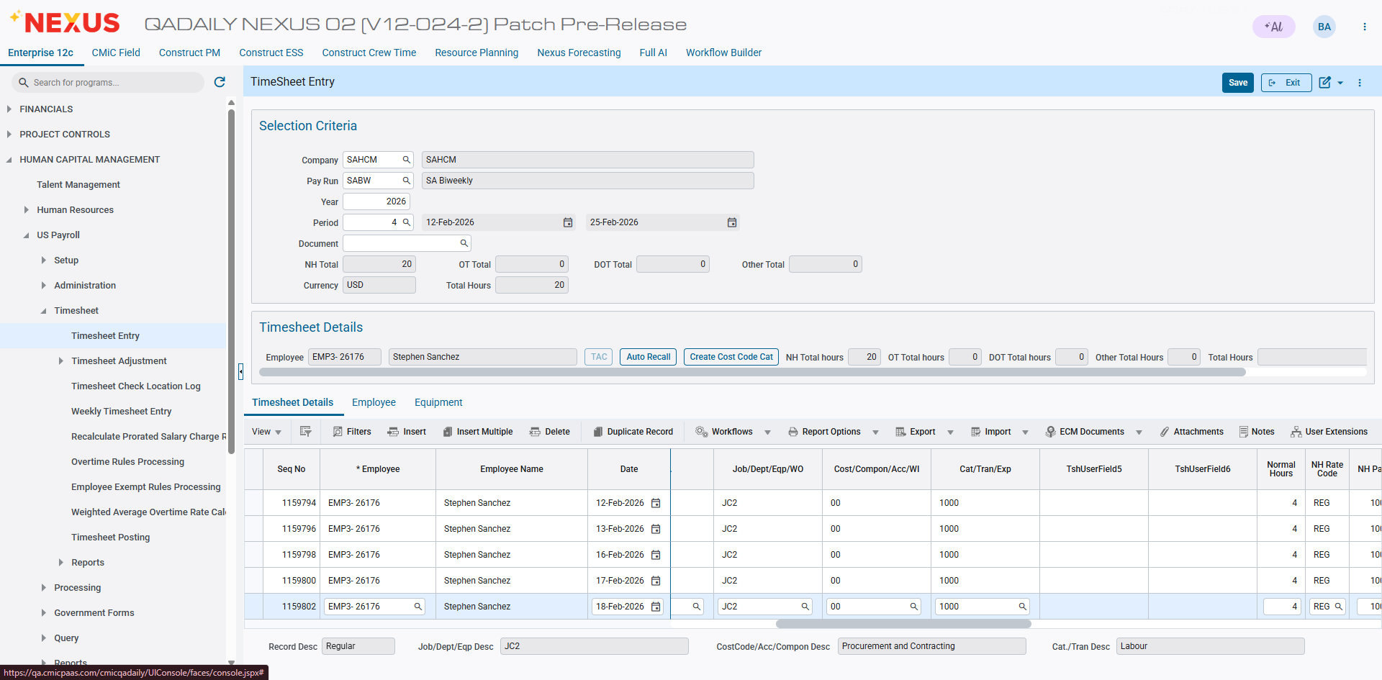

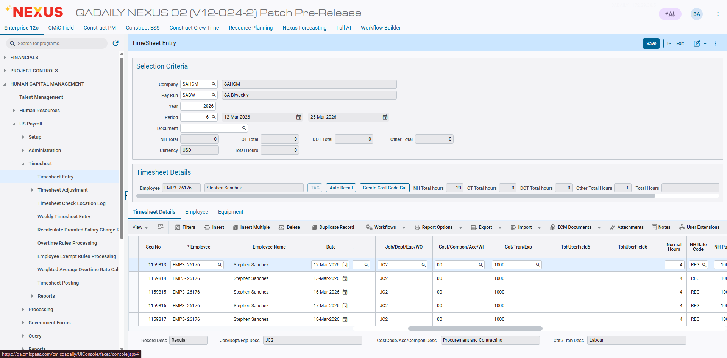

Posted, payroll and check processed – No sick accrual in period 4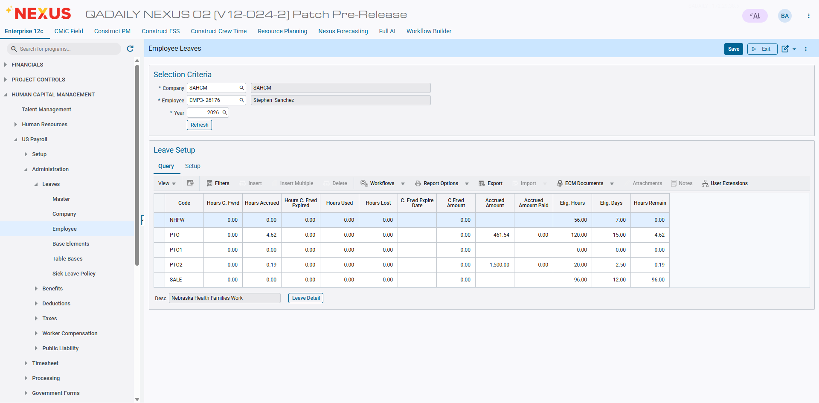

Period 5
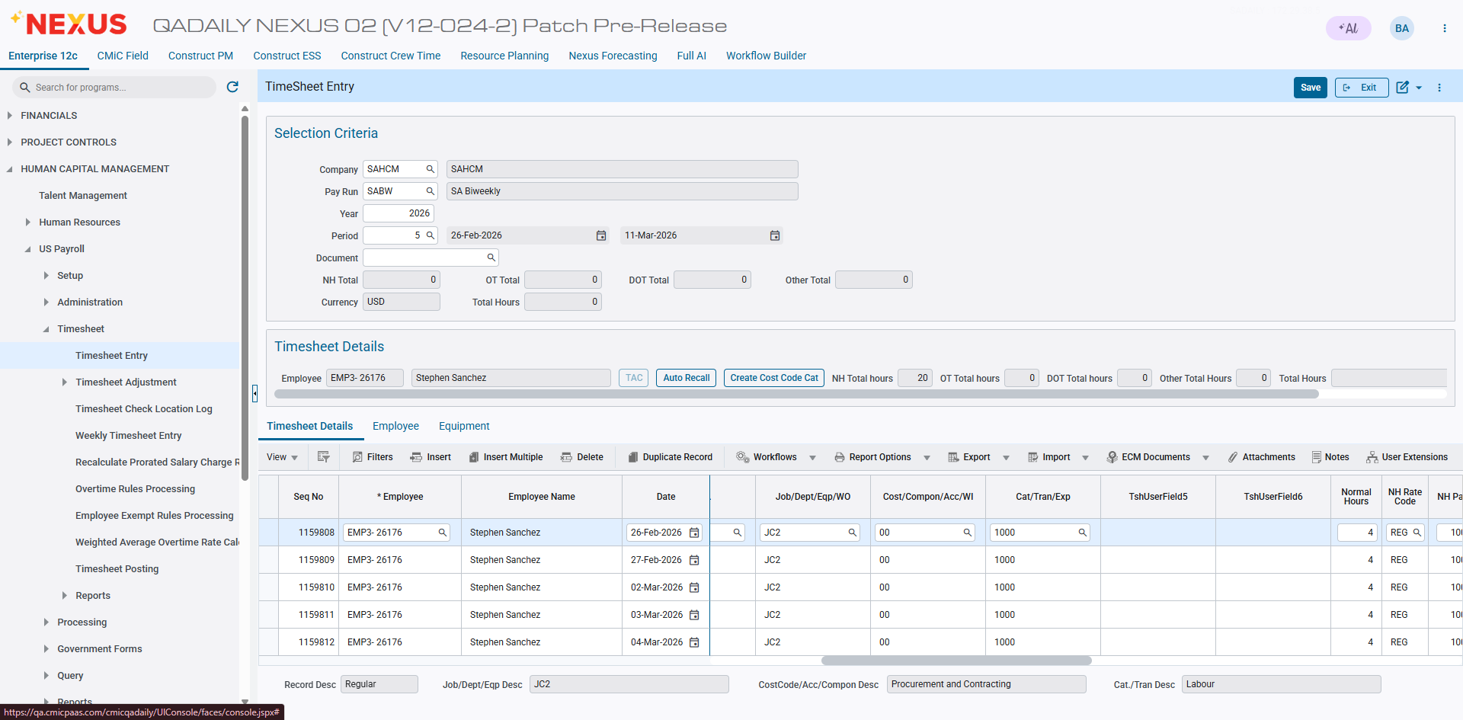
Posted, payroll and check processed – Still no sick accrual in period 5

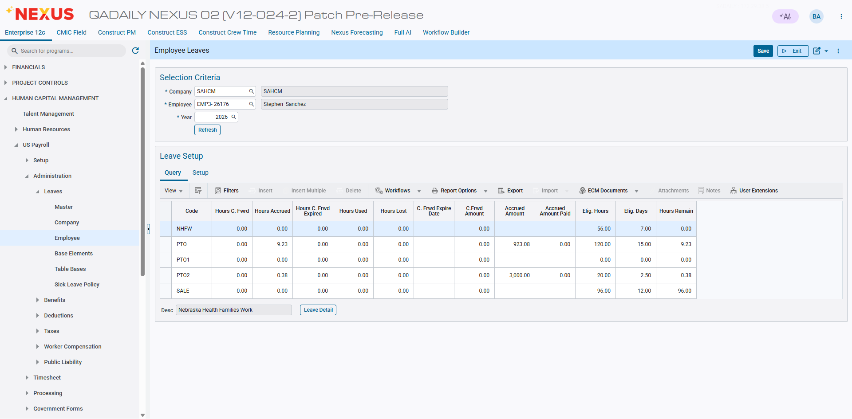

Period – 6

Posted, payroll and check processed – Sick Hours not accrued in period 6
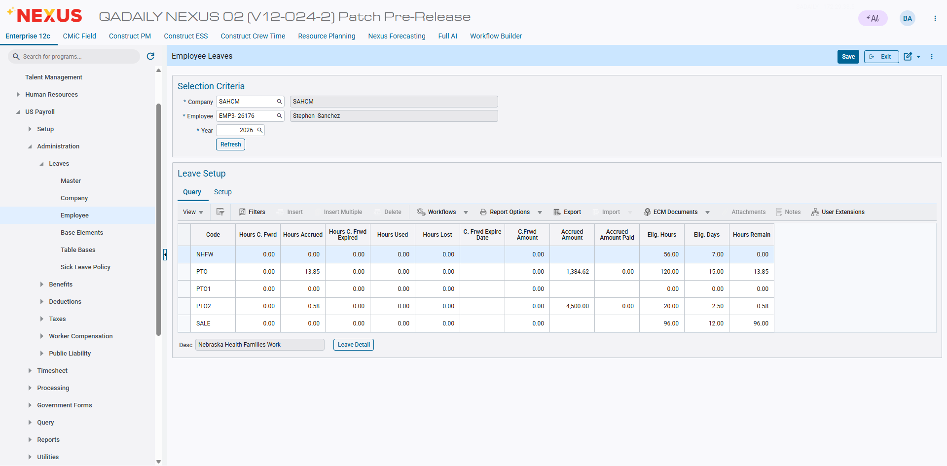

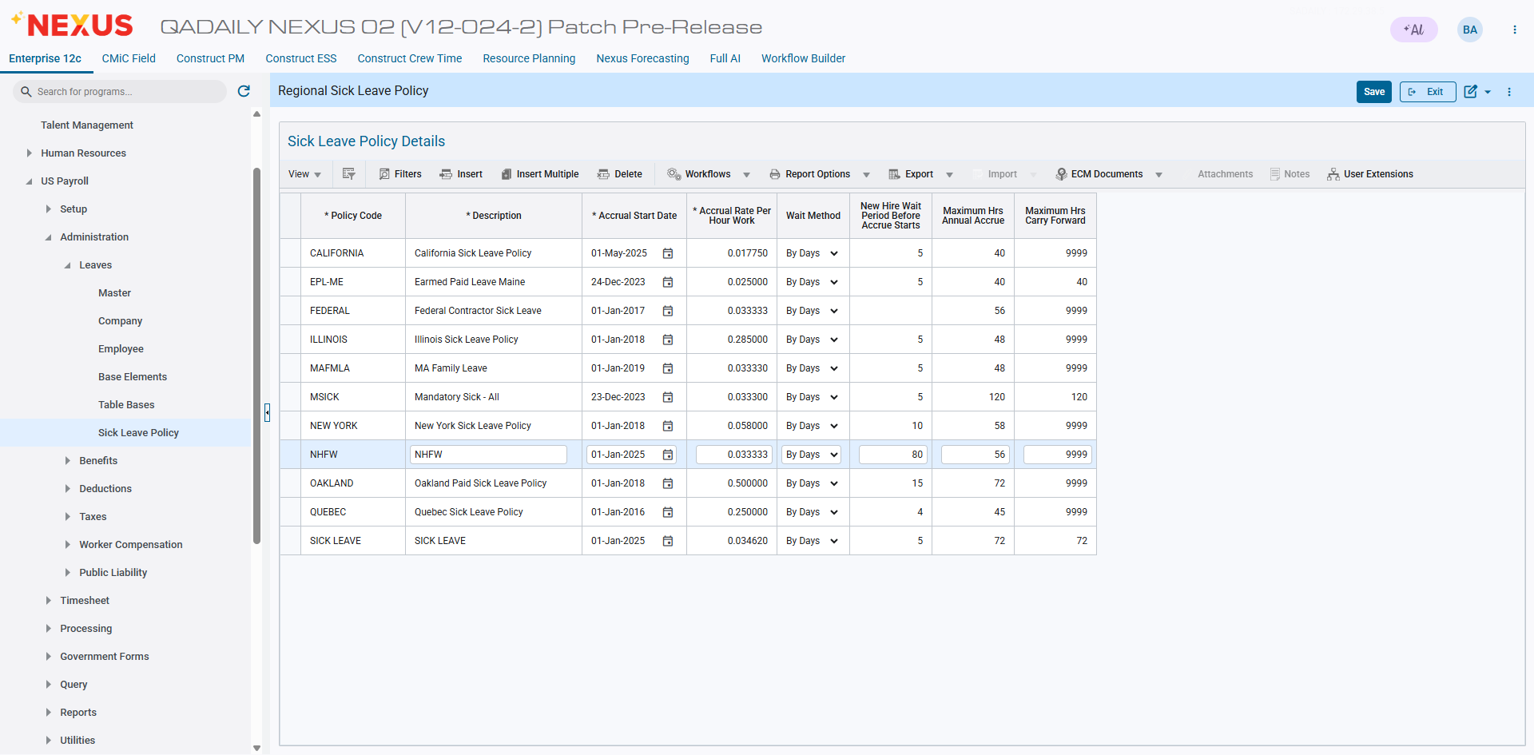

Period – 7
Hours Entered 16

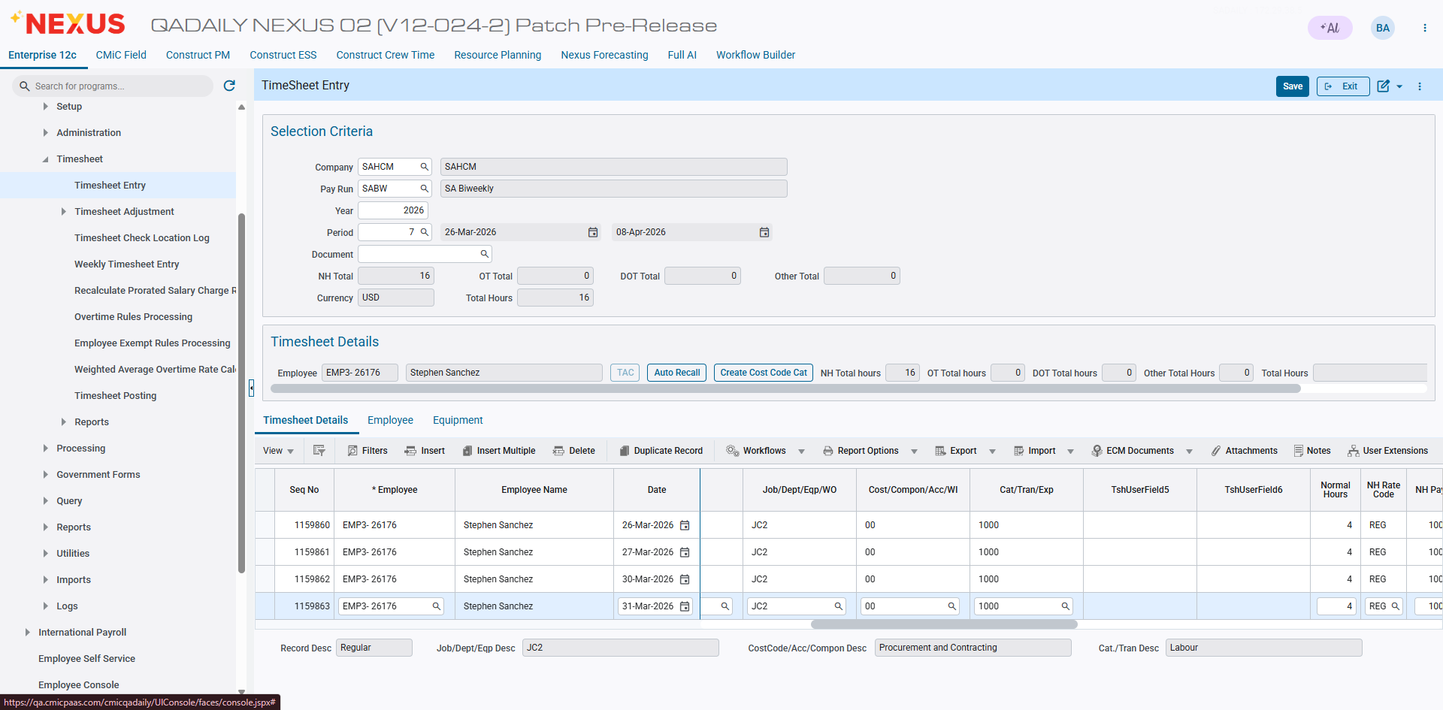

Posted, payroll and check processed – Sick Hours accrued in period 7

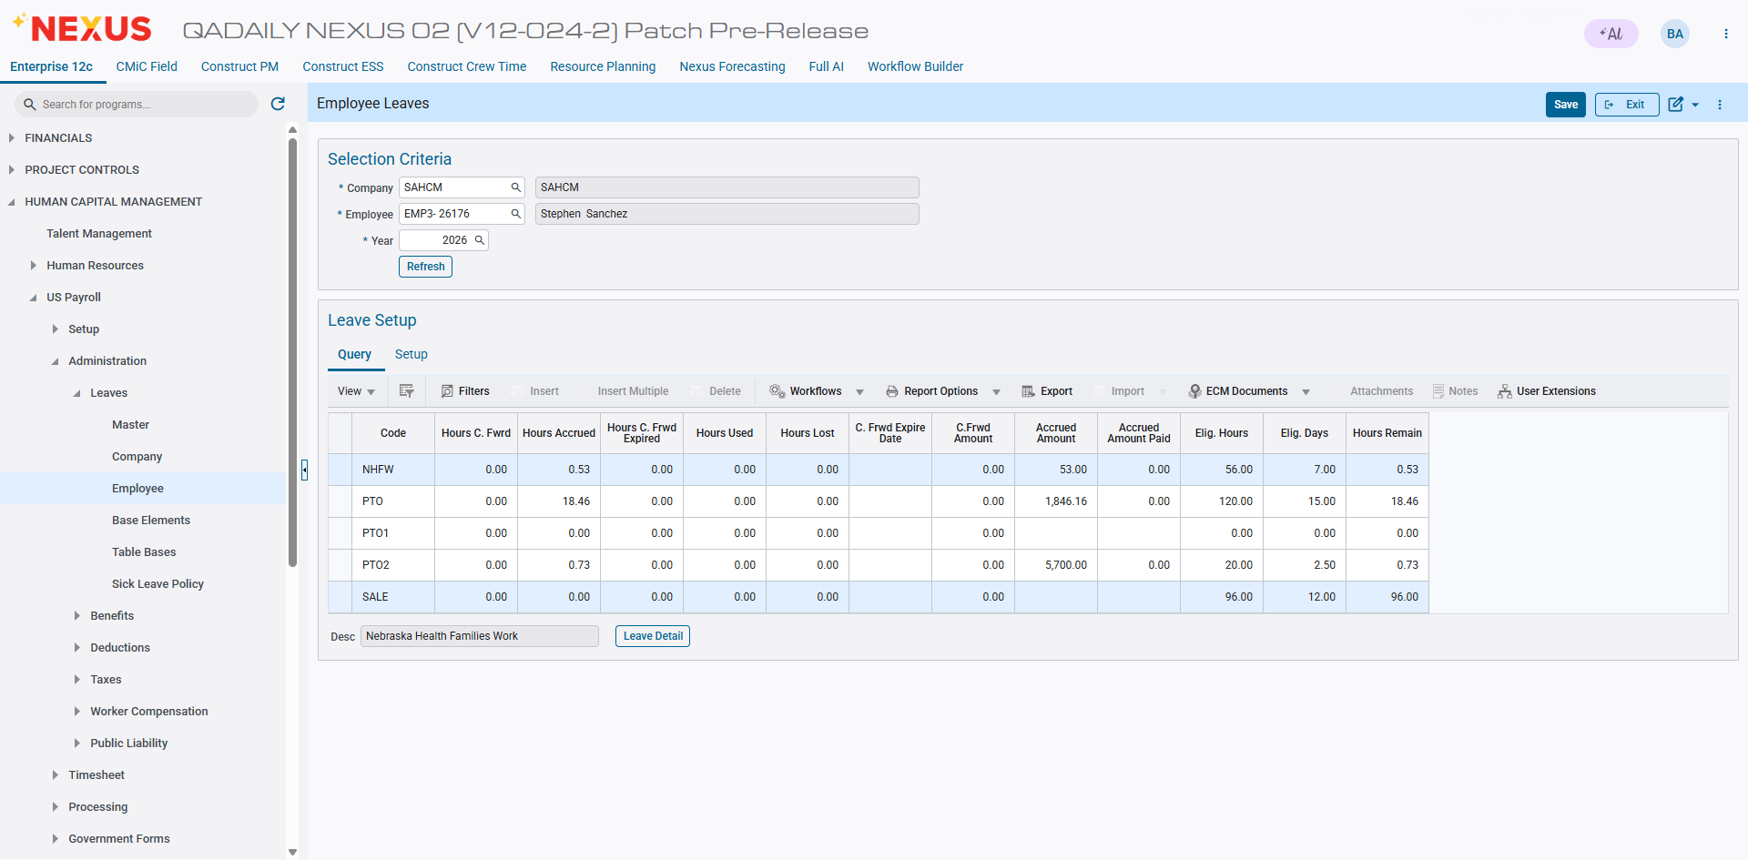

Project Management

Request for Payment - Payment Mode and Paymode Type (FIN-19656)
Two new fields: ‘Payment Mode’ and ‘Paymode Type’, have been added to the Request for Payment screen in CMiC Field. These fields default to the values configured for the vendor on the Maintain Vendor screen under the Accounting tab for Third-Party Payments.
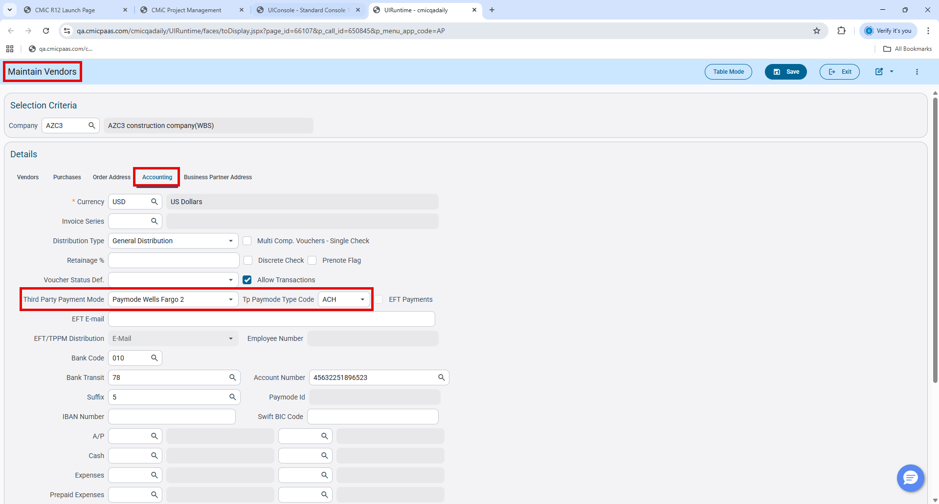
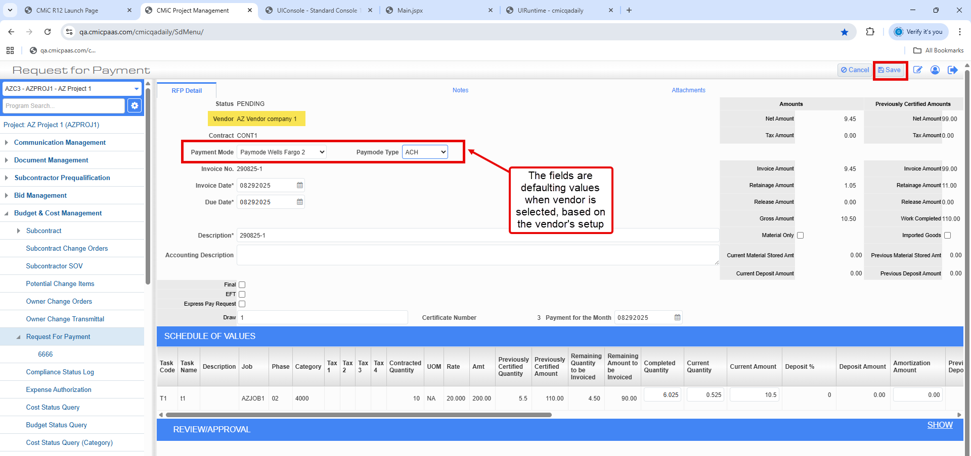
A validation message has been implemented to appear when the Paymode Type field is left blank on the RFP screen.
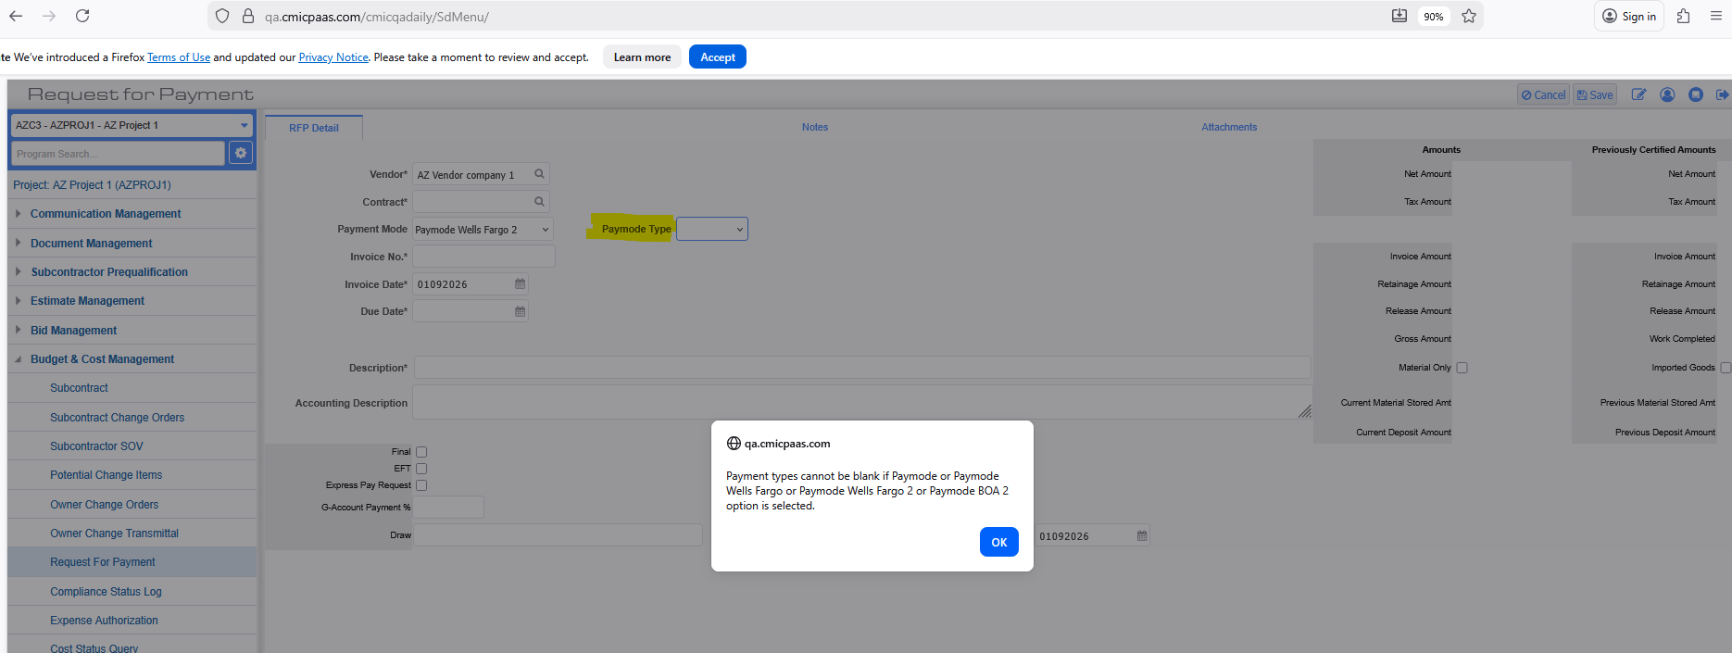
Additionally, a validation message has been implemented when a Payment Type is selected that differs from the following specified Payment types:
- Paymode
- Paymode Wells Fargo
- Paymode Wells Fargo 2
- Paymode BOA 2
This validation is applicable when users attempt to select the 'Paymode Type’.
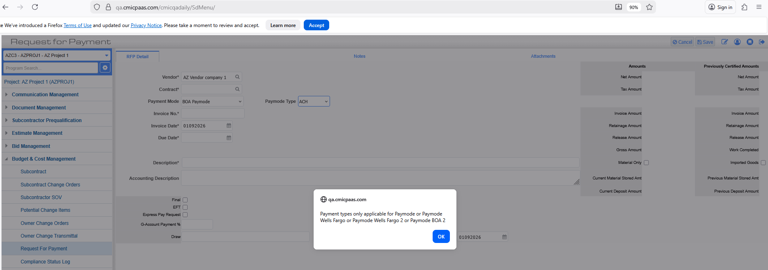

Checklist Templates - Warnings for Removing Tags (CF-27855)
When removing checklist template tags at the system or project level, the application previously did not display a warning or confirmation message. As a result, users could remove checklist template tags without being informed of the potential impact of their action. To prevent accidental removal, a warning or confirmation message is now displayed before tags are removed at the system or project level.
System Checklist Template:
After clicking the “X” icon, all tags associated with the selected template are removed, and a warning message is displayed to inform the user about the action:
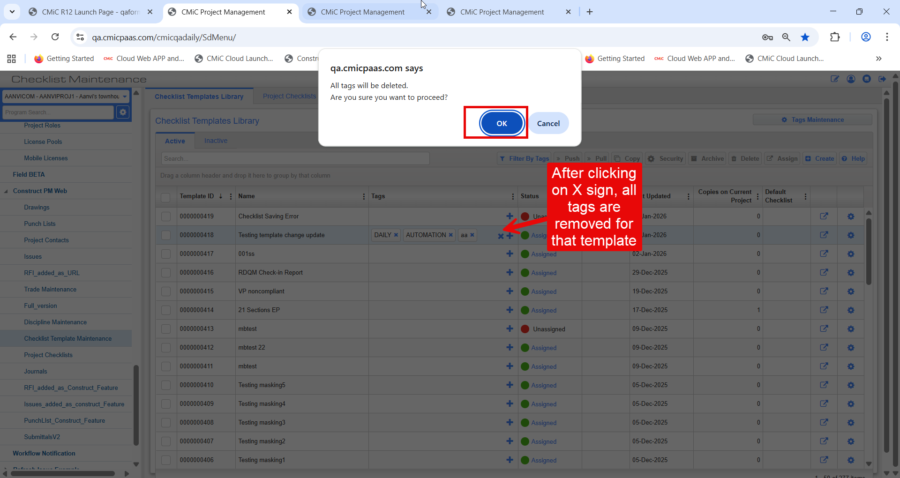
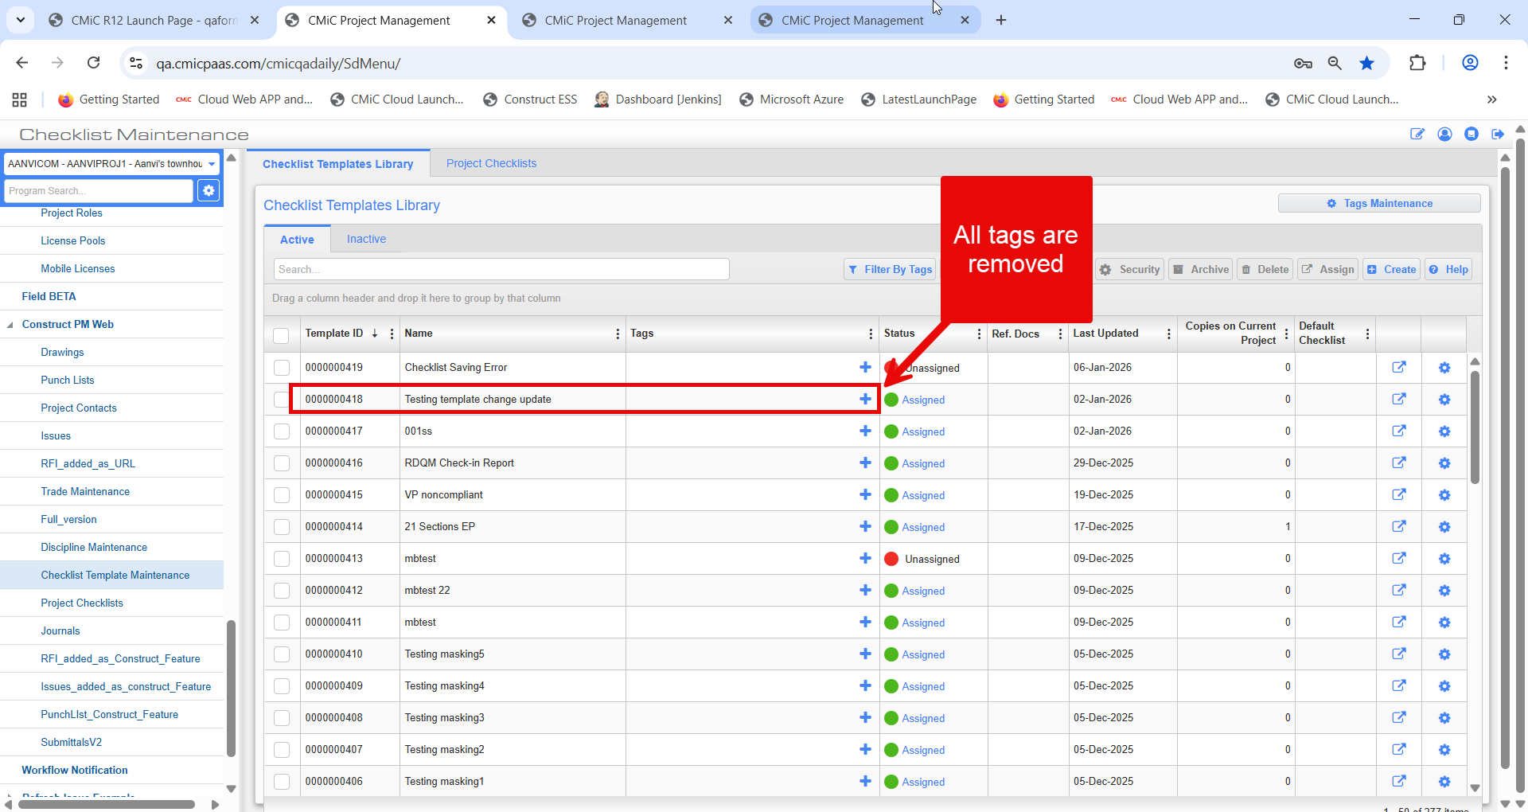

Project Checklist Template:
After clicking the “X” icon, all tags associated with the selected template are removed, and a warning message is displayed to inform the user about the action.
NOTE: The “X” icon for removing tags is displayed only for project-level checklist templates. If a project-level checklist template is linked to a system-level checklist template, the “X” icon is not displayed for tags.

Project-level checklist template is linked to a System-level checklist template:
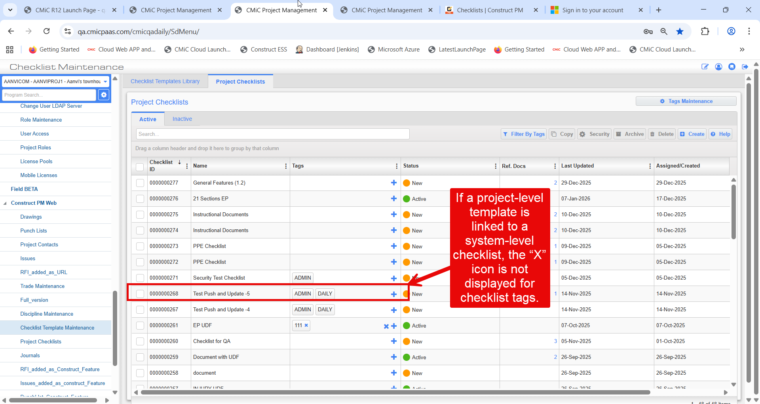

Project-level checklist template not linked to a System-level template:
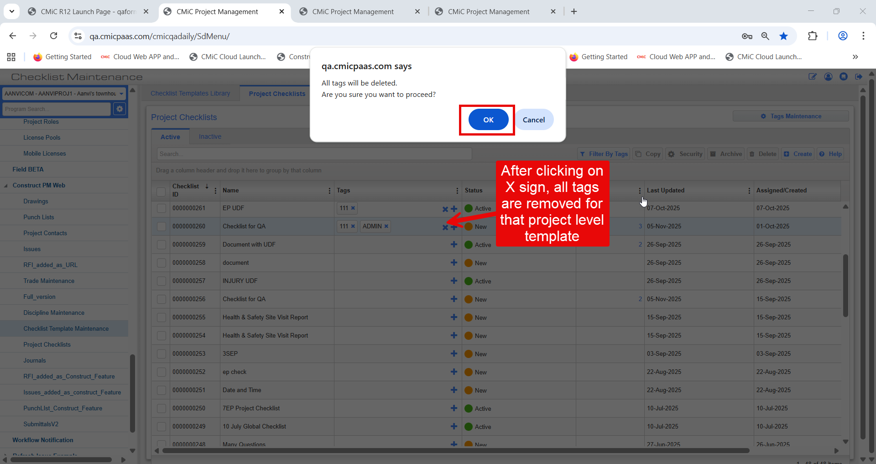
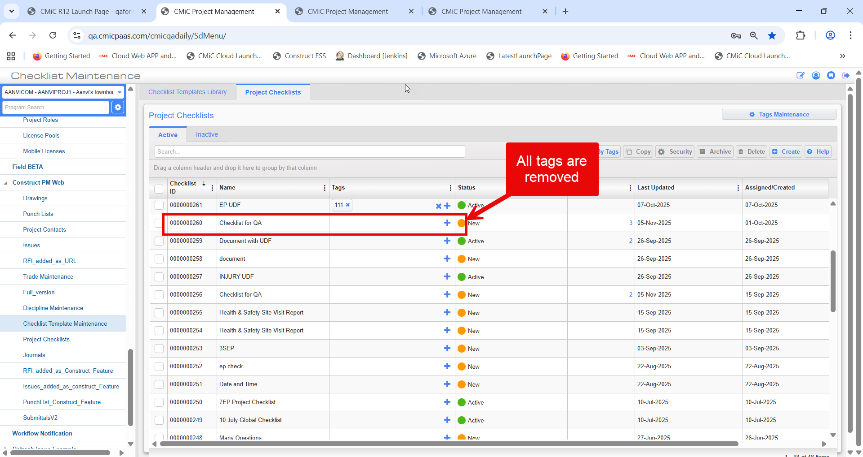

Punch List Report (PMPL02) Enhancements (CF-31239)
Modifications
The title sheet of the PMPL02 report has been enhanced to display both the Description and the Record Number concurrently.
Fields Updated on Title Sheet:
- Description: Restored to the title sheet to be displayed alongside the Record Number for better report identification.
- ​Record Number: Continues to be displayed as a primary identifier in the report header.
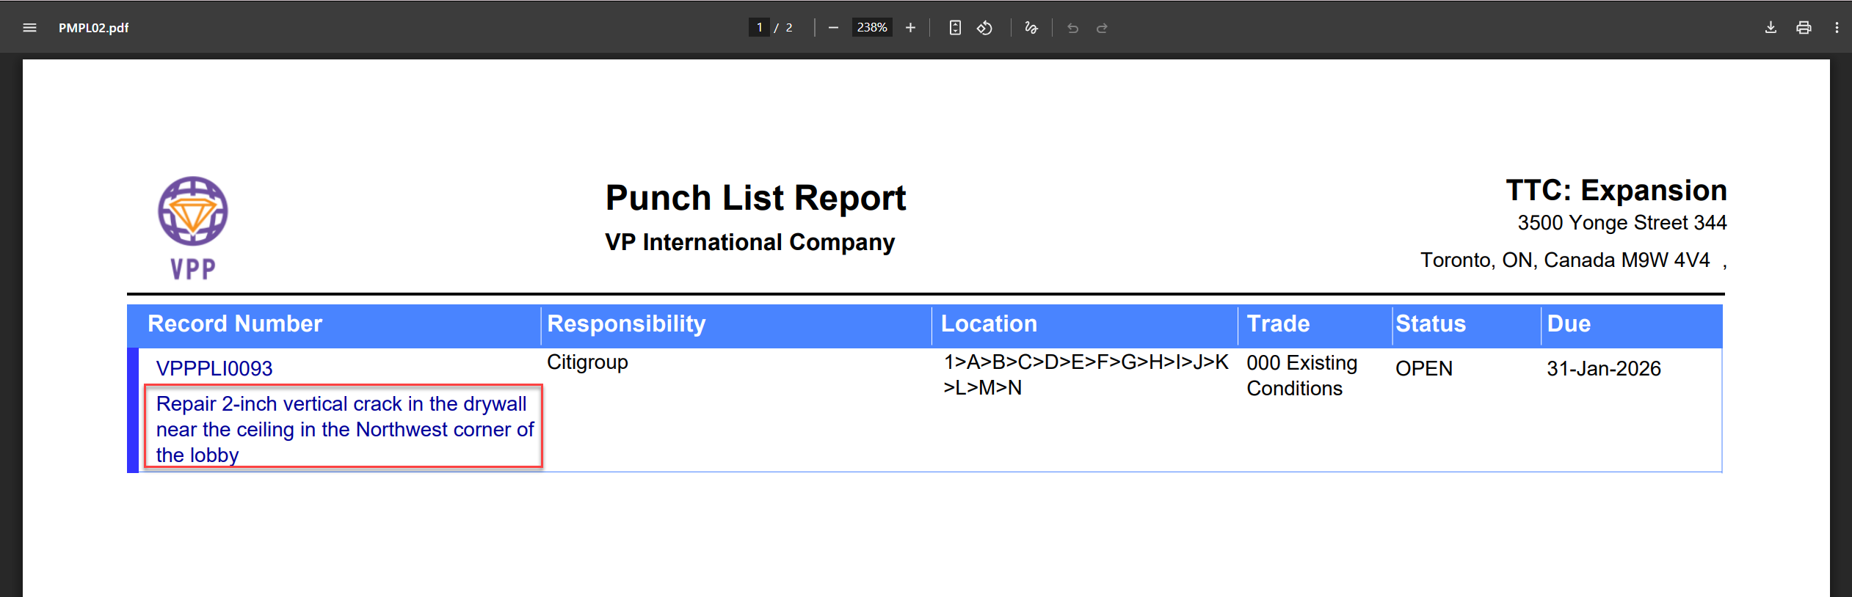

New Projected Final Flag Type and Forecasting (Beta Version) (PC-7126)
Overview
CMiC has introduced a new Projected Final Flag type named as Projected Cost Forecast represented by the code – F. This new type can be set to default for the Company in the Job Cost Control file and can be overridden at the Budget level like the other existing types (Ex. C, S, L). Billing Codes with this type can also included in the Standard Contract Forecasting program and used to forecast cost and revenue based on the system defined rules and calculations.
In addition, new flags in Job Cost Control as well as new columns in Contract Forecasting have been introduced to provide the user with more control and detail when forecasting the Job/Contract.
Setup
- To view the newly added flags in the Job Cost Control, user needs to expose them using the Lite Editor. (Refer section on New Job Cost Control Flags for more information).
- To view the newly added columns in Contract Forecasting program, the respective column’s field security for the specific user role should be set to ‘Unrestricted (Read-Only)’. (Refer section on New Contract Forecasting Columns for more information).
Implementation
Projected Final Flag Type – Projected Cost Forecast (F)
The new Projected Final Flag Type – Projected Cost Forecast (F) is available for selection in the Job Cost Control file from the drop-down menu under the Job Setup tab.

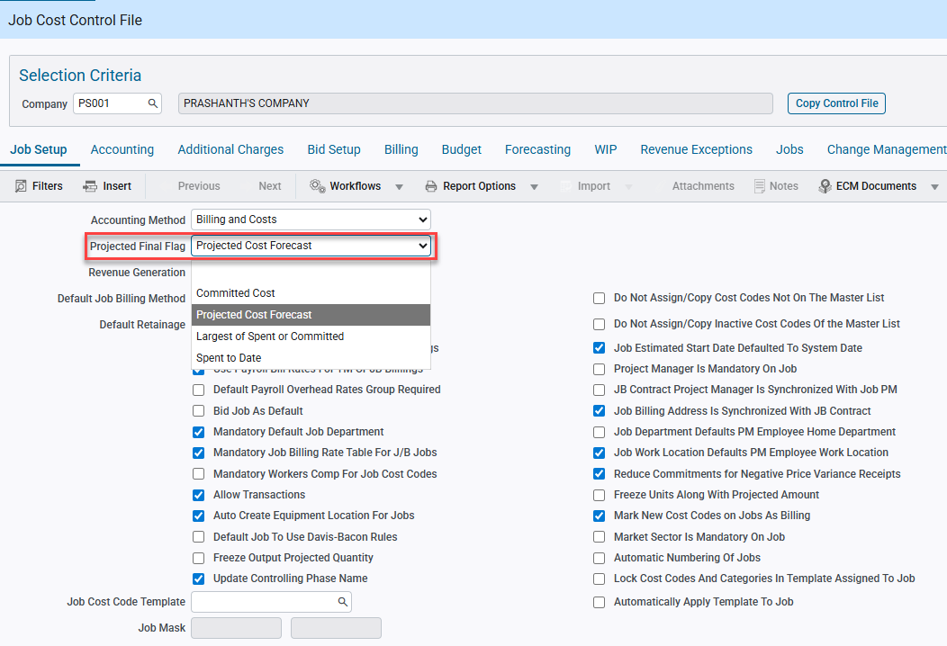
Pgm: JCCTRLFM; Path: Project Controls > Job Costing > Setup > Local Tables > Control File

If selected, for any newly created Job the Cost Code and Category lines in the Enter Budget screen will have their Projected Final Type automatically set to F which can then again be overridden to other valid types on a case-by-case basis.

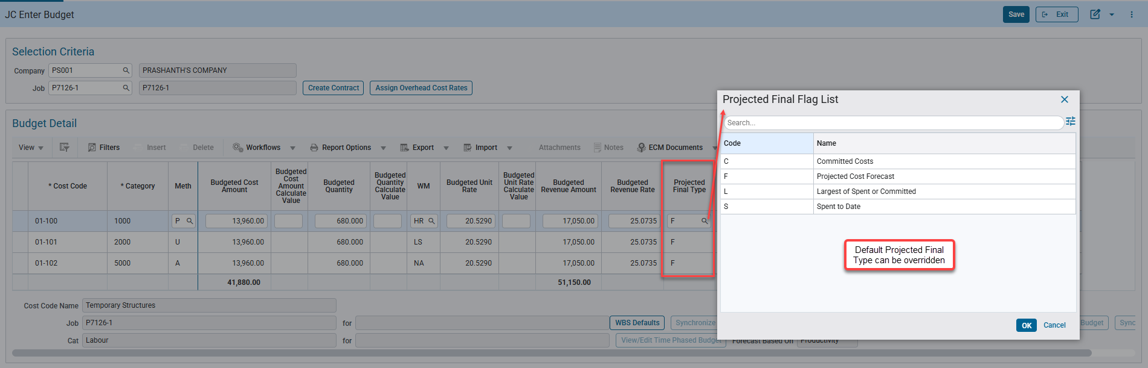
Pgm: JCBUDGET; Path: Project Controls > Job Costing > Job > Enter Budget
Billing Codes with the F Projected Final Type are also included in the Standard Contract Forecasting program and follow the below rules:
- Projected Cost Forecast will always be in sync and matches the Projected Cost Forecast Including Pending CO as well as the WIP Projected Cost Forecast.
NOTE: This is true even if the newly introduced flag in JC Control – “Sync Projected Cost and Projected Cost Including Pending PCI” is unchecked. (Refer section on New Job Cost Control Flags for more information.
- Projected Cost Forecast = Projected Cost Budget, unless there are overrides to the Forecast.
- For F type Bill Codes, forecast overrides can be either directly made via the main forecasting screen or via the popups (Productivity/Units/Cost Detail). Any overrides made to the Projected Cost Forecast also updates the Cost to Complete, Projected Cost Forecast Including Pending CO and the WIP Projected Cost Forecast amounts
- Once the amounts are overridden, they can neither be cleared manually (i.e. removing the Go Forward Overrides in the popup) nor via the Clear Overrides button in the header.
- The overrides remain even if the user later creates Pending or Posted Change Orders causing the Projected Cost Budget to change.
NOTE: Once Projected Cost Forecast is overridden, it will no longer be in sync with the Projected Cost Budget in that period.
- Clicking on Retrieve Overrides won’t update the override amounts in the current period.
- To carry the overrides into the future period, the forecast must be stored for the current period and the JC Control flag “Copy Last Stored Forecast” should be checked. Else, system will recalculate the forecast and other amounts for the upcoming period based on the normal rules and logic.
- If overrides are carried forward to the next period, then depending upon the following rules, the Projected Cost Forecast amount overrides in the future period will be color coded.
  - If override is only less than the Spent/Committed Total amount, then the amount will be highlighted in yellow (Will be shaded orange in Kendo Forecasting program). Hovering the cursor on top of the highlighted amount will display the following message – “Projected Cost Forecast override is less than Spent/Committed Total amount”.
  - If the override is also less than the Actual Spent amount, then the amount will be highlighted in red. Hovering the cursor on top of the highlighted amount will display the following message – “Projected Cost Forecast override is less than both the Spent/Committed Total and Actual Cost amounts”.
NOTE: Overridden forecast amounts won’t be color coded in the same period when the overrides were performed. To see the color codes, the overrides for the current period must be stored and a forecast for a new period should be generated while the “Copy Last Stored Forecast” flag in JC Control is checked. The forecast amounts for the next period will now be color coded provided it satisfies the above logic.
- There are no changes to the interactions with existing flags that affect forecast amounts such as “Include Pending PCI to P/U Line” in Project System Options, “Internal Change Orders Update Budget” in CM Control and PCI Status Codes flag (i.e. Only Pending PCIs with Forecast flag checked will be considered for calculations) etc.

New Contract Forecasting Columns
To enhance the Contract Forecasting program, five new columns have been added, and they are available for selection in the Configure View if not already present in the main screen.

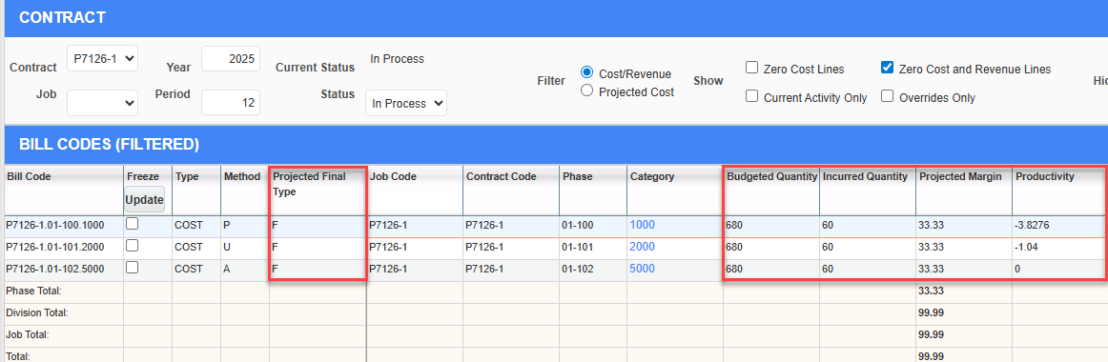

When forecast for any given period is archived then the new columns are also included in the forecast archive table in the backend.
NOTE: If the newly added columns are still not visible in the main screen, then it is likely that the user does not have the required field security, and the necessary access must be given to view them. (Refer the Setup section for more information).
Projected Final Type
- This new read-only column displays the Projected Final Type code of the billing code defaulting from the corresponding Cost Code/Category record in the Enter Budget screen.
- Updating the Projected Final Type in Enter Budget program will also update the code in the forecasting program once the forecast is refreshed.
Budgeted Quantity
- This new read-only column displays the current budgeted quantity of the bill codes and for P/U method codes this value matches with the Budgeted Input Quantity in the popup.
- For P and U method, it considers the Pending PCI quantity along with the Original budget and Posted PCI quantity if the Project System Options flag “Include Pending PCI to P/U Line” is checked. If unchecked, then Pending PCI quantity is not considered.
- For A method, always only the posted PCI quantity is considered with the Original budget quantity.
Incurred Quantity
- This new read-only column displays the actual total spent quantity for the bill code.
Projected Margin
- This new read-only column displays the margin/profit percentage of the bill code in the current year and period.
- Calculated as (Projected Profit / Adjusted Revenue Forecast) * 100. If Adjusted Revenue Forecast is zero, then system uses the regular Revenue Forecast amount for calculations.
- Projected Profit in turn equals the difference between Adjusted Revenue Forecast and Projected Cost Forecast.
Productivity
- This new read-only column displays the Current Productivity of the P/U bill codes in the popup.
- If there are overrides to the forecast, then it will instead display the Go Forward Productivity.
NOTE: In case of overrides to the forecast, it is recommended to refresh the forecast to view the updated Productivity value in the main screen though it won’t affect the overrides as mentioned earlier. Same when carrying the overrides to the next period.
- If the Completed amount is zero and/or there is no posted phase quantity completion, then the Productivity will be zero.

New Job Cost Control Flags
In addition to the existing flags, two new flags have been added that impact the contract forecasting calculations as follows:
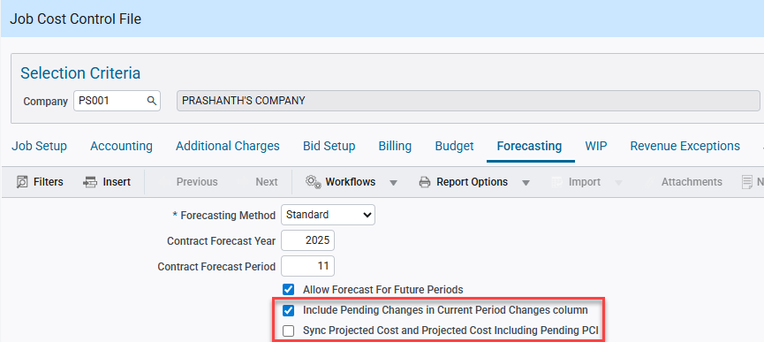
Pgm: JCCTRLFM; Path: Project Controls > Job Costing > Setup > Local Tables > Control File

Sync Projected Cost and Projected Cost Including Pending PCI
- If this flag is checked, then Projected Cost Forecast will be synced with Projected Cost Forecast Including Pending Change Orders column, and the two amounts will always be equal even if there are Pending PCIs included in the current period.
- As a result, Projected Cost Forecast Including Pending Change Orders will not show any Pending PCIs for P/U budget methods if the Project System Options flag “Include Pending PCI to P/U Line” is unchecked while the JC Control flag is checked.
- This flag is only applicable for bill codes with the following Projected Final Types: C – Committed Costs, S – Spent to Date and L – Largest of Spent or Committed. As for F type, Projected Cost Forecast and Projected Cost Forecast Including Pending Change Orders will always be in sync irrespective of the state of the flag.
Include Pending Changes in Current Period Changes column
- If this flag is checked, then Pending Change Order amounts will be considered in the existing Current Period Changes column. Else, the column will only continue to include only the posted Changes created in the current period.
- Column will include the Pending PCI’s for P and U Budget method even if the Project System Options flag “Include Pending PCI to P/U Line” is unchecked.

Example with Screenshots
Billing Contract: P7126-1 has three billing codes with the same Projected Final Type – F and the following Budget Method and Initial Budget as follows:
Bill Code 1: P7126-1.01-100.1000 with P (Productivity) method, Initial Budgeted Amount and Quantity as 10,000 and 500 (Phase/Cost Code Budget – 50) respectively.
Bill Code 2: P7126-1.01-101.2000 with U (Units) method, Initial Budgeted Amount and Quantity as 10,000 and 500 (Phase/Cost Code Budget – 50) respectively.
Bill Code 3: P7126-1.01-102.5000 with A (Amounts) method, Initial Budgeted Amount and Quantity as 10,000 and 500 respectively.
The Job/Contract has the following flags checked,
- “Include Pending PCI to P/U Line” in Project System Options in the Field application.
- “Internal Change Orders Update Budget” in Change Management Control file.
- “Include Pending Changes in Current Period Changes column” and “Copy Last Stored Forecast” in Job Cost Control.

Then Job Cost transactions for $1000 each Cost Code/Category were posted along with Phase Quantity Completion for P and U lines.
Later a Subcontract with each SOV line corresponding to the three Cost Code/Category combinations was posted in the same period for about $5000 each.

Forecast was generated for the Current Year and Current Period (E.g. Year – 2025, Period – 11).
The amounts and values for the selected columns are as follows:
 | P7126-1.01-100.1000 (P Method) | P7126-1.01-101.2000 (U Method) | P7126-1.01-102.5000 (A Method) | Remarks
Current Cost Budget | 10,000 | 10,000 | 10,000
Projected Cost Budget | 10,000 | 10,000 | 10,000 | Same as Current Budget because there are no PCIs
Pending Internal PCI | 0 | 0 | 0
Pending External PCI | 0 | 0 | 0
Actual Cost | 1,500 | 1,500 | 1,500 | Posted Job Cost transaction amounts
Committed Amount | 5,000 | 5,000 | 5,000 | Posted Subcontract
Spent/Committed | 6,500 | 6,500 | 6,500
Current Period Changes | 0 | 0 | 0 | No Pending or Posted PCIs
Budgeted Quantity | 500 | 500 | 500 | Budgeted Input/Category Quantity
Incurred Quantity | 60 | 60 | 60 | Posted Job Cost transaction quantities
Projected Margin | 33.33 | 33.33 | 33.33 | Projected Profit/Adjusted Revenue Forecast = 5000/15000 * 100
Productivity | 0.1167 | 0.1167 | 0 | For P and U Method, Current Output Rate / Current Input Rate = (6500/60)/(6500/7)
Projected Cost Forecast | 10,000 | 10,000 | 10,000 | Projected Cost Budget
Projected Cost Forecast (Incl Pending CO) | 10,000 | 10,000 | 10,000 | Projected Cost Forecast
Cost to Complete | 3,500 | 3,500 | 3,500 | Projected Cost Forecast – Spent/Committed = 10000 - 6500
Adjusted Revenue Forecast | 15,000 | 15,000 | 15,000
Projected Profit | 5,000 | 5,000 | 5,000 | Adjusted Revenue Forecast - Projected Cost Forecast = 15000 - 10000

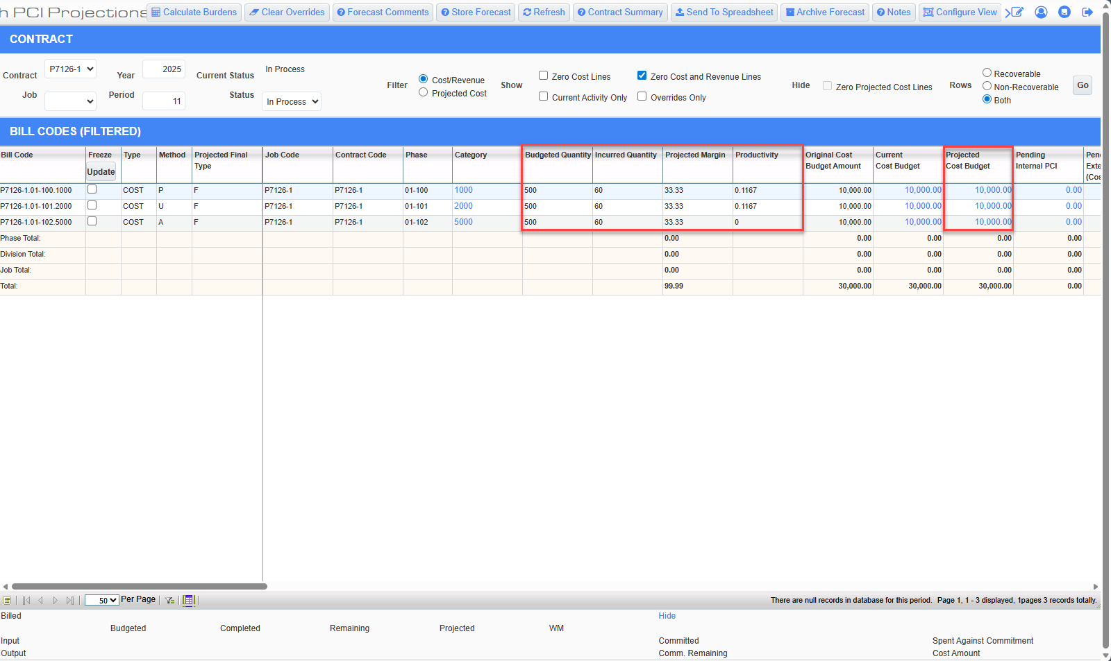
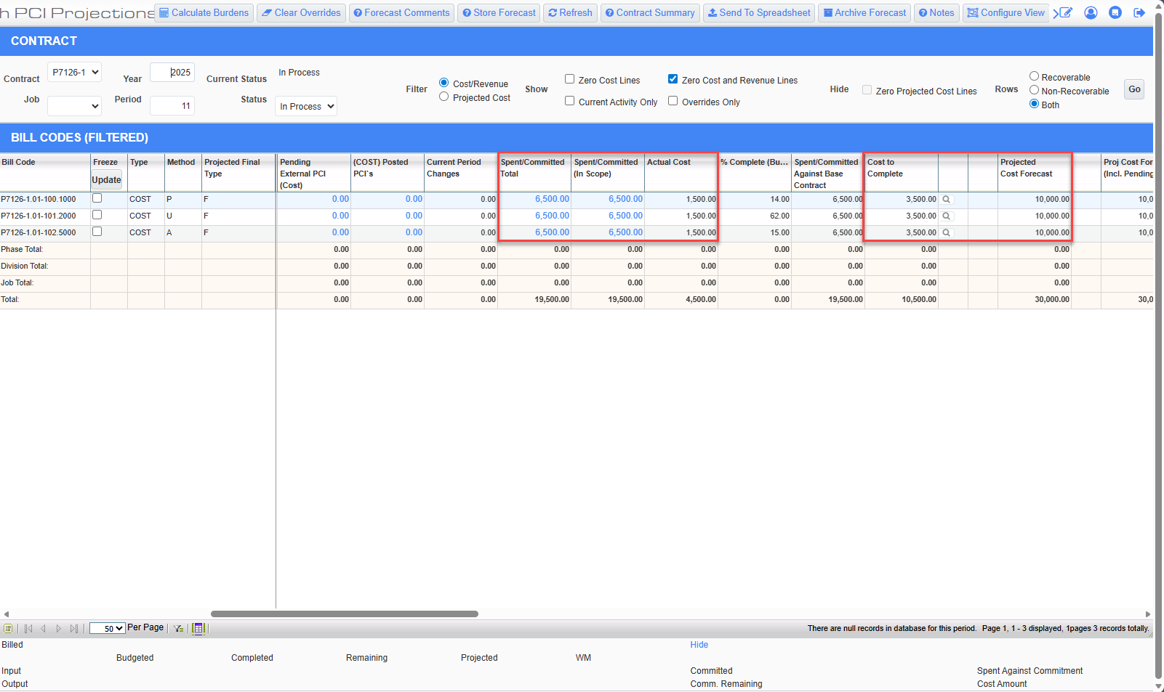
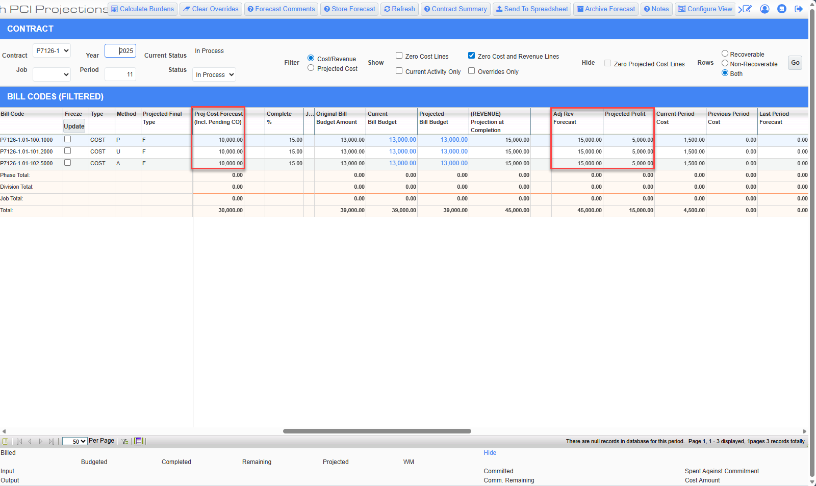
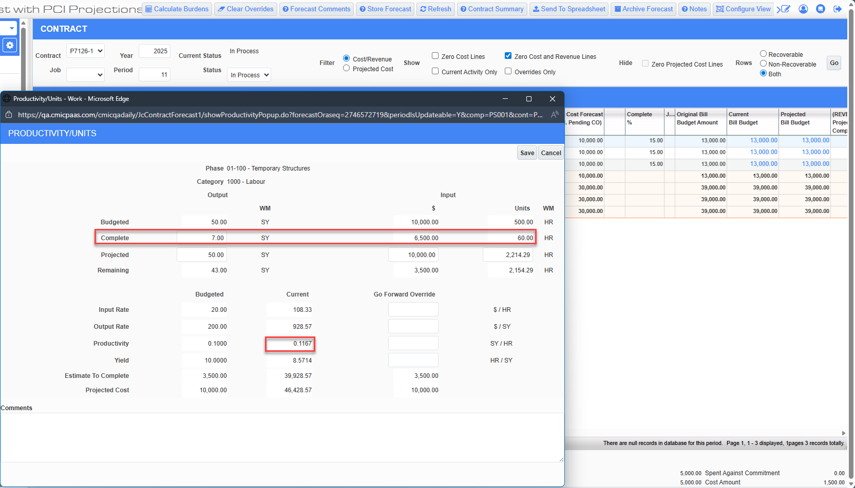
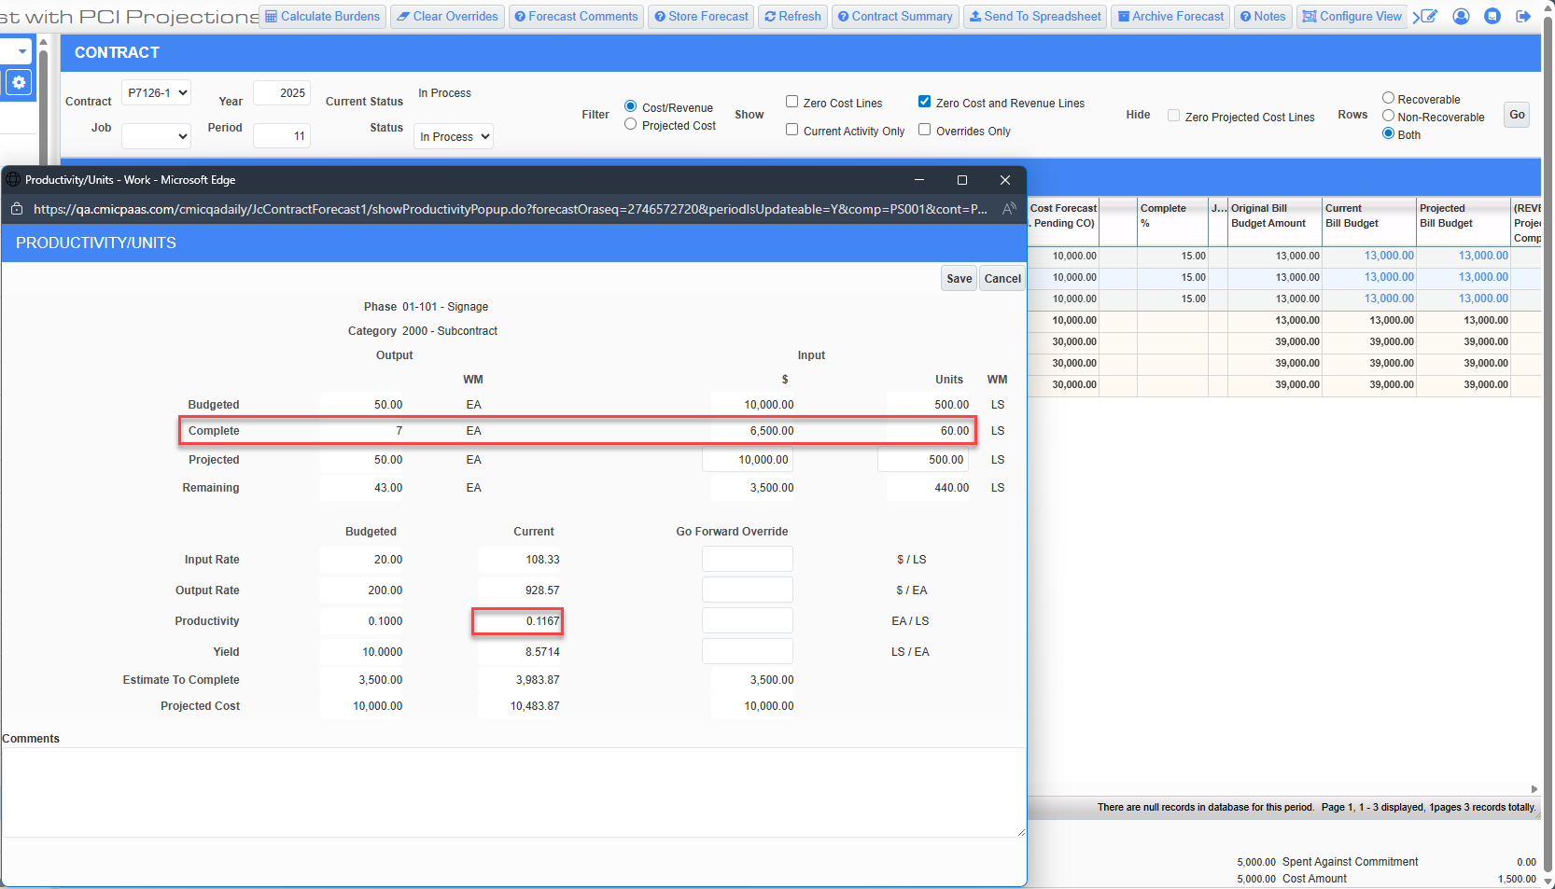

Then created one External PCI and one Internal PCI with three lines corresponding to the three billing codes in the Contract with the “Forecast” flag checked and the Reference Date in the current year and period as follows:
Each line in the External PCI has the Quantity of 75 with Final and Billing amounts as 1,650 and 2,025 respectively.
Whereas each line in the Internal PCI has the Quantity of 30 with the Final amount as 660.

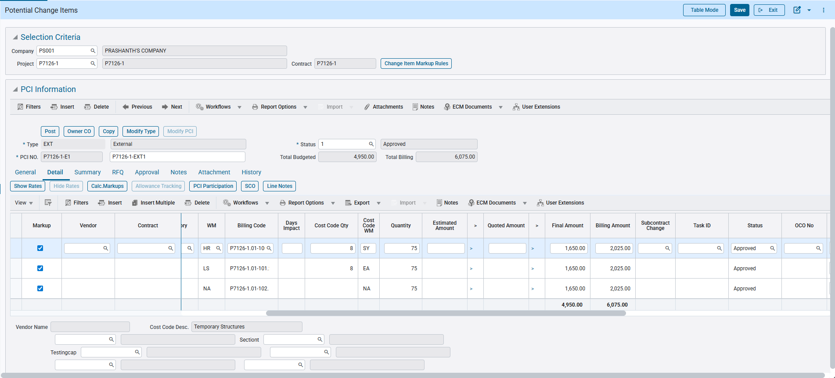
Pgm: PMCHGFM; Path: Project Controls > Change Management > Setup > Change Orders > Enter PCI

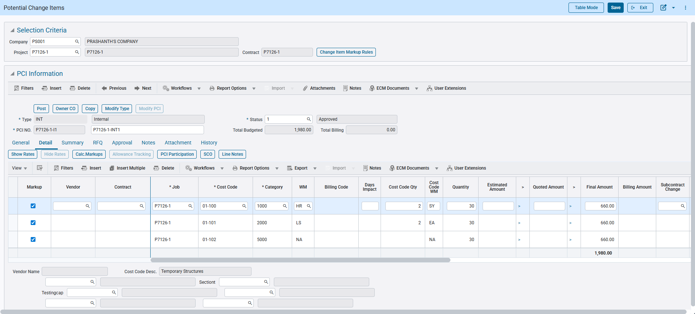
Pgm: PMCHGFM; Path: Project Controls > Change Management > Setup > Change Orders > Enter PCI

When the forecast is refreshed for the same year and period, the values are updated as follows:
 | P7126-1.01-100.1000 (P Method) | P7126-1.01-101.2000 (U Method) | P7126-1.01-102.5000 (A Method) | Remarks
Current Cost Budget | 10,000 | 10,000 | 10,000 | Remains same
Projected Cost Budget | 12,310 | 12,310 | 12,310 | Includes Pending Internal and External PCI
Pending Internal PCI | 660 | 660 | 660
Pending External PCI | 1,650 | 1,650 | 1,650
Actual Cost | 1,500 | 1,500 | 1,500
Committed Amount | 5,000 | 5,000 | 5,000
Spent/Committed | 6,500 | 6,500 | 6,500
Current Period Changes | 2,310 | 2,310 | 2,310 | Pending PCIs
Budgeted Quantity | 650 | 650 | 500 | Includes Pending PCI quantity for P and U lines because the “Include Pending PCI to P/U Line” in Project System Options is checked.
Incurred Quantity | 60 | 60 | 60 | Posted Job Cost transaction quantities
Projected Margin | 41.21 | 41.21 | 41.21 | Projected Profit/Adjusted Revenue Forecast = 8630/20940 * 100
Productivity | 0.1167 | 0.1167 | 0
Projected Cost Forecast | 12,310 | 12,310 | 12,310 | Projected Cost Budget
Projected Cost Forecast (Incl Pending CO) | 12,310 | 12,310 | 12,310 | Projected Cost Forecast
Cost to Complete | 5,810 | 5,810 | 5,150 | Projected Cost Forecast – Spent/Committed – Pending Internal PCI (For A method) = 12310 – 6500 – 660 (For A method)
Adjusted Revenue Forecast | 20,940 | 20,940 | 20,940
Projected Profit | 8,630 | 8,630 | 8,630 | Adjusted Revenue Forecast - Projected Cost Forecast = 20940 - 12310

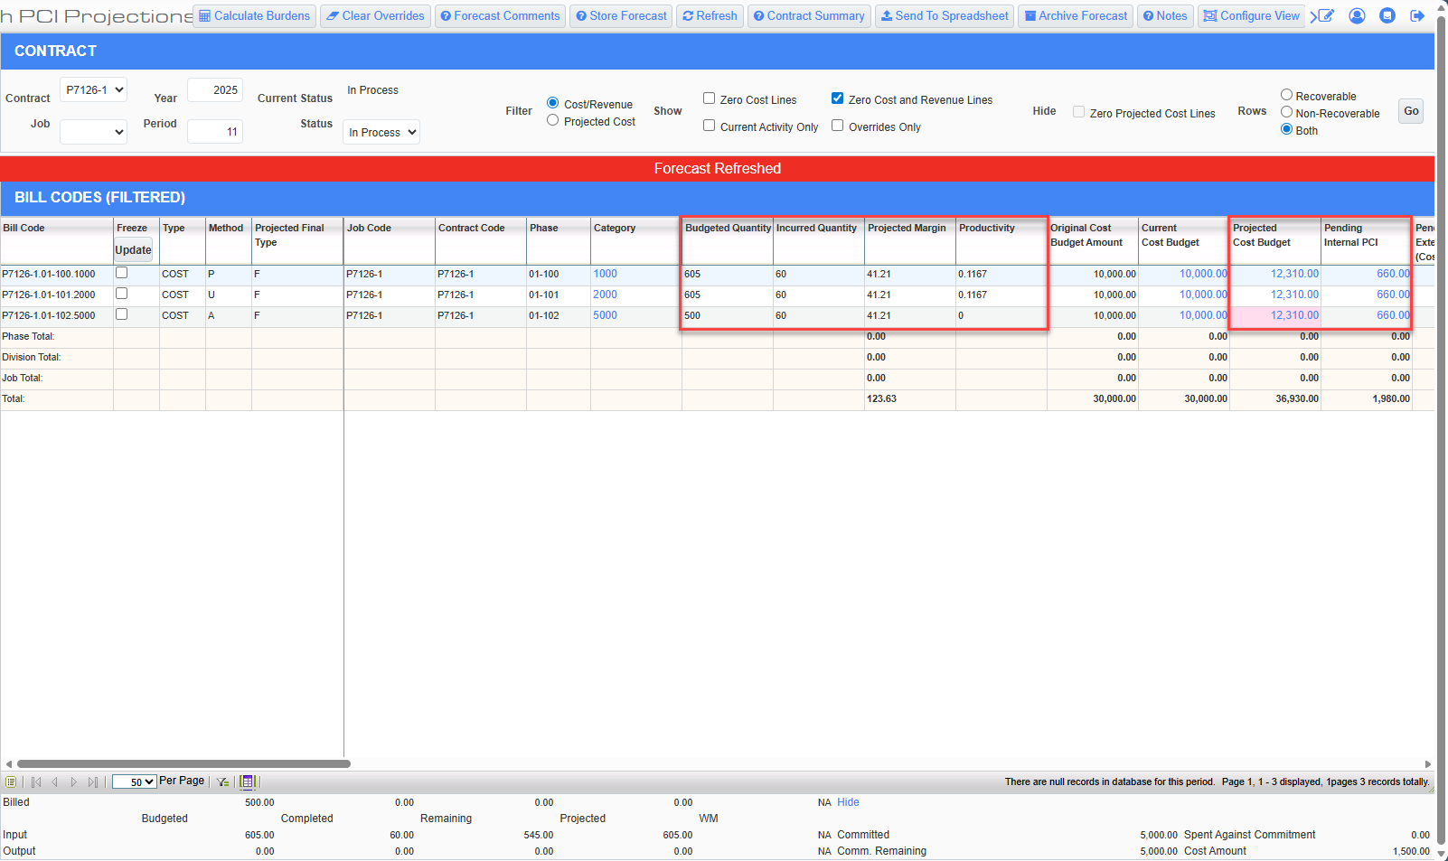
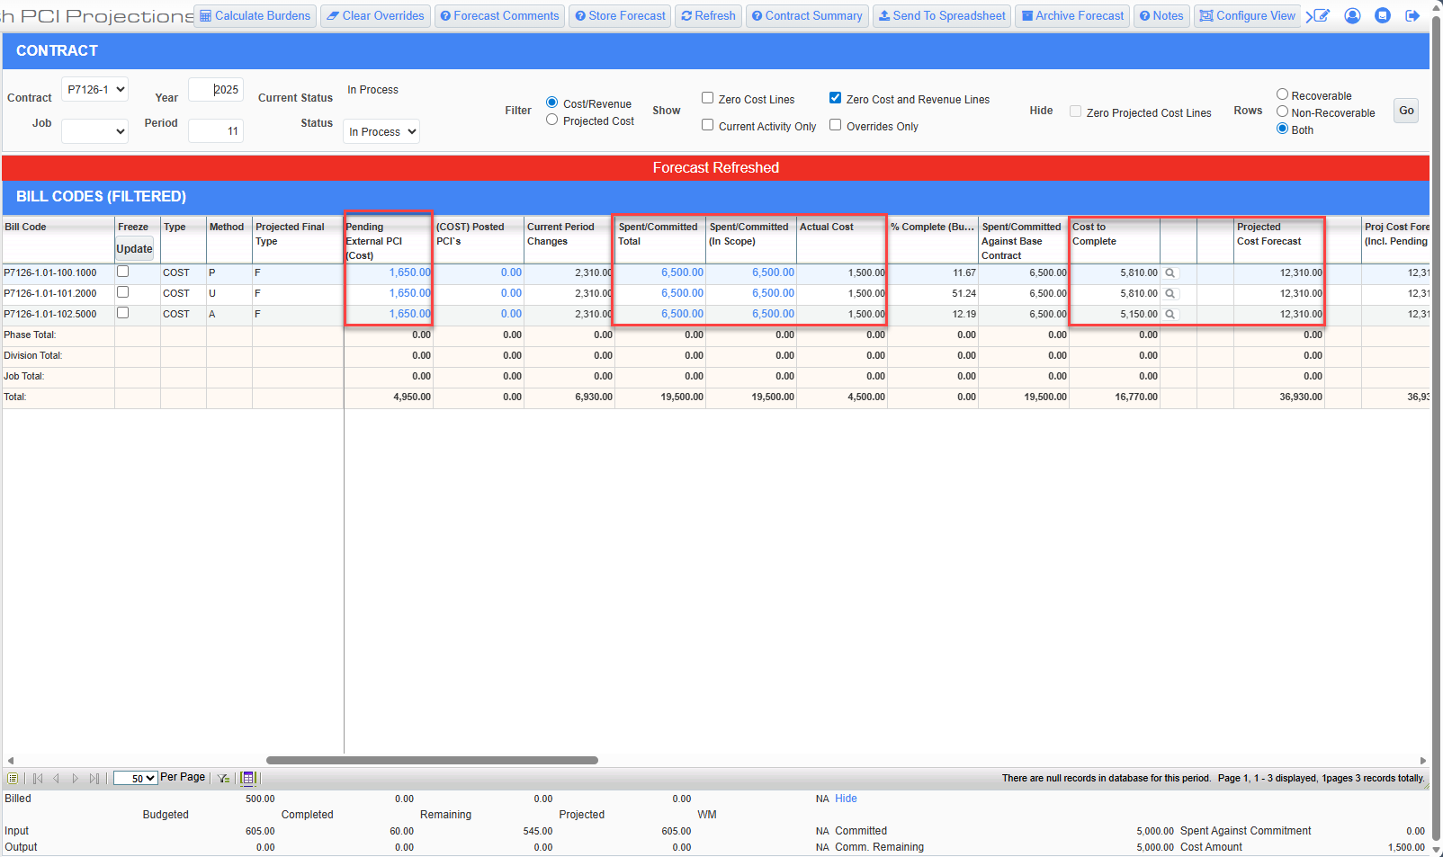
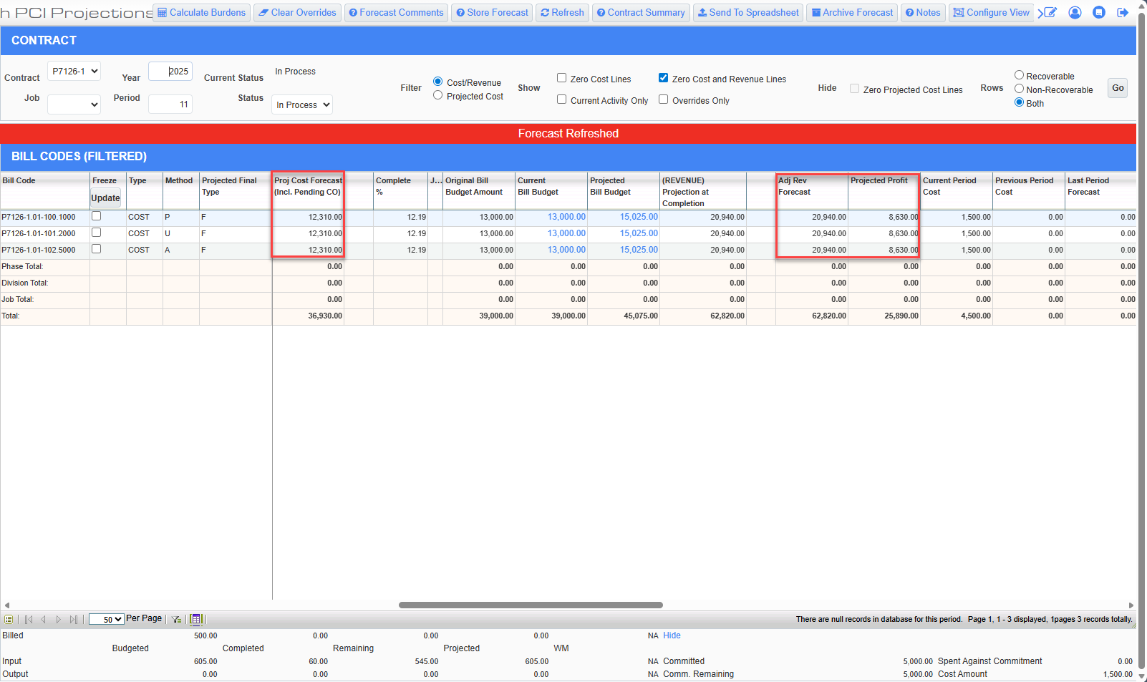
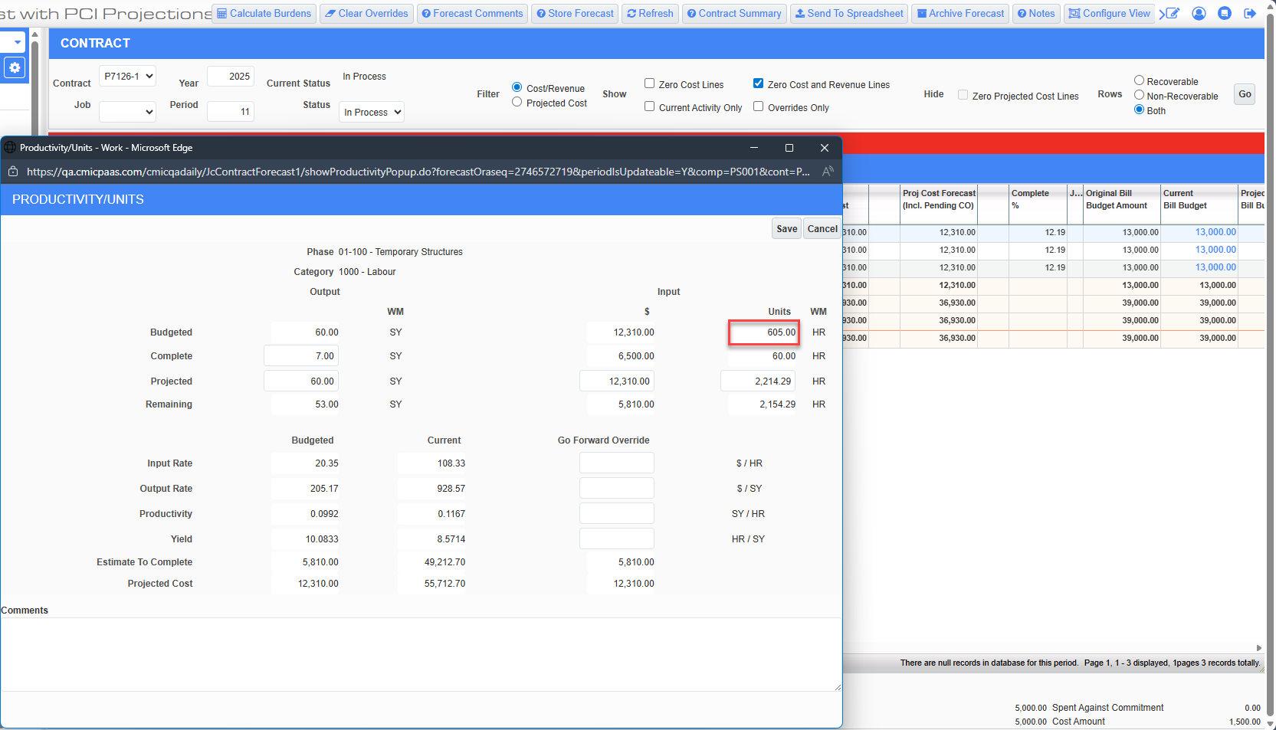
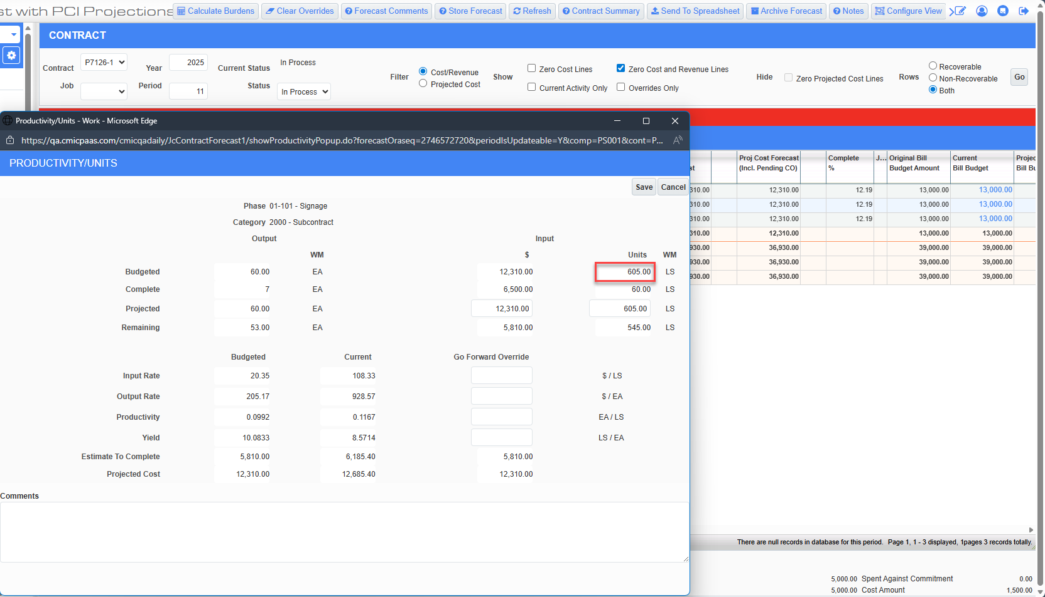

Overrides were done to the Projected Cost Forecast for both the P and U method Billing Codes.
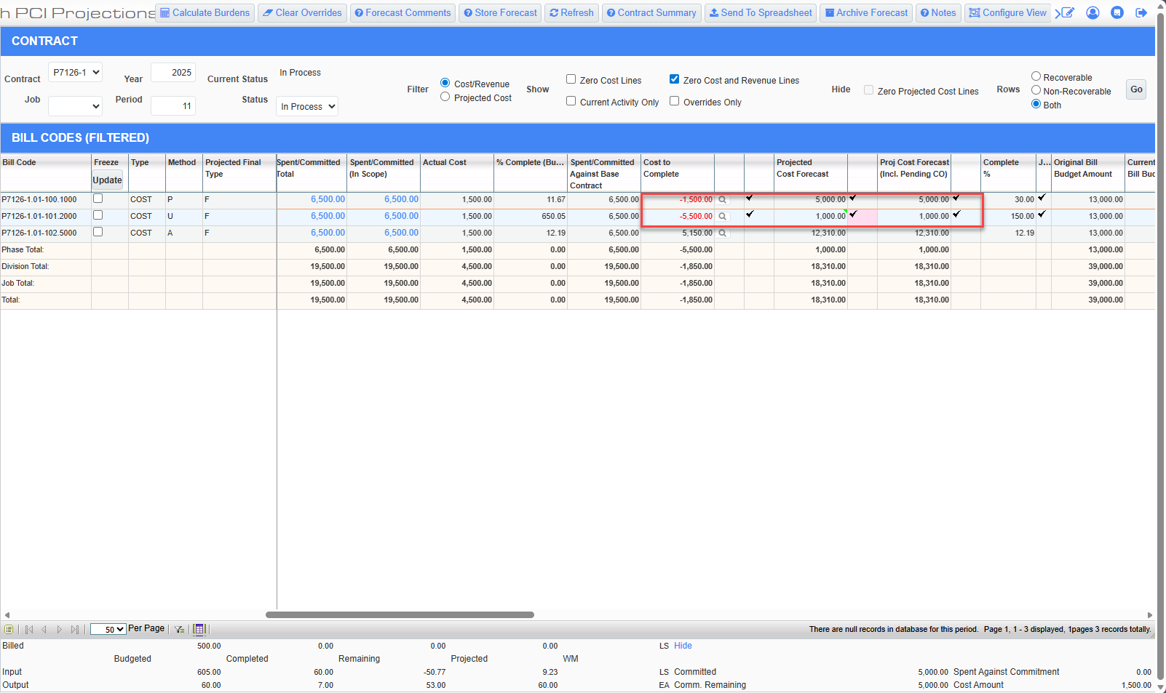

As soon as the user updates the Forecast Amount and tabs out if the overrides were done in the main screen or clicks Save in the Productivity/Units popup system will automatically updates the Projected Cost Amount Including Pending CO to be the same as the Forecast override and also recalculates the Cost to Complete amount.
The overrides remain even if the forecast is refreshed or clicking on Clear Overrides button or manually removing the Go Forward Overrides in the popup.

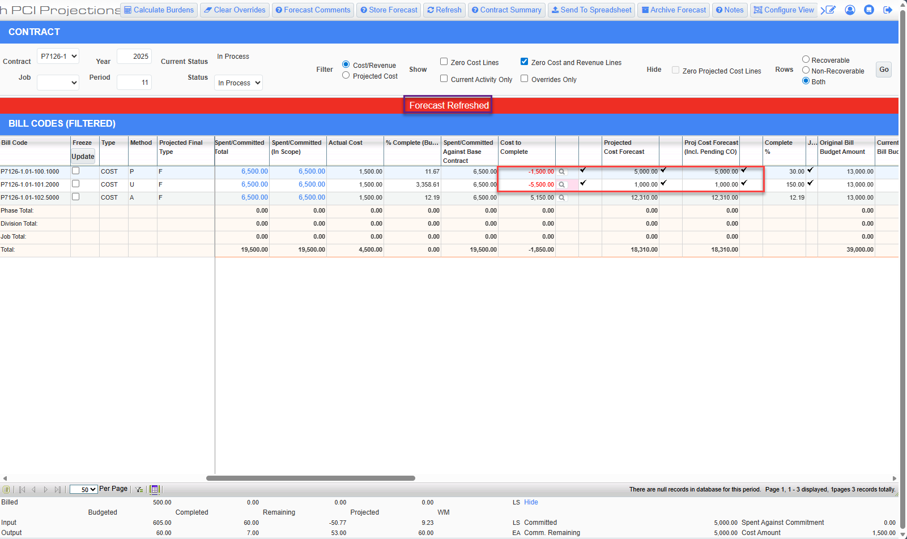
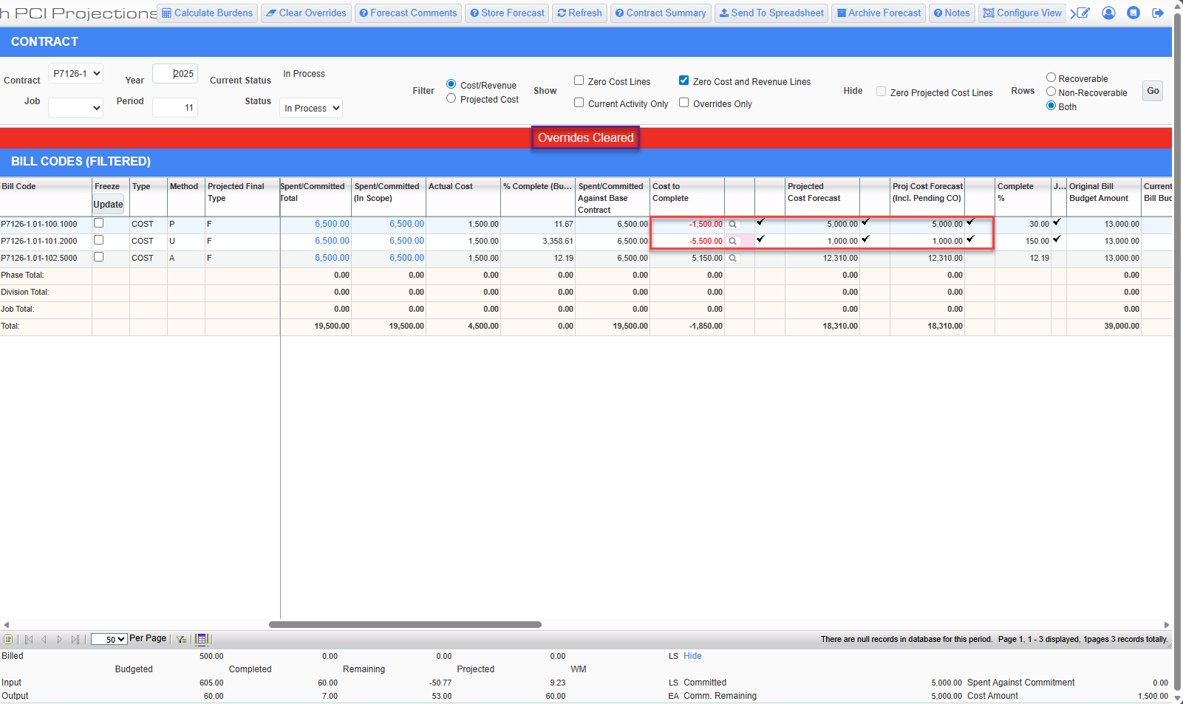
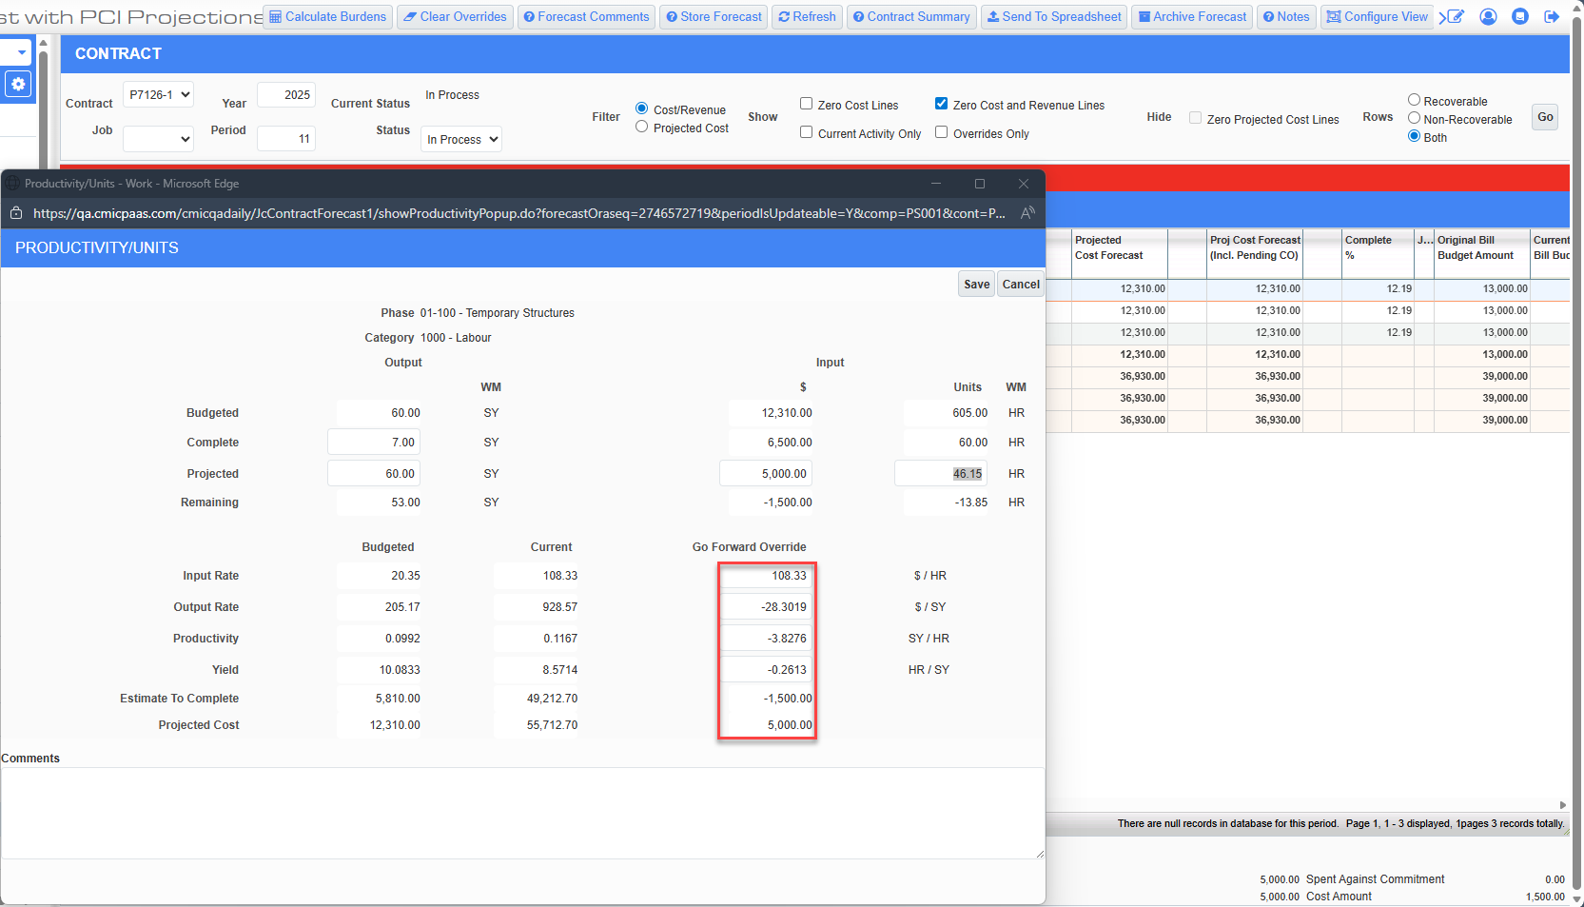
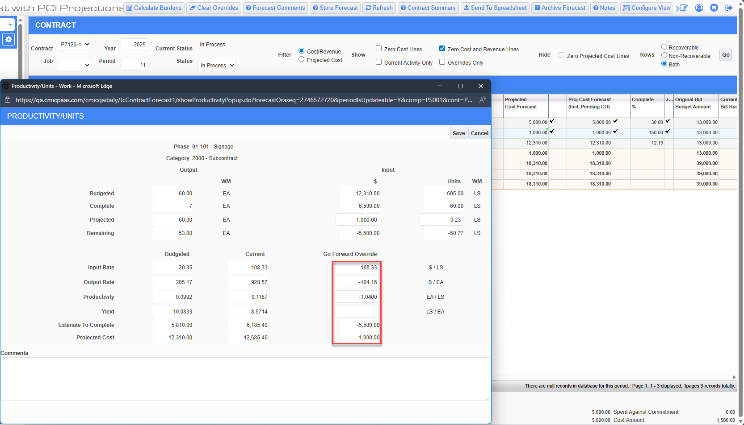

The overrides for P and U method Bill Codes also result in the changes to the Productivity as a result of the Go Forward Input and Output Rates respectively.
Then posted the previous two pending PCIs (1 External and 1 Internal) as well as another External PCI with the same amount.
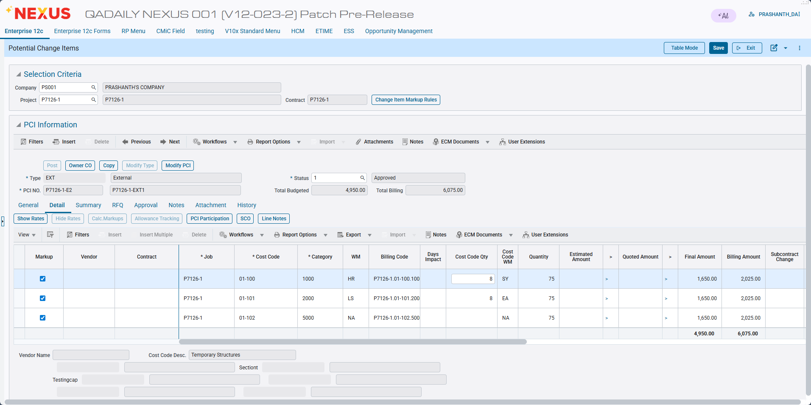
Pgm: PMCHGFM; Path: Project Controls > Change Management > Setup > Change Orders > Enter PCI

After forecast is refreshed for the current period, the Current Cost Budget for all three bill codes is updated to 13,960 and it matches the Projected Cost Budget.
For A method bill code (P7126-1.01-102.5000), since there are no overrides, the amounts are updated as follows:
- Projected Cost Forecast to 13,960 to continue matching the Projected Cost Budget.
- Projected Cost Forecast (Including Pending CO) also to 13,960
- Cost to Complete to 7,460
However, for P and U method bill codes which have forecasting overrides, there are no change to the overridden amounts.
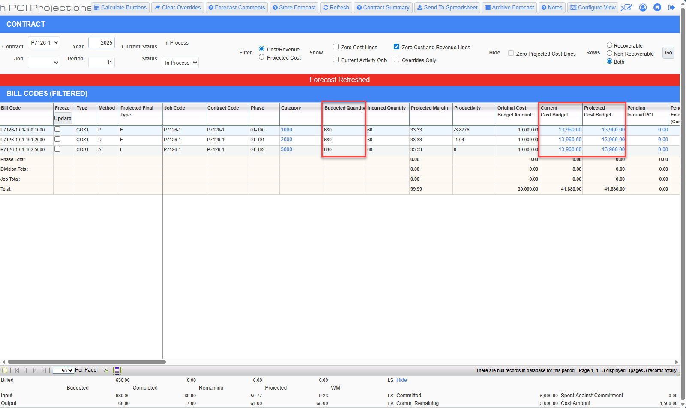
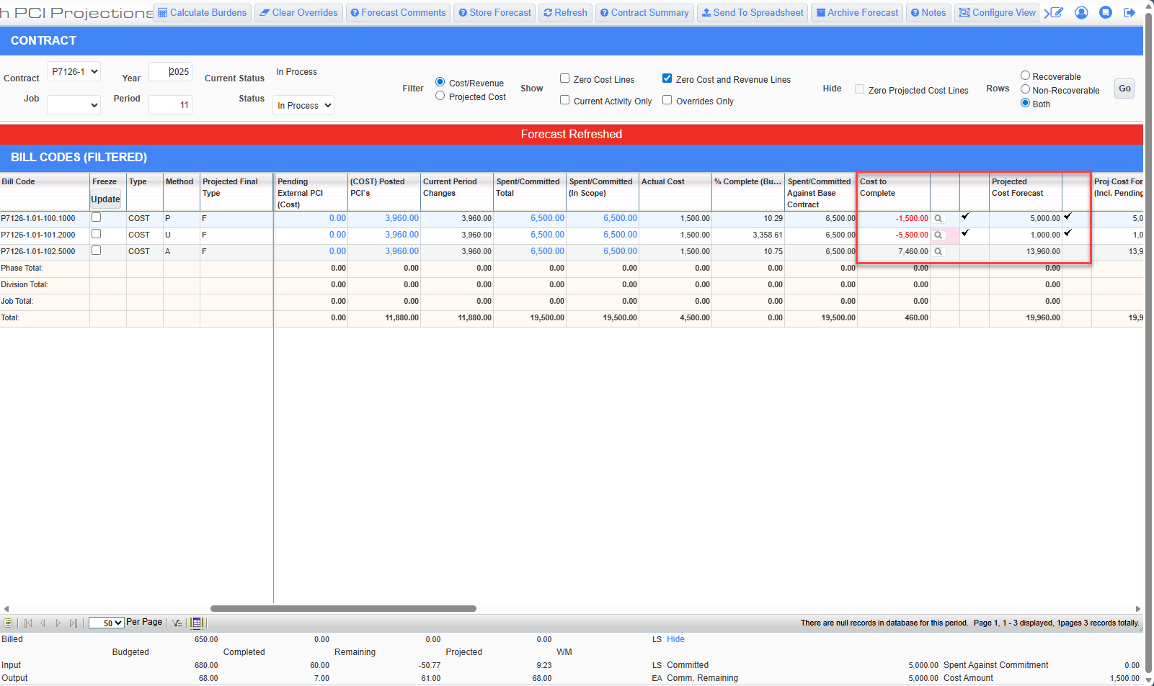
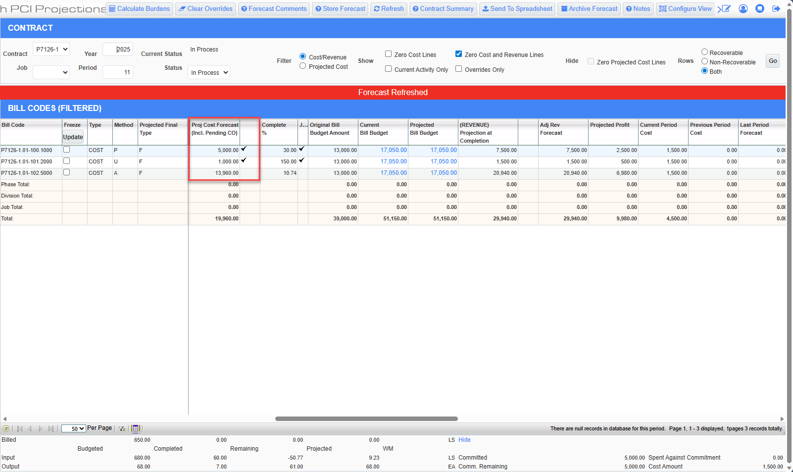

Finally, the forecast for the current period is stored with the overrides.
Then the forecast is generated for the upcoming period (Period 12), but the Projected Cost Forecast overrides are color coded yellow and red respectively because the amounts are either less than the Spent/Committed or also less than the Actual Costs.

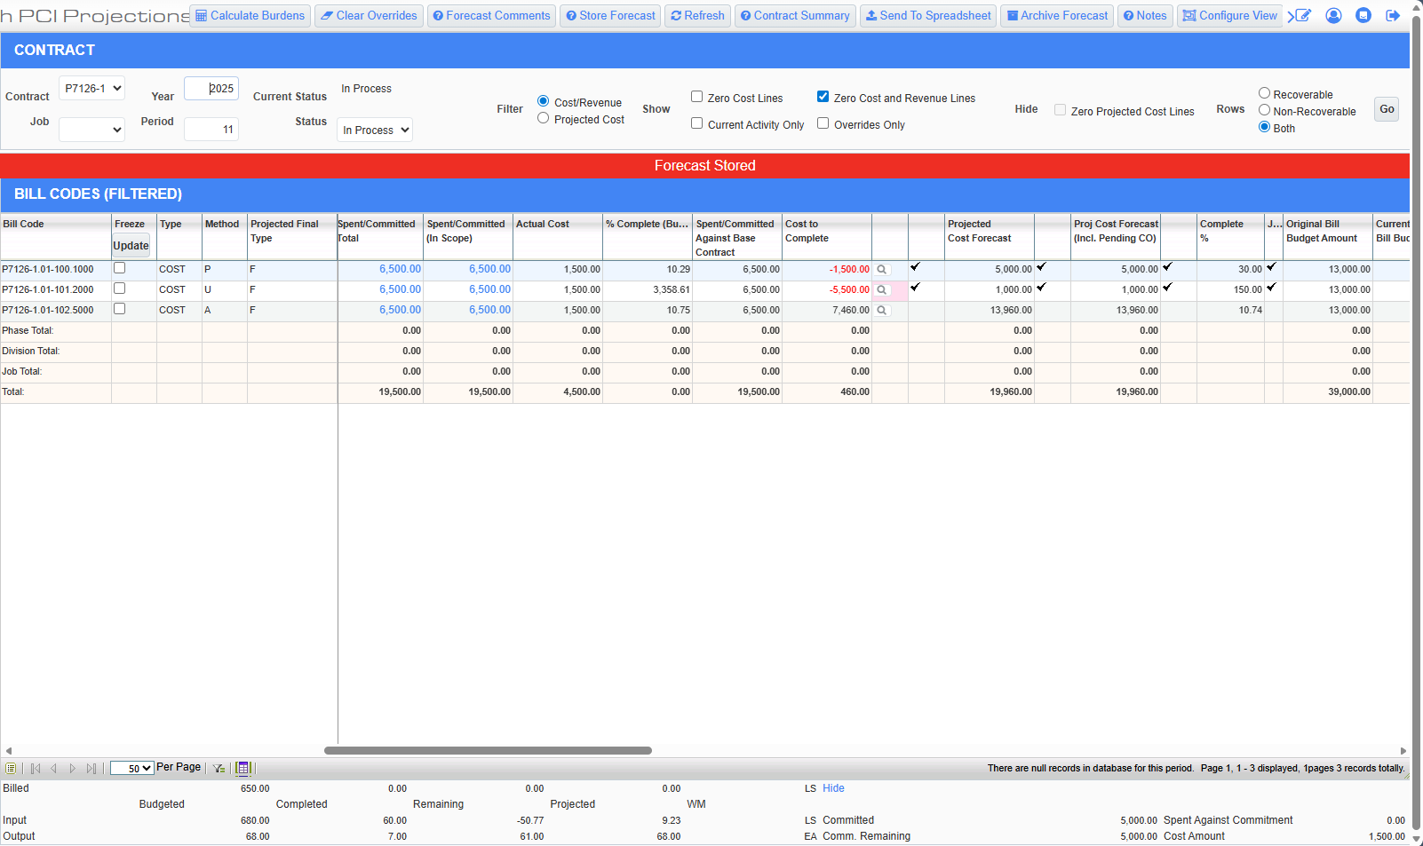
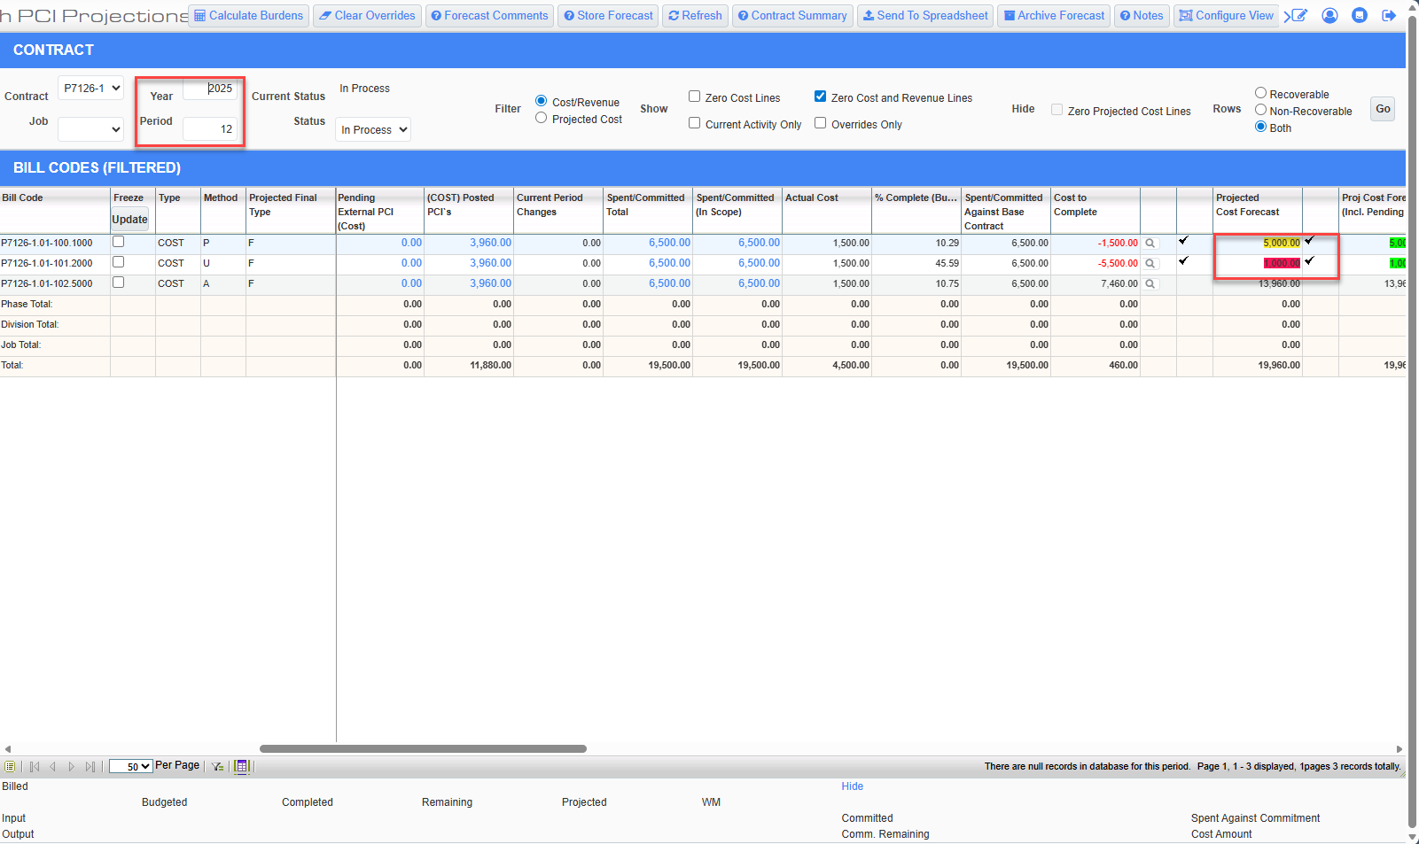

Hovering the cursor on top of the color-coded amount displays a tool tip mentioning the underlying color-coding rule.
Amount is highlighted in yellow when it is only less than the Spent/Committed amount.

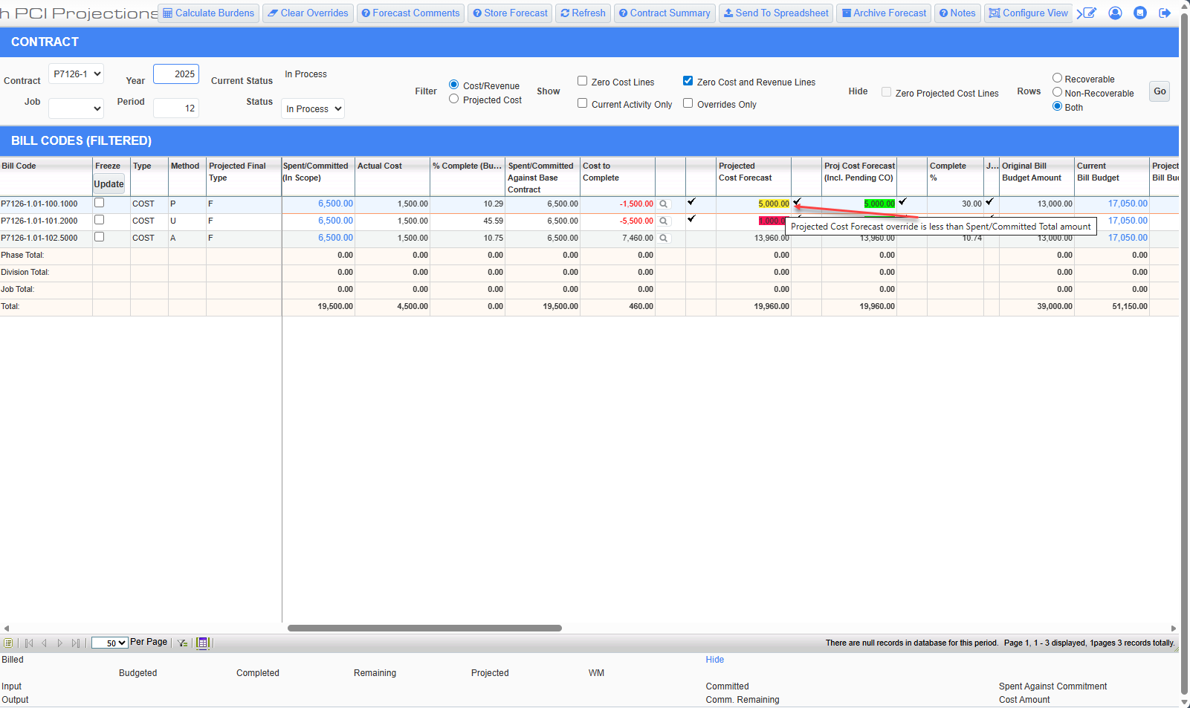

Amount is highlighted in red when it is also less than the Actual Cost.

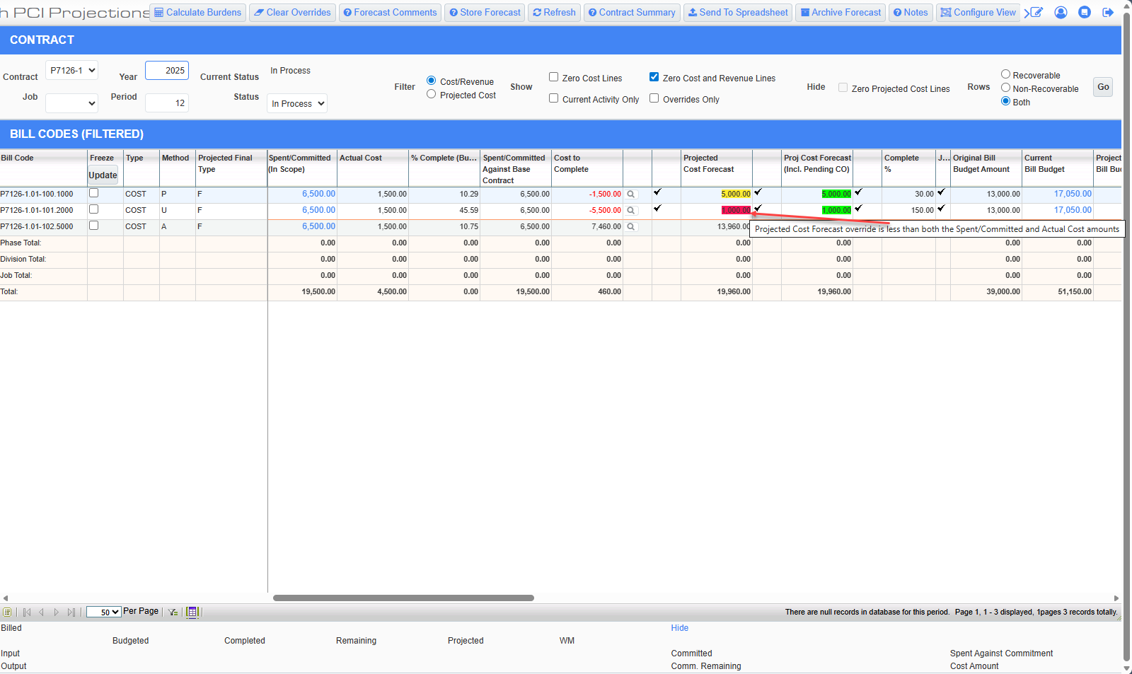

Same Contract in the Kendo forecasting program.

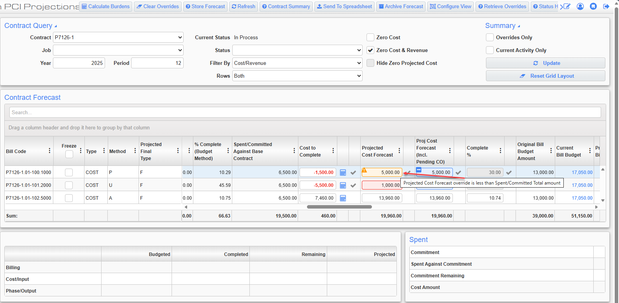
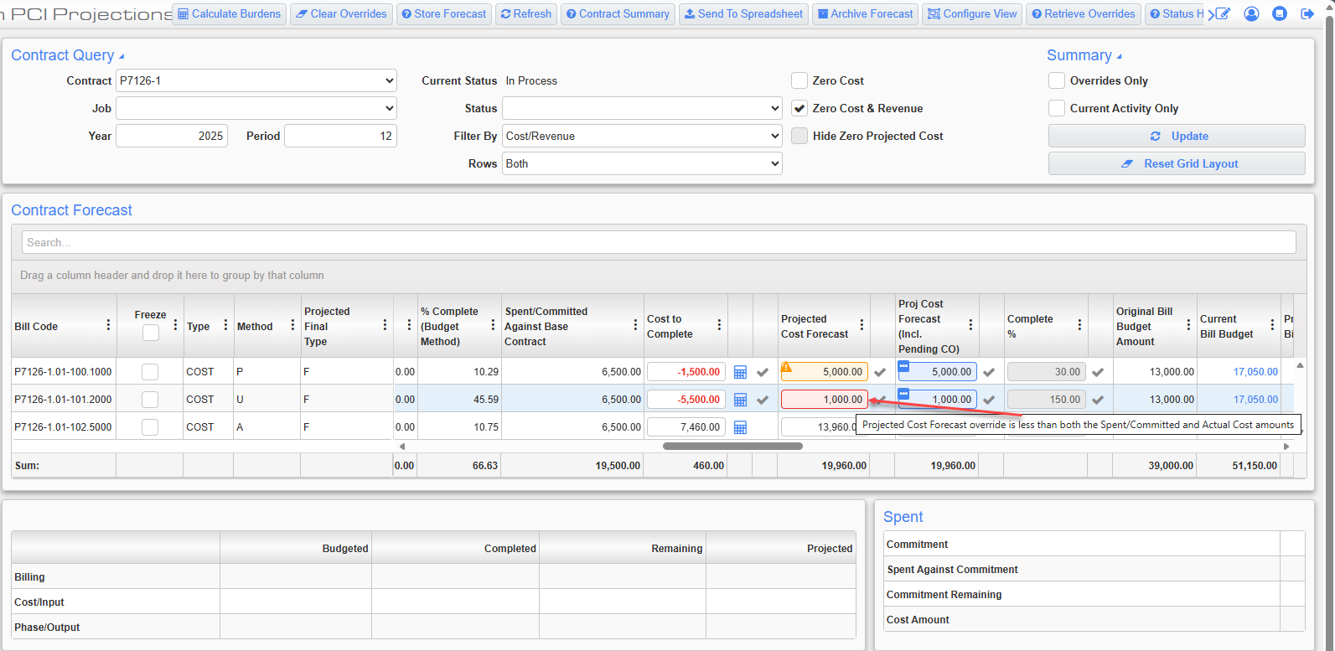

Forecasting Productivity Pop Up - Additional Decimal Request (PC-19021)
Overview
The CMiC Contract Forecasting module has been enhanced with a modified user interface to improve precision in productivity tracking. Within the Productivity popup, two key fields—Productivity and Yield—now support and display four decimal digits. This change ensures more accurate data entry and calculations while maintaining the familiar layout and workflow of the CMiC application. The update is permanent and enabled by default, requiring no configuration flags or user activation.
Pre-requisites
- Go to Field → Budget & Cost Management → Contract Forecasting.
- Locate the line with the P/U method.
- Access the Cost to Complete functionality, which opens the Productivity popup.
Modifications
- Increased Decimal Precision: The Productivity and Yield fields within the Productivity popup now allow and display up to four decimal digits.
- Columns Affected: The change applies to all three columns—Budgeted, Current, and Go Forward Override.
- Data Consistency: All other fields and calculations that depend on Productivity or Yield use the updated four-decimal precision for their internal calculations, even if their displayed values continue to round to two decimals on the base Contract Forecasting screen.
- Default Behavior: The enhancement is always active and does not require a system flag or additional configuration.

Implementation
Productivity and Yield values entered in the popup are now stored and calculated with four-decimal precision across all relevant columns. Any dependent fields and calculations use the same precision internally, while displayed results outside these two fields continue to round to two decimals where applicable. This ensures greater accuracy without changing existing workflows.
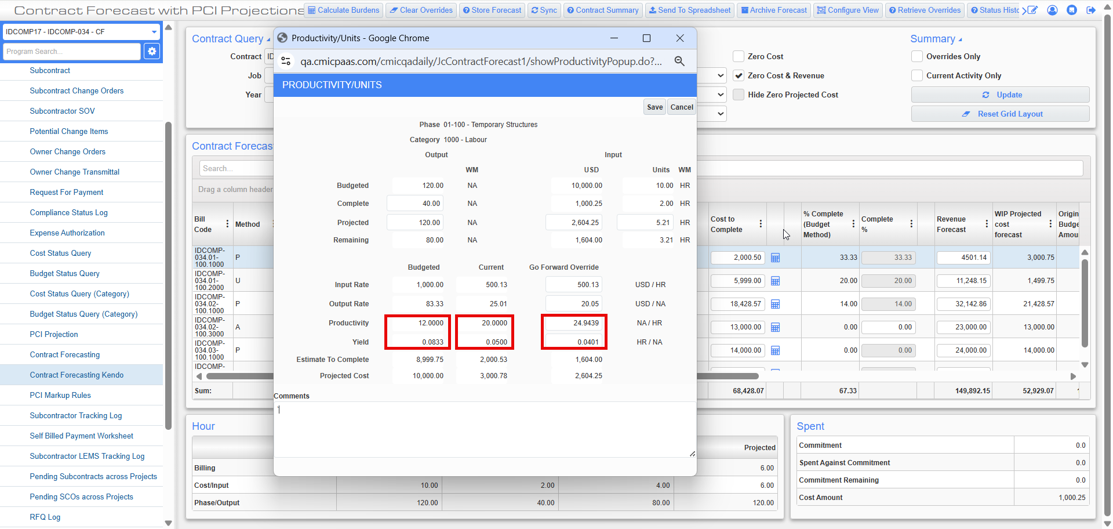

Contract Forecasting-New Columns for Archive Forecast (JBJCPC-1982)

Overview:

The Contract Forecast program has been enhanced with the addition of four new columns that display historical forecast data. These columns show the previously archived values for Cost, Revenue and Profit, giving users greater visibility into how forecasts have changed over time.

Modifications:

The following columns have been added to the Contract forecast program

Existing columns:

- Archive Projected Forecast (Incl.Pending CO)- JCCF_AR_COST_FCST_INCL_PCI_AMT
This column displays the value of Projected Cost Forecast (Incl. Pending CO)-JCCF_COST_FCST_INCL_PCI_AMT from the most recent archived period.
Example: If the current period is Period 9, but Periods 7 and 8 were not archived, and the last period archived was Period 6, then this column in Period 9 will show the Projected Cost Forecast including pending CO value from Period 6.

- Variance From Archive Forecast- JCCF_AR_COST_FCST_VARIANCE_AMT:
Calculated field= Projected Cost Forecast (Incl.Pending CO)-Archive Projected Forecast (Incl.Pending CO)

New Columns:

- Last Archived Forecast Revenue Amount- JCCF_AR_FCST_REV_AMT
This column displays the Adjusted Revenue Forecast (JCCF_ADJ_FORECAST_REVENUE_AMT) value from the most recent archived period.
Example: If the current period is Period 9, but Periods 7 and 8 were not archived, and the last archived period was Period 6, then this column in Period 9 will display the Adjusted Revenue forecast value from period 6.

- Archived Revenue Forecast Variance- JCCF_AR_REV_FCST_VAR_AMT:
Calculated field=Adjusted Revenue Forecast -Last Archived Forecast Revenue Amount

- Last Archived Profit Amount- JCCF_AR_PROFIT_AMT:
This column displays the Projected profit (JCCF_PROJECTED_PROFIT) value from the most recent archived period.
Example: If the current period is Period 9, but Periods 7 and 8 were not archived, and the last period archived was Period 6, then this column in Period 9 will display the Projected profit value from period 6.

- Archived Profit Variance- JCCF_AR_PROFIT_VAR_AMT:
Calculated field= Projected Profit-Last Archived Profit Amount

Note:
Field-level security has been applied to these new columns in Role Maintenance. By default, they are set to ‘Hidden’. To view these columns:

- The user must have ‘Unrestricted’ field security access.
- The columns must be enabled via the ‘Configure View’ option on the Contract Forecasting screen.
Screenshots:

Field security in Role Maintenance:

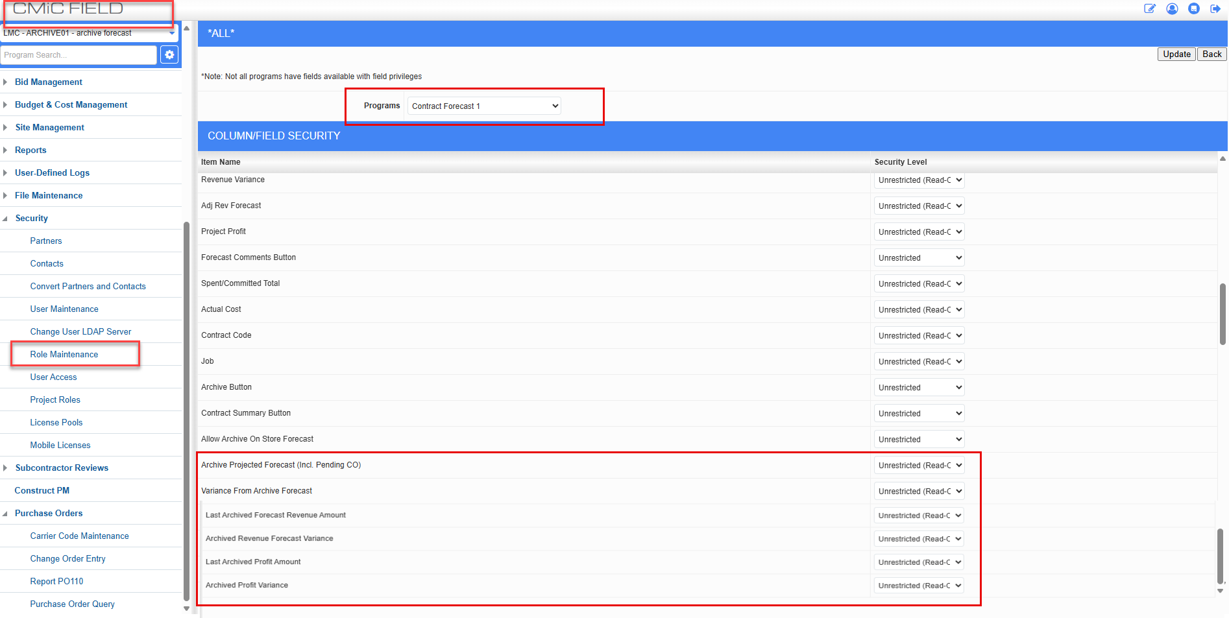
CMIC Field>Security>Role Maintenance>Assign Field Security

Configure View:

The columns can be made visible via Configure view

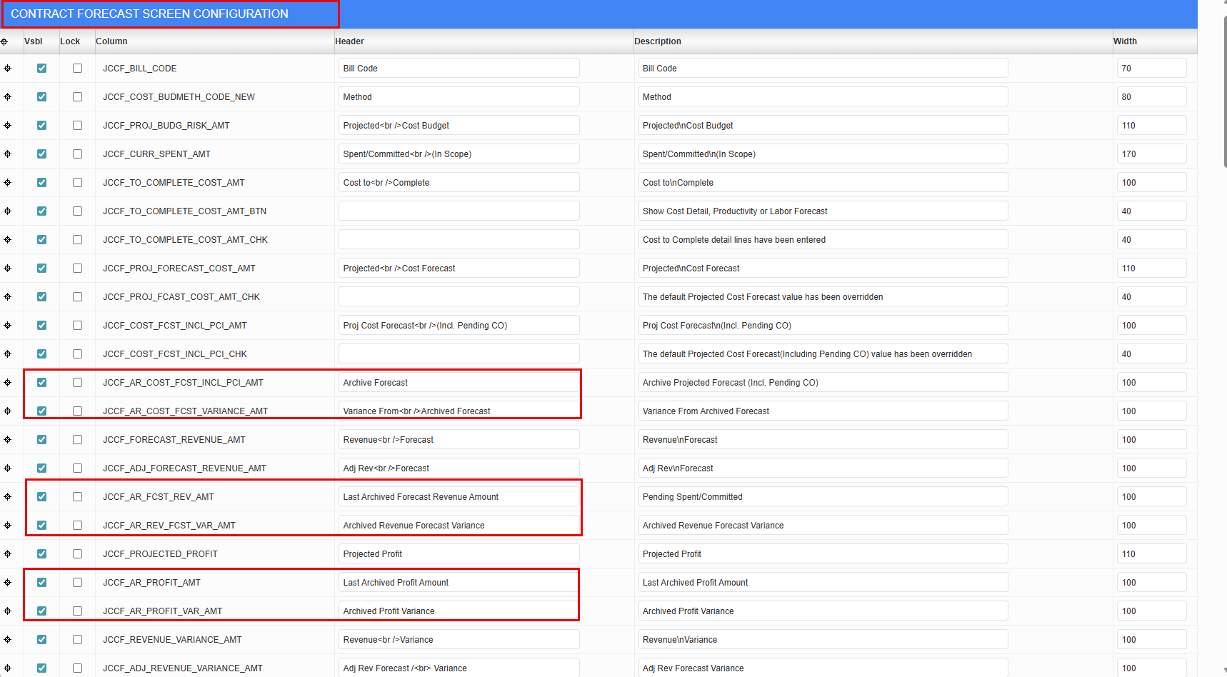

Examples:

Storing and Archiving forecast for Period 1

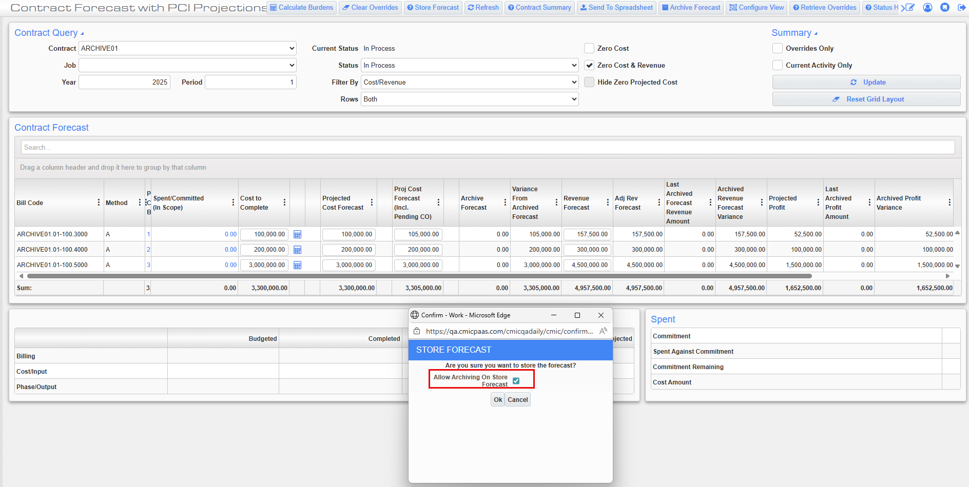

Forecast stored and archived for Period 1

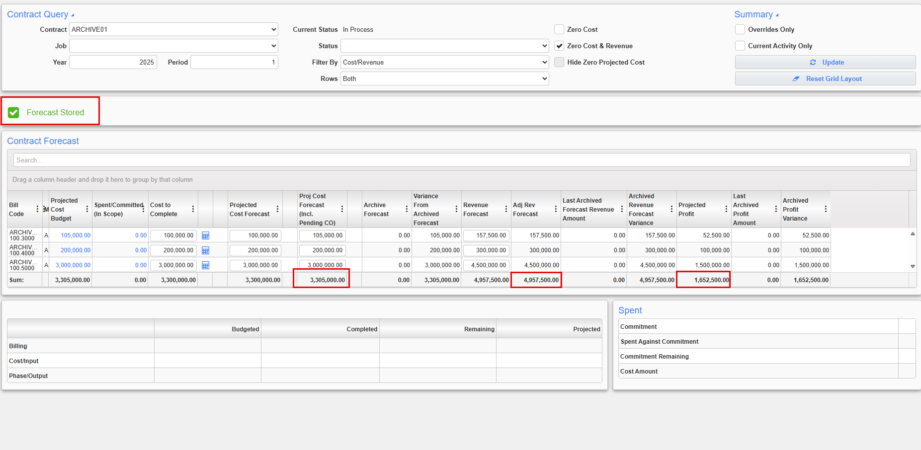

The following values from Period 1 will be displayed in the archived columns (Archive Forecast, Last Archived Forecast Revenue Amount, Last Archived profit amount) for Period 2

Projected cost Forecast Including pending CO=3,305,000.00

Adjusted Revenue Forecast=4,957,500.00

Projected Profit=1,652,500.00

Period 2 Archived columns showing the values from Period 1

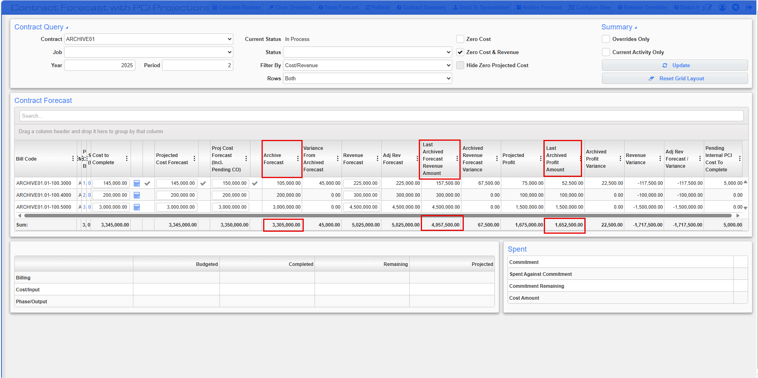

Variance columns for P2

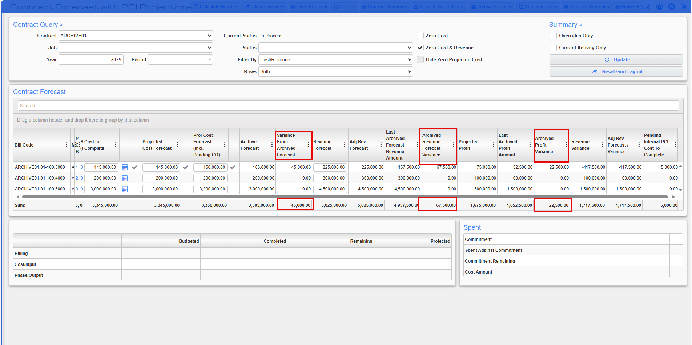

Variance from Archived Forecast
=Projected cost forecast (Incl. Pending CO)-Archive Forecast
=3,350,000.00-3,305,000.00
=45,000.00

Archived Revenue forecast Variance
=Adjusted Revenue Forecast-Last Archived Forecast Revenue amount
=5,025,000.00-4,957,500.00
=67,500.00

Archived Profit Variance
=Projected Profit-Last Archived Profit amount
=1,675,000.00-1,652,500.00
=22,500.00

Specifications Upload – Extract with AI (CF-33530)
AI-based extraction for specifications has been implemented, enhancing both the efficiency and accuracy of the extraction process.

Modifications
Like the Drawings extraction feature, a new button labeled "Extract with AI" has been implemented on the Drawings and Specifications Upload interface specifically for the Document Type designated as "Specifications."
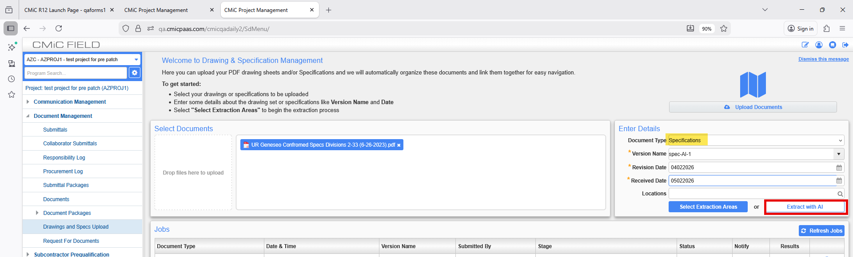
Implementation
Users may access the 'Drawings and Specs Upload' interface to submit specification documents utilizing the newly implemented AI extraction process.
Procedure:
- Select the specification document intended for upload.
- Choose 'Specifications' as the 'Document Type' from the dropdown menu.
- Provide the version name, revision date, received date, and applicable locations.
- Activate the [Extract with AI] button to initiate the extraction process.

The extraction process now commences, and users are presented with a notification regarding the ongoing processing. Click "Okay" on the notification to proceed.
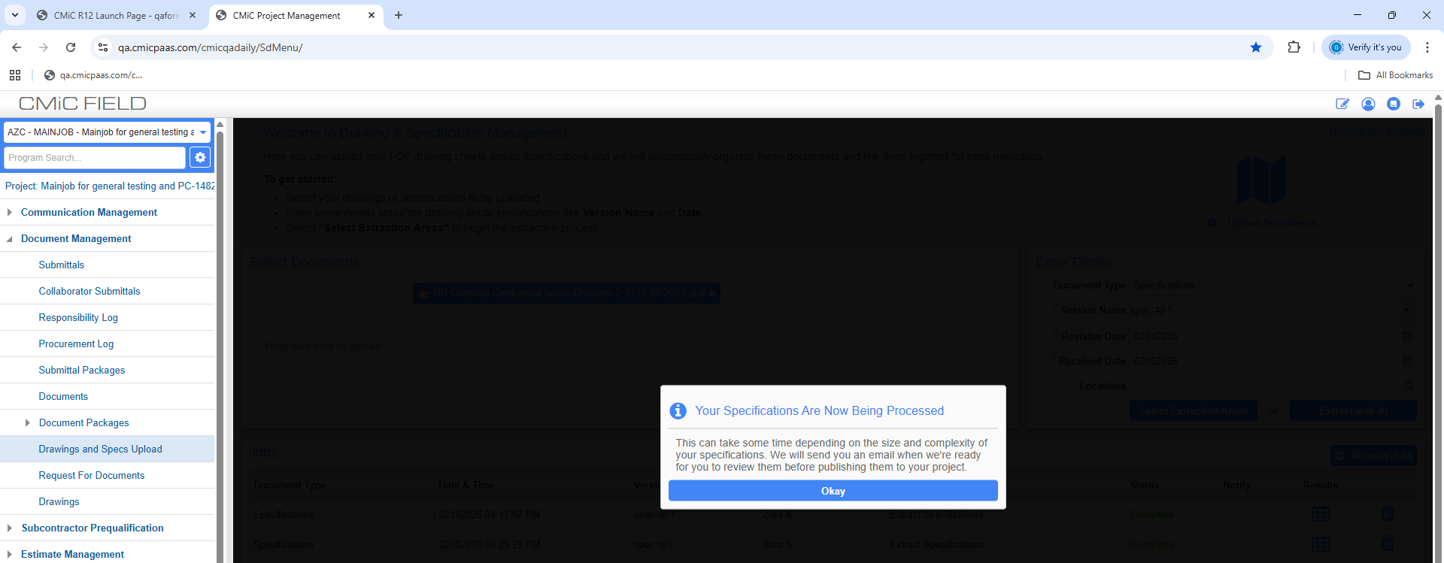
The job is now scheduled, and its status is displayed as "Queued."
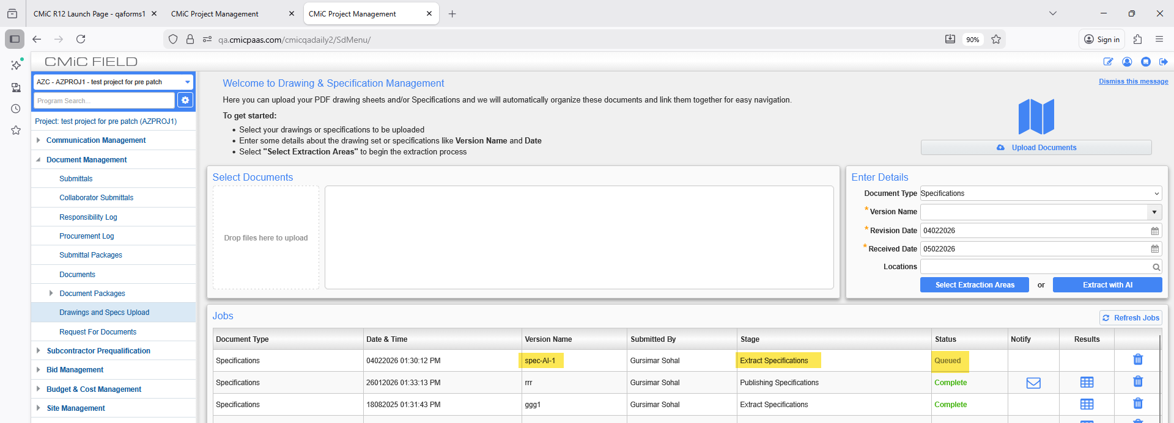
Users may select the [Refresh Jobs] button to retrieve the most current status of the scheduled job.
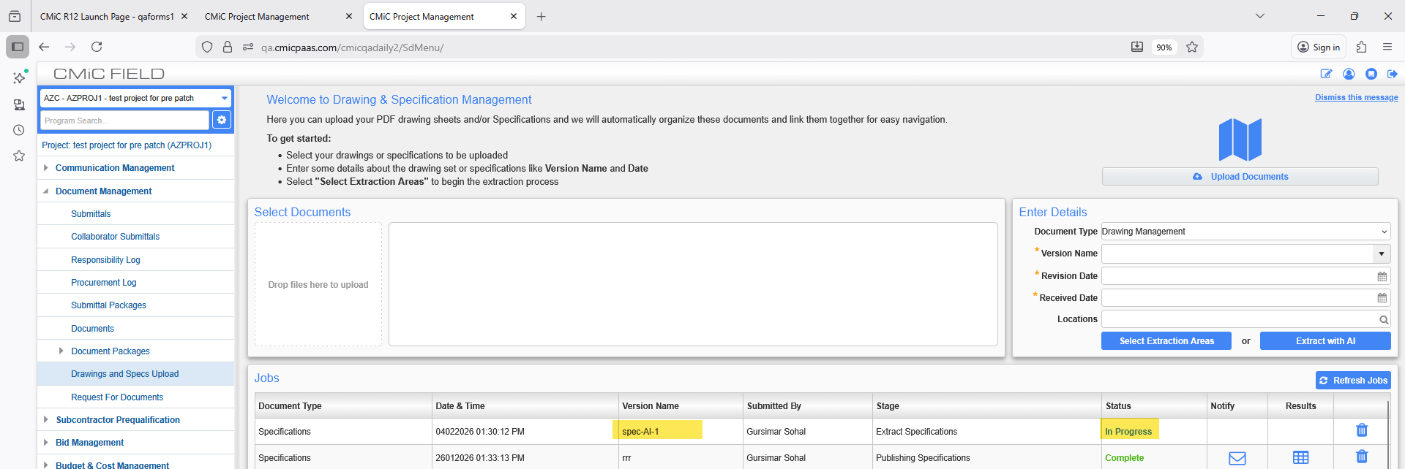
The user will now receive an email notification upon the completion of the specifications processing.
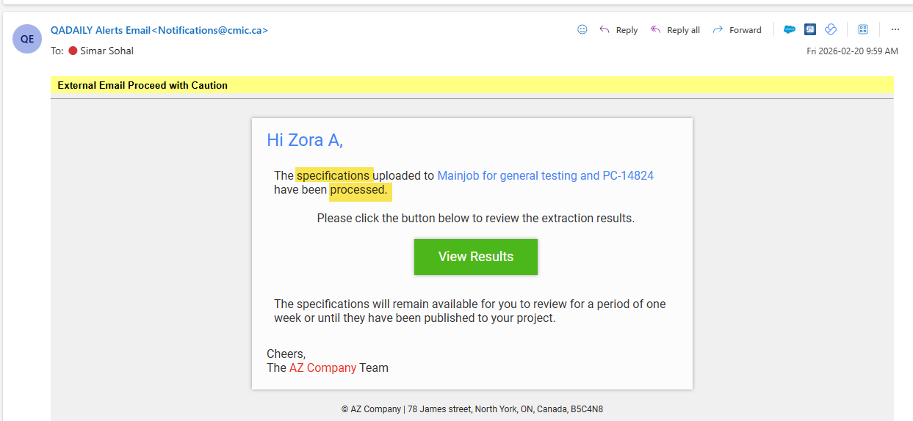
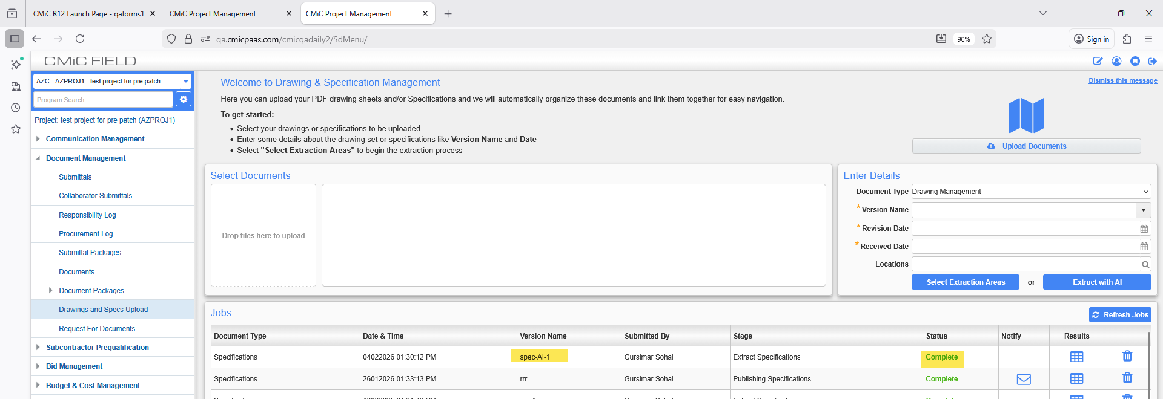
By selecting the [View Results] option, users are directed to the validation page where they may modify the specifications and subsequently publish the updated versions.
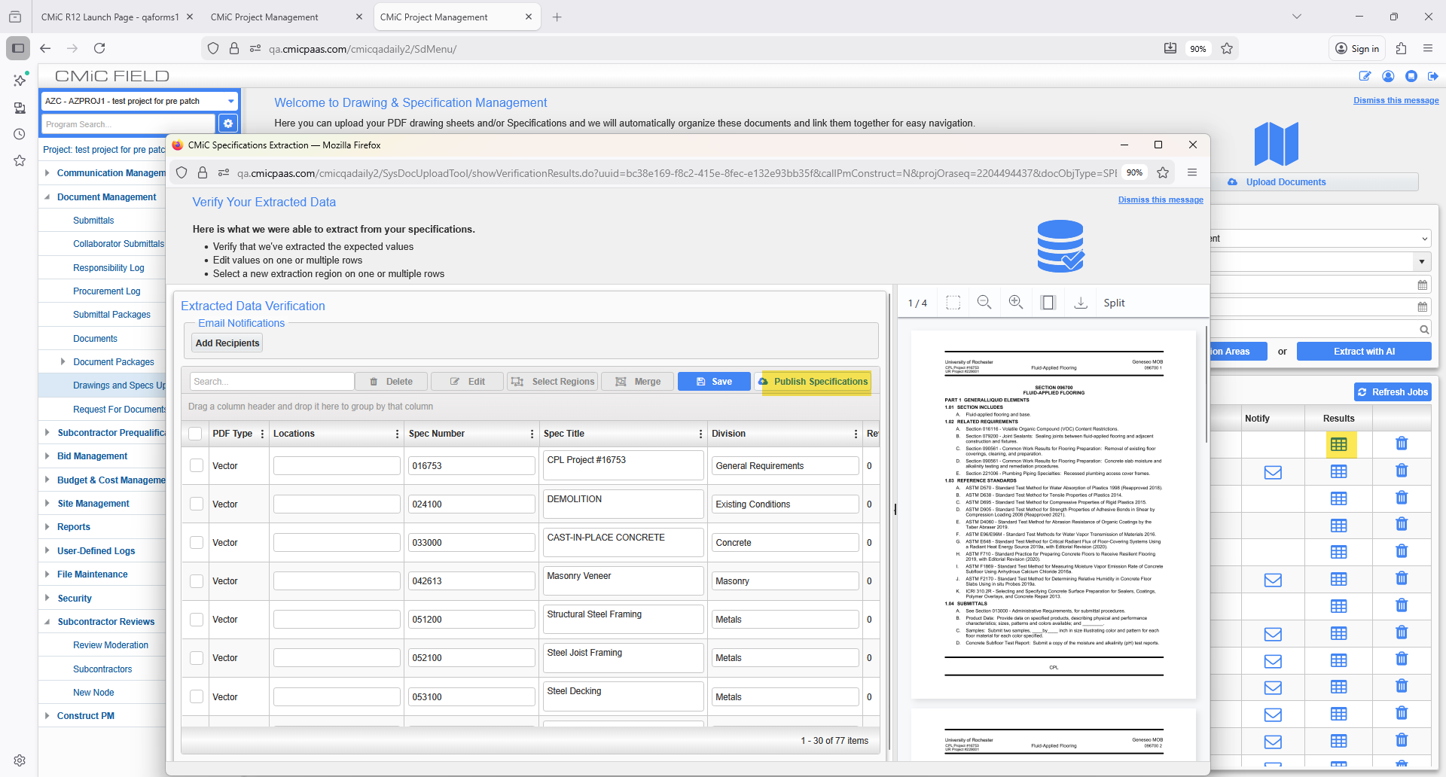
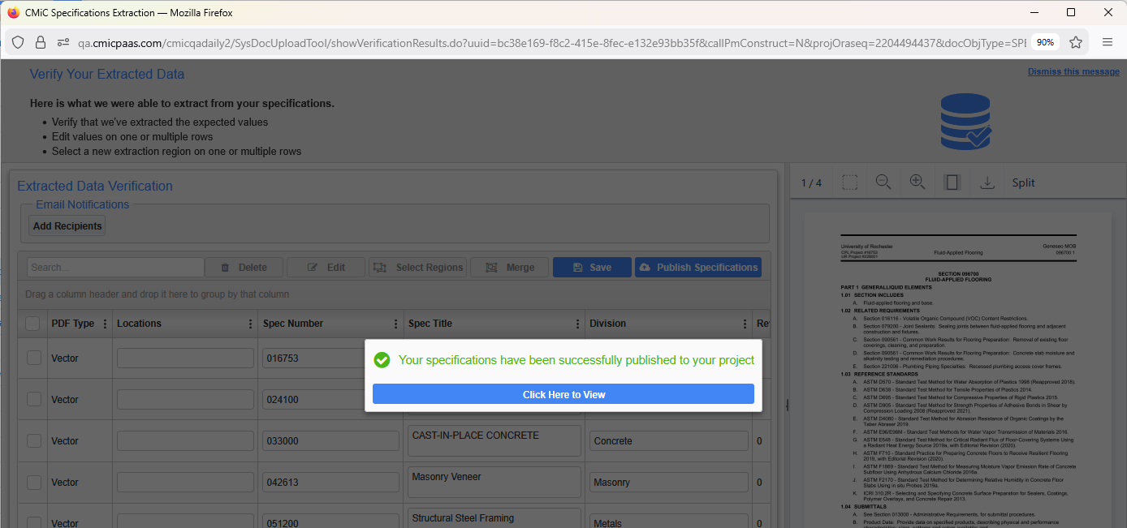
Refresh the jobs once more.
The status will be indicated as ‘In Progress’ during the Publishing Specifications stage.
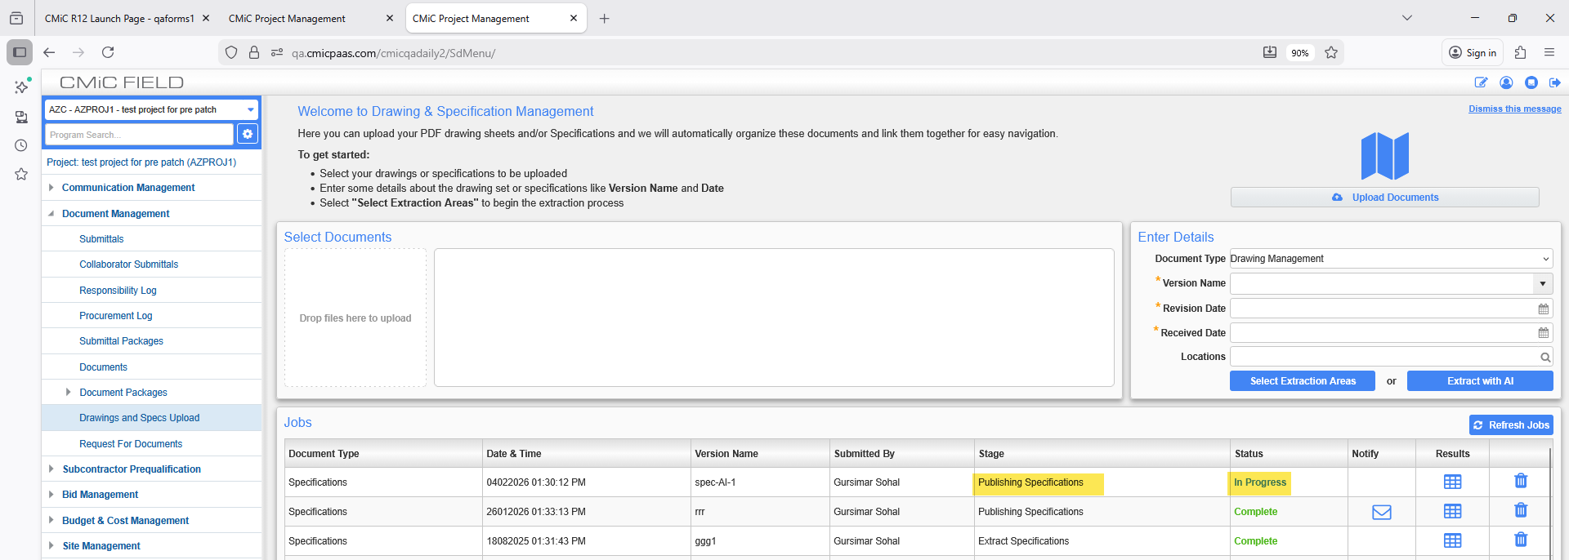
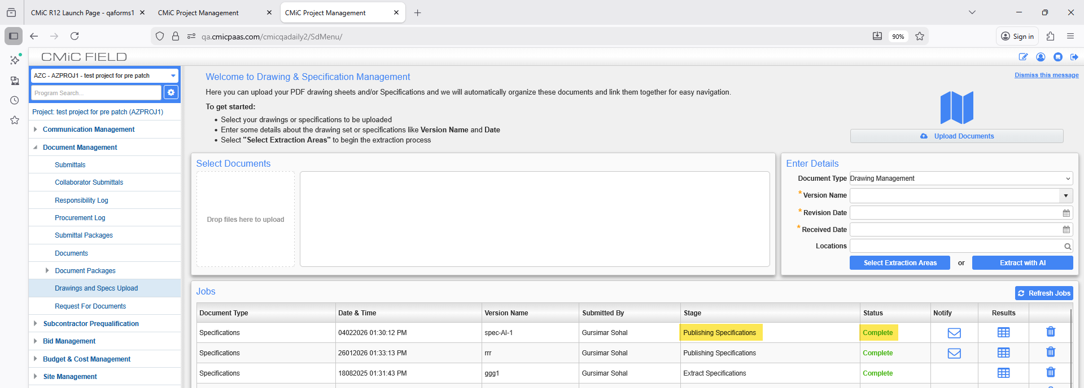
When the status is marked as COMPLETE, the user will receive an email notification confirming the publication of the specifications. Additionally, an "Envelope" icon will be displayed in the notify column for the Job on the "Drawings and Specs Upload" screen.

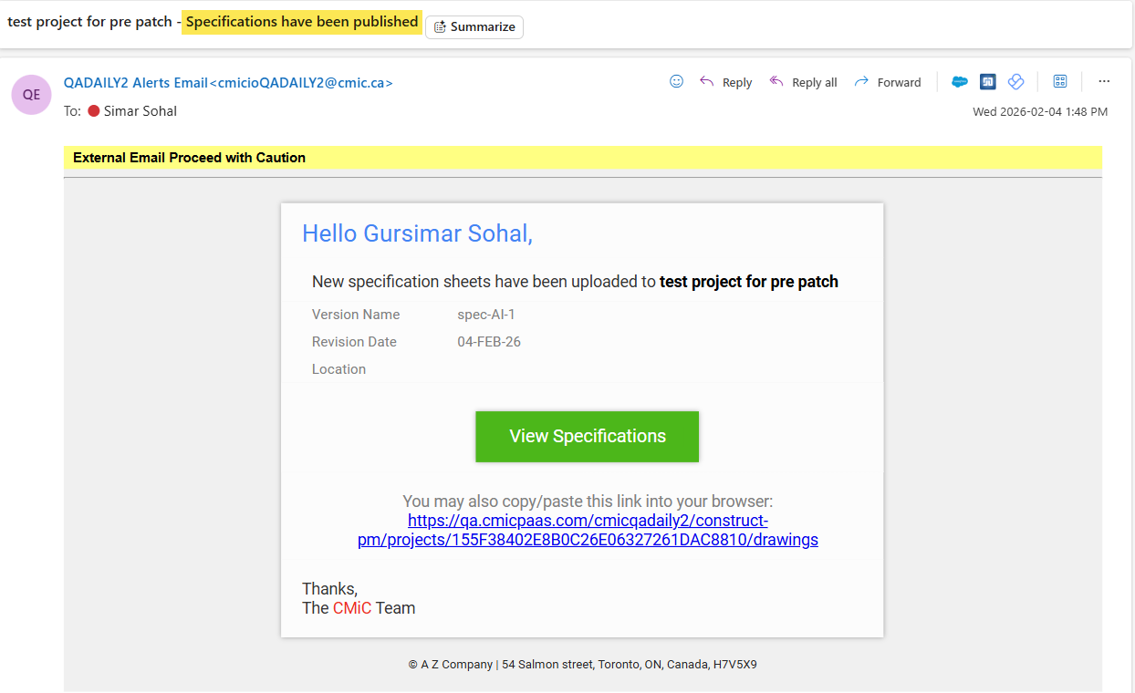

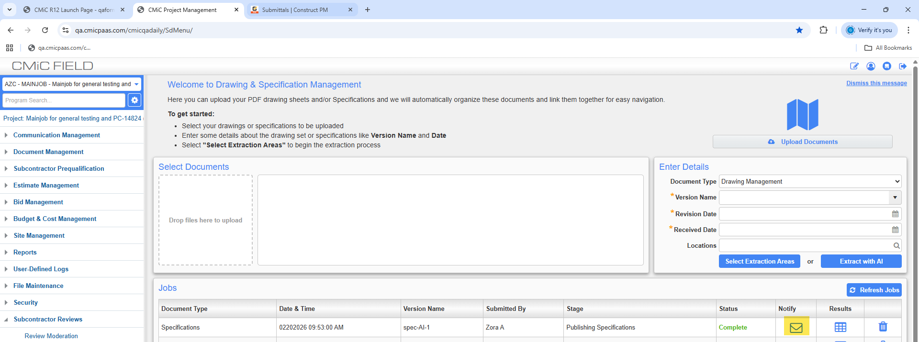

Purchase Order

Blanket Order Entry: Updated Expiry Date Validation (CAM-9802)
Overview:
Enhancements have been implemented in Blanket Order Entry (POBLENTC). The validation logic for the expiry date field has been updated to display a warning message instead of a validation error.

Modifications:
The previous validation message has been replaced with a warning message when the expiry date is earlier than the current system date.
When expiry date is earlier than the current system date in Blanket Rules section, then updated warning message:
“Info: Expiry date is earlier than current system date.”
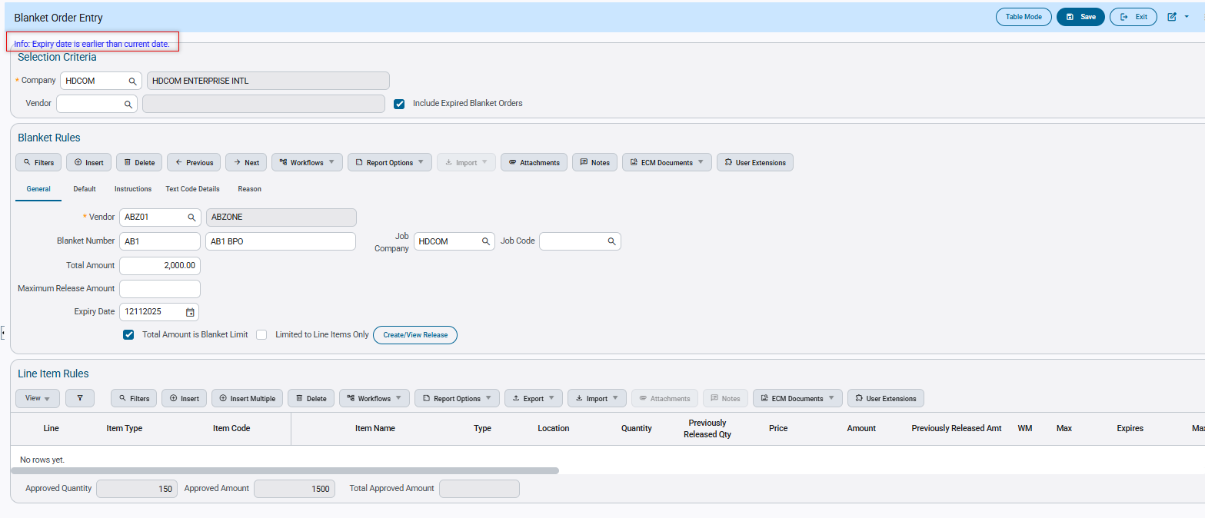
When expiry date is earlier than the current system date in Line Item Rules section, then updated warning message:
“Info: Item Expiry date is earlier than current system date.”

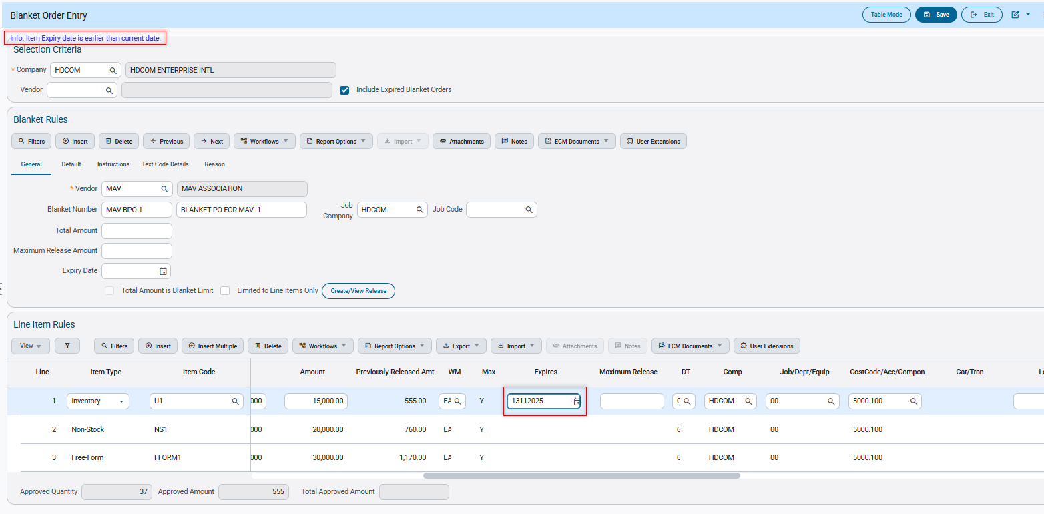

Blanket Order – Control File Text Codes now default on Blanket Order Entry (CAM-9147)
Prerequisites
Ensure that the Purchase Order Control File has Text Codes set within the Purchase Order tab:
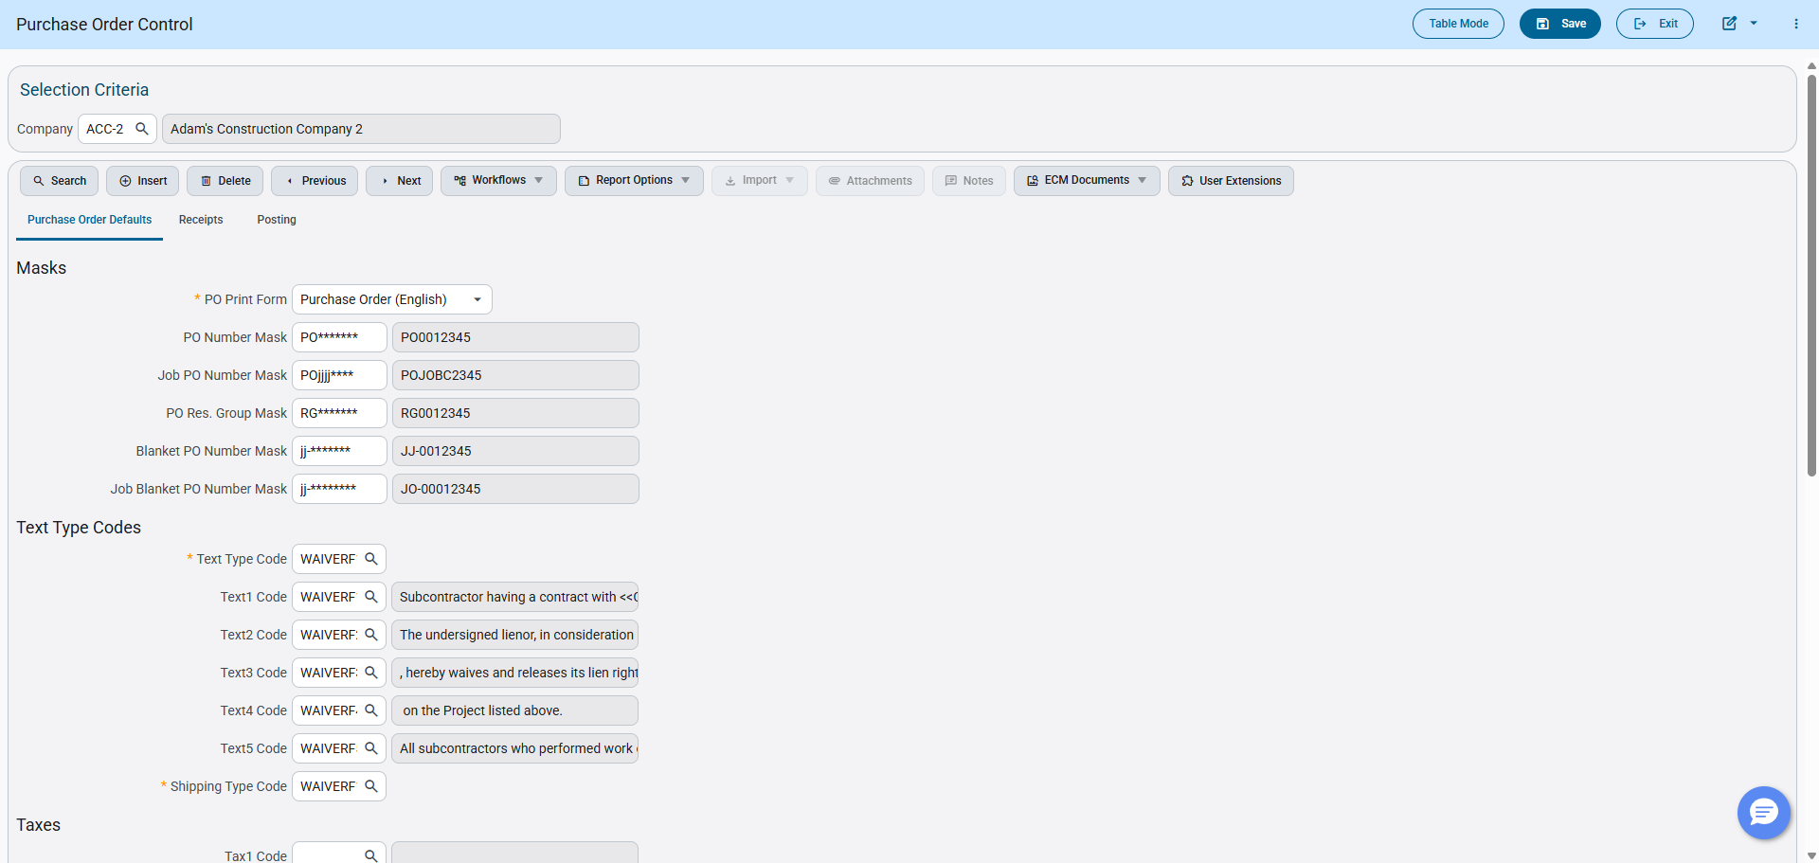
Overview
The Blanket Order entry program on creation, now appends the Text Codes which have been specified within the Purchase Order Control File. This allows the user to save time inputting data and increase efficiency when creating a new Blanket Order.
Modifications
Runtime feature program:
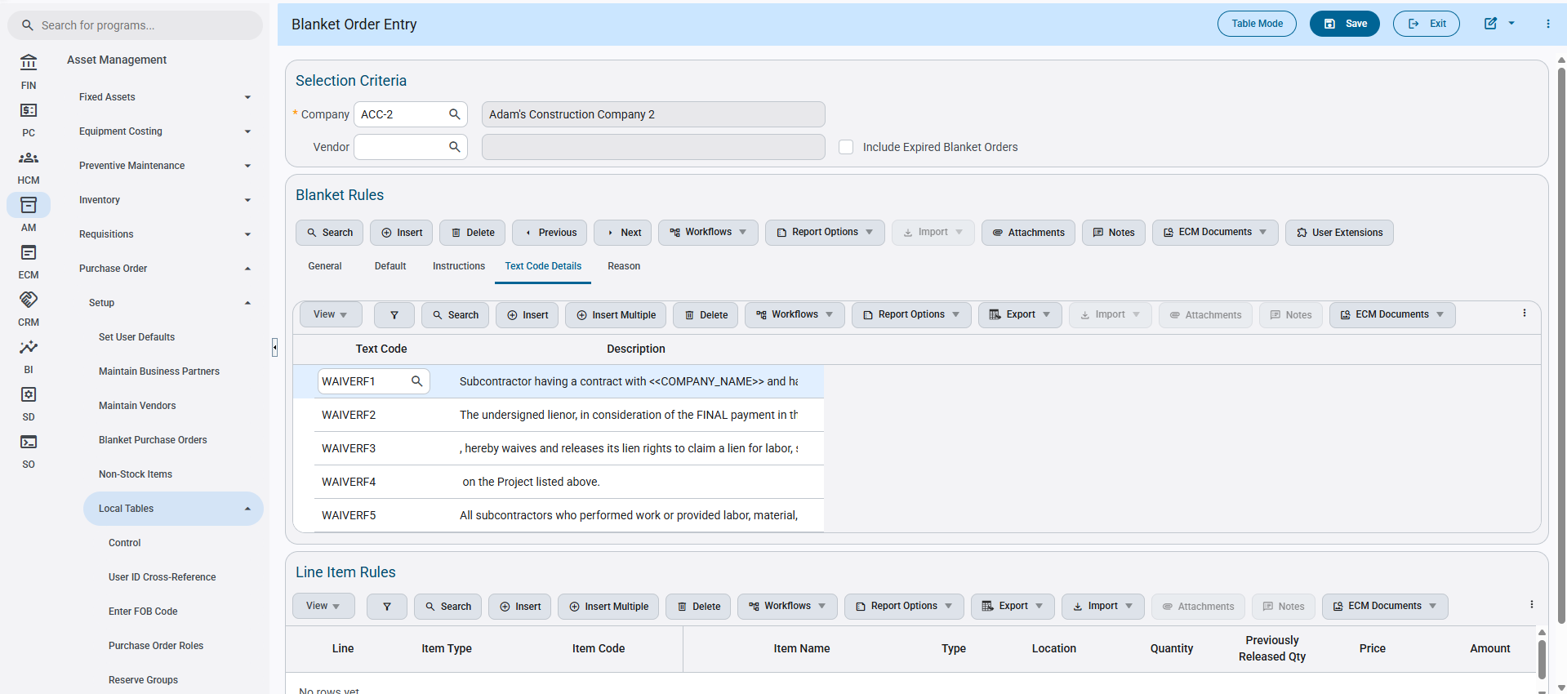
Implementation
The Blanket Order entry program has been updated to append the Text Codes saved within the Purchase Order Control File, to allow faster integration while creating new Blanket Orders.
To ensure the process is correct, the user will first set some Text Codes within the Control File under the first tab Purchase Order Details – Text Type Codes section.
Once the settings have been saved, the user will open the Blanket Order Entry program and enter their mandatory header details.
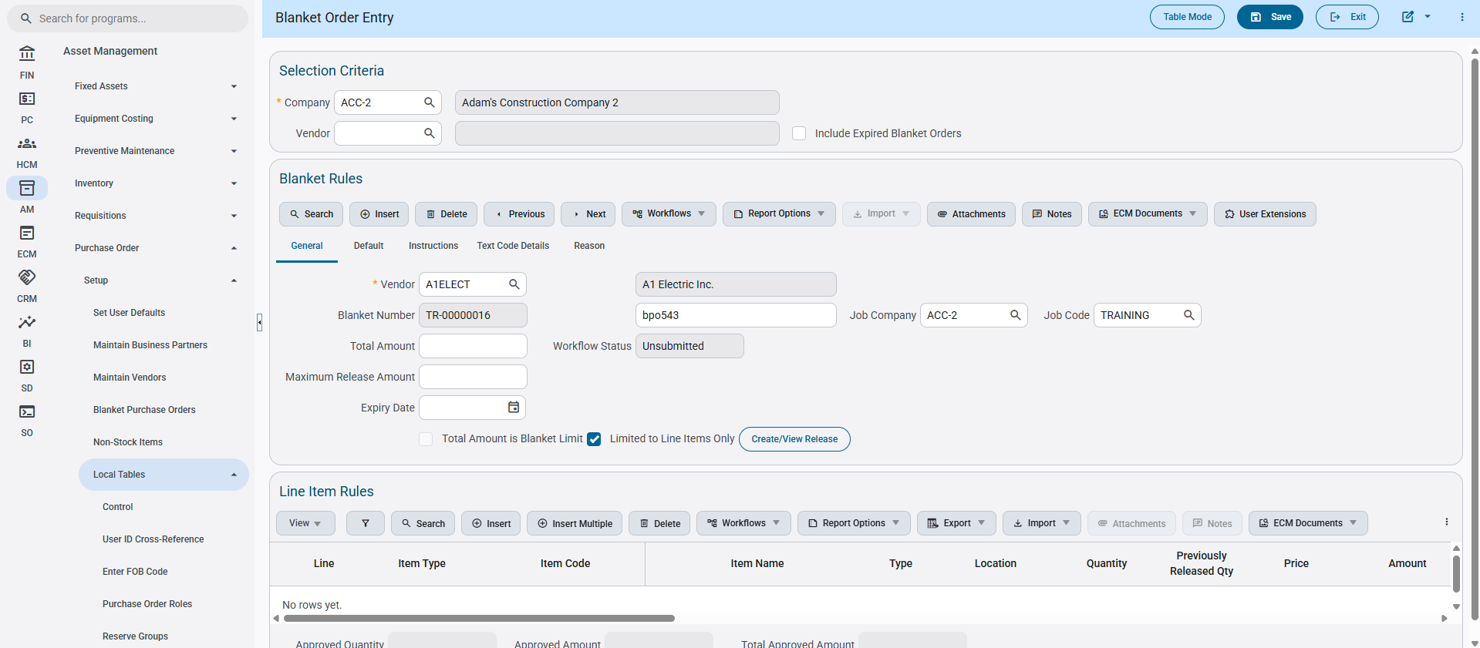
Once entered and saved, the Text Codes entered on the Control File will auto populate the Text Codes within the Text Code Details tab within the Blanket Rules section.
The user is limited to having five text codes defaulted to the Blanket Order, and will have to insert additional codes if necessary to their needs.

Blanket Order – New description fields added to Blanket Purchase Order (CAM-8763)
Overview
Two new description fields Job Code and Department have been added to the Blanket Purchase Order Entry program. This change aims to add more clarity and information for the user’s convenience.
Prerequisites
These fields are optional and are by default hidden within the Lite Editor. They must be added to be viewed.
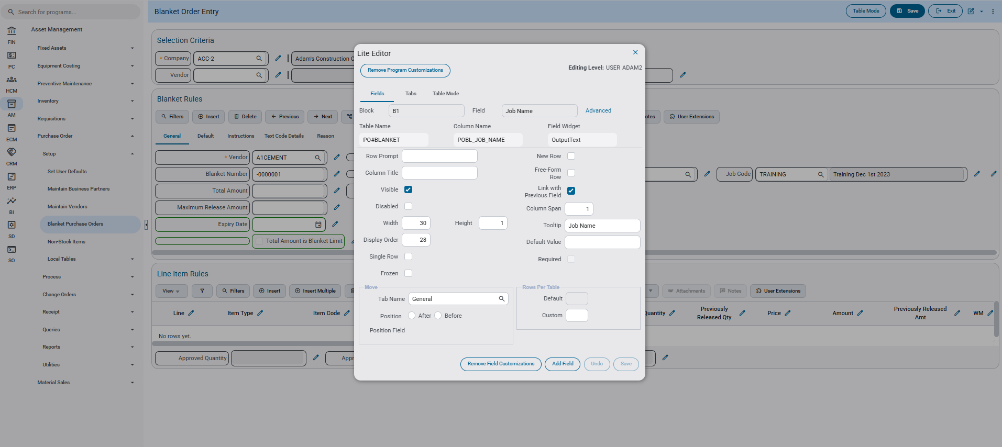
Modifications
Runtime feature program:
Job Code Description Field –
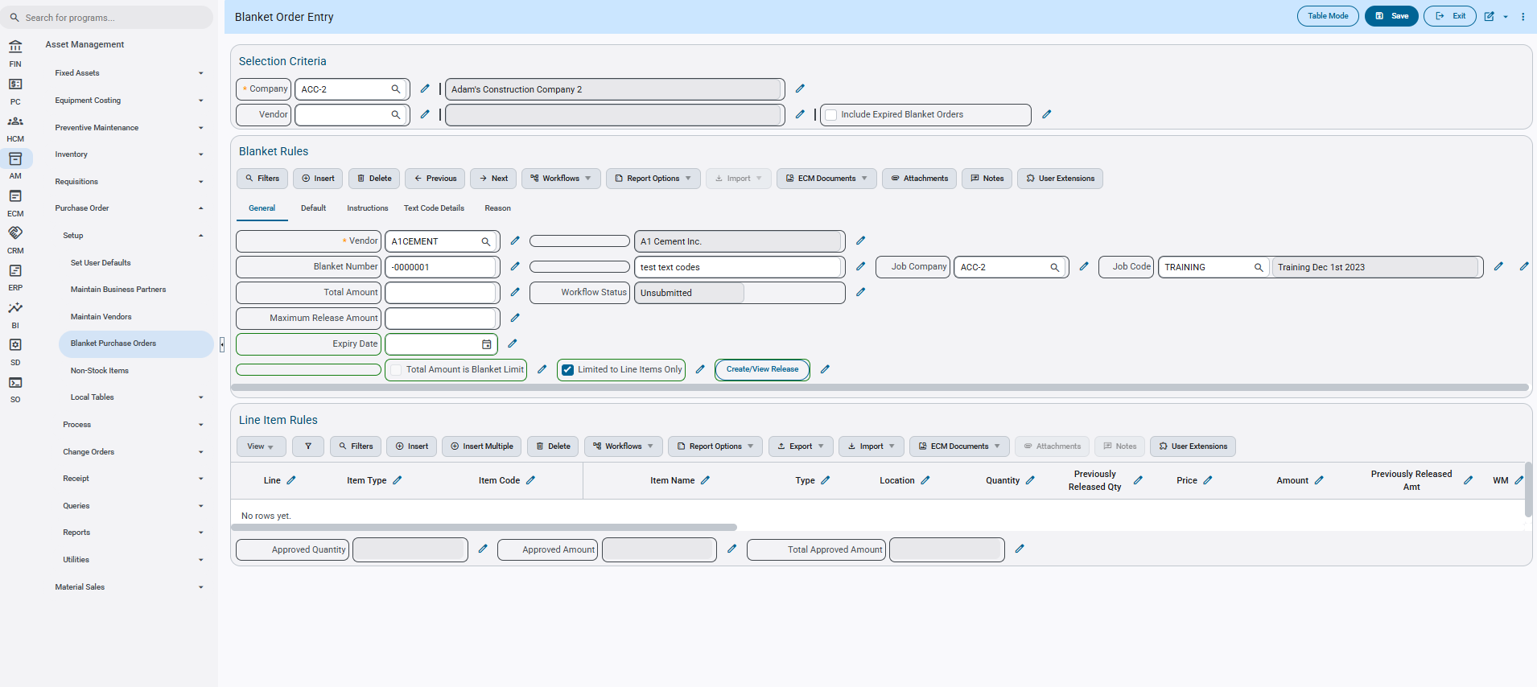
Department Description Field –
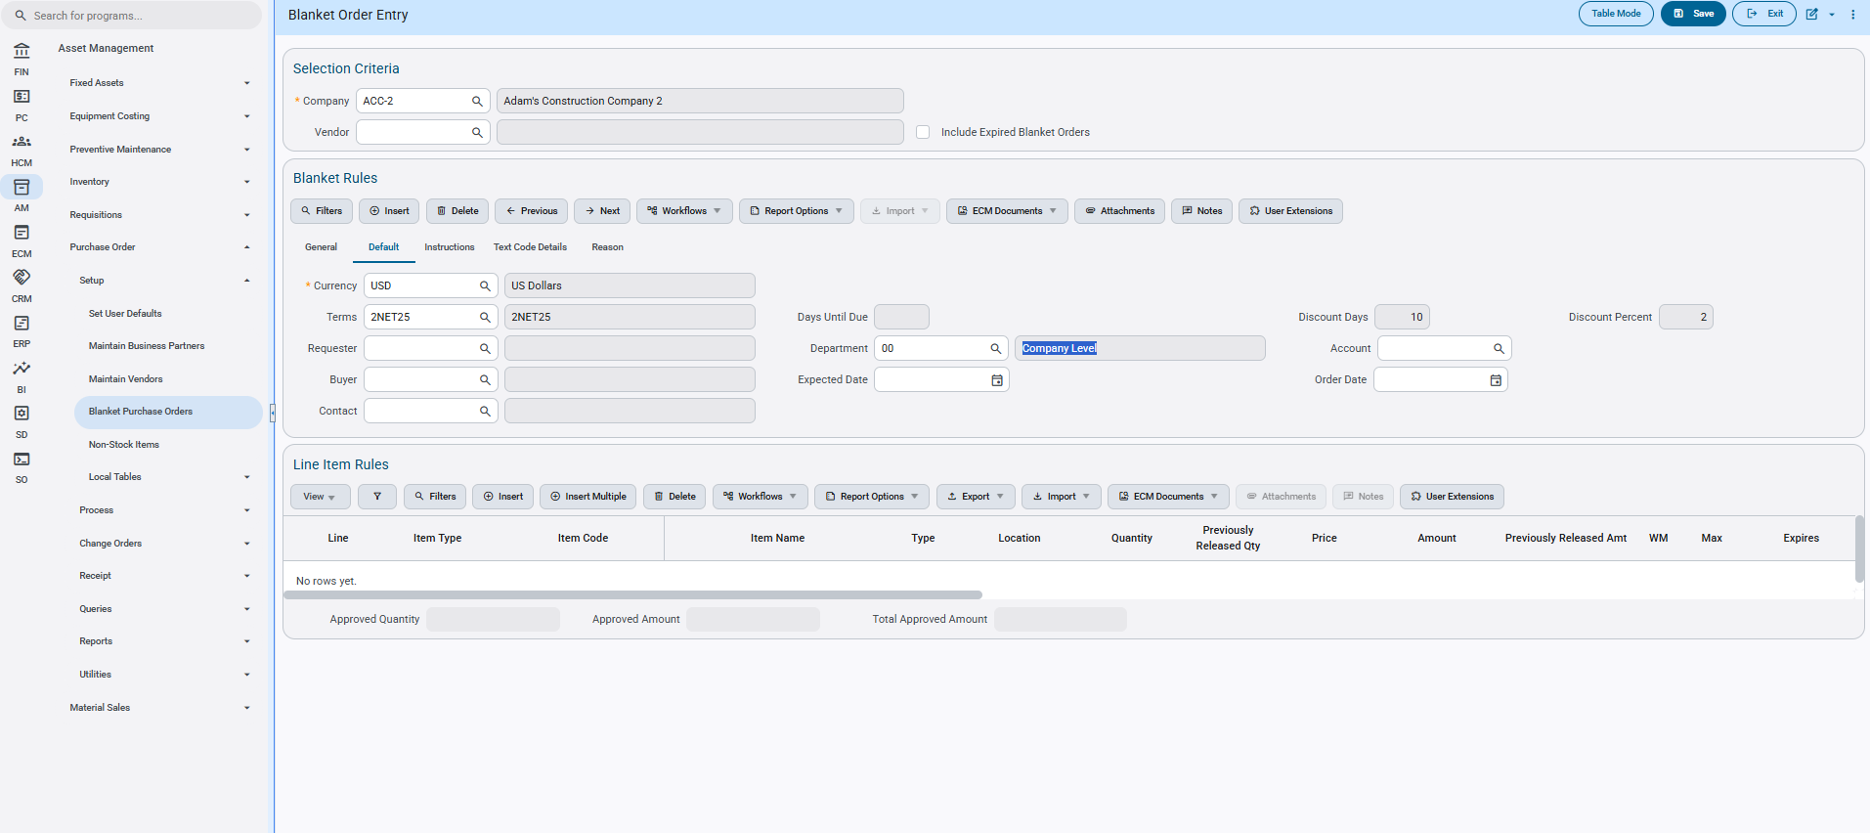
Implementation
The two new description fields added to the Blanket Purchase Order program provide some additional clarity for the Job Code and the Department set.
Job Code Description field is located within the General Tab on the Blanket Rules header, where as Department Description field is located within the Default tab as seen above.

Change Order – Three new columns added to Purchase Order Lookup (CAM-8118)
Overview
Three new columns have been added to the Purchase Order Lookup Table within the Enter Change Order program. This allows users to search for their Purchase Order on the Vendor Name and/or Purchase Date.
Modifications
Runtime feature program:
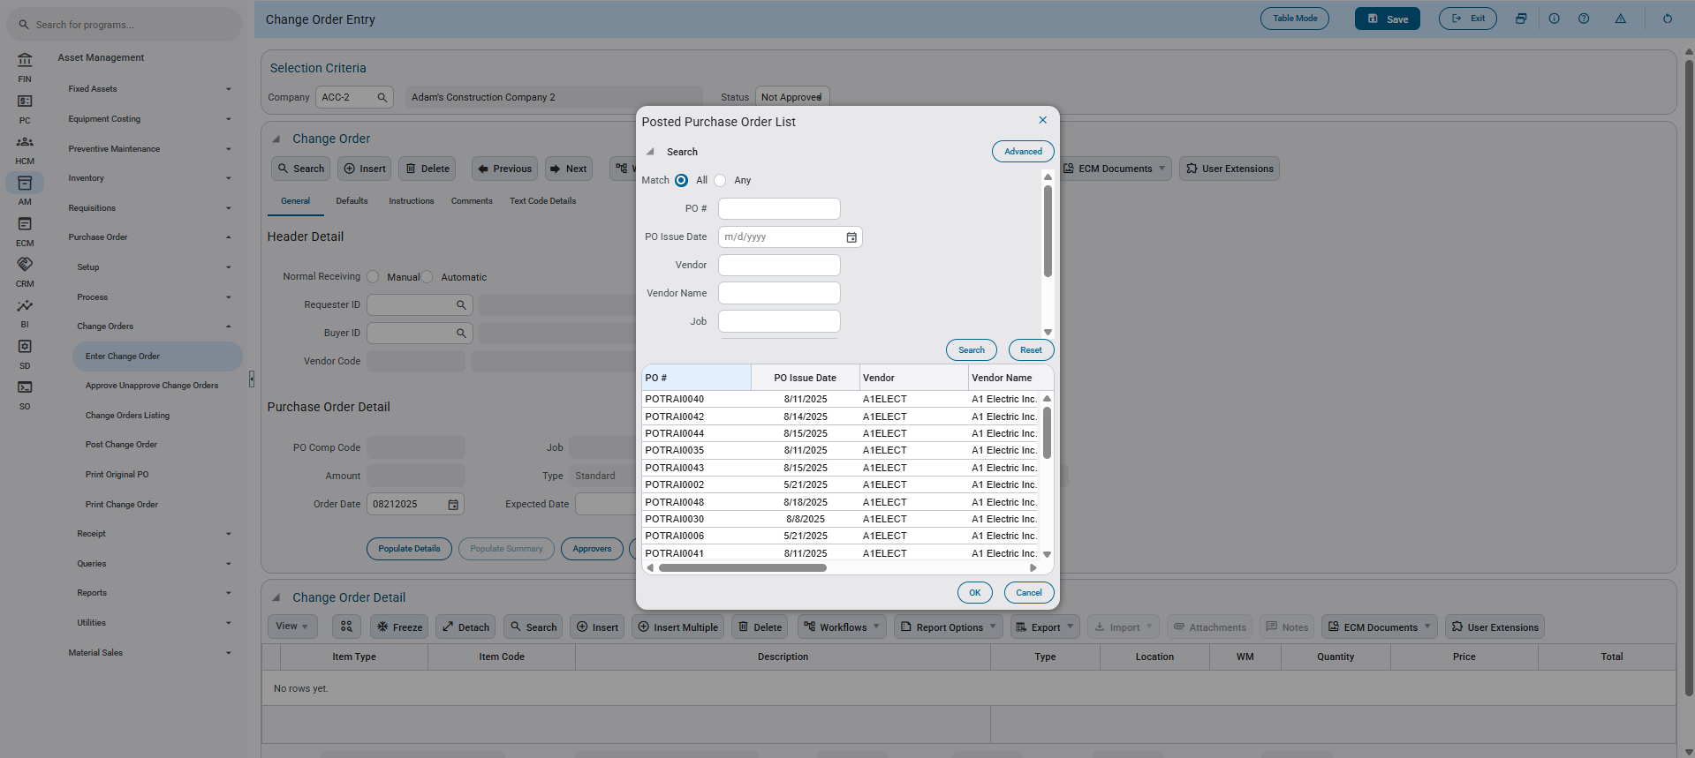
Implementation
The Purchase Order selection LOV now contains additional columns and search parameters in order to assist the user in finding their exact Purchase Order. PO Issue Date and Vendor Name have been included as new search parameters. PO Issue Date, Vendor Name, and Created By (USERID) have been included as new columns on the table.
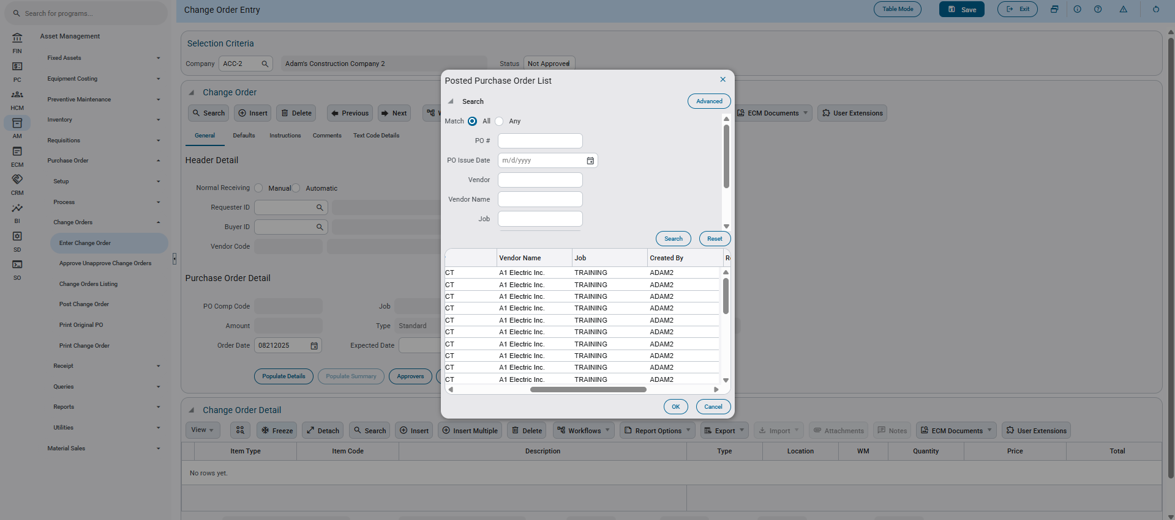

Construct PM – New Column Title and Calculation for Receiving Shipments (CAM-9321)
Overview
The Received header title within Construct PM – Receiving within a Shipment has been replaced with Outstanding, and the calculation of the column has now been replaced by Order qty - (Received qty + Claimed qty).
This change will ensure and prevent any discrepancies between received and total remaining values.
Modifications
Runtime feature program:
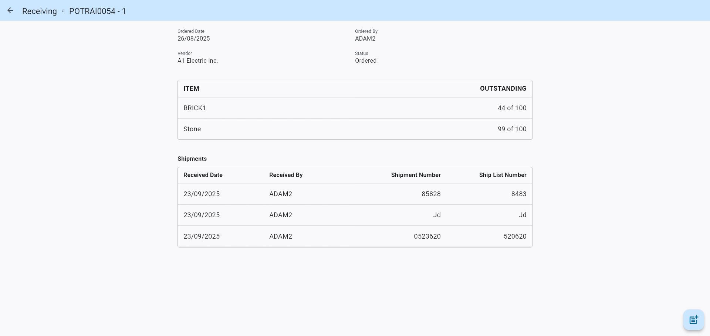
Implementation
The Outstanding header and calculation have been changed to allow the user to better understand how the resulting values are displayed. Showing the total remaining quantities of items that have yet to be collected.
The calculation now for items in receipts is as follows:
Order qty - (Received qty + Claimed qty)
The total remaining outstanding value is calculated from taking the total item received/claimed amount out of the total order quantity of that item.
As follows, we have here an empty/blank non-received shipment.
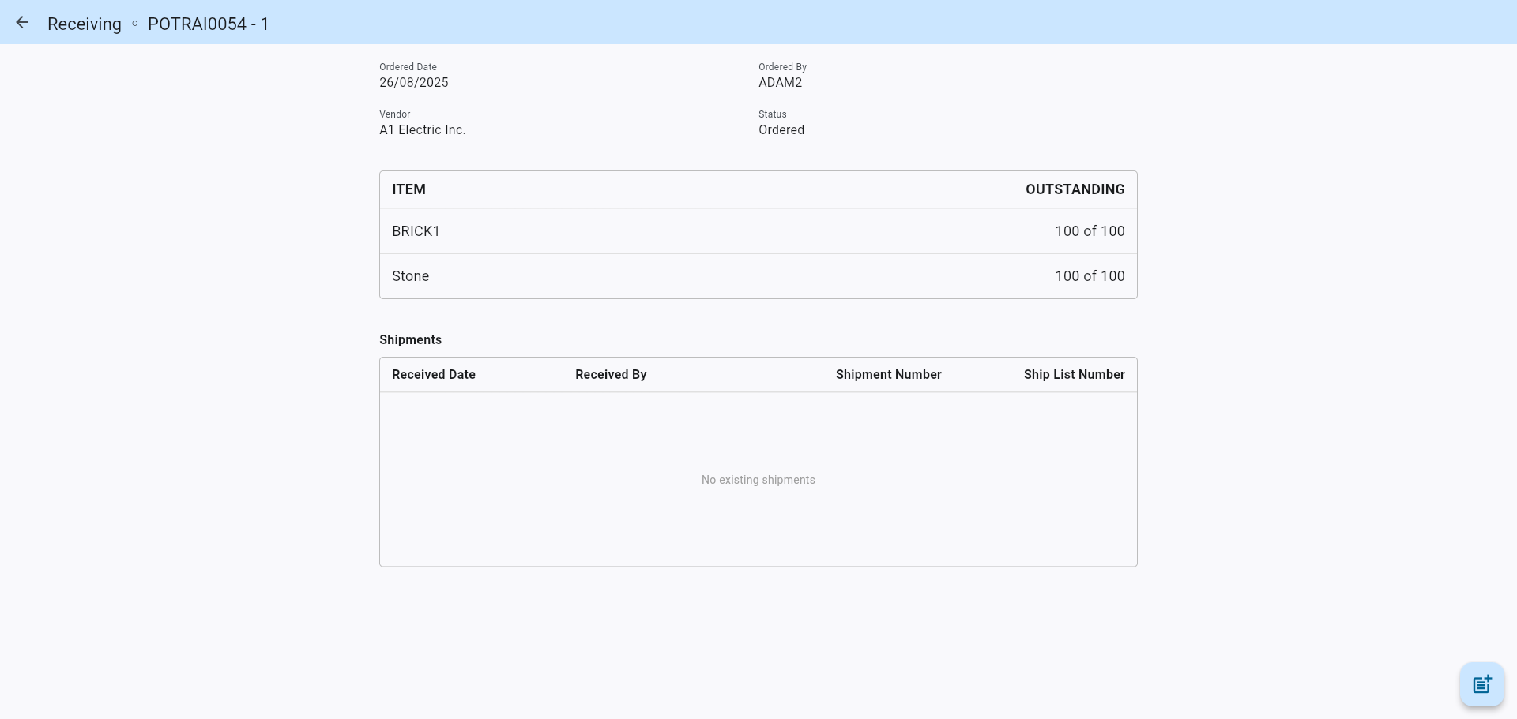
Both items listed display the total remaining quantity for their respective detail line.
A new shipment receipt is created as an example, with 15 totaled value for item 1 and 30 for item 2, while ignoring the Rejected column.
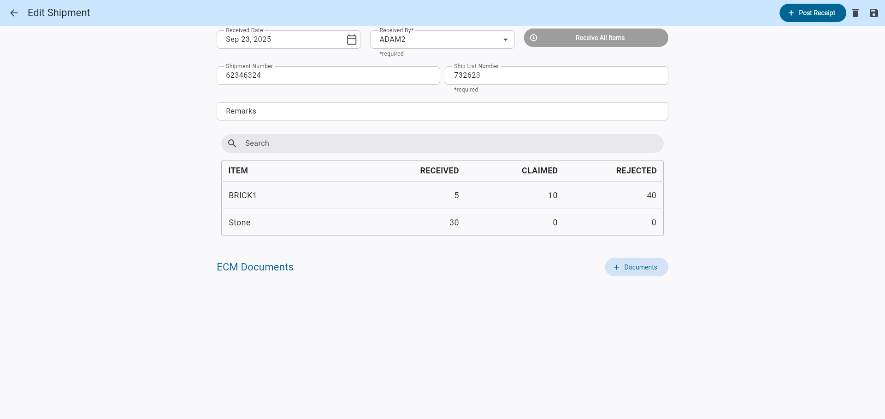
Once saved and returned to the main shipment page, the Outstanding value is calculated and displayed as follows.
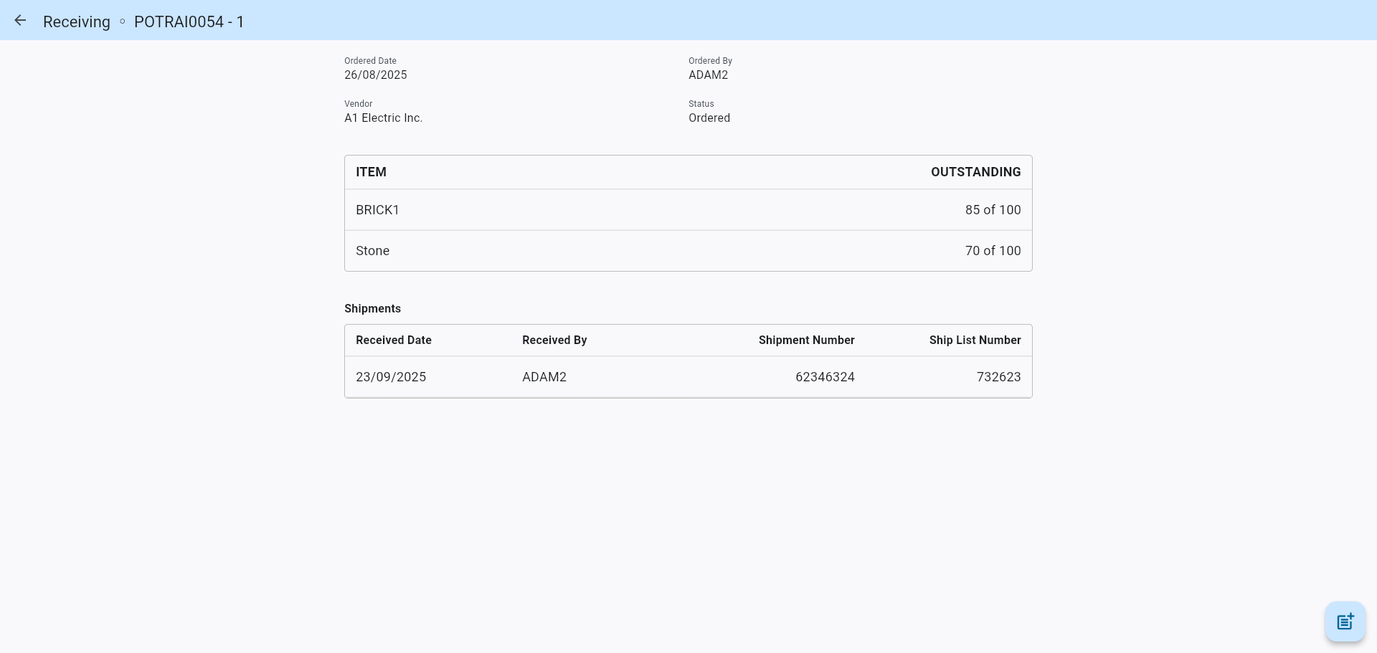
Each item shows how much quantity is able to be received for future shipments and receipts, ensuring that the user can make clear decisions when doing business.

Control File – New Flag setting included for Receipt posting (CAM-9166)
Overview
A new checkbox flag “Exclude Unposted Receipt Quantity at the time of Posting” has been added to the PO Control File – Receipts Tab. This logic aims to assist various cases of variance.
Checked Flag: the system will validate variance by excluding unposted receipt quantities (including negative receipt amounts entered and saved, but not yet posted).
Unchecked Flag: the system will take into account all receipts for the Purchase Order regardless of status before validating variance.
This validation will ensure that the system does not allow posting receipts more than the ordered quantity when there remain records in a saved/unposted state. By default, the flag will remain unchecked.
Prerequisites
Ensure that the Verify Receipt Quantity checkbox is checked:
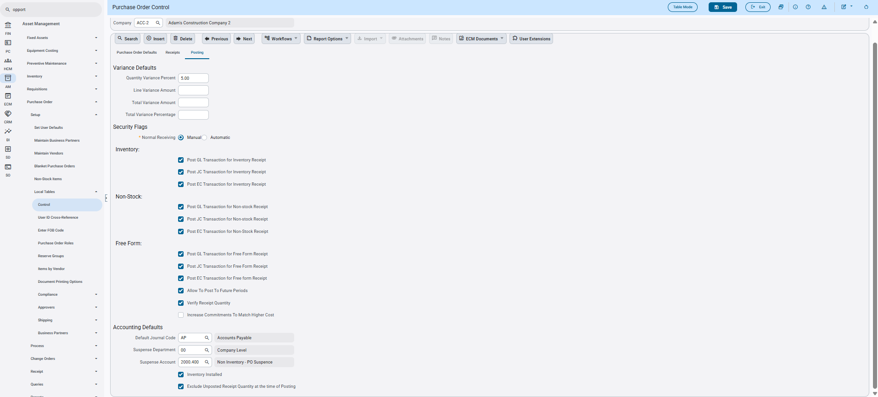
Ensure that the PORCPTVAR Privilege for the user is unchecked:
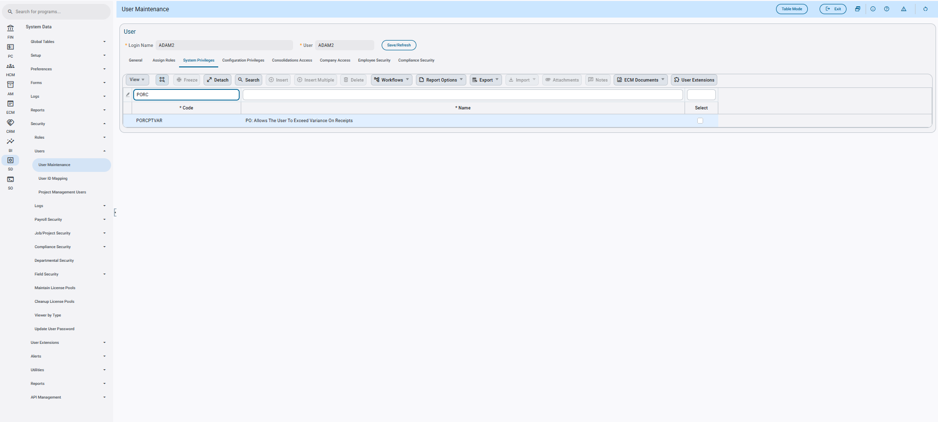
Modifications
Runtime feature program:
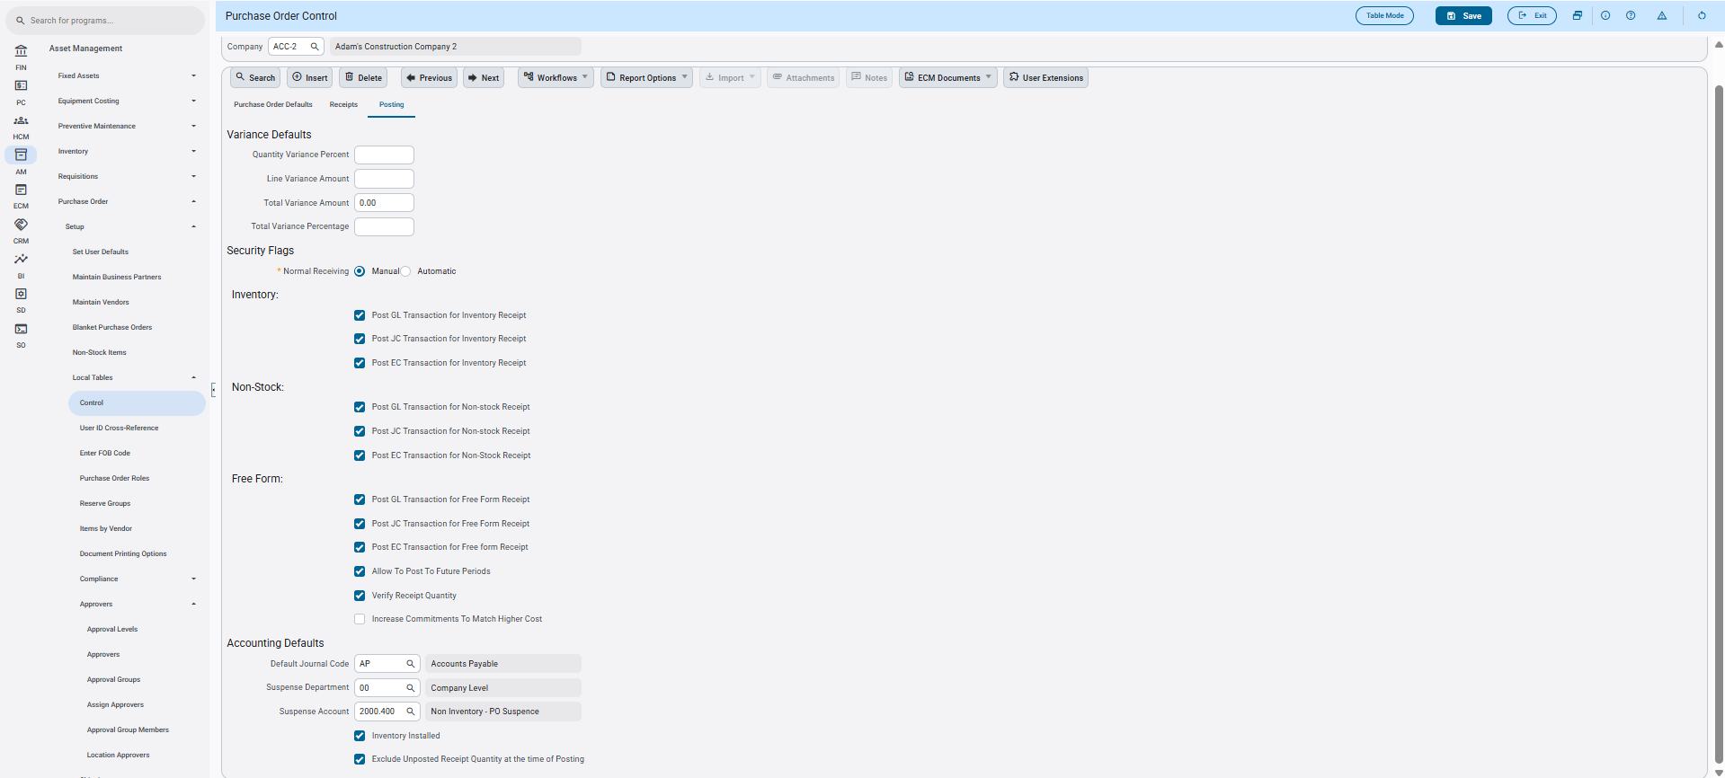
Implementation
Quantity Variance Percentage will be used as an example of how the new checkbox operates.
First the user will set a value for the variance, and ensure that the new checkbox is checked:
In this case, a value of 5 indicates that total Quantity of all Receipts for the Purchase Order does not exceed 5% in total.
First the user creates a Purchase Order with a quantity posted of 100.
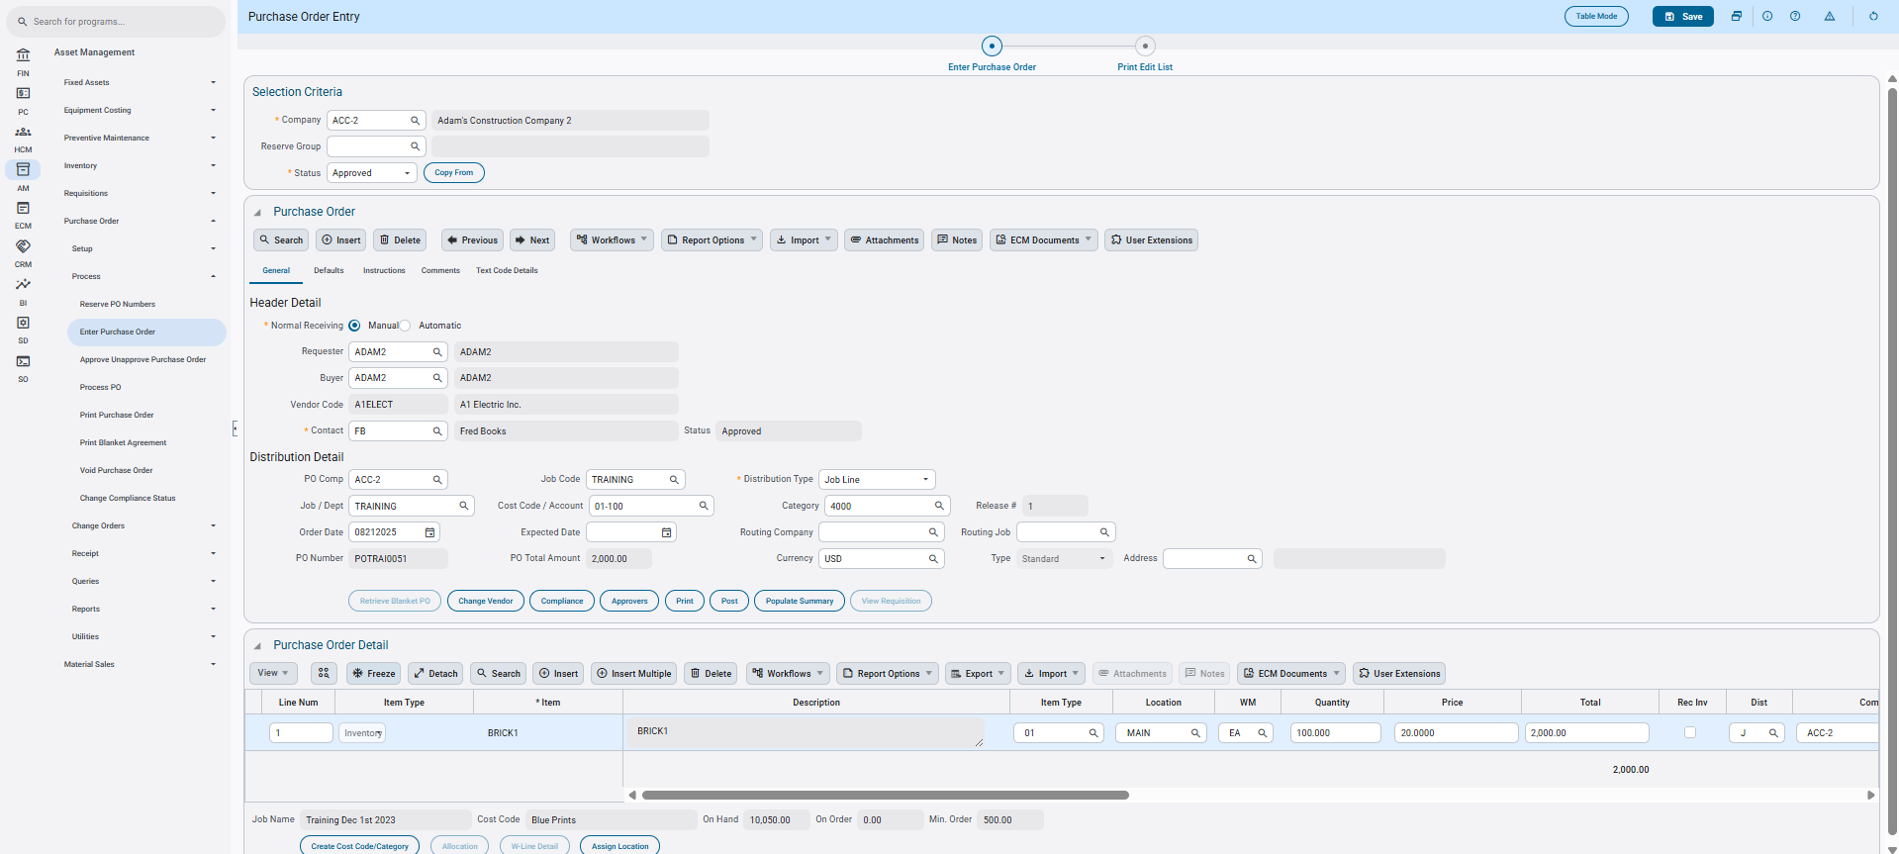
Then the user will create separate receipts to validate the functionality of the checkbox.
In order we will have as follows:
Receipt 1 – 50 Received qty – Posted
Receipt 2 - -50 Received qty – Saved
Receipt 3 – 55/56 Received qty – Attempted Posting
Using this combination totals the Purchase Order’s quantity to the set variance of 5%, and the checkbox un-checked would normally calculate the combined total at 55 because of the second receipt.
Receipt 1 – 50 Received qty Posted:
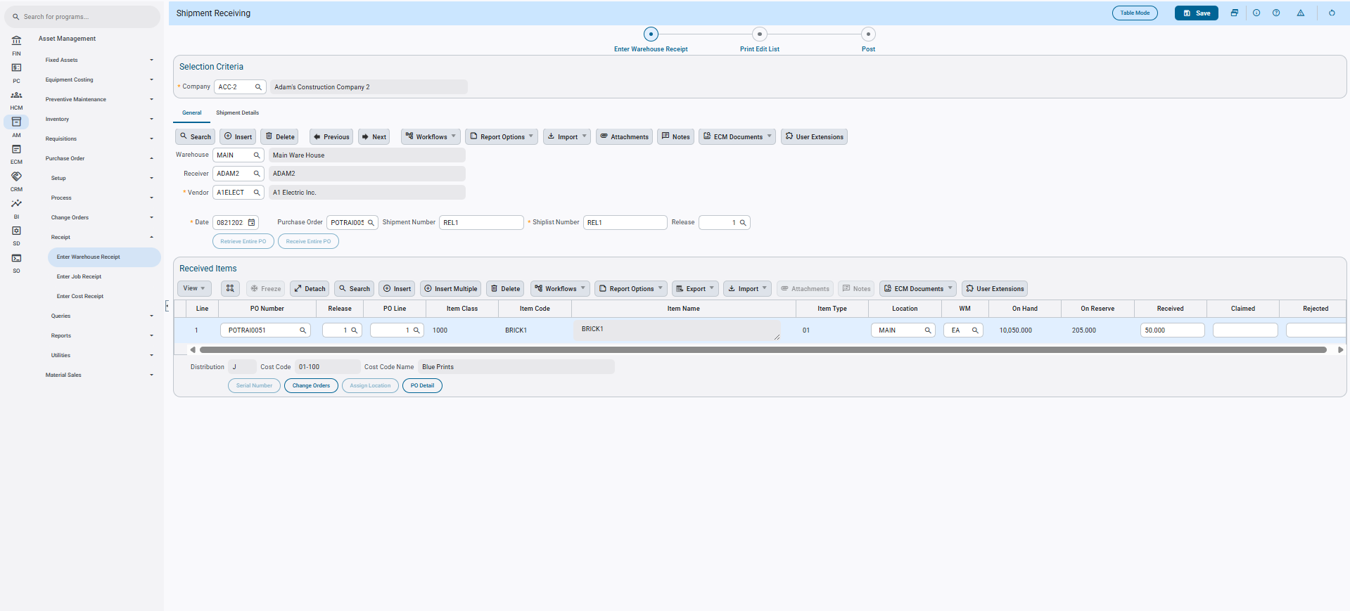
Receipt 2: -50 Received qty Saved:
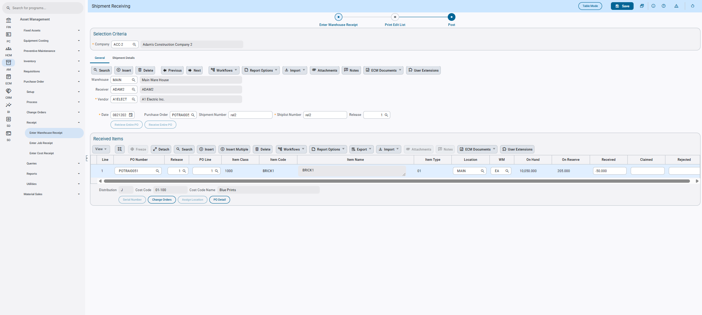
Receipt 3: 55 qty Saved:
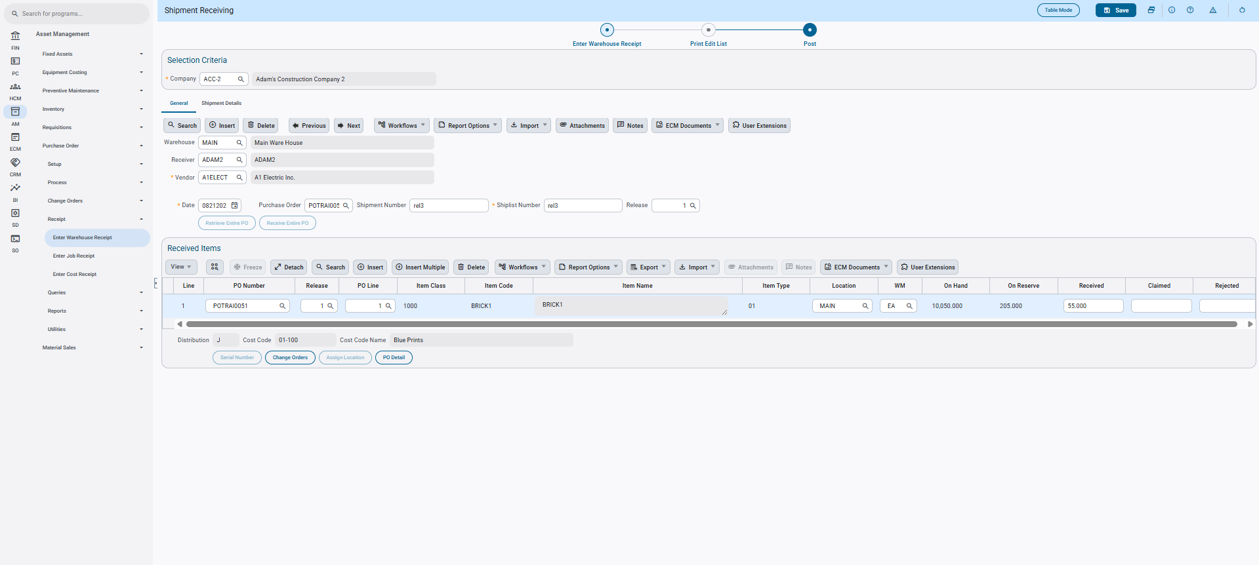
At the time of posting the third receipt, functionality will allow it to be accepted and process accordingly since the flag checked calculates the totals of the receipts to 105 qty.
But if the third receipt is set to 56 and attempted to be posted, the total exceeds the variance limit of 5% and provides this error.
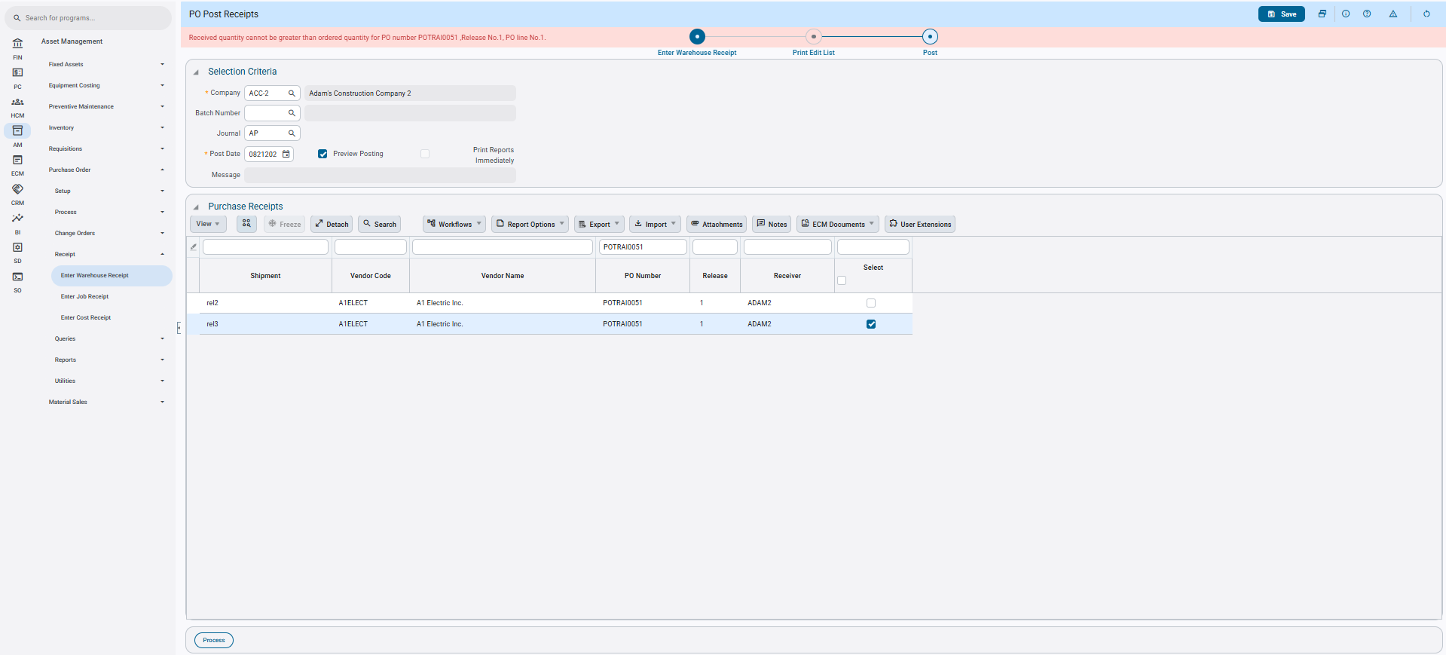
The user is prevented from exceeding the set variance limit. If the user were to leave the new flag unchecked, the user would have no limitation to the amount of unposted receipt totals affecting the set variance limits.
NOTE: This behaviour will trigger the same for all variance types, and as well as set limits to zero. If there is no variance limit set, it will be treated as null and ignored. But if the user sets the variances at zero, the behaviour will be that the quantity (or amount) of the Purchase Order will never be exceeded.

Purchase Order – New Enhancement for Job Line Distribution Type introduced (CAM-9857)
Overview
A new enhancement for Purchase Order Entry has been introduced. When creating a Purchase Order through the “Create Order From Requisition” (PORCRPOC) Program with a Job Code provided within the Requisition Header, the Purchase Order Distribution Type will be defaulted to Job Line.
This enhancement aims to provide the user with an easier and more streamlined Purchase Order creation process.
Modifications
Runtime feature program:
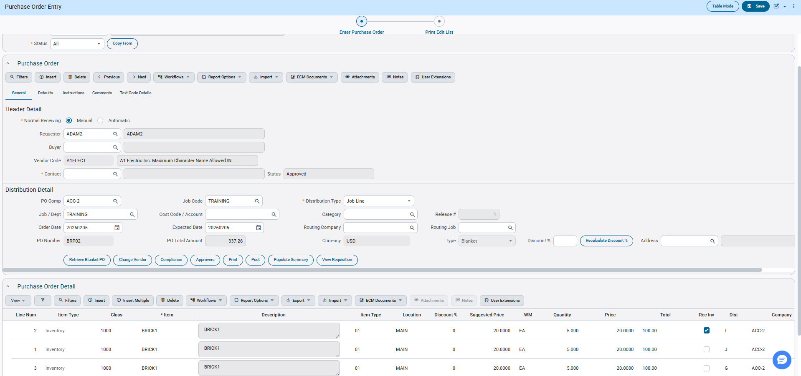
Implementation
The enhancement allows the user to have the Purchase Order created from a Requisition, defaulted to a Job Line Distribution Type when the Job Code in the Requisition Header is added.
This can be accomplished as well through a Blanket Order with the same conclusive steps.
The user begins the process by first creating a Requisition with a Job Comp and Job Code within the header details.
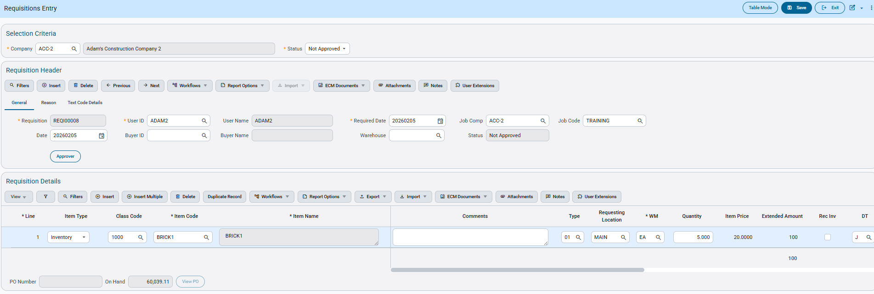
The user will then select and create a Purchase Order from the Requisition using the Create Order from Requisition program.
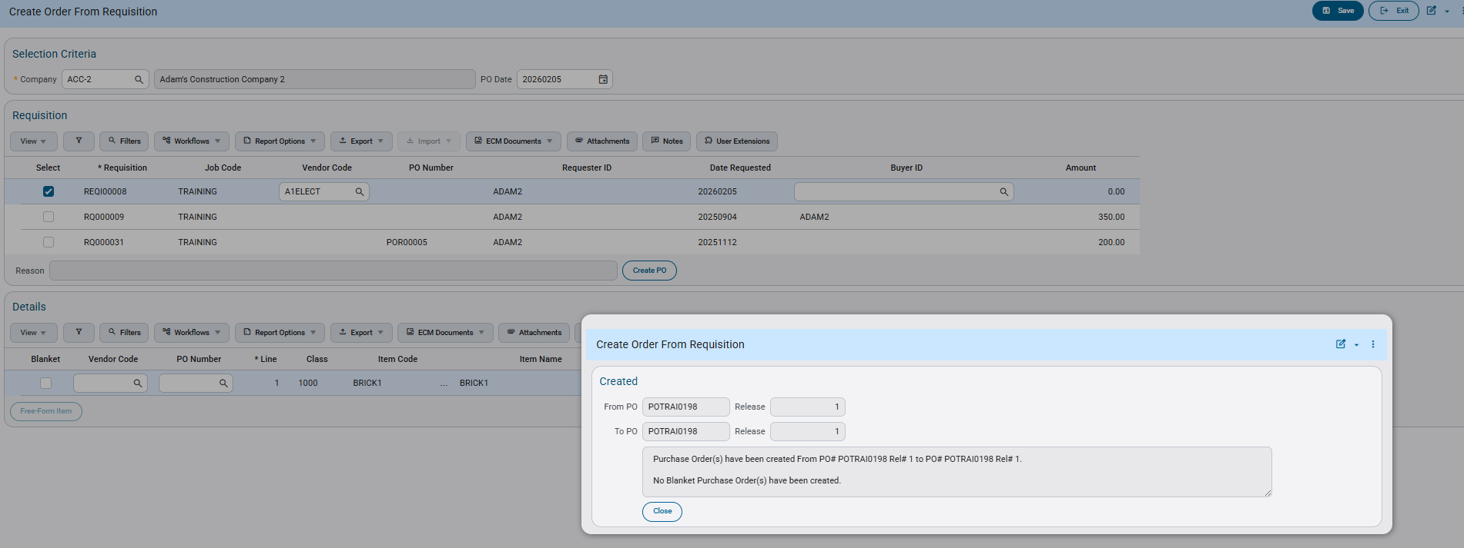
The resulting Purchase Order created is now defaulted to a Job Line Distribution Type, and has the Job Code displayed within the Header details as well.
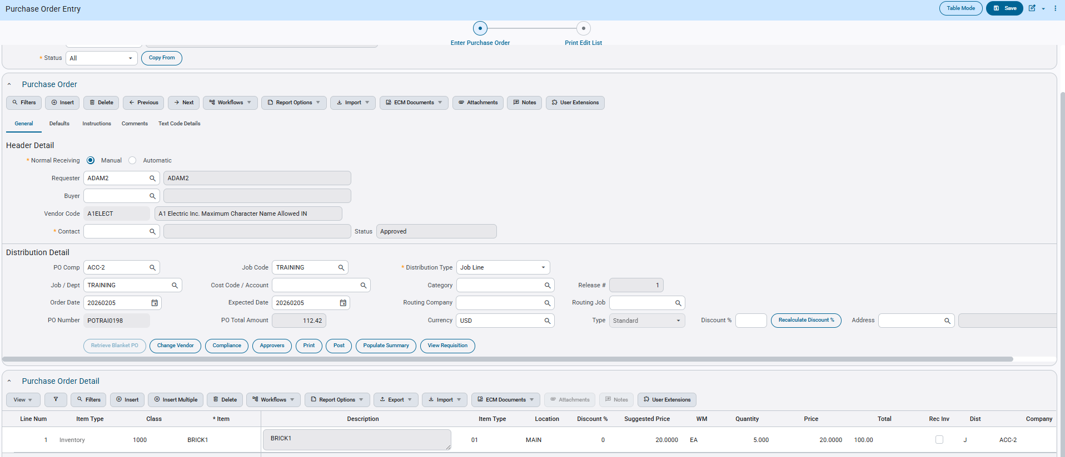

POMaster API – Advanced Payment fields added to GET Request (CAM-9619)
Overview
Three new Advanced Payment body fields have been added to the GET Request for POMaster API.
PomstAdvPayAmt – Advanced Payment Amount
PomstAdvPayPct – Advanced Payment Percentage
PomstAdvPayMultiFlag - Advanced Payment: Multiple Advanced Payments Flag
These fields have been included in the GET Request body visible for every Purchase Order.
Modifications
Runtime feature program:
Purchase Order Entry program in enterprise : A sample of ‘Advanced Payment’ parameters filled in;
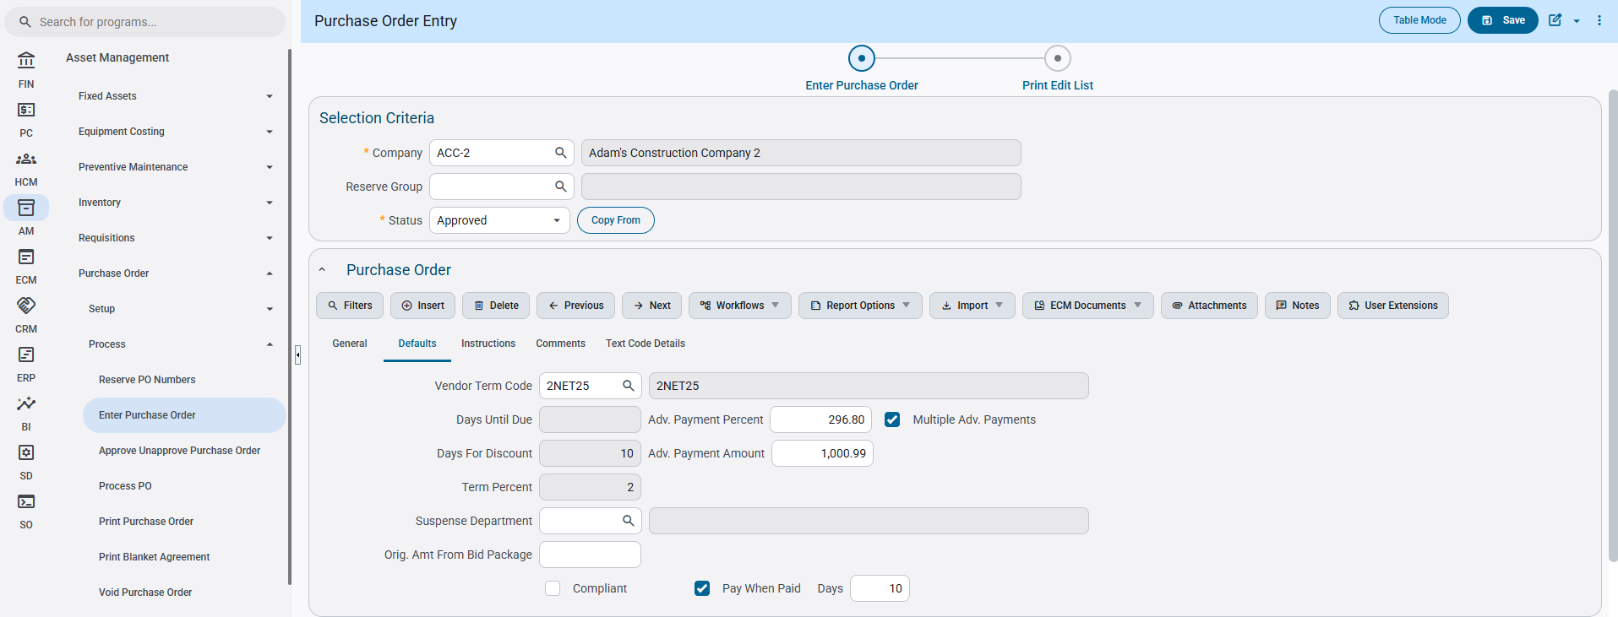
Payload for GET Request –
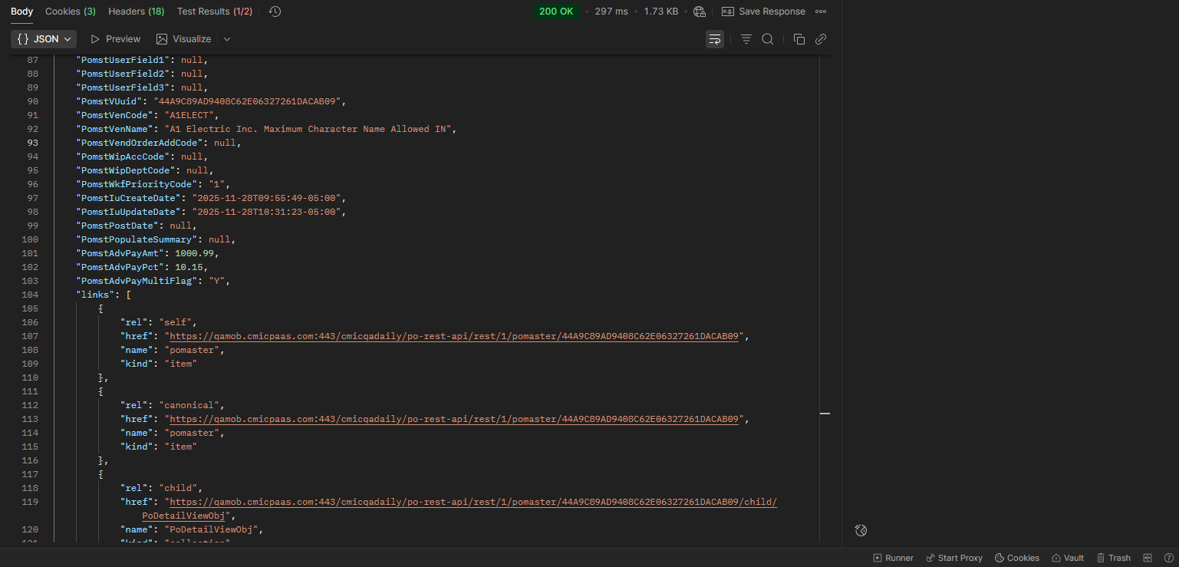
Implementation
Three new Advanced Payment Parameters have been included in the POMaster API – GET Response.
When running the endpoint: /po-rest-api/rest/1/pomaster, a list of Purchase Orders will be visible to the user. On each of the orders after the PomstPopulateSummary line, the Advanced Payment attributes are included for the user to now view additional details on their order.
To view the attributes, the user will enter and save header details for a new Purchase Order, while including data entered on the Defaults tab for Advanced Payment.
After saving successfully, the user can run the API Endpoint /po-rest-api/rest/1/pomaster (via VUUID for specific Purchase Order) to view the Advanced Payment attributes within the payload.

LEM Maintenance Program (Beta Version) (CAM-6390)
Overview
The LEMS Maintenance Program serves as a central transaction log that groups all related transactions under the same LEMS number. It allows users to view and track the status of LEMS reports, including approval status, cost amounts, and other key transaction details.
The program also supports adding transactions that were missed or not included during the original LEMS ticket creation process. Once LEM-designated transactions are entered into CMiC, this screen provides a single repository for monitoring and managing those transactions.
Setup
- Enable LEMS Tracking: in JC Control>LEMS Tracking tab>enable LEMS and provide a LEMS Number mask for auto generation.
- You LEMS Mask must include at least one character for date
  - Y=Year
  - M=Month
  - D=Day of the month
  - J=Job Number
  - *=sequential number
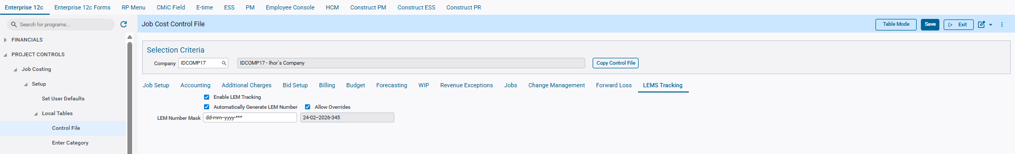
Job Costing>Setup>Control>LEMS Tracking Tab
- Modify the LEM field in Field Maintenance: Change the ‘Lookup Table’ column to display “Use Valid Data as LOV.” Go to Field Maintenance>Query ‘LEM’>Change ‘Lookup Table’ to be “Use Valid Data as LOV” (This is temporary workaround until CMiC provides a fix.)
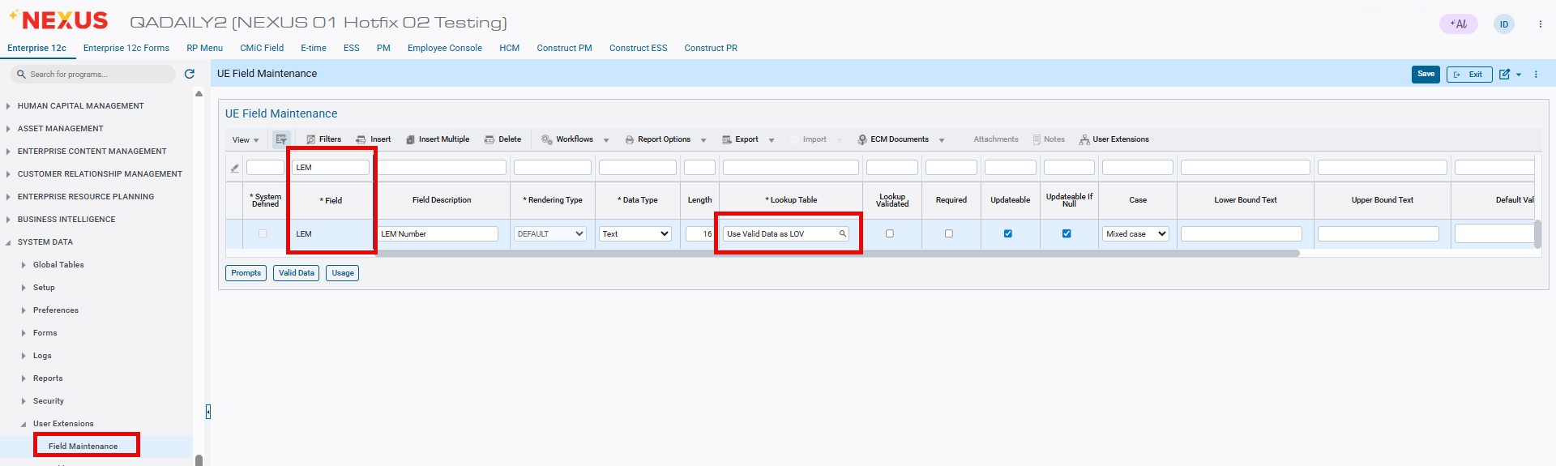
System Data>User Extensions> Field Maintenance
- Assign “LEM” field to WBS 1-4. There must be an empty WBS slot for LEMS Tracking to work, without this you cannot assign a LEMS Number.
  - This can be done at the WBS Company Setup or WBS Job Setup (WBS tab on job setup)
  - If you do not see the ‘LEM’ field in the popup, go back to step 2.
  - Enable the ‘Editable’ flag for the WBS slot the LEM is assigned to.
  - If the company or job does not have LEM and LEM WBS set up, that company—and consequently its job transactions—will not be displayed on the LEM Number Assignment screen.
- Once transactions are posted for a job/company with a proper LEM setup, they will appear on the LEM Number Assignment screen.(The screen can be accessed via the link: https://qa.cmicxxx.com/cmicxxxxx/construct-lem/lem-assignment, where qa.cmicxxx.com/cmicxxxxx is your environment.)
  - You can filter and/or select the desired transactions and generate a LEM number for them. These transactions will then be grouped under the generated LEM number.
  - Please note that this screen is currently under development.
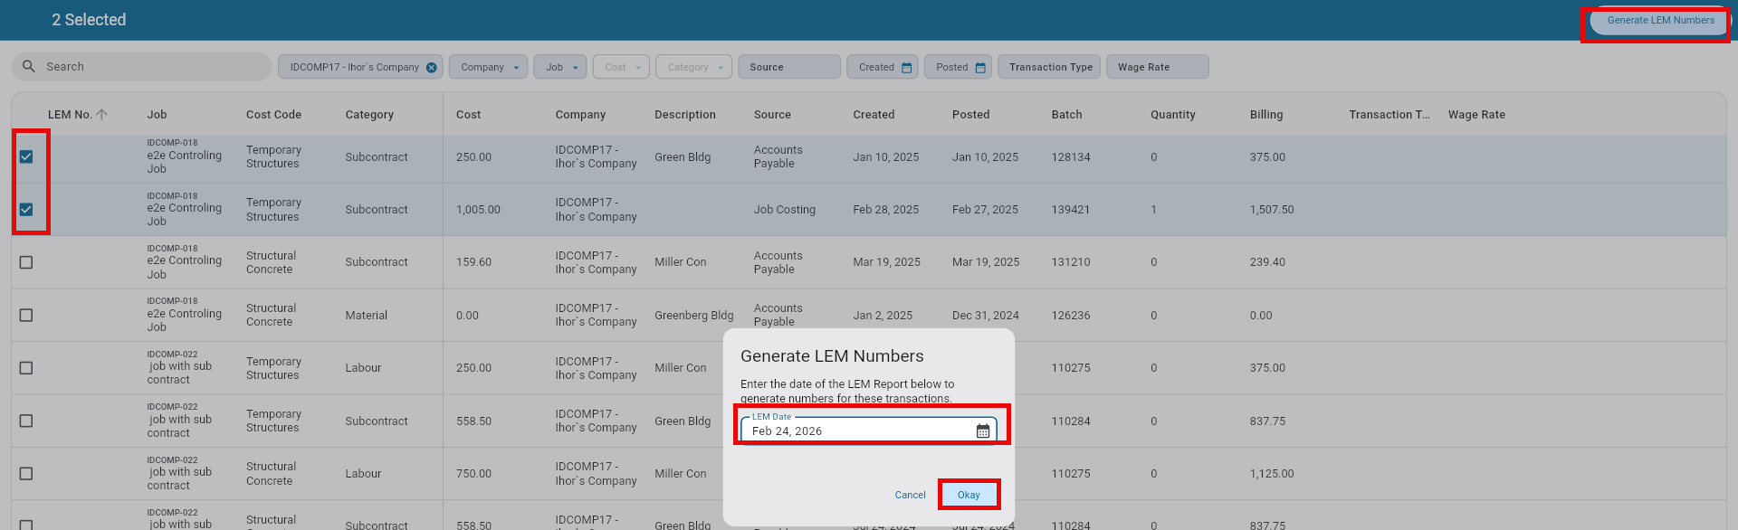
Implementation
LEMS Maintenance provides functionality to view, manage, and maintain LEMS tickets and their associated transactions.
- View LEMS List
Displays a list of all created LEMS tickets along with the transactions included in each
  - Users must select a company to display the corresponding LEMS records.
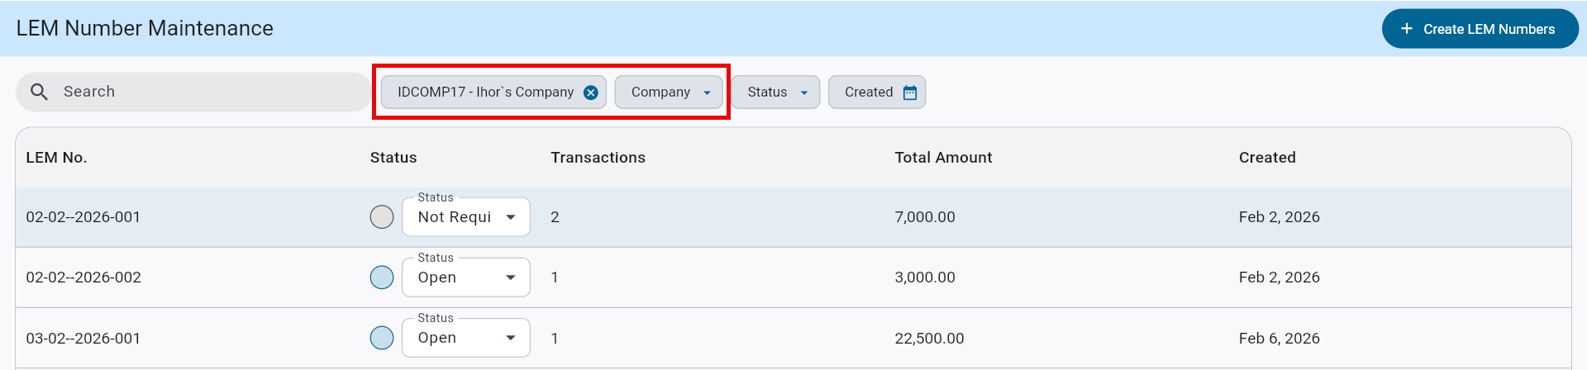
- LEM Ticket Status & Summary
Users can set or update the status of a selected LEMS ticket and view summary information, including:
  - Total amount
  - Number of transactions included in the LEMS
- Create LEM Number (under development)
Allows users to navigate to the LEM Assignment screen to assign a LEM number to transactions.
- Transaction Details View
Selecting a LEMS row displays the transactions associated with that LEM number.
  - Users can move or remove transactions from a LEM number.
  - Users can change the status of LEM ticket.
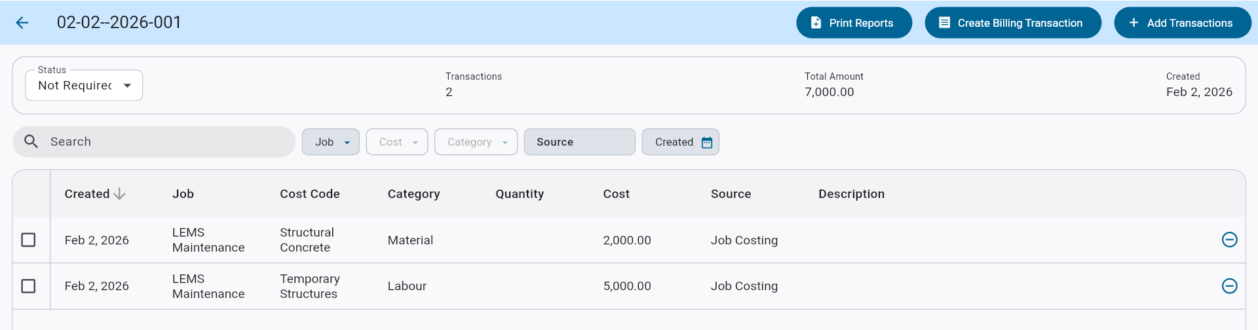
- Create Billing Transaction (under development)
Opens the JC Transaction program to create billing-only transactions with:
- Add Transaction (under development)
Allows users to add a transaction for the LEMS job that was not originally included in the LEMS.
- Print Reports (under development)
Provides options to print LEMS-related reports.

Requisitions

Construct PM Requisitions – Buyer Field introduced to Requisition Entry (CAM-5234)
Overview
The Buyer Field has now been included within the Construct PM - Requisition tab. This addition allows the user to set a Buyer for the newly created Requisition. The Requestor creates the Requisition, and the stated Buyer is referred to as the actual buyer for the full Requisition.
This change aims to provide the user with additional configuration privileges for a more detailed result.
Modifications
Runtime feature program:
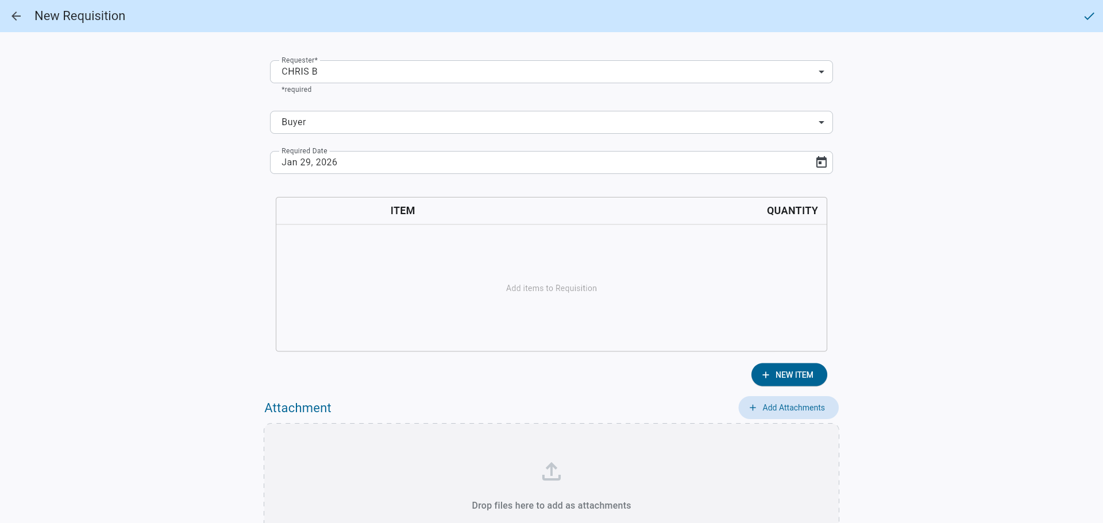
Implementation
The Buyer field allows the user to set an actual buyer for the Requisition Order. The user first clicks the Create Requisition button on the Requisition tab of Construct PM.
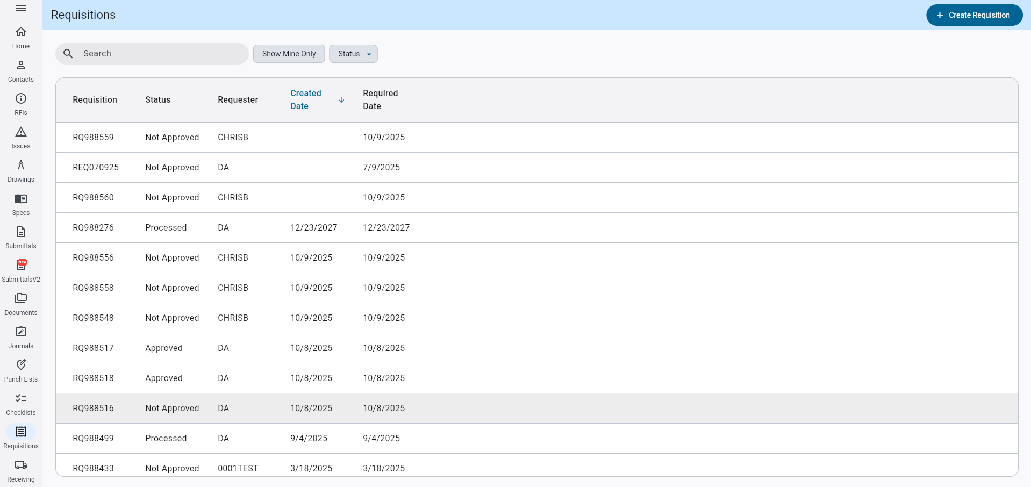
After clicking, the user will immediately be able to set a Buyer on the second LOV from the top of the page.
The Buyer LOV is limited to the setup within the Requisition > User ID Cross Reference program for the company’s set defaults.
The user will then click the LOV to view the list of users, select one, and the LOV will close by itself.
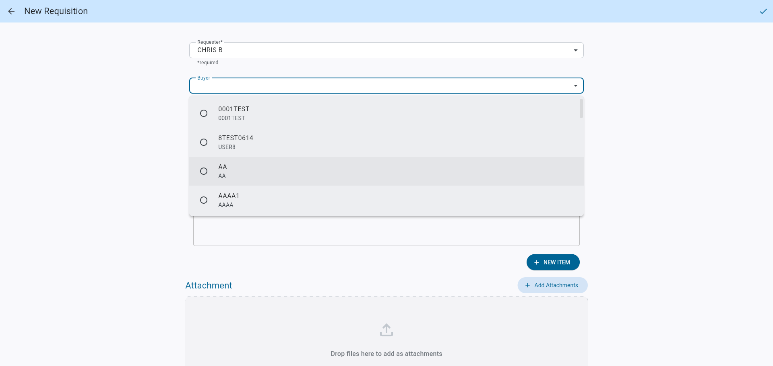
The Requisition will now have that buyer set and ready for any further actions.
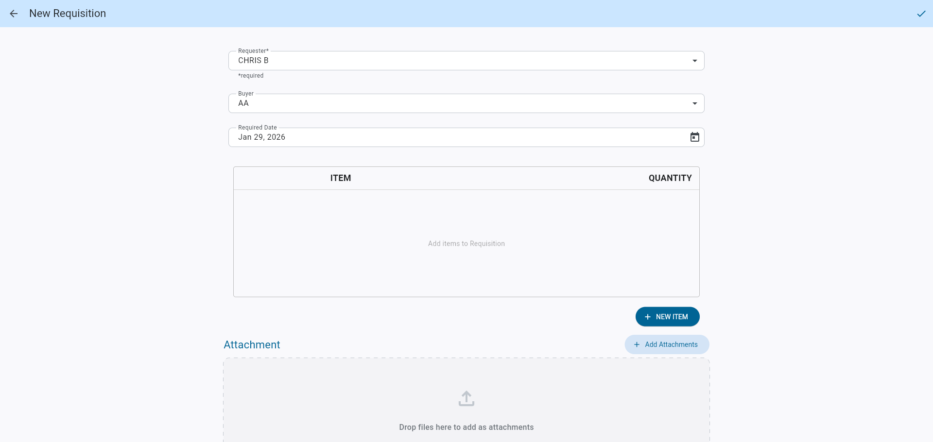

Subcontract Management

Print multiple SCCHGDOC reports from Print Document (SCPRINT) Program (PC-15640)
Overview
The SCPRINT program has been enhanced to restore the ability to print multiple Subcontract Change Order (SCO) documents at once—functionality that was previously available in Forms but lost during the R12 upgrade. This improvement allows users to select multiple SCOs from a single screen and generate one consolidated PDF containing individual reports for each selected change order.
Modifications
The SCPRINT program has been modified to include the “SC Change Order Document” as a selectable option in the Document drop-down list. When this option is selected, the screen dynamically updates to display only Subcontract Change Orders (SCOs)—including both posted and unposted records, with the “Posted” status clearly indicated. Users can now select multiple SCOs simultaneously and generate a single PDF containing separate reports for each selected change order. This functionality mirrors the existing SCPRINT process for base subcontracts. Additionally, the printed SCO reports will automatically include Change Code Details, as the associated parameter is hardcoded to Y.
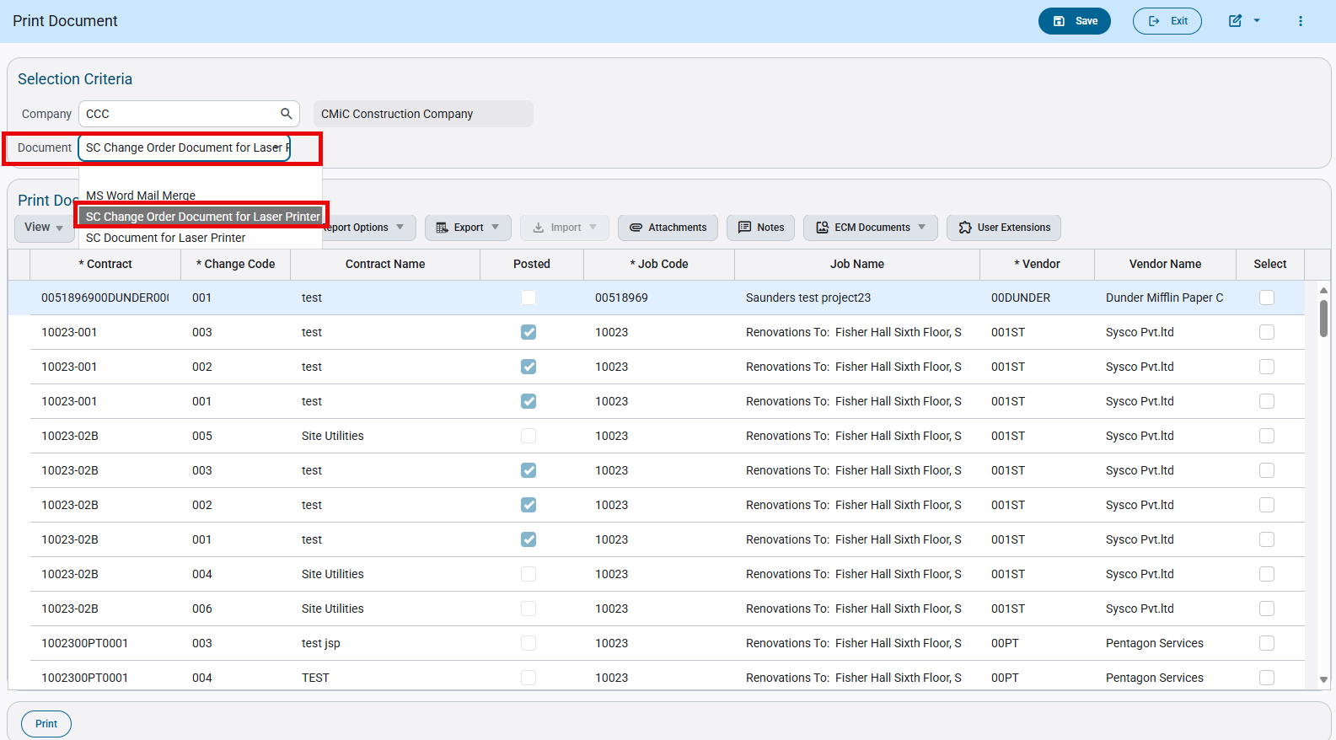
Subcontract Management > Contracts > Print Contract
Implementation
Go to Subcontract Management > Contracts > Print Contract > Select “SC Change Order Document” from the document drop down > Select the subcontract and print the report
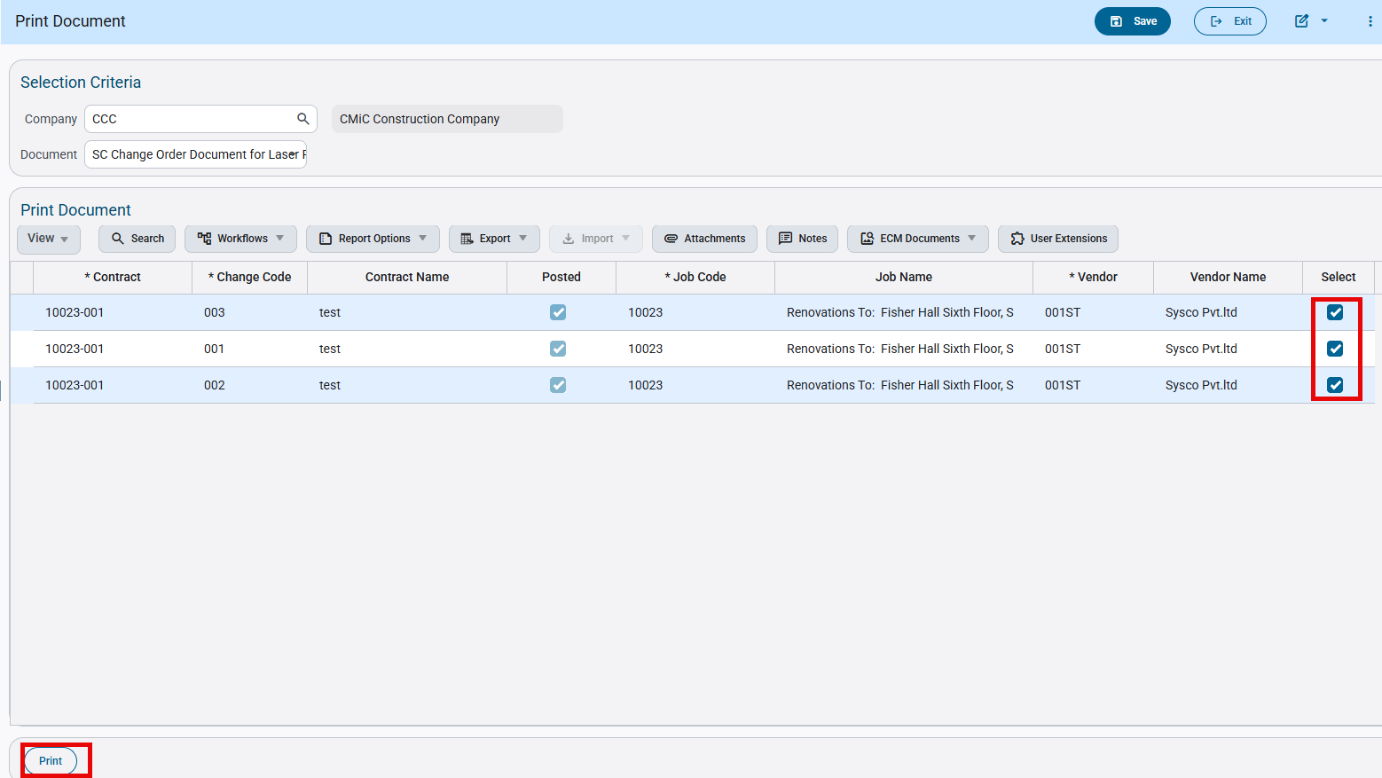
Subcontract Management > Contracts > Print Contract

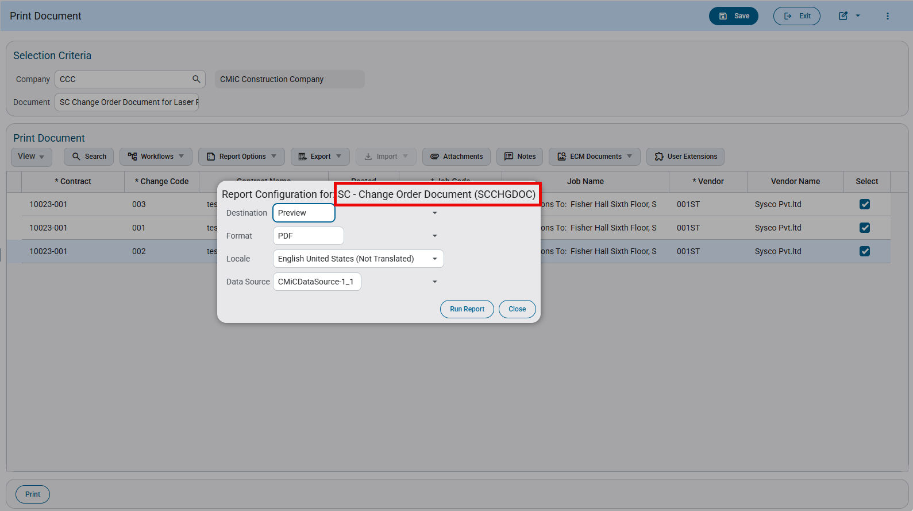
Subcontract Management > Contracts > Print Contract
A single PDF report is generated containing all the selected change orders on separate pages.
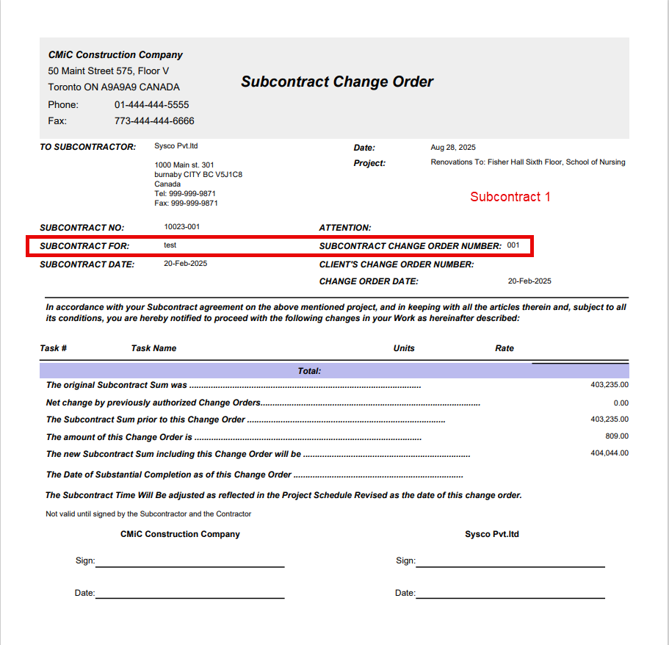
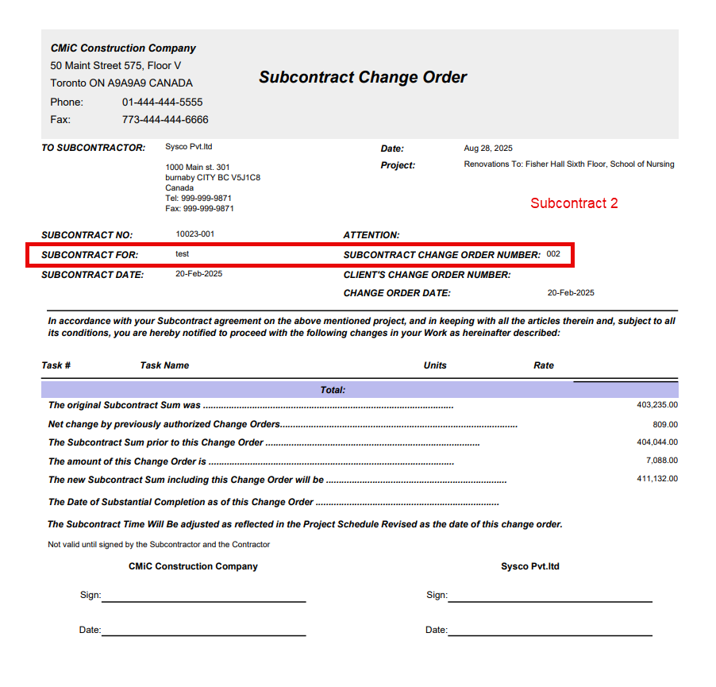
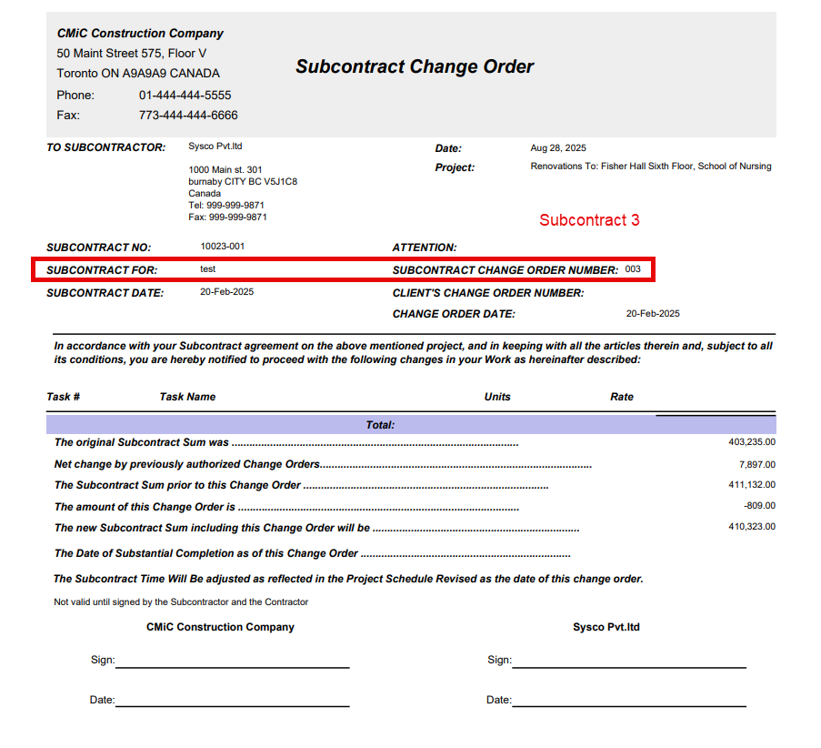

Missing Advance-Related Fields in RFP API (PC-20246)
Overview
The existing API endpoints used to create vouchers and their details do not currently support information required for Advance Payment and Deposit functionality. Specifically, fields such as deposit amount, deposit percentage, and amortization values are missing from the available payload. As a result, external systems are unable to fully create or manage invoices that rely on these features.
To address this gap, enhancements are planned for the voucher header and detail APIs, as well as the schedule-related endpoint, to ensure that all required deposit and amortization values can be submitted and retrieved through the API.
Modifications
The following API endpoints will be updated:
- ap-rest-api/rest/1/apvoucher
- New header fields will be added to support deposit and advance payment indicators.
    - VouDepositAmt
    - VouDepositPayFlag
  - New detail fields will be added to support current deposit and amortization amounts and percentages.
    - VdistTranScschCurrDepositAmt
    - VdistTranScschCurrDepositPct
    - VdistTranScschPrvDepositAmt
    - VdistTranScschPrvDepositPct
    - VdistTranScschContDepositAmt
    - VdistTranScschContDepositPct
- pm-rest-api/rest/1/scsched
- New view-only fields will be added to expose deposit and amortization values.
    - ScschPrevDepositPct
    - ScschPrevDepositAmt
    - ScschCurrDepositPct
    - ScschCurrDepositAmt
    - ScschContDepositPct
    - ScschContDepositAmt
Implementation
This section explains how the new fields work and the rules for using them.
Voucher Header Fields
VouDepositAmt
- Sets the total deposit or amortization amount for the voucher. Its interpretation depends on VouDepositPayFlag:
• Y → detail fields are treated as deposit values
• N → detail fields are treated as amortization values
- If a value is provided both at the header level (VouDepositAmt) and in the detail lines, the sum of all detail values must equal the header amount. This validation applies to both amounts and percentages.
VouDepositPayFlag
- Can only be set to Y if the SC Control flag "Use RFP Screen For Advance Payment Creation" on the RFP tab is enabled.
- Determines how detail fields are interpreted:
• Y → detail fields are treated as deposit values
• N → detail fields are treated as amortization values
Voucher Details Fields
VdistTranScschCurrDepositAmt
- Matches the UI field Amortization Amount or Current Deposit Amount based on VouDepositPayFlag settings:
• VouDepositPayFlag = Y → represents Current Deposit Amount
• VouDepositPayFlag = N → represents Amortization Amount
- If only amount or percentage is provided, the system calculates the missing value.
- If both are provided, they must match mathematically; otherwise, the API returns an error.
- Upon posting (VouBchPost = Y), the value moves to corresponding fields based on the VouDepositPayFlag settings.
VdistTranScschCurrDepositPct
- Matches the UI field Amortization Percentage or Current Deposit Percentage based on VouDepositPayFlag settings:
• VouDepositPayFlag = Y → represents Current Deposit Percentage
• VouDepositPayFlag = N → represents Amortization Percentage
- Follows the same calculation and validation rules as the amount field.
- Upon posting (VouBchPost = Y), the value moves to corresponding fields based on the VouDepositPayFlag settings.
VdistTranScschPrvDepositAmt
- Read-only field that matches the UI Previous Amortization Amount.
- Automatically updated when VouBchPost = Y and VouDepositPayFlag = N.
VdistTranScschPrvDepositPct
- Read-only field that matches the UI Previous Amortization %.
- Automatically updated when VouBchPost = Y and VouDepositPayFlag = N.
VdistTranScschContDepositAmt
- Read-only field that matches the UI Previous Deposit Amount.
- Automatically updated when VouBchPost = Y and VouDepositPayFlag = Y.
VdistTranScschContDepositPct
- Read-only field that matches the UI Previous Deposit %.
- Automatically updated when VouBchPost = Y and VouDepositPayFlag = Y.

Validation
All validation rules in the API follow the same logic as the UI. The following cases are enforced:
Amortization rules
  - Amortization Amount cannot exceed the total Deposit Amount.
  - Amortization Amount cannot exceed the Current Amount for the line.
Deposit rules
  - When VouDepositPayFlag = Y, the user can only enter Deposit Amount or Deposit Percentage. No other fields are allowed.
  - Deposit Amount cannot exceed the Contract Amount.
Negative values
  - Amounts and percentages cannot be negative.
Header and detail consistency
  - If a value is provided at both the header and detail level, the sum of detail values must match the header value.
  - This validation applies to both Amount and Percentage fields.
Percentage and Amount matching
  - If both Amount and Percentage are provided for a line, they must be mathematically consistent with the line’s Current Amount.
  - If they do not match, the API returns an error: “Deposit % and Amt are incorrect.”
Other validations
  - All remaining validations mirror UI behavior, including required fields based on VouDepositPayFlag, maximum limits, and posting rules.
  - Any invalid input will result in an API error with a descriptive message.

Subcontractor Prequalification

Prequalification Control - Add Free-Form Email Notification (CF-33793)
This enhancement introduces a new feature in Subcontractor Prequalification that allows internal reviewers to send a manual, free-form correction request email directly from the subcontract record or the self-service questionnaire, without triggering a password reset.
The goal is to make it easier for reviewers to notify subcontractors about missing, incorrect, or incomplete information and allow subcontractors to return to their questionnaire using their existing password. When a correction request is sent, the subcontractor can only edit the Attachments section; all other sections of the questionnaire remain read-only, ensuring data integrity while still allowing required updates.
Pre-requisites
This section contains any pre-requisites.
Modifications
Following modifications have been made as part of this enhancement:
- Two text boxes have been added in the Prequalifications Control screen – ‘Subcontractor Information Required Subject’ and ‘Subcontractor Information Required Body’.
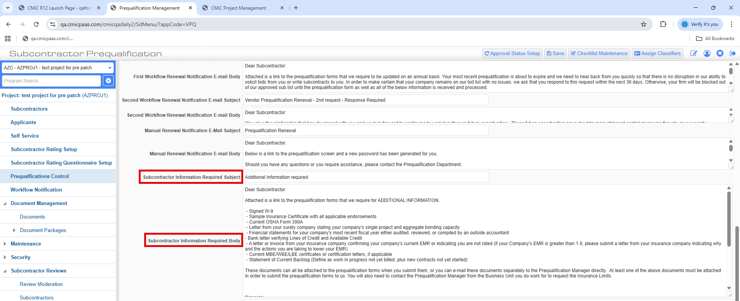
- The two fields have also been added to PM CMiC Field > Prompt Maintenance screen, to allow the users to rename these text-boxes if required.
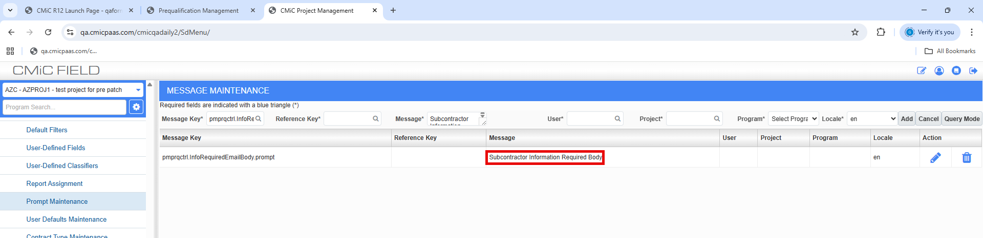
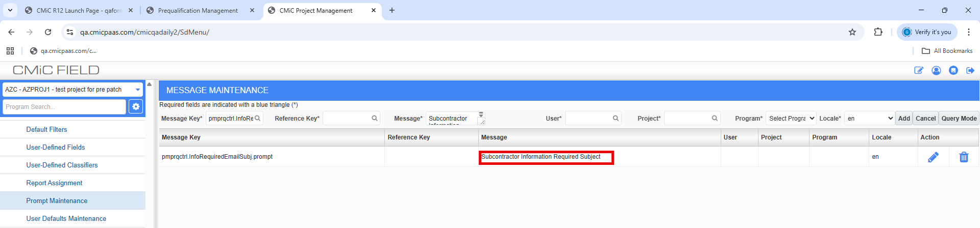

- A new free form email template called “Subcontractor Information Required Subject” has been added on the subcontractor prequal profile launching from the “Reset Self-Service Password” button.
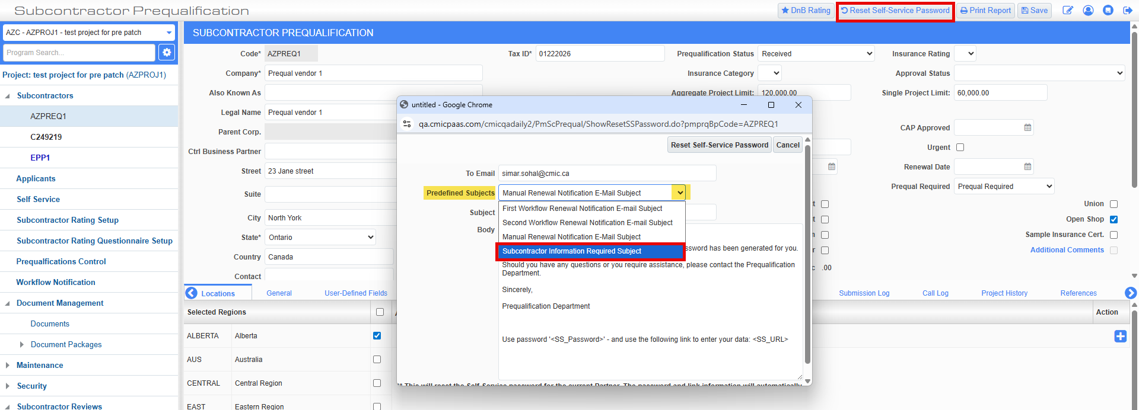
NOTE: When this email template is selected from the drop-down menu, then the Subject and Body fields populate from the text entered for the fields in the Prequal control screen.
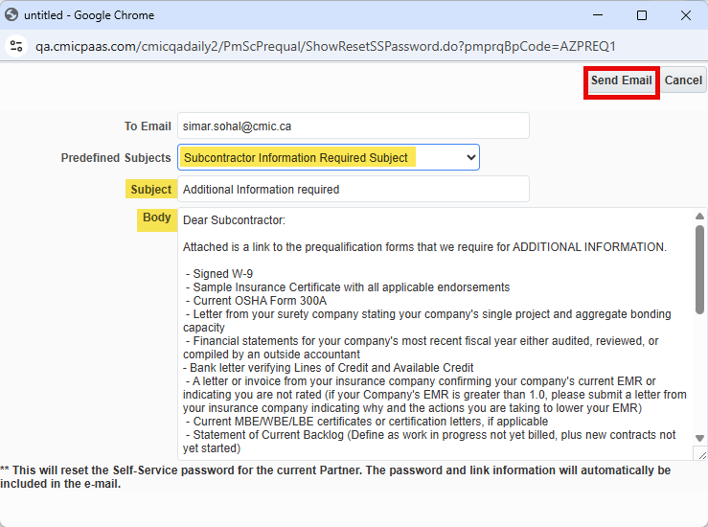
- A new Prequal status “Additional Information Required” has been introduced for when subcontractors re-access their self-service questionnaire and upload new attachments.
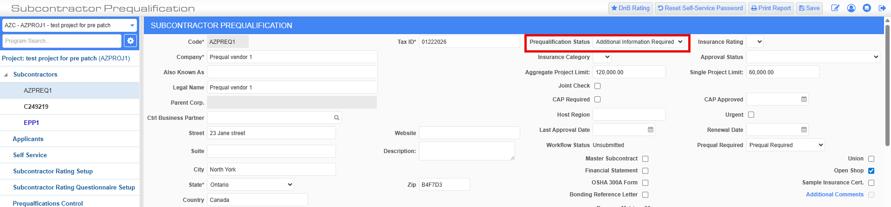
Implementation
When the “Subcontractor Information Required Subject” is selected from the drop-down in the [Reset password] pop-up, the subcontractor will receive the email notification for additional information required, when user clicks on [Send Email] in the pop-up.
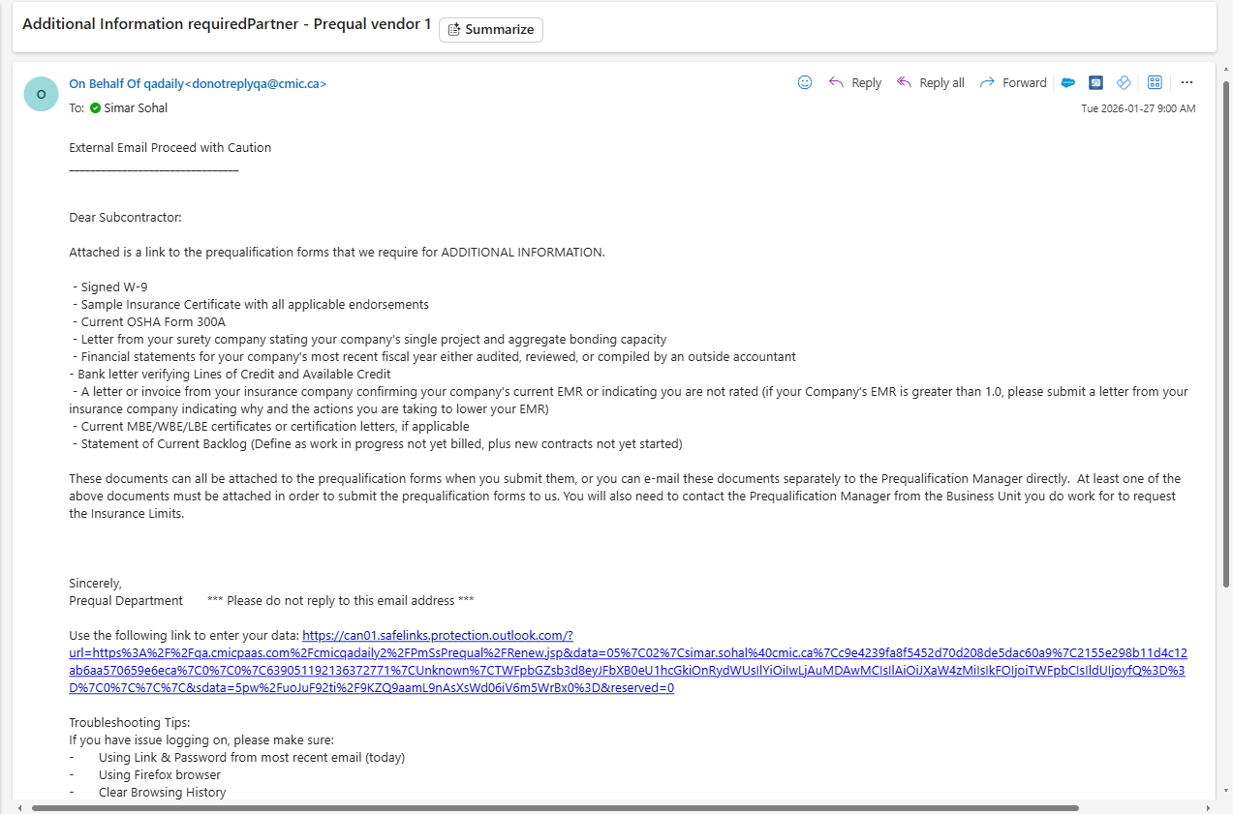
When email is sent to the subcontractor, then the Prequal Status for the subcontractor appears as “Additional Information Required”.
Clicking on the link opens the subcontractor’s self-service form, and the subcontractor can re-access it by entering their existing password.
Pages 1-5 on the self-service questionnaire appear as read-only to the subcontractor. Only page 6 is unrestricted, and the subs can add any missing/ required documents and submit the form.
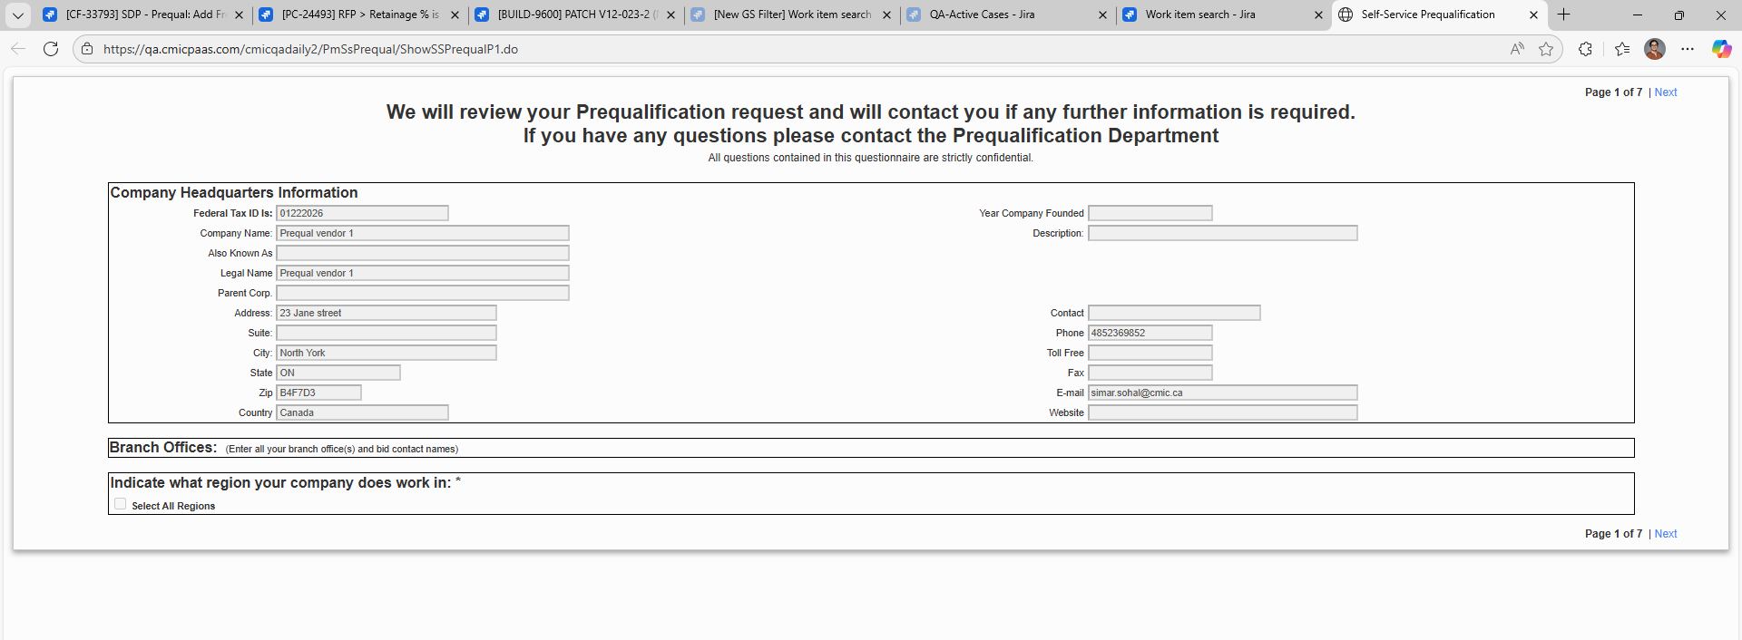
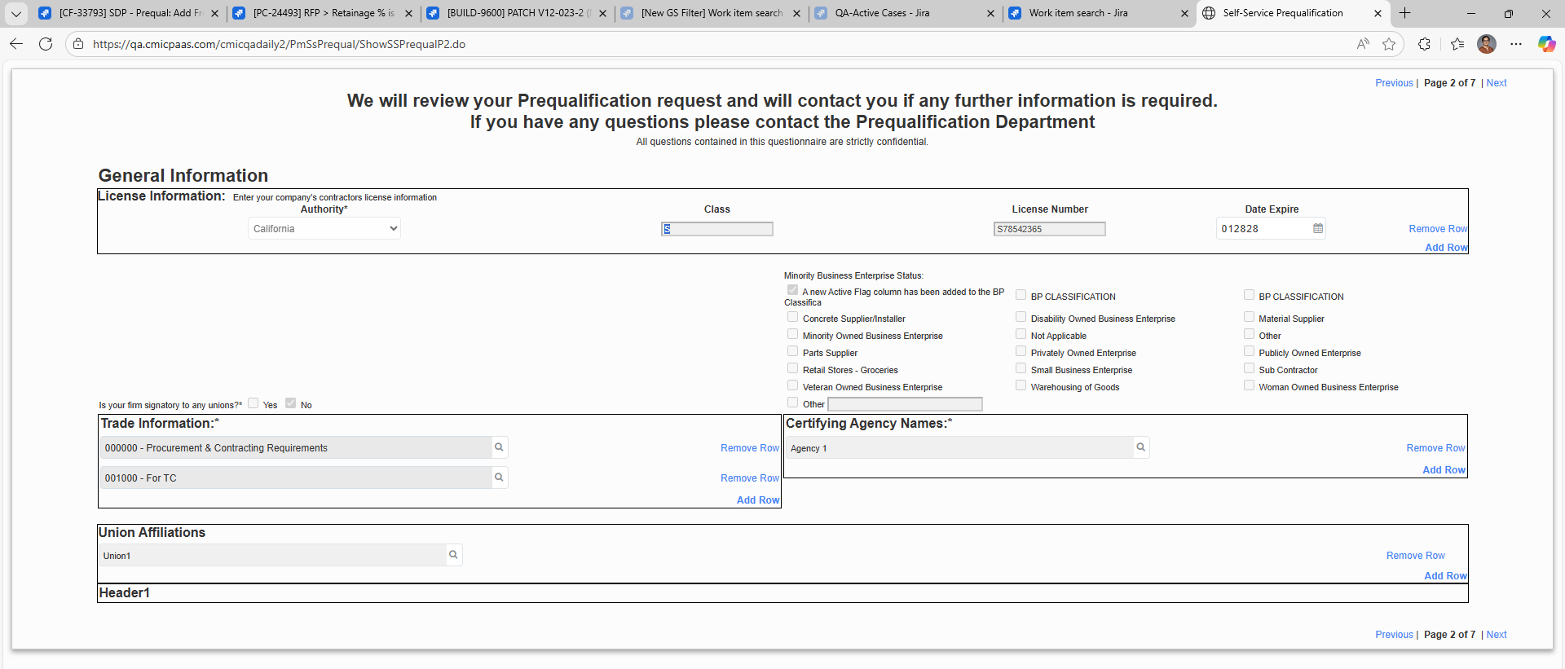
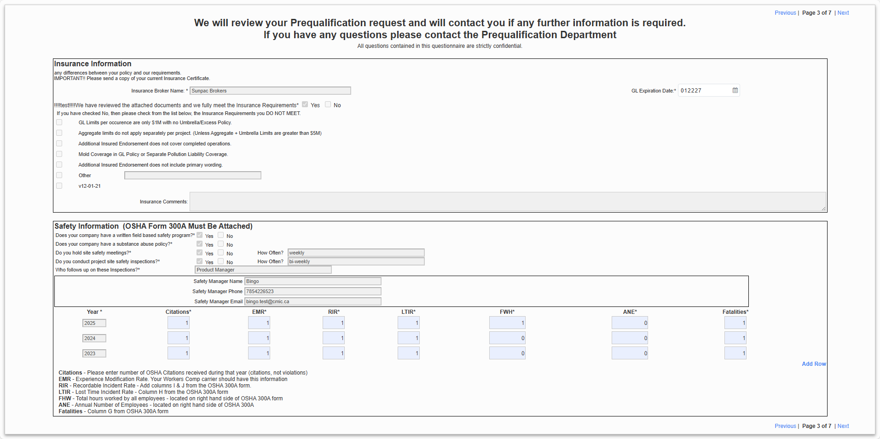
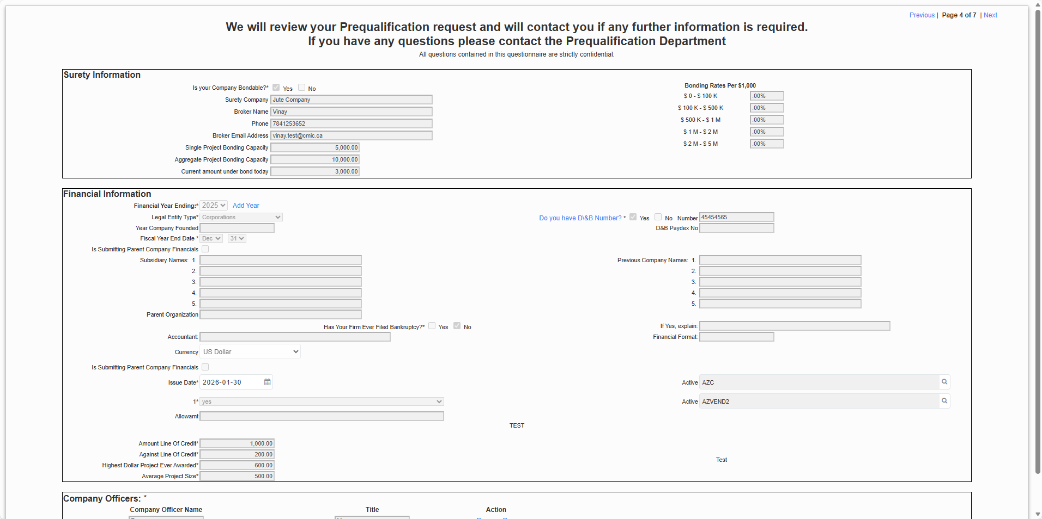
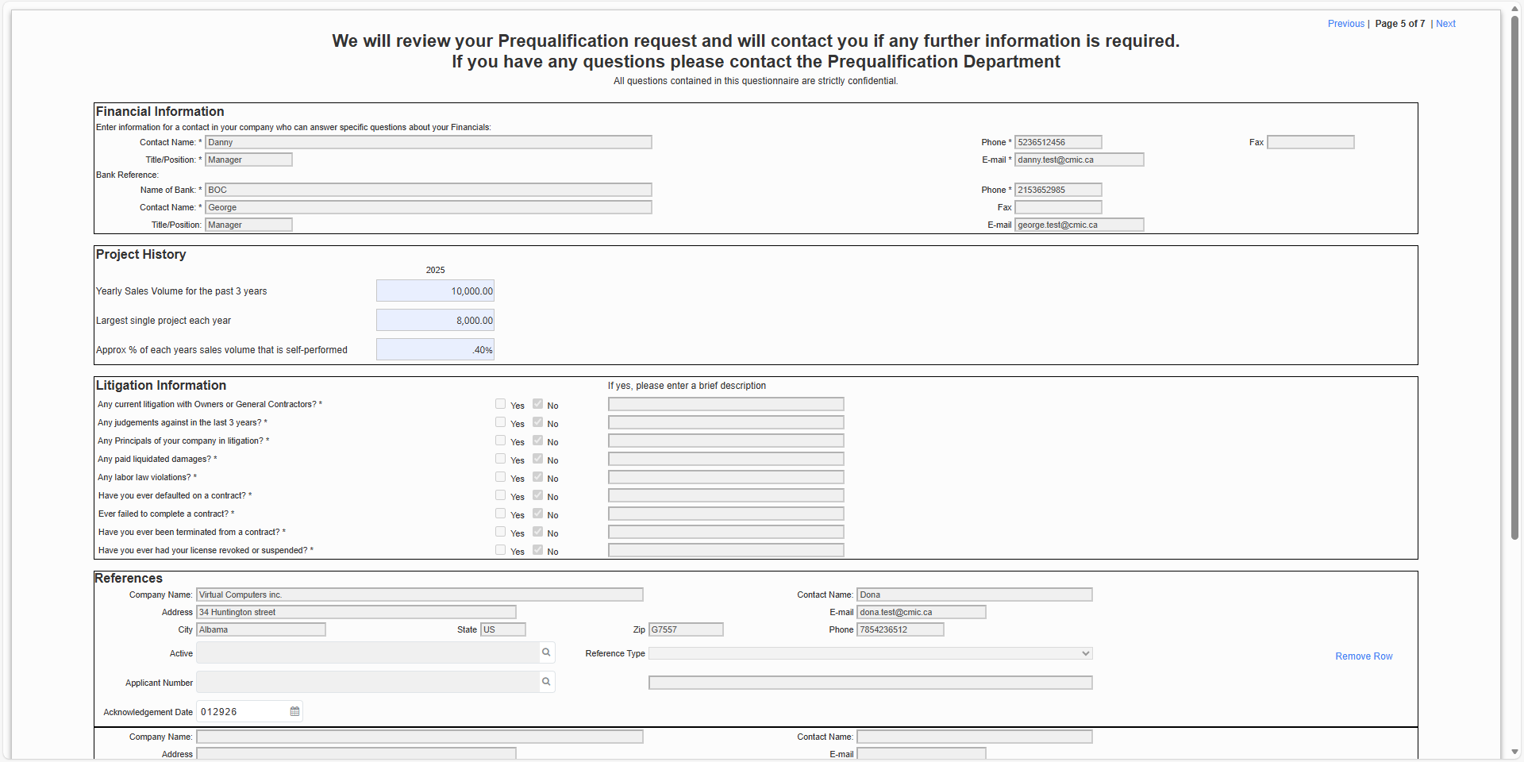
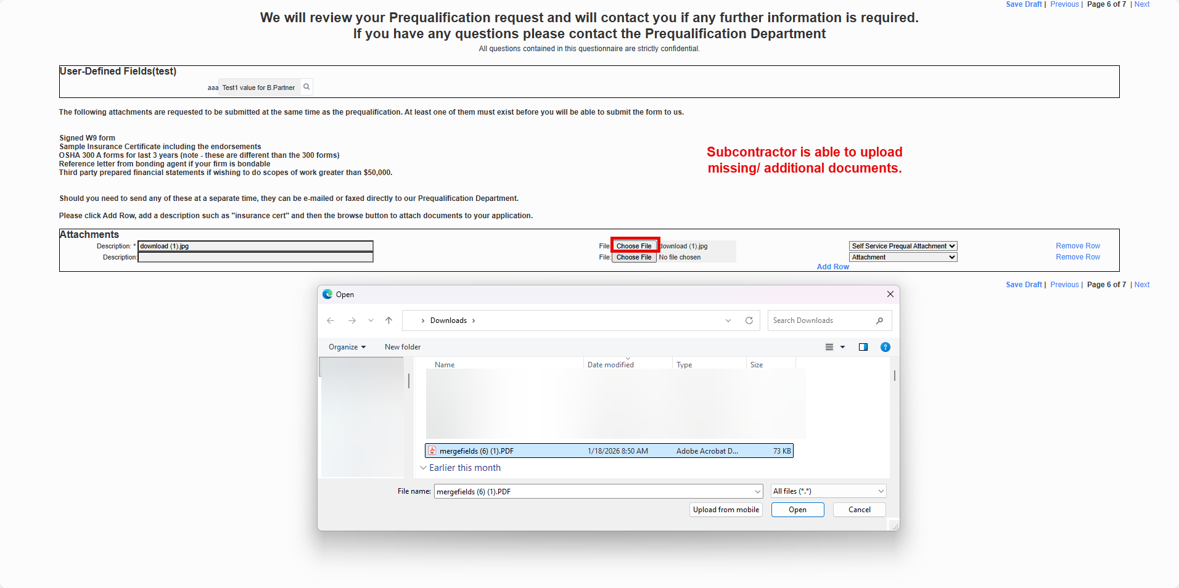

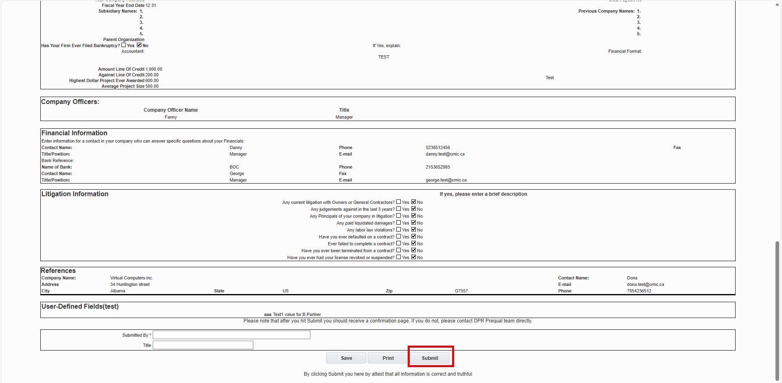

When the questionnaire is submitted, the subs’ Prequal status appears as ‘Received’.
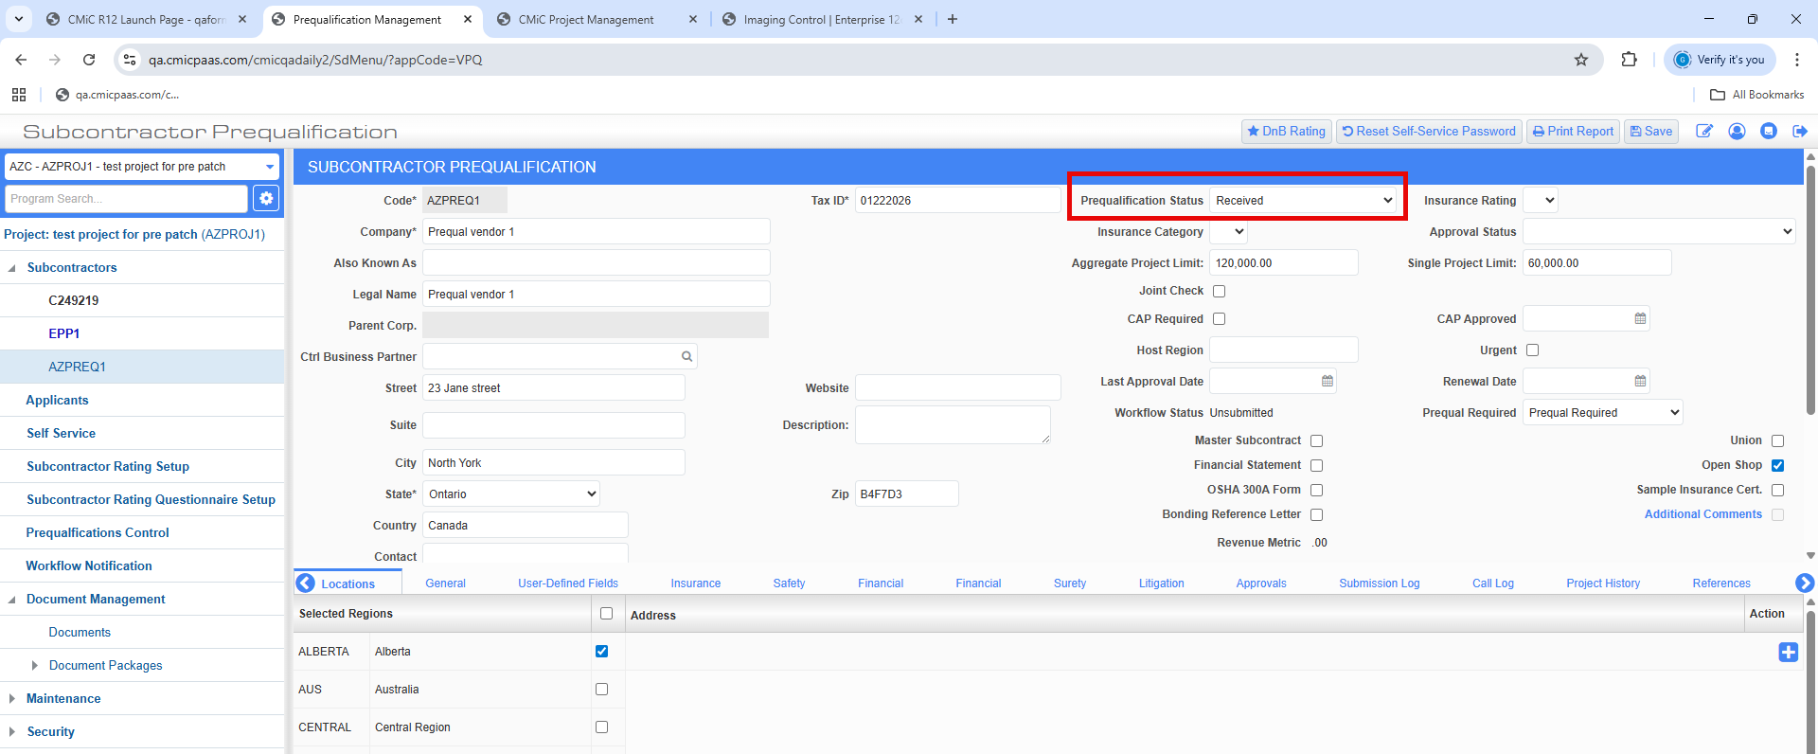

System Data

Added System Privilege to prevent posting to Inactive Departments (FIN-16105)

Overview:
New System privilege GLPSTIADEP to prevent posting to Inactive Departments.
Modifications:
A new system privilege “GLPSTIADEP - GL: user cannot post to inactive departments” is added to control users from posting to Inactive Departments. The default value of this privilege is unchecked.
When the flag is checked and a user tries to post to Inactive Departments, an error message appears. If the flag is unchecked, user can post to Inactive Departments successfully.
New system privilege GLPSTIADEP is shown below:
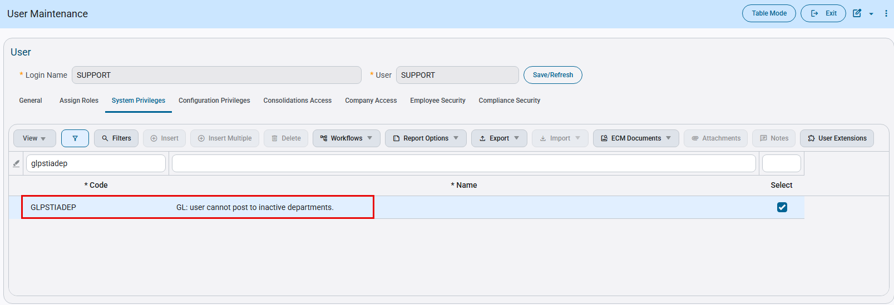
System Data > Users > User Maintenance > System Privileges tab
If flag is checked, an error appears as shown below when posting to Inactive Departments.
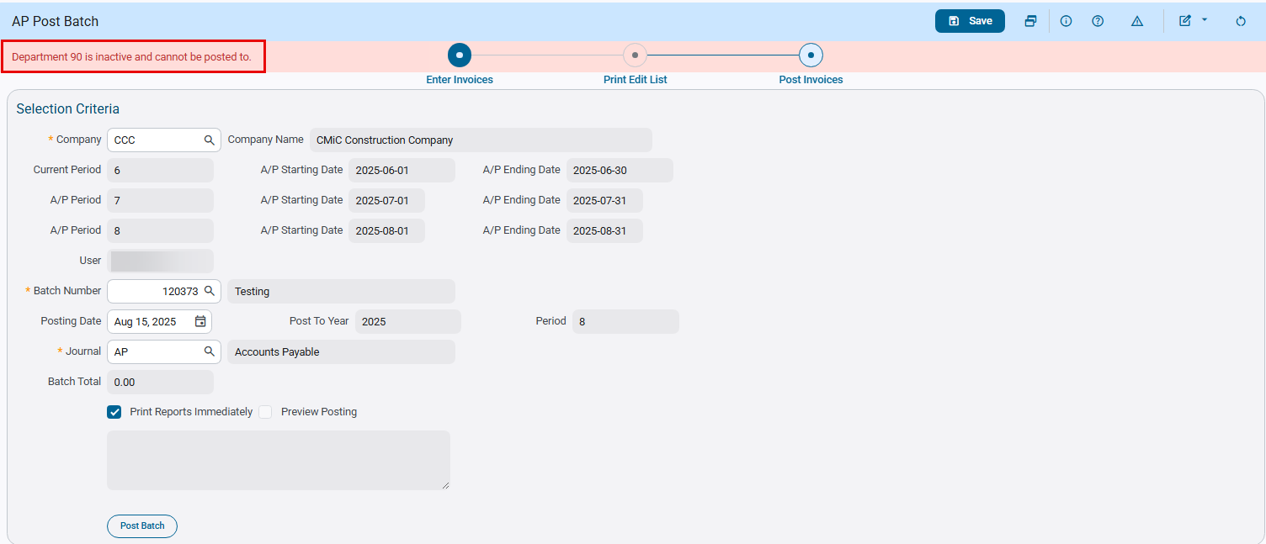

Construct UAC – Permission Templates renamed across entire program (CAM-10255)
Overview
Permission Templates has been renamed across the entire Construct UAC program from tab titles to program List of Values. This update has been included to better align with standard terminology and improve clarity for users.
Modifications
Runtime feature program:
Permission Templates Main Tab Title
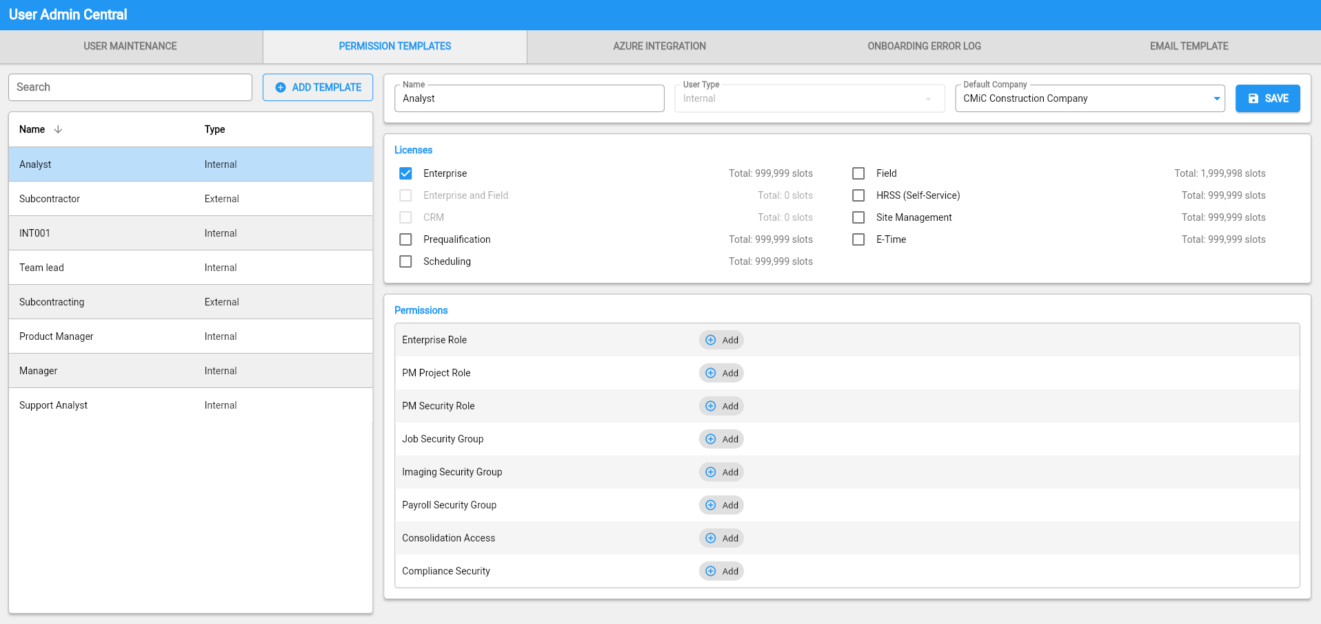
User Maintenance User Creation Window
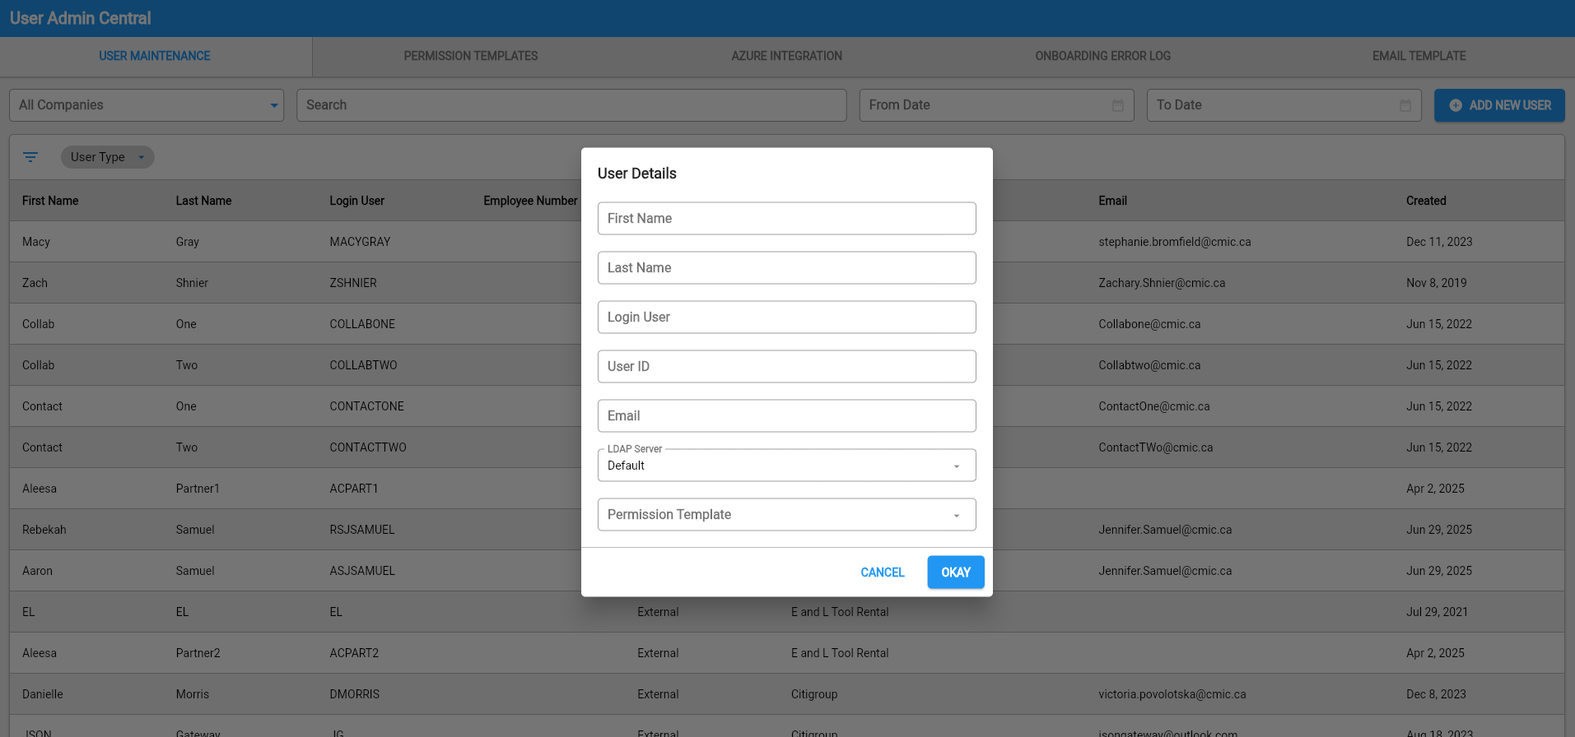
Onboarding Error Log User Window Pop-up
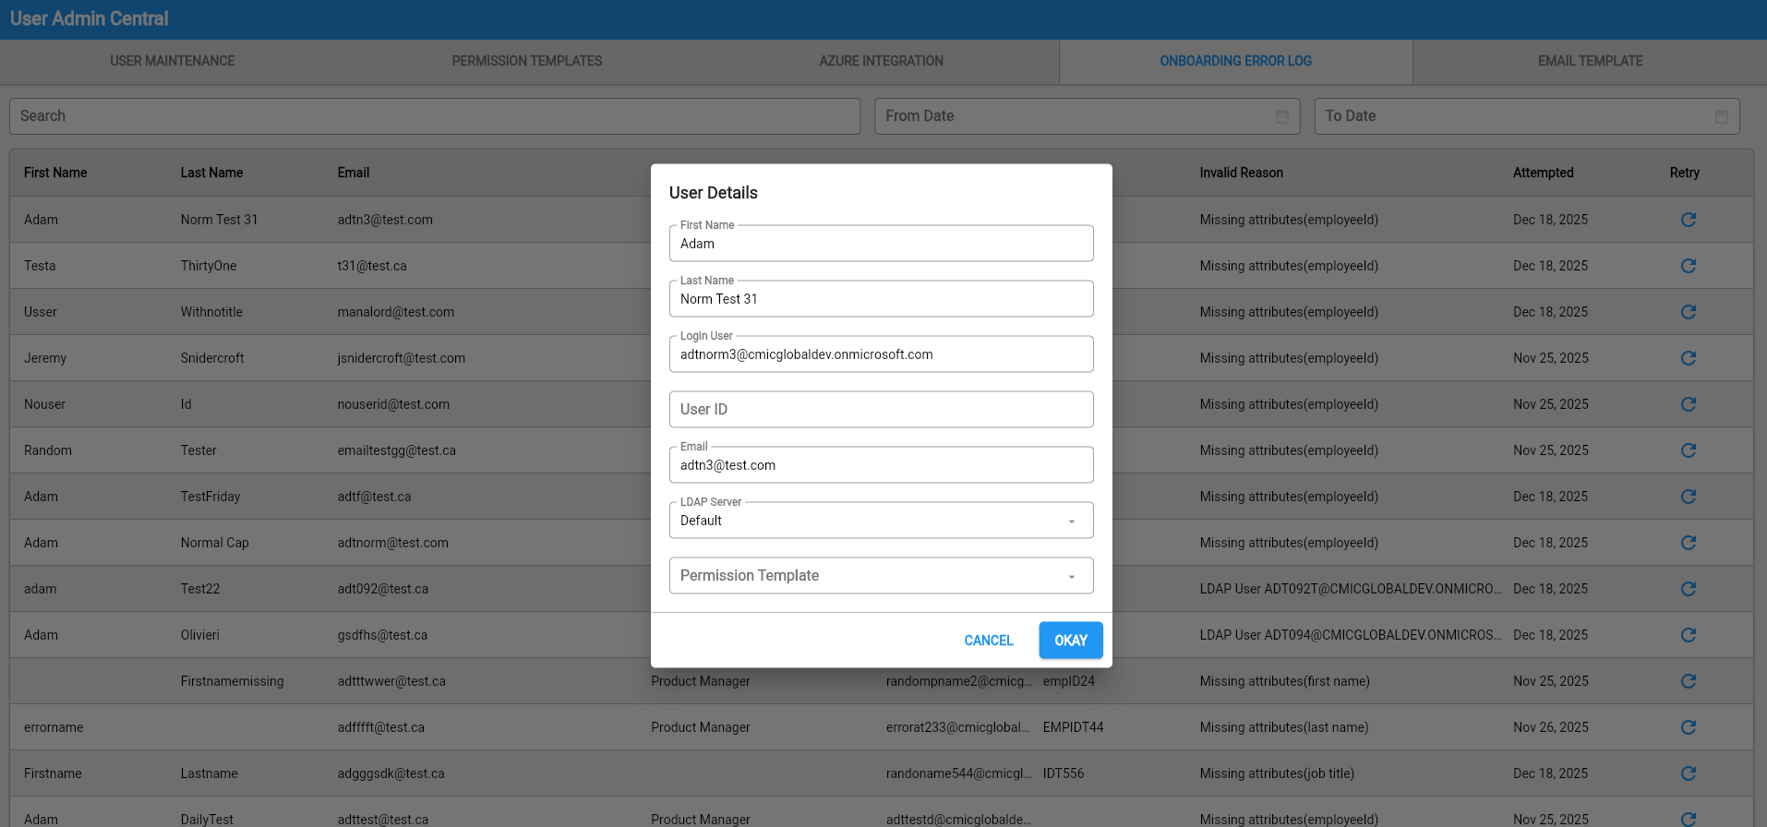
Implementation
Permission Templates title has been adjusted in various places across the Construct UAC application.
The change is included in the following programs:
- Permission Templates Main Tab Title – From “Permissions Templates” to “Permission Templates”
- User Maintenance User Creation Window – From “Permissions Templates” to “Permission Template”
- Onboarding Error Log User Window Pop-up – From “Permissions Templates” to “Permission Template”

Enterprise Role Security to access AI Agents Implementation (CAM-9732)
Overview
A program ‘Assign Roles to Agents’ (AIAGENTROLES) has been added to System Data. This implementation allows the administrators to limit the AI agents that users can interact with through Enterprise Security Roles.
The program includes three different tabs for Role to Agent mapping. All three of them produce the same end result, but different ways to map Roles and the associated AI Agents.
- Assign Roles to Agent
  - Selecting an Agent and manually assigning/unassigning Security Roles for that Agent
- Assign Agents to Role
  - Selecting a Role and manually assigning/unassigning Agents to that Role
- Agents-Roles
  - Program allowing multiple Agents to be assigned/unassigned to multiple Roles via Selection
A System Privilege ‘CMIC AI: Allows the user to modify security’ (AISECMNG) is added to the Security Roles. When checked (Y), users (administrators) assigned with the specific Security Role will be able to view, select and assign AI Agents within ‘Assign Roles to Agents’ program. When un-checked (N), users will not be able to view/modify any AI Agents within this program.
Prerequisites
The System Privilege AISECMNG must be checked (Y) for an user / administrator) in order to view the AI Agents within the ‘Assign Roles to Agents’ program.
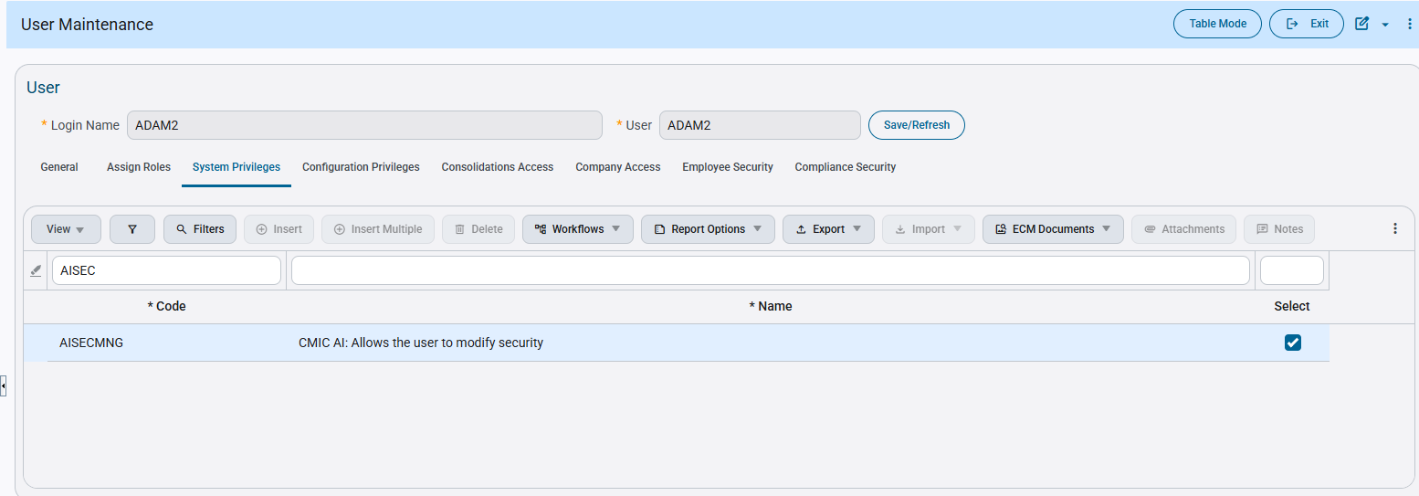
Modifications
Security Role / User System Privilege ‘CMIC AI: Allows the user to modify security’ (AISECMNG)
‘Assign Roles to Agents’ (AIAGENTROLES)
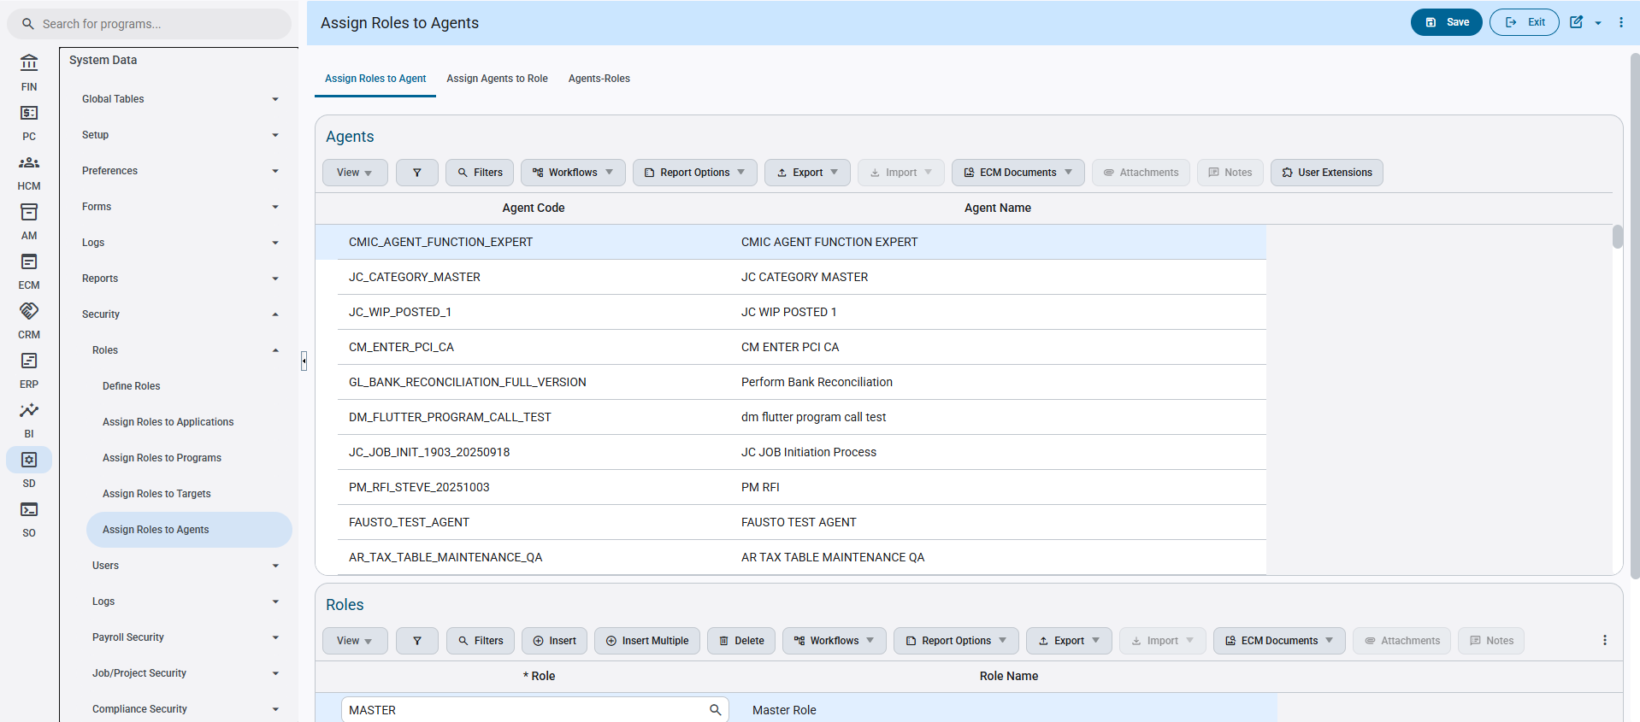
System Data>Security>Roles>Assign Roles To Agents
Implementation
The program ‘CMIC AI: Allows the user to modify security’ (AISECMNG) has been added to the Enterprise system under the System Data > Security > Roles Tree view.
The users/administrators with this system privilege assigned, can assign or unassign Roles to AI Agents with three different ways added for convenience.
Once this has been completed, the user can move onto the following..
Note: The tabs work separately but all have the same functional result.
1st Tab – Assign Roles to Agent
- The user first selects and highlights an Agent they want to modify access in the Agents Table. Upon doing so, the program will reveal which Roles are assigned to that Agent within the Roles Table below.
- The user will then click Insert within the Roles table and using the List of Values, select a Role they want assigned to the AI Agent. The user will then click save.
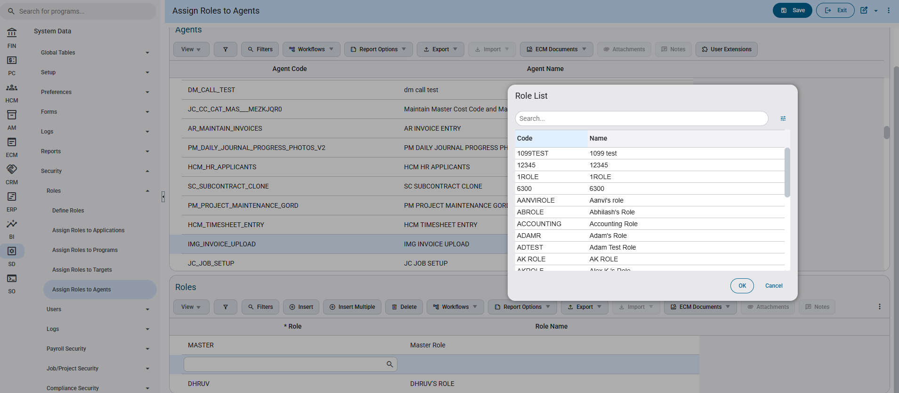
- The inserted Role has now been successfully assigned to the AI Agent, upon refreshing the program, the users assigned with this role will now be able to see the AI Agent within the AI program.
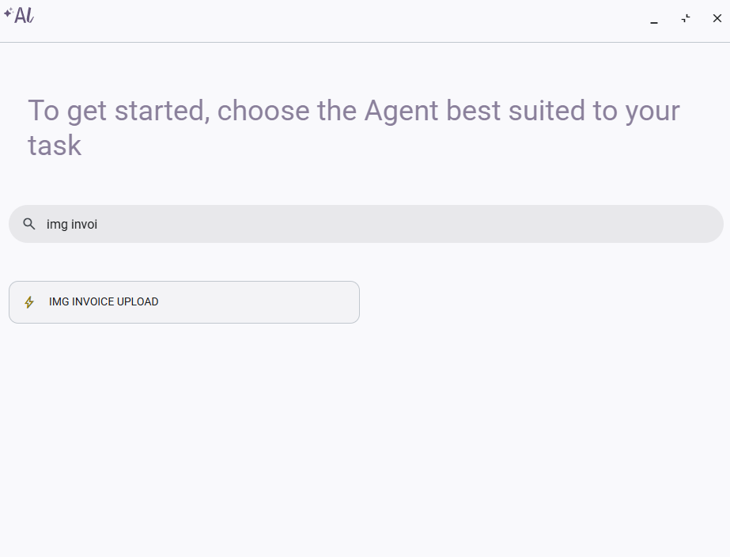
2nd Tab – Assign Agents to Roles
- The user first selects which Role they want to modify access to AI Agents in the Roles Table. Upon doing so, the program will reveal which Agents are assigned to that Role within the Agents Table below.
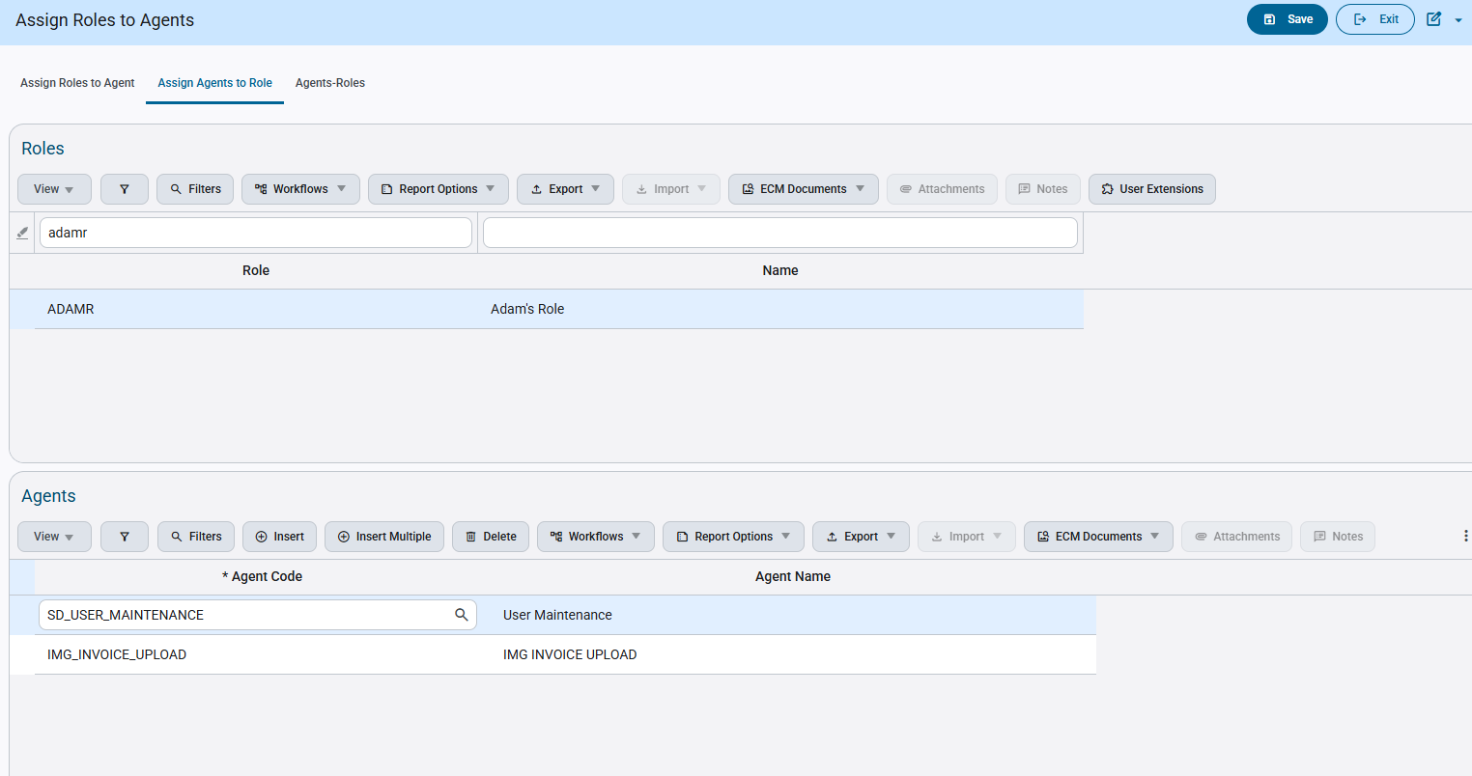
- The user will then click Insert within the Agents table and using the List of Values, select an AI Agent they want assigned to the Role. The user will then click save.
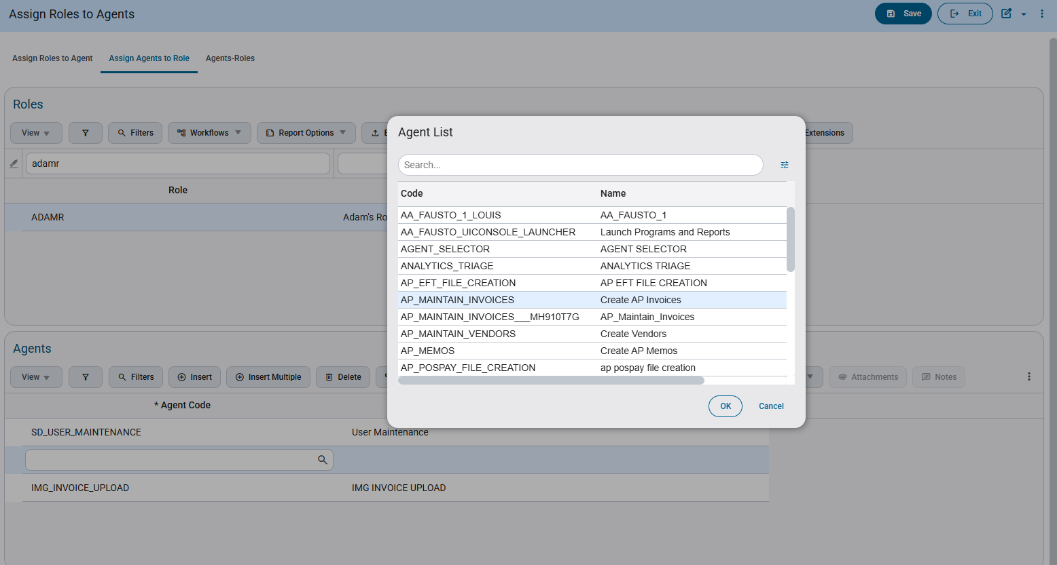
- The inserted Agent has now been successfully assigned to the Role, upon refreshing the program, the user using the role will now be able to see the AI Agent within the AI program.
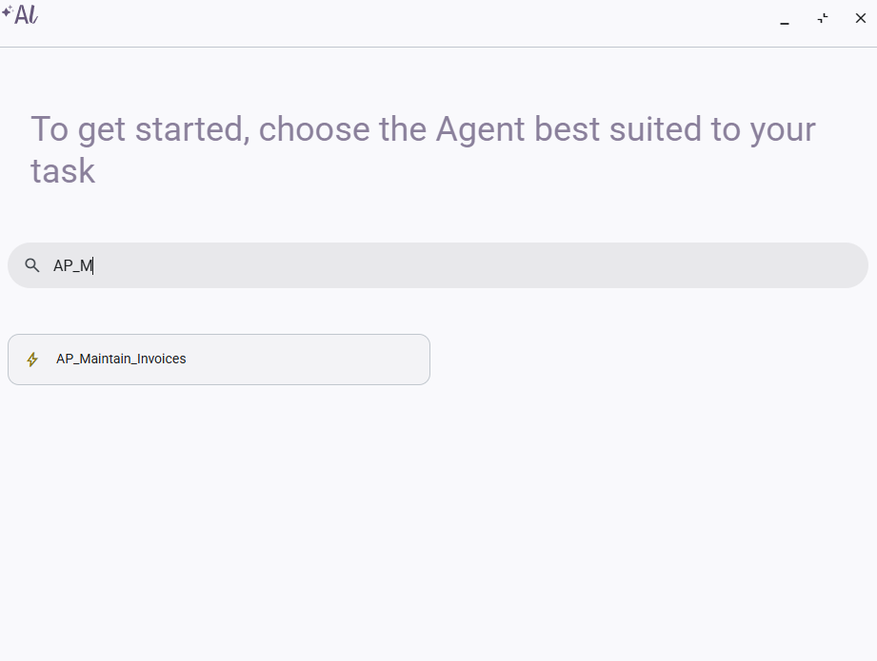
3rd Tab – Agents-Roles
- At first glance, the program will open with two tables side by side, containing AI Agents and Roles applicable for modification. The user will first select of the AI Agents they want to assign using the corresponding checkboxes beside each.
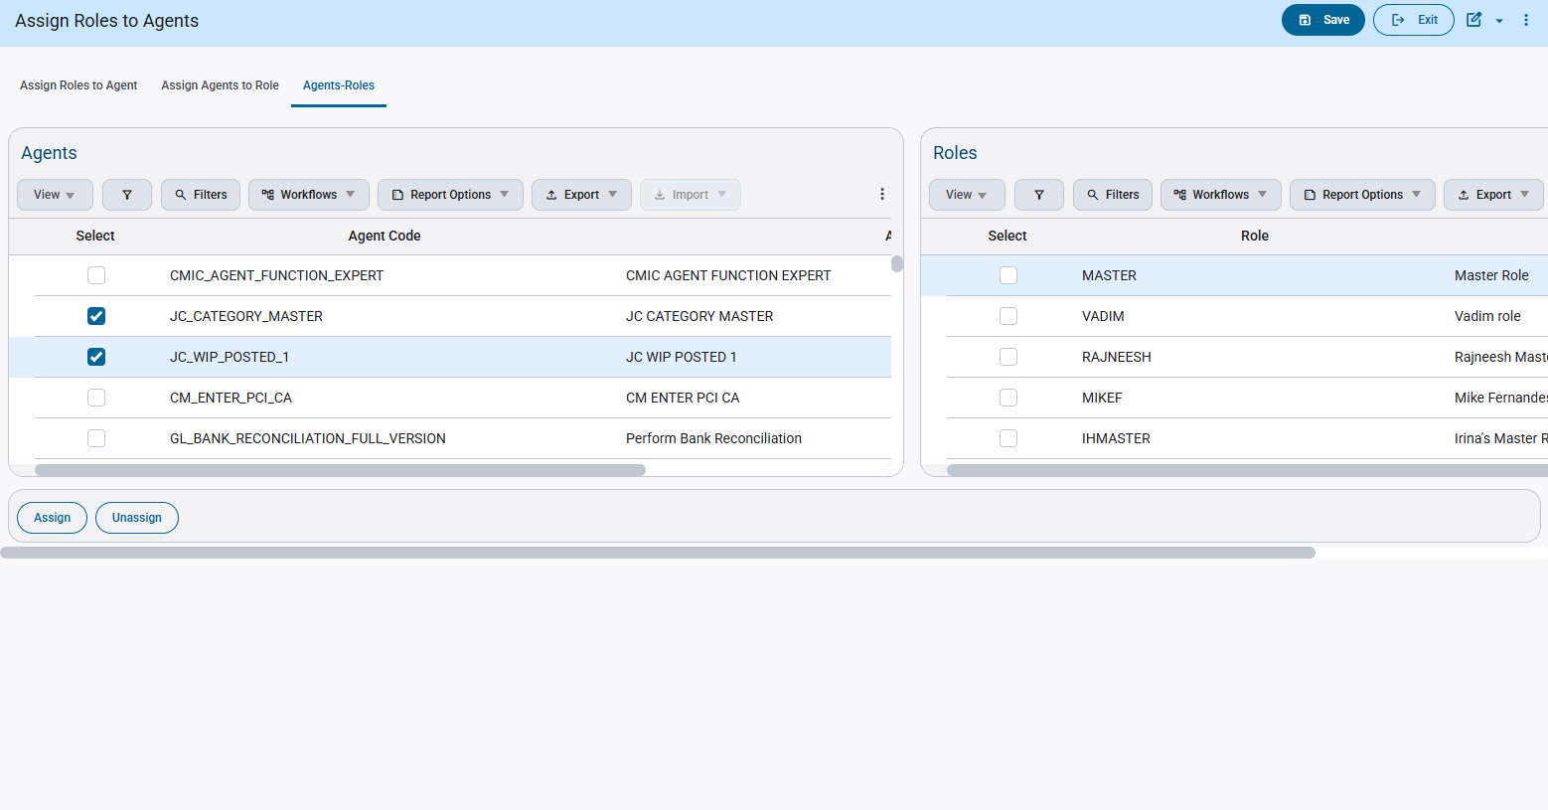
- The user will then select which Roles they want assigned to the AI Agents selected using their corresponding checkboxes beside each
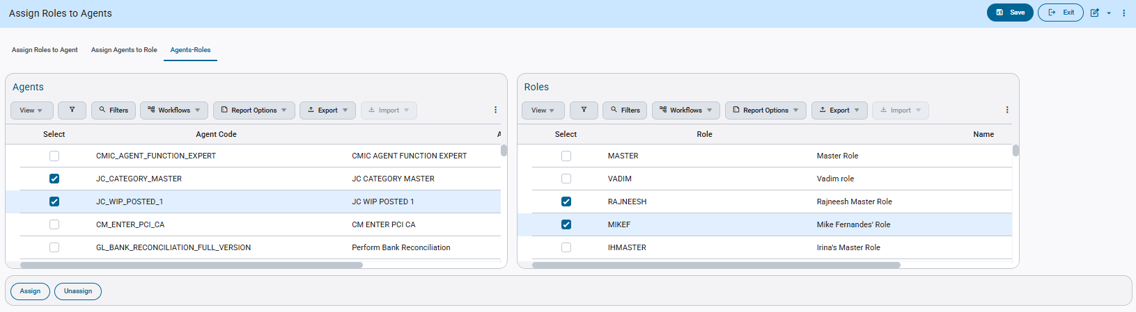
- The user will then click the Assign button on the bottom of the screen to then assign the selected AI Agents to each of the selected Roles.
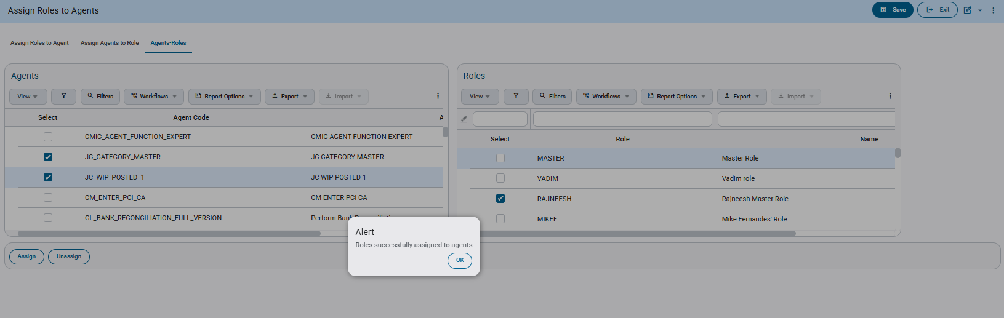
- As soon as the user closes the alert, the approval is confirmed and the users will be able to see the AI agents within the AI program.
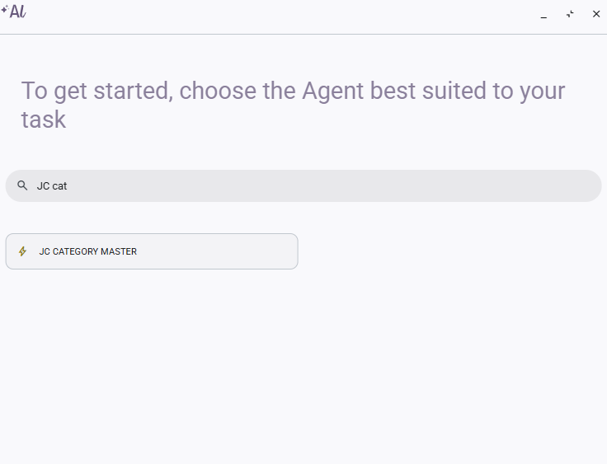
- The user using the same steps provided above, can also unassign the AI Agents to the Roles by using the Unassign button instead. Upon doing so and closing the alert, the program will unassign the AI Agents to the Roles. The users associated with those AI Agents will no longer be able to see them within the AI program.
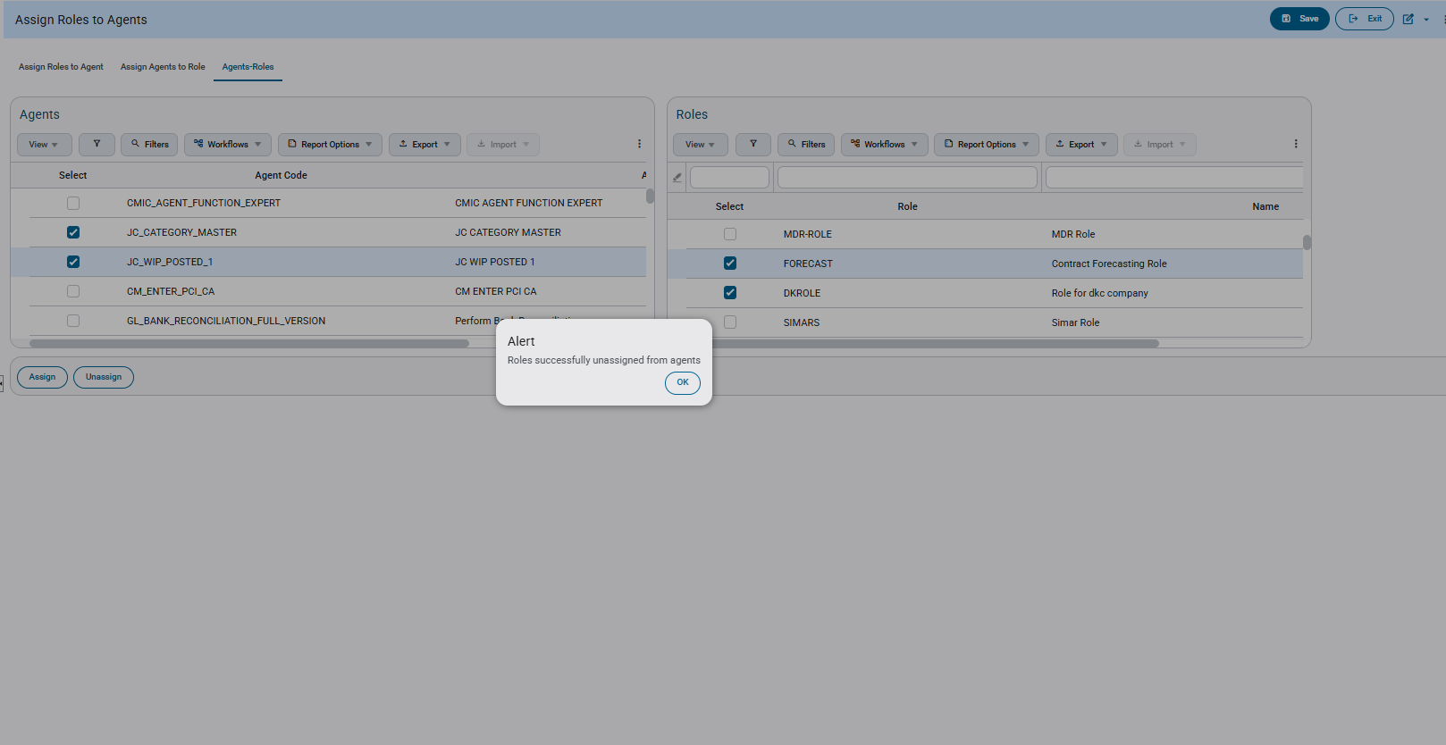
AI Program after Unassigning:
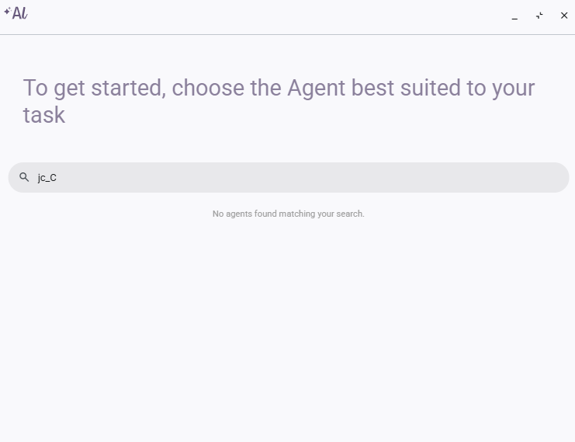

Merge Partner/Contact - New Enhancements to Merge Utility (CAM-7693)
Overview
The ‘Merge Partner/Contact’ program (SDPARTNERCONTACTMERGE) has been updated to make merging Partners and Contacts simpler and more flexible. Previous limitations that prevented certain records from being merged have been removed, allowing users to complete merges without needing to manually deduplicate data beforehand.
These enhancements ensure that important information—such as users, notes, and movement history—is preserved and correctly reassigned during the merge process.
- Merging Partners/Contacts with Associated Users
  - Contacts and users linked to the secondary Partner/Contact are automatically reassigned to the primary record during the merge.
  - The secondary contact can continue to log in using the primary contact record after the merge.
  - The secondary contact record is not deleted. Instead, it becomes orphaned, meaning it remains in the system but is no longer associated with a Partner.
- Merging Partners/Contacts with Notes
- All notes from the secondary Partner/Contact are moved to the primary record, ensuring no historical information is lost.
- Merging Partners/Contacts with Movement History
- Movement history from the secondary Partner/Contact is transferred to the primary record for full continuity.
Modifications
Runtime Feature Program:
Contact Merging -
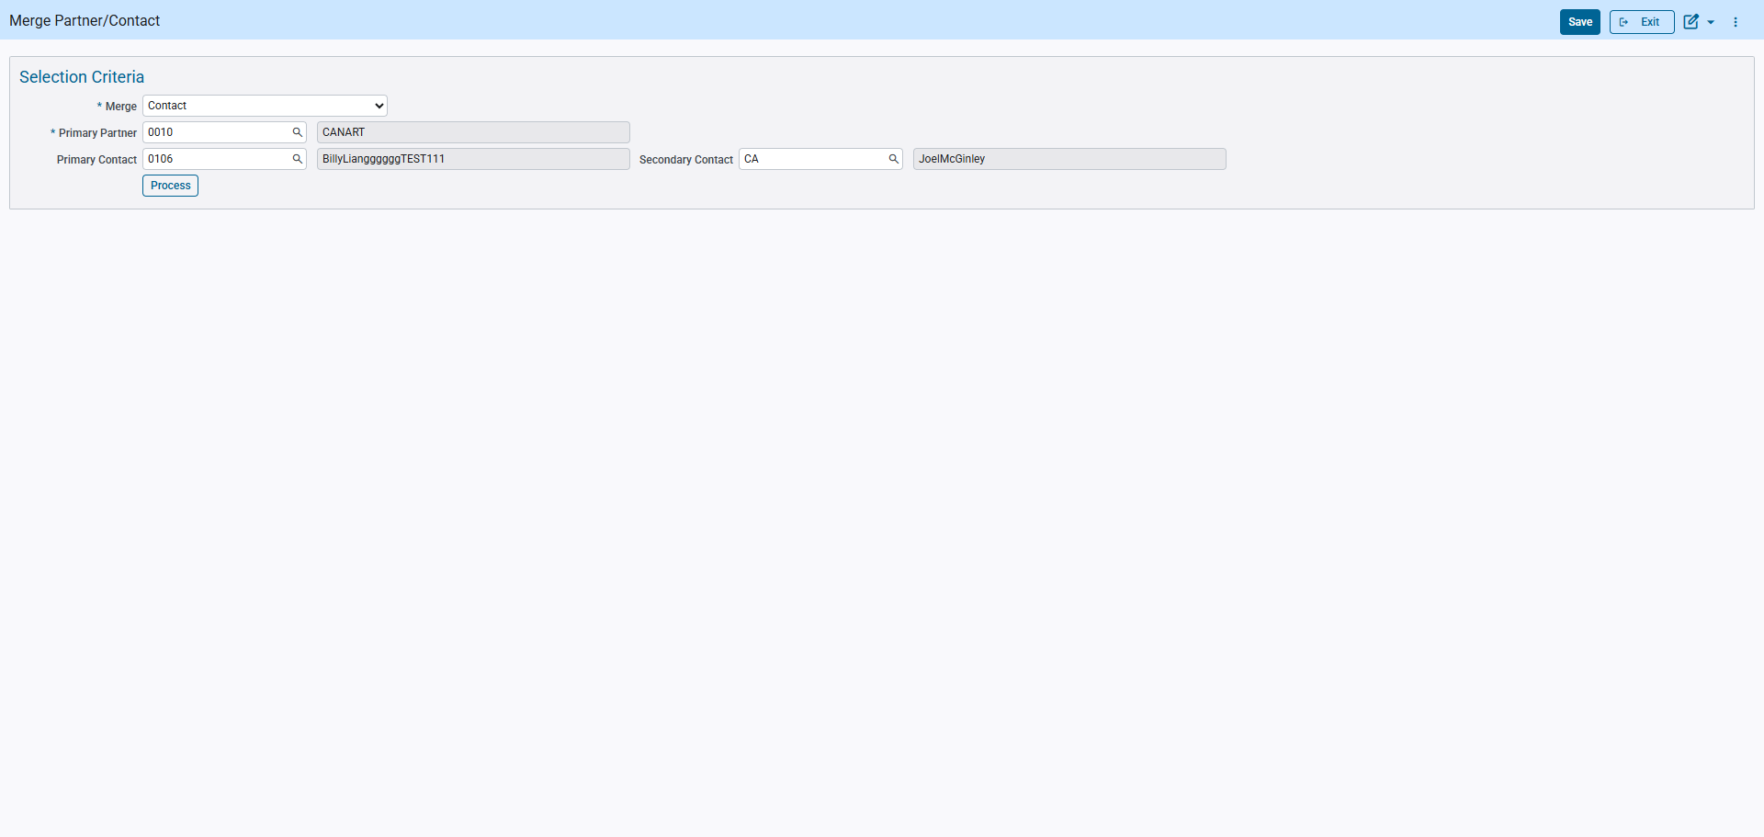
Implementation
The ‘Merge Partner/Contact’ program (SDPARTNERCONTACTMERGE) has been enhanced to better support the merging of user-related data within Partners and Contacts. These updates ensure that user access, historical records, and related information are preserved when a merge is performed.
The enhancements listed below improve how users, notes, and movement history are handled. A step-by-step example of the merge process is also included later in this guide.
New Merging Enhancements
- Merging Partners/Contacts Associated with Users
- Contact records and associated user information from the secondary Partner/Contact are merged into the primary contact once the merge is validated.
- Users can continue to log in using the primary contact, with access to all previous records.
- The original (secondary) contact record is not deleted. Instead, it becomes orphaned, meaning it remains in the system but is no longer associated with a Partner.
- Merging Partners/Contacts with Notes
- Notes include messages and attachments created at the contact level.
- All notes from the secondary contact are transferred and appended to the primary contact to maintain a complete history.
- Merging Partners/Contacts with Movement History
- Movement history associated with the secondary Partner/Contact is moved to the primary record, ensuring continuity of historical tracking.

Demonstration of Utility – Partner Merging with Notes/Attachments
Step 1:
The user will first open the Merge Contact/Partner Utility and have two Business Partners where one contains some Notes and Attachments with another with some as well.
Partner 1:
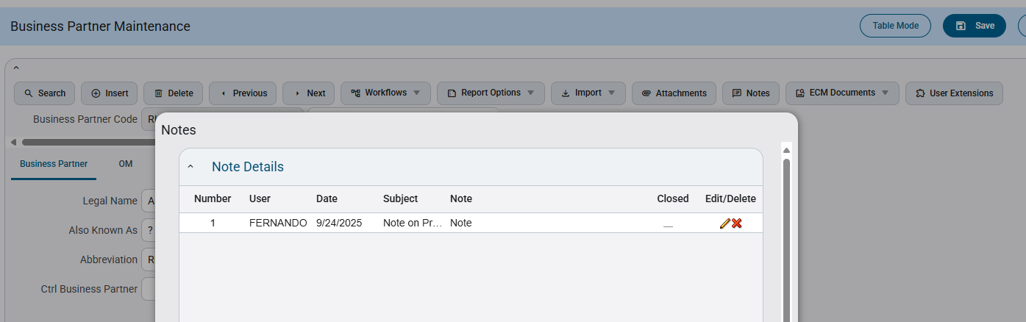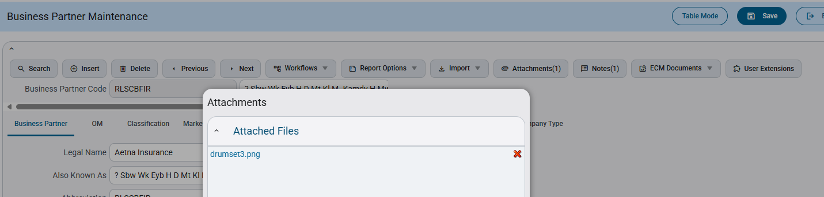
Partner 2:
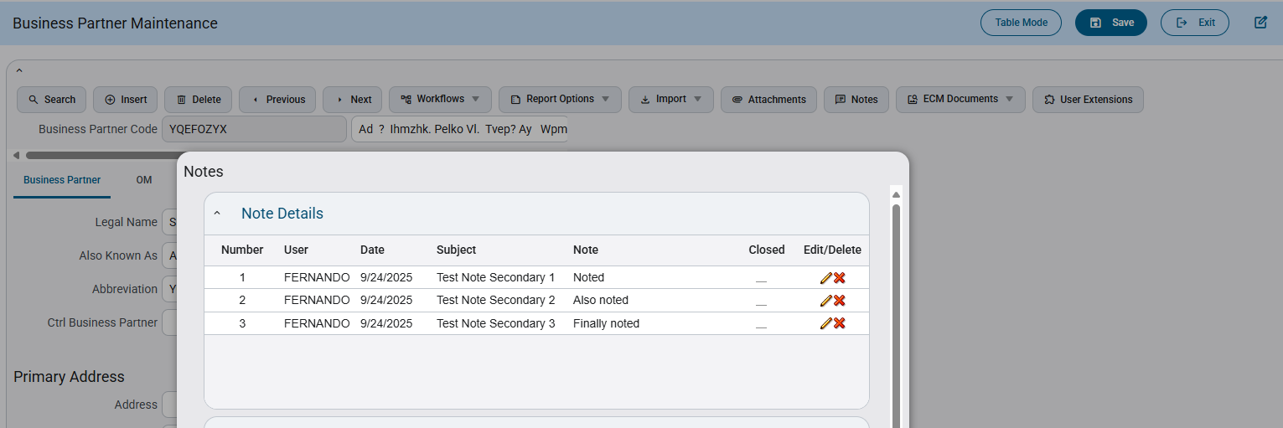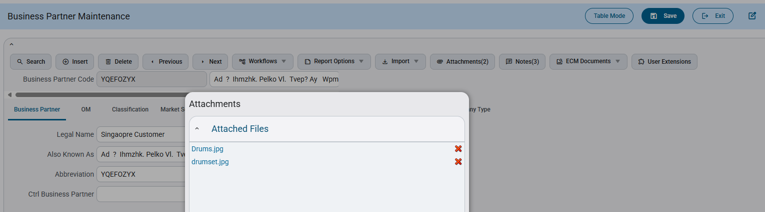
Step 2:
The user will proceed and select Business Partner for the merge within the utility, select partner 1 into the Primary Partner LOV and partner 2 into the Secondary Partner LOV, then click Process for validation
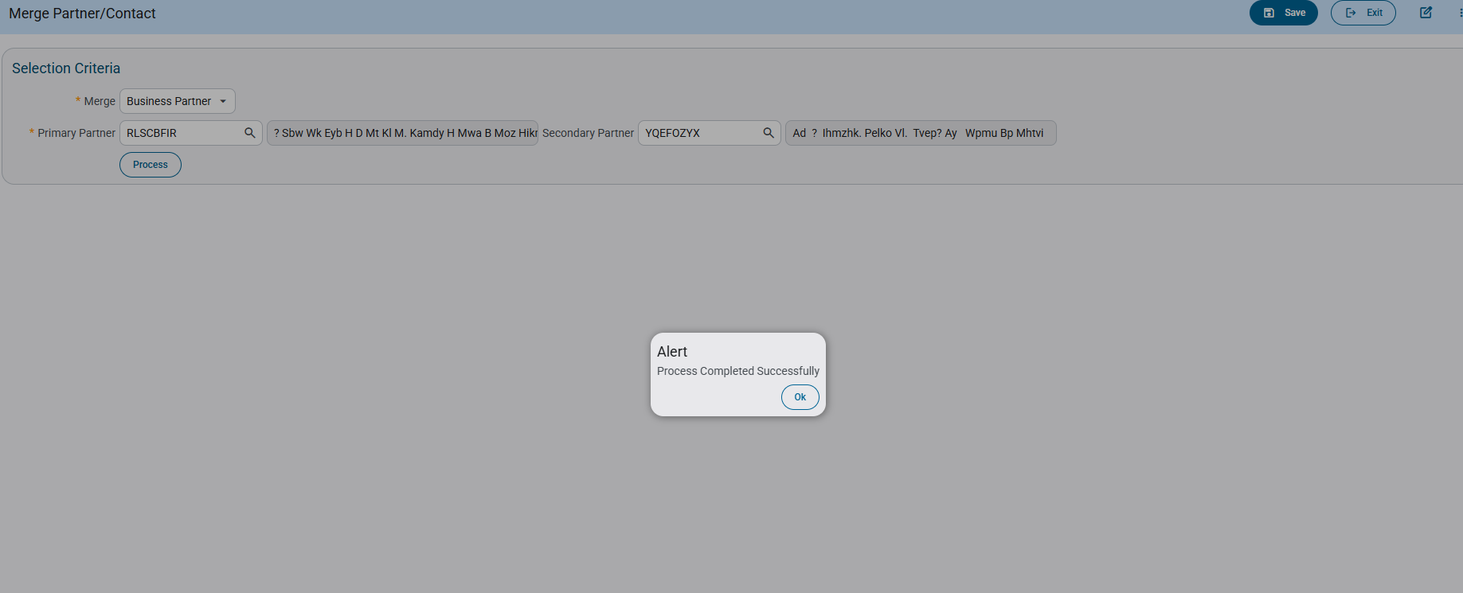
The validation has been triggered and the merged Business Partner is successful.
Step 3:
The Business partner will now contain all Notes and Attachments from both Partner 1 and Partner 2.
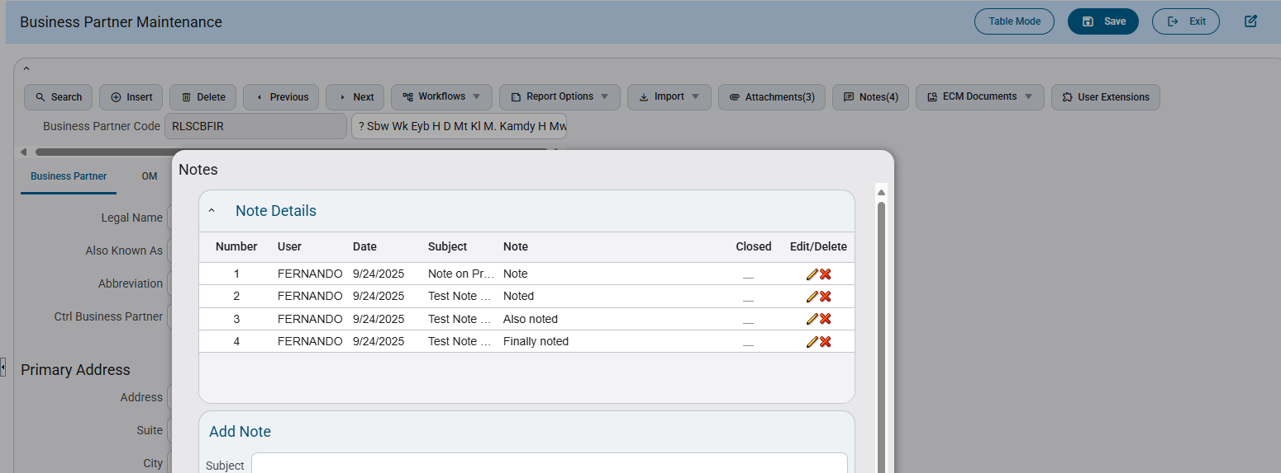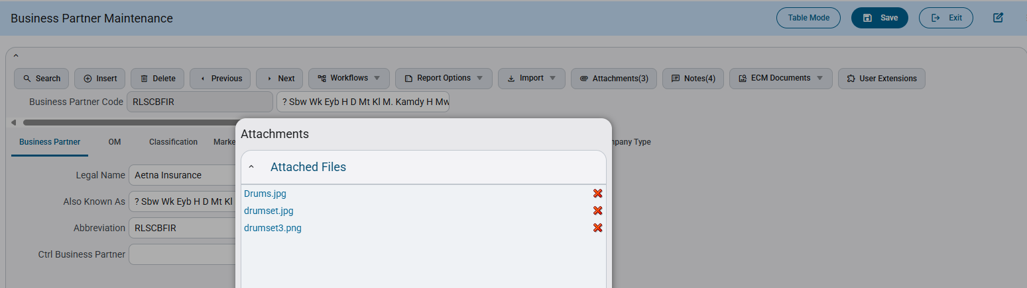

Print Posting Reports Program (SYSRUN): Added “Query Data” Button (CAM-9523)
Overview:
A new “Query Data” button has been added to the Print Posting Reports Program (SYSRUN) to improve usability and system performance.

Modifications:
Previously, all records were automatically displayed when the program was launched. This behavior has been modified. A new “Query Data” button has been introduced, allowing users to retrieve records only after clicking the button. This enhancement improves overall performance both during program launch and during record retrieval.
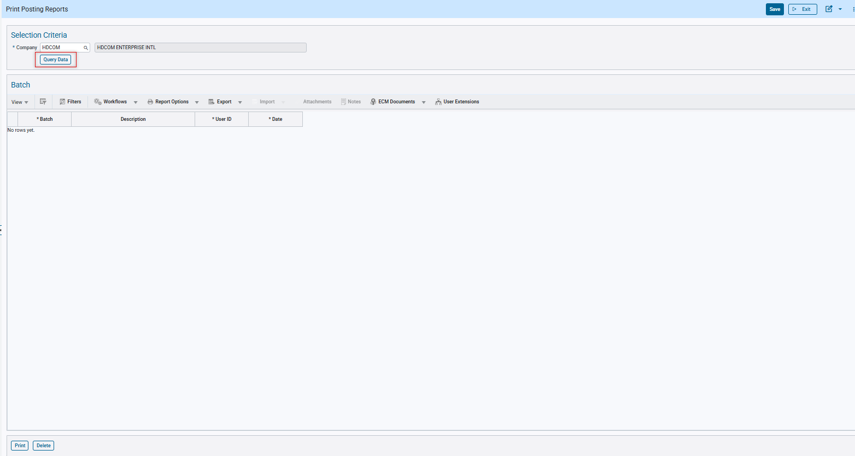
After clicking on Query Data button, records will be displayed.
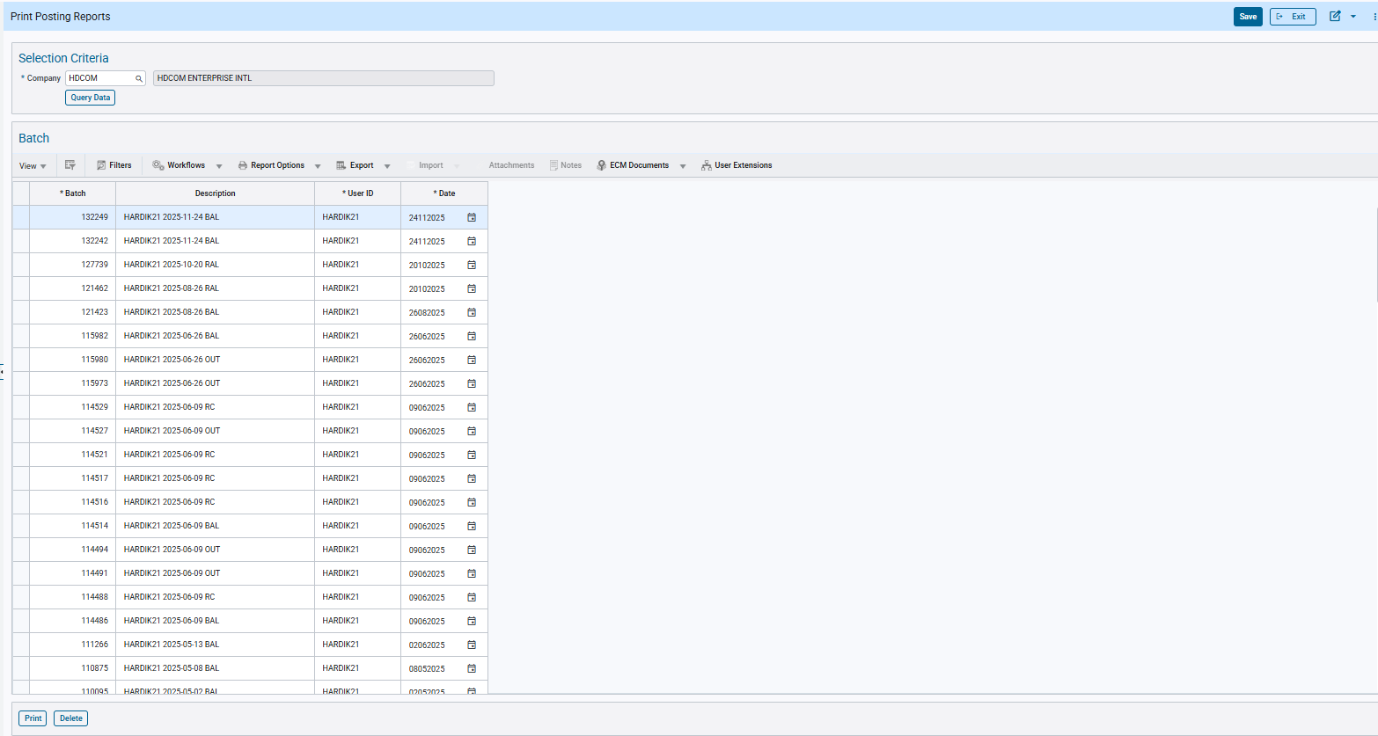

Subscription URL Definitions (SDWEBHOOKDFN): URL Field Length Enhanced to 4,000 Characters (CAM-9695)
Overview:
The URL field length in the Subscription URL Definitions (SDWEBHOOKDFN) program has been modified to support up to 4,000 characters.

Modifications:
The maximum length of the URL field in the Subscription URL Definitions (SDWEBHOOKDFN) program has been increased to 4,000 characters.
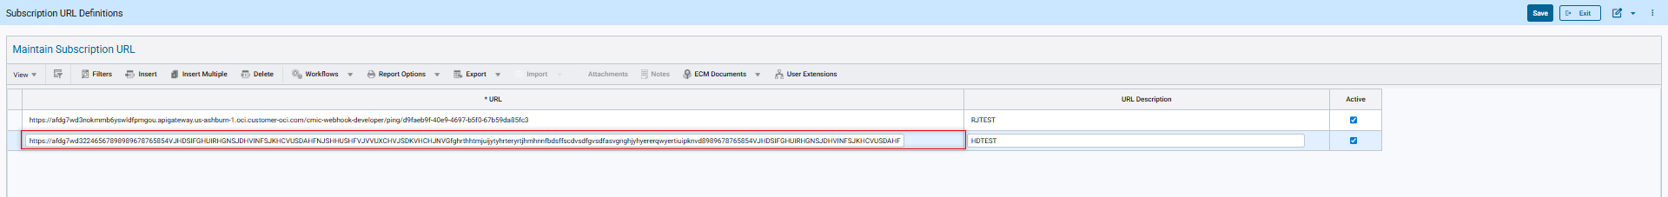

System Data – New UIRuntime Feature added to All Programs (TOOL-8107)
Overview
A new UIRuntime Feature has been included for all featured Table-View programs.
RequireSearchBeforeInsert: Describe as per the description in the program
This new addition occurs on program loading in log/table mode, which will prevent the user from inserting a new record until a query via search is completed first.
This change aims to serve as a preliminary measure to prevent duplication within the system.
Pre-requisites
By default, this setting is OFF by default. The user will have to enable the feature for a specific program to ensure that the functionality is working.
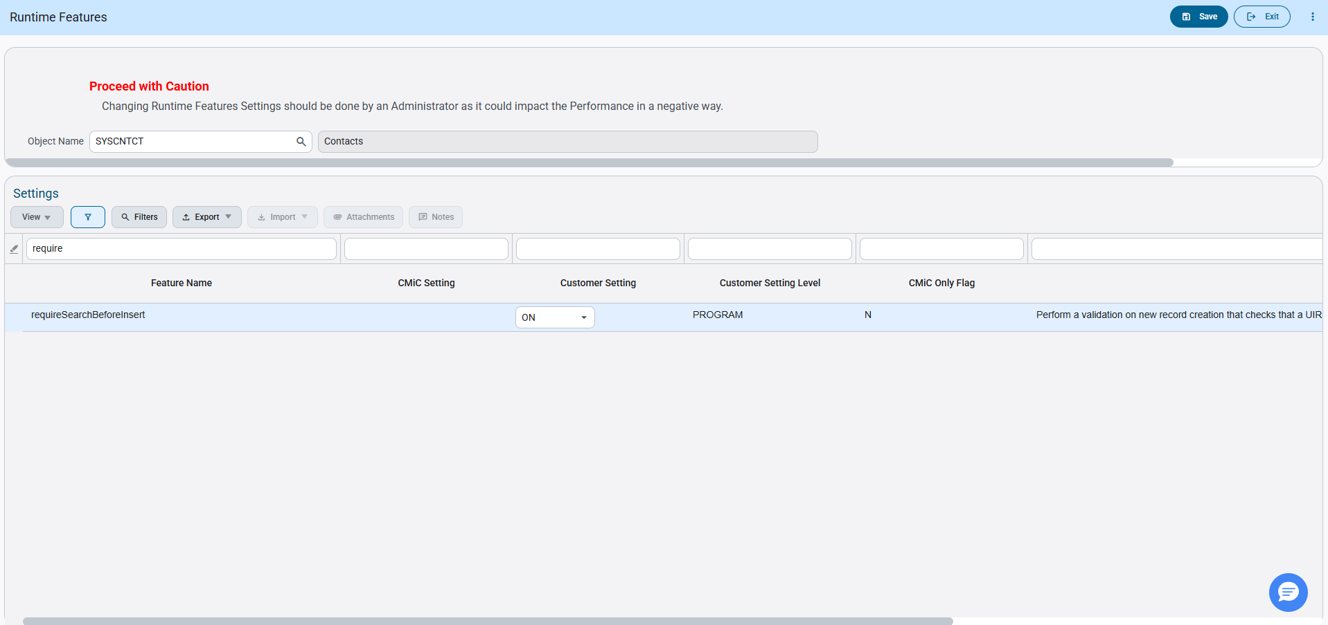
Modifications
Runtime feature program:
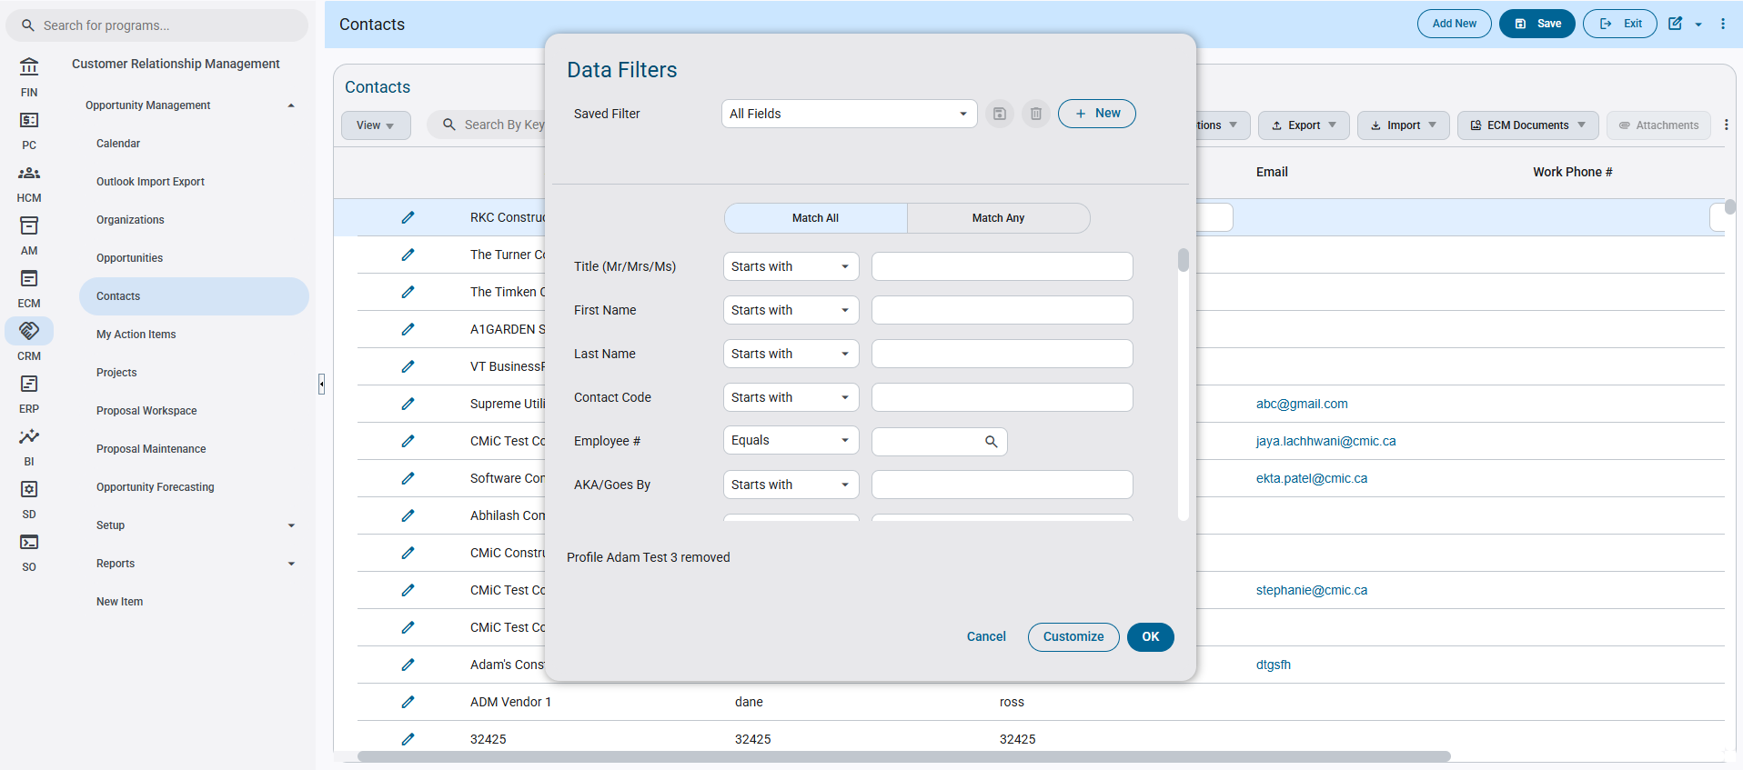
Implementation
The user must first enable the UIRuntime Feature within the Runtime Features (SDRUNTIMEFEATURE) program, for the desired program to take effect. For this document’s purposes, will be using the Contacts (SYSCNTCT) program as reference.
The Feature ‘requireSearchBeforeInsert’ must be enabled for the program in order to see the new functionality.
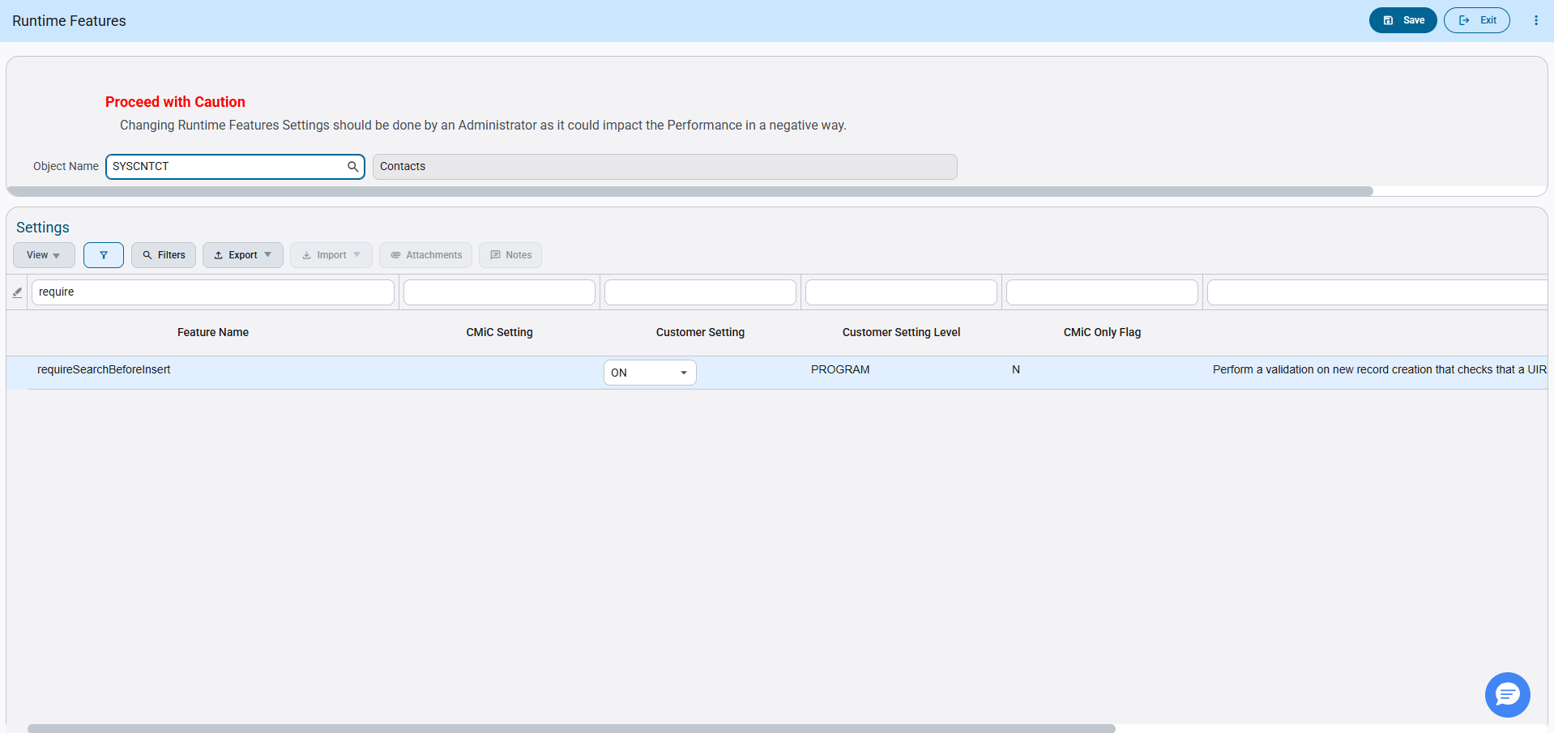
After the user enables and saves the setting, once the associated program is opened, a Query for Data Filters will immediately pop open.
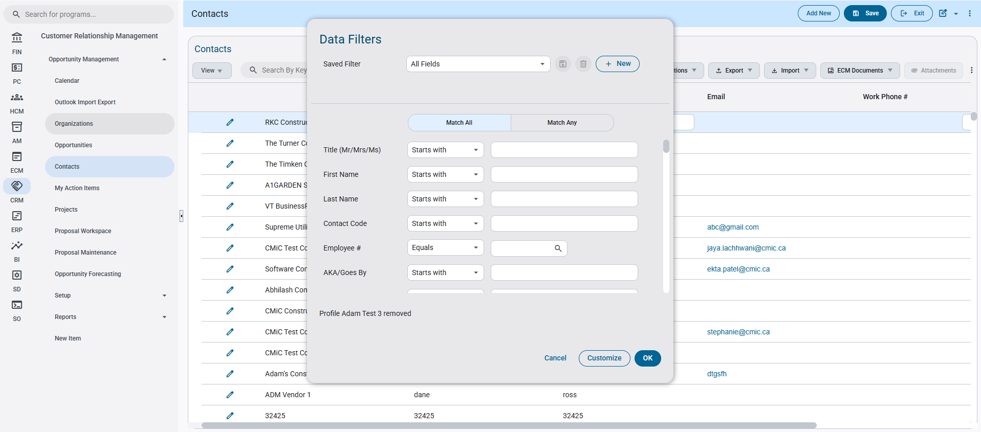
The user at this point will click cancel on the Data Filter, and attempt to insert a new record on the Table Mode via “Insert” in the Toolbar, or using the “Add New” button on the top right of the screen.
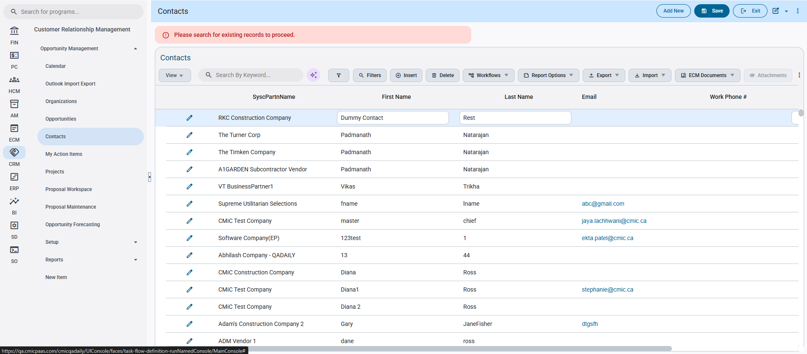
The new functionality will prevent the user from inserting a new record through an error validation, and they will have to complete a queried search (Search By Keyword…, AI Query, Query by Example, or Filter Search) in order to proceed accordingly.
By example, the user will enter some values into the “Search By Keyword…” to filter the records.
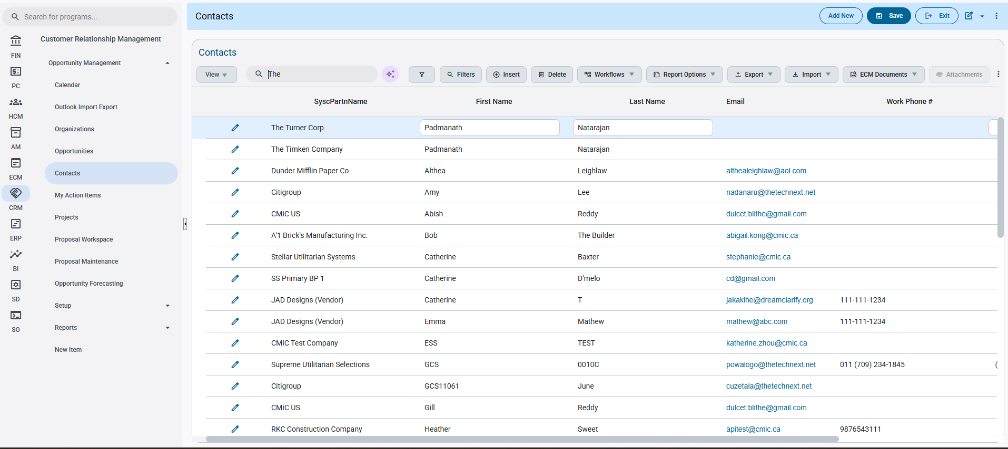
Afterwards, the user will now be able to insert and edit a new record without the error validation occurring again.
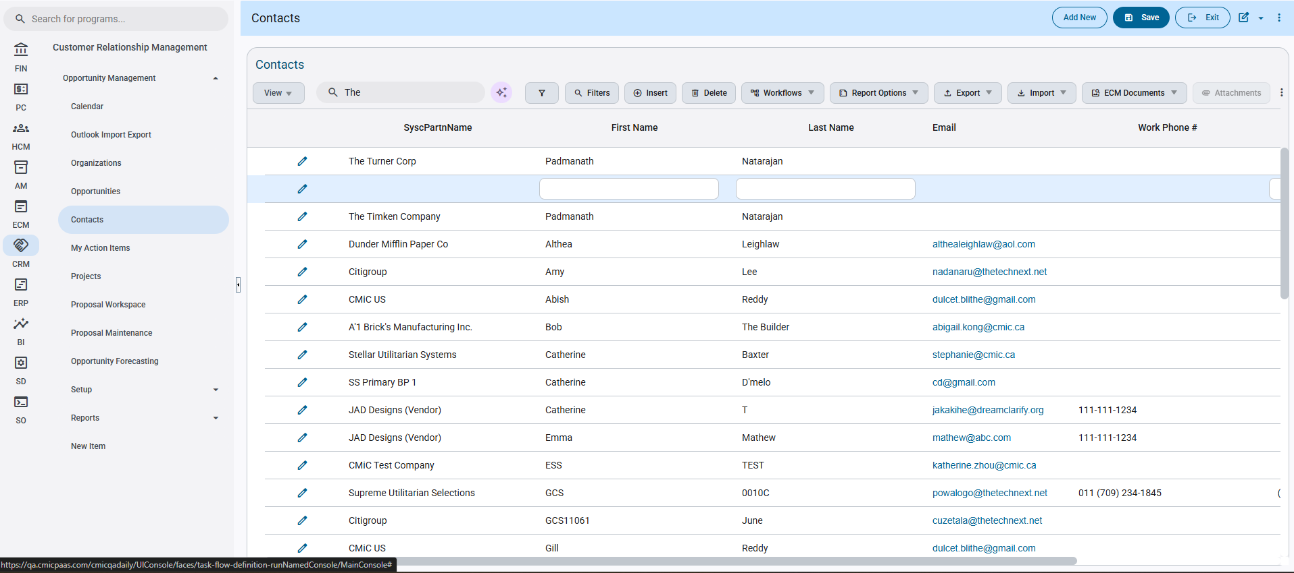
Note: The user will have to repeat the same process every time they refresh the screen or program, otherwise they click OK on the initial Filter and the error validation will no longer occur for that session. This is also only applicable during table mode/log mode launch.

System Data – SDROLETOAPI is replaced with SDAPITOROLE (CAM-8910)
Overview
The Assign Role to API program has been replaced with the Assign API to Role program within the application train. This change appropriately displays the correct program to provide the user with better clarity and understanding.
Modifications
Runtime feature program:
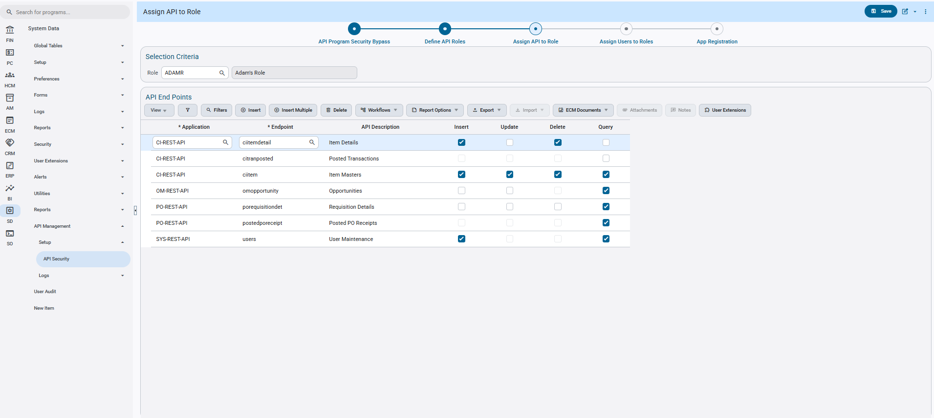Implementation
SDROLETOAPI has been replaced with SDAPITOROLE within the menu train for API Security. This program allows the user to assign API’s directly to a user role as well as customizing the permissions for each API. Insert – Update - Delete - Query
To demonstrate, the user will assign a new API endpoint for their role to authorize them access for API calls to that specific endpoint.
The user first inserts their Role into the Selection Criteria
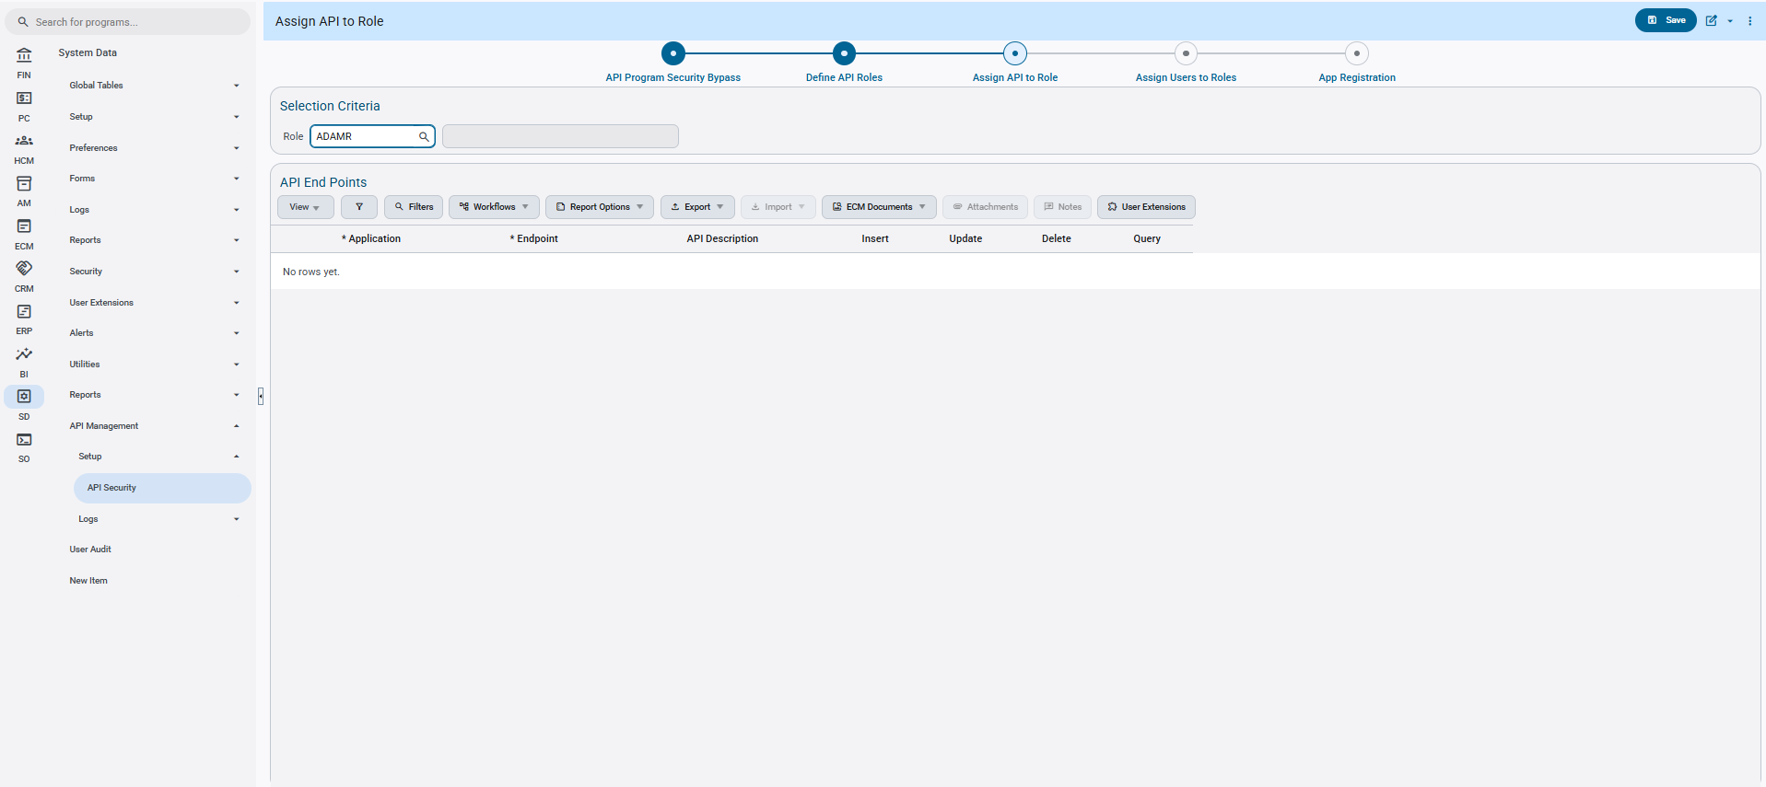
After tabbing out, the user will see the API End Points table displayed.
The user will then click insert in the table to add a new entry, then select an API Application within the first LOV, and then select an Endpoint for that application within the second LOV.
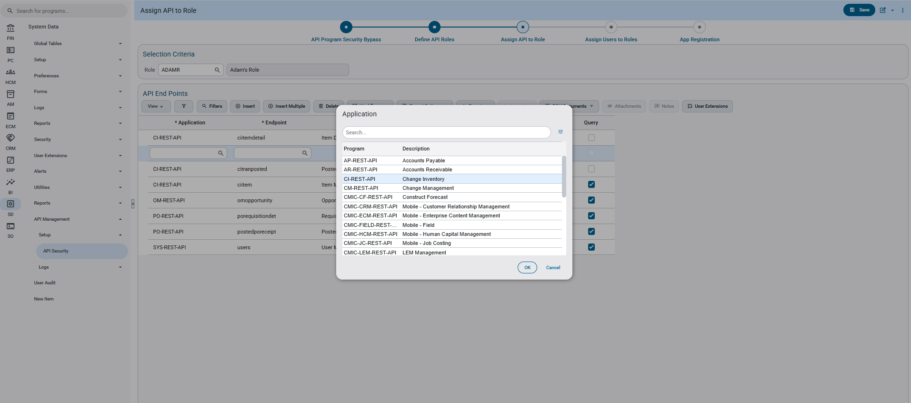
The user can then configure the editing permissions for the API End Point, and once satisfied the user will click save on the menu bar and complete the configuration.
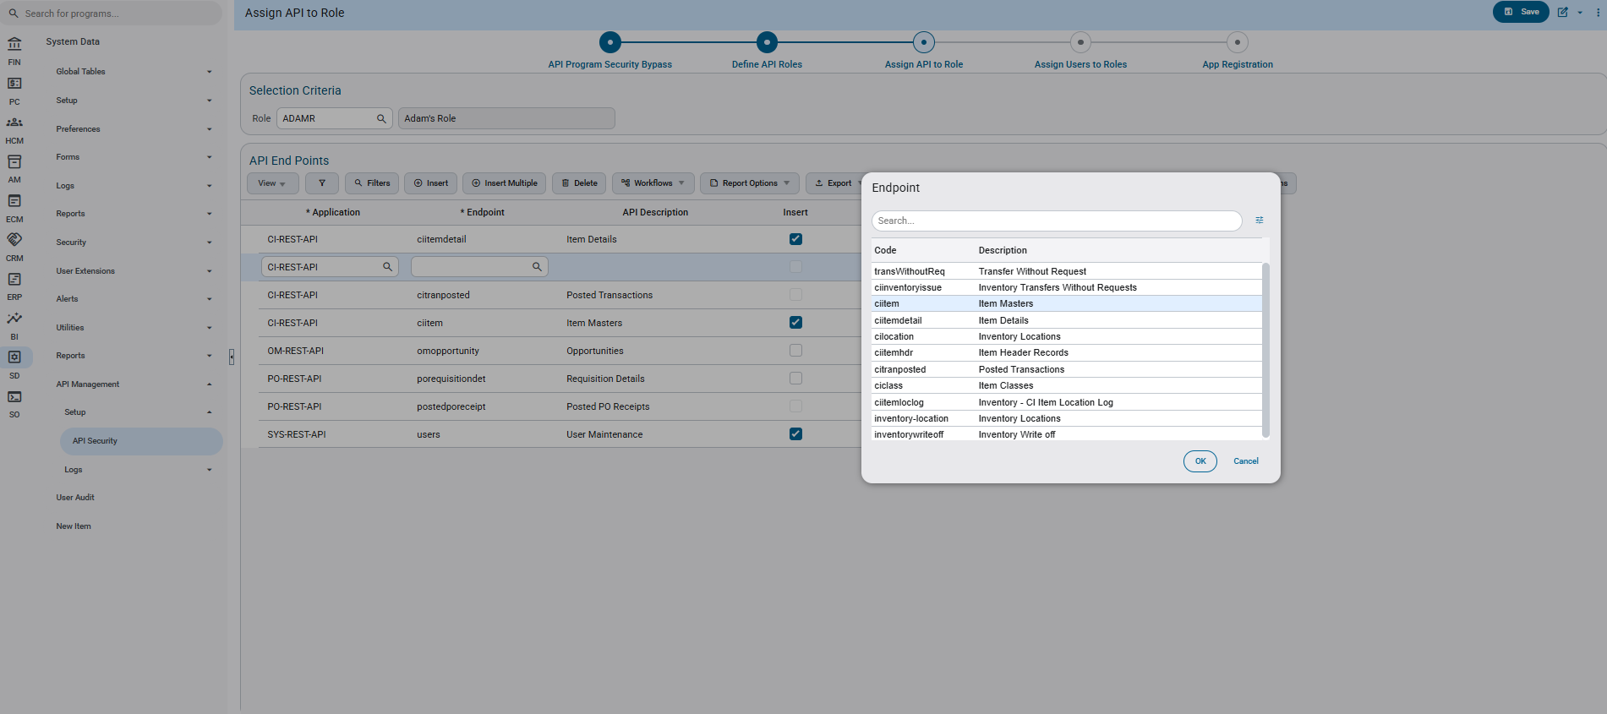
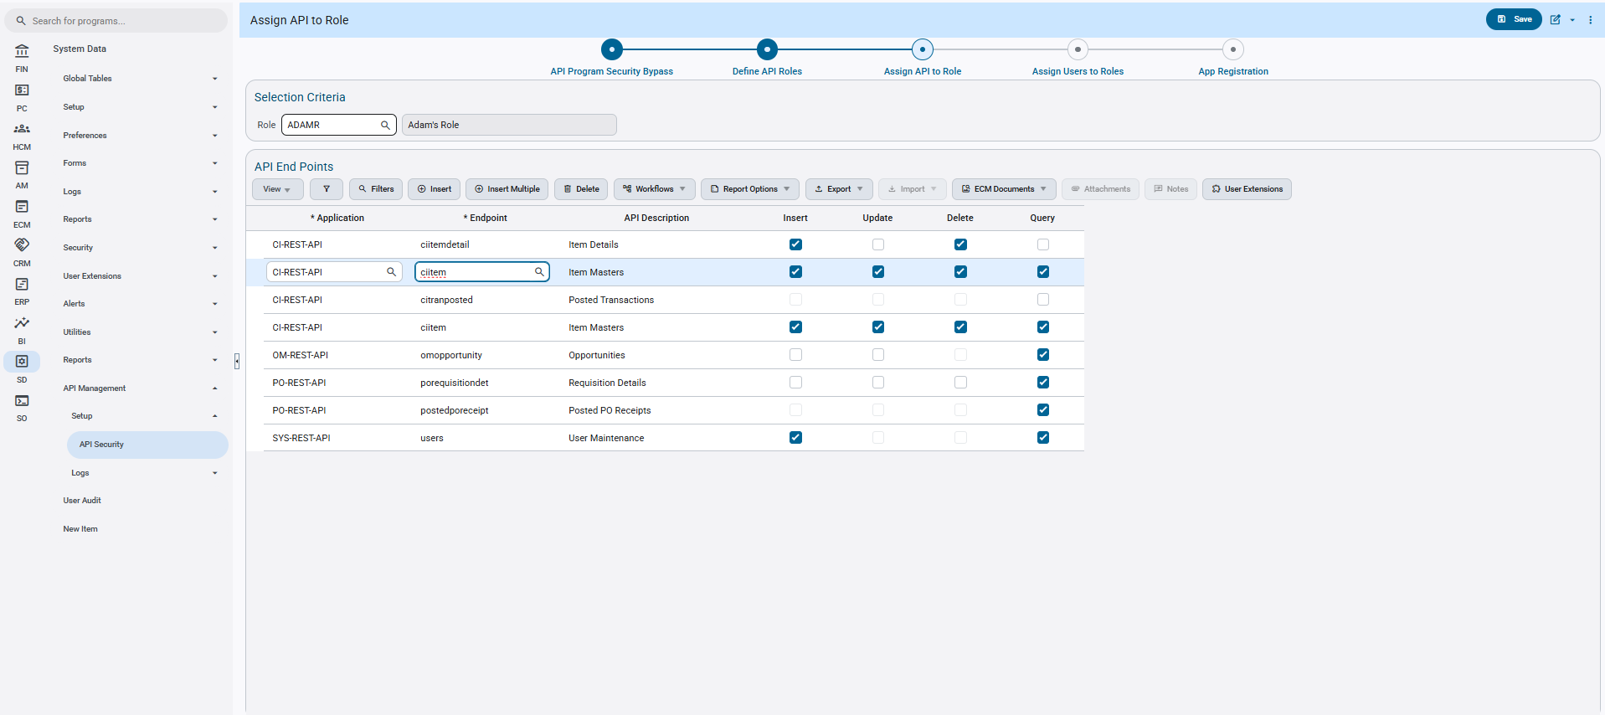

System Options – New LOV added within the SYSOPT AI tab (CAM-8568)
Overview
A new optional LOV field has been added to the AI tab of the SYSOPT program. This field allows to select a BI Canvas to be used as an AI dataset.
Modifications
Runtime feature program:
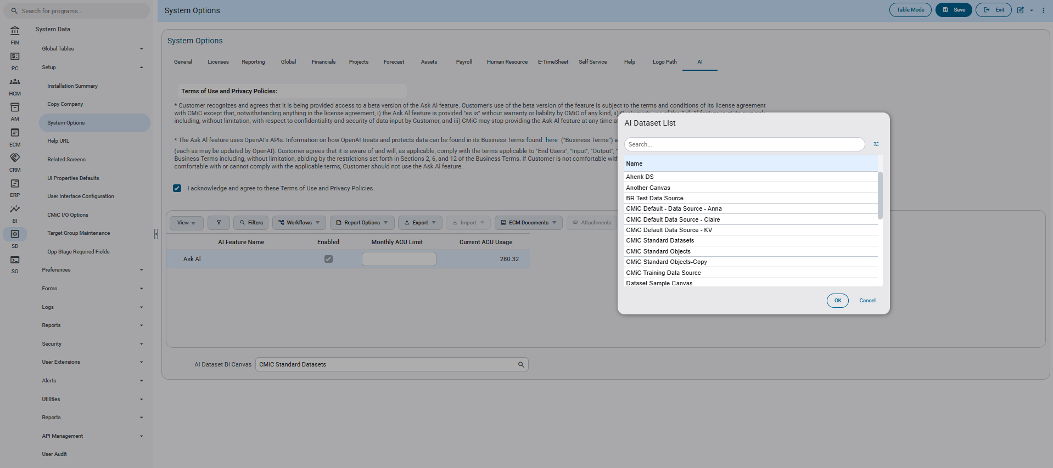
Implementation
A new optional LOV has been included in the SYSOPT program, AI tab named AI Dataset BI Canvas. This new implementation allows the user to select a BI Canvas to be used as an AI dataset within the database.
The List of Values is optional and can be left empty, any listed AI Dataset can be selected and activated.
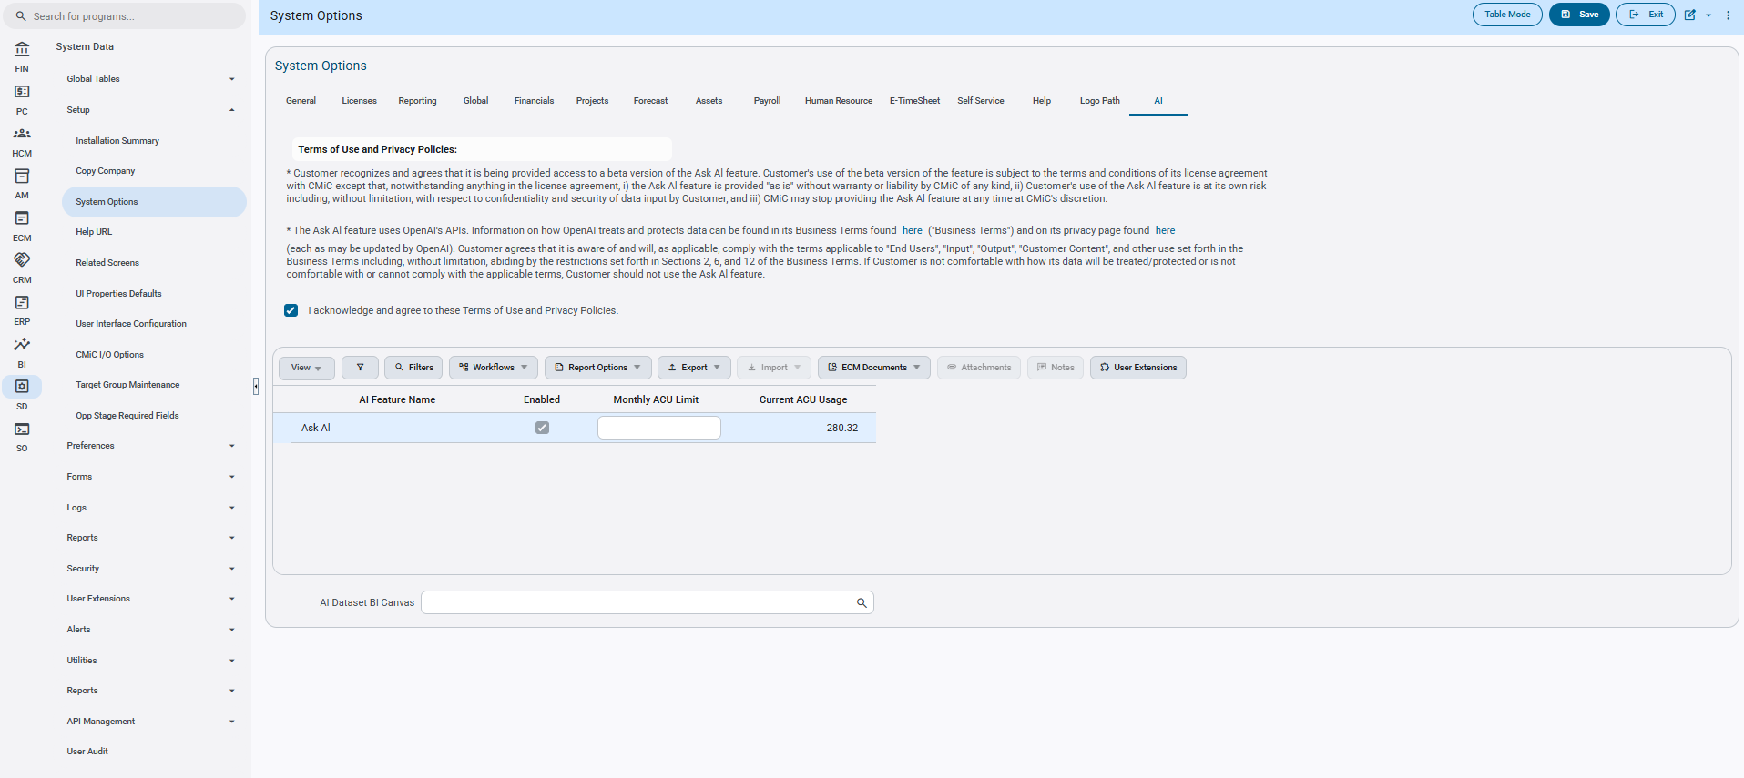
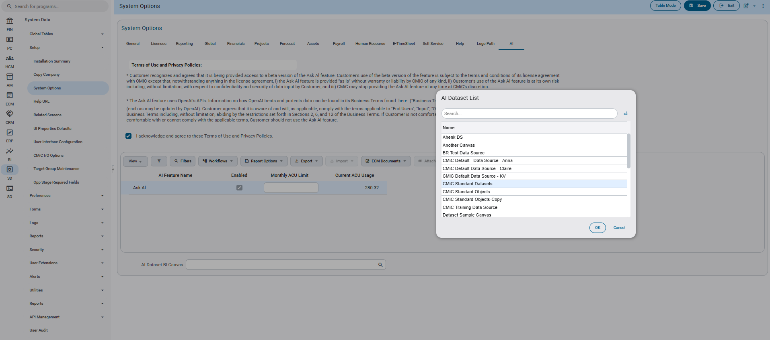
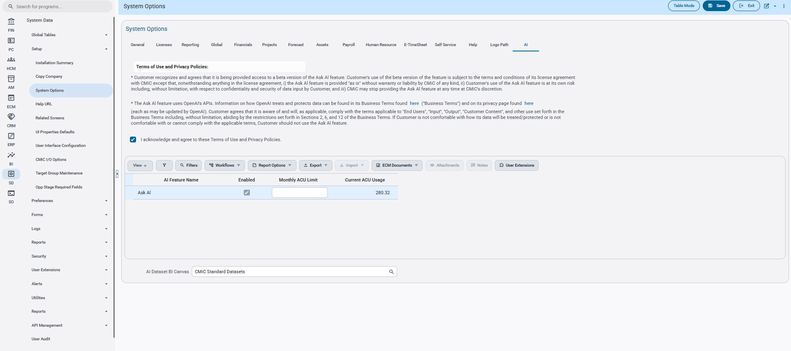

UIRuntime Error – Window now includes a close button (TOOL-5109)
Overview
Now included within any UIRuntime Error windows, a new “Close” button has been implemented to allow the user to escape the program without the need to refresh the screen.
Modifications
Runtime feature program:
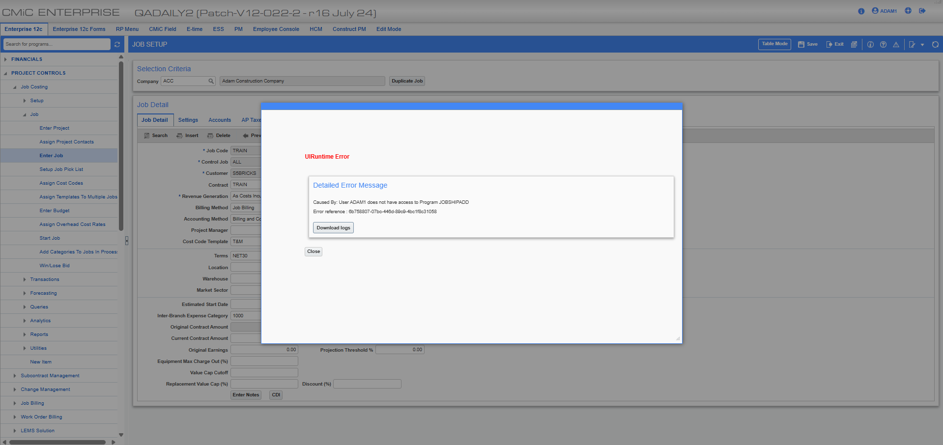
Implementation
A new close button has been included within the UIRuntime Error screen. This new change now lets a user cleanly leave an error window without having to refresh their browser to escape it.

Updated Descriptions for UACCREATE and UACMODIFY System Privileges (CAM-8949)
Overview:
In System Privileges, the descriptions for the UACCREATE and UACMODIFY privilege codes have been updated.

Modifications:
The descriptions for the two system privileges have been updated as follows:

  - UACCREATE:
SD: Allows creation of Users and Templates [User Admin Central, API]
  - UACMODIFY:
SD: Allows modification of Users, Templates, and Onboarding data [User Admin Central, API]

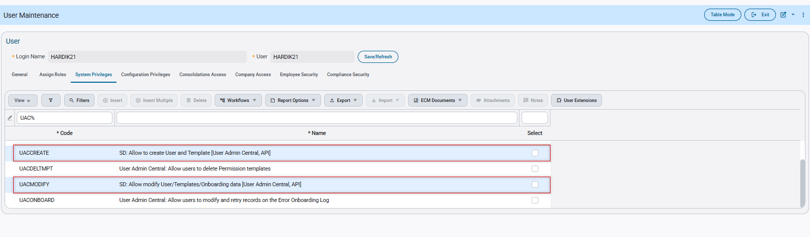

User Maintenance – Change Order privilege renamed and readjusted (CAM-7166)
Overview
The Change Order privilege POCOQTY while unchecked has been readjusted and renamed to prevent the reversing of received invoiced items for a Purchase Order. This change allows the user to make cleaner decisions and actions with the software.
Modifications
Runtime feature program:
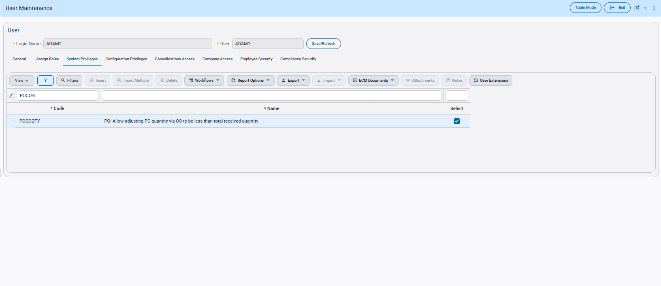
Implementation
The name change of the POCOQTY has been implemented to allow the user to better understand it’s functionality. Additionally, the privilege itself will now prevent the user from being able to reverse the received quantity of already invoiced items in a Purchase Order when unchecked. While checked, this can be bypassed.
A demonstration of the privilege change is as follows..
The user first activates the POCOQTY privilege within User Maintenance for their specific user and saves it.
Afterwards the user will create a Purchase Order, have it posted and partially received.
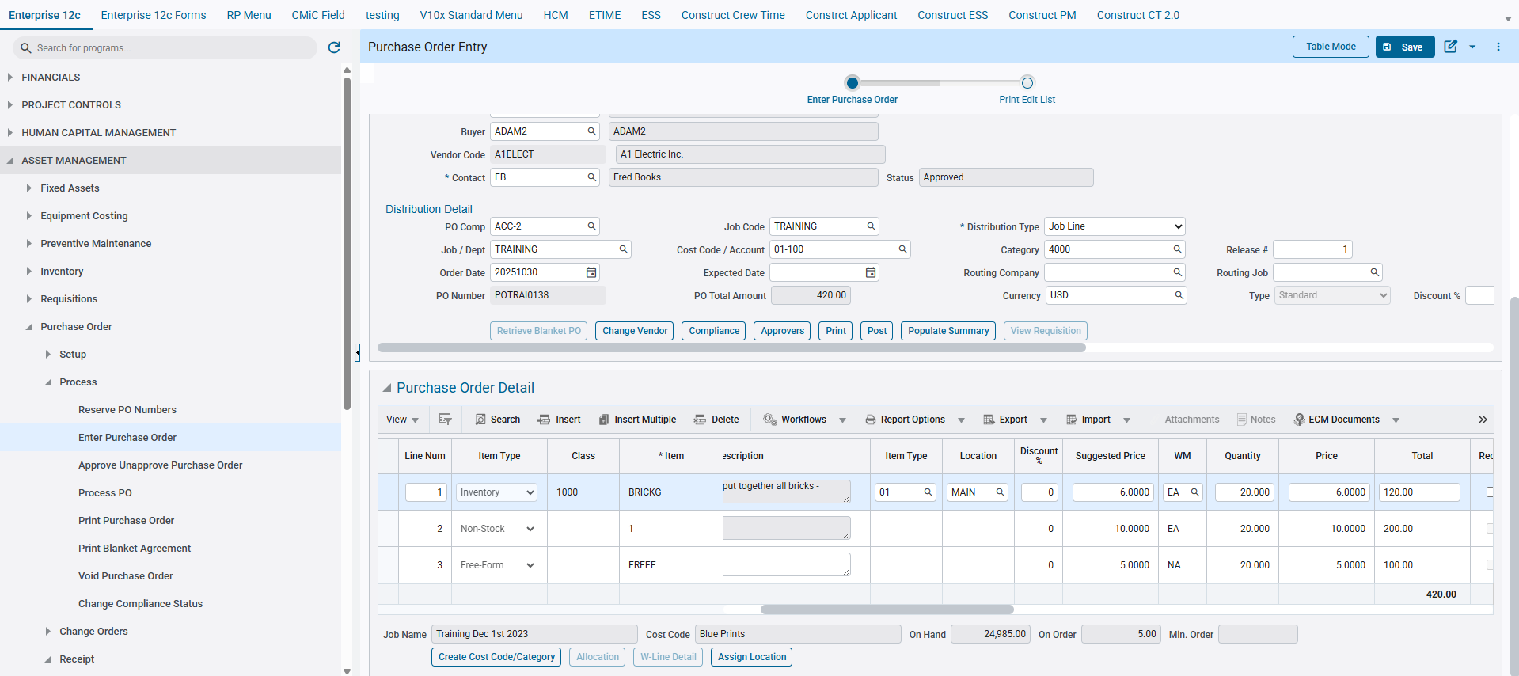
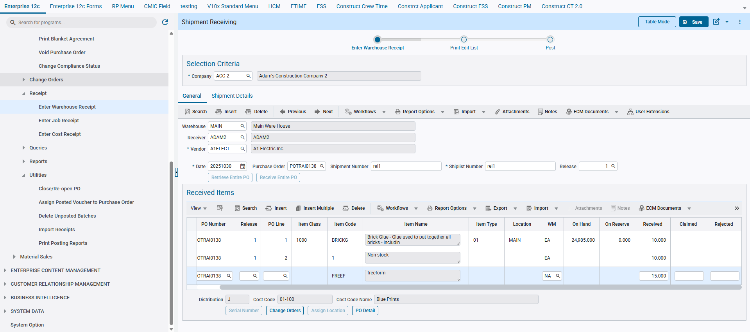
At this point the PO now has some invoiced quantity, and the privilege will prevent the user from exceeding the PO Unreceived Quantity and therefore reversing it through a negative balanced Change Order.
The user will then create a Change Order with negative quantities, and be prevented from doing so.
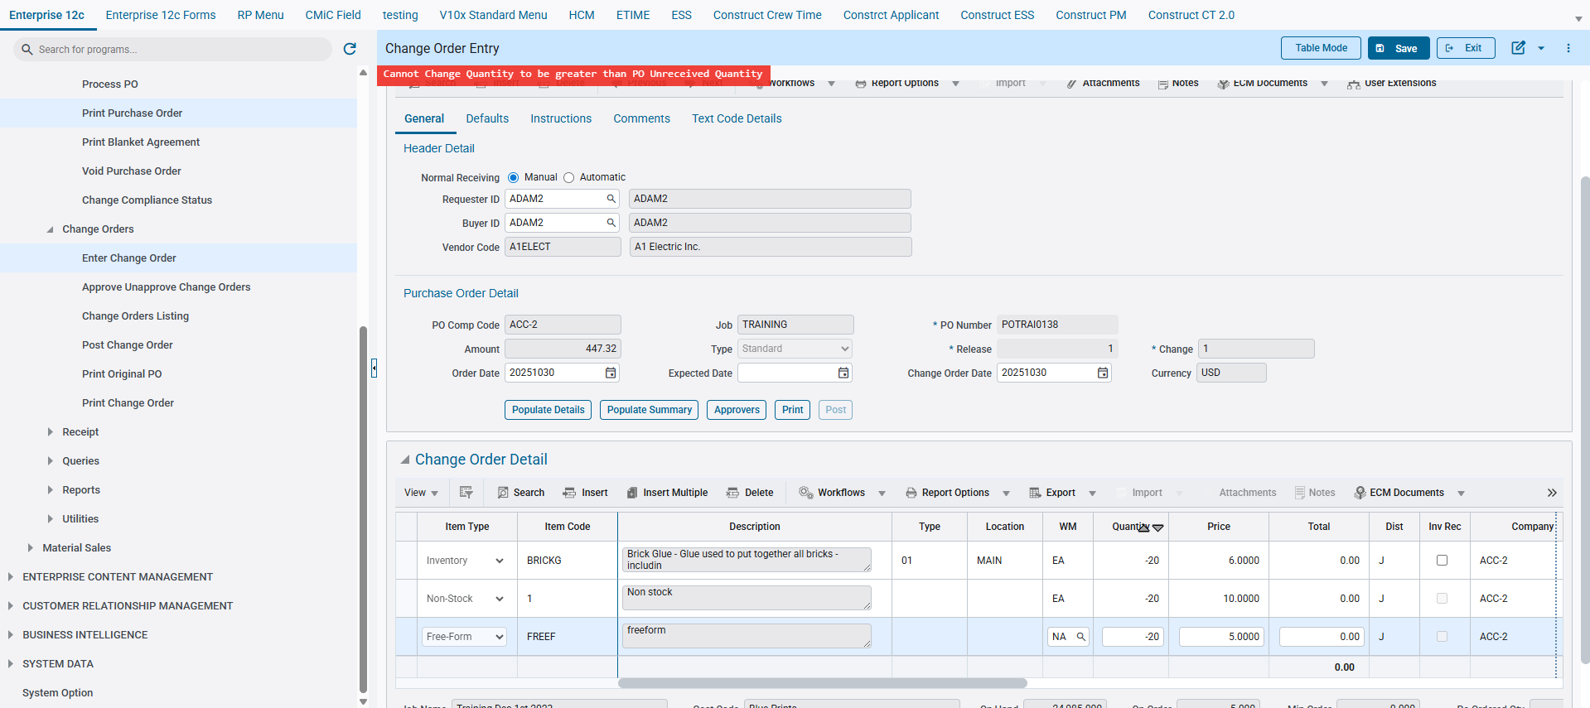
If the privilege is instead checked, the CO can be created and have the Received quantities reversed.

User Password Management and Security Enhancements – (CAM-9505)
Overview:
Enhancements have been made to the ‘User Maintenance’ (SDUSRMNT) program to improve user password management and security within CMiC. Password creation and maintenance have been removed from ‘User Maintenance’ (SDUSRMNT) and are now handled through the CMiC Sign-In password reset process.
The ‘Update User Password’ (SDSSOPW) program is also modified to support the process. The Password fields have been removed. This program allows administrators to reset the password for user accounts, and the users must use ‘Having Trouble Signing In?’ option in the Single Sign-on log in page to reset their password with a new one. This program is used by Administrators to update LDAP passwords for users.

Modifications:
- User Creation and Password setup Process
User Maintenance (SDUSRMNT) program is modified to improve security and standardize password management process.
The “Password” and “Re-Type Password” fields, as well as the “Change Password” button, have been removed from the program.
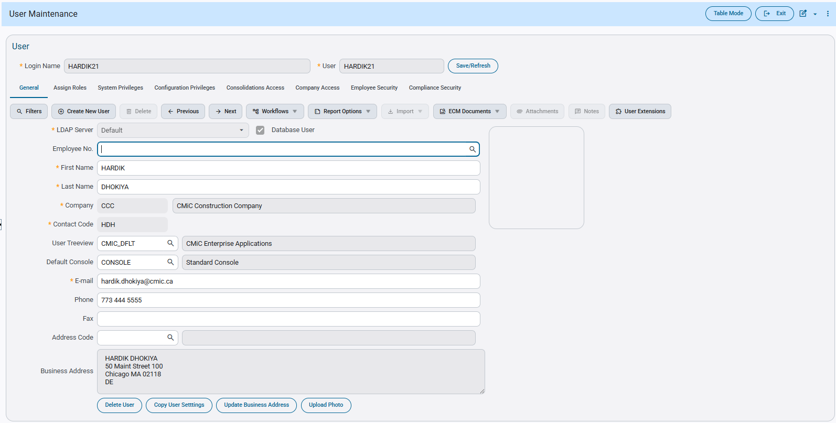 System Data > Security > Users / User Maintenance
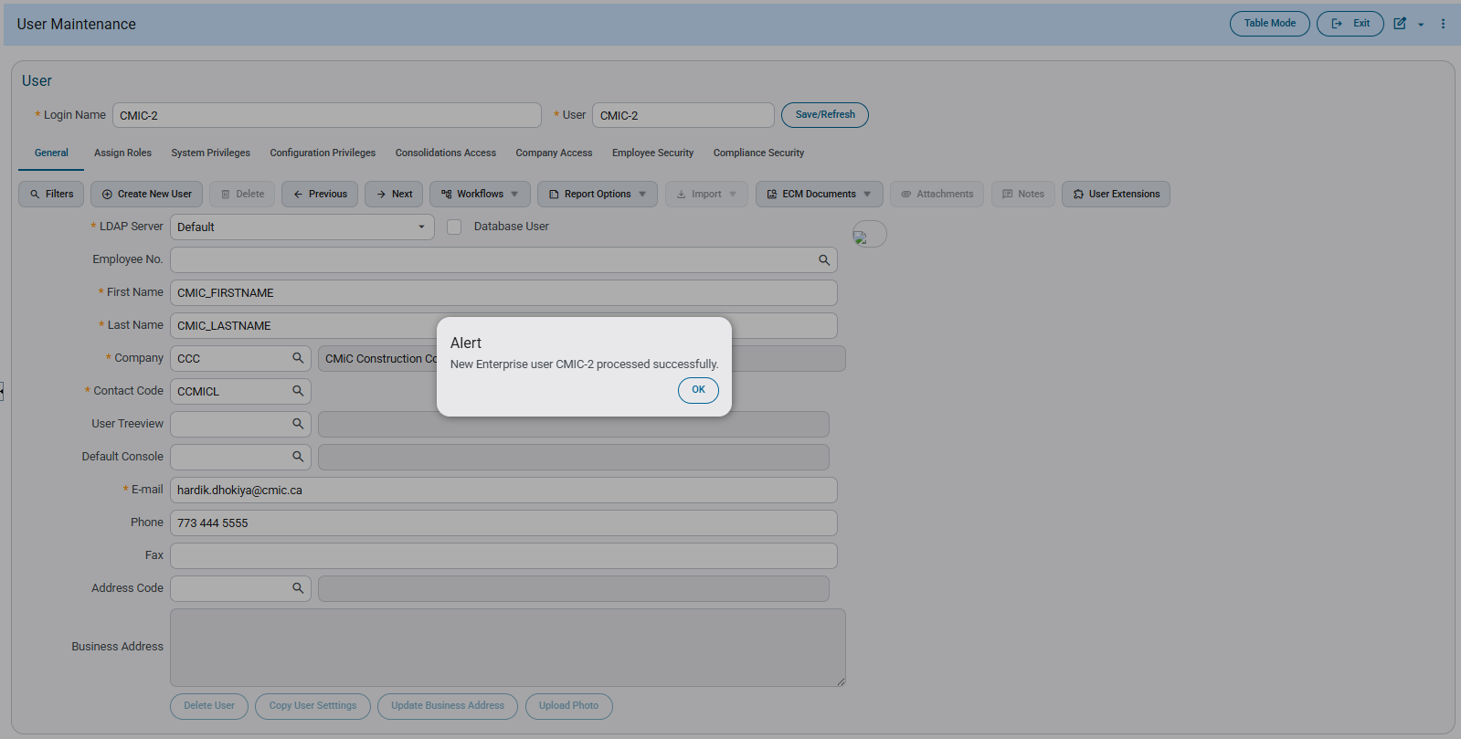–
The above User Entry program shows that a new user created without providing a password.
Passwords can no longer be assigned during user creation. Users must initiate password creation through the “Having trouble signing in?” link on the CMiC Sign-In page.

After entering the email address associated with the user account and selecting Reset Password, a system-generated email is sent containing a secure password reset link.
The link is valid for a maximum of one hour and can be used to change the password only once. If another attempt is made using the same link, the following message will be displayed:
“The link for changing password is expired. Please send a new request.”

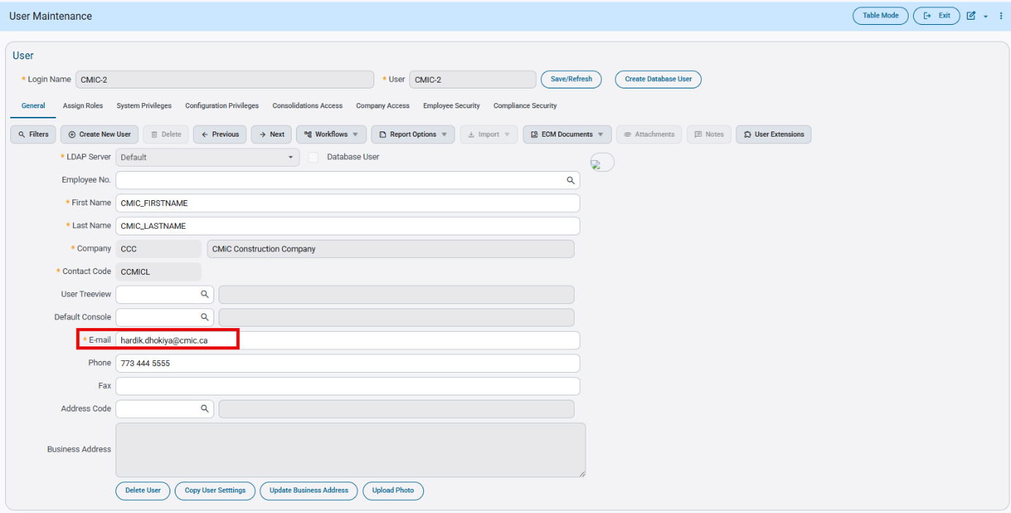



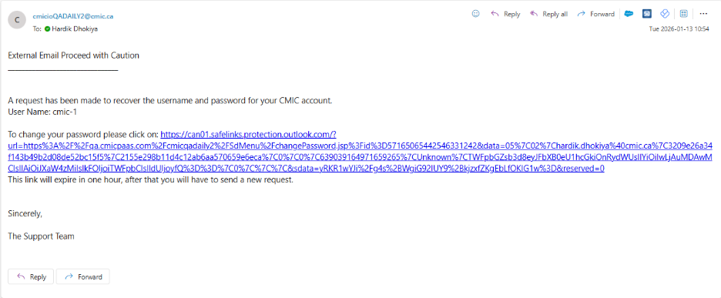

Upon accessing the link, users are directed to the change your password page, where they must enter the User ID, New Password, and Confirm New Password. After successful submission, a confirmation message stating “You have successfully changed your password” is displayed, and the user may log in using the newly created password.
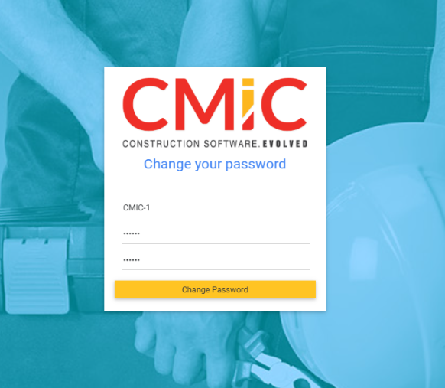
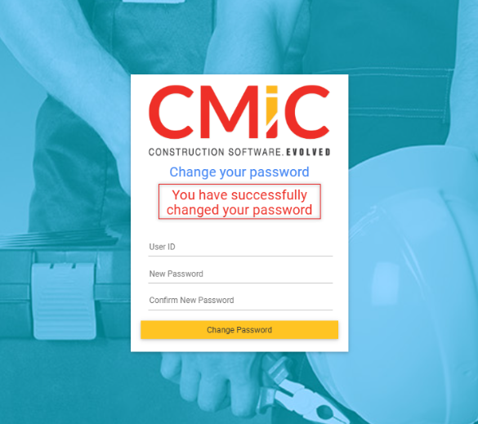

- Update User Password through ‘Update User Password’ program
The ‘Update User Password’ (SDSSOPW) allows administrators to update the LDAP Password.
To update a password, the administrators must select a user id for Single Sign-On User Profile, select the Update LDAP Password checkbox, and then click Submit.

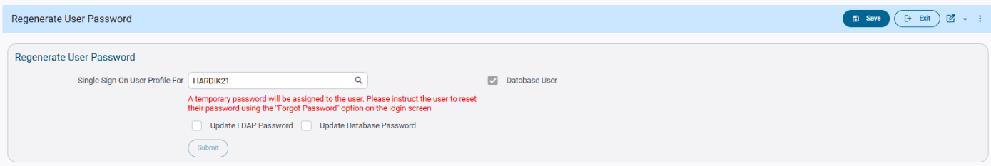

Once the administrator clicks Submit, an alert message stating, “Password Changed Successfully!” is displayed, and the user will no longer be able to log in using the old password.
Administrators must notify the users to reset their password on their next log in. To update the password, users must follow the same process as the new user password setup by selecting the “Having trouble signing in?” link on the CMiC Sign-In page.
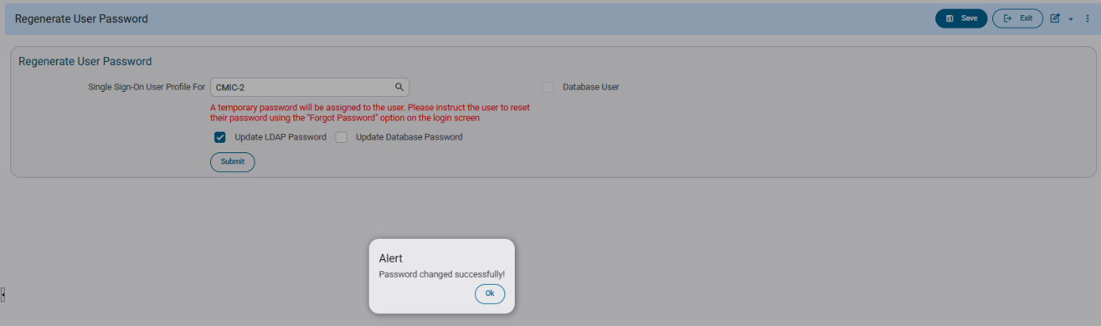

- Security Question/Answers for Forgot Password
Security questions and passwords can be updated in the User Defaults section of Project Contact Detail program.
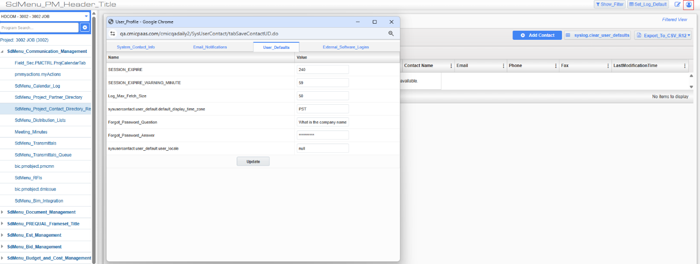

Once the security question is updated with a value, then it becomes mandatory when password reset is attempted. The email address must be linked to a system contact, and that system contact must be associated with a CMIC user account. To complete the password reset process, the security question must be answered correctly.



When clicked on ‘Reset Password’ button, it displays screen with Security question and security question must be correctly answered to complete the password reset process.

After clicking the Answer button, a message stating “Reset Password Instructions have been sent” is displayed. An email is then sent to the associated email address, and the user must follow the same new password setup process to complete the password reset
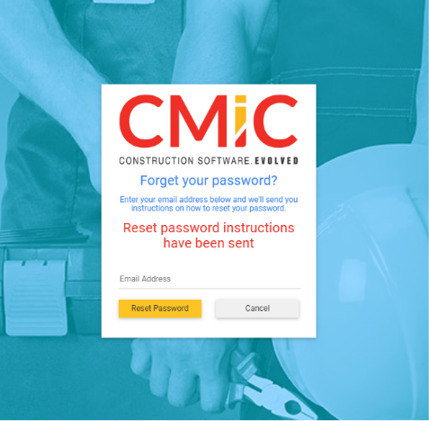

Ability to update password by logged in user in User Settings:
Logged in users can reset their password in user setting as shown in the screenshot below; this update can only be performed by logged in users to their individual user profile. This is an existing functionality.
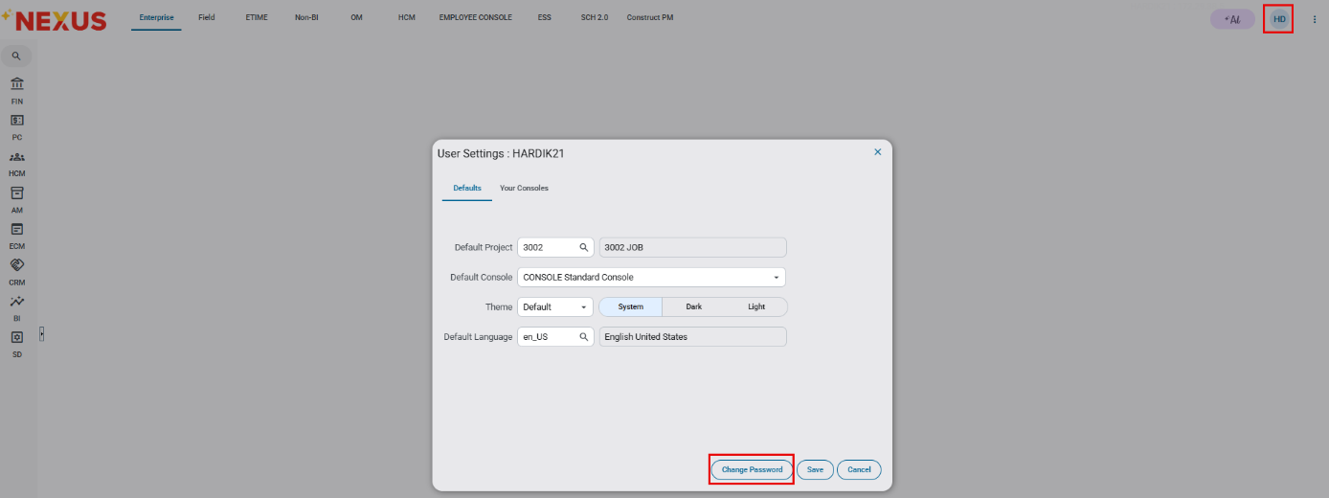

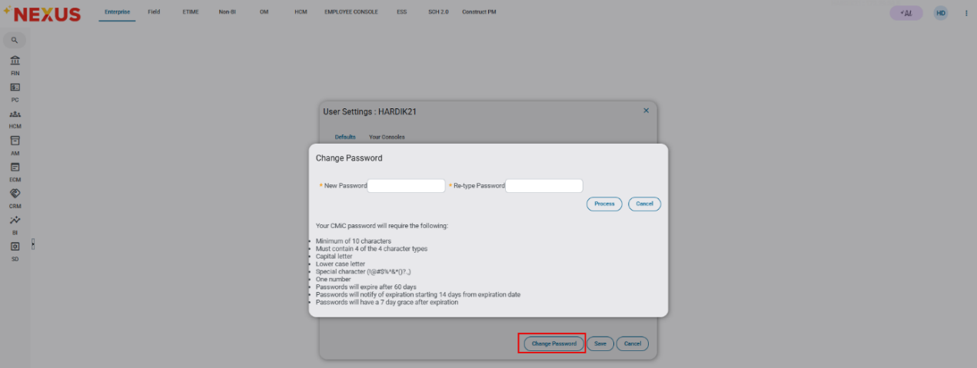

Modifications released in Hotfix 01:
- Program Name and Menu target name updated to ‘Regenerate User Password’ from ‘Update User Password’.
- Old Password field is removed from this program.
- [Submit] button will be disabled if none of the checkbox is checked.
- Password related fields are removed in CMiC Field program and ‘No User’ radio option is disabled in enterprise user program.
The program name has been updated to “Regenerate User Password”
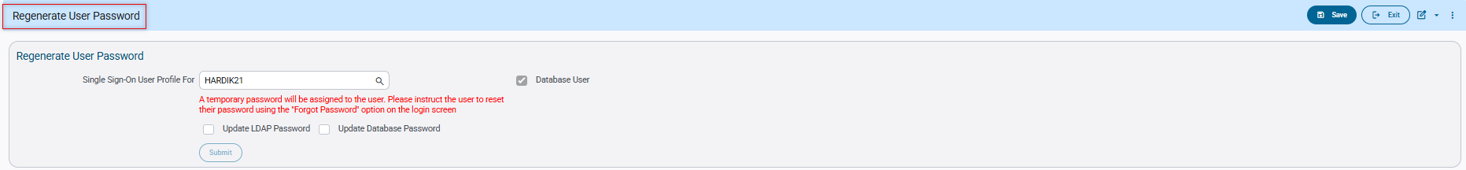

The Submit button is disabled by default and becomes enabled only when at least one checkbox is selected.
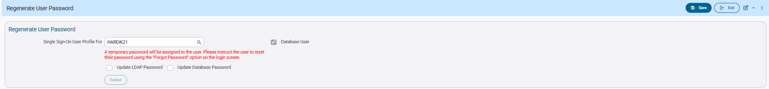
Regardless of whether a user is a database user, administrators can check the Update LDAP Password checkbox. Upon clicking Submit, only LDAP users will be assigned a temporary password.
Only Checked the Update LDAP Password flag
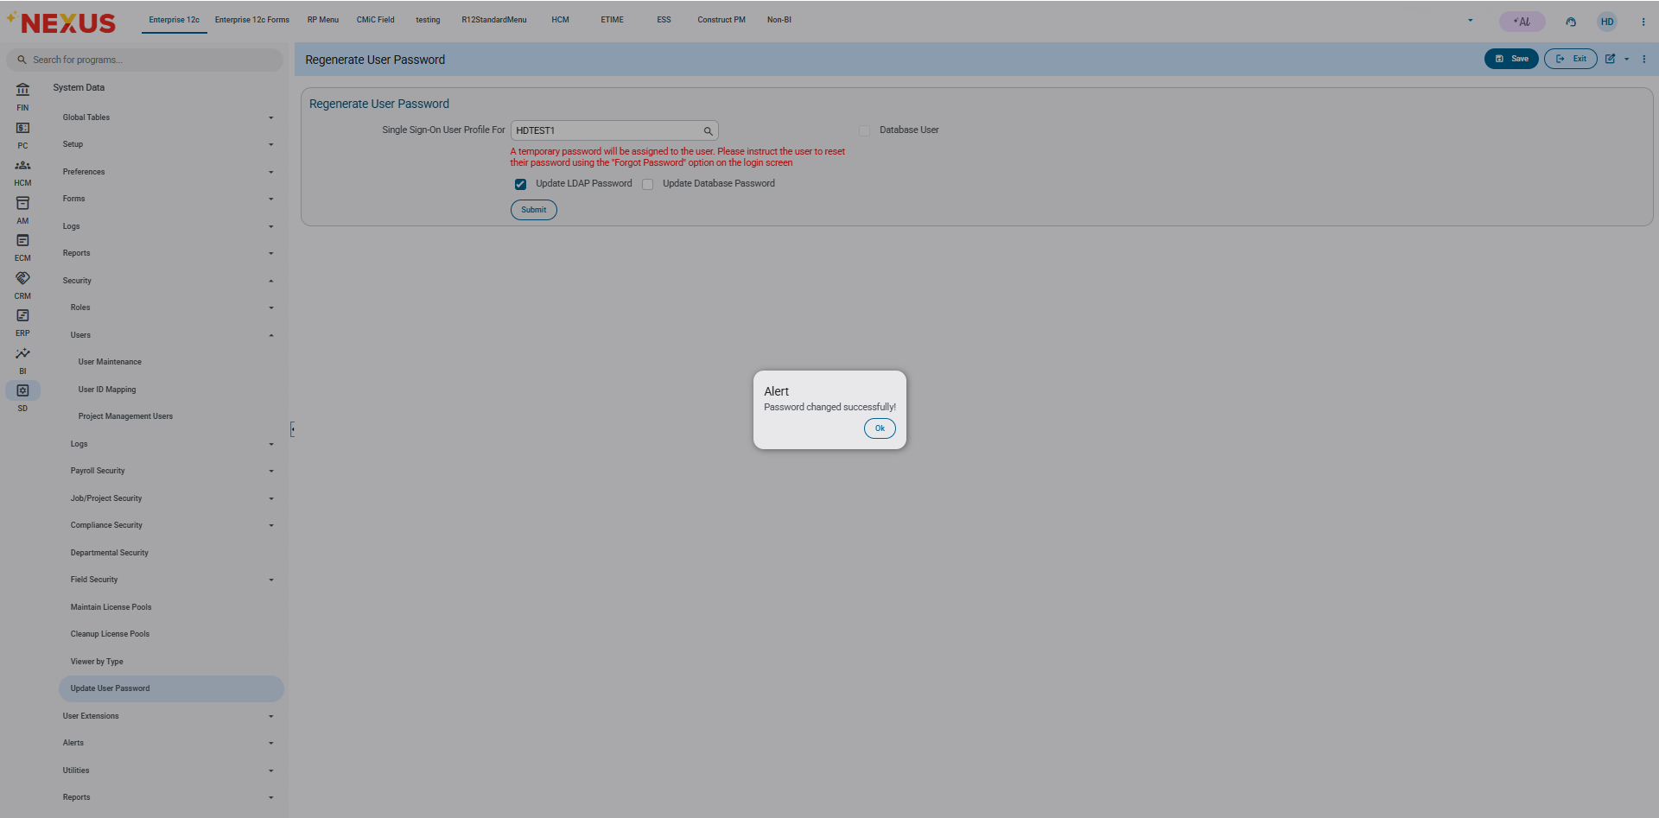
Reset the password

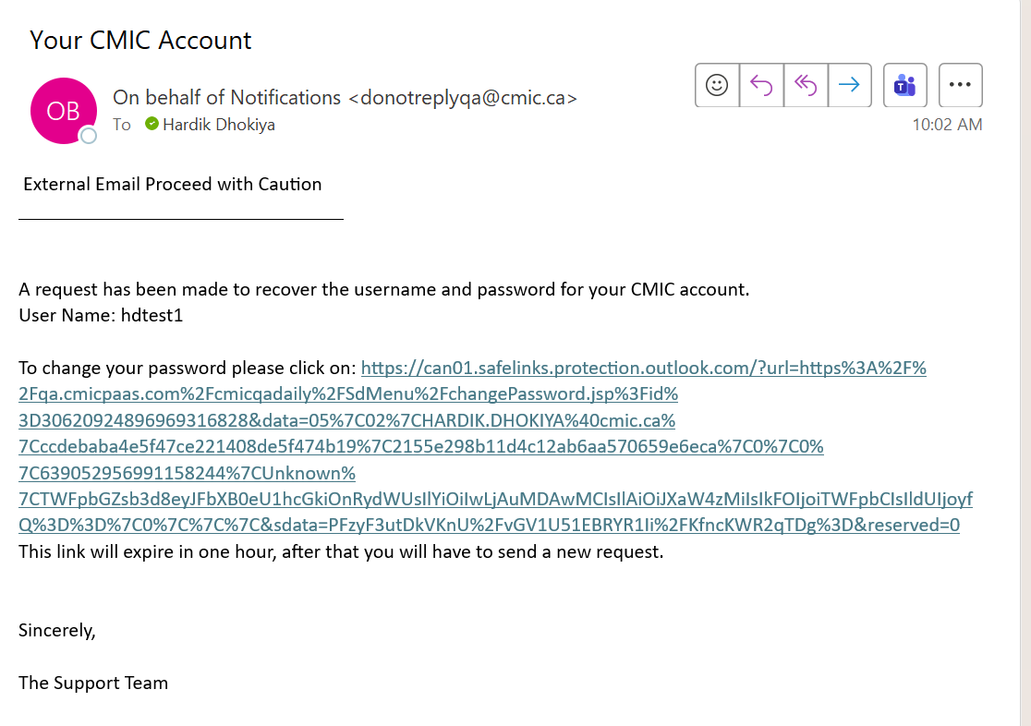

Logged in with updated password

CMiC Field application modifications:
New password and Re-Type password fields (4 fields) are now removed in CMiC Field > User maintenance program in ‘LDAP User’ and ‘Enterprise User’ sections. New users created in CMiC Field, will be required to reset/set their password through ‘forgot your password’ procedure on the login page.
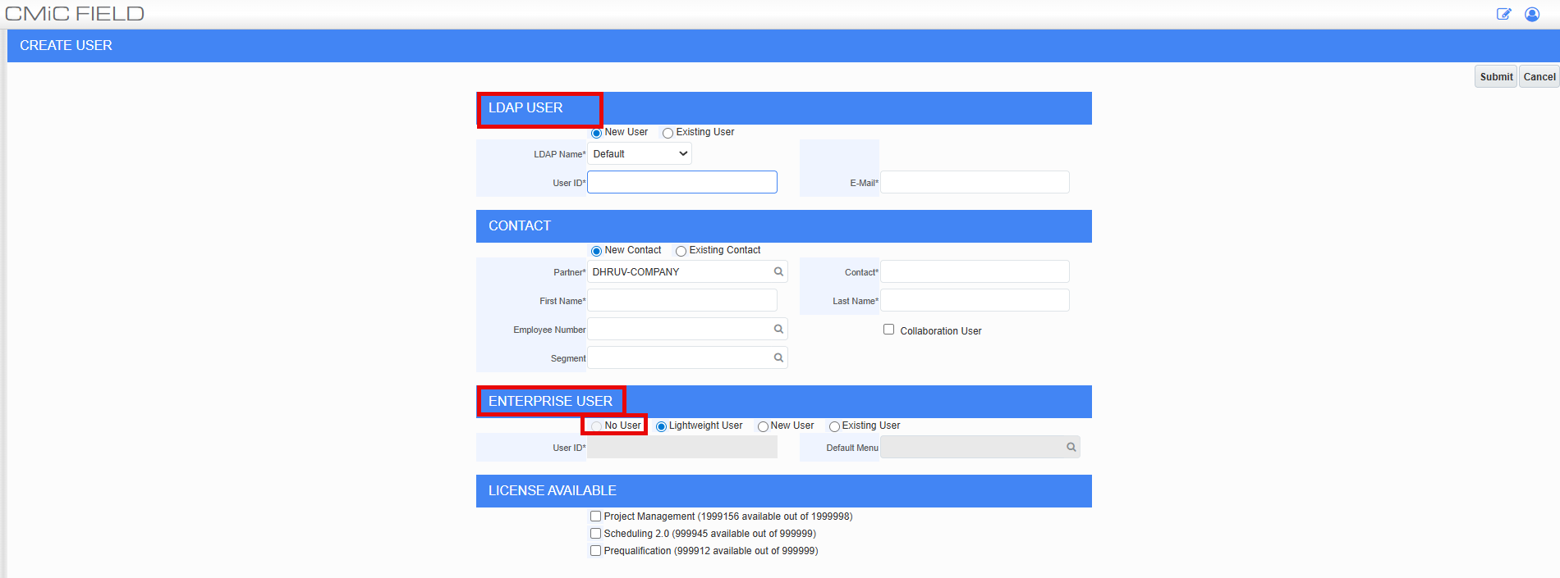

[Create Database User] button changes:
The ‘New password’ and ‘Re-type password’ fields will be removed from the [Create Database User] button pop-up.
When updating an existing non-database user to a database user, the admin can select the ‘Database User’ flag and click the [Create Database User] button. Confirmation pop-up will appear to confirm selected action.
The pop-up will display: ‘Please confirm if you would like to create database user USER ID’, the admin can click on [Process] to create a database user or click on [Cancel] to abort.
Once a database user is created, a temporary password is automatically set for database, but neither the user or admin can see or use it. The new database user cannot login right away. They must contact the DBAs (Database Administrators) to request a secure password reset and to obtain their new password.
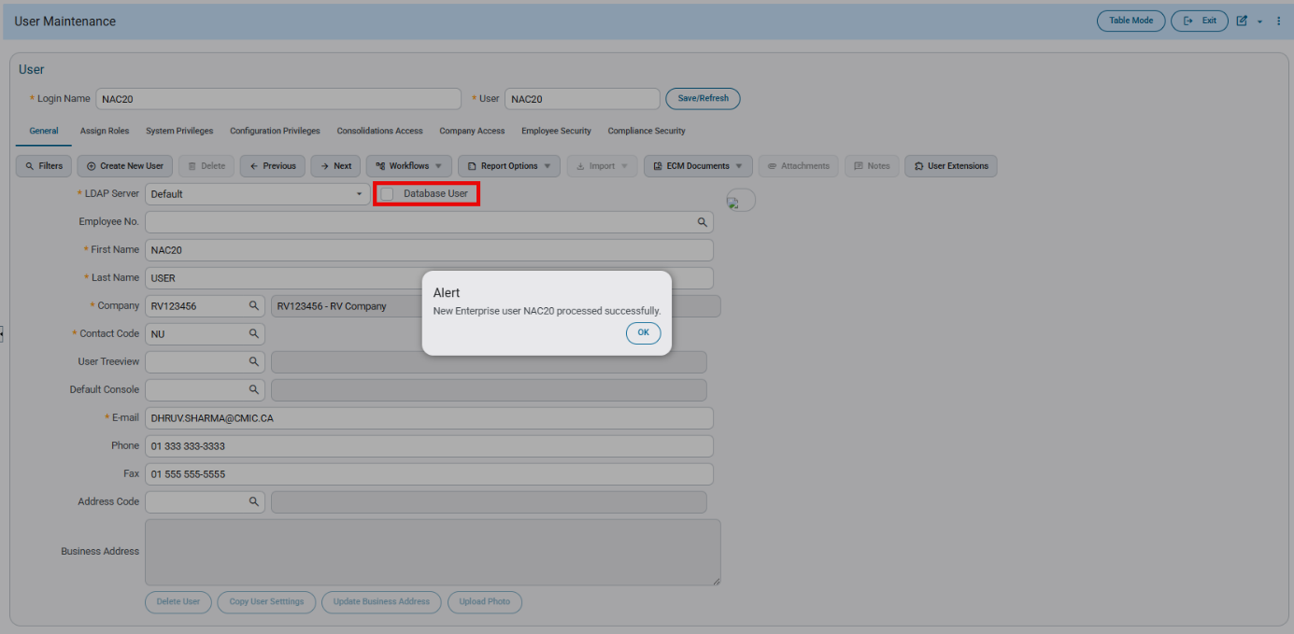
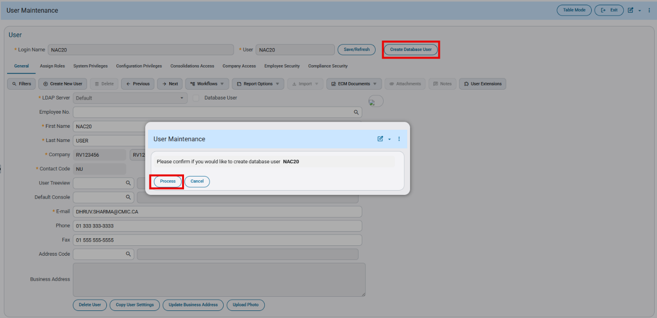

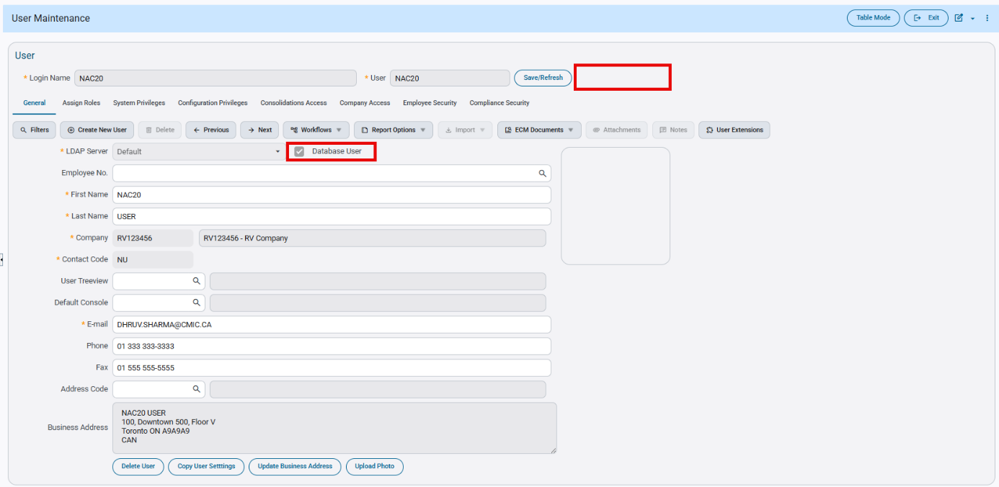
ESS User: Password Reset Required After User Creation
Overview
This document outlines the process and system behavior when a newly created ESS user must reset their password, even though a password was provided during user creation.
In certain cases, after completing the ESS registration process and successfully creating the user account, the system returns “Authentication Failed” or “Invalid Credentials” during login.
To ensure proper authentication and access synchronization, the user must complete a Password Reset before successfully logging in. This is due to the security enhancements implemented under CAM-9505.
This will be enhanced in Nexus 2.0.
Pre-requisites
An employee must exist in Employee Profile.
Pgm: PYEMPLOY – Employee Profile; Treeview path: US Payroll > Setup > Employees > Employee Profile
- ESS Access must be enabled in Employee Maintenance.
- Valid email address must be configured against the employee profile.
- Required ESS security roles must be assigned.
Modifications
The current behavior is that after successful ESS user registration and password creation, the user needs to perform “Have trouble signing in” process flow, so that a password reset action is performed prior to first login authentication and the user can login successfully.
User Registration Flow
- ESS Access
Update “ESS Access” of the employee through HCM.
HCM-Employee Maintenance.

- Registration Email
Employee receives registration email and click the Register link.
Register User
- Create a new user.
- Click “Don’t have an account? Sign up” link.
- User enters User ID and Password.
- Account creation completes successfully.
Login Screen
Create User
- Login Attempt
- • User enters credentials.
- • System returns 'Authentication Failed' or 'Invalid Credentials'.
Login Screen
- Reset Password
- Click on “Having Trouble Signing in”
- Click on the email received for resetting the password
- Provide new credentials
- User can log in with the new reset password.
Forgot Password Screen

ResetPassword Screen

Login Successful

User Preferences – Mass Update feature (CAM-10730)
Overview
The User Preferences program has been enhanced to support a Mass Update User Preferences feature. This allows authorized users to update selected preference fields for all users’ system-wide in a single action.
The previously existing Reset All Users’ Time Zones button has been removed and replaced with the new Mass Update User Preferences button.
Pre-requisites
To access and use the Mass Update User Preferences feature, the user must have the following privilege:
- SYSUSRCRE – Allows the user to change preferences of other users.
If the user does not have this privilege, the Mass Update User Preferences button will be hidden.
Modifications
Changes Introduced
- Removed: Reset All Users’ Time Zones button.
- Added: Mass Update User Preferences button.

New Pop-Up Screen
When the button is clicked, a pop-up window appears listing all available preference fields that can be updated for all users.
- The Process button remains disabled until at least one preference is selected.
- After selecting one or more preferences, the Process button is enabled.
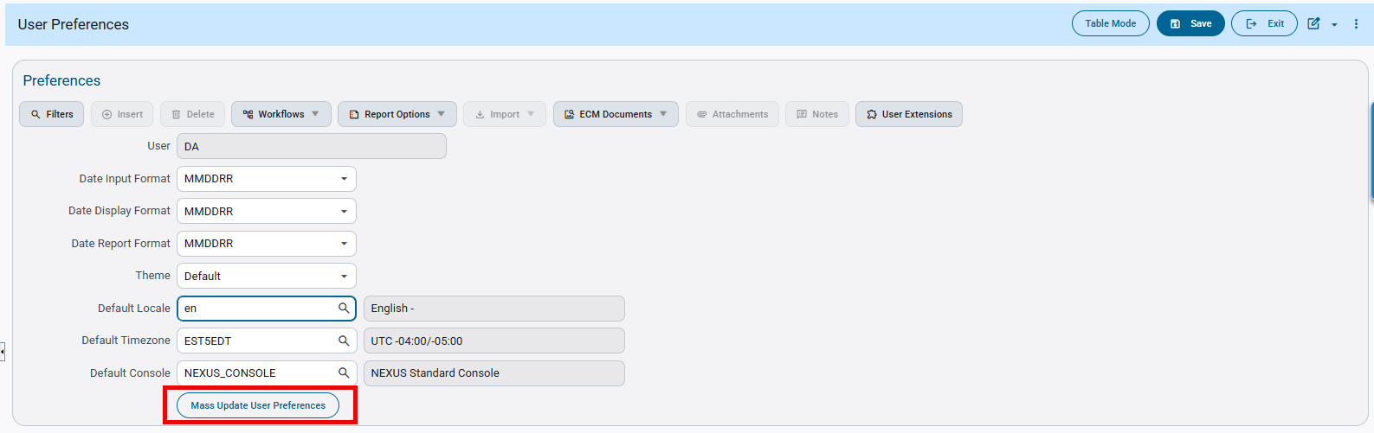
System Data > Preferences > User Preferences > [Mass Update Preferences]

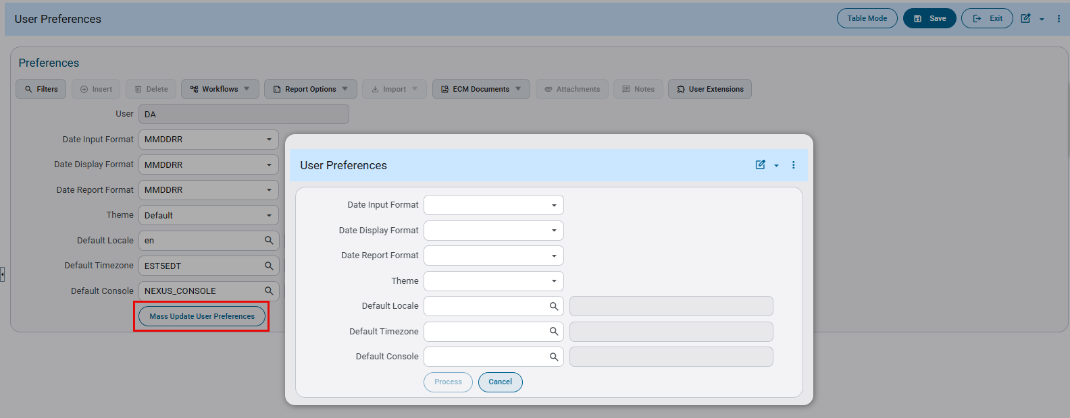
System Data > Preferences > User Preferences > [Mass Update Preferences] button pop-up

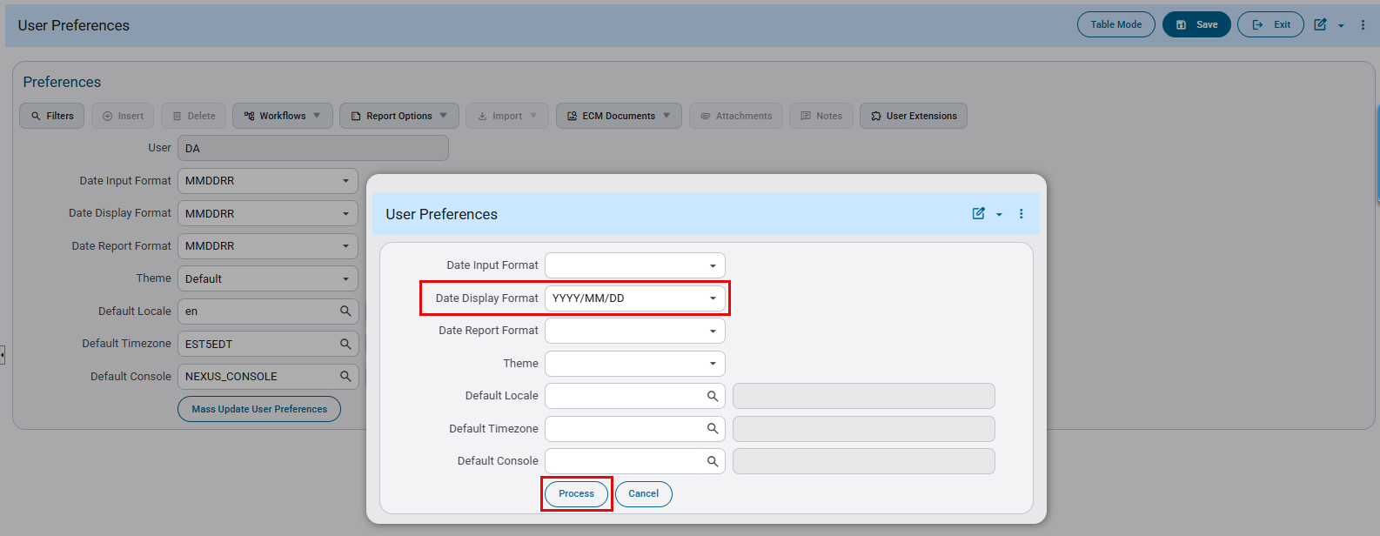
System Data > Preferences > User Preferences > [Mass Update Preferences] button pop-up

Confirmation Workflow
- After clicking Process, an alert message appears:
“This action will update the selected preferences for all users. Do you want to continue?”
- User Options:
  - Continue → The system propagates the updated preferences to all users.
  - Cancel → The mass update action is aborted.
- Upon successful update, a confirmation message is displayed:
“User preferences updated successfully.”
- Click OK to close the confirmation pop-up.

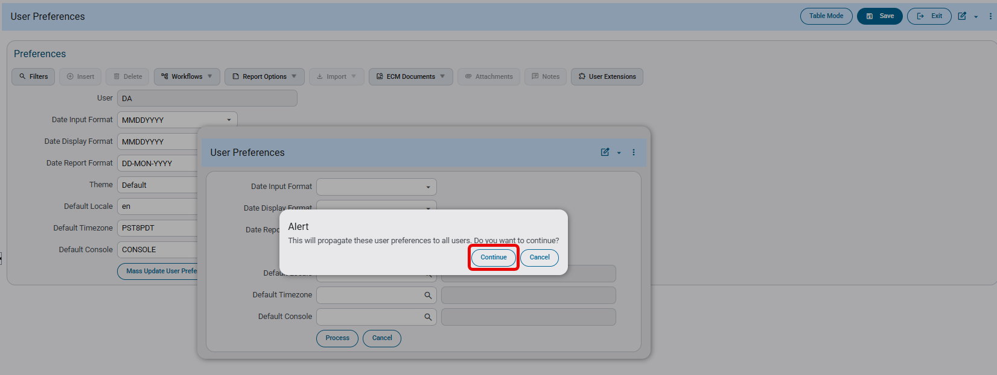
System Data > Preferences > User Preferences > [Mass Update Preferences] – Alert pop-up
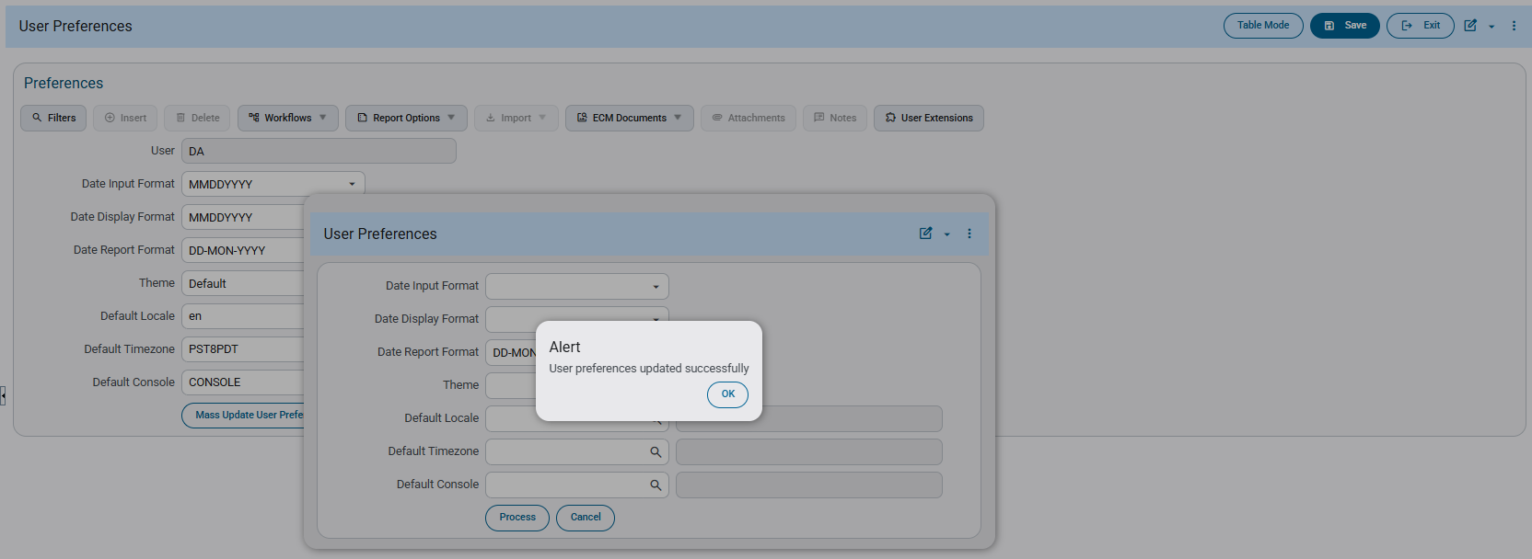System Data > Preferences > User Preferences > [Mass Update Preferences] – Confirmation pop-up

Implementation

- Updating Date Report Format for all users: Select date report format preference for all users from available formats. Click on [Process] button and click on [Continue] to propogate selected date report format for all users.
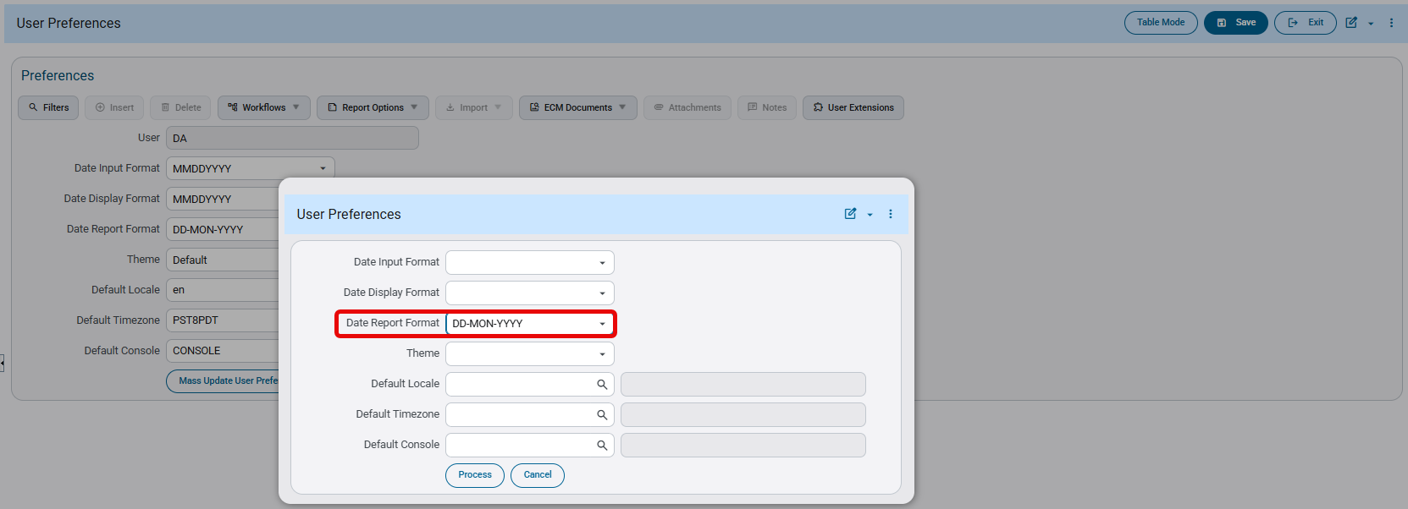

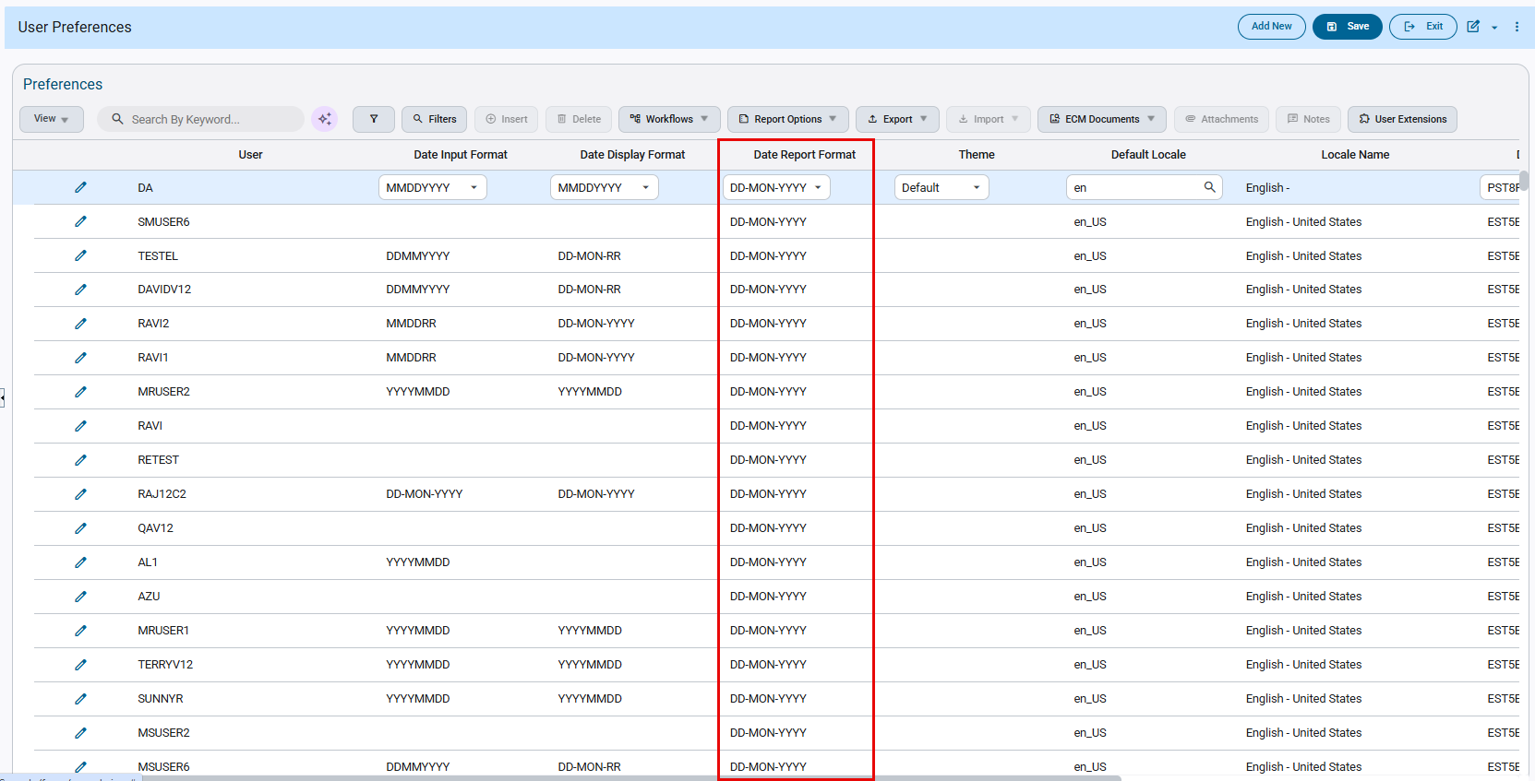
- Updating ‘Theme’ for all users: Select theme preference for all users from available formats. Click on [Process] button and click on [Continue] to propogate selected theme for all users.
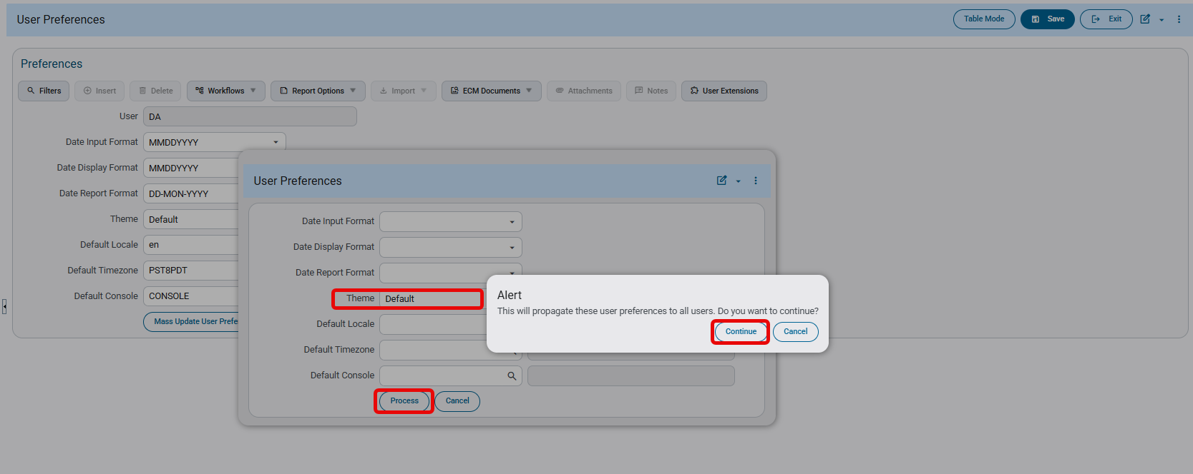
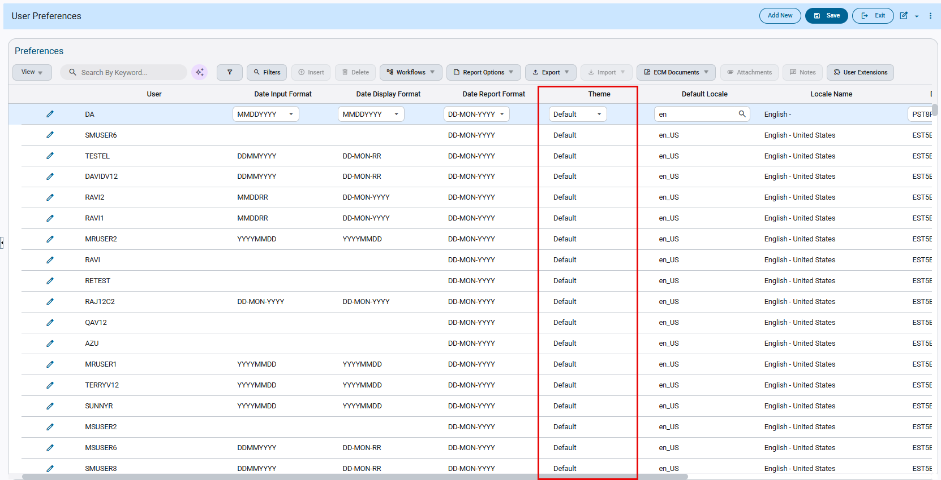
- Updating ‘Date Input Format’ for all users: Select date input format preference for all users from available formats. Click on [Process] button and click on [Continue] to propogate selected date input format for all users.

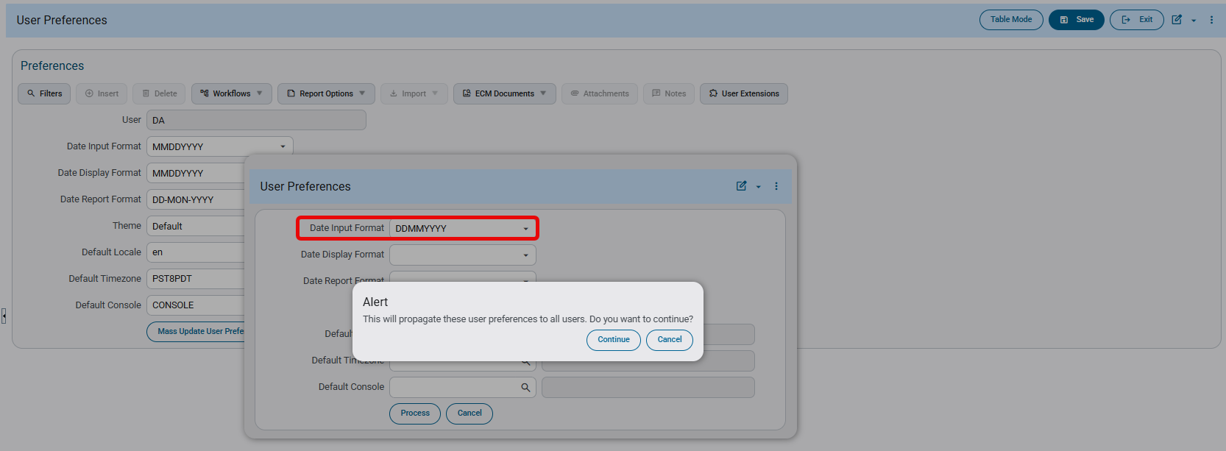
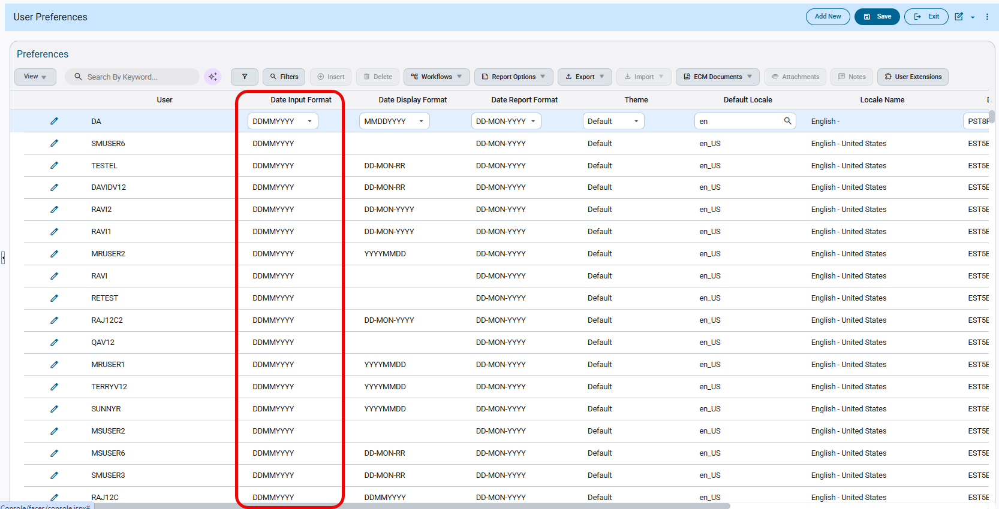
- Updating Date Display format for all users: Select date display format preference for all users from available formats. Click on [Process] button and click on [Continue] to propogate selected date report format for all users.

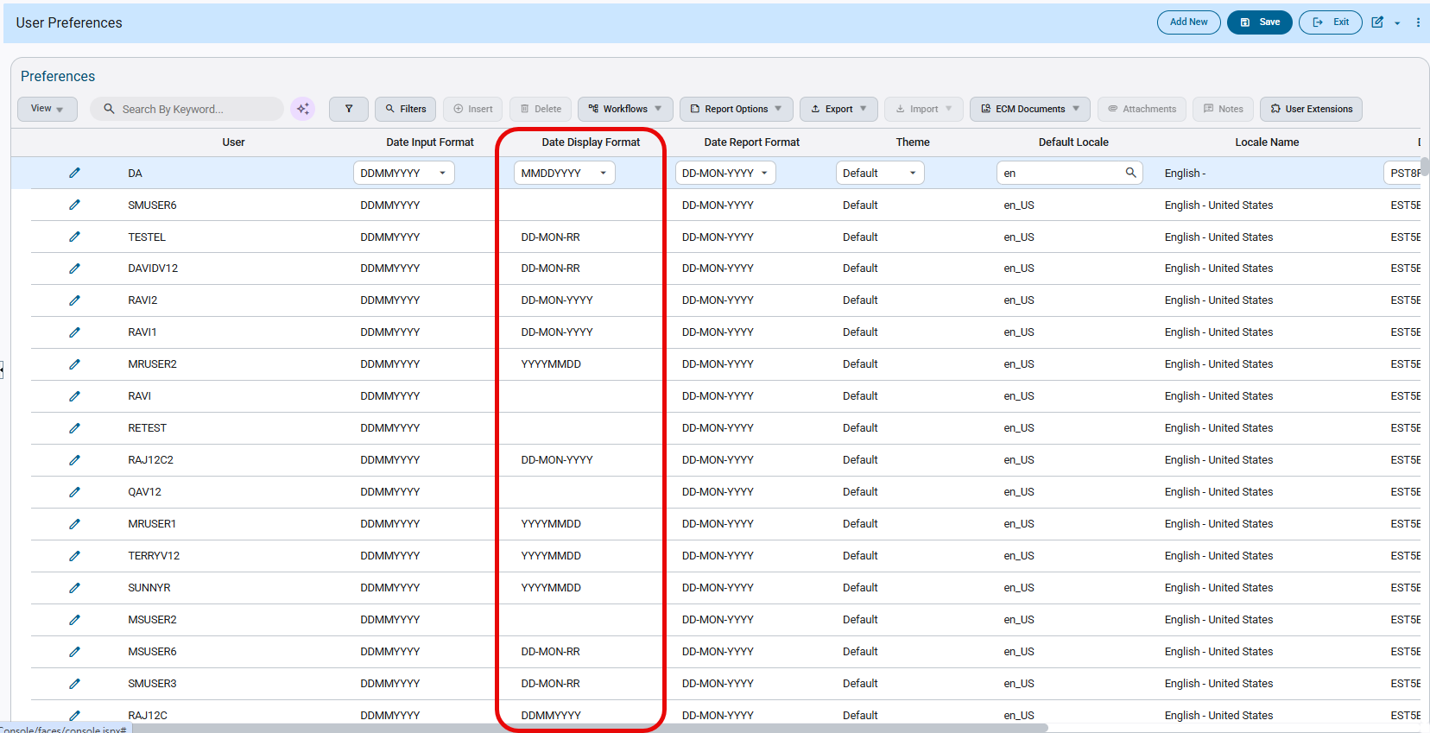
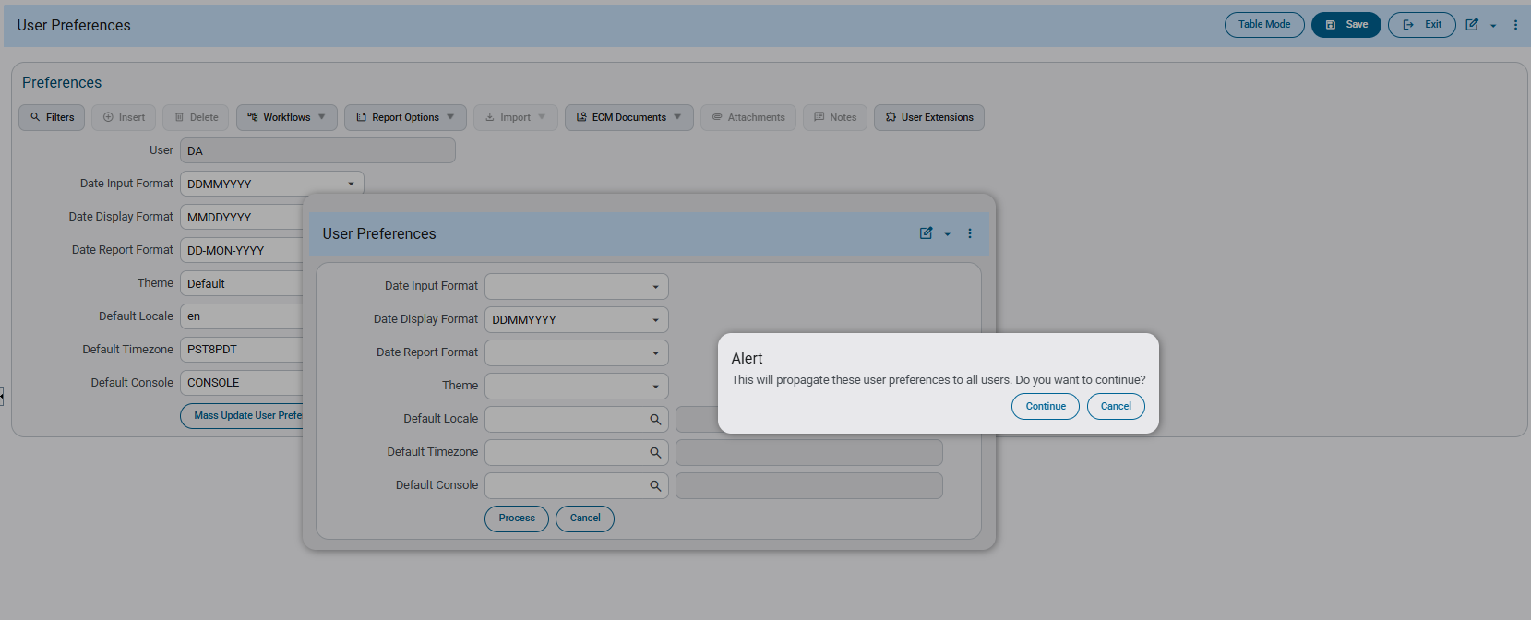
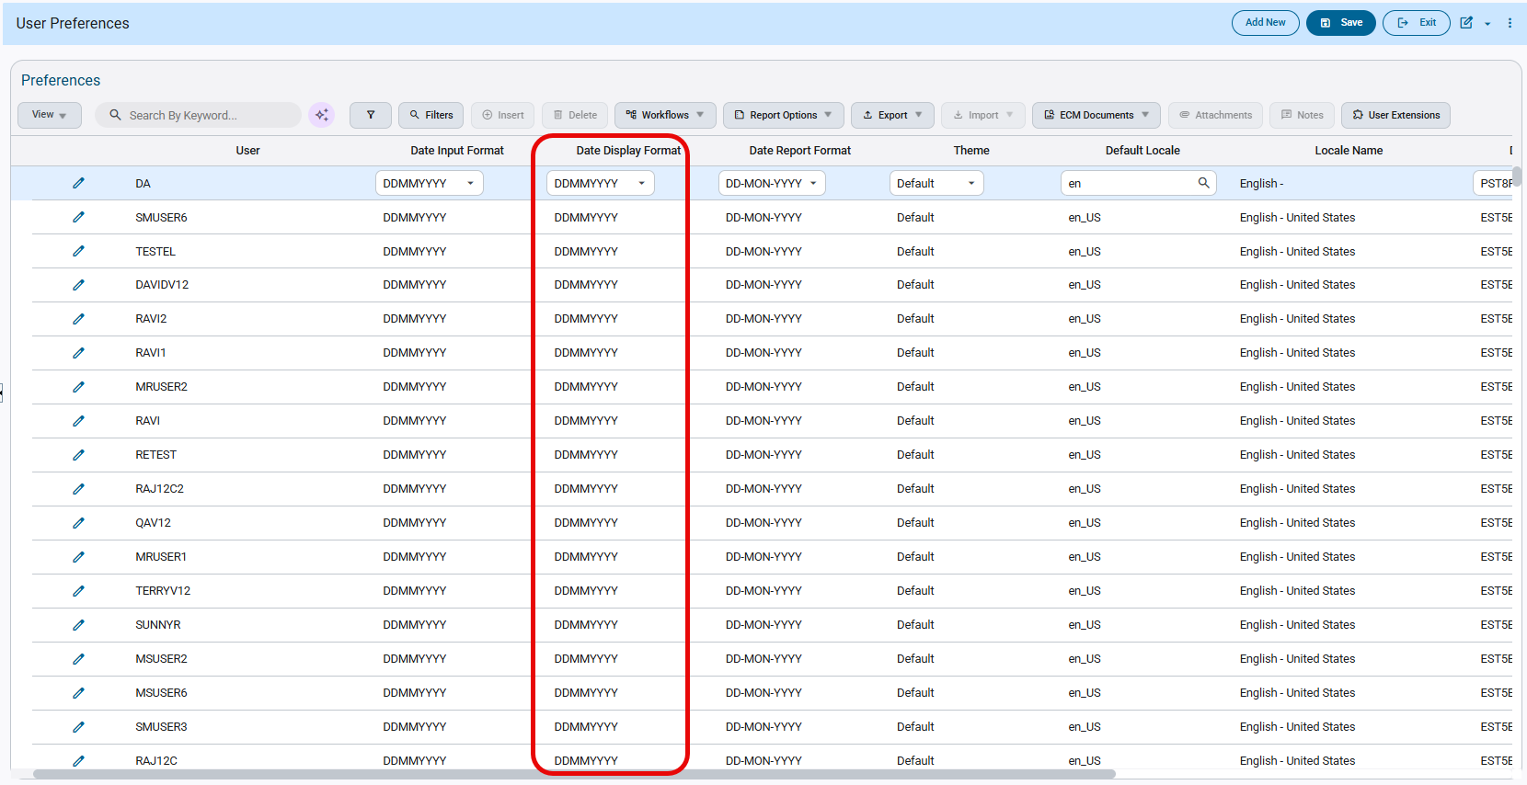
- Updating more than one user preferences at the same time i.e., Default locale, Default console and Default time zone: Select three prefreneces together for all users from available formats. Click on [Process] button and click on [Continue] to propogate selected preferences for all users.
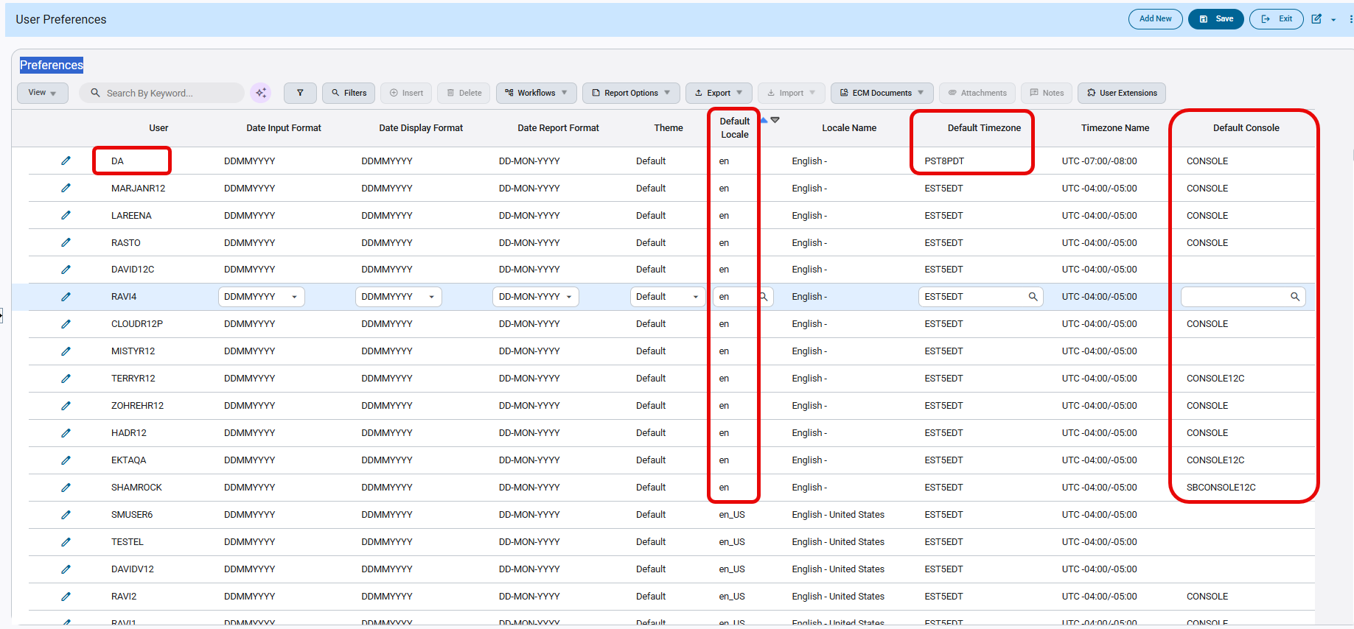
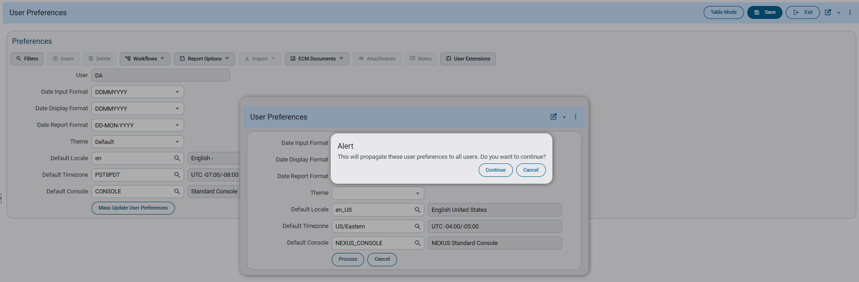
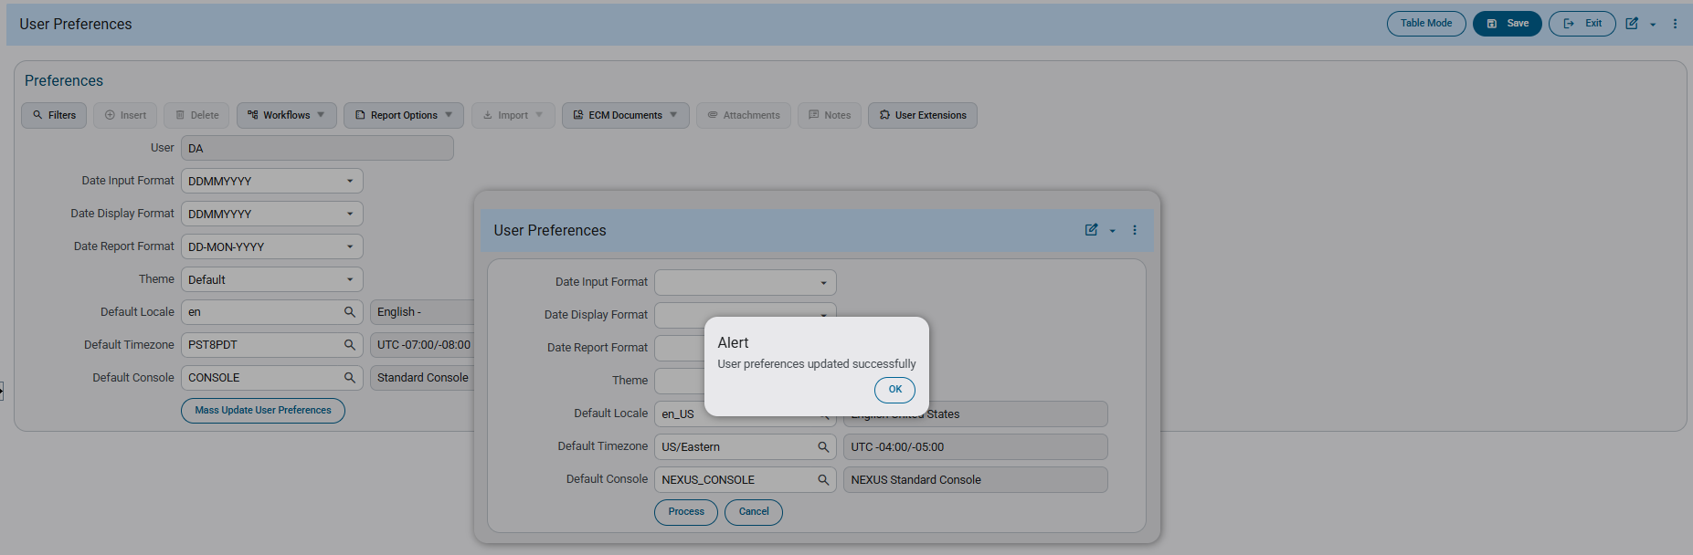
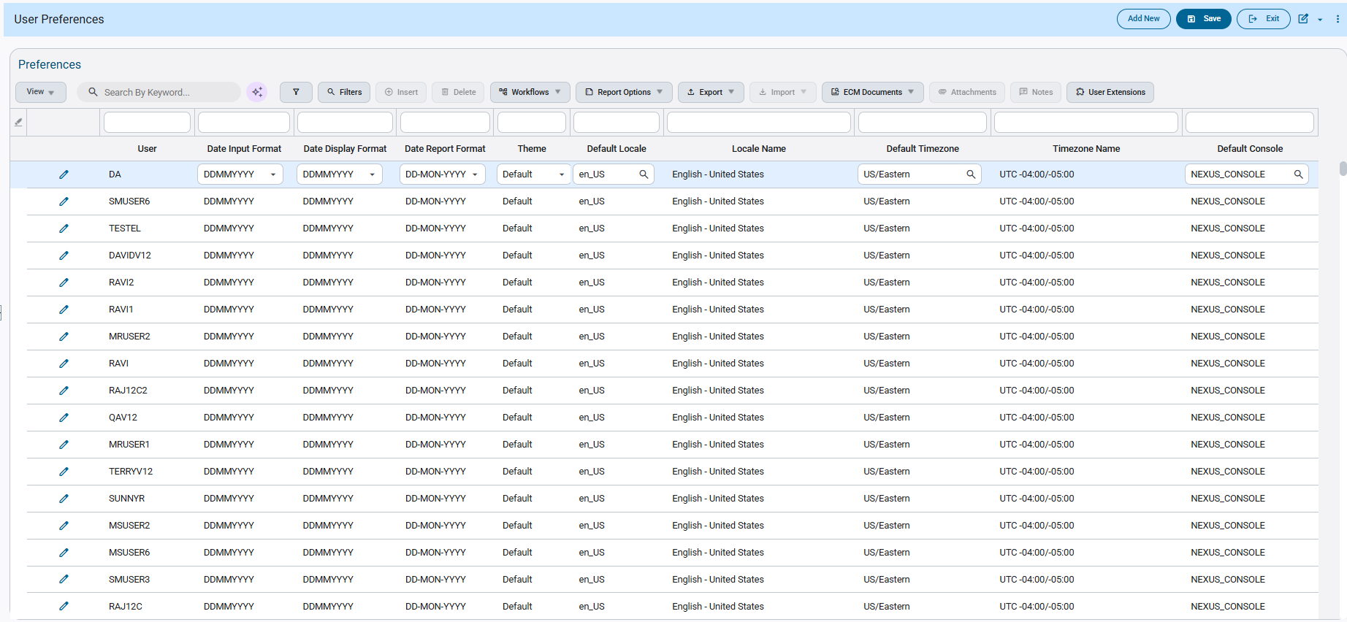

New API Endpoint for User Assignment to Job Security Group (JBJCPC-2959)
Overview:
Currently, to assign an active user to a particular job/project security group, they must be manually added in the Users By Job Security Group program under System Data.
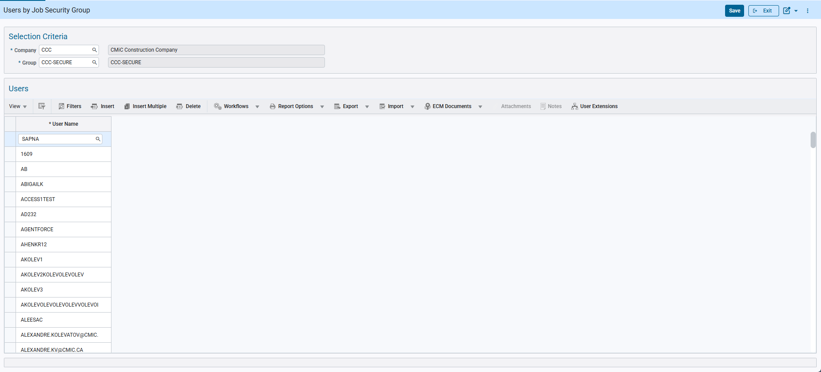
System Data > Security > Job/Project Security > Assign Users to Security Groups
Now for added flexibility and convenience, a new API endpoint that automates the assignment of system users to job security groups has been implemented. The goal is to ensure consistency of Job Security group assignment, improving efficiency and reducing manual administrative intervention.

Setup:
The new API endpoint is titled: jcjobsecgrpuser and it can be made accessible for a specific API user role via the Assign API to Role program under System Data.
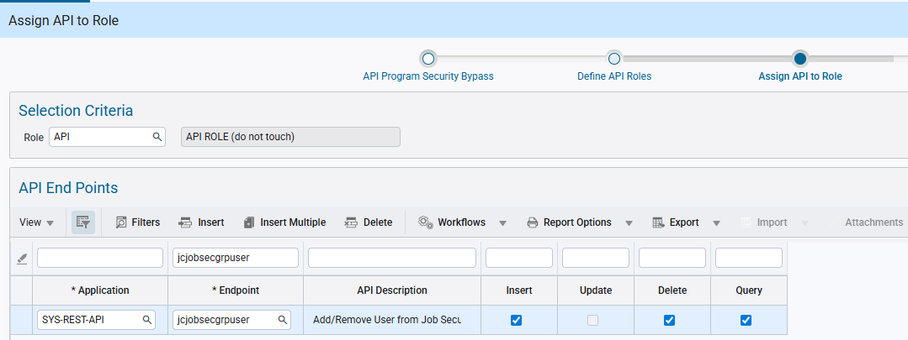
System Data > API Management > Setup > API Security
By default, the API endpoint supports the Querying, Insertion and Deletion of users in a job/project security group via the GET, POST and DELETE API requests respectively.
NOTE: The endpoint doesn’t support PATCH request and hence cannot make updates to existing Users assigned to the Job/Project Security Group.
This endpoint enables the assignment of users to job/project security groups, thereby granting them access to associated jobs and projects. Users can belong to multiple security groups simultaneously.

Implementation:
GET Request:
This method is primarily used to retrieve the list of active users currently assigned to a job/project security group.
It supports the following finders for data filtering and optimizing request performance:
- findByUser – Querying by a specific User ID
  - Retrieves the entire list of job/project security groups across all companies to which the user is assigned.
- findByCompCode – Querying by a specific Company Code
  - Retrieves the entire list of job/project security groups under the specific company with all the users assigned to them.
- findByGroupCode – Querying by a specific Job/Project Security Group
  - Retrieves the entire list of users assigned to the security group across all the companies.
NOTE: A specific user assigned to a specific job/project security group under a company can be uniquely retrieved using the VUUID which acts a primary key for querying.
Upon a successful request, the system will provide a 200 – OK response displaying the following attributes for the queried data.
- JsguUser – User ID
- JsguCompCode – Company Code
- JsguGrpCode – Security Group
- JsguGrpName – Security Group Name
- JsguVUuid – vuuid (Unique system generated ID)
A sample of a successful GET request with response displaying attributes,
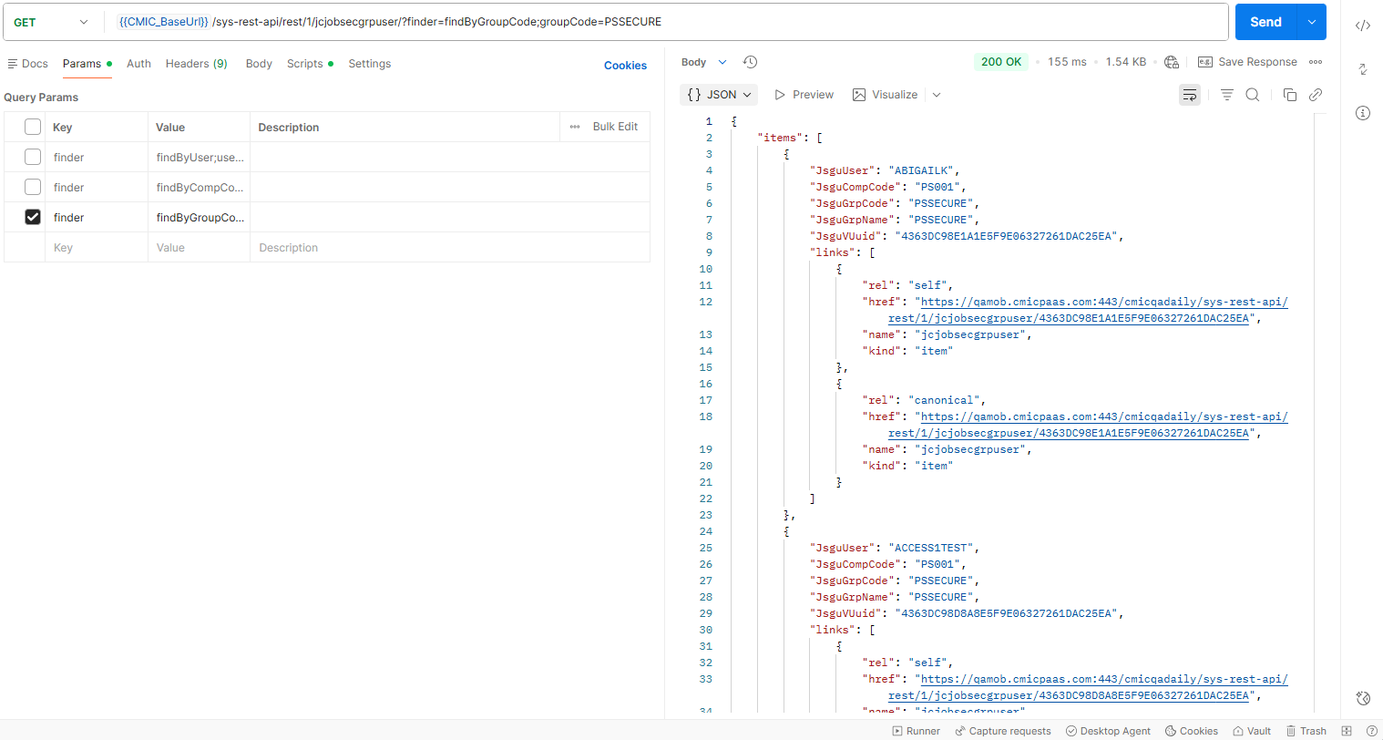

In case of querying with an invalid data or to access a security group/company to which the API user doesn’t have access, then still a 200 – OK response is received but without displaying any attributes.
A sample of a GET request with response not displaying any attributes,
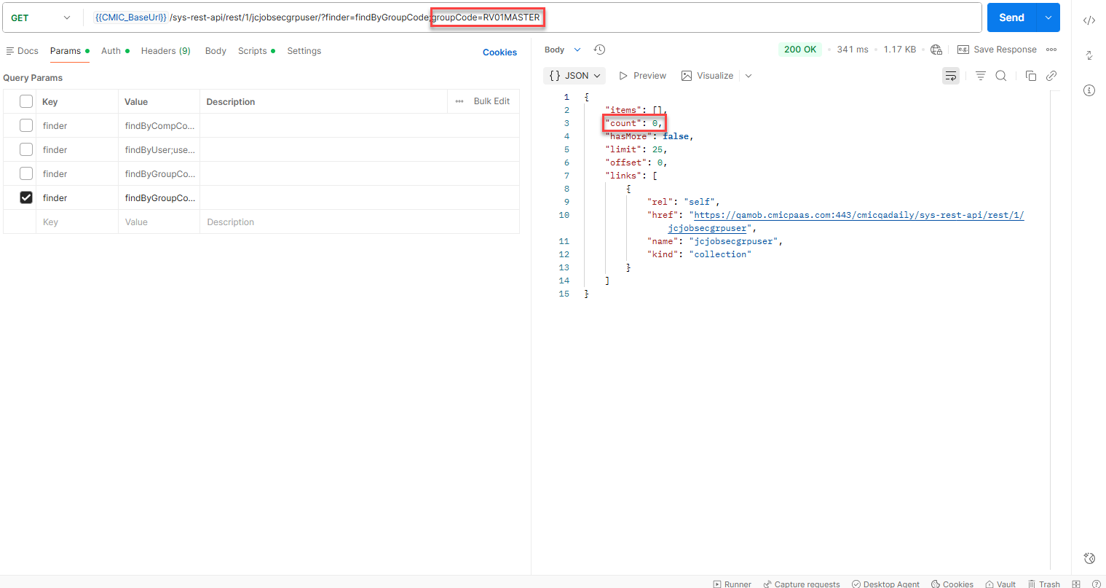
NOTE: For more information, refer the API documentation: https://developers.cmicglobal.com/apidocs/retrieve-users-assigned-to-job-security-groups

POST Request:
This method is primarily used to assign an active user to a specific job/project security group under a company.
- When this user is assigned a job security group, they will gain access to all jobs and projects with that security group assigned.
- When this user creates a job or project, the job or project will automatically get assigned the same security groups that the user is associated with.
The following is a sample of API payload in JSON consisting of all 5 parameters supported:
{
"JsguUser": "CLOUDR12P",
"JsguCompCode": "PS001",
"JsguGrpCode": "PSSECTEST2",
"JsguGrpName": " PSSECTEST2",
"JsguVUuid": ""
}
Out of these parameters the following are mandatory and sending a request with any of them missing will result in a 400 – Bad Request:
- JsguUser – User ID
- JsguCompCode – Company Code
- JsguGrpCode – Security Group
NOTE: Sending invalid data or group/company to which the API user doesn’t have access will also result in a 400 response. Same is displayed when attempting to add a duplicate user under a security group.
Upon successful addition of the user to the security group, a 201 – Created response is received with the unique system generated vuuid.
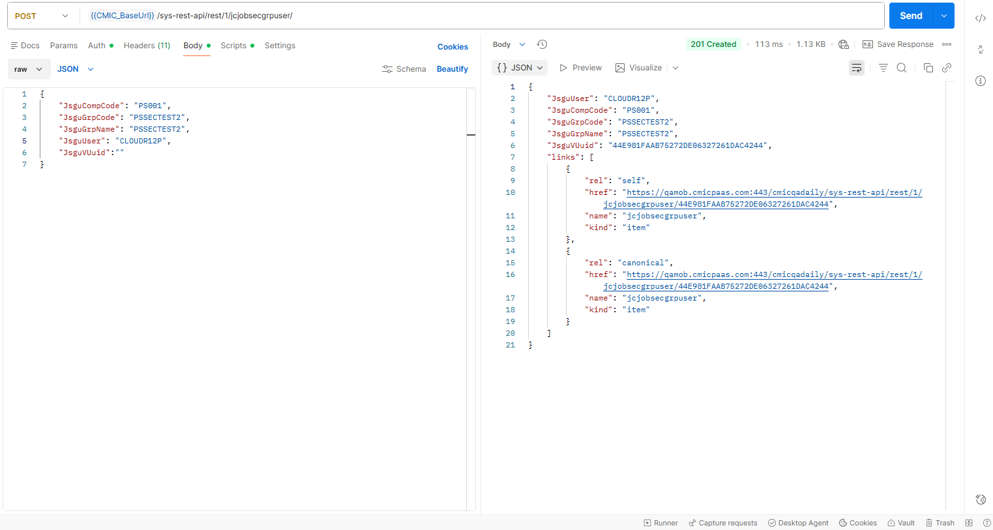
The newly added user is also visible in the Users By Job Security Group program for the specific company and security group.
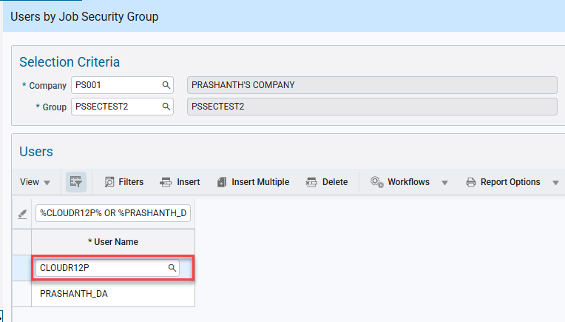
System Data > Security > Job/Project Security > Assign Users to Security Groups
NOTE: For more information, refer the API documentation: https://developers.cmicglobal.com/apidocs/assign-user-to-job-security-group

DELETE Request:
This method is primarily used to delete an existing active user assigned to a specific job/project security group under a company.
The request is sent with a valid VUUID, which happens to uniquely identify an user assigned to a specific job/project security group under a company.
Upon successful deletion, a 204 – No Content response is received.
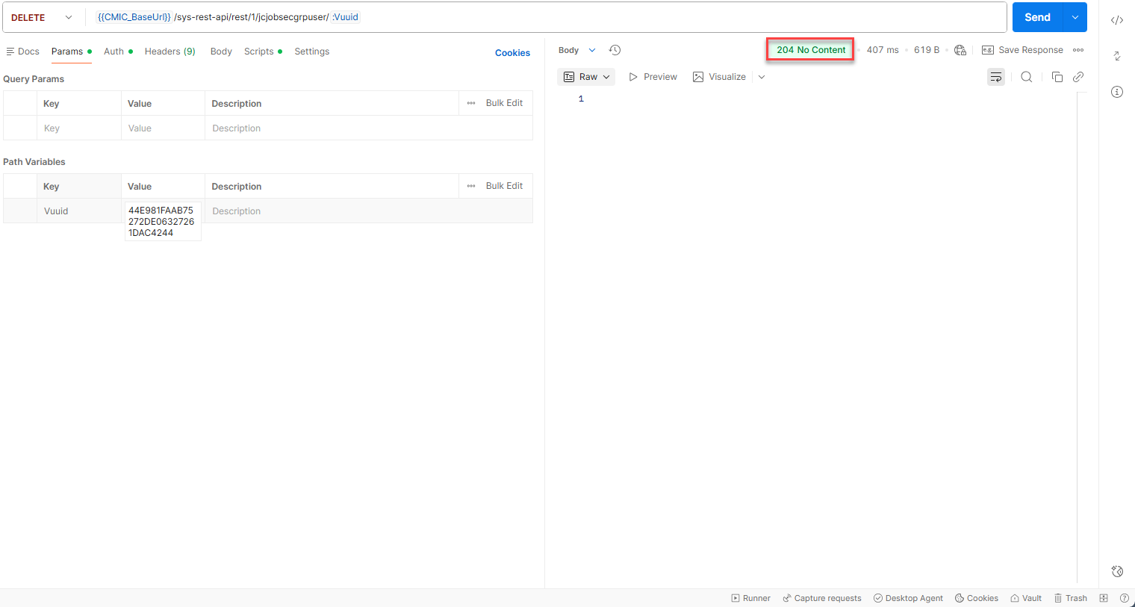
The user corresponding to the ID is also removed from the specific job/project security group in the Users By Job Security Group program.
Querying in the UI shows that the user CLOUDR12P is no longer assigned to the security group PSSECTEST2 under the company PS001.
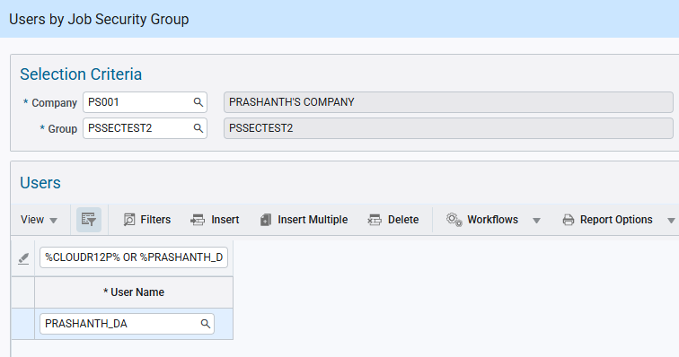
System Data > Security > Job/Project Security > Assign Users to Security Groups
NOTE: For more information, refer the API documentation: https://developers.cmicglobal.com/apidocs/remove-user-from-security-group

New API Endpoint for creation of Job/Project Security Groups (JBJCPC-3765)
Overview:
Currently, to create a new job/project security group, they must be manually added in the Job/Project Security Groups program under System Data.
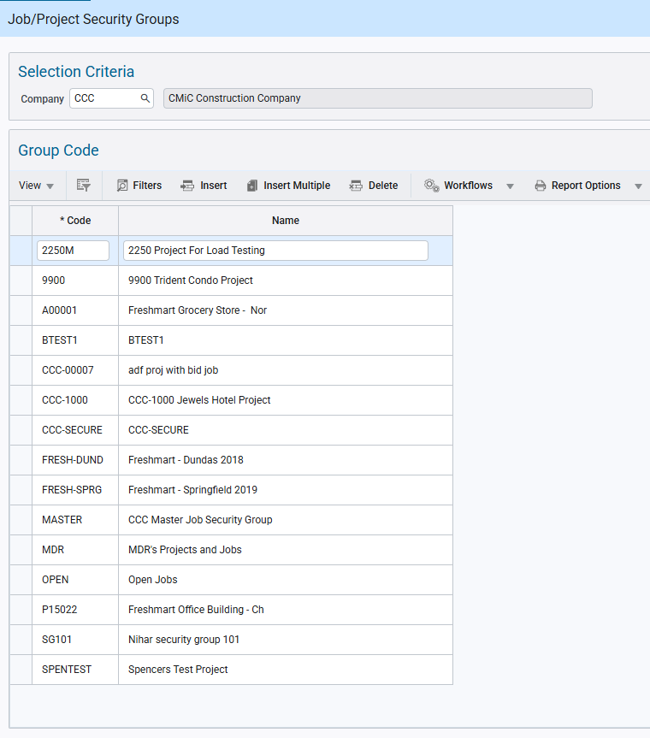
System Data > Security > Job/Project Security > Create Security Groups
Now for added flexibility and convenience, a new API endpoint that automates the creation of Job/Project Security groups has been implemented. The goal is to ensure consistency of Job-to-Job Security group assignment, improving efficiency and reducing manual administrative intervention.
The scope encompasses the “Job/Project Security Groups” program in CMiC and is focused on delivering endpoint functionality that supports the creation, updating, deletion, and retrieval of security groups. These groups are applicable to jobs or projects, and the endpoint functionality will be designed to align closely with the existing UI capabilities.

Setup:
The new API endpoint is titled: jcjobsecgrp and it can be made accessible for a specific API user role via the Assign API to Role program under System Data.
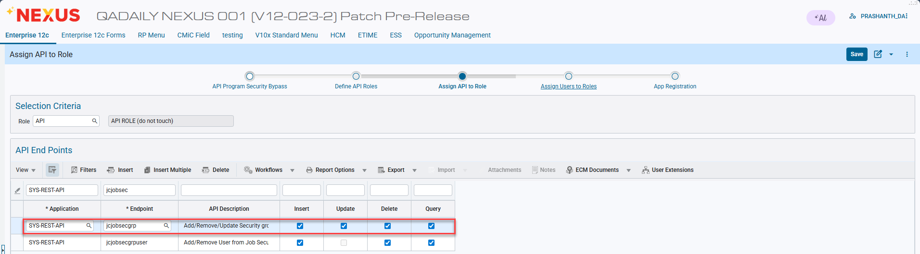
System Data > API Management > Setup > API Security
By default, the API endpoint supports the Querying, Insertion, Updating and Deletion of job/project security groups via the GET, POST, PATCH and DELETE API requests respectively.

Implementation:
GET Request:
This method is primarily used to retrieve the list of job/project security groups currently under a company.
It supports the following finders for data filtering and optimizing request performance:
- findByCompCode – Querying by a specific Company Code
  - Retrieves the entire list of job/project security groups under the specific company.
- findByGroupCode – Querying by a specific Job/Project Security Group
  - Retrieves the entire list of companies which contain the specific security group.
NOTE: A specific job/project security group under a company can be uniquely retrieved using the VUUID which acts a primary key for querying.
Upon a successful request, the system will provide a 200 – OK response displaying the following attributes for the queried data.
- JsgRowid – Row ID (System generated)
- JsgCompCode – Company Code
- JsgCode – Security Group
- JsgName – Security Group Name
- DiscriminatorCode
- JsgVUuid – vuuid (Unique system generated ID)
A sample of a successful GET request with response displaying attributes,
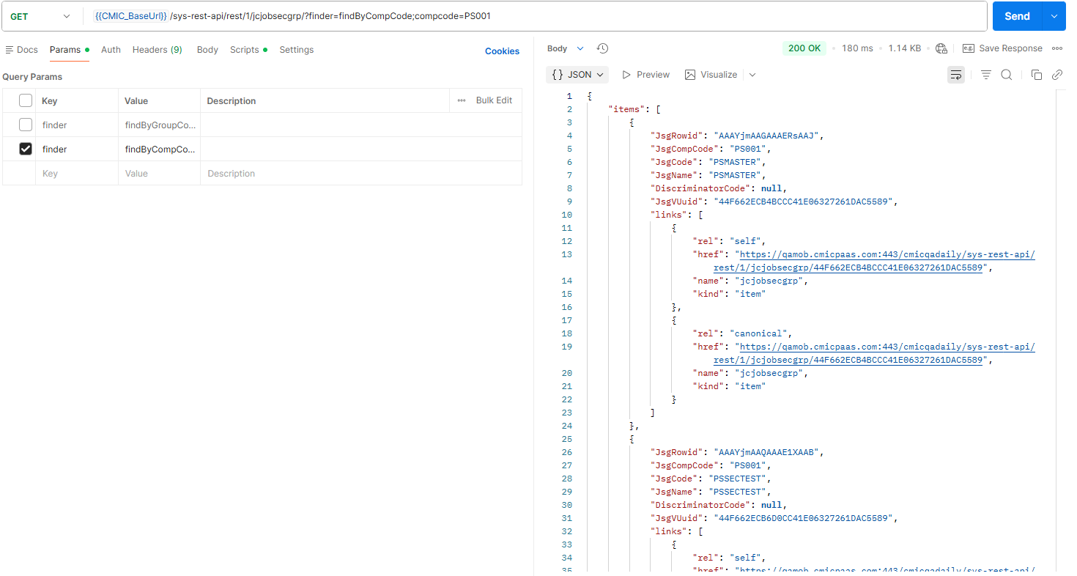

In case of querying with an invalid data or to access a security group to which the user doesn’t have access, then still a 200 – OK response is received but without displaying any attributes.
A sample of a GET request with response not displaying any attributes,
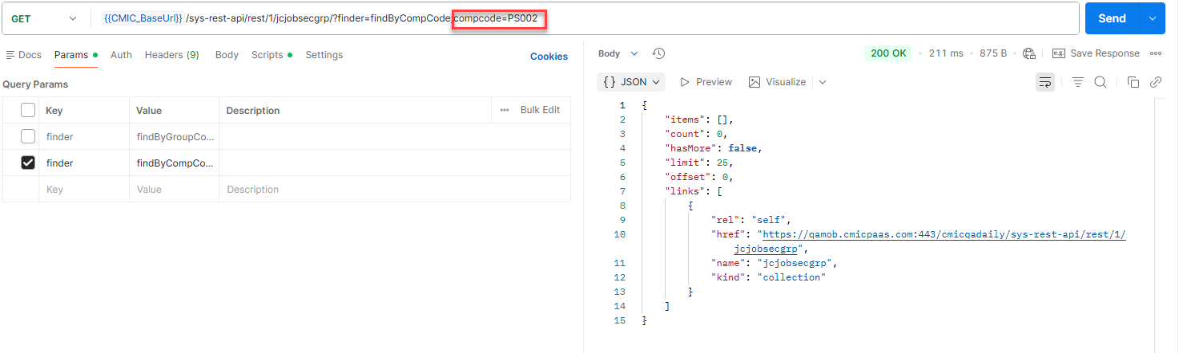
NOTE: For more information, refer the API documentation: https://developers.cmicglobal.com/apidocs/retrieve-security-groups-by-vuuid

POST Request:
This method is primarily used to create a new job/project security group for a company.
- Security group codes and names will be created and associated with the appropriate company code.
- Each group is uniquely identified within its company context.
The following is a sample of API payload in JSON consisting of all the supported parameters:
{
"JsgCompCode": "ZZ",
"JsgCode": "UIC3",
"JsgName": "Adding a record - API",
"JsgVUuid": "",
}
Out of these parameters the following are mandatory and sending a request with any of them missing will result in a 400 – Bad Request:
- JsgCompCode – Company Code
- JsgCode – Security Group
NOTE: Sending invalid data or group/company to which the API user doesn’t have access will also result in a 400 response. Same is received when attempting to create a duplicate group under the same company, but creating under a different company is allowed.
Upon successful addition of the user to the security group, a 201 – Created response is received with the unique system generated vuuid.
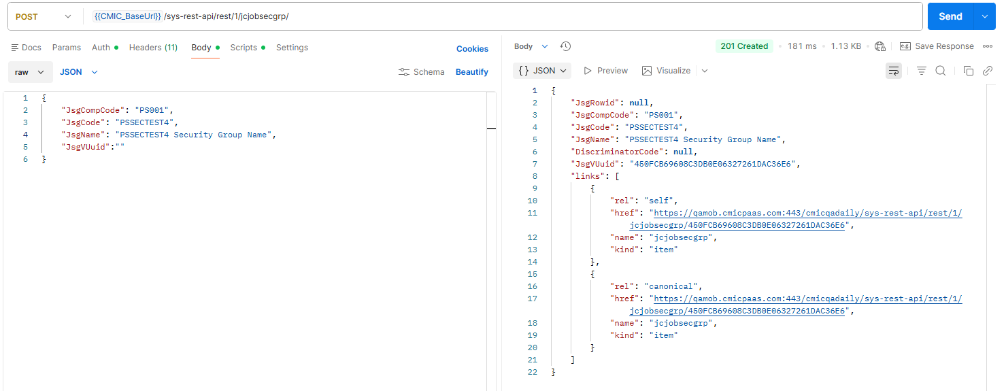
The newly created security group is also visible in the Job/Project Security Groups program for the specific company.
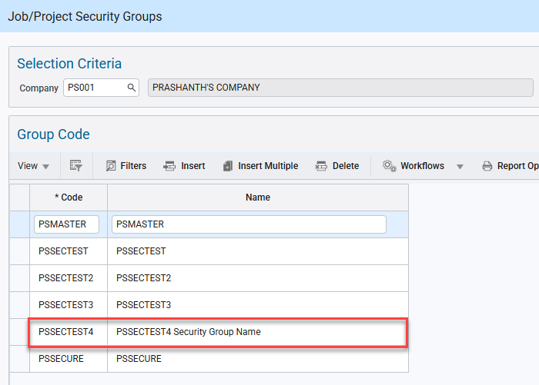
System Data > Security > Job/Project Security > Create Security Groups
NOTE: For more information, refer the API documentation: https://developers.cmicglobal.com/apidocs/create-security-group

PATCH Request:
This method is primarily used to update the name of an existing specific job/project security group under a company.
- The endpoint will mirror the current program functionality by allowing edits only to the security group name once the group has been assigned to any jobs or projects.
- If a security group code is already assigned to a job, updating the group name will automatically reflect across all associated jobs or projects.
- The endpoint will only allow updates to the group code if the group has just been created and has not yet been assigned to any job or project.
The following is a sample of API payload in JSON consisting of the job/project security group name which can be updated under all circumstances:
{
"JsgName": "Adding a record - API"
}
Additionally, job/project security group code can also be updated, but a successful 200 – OK response is received ONLY if the security group has no jobs/projects assigned to it. Else, a 400 – Bad Request error is received.
NOTE: Attempting to update the company code will always result in a 400 response.
An example of a successful update of security group name.
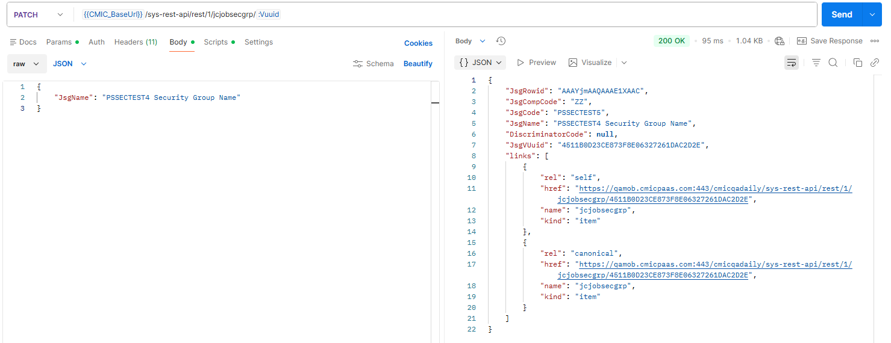
The newly created security group is also visible in the Job/Project Security Groups program for the specific company.
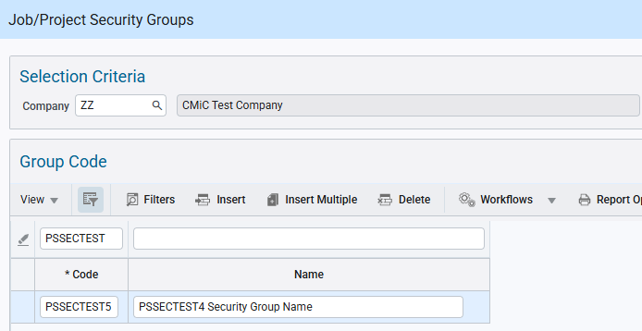
System Data > Security > Job/Project Security > Create Security Groups
NOTE: For more information, refer the API documentation:

DELETE Request:
This method is primarily used to delete an existing job/project security group under a company.
The request is sent with a valid VUUID, which happens to uniquely identify a specific job/project security group under the company.
Upon successful deletion, a 204 – No Content response is received.
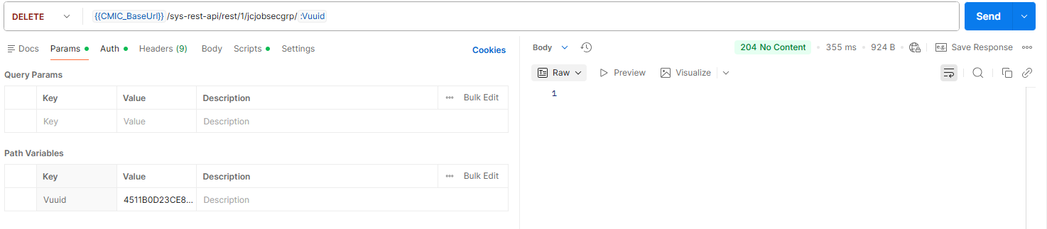
The user corresponding to the ID is also removed from the specific job/project security group in the Users By Job Security Group program.
Querying in the UI shows that the Security Group PSSECTTEST5 corresponding to the VUUID is no longer assigned to the Company ZZ.

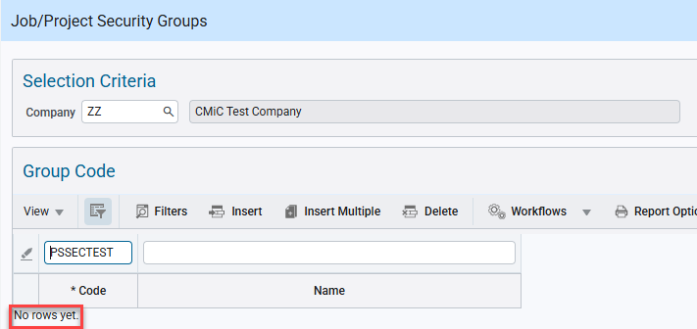
System Data > Security > Job/Project Security > Create Security Groups
Additionally, the Security Group is also not listed in the Job and Project screens.

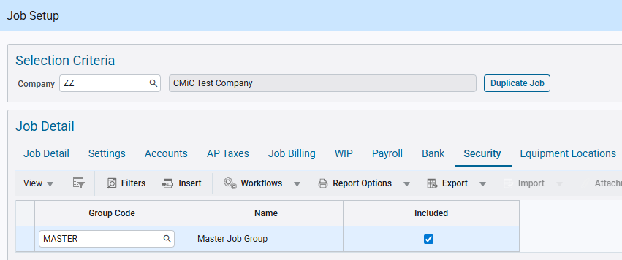
Project Controls > Job Costing > Job > Enter Job
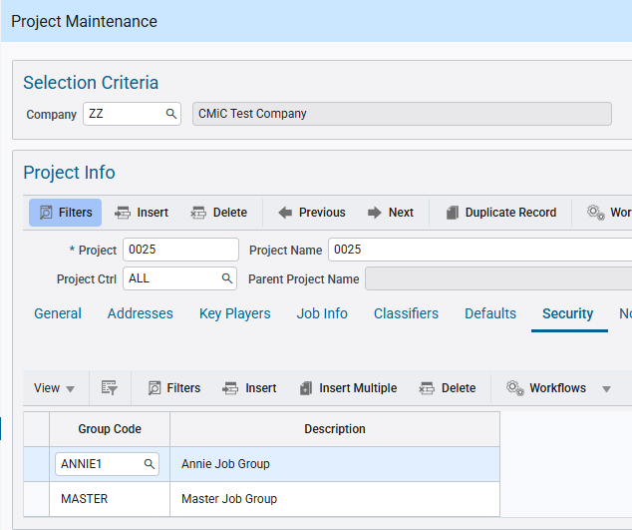
Project Controls > Job Costing > Job > Enter Project
NOTE: For more information, refer the API documentation: https://developers.cmicglobal.com/apidocs/delete-a-security-group

New API Endpoint for Job Assignment to Security Group (JBJCPC-3766)
Overview:
Currently, to assign a valid job to a particular job/project security group, they must be manually added in the Job/Projects By Security Group program under System Data.
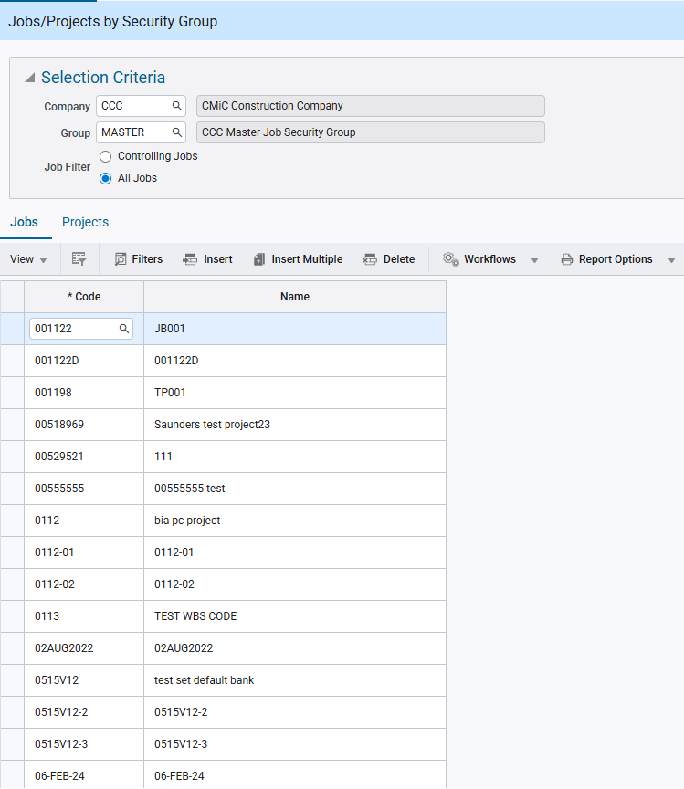
System Data > Security > Job/Project Security > Assign Job/Projects to Security Groups
Now for added flexibility and convenience, a new API endpoint that automates the assignment of Jobs to Job/Projects Security groups has been implemented. The goal is to ensure consistency of Job-to-Job Security group assignment, improving efficiency and reducing manual administrative intervention.
This endpoint will support the existing functionality as follows,
- Assign jobs and projects linked to it to the same security group.
- If the assigned job is a control job, then all the sub jobs will inherit the same security group.

Setup:
The new API endpoint is titled: jcjobsecgrpjob and it can be made accessible for a specific API user role via the Assign API to Role program under System Data.
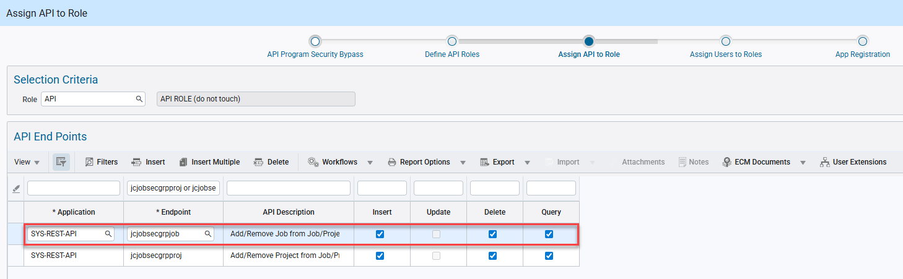
System Data > API Management > Setup > API Security
By default, the API endpoint supports the Querying, Insertion and Deletion of jobs in a job/project security group via the GET, POST and DELETE API requests respectively.
NOTE: The endpoint doesn’t support PATCH request and hence cannot make updates to existing jobs assigned to the security group.
This endpoint enables the assignment of jobs to security groups, thereby granting access to the users associated with the groups. Multiple jobs can be linked to a single security group, and each job can also be associated with multiple groups, supporting flexible access control.

Implementation:
GET Request:
This method is primarily used to retrieve the list of valid jobs currently assigned to a security group.
It supports the following finders for data filtering and optimizing request performance:
- findByJobCode – Querying by a specific Job Code
  - Retrieves the entire list of job security groups across all companies to which the job is assigned.
- findByCompCode – Querying by specific Company Code
  - Retrieves the entire list of jobs across all the security groups under the specific company.
- findByGroupCode – Querying by specific Job/Project Security Group
  - Retrieves the entire list of jobs assigned to the specific security group across all the companies.
NOTE 1: It is recommended to only use a single finder to filter to query the results based on the requirement as the system is set to correctly respond only to a single finder.
NOTE 2: A specific job assigned to a specific job/project security group under a company can be uniquely retrieved using the VUUID which acts a primary key for querying.
Upon a successful request, the system will provide a 200 – OK response displaying the following attributes for the queried data.
- JsgjGroupCode – Security Group Code
- JsgjJobCode – Job Code
- JsgjCompCode – Company Code
- JsgjJobName – Job Name
- JsguVUuid – vuuid (Unique system generated ID)
A sample of a successful GET request with response displaying attributes,
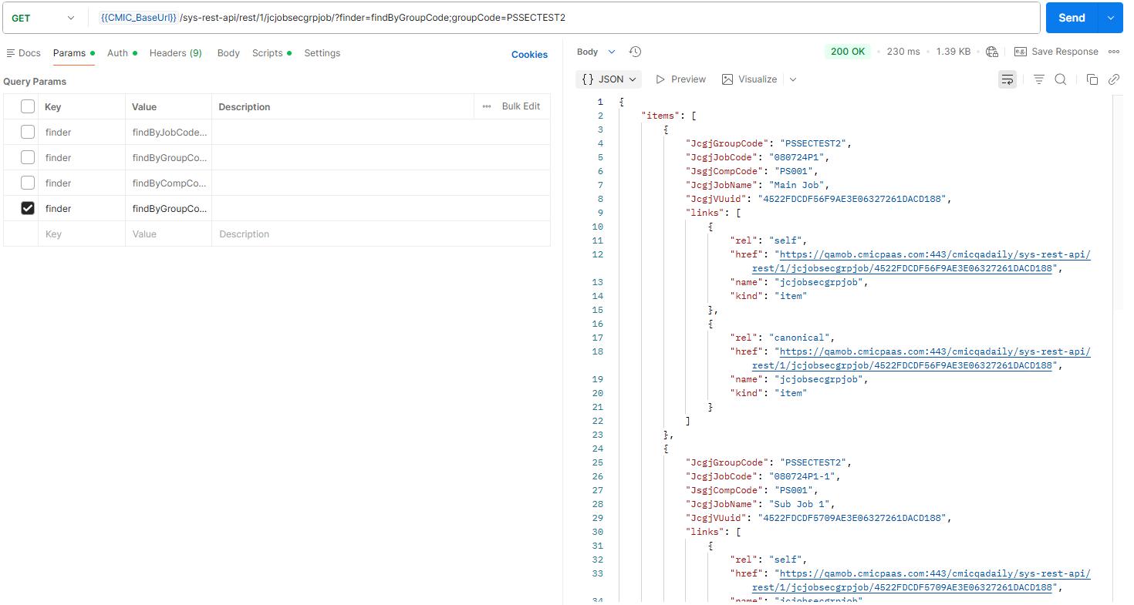

In case of querying for an invalid data or to which the API user doesn’t have access, then still a 200 – OK response is received but without displaying any attributes.
A sample of a GET request with response not displaying any attributes,
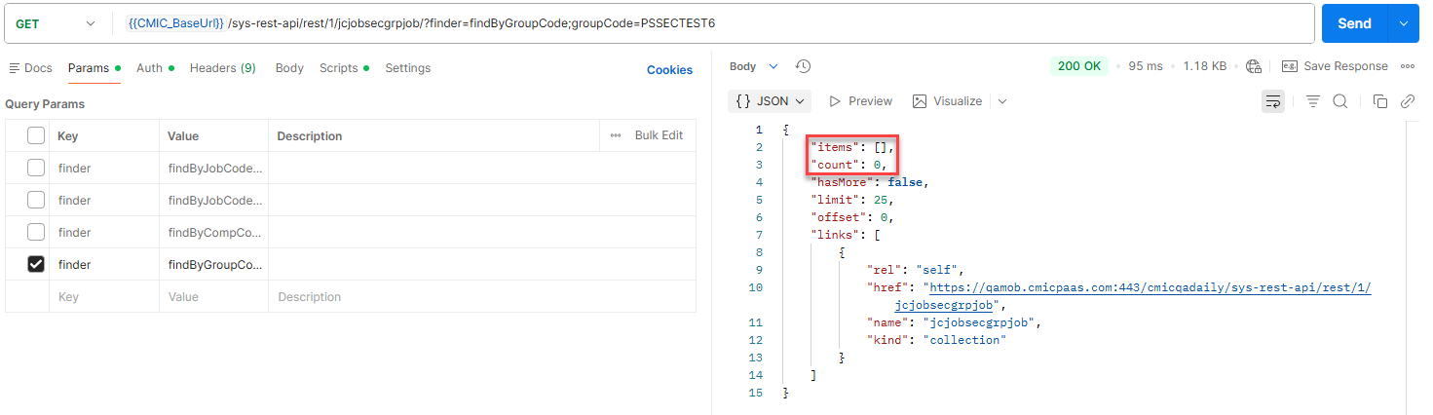
NOTE: For more information, refer the API documentation: https://developers.cmicglobal.com/apidocs/retrieve-job-assigned-to-security-groups

POST Request:
This method is primarily used to assign a valid job to a specific job/project security group under a company.
- Upon successful assignment of a new job to a job security group, any users assigned to that security group will gain access to that new job. Jobs may be assigned to multiple groups.
- If the job is linked to a project, the same security group will automatically be assigned to the associated project.
- Sub-jobs linked to a control job inherit the security group from the control job.
NOTE: If a default security group is assigned to the company for the user in the Set User Defaults program in Job Costing module, then all the jobs created by the API endpoint will also have this default security group assigned to them in addition to the security group specified in the payload. This is similar to the existing functionality in the Enterprise application.
The following is a sample of API payload in JSON consisting of all the parameters supported:
{
"JcgjGroupCode": "JOBTEST",
"JcgjJobCode": "PC-20246",
"JcgjJobName": "API Test Job",
"JsgjCompCode": "ZZ",
"JcgjVUuid": ""
}
Out of these parameters the following are mandatory and sending a request with any of them missing will result in a 400 – Bad Request:
- JsgjJobCode – Job Code
- JsgjCompCode – Company Code
- JsgjGroupCode – Security Group Code
NOTE: Sending invalid data or group/company to which the API user doesn’t have access will also result in a 400 response. Same is displayed when attempting to add a duplicate job under the same security group in a company, but system allows the same job to be assigned to a different security group under the company.
Upon successful addition of the user to the security group, a 201 – Created response is received with the unique system generated vuuid.
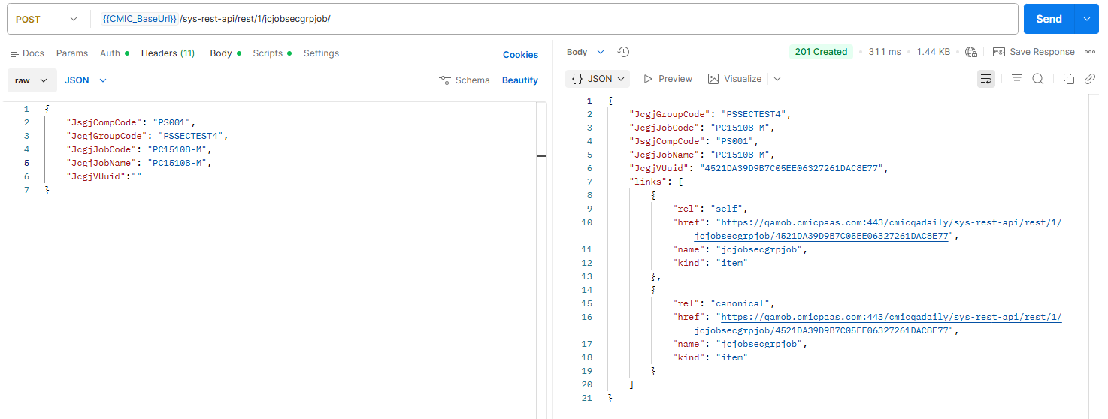
The newly added job is also visible in the Job/Projects By Security Group program for the specific company and security group.
If the job added is a control job as is the case in the above example, then the sub jobs associated with this control job are also assigned under the same security group.
Similarly, the project linked to the control job will also be assigned to the same security group.
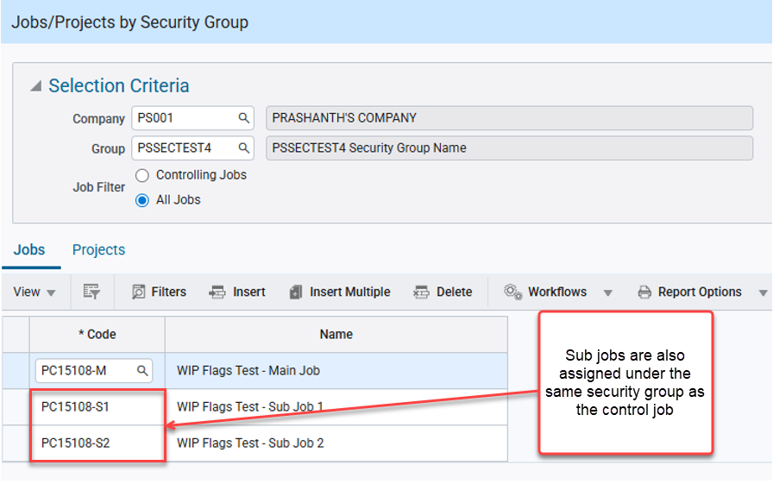
System Data > Security > Job/Project Security > Assign Jobs/Projects to Security Groups
NOTE: For more information, refer the API documentation: https://developers.cmicglobal.com/apidocs/assign-job-to-security-group

DELETE Request:
This method is primarily used to remove an existing job assigned to a specific job/project security group under a company.
The request is sent with a valid VUUID, which happens to uniquely identify a job assigned to a specific job/project security group under a company.
Upon successful deletion, a 204 – No Content response is received.
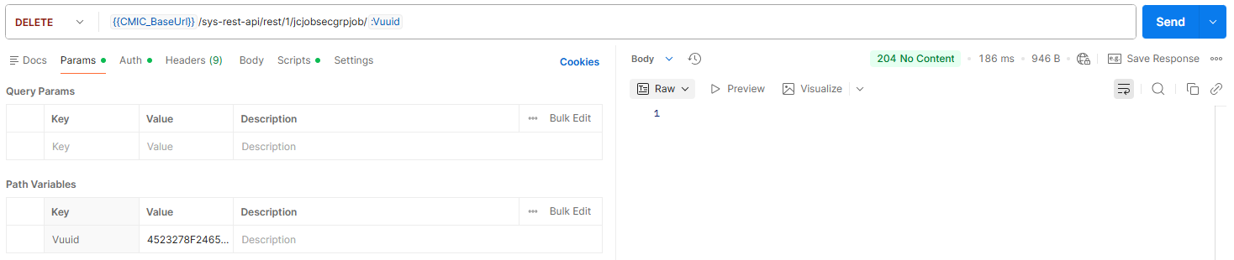
The job corresponding to the ID is also removed from the specific job/project security group in the Job/Projects By Security Group program.
Querying in the UI shows that the Job corresponding to the VUUID is no longer assigned to the security group PSSECTTEST3 under company PS001.
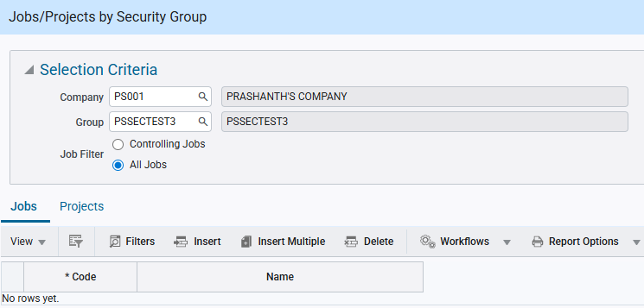
System Data > Security > Job/Project Security > Assign Jobs/Projects to Security Groups
NOTE: For more information, refer the API documentation: https://developers.cmicglobal.com/apidocs/remove-job-from-security-group

New API Endpoint for Project Assignment to Security Group (JBJCPC-3766)
Overview:
Currently, to assign a valid project to a particular job/project security group, they must be manually added in the Job/Projects By Security Group program under System Data.
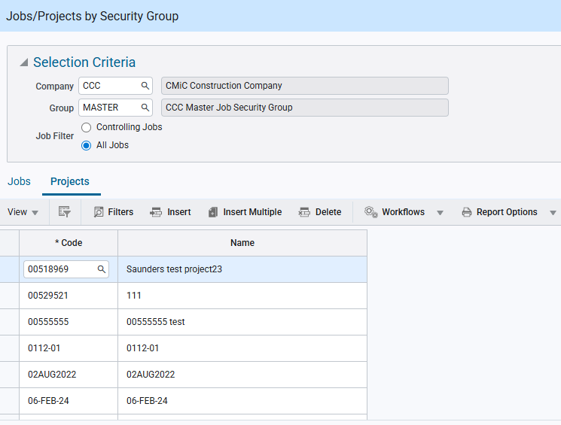
System Data > Security > Job/Project Security > Assign Job/Projects to Security Groups
Now for added flexibility and convenience, a new API endpoint that automates the assignment of Projects to Job/Projects Security groups has been implemented. The goal is to ensure consistency of Project-to-Project Security group assignment, improving efficiency and reducing manual administrative intervention.
This endpoint will support the existing functionality as follows,
- Assign project and control job linked to it to the same security group.
- If the assigned project is a control project, then all the sub projects will inherit the same security group.
- If the project is linked to a project, the project will also be assigned to the same security group. Users in the group will gain access to both the project and the associated project.

Setup:
The new API endpoint is titled: jcjobsecgrpproj and it can be made accessible for a specific API user role via the Assign API to Role program under System Data.
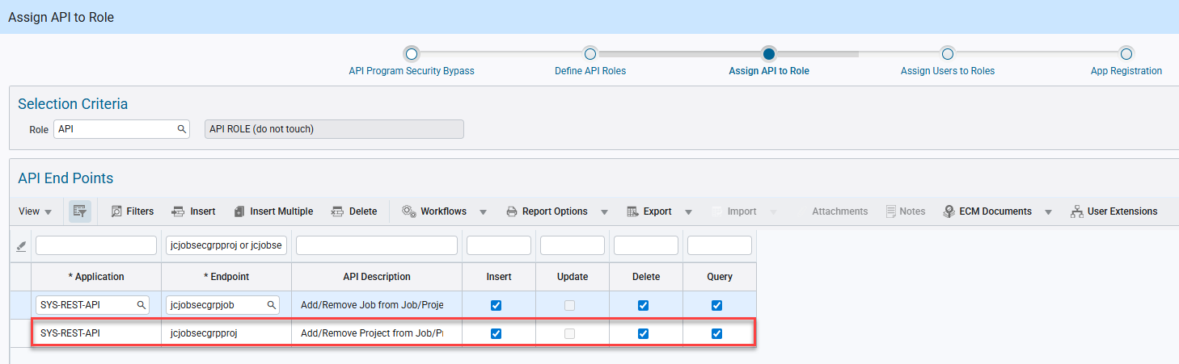
System Data > API Management > Setup > API Security
By default, the API endpoint supports the Querying, Insertion and Deletion of projects in a job/project security group via the GET, POST and DELETE API requests respectively.
NOTE: The endpoint doesn’t support PATCH request and hence cannot make updates to existing projects assigned to the security group.
This endpoint enables the assignment of projects to security groups, thereby granting access to the users associated with the groups. Multiple projects can be linked to a single security group, and each project can also be associated with multiple groups, supporting flexible access control.

Implementation:
GET Request:
This method is primarily used to retrieve the list of valid projects currently assigned to a security group.
It supports the following finders for data filtering and optimizing request performance:
- findByProjCode – Querying by a specific Project Code
  - Retrieves the entire list of security groups across all companies to which the project is assigned.
- findByCompCode – Querying by specific Company Code
  - Retrieves the entire list of projects across all the security groups under the specific company.
- findByGroupCode – Querying by specific Job/Project Security Group
  - Retrieves the entire list of projects assigned to the specific security group across all the companies.
NOTE 1: It is recommended to only use a single finder to filter to query the results based on the requirement as the system is set to correctly respond only to a single finder.
NOTE 2: A specific project assigned to a specific job/project security group under a company can be uniquely retrieved using the VUUID which acts a primary key for querying.
Upon a successful request, the system will provide a 200 – OK response displaying the following attributes for the queried data.
- JsgpGroupCode – Security Group Code
- JsgpProjCode – Project Code
- JsgpCompCode – Company Code
- JsgpProjName – Project Name
- JsgpVUuid – vuuid (Unique system generated ID)
A sample of a successful GET request with response displaying attributes,
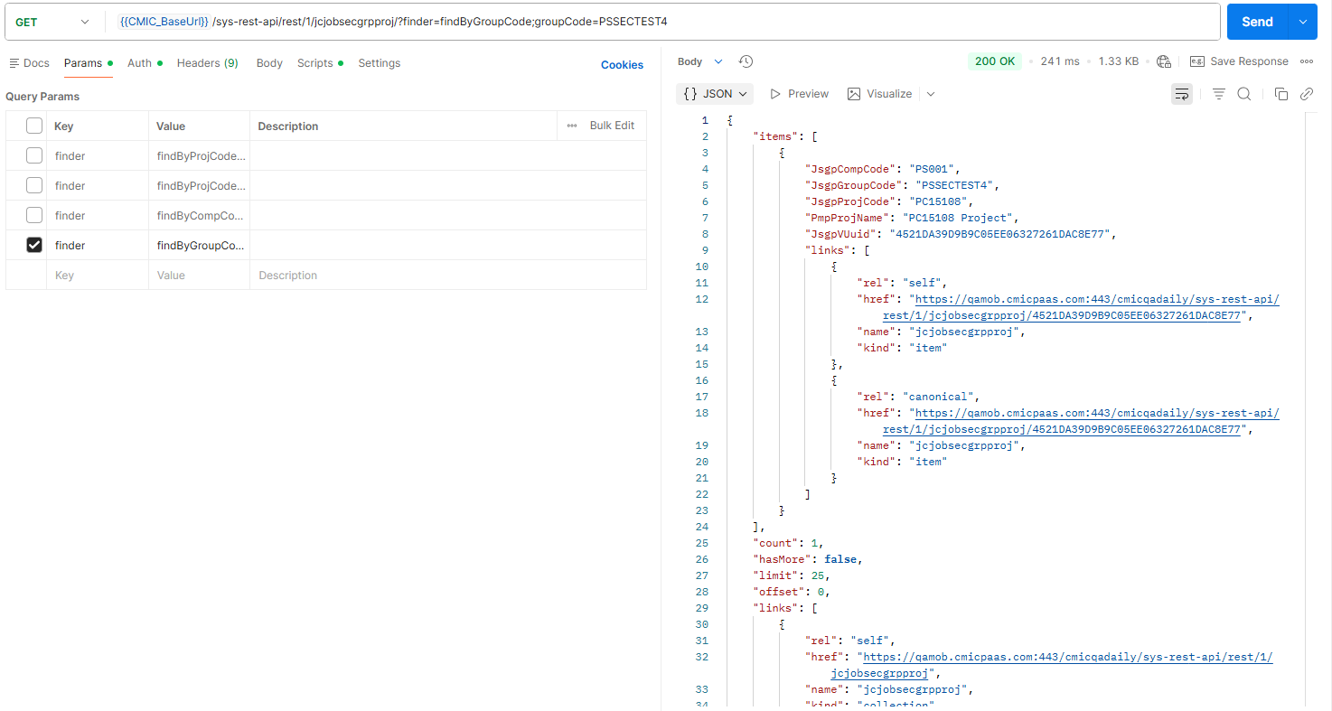

In case of querying for an invalid data or to which the API user doesn’t have access, then still a 200 – OK response is received but without displaying any attributes.
A sample of a GET request with response not displaying any attributes,
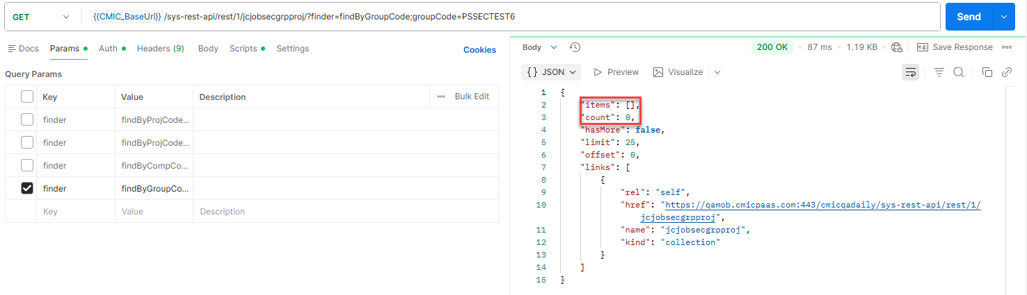
NOTE: For more information, refer the API documentation: https://developers.cmicglobal.com/apidocs/retrieve-project-assigned-to-security-groups

POST Request:
This method is primarily used to assign a valid project to a specific job/project security group under a company.
- Upon successful assignment of a new project to a project security group, any users assigned to that security group will gain access to that new project. Projects may be assigned to multiple groups.
- If the project is linked to a job, the same security group will automatically be assigned to the associated job.
NOTE: If the linked job is a control job, then the sub jobs associated with the control job do not inherit the security group.
- Sub-jobs linked to a control job inherit the security group from the control job.
NOTE: If a default security group is assigned to the company for the user in the Set User Defaults program in Job Costing module, then all the projects created by the API endpoint will also have this default security group assigned to them in addition to the security group specified in the payload. This is similar to the existing functionality in the Enterprise application.

The following is a sample of API payload in JSON consisting of all the parameters supported:
{
"JcgpGroupCode": "JOBTEST",
"JcgpProjCode": "PC-20246",
"JcgpProjName": "API Test Project",
"JsgpCompCode": "ZZ",
"JcgpVUuid": ""
}
Out of these parameters the following are mandatory and sending a request with any of them missing will result in a 400 – Bad Request:
- JsgpProjCode – Job Code
- JsgpCompCode – Company Code
- JsgpGroupCode – Security Group Code
NOTE: Sending invalid data or group/company to which the API user doesn’t have access will also result in a 400 response. Same is displayed when attempting to add a duplicate project under the same security group in a company, but system allows the same project to be assigned to a different security group under the company.
Upon successful addition of the user to the security group, a 201 – Created response is received with the unique system generated vuuid.
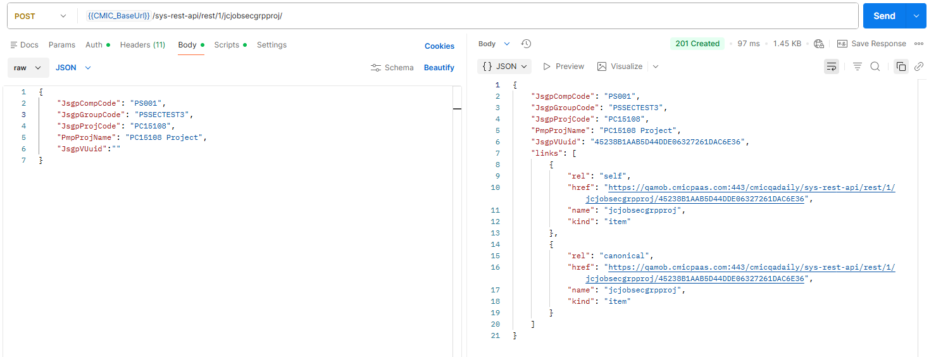
The newly added project is also visible in the Job/Projects By Security Group program for the specific company and security group.
Note that any control job linked to the project will also be added to the same security group.
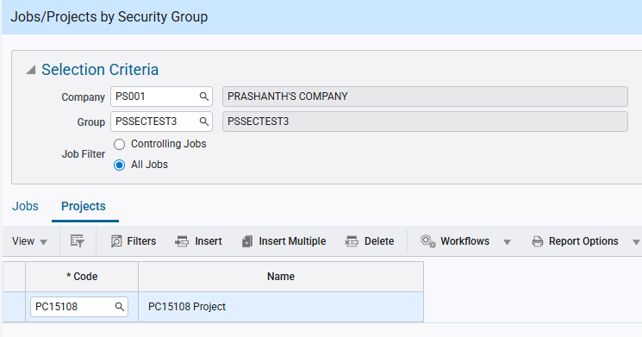
System Data > Security > Job/Project Security > Assign Jobs/Projects to Security Groups
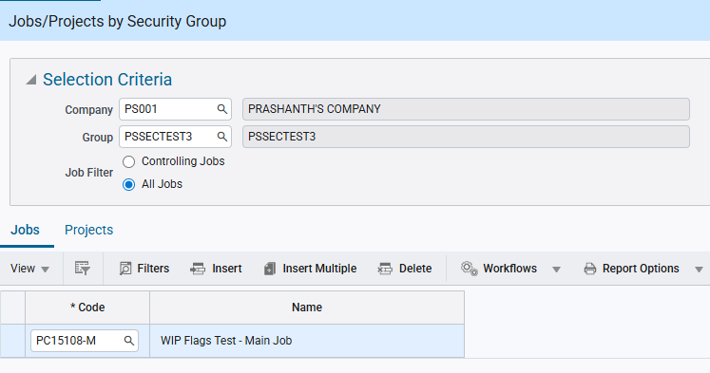
System Data > Security > Job/Project Security > Assign Jobs/Projects to Security Groups
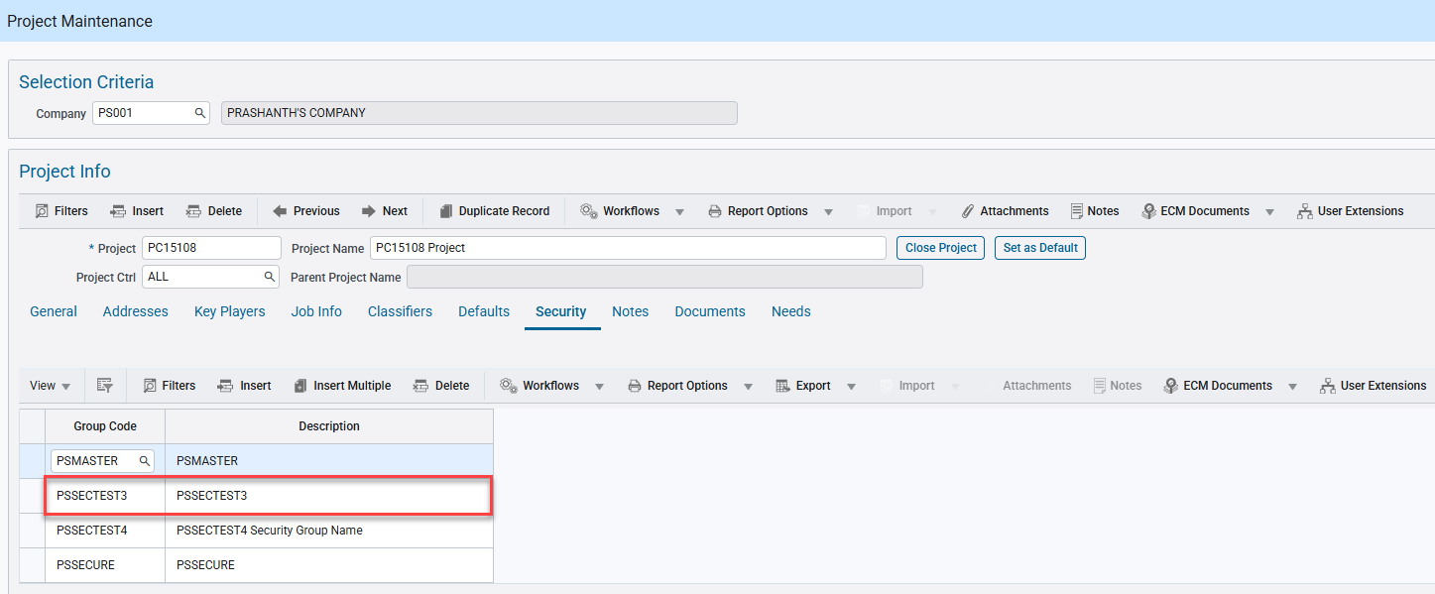
Project Controls > Job Costing > Job > Enter Project
NOTE: For more information, refer the API documentation: https://developers.cmicglobal.com/apidocs/assign-project-to-security-group

DELETE Request:
This method is primarily used to remove an existing project assigned to a specific job/project security group under a company.
The request is sent with a valid VUUID, which happens to uniquely identify a project assigned to a specific job/project security group under a company.
Upon successful deletion, a 204 – No Content response is received.
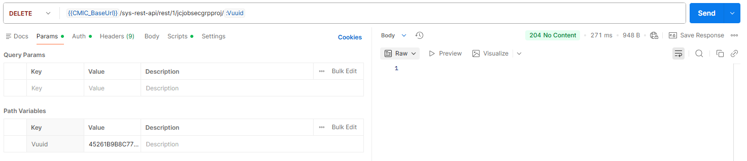
The project corresponding to the ID is also removed from the specific job/project security group in the Job/Projects By Security Group program.
Querying in the UI shows that the project corresponding to the VUUID is no longer assigned to the security group PSSECTTEST3 under company PS001.
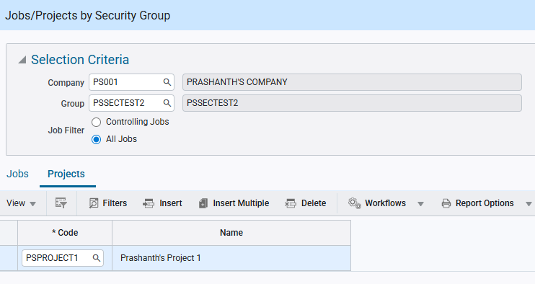
System Data > Security > Job/Project Security > Assign Jobs/Projects to Security Groups
However, note that the linked Control Job PC15108-M is still assigned to the Job/Project security Group and must be removed manually to be unassigned from the group. This is as per the existing functionality in the Enterprise application.

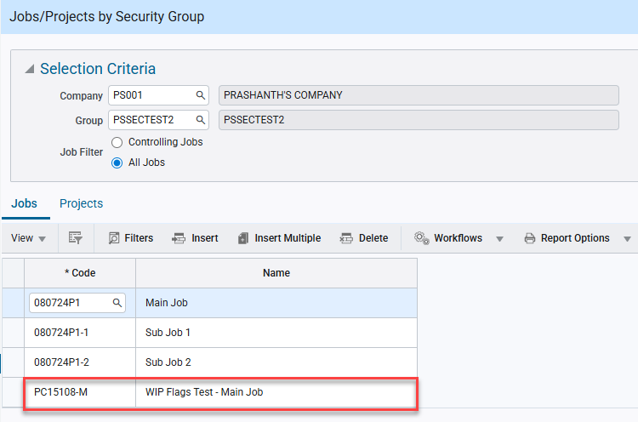
System Data > Security > Job/Project Security > Assign Jobs/Projects to Security Groups
NOTE: For more information, refer the API documentation: https://developers.cmicglobal.com/apidocs/remove-project-from-security-group

Enhancement to sysrelateddocquery API (FIN-20956)

Overview:
Enhancement to API endpoint: sys-rest-api/rest/1/sysrelateddocquery
Modifications:
sys-rest-api/rest/1/sysrelateddocquery endpoint is modified to enable support for Object AP Voucher as specified below:
Use: ObjectType = APVOU
Keys:
- ObjectKey1 = Company Code
- ObjectKey2 = Vendor Code
- ObjectKey3 = Invoice Code
- ObjectKey4 = Duplicate ID
When Duplicate ID is NULL, simply remove it or leave it blank.
